Using 2D Structural Alerts to Define Chemical Categories for Molecular Initiating Events
Timothy E. H. Allen† Jonathan M. Goodman,*† Steve Gutsell,‡ and Paul J. Russell‡
*Corresponding author: jmg11@cam.ac.uk
†Centre for Molecular Informatics, Department of Chemistry, University of Cambridge, Lensfield Road, Cambridge, CB2 1EW, United Kingdom
‡Unilever Safety and Environmental Assurance Centre, Colworth Science Park, Sharnbrook, Bedfordshire, MK44 1LQ, United Kingdom

ABSTRACT
Molecular Initiating Events (MIEs) are important concepts for in silico predictions. They can be used to link chemical characteristics to biological activity through an adverse outcome pathway (AOP). In this work, we capture chemical characteristics in 2D structural alerts, which are then used as models to predict MIEs. An automated procedure has been used to identify these alerts, and the chemical categories they define have been used to provide quantitative predictions for the activity of molecules that contain them. This has been done across a diverse group of 39 important pharmacological human targets using open source data. The alerts for each target combine into a model for that target, and these models are joined into a tool for MIE prediction with high average model performance (Sensitivity = 82 %, Specificity = 93 %, Overall Quality = 93 %, Matthews Correlation Coefficient = 0.57). The result is substantially improved from our previous study (Allen, Liggi, et al. 2016) for which the mean Sensitivity for each target was only 58%. This tool provides the first step in an AOP-based risk assessment, linking chemical structure to toxicity endpoint.
KEYWORDS: Molecular Initiating Event (MIE), Structure Activity Relationship (SAR), Adverse Outcome Pathway (AOP), Human Toxicology, Risk Assessment.

GRAPHICAL ABSTRACT
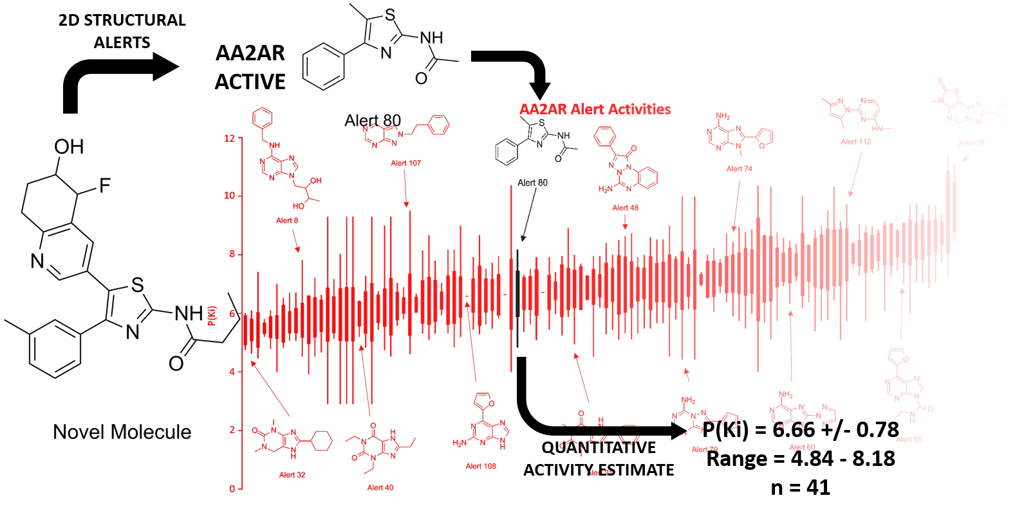
INTRODUCTION
The adverse outcome pathway (AOP) framework collects chemical and biological information together into a modular framework to support toxicity risk assessment. (Ankley et al., 2010; Villeneuve et al., 2014) The building blocks of AOPs are:
- Key Events (KEs), identifiable perturbations in biological systems
- Key Event Relationships (KERs), links between these perturbations. (OECD)
The Molecular Initiating Event (MIE) (Allen et al., 2014; Allen, Goodman, et al., 2016) is a key event that spans the disciplines of chemistry and biology, linking the chemical properties of a molecule to an interaction at a biological target. The MIE presents a particularly interesting target for chemistry-based predictions, providing the ability to link chemical structure of a novel molecule to potential MIEs. As MIEs are essentially chemical interactions between a toxicant molecule and a biological molecule, the chemical characteristics of the toxicant molecule must be related to the MIE. By identifying chemical characteristics in compounds with known MIEs, predictions of MIEs can be made for novel molecules. In 2016 we presented a number of MIE models for human targets based on computationally extracted common fragments (structural alerts), combined with literature knowledge and crystal structures. (Allen, Liggi, et al., 2016) These models performed well, but higher performance, particularly a lower false-positive rate, and quantitative predictions, are desirable for greater impact and model use.
MIE modelling approaches have also seen use elsewhere. (Casalegno and Sello, 2013; Gerberick et al., 2007; Sanderson et al., 2016) Many of these approaches use chemistry as the basis for computational models for the prediction of MIEs or KEs. This has included chemical categorization for electrophilic chemicals known to be genotoxic, (Enoch et al., 2011) using chemical fragments and descriptors to model the MIE for retinoic acid receptor binding, (Steinmetz et al., 2015) and using the chemistry of a toxicant to identify how toxic outcomes happen, for example, for mitochondrial toxicants. (Nelms et al., 2015) The continued development and evolution of computational models based on MIEs is critical to provide risk assessment and chemical screening procedures for toxicology in the future.
It is vitally important to the toxicology community for MIE models to provide quantitative estimates of molecular activity. (Auer et al., 1990; Verhaar et al., 1992; Russom et al., 1997; Roberts et al., 2007, 2011) Without such estimates, only a binary hazard-style safety assessment can be conducted, rather than a risk-assessment incorporating exposure, dose and response. One example of this is the development of a quantitative model for the skin sensitization AOP, (MacKay et al., 2013; Maxwell et al., 2014) linking an MIE model for the haptenization of proteins into a toxicodynamic model to estimate the T-cell response. By providing estimates of molecular activity, models can contribute to risk assessments, allowing chemical exposure to be considered, and a safe dose calculated.
In this paper, we report a new procedure for the in silico prediction of MIEs. Computational models using 2D structure activity relationships (SARs) for MIEs have been developed based on important human pharmacological targets. These targets were chosen from Bowes 2012 (Bowes et al., 2012) and from our earlier work (Allen et al., 2014) (Table 1). These models are based on biological receptor binding data that have been collected from the open source database ChEMBL, (ChEMBL database) and were generated by a new computational algorithm which automatically develops 2D structural alerts. This significantly increases the performance of the models relative to earlier work. These fragments each define a small chemical category of very similar ChEMBL chemicals, allowing for a read-across style prediction of an MIE. These small chemical categories lend themselves well to quantitative predictions, as the molecules within them often have similar activity values (i.e. Ki or IC₅₀). Each chemical category is, therefore, presented with an estimated activity value (mean) and error (standard deviation), providing quantitative estimates for the chemical activity of novel molecules predicted using these SARs. All the structural alerts for each target are then combined to form a model for molecular activity at that target. The models are then combined to form a tool for MIE prediction (Figure 1).
Two-dimensional structural alerts link the chemistry of a molecule to its activity, by establishing the chemical core of binder molecules. The chemistry of these binders is well modelled using chemical structures, even when they are only fragments, as the chemical structure defines the shape and interaction potential of a molecule, i.e. through hydrogen bonds. Structural alerts are mechanistically transparent and computationally simple, allowing many molecules to be rapidly assessed and their predictions to be trusted to a higher level than black-box methods for which the user has no understanding of the internal workings. They also have some limitations. Using 2D fragments to model 3D molecules and receptors is an incomplete picture of toxicology and their applicability domain limited to similar molecules. A large amount of data is required to extract such characteristics. Areas of chemical space without sufficient population will not be picked up by such methods. Overall, however, 2D structural alerts are a good choice for in silico model construction, as their mechanistic insights outweigh their limitations.

MATERIALS AND METHODS
Data Set.
The data was taken from ChEMBL (https://www.ebi.ac.uk/chembl/, version 19, data collected November 2014), which contains more than a million annotated compounds comprising over twelve million bioactivities covering in excess of 10 000 targets, all abstracted from the primary scientific literature. (Bento et al., 2014) Compounds with a confidence score of 8 or 9 and with reported activities (K_{i}/K_{d}/IC₅₀/EC₅₀) less than, or equal to, 10 µM against human protein targets were treated as positives and used for model generation (Table 1). These cutoffs were chosen to provide chemicals with a pharmacologically-relevant activity at a specific, well-defined, human target. A cut-off of 10 µM ensures that the compounds have a good degree of biological activity and represents a trade-off between activity and dataset size. A confidence score of 8 represents the assignment of homologous single proteins, and 9 direct single protein interactions. (ChEMBL database) These compounds are binders irrespective of agonistic and antagonistic activity. Non-binders were omitted from the generation of the models because of the small fraction of compounds found in ChEMBL with reported activities weaker than 10 µM. Only receptors with at least twenty active compounds were used to ensure enough information is available to construct appropriate in silico models. The data set for each target was split randomly into 75 % training set and a 25 % test set using Pipeline Pilot, (Accelrys Software Inc.) so internal validation could be provided. Duplicate data points were removed. This was performed on the molecular structure of each chemical based on its atomic connectivity, resulting in different tautomers, enantiomers and salts being treated as different data points. The training sets were then combined and uniquified to make an amalgamated training set, and the test sets were combined in an analogous fashion to make an amalgamated test set. These give a representation of ChEMBL chemical space. The amalgamated sets were not used in the development of models, but were used in the internal validation. These compounds had unknown activity across each receptor but were used as anticipated negatives to give an idea of chemical space. This is done to overcome bias in the ChEMBL set towards positives, and allow model quality to be better assessed than through the use of sensitivity alone. In total 51 179 activities across 30 349 unique compounds and 45 human targets were extracted for model construction.
In cases where several targets belonged to the same family (i.e. the delta, kappa and mu opioid receptors are all opioid receptors), combined data sets were made. This is the case for alpha adrenergic receptors, beta-adrenergic receptors, cannabinoid receptors, dopamine receptors, histamine receptors, muscarinic acetylcholine receptors, opioid receptors, serotonin receptors (excluding the 3A as it is an ion channel and not a GPCR) and cyclooxygenases. These family groups were chosen based on overlap within their ChEMBL data and in the alerts developed in our previous work. (Allen, Liggi, et al., 2016)
Structural Alert Construction.
Canonical SMILES for each positive compound were used to automatically generate 2D fragment-based structural alerts (Figure 2). A maximal common substructure generating algorithm in Pipeline Pilot (Accelrys Software Inc.) was used to identify the largest fragment common to 2 % of the training set. This small percentage was chosen to provide very tight chemical categories of relatively few chemicals to improve model performance. Fragments were identified based on matching atom types and charges between molecules. Partial aliphatic rings were allowed within fragments. The structural alert was then coded in SMILES and its performance statistics calculated using the test sets. Molecules matching this structural alert were then removed from the original training set using a substructure filter and the procedure would begin again, starting with a maximal common substructure search. Each subsequently identified structural alert would be appended to the SMILES output file, building a library of alerts to make up a model. This iterative cycle ran until categories become small enough that they contain only a single chemical. At this point, the SMILES and statistical performance measures are output for interpretation and model construction.
During the model construction, it was found that more than twenty chemicals were required to construct models using this computational algorithm, due to low sensitivity values being produced when fewer binders were available in the dataset (Figure 3). A new cut off of 200 chemicals was chosen and as a result of this, models for the endothelin receptor A, GAR transformylase, phosphodiesterase 3A, glutamate receptor, sodium channel V subunit alpha, and voltage-gated K channel subunit Kv7.1 are not included in this work. In the cases of GAR transformylase, glutamate receptor, and voltage-gated K channel subunit Kv7.1 no structural alerts suitable for the risk assessment (RA-models) or Screen-models were developed, and in the cases of endothelin receptor A, phosphodiesterase 3A, and sodium channel V subunit alpha few alerts were developed with low model performance, particularly, low sensitivity. The histamine H2 receptor was not omitted as it sits in a tight receptor family with the histamine H1 receptor, giving a large histamine receptor data set. The same negative test set was maintained, to allow comparison with our previous structural alerts. (Allen, Liggi, et al., 2016)
Structural Alert Validation and Model Construction.
Test sets were used to calculate sensitivity (SE) for each structural alert using the number of true positives (TP) and false negatives (FN).
$$SE=\frac{TP}{TP+FN}$$
In order to provide a negative test set for each human receptor target the test set for the target of interest was subtracted from the amalgamated test set and so the negative test sets are not all the same. This warns if the alert hits many molecules in diverse areas of ChEMBL chemical space, and provides statistical performance data, but the chemicals are untested against the target of interest and are treated as negatives only for the purpose of this analysis. This is done to provide analysis and get a confidence score for structural alerts. Although these results must be treated carefully, they should provide greater guidance than sensitivity-only calculations. Specificity (SP) is calculated from these results using the number of true negatives (TN) and false positives (FP).
$$SP=\frac{TN}{TN+FP}$$
Overall quality (Q) is calculated based on the total number of correct predictions.
$$Q=\frac{TP+TN}{TP+TN+FP+FN}$$
To overcome the issue of having a larger negative test set than positive set, the Matthews correlation coefficient (MCC) was used to evaluate overall balanced performance;(Matthews, 1975)
$$MCC=\frac{TP×TN-FP×FN}{\sqrt{(TP+FP)(TP+FN)(TN+FP)(TN+FN)}}$$
To use the structural alerts as in silico models for toxicity evaluation it is important to consider which alerts provide good predictions from two standpoints – the best overall performance of the model (high sensitivity, specificity and MCC) for a risk assessment procedure (referred to as RA-models), and aiming to minimize false negative predictions (getting the highest sensitivity possible, often at the cost of a lower specificity) for the purposes of screening large numbers of chemicals and not missing positives (referred to as Screen-models). It has been determined that using all of the structural alerts with two or more molecules in the training set gives a suitable screening model, allowing a scientist to point to at least two other positive molecules which are hits in ChEMBL. While this method risks overfitting the alerts to the training data, the average number of training set chemicals per structural alert is relatively high. On average, there are 10.8 training set chemicals per structural alert in the Screen-models and 18.3 per alert in the RA-models. These numbers are significantly higher than that required by the “Topliss and Costello rule” (Topliss and Costello, 1972) which states that the ratio of chemicals to descriptors should be at least 5:1 for simple linear regression quantitative SARs (QSARs). This is to minimize the risk of chance correlation and overfitting. For risk assessment the rate of over-firing needs to be reduced to increase overall model performance, leading to the choice of structural alerts with five or more molecules in the training set, and more true positives than false positives in the test set, indicating that the fragment is truly indicative of activity, and not just common among ChEMBL chemicals.
Structural Alerts as Chemical Categories for Quantitative Predictions.
The structural alerts developed as part of this work can be thought of as very specific chemical categories, grouping a small number of ChEMBL compounds based on a high level of structural similarity. Predictions made using these alerts can be considered as read-across. To further exploit this, each chemical category can be used to imply an activity range for molecules that fit within them. To calculate this, the extracted ChEMBL data for each target, in turn, were re-examined and the specific type of activity (K_{i}/K_{d}/IC₅₀ or EC₅₀) with the most data points was chosen to be analyzed using a KNIME workflow. (Berthold et al., 2007) Only one type of activity was used for each target. For molecules with multiple activity data points, the most active were retained and the others removed, to provide a conservative estimate of activity for that specific molecule. The data were then filtered for each structural alert, picking out, in turn, the molecules that comprise that chemical category. The mean, standard deviation and absolute range for the activity of each category were then calculated, providing a quantitative estimation of biological activity, and uncertainty, for that structural alert-based chemical category.
RESULTS AND DISCUSSION
Structural Alerts.
A total of 4 810 structural alerts were identified across 39 pharmacologically important human targets (available as SMILES stings with performance statistics in the supporting information). This information can assist a toxicologist in determining the likelihood that a prediction made by the model is correct. For example, for the adenosine A2A receptor (AA2AR), Alert 1 has 31 true positives (TPs) in the test set and zero false positives (FPs). Therefore, despite a low sensitivity of 3.83 %, we can have high confidence a positive prediction made using this alert is correct. For Alert 87, there are 9 TPs and 11 FPs in the test set, reducing this level of confidence. It is important this information is taken into account when a prediction is made, and hence such information is included in the supporting information. All of these structural alerts are used in the Screen-models. Of these alerts, 2 829 were used in the RA-models representing alerts with a higher number of training set molecules in their chemical categories, and predicting a higher number of true positives than false positives.
Combined Models.
The structural alerts developed in this work have been combined into two distinct models for each target, each with a different performance goal. The RA-model (Table 2) has the highest overall performance across sensitivity, specificity, and MCC. The Screen-model (Table 3) aims to correctly predict as many of the positives as possible, getting a high sensitivity at the cost of specificity.
The difference between the models is shown in the averages for all of the RA-models (SE = 66.30 %, SP = 98.58 %, Q = 97.80 %, MCC = 0.666) when compared to the Screen-models (SE = 81.92 %, SP = 93.45 %, Q = 93.49 %, MCC = 0.569). In total 48 models were compiled from the structural alerts, including models for each target and models for the target families identified earlier. Of the RA-models, 47 score an MCC value greater than 0.4, 32 score greater than 0.6, and 11 score greater than 0.8. An MCC value of greater than 0.8 suggests that, for a balanced test set, 90 % of predictions will be correct, 0.6 suggests 80 % will be correct and 0.4 suggests 70 % will be correct. These results show a high level of performance for these models. Of the Screen-models, 46 models scored sensitivity values of 50 % or more, 37 scored 75 % or more and 19 scored 90 % or more. This shows that the majority of these models are catching a high proportion of the positive compounds. Computational methods based on 2D structural alerts are relatively quick and inexpensive, and are ideal for screening chemicals early in development, and supplementing and targeting other toxicity tests, by providing an estimation of activity. These results must be treated with a note of caution, however, as the remainder of the ChEMBL training set was used as a negative test set, meaning these compounds have not been confirmed as true negatives.
To compare these new models to existing models constructed for the same targets in our previous work (Allen, Liggi, et al., 2016) changes in SE, SP, Q and MCC are included in Tables 2 and 3. For example, for the AA2AR RA-model SE improves by 28.27 %, SP by 4.02 %, Q by 5.71 %, and the MCC by 0.390 compared to the old models. This shows much improved statistical performance in this case. As an average across all models, SE improves by 9.81 %, SP by 10.70 %, Q by 11.03 %, and the MCC by 0.394 for the RA-models and SE improves by 25.57 %, SP by 6.53 %, Q by 7.49 %, and the MCC by 0.317 for the Screen-models, showing significant improvement.
For more detailed toxicological assessment novel compounds can be compared to other chemicals in ChEMBL following assessment using these methods. Each structural alert is the basis of a chemical category, containing a small number of chemically similar ChEMBL chemicals. This methodology can be thought of as read-across, reading across from a small number of similar ChEMBL chemicals to a novel compound. Information on these chemicals and their activities are available through ChEMBL for further analysis, to build weight of evidence for computational risk assessment.
Quantitative Predictions.
These small chemical categories also provide the basis for quantitative assessment of the novel chemicals. For each chemical category, the activities of molecules within that category have been analyzed to provide a mean, standard deviation and absolute range (available in the supporting information). This allows these 2D structural alerts to provide quantitative information on the activity of novel molecules.
As an example, the P(Ki) activity values for molecules within each of the AA2AR chemical categories have been plotted as a box and whisker plot in Figure 4. Some of the data points have been colored red and their structural alerts have been included in the plot to give examples of how this information can be used in toxicity assessment. For example, if a novel chemical fell into the category for Alert 32, 40 or 60 it would be possible to make a prediction of activity within a range of about one log unit. If the novel molecule fell into the category for Alert 107 or 79 perhaps further calculations or additional experimental research would be required to further refine the quantitative activity estimate, as the standard deviation and range are wide. Depending on the estimation of exposure in the risk assessment, this may not matter as the exposure may be many times lower than the amount required for a biological response, depending on the activity estimation obtained.
Biological Relevance.
The AOP Wiki is the largest repository for the construction and development of AOPs. (AOP Wiki) A search has been conducted to find AOPs containing the MIE predicted in this work, and pathways were found for the following targets:
- acetylcholinesterase
- androgen receptor (5 pathways)
- beta-2 adrenergic receptor (2 pathways)
- cyclooxygenase (7 pathways)
- ether-a-go-go voltage-gated potassium channel
- glucocorticoid receptor (2 pathways)
- histamine H2 receptor (2 pathways)
- mu opioid receptor (2 pathways)
- serotonin 1A receptor (2 pathways)
- serotonin transporter (5 pathways)
These 29 pathways are a significant increase on the 19 pathways available in 2016 for the same targets. (Allen, Liggi, et al., 2016) While the majority of these pathways are under development the expansion of the AOP Wiki is an important step in AOP-based safety science, particularly where pathways can be constructed to compliment robust in silico tools. As such, it should be viewed as a valuable goal, and the expansion seen shows promise for this project.
Further information on the clinical pathways that may be affected by chemical binding at these targets is presented in the Bowes 2012 article. (Bowes et al., 2012)
The structural alerts developed in this work can be used to infer information about the biological targets examined. For example, for the Mu Opioid Receptor (MOR) a number of alerts can be found with structural similarity to the typical Opioid Receptor binder morphine. These can be compared to a crystal structure of morphine (Manglik et al., 2012) to identify how molecules containing them can bind to the receptor. Several of these are shown in Figure 5, along with relevant information from the crystal structure. While it would be difficult to gain such specific information without the crystal structure, similar structural alerts could be grouped to give some insight for cases without a crystal structure. In addition to this, structural alerts contained within new molecules could guide compound development – as potential hydrogen bonding groups within the alerts are good targets for modification to reduce the toxic potential of new molecules, due to their prevalence in chemical-biological interactions. For example, in the MOR case a molecule containing alert 1, 6 or 14 could be modified by methylation of the hydroxyl group in the top right hand corner, to remove this potential hydrogen bonding interaction.
CONCLUSIONS
For 39 pharmacologically important human targets, a total of 4 810 structural alerts have been identified computationally. These structural alerts have been combined into two distinct models for each target, incorporating different numbers of alerts to fit their purpose. The RA-model aims to have the highest overall performance and the Screen-model aims to correctly predict as many of the positives as possible. Of the 48 RA-models 47 score an MCC value greater than 0.4, 32 score greater than 0.6 and 11 score greater than 0.8, and of the 48 Screen-models 46 models scored sensitivity values of 50 % or more, 37 scored 75 % or more and 19 scored 90 % or more. The results show these are high-quality models. Each of the chemical categories used in these models also provides a quantitative estimation of molecular activity, based on the mean and standard deviation of ChEMBL positives in the category. The large size of the structural alerts results in small, tight chemical categories containing few chemicals. The result of collecting a high number of these categories has been high model performance and tight molecular activity predictions.
MIEs are key chemical-biological interactions that need to be better understood and predicted to aid in driving forward AOP risk assessment. A number of approaches will be needed to do this, and in this publication we present a drastically improved computational method using mechanistically transparent structural alerts, including quantitative activity predictions, providing a step forward for the prediction of receptor binding MIEs. Combining this understanding of MIEs with AOP information, predictive tools and experimental methods, as well as quantitative links between KEs, can make AOP-based risk assessment a reality. By driving these approaches, we continue to take strides towards risk assessment with alternative methods to animal experiments.
This work presents a considerable step forward in model performance from out previous work (Allen, Liggi, et al., 2016). It also further supports the use of MIEs as an anchor for the development of computational toxicity models, and the use of 2D chemical structural alerts for modelling them to gain qualitative and quantitative predictions.
ASSOCIATED CONTENT
Supporting Information.
Performance statistics, quantitative activity estimates (mean, standard deviation and range) and SMILES for the structural alerts developed in this work.
AUTHOR INFORMATION
Author Contributions
The manuscript was written through contributions of all authors. All authors have given approval to the final version of the manuscript.
Funding Sources
This work was supported by Unilever.
Data Statement
According to the University of Cambridge data management policy, all the data used in this paper are available either in the paper or in the SI. A copy of the data is also available in the University of Cambridge repository at: https://www.repository.cam.ac.uk/
ABBREVIATIONS
AA2AR, adenosine A2A receptor; AOP, adverse outcome pathway; FN, false negative; FP, false positive; GPCR, G-protein coupled receptor; KE, key event; KER, key event relationship; MCC, Matthews correlation coefficient; MIE, molecular initiating event; MOR, mu opioid receptor; Q, overall quality; (Q)SAR, (quantitative) structure-activity relationship; RA-models, risk assessment models; SE, sensitivity; SP, specificity; TN, true negative; TP, true positive.

REFERENCES
Accelrys Software Inc. Pipeline Pilot v.8.0.1.500.
Allen, T.E.H., Goodman, J.M., et al. (2016) A History of the Molecular Initiating Event. Chem. Res. Toxicol., 29, 2060–2070.
Allen, T.E.H. et al. (2014) Defining Molecular Initiating Events in the Adverse Outcome Pathway framework for risk assessment. Chem. Res. Toxicol., 27, 2100–2112.
Allen, T.E.H., Liggi, S., et al. (2016) Using Molecular Initiating Events to Generate 2D Structure Activity Relationships for Toxicity Screening. Chem. Res. Toxicol., 29, 2060–2070.
Ankley, G.T. et al. (2010) Adverse outcome pathways: A conceptual framework to support ecotoxicology research and risk assessment. Environ. Toxicol. Chem., 29, 730–741.
Auer, C.M. et al. (1990) Mode of Action and the assessment of chemical hazards in the presence of limited data: Use of Structure-Activity Relationships (SAR) under TSCA, Section 5. Environ. Health Perspect., 87, 183–197.
Bento, A.P. et al. (2014) The ChEMBL bioactivity database: An update. Nucleic Acids Res., 42, 1083–1090.
Berthold, M.R. et al. (2007) KNIME: The Konstanz Information Miner. Stud. Classif. Data Anal. Knowl. Organ. (GfKL 2007).
Bowes, J. et al. (2012) Reducing safety-related drug attrition: the use of in vitro pharmacological profiling. Nat. Rev. Drug Discov., 11, 909–922.
Casalegno, M. and Sello, G. (2013) Determination of toxicant mode of action by augmented top priority fragment class. J. Chem. Inf. Model., 53, 1113–1126.
ChEMBL database
Enoch, S.J. et al. (2011) The use of a chemistry-based profiler for covalent DNA binding in the development of chemical categories for read-across for genotoxicity. ATLA, 39, 131–145.
European Commission Institute for Health and Consumer Protection AOP Wiki.
Gerberick, G.F. et al. (2007) Quantification of chemical peptide reactivity for screening contact allergens: A classification tree model approach. Toxicol. Sci., 97, 417–427.
MacKay, C. et al. (2013) From pathways to people: Applying the adverse outcome pathway (AOP) for skin sensitization to risk assessment. ALTEX, 30, 473–486.
Manglik, A. et al. (2012) Crystal structure of the µ-opioid receptor bound to a morphinan antagonist. Nature, 485, 321–326.
Matthews, B.W. (1975) Comparison of the Predicted and Observed Secondary Structure of T4 Phage Lysozyme. Biochim. Biophys. Acta, 405, 442–451.
Maxwell, G. et al. (2014) Applying the skin sensitisation adverse outcome pathway (AOP) to quantitative risk assessment. Toxicol. Vitr., 28, 8–12.
Nelms, M.D. et al. (2015) Development of an in silico profiler for mitochondrial toxicity. Chem. Res. Toxicol., 28, 1891–1902.
OECD Proposal for a Template, and Guidance on Developing and Assessing the Completeness of Adverse Outcome Pathways, Appendix I, Collection of Working Definitions.
Roberts, D.W. et al. (2011) Chemistry-based risk assessment for skin sensitization: quantitative mechanistic modeling for the S(N)Ar domain. Chem. Res. Toxicol., 24, 1003–1011.
Roberts, D.W. et al. (2007) Mechanistic applicability domain classification of a local lymph node assay dataset for skin sensitization. Chem. Res. Toxicol., 20, 1019–1030.
Russom, C.L. et al. (1997) Predicting modes of toxic action from chemical structure: acute toxicity in the fathead minnow (Pimephales promelas). Environ. Toxicol. Chem., 16, 948–967.
Sanderson, P.N. et al. (2016) Mechanistic understanding of molecular initiating events (MIEs) using NMR spectroscopy. Toxicol. Res., 5, 34–44.
Steinmetz, F.P. et al. (2015) Screening chemicals for receptor-mediated toxicological and pharmacological endpoints: Using public data to build screening tools within a KNIME workflow. Mol. Inform., 34, 171–178.
Topliss, J.G. and Costello, R.J. (1972) Chance correlations in structure-activity studies using multiple regression analysis. J. Med. Chem., 15, 1066–1068.
Verhaar, H.J.M. et al. (1992) Classifying environmental pollutants. 1: Structure-activity relationships for prediction of aquatic toxicity. Chemosphere, 25, 471–491.
Villeneuve, D.L. et al. (2014) Adverse outcome pathway (AOP) development I: Strategies and principles. Toxicol. Sci., 142, 312–320.

FIGURES & LEGENDS
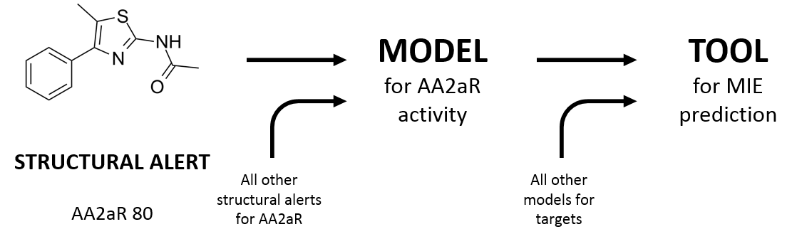
Figure 1. Diagram showing the relationship between structural alerts, models and the MIE tool. Each individual fragment produced by Pipeline Pilot is a structural alert, the structural alerts for one target are combined into a model for that target. The models for all targets are combined into the tool for MIE prediction. AA2aR=adenosine A2a receptor.
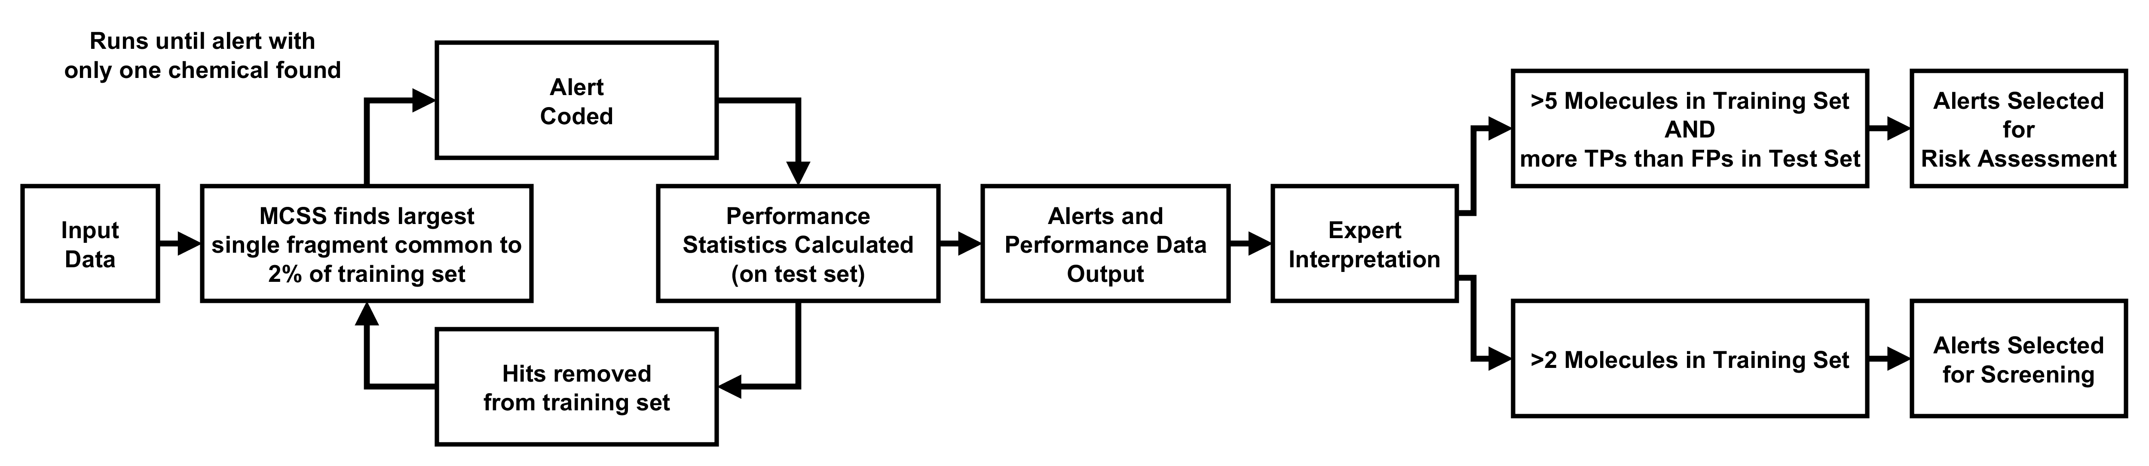
Figure 2. A figure showing the computational procedure for structural alert generation and the criteria for model construction. An iterative process is used to find the largest alert common to 2% of the training set, code the alert as a SMILES string and calculate its performance statistics. This iterative loop runs until a fragment is identified which is contained in only one chemical. Once all alerts and their performance data are output a human expert can judge on their effectiveness, in this case, we present two model building scenarios, one for risk assessment and one for chemical screening. MCSS=Maximal Common Substructure.
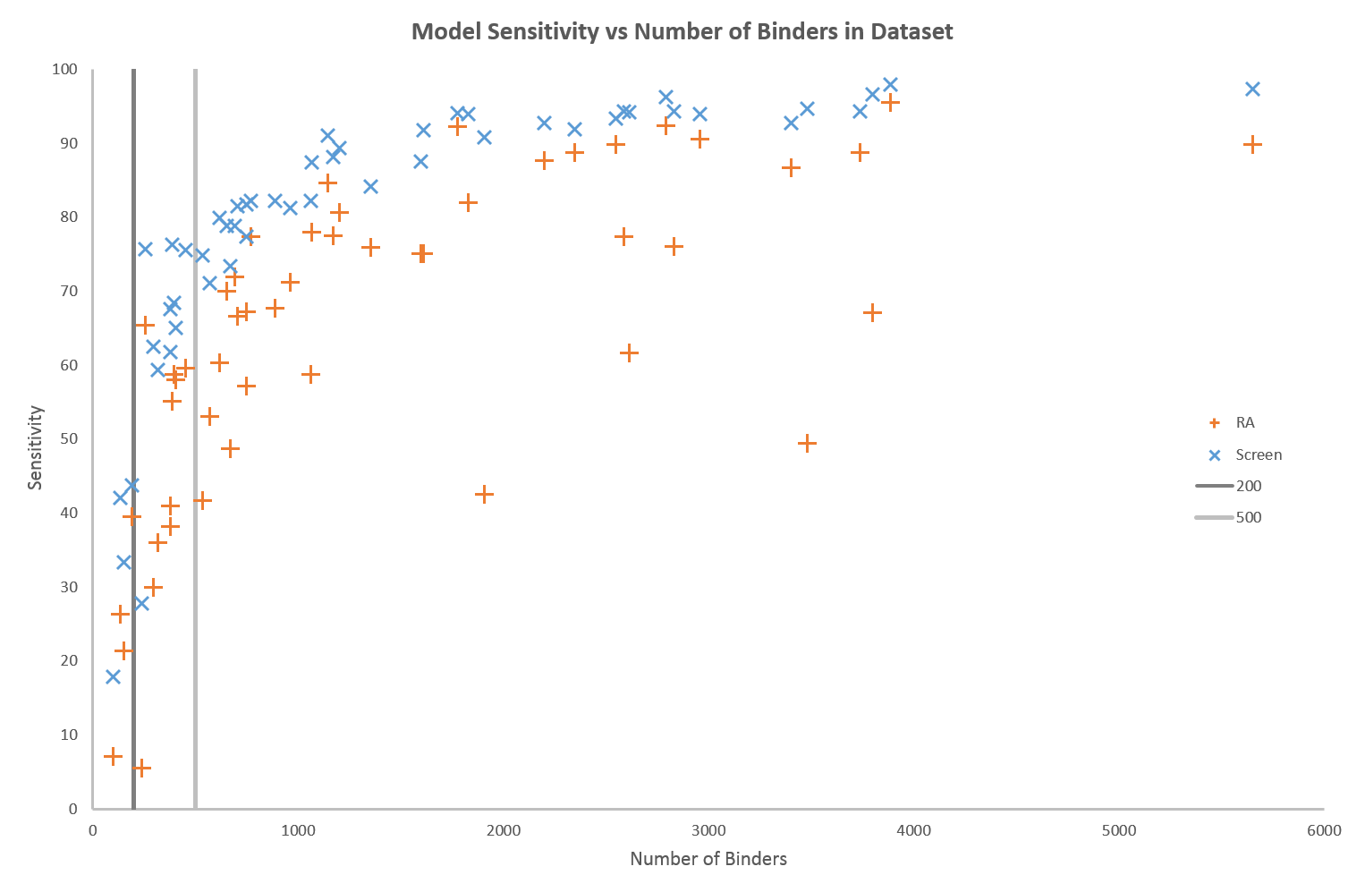
Figure 3. A graph showing the relationship between the total number of binders in a target dataset and the sensitivity of the produced RA-models and Screen-models. Solid vertical lines show potential cutoffs based on models performance at 200 and 500 binders.
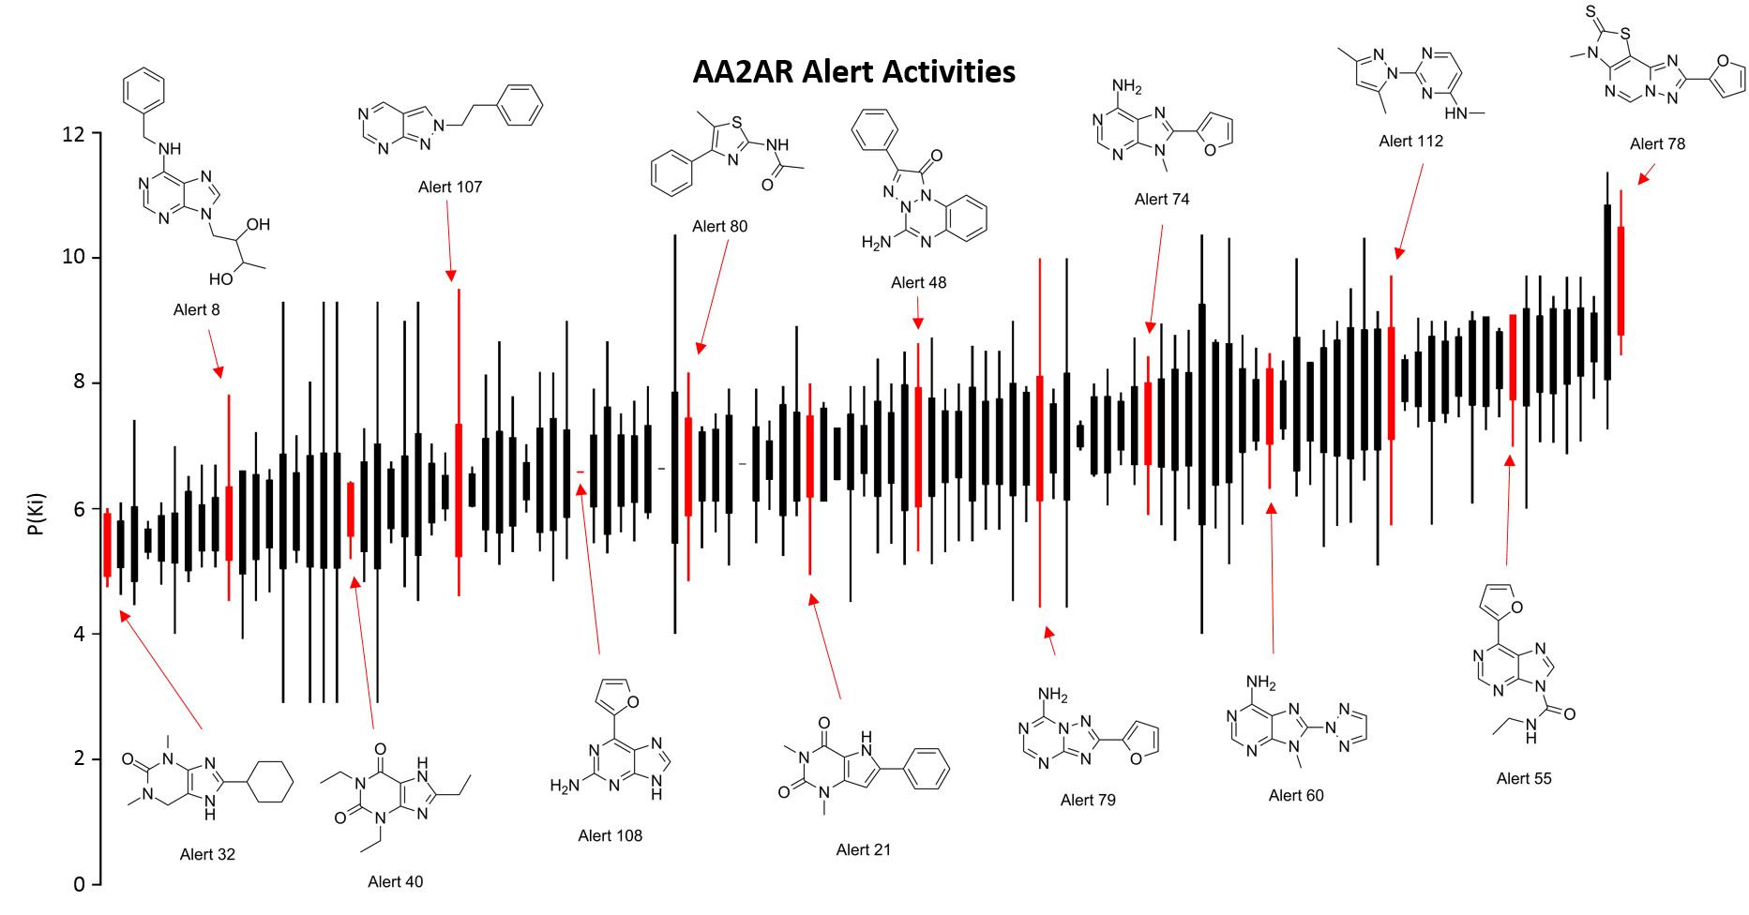
Figure 4. A box and whisker plot showing P(Ki) values for chemical categories of adenosine A2A receptor (AA2AR) binders. The categories are defined by specific structural alerts. The box is the mean value +/- the standard deviation and the whisker shows the absolute range. The categories are ordered from lowest to highest mean P(Ki). Some of the category alerts are shown for clarity.

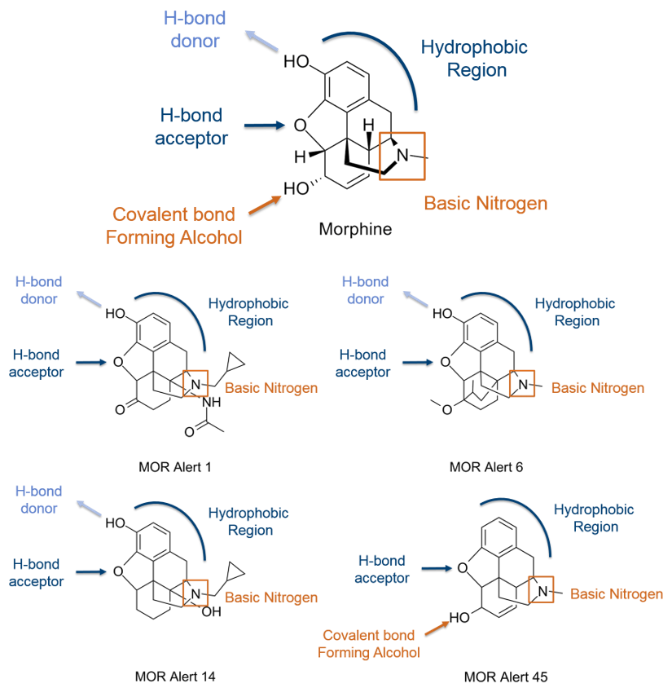
Figure 5. A comparison of several Mu Opioid Receptor structural alerts found to match existing crystal structure information for the typical Opioid Receptor binder morphine. Each of the alerts show four of the five features identified from the crystal structure. (Manglik et al., 2012) MOR=mu opioid receptor.
TABLES
Target | Binders | Binders  Training  Set | Binders  Test Set  (positive) | Test Set  (negative)
G-Protein Coupled Receptors
Adenosine A2A Receptor | 2960 | 2150 | 810 | 10820
Alpha-1a Adrenergic Receptor | 705 | 510 | 195 | 11435
Alpha-2a Adrenergic Receptor | 380 | 269 | 111 | 11519
Beta-1 Adrenergic Receptor | 694 | 505 | 189 | 11441
Beta-2 Adrenergic Receptor | 770 | 540 | 230 | 11400
Cannabinoid CB1 Receptor | 3738 | 2688 | 1050 | 10580
Cannabinoid CB2 Receptor | 3405 | 2435 | 970 | 10660
Cholecystokinin Receptor A | 255 | 177 | 78 | 11552
Dopamine D1 Receptor | 453 | 322 | 131 | 11499
Dopamine D2 Receptor | 2589 | 1831 | 758 | 10872
Histamine H1 Receptor | 672 | 499 | 173 | 11457
Histamine H2 Receptor | 191 | 141 | 50 | 11580
Muscarinic Acetylcholine Receptor M1 | 887 | 639 | 248 | 11382
Muscarinic Acetylcholine Receptor M2 | 620 | 456 | 164 | 11466
Muscarinic Acetylcholine Receptor M3 | 1067 | 772 | 295 | 11335
Delta Opioid Receptor | 2550 | 1657 | 893 | 10737
Kappa Opioid Receptor | 2347 | 1721 | 626 | 11004
Mu Opioid Receptor | 2793 | 2056 | 737 | 10893
Serotonin 1A Receptor | 1777 | 1273 | 504 | 11126
Serotonin 1B Receptor | 396 | 282 | 114 | 11516
Serotonin 2A Receptor | 1612 | 1162 | 450 | 11180
Serotonin 2B Receptor | 750 | 555 | 195 | 11435
Vasopressin V1A Receptor | 651 | 471 | 180 | 11450
Enzymes
Acetylcholinesterase | 1355 | 989 | 366 | 11264
Cyclooxygenase 1 | 379 | 274 | 105 | 11525
Cyclooxygenase 2 | 964 | 686 | 278 | 11352
Dihydrofolate Reductase | 404 | 294 | 110 | 11520
Histone Deacetylase 1 | 1202 | 882 | 320 | 11310
Monoamine Oxidase A | 533 | 382 | 151 | 11479
Phosphodiesterase 4D | 385 | 267 | 118 | 11512
Thymidylate Synthase | 239 | 178 | 61 | 11569
Tyrosine-Protein Kinase | 568 | 414 | 154 | 11476
Ion Channels
Potassium Voltage Gated Channel KQT-like Member 1 | 295 | 215 | 80 | 11550
Serotonin 3A Receptor | 316 | 230 | 86 | 11544
Nuclear Receptors
Androgen Receptor | 1598 | 1186 | 412 | 11218
Glucocorticoid Receptor | 2201 | 1622 | 579 | 11051
Transporters
Dopamine Transporter | 1908 | 1414 | 494 | 11136
Norepinephrine Transporter | 2616 | 1923 | 693 | 10937
Serotonin Transporter | 3480 | 2578 | 902 | 10728

Table 1. Pharmacological targets analyzed in this work. Data were extracted from ChEMBL version 19. The total test set in each case was 11 630 compounds.

 |  |  |  |  |  |  |  |  | Vs Previous Models
Target | Alerts | Binders |  | SE | SP | Q | MCC |  | ΔSE | ΔSP | ΔQ | ΔMCC
GPCRs
Adenosine A2A Receptor | 115 | 2960 |  | 90.62 | 99.61 | 98.99 | 0.920 |  | 28.27 | 4.02 | 5.71 | 0.390
Alpha Adrenergic Receptors | 50 | 1062 |  | 58.75 | 99.56 | 98.50 | 0.670
Alpha-1a Adrenergic Receptor | 42 | 705 |  | 66.67 | 99.60 | 99.05 | 0.697 |  | 37.44 | 8.99 | 9.47 | 0.611
Alpha-2a Adrenergic Receptor | 24 | 380 |  | 38.18 | 99.90 | 99.32 | 0.547 |  | -0.91 | 1.93 | 1.90 | 0.312
Beta Adrenergic Receptors | 76 | 1145 |  | 84.64 | 99.94 | 99.45 | 0.907
Beta-1 Adrenergic Receptor | 52 | 694 |  | 71.96 | 99.23 | 98.79 | 0.655 |  | -24.34 | 2.74 | 2.30 | 0.118
Beta-2 Adrenergic Receptor | 57 | 770 |  | 77.39 | 99.25 | 98.82 | 0.718 |  | -16.09 | 2.49 | 2.12 | 0.142
Cannabinoid Receptors | 141 | 5652 |  | 89.78 | 99.13 | 97.68 | 0.910
Cannabinoid CB1 Receptor | 128 | 3738 |  | 88.76 | 93.76 | 93.31 | 0.688 |  | 71.71 | -2.50 | 4.20 | 0.512
Cannabinoid CB2 Receptor | 121 | 3405 |  | 86.70 | 93.94 | 93.34 | 0.668 |  | 65.36 | -5.24 | 0.64 | 0.306
Cholecystokinin Receptor A | 16 | 255 |  | 65.38 | 99.91 | 99.68 | 0.738 |  | -32.05 | 8.20 | 7.93 | 0.482
Dopamine Receptors | 77 | 2832 |  | 76.00 | 97.07 | 95.52 | 0.691
Dopamine D1 Receptor | 27 | 453 |  | 59.54 | 99.05 | 98.61 | 0.492 |  | 25.19 | 0.13 | 0.41 | 0.198
Dopamine D2 Receptor | 80 | 2589 |  | 77.44 | 96.66 | 95.41 | 0.668 |  | 22.43 | 7.64 | 8.61 | 0.353
Histamine Receptors | 40 | 748 |  | 57.14 | 99.60 | 98.86 | 0.634
Histamine H1 Receptor | 32 | 672 |  | 48.73 | 99.84 | 99.15 | 0.625 |  | 20.25 | 3.38 | 3.61 | 0.475
Histamine H2 Receptor | 7 | 191 |  | 39.58 | 99.99 | 99.74 | 0.612 |  | -39.58 | 17.47 | 17.23 | 0.509
Muscarinic Acetylcholine Receptors | 81 | 1828 |  | 81.93 | 99.64 | 98.74 | 0.863
Muscarinic Acetylcholine Receptor M1 | 58 | 887 |  | 67.74 | 98.56 | 97.90 | 0.575 |  | 23.79 | 16.43 | 16.59 | 0.478
Muscarinic Acetylcholine Receptor M2 | 48 | 620 |  | 60.37 | 98.45 | 97.91 | 0.455 |  | 15.24 | 16.49 | 16.47 | 0.372
Muscarinic Acetylcholine Receptor M3 | 69 | 1067 |  | 77.97 | 98.88 | 98.35 | 0.700 |  | 34.58 | 3.88 | 4.66 | 0.446
Target | Alerts | Binders |  | SE | SP | Q | MCC |  | ΔSE | ΔSP | ΔQ | ΔMCC
Opioid Receptors | 125 | 3887 |  | 95.52 | 98.99 | 98.58 | 0.933
Delta Opioid Receptor | 98 | 2550 |  | 89.78 | 94.27 | 94.08 | 0.589 |  | 37.13 | 0.48 | 2.08 | 0.243
Kappa Opioid Receptor | 97 | 2347 |  | 88.69 | 94.73 | 94.44 | 0.614 |  | 37.34 | 0.79 | 2.55 | 0.263
Mu Opioid Receptor | 102 | 2793 |  | 92.41 | 93.94 | 93.85 | 0.639 |  | 38.85 | -0.55 | 1.69 | 0.235
Serotonin Receptors | 81 | 3799 |  | 67.15 | 96.61 | 93.65 | 0.645
Serotonin 1A Receptor | 71 | 1777 |  | 70.63 | 96.92 | 95.78 | 0.579 |  | 8.53 | 0.40 | 0.76 | 0.077
Serotonin 1B Receptor | 27 | 396 |  | 58.77 | 99.51 | 99.11 | 0.559 |  | -27.19 | 6.69 | 6.35 | 0.272
Serotonin 2A Receptor | 69 | 1612 |  | 75.11 | 95.62 | 94.82 | 0.530 |  | 44.00 | 0.59 | 2.27 | 0.318
Serotonin 2B Receptor | 50 | 750 |  | 67.18 | 97.58 | 97.07 | 0.452 |  | 48.21 | 3.17 | 3.92 | 0.378
Vasopressin V1A Receptor | 47 | 651 |  | 70.00 | 99.97 | 99.51 | 0.825 |  | -3.89 | 17.68 | 17.34 | 0.646
Enzymes
Acetylcholinesterase | 78 | 1355 |  | 75.96 | 99.58 | 98.84 | 0.800 |  | 9.29 | 15.82 | 15.61 | 0.570
Cyclooxygenases | 63 | 1171 |  | 77.46 | 99.94 | 99.25 | 0.866
Cyclooxygenase 1 | 23 | 379 |  | 40.95 | 99.61 | 99.08 | 0.443 |  | -1.90 | 12.25 | 12.12 | 0.358
Cyclooxygenase 2 | 60 | 964 |  | 71.22 | 99.52 | 98.84 | 0.741 |  | 0.36 | 11.01 | 10.76 | 0.470
Dihydrofolate Reductase | 22 | 404 |  | 58.00 | 99.97 | 99.60 | 0.735 |  | -7.00 | 8.59 | 8.46 | 0.554
Histone Deacetylase 1 | 72 | 1202 |  | 80.63 | 99.63 | 99.11 | 0.828 |  | 4.38 | 25.11 | 24.54 | 0.641
Monoamine Oxidase A | 24 | 533 |  | 41.72 | 99.92 | 99.17 | 0.601 |  | -9.27 | 24.72 | 24.28 | 0.533
Phosphodiesterase 4D | 25 | 385 |  | 55.08 | 99.97 | 99.51 | 0.718 |  | -11.02 | 6.71 | 6.53 | 0.490
Target | Alerts | Binders |  | SE | SP | Q | MCC |  | ΔSE | ΔSP | ΔQ | ΔMCC
Thymidylate Synthase | 6 | 239 |  | 5.56 | 100.00 | 99.56 | 0.235 |  | -25.93 | 1.85 | 1.72 | 0.091
Tyrosine-Protein Kinase | 40 | 568 |  | 53.02 | 100.00 | 99.40 | 0.726 |  | 0.67 | 8.60 | 8.50 | 0.555
Ion Channels
Potassium Voltage Gated Channel KQT 1 | 18 | 295 |  | 30.00 | 100.00 | 99.52 | 0.546 |  | -45.00 | 52.44 | 51.77 | 0.509
Serotonin 3A Receptor | 16 | 316 |  | 36.05 | 99.93 | 99.46 | 0.533 |  | 13.95 | 0.03 | 0.13 | 0.162
Nuclear Receptors
Androgen Receptor | 63 | 1598 |  | 75.07 | 99.91 | 99.19 | 0.846 |  | 6.82 | 1.90 | 2.05 | 0.273
Glucocorticoid Receptor | 86 | 2201 |  | 87.61 | 99.96 | 99.48 | 0.929 |  | 70.80 | 1.51 | 4.20 | 0.725
Transporters
Dopamine Transporter | 31 | 1908 |  | 42.53 | 99.04 | 96.93 | 0.504 |  | 4.83 | 11.04 | 10.81 | 0.359
Norepinephrine Transporter | 47 | 2616 |  | 61.60 | 97.81 | 95.82 | 0.596 |  | -15.20 | 60.74 | 56.57 | 0.530
Serotonin Transporter | 46 | 3480 |  | 49.46 | 97.20 | 93.80 | 0.500 |  | -27.57 | 59.51 | 53.32 | 0.422
Average (All Targets) |  |  |  | 66.30 | 98.58 | 97.80 | 0.666

Table 2. Results for RA-models for each target with the remaining test sets acting as negatives, including a comparison to our previously published models (Allen, Liggi, et al., 2016) (Δ). These are colored blue or orange, to show increased or decreased performance respectively. SE=Sensitivity, SP=Specificity, Q=Overall Quality, MCC=Matthews Correlation Coefficient.
 |  |  |  |  |  |  |  |  | Vs Previous Models
Target | Alerts | Binders |  | SE | SP | Q | MCC |  | ΔSE | ΔSP | ΔQ | ΔMCC
GPCRs
Adenosine A2A Receptor | 148 | 2960 |  | 93.95 | 99.45 | 99.07 | 0.929 |  | 31.60 | 3.86 | 5.80 | 0.398
Alpha Adrenergic Receptors | 101 | 1062 |  | 82.18 | 92.18 | 91.92 | 0.399
Alpha-1a Adrenergic Receptor | 83 | 705 |  | 81.54 | 97.45 | 97.18 | 0.525 |  | 52.31 | 6.84 | 7.60 | 0.439
Alpha-2a Adrenergic Receptor | 60 | 380 |  | 61.82 | 95.52 | 95.20 | 0.254 |  | 22.73 | -2.46 | -2.22 | 0.018
Beta Adrenergic Receptors | 102 | 1145 |  | 91.11 | 99.49 | 99.23 | 0.879
Beta-1 Adrenergic Receptor | 76 | 694 |  | 78.84 | 99.18 | 98.85 | 0.690 |  | -17.46 | 2.69 | 2.36 | 0.152
Beta-2 Adrenergic Receptor | 87 | 770 |  | 82.17 | 99.05 | 98.72 | 0.717 |  | -11.30 | 2.29 | 2.02 | 0.142
Cannabinoid Receptors | 187 | 5652 |  | 97.39 | 88.26 | 89.67 | 0.716
Cannabinoid CB1 Receptor | 170 | 3738 |  | 94.29 | 81.12 | 82.30 | 0.495 |  | 77.24 | -15.15 | -6.81 | 0.318
Cannabinoid CB2 Receptor | 165 | 3405 |  | 92.78 | 87.30 | 87.76 | 0.560 |  | 71.44 | -11.89 | -4.94 | 0.199
Cholecystokinin Receptor A | 32 | 255 |  | 75.64 | 99.78 | 99.62 | 0.727 |  | -21.79 | 8.07 | 7.87 | 0.471
Dopamine Receptors | 142 | 2832 |  | 94.26 | 81.22 | 82.18 | 0.459
Dopamine D1 Receptor | 57 | 453 |  | 75.57 | 98.22 | 97.96 | 0.488 |  | 41.22 | -0.70 | -0.23 | 0.195
Dopamine D2 Receptor | 142 | 2589 |  | 94.33 | 81.44 | 82.28 | 0.441 |  | 39.31 | -7.58 | -4.52 | 0.126
Histamine Receptors | 93 | 748 |  | 81.77 | 94.72 | 94.50 | 0.403
Histamine H1 Receptor | 80 | 672 |  | 73.42 | 97.07 | 96.75 | 0.422 |  | 44.94 | 0.61 | 1.21 | 0.273
Histamine H2 Receptor | 28 | 191 |  | 43.75 | 99.84 | 99.60 | 0.477 |  | -35.42 | 17.31 | 17.09 | 0.374
Muscarinic Acetylcholine Receptors | 127 | 1828 |  | 93.92 | 94.62 | 94.58 | 0.652
Muscarinic Acetylcholine Receptor M1 | 98 | 887 |  | 82.26 | 95.98 | 95.69 | 0.488 |  | 38.31 | 13.86 | 14.38 | 0.391
Muscarinic Acetylcholine Receptor M2 | 83 | 620 |  | 79.88 | 94.58 | 94.37 | 0.357 |  | 34.76 | 12.62 | 12.93 | 0.274
Muscarinic Acetylcholine Receptor M3 | 106 | 1067 |  | 87.46 | 96.67 | 96.44 | 0.582 |  | 44.07 | 1.68 | 2.75 | 0.328
Target | Alerts | Binders |  | SE | SP | Q | MCC |  | ΔSE | ΔSP | ΔQ | ΔMCC
Opioid Receptors | 154 | 3887 |  | 97.98 | 98.39 | 98.34 | 0.925
Delta Opioid Receptor | 120 | 2550 |  | 93.32 | 93.96 | 93.93 | 0.599 |  | 40.67 | 0.16 | 1.93 | 0.253
Kappa Opioid Receptor | 126 | 2347 |  | 91.92 | 94.14 | 94.03 | 0.613 |  | 40.57 | 0.21 | 2.14 | 0.261
Mu Opioid Receptor | 134 | 2793 |  | 96.21 | 93.39 | 93.55 | 0.645 |  | 42.64 | -1.09 | 1.38 | 0.241
Serotonin Receptors | 152 | 3799 |  | 96.66 | 59.92 | 63.60 | 0.341
Serotonin 1A Receptor | 129 | 1777 |  | 94.05 | 88.45 | 88.69 | 0.469 |  | 31.94 | -8.06 | -6.33 | -0.033
Serotonin 1B Receptor | 55 | 396 |  | 68.42 | 99.24 | 98.94 | 0.564 |  | -17.54 | 6.43 | 6.19 | 0.277
Serotonin 2A Receptor | 119 | 1612 |  | 91.78 | 77.54 | 78.09 | 0.308 |  | 60.67 | -17.49 | -14.46 | 0.096
Serotonin 2B Receptor | 87 | 750 |  | 77.44 | 85.17 | 85.04 | 0.220 |  | 58.46 | -9.24 | -8.11 | 0.146
Vasopressin V1A Receptor | 76 | 651 |  | 78.89 | 99.97 | 99.64 | 0.874 |  | 5.00 | 17.67 | 17.47 | 0.696
Enzymes
Acetylcholinesterase | 117 | 1355 |  | 84.15 | 96.08 | 95.71 | 0.571 |  | 17.49 | 12.32 | 12.48 | 0.341
Cyclooxygenases | 106 | 1171 |  | 88.17 | 97.84 | 97.54 | 0.693
Cyclooxygenase 1 | 57 | 379 |  | 67.62 | 99.21 | 98.93 | 0.539 |  | 24.76 | 11.85 | 11.97 | 0.454
Cyclooxygenase 2 | 98 | 964 |  | 81.29 | 98.28 | 97.88 | 0.651 |  | 10.43 | 9.78 | 9.79 | 0.380
Dihydrofolate Reductase | 53 | 404 |  | 65.00 | 99.95 | 99.65 | 0.770 |  | 0.00 | 8.58 | 8.50 | 0.589
Histone Deacetylase 1 | 111 | 1202 |  | 89.38 | 89.50 | 89.49 | 0.388 |  | 13.13 | 14.98 | 14.93 | 0.200
Monoamine Oxidase A | 74 | 533 |  | 74.83 | 94.36 | 94.11 | 0.317 |  | 23.84 | 19.17 | 19.23 | 0.249
Phosphodiesterase 4D | 56 | 385 |  | 76.27 | 99.93 | 99.69 | 0.835 |  | 10.17 | 6.67 | 6.71 | 0.607
Target | Alerts | Binders |  | SE | SP | Q | MCC |  | ΔSE | ΔSP | ΔQ | ΔMCC
Thymidylate Synthase | 32 | 239 |  | 27.78 | 99.90 | 99.56 | 0.391 |  | -3.70 | 1.74 | 1.72 | 0.247
Tyrosine-Protein Kinase | 76 | 568 |  | 71.14 | 99.98 | 99.61 | 0.834 |  | 18.79 | 8.58 | 8.71 | 0.663
Ion Channels
Potassium Voltage Gated Channel KQT 1 | 50 | 295 |  | 62.50 | 99.33 | 99.08 | 0.492 |  | -12.50 | 51.77 | 51.33 | 0.454
Serotonin 3A Receptor | 49 | 316 |  | 59.30 | 99.59 | 99.29 | 0.552 |  | 37.21 | -0.31 | -0.03 | 0.180
Nuclear Receptors
Androgen Receptor | 104 | 1598 |  | 87.54 | 99.21 | 98.87 | 0.814 |  | 19.29 | 1.20 | 1.73 | 0.241
Glucocorticoid Receptor | 112 | 2201 |  | 92.70 | 99.87 | 99.59 | 0.944 |  | 75.88 | 1.41 | 4.31 | 0.740
Transporters
Dopamine Transporter | 116 | 1908 |  | 90.80 | 86.67 | 86.83 | 0.399 |  | 53.10 | -1.33 | 0.71 | 0.254
Norepinephrine Transporter | 130 | 2616 |  | 94.20 | 87.96 | 88.31 | 0.504 |  | 17.40 | 50.89 | 49.05 | 0.438
Serotonin Transporter | 148 | 3480 |  | 94.68 | 74.42 | 75.86 | 0.386 |  | 17.65 | 36.74 | 35.38 | 0.307
Average (All Targets) |  |  |  | 81.92 | 93.45 | 93.49 | 0.569

Table 3. Results for Screen-Models for each target with the remaining test sets acting as negatives, including a comparison to our previously published models (Allen, Liggi, et al., 2016) (Δ). These are colored blue or orange, to show increased or decreased performance respectively. SE=Sensitivity, SP=Specificity, Q=Overall Quality, MCC=Matthews Correlation Coefficient.

