Inhibition of alpha-synuclein fibril elongation by Hsp70 is governed by a kinetic binding competition between alpha-synuclein species
Francesco A. Aprile,† Paolo Arosio,† Giuliana Fusco,† Serene W. Chen,† Janet R. Kumita,† Anne Dhulesia,† Paolo Tortora,‡ Tuomas P.J. Knowles,† Michele Vendruscolo,† Christopher M. Dobson,† and Nunilo Cremades *,§
†Department of Chemistry, University of Cambridge, Lensfield Road, Cambridge CB2 1EW, United Kingdom
‡Department of Biotechnology and Bioscience, University of Milano-Bicocca, Piazza della Scienza 2, 20126 Milan, Italy
§ Biocomputation and Complex Systems Physics Institute (BIFI)-Joint Unit BIFI-IQFR(CSIC), University of Zaragoza, Spain, 50018 Zaragoza, Spain
* Corresponding author. E-mail: ncc@unizar.es. Phone number: +34-876555417

ABSTRACT: The Hsp70 family of chaperones plays an essential role in suppressing protein aggregation in the cell. Here we investigate the factors controlling the intrinsic ability of human Hsp70 to inhibit the elongation of amyloid fibrils formed by the Parkinson’s disease-related protein α-synuclein,. Using kinetic analysis, we show that Hsp70 has a kinetically driven preferential binding to fibrils by modulating the association and dissociation rate constants of binding to different aggregated states of α-synuclein, without large variations in the corresponding thermodynamic affinities. Our findings illustrate the importance of the kinetics of binding of molecular chaperones, and also of potential therapeutic molecules, in the efficient suppression of specific pathogenic events linked to neurodegeneration.
The 70 kDa heat shock protein (Hsp70) family provides a major line of defense against protein misfolding and aggregation ⁽¹⁻³⁾, and its activity has been linked to the protection against amyloid diseases ⁽⁴⁾. In particular, Hsp70 has been found to inhibit strongly the in vitro aggregation of α-synuclein (αSyn) ⁽⁵⁾, a 140-residue intrinsically disordered protein whose deposition in the brain is associated with Parkinson’s disease (PD) ^{(1, 6, 7)}, and studies in vivo show that Hsp70 plays a fundamental protective role against αSyn-induced pathologies ^{(4, 8, 9)}. Recently, it has been shown that, Hsp70 is also able to disaggregate amyloid fibrils when acting in a concerted manner with a complex co-chaperone network ^{(10, 11)}. Interestingly, Hsp70 is still able to suppress effectively fibril formation in the absence of co-chaperones via its intrinsic anti-aggregation activity ⁽²⁾.
As Hsp70 has been shown to be able to inhibit amyloid formation in vitro at sub-stoichiometric concentrations relative to the aggregating protein ^{(1, 6, 7)}, it has been suggested that Hsp70 possesses an intrinsically higher binding affinity for aggregated relative to monomeric amyloidogenic proteins ^{(1, 6, 12, 13)}. In the case of αSyn, it was shown that Hsp70 (even in the absence of co-chaperones) is able to bind many αSyn species ⁽¹¹⁾ with preferential binding to the monomeric ⁽²⁾, prefibrillar ^{(1, 13)} or fibrillar ⁽¹³⁾ forms of the protein, all being proposed as the key step in the process of Hsp70 inhibition of αSyn fibril formation.
In order to shed light into the mechanism of the intrinsic anti-aggregation activity of Hsp70 (isoform 1A) and the specific inhibitory contributions of the interactions between Hsp70 and various αSyn aggregated species, we investigated the effect of Hsp70 at physiological pH on the aggregation of αSyn (Figure 1) in the absence and presence of ATP and 5% preformed αSyn fibrils (also called ‘seeds’; Figure S1). Hsp70 showed a strong inhibition in both conditions, where either multiple nucleation and elongation events, or only elongation processes, respectively, govern the system ⁽¹⁴⁾. We then studied αSyn fibril elongation to investigate the effect of the chaperone on a key microscopic step of amyloid proliferation.
To inhibit fibril elongation, Hsp70 must interact with either the monomeric or fibrillar forms of αSyn, or both. In agreement with previous reports ^{(1, 2)}, we found that Hsp70 binds both forms of the protein (Figure 1c,d), and determined the apparent dissociation constant of Hsp70 to monomeric αSyn, K_{d,M}, to be 24 ± 3 µM in the nucleotide-free form and 1.8 ± 0.2 µM in the ATP-bound form of the chaperone (Figure 1c), in agreement with earlier studies ⁽²⁾.
Given that Hsp70 is able to bind αSyn both in its monomeric and fibrillar forms, we set out to identify the specific contributions of these interactions to the overall mechanism of inhibition by carrying out a detailed kinetic analysis ^{(15, 16)}. We found a progressive decrease in the initial fibril elongation rate with increasing concentrations of Hsp70, with significant effects even at a 1:10 molar ratio of chaperone to monomeric αSyn (Figure 2b). We then set out to analyze globally the initial kinetic profiles obtained by using a series of different mechanistic models.
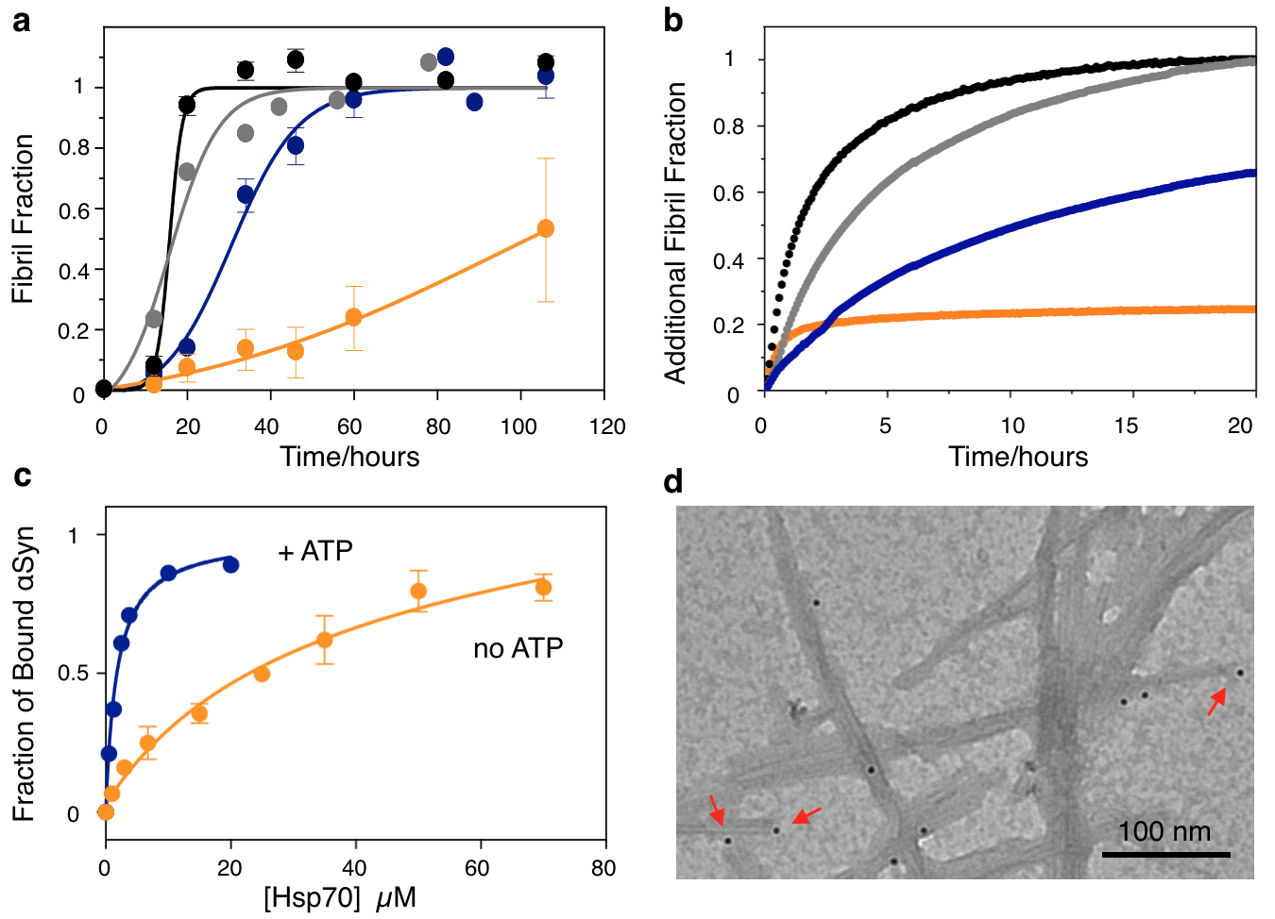
Figure 1. ThT fluorescence-based aggregations of 70 μM monomeric αSyn in the absence (a) and presence (b) of 5% seeds. Dots represent the experimental data and straight lines the best fit. Conditions: absence of Hsp70 and ATP (black), presence of Hsp70 and absence of ATP (orange), presence of Hsp70 and ATP (blue) (in the case of the experiments in (a) an ATP regeneration system was also used, see Supplementary Information), and absence of Hsp70 and presence of ATP (grey). Hsp70 was added at 1:10 Hsp70:αSyn protein molar ratio. (c) Hsp70 binding assays to monomeric dansylated αSyn in the absence (orange) and presence (blue) of 5 mM ATP. (d) Immunogold-TEM images of αSyn fibrils in the presence of Hsp70; arrows show exampled of bound Hsp70 to fibril ends (see Figure S2 as negative control).

In the light of our results, we considered a model in which Hsp70 binds both to αSyn monomers and fibril ends (Figure 2a, kinetic equations reported in the Supplementary methods) and performed global analysis of the series of aggregation profiles measured at different Hsp70 concentrations which has allow us for a robust evaluation of the kinetic parameters describing the aggregation process. The elongation rate constant (k₊) was independently estimated to be 500 M⁻¹.s⁻¹, by fitting the results of seeding experiments at different concentrations of seeds in the absence of Hsp70 (Figure S3), and was assumed to be independent of the concentration of Hsp70. The equilibrium dissociation constant for monomeric αSyn was also fixed as a known parameter (K_{d,M} = k_{off,M}/k_{on,M} = 1.8 µM, determined in the presence of ATP by fluorescence titration experiments, Figure 1c). The association and dissociation rate constants k_{on,F} and k_{off,F} were evaluated for the different mechanistic scenarios.
In a first set of calculations, the binding of Hsp70 to αSyn fibrils was neglected, and we attempted to describe the experimental data by considering only interactions with αSyn monomers; the results (Figure 2b, left) show that this model is incompatible with the experimental data, since only a very small decrease in the αSyn fibril elongation rate is possible at such low sub-stoichiometric concentrations of Hsp70 with respect to αSyn monomers. Importantly, variations by even four orders of magnitude in the K_{d,M} value, between 0.09 and 90 µM, did not change the conclusions of this analysis (Figure S4).
Repeating the calculation with the assumption that Hsp70 binds to both monomers and fibrils, the simulations described well the global set of experimental data (Figure 2b, centre). Evaluation of the binding parameters (Figure S5) shows that the affinity of Hsp70 for fibril ends that was obtained from the best fit (K_{d,F} = 9 μM) is of the same order of magnitude as the value measured experimentally for the binding of Hsp70 to the monomer, and is in agreement with the K_{d,F} value (3.1±0.4 μM) that Gao et al. recently obtained under similar experimental conditions ⁽¹¹⁾.
An important result from this kinetic analysis is that, despite the similar thermodynamic binding affinities of Hsp70 for monomeric and fibrillar αSyn, the corresponding on-rate constants for the binding obtained from the fitting are remarkably different, being more than 200-fold larger for the fibrils than for the monomers. The k_{on,F} value that we obtained from the analysis was 230 M⁻¹.s⁻¹, in good agreement with the value obtained experimentally under similar conditions in a recent study (123±38 M⁻¹.s⁻¹) ⁽¹¹⁾. By contrast, the k_{on,M} value obtained from the kinetic analysis was 1 M⁻¹.s⁻¹. In order to determine this value experimentally, we followed the association kinetics of Alexa488-αSyn in its monomeric form to Hsp70 at a variety of chaperone concentrations by fluorescence polarization experiments under pseudo-first order conditions (Figure S6); the k_{on,M} value obtained was 2.2±0.2 M⁻¹.s⁻¹, in good agreement with the value obtained from the kinetic analysis.
The difference of two orders of magnitude in the k_{on} value of Hsp70 between monomeric and fibrillar αSyn explains why the inhibitory effect of Hsp70 is dominated by its interactions with the fibril ends even under conditions where there is an excess of αSyn monomers. These results suggest that the competition of the binding of Hsp70 to αSyn fibrils and monomers, and ultimately the intrinsic holdase activity of Hsp70, is primarily modulated by kinetic rather than thermodynamic effects.
To validate this conclusion, we carried out a series of simulations where k_{on,M} and k_{on,F} were assumed to be equal (230 M⁻¹.s⁻¹), and the affinity of Hsp70 for fibrils was then increased significantly with respect to that for monomers (K_{d,F} = 0.18 μM, Figure 2b, graph on the right; simulations with even lower K_{d,F} values yielded very similar results, data not shown). In this case, as in the previous simulations, the binding of Hsp70 is directed to fibril ends rather than to monomers, but in contrast to previous simulations, the preference for binding to fibrils is established by thermodynamic competition. In this scenario, the simulations are not compatible with the experimental data (R²= 0.54 versus R²=0.02 for the model of kinetic competition). A thermodynamic preference for the binding of Hsp70 to αSyn fibrils with respect to monomers is, therefore, not able to explain the high efficacy of Hsp70 in the inhibition of αSyn fibril elongation under conditions with a significant excess of monomeric αSyn and at sub-stoichiometric concentrations of Hsp70 with respect to αSyn monomers. Overall, our analysis supports a model in which preferential interaction of Hsp70 with αSyn fibrils, under physiologically relevant conditions with ATP/ADP cycling, underlies the intrinsic ability of Hsp70 to inhibit αSyn fibril elongation. Importantly, the analysis indicates that this preferential interaction can be primarily attributed to differences in the kinetics rather than the thermodynamics of binding of the chaperone to the different αSyn species.
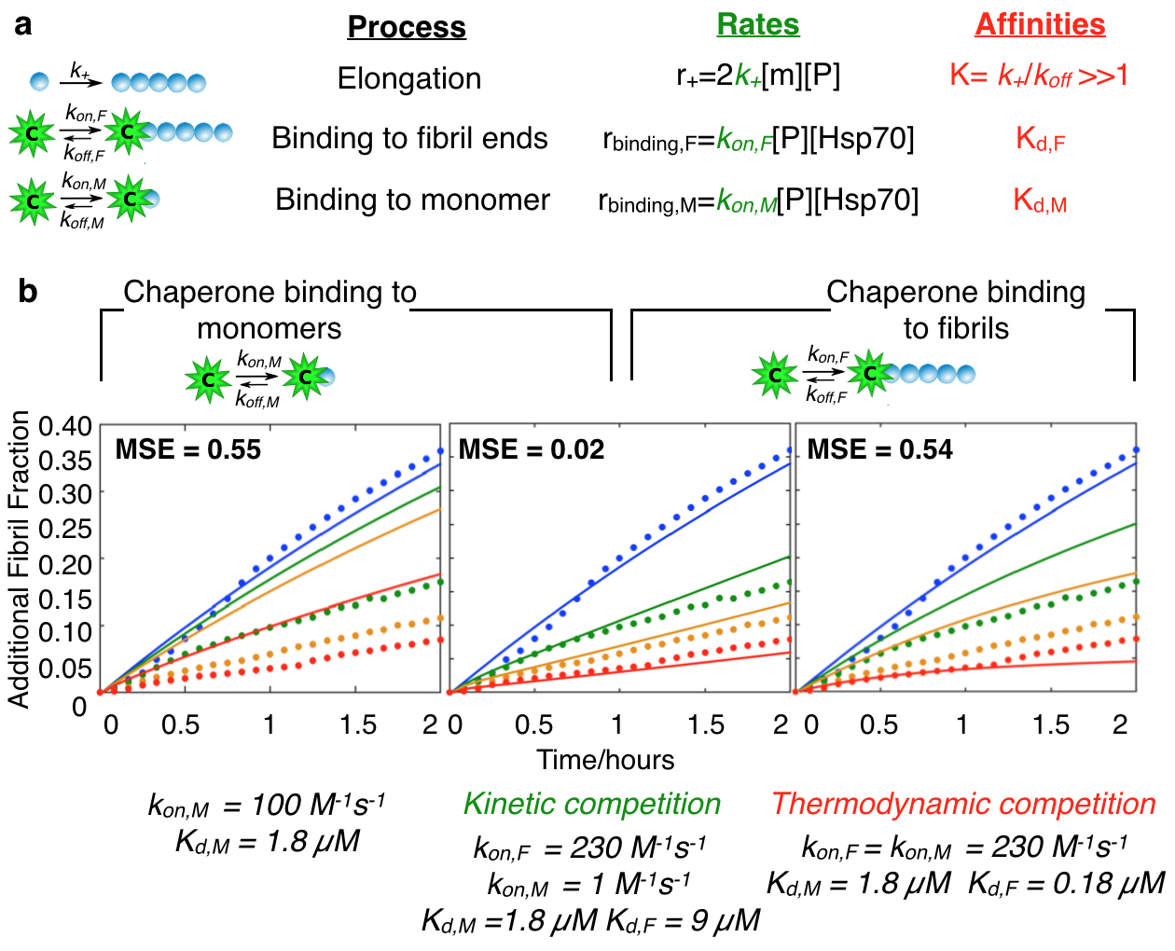
Figure 2. (a) Illustration of the microscopic events considered in the kinetic analysis. The parameters m and P represent the concentration of monomeric αSyn and the number of fibrils, respectively. (b) Fits of simulations (solid lines) to experimental data (dotted lines) for the αSyn fibril elongation reactions at different Hsp70 concentrations (from blue to red; 0, 7, 14, 35 µM). Three different scenarios of binding of Hsp70 to αSyn species were considered; from left to right: binding only to monomeric species; binding to both monomers and fibrils with similar affinity but different rates (kinetic competition); or with similar rates but different affinities (thermodynamic competition). The MSE values and the different binding constants for each set of analysis that were obtained from the best fit of the data are also reported.

There are three requirements for this kinetic inhibition to take place. First, the concentration of chaperone needs to be at least of the same order of magnitude as the concentration of fibril ends. In our experiments, the concentration of chaperone molecules has always exceeded the concentration of fibril ends. Second, in order for Hsp70 to compete efficiently with the addition of αSyn monomers to the fibril ends and, therefore, to suppress effectively αSyn fibril elongation, the value of k_{on,F} needs to be at least of the same order of magnitude as that of the fibril elongation rate (k₊); according to our analysis, k₊ = 500 M⁻¹.s⁻¹ and k_{on,F} = 230 M⁻¹.s⁻¹. Third, in order for Hsp70 to be active in the presence of an excess of monomers with respect to fibrils of αSyn, when having similar affinities for both species, the chaperone needs to exhibit a much faster association rate for the fibrils than for the monomers. Indeed, our analysis reveals that the association rate of Hsp70 for αSyn fibril ends is two orders of magnitude greater than the rate of association for monomers. Under these conditions, a significant fraction of fibril ends are bound to chaperone molecules and are therefore unable to bind new αSyn monomers (Figure S7).
The k_{on,F}/k_{on,M} ratio appears to be a key parameter for the inhibition of the elongation of fibrils by Hsp70 and provides an upper boundary for the relative concentrations of αSyn monomers and fibrils (C_{M}/C_{F}) at which Hsp70 is able to inhibit αSyn fibril elongation by this kinetically driven preferential binding mechanism (C_{M}/C_{F} = k_{on,F}/k_{on,M}; i.e., C_{M} ≈ 200C_{F}). Below such a boundary, the chaperone can inhibit fibril elongation, whereas above this threshold the faster turnover of binding for Hsp70 to fibril ends would not be able to compensate for the excess of monomeric αSyn.
Given that the binding of Hsp70 to proteins is hydrophobically-driven ⁽¹⁷⁻²³⁾, one of the reasons why the k_{on} of Hsp70 varies with the aggregation state of αSyn could be related to the different areas of hydrophobic surfaces that are exposed to the solvent, which is much greater in the fibrillar than in the monomeric state ^{(24, 25)}, a feature shared with other amyloid proteins and peptides ^{(26, 27)}. A high level of solvent exposed hydrophobicity in the fibrillar form of αSyn could result in a relatively low energy barrier for water desolvation upon complex formation with Hsp70, which would result in a faster association rate. A similar mechanism of kinetically-driven competitive binding has been proposed for the association of thrombin with two ligand proteins ⁽²⁸⁾, where a correlation was observed between the entropic contribution of protein desolvation upon complex formation and the association rate constants between the two complexes. These findings suggest that similar behavior would be expected for certain αSyn oligomeric species generated during the initial stages of fibril formation, which have been shown to possess a high degree of solvent exposed hydrophobic surface area relative to the fibrillar state ⁽²⁴⁾; consistent with earlier studies that suggested that binding of Hsp70 to oligomeric pre-fibrillar intermediates is critical for the inhibition of αSyn fibril assembly ^{(1, 13)}.
Our findings suggest, therefore, that a similar kinetically driven preferential binding mechanism to that observed for αSyn fibril elongation could in addition govern the inhibition of the early stages of αSyn aggregation by Hsp70, and could represent a general mechanism by which Hsp70, and potentially other molecular chaperones, inhibits amyloid fibril formation. Although the affinities and rates of binding of Hsp70 to substrates can vary at cellular conditions where other chaperones/co-chaperones may be present ⁽¹¹⁾, the strong intrinsic inhibitory activity of Hsp70 observed in vitro suggests that the intrinsic kinetically-driven mechanism of Hsp70 inhibition of fibril elongation may significantly contribute to the overall anti-aggregation activity of the chaperone in vivo. Importantly, we find that there is a complex interplay between the kinetics and thermodynamics of binding of Hsp70 to different types of protein aggregates. The tight balance between these factors, therefore, could be a key aspect of the suppression of pathogenic events, including the nucleation and spreading of aggregate formation by molecular chaperones, and could also be an important aspect to consider in the design of future therapeutic agents targeted towards misfolding diseases.
ASSOCIATED CONTENT
Supporting Information. Supplementary methods; AFM of seeds (Figure S1); control TEM (Figure S2); αSyn fibril elongation (Figure S3); MSE as a function of K_{d,M} (Figure S4); MSE as a function of K_{d,F} (Figure S5); fluorescence polarization experiments (Figure S6); free fibril ends during reaction (Figure S7); monomer consumption (Figure S8).
AUTHOR INFORMATION
Funding Sources
No competing financial interests have been declared.
This work was supported by The Wellcome Trust (CMD, TPJK and MV), the Agency for Science, Technology and Research, Singapore (SWC), and the Spanish Ministry of Economy and Competitiveness (BFU2015-64119-P and RYC-2012-12068; NC).
REFERENCES
1. Dedmon, M. M., Christodoulou, J., Wilson, M. R., and Dobson, C. M. (2005), J Biol Chem 280, 14733-14740.
2. Roodveldt, C., Bertoncini, C. W., Andersson, A., van der Goot, A. T., Hsu, S. T., Fernández-Montesinos, R., de Jong, J., van Ham, T. J., Nollen, E. A., Pozo, D., Christodoulou, J., and Dobson, C. M. (2009), EMBO J 28, 3758-3770.
3. Muchowski, P. J., Schaffar, G., Sittler, A., Wanker, E. E., Hayer-Hartl, M. K., and Hartl, F. U. (2000), Proc Natl Acad Sci U S A 97, 7841-7846.
4. Muchowski, P. J., and Wacker, J. L. (2005), Nat Rev Neurosci 6, 11-22.
5. Arosio, P., Michaels, T. C., Linse, S., Månsson, C., Emanuelsson, C., Presto, J., Johansson, J., Vendruscolo, M., Dobson, C. M., and Knowles, T. P. (2016), Nat Commun 7, 10948.
6. Månsson, C., Arosio, P., Hussein, R., Kampinga, H. H., Hashem, R. M., Boelens, W. C., Dobson, C. M., Knowles, T. P., Linse, S., and Emanuelsson, C. (2014), J Biol Chem 289, 31066-31076.
7. Kumita, J. R., Poon, S., Caddy, G. L., Hagan, C. L., Dumoulin, M., Yerbury, J. J., Stewart, E. M., Robinson, C. V., Wilson, M. R., and Dobson, C. M. (2007), J Mol Biol 369, 157-167.
8. Auluck, P. K., Chan, H. Y., Trojanowski, J. Q., Lee, V. M., and Bonini, N. M. (2002), Science 295, 865-868.
9. Klucken, J., Shin, Y., Masliah, E., Hyman, B. T., and McLean, P. J. (2004), J Biol Chem 279, 25497-25502.
10. Nillegoda, N. B., Kirstein, J., Szlachcic, A., Berynskyy, M., Stank, A., Stengel, F., Arnsburg, K., Gao, X., Scior, A., Aebersold, R., Guilbride, D. L., Wade, R. C., Morimoto, R. I., Mayer, M. P., and Bukau, B. (2015), Nature 524, 247-251.
11. Gao, X., Carroni, M., Nussbaum-Krammer, C., Mogk, A., Nillegoda, N. B., Szlachcic, A., Guilbride, D. L., Saibil, H. R., Mayer, M. P., and Bukau, B. (2015), Mol Cell 59, 781-793.
12. Daturpalli, S., Waudby, C. A., Meehan, S., and Jackson, S. E. (2013), J Mol Biol 425, 4614-4628.
13. Huang, C., Cheng, H., Hao, S., Zhou, H., Zhang, X., Gao, J., Sun, Q. H., Hu, H., and Wang, C. C. (2006), J Mol Biol 364, 323-336.
14. Buell, A. K., Galvagnion, C., Gaspar, R., Sparr, E., Vendruscolo, M., Knowles, T. P., Linse, S., and Dobson, C. M. (2014), Proc Natl Acad Sci U S A 111, 7671-7676.
15. Cohen, S. I., Vendruscolo, M., Dobson, C. M., and Knowles, T. P. (2012), J Mol Biol 421, 160-171.
16. Cohen, S. I., Arosio, P., Presto, J., Kurudenkandy, F. R., Biverstål, H., Dolfe, L., Dunning, C., Yang, X., Frohm, B., Vendruscolo, M., Johansson, J., Dobson, C. M., Fisahn, A., Knowles, T. P., and Linse, S. (2015), Nat Struct Mol Biol 22, 207-213.
17. Gething, M. J., and Sambrook, J. (1992), Nature 355, 33-45.
18. Gaitanaris, G. A., Vysokanov, A., Hung, S. C., Gottesman, M. E., and Gragerov, A. (1994), Mol Microbiol 14, 861-869.
19. Rüdiger, S., Germeroth, L., Schneider-Mergener, J., and Bukau, B. (1997), EMBO J 16, 1501-1507.
20. Bukau, B., Deuerling, E., Pfund, C., and Craig, E. A. (2000), Cell 101, 119-122.
21. Hartl, F. U., and Hayer-Hartl, M. (2002), Science 295, 1852-1858.
22. Young, J. C., Agashe, V. R., Siegers, K., and Hartl, F. U. (2004), Nat Rev Mol Cell Biol 5, 781-791.
23. Mayer, M. P., and Bukau, B. (2005), Cell Mol Life Sci 62, 670-684.
24. Chen, S. W., Drakulic, S., Deas, E., Ouberai, M., Aprile, F. A., Arranz, R., Ness, S., Roodveldt, C., Guilliams, T., De-Genst, E. J., Klenerman, D., Wood, N. W., Knowles, T. P., Alfonso, C., Rivas, G., Abramov, A. Y., Valpuesta, J. M., Dobson, C. M., and Cremades, N. (2015), Proc Natl Acad Sci U S A 112, E1994-2003.
25. Hoyer, W., Antony, T., Cherny, D., Heim, G., Jovin, T. M., and Subramaniam, V. (2002), J Mol Biol 322, 383-393.
26. Bolognesi, B., Kumita, J. R., Barros, T. P., Esbjorner, E. K., Luheshi, L. M., Crowther, D. C., Wilson, M. R., Dobson, C. M., Favrin, G., and Yerbury, J. J. (2010), ACS Chem Biol 5, 735-740.
27. Bhattacharya, M., Jain, N., and Mukhopadhyay, S. (2011), J Phys Chem B 115, 4195-4205.
28. Baerga-Ortiz, A., Bergqvist, S., Mandell, J. G., and Komives, E. A. (2004), Protein Sci 13, 166-176.

For Table of Contents Use Only

