Understanding Fluoroethylene Carbonate and Vinylene Carbonate Based Electrolytes for Si Anodes in Lithium Ion Batteries with NMR Spectroscopy

Yanting Jin,† Nis-Julian H. Kneusels,† Lauren E. Marbella,† Elizabeth Castillo-Martínez,† Pieter C. M. M. Magusin,† Robert S. Weatherup,† Erlendur Jónsson,† Tao Liu,† Subhradip Paul,§ and Clare P. Grey*,†

†Department of Chemistry, University of Cambridge, Lensfield Road, Cambridge CB2 1EW, United Kingdom
§DNP MAS NMR Facility, Sir Peter Mansfield Magnetic Resonance Centre, University of Nottingham, Nottingham NG7 2RD, United Kingdom
ABSTRACT: Fluoroethylene carbonate (FEC) and vinylene carbonate (VC) are widely used as electrolyte additives in lithium ion batteries. Here we analyze the solid electrolyte interphase (SEI) formed on binder-free silicon nanowires (SiNWs) electrodes in pure FEC or VC electrolytes containing 1 M LiPF₆ by solid-state nuclear magnetic resonance (ssNMR) with and without dynamic nuclear polarization (DNP) enhancement. We find that the polymeric SEIs formed in pure FEC or VC electrolytes consist mainly of cross-linked polyethylene oxide (PEO) and aliphatic chain functionalities along with additional carbonate and carboxylate species. The formation of branched fragments is further confirmed by ¹³C-¹³C correlation NMR experiments. The presence of cross-linked PEO-type polymers in FEC and VC correlates with good capacity retention and high Coulombic efficiencies of the SiNWs. Using ²⁹Si DNP NMR, we are able to probe the interfacial region between SEI and the Si surface for the first time with NMR spectroscopy. Organosiloxanes are identified to form upon cycling, confirming that some of the organic SEI is covalently bonded to the Si surface. We suggest that both the polymeric structure of the SEI and the nature of its adhesion to the redox-active materials are important for electrochemical performance.
Introduction

To improve the energy density of next generation rechargeable batteries, it is imperative to investigate materials with higher capacity, and that can expand the operating voltage window of the battery. Silicon is a promising anode for lithium ion batteries (LIBs) possessing high specific capacity (3579 mAh/g) and low operating voltage (0.1-0.4 V versus Li/Li⁺).¹ However, the large volume expansion of Si (~300%) during full lithiation leads to fracturing and rapid capacity fade. One strategy to avoid this problem is to use nano-Si, which can sustain the volume variation without significant pulverization.¹ Yet, nano-Si has a much larger specific surface area and this leads to more electrolyte decomposition on the Si surface, as conventional carbonate-based electrolytes are unstable below 1.2 V versus Li/Li⁺, the electrolyte being reduced to form a passivating layer known as the solid electrolyte interphase (SEI).² Formation of a stable SEI can help prevent further electrolyte decomposition. While the conventional LP30 electrolyte (1 M LiPF₆ in ethylene carbonate (EC) and dimethyl carbonate (DMC), 50/50, v/v) forms a stable SEI on graphite anodes used in commercial LIBs, the SEI formed on Si is highly unstable and does not prevent continuous electrolyte break-down. The large volume change that occurs on lithiation of silicon likely causes the SEI on Si to crack; subsequent electrolyte reduction occurs on the fresh exposed Si/lithium silicide surface, which leads to incremental irreversible capacity loss.^{1,3}
The organic SEI formed in standard LP30 electrolytes mainly consists of lithium alkyl carbonates⁷ and linear PEO-type polymers^{8,9} or oligomers¹⁰, the (-OCH₂CH₂)_{n} species representing as much as 50% of the total SEI carbon content on the basis of our ¹³C NMR studies.⁸ Short oligomers such as lithium ethylene dicarbonate (LEDC) have been suggested as passivating species in SEI.^{4,5} However, our previous work showed that LEDC is a soluble and transient species in the LP30 electrolytes.⁶ discuss – I think by adding this sentence you’ve added confusion into what made sense previously. A wide range of soluble degradation products are also present in the electrolyte after prolonged cycling⁶, and their continual formation may contribute to the continuous capacity loss of Si anodes in LP30 electrolytes. The electrodes become clogged with SEI, and the decomposition of EC (and attack of DMC by the EC radicals) which forms soluble products proceeds essentially unabated.^{8,9,6}
To date, various strategies have been used to stabilize the SEI on Si. Coating Si with carbon^{11–15} and metal^{16,17} can partially stabilize the Si surface and the use of silicon alloys can decrease the activity of lithiated Si towards electrolyte reduction.¹⁸ Apart from coatings and alloying, one of the most cost-effective ways to form a stable SEI is to use electrolyte additives that modify the composition and properties of the SEI.^{19,20} Among numerous additives, fluoroethylene carbonate (FEC) and vinylene carbonate (VC) are the two most widely used for both Li- and Na-ion systems.^{21–24} Both additives are structurally related to EC. FEC is a fluorinated form of EC, whereas VC contains a double bond, the double bond polymerizing during decomposition to form oligomers and insoluble polymers. FEC and VC not only improve the capacity retention²⁴ but also enhance the thermal stability of the lithiated Si anode.²⁵
A variety of techniques have been used to probe the SEI formed in the presence of FEC and VC on both graphite and high capacity Si electrodes in LIBs.²⁶ The organic SEI derived from VC was characterized by Ota et al., who used solution NMR spectroscopy and gas chromatography to prove that poly(VC)-type species were formed on graphite cycled in pure VC electrolyte.²⁷ The formation of poly(VC) has been confirmed by Ouatani et al., who directly synthesized poly(VC) via radical polymerization and compared the XPS valence spectra of synthetic poly(VC) with the SEI formed on graphite.²⁸ Moving from graphite to Si, the addition of VC also enhances the electrochemical performance for Si, and its beneficial effect is generally attributed to the polymeric species that are formed.²⁹ Nakai et al. studied the SEI formed on a Si thin film in a FEC-based electrolyte without EC.³⁰ They found evidence for organic polymers with low oxygen content (e.g., a polyene-type polymer) by using a combination of X-ray photoelectron spectroscopy (XPS) and time-of-flight secondary ion mass spectrometry (ToF-SIMS).³⁰ According to the authors, these oxygen deficient polymers prevent the oxidation of the Si surface, and thus, can preserve the active Si material during battery cycling. Conversely, Schroder et al. argued that while oxidation processes are unlikely to occur in the reducing environment on the anode of the battery, the reduction of FEC leads to the formation of a kinetically stable SEI consisting of a denser layer of LiF and Li₂O that prevents further electrolyte decomposition.³¹
Our previous study clearly showed that FEC reacts to form VC and vinxoyl species, both being observed via solution NMR in the electrolyte.⁶ No lithium vinylene dicarboante (Li₂VDC) was observed from the decomposition of FEC.⁶ An insoluble cross-linked PEO-type polymer is also formed from EC and FEC reactions, with fewer EC degradation products being found in the electrolyte in the presence of FEC than with EC/DMC alone. This cross-linked polymer results from reactions involving VC, vinxoyl radicals and EC/DMC and is correlated with improved electrochemical performance.
The nature of the interactions between the SEI species and the Si surface are critical for the stability of the SEI. However, the surface structures of cycled Si remain elusive due to the inherent difficulty in characterizing the buried interphase. Despite these difficulties, XPS studies have reported that, in the cycled Si electrode, the Si 2p peak corresponding to SiO₂ shifts to a lower binding energy, indicating that SiO₂ may be reduced due to alloying with Li or the formation of a Si-C species.^{32–34} However, detailed information concerning the nature of the chemical species and structure of the cycled Si surface is still lacking. ²⁹Si NMR is a powerful tool for analyzing Si-containing species, because the various mono- (M), di- (D), tri- (T), and quaternary- (Q) substituted siloxanes (Si(OR)_{n}(R’)_{(4-n)} with R denoting Si, C, or H and R’ denoting an alkyl moiety) all resonate in distinct chemical shift ranges. Furthermore, a more detailed ²⁹Si NMR analysis can even yield a picture of the second coordination sphere around the Si atoms, again based on the chemical shift. However, ²⁹Si NMR is not routinely used to probe cycled Si electrodes due to ²⁹Si’s unfavorable NMR properties (e.g. low natural abundance (4.7%), low gyromagnetic ratio, and long T₁ relaxation times), which generally result in prohibitively long experimental times. To overcome these barriers, we leveraged the signal enhancement from both dynamic nuclear polarization (DNP) from electrons and cross-polarization (CP) from protons^{35–37} to monitor structural changes in the Si surface following cycling vs. Li.
In this study, we characterize both the SEIs derived from 1 M LiPF₆ dissolved in pure FEC or VC electrolytes by conventional and DNP magic angle spinning (MAS) solid state NMR (ssNMR) spectroscopy. Pure FEC and VC electrolytes are used to examine their individual effect on Si anodes; they are also used as model systems to study the decomposition of FEC and VC. Binder-free silicon nanowires (SiNWs) are used to avoid interference from polymer binder in subsequent analyses and to ensure that good electrical connection with the current collector is maintained for multiple cycles (i.e., avoiding dead Si that becomes electrically disconnected during cycling). The chemical structures of the organic SEI formed in FEC and VC are correlated to their electrochemical performances. We show that heterogeneous polymers are formed during the reduction of FEC and VC, which consist of cross-linked PEO-type polymers and aliphatic chains. The presence of highly cross-linked PEO-type polymers correlates with good capacity retention.
Experimental methods
Coin cells: SiNWs were grown by chemical vapor deposition (CVD) as described previously.³⁸ ¹³C₃-labeled FEC was synthesized by using a previously reported procedure.⁶ Li half-cells were then assembled with the SiNWs electrodes in 2032-type coin cells, using the freshly prepared electrolytes listed in Table 1. Borosilicate glass fiber was used as the separator and around 10 drops (~0.15 mL) of electrolyte were used for each cell. Coin cell assembly was carried out in an Ar filled glovebox (H₂O < 0.1 ppm, O₂ < 0.1 ppm). The coin cells were discharged/charged at room temperature at a constant current (C/30, 120 mA/g) between 0.001 V – 2 V vs Li/Li⁺ for the first cycle using a Biologic VSP, MPG-2 or Lanhe (Wuhan, China) battery test systems. After the first cycle, the coin cells were then cycled at C/10 (360 mA/g). Approximately 30 days were needed to complete 50 cycles. After cycling, the cells were disassembled in the glovebox and the SiNW electrodes were dried under vacuum overnight (~16-20 h) to remove excess electrolyte solvents without rinsing.

Table 1. Electrolyte formulations with 1 M LiPF₆ in different solvent mixtures
Electrolyte solvents | Abbreviation
EC/DMC = 50/50 (v/v) | LP30
EC/DMC/FEC = 45/45/10 (v/v/v) | LP30 + FEC
FEC (fluoroethylene carbonate) | FEC
VC (vinylene carbonate) | VC
FEC/¹³C₃ FEC = 95/5 (v/v) | ¹³C₃ FEC

Solid-state NMR measurements (¹H, ¹³C) were performed at 11.7 T with a Bruker Avance III spectrometer equipped with a 2.5 mm probe-head at a MAS speed of 30 kHz for ¹H NMR spectra and 10 kHz for ¹H-¹³C CP NMR spectra. The π/2 pulse lengths were 2.7 µs for ¹H. The chemical shifts of ¹H, ¹³C were referenced with adamantane (¹H at 1.87 and ¹³C at 38.6 ppm). Between 64-256 transients

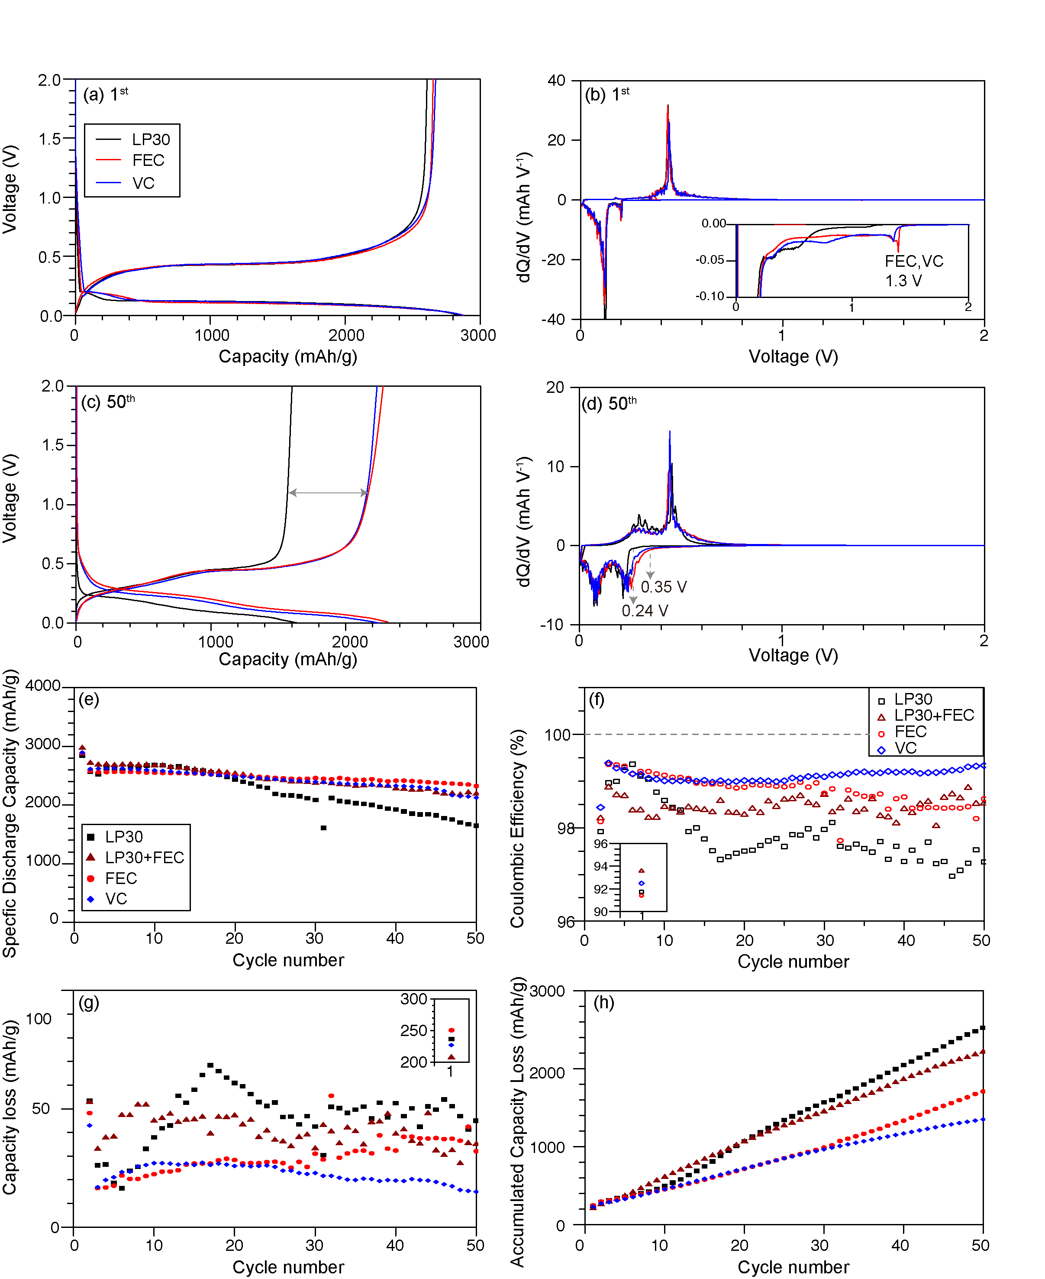
Figure 1 Electrochemistry of SiNWs cycled in standard LP30, LP30 + 10 vol % FEC, and 1 M LiPF₆ in FEC or VC, electrolytes (colored in black, dark red, red and blue, respectively. The voltage profiles and the dQ/dV curves of the SiNWs at the 1st cycle (a-b) and the 50th cycle (c-d) for LP30, FEC and VC. Discharge/lithiation capacity versus cycle number (e) and the corresponding Coulombic efficiency (CE) during cycling (f) for all four electrolytes. The initial CE is shown in the insert in (f). Capacity loss (defined as the lithiation capacity minus the delithiation capacity) during each cycle (g) and accumulated capacity loss versus cycle number (h). The capacity loss of the 1st cycle is shown in the insert in (g). The legend in (g-h) is the same as in (e). Cells were cycled at C/30 for the 1st cycle, then at C/10 for later cycles between 0.001 V – 2 V.

were collected using recycle delays of 15 s for ¹H experiments. ¹H-¹³C CP NMR spectra were acquired with a CP contact time of 2 ms, a recycle delay of 3 s and 21k – 28k scans. RF nutation frequencies were (¹H) 92.5 kHz (50-100% linearly ramped during CP), (¹³C) 82.5 kHz, and SPINAL64³⁹ (¹H) decoupling at 80 kHz. ¹³C direct excitation of ¹³C₃ FEC 100 sample was measured with recycle delay of 60 s and 5648 scans over the duration of 102.5 hours.

DNP NMR experiments were performed on a 14.1 T Bruker Avance III HD spectrometer with a 395 GHz gyrotron microwave source and using a 3.2 mm triple resonance wide-bore probe at the Nottingham DNP MAS NMR Facility. The sample transfer and preparation procedure have been described before,⁶ with the exception that a radical solution of 16mM TEKPol dissolved in 1,1,2,2-tetrachloroethane (TCE) instead of dichlorobenzene was used to achieve better signal enhancement. The sample mass, dilution ratio of KBr and the volume of radical solutions are listed in Table S1.
¹H-¹³C CP and ¹H-²⁹Si CP DNP NMR spectra were acquired with a 90-100% ramped contact pulse⁴⁰ on the ¹H channel and 100 kHz ¹H decoupling using swept frequency two pulse phase modulation (SW_{f} -TPPM)⁴¹ sequence with MAS frequency of 12.5 kHz. The relaxation delay was 3-4 s, and the CP contact time 2 ms for ¹³C and 5 ms for ²⁹Si.
Double quantum (DQ) – single quantum (SQ) ¹³C-¹³C dipolar correlation spectra were acquired using POST-C7⁴² for DQ excitation and reconversion at a MAS rate of 8 kHz. Proton decoupling was achieved by a SW_{f}-TPPM sequence with 100 kHz RF amplitude on the ¹H channel. 256 transients were recorded for each of 128 complex points interleaved, by using a 2 s of recycle delay for the recovery of ¹H magnetization.
¹H-²⁹Si HETCOR spectra were measured using 5 ms contact time, continuous wave Lee Goldberg (CWLG) proton decoupling, 2048 scans per slice with 32 increments and a recycle delay of 3 s with MAS frequency of 12.5 kHz.
Results:
Electrochemistry
The electrochemical performance of SiNWs cycled in Li half-cells using the electrolytes listed in Table 1 are shown in Figure 1. The features in the first discharge/charge curves of the SiNWs in Figure 1a are similar to one another, indicating that pure FEC and pure VC based electrolytes do not affect the Si lithiation and delithiaton mechanisms. However, the corresponding dQ/dV plot in Figure 1b reveals that FEC and VC are preferentially decomposed as early as 1.3 V vs. Li/Li⁺, whereas LP30 electrolyte decomposition starts around 0.8 V. The process at around 0.2 V is due to the lithiation of gold, which is used as a catalyst for SiNWs growth. In the 50th cycle (Figure 1c), both the pure FEC and VC samples maintain similar voltage curves with the characteristic Si de/lithiation plateaus. However, the voltage profile of the LP30 sample shows a lower lithiation voltage (0.24 V vs. Li/Li⁺) than the SiNWs cycled in pure FEC and VC electrolytes (~0.35 V), with the lower lithiation voltage reflecting an increase in resistance, which may come from the reduced porosity of the electrodes and a thicker SEI.⁹ The delithiation voltage curves are similar for all three samples in the 0—0.42 V range, but after this point they begin to diverge, as manifested in a change in the peak intensity around 0.42—0.70 V in the dQ/dV plots (Figure 1d). A lower delithiation capacity is obtained in the LP30 sample after 50 cycles than with pure FEC and VC electrolytes in this voltage range, as seen in Figure 1c; this may again be related to the transport properties and resistance of the SEI as suggested by the work of Michan et al.⁹, which showed that most of the capacity could be regained when the cells containing LP30 only were cycled at extremely low rates.
In general, SiNWs cycled with FEC or VC-containing electrolytes show improved capacity retention when compared to standard LP30 electrolytes without any additives (Figure 1e). After 50 cycles, the LP30 sample retains only 58% of the initial capacity; whereas, cells cycled with FEC or VC based electrolytes retain 73–81% of their initial capacities (see Table S2 in SI for details). The Coulombic efficiencies (CE) (defined as the delithiation capacity versus lithation capacity) of SiNWs cycled in FEC- and VC- containing electrolytes show marked differences (Figure 1f). SiNWs cycled with pure VC show the highest average CE of 99.1% from the 2rd to 50th cycle. FEC-containing samples exhibit a slightly lower average CE of 98.8% with pure FEC and 98.4% for LP30 + FEC sample. Yet, both FEC-containing samples are higher than the standard LP30 sample (97.8%). The CE provides a measure of the irreversible reactions that occur during each cycle (e.g. Li⁺ and/or solvent consumption), the higher the CE, the more reversible the reaction is. The CEs of FEC and VC samples, while noticeably improved over those in LP30 electrolytes, are still less than 99.5%. Pure FEC and VC electrolytes outperform the LP30 based electrolyte, as their capacity loss during each cycle (i.e. the lithiation capacity minus the delithiation capacity) and the accumulated capacity losses across multiple cycles are all smaller than LP30 samples (Figure 1g and h). Additional electrochemical impedance spectroscopy data (Figure S1) and rate performance data (Figure S2) also suggest that the SEI formed in FEC has a higher Li⁺ conductivity than those formed in LP30 electrolyte. Further chemical analysis was then carried out to understand the observed electrochemical differences.
¹³C₃ labelled FEC is synthesized and prepared as an electrolyte (1M LiPF₆ in FEC/¹³C₃ FEC) for cycling with SiNWs. The electrochemical performance of ¹³C₃ FEC sample is shown in Figure S13 and it exhibits similar capacity retention with those of the ¹³C natural abundance FEC and LP30+FEC samples. The initial CE of the ¹³C₃ FEC sample is 92.2 %, which is even slightly higher than the FEC sample (91.4 %) presented here, but this difference is within the error associated with variations in the SiNWs electrodes. The electrochemical results suggest that the cells containing the ¹³C₃ FEC synthesized as part of this study are representative of cells cycled in battery grade FEC electrolytes.
Organic SEI components revealed by ¹H and ¹³C ssNMR spectroscopy
Figure 2 shows the ¹H and ¹H-¹³C CP NMR spectra of SiNWs cycled in all the electrolyte formulations after the first, 30 and 50 cycles in the delithiated state. The results and assignments for the LP30 and LP30 + FEC system have been discussed in detail previously⁶, but are included here to facilitate comparison with the pure FEC and VC systems. For SiNWs cycled in the standard LP30 electrolyte with and without 10 vol% FEC (Figure 2a and 2d), the organic SEI mainly consists of PEO-type polymeric species (-CH₂CH₂O-) as indicated by both the prominent ¹H and ¹³C resonances at 4.7 ppm and 70 ppm, respectively.^{8,9} On adding 10 vol% FEC, an extra ¹³C resonance at approximately 103 ppm is seen (Figure 2d), which is assigned to a cross-linking acetal carbon (RCH(OR’)₂) moiety.⁶
Similar to the LP30 + FEC sample, ¹³C NMR spectra of SiNWs cycled in pure FEC and VC (Figures 2e and 2f) also contain acetal carbons (100-108 ppm) and ethylene oxide carbons (70-77 ppm), consistent with the presence of cross-linked PEO-type polymers and the formation of poly(VC). However, although both FEC and VC induced SEIs show a beneficial effect in terms of the capacity retention of the Si electrode, the chemical compositions of FEC- and VC-derived polymers are not identical.
The acetal carbons in VC and FEC samples have ¹³C chemical shifts at 108 and 103 ppm, respectively. Based on the prior study by Leifer and coworkers⁴³, the chemical shift is influenced by the R group in the acetal carbon, the 108 ppm VC resonance being tentatively attributed to an acetal carbon connected to a cyclic R group, potentially in a poly(VC) type cross-linking species⁴⁴; the 103 ppm component of the broader peak in the FEC sample is likely an acetal carbon bound to linear R groups, with the FEC samples also containing the higher frequency peak but in smaller proportions. We note that small differences in chemical shifts will also likely result from differences in the nearby chemical species and from different polymer conformations. These assignments are supported by ¹H and ¹³C NMR of the ethylene oxide region: the most intense ¹³C peak of the pure VC sample (77 ppm) is 7 ppm higher in frequency than that of the FEC sample (Figures 2e and 2f). The ¹H NMR shows a similar trend: the main broad peak is at around 5.1 ppm for pure VC samples (Figure 2c), yet the primary ¹H resonance is observed at approximately 3.8 ppm for FEC samples (Figure 2b). The broad 5.1 ppm peak is assigned to a proton on branched ethylene oxide (–CHO-) in poly(VC), consistent with the solution NMR result report by Ota et al.²⁷ Note that the broad peak in ¹H NMR at around 5.1 ppm in the VC sample can also arise from vinylic protons

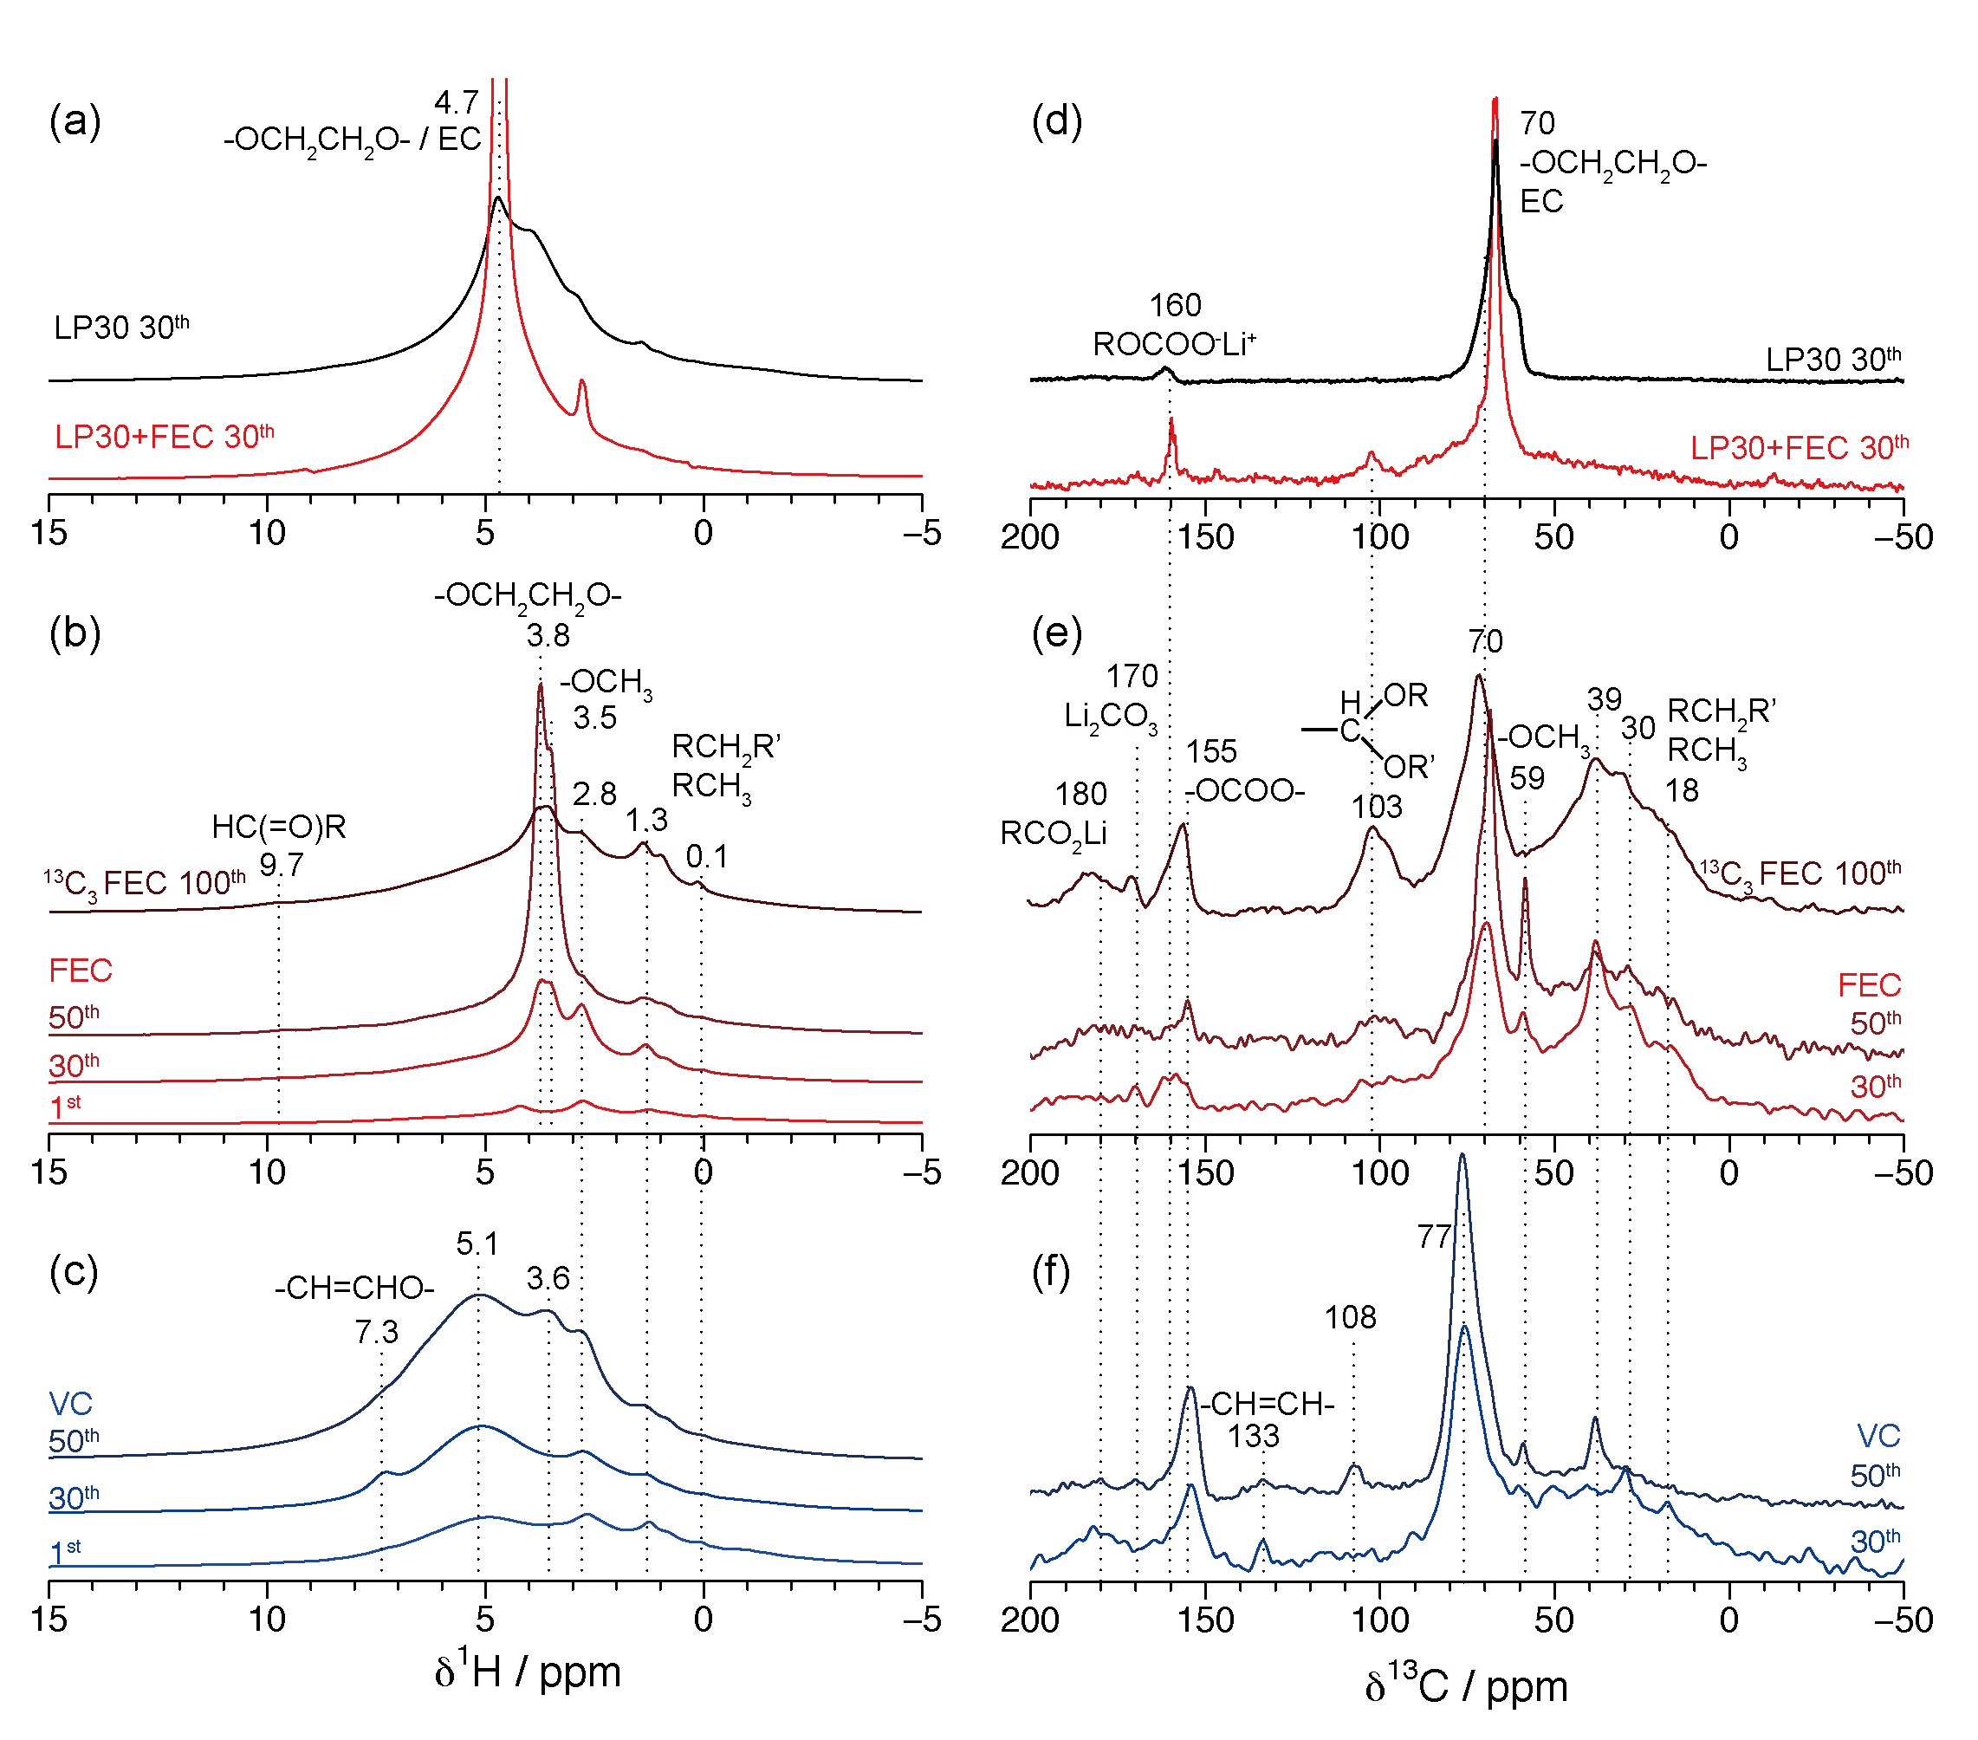
Figure 2 ¹H MAS NMR spectra (a-c) and ¹H-¹³C CP MAS NMR spectra (d-f) of SiNWs cycled in LP30, LP30 + 10 vol% FEC, pure FEC and VC electrolytes for the 1st, 30th and 50th cycle. Spectra of SiNWs cycled in 95% natural abundance FEC+5 vol% ¹³C₃ FEC for 100 cycles are included in (b, e). All spectra were measured at room temperature using conventional ssNMR.

(HCR=CR₂), but such an alkene carbon is only present in trace amounts in the ¹³C NMR spectra. The major ¹H and ¹³C resonances in the VC sample are more deshielded than the FEC sample, possibly due to the formation of a structurally more strained polymer (e.g. poly(VC)^{44,45}), rather than a branched PEO polymer.
In contrast to the LP30-containing systems, SEIs produced from pure FEC or VC contain a higher concentration of aliphatic species, as indicated by the ¹³C resonances between 0–40 ppm (Figures 2e and 2f). Aliphatic carbons can be formed by reducing FEC and VC, with the release of CO₂ gas (see discussion for more details) and involve reactions of more than one FEC/VC molecule. Methoxide groups (ROCH₃) are also seen for all the FEC and VC samples, which are manifested as a ¹H peak at 3.5 ppm and a sharp ¹³C peak at 59 ppm, and are correlated to one another in the ¹H-¹³C heteronuclear correlation (HETCOR) spectrum (Figure S8). The assignment is further supported by the narrow peak width of the 59 ppm ¹³C NMR resonance, where the relatively sharp peak can be explained by motional averaging due to fast rotation of the methoxide group.
In order to improve the signal to noise ratio in the ¹³C NMR spectra of ¹³C natural abundance samples, DNP NMR was used to compare the SEIs formed in LP30, FEC, and VC electrolytes after 50 cycles (Figure 3a). With a signal enhancement of around 15 for each sample, ¹H-¹³C CP reveals the finer details concerning the polymeric species in the 100–200 ppm region. Figure 3a shows that sp²-hydridized carbon species (-CH=CH-) with ¹³C resonances in the range of 120–140 ppm are present in both FEC and VC samples (shaded in grey), but not in the LP30 sample. SiNWs cycled in FEC contain additional aldehyde carbons (HC(=O)R) with a ¹³C resonance at 210 ppm. Lithium carboxylate species (RCOO⁻Li⁺) with a ¹³C resonance around 180 ppm are also more pronounced in the FEC sample. Both FEC and VC samples contain an intense ¹³C NMR peak at 155 ppm and a weak signal at 170 ppm that can be assigned to alkyl carbonate (ROCOOR’ ) and Li₂CO₃, respectively.⁴⁶ For the LP30 sample, the intense ¹³C peak at 160 ppm is assigned to lithium alkyl carbonate (ROCOO⁻Li⁺), likely from the terminal carbonate species found in linear oligomers such as LEDC and LBDC (lithium ethylene dicarbonate and lithium buthylene dicarbonate, respectively), but also at the end of longer polymer chains.⁸ In short, ¹³C DNP NMR shows that, apart from the cross-linked PEO polymer, the organic SEIs derived from FEC and VC also contain lithium/alkyl carbonates and additional small amounts of unsaturated carbons.

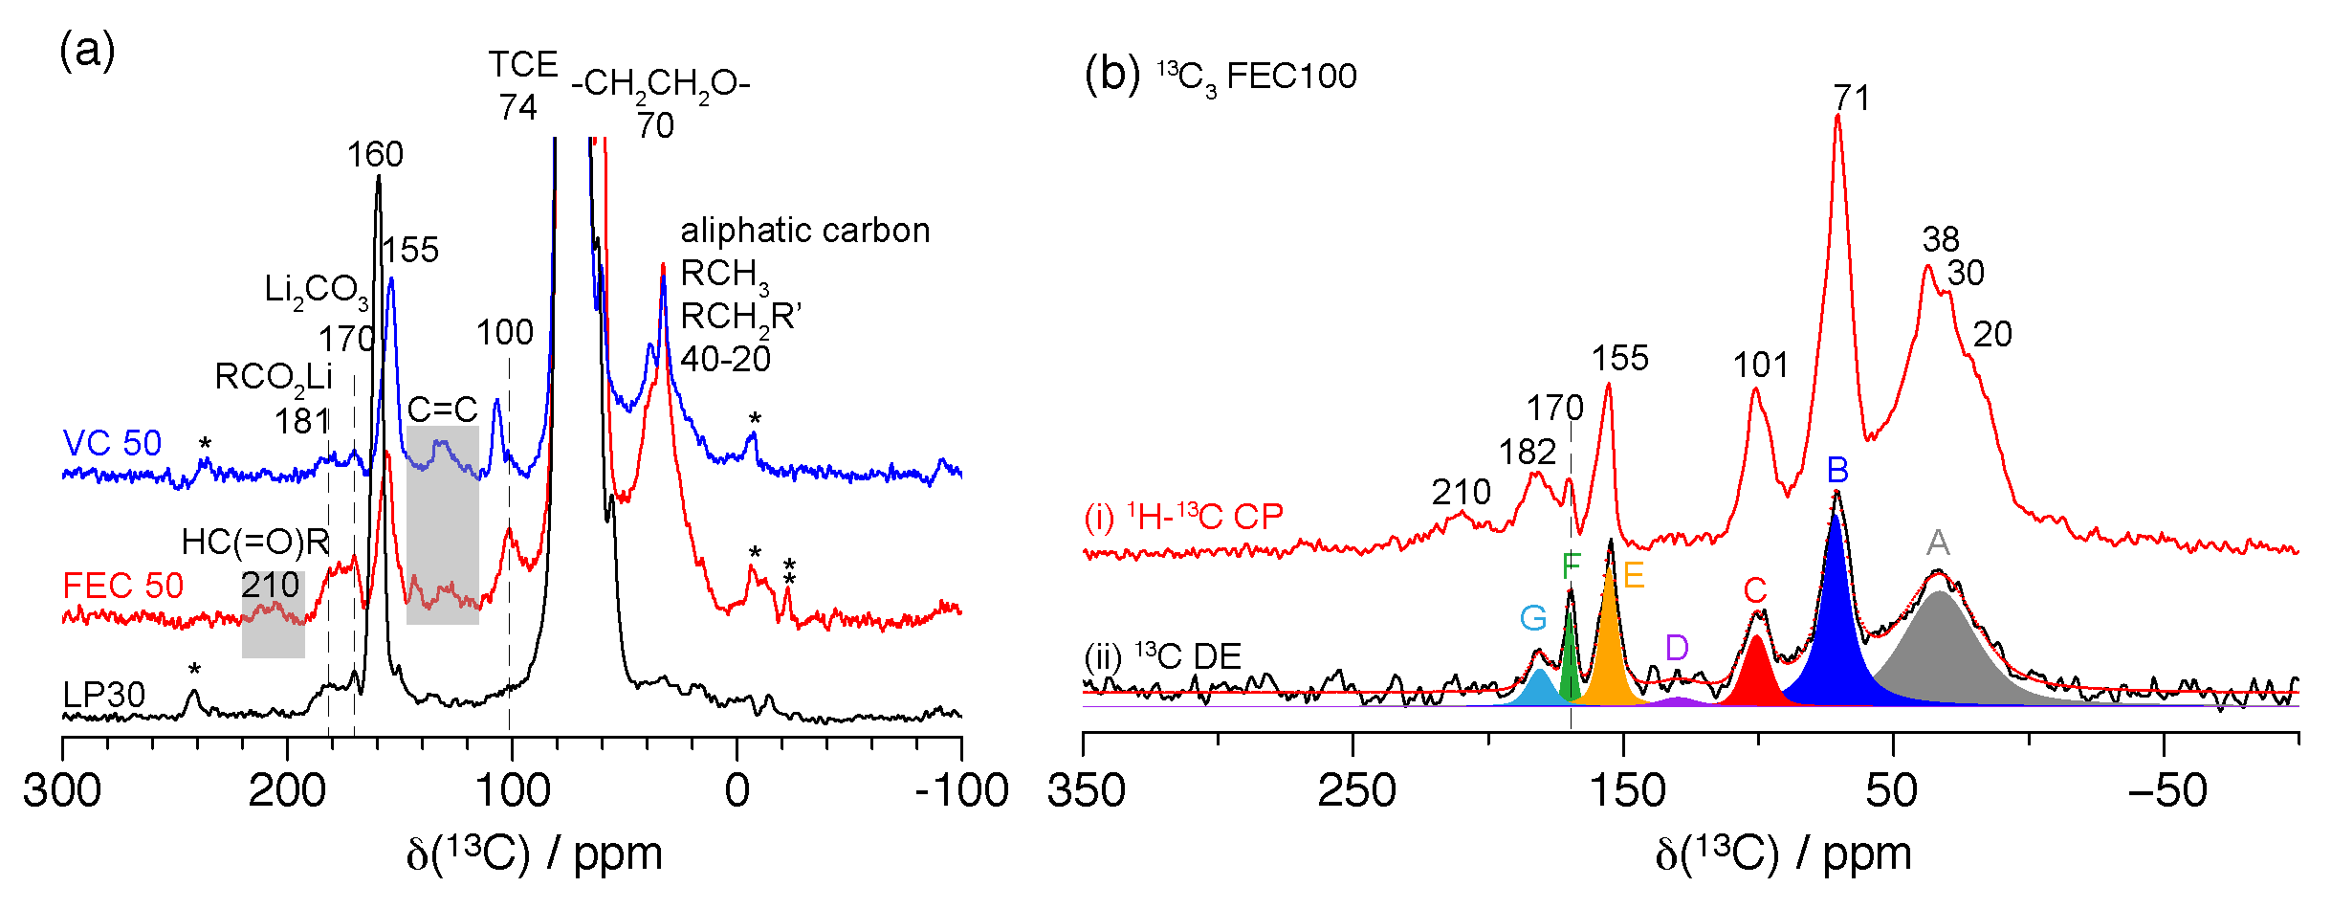
Figure 3 (a) ¹H-¹³C CP DNP NMR (105 K) spectra of SiNW cycled in LP30 (black), FEC (red) and VC (blue) for 50 cycles, where the intense (truncated) peak at 74 ppm is due to the DNP solvent tetrachloroethane (TCE); * = spinning sidebands. (b) Conventional, room temperature ¹³C CP NMR of SiNW cycled in FEC + 5% ¹³C₃ FEC for 100 cycles (i) measured by ¹H-¹³C CP, (ii) measured by ¹³C direct excitation (DE) with a recycle delay of 60 s to extract quantitative information.

¹³C NMR spectra were also recorded for SiNWs cycled with ¹³C-enriched electrolyte (FEC + 5 % ¹³C₃ FEC after 100 cycles, abbreviated as ¹³C₃ FEC100) using room-temperature NMR techniques (Figure 3b). The ¹H-¹³C CP NMR spectrum (Figure 3b, i) is comparable to the spectrum of SiNWs cycled in FEC for 50 cycles (FEC50) obtained using DNP NMR (Figure 5a). The striking resemblance between the spectra of FEC50 and ¹³C₃ FEC100 suggests that the chemical units of the organic the SEI formed in FEC from the 50th to the 100th cycle are chemically similar to each other, indicating that the chemical units of the polymeric SEI are stable during cycling, though the SEI thickness may vary. Furthermore, although no quantitative comparisons of these spectra were performed, we did not see any significant alteration in the chemical species found in the SEI, following the preparation of the sample for the DNP experiment, although it is likely that some of the organic components may dissolve in the TCE solvent used for DNP experiments.
Quantitative information about the organic SEI in the ¹³C₃ FEC100 sample is obtained from direct excitation (DE) room-temperature ¹³C NMR spectra (Figure 3b, ii). The integrated intensities of the deconvoluted peaks are summarized in Table 2. The organic species in the ¹³C₃ FEC100 sample primarily consist of aliphatic moieties (41% of the total peak area) and PEO-type oligomers (30%). Relatively small concentrations of alkyl carbonate (11%), carboxylate (4%) and lithium carbonate (4%) species are also present in the SEI. The quantitative ¹³C NMR spectrum suggests that the branching units (acetal carbons, C in Table 2) account for 8% of the total integral of the spectrum, indicating that the polymers are highly cross-linked. Peak D at 128 ppm (Figure 3b, ii), which is attributed to alkene carbons, is also present in the deconvoluted spectrum and it is consistent with the DNP NMR spectra of FEC and VC samples (Figure 3a). Note that such alkene species are also observed as soluble products in the cycled FEC electrolyte (Figure S3). The unsaturated carbon units are likely the base units for polymerization.^{6,47}

Table 2 Summary of the intensity and assignments of the peaks obtained by deconvolution of the ¹³C direct excitation ssNMR spectrum of the ¹³C₃ FEC sample.
Label | Peak centre / ppm | Peak width/ppm | Relative Intensity (%) | Assignment
A | 33.1 | 32.2 | 41 | RCH₂R'
B | 71.5 | 11.6 | 30 | -CH₂CH₂O-
C | 100.7 | 11.4 | 8 | RCH(OR’)₂
D | 129.7 | 15.9 | 2 | RCH=CHR'
E | 155.3 | 7.3 | 11 | ROCO₂R’
F | 169.9 | 4.4 | 4 | Li₂CO₃
G | 180.9 | 10.4 | 4 | RCO₂Li

Molecular fragments in the organic SEI
To establish the connectivity between distinct chemical motifs observed in the organic SEI, we performed a 2D double-quantum single-quantum (DQ-SQ) ¹³C homonuclear dipolar correlation experiment using POST-C7 with DNP enhancement on the ¹³C₃ FEC100 sample (Figure 4). In this spectrum, two spins with resonance frequencies v₁ and v₂ result in a correlation at v₁ + v₂ in the indirect dimension of the 2D spectrum if they are coupled through space. Here, the spectrum mainly shows one-bond carbon-carbon correlations. Three broad peaks are observed in the ¹³C spectrum with spectral ranges of 10 – 40 ppm, 60 – 85 ppm and 90 – 110 ppm, which are labeled A, B and C, respectively, consistent with the labeling scheme shown in Table 2. A is assigned to alkyl groups, B is attributed to PEO-type ethylene oxide carbons⁸ (-CH₂-CH₂O-) in linear and branched moieties, and C mainly arises from an acetal carbon with two oxygen bound to it (-CH(OR)₂)^{9,6,43}. Possible molecular fragments based on the one-bond correlations are depicted on the right panel in Figure 4. The strongest

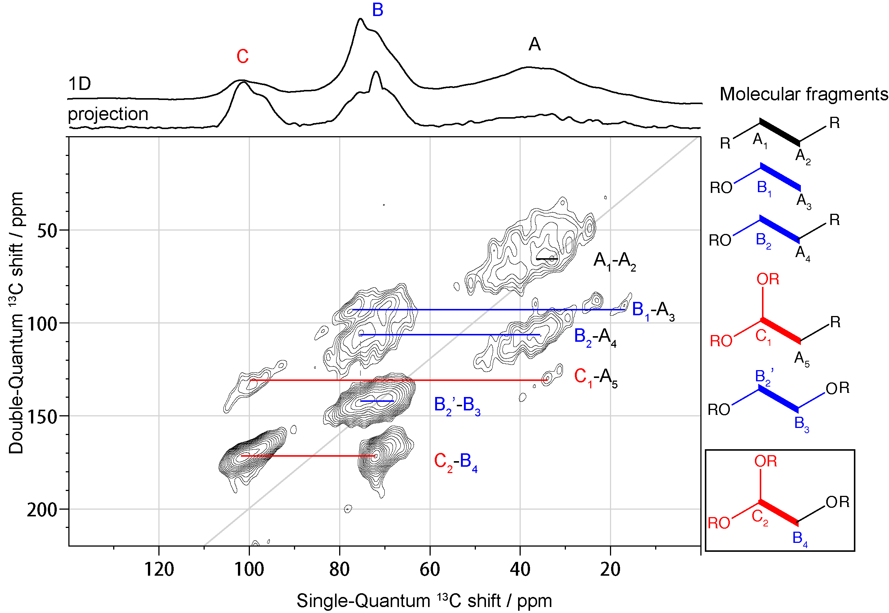
Figure 4 DNP enhanced 2D DQ–SQ ¹³C–¹³C POST-C7 dipolar correlation spectrum of SiNW cycled in FEC+ 5% ¹³C₃ FEC for 100 cycles. 1D ¹H-¹³C CP NMR and the total projection in the SQ dimension are overlaid on top. The corresponding molecular fragments are listed on the right panel. The branching fragments are colored in red; the fragments containing ethylene oxide carbons are colored in blue and the alkyl chains in black. The spectrum is recorded at 105 K. The MAS frequency and the number of scans is 8 kHz and 384, respectively. The spectrum is obtained in ~ 9 h with a recycle delay of 2 s, 1.8 ms evolution time, and 2 ms POST-C7 mixing time.
Scheme 1 Possible molecular fragments observed in the FEC/VC decomposition products. The cyclic region is highlighted in yellow, the branching units are colored in red, ethylene oxide units in blue and alkyl chains in grey. The cross-linked poly(VC) unit is shaded in yellow. Carbons labeled with A-C are consistent with the results from the 2D carbon correlation NMR experiment shown in Figure 4. The ¹³C NMR shifts are derived from Figures 2e and f. The relative concentrations of the different species vary between the SEIs formed with different electrolytes.
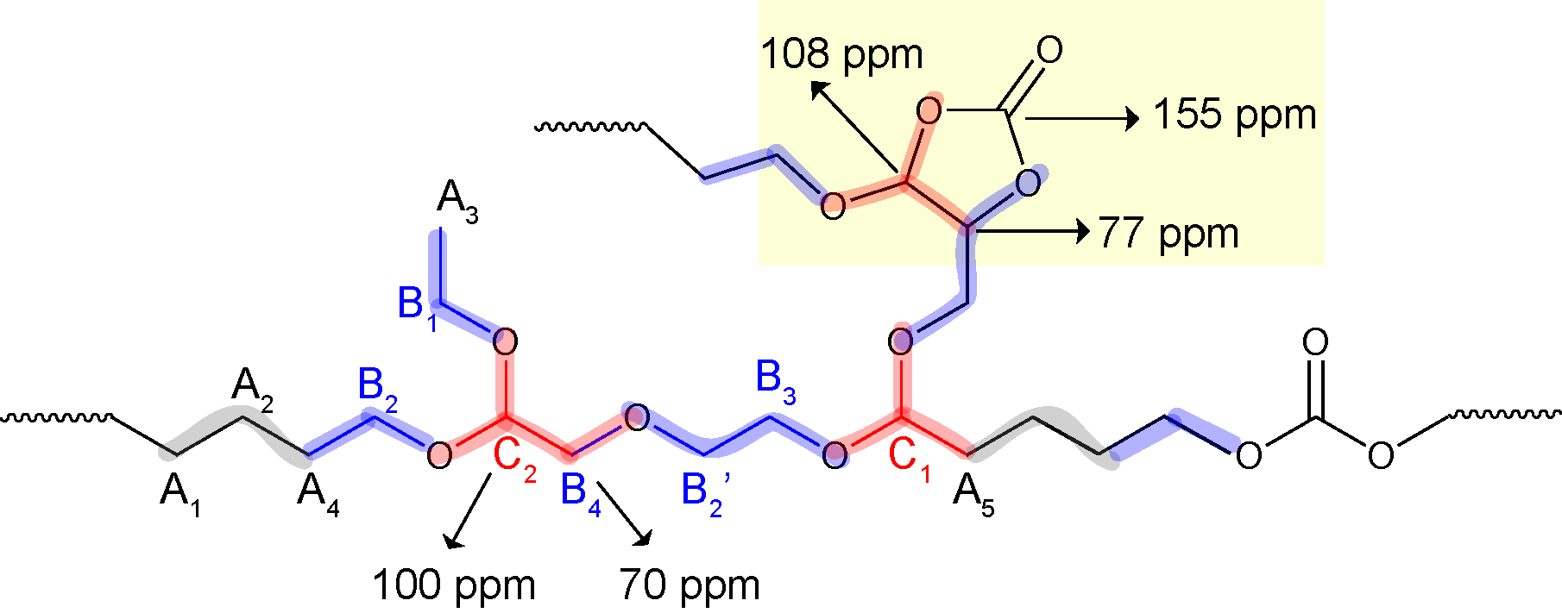

correlation observed is between B₄ and C₂, followed by B₂’ and B₃. The B₂’-B₃ correlation is assigned to connections between ethylene oxide fragments (-OCH₂CH₂O-) that are found in PEO-type polymers.⁴⁴ The B₄-C₂ correlation indicates that acetal carbon C is directly bound to a PEO-type ethylene oxide carbon B, which provides strong evidence that the acetal carbon C is, indeed, a branching unit in the PEO-type polymer. Note that B₄ has a ¹³C shift of 72 ppm (see Table S4 for all the correlation peaks in Figure 4), which can be assigned to a linear ethylene oxide (EO) carbon instead of a branched EO unit (-CH₂CHRO-, with ¹³C shift around 77 ppm)⁴⁸. Moreover, the B₄-C₂ fragment ((RO)₂CH-CH₂OR’) has the same connectivity as that of a soluble decomposition product we previously identified in the cycled LP30 + FEC electrolyte⁶ (the structure is highlighted in the box in Figure 4). In the presence of FEC, the B₄-C₂ branched molecular fragment is found in both the soluble degradation products and in the insoluble component; it

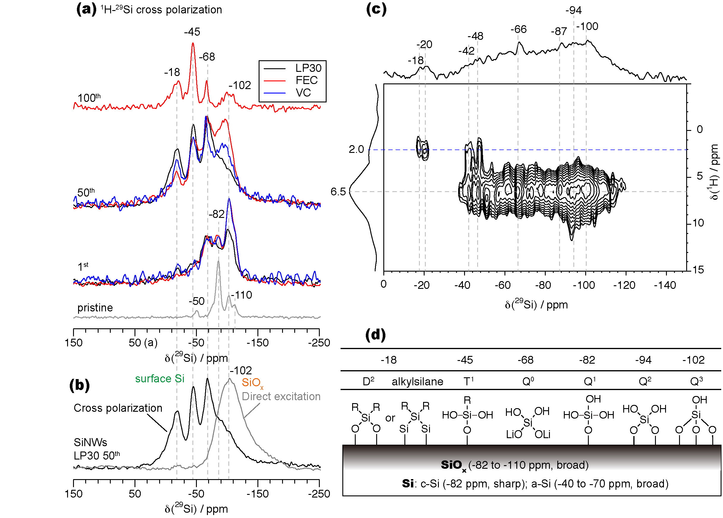
Figure 5 ²⁹Si NMR spectra of cycled Si using different techniques. (a) ¹H-²⁹Si CP DNP NMR of SiNWs after the first, 50 and 100 cycles; pristine silicon nanoparticles were measured by ¹H-²⁹Si CP NMR without DNP and its spectrum is included for comparison. (b) ²⁹Si DNP NMR using cross polarization (CP) and direct excitation (DE) on SiNWs cycled in LP30 for 50 cycles, with recycle delay of 3.5 s and 10 s, respectively. The CP spectrum mainly shows proton-containing surface species, whereas the DE spectrum (grey in b) mainly contains signals from the outer SiO_{x} shell on the SiNWs. (c) ¹H-²⁹Si HETCOR of SiNWs cycled in FEC for 50 cycles with a 5 ms contact time and recycle delay of 3 s. (d) Cartoon showing possible Si surface structures and their corresponding chemical shifts; R denotes an alkyl group. The proposed structures are mainly based on the ¹H-²⁹Si HETCOR result. ²⁹Si shifts of SiO_{x} and Si species are summarized: crystalline silicon (c-Si) -81 ppm; amorphous silicon (a-Si) -40 to -70 ppm⁴⁹.

appears to be a unique decomposition product from FEC that is absent in standard LP30 electrolyte.
Weaker A-B, A-A and A-C correlations are also observed, the latter being assigned to acetal carbons connected to aliphatic groups. Within the broad peak A, the A₃ environment with ¹³C resonance at 18 ppm is assigned to a terminal methyl group (-CH₃)⁸, while other A sites with ¹³C shifts spanning from 30-40 pm arise from other alkyl groups (-CH₂R, -CHR₂, -CR₃). The A₁-A₂ correlations correspond to the connections within aliphatic carbon chains, while the A₃-B₁ and A₄-B₂ peaks correspond to PEO-type carbons being bound to aliphatic carbons.
Aliphatic carbons (A) are the major species in the organic SEI (Table 2), but its correlations to other peaks are weaker than the correlations for B-C and B-B in Figure 4. The aliphatic carbon chain with A-A correlation is less pronounced probably due to its formation pathway that involves more than one molecular fragment. Since only 5 vol % ¹³C₃ FEC is used in the electrolyte, the probability of finding a two ¹³C labeled spin pairs in aliphatic chains is largely decreased.
A possible molecular fragment containing all the correlations observed in Figure 4 is depicted in Scheme 1. The branching units are shaded in red, ethylene oxide chains in blue and alkyl carbons in grey. The structure also contains a poly(VC) unit highlighted in yellow. Characteristic ¹³C NMR shifts observed in the cycled FEC/VC sample (Figure 2e and f) are also tentatively assigned in this structure. In part due to the low enrichment level (5% ¹³C₃ FEC in the electrolyte) and dipolar truncation, multiple-bond correlations were not obtained. Nevertheless, various one-bond correlations detected in the system reflect the disordered polymeric structure that is formed.

Lithiated and Fluorinated Components in the SEI:
Inorganic Li salts are also observed by ⁷Li and ¹⁹F ssNMR (Figure S6). Inorganic LiF and residual LiPF₆ salt are clearly present in the cycled electrodes.

The SiO_{x}-SEI Interface
Figure 5a shows the ¹H-²⁹Si CP NMR spectra of pristine Si nanoparticles (SiNPs) measured with conventional NMR and SiNWs after the first, 50 and 100 cycles in different electrolytes with DNP enhancement. The spectrum of pristine SiNPs is shown here for comparison since the SiNPs are expected to show similar surface species to the SiNWs. Moreover, SiNPs are available in larger quantities allowing us to collect a spectrum with improved signal-to-noise ratio. The spectrum of the pristine SiNPs mainly consists of sharp resonances from bulk crystalline Si (-82 ppm)⁵⁰ and Q-site hydroxyl-terminated silicates (²⁹Si resonances at -102 ppm for Q³ and -112 ppm for Q⁴, where Q^{n} represents (SiO)_{n}Si( (OH)_{4-n} environments) ⁵¹. The weak peak at -50 ppm is tentatively assigned to the amorphous Si component in the nanoparticles.⁴⁹
After cycling, the Si surface changes dramatically and di- (D), tri- (T), substituted siloxanes are observed (Figure 5a). We excluded the formation of hydrogen terminated Si species because no dramatic intensity decrease was observed in the ¹H-²⁹Si dipolar dephasing experiment for all the resonances observed in the ²⁹Si NMR spectra (Figure S11), indicating that there are no Si-H bonds.
After the first cycle, a new resonance at approximately -68 ppm arises, which can be tentatively assigned either to T³ organosiloxane ((SiO)₃SiR, where R is aliphatic carbons)³⁵ or to Q⁰ single (non-bridging) tetrahedral silicate (possibly with some charge-balancing Li⁺ ions, Li_{n}H_{4-n}SiO₄, where n = 1 to 3). The ¹H-²⁹Si HETCOR of the SiNWs cycled in FEC for 50 cycles (Figure 5c) shows that the ²⁹Si resonance around -66 ppm is connected to hydroxyl group(s) with ¹H shift at 6.5 ppm, but shows no cross peaks with protons on alkyl carbons (with ¹H shift around 2.0 ppm), indicating that Si-C(H) groups are not present. Therefore, the HETCOR data support the assignment of the -68 ppm ²⁹Si resonance to a Q⁰ silicate rather than T³ organosiloxane. By using various CP contact times, we find that the -68 ppm component has a fast CP build-up curve (Figure S10), confirming that this species is in close proximity to protons, suggesting that it is associated with a silanol group (Li_{n}H_{4-n}SiO₄) instead of a proton-free lithium orthosilicate (Li₄SiO₄). Moreover, the intensity of the -68 ppm peak increased dramatically after air exposure and a second resonance at -60 ppm is observed (Figure S12). This may be due to the further hydrolysis of the Li_{n}H_{4-n}SiO₄ and the other Q site species leading to the formation of a species that contains more abundant protons.
The -82 ppm peak in the SiNWs after the first cycle is attributed to Q¹ sites ((SiO)Si((OH)₃) instead of crystalline Si (²⁹Si shift at -81 to -85 ppm)⁵², as crystalline Si is completely amorphised during the first cycle based on the electrochemistry (amorphous Si has a very broad ²⁹Si shift around -40 to -70 ppm⁴⁹). The HETCOR spectrum (Figure 5c) confirms that the -82 ppm species is associated with a silanol proton (6.5 ppm)³⁵. Of note, the HETCOR spectrum reveals that although the Q¹ (-82 ppm) resonance is more distinct, the broad silanol resonance spreads from -40 to -120 ppm, the region around -94 ppm corresponding to a Q² environment (i.e., Si(OSi)₂(OH)₂). The broad resonance reflects the distribution of local environments in the amorphous Si(OR)_{n}(R’)_{(4-n)} (n = 0, 1) network, (including Si-OH vs. Si-O⁻Li⁺ termination and Si-O vs. SiR connectivity).
Two new ²⁹Si peaks at -18 ppm and -45 ppm become more pronounced in the SiNWs after 50 cycles. Based on its distinct chemical shift, the -18 ppm peak can be assigned to D² (SiO)₂SiR₂ ⁵³ or an alkylsilane (Si)₂SiR₂⁵⁰ (Figure 5d). This assignment is confirmed by ¹H-²⁹Si HETCOR (Figure 5c), where the ²⁹Si peak at -18 ppm is only correlated to the protons on alkyl species (2.0 ppm). For the -45 ppm Si peak, correlations to both the protons on alkyl carbons (2.0 ppm) and hydroxide protons (6.5 ppm) are observed in the ¹H-²⁹Si HETCOR spectrum, thus the -45 ppm resonance can be ascribed to a T¹ site (SiO)SiR(OH)₂.⁵⁴ Such organosiloxane species can be formed via the reduction of the hydroxyl groups on the surface forming a Si-C bond (possible reactions will be discussed later). A similar trend is observed in SiNWs after 100 cycles in ¹³C₃FEC electrolyte: the intensity of organosiloxane species with a ²⁹Si shift at -45 ppm increases further, while the relative intensity of the Q³ sites at -102 ppm significantly decreases. In general, we find that the hydroxyl terminated species on the Si surface are gradually converted to organosiloxanes as a function of cycling.
Figure 5b compares the ²⁹Si NMR spectra obtained by cross polarization (CP) vs. direct excitation (DE) of SiNWs cycled in LP30 for 50 cycles. In the ¹H²⁹Si CP experiment, polarization of ²⁹Si nuclei located near the surface is enhanced as there are few protons inside the bulk Si and CP transfers are only effective up to a few angstroms. In the DE experiment, any Si species (both protonated and non-protonated) close to DNP biradicals are enhanced with a penetration depth of 1-5 nm.⁵⁵ The broad peak around -102 ppm in the DE spectrum indicates that a wide range of environments are present, including Q³ site hydroxide terminated silicates and SiO_{x} non-protonated species. Both the -18 and -45 ppm peaks are also observed but are much weaker. These results suggest that the organosiloxane species observed in the ¹H-²⁹Si CP DNP NMR spectra are at the extreme surface of the SiO_{x} layer and only account for a small fraction of the oxide layer (1-5 nm) in the cycled Si anode.
Apart from the cycle number, the electrolyte solvents also affect the relative intensities of each Si component. Though CP DNP NMR is not absolutely quantitative, the intensity difference allows an estimation of the relative populations of different Si sites. All spectra are normalized by the -68 ppm Q⁰ silicate peak (arbitrarily selected) to facilitate the comparison. After the first cycle, the relative intensity of Q³ site (-102 ppm) in the LP30 sample is much smaller than those in the FEC and VC samples. This indicates that native hydroxyl groups are converted to the silicate/organosiloxane sites, but that this conversion is more pronounced (or rapid) in LP30 than in pure FEC and VC electrolytes (i.e. more organosiloxanes and Q⁰ species are formed in LP30). In the 50th cycle, the same trend is observed: the Q³ sites in LP30 are weaker compared to VC and FEC, with FEC still having the most intense Q³ peak. The peak intensities of organosiloxanes (-18 ppm and -45 ppm) are also slightly larger in the LP30 sample than in the FEC and VC samples. In short, the SiO_{x} surface reduction is more pronounced in the LP30 than in FEC and VC electrolytes.
Discussion
The SEI derived from pure FEC and VC electrolytes contains a large amount of branched or cross-linked PEO, which is similar to LP30 + 10 vol% FEC, but different from the linear PEO-type polymer observed in the additive-free LP30 sample.^{8,9,6} In this study, the cross-linking units were found to be acetal carbons connected to PEO-type carbons, as confirmed by a ¹³C-¹³C homonuclear correlation NMR experiment (Figure 4). Across all samples, we find that the presence of the acetal carbon is consistently associated with improved capacity retention. Methoxide groups are also observed, which likely represent end (terminal) groups of the organic polymer. Of note, the hydroxyl groups in PEO-type solid polymer electrolytes have been chemically modified to form methoxide groups, which are expected to reduce the polymers’ reactivity towards Li metal⁵⁶ and potentially increase the chemical stability of the SEIs.
Cross-linked PEO can be formed following the reaction pathway described in our previous work.⁶ Briefly, FEC defluorinates forming an EC radical, which transforms to VC via hydrogen loss. Alternatively, the EC radical forms vinoxyl radical (O=CHCH₂• or •OCH=CH₂) with concurrent loss of CO₂ (Scheme 1). VC can also be reduced to a radical anion (⁻OCH=CH•), which is stabilized by π conjugation. The vinoxyl radical can react with an sp²-hybridized carbon, forming branched species containing acetal carbons, aldehyde and alkene terminations (see reference ⁶, scheme 3), all of which are observed in our ¹³C NMR experiments. In EC based electrolyte, no such branched species were observed. One possible explanation is that for EC ring-opening reduction dominates, and the reduced species (e.g. •CH₂CH₂OCOO⁻) cannot easily lose protons to form the vinoxyl radicals. Due to the lack of vinoxyl radicals and unsaturated carbons, no significant concentrations of branched polymers are formed in standard LP30 electrolyte.

Scheme 2. Possible reduction reactions for FEC and VC based on Ref ^{6,57}.
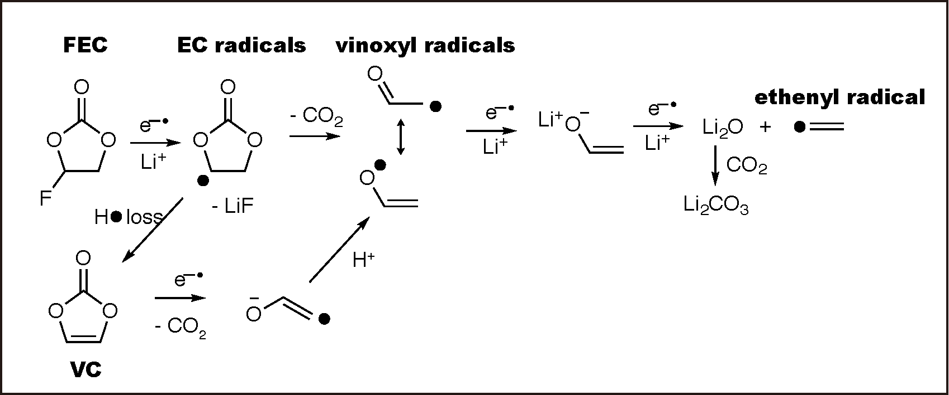
Apart from the cross-linked PEO, the SEIs formed from pure FEC and VC also contain a large amount of aliphatic carbons, which are absent in EC based sample. The large quantities of alkyl carbons in the FEC and VC samples are consistent with the oxygen-deficient species identified by Nakai et al. in the SEI formed on Si thin films in a FEC/DMC solvent.³⁰ Based on XPS and ToF-SIMS results, the authors concluded that the oxygen-deficient species is a polyene type polymer. Here, we observed that such oxygen-deficient polymers primarily contain alkyl chains instead of unsaturated carbons (with ¹³C resonances around 120-140 ppm), although a small amount alkenes are observed in pure FEC/VC electrolytes (Figure S3). Oxygen deficient species can be formed by further reduction of vinoxyl radicals with the formation of Li₂O (Scheme 2). The reduced species, such as ethenyl radicals⁵⁷, can form dimers that subsequently polymerize, resulting in cross-linked aliphatic chains. Reactions with other radicals, including those formed on reductive ring-opening of the cyclic carbonate can also generate aliphatic groups; this mechanism is thought to be responsible for LEDC and LBDC formation.⁸ Though we have not observed the radicals, reduction reactions of this nature must occur as the aliphatic carbons account for ~41% of the total carbon signal (Table 2). Fewer aliphatic carbons were observed in the EC/DMC system, presumably because the major reduction reactions do not involve the formation of ethylene radicals and/or require reactions involving radical (re)combination.⁴⁴
²⁹Si DNP NMR reveals the bonding nature between the organic SEIs and Si surface. Organosiloxane species grow on the Si surface as a function of cycling. The formation of Si-C bonds has previously been predicted by Balbuena and coworkers using DFT and ab initio molecular dynamic simulations.⁵⁸ Prior experimental evidence of a Si-C species comes from XPS Si 2p spectra, where the SiO₂ peak shifts to lower binding energy after cycling (from 103 eV to 101 eV), indicating that the SiO₂ surface undergoes a reduction process during cycling.^{32–34} Our XPS Si 2p peaks of cycled SiNWs sample are broad: the 101 eV peak is not well resolved from the 103 eV peak (see SI, Figure S4 for details). Nevertheless, the XPS data seems to suggest that the SEI in the VC sample is thicker than the FEC and LP30 samples after the same number of cycles.
Here, we utilized DNP and revealed detailed molecular structure concerning the Si surface. The formation of the organosiloxane is correlated with the reduction of the native oxide layer (SiO_{x}) on SiNWs. Reduction of the hydroxyl groups on SiO_{x} surface likely leads to the formation of thermodynamically stable species (e.g. LiOH, Li₂O and H₂) as well as an under-coordinated silica radical (SiO)₂Si(OH)• (one possible reaction is illustrated in reaction 1). Note that the evolution of H₂ gas from the reduction of FEC-based electrolyte has been reported by Jung et al. using on-line electrochemical mass spectrometry.⁵⁷

(SiO)₂Si(OH)₂ + 2Li⁺ + 2e⁻ (SiO)₂Si(OH)• + Li₂O + $\frac{1}{2}$H₂ (1)

The under-coordinated silica species can react further with the solvent, forming Si-C bonds as outlined by reactions 2, 3 and 4. Reactions with radicals formed via direct transfer of electron from the Li-Si-O surface may also occur.⁵⁸

(SiO)₂Si(OH)• + R-H (SiO)₂SiR(OH) + H•     (2)
or (SiO)₂Si(OH)• + EC (SiO)₂Si(OH)-CH₂CH₂-O(C=O) O•     (3)
(SiO)₂Si(OH)-CH₂CH₂-O(C=O)O• + Li⁺ + e⁻ (SiO)₂Si(OH)-CH₂CH₂-O⁻Li⁺ + CO₂ (4) 

The D² site (-18 ppm) observed in ²⁹Si NMR (Figure 5) can be formed via the reduction reactions proposed above, by substitution of two -OH groups in (SiO)₂Si(OH)₂ with two R groups. The growth of the D_{n} and T_{n} species as a function of cycle number indicates a dynamic change of Si surface species and a sequential reduction process of the SiO_{x} surface.
SiNWs cycled in LP30 electrolyte show more severe reduction of SiO_{x} compared to those cycled in pure FEC or VC electrolytes. One possible origin for this difference may lie in the variation of the polymeric SEI structures. For example, the cross-linked polymer formed from FEC and VC may inhibit solvent permeation through the SEI and thus slow down the reaction between the solvents and the SiO_{x} surface. Since the EC reduction mechanisms occur at lower voltages, i.e., EC is more stable, it may be that coupled reactions involving EC reduction and Si-C bond formation play an important role in reducing the SiO_{x} surface. Finally, the differences may also be related to the different changes in silicon morphologies on cycling EC vs. FEC/VC electrolytes, leading to variations in the nature and quantities of exposed surfaces.
Calculations have shown that the lithiated silicon reacts with EC (and related molecules) by attack of the carbonate carbon, which does not result in the formation of a long-lived Si-C bond.⁴⁷ Instead breakdown products such as ethylene and Li₂CO₃, are formed.⁴⁷ Thus, although the exposure of fresh (lithiated) silicon surfaces presumably promotes further electrolyte reactions, the fully lithiated silicides may not generate the stable Si-C species seen in this study, consistent with our suggestion that they arise from reactions of the silanol groups. Perez-Beltran et al. have shown by calculations that reduction of Si-OH groups can lead to the formation of Si-H,⁵⁹ but we see no evidence for them in our NMR studies.
According to the well-known mosaic model³ and experimental evidences from XPS and TOF-SIMS³¹, the SEI consists of two layers: the inner SEI close to the electrode surface that mainly consists of inorganic Li salts (such as Li₂O, LiF and Li₂CO₃) and the outer layer of the SEI which primarily contains the polymeric components. However, the important conclusions we draw from the ²⁹Si DNP NMR is that the Si surface is not entirely covered by inorganic species but is partially bonded to the organic SEI.
Since these organosiloxanes are formed on Si surfaces during electrochemical cycling, this suggests some stability of the Si-C bonds in the reducing environment. SiNP uniformly coated with PEO-VC type polymer that contain such Si-C bonds via click chemistry have been demonstrated to improve the cycle life of Si anodes,⁶⁰ and the formation of such Si-C species may also be relevant for strategies involving conformal coating Si with carbon and, in part, explain why carbon coatings help increase the CE and capacity retention.^{11,13} Additional information concerning the spatial arrangement of the organosiloxane layer on Si will be helpful to understand its passivating ability (e.g. is it a monolayer, or a core-shell structure, or simply formed in discrete regions on the surface).⁶¹ It is possible that such an interfacial layer maybe further tailored to achieve certain binding modes on the Si surface that might help to decrease the side reactions between Si and the electrolyte.
Inorganic Li salts are also observed by ⁷Li and ¹⁹F ssNMR (Figure S6). Inorganic LiF and residual LiPF₆ salt are clearly present in the cycled electrodes. The decomposition of both the PF₆⁻ anion and FEC contributes to the formation of LiF. The presence of Li₂CO₃ is also confirmed by ¹³C NMR as evidenced by the ¹³C NMR resonance at 170 ppm (Figures 2 and 3). The role of inorganic species in the SEI is still unclear as they are observed in all the electrolyte formulations studied here and their presence does not correlate with improved electrochemistry. The functionality of the inorganic Li salts may result from both the chemical structure as well as other factors including particle size, spatial distribution in the SEI, and interaction with the organic SEI. Quantification of the ratio of inorganic to organic components in the SEI as well as the mechanical properties of the hybrid system will be relevant for understanding the functionality of the SEI as well as the design of artificial SEI.
Previous XPS study of the SEI by Schroder et al. suggest that the Si surface can be passivated by forming Si-F species.³¹ In this work, no strong evidence to support the formation of Si-F species was found in the ²⁹Si NMR and Si 2p XPS spectra of cycled electrodes: these species have ²⁹Si NMR signals at around -105 to -130 ppm⁶² (Figure S9) and Si 2p XPS peaks around 106 eV⁶³ (Figure S4), but no obvious peaks were observed in either the XPS or NMR spectra. The ¹⁹F ssNMR spectra of cycled SiNWs (Figure S6), do contain a small peak at -122 ppm, which is assigned to SiO_{x}F_{y} species. This peak is not consistently observed, however, and is attributed to the contamination of the sample by glass fiber (Figure S6) from the borosilicate separator. The results imply that while small amounts of Si-F species may be present on the electrode surface, they are not the dominant species, as they are below the detection limit of ¹⁹F NMR and XPS.
Based on our initial chemical analysis, the difference in the electrochemical performance of LP30, FEC and VC can be explained at least in part by the differences in their polymeric SEIs. In EC-based electrolyte, linear PEO-type polymers form and some of the degradation products are more soluble than those derived from electrolyte containing FEC additives.⁶ The linear PEO-type polymer may not be able to accommodate the volume expansion of Si anode or have poorer Li ion conductivity than the branched PEO.⁶⁴ Furthermore, continuous solvent decomposition on the Si surface leads to pore clogging of the electrode, which ultimately restricts the Li ion diffusion through the SEI.⁹
With the addition of FEC or VC, a heterogeneous polymer forms with specific functionalities: the cross-linked PEO/poly(VC) part can conduct Li ions and the aliphatic region may be electronic insulating and/or help prevent permeation of polar solvents. However, the cross-linked polymers formed in pure FEC and VC electrolytes are not perfect as we still observe the continuous formation of organosiloxanes and Coulombic efficiencies of less than XX in these systems.
The mechanical properties of cross-linked polymers may also be different from their linear counterpart as they can be more elastic, thus helping to sustain the volume expansion of the Si anode and better protect the active material during cycling.⁶⁵ In addition to the composition, the microstructure of the polymer (chain length, molecular weight, arrangement of repeating units in the backbone, etc.) can also influence the mechanical and ionic properties of the SEI, which is outside the scope of this current study.
To understand the heterogeneous organic SEI detected in the FEC and VC electrolyte better, knowledge from the field of solid polymer electrolytes (SPE) is of relevance, where new hybrid- and block-co-polymers show promising results for increasing ionic conductivity.⁶⁶ For example, Khurana et al. reported a cross-linked SPE consisting of polyethylene and PEO with short chain polyethylene glycol plasticizer, which is chemically similar to the organic SEI we detected in the FEC sample. Such SPE was found to exhibit high lithium conductivity (> 1.0 x 10⁻⁴ S/cm at 25 ˚C) and was able to suppress the growth of Li dendrites.⁶⁷ The relationship between the degree of cross-linking and Li ion conductivity was also explored by Thiam et al.,⁶⁸ who showed that the higher Li ion conductivity of PEO polymers (1.0 x 10⁻⁴ S/cm at 30˚C ) can be obtained by controlling the cross-link density. Correlating the structure of the polymeric SEI with the electrochemical performance is key to fully understanding the SEI on alloy type anodes.
Finally, we return to the question of the Coulombic efficiencies, noting that while commercial cells use less electrolyte and thus the equilibrium between solid and liquid (dissolved) components will be different, the trends should still be similar. Despite the formation of more cross-linked polymers, and tethers to the SiO_{x} matrix, the CEs (approx. 99.1%) are still below that required for a commercial product. (Care must be taken in interpreting these numbers as parasitic reactions can occur on Li deposition meaning it is not necessarily 100% efficient, i.e., the total charge passed on charge may not correspond to 100% Li deposition. However, on discharge, since the Li metal is in excess, this does not affect the additional capacities measured on Li stripping and lithiation of silicon. Thus, we believe that the CE does reflect the CE of the silicon anode.) It is clear that solvent still penetrates through the SEI and approaches the SiO_{x} surface sufficiently closely to allow electron tunneling and solvent reduction. Strategies that reduce solvent penetration are required to improve the SEI and we speculate that the success of cellulose binders⁶⁹ lies in part due to the strong bonds to the SiO_{x} surface and the fact that it does not swell in carbonate electrolytes.
Conclusion
This work has identified key chemical signatures on the surface and interphase of Si electrodes cycled in pure FEC and VC and a standard LP30 carbonate electrolyte with 1 M LiPF₆. The SiNW electrodes cycled in FEC and VC electrolytes show better electrochemical performance than those cycled in standard LP30 based electrolytes. ¹³C NMR experiments of both ¹³C enriched and natural abundance electrolytes reveal that the organic electrochemical decomposition products of FEC and VC mainly consist of cross-linked PEO and alkyl chains with carbonate and carboxylate units forming 15% of the carbon content of the FEC-derived polymer. VC contains more cross-linked poly(VC) than the FEC-derived polymer.The highly cross-linked PEO has three potentially positive implications for the stability of Si anodes. It may (i) reduce solvent penetration and swelling of the SEI helping to reduce further solvent reduction, (ii) accommodate the expansion and contraction of the silicon and (iii) may possibly have improved Li ion conductivities than linear PEO found in EC-based electrolytes⁶⁸. Studies are currently underway to test these hypotheses.
The evolution of the Si surface structure is revealed by ²⁹Si DNP NMR. The hydroxyl terminated SiO_{x} is gradually reduced to form organosiloxane species containing Si-C bonds, indicating that the Si surface is not entirely covered by inorganic Li salts but some SiO_{x} groups are also bonded to organic SEI components. We believe that the Si-C bonds on cycling have intrinsic stability in the reducing environment. However, the presence of the Si-C bond alone does not necessarily correlate to improved electrochemical performance. Likely it is both the chemical structures of the organic SEI and the uniformity of the SEI coverage on the active material that influence the cycle life of Si. Overall, this work has provided fundamental insight into the chemical species that form on cycling and result in increased Coulombic efficiencies and capacity retention in Si anodes for Li-ion batteries.
ASSOCIATED CONTENT
Supporting Information
The Supporting Information is available free of charge on the ACS Publications website.
Further information about EIS, FTIR, XPS and ssNMR and experimental details are available. (PDF)
AUTHOR INFORMATION
Corresponding Author
* cpg27@cam.ac.uk
Notes
The authors declare no competing financial interest.
ACKNOWLEDGEMENT
The authors thank Prof. S. Hofmann for providing access to the CVD system to synthesize the SiNWs, YJ thanks Prof. L.M. Peng, Drs. W.B.Zhao, and D. Halat for useful discussion, and the Cambridge Trust and Chinese Scholarship Council for PhD funding. L.E.M acknowledges financial support through a FP7 Marie Cure International Incoming Fellowship. E.C.M acknowledges financial support through a H2020 Marie Sklodowska Cure Individual Fellowship. R.S.W. acknowledges a Research Fellowship from St. John’s College, Cambridge and a H2020 Marie Sklodowska-Curie Individual Fellowship (Global) under grant ARTIST (No. 656870). We acknowledge the Elettra Sincrotrone Trieste storage ring for provision of synchrotron radiation at the Escamicroscopy beamline and thank the Elettra staff, S. Emge and A. Gunnarsdóttir for support of the experiments. Financial support from the Engineering and Physical Sciences Research Council (U.K.) under the Supergen consortium and Amorpheous grant (EP/N001583/1) is acknowledged. The DNP experiments were performed at the DNP MAS NMR Facility at the University of Nottingham, with thanks to the EPSRC for funding of pilot studies (EP/L022524/1).
Reference:
(1) Obrovac, M. N.; Chevrier, V. L. Chem. Rev. 2014, 114, 1144–1502.
(2) Xu, K. Chem. Rev. 2004, 104 (10), 4303–4417.
(3) Peled, E.; Menkin, S. J. Electrochem. Soc. 2017, 164 (7), A1703–A1719.
(4) Aurbach, D.; Ein‐Eli, Y.; Markovsky, B.; Zaban, A.; Luski, S.; Carmeli, Y.; Yamin, H. J. Electrochem. Soc. 1995, 142 (9), 2882–2890.
(5) Xu, K.; Zhuang, G. R. V; Allen, J. L.; Lee, U.; Zhang, S. S.; Ross, P. N.; Jow, T. R. J. Phys. Chem. B 2006, 110, 7708–7719.
(6) Jin, Y.; Kneusels, N.-J. H.; Magusin, P. C. M. M.; Kim, G.; Castillo-Martinez, E.; Marbella, L. E.; Kerber, R. N.; Howe, D. J.; Paul, S.; Liu, T.; Grey, C. P. J. Am. Chem. Soc. 2017, 139 (42), 14992–15004.
(7) Aurbach, D.; Daroux, M. L.; Faguy, P. W.; Yeager, E. J. Electrochem. Soc. 1987, 134 (7), 1611–1620.
(8) Michan, A. L.; Leskes, M.; Grey, C. P. Chem. Mater. 2015, 28, 385–398.
(9) Michan, A. L.; Divitini, G.; Pell, A. J.; Leskes, M.; Ducati, C.; Grey, C. P. J. Am. Chem. Soc. 2016, 138, 7918–7931.
(10) Gireaud, L.; Grugeon, S.; Pilard, S.; Guenot, P.; Tarascon, J. M.; Laruelle, S. Anal. Chem. 2006, 78 (11), 3688–3698.
(11) Ng, S. H.; Wang, J.; Wexler, D.; Konstantinov, K.; Guo, Z. P.; Liu, H. K. Angew. Chemie - Int. Ed. 2006, 45 (41), 6896–6899.
(12) Hu, Y. S.; Demir-Cakan, R.; Titirici, M. M.; Müller, J. O.; Schlögl, R.; Antonietti, M.; Maier, J. Angew. Chemie - Int. Ed. 2008, 47 (9), 1645–1649.
(13) Liu, N.; Lu, Z.; Zhao, J.; Mcdowell, M. T.; Lee, H. W.; Zhao, W.; Cui, Y. Nat. Nanotechnol. 2014, 9 (3), 187–192.
(14) Han, X.; Chen, H.; Liu, J.; Liu, H.; Wang, P.; Huang, K.; Li, C.; Chen, S.; Yang, Y. Electrochim. Acta 2015, 156, 11–19.
(15) Han, X.; Chen, H.; Zhang, Z.; Huang, D.; Xu, J.; Li, C.; Chen, S.; Yang, Y. J. Mater. Chem. A 2016, 4 (45), 17757–17763.
(16) Chen, H.; Xiao, Y.; Wang, L.; Yang, Y. J. Power Sources 2011, 196 (16), 6657–6662.
(17) Han, X.; Chen, H.; Li, X.; Lai, S.; Xu, Y.; Li, C.; Chen, S.; Yang, Y. ACS Appl. Mater. Interfaces 2016, 8 (1), 673–679.
(18) Miyachi, M.; Yamamoto, H.; Kawai, H.; Ohta, T.; Shirakata, M. J. Electrochem. Soc. 2005, 152 (10), A2089.
(19) Haregewoin, A. M.; Wotango, A. S.; Hwang, B.-J. Energy Environ. Sci. Energy Environ. Sci 2016, 9 (9), 1955–1988.
(20) Zhao, W.; Ji, Y.; Zhang, Z.; Lin, M.; Wu, Z.; Zheng, X.; Li, Q.; Yang, Y. Curr. Opin. Electrochem. 2017.
(21) Aurbach, D.; Gamolsky, K.; Markovsky, B.; Gofer, Y.; Schmidt, M.; Heider, U. Electrochim. Acta 2002, 47 (9), 1423–1439.
(22) Xu, K. Chem. Rev. 2014, 114 (23), 11503–11618.
(23) Cheng, X.-B.; Zhang, R.; Zhao, C.-Z.; Zhang, Q. Chem. Rev. 2017, 117 (15), 10403–10473.
(24) Xiao, Y.; Hao, D.; Chen, H.; Gong, Z.; Yang, Y. ACS Appl. Mater. Interfaces 2013, 5 (5), 1681–1687.
(25) Profatilova, I. A.; Stock, C.; Schmitz, A.; Passerini, S.; Winter, M. J. Power Sources 2013, 222, 140–149.
(26) Nie, M.; Abraham, D. P.; Chen, Y.; Bose, A.; Lucht, B. L. J. Phys. Chem. C 2013, 117, 13403–13412.
(27) Ota, H.; Sakata, Y.; Inoue, A.; Yamaguchi, S. J. Electrochem. Soc. 2004, 151 (10), A1659.
(28) El Ouatani, L.; Dedryvère, R.; Siret, C.; Biensan, P.; Reynaud, S.; Iratçabal, P.; Gonbeau, D. J. Electrochem. Soc. 2009, 156 (2), A103.
(29) Chen, L.; Wang, K.; Xie, X.; Xie, J. Electrochem. Solid-State Lett. 2006, 9 (11), A512.
(30) Nakai, H.; Kubota, T.; Kita, A.; Kawashima, A. J. Electrochem. Soc. 2011, 158 (7), 798–801.
(31) Schroder, K.; Alvarado, J.; Yersak, T. a.; Li, J.; Dudney, N.; Webb, L. J.; Meng, Y. S.; Stevenson, K. J. Chem. Mater. 2015, 27 (16), 5531–5542.
(32) Chan, C. K.; Ruffo, R.; Hong, S. S.; Huggins, R. a.; Cui, Y. J. Power Sources 2009, 189 (1), 34–39.
(33) Lindgren, F.; Xu, C.; Niedzicki, L.; Marcinek, M.; Gustafsson, T.; Björefors, F.; Edström, K.; Younesi, R. ACS Appl. Mater. Interfaces 2016, 8 (24), 15758–15766.
(34) Xu, C.; Lindgren, F.; Philippe, B.; Gorgoi, M.; Björefors, F.; Edstrom, K.; Gustafsson, T. Chem. Mater. 2015, 150312112229002.
(35) Lelli, M.; Gajan, D.; Lesage, A.; Caporini, M. A.; Vitzthum, V.; Miéville, P.; Héroguel, F.; Rascón, F.; Roussey, A.; Thieuleux, C.; Boualleg, M.; Veyre, L.; Bodenhausen, G.; Copéret, C.; Emsley, L. J. Am. Chem. Soc. 2011, 133 (7), 2104–2107.
(36) Sangodkar, R. P.; Smith, B. J.; Gajan, D.; Rossini, A. J.; Roberts, L. R.; Funkhouser, G. P.; Lesage, A.; Emsley, L.; Chmelka, B. F. J. Am. Chem. Soc. 2015, 137 (25), 8096–8112.
(37) Berruyer, P.; Lelli, M.; Conley, M. P.; Silverio, D. L.; Widdifield, C. M.; Siddiqi, G.; Gajan, D.; Lesage, A.; Copéret, C.; Emsley, L. J. Am. Chem. Soc. 2017, 139 (2), 849–855.
(38) Ogata, K.; Salager, E.; Kerr, C. J.; Fraser, a E.; Ducati, C.; Morris, a J.; Hofmann, S.; Grey, C. P. Nat. Commun. 2014, 5, 3217.
(39) Fung, B. M.; Khitrin, A. K.; Ermolaev, K. J. Magn. Reson. 2000, 101, 97–101.
(40) Metz, G.; Wu, X. L.; Smith, S. O. Journal of Magnetic Resonance. 1994, pp 219–227.
(41) Thakur, R. S.; Kurur, N. D.; Madhu, P. K. Chem. Phys. Lett. 2006, 426 (4–6), 459–463.
(42) Hohwy, M.; Jakobsen, H. J.; Edén, M.; Levitt, M. H.; Nielsen, N. C. J. Chem. Phys. 1998, 108 (7), 2686–2694.
(43) Leifer, N.; Smart, M. C.; Prakash, G. K. S.; Gonzalez, L.; Sanchez, L.; Smith, K. A.; Bhalla, P.; Grey, C. P.; Greenbaum, S. G. J. Electrochem. Soc. 2011, 158 (5), A471–A480.
(44) Michan, A. L.; Parimalam, B. S.; Leskes, M.; Kerber, R. N.; Yoon, T.; Grey, C. P.; Lucht, B. L. Chem. Mater. 2016, 28, 8149–8159.
(45) Etacheri, V.; Haik, O.; Goffer, Y.; Roberts, G. a.; Stefan, I. C.; Fasching, R.; Aurbach, D. Langmuir 2012, 28 (1), 965–976.
(46) Leskes, M.; Kim, G.; Liu, T.; Michan, A. L.; Aussenac, F.; Dorffer, P.; Paul, S.; Grey, C. P. J. Phys. Chem. Lett. 2017, 8, 1078–1085.
(47) Soto, F. A.; Ma, Y.; Martinez De La Hoz, J. M.; Seminario, J. M.; Balbuena, P. B. Chem. Mater. 2015, 27 (23), 7990–8000.
(48) Ichikawa, K.; Dickinson, L. C.; MacKnight, W. J.; Watanabe, M. Polym. J. 1997, 29, 429.
(49) Shao, W.-L.; Shinar, J.; Gerstein, B. C.; Li, F.; Lannin, J. S. Phys. Rev. B 1990, 41 (13), 9491–9494.
(50) Lee, D.; Kaushik, M.; Coustel, R.; Chenavier, Y.; Chanal, M.; Bardet, M.; Dubois, L.; Okuno, H.; Rochat, N.; Duclairoir, F.; Mouesca, J. M.; De Paëpe, G. Chem. A Eur. J. 2015, 21 (45), 16047–16058.
(51) Lippmaa, E.; Magi, M.; Satnoson, A.; Engelhardt, G.; Grimmer, A.-R. J. Am. Chem. Soc. 1980, 5 (6), 4889–4893.
(52) Giuliani, J. R.; Harley, S. J.; Carter, R. S.; Power, P. P.; Augustine, M. P. Solid State Nucl. Magn. Reson. 2007, 32 (1), 1–10.
(53) Glaser, R. H.; Wilkes, G. L.; Bronnimann, C. E. J. Non. Cryst. Solids 1989, 113 (1), 73–87.
(54) Mabboux, P.-Y.; Gleason, K. K. J. Electrochem. Soc. 2005, 1 (152), 7–13.
(55) Lafon, O.; Rosay, M.; Aussenac, F.; Lu, X.; Trébosc, J.; Cristini, O.; Kinowski, C.; Touati, N.; Vezin, H.; Amoureux, J. P. Angew. Chemie - Int. Ed. 2011, 50 (36), 8367–8370.
(56) Kelly, I. E.; Owen, J. R.; Steele, B. C. H. J. Power Sources 1985, 14 (13), 13–21.
(57) Jung, R.; Metzger, M.; Haering, D.; Solchenbach, S.; Marino, C.; Tsiouvaras, N.; Stinner, C.; Gasteiger, H. A. J. Electrochem. Soc. 2016, 163 (8), 1705–1716.
(58) Martínez de la Hoz, J. M.; Balbuena, P. B. Phys. Chem. Chem. Phys. 2014, 16 (32), 17091.
(59) Perez-Beltran, S.; Ramírez-Caballero, G. E.; Balbuena, P. B. J. Phys. Chem. C 2015, 119 (29), 16424–16431.
(60) Gao, Y.; Yi, R.; Li, Y. C.; Song, J.; Chen, S.; Huang, Q.; Mallouk, T. E.; Wang, D. J. Am. Chem. Soc. 2017, 139 (48), 17359–17367.
(61) Lee, D.; Monin, G.; Duong, N. T.; Lopez, I. Z.; Bardet, M.; Mareau, V.; Gonon, L.; Gaël De Paëpe. J. Am. Chem. Soc. 2014, 136 (39), 13781–13788.
(62) Hoffner, F. M.; Delmotte, L.; Kessler, H. Zeolites 1993, 13, 60–63.
(63) Chan, C. K.; Ruffo, R.; Hong, S. S.; Cui, Y. J. Power Sources 2009, 189 (2), 1132–1140.
(64) Watanabe, M.; Endo, T.; Nishimoto, A.; Miura, K.; Yanagida, M. J. Power Sources 1999, 81–82, 786–789.
(65) Dargel, V.; Shpigel, N.; Sigalov, S.; Nayak, P.; Levi, M. D.; Daikhin, L.; Aurbach, D. Nat. Commun. 2017, 8 (1), 1389.
(66) Golodnitsky, D.; Strauss, E.; Peled, E.; Greenbaum, S. J. Electrochem. Soc. 2015, 162 (14), A2551–A2566.
(67) Khurana, R.; Schaefer, J. L.; Archer, L. A.; Coates, G. W. J. Am. Chem. Soc. 2014, 136 (20), 7395–7402.
(68) Thiam, A.; Antonelli, C.; Iojoiu, C.; Alloin, F.; Sanchez, J. Y. Electrochim. Acta 2017, 240, 307–315.
(69) Kovalenko, I.; Zdyrko, B.; Magasinski, A.; Hertzberg, B.; Milicev, Z.; Burtovyy, R.; Luzinov, I.; Yushin, G. Science (80-. ). 2011, 334 (7), 75–79.

Table of Contents

