Screening for fetal growth restriction using ultrasound and the sFLT1:PlGF ratio in a prospective cohort study of nulliparous women

Short title: Combined screening for fetal growth restriction

Francesca Gaccioli, Ph.D.^{a,b,1}
Ulla Sovio, Ph.D.^{a,b,1}
Emma Cook, B.Sc.ª
Martin Hund, Ph.D.^{c}
Professor D. Stephen Charnock-Jones, Ph.D.^{a,b,2}
Professor Gordon C. S. Smith, D.Sc.^{a,b,2,3}

ªDepartment of Obstetrics and Gynaecology, University of Cambridge; NIHR Cambridge Comprehensive Biomedical Research Centre, Cambridge, United Kingdom
^{b}Centre for Trophoblast Research (CTR), Department of Physiology, Development and Neuroscience, University of Cambridge, Cambridge, United Kingdom
^{c}Roche Diagnostics International, Rotkreuz, Switzerland

¹Francesca Gaccioli and Ulla Sovio contributed equally to this work.
²D. Stephen Charnock-Jones and Gordon C. S. Smith contributed equally to this work.

³Corresponding author:
Professor Gordon C. S. Smith, Department of Obstetrics and Gynaecology, University of Cambridge, Box 223 The Rosie Hospital, Cambridge, CB2 0SW, UK.

Tel: +44 (0)1223 336871, Fax: +44 (0)1223 215327, E-mail: gcss2@cam.ac.uk

ABSTRACT

Background
Fetal growth restriction is a major determinant of perinatal morbidity and mortality. The condition has no gold standard definition but a widely used proxy is delivery of a small for gestational age (SGA) infant (<10th percentile) combined with an adverse pregnancy outcome. Effective screening for FGR is an area of unmet clinical need. We sought to determine the diagnostic effectiveness of the combination of ultrasonic fetal biometry and measurement of the ratio of soluble fms-like tyrosine kinase receptor 1 (sFLT1) to placenta growth factor (sFLT1:PlGF) in predicting adverse pregnancy outcome associated with delivery of an SGA infant.

Methods
We recruited 4,512 nulliparous women to a prospective cohort study which involved serial antenatal blood sampling and blinded ultrasound scans. We determined the association between the combination of an elevated sFLT1:PlGF ratio (>85th percentile) and ultrasonically suspected SGA (<10th percentile) at both 28 and 36 weeks of gestational age (wkGA). The outcome following the 28wkGA measurement was preterm delivery of an SGA infant. The outcome following the 36wkGA measurement was subsequent delivery of an SGA infant associated with maternal preeclampsia or perinatal morbidity or mortality. All definitions of exposure and outcome were predefined prior to conducting the analysis.

Findings
At 28wkGA, 47/3981 (1·2%) women had the combination of ultrasonic SGA and an elevated sFLT1:PlGF ratio: the positive likelihood ratio for preterm delivery of an SGA infant associated with this combination was 41·1 (95% CI 23·0-73·6), the sensitivity was 38·5% and the specificity was 99·1%. At 36wkGA, 102/3747 (2·7%) women had the combination of ultrasonic SGA and an elevated sFLT1:PlGF ratio: the positive likelihood ratio for delivery of an SGA infant associated with maternal preeclampsia or perinatal morbidity or mortality was 17·5 (95% CI 11·8-25·9), the sensitivity was 37·9% and the specificity was 97·8%. The positive likelihood ratios at both gestational ages were much higher than previously described definitions of suspected fetal growth restriction employing purely ultrasonic assessment.

Interpretation
The combination of ultrasonically suspected SGA plus an elevated sFLT1:PlGF ratio in unselected nulliparous women identifies a relatively small proportion of women who have high absolute risks of clinically important adverse outcomes. Screening and intervention based on this approach is likely to result in net benefit and this would be an appropriate subject for a randomised controlled trial.

Funding
NIHR Cambridge Comprehensive Biomedical Research Centre, Medical Research Council, and Stillbirth and neonatal death society (Sands).

Introduction

Fetal growth restriction (FGR) is defined as a fetus whose growth has failed to reach its genetically determined potential. The condition has no gold standard definition and is studied using proxies, principally small for gestational age (SGA), generally defined as <10th percentile, plus either ultrasonic evidence of FGR (slow growth and/or utero-placental insufficiency) or associated complications, including preterm birth, preeclampsia, stillbirth, perinatal asphyxia and neonatal morbidity (see Gaccioli et al, 2018 for review).¹ Multiple aspects of obstetric care are influenced by suspected FGR, including antenatal assessment of fetal well-being, maternal assessment for preeclampsia, the interpretation and response to fetal monitoring in labour, and the timing and mode of delivery.² However, currently, screening for FGR in the USA and UK is based on clinical grounds,^{3,4} i.e. women are selected for ultrasonographic fetal biometry on the basis of prior risk factors, acquired complications of pregnancy, or if they appear "small for dates" on clinical examination. Multiple studies have reported that this approach has poor sensitivity for detecting small babies⁵⁻⁹ and undiagnosed FGR is a common finding in audits of perinatal deaths.^{10,11} An alternative to the current approach is universal ultrasound, and this has been implemented in some European countries. However, a meta-analysis of randomized controlled trials (RCTs), including 13 studies which recruited a total of ~35,000 women, failed to show any improvement in outcomes.¹² Specifically, the use of routine late pregnancy ultrasound was not associated with a reduced risk of perinatal death (stillbirth or neonatal death) or perinatal morbidity (e.g. depressed Apgar score, neonatal unit admission, need for resuscitation). Moreover, a study from France, where a late pregnancy ultrasound scan is routine, demonstrated high rates of iatrogenic prematurity among false positives.¹³ Better screening for FGR is, therefore, an area of unmet clinical need.

Expression microarray studies identified up-regulation of fms-like tyrosine kinase 1 (FLT1) as one of the key changes in the placental transcriptome in preeclampsia and this was mirrored by elevated levels of soluble FLT1 (sFLT1) protein in the mother’s blood.¹⁴ sFLT1 binds placenta growth factor (PlGF), hence preeclampsia is associated with an elevated sFLT1:PlGF ratio.¹⁴ A large scale, prospective study has demonstrated that an elevated sFLT1:PlGF ratio provided clinically useful assessment of risk in women with suspected preeclampsia¹⁵ and this test is now recommended in the UK by the National Institute for Health and Care Excellence (NICE).¹⁶ A large body of evidence also implicates dysfunction of the placenta in many cases of FGR, including those leading to stillbirth.¹⁷ However, it is currently unclear whether the sFLT1:PlGF ratio might have utility in screening for FGR. We studied a large prospective cohort of unselected nulliparous women with a singleton pregnancy to evaluate the combination of ultrasonic fetal biometry and the sFLT1:PlGF ratio as a screening test to predict delivery of an SGA infant combined with an adverse pregnancy outcome (preterm birth ± perinatal morbidity or mortality ± maternal preeclampsia).

Methods

Study design
The Pregnancy Outcome Prediction (POP) study was a prospective cohort study of nulliparous women attending the Rosie Hospital, Cambridge (UK) for their dating ultrasound scan between January 14, 2008, and July 31, 2012. Women with a viable singleton pregnancy were eligible for inclusion. The study has been previously described in detail.^{6,18,19} Women were recruited following their dating ultrasound scan (which was scheduled for ~12wkGA) and had blood taken on the day of recruitment and at three subsequent visits at the NIHR Cambridge Clinical Research Facility (at ~20wkGA, ~28wkGA and ~36wkGA). At each of these visits an ultrasound scan was also performed, and at the 20wkGA visit a questionnaire was completed by interview to retrieve demographic data and medical history. Ethical approval for the study was given by the Cambridgeshire 2 Research Ethics Committee (reference number 07/H0308/163) and all participants provided written informed consent. The reporting of this study conforms to the STARD 2015 guidelines for reporting diagnostic accuracy studies (http://www.stard-statement.org/) and we have included a completed checklist (appendix).

Ultrasonic assessment
The current analysis focused on the research ultrasound scan data and blood sampling performed at 28wkGA and at 36wkGA. The conduct, analysis and reproducibility of the ultrasound data have previously been described in detail.⁶ At each gestational age, an estimated fetal weight (EFW) was calculated using the equations described by Hadlock et al,²⁰ and converted into a percentile for gestational age.²¹ Additionally, Doppler flow velocimetry of the uterine and umbilical arteries was performed. Women and clinicians were blinded to the results of the research ultrasound scan unless there was one or more of the following: (i) breech presentation (at 36wkGA only), (ii) previously unrecognized congenital anomaly, (iii) previously unrecognized placenta praevia, or (iv) severe oligohydramnios, defined as an amniotic fluid index <5.

Biochemical assays
Serum samples were collected as previously reported,¹⁸ stored at -80°C and levels of sFLT1 and PlGF were measured using Roche Elecsys assays on the electro-chemiluminescence immunoassay platform, Cobas e411 (Roche Diagnostics).²² Using this system, the intra-assay coefficient of variation for human serum samples is <2% for sFLT1 and PlGF, and the inter-assay coefficients of variation are 2·3 to 4·3% for the sFLT1 assay and 2·7 to 4·1% for the PlGF assay.

Classification of screening status
Women were screened with ultrasound and blood testing at both 28wkGA and 36wkGA. At 28wkGA, screen positive was defined as an EFW <10th percentile and an sFLT1:PlGF ratio >5·78. At 36 wkGA, screen positive was defined as an EFW <10th percentile and an sFLT1:PlGF ratio >38. The 38 threshold had been previously described from multicentre development and validation studies.¹⁵ However, we did not use >38 for the 28wkGA measurement as it represented very extreme elevation at that gestational age (>99·5th percentile²²). The two thresholds of sFLT1:PlGF ratio employed were the 85th percentile at each of the gestational ages.

We compared the associations with the above definitions of screen positive with purely ultrasonic methods. Specifically, we analysed (i) ultrasonic EFW <10th plus low abdominal circumference growth velocity as defined in a previous analysis of the cohort,⁶ and (ii) definitions of FGR (both early onset and late onset) based on biometry, growth velocity and Doppler flow velocimetry described following a Delphi procedure²³ (see appendix for diagnostic criteria).

Definitions and analysis plan
All classification of outcomes was performed blind to the results of the research ultrasound scan and maternal serum levels of sFLT1 and PlGF. The definitions of all exposures, outcomes, and statistical methods were agreed prior to performing data analysis and are documented in signed and dated analysis plans (appendix).

Ascertainment and definitions of outcomes
The primary outcome following the 28wkGA assessment was subsequent preterm delivery (<37wkGA) of an SGA infant (birth weight <10th percentile). Preterm SGA was defined using a customised reference standard using the Gestation-Related Optimal Weight (GROW) version 6.7.8.1 (UK) bulk calculator (Perinatal Institute).²⁴ The rationale for using this reference standard was that this is a widely employed method for calculating birth weight percentile using a fetal growth standard and that use of a fetal growth standard may be more appropriate than a birth weight based standard when assessing preterm births. The basis for that view is the observation that babies born preterm are more likely to have exhibited reduced growth velocity,^{25,26} hence it is problematic to derive a normal birth weight range for preterm deliveries based on observed birth weights. A sensitivity analyses addressed the effect of using a non-customized, birth weight based growth standard in the definition of preterm SGA.

The primary outcome following the 36wkGA assessment was subsequent delivery of an SGA infant experiencing complications (perinatal morbidity, non-anomalous perinatal death or maternal preeclampsia). At this gestational age, an SGA infant was defined as an infant with a birth weight <10th percentile for sex and gestational age using a population-based UK reference range.²⁷

Perinatal morbidity was defined as ≥1 of the following: a 5 minute Apgar score <7, metabolic acidosis (cord pH <7·10 with a base deficit >10mEq/L), or admission to the neonatal unit at term for ≥48 hours within 48 hours of delivery. We also studied a sub-group of infants who experienced severe adverse perinatal outcome, and this was defined as ≥1 of the following: non-anomalous stillbirth or term livebirth associated with neonatal death, hypoxic ischemic encephalopathy, severe metabolic acidosis (a cord blood pH <7·0 and a base deficit of >12mEq/L), or treatment with inotropes or mechanical ventilation. Preeclampsia was defined and classified on the basis of the 2013 ACOG criteria (appendix).²⁸

Statistical analysis
The sample size for the present study was determined by recruitment to the POP study. Power calculations demonstrated that with 4000 women in a given analysis and a 4-fold increase in risk associated with an exposure affecting 5% of the population, we had 74% power to detect the association if the incidence of the condition was 0·65% and 94% power if the incidence was 1·5%. Women who had missing screen positive status or outcome were excluded from the analyses (appendix). Screening performance was assessed using 2x2 tables and standard summary statistics when the exposures were treated categorically. 95% confidence intervals for the positive and negative likelihood ratios were estimated using the method described by Simel et al (1991).²⁹ For the other screening statistics (sensitivity, specificity, and positive and negative predictive values), 95% confidence intervals were calculated using a method (logit-transformed) to ensure the interval is always within the possible range (0% to 100%).³⁰ When screening measurements were treated as continuous variables, associations were quantified by the area under the receiver operating characteristic curve (ROC). Additionally, time-to-event analysis was performed. Delivery with the given outcome was the event and delivery without the outcome was treated as competing risk. This analysis was performed using Stata package –stcrreg– followed by –stcurve– with option “cif” to generate cumulative incidence plots of the outcome from the time of measurement, using gestational age as the timescale. This employs a semiparametric partial likelihood based time to event regression model with competing risks, and the method is described in detail elsewhere.³¹ Analyses were performed using Stata 14.2 and Stata 15.1 (StataCorp, College Station, TX, USA).

Role of the funding source
Dr Martin Hund, an employee of Roche Diagnostics International Ltd, gave input into the prospective analysis plans and read and approved the final version of the paper. Otherwise, none of the funding sources had any role in the study design, collection, analysis, or interpretation of the data and the manuscript writing and submission. US and GCSS (corresponding author) had full access to all the data in the study. The corresponding author had the final responsibility to submit for publication.

Results

4512 women were recruited to the study. A flow diagram of the study profile has previously been published.⁶ The study group for the present analysis included 4098 women (91% of the recruited) who had a measurement of the sFLT1:PlGF ratio and EFW at 28wkGA and/or 36wkGA and outcome data available. 3981 women were included in the analysis based on 28wkGA measurements and 3747 were included in the analysis based on 36wkGA measurements. In total, 84 (2·0%) women experienced one of the primary outcomes, and the characteristics of the study group are tabulated by the primary outcomes (Table 1).

At 28wkGA, 320 (8·0%) women had an ultrasonic EFW <10th percentile, 593 (14·9%) women had an sFLT1:PlGF ratio >5·78 and 47 women (1·2%) women had the combination (Table 2). The positive likelihood ratio (LR+) for preterm delivery of an SGA infant associated with this combination was 41·1 (95% CI 23·0-73·6), the positive predictive value (PPV) was 21·3% and the screen positive group included over a third of the women who had a preterm delivery of an SGA infant. Delivery occurred 2 or more weeks following the 28wkGA measurements in ~95% of the cases (Figure 1A). At 36wkGA, 521 (13·9%) women had an ultrasonic EFW <10th percentile, 563 (15·0%) women had an sFLT1:PlGF ratio >38 and 102 women (2·7%) screened positive with both tests (Table 3). The LR+ for delivery of an SGA infant associated with maternal preeclampsia or perinatal morbidity or mortality associated with the combination was 17·5 (95% CI 11·8-25·9). The PPV was 21·6% and the screen positive group included over a third of the women who had the outcome. Delivery occurred 2 or more weeks following the 36wkGA measurements in ~80% of cases (Figure 1B).

We compared the predictive ability of the combination of ultrasonic SGA and an elevated sFLT1:PlGF ratio with two other previously described indicators of FGR: low abdominal circumference growth velocity⁶ and a composite measure generated by a Delphi procedure.²³ At both 28wkGA (Table 2) and 36wkGA (Table 3), the positive predictive value was approximately twice as high for combined ultrasonic and biochemical screening compared with the best performing purely ultrasonic method.

We performed a pre-specified subgroup analysis where we analysed the relationship between the sFLT1:PlGF ratio and the risk of preeclampsia, with or without SGA, using ROC curve analysis (Figure 2). The association between the sFLT1:PlGF ratio at 28wkGA and preeclampsia leading to preterm birth was very strong when the infant was SGA (Figure 2A) with an area under the ROC curve (95% CI) of 0·95 (0·90-1·00). The corresponding values for preterm preeclampsia where the birth weight was ≥10th percentile (Figure 2B) were 0·66 (0·53-0·79). Similarly, the sFLT1:PlGF ratio at 36wkGA was very strongly associated with preeclampsia combined with SGA (Figure 2C), with an area under the ROC curve of 0·95 (0·92-0·99). The corresponding value for preeclampsia without SGA (Figure 2D) was 0·77 (0·74-0·81).

We performed a series of other pre-specified secondary and sensitivity analyses (Tables 4-6). On its own, PlGF at 28wkGA was equally predictive of preterm SGA as the sFLT1:PlGF ratio, whereas sFLT1 was a considerably weaker predictor of preterm SGA than the sFLT1:PlGF ratio. Similarly, at 36wkGA, PlGF was equally predictive of late FGR as the sFLT-1:PlGF ratio. However, sFLT1 was only slightly weaker or similar as a predictor compared to the sFLT1:PlGF ratio at 36wkGA. Adjustment of the PlGF or sFLT1 values for the exact gestational age or maternal weight at the measurement made little or no difference to the results. We also found that use of a non-customised and birth weight based standard to define preterm delivery of an SGA infant actually resulted in a stronger association with the combination of EFW <10th and an elevated sFLT1:PlGF ratio: the positive LR was 53 and the sensitivity was 54% (appendix). Further pre-specified secondary analyses and additional analyses suggested by the reviewers are presented in the appendix.

Discussion

In this study, we evaluated the combination of ultrasonic suspicion of SGA plus an elevated sFLT1:PlGF ratio as a screening test for delivery of an SGA infant combined with an adverse pregnancy outcome. We found that the combination was strongly predictive for preterm delivery of an SGA infant when measured at 28wkGA and for term delivery of an SGA infant with maternal preeclampsia or perinatal morbidity or mortality when measured at 36wkGA. Screening for FGR is an area of unmet clinical need. Previous studies using purely ultrasonic methods of screening had failed to show that screening prevented adverse outcomes, such as perinatal morbidity and mortality.¹² Detailed analysis of data from France, where universal ultrasound screening was implemented despite the lack of supportive trial data, indicated a marked excess of adverse outcomes among pregnancies incorrectly suspected to be affected by an SGA infant (i.e. false positives).¹³ Screening did not appear to result in an overall improvement in outcomes, as any benefit arising from identifying true positives was outweighed by harm caused to false positives. Using the combination of ultrasonic fetal biometry and the sFLT1:PlGF ratio, we found that the positive predictive value was >20% at both gestational ages and the false positive rate was 0·4% at 28wkGA and 2·2% at 36wkGA. Hence, this approach identifies women with high absolute risks of adverse pregnancy outcome with very low false positive rates in the healthy population.

Clinically effective screening also requires that the screening test is coupled with an intervention. At 28wkGA, women who were identified as high risk by this screening test could be offered enhanced fetal assessment with the option of medically indicated delivery, as performed for women with suspected FGR identified using the current approach of targeted ultrasound. There is high quality RCT evidence that assessment of high risk pregnancies using serial umbilical artery Doppler reduces the risk of perinatal death.³² Moreover, identification of high risk fetuses may allow optimisation of other aspects of care, including use of antenatal steroids and timing and mode of delivery. At 36wkGA, identifying late FGR has the advantage that the primary intervention to prevent stillbirth, i.e. medically indicated delivery (principally induction of labour), has reduced potential to cause harm through iatrogenic prematurity. We believe that it is plausible that a randomised controlled trial of screening and intervention using this approach would demonstrate improved clinical outcomes and this is an appropriate area for future research.

An issue with some studies reporting novel diagnostic methods is that the definition of screen positive is based on the observed patterns of association within the population. This approach can lead to over-optimistic estimates of screening performance as there is the potential to set the thresholds defining screening status based on the associations observed in the given study. The findings of such studies require, therefore, to be externally validated. This was not the case, however, in the present study. The definition of screen positive was based on two previously described and widely accepted thresholds, namely, an EFW <10th percentile and an sFLT1:PlGF ratio >38. The former is a widely accepted definition for SGA.¹ The latter was obtained from previous multicentre development and validation studies.¹⁵ The only modification made in the present study was to use a different threshold at 28wkGA, as the >38 level of the ratio represented much more extreme elevation at 28wkGA than at 36wkGA. However, this and all other thresholds and definitions employed in the present study were predefined in an analysis plan which was finalised prior to any analysis of the associations with FGR. Given the fact that all analyses were pre-specified, there is no capacity for data-driven analyses in our primary exposures and outcomes, hence there is no novel algorithm which requires external validation.

We performed a series of secondary analyses, both pre-specified and in response to peer review comments. In contrast to the primary analysis, these should be treated as hypothesis generating rather than hypothesis testing. One such analysis addressed the use of lower thresholds of EFW and sFLT1:PlGF ratio to define screen positive. We found that when the thresholds for screen positive were lowered to result in a similar false positive rate to the Delphi-derived ultrasonic definition of FGR, the positive and negative LRs were similar comparing the two methods. Clearly, any false result in a diagnostic test has the potential to cause harm. However, the relative concerns about false positives and false negatives depends on the context. The Delphi-derived definition of FGR was obtained from a process of surveying maternal fetal medicine specialists. This professional group will generally be scanning in the context of a high risk pregnancy and the result of a negative test might be to reduce the level of surveillance in a high risk woman. In this context, a false negative result may be more concerning than a false positive. However, the context for the current analysis is screening low risk women. The result of a negative test would simply be that the women would continue to receive the low risk care that she would have received had she not had the test performed. In the context of screening low risk women, false positive results may be of particular concern as they will generate unnecessary anxiety and healthcare costs, and may lead to short and long term harm through iatrogenic prematurity. Hence, we believe that the screening performance achieved using the combination of EFW and the sFLT1:PlGF ratio may be particularly suitable for screening low risk populations. Another aspect of this approach is that the test could be applied sequentially. Women could initially have the blood test and ultrasound might only be performed when the sFLT1:PlGF ratio was above the given threshold. This approach would lead to less pressure on imaging services. In contrast, screening using the Delphi-derived ultrasonic approach would require serial use of ultrasound in the whole population. It is not clear that healthcare systems have the capacity to deliver these imaging procedures at this scale. Moreover, the Delphi-derived ultrasonic approach also depends on utero-placental Doppler, which are highly operator dependent, and implementation of these methods across the entire obstetric population may be problematic.

Interestingly, we found that the combination of SGA and preeclampsia was exceptionally strongly associated with the sFLT1:PlGF ratio. At both 28wkGA and 36wkGA, the area under the ROC curve was 0·95 indicating that elevation of the ratio was almost invariably observed in this group. This observation is consistent with the hypothesis that there are distinct placental and maternal phenotypes of preeclampsia³³ and suggests that the sFLT1:PlGF ratio may also help define different sub-types of disease. The pathophysiological pathways leading to FGR are complex and have recently been reviewed.³⁴ The sFLT1:PlGF ratio clearly identifies one phenotype of FGR with extremely high predictive accuracy. Other markers might reflect different aetiologies of FGR. For example, we have previously shown that maternal levels of delta-like homolog-1 (DLK1) were invariably lower in SGA infants with abnormal umbilical artery blood flow compared with matched controls.³⁵ Related animal studies demonstrated that maternal DLK1 was derived from the fetus, unlike sFLT1 which is synthesised by the placenta. We speculate that panels of biochemical markers might allow identification of multiple different aetiologies of FGR and measurement of such panels, combined with ultrasonic EFW, might result in future tests with higher sensitivity but similarly low false positive rates. Finally, secondary analyses demonstrated that PlGF on its own was similarly predictive for these outcomes as the sFLT1:PlGF ratio, particularly at 28wkGA, and further studies might address whether the combination of ultrasonic suspicion of SGA plus a low PlGF might be a more cost-effective method of screening for FGR.

The present study had a number of strengths. First, our study was sufficiently large to be powered for relatively uncommon adverse pregnancy outcomes. Second, the results of ultrasonographic fetal biometry were blinded. Very few studies have evaluated prenatal ultrasonography with blinding, which is one of the key characteristics for a study of diagnostic effectiveness. Third, the biochemical analyses of the sFLT1:PlGF ratio also had a number of strengths: they were also performed blind to clinical outcome; they were performed using an automated, clinical grade and widely available immunoassay platform; the ratio can readily be calculated without complex corrections for maternal characteristics; and, the threshold employed for screen positive at 36wkGA was previously generated for preeclampsia from a large scale study and validated in another study.^{15,22} Fourth, the primary exposures, the primary outcomes and the analyses were defined in pre-specified analysis plans. Finally, as the cohort was selected on the basis of nulliparity and singleton pregnancy alone, it included many low risk women. It is well recognized that studies can overestimate the positive predictive value of a screening test by extrapolating the results of selected and high risk cohorts to the general population.³⁶ Therefore, given that the present study used a cohort with a large proportion of low risk women drawn for a largely healthy population, it is likely that the combination of EFW <10th percentile and sFLT1:PlGF ratio >85th percentile will be at least equally predictive in other populations, and it may even be more strongly predictive of FGR when evaluated in other settings.

The study also had limitations. We revealed the results of the research ultrasound scan in 5·4% of the study group (the majority of cases were for breech presentation at 36wkGA). However, the main findings were the same when the analysis was confined to women who did not have their research scan results revealed. Second, the study was confined to first and singleton pregnancies. Hence, the current results cannot be safely extrapolated to multiparous women or multiple pregnancies and further studies will be required for these populations. However, the selection of nulliparous women was purposeful, as these women have higher rates of adverse outcomes and the most informative method of assessing risk of obstetric complications, namely, past obstetric history, is necessarily not available. Another issue which limits the external validity of the data for some populations is that the POP study cohort was largely of white ethnicity. However, both elements of the screening test are likely to be applicable in other populations as fetal growth is quite consistent across different ethnic groups³⁷ and previous reports have indicated that the sFLT1:PlGF ratio is similarly associated with preeclampsia in black Africans³⁸ and with placental dysfunction in a USA population where >90% of women were African American.³⁹ A further limitation is the relatively small number of events following each of the screening assessments, despite the large number of women in the cohort. The low event rate partly reflects the fact that the outcomes studied were clinically significant, hence uncommon. The small number of cases introduces some uncertainty in the exact screening properties of the test, and this is illustrated in the 95% CI. However, examination of the 95% CI demonstrates that the lower limit of the positive predictive value at both gestational ages is >10. This indicates that screen positive women are at significant risk. Secondly, the lower limit of the sensitivity is >97% at both time points, indicating that the false positive rate is <3% even with the most pessimistic assessment of our results. A final relative weakness is that the data were generated using a single immunoassay platform, and the optimal cut-off sFLT1:PlGF ratio may differ when other assays are used.

Research in Context

Evidence before this study
It is currently clear that fetal growth restriction (FGR) is a major cause of potentially preventable perinatal morbidity and mortality. However, there is no clear evidence that screening for the condition results in improved clinical outcomes. The NICE Guideline, “Antenatal Care”, had previously performed systematic reviews of the diagnostic and clinical effectiveness of screening for small babies. These reviews flagged the lack of high quality studies and identified development of better methods for screening as a priority area for future research. A recent meta-analysis of 13 randomized controlled trials, which recruited a total of ~35,000 women, evaluated the effect of universal ultrasound on obstetric practice and failed to show any improvement in pregnancy outcomes. There is also evidence that use of universal ultrasound, one of the most obvious approaches to screening, could actually lead to iatrogenic harm through the adverse effects of iatrogenic prematurity on false positives. A crucial element for any screening study is a test which has a low false positive rate and a high positive likelihood ratio.

Added value of this study
The key finding of the present study is that the combination of ultrasonic suspicion of a baby being small and a blood test indicating placental dysfunction (elevated sFLT1:PlGF ratio) was strongly predictive of clinically important adverse pregnancy outcomes. For preterm birth of a small baby, the positive LR was ~40 and for term delivery of a small baby with either maternal preeclampsia or perinatal morbidity or mortality, the positive LR was ~20. Only 1-3% of the population screened positive at each gestational age. Both associations were far stronger than the previously described best performing methods using purely ultrasonic assessment and the false positive rate was much lower.

Implications of all the available evidence
Trials of screening and intervention based on this test have a realistic chance of demonstrating clinical effectiveness in reducing rates of adverse pregnancy outcomes associated with FGR.

Acknowledgements.
We are extremely grateful to all of the participants in the Pregnancy Outcome Prediction study. We would like to thank Leah Bibby, Samudra Ranawaka, Katrina Holmes, Josephine Gill and Ryan Millar for technical assistance in performing the biochemical assays. The study was funded by the National Institute for Health Research (NIHR) Cambridge Comprehensive Biomedical Research Centre (Women’s Health theme), and project grants from the Medical Research Council (United Kingdom; G1100221) and the Stillbirth and neonatal death society (Sands). The study was also supported by Roche Diagnostics (provision of equipment and reagents for analysis of sFLT1 and PlGF), by GE Healthcare (donation of two Voluson i ultrasound systems for this study), and by the NIHR Cambridge Clinical Research Facility, where all research visits took place.

Contribution
Study concept and design: GCSS.
Acquisition of data: FG, EC, MH.
Analysis and interpretation of data: US, DSCJ, GCSS.
Drafting of the manuscript: FG, US, GCSS.
Critical revision of the manuscript for important intellectual content: FG, US, EC, MH, DSCJ, GCSS.
Final approval of the version to be published: FG, US, EC, MH, DSCJ, GCSS.

Data access and responsibility
US and GCSS had full access to all the data in the study and take responsibility for the integrity of the data and the accuracy of the data analysis.

Declaration of interests & financial disclosure
FG, US, EC, DSCJ and GCSS report grants from National Institute for Health Research (NIHR) Cambridge Comprehensive Biomedical Research Centre, grants from Medical Research Council, grants from Stillbirth and neonatal death society (Sands), non-financial support from Roche Diagnostics Ltd, non-financial support from GE Healthcare, non-financial support from NIHR Cambridge Clinical Research Facility, during the conduct of the study. GCSS reports grants from Scottish Government (Chief Scientist Office Division), grants and personal fees from GlaxoSmithKline Research and Development Limited, personal fees from Roche Diagnostics International Limited, outside the submitted work; in addition, GCSS has a patent PCT/EP2014/062602 pending. MH reports being employee of Roche Diagnostics International Ltd and holding stock in F. Hoffmann-La Roche. Information on financial disclosure is accurate, complete and up-to date for authors.

Previous presentation
Elements of the contents of this paper were presented at the Society for Maternal Fetal Medicine, Las Vegas (2017) and Dallas (2018).

References
1. Gaccioli F, Aye I, Sovio U, Charnock-Jones DS, Smith GCS. Screening for fetal growth restriction using fetal biometry combined with maternal biomarkers. Am J Obstet Gynecol 2018; 218(2S): S725-S37.
2. Adelson P, Spurrett B, Trudinger B, Frommer M. A New South Wales population-based study of stillbirths weighing 2,500 g or more. Aust N Z J Obstet Gynaecol 1993; 33(2): 166-73.
3. National Institute for Health and Care Excellence (NICE) guideline. Antenatal care for uncomplicated pregnancies (CG62). London (UK), March 2008.
4. American College of Obstetricians and Gynecologists. Practice bulletin no. 134: fetal growth restriction. Obstet Gynecol 2013; 121(5): 1122-33.
5. Gardosi J. Intrauterine growth restriction: new standards for assessing adverse outcome. Best Pract Res Clin Obstet Gynaecol 2009; 23(6): 741-9.
6. Sovio U, White IR, Dacey A, Pasupathy D, Smith GC. Screening for fetal growth restriction with universal third trimester ultrasonography in nulliparous women in the Pregnancy Outcome Prediction (POP) study: a prospective cohort study. Lancet 2015; 386(10008): 2089-97.
7. Bais JM, Eskes M, Pel M, Bonsel GJ, Bleker OP. Effectiveness of detection of intrauterine growth retardation by abdominal palpation as screening test in a low risk population: an observational study. Eur J Obstet Gynecol Reprod Biol 2004; 116(2): 164-9.
8. Sparks TN, Cheng YW, McLaughlin B, Esakoff TF, Caughey AB. Fundal height: a useful screening tool for fetal growth? J Matern Fetal Neonatal Med 2011; 24(5): 708-12.
9. Chauhan SP, Rouse DJ, Ananth CV, et al. Screening for intrauterine growth restriction in uncomplicated pregnancies: time for action. Am J Perinatol 2013; 30(1): 33-9.
10. Saastad E, Vangen S, Froen JF. Suboptimal care in stillbirths - a retrospective audit study. Acta Obstet Gynecol Scand 2007; 86(4): 444-50.
11. Stacey T, Thompson JM, Mitchell EA, Zuccollo JM, Ekeroma AJ, McCowan LM. Antenatal care, identification of suboptimal fetal growth and risk of late stillbirth: findings from the Auckland Stillbirth Study. Aust N Z J Obstet Gynaecol 2012; 52(3): 242-7.
12. Bricker L, Medley N, Pratt JJ. Routine ultrasound in late pregnancy (after 24 weeks' gestation). Cochrane Database Syst Rev 2015; (6): CD001451.
13. Monier I, Blondel B, Ego A, Kaminiski M, Goffinet F, Zeitlin J. Poor effectiveness of antenatal detection of fetal growth restriction and consequences for obstetric management and neonatal outcomes: a French national study. BJOG 2015; 122(4): 518-27.
14. Hod T, Cerdeira AS, Karumanchi SA. Molecular Mechanisms of Preeclampsia. Cold Spring Harb Perspect Med 2015; 5(10).
15. Zeisler H, Llurba E, Chantraine F, et al. Predictive Value of the sFlt-1:PlGF Ratio in Women with Suspected Preeclampsia. N Engl J Med 2016; 374(1): 13-22.
16. Iliodromiti S, Mackay DF, Smith GC, et al. Customised and Noncustomised Birth Weight Centiles and Prediction of Stillbirth and Infant Mortality and Morbidity: A Cohort Study of 979,912 Term Singleton Pregnancies in Scotland. PLoS Med 2017; 14(1): e1002228.
17. Smith GC, Fretts RC. Stillbirth. Lancet 2007; 370(9600): 1715-25.
18. Pasupathy D, Dacey A, Cook E, Charnock-Jones DS, White IR, Smith GC. Study protocol. A prospective cohort study of unselected primiparous women: the pregnancy outcome prediction study. BMC Pregnancy Childbirth 2008; 8: 51.
19. Gaccioli F, Lager S, Sovio U, Charnock-Jones DS, Smith GCS. The pregnancy outcome prediction (POP) study: Investigating the relationship between serial prenatal ultrasonography, biomarkers, placental phenotype and adverse pregnancy outcomes. Placenta 2017; 59: S17-S25.
20. Hadlock FP, Harrist RB, Sharman RS, Deter RL, Park SK. Estimation of fetal weight with the use of head, body, and femur measurements--a prospective study. Am J Obstet Gynecol 1985; 151(3): 333-7.
21. Hadlock FP, Harrist RB, Martinez-Poyer J. In utero analysis of fetal growth: a sonographic weight standard. Radiology 1991; 181(1): 129-33.
22. Sovio U, Gaccioli F, Cook E, Hund M, Charnock-Jones DS, Smith GC. Prediction of Preeclampsia Using the Soluble fms-Like Tyrosine Kinase 1 to Placental Growth Factor Ratio: A Prospective Cohort Study of Unselected Nulliparous Women. Hypertension 2017; 69(4): 731-8.
23. Gordijn SJ, Beune IM, Thilaganathan B, et al. Consensus definition of fetal growth restriction: a Delphi procedure. Ultrasound Obstet Gynecol 2016; 48(3): 333-9.
24. Gardosi J, Francis A. Customised Weight Centile Calculator. GROW v6.7.8.1(UK), 2016. Gestation Network, www.gestation.net.
25. Gaillard R, Steegers EA, de Jongste JC, Hofman A, Jaddoe VW. Tracking of fetal growth characteristics during different trimesters and the risks of adverse birth outcomes. Int J Epidemiol 2014; 43(4): 1140-53.
26. Partap U, Sovio U, Smith GC. Fetal Growth and the Risk of Spontaneous Preterm Birth in a Prospective Cohort Study of Nulliparous Women. Am J Epidemiol 2016; 184(2): 110-9.
27. Freeman JV, Cole TJ, Chinn S, Jones PR, White EM, Preece MA. Cross sectional stature and weight reference curves for the UK, 1990. Arch Dis Child 1995; 73(1): 17-24.
28. Report of the American College of Obstetricians and Gynecologists' Task Force on Hypertension in Pregnancy. Hypertension in pregnancy. Obstet Gynecol 2013; 122(5): 1122-31.
29. Simel DL, Samsa GP, Matchar DB. Likelihood ratios with confidence: sample size estimation for diagnostic test studies. J Clin Epidemiol 1991; 44(8): 763-70.
30. Dean N, Pagano M. Evaluating Confidence Interval Methods for Binomial Proportions in Clustered Surveys. Journal of Survey Statistics and Methodology 2015; 3(4): 484-503.
31. Fine JP, Gray RJ. A Proportional Hazards Model for the Subdistribution of a Competing Risk. Journal of the American Statistical Association 1999; 94(446): 496-509.
32. Alfirevic Z, Stampalija T, Dowswell T. Fetal and umbilical Doppler ultrasound in high-risk pregnancies. Cochrane Database Syst Rev 2017; 6: CD007529.
33. Ness RB, Roberts JM. Heterogeneous causes constituting the single syndrome of preeclampsia: a hypothesis and its implications. Am J Obstet Gynecol 1996; 175(5): 1365-70.
34. Kingdom JC, Audette MC, Hobson SR, Windrim RC, Morgen E. A placenta clinic approach to the diagnosis and management of fetal growth restriction. Am J Obstet Gynecol 2018; 218(2S): S803-S17.
35. Cleaton MA, Dent CL, Howard M, et al. Fetus-derived DLK1 is required for maternal metabolic adaptations to pregnancy and is associated with fetal growth restriction. Nat Genet 2016; 48(12): 1473-80.
36. Usher-Smith JA, Sharp SJ, Griffin SJ. The spectrum effect in tests for risk prediction, screening, and diagnosis. BMJ 2016; 353: i3139.
37. Papageorghiou AT, Ohuma EO, Altman DG, et al. International standards for fetal growth based on serial ultrasound measurements: the Fetal Growth Longitudinal Study of the INTERGROWTH-21st Project. Lancet 2014; 384(9946): 869-79.
38. Meeme A, Buga GA, Mammen M, Namugowa AV. Angiogenic imbalance as a contributor to the pathophysiology of preeclampsia among black African women. J Matern Fetal Neonatal Med 2017; 30(11): 1335-41.
39. Korzeniewski SJ, Romero R, Chaiworapongsa T, et al. Maternal plasma angiogenic index-1 (placental growth factor/soluble vascular endothelial growth factor receptor-1) is a biomarker for the burden of placental lesions consistent with uteroplacental underperfusion: a longitudinal case-cohort study. Am J Obstet Gynecol 2016; 214(5): 629 e1- e17.
40. Noble M, McLennan D, Wilkinson K, Whitworth A, Barnes H, Dibben C. The English Indices of Deprivation 2007. London, UK: Department for Communities and Local Government; 2008.

Legends for Figures

Figure 1.
A. Cumulative incidence of preterm delivery of an SGA infant (birth weight <10th customised percentile) following 28wkGA measurement by screening status. Screen positive was defined as an EFW <10th percentile for gestational age, combined with sFLT1:PlGF ratio >5·78. Number at risk: 3934 screen negatives and 47 screen positives. B. Cumulative incidence of delivery of an SGA infant plus a complication following 36wkGA measurement by screening status. Screen positive was defined as an EFW <10th percentile for gestational age, combined with sFLT1:PlGF ratio >38. Number at risk: 3645 screen negatives and 102 screen positives. SGA was defined as birth weight <10th population-based percentile and a complication was defined as one or more of the following: (i) non-anomalous perinatal death, (ii) any neonatal morbidity, or (iii) maternal preeclampsia. Abbreviations: wkGA denotes weeks of gestational age, EFW denotes estimated fetal weight, sFLT1 denotes soluble fms-like tyrosine kinase 1, PlGF denotes placenta growth factor, and SGA denotes small for gestational age.

Figure 2.
ROC curve analysis of the relationship between the sFLT1:PlGF ratio. A. at 28wkGA and the risk of preeclampsia with delivery of a preterm SGA infant (birth weight <10th customised percentile, n=12 cases). B. at 28wkGA and the risk of preeclampsia with delivery of a preterm non-SGA infant (birth weight ≥10th customised percentile, n=14 cases). C. at 36wkGA and the risk of preeclampsia with delivery of a SGA infant (birth weight <10th population-based percentile, n=21 cases). D. at 36wkGA and the risk of preeclampsia with delivery of a non-SGA infant (birth weight ≥10th population-based percentile, n=203 cases). Abbreviations: ROC denotes receiver operating characteristic, wkGA denotes weeks of gestational age, sFLT1 denotes soluble fms-like tyrosine kinase 1, PlGF denotes placenta growth factor, and SGA denotes small for gestational age.
Table 1. Characteristics of the study cohort (n=4098) by primary outcome status

Characteristic |  | Preterm SGA  (n=26) | SGA + complication (n=58) | All others  (n=4014)
Maternal characteristics
Age, years |  | 30 (25-35) | 31 (27-35) | 30 (27-33)
Age stopped FTE, years |  | 19 (18-22) | 21 (18-22) | 21 (18-23)
 | Missing | 1 (3·9) | 1 (1·7) | 120 (3·0)
Height, cm |  | 164 (160-167) | 162 (158-167) | 165 (161-169)
Deprivation quartile
 | 1 (lowest) | 4 (15) | 18 (31) | 975 (24)
 | 2 | 5 (19) | 8 (14) | 962 (24)
 | 3 | 9 (35) | 18 (31) | 957 (24)
 | 4 (highest) | 7 (27) | 11 (19) | 956 (24)
 | Missing | 1 (3·9) | 3 (5·2) | 164 (4·1)
Ethnicity
 | Non-white | 1 (3·9) | 1 (1·7) | 225 (5·6)
 | White | 25 (96) | 57 (98) | 3721 (93)
 | Missing | 0 (0·0) | 0 (0·0) | 68 (1·7)
Married |  | 17 (65) | 38 (66) | 2733 (68)
Smoker |  | 1 (3·9) | 9 (16) | 191 (4·8)
Any alcohol consumption |  | 1 (3·9) | 4 (6·9) | 181 (4·5)
 | Missing | 0 (0·0) | 0 (0·0) | 1 (<0·1)
BMI, kg/m² |  | 27 (22-30) | 24 (22-27) | 24 (22-27)
 | Missing | 0 (0·0) | 0 (0·0) | 1 (<0·1)
Type 1 or type 2 DM |  | 0 (0·0) | 0 (0·0) | 14 (0·4)
Chronic hypertension |  | 6 (23) | 8 (14) | 198 (4·9)
Renal disease |  | 0 (0·0) | 2 (3·5) | 38 (1·0)
Birth outcomes
Birth weight, g |  | 1840 (1510-2130) | 2588 (2335-2845) | 3433 (3125-3745)
Birth weight, centile (pop) |  | 11 (3·0-15) | 3·4 (1·2-5·7) | 45 (25-67)
Birth weight, centile (cust) |  | 3·9 (0·8-5·2) | 2·5 (0·7-6·5) | 46 (25-70)
Gestational age, weeks |  | 34·2 (33·3-36·0) | 40·1 (39·0-41·1) | 40·3 (39·3-41·1)
Induction of labour |  | 4 (15) | 26 (45) | 1280 (32)
Mode of delivery
 | Spontaneous vaginal | 4 (15) | 19 (33) | 1977 (49)
 | Operative vaginal | 3 (12) | 15 (26) | 948 (24)
 | Pre-labor caesarean | 18 (69) | 12 (21) | 378 (9·4)
 | Intrapartum caesarean | 1 (3·9) | 12 (21) | 701 (17)
 | Missing | 0 (0·0) | 0 (0·0) | 10 (0·3)
Gestational age at scan
12 week scan |  | 12·6 (12·0-13·1) | 12·7 (12·1-13·1) | 12·6 (12·1-13·1)
20 week scan |  | 20·3 (20·0-20·7) | 20·3 (20·1-20·6) | 20·3 (20·0-20·6)
 | Missing | 0 (0·0) | 0 (0·0) | 4 (0·1)
28 week scan |  | 28·1 (27·9-28·3) | 28·3 (28·0-28·6) | 28·3 (28·0-28·6)
 | Missing | 0 (0·0) | 0 (0·0) | 20 (0·5)
36 week scan |  | 36·0 (35·7-36·1) | 36·1 (36·0-36·4) | 36·1 (36·0-36·4)
 | Missing | 20 (77) | 0 (0·0) | 209 (5·2)
Exposures at 28wkGA
EFW centile |  | 13 (4·1-28) | 17 (10-29) | 40 (22-61)
EFW<10th |  | 12 (46) | 13 (22) | 303 (7·6)
 | Missing | 0 (0·0) | 1 (1·7) | 25 (0·6)
sFlt-1, pg/ml |  | 2408 (1407-4322) | 1982 (1349-2581) | 1489 (1078-2038)
 | Missing | 0 (0·0) | 0 (0·0) | 110 (2·7)
PlGF, pg/ml |  | 137 (51-222) | 315 (181-546) | 542 (374-789)
 | Missing | 0 (0·0) | 0 (0·0) | 110 (2·7)
sFlt-1:PlGF ratio |  | 16 (5·5-70) | 5·6 (2·8-9·8) | 2·7 (1·8-4·2)
sFlt-1:PlGF ratio >5·78 |  | 19 (73) | 28 (48) | 548 (14)
 | Missing | 0 (0·0) | 0 (0·0) | 110 (2·7)
EFW <10th and  sFLT1:PlGF ratio >5·78 |  | 10 (38) | 4 (6·9) | 33 (0·8)
 | Missing | 0 (0·0) | 1 (1·7) | 116 (2·9)
Ultrasonic EFW <10th and lowest decile of ACGV |  | 3 (12) | 4 (6·9) | 83 (2·1)
 | Missing | 0 (0·0) | 1 (1·7) | 44 (1·1)
Delphi procedure definition of FGR |  | 12 (46) | 8 (14) | 99 (2·5)
 | Missing | 1 (3·9) | 2 (3·5) | 128 (3·2)
Exposures at 36wkGA
EFW centile |  | 0·9 (0·5-2·2) | 5·9 (2·4-12) | 37 (19-63)
EFW<10th |  | 6 (23) | 39 (67) | 492 (12)
 | Missing | 20 (77)* | 0 (0·0) | 221 (5·5)
sFlt-1, pg/ml |  | 5896 (4250-6314) | 5284 (3356-9051) | 3013 (2209-4267)
 | Missing | 21 (81) | 0 (0·0) | 301 (7·5)
PlGF, pg/ml |  | 97 (77-102) | 139 (71-209) | 260 (155-447)
 | Missing | 21 (81) | 0 (0·0) | 301 (7·5)
sFlt-1:PlGF ratio |  | 58 (55-65) | 40 (17-102) | 12 (5·3-24)
sFlt-1:PlGF ratio >38 |  | 4 (15) | 31 (53) | 531 (13)
 | Missing | 21 (81) | 0 (0·0) | 301 (7·5)
EFW <10th and  sFLT1:PlGF ratio >5·78 |  | 4 (15) | 22 (38) | 76 (1·9)
 | Missing | 21 (81) | 0 (0·0) | 330 (8·2)
Ultrasonic EFW <10th and lowest decile of ACGV |  | 4 (15) | 18 (31) | 142 (3·5)
 | Missing | 20 (77) | 0 (0·0) | 236 (5·9)
Delphi procedure definition of FGR |  | 6 (23) | 35 (60) | 385 (9·6)
 | Missing | 20 (77) | 1 (1·7) | 280 (7·0)

*The high rate of missing values reflects the fact that 77% of these women delivered prior to their schedule 36wkGA research visit.
Data are expressed as median (IQR) or n (%) as appropriate. For fields where there is no category labelled "missing", data were 100% complete. Complication was defined as perinatal morbidity or mortality or preeclampsia. Maternal age was defined as age at recruitment. All other maternal characteristics were defined by self-report at the 20 weeks questionnaire, from examination of the clinical case record, or linkage to the hospital’s electronic databases. Socio-economic status was quantified using the Index of Multiple Deprivation (IMD) 2007, which is based on census data from the area of the mother’s postcode.⁴⁰ Abbreviations: FTE denotes full time education, BMI denotes body mass index, DM denotes diabetes mellitus, pop denotes population-based, cust denotes customised, SGA denotes small for gestational age (customised reference was used to define preterm SGA i.e. the primary outcome for the analysis based on the 28wkGA measurements and population-based reference was used to define SGA + complication at/near term i.e. the primary outcome for the analysis based on the 36wkGA measurements), EFW denotes estimated fetal weight, sFLT1 denotes soluble fms-like tyrosine kinase 1, PlGF denotes placenta growth factor, ACGV denotes abdominal circumference growth velocity, and FGR denotes fetal growth restriction.
Table 2. Diagnostic effectiveness of ultrasonic and biochemical screening at 28wkGA for preterm delivery of an SGA infant*

Screening test |  |  | TP/FP | TN/FN | Positive LR  (95% CI) | Negative LR  (95% CI) | Sensitivity  (95% CI) | Specificity  (95% CI) | PPV  (95% CI) | NPV  (95% CI)
 | Ultrasonic EFW <10th |  | 12/308 | 3647/14 | 5·9  (3·9-9·1) | 0·58  (0·41-0·83) | 46·2  (27·3-66·2) | 92·2  (91·3-93·0) | 3·8  (2·1-6·5) | 99·6  (99·4-99·8)
 | sFLT1:PlGF ratio >5·78 |  | 19/574 | 3381/7 | 5·0  (3·9-6·4) | 0·31  (0·17-0·59) | 73·1  (51·7-87·3) | 85·5  (84·4-86·6) | 3·2  (2·1-5·0) | 99·8  (99·6-99·9)
 | Ultrasonic EFW <10th  and sFLT1:PlGF ratio >5·78 |  | 10/37 | 3918/16 | 41·1  (23·0-73·6) | 0·62  (0·46-0·84) | 38·5  (21·1-59·3) | 99·1  (98·7-99·3) | 21·3  (11·6-35·8) | 99·6  (99·3-99·8)
 | Ultrasonic EFW <10th  and lowest decile of ACGV† |  | 3/85 | 3852/23 | 5·3  (1·8-15·8) | 0·90  (0·79-1·04) | 11·5  (3·5-32·1) | 97·8  (97·3-98·3) | 3·4  (1·1-10·3) | 99·4  (99·1-99·6)
 | Delphi procedure definition of early FGR† |  | 12/106 | 3747/13 | 17·4  (11·1-27·3) | 0·53  (0·37-0·78) | 48·0  (28·4-68·2) | 97·2  (96·7-97·7) | 10·2  (5·8-17·2) | 99·7  (99·4-99·8)

*SGA was defined as a customised birth weight percentile <10th (see methods). †See appendix for definitions. Abbreviations: SGA denotes small for gestational age, TP denotes true positive, FP denotes false positive, TN denotes true negative and FN denotes false negative, LR denotes likelihood ratio, CI denotes confidence interval, PPV denotes positive predictive value, NPV denotes negative predictive value, EFW denotes estimated fetal weight, sFLT1 denotes soluble fms-like tyrosine kinase 1, PlGF denotes placenta growth factor, ACGV denotes abdominal circumference growth velocity, and FGR denotes fetal growth restriction.

Table 3. Diagnostic effectiveness of ultrasonic and biochemical screening at 36wkGA for subsequent delivery of an SGA infant* associated with either maternal preeclampsia or perinatal morbidity or mortality

Screening test |  |  | TP/FP | TN/FN | Positive LR  (95% CI) | Negative LR  (95% CI) | Sensitivity  (95% CI) | Specificity  (95% CI) | PPV  (95% CI) | NPV  (95% CI)
 | Ultrasonic EFW <10th |  | 39/482 | 3207/19 | 5·1  (4·2-6·3) | 0·38  (0·26-0·54) | 67·2  (53·8-78·3) | 86·9  (85·8-88·0) | 7·5  (5·5-10·1) | 99·4  (99·1-99·6)
 | sFLT1:PlGF ratio >38 |  | 31/532 | 3157/27 | 3·7  (2·9-4·8) | 0·54  (0·41-0·72) | 53·4  (40·3-66·1) | 85·6  (84·4-86·7) | 5·5  (3·9-7·7) | 99·2  (98·8-99·4)
 | Ultrasonic EFW <10th  and sFLT1:PlGF ratio >38 |  | 22/80 | 3609/36 | 17·5  (11·8-25·9) | 0·63  (0·52-0·78) | 37·9  (26·1-51·4) | 97·8  (97·3-98·3) | 21·6  (14·5-30·8) | 99·0  (98·6-99·3)
 | Ultrasonic EFW<10th  and lowest decile of ACGV* |  | 18/143 | 3532/40 | 8·0  (5·3-12·1) | 0·72  (0·60-0·85) | 31·0  (20·2-44·4) | 96·1  (95·4-96·7) | 11·2  (7·1-17·1) | 98·9  (98·5-99·2)
 | Delphi procedure definition of late FGR* |  | 35/377 | 3257/22 | 5·9  (4·7-7·4) | 0·43  (0·31-0·60) | 61·4  (47·9-73·4) | 89·6  (88·6-90·6) | 8·5  (6·2-11·6) | 99·3  (99·0-99·6)

*SGA was defined using a non-customised birth weight standard (see methods). Abbreviations: TP denotes true positive, FP denotes false positive, TN denotes true negative and FN denotes false negative, LR denotes likelihood ratio, CI denotes confidence interval, PPV denotes positive predictive value, NPV denotes negative predictive value, EFW denotes estimated fetal weight, sFLT1 denotes soluble fms-like tyrosine kinase 1, PlGF denotes placenta growth factor, ACGV denotes abdominal circumference growth velocity, and FGR denotes fetal growth restriction.

Table 4. Diagnostic effectiveness of biochemical screening for preterm delivery of an SGA infant using absolute concentrations and gestational age and maternal weight adjusted multiples of the median of sFLT1 and PlGF at 28wkGA

Finding |  | TP/FP | TN/FN | Positive LR  (95% CI) | Negative LR  (95% CI) | Sensitivity | Specificity | PPV | NPV
 | Highest decile sFLT1:PlGF ratio | 19/377 | 3578/7 | 7·7  (6·0-9·9) | 0·30  (0·16-0·56) | 73·1 | 90·5 | 4·8 | 99·8
 | Highest decile sFLT1 | 12/385 | 3570/14 | 4·7  (3·1-7·3) | 0·60  (0·42-0·85) | 46·2 | 90·3 | 3·0 | 99·6
 | Lowest decile PlGF | 21/376 | 3579/5 | 8·5  (6·9-10·5) | 0·21  (0·10-0·47) | 80·8 | 90·5 | 5·3 | 99·9
 | Highest decile sFLT1 MoM | 13/385 | 3570/13 | 5·1  (3·5-7·6) | 0·55  (0·38-0·81) | 50·0 | 90·3 | 3·3 | 99·6
 | Lowest decile PlGF MoM | 20/377 | 3578/6 | 8·1  (6·4-10·2) | 0·26  (0·13-0·51) | 76·9 | 90·5 | 5·0 | 99·8

Abbreviations: TP denotes true positive, FP denotes false positive, TN denotes true negative and FN denotes false negative, LR denotes likelihood ratio, CI denotes confidence interval, PPV denotes positive predictive value, NPV denotes negative predictive value, sFLT1 denotes soluble fms-like tyrosine kinase 1, PlGF denotes placental growth factor, wkGA denotes weeks of gestational age, and MoM denotes multiples of the median adjusted for the exact gestational age and maternal weight. The cut-off points of the highest decile were 6·90 for the sFLT1:PlGF ratio, 2788·5 for the sFLT1, and 1·83 for the sFLT1 MoM. The cut-off points for the lowest decile of the PlGF were 252·7 and 0·48 for the PlGF MoM.
Table 5. Diagnostic effectiveness of biochemical screening for subsequent delivery of an SGA infant associated with either maternal preeclampsia or perinatal morbidity or mortality using absolute concentrations and gestational age and maternal weight adjusted multiples of the median of sFLT1 and PlGF at 36wkGA

Finding |  | TP/FP | TN/FN | Positive LR  (95% CI) | Negative LR  (95% CI) | Sensitivity | Specificity | PPV | NPV
 | Highest decile sFLT1:PlGF ratio | 25/347 | 3342/33 | 4·6  (3·4-6·3) | 0·63  (0·50-0·79) | 43·1 | 90·6 | 6·7 | 99·0
 | Highest decile sFLT1 | 24/349 | 3340/34 | 4·4  (3·2-6·0) | 0·65  (0·52-0·80) | 41·4 | 90·5 | 6·4 | 99·0
 | Lowest decile PlGF | 25/348 | 3341/33 | 4·6  (3·3-6·2) | 0·63  (0·50-0·79) | 43·1 | 90·6 | 6·7 | 99·0
 | Highest decile sFLT1 MoM | 24/349 | 3340/34 | 4·4  (3·2-6·0) | 0·65  (0·52-0·80) | 41·4 | 90·5 | 6·4 | 99·0
 | Lowest decile PlGF MoM | 24/349 | 3340/34 | 4·4  (3·2-6·0) | 0·65  (0·52-0·80) | 41·4 | 90·5 | 6·4 | 99·0

Abbreviations: sFLT1 denotes soluble fms-like tyrosine kinase 1, PlGF denotes placental growth factor, wkGA denotes weeks of gestational age, TP denotes true positive, FP denotes false positive, TN denotes true negative and FN denotes false negative, LR denotes likelihood ratio, CI denotes confidence interval, PPV denotes positive predictive value, NPV denotes negative predictive value, and MoM denotes multiples of the median adjusted for the exact gestational age and maternal weight. The cut-off points of the highest decile were 49·8 for the sFLT1:PlGF ratio, 6266 for the sFLT1, and 2·06 for the sFLT1 MoM. The cut-off points for the lowest decile of the PlGF were 104·4 and 0·42 for the PlGF MoM.

Table 6. Receiver operating characteristic curve analysis of continuous biochemical exposures measured at 28wkGA and 36wkGA and the respective primary outcomes (see methods)

Gestational age: |  | 28wkGA |  |  | 36wkGA
Exposure |  | AUROCC (95% CI) | P-value from comparison  with sFLT-1:PlGF ratio* |  | AUROCC (95% CI) | P-value from comparison  with sFLT-1:PlGF ratio*
 | sFLT1:PlGF ratio | 0·89 (0·82-0·97) | N/A |  | 0·77 (0·70-0·84) | N/A
 | sFLT1 | 0·74 (0·62-0·85) | 0·0012 |  | 0·73 (0·66-0·81) | 0·089
 | PlGF | 0·89 (0·81-0·98) | 0·93 |  | 0·75 (0·69-0·82) | 0·42
 | sFLT1 MoM | 0·75 (0·64-0·86) | 0·0024 |  | 0·73 (0·65-0·80) | 0·032
 | PlGF MoM | 0·88 (0·79-0·97) | 0·56 |  | 0·76 (0·70-0·83) | 0·82

*The P-value is from the De Long test for the equality of the AUROCC. The AUROCC for sFLT1:PlGF ratio to predict the Delphi procedure definition of ultrasonic diagnosis of fetal growth restriction was 0·55 (95% CI 0·50-0·61) at 28wkGA and 0·57 (95% CI 0·54-0·60) at 36wkGA· Abbreviations: wkGA denotes weeks of gestational age, AUROCC denotes area under the receiver operating characteristic curve, CI denotes confidence interval, sFLT1 denotes soluble fms-like tyrosine kinase 1, PlGF denotes placental growth factor, and MoM denotes multiple of the median adjusted for gestational age and maternal weight.

Supplementary Appendix for Gaccioli F, Sovio U, Cook E, Hund M, Charnock-Jones DS, Smith GCS
Screening for fetal growth restriction using ultrasound and the sFLT1:PlGF ratio in a prospective cohort study of nulliparous women

Contents

Panel S1. Diagnostic criteria
Panel S2. Analysis plans

Figure S1. STARD flowchart for the primary analysis based on measurements at 28wkGA
Figure S2. STARD flowchart for the primary analysis based on measurements at 36wkGA
Figure S3. Receiver operating characteristic curve analysis of the relationship between the sFLT1:PlGF ratio and the risk of preterm delivery of an SGA infant (by customised birth weight standard, n=12) among women with an EFW <10th percentile at 28wkGA (total n=320)
Figure S4. Receiver operating characteristic curve analysis of the relationship between the sFLT1:PlGF ratio and the subsequent risk of delivering an SGA infant with either maternal preeclampsia or perinatal morbidity or mortality (n=39) among women with an EFW <10th percentile at 36wkGA (total n=521)

Table S1. Screening performance of ultrasonic and biochemical screening at 28wkGA for preterm delivery of an SGA infant using population-based birth weight percentile
Table S2. Screening performance of ultrasonic and biochemical screening at 28wkGA for preterm delivery of an SGA infant using partially customised birth weight percentile
Table S3. Screening performance of ultrasonic and biochemical screening at 28wkGA for preterm delivery of an infant with a birth weight <5th percentile (customised)
Table S4. Outcome data of 47 women who screened positive with ultrasonic EFW <10th percentile and sFLT1:PlGF ratio >5.78 at 28wkGA
Table S5. Screening performance of ultrasonic and biochemical screening at 28wkGA for subsequent delivery of an SGA infant (birth weight <10th customised centile) at any gestational age (preterm or term)
Table S6. Screening performance of ultrasonic and biochemical screening at 28wkGA for subsequent delivery of an SGA infant (birth weight <10th customised centile) with maternal preeclampsia or perinatal morbidity or mortality at any gestational age
Table S7. Screening performance of ultrasonic and biochemical screening at 36wkGA for subsequent risk of delivering an SGA infant with either maternal preeclampsia with severe features or severe adverse perinatal outcome
Table S8. Screening performance of ultrasonic and biochemical screening at 36wkGA for subsequent delivery of an infant with a birth weight <3rd percentile (using population reference) irrespective of perinatal morbidity or preeclampsia
Table S9. Outcome data of 102 women who screened positive with ultrasonic EFW <10th percentile and sFLT1:PlGF ratio >38 at 36wkGA
Table S10. Screening performance for subsequent risk of delivering an SGA infant with either maternal preeclampsia or perinatal morbidity or mortality of biochemical screening versus ultrasonic measurements among women with EFW <10th at 36wkGA
Table S11. Screening performance of ultrasonic and biochemical screening for subsequent risk of delivering an SGA infant with either maternal preeclampsia or perinatal morbidity or mortality using the sFLT1:PlGF ratio threshold of 110 at 36wkGA
Table S12. Screening performance of biochemical screening (sFLT1:PlGF ratio >5.78 at 28wkGA) for preterm non-SGA infants experiencing complications excluding preeclampsia and gestational hypertension
Table S13. Screening performance of biochemical screening (sFLT1:PlGF ratio >38 at 36wkGA) for non-SGA infants experiencing complications excluding preeclampsia and gestational hypertension

Analyses requested by peer reviewers

Figure S5. Receiver operating characteristic curve analysis of the relationship between sFLT1 at 28wkGA and A. the risk of preeclampsia with delivery of a preterm SGA infant (n=12 cases), B. the risk of preeclampsia with delivery of a preterm non-SGA infant (n=14 cases).
Figure S6. Receiver operating characteristic curve analysis of the relationship between PlGF at 28wkGA and A. the risk of preeclampsia with delivery of a preterm SGA infant (n=12 cases), B. the risk of preeclampsia with delivery of a preterm non-SGA infant (n=14 cases).
Figure S7. Receiver operating characteristic curve analysis of the relationship between sFLT1 at 36wkGA and A. the risk of preeclampsia with delivery of a SGA infant (n=21 cases), B. the risk of preeclampsia with delivery of a non-SGA infant (n=203 cases).
Figure S8. Receiver operating characteristic curve analysis of the relationship between PlGF at 36wkGA and A. the risk of preeclampsia with delivery of a SGA infant (n=21 cases), B. the risk of preeclampsia with delivery of a non-SGA infant (n=203 cases).

Table S14. Screening performance of ultrasonic and biochemical screening at 28wkGA for preterm delivery of an SGA infant within the whole cohort using customised birth weight percentile: comparison between the combination of EFW and sFLT1:PlGF ratio using different thresholds and the Delphi procedure.
Table S15. Screening performance of ultrasonic and biochemical screening at 36wkGA for subsequent risk of delivering an SGA infant with either maternal preeclampsia or perinatal morbidity or mortality within the whole cohort using population-based birth weight percentile: comparison between the combination of EFW and sFLT1:PlGF ratio using different thresholds and the Delphi procedure.

STARD checklist

Supplementary References

Panel S1. Diagnostic criteria

Diagnosis of preeclampsia (based on the 2013 ACOG Guideline(1))

Hypertension, for the purposes of diagnosis of preeclampsia, was defined as one or more of the following:
- 2x diastolic blood pressure (DBP) >89 mmHg at least 4 hours apart
- 1x DBP >89 mmHg + (new antihypertensive treatment AND/OR magnesium sulphate)
- 1x DBP>109 mmHg
- 2x systolic blood pressure (SBP) >139 mmHg at least 4 hours apart
- 1x SBP >139 mmHg + (new antihypertensive treatment AND/OR magnesium sulphate)
- 1x SBP >159 mmHg

Severe hypertension, for the purposes of diagnosis of preeclampsia with severe features, was defined as any one of the following:
- 2x DBP >109 mmHg at least 4 hours apart
- 2x SBP >159 mmHg at least 4 hours apart
- 1x DBP >109 mmHg + (new antihypertensive Rx AND/OR magnesium sulphate)
- 1x SBP >159 mmHg + (new antihypertensive Rx AND/OR magnesium sulphate)

Proteinuria was defined as one or more of the following:
- Greater than or equal to 300 mg per L in a 24 hour urine collection
- 2x dipstick reading of 1+ or greater 4 hours apart at >20 weeks gestational age

Low platelets was defined as:
- Platelets <100 at ≥ 24 weeks gestational age up to 48h after delivery in a woman with normal levels (>150) <20 weeks

Elevated creatinine was defined as:
- Creatinine >99mmol/L at ≥ 24 weeks gestational age up to 48h after delivery in women with normal levels or unrecorded <20 weeks. If the first onset of the hypertension was after delivery measurements up to 7d after birth were included in the definition.

Elevated alanine transaminase (ALT) was defined as:
- ALT >49 at ≥ 24 weeks gestational age up to 48h after delivery in a woman with normal levels or unrecorded <20 weeks

Pulmonary oedema was defined on the basis of whether it was documented as being present when reviewing the paper case record

Severe cerebral or visual disturbance was defined as:
- Severe cerebral or visual disturbance documented in the paper case record, plus evidence of significant clinical concern, including 2 or more measures of uric acid

Preeclampsia was defined as:
- Hypertension (defined above) AND (Proteinuria AND/OR low platelets AND/OR elevated ALT AND/OR elevated creatinine AND/OR pulmonary oedema AND/OR severe cerebral/visual symptoms)
Preeclampsia with severe features was defined as:
- Preeclampsia AND (severe hypertension AND/OR low platelets AND/OR elevated ALT AND/OR elevated creatinine AND/OR pulmonary oedema AND/OR severe cerebral/visual symptoms)

Gestational hypertension (GH) was defined as hypertension (as above) but not preeclampsia in a woman who was not hypertensive prior to 20 weeks and had no history of renal disease or essential hypertension.

Severe gestational hypertension was defined as GH AND severe hypertension

Pre-existing hypertension was defined as:
- Record of any documented history of essential hypertension or documented past or present use of anti-hypertensives when booking for antenatal care AND/OR any DBP>89 prior to 20 weeks gestational age AND/OR any SBP>139 prior to 20 weeks gestational age

Pre-existing renal disease was defined as:
- Record of any documented history of renal disease AND/OR heavy proteinuria prior to 20 weeks

Super-imposed preeclampsia
- If there is pre-existing hypertension or renal disease, then preeclampsia is defined as super-imposed. Diagnosis of superimposed preeclampsia required either new proteinuria or evidence of systemic involvement.

Diagnosis of fetal growth restriction (FGR) using estimated fetal weight (EFW) and abdominal circumference (AC) growth velocity (based on Sovio et al, 2015(2))

Early FGR:

EFW using Hadlock equation and normal range <10th percentile at 28 weeks

AND

Change in the fetal AC z score from 20 weeks to 28 weeks in the lowest decile (less than -1.3289)

Late FGR:

EFW using Hadlock equation and normal range <10th percentile at 36 weeks

AND

Change in the fetal AC z score from 20 weeks to 36 weeks in the lowest decile (less than -1.4808)

Diagnosis of FGR using criteria of the Delphi procedure, described by Gordijn et al, Ultrasound Obstet Gynecol 2016.(3)

Early FGR (GA < 32 weeks, diagnosed at ~28 weeks):

AC <3rd percentile using INTERGROWTH-21ST reference(4) AND/OR EFW <3rd percentile using Hadlock equation(5) and Hadlock reference(6) AND/OR absent end-diastolic flow in the umbilical artery (UA-AEDF)

AND/OR

(i) AC < 10th percentile AND/OR EFW <10th percentile
AND
(ii) Pulsatility index in the uterine artery above the 95th percentile using Gomez reference(7) AND/OR pulsatility in the umbilical artery above the 95th percentile using Acharya reference(8)

Late FGR (GA ≥ 32 weeks, diagnosed at ~36 weeks):

AC <3rd percentile using INTERGROWTH-21ST reference⁴ AND/OR EFW <3rd percentile using Hadlock equation⁵ and Hadlock reference⁶

AND/OR

Two out of three of the following:
(i) AC < 10th percentile AND/OR EFW <10th percentile
(ii) AC AND/OR EFW crossing percentiles >2 quartiles (crossing percentiles from 75th to 25th is equivalent to a change in z score of less than -1.35) from 20wkGA to 36wkGA visit or from 28wkGA to 36wkGA visit
(iii) Pulsatility index in the umbilical artery above the 95th percentile using Acharya reference⁷

Note: the original definition for late FGR (iii) also included "AND/OR cerebro-placental ratio below the 5th percentile" (this is the ratio of the pulsatility index of the middle cerebral artery (MCA) to the pulsatility index of the umbilical artery, as measured by Doppler flow velocimetry). However, this could not be measured as Doppler flow velocimetry of the MCA was not performed as part of the POP study.

Panel S2. Analysis plans

Analysis plan for assessing the diagnostic effectiveness of ultrasonic fetal biometry plus sFLT1 and PlGF at ~28 weeks of gestational age (wkGA) as a screening test for delivery of a small for gestational age (SGA) fetus, in the Pregnancy Outcome Prediction study (PMID 19019223 & 26360240).

1. Aim
To assess the diagnostic effectiveness of screening for SGA and associated complications using the combination of ultrasonic fetal biometry and measurement of sFLT1 and PlGF at ~28wkGA using data from the Pregnancy Outcome Prediction study (PMID 19019223 & 26360240).
2. Defining exposure
2.1 Primary exposure
The primary exposure will be the combination of ultrasonic diagnosis of SGA plus screen positive by biochemical testing at the 28wkGA visit. Ultrasonic diagnosis of SGA will be defined as lowest decile of estimated fetal weight (EFW), based on a previously published reference range (Hadlock et al, 1991), as previously described (PMID 26360240). Screen positive by biochemical testing: At 36 weeks, we used a previously defined cut off of >38 for the sFLT1:PlGF ratio, which was equivalent to >85th percentile using the distribution in our population. However, this threshold represents the 99.5th percentile at 28 weeks, hence we will use the cut point >5.78 at 28 weeks, which reflects the 85th percentile at 28 weeks.
2.2 Secondary exposures
2.2.1 Alternative classifications of the biochemical data
In order to compare different methods of characterising the biochemical data, we will explore the association between the outcome (see below) and the biochemical data on its own (i.e. without reference to US diagnosis of SGA). We will compare the sFLT1:PlGF ratio with sFLT1 on its own and PlGF on its own. In all of the following, analysis of the ratio will be on the basis of the absolute values of sFLT1 and PlGF, not on the derived multiples of the median. When using analysis of multiples of the median for values of sFLT1 or PlGF on their own, where the maternal weight is missing, the multiples of the median will be calculated using gestational age without correction for maternal weight.
Associations will be compared using:
(i) the highest decile of the sFLT1:PlGF ratio will be compared with the highest decile of sFLT1 and the lowest decile of PlGF, using study derived thresholds of the sFLT1:PlGF ratio and of the absolute concentrations of sFLT1 and PlGF.
(ii) the highest decile of the sFLT1:PlGF ratio will be compared with the highest decile of sFLT1 and the lowest decile of PlGF, using study derived thresholds of the sFLT1:PlGF ratio and study derived thresholds of sFLT1 and PlGF expressed as gestational age and maternal weight adjusted multiples of the median.
(iii) the sFLT1:PlGF ratio, sFLT1 and PlGF will all be compared as continuous variables, using the absolute concentrations of sFLT1 and PlGF.
(iv) the sFLT1:PlGF ratio, sFLT1 and PlGF will all be compared as continuous variables, using gestational age and maternal weight adjusted multiples of the median of sFLT1 and PlGF.
If one of the above approaches indicates that sFLT1 on its own or PlGF on its own are superior to the sFLT1:PlGF ratio, we will repeat the primary analysis using the given approach.
2.2.2 More inclusive classifications
We will repeat the main analysis using the threshold <20th percentile of EFW for the 28wkGA ultrasound and >80th percentile for the sFLT1:PlGF ratio.
3. Defining outcomes
3.1 Primary outcome
The primary outcome will be preterm delivery of an SGA infant defined by customised birth weight <10th percentile, using Gestation-Related Optimal Weight (GROW) calculator version 6.7.8.
3.2 Secondary outcomes
3.2.1. We will repeat the analysis using customised birth weight <5th percentile cut-off.
3.2.2. Population-based SGA using birth weight standard
We will repeat the analyses for the preterm delivery outcome where SGA is defined by birth weight <10th percentile for sex and gestational age, as previously described (PMID 26360240).
3.2.3. Population-based SGA using fetal weight standard
We will repeat the analysis using a fetal growth standard (Hadlock) adjusted only for sex and gestational age.
3.2.4. We will repeat the above analyses for any delivery of an SGA infant, whether preterm or term.
3.2.5. We will also compare the associations with complications at term, as described in our previous analysis plan, dated 14 May 2016.
4. Secondary analyses
4.1 Risk of perinatal morbidity in non-SGA infants
We will repeat the analyses relating biochemical data (i.e. without US) to the outcomes of subsequent delivery of a non-SGA infant (i) experiencing any perinatal complications, (ii) severe adverse perinatal outcome (both excluding cases with any pregnancy associated hypertensive morbidity, i.e. gestational hypertension or preeclampsia of any severity [this analysis will include women with pre-existing essential hypertension unless they also have super-imposed preeclampsia]).
4.2 Comparison of primary outcome in relation to presence or absence of preeclampsia, i.e. the main analyses above will be repeated separating the primary outcomes into those with or without a diagnosis of gestational hypertension or preeclampsia.
4.3 All preterm birth
We will also analyse the exposures in relation to the risk of any subsequent preterm birth. We will also analyse the association with sub-groups of preterm birth, as defined in PMID 27370790.
5. Analytic approach
Analysis will be performed using 2x2 tables and calculation of standard screening summary statistics (sensitivity, specificity, positive predictive value, negative predictive value, and positive and negative likelihood ratios). We will also describe the association between the outcomes and the sFLT1:PlGF ratio or PlGF as continuous variables by plotting the receiver operating characteristic (ROC) curve and estimating the c statistic (= the area under the ROC curve). C statistics will be compared using the method of De Long (PMID 3203132). Finally, we will analyse preterm birth by time to event methods, i.e. plot of cumulative incidence of birth from time of measurement, while accounting for competing risks (PMID 22906914).
6. Presentation of results.
In the publication, any analyses not described above will be clearly identified as not part of the original analysis plan.
7. Additional post hoc analyses:
7.1 We also calculated the area under the ROC curve for preeclampsia leading to preterm birth associated with delivery of a non-SGA infant.
7.2. We repeated the main analysis (primary exposure and primary outcome) excluding the women who had their research scan result revealed.
7.3 We performed ROC curve analysis of the sFLT1:PlGF ratio in women with an EFW <10th to assess the suitability of the >85th percentile threshold.
7.4. We analysed the Delphi procedure definition of early FGR in relation to the primary outcome. We also analysed the combination between the Delphi definition and the sFLT1:PlGF ratio in relation to the primary outcome.
8. Analyses included in the plan where data are not presented in the paper or Supplementary Appendix.
8.1 We did not report the comparison of primary outcome in relation to presence or absence of preeclampsia (4.2) since our numbers for this stratified analysis were inadequate.
8.2. We did not report the analysis by different subgroups of preterm birth (4.3) since our numbers for this analysis using the primary exposure were inadequate.

Analysis plan for assessing the diagnostic effectiveness of ultrasonic fetal biometry plus sFLT1 and PlGF at ~36 weeks of gestational age (wkGA) as a screening test for delivery of a small for gestational age (SGA) fetus with associated morbidity, in the Pregnancy Outcome Prediction study (PMID 19019223 & 26360240).

1. Aim
To assess the diagnostic effectiveness of screening for SGA and associated complications using the combination of ultrasonic fetal biometry and measurement of sFLT1 and PlGF at ~36wkGA using data from the Pregnancy Outcome Prediction study (PMID 19019223 & 26360240).
2. Defining exposure
2.1 Primary exposure
The primary exposure will be the combination of ultrasonic diagnosis of SGA plus screen positive by biochemical testing at the 36wkGA visit. Ultrasonic diagnosis of SGA will be defined as lowest decile of estimated fetal weight (EFW), based on a previously published reference range (Hadlock et al, 1991), as previously described (PMID 26360240). Screen positive by biochemical testing will be defined as an sFLT1:PlGF ratio of >38, as previously described for predicting the absence of preeclampsia among women who were clinically suspected to have the condition (PMID 26735990).
2.2 Secondary exposures
2.2.1 Analysis of more severe elevation of the ratio
We will also study the associations using a second threshold of the sFLT1:PlGF ratio, namely, >110.
2.2.2 Alternative classifications of the biochemical data
In order to compare different methods of characterising the biochemical data, we will explore the association between the outcome (see below) and the biochemical data on its own (i.e. without reference to US diagnosis of SGA). We will compare the sFLT1:PlGF ratio with sFLT1 on its own and PlGF on its own. In all of the following, analysis of the ratio will be on the basis of the absolute values of sFLT1 and PlGF, not on the derived multiples of the median. When using analysis of multiples of the median for values of sFLT1 or PlGF on their own, where the maternal weight is missing, the multiples of the median will be calculated using gestational age without correction for maternal weight.
Associations will be compared using:
(i) the highest decile of the sFLT1:PlGF ratio will be compared with the highest decile of sFLT1 and the lowest decile of PlGF, using study derived thresholds of the sFLT1:PlGF ratio and of the absolute concentrations of sFLT1 and PlGF.
(ii) the highest decile of the sFLT1:PlGF ratio will be compared with the highest decile of sFLT1 and the lowest decile of PlGF, using study derived thresholds of the sFLT1:PlGF ratio and study derived thresholds of sFLT1 and PlGF expressed as gestational age and maternal weight adjusted multiples of the median.
(iii) the sFLT1:PlGF ratio, sFLT1 and PlGF will all be compared as continuous variables, using the absolute concentrations of sFLT1 and PlGF.
(iv) the sFLT1:PlGF ratio, sFLT1 and PlGF will all be compared as continuous variables, using gestational age and maternal weight adjusted multiples of the median of sFLT1 and PlGF.
If one of the above approaches indicates that sFLT1 on its own or PlGF on its own are superior to the sFLT1:PlGF ratio, we will repeat the primary analysis using the given approach.
2.2.3 Comparison with abdominal circumference growth velocity (ACGV)
We previously demonstrated that lowest decile of ACGV discriminated between SGA infants who were or were not at increased risk of perinatal morbidity (PMID 26360240). We will compare the ability of the biochemical measures (expressed as deciles) to discriminate between ultrasonically diagnosed SGA infants at risk of the primary outcome, with the ability of lowest decile of ACGV. We will also compare the association between ultrasonic SGA + lowest decile of ACGV with or without sFLT1:PlGF ratio >38 and the risk of the primary outcome.
3. Defining outcomes
3.1 Primary outcome
The primary outcome will be subsequent delivery of an SGA infant (birth weight <10th percentile for sex and gestational age, as previously described (PMID 26360240) experiencing 1 or more of the following complications, (i) non-anomalous perinatal death (i.e. stillbirth or neonatal death), (ii) any neonatal morbidity, or (iii) maternal preeclampsia. The composite outcome "any neonatal morbidity" will be defined as per our previous publication (PMID 26360240) and preeclampsia will be defined as per the 2013 ACOG classification (PMID 24150027).
3.2 Secondary outcomes
3.2.1 SGA plus severe adverse outcome
We will also study the associations with the outcome of an SGA infant experiencing severe adverse outcome, and this will be defined as either severe adverse perinatal outcome (defined as previously described in PMID 26360240) or preeclampsia with severe features as per the 2013 ACOG classification (PMID 24150027).
3.2.2 Severe SGA ± adverse outcome
We will also study the association with severe SGA, defined as a birth weight percentile <3rd, irrespective of the presence or absence of neonatal or maternal morbidity.
4. Analytic approach
Analysis will be performed using 2x2 tables and calculation of standard screening summary statistics (sensitivity, specificity, positive predictive value, negative predictive value, and positive and negative likelihood ratios). We will also describe the association between the outcomes and the sFLT1:PlGF ratio or PlGF as continuous variables by plotting the receiver operating characteristic (ROC) curve and estimating the c statistic (= the area under the ROC curve). C statistics will be compared using the method of De Long (PMID 3203132). The ability of measurements to differentiate between ultrasonic diagnosis of SGA and the risk of morbidity will be assessed using stratified analysis and comparing associations using the Mantel-Haenszel test, as previously described for ACGV and a range of other markers of fetal growth restriction (PMID 26360240).
5. Secondary analyses
5.4.1 Comparison with ultrasonic diagnosis of FGR
A recent DELPHI consensus process (PMID 26909664) has described a widely accepted definition of late (>32 weeks) fetal growth restriction. The definition is as follows:
1: Abdominal circumference below the 3rd centile, or estimated fetal weight below the 3rd centile
OR
2: At least two out of three of the following:
(i) AC < 10th centile OR EFW <10th centile
(ii) AC OR EFW crossing centiles >2 quartiles (crossing centiles from 75th to 25th is equivalent to a decrease in z score of >1.35 which will be used as a basis of this definition) from 20wkGA to 36wkGA visit or from 28wkGA to 36wkGA visit.
(iii) Cerebro-placental ratio below the 5th centile OR pulsatility index in the umbilical
artery above the 95th centile.
This definition will be applied using primarily the InterGrowth-21st normal range for AC (PMID 25209488), the Hadlock normal range for EFW (PMID 1887021), and the Acharya normal range for umbilical artery Doppler PI (PMID 15746695). We will also repeat the analysis using internally derived reference ranges (PMID 26360240). We are unable to include the cerebro-placental ratio in the definition as MCA Doppler was not performed in the POPs study.
We will determine the ability of the sFLT1:PlGF ratio to predict this ultrasonic diagnosis. We will also compare the ability of the findings above versus an sFLT1:PlGF ratio >38 or >110 to differentiate between SGA infants (on the basis of the 36wkGA research ultrasound) at risk of morbidity (same methods as described above for the AC growth velocity in section 2.2.3).
5.4.2 Customised birth weight percentile
We will repeat the analyses relating biochemical data (i.e. without US) to the primary and secondary outcomes where SGA birth weight is defined by customised birth weight percentile (defined as previously described in PMID 26360240).
5.4.3 Risk of perinatal morbidity in non-SGA infants
We will repeat the analyses relating biochemical data (i.e. without US) to the outcomes of subsequent delivery of a non-SGA infant (i) experiencing any perinatal complications, (ii) severe adverse perinatal outcome (both excluding cases with any pregnancy associated hypertensive morbidity, i.e. gestational hypertension or preeclampsia of any severity [this analysis will include women with pre-existing essential hypertension unless they also have super-imposed preeclampsia]).
5.4.4 Comparison of primary outcome in relation to presence or absence of preeclampsia, i.e. the main analyses above will be repeated separating the primary outcomes into those with or without a diagnosis of gestational hypertension or preeclampsia.
6. Presentation of results.
In the publication, any analyses not described above will be clearly identified as not part of the original analysis plan.
7. Statement
The above plan was drawn up prior to any analysis of the relationship between sFLT1, PlGF, or the ratio of sFLT1:PlGF and the maternal risk of adverse outcome in the Pregnancy Outcome Prediction study, with one exception. A previous analysis plan (23rd February 2016) included quantifying the association between the sFLT1: PlGF ratio and the risk of preeclampsia associated with SGA birth weight, and we further analysed the association between the ratio and the risk of preeclampsia associated with severe SGA. This analysis was confined to using the ROC curve and did not include ultrasonic assessment of SGA.
8. Additional post hoc analyses:
8.1 We also calculated the area under the ROC curve for preeclampsia associated with delivery of a non-SGA infant.
8.2. We repeated the main analysis (primary exposure and primary outcome) excluding the women who had their research scan result revealed.
8.3 We performed ROC curve analysis of the sFLT1:PlGF ratio in women with an EFW <10th to assess the suitability of the >38 threshold.
9. Analyses included in the plan where data are not presented in the paper or Supplementary Appendix.
9.1 We did not report the analysis of the Delphi procedure definition of FGR using internally derived references ranges as it had no effect on the results.
9.2 We did not report any analyses where SGA birth weight is defined by customised birth weight percentile as it had no effect on any of the results.

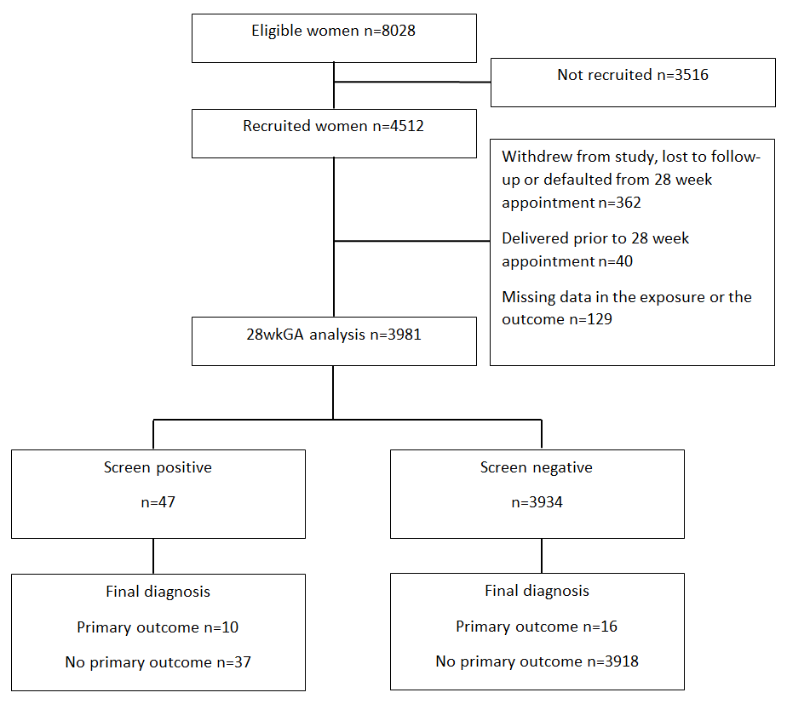
Figure S1. STARD flowchart for the primary analysis based on measurements at 28wkGA
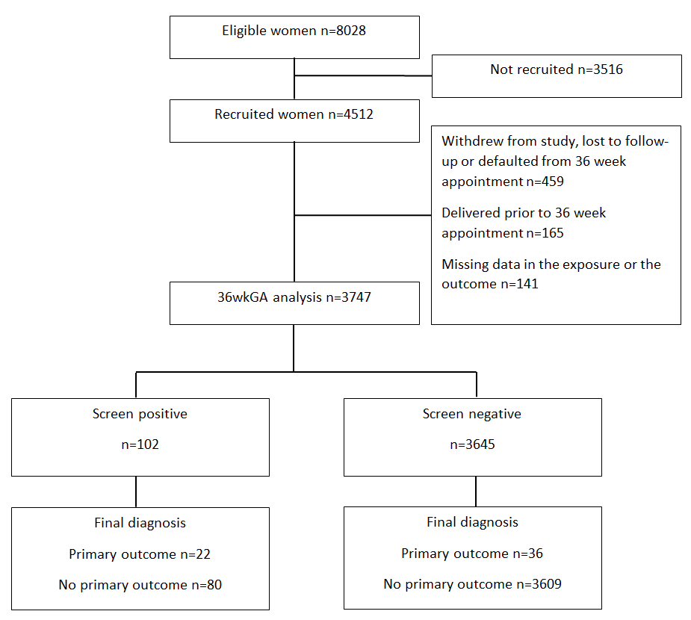
Figure S2. STARD flowchart for the primary analysis based on measurements at 36wkGA
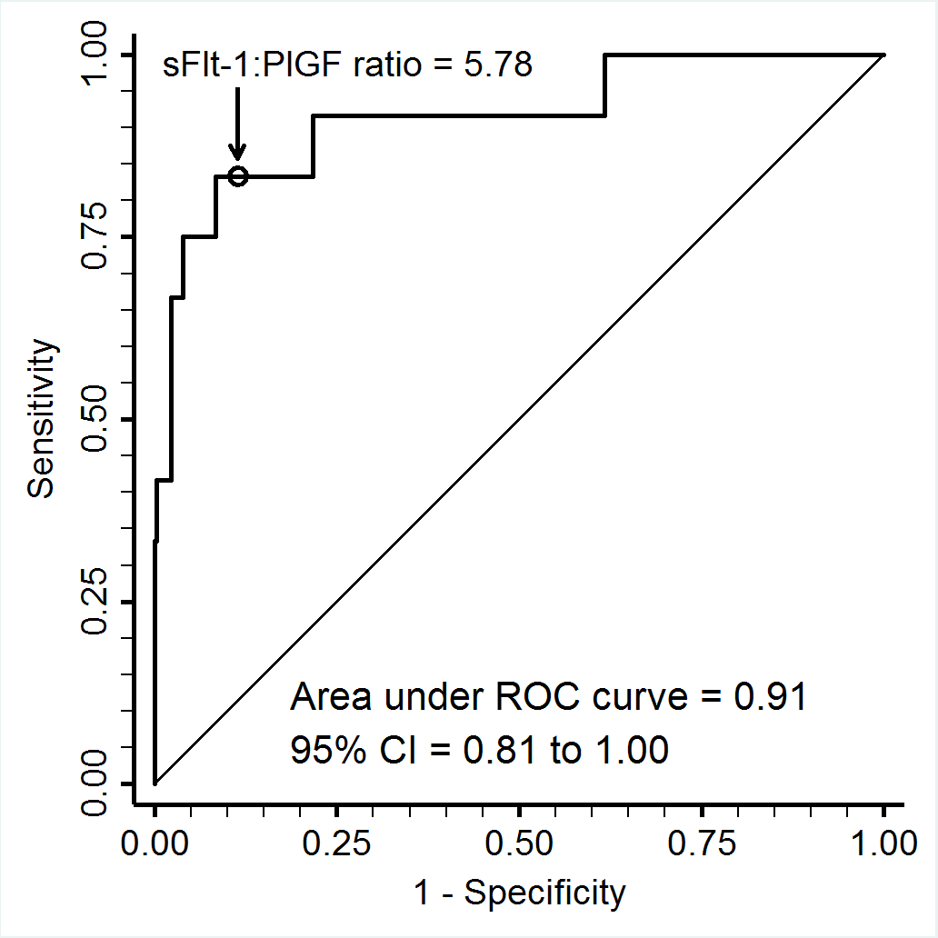

Figure S3. Receiver operating characteristic curve analysis of the relationship between the sFLT1:PlGF ratio and the risk of preterm delivery of an SGA infant (by customised birth weight standard, n=12) among women with an EFW <10th percentile at 28wkGA (total n=320)

Figure S4. Receiver operating characteristic curve analysis of the relationship between the sFLT1:PlGF ratio and the subsequent risk of delivering an SGA infant with either maternal preeclampsia or perinatal morbidity or mortality (n=39) among women with an EFW <10th percentile at 36wkGA (total n=521)

Table S1. Screening performance of ultrasonic and biochemical screening at 28wkGA for preterm delivery of an SGA infant using population-based birth weight percentile

Screening test |  |  | TP/FP | TN/FN | Positive LR  (95% CI) | Negative LR  (95% CI) | Sensitivity | Specificity | PPV | NPV
 | Ultrasonic EFW <10th |  | 9/311 | 3657/4 | 8.8  (6.1-12.9) | 0.33  (0.15-0.75) | 69.2 | 92.2 | 2.8 | 99.9
 | sFLT1:PlGF ratio >5.78 |  | 9/584 | 3384/4 | 4.7  (3.2-6.8) | 0.36  (0.16-0.82) | 69.2 | 85.3 | 1.5 | 99.9
 | Ultrasonic EFW <10th and sFLT1:PlGF ratio >5.78 |  | 7/40 | 3928/6 | 53.4  (29.6-96.4) | 0.47  (0.26-0.84) | 53.8 | 99.0 | 14.9 | 99.8
 | Ultrasonic EFW <10th and lowest decile of ACGV* |  | 2/86 | 3864/11 | 7.1  (1.9-25.7) | 0.86  (0.69-1.09) | 15.4 | 97.8 | 2.3 | 99.7
 | Delphi procedure definition of early FGR* |  | 9/109 | 3756/4 | 24.5  (16.3-36.9) | 0.32  (0.14-0.72) | 69.2 | 97.2 | 7.6 | 99.9

*See Panel S1 for definitions. Abbreviations: wkGA denotes weeks of gestational age, TP denotes true positive, FP denotes false positive, TN denotes true negative and FN denotes false negative, LR denotes likelihood ratio, CI denotes confidence interval, PPV denotes positive predictive value, NPV denotes negative predictive value, EFW denotes estimated fetal weight, sFLT1 denotes soluble fms-like tyrosine kinase 1, PlGF denotes placenta growth factor, ACGV denotes abdominal circumference growth velocity, and FGR denotes fetal growth restriction.

Table S2. Screening performance of ultrasonic and biochemical screening at 28wkGA for preterm delivery of an SGA infant using partially customised birth weight percentile*

Screening test |  |  | TP/FP | TN/FN | Positive LR  (95% CI) | Negative LR  (95% CI) | Sensitivity | Specificity | PPV | NPV
 | Ultrasonic EFW <10th |  | 15/305 | 3633/28 | 4.5  (3.0-6.9) | 0.71  (0.57-0.87) | 34.9 | 92.3 | 4.7 | 99.2
 | sFLT1:PlGF ratio >5.78 |  | 21/572 | 3366/22 | 3.4  (2.5-4.6) | 0.60  (0.45-0.80) | 48.8 | 85.5 | 3.5 | 99.4
 | Ultrasonic EFW <10th and sFLT1:PlGF ratio >5.78 |  | 10/37 | 3901/33 | 24.8  (13.2-46.5) | 0.77  (0.66-0.91) | 23.3 | 99.1 | 21.3 | 99.2
 | Ultrasonic EFW <10th and lowest decile of ACGV† |  | 4/84 | 3836/39 | 4.3  (1.7-11.3) | 0.93  (0.84-1.02) | 9.3 | 97.9 | 4.5 | 99.0
 | Delphi procedure definition of early FGR† |  | 14/104 | 3733/27 | 12.6  (7.9-20.1) | 0.68  (0.54-0.84) | 34.1 | 97.3 | 11.9 | 99.3

*Partially customised birth weight percentile used the Hadlock fetal weight standard (similarly to fully customised percentile), and customisation was performed only for fetal sex and gestational age. The partially customised birth weight percentile was calculated using the GROW v6.7.8.1(UK) bulk calculator (Perinatal Institute). †See Panel S1 for definitions. Abbreviations: wkGA denotes weeks of gestational age, TP denotes true positive, FP denotes false positive, TN denotes true negative and FN denotes false negative, LR denotes likelihood ratio, CI denotes confidence interval, PPV denotes positive predictive value, NPV denotes negative predictive value, EFW denotes estimated fetal weight, sFLT1 denotes soluble fms-like tyrosine kinase 1, PlGF denotes placenta growth factor, ACGV denotes abdominal circumference growth velocity, and FGR denotes fetal growth restriction.

Table S3. Screening performance of ultrasonic and biochemical screening at 28wkGA for preterm delivery of an infant with a birth weight <5th percentile (customised)

Screening test |  |  | TP/FP | TN/FN | Positive LR  (95% CI) | Negative LR  (95% CI) | Sensitivity | Specificity | PPV | NPV
 | Ultrasonic EFW <10th |  | 10/310 | 3653/8 | 7.1  (4.6-10.9) | 0.48  (0.29-0.81) | 55.6 | 92.2 | 3.1 | 99.8
 | sFLT1:PlGF ratio >5.78 |  | 14/579 | 3384/4 | 5.3  (4.1-6.9) | 0.26  (0.11-0.62) | 77.8 | 85.4 | 2.4 | 99.9
 | Ultrasonic EFW <10th and sFLT1:PlGF ratio >5.78 |  | 9/38 | 3925/9 | 52.1  (29.8-91.3) | 0.50  (0.32-0.80) | 50.0 | 99.0 | 19.1 | 99.8
 | Ultrasonic EFW <10th and lowest decile of ACGV† |  | 2/86 | 3859/16 | 5.1  (1.4-19.1) | 0.91  (0.77-1.07) | 11.1 | 97.8 | 2.3 | 99.6
 | Delphi procedure definition of early FGR† |  | 10/108 | 3752/8 | 19.9  (12.6-31.2) | 0.46  (0.27-0.77) | 55.6 | 97.2 | 8.5 | 99.8

The customised birth weight percentile was calculated using the GROW v6.7.8.1(UK) bulk calculator (Perinatal Institute). †See Panel S1 for definitions. Abbreviations: wkGA denotes weeks of gestational age, TP denotes true positive, FP denotes false positive, TN denotes true negative and FN denotes false negative, LR denotes likelihood ratio, CI denotes confidence interval, PPV denotes positive predictive value, NPV denotes negative predictive value, EFW denotes estimated fetal weight, sFLT1 denotes soluble fms-like tyrosine kinase 1, PlGF denotes placenta growth factor, ACGV denotes abdominal circumference growth velocity, and FGR denotes fetal growth restriction.

Table S4. Outcome data of 47 women who screened positive with ultrasonic EFW <10th percentile and sFLT1:PlGF ratio >5.78 at 28wkGA

Characteristic
Clinical scan between 22-27 completed weeks
 | Performed, n (%) | 7 (15)
 | Demonstrated EFW<10th, n (%) | 4 (8.5)
Hypertensive before or at 28 week scan, n (%) |  | 4 (8.5)
Induced labor, n (%) |  | 14 (30)
Mode of delivery
 | Spontaneous vaginal, n (%) | 28 (60)
 | Operative vaginal, n (%) | 7 (15)
 | Pre-labor caesarean, n (%) | 10 (21)
 | Intrapartum caesarean, n (%) | 2 (4.3)
Birth weight (g)
 | Birth weight (IQR) | 2800 (2190-3175)
 | Centile (IQR) | 7.6 (1.3-20.7)
 | Birth weight <2,500g | 16 (34)
 | Birth weight <10th percentile, n (%) | 25 (53)
 | Birth weight <3rd percentile, n (%) | 15 (32)
Gestational age at delivery (weeks)
 | Median (IQR) | 39.7 (37.4-40.7)
 | Preterm birth, n (%) | 10 (21)
Preeclampsia, n (%)
 | Any | 7 (15)
 | With severe features | 4 (8.5)
 | With birth weight <10th percentile | 6 (13)
 | With birth weight <3rd percentile | 5 (11)
Perinatal morbidity
 | Any morbidity preterm or term | 13 (28)
 | Apgar <7, n (%) | 2 (4.3)
 | Metabolic acidosis, n (%) | 1 (2.1)
 | Admission to neonatal unit, n (%) | 12 (26)
 | Severe morbidity/mortality, n (%) | 2 (4.3)*
 | Stillbirth, n (%) | 0 (0.0)

Data are expressed as median (IQR) or n (%) as appropriate. Birth weight centile was calculated using the customised birth weight reference (GROW v6.7.8.1(UK) bulk calculator, Perinatal Institute). Abbreviations: wkGA denotes weeks of gestational age, EFW denotes estimated fetal weight, sFLT1 denotes soluble fms-like tyrosine kinase 1, PlGF denotes placental growth factor.
*One of the two had severe metabolic acidosis and neonatal death at term.

Table S5. Screening performance of ultrasonic and biochemical screening at 28wkGA for subsequent delivery of an SGA infant (birth weight <10th customised centile) at any gestational age (preterm or term)

Screening test |  |  | TP/FP | TN/FN | Positive LR  (95% CI) | Negative LR  (95% CI) | Sensitivity | Specificity | PPV | NPV
 | Ultrasonic EFW <10th |  | 96/224 | 3360/301 | 3.9  (3.1-4.8) | 0.81  (0.76-0.86) | 24.2 | 93.8 | 30.0 | 91.8
 | sFLT1:PlGF ratio >5.78 |  | 113/480 | 3104/284 | 2.1  (1.8-2.5) | 0.83  (0.78-0.88) | 28.5 | 86.6 | 19.1 | 91.6
 | Ultrasonic EFW <10th and sFLT1:PlGF ratio >5.78 |  | 25/22 | 3562/372 | 10.3  (5.8-18.0) | 0.94  (0.92-0.97) | 6.3 | 99.4 | 53.2 | 90.5
 | Ultrasonic EFW <10th and lowest decile of ACGV* |  | 26/62 | 3504/371 | 3.8  (2.4-5.9) | 0.95  (0.93-0.98) | 6.5 | 98.3 | 29.5 | 90.4
 | Delphi procedure definition of early FGR* |  | 55/62 | 3430/330 | 8.0  (5.7-11.4) | 0.87  (0.84-0.91) | 14.3 | 98.2 | 47.0 | 91.2

*See Panel S1 for definitions. Abbreviations: wkGA denotes weeks of gestational age, SGA denotes small for gestational age, TP denotes true positive, FP denotes false positive, TN denotes true negative and FN denotes false negative, LR denotes likelihood ratio, CI denotes confidence interval, PPV denotes positive predictive value, NPV denotes negative predictive value, EFW denotes estimated fetal weight, sFLT1 denotes soluble fms-like tyrosine kinase 1, PlGF denotes placenta growth factor, ACGV denotes abdominal circumference growth velocity, and FGR denotes fetal growth restriction.

Table S6. Screening performance of ultrasonic and biochemical screening at 28wkGA for subsequent delivery of an SGA infant (birth weight <10th customised centile) with maternal preeclampsia or perinatal morbidity or mortality at any gestational age

Screening test |  |  | TP/FP | TN/FN | Positive LR  (95% CI) | Negative LR  (95% CI) | Sensitivity | Specificity | PPV | NPV
 | Ultrasonic EFW <10th |  | 25/295 | 3589/72 | 3.4  (2.4-4.8) | 0.80  (0.71-0.90) | 25.8 | 92.4 | 7.8 | 98.0
 | sFLT1:PlGF ratio >5.78 |  | 55/538 | 3346/42 | 4.1  (3.4-5.0) | 0.50  (0.40-0.63) | 56.7 | 86.1 | 9.3 | 98.8
 | Ultrasonic EFW <10th and sFLT1:PlGF ratio >5.78 |  | 14/33 | 3851/83 | 17.0  (9.4-30.7) | 0.86  (0.80-0.94) | 14.4 | 99.2 | 29.8 | 97.9
 | Ultrasonic EFW <10th and lowest decile of ACGV† |  | 8/80 | 3786/89 | 4.0  (2.0-8.0) | 0.94  (0.88-0.99) | 8.2 | 97.9 | 9.1 | 97.7
 | Delphi procedure definition of early FGR† |  | 19/99 | 3688/72 | 8.0  (5.1-12.5) | 0.81  (0.73-0.90) | 20.9 | 97.4 | 16.1 | 98.1

†See Panel S1 for definitions. Abbreviations: wkGA denotes weeks of gestational age, SGA denotes small for gestational age, TP denotes true positive, FP denotes false positive, TN denotes true negative and FN denotes false negative, LR denotes likelihood ratio, CI denotes confidence interval, PPV denotes positive predictive value, NPV denotes negative predictive value, EFW denotes estimated fetal weight, sFLT1 denotes soluble fms-like tyrosine kinase 1, PlGF denotes placenta growth factor, ACGV denotes abdominal circumference growth velocity, and FGR denotes fetal growth restriction.

Table S7. Screening performance of ultrasonic and biochemical screening at 36wkGA for subsequent risk of delivering an SGA infant with either maternal preeclampsia with severe features or severe adverse perinatal outcome

 | Screening test |  | TP/FP | TN/FN | Positive LR  (95% CI) | Negative LR  (95% CI) | Sensitivity | Specificity | PPV | NPV
 | Ultrasonic EFW <10th percentile |  | 8/513 | 3222/4 | 4.9  (3.2-7.3) | 0.39  (0.17-0.86) | 66.7 | 86.3 | 1.5 | 99.9
 | sFLT1:PlGF ratio >38 |  | 8/555 | 3180/4 | 4.5  (3.0-6.7) | 0.39  (0.18-0.87) | 66.7 | 85.1 | 1.4 | 99.9
 | Ultrasonic EFW <10th percentile and sFLT1:PlGF ratio >38 |  | 5/97 | 3638/7 | 16.0  (8.0-32.2) | 0.60  (0.37-0.97) | 41.7 | 97.4 | 4.9 | 99.8
 | Ultrasonic EFW <10th percentile and lowest decile ACGV* |  | 4/157 | 3564/8 | 7.9  (3.5-17.8) | 0.70  (0.47-1.04) | 33.3 | 95.8 | 2.5 | 99.8
 | Delphi procedure definition of late FGR* |  | 7/405 | 3274/5 | 5.3  (3.3-8.6) | 0.47  (0.24-0.91) | 58.3 | 89.0 | 1.7 | 99.8

Abbreviations: wkGA denotes weeks of gestational age, TP denotes true positive, FP denotes false positive, TN denotes true negative and FN denotes false negative, LR denotes likelihood ratio, CI denotes confidence interval, PPV denotes positive predictive value, NPV denotes negative predictive value, EFW denotes estimated fetal weight, sFLT1 denotes soluble fms-like tyrosine kinase 1, PlGF denotes placental growth factor, ACGV denotes abdominal circumference growth velocity, and FGR denotes fetal growth restriction.
*See Panel S1 for definitions

Table S8. Screening performance of ultrasonic and biochemical screening at 36wkGA for subsequent delivery of an infant with a birth weight <3rd percentile (using population reference) irrespective of perinatal morbidity or preeclampsia

 | Screening test |  | TP/FP | TN/FN | Positive LR  (95% CI) | Negative LR  (95% CI) | Sensitivity | Specificity | PPV | NPV
 | Ultrasonic EFW <10th percentile |  | 60/461 | 3208/18 | 6.1  (5.3-7.1) | 0.26  (0.18-0.40) | 76.9 | 87.4 | 11.5 | 99.4
 | sFLT1:PlGF ratio >38 |  | 29/534 | 3135/49 | 2.6  (1.9-3.4) | 0.74  (0.62-0.87) | 37.2 | 85.4 | 5.2 | 98.5
 | Ultrasonic EFW <10th percentile and sFLT1:PlGF ratio >38 |  | 25/77 | 3592/53 | 15.3  (10.3-22.6) | 0.69  (0.60-0.81) | 32.1 | 97.9 | 24.5 | 98.5
 | Ultrasonic EFW <10th percentile & lowest decile ACGV* |  | 22/139 | 3516/56 | 7.4  (5.0-11.0) | 0.75  (0.65-0.86) | 28.2 | 96.2 | 13.7 | 98.4
 | Delphi procedure definition of late FGR* |  | 53/359 | 3254/25 | 6.8  (5.7-8.2) | 0.36  (0.26-0.49) | 67.9 | 90.1 | 12.9 | 99.2

Abbreviations: wkGA denotes weeks of gestational age, SGA denotes small for gestational age, TP denotes true positive, FP denotes false positive, TN denotes true negative and FN denotes false negative, LR denotes likelihood ratio, CI denotes confidence interval, PPV denotes positive predictive value, NPV denotes negative predictive value, EFW denotes estimated fetal weight, sFLT1 denotes soluble fms-like tyrosine kinase 1, PlGF denotes placental growth factor, ACGV denotes abdominal circumference growth velocity, and FGR denotes fetal growth restriction.
*See Panel S1 for definitions

Table S9. Outcome data of 102 women who screened positive with ultrasonic EFW <10th percentile and sFLT1:PlGF ratio >38 at 36wkGA

Characteristic
Clinically-indicated scan between 24-35 weeks
 | Performed, n (%) | 38 (37)
 | Demonstrated EFW<10th, n (%) | 14 (14)
Hypertensive before or at 36 week scan, n (%) |  | 14 (14)
Induced labour, n (%)
 | All, n (%) | 37 (36)
 | Prior to 40 weeks, n (%) | 22 (22)
Mode of delivery
 | Spontaneous vaginal, n (%) | 53 (52)
 | Operative vaginal, n (%) | 22 (22)
 | Pre-labour caesarean, n (%) | 16 (16)
 | Intrapartum caesarean, n (%) | 11 (11)
Birth weight (g)
 | Birth weight (IQR) | 2710 (2390-3000)
 | Centile (IQR) | 10.4 (3.3-21.2)
 | Birth weight <2,500g | 33 (32)
 | Birth weight <10th percentile, n (%) | 48 (47)
 | Birth weight <3rd percentile, n (%) | 25 (25)
Gestational age at delivery (weeks)
 | Median (IQR) | 39 (38-40)
Preeclampsia, n (%)
 | Any | 23 (23)
 | With severe features | 13 (13)
 | With birth weight <10th percentile | 11 (11)
 | With birth weight <3rd percentile | 6 (5.9)
Perinatal morbidity
 | Any morbidity | 19 (19)
 | Apgar <7, n (%) | 0 (0.0)
 | Metabolic acidosis, n (%) | 1 (1.0)
 | Admission to neonatal unit, n (%) | 18 (18)
 | Severe morbidity/mortality, n (%) | 1 (1.0)

Data are expressed as median (IQR) or n (%) as appropriate. Birth weight centile was calculated using a population-based UK reference range. Abbreviations: EFW denotes estimated fetal weight, sFLT1 denotes soluble fms-like tyrosine kinase 1, PlGF denotes placental growth factor, wkGA denotes weeks of gestational age, and IQR denotes interquartile range.

Table S10. Screening performance for subsequent risk of delivering an SGA infant with either maternal preeclampsia or perinatal morbidity or mortality of biochemical screening versus ultrasonic measurements among women with EFW <10th at 36wkGA

Finding |  |  | TP/FP | TN/FN | Positive LR  (95% CI) | Negative LR  (95% CI) | Sensitivity | Specificity | PPV | NPV
 | Highest decile sFLT1:PlGF ratio |  | 17/60 | 422/22 | 3.5  (2.3-5.4) | 0.64  (0.49-0.85) | 43.6 | 87.6 | 22.1 | 95.0
 | sFLT1:PlGF ratio >38 |  | 22/80 | 402/17 | 3.4  (2.4-4.8) | 0.52  (0.36-0.75) | 56.4 | 83.4 | 21.6 | 95.9
 | Lowest decile ACGV* |  | 18/143 | 337/21 | 1.5  (1.1-2.2) | 0.77  (0.57-1.03) | 46.2 | 70.2 | 11.2 | 94.1
 | Delphi procedure definition of late FGR* |  | 34/330 | 150/5 | 1.3  (1.1-1.5) | 0.41  (0.18-0.94) | 87.2 | 31.3 | 9.3 | 96.8
 | Lowest decile ACGV & sFLT1:PlGF ratio >38 |  | 12/27 | 453/27 | 5.5  (3.0-9.9) | 0.73  (0.59-0.91) | 30.8 | 94.4 | 30.8 | 94.4
 | Lowest decile ACGV & sFLT1:PlGF ratio ≤38 |  | 6/116 | 364/33 | 0.6  (0.3-1.4) | 1.12  (0.97-1.29) | 15.4 | 75.8 | 4.9 | 91.7

Abbreviations: EFW denotes estimated fetal weight, wkGA denotes weeks of gestational age, TP denotes true positive, FP denotes false positive, TN denotes true negative and FN denotes false negative, LR denotes likelihood ratio, CI denotes confidence interval, PPV denotes positive predictive value, NPV denotes negative predictive value, sFLT1 denotes soluble fms-like tyrosine kinase 1, PlGF denotes placental growth factor, FGR denotes fetal growth restriction, and ACGV denotes abdominal circumference growth velocity. The cut-off points were 49.82 for the highest decile of sFLT1:PlGF ratio and -1.4808 for the lowest decile of the ACGV.
*See Panel S1 for definitions
Table S11. Screening performance of ultrasonic and biochemical screening for subsequent risk of delivering an SGA infant with either maternal preeclampsia or perinatal morbidity or mortality using the sFLT1:PlGF ratio threshold of 110 at 36wkGA

Finding |  |  | TP/FP | TN/FN | Positive LR  (95% CI) | Negative LR  (95% CI) | Sensitivity | Specificity | PPV | NPV
 | sFLT1:PlGF ratio >110 |  | 13/56 | 3633/45 | 14.8  (8.6-25.5) | 0.79  (0.69-0.90) | 22.4 | 98.5 | 18.8 | 98.8
 | Ultrasonic EFW <10th percentile & sFLT1:PlGF ratio >110 |  | 10/8 | 3681/48 | 79.5  (32.6-194.1) | 0.83  (0.74-0.93) | 17.2 | 99.8 | 55.6 | 98.7

Abbreviations: sFLT1 denotes soluble fms-like tyrosine kinase 1, PlGF denotes placental growth factor, wkGA denotes weeks of gestational age, TP denotes true positive, FP denotes false positive, TN denotes true negative and FN denotes false negative, LR denotes likelihood ratio, CI denotes confidence interval, PPV denotes positive predictive value, NPV denotes negative predictive value, and EFW denotes estimated fetal weight.

Table S12. Screening performance of biochemical screening (sFLT1:PlGF ratio >5.78 at 28wkGA) for preterm non-SGA infants experiencing complications excluding preeclampsia and gestational hypertension*

Outcome |  |  | TP/FP | TN/FN | Positive LR  (95% CI) | Negative LR  (95% CI) | Sensitivity | Specificity | PPV | NPV
 | Preterm non-SGA + perinatal complications |  | 12/581 | 3344/44 | 1.45  (0.87-2.40) | 0.92  (0.80-1.06) | 21.4 | 85.2 | 2.0 | 98.7
 | Preterm non-SGA + severe adverse perinatal outcome |  | 5/588 | 3383/5 | 3.38  (1.81-6.30) | 0.59  (0.32-1.09) | 50.0 | 85.2 | 0.84 | 99.9

*Complication is defined as perinatal morbidity or non-anomalous perinatal death excluding preeclampsia and gestational hypertension. Abbreviations: sFLT1 denotes soluble fms-like tyrosine kinase 1, PlGF denotes placental growth factor, wkGA denotes weeks of gestational age, non-SGA denotes not small for gestational age (birth weight ≥10th percentile using customised standard), TP denotes true positive, FP denotes false positive, TN denotes true negative and FN denotes false negative, LR denotes likelihood ratio, CI denotes confidence interval, PPV denotes positive predictive value and NPV denotes negative predictive value.

Table S13. Screening performance of biochemical screening (sFLT1:PlGF ratio >38 at 36wkGA) for non-SGA infants experiencing complications excluding preeclampsia and gestational hypertension*

Outcome |  |  | TP/FP | TN/FN | Positive LR  (95% CI) | Negative LR  (95% CI) | Sensitivity | Specificity | PPV | NPV
 | Non-SGA + any perinatal complications |  | 27/536 | 3034/150 | 1.02  (0.71-1.45) | 1.00  (0.94-1.06) | 15.3 | 85.0 | 4.8 | 95.3
 | Non-SGA + severe adverse perinatal outcome |  | 5/558 | 3169/15 | 1.67  (0.78-3.58) | 0.88  (0.68-1.14) | 25.0 | 85.0 | 0.89 | 99.5

*Complication is defined as perinatal morbidity or non-anomalous perinatal death excluding preeclampsia and gestational hypertension. Abbreviations: sFLT1 denotes soluble fms-like tyrosine kinase 1, PlGF denotes placental growth factor, wkGA denotes weeks of gestational age, non-SGA denotes not small for gestational age (birth weight ≥10th percentile using population based standard), TP denotes true positive, FP denotes false positive, TN denotes true negative and FN denotes false negative, LR denotes likelihood ratio, CI denotes confidence interval, PPV denotes positive predictive value and NPV denotes negative predictive value.

Analyses requested by peer reviewers

A B

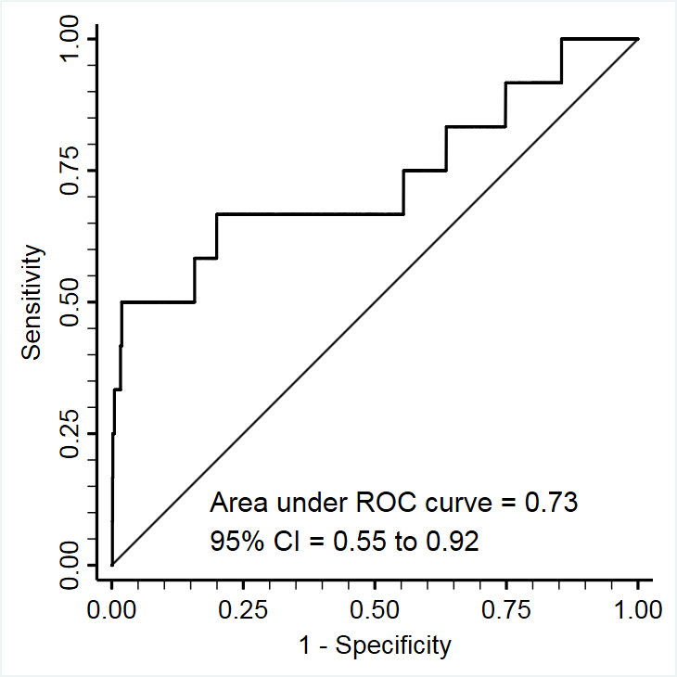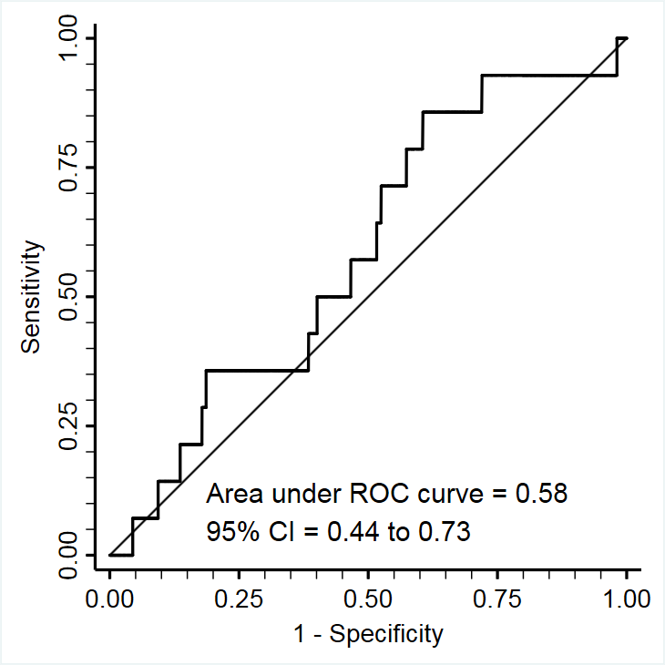

Figure S5. Receiver operating characteristic curve analysis of the relationship between sFLT1 at 28wkGA and A. the risk of preeclampsia with delivery of a preterm SGA infant (n=12 cases), B. the risk of preeclampsia with delivery of a preterm non-SGA infant (n=14 cases).

A B

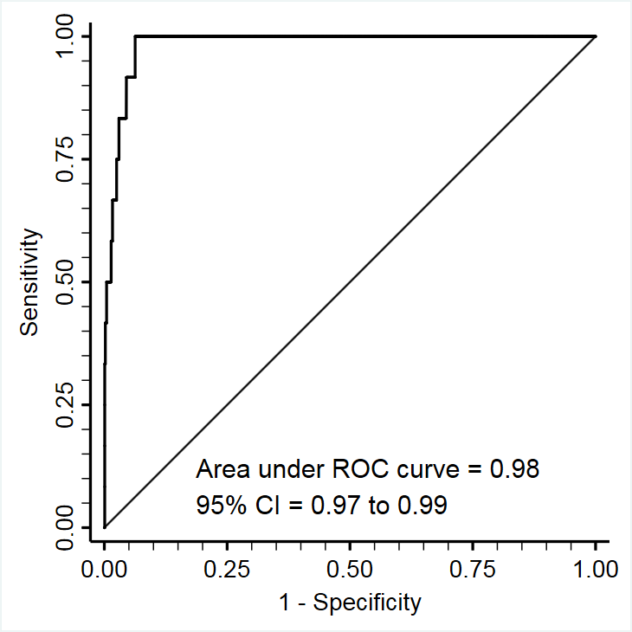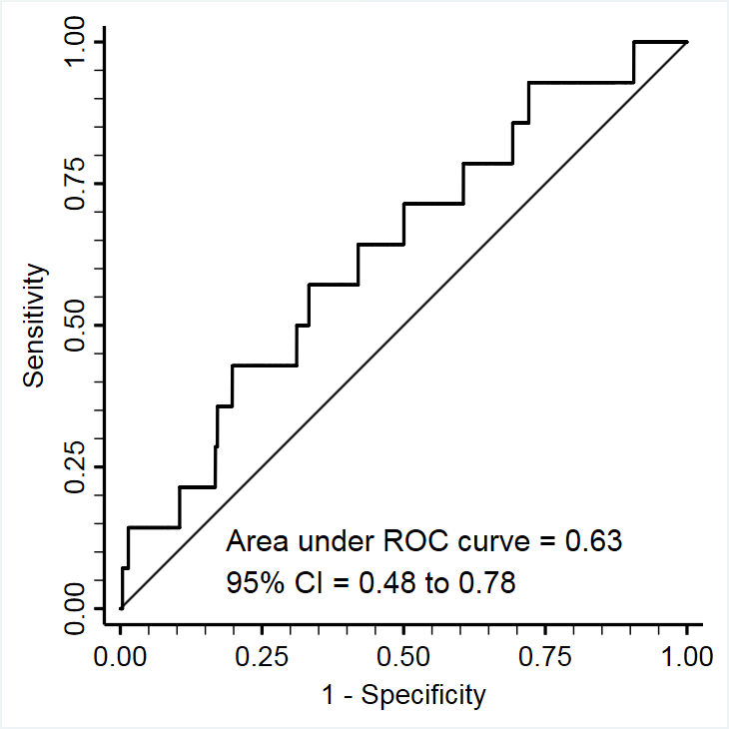

Figure S6. Receiver operating characteristic curve analysis of the relationship between PlGF at 28wkGA and A. the risk of preeclampsia with delivery of a preterm SGA infant (n=12 cases), B. the risk of preeclampsia with delivery of a preterm non-SGA infant (n=14 cases).

A B

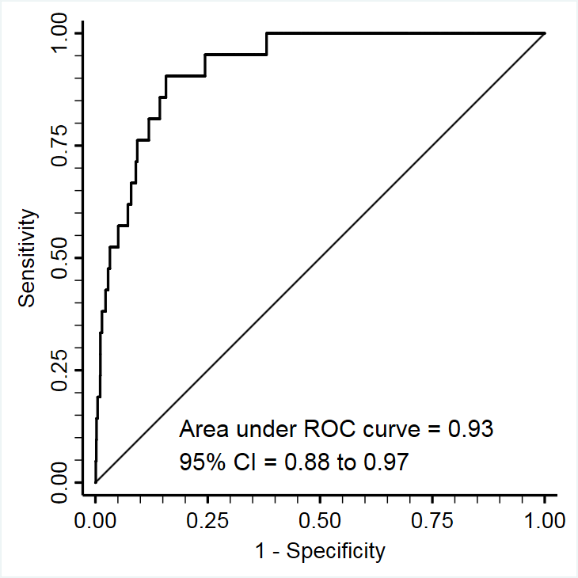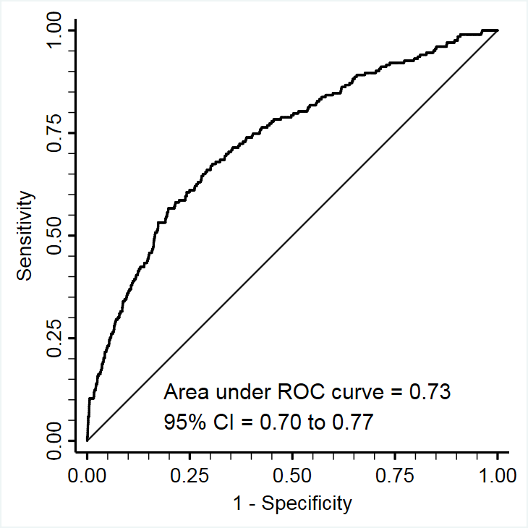
Figure S7. Receiver operating characteristic curve analysis of the relationship between sFLT1 at 36wkGA and A. the risk of preeclampsia with delivery of a SGA infant (n=21 cases), B. the risk of preeclampsia with delivery of a non-SGA infant (n=203 cases).

A B

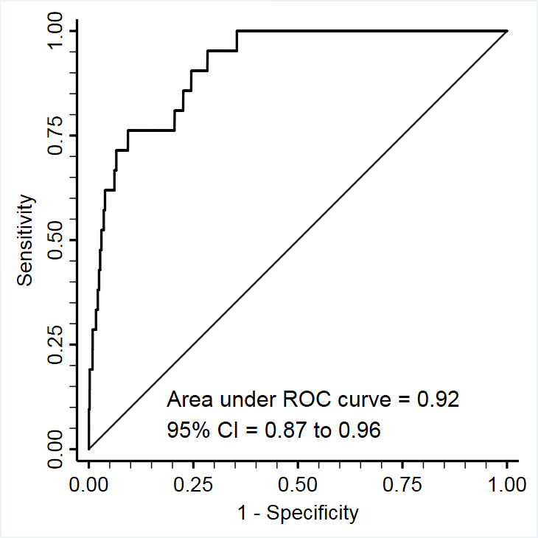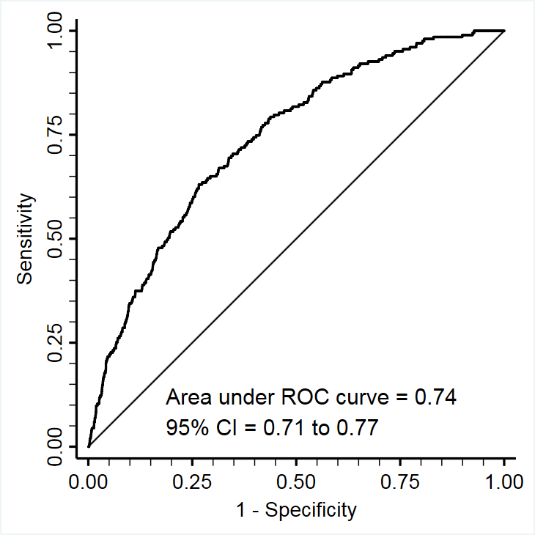
Figure S8. Receiver operating characteristic curve analysis of the relationship between PlGF at 36wkGA and A. the risk of preeclampsia with delivery of a SGA infant (n=21 cases), B. the risk of preeclampsia with delivery of a non-SGA infant (n=203 cases).

Table S14. Screening performance of ultrasonic and biochemical screening at 28wkGA for preterm delivery of an SGA infant within the whole cohort using customised birth weight percentile: comparison between the combination of EFW and sFLT1:PlGF ratio using different thresholds and the Delphi procedure

Screening test |  | Scr+ (%) | TP/FP | TN/FN | Positive LR  (95% CI) | Negative LR  (95% CI) | Sensitivity | Specificity | PPV | NPV
 | Ultrasonic EFW <15th and  sFLT1:PlGF ratio >5.78 (85th percentile) | 2.5% | 11/87 | 3868/15 | 19.2  (11.7-31.5) | 0.59  (0.42-0.82) | 42.3 | 97.8 | 11.2 | 99.6
 | Ultrasonic EFW <16.5th and  sFLT1:PlGF ratio >5.53 (83.5th percentile) | 3.0% | 12/109 | 3846/14 | 16.7  (10.6-26.4) | 0.55  (0.39-0.79) | 46.2 | 97.2 | 9.9 | 99.6
 | Ultrasonic EFW <20th and  sFLT1:PlGF ratio >4.94 (80th percentile) | 5.0% | 13/187 | 3768/13 | 10.6  (7.0-15.9) | 0.52  (0.36-0.77) | 50.0 | 95.3 | 6.5 | 99.7
 | Delphi procedure definition of early FGR† | 3.0% | 12/106 | 3747/13 | 17.4  (11.1-27.3) | 0.53  (0.37-0.78) | 48.0 | 97.2 | 10.2 | 99.7

*Customised birth weight percentile was calculated using the GROW v6.7.8.1(UK) bulk calculator (Perinatal Institute). †See appendix for definitions. Abbreviations: Scr+ denotes screen positive, TP denotes true positive, FP denotes false positive, TN denotes true negative and FN denotes false negative, LR denotes likelihood ratio, CI denotes confidence interval, PPV denotes positive predictive value, NPV denotes negative predictive value, EFW denotes estimated fetal weight, sFLT1 denotes soluble fms-like tyrosine kinase 1, PlGF denotes placenta growth factor, and FGR denotes fetal growth restriction.

Table S15. Screening performance of ultrasonic and biochemical screening at 36wkGA for subsequent risk of delivering an SGA infant with either maternal preeclampsia or perinatal morbidity or mortality within the whole cohort using population-based birth weight percentile: comparison between the combination of EFW and sFLT1:PlGF ratio using different thresholds and the Delphi procedure

Screening test |  | Scr+ (%) | TP/FP | TN/FN | Positive LR  (95% CI) | Negative LR  (95% CI) | Sensitivity | Specificity | PPV | NPV
 | Ultrasonic EFW <20th and  sFLT1:PlGF ratio >30.1 (80th percentile) | 6.7 | 31/220 | 3469/27 | 9.0  (6.8-11.8) | 0.50  (0.38-0.65) | 53.4 | 94.0 | 12.4 | 99.2
 | Ultrasonic EFW <25th and  sFLT1:PlGF ratio >25.3 (75th percentile) | 9.8 | 35/333 | 3356/23 | 6.7  (5.3-8.4) | 0.44  (0.32-0.60) | 60.3 | 91.0 | 9.5 | 99.3
 | Ultrasonic EFW <26.5th and  sFLT1:PlGF ratio >24.0 (73.5th percentile) | 11.1 | 36/379 | 3310/22 | 6.0  (4.8-7.5) | 0.42  (0.30-0.59) | 62.1 | 89.7 | 8.7 | 99.3
 | Delphi procedure definition of late FGR* | 11.2 | 35/377 | 3257/22 | 5.9  (4.7-7.4) | 0.43  (0.31-0.60) | 61.4 | 89.6 | 8.5 | 99.3

*See appendix for definitions. Abbreviations: Scr+ denotes screen positive, TP denotes true positive, FP denotes false positive, TN denotes true negative and FN denotes false negative, LR denotes likelihood ratio, CI denotes confidence interval, PPV denotes positive predictive value, NPV denotes negative predictive value, EFW denotes estimated fetal weight, sFLT1 denotes soluble fms-like tyrosine kinase 1, PlGF denotes placenta growth factor, and FGR denotes fetal growth restriction.
STARD checklist

 | Section & Topic | No | Item | Reported on page #
 | TITLE OR ABSTRACT
 |  | 1 | Identification as a study of diagnostic accuracy using at least one measure of accuracy  (such as sensitivity, specificity, predictive values, or AUC) | 2
 | ABSTRACT
 |  | 2 | Structured summary of study design, methods, results, and conclusions  (for specific guidance, see STARD for Abstracts) | 2-3
 | INTRODUCTION
 |  | 3 | Scientific and clinical background, including the intended use and clinical role of the index test | 4-5
 |  | 4 | Study objectives and hypotheses | 5
 | METHODS
 | Study design | 5 | Whether data collection was planned before the index test and reference standard were performed (prospective study) or after (retrospective study) | 6
 | Participants | 6 | Eligibility criteria | 6
 |  | 7 | On what basis potentially eligible participants were identified  (such as symptoms, results from previous tests, inclusion in registry) | 6
 |  | 8 | Where and when potentially eligible participants were identified (setting, location and dates) | 6
 |  | 9 | Whether participants formed a consecutive, random or convenience series | 6
 | Test methods | 10a | Index test, in sufficient detail to allow replication | 6-7
 |  | 10b | Reference standard, in sufficient detail to allow replication | 6-8
 |  | 11 | Rationale for choosing the reference standard (if alternatives exist) | 6-8
 |  | 12a | Definition of and rationale for test positivity cut-offs or result categories  of the index test, distinguishing pre-specified from exploratory | 6-8
 |  | 12b | Definition of and rationale for test positivity cut-offs or result categories  of the reference standard, distinguishing pre-specified from exploratory | 6-8
 |  | 13a | Whether clinical information and reference standard results were available  to the performers/readers of the index test | 6,8
 |  | 13b | Whether clinical information and index test results were available  to the assessors of the reference standard | 6,8
 | Analysis | 14 | Methods for estimating or comparing measures of diagnostic accuracy | 8-9
 |  | 15 | How indeterminate index test or reference standard results were handled | 10
 |  | 16 | How missing data on the index test and reference standard were handled | 10
 |  | 17 | Any analyses of variability in diagnostic accuracy, distinguishing pre-specified from exploratory | 10-11
 |  | 18 | Intended sample size and how it was determined | 9
 | RESULTS
 | Participants | 19 | Flow of participants, using a diagram | Appendix
 |  | 20 | Baseline demographic and clinical characteristics of participants | Table 1
 |  | 21a | Distribution of severity of disease in those with the target condition | N/A
 |  | 21b | Distribution of alternative diagnoses in those without the target condition | N/A
 |  | 22 | Time interval and any clinical interventions between index test and reference standard | Table 1
 | Test results | 23 | Cross tabulation of the index test results (or their distribution)  by the results of the reference standard | Tables 2-5
 |  | 24 | Estimates of diagnostic accuracy and their precision (such as 95% confidence intervals) | Tables 2-5
 |  | 25 | Any adverse events from performing the index test or the reference standard | N/A
 | DISCUSSION
 |  | 26 | Study limitations, including sources of potential bias, statistical uncertainty, and generalisability | 17-18
 |  | 27 | Implications for practice, including the intended use and clinical role of the index test | 13-14
 | OTHER INFORMATION
 |  | 28 | Registration number and name of registry | N/A
 |  | 29 | Where the full study protocol can be accessed | 6
 |  | 30 | Sources of funding and other support; role of funders | 3,10

Supplementary References

1. Report of the American College of Obstetricians and Gynecologists' Task Force on Hypertension in Pregnancy. Hypertension in pregnancy. Obstet Gynecol. 2013;122(5):1122-31.
2. Sovio U, White IR, Dacey A, Pasupathy D, Smith GC. Screening for fetal growth restriction with universal third trimester ultrasonography in nulliparous women in the Pregnancy Outcome Prediction (POP) study: a prospective cohort study. Lancet. 2015;386(10008):2089-97.
3. Gordijn SJ, Beune IM, Thilaganathan B, Papageorghiou A, Baschat AA, Baker PN, et al. Consensus definition of fetal growth restriction: a Delphi procedure. Ultrasound Obstet Gynecol. 2016;48(3):333-9.
4. Papageorghiou AT, Ohuma EO, Altman DG, Todros T, Cheikh Ismail L, Lambert A, et al. International standards for fetal growth based on serial ultrasound measurements: the Fetal Growth Longitudinal Study of the INTERGROWTH-21st Project. Lancet. 2014;384(9946):869-79.
5. Hadlock FP, Harrist RB, Sharman RS, Deter RL, Park SK. Estimation of fetal weight with the use of head, body, and femur measurements--a prospective study. Am J Obstet Gynecol. 1985;151(3):333-7.
6. Hadlock FP, Harrist RB, Martinez-Poyer J. In utero analysis of fetal growth: a sonographic weight standard. Radiology. 1991;181(1):129-33.
7. Gomez O, Figueras F, Fernandez S, Bennasar M, Martinez JM, Puerto B, et al. Reference ranges for uterine artery mean pulsatility index at 11-41 weeks of gestation. Ultrasound Obstet Gynecol. 2008;32(2):128-32.
8. Acharya G, Wilsgaard T, Berntsen GK, Maltau JM, Kiserud T. Reference ranges for serial measurements of umbilical artery Doppler indices in the second half of pregnancy. Am J Obstet Gynecol. 2005;192(3):937-44.

