The development and optimisation of 3D black-blood R₂* mapping of the carotid artery wall

Jianmin Yuan ^{a, *}, Martin J. Graves ^{a, b}, Andrew J. Patterson ^{b}, Andrew N. Priest ^{b}, Pascal P. R. Ruetten ª, Ammara Usman ª and Jonathan H. Gillard ª

ª Department of Radiology, University of Cambridge, United Kingdom
^{b} Department of Radiology, Cambridge University Hospitals NHS Foundation Trust, United Kingdom

* Corresponding author:
Jianmin Yuan
Department of Radiology
University of Cambridge School of Clinical Medicine
Level 5, Box 218, Addenbrooke's Hospital, Hills Rd.
Cambridge CB2 0QQ, UK
Tel: +44 (0)1223 767834
Email: jy338@cam.ac.uk

Abstract
Purpose
To develop and optimise a 3D black-blood R₂* mapping sequence for imaging the carotid artery wall, using optimal blood suppression and k-space view ordering.

Methods
Two different blood suppression preparation methods were used; Delay Alternating with Nutation for Tailored Excitation (DANTE) and improved Motion Sensitive Driven Equilibrium (iMSDE) were each combined with a three-dimensional (3D) multi-echo Fast Spoiled GRadient echo (ME-FSPGR) readout. Three different k-space view-order designs: Radial Fan-beam Encoding Ordering (RFEO), Distance-Determined Encoding Ordering (DDEO) and Centric Phase Encoding Order (CPEO) were investigated. The sequences were evaluated through Bloch simulation and in a cohort of twenty volunteers. The vessel wall Signal-to-Noise Ratio (SNR), Contrast-to-Noise Ratio (CNR) and R₂*, and the sternocleidomastoid muscle R₂* were measured and compared. Different numbers of acquisitions-per-shot (APS) were evaluated to further optimise the effectiveness of blood suppression.

Results
All sequences resulted in comparable R₂* measurements to a conventional, i.e. non-blood suppressed sequence in the sternocleidomastoid muscle of the volunteers. Both Bloch simulations and volunteer data showed that DANTE has a higher signal intensity and results in a higher image SNR than iMSDE. Blood suppression efficiency was not significantly different when using different k-space view orders. Smaller APS achieved better blood suppression.

Conclusion
The use of blood-suppression preparation methods does not affect the measurement of R₂*. DANTE prepared ME-FSPGR sequence with a small number of acquisitions-per-shot can provide high quality black-blood R₂* measurements of the carotid vessel wall.

Keywords
Blood suppression, quantitative R₂* mapping, carotid imaging

1. Introduction
The measurement of the T₂* relaxation time has been used to assess iron concentration in the myocardium [1, 2], and liver [3] as well as being used to monitor the uptake of Ultra-small Superparamagnetic Particles of Iron Oxide (USPIO) in the vessel wall [4-7]. Good reproducibility has been found when using conventional multi-echo gradient-echo based T₂* sequences [8]. Recently, black-blood preparation based on double-inversion-recovery (DIR) has been introduced for cardiac T₂* imaging with improved myocardial-to-blood contrast, clearer myocardial borders, and less blood signal contamination [9-11]. Black-blood T₂* sequences have reportedly achieved comparable T₂* measurement, and superior reproducibility compared to bright-blood sequences [9-11].

In vessel wall imaging, the two dimensional (2D) black-blood T₂* sequences using DIR or quadruple inversion-recovery (QIR) have been used to distinguish symptomatic from asymptomatic plaque [12]. Significant differences in T₂* values have also been found in different plaque components [13]. Changes in T₂*-weighted imaging following the administration of USPIO have been used as a surrogate biomarker for changes in plaque inflammation [14-16].

However, the use of blood suppression techniques such as DIR or QIR might not be sufficient for 3D imaging [17, 18]. Residual flow artefacts make the separation of the wall and lumen difficult, the partial volume in the wall pixels close to the lumen requires complex post-processing for accurate T₂* mapping [19, 20]. Alternative blood suppression techniques which have been introduced in recent years, such as motion-sensitive driven equilibrium (MSDE) [21, 22] and DANTE [23], have shown superior blood suppression, especially for 3D imaging. They have been used in the majority of recent clinical studies to evaluate 3D carotid plaque morphology and function [18, 24-27]. However, there are limited studies exploring the application of these techniques for 3D T₂* mapping [28, 29].

The aim of this study was to develop an optimised 3D black-blood T₂* sequence for carotid vessel wall imaging. Different 3D black-blood preparations were compared and optimised k-space view orders were designed through Bloch simulation and evaluated in a volunteer study. The T₂* relaxivity, R₂* = 1/T₂*, is used in this study, since it has a positive linear relationship with tissue iron concentration [3].

2. Materials and Methods
2.1 Sequence
The basic sequence consists of a blood suppression module, followed by a fat-suppressed 3D multi-echo fast spoiled gradient echo sequence (ME-FSPGR) followed by a delay time (Td). Fig.1A shows the sequence diagram for one shot. Two black-blood techniques, iMSDE (Fig. 1B) [22] and DANTE (Fig.1C) [23], were compared. The iMSDE module consists of a non-selective 90˚ tip-down pulse, two composite 180˚ refocusing pulses and a -90˚ tip-up pulse. Motion sensitive gradients were used between the RF pulses for blood suppression. The DANTE preparation comprises a train of low amplitude hard RF pulses interspersed with gradients applied along all three directions.

Fat saturation was achieved using a standard chemical shift saturation pulse. Each shot comprises the blood suppression preparation, fat suppression, multiple ME-FSPGR acquisitions and Td (Fig.1D). The number of ME-FSPGR acquisitions-per-shot (APS) is user selectable. Each ME-FSPGR acquisition comprises six echoes. The delay time (Td) is applied at the end of the FSPGR acquisitions to allow the magnetisation to recover and improve the overall Signal-to-Noise Ratio (SNR). During the readout, the k-space points in the k_{y}-k_{z} plane were acquired per their distance from the k-space centre to achieve optimal blood suppression.

Three different k-space view orders were implemented and compared. The first method was Radial Fan-beam Encoding Ordering (RFEO) [30] (Fig.2A). In this method, the k-space points in the k_{y}-k_{z} plane were first sorted into different shots by their polar angle, and then within each shot, the points were sorted by their distance from the k-space centre. The second method was the Distance-Determined Encoding Ordering [31] (DDEO, Fig.2B). In this method, all the k-space points in the k_{y}-k_{z} plane were first sorted by their distance from the k-space centre, and then the i^{th} × N points were allocated to the i^{th} place in each shot (i is from 1 to the APS, N is the total number of shots). The third method was Centric Phase Encoding Order (CPEO, Fig.2C), in which each shot consists of a single line along k_{z}.

The other fixed parameters for the acquisition were: Td = 200 ms; TE = 4.9, 10.4, 15.7, 21.1, 26.4 and 31.8 ms; TR = 36.8 ms; flip angle = 15°; receiver bandwidth = ±31.25 kHz; acquisition plane: axial; field-of-view (FOV): 140×140×80 mm³; acquisition matrix: 224×224×40. The images were interpolated to a 512×512×80 reconstructed matrix size using zero-filling. A unipolar echo acquisition was used to minimise off-resonance effects.

2.2 Bloch simulation
Bloch equation simulations were performed to study the signal evolution of the vessel wall with the different black-blood methods and k-space view orderings, using a custom algorithm, based on the code from Brian Hargreaves at Stanford University (http://mrsrl.stanford.edu/~brian/bloch/), in Matlab (MathWorks, Natick, MA, USA). The relaxation times used in the simulation were: T₁_blood = 1500 ms, T₂_blood = 128 ms, T₁_wall = 1000 ms and T₂_wall = 50 ms [13, 18]. Other parameters were the same as for the volunteer protocol.

2.3 Volunteer studies
Twenty volunteers (ten male, mean age 29, range: 24-41 years) were recruited for this study. The study protocol was reviewed and approved by a local ethics committee and written informed consent was obtained from each volunteer. All scans were performed using a 1.5T system (MR450w, GE Healthcare, Waukesha, WI), using a 4-channel phased-array neck coil (PACC, MachNet, Roden, The Netherlands).

The volunteers were initially scanned with the ME-FSPGR sequence combined with i) DANTE, ii) iMSDE, and iii) without black-blood preparation. The readouts used the RFEO method with a fixed APS of 40. The three different view orders were evaluated using the DANTE preparation with an APS of 40 for all of the volunteers. The scanning time for the RFEO and DDEO acquisitions was 6min15s and 7minutes for CPEO. To further optimise the blood suppression, seven volunteers were scanned with the DANTE preparation and RFEO order using different APS (APS = 10, 40, 70 and 100).

In the R₂* calculation, the noise in the image was corrected by subtracting the background signal intensity in the power images [32]

${I_{c}(TE)}^{2}={I(TE)}^{2}{-I_{n}(TE)}^{2}$ (1)

where $I_{c}(TE)$ and $I(TE)$ are noise corrected and uncorrected image at different TE, and $I_{n}(TE)$ was the background noise intensity. Then the R₂* fitting was using

${I_{c}(TE)}^{2}=I_{0}^{2}e^{-2TE{×R}_{2}^{*}}$ (2)

2.4 Image analysis
In all the volunteer images, the lumen and wall contours of three contiguous slices 5 mm below the bifurcation were manually drawn by an experienced reviewer in OsiriX (OsiriX 5.5.2, Pixmeo, Geneva, Switzerland). A region of noise was also drawn in an artefact-free background by the same observer. The standard deviation of the background region was used as the noise level. Vessel wall SNR and wall-lumen Contrast-to-Noise Ratio (CNR) were calculated. The SNR was calculated as:

SNR = 0.695×S/$σ$ (3)

where S is the signal intensity, $σ$ is the standard deviation of the noise, and the multiplier 0.695 considers four-channel used in the carotid coil [33]. The wall-lumen CNR was defined as the difference between wall SNR and lumen SNR:

CNR_{wall-lumen} = SNR_{wall}-SNR_{lumen} (4)

The SNR of a single region drawn in the sternocleidomastoid muscle was also calculated for each scan. To test the inter-reviewer reproducibility, the images from DANTE prepared sequence with RFEO readout and APS value of 10 were analysed by a second reviewer, and the results were compared with the first reviewer. Both of the reviewers were blinded to the subjects’ information and made their measurements independently. The data are presented as mean ± sd (standard deviation). A paired student’s t-test was used to compare the difference. The interclass correlations (ICCs) of the vessel wall and muscle R₂* values measured from two reviewers were calculated. The statistical analysis was performed using R [34] (version 3.2.2, R Development Core Team, Vienna, Austria).

3. Results
To achieve adequate blood suppression, the iMSDE preparation was empirically optimised with a gradient amplitude of 20 mT/m, duration of 1500 ms and slew rate of 120 mT/m/ms. The DANTE parameters were set at: number of pulses 100, gradient amplitude 20 mT/m, flip angle 13˚, repetition time ~1 ms.

Fig. 3 shows the Bloch simulation of the vessel wall longitudinal magnetisation change over time and one corresponding volunteer image using RFEO with an APS of 40. The DANTE prepared sequence achieves a higher signal compared to the iMSDE prepared version. In the volunteer scans, The quantitative measurement of vessel wall and sternocleidomastoid muscle are shown in Table 1. The vessel wall SNR and CNR are significantly higher in DANTE than iMSDE (both p < 0.01). The R₂* values of the vessel wall were similar (p = 0.84). The muscle R₂* values were unaffected by the blood suppression schemes (p = 0.34 for DANTE vs. no blood suppression; p = 0.28 for iMSDE vs. no blood suppression). The muscle has similar SNR in DANTE compared to no blood suppression (p = 0.92), while has significantly lower SNR in iMSDE (p < 0.01).

Fig. 4 shows the Bloch simulation of the longitudinal magnetisation recovery of blood using the different k-space view orders. After each black-blood pulse, the blood longitudinal magnetisation recovers from zero due to T₁ relaxation. Since the image contrast is mainly determined by the k-space centre, a method that allocates the low blood signal points to the k-space centre can achieve optimal blood suppression. Under this assumption, the DDEO method (centre column) should achieve the best blood suppression.

Fig. 5 shows a volunteer study acquired using the DANTE prepared sequence with the three different k-space orders. These T₂*-weighted images are obtained using a sum-of-squares combination of the different echoes. The RFEO and DDEO orders achieved better blood suppression than the CPEO order. The results show that volunteer wall-lumen CNR of RFEO (7.0 ± 1.6) and DDEO (6.6 ± 1.8) are comparable, and higher than the CPEO method (5.8 ± 2.0). However, none of the differences was significant (p = 0.28 for RFEO vs. CPEO, p = 0.48 for DDEO vs. CPEO).

Some of the volunteer images showed insufficient blood suppression with the use of APS = 40. Thus, the effectiveness of changing the APS on blood suppression was further investigated in the volunteers. One example of a volunteer study with different APS is shown in Fig.6. The results show that the SNR and R₂* value measured from vessel wall and the sternocleidomastoid muscle were similar with different APS, while the CNR of the vessel wall decreases with increasing APS, indicating the blood suppression efficiency decreases with increasing APS. The results from two reviewers correlated very well. The ICC for the vessel wall and muscle R₂* were 0.87 and 0.90, respectively.

4. Discussion
Vessel wall multi-echo T₂* imaging could be used for plaque component classification [13, 35], USPIO uptake quantification [6, 14, 36] and potentially also for susceptibility weighted imaging (SWI) [37, 38] and quantitative susceptibility mapping (QSM) [39]. Unlike 3D FSE based T₂ mapping sequences [40, 41], in which the readout has an intrinsic blood suppression effect, the blood suppression for GRE-based T₂* mapping is challenging. So far only limited studies have explored black-blood T₂* mapping. This study, for the first time, shows the feasibility of implementing black-blood techniques into a 3D T₂*/R₂* mapping sequence.

The iMSDE preparation demonstrated a lower SNR compared to DANTE in this study, which is in agreement with a previous study [18]. The T₂ decay during the iMSDE preparation leads to lower image SNR, which may limit the application in some low-signal regions [29]. When applied to high field MRI (e.g., 7T), DANTE may also be more suitable due to the specific absorption rate (SAR) restrictions [18].

Three different k-space filling orders were implemented and compared. There was no difference between the RFEO and DDEO orders, in that they both showed better blood suppression than CPEO. Both RFEO and DDEO fill the k-space centre immediately after the blood suppression pulse. Therefore, the reconstructed images have the most effective blood suppression. The results showed non-significant differences between these three methods, indicating that the choice of view-ordering does not a major influence on image quality. The choice of the APS, on the other hand, is more important for blood suppression. Larger APS values allow longer blood T₁ recovery between the blood suppression pulses, which will result in insufficient blood suppression. The RFEO and DDEO provide flexible APS during the scan while the CPEO has limited options for APS (APS must be fractions of slice number, e.g., 1, 1/2, 1/3 et al of slice number). The DDEO method may be more suitable when the APS is very short; in this case, the RFEO method may not be optimal as the outer k-space regions cannot be reached even with a small polar angle. The large jumps in the k-space ordering utilised in the DDEO method may increase eddy current effects, as, has been previously reported albeit using balanced steady-state free precession (SSFP) sequence [42]. However, no such eddy current artefact was observed in this study.

It should be noted that cardiac gating was not used in this study, which is one of the limitations of this study. The effect of trigger delay is not examined. However, the addition of ECG gating would result in variable Td values and hence variable magnetisation recovery between different the shots. Furthermore, a previous study showed that comparable vessel wall morphological measurement can be achieved with a ungated 3D sequence [43].Another limitation is that no patient image is available in this study. This study aims to optimise the black-blood R₂* mapping sequences in the volunteer. The result from this study is worth trying in the patient studies.

5. Conclusion
This study has developed and optimised a 3D black-blood R₂* mapping sequence through Bloch simulation and volunteer imaging. The results show that the DANTE preparation is better than iMSDE in terms of image SNR. In addition, the RFEO and DDEO k-space ordering methods have similar blood suppression efficiency, and no significant CNR differences were observed between them and CPEO method. The RFEO and DDEO method provide more flexibility with different APS values. Smaller APS could achieve better blood suppression effect.

Conflicts of interest
None.

Acknowledgements
The project was supported by the Addenbrooke’s Charitable Trust and the National Institute of Health Research Comprehensive Biomedical Research Centre award to Cambridge University Health Partners.

References
[1] Westwood M, Anderson L J, Firmin D N, Gatehouse P D, Charrier C C, Wonke B, et al. A single breath-hold multiecho T2* cardiovascular magnetic resonance technique for diagnosis of myocardial iron overload. J Magn Reson Imaging 2003;18:33-9.
[2] Kirk P, He T, Anderson L J, Roughton M, Tanner M A, Lam W W, et al. International reproducibility of single breathhold T2* MR for cardiac and liver iron assessment among five thalassemia centers. J Magn Reson Imaging 2010;32:315-9.
[3] Wood J C, Enriquez C, Ghugre N, Tyzka J M, Carson S, Nelson M D, et al. MRI R2 and R2* mapping accurately estimates hepatic iron concentration in transfusion-dependent thalassemia and sickle cell disease patients. Blood 2005;106:1460-5.
[4] Alam S R, Stirrat C, Richards J, Mirsadraee S, Semple S I, Tse G, et al. Vascular and plaque imaging with ultrasmall superparamagnetic particles of iron oxide. J Cardiovasc Magn Reson 2015;17:1.
[5] Richards J M, Semple S I, MacGillivray T J, Gray C, Langrish J P, Williams M, et al. Abdominal aortic aneurysm growth predicted by uptake of ultrasmall superparamagnetic particles of iron oxide a pilot study. Circ Cardiovasc Imaging 2011;4:274-81.
[6] Patterson A J, Tang T Y, Graves M J, Müller K H, Gillard J H. In vivo carotid plaque MRI using quantitative T2* measurements with ultrasmall superparamagnetic iron oxide particles: a dose-response study to statin therapy. NMR Biomed 2011;24:89-95.
[7] McBride O M, Berry C, Burns P, Chalmers R T, Doyle B, Forsythe R, et al. MRI using ultrasmall superparamagnetic particles of iron oxide in patients under surveillance for abdominal aortic aneurysms to predict rupture or surgical repair: MRI for abdominal aortic aneurysms to predict rupture or surgery-the MA3RS study. Open heart 2015;2:e000190.
[8] Westwood M A, Anderson L J, Firmin D N, Gatehouse P D, Lorenz C H, Wonke B, et al. Interscanner reproducibility of cardiovascular magnetic resonance T2* measurements of tissue iron in thalassemia. J Magn Reson Imaging 2003;18:616-20.
[9] He T, Gatehouse P D, Kirk P, Tanner M A, Smith G C, Keegan J, et al. Black-blood T2* technique for myocardial iron measurement in thalassemia. J Magn Reson Imaging 2007;25:1205-9.
[10] Smith G C, Carpenter J P, He T, Alam M H, Firmin D N, Pennell D J. Value of black blood T2* cardiovascular magnetic resonance. J Cardiovasc Magn Reson 2011;13:1.
[11] Khater N H, El Shahat H M, Fahmy H S, El Hadidy S S. Comparative study between black blood T2∗ and conventional bright GRE sequences in assessment of myocardial iron concentration. The Egyptian Journal of Radiology and Nuclear Medicine 2016;47:407-12.
[12] Raman S V, Winner M W, Tran T, Velayutham M, Simonetti O P, Baker P B, et al. In vivo atherosclerotic plaque characterization using magnetic susceptibility distinguishes symptom-producing plaques. JACC Cardiovasc Imaging 2008;1:49-57.
[13] Degnan A J, Young V E, Tang T Y, Gill A B, Graves M J, Gillard J H, et al. Ex vivo study of carotid endarterectomy specimens: quantitative relaxation times within atherosclerotic plaque tissues. Magn Reson Imaging 2012;30:1017-21.
[14] Kooi M, Cappendijk V, Cleutjens K, Kessels A, Kitslaar P, Borgers M, et al. Accumulation of ultrasmall superparamagnetic particles of iron oxide in human atherosclerotic plaques can be detected by in vivo magnetic resonance imaging. Circulation 2003;107:2453-8.
[15] Tang T Y, Muller K H, Graves M J, Li Z Y, Walsh S R, Young V, et al. Iron oxide particles for atheroma imaging. Arterioscler Thromb Vasc Biol 2009;29:1001-8.
[16] Tang T Y, Howarth S P, Miller S R, Graves M J, Patterson A J, Jean-Marie U, et al. The ATHEROMA (Atorvastatin Therapy: Effects on Reduction of Macrophage Activity) Study: evaluation using ultrasmall superparamagnetic iron oxide-enhanced magnetic resonance imaging in carotid disease. J Am Coll Cardiol 2009;53:2039-50.
[17] Koktzoglou I, Chung Y-C, Carroll T J, Simonetti O P, Morasch M D, Li D. Three-dimensional Black-Blood MR Imaging of Carotid Arteries with Segmented Steady-State Free Precession: Initial Experience 1. Radiology 2007;243:220-8.
[18] Li L, Chai J T, Biasiolli L, Robson M D, Choudhury R P, Handa A I, et al. Black-blood multicontrast imaging of carotid arteries with DANTE-prepared 2D and 3D MR imaging. Radiology 2014;273:560-9.
[19] Sharkey-Toppen T P, Mihai G, Maiseyeu A, Tran T, Clymer B D, Simonetti O P, et al. Improved in vivo human carotid artery wall T2* estimation. Magn Reson Imaging 2013;31:44-52.
[20] Raman S V, Sharkey-Toppen T P, Tran T, Liu J X, McCarthy B, He X, et al. Iron, inflammation and atherosclerosis risk in men vs. perimenopausal women. Atherosclerosis 2015;241:249-54.
[21] Wang J, Yarnykh V L, Hatsukami T, Chu B, Balu N, Yuan C. Improved suppression of plaque-mimicking artifacts in black-blood carotid atherosclerosis imaging using a multislice motion-sensitized driven-equilibrium (MSDE) turbo spin-echo (TSE) sequence. Magn Reson Med 2007;58:973-81.
[22] Wang J, Yarnykh V L, Yuan C. Enhanced image quality in black-blood MRI using the improved motion-sensitized driven-equilibrium (iMSDE) sequence. J Magn Reson Imaging 2010;31:1256-63.
[23] Li L, Miller K L, Jezzard P. DANTE-prepared pulse trains: A novel approach to motion-sensitized and motion-suppressed quantitative magnetic resonance imaging. Magn Reson Med 2012;68:1423-38.
[24] Yuan J, Makris G, Patterson A, Usman A, Das T, Priest A, et al. Relationship between carotid plaque surface morphology and perfusion: a 3D DCE-MRI study. Magnetic Resonance Materials in Physics, Biology and Medicine 2017;1-9.
[25] Zhu C, Graves M J, Yuan J, Sadat U, Gillard J H, Patterson A J. Optimization of Improved Motion-sensitized Driven-equilibrium (iMSDE) blood suppression for carotid artery wall imaging. J Cardiovasc Magn Reson 2014;16:1.
[26] Balu N, Yarnykh V L, Chu B, Wang J, Hatsukami T, Yuan C. Carotid plaque assessment using fast 3D isotropic resolution black-blood MRI. Magn Reson Med 2011;65:627-37.
[27] Yuan J, Usman A, Das T, Patterson A, Gillard J, Graves M. Imaging Carotid Atherosclerosis Plaque Ulceration: Comparison of Advanced Imaging Modalities and Recent Developments. American Journal of Neuroradiology 2016;https://doi.org/10.3174/ajnr.A5026
[28] Su S, Ren Y, Shi C, Zhang X, Zheng H, Liu X, et al. Black-Blood T2* Mapping with Delay Alternating with Nutation for Tailored Excitation. Proceedings of the 24th scientific meeting, International Society for Magnetic Resonance in Medicine, Singapore. 2016. p1573.
[29] Newbould R D, Owen D R, Shalhoub J, Brown A P, Gambarota G. Motion-sensitized driven equilibrium for blood-suppressed T2* mapping. J Magn Reson Imaging 2011;34:702-9.
[30] Vu A T, Patent US7265547 B2, 2007.
[31] Feiweier T, Patent US7728588 B2, 2010.
[32] Miller A J, Joseph P M. The use of power images to perform quantitative analysis on low SNR MR images. Magn Reson Imaging 1993;11:1051-6.
[33] Constantinides C D, Atalar E, McVeigh E R. Signal‐to‐noise measurements in magnitude images from NMR phased arrays. Magn Reson Med 1997;38:852-7.
[34] Team R C. R: A language and environment for statistical computing. R Foundation for Statistical Computing, Vienna, Austria. 2013. 3-900051-07-0 http://www.R-project.org/.
[35] Harteveld A, Denswil N, Siero J, Zwanenburg J, Vink A, Pouran B, et al. Quantitative intracranial atherosclerotic plaque characterization at 7t mri: an ex vivo study with histologic validation. American Journal of Neuroradiology 2016;37:802-10.
[36] Trivedi R A, Mallawarachi C, Jean-Marie U, Graves M J, Horsley J, Goddard M J, et al. Identifying inflamed carotid plaques using in vivo USPIO-enhanced MR imaging to label plaque macrophages. Arterioscler Thromb Vasc Biol 2006;26:1601-6.
[37] Yang Q, Liu J, Barnes S R, Wu Z, Li K, Neelavalli J, et al. Imaging the vessel wall in major peripheral arteries using susceptibility-weighted imaging. J Magn Reson Imaging 2009;30:357-65.
[38] Yang Q, Li K, Liu J, Barnes S, Wu Z, Neelavalli J, et al. Imaging the vessel wall in major peripheral arteries using susceptibility weighted imaging: visualizing calcifications. J Cardiovasc Magn Reson 2009;11:O12.
[39] Wang C, Liu S, Buch S, Choi H S, Hwang E-J, Fan Z, et al. Quantitative Susceptibility Mapping of Atherosclerosis in Carotid Arteries. Proceedings of the 24th scientific meeting, International Society for Magnetic Resonance in Medicine, Singapore. 2016. p2552.
[40] Yuan J, Usman A, Reid S A, King K F, Patterson A J, Gillard J H, et al. Three-dimensional black-blood T2 mapping with compressed sensing and data-driven parallel imaging in the carotid artery. Magn Reson Imaging 2017;37:62-9.
[41] Biasiolli L, Lindsay A C, Chai J T, Choudhury R P, Robson M D. In-vivo quantitative T2 mapping of carotid arteries in atherosclerotic patients: segmentation and T2 measurement of plaque components. J Cardiovasc Magn Reson 2013;15:1.
[42] Bieri O, Markl M, Scheffler K. Analysis and compensation of eddy currents in balanced SSFP. Magn Reson Med 2005;54:129-37.
[43] Chengcheng Z, Graves M J, Sadat U, Young V E, Gillard J H, Patterson A J. Comparison of gated and ungated black-blood fast spin-echo MRI of carotid Vessel Wall at 3T. Magn Reson Med Sci 2016;15:266-72.

Table 1. Quantitative measurement from vessel wall and sternocleidomastoid muscle in no blood suppression, DANTE and iMSDE prepared ME-FSPGR sequences. Due to the partial volume effect of the lumen signal, the vessel wall SNR, CNR and R₂* values without blood suppression is not reported.
Blood suppression | Vessel wall SNR | Vessel wall CNR | Vessel wall R₂* | sternocleidomastoid muscle SNR | sternocleidomastoid muscle R₂*
no | - | - | - | 40.2 ± 14.0 | 36.0 ± 5.6
DANTE | 12.2 ± 4.5 | 7.2 ± 2.6 | 32.6 ± 6.7 | 39.9 ± 16.9 | 34.8 ± 4.8
iMSDE | 8.5 ± 1.5 | 5.0 ± 1.2 | 33.4 ± 7.6 | 21.6 ± 13.1 | 37.6 ± 6.8

Figure legends
Figure 1. Overview of the black-blood ME-FSPGR sequence in one shot. (A) A shot consists of blood suppression preparation pulse, a standard chemical saturation pulse, and multiple acquisitions. The number of acquisition is defined as acquisitions-per-shot (APS). A delay time (Td) is used at the end of each shot. Two different blood suppressions, iMSDE (B) and DANTE (C) were used. Τ is the time interval between the 90˚ and 180˚ pulse in iMSDE. $α$ is the flip angle in DANTE. t_{D} is the repetition time of DANTE pulse. (D) The ME-FSPGR acquisition contains six echoes.

Figure 2. Example of three different k-space orderings using matrix of 32×32. The color bar shows the acquisition order within each of the shot: from the 1st point to the APS^{th} point; APS = 32 is used in this example.

Figure 3. Upper row: Bloch simulation of the ME-FSPGR sequence, and with DANTE or iMSDE preparation. Vessel wall material properties of T₁ = 1000 ms and T₂ = 50 ms are used in the simulation. Centre row: corresponding volunteer images with six echoes acquired. Bottom row: corresponding R₂* maps of the vessel wall.

Figure 4. Blood T₁ recovery in k-space using three different k-space view orderings. Upper row shows an example of 32×32 k-space using APS equals to 32. Centre row shows the example of 224×40 k-space using APS equals to 40. Bottom row shows the one line of k-space (k_{y} = 0) in 224×40 matrix example.

Figure 5. An example of volunteer image using three different k-space view ordering. The sum-of-squares of echoes is presented.

Figure 6. Comparison of different APS using DANTE prepared acquisition. (A): A volunteer image showing different APS. The six different echoes and R₂* map are presented. Large APS results in insufficient blood suppression. (B-D): Measurement of SNR, CNR and R₂* of vessel wall and sternocleidomastoid muscle.

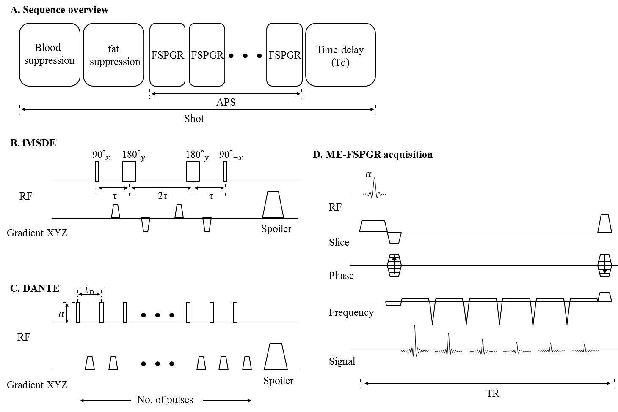

Figure 1

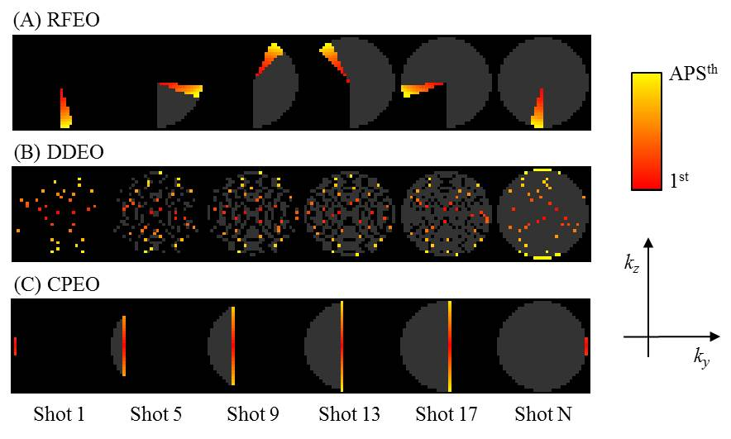
Figure 2

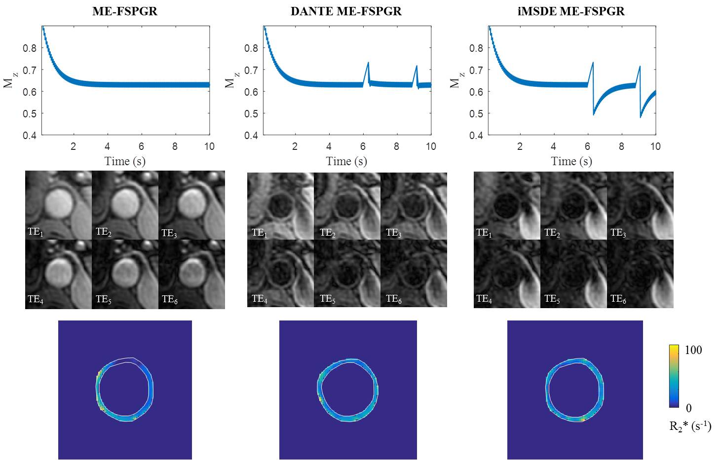
Figure 3

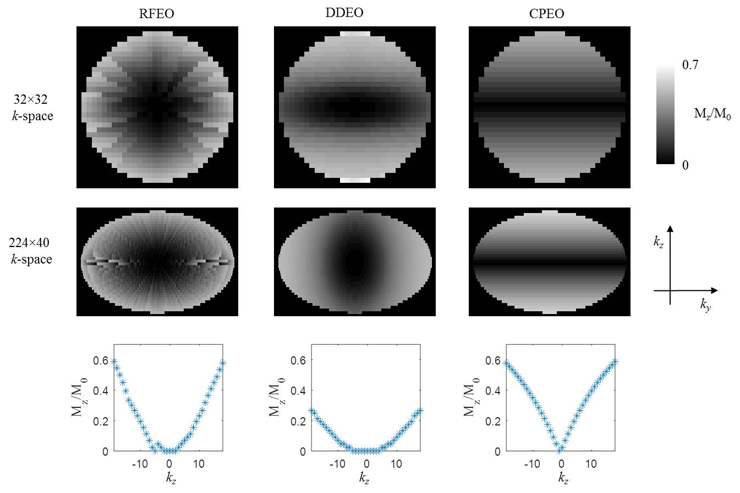
Figure 4
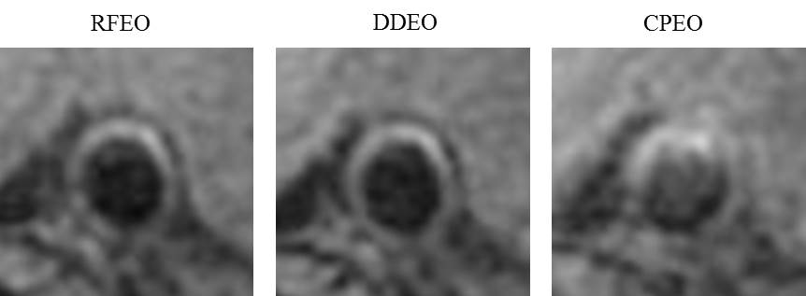
Figure 5

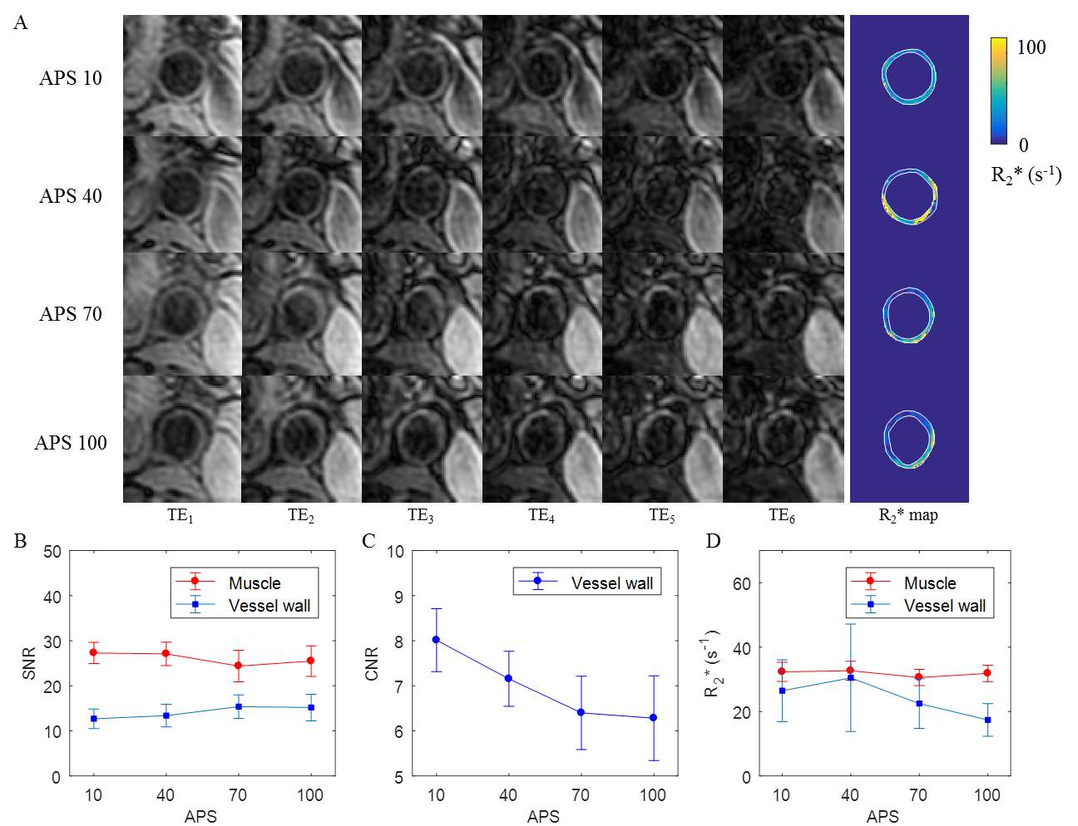
Figure 6

