Introduction of an Abbreviated Breast MRI Service in the UK as part of the BRAID Trial: Practicalities, Challenges and Future Directions

Authors: Sarah Vinnicombe¹, Helen Harvey², Nuala A Healy³, Vasiliki Papalouka³, Amy Schiller², Penelope Moyle³, Fleur Kilburn-Toppin³, Iris Allajbeu⁴, Nisha Sharma⁵, Anthony J Maxwell^{6,7}, Nicholas Payne⁴, Martin Graves⁸, Fiona J Gilbert⁴.

- Thirlestaine Breast Centre, Gloucestershire NHS Foundation Trust, Thirlestaine Road, Cheltenham, GL53 7AS
- Department of Radiology, Cambridge University Hospitals NHS Foundation Trust, Addenbrookes’ Hospital, Hills Road, Cambridge CB2 0QQ, UK
- Cambridge Breast Unit, Cambridge University Hospitals NHS Foundation Trust, Addenbrookes’ Hospital, Hills Road, Cambridge CB2 0QQ, UK
- Department of Radiology, University of Cambridge School of Clinical Medicine, Box 218, Level 5, Cambridge Biomedical Campus, Cambridge, CB2 0QQ, UK
- Breast unit, level 1 Chancellor wing, St James Hospital, Beckett Street, Leeds, LS9 7TF, UK
- Nightingale Centre, Manchester University NHS Foundation Trust, Wythenshawe Hospital, Southmoor Road, Manchester M23 9LT, UK.
- Division of Informatics, Imaging & Data Sciences, School of Health Sciences, Faculty of Biology, Medicine and Health, University of Manchester, Manchester M13 9PT, UK
- MRIS, Cambridge University Hospitals, Box 216, Cambridge Biomedical Campus, Cambridge, CB2 0QQ, UK

Acknowledgements: The BRAID study is funded by Cancer Research UK and GE Healthcare. The views expressed are those of the authors and not necessarily those of the National Health Service, the National Institute for Health Research, or the Department of Health and Social Care or CRUK. F.J.G. has an National Institute for Health Research Senior Investigator award.

Disclosure: The authors of this manuscript receive funding and equipment loan from GE Healthcare and contrast from Bayer.

Corresponding author: Fiona J. Gilbert
Telephone No.: +44 (0) 1223 746439
Email: fjg28@cam.ac.uk
Address: Radiology Department, University of Cambridge |Box 218|Cambridge Biomedical Campus | Cambridge CB2 0QQ

Abstract
Introduction
Women with mammographically dense breasts have an increased risk of breast cancer. Dense breasts can limit detection of small breast lesions due to overlapping fibroglandular tissue. BRAID is a randomised, multi-centre UK study assessing the impact of supplementary imaging, including abbreviated breast MRI (ABB-MRI), in detection of breast cancer in women aged 50-70 years with dense breasts. ABB-MRI is a shorter protocol breast MRI, allowing much faster acquisition times. The aim of this study is to review the feasibility of introducing ABB-MRI into the NHS setting as a part of a research trial.

Protocol
ABB-MRI is performed on a 1.5 tesla MRI scanner. Sequences obtained include a 2 mm axial T2 weighted sequence, a dual echo (Dixon water/fat separation) 3D DCE acquisition consisting of one pre- and two post-contrast images with generation of post-contrast subtracted images and post-processed MIP images.

Scheduling
ABB-MRIs are performed on a dedicated breast MRI list. Participants arrive 30 minutes prior to appointment time with pre-filled safety questionnaire. ABB-MRIs are scheduled for a 20-minute appointment slot, allowing 10 women to be scanned in a 3-hour session. Specific roles are allocated to staff members.

Improving Efficiency of ABB-MRI in the UK
Challenges encountered are similar to those encountered with FDP: IV cannulation, BMI and claustrophobia. Dedicated MR sessions with standard contrast doses and prefilled safety questionnaires help improve efficiency of sessions and allow examination times under 15 minutes.

Introduction
Women aged 50-70 years in the UK are invited to attend for mammography every 3 years by the NHS Breast Screening programme (NHSBSP)¹. A variety of breast parenchymal patterns are encountered at mammography and mammographic breast density can be subjectively classified into four groups using the American College of Radiology Breast Imaging Reporting and Data System (BI-RADS): the breasts are almost entirely fatty (BI-RADS a), there are scattered areas of fibroglandular density (BI-RADS b), the breasts are heterogeneously dense, which may obscure small masses (BI-RADS c) and the breasts are extremely dense, which lowers the sensitivity of mammography (BI-RADS d)². The effectiveness of screening mammography has been shown to be limited in women with dense breasts (BI-RADS c and d)^{3,4,5}. Mammographic appearances of dense breasts can pose a diagnostic challenge due to overlapping fibroglandular tissue, with masking of small breast lesions. In addition, women with dense breasts are at increased risk of developing breast cancer ^{5,6}. Although breast density decreases with age, up to 40% of women in the population screening age (50-70 years) are estimated to have dense breasts (BI-RADS c and d)^{7,8,9}. The cumulative effect of limited sensitivity of mammography and increased risk of breast cancer has led to much discussion about the need for supplemental imaging in women with dense breasts.

BRAID is an ongoing randomised, multi-centre UK study assessing the impact of supplementary imaging in the detection of breast cancer in women aged 50-70 years with dense breasts (BIRADS C or D) on screening mammography in the NHSBSP¹⁰. Ethical approval was obtained for this study. Women with dense breasts are randomised to either standard of care (no supplementary imaging) or supplementary imaging with abbreviated breast MRI (ABB-MRI), automated whole breast ultrasound (ABUS) or contrast enhanced spectral mammography (CESM). The study hypothesis is that more cancers will be detected in dense breasts at an earlier stage with supplemental imaging. In order for the supplemental MRI to be adopted in clinical screening, a rapid protocol with minimum examination time is required before the test could be considered to be cost-effective. The Cambridge Breast Unit has recently introduced ABB-MRI as part of the BRAID trial with the aim of producing a high-quality examination in less than ten minutes scan time. This technical report gives a brief background of ABB-MRI, illustrates the protocol for ABB-MRI, discusses participant scheduling and flow, and details challenges and future directions of ABB-MRI.

Background To Abbreviated Breast MRI
The value of supplemental imaging with full diagnostic protocol (FDP) breast MRI for screening women with dense breasts has been well established, including a reduction in the number of interval cancers^{11,12}. However, the associated high cost and long examination times when compared with screening mammography limits its potential use as a population-based screening tool. Fischer et al were the first group to propose an alternative to FDP breast MRI, with a pre-contrast and 2 post-contrast phases in a dynamic contrast enhanced (DCE) acquisition in combination with derived subtracted images and maximum intensity projection (MIP) images, resulting in a scan time of 4-5 mins¹³. Kuhl et al. devised an even shorter protocol using only one post contrast phase in conjunction with pre-contrast, subtracted and MIP images¹⁴. The ABB-MRI image acquisition time was considerably shorter than that of FDP (3 minutes vs 17 minutes). Specificity and positive predictive value of ABB-MRI and FDP were similar, with ABB-MRI demonstrating a high negative predictive value. Subsequent studies have also reported that the sensitivity and specificity of a modified shorter protocol breast MRI is comparable to FDP¹⁵⁻¹⁸. However, due to the large variation in patient population, study methodology and abbreviated protocols reported, the level of current evidence comparing sensitivity and specificity of ABB-MRI to FDP remains very low^{19,20}. Studies have illustrated fast reading times associated with ABB-MRI and also potential ease of introduction for multi-professional mammogram readers who do not routinely report breast MRI^{14,21}.

The aim of this technical report is to review our experience on the feasibility of introducing ABB-MRI into the NHS setting as a part of a research trial.

Abbreviated Breast MRI Protocol
The ABB-MRI trial protocol for the BRAID study has been designed and optimised following consultation with medical physicists, radiographers and radiologists and carefully implemented with physics support. At Cambridge, ABB-MRI is performed on a 1.5 tesla wide-bore MRI scanner (450w, GE Healthcare, Waukesha, WI) using a dedicated 8-channel breast coil. Following informed consent participants are placed in a prone position with the breasts in slight compression, to reduce motion artefact.

Following acquisition of the localiser, a 2 mm axial T2 weighted sequence is obtained. A dual echo (Dixon water/fat separation) 3D DCE acquisition consisting of one pre- and two post-contrast images. Table 1 illustrates the T2 and 3D DCE ABB-MRI parameters used in the BRAID trial and those implemented at the individual centres. 0.1 mL/kg body weight of gadobutrol (Gadovist, Bayer, Berlin) was injected via a power injector at a rate of 3 mL/s followed by a 25 mL saline flush at the same rate. The acquisition of post-contrast images was commenced simultaneous with initiation of contrast injection. Post-contrast subtracted images and post-processed MIP images are generated by the radiographers and all images are sent to PACS for double reporting.

Table 2 illustrates the type of image acquired and the duration of each sequence. The total scan time is approximately eight minutes from commencement of localiser sequence to completion of the second post-contrast sequence. MIP and subtracted images are automatically generated at the workstation and thus not included in scan time.

Following review of protocols, the above protocol was adopted, including a second dynamic post-contrast sequence and T2 weighted sequence to evaluate if these sequences improved accuracy and reader confidence. Additional sequences were not included to minimise scan time. The parameters were then selected to be achievable across the 3 sites of the study.

Scheduling & Participant Flow
An MRI safety questionnaire is enclosed with the participant’s appointment letter to allow completion prior to arrival. All participants are requested to arrive 30 minutes before their allocated appointment time, enabling timely preparation and avoiding potential delays. ABB-MRIs are performed in a dedicated breast MRI list on a single MRI scanner. This avoids time delays with changing coils. ABB-MRIs are currently scheduled for a 20-minute appointment slot. This allows sufficient time for the participant to be cannulated, queries to be addressed and then positioned in the scanner, including the approximately 8-minute scan time. In practice the leeway within the 20-minute appointment slots currently allows 10 women to be scanned in a 3-hour session and the aim is to reduce the slot time to 15 minutes.

Staffing comprises a minimum of two experienced breast MRI radiographers and a health care assistant (HCA). Prior to commencement of the session, specific roles are discussed and allocated to ensure clear communication and improved efficiency. The individual roles of the staff members are detailed in Table 3. When the participant arrives at the MRI unit, they are greeted by the HCA who checks the MRI safety questionnaire and weighs the participant. The HCA then directs the participant to the changing room and subsequently to the preparation room. Here the participant is cannulated by a radiographer, their MRI safety form is checked again and any potential queries are addressed. The second radiographer prepares the MRI scan room, including wiping the scanner table and filling the power injector with contrast agent and saline. Once ready, the participant is escorted from the preparation room to the MRI scan room, positioned in the prone position with the breasts under gentle compression within the breast coil and connected to the power injector. Following image acquisition as per ABB-MRI protocol, the scan is completed by the second radiographer and the participant is subsequently directed to the changing room to have her cannula removed and get dressed. The next participant is waiting in the preparation room with an IV cannula in situ, ready to enter the MRI scan room. Figure 1 illustrates the movement of the participant in the MRI department when they arrive for their appointment.

Challenges Encountered in Introducing an Abbreviated Breast MRI Screening Service
In our experience, participants tend to tolerate the abbreviated protocol much better than the full MRI protocol, which has a duration of up to 30 minutes in Addenbrooke’s hospital, Cambridge. The shorter scan time associated with ABB-MRI allows the participant to remain in position more comfortably, thus improving image quality with reduced movement artefact. Some movement artefact was noted on initial image analysis of women with small breasts, mostly affecting the subtracted images. To overcome this, biopsy plates are now used in all women to apply a degree of immobilisation through gentle compression, thereby reducing motion.

Generally, ABB-MRI sessions run smoothly allowing scanning of 9-10 participants in a 3-hour window. This can occasionally be difficult or impossible as participant factors can introduce time constraints. Claustrophobia can be an issue, although it is mitigated in our institution as the patient is positioned prone, entering the magnet feet first, using a wide bore scanner. In some cases, however, it remains a problem for the participant and can lead to significant delays.

Participant weight and body habitus can also be a potential limiting factor as the MRI scan table accommodates a maximum weight of 140 kg, which precludes some participants from undergoing imaging. Despite the use of a wide bore scanner, abdominal girth may also preclude scanning. In participants with reduced mobility, for whatever reason, significant additional time may be required to carefully position the participant prone on the table. Following completion of imaging, getting the participant off the table can prove a challenging and time-consuming process. Information on participant weight, abdominal girth, and mobility is currently unknown prior to the participant’s arrival for their appointment slot, therefore this must be managed ad hoc, potentially resulting in delays or inability to perform the scan.

All ABB-MRI participants require IV cannulation to allow injection of contrast agent. Although mostly straightforward, in some cases cannulation may prove challenging and require further attempts by other radiographers or doctors. Difficulty with cannulation can significantly increase the overall participant appointment time. In cases with failed cannulation, participants can be offered appointments on an alternative day with a visit to a ‘Vascular Access’ Unit for cannulation prior to appointment time.

It should be noted that while many of these challenges are also difficulties in FDP breast MRI their effects are increased in ABB-MRI, as similar durations of delay are incurred but participants are scheduled for much shorter appointments, with less opportunity to recoup the time lost. Methods to negate these challenges are currently being discussed, including inserting a paragraph in the appointment letter asking the participant to contact the unit if they suffer from claustrophobia, weigh more than 140kg, have a history of difficulty with IV cannulation or phlebotomy, or have mobility issues.

Improving the Efficiency of Abbreviated Breast MRI in the UK
Modifications of the initial protocol have been proposed in order to improve efficiency and allow additional participants to be scanned. We have compiled a list of tips with means of implementing these, to enable quicker participant turnaround. These recommendations are illustrated in Table 4. With increasing departmental experience of ABB-MRI, future participants will be allocated 15-minute appointment slots, allowing a total of 12 participants to be scanned in a 3-hour dedicated ABB-MRI list. Ideally this slot time would be reduced even further to minimise the costs associated with scanner time. As a further potential time saving, it has been proposed that all participants are injected with a fixed 10 ml of Gadovist, irrespective of participant weight, rather than a dose of 0.1 ml/kg body weight as they currently receive. This would facilitate the use of pre-filled 10 ml syringes, reducing waste and improving efficiency through reducing preparation time for the radiographers.

Offering widespread screening ABB-MRI for women with dense breasts currently poses a number of challenges when compared to the comparatively inexpensive, ubiquitous standard of full-field digital mammography (FFDM). Current NHSBSP practice of 2-view FFDM mammography takes approximately 6-7 minutes to perform on a dedicated screening van by a trained radiographer. To be cost-effective, ABB-MRI scan times must be kept to a minimum while retaining high sensitivity and specificity and there must be adequate infrastructure in place (both in terms of scanner access and availability of trained personnel) to allow imaging of the sizeable subset of women at population risk with dense breasts (estimated to be up to 40% of population-risk NHSBSP screened group)^{8,9}. One of the advantages of ABB-MRI is that it can be undertaken in MR units which already undertake breast MRI and does not require significant investment in additional hardware. The DENSE trial of FDP MRI in women with dense breasts has demonstrated impressive results, indicating the clinical utility of supplemental imaging in this cohort of women¹².

Conclusion
Our initial experience with ABB-MRI as part of the BRAID trial has proven extremely positive, indicating that a shortened, less costly protocol is potentially feasible in a UK NHS setting.

References
- Quality Assurance Guidelines for Breast Cancer Screening Radiology, 2nd edition. NHS Cancer Screening Programmes, 2011 (NHSBSP Publication No 59)
- D’Orsi CJ, Sickles EA, Mendelson EB, et al. ACR BI-RADS® Atlas, Breast Imaging Reporting and Data System. Reston, VA, American College of Radiology; 2013
- Carney PA, Miglioretti DL, Yankaskas BC et al. Individual and combined effects of age, breast density, and hormone replacement therapy use on the accuracy of screening mammography. Ann Inter Med. 2003; 138 (3):168-175
- Mandelson MT, Oestreicher N, Porter PL, et al. Breast density as a predictor of mammographic detection: comparison of interval- and screen-detected cancers. J Natl Cancer Inst 2000;92(13):1081e7.
- Chiu SYH, Duffy S, Yen AMF, et al. Effect of baseline breast density on breast cancer incidence, stage, mortality, and screening parameters: 25-year follow-up of a Swedish mammographic screening. Cancer Epidemiol Biomarkers Prev 2010;19(5):1219e28.
- McCormack VA, dos Santos Silva I. Breast density and parenchymal patterns as markers of breast cancer risk: a meta-analysis. Cancer Epidemiol Biomarkers Prev. 2006;15(6):1159–1169
- Burton A, Maskareinec G, Perez-gomez B, et al. Mammographic density and ageing: a collaborative pooled analysis of cross-sectional data from 22 countries worldwice. Plos Med. 2017; 14 (6):1e20
- Sprague BL, Gangnon RE, Burt V, et al. Prevalence of mammographically dense breasts in the United States. J Natl Cancer Inst 2014;106(10).
- Vinnicombe SJ. Breast density: why all the fuss? Clin Radiol. 2018 Apr;73(4):334-357.
- Breast screening - Risk Adaptive Imaging for breast Density (BRAID)
https://clinicaltrials.gov/ct2/show/record/NCT04097366
- Melnikow J, Fenton JJ, Whitlock EP, et al. Supplemental screening for breast cancer in women with dense breasts: a systematic review for the U.S. Preventive Services Task Force. Ann Intern Med 2016;164(126):268e78.
- Bakker MF, de Lange SV, Pijnappel RM, et al. Supplemental MRI screening for women with extremely dense tissue. DENSE Trial Study Group. N Engl J Med. 2019; 381(22):2091-2102
- Fischer U, Korthauer A, Baum F et al. Short first-pass MRI of the breast. Acta Radiol. 2012;53(3):267-9.
- Kuhl CK, Schrading S, Strobel K, et al (2014) Abbreviated breast Magnetic Resonance Imaging (MRI): First postcontrast subtracted images and maximum-intensity projection - A novel approach to breast cancer screening with MRI. J Clin Oncol 32:2304–2310.
- Panigrahi B, Mullen L, Falomo E, Panigrahi B, Harvey S. An Abbreviated Protocol for High-risk Screening Breast Magnetic Resonance Imaging: Impact on Performance Metrics and BI-RADS Assessment. Acad Radiol. 2017;24(9):1132-1138.
- Mango VL, Morris EA, David Dershaw D, Abramson A, Fry C, Moskowitz CS, et al. Abbreviated protocol for breast MRI: are multiple sequences needed for cancer detection? Eur J Radiol. 2015;84(1):65–70.
- Grimm LJ, Soo MS, Yoon S, Kim C, Ghate SV, Johnson KS. Abbreviated screening protocol for breast MRI: a feasibility study. Acad Radiol. 2015;22(9):1157–62.
- Harvey SC, Di Carlo PA, Lee B et al. An abbreviated protocol for high-risk screening breast MRI saves time and resources. J Am Coll Radiol 2016;13:374-38
- Geach R, Jones LI, Harding SA et al. The potential utility of abbreviated breast MRI (FAST MRI) as a tool for breast cancer screening: a systematic review and meta-analysis. Clin Radiol. 2020. S0009-9260(20)30388-3
- Baxter GC, Selamoglu A, McKay J et al. A meta-analysis comparing the diagnostic performance of abbreviated MRI and a full diagnostic protocol in breast cancer. Clin Radiol. 2020. S0009-9260(20)30397-4
- Jones LI, Geach R, Harding SA et al. Can mammogram readers swiftly and effectively learn to interpret first post-contrast acquisition subtracted (FAST) MRI, a type of abbreviated breast MRI?: a single centre data-interpretation study. Br J Radiol. 2019 Dec; 92(1104):20190663

Legends

Table 1. Displays the ABB-MRI T2 weighted imaging and 3D DCE with Dixon Water/Fat separation MRI parameters implemented at each BRAID site. (*= The Manchester site is using Siemens’ Q-FatSat not Dixon).

Table 2. Description of sequences utilised in abbreviated Breast MRI, with illustration and average duration.

Table 3. Individuals involved in the abbreviated breast MRI scanning process and their specific roles in participant flow.

Table 4. Tips and Tricks to improve the efficiency of abbreviated breast MRI

Figure 1. Diagram illustrating the movement of participants in the MRI breast department attending for Abbreviated Breast MRI.

Table 1. Displays the ABB-MRI T2 weighted imaging and 3D DCE with Dixon Water/Fat separation MRI parameters implemented at each BRAID site. (*= The Manchester site is using Siemens’ Q-FatSat not Dixon).

MRI  parameter | T2W FSE/TSE |  |  |  | 3D DCE with Dixon*
 | Cambridge | Cheltenham | Leeds | Manchester | Cambridge | Cheltenham | Leeds | Manchester
Vendor | GE | Philips | Siemens | Siemens | GE | Philips | Siemens | Siemens
Field strength | 1.5 T | 3 T | 1.5 T | 1.5 T | 1.5 T | 3 T | 1.5 T | 1.5 T
Breast coil channels | 8 | 16 | 16 | 18 | 8 | 16 | 16 | 18
Scan plane | Axial | Axial | Axial | Axial | Axial | Axial | Axial | Axial
Field of View | 350 mm | 350 mm | 350 mm | 350 mm | 350 mm | 350 mm | 350 mm | 350 mm
Slice thickness | 2 mm | 2 mm | 1.8 mm | 2 mm | 2 mm | 2 mm | 2 mm | 1 mm
Frequency encoding direction | Anterior-posterior | Anterior-posterior | Anterior-posterior | Anterior-posterior | Anterior-posterior | Anterior-posterior | Anterior-posterior | Anterior-posterior
TR | 5091 ms | 8200 ms | 9500 ms | 8760 ms | 6.8 ms | Minimum | 7.42 ms | 5.27 ms
TE | 85 ms | 85 ms | 73 ms | 85 ms | Minimum | Minimum | 2.39 ms | 2.12 ms
Refocus/excitation flip angle | 160° | 110° | 180° | 150º | 10° | 15° | 20° | 10º
Frequency x Phase | 384 x 224 | 356 x 448 | 448 x 448 | 410 x 512 | 350 x 350 | 240 x 357 | 448 x 340 | 291 x 416
Acquired voxel size | 0.9 x 1.6 x 2.0 mm | 0.7 x 0.76 x 2.0 mm | 0.8 x 0.8 x 1.8 mm | 0.68 x 0.68 x 2.0 mm | 1.0 x 1.0 x 2.0 mm | 1.0 x 1.0 x 2.0 mm | 1.0 x 1.0 x 2.0 mm | 0.84 x 0.84 x 1.0 mm
Bandwidth | ±50 kHz | ±60 kHz | 151 Hz/px | 200 Hz/px | ±83.3 kHz | ±114 kHz | 400 Hz/px | 320 Hz/px
Phase acceleration | 2 (ARC) | 2.2 (SENSE) | 3 (GRAPPA) | 3 (GRAPPA) | 2 (ARC) | 3 (SENSE) | 4 (GRAPPA) | 2 (GRAPPA)
Number of signal averages | 1 | 1 | 1 | 1 | 1 | 1 | 1 | 1
Slices / Locations per slab | 82 | 79 | 112 | 84 | 90 | 188 | 112 | 160
Average Acquisition time | 1 min 48 sec | 3 min 33 sec | 4 min 28 sec | 3 min 14 sec | 3 min 20 sec | 3 min 7 sec | 3 min 21 sec | 4 min 06 sec
Average temporal resolution |  |  |  |  | 1 min 5 sec | 1 min 1 sec | 58 sec | 1 min 11 sec

Table 2. Description of sequences utilised in abbreviated Breast MRI, with illustration and average duration.

Sequence | Image | Description of Sequence | Average Duration of Sequence
Localiser |  | Gradient echo | 18 seconds
Axial T2 | 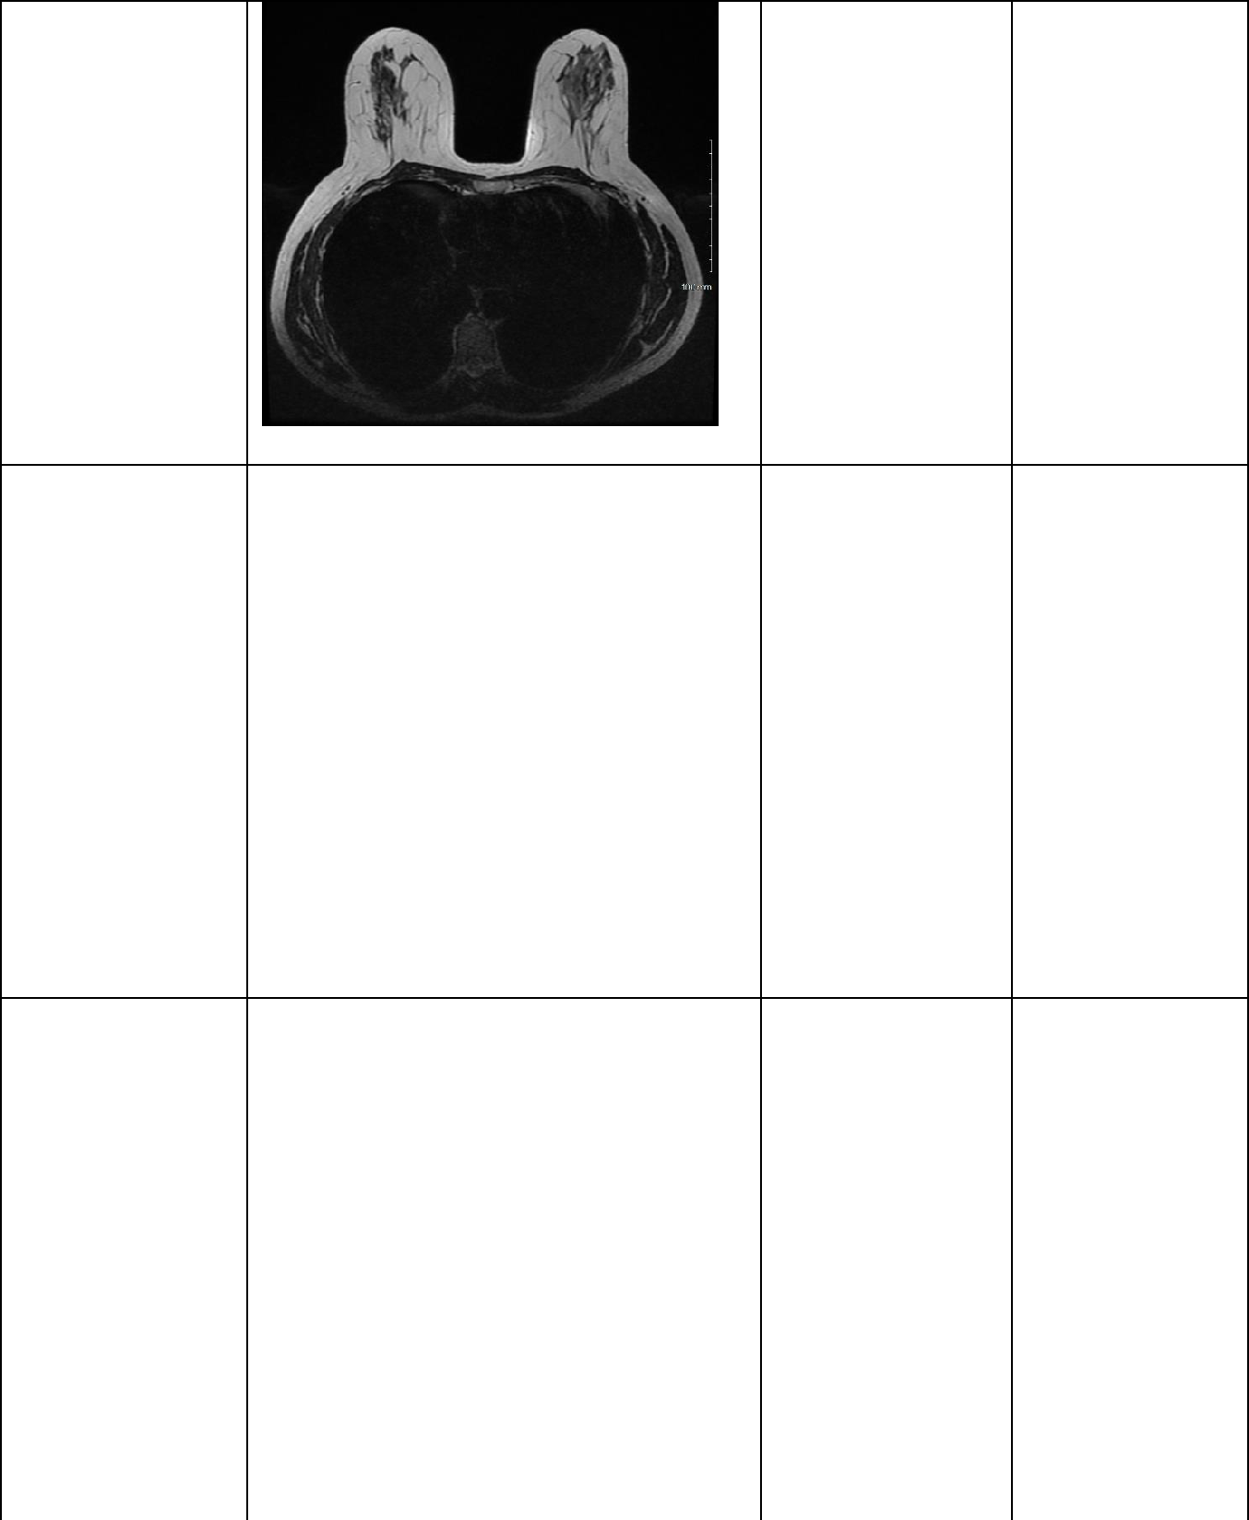 | Axial T2 weighted Image (2mm thickness) | 108 seconds on average (range 81-178)
3D Axial VIBRANT FLEX High Resolution | 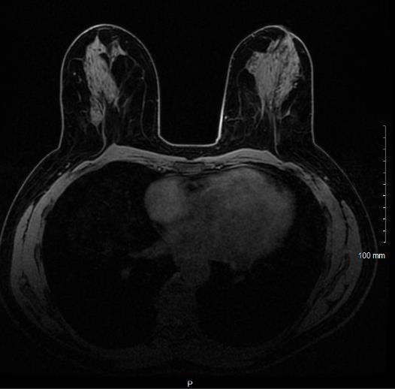 | T1 weighted dedicated dynamic breast with water/fat separation | 67 seconds  (200 seconds in total)
Post-Processing MIP | 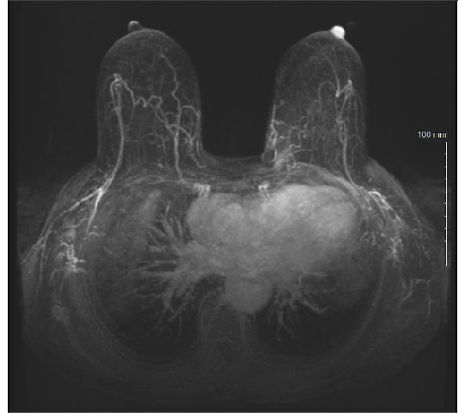
Total Scan Time |  |  | 480 seconds

Table 3. Individuals involved in the abbreviated breast MRI scanning process and their specific roles in participant flow.

Individual | Role
Health Care Assistant | - Direct participant from waiting room to changing room and give instructions on changing  - Ensure participant safety questionnaire is completed including measurement of participant weight  - Patient check-in and registration on radiology information system (RIS)  - Escort participant to preparation room for IV cannulation  - Remove cannula once examination is complete and direct participant to changing room
Radiographer 1 | - Cannulate participant  - Go through safety form with participant  - Explain procedure to participant
Radiographer 2 | - Wipe down scanner table  - Fill power injector with contrast agent and saline  - Patient registration on the scanner  - Place oil marker on skin of left breast  - Position participant prone for scan including breast compression  - Connect power injector to cannula  - Perform scan

Table 4. Tips and Tricks to improve the efficiency of abbreviated breast MRI

Tip to improve participant throughput | Method Employed
Participant arrival 30 minutes prior to appointment time | Request participant on appointment letter to arrive 30 minutes prior to scheduled appointment time
Pre-filled MRI safety questionnaire | Safety questionnaire enclosed with appointment letter
Schedule ABB-MRIs consecutively in a dedicated breast session with experienced breast MRI radiographers | Liaise with lead MRI radiographer to appropriately schedule staff and participants
Specific roles for individual members of the imaging Team | Team meeting prior to commencement of MRI list

Figure 1. Diagram illustrating the movement of participants in the MRI breast department attending for Abbreviated Breast MRI.

