Quantifying the effect of dobutamine stress on myocardial Pi and pH in healthy volunteers; a ³¹P MRS study at 7T

Andrew Apps¹, Ladislav Valkovič^{1,2}, Mark Peterzan¹, Justin Y.C. Lau^{1,3}, Moritz Hundertmark¹, William Clarke¹, Elizabeth M Tunnicliffe¹, Jane Ellis¹, Damian J. Tyler^{1,3}, Stefan Neubauer¹, Oliver Rider¹, Christopher T. Rodgers^{1,5} ^{Ϯ}, Albrecht Ingo Schmid^{1,6}*^{Ϯ}

¹ Oxford Centre for Clinical Magnetic Resonance Research (OCMR), Division of Cardiovascular Medicine, Radcliffe Department of Medicine, University of Oxford, Oxford, UK.
² Department of Imaging Methods, Institute of Measurement Science, Slovak Academy of Sciences, Bratislava, Slovakia
³ Department of Physiology, Anatomy and Genetics, University of Oxford, Oxford, UK.
⁵ Wolfson Brain Imaging Centre, University of Cambridge, Cambridge, UK.
⁶ Centre for Medical Physics and Biomedical Engineering, Medical University of Vienna, Vienna, Austria
^{Ϯ} CTR and AIS are joint senior authors for this work.

Email Addresses (by order in authorship)
Andrew.apps@cardio.ox.ac.uk
ladislav.valkovic@cardiov.ox.ac.uk
mark.peterzan@stcatz.ox.ac.uk
justin.lau@cardiov.ox.ac.uk
moritz.hundertmark@cardiov.ox.ac.uk
william.clarke@ndcn.ox.ac.uk
elizabeth.tunnicliffe@cardiov.ox.ac.uk
jane.ellis@rdm.ox.ac.uk
damian.tyler@dpag.ox.ac.uk
stefan.neubauer@cardiov.ox.ac.uk
oliver.rider@cardiov.ox.ac.uk
ctr28@cam.ac.uk
Albrecht.schmid@meduniwien.ac.at

Correspondence to
Assoc. Prof. Dipl. Ing. Dr. Albrecht Ingo Schmid
Medical University of Vienna
Centre for Medical Physics and Biomedical Engineering
Lazarettgasse 14
1090 Wien
Tel: +43 1 40400 64610
Email: Albrecht.schmid@meduniwien.ac.at

Keywords: Cardiac energetics, phosphorous spectroscopy, 7T, STEAM, myocardial pH
Word count: 4635 (excluding abstract, figures, references)

Abstract

Purpose
Phosphorus spectroscopy (³¹P-MRS) is a proven method to probe cardiac energetics. Studies typically report the phosphocreatine (PCr) to adenosine triphosphate (ATP) ratio. We focus on another ³¹P signal: inorganic phosphate (Pi) whose chemical shift allows computation of myocardial pH, with Pi/PCr providing additional insight into cardiac energetics. Pi is often obscured by signals from blood 2,3-diphosphoglycerate (2,3-DPG). We introduce a method to quantify Pi in 14min, without hindrance from 2,3-DPG.

Methods
Using a ³¹P STimulated Echo Acquisition Mode (STEAM) sequence at 7T that inherently suppresses signal from 2,3-DPG, the Pi peak was cleanly resolved. Resting state UTE-CSI (PCr/ATP) and STEAM-³¹P-MRS (Pi/PCr, pH) were undertaken in 23 healthy controls, pH and Pi/PCr were subsequently recorded during dobutamine infusion.

Results
We achieved a clean Pi signal both at rest and stress with good 2,3-DPG suppression. Repeatability coefficient (8 subjects) for Pi/PCr was 0.036 and 0.12 for pH. We report myocardial Pi/PCr and pH at rest and during catecholamine stress in healthy controls. Pi/PCr was maintained during stress (0.098±0.031 [rest] vs 0.098±0.031 [stress] p=0.95), similarly pH did not change (7.09±0.07 [rest] vs 7.08±0.11 [stress] p=0.81). Feasibility for patient studies was subsequently successfully demonstrated in a patient with cardiomyopathy.

Conclusion
We introduced a method that can resolve Pi using 7T STEAM ³¹P-MRS. We demonstrate the stability of Pi/PCr and myocardial pH in volunteers at rest and during catecholamine stress. This protocol is feasible for studying patients, justifying onward clinical trials.

Introduction

The beating heart is powered by chemical potential energy (ΔG_{ATP}) released during the hydrolysis of adenosine triphosphate (ATP) into the products adenosine diphosphate (ADP) and inorganic phosphate (Pi). Instantaneous myocardial ATP content is low and only sufficient to sustain a few beats (1). Maintenance of [ATP] local to the myofibril is achieved by rapid phosphotransfer from a reservoir of phosphocreatine (PCr) to ADP, catalysed by the enzyme creatine kinase (CK) (2). The heart’s energetic state can be summarised via the relative concentrations of these high energy phosphate (HEP) metabolites, which can be measured in-vivo using phosphorus magnetic resonance spectroscopy (³¹P-MRS).

Much of the existing ³¹P-MRS literature has focused on reporting the PCr/ATP ratio as a measure of myocardial energetics. Resting PCr/ATP is reduced not only in heart failure (3, 4), but also in systemic conditions at risk of developing a cardiomyopathy phenotype such as obesity (5, 6) and diabetes (7). Abnormal energetics confer a poor prognosis (3), and as such represents an attractive therapeutic target with a need to develop further tools to assess it. However focussing solely on PCr/ATP can mask reductions in both PCr and ATP concentration in progressive heart failure (8-10). Pathological energy metabolism is characterised by an abnormal response to stress. In the healthy heart PCr/ATP is maintained within the cardiac cycle (11) and during incremental stress (5, 7, 12-14), whereas pathological energy metabolism, evidenced by a reduced ratio is often exacerbated or uncovered during such stress (5, 7, 13). Novel techniques to study the HEP pool should thus be acceptable for use during pharmacological stress.

In myocardium, free ADP concentration is too low (20-60 µM) to observe directly by ³¹P-MRS in vivo (15), Pi however can be (~1 mM) and is an attractive candidate for assessing metabolism in-vivo for a variety of reasons (16, 17). Firstly, Pi plays an important signalling role in the control of oxidative phosphorylation, ensuring ATP regeneration responds to an increase in demand. Pi stimulates oxygen consumption in isolated mitochondria (18) and various in-silico models directly implicate the small increase in cellular Pi consequent to increased ATP hydrolysis at high workloads, as a crucial mechanism to upregulate oxidative phosphorylation and maintain ΔG_{ATP} (19-21). Secondly, a rise in [Pi] has been modelled to follow a reduction in the forward CK rate constant (22), which is shown to be reduced by up to 50% in heart failure (23, 24). Pi may thus represent a proxy through which CK flux can be investigated. Indeed, Pi is predicted to increase over 3x during exercise in hypertrophic cardiomyopathy by a biophysical model of energy metabolism used to model the energetic response to exercise in the condition. These increases were further exacerbated by creatine loss (25). Additionally, Pi/PCr may offer a more sensitive marker of early pathological energy metabolism than PCr/ATP. Pi is implicated in the initial increase in glucose oxidation seen in early compensated heart failure (26); it stimulates both glycolysis and glycogenolysis (27) and is shown to be elevated in hypertrophy (28, 29). For example, Pi/PCr was shown to increase during intra-cardiac pacing in dogs with LVH but not in controls, whereas PCr/ATP remained stable in both groups (30). Finally intracellular pH can be calculated from the frequency difference between Pi and other metabolites. A fall in pH is a clinically relevant parameter heralding contractile dysfunction and dysrhythmia (31).

Data on human cardiac Pi are scarce because overlap from 2,3-DPG has made it challenging to quantify reliably (figure 1). The myocardium forms a comparatively thin wall around the blood-filled ventricle, and resolving blood from heart muscle tissue by localisation techniques is not possible given the voxel size required for adequate ³¹P-MRS SNR. Various ³¹P-MRS approaches have been suggested to measure Pi in the presence of contaminating blood pool 2,3-DPG. We have recently reported Pi using a long-TR CSI protocol (32). The defining feature was the favourable balance of myocardial Pi to blood 2,3-DPG signal intensity in the case of long repetition times with adiabatic excitation. 2,3-DPG peaks however were still present, to some extents still obscuring Pi, and sampling was very long (45 min), rendering the protocol unsuitable for use during vasoactive stress studies. Other approaches have been tried in the past at lower field strengths, including ¹H-decoupled ³¹P-MRS to reduce Pi and 2,3-DPG linewidths in the hope of achieving separated peaks (33, 34), Pi was reported only for about half the healthy subjects. This is infeasible at 7T due to regulatory limits on specific absorption rate (SAR) and the restriction on peak B₁⁺ for ¹H.

We therefore aimed at developing a measurement technique for Pi that provides both an adequate SNR within a scan time that allows stress measurements in both controls and patients, and good blood signal suppression to allow reliable quantification of Pi amplitude and frequency (pH). STEAM has been previously shown to suppress signal from moving spins in blood in ¹H-MRI (35, 36), and is also a commonly used and available MRS technique. In contrast to CSI (37), which generates GRE-like bright blood contrast, STEAM generates dark-blood contrast. We investigated a 14 minute STEAM protocol to demonstrate cardiac Pi without obstruction, at rest but also during catecholamine stress, i.e. at a new steady-state. Given the potential impact of the mixing time (T_{M}) on susceptibility of various factors such as SNR, heart rate, myocardial deformation and SNR to impact measurements during the mixing time (T_{M}), we first verified the repeatability of Pi/PCr and pH measurements in 9 control participants. We then tested the hypothesis that Pi/PCr and pH may change in response to increasing cardiac work in a healthy cohort of 23 healthy controls, and finally demonstrated feasibility in a patient with cardiomyopathy in preparation for future clinical studies.

Methods

Ethics and Study Cohort

Healthy volunteers for intra-exam repeatability studies were recruited according to our institutions ethics regulations, prior to undertaking dobutamine stress studies. Research studies involving dobutamine stress at 7T were approved by the National Research Ethics Committee service (3/SC/0376) and written informed consent was obtained from each participant. 9 participants (2F, age 37±9) were recruited for repeatability experiments (one of which was scanned on different days), 23 participants (8F, age 41±1, BMI 24±2 kg/m²) were subsequently recruited for the stress studies. Subjects were healthy; they were excluded if they were taking prescription medication, had a contraindication to 7T MR imaging (defined by institutional SOPs), or had a medical history of cardiovascular disease, peripheral vascular disease, diabetes mellitus, hypertension, or undiagnosed chest pain. All participants had a normal clinical cardiovascular examination and normal resting global cardiac function on cine ¹H MR imaging. To demonstrate the feasibility for future patient studies, we recruited one patient with idiopathic dilated cardiomyopathy ([DCM] 55-year old male, BMI 26 kg/m², left ventricular ejection fraction 25%, with no evidence of coronary artery disease on CT coronary angiography).

Pulse Sequence Design

This work employed a STEAM sequence for ³¹P-MRS at 7T. Unlike the GRE/FLASH-like contrast of CSI sequences often used for cardiac ³¹P-MRS, STEAM ¹H cardiac imaging achieves dark blood contrast because of incoherent motion of the blood during T_{M}, which leads to dephasing of the blood signal (35). Meanwhile, the myocardium is relatively immobile so that myocardial ³¹P signals are preserved if the T_{M} is chosen appropriately (36). The RF coil used had good receive sensitivity with 16 receive channels but a rather low transmit field (peak B₁⁺ was about 10 µT at the depth of the heart), meaning that long (4.5ms truncated sinc) pulses were required to obtain the 90^{O} pulses required by STEAM. Such pulses have small bandwidth and, when compounded by large voxel dimensions, result in significant chemical shift displacement. We thus split the experiment into two excitations, centring the RF pulses on the PCr peak in the first scan and on Pi in the second scan. These two were interleaved during T_{R}. This has an additional advantage that T_{E} and in particular T_{M} can be set to different values for Pi and PCr. Based on STEAM imaging data (36), a T_{M} of 60 ms was chosen for Pi, representing a good compromise between blood suppression and sensitivity to diffusion and cardiac motion which would cause dephasing and signal loss. A flow phantom comprised of both stationary and moving (3ml/s) compartments, each containing Pi at different pH, was used to confirm that a T_{M} of 60ms was a suitable choice, prior to beginning the study. The flowing compartment could be adequately suppressed using the chosen parameter of T_{M} 60ms, with little impact on the static compartment. In contrast, test with a shorter T_{M} of 7ms showed incomplete suppression of signals from the flowing compartment, and the residual peak could be fitted in MATLAB (figure 2). Recording of the stimulated echo for each metabolite was in early systole just following the isovolumetric contraction period (38); the point of data collection within the cardiac cycle was thus fairly constant despite the heart rate increasing during stress. Scalar coupling during the prolonged T_{M} further helps suppress signals from 2,3-DPG. We used the shortest possible echo time (T_{E} = 13 ms) to minimise effects of T₂ relaxation on the Pi signal. T₁ relaxation is practically irrelevant given the long relaxation times. PCr was acquired with short T_{M} (7ms). The sequence is summarised in figure 3.

³¹P-MRS protocols

All scanning was performed on a Magnetom whole-body 7T MRI scanner (Siemens, Erlangen, Germany). Using a 10cm ¹H transmit/receive loop (Rapid Biomedical, Rimpar, Germany), localisers were acquired with 3-lead ECG gating in the main cardiac orientations (37), and subject-specific B₀-shimming was performed ensuring coverage of the whole heart (39). Localisers were acquired at the end of expiration making contamination of the voxel of interest by sub diaphragmatic structures during our free breathing MRS protocols highly unlikely. With the participant asked to remain as still as possible the table was moved out and the ¹H coil was then removed and swapped for a 16-element array ³¹P coil (Rapid Biomedical, Rimpar, Germany). This comprised a rigid 27 x 28 cm² transmit ³¹P element, combined with a flexible set of 16 receive elements (size 8 x 5.5 cm², arranged in a 4 x 4 grid). ³¹P-FLASH localisers were acquired from five fiducial markers mounted on the coil to determine the coil position, and a set of non-localised inversion recovery free induction decay scans (IR-FIDs) were acquired for each participant. Using these, the coil B₁⁺ map was calculated using the Biot-Savart Law to estimate the required power to provide a 90⁰ flip angle in the STEAM voxel placed over the cardiac septum. The unavoidable B1+ inhomogeneity of a surface transmitter leaves residual 20-30% variation in flip angle across the STEAM voxel. This approach for MRS calibration at 7T was previously described (40)

First, PCr/γ-ATP ratio was measured using a ultra-short-echo-time chemical shift imaging (UTE-CSI) pulse sequence with T_{R} of 2.2s, run at rest with free breathing, acquisition weighting (matrix size 8 × 16 × 6), and zero-filled to 8 × 16 × 8 for reconstruction. The nominal voxel size was 25 × 15 × 33mm³. Excitation was with a shaped pulse centred at +300Hz relative to PCr [21]. The CSI orientation was cardiac short axis in-plane rotated so the phase encoding direction with the highest resolution was in the anterior-posterior direction to minimise skeletal muscle contamination. Next, ECG-triggered, free-breathing STEAM-³¹P-MRS spectra were acquired with shot-to-shot interleaving of acquisitions centred: (a) on PCr (0ppm, T_{M}=7ms, figure 3a, ‘PCr interleaf’) and (b) on Pi (4.8ppm, T_{M}=60ms, figure 3b, ‘Pi interleaf’). A T_{R} of 3s was used, with the first pulse of the next acquisition delivered on the subsequent R wave. This meant the effective T_{R} for each metabolite was 2 x (T_{R} plus an inter-trigger delay time) ≈ 7s. 128 averages were acquired, with scans typically lasting 14 min. The long effective T_{R} ensured 80-90% recovery of magnetization between consecutive excitations, improving the detectability of static spins with long T₁, such as cardiac Pi (32). Our STEAM-³¹P-MRS voxel placement (figure 3c /3d) ensured maximal septal coverage and minimal skeletal muscle contamination. Voxel size for STEAM was adjusted slightly between subjects (58±12 mL).

Dobutamine Infusion protocol including ³¹P-STEAM MRS

Immediately following the resting state STEAM-³¹P-MRS acquisition, an intravenous dobutamine infusion (GRASEBY ™ 3500 anaesthesia pump, Graseby medical, UK) was started at a dose of 5 µg/kg/min, increasing at regular intervals up to a maximum dose of 40 µg/kg/min to achieve a target heart rate of 65% of the age predicted maximal heart rate. During the infusion, participants had continuous ECG and heart rate monitoring by pulse oximetry, and non-invasive blood pressure monitoring (VICORDER ®, SMT Medical, Germany) every minute. The mean rate pressure product (RPP = systolic blood pressure × heart rate) was recorded at rest and during stress. Heart rate was maintained at target for the duration of the stress, and the STEAM-³¹P-MRS measurement described above was repeated. The DCM patient also consented to a recovery STEAM-³¹P-MRS measurement when their heart rate had normalised after the infusion. All stress scans were overseen by two experienced operators (AA, a clinician with 6 years of cardiology practice, and 2 years of MR imaging, and either LV, AIS or JE with 8, 15 and 3 years of 7T ³¹P MRS experience respectively).

Data analysis

Coil combination was done using WSVD on the PCr spectra (41). Fitting was performed using the open-source Matlab-based “OXSA” toolbox (42, 43). UTE-CSI spectra were fitted as previously described (40) using 12 Lorentzian peaks for ATP, PCr, and DPG with literature values for scalar couplings and initial frequency estimates. Peak amplitudes were corrected for partial saturation and blood contamination (40). We report the PCr/γ-ATP ratio, because α-ATP overlaps with NADPH, and β-ATP was incompletely excited. To fit STEAM-³¹P-MRS spectra, first the ‘PCr-interleaf’ spectrum was fitted, then the ‘Pi-interleaf’ spectrum was fitted using 4 Lorentzian peaks at PCr, Pi and two phosphodiester frequencies, signals typically found in these spectra. The algorithm fitting the Pi frequency was constrained to search between +4.2 and +5.8 ppm relative to PCr; (frequency taken from the PCr interleaf), Pi and PCr linewidths were set to be equal to improve the stability of fitting. The PCr phases were used as starting points for the Pi parameter fitting, and both peaks were corrected for partial saturation using literature values (40, 44). Cramér-Rao lower bounds (CRLB) (45) were calculated for the Pi amplitudes, and pH was calculated from the Pi chemical shift (taken from the Pi interleaf) relative to that of PCr (taken from the PCr interleaf) using a modified Henderson–Hasselbalch relationship : $pH\left(δ\right)=6.77+\log_{10}{\frac{δ-3.23}{5.70-δ}}$ (46). The chemical shift measurement required for pH estimation was taken from two separate excitations, however, systematic frequency shifts were extremely unlikely to happen with the same periodicity given the length of scan. Indeed, reassuringly over the 128 averages comprising each scan, frequency fluctuations of the PCr acquisition were found to effectively average toward zero mean frequency offset (Figure 4a), with the distribution of frequency offsets lying within the fitted line width (65Hz, Figure 4b). To test the repeatability of cardiac Pi/PCr quantification and pH calculation, Bland-Altman analysis of agreement was used to compare the two measurements and coefficients of repeatability were estimated, as described by Bartlett et al, defined as $1.96 × \sqrt{2}×within subject SD$ (47).

We sought to undertake a paired analysis of the effect of stress on Pi/PCr. Myocardial [Pi] is extremely low, thus poor SNR at rest or any significant loss of SNR as is sometimes encountered during dobutamine stress, may impact our ability to identify its resonance. Data were included for analysis if the Pi peak was clearly resolved (defined as SNR >2.5 and visually obvious). Details of evaluating data quality and inclusion from all participants in the study are given in the supporting information table S1. Statistical analysis was performed in GraphPad Prism v6.01 (GraphPad, La Jolla, CA, USA). Results are given as mean ± standard deviation. Comparisons between rest and stress values for pH and Pi/PCr were undertaken using paired Student’s t-tests.

Results

Repeatability

Prior to investigating the effect of dobutamine on cardiac Pi/PCr and pH, to confirm the precision of measurements we performed intra-exam repeatability studies at rest. Pi was clearly identified (by the above criteria) in 17/18 scans undertaken for repeatability, with mean Pi SNR 9.2±3.5, and CRLB 25±16%. A representative fit of the Pi peak demonstrating the residual signal can be found in Supplementary Figure S1. No significant differences were seen between scans one and two for Pi/PCr (0.103±0.044 vs. 0.097±0.039 p=0.53 [n=8]]) or pH (7.06±0.05 vs 7.04±0.06 p=0.52 [n=8]). The mean absolute bias between scans was +0.006 (Pi/PCr) and +0.02 (pH), with 95% limits of agreement of ±0.052 (Pi/PCr) and ±0.16 (pH). The coefficient of repeatability for Pi/PCr was 0.036, and that for pH 0.12. Results are demonstrated in a Bland-Altman plot (figure 5), with a typical pair of spectra shown in figure 6a,b.

Resting myocardial energetics and pH in healthy controls

Mean blood- and saturation-corrected PCr/γ-ATP was recorded successfully in 22/23 of this group and was 2.11±0.45. Mean STEAM-³¹P-MRS SNR for PCr was 78±42. Pi had a lower signal due to its low concentration; we were able to resolve Pi successfully in 20/23 subjects at rest by visual inspection, and using a cut-off of SNR >2.5 (6.7±3.9, CRLB 35±17%). Average acquisition duration was 15.1±0.9 min. 2,3-DPG was not visible in any of the ³¹P STEAM spectra above the noise floor. Considering the 20 spectra with unambiguous peak detection, mean resting Pi/PCr 0.098±0.030 and myocardial pH 7.07±0.08.

Stress in healthy controls

22 of 23 healthy controls underwent successful STEAM-³¹P-MRS at stress (one scan was aborted due to a failure of the blood pressure monitoring system). All dobutamine infusions were well tolerated. Mean STEAM-³¹P-MRS stress scan length was 13.6±1.1 minutes. A typical pair of spectra from a healthy volunteer is shown in figure 6c,d. Using the above-described criteria for the resting state spectra, Pi was adequately identified in 18 of the 22 stress scans (stress Pi/PCr 0.096±0.031, pH 7.08±0.10). In five participants Pi detection was not robust either at rest (1), stress (2), or both (2) to justify inclusion in a paired analysis. This was undertaken on 17 datasets. More details can be found summarised in supporting information table S1, and Supplementary Figure S2. Pi/PCr was not significantly different during stress (0.098±0.031 [rest] vs 0.098±0.031 [stress], p=0.95). Similarly pH did not change (7.09±0.07 [rest] vs 7.08±0.11 [stress], p=0.81), figure 7).

Dilated cardiomyopathy patient

The patient with DCM underwent stress at 7T without complication or complaint, and tolerated the protocol well allowing for a recovery STEAM-³¹P-MRS scan (HR 64 → 108 → 64) RPP 8970 → 13417 → 7680 [rest/stress/recovery]. Pi was robustly seen in all three scans. Data is presented in Figure 6 to demonstrate feasibility; resting PCr/ATP was unusually high for a DCM population recorded at 2.46, although within the range of values published in this population, at this field strength (4). Pi/PCr increased fourfold during stress and fell back during recovery (stress/rest/recovery [0.076/0.268/0.119], pH fell during stress (7.1/6.7/6.9).

Discussion

As was our goal, STEAM-³¹P-MRS at 7T generated dark-blood contrast with sufficient SNR to allow Pi peak demonstration, with minimal 2,3-DPG contamination in human ³¹P spectra. The reasonable length of the scan, meant that Pi estimation was also straightforward during stress. Although SNR, primarily due to low concentrations and the heart’s unfavourable geometry, limited our ability to measure Pi in 100% of scans, we report a technique whose repeatability competes with the slower CSI approach to Pi estimation (32) and the computation of PCr/ATP both at 3T (48) and 7T (39). The protocol is feasible for use in patients, which will be further investigated, and can be delivered during dobutamine infusion at 7T; indeed our study is the first to deliver vasoactive stress during MR examinations at this field strength. We demonstrated no change in myocardial pH or Pi/PCr during dobutamine stress in healthy controls, which was well tolerated by all participants. Resting state PCr/ATP in our volunteers (2.1±0.5) was comparable to recently published values at 7T of 2.1±0.2 (32) and 1.9±0.4 (39), corroborating normal resting myocardial energetics in this cohort. We measured resting myocardial pH (7.07±0.08) to be more acidic than blood pH (7.35-7.45) (49) consistent with that measured in other studies employing both a UTE-CSI with long T_{R} method at 7T (7.12±0.04 (32)), or a ¹H decoupling method at 1.5T (7.08±0.03 (33)) to quantity cardiac pH. Our reported P_{i}/PCr of 0.095±0.030 agrees with previous human cardiac studies of 0.097±0.072 (33) and 0.11±0.02 (32).

Myocardial Pi concentration is low, and hence poor SNR reduces our ability to define Pi, to a greater extent than other phosphorous containing metabolites during ³¹P-MRS spectroscopy. In some cases in our study (4/41 - pooled total rest scans) SNR prevented us from reliably quantifying Pi, these four cases had lower PCr SNR, (values of 29, 37, 35 and 41), compared to the group average of 92. As is the case in human ³¹P-MRS anatomic variability is the primary reason, however compared to GRE-like sequences, STEAM sequences may suffer signal loss due to diffusion and myocardial motion. Indeed, during stress we did see a fall in SNR in some volunteers (which in two cases led to a failure to evaluate Pi with any certainty). This is likely due to extra motion (cardiac, respiratory and also participant restlessness). SNR changes are however presumed to effect both interleaves equally, and when quantified, Pi/PCr was unchanged and Pi Peak position (and thus measured pH) remains unaffected. Assessing myocardial Pi during stress is essential to uncover latent energetic deficits which may manifest in very large movements at higher workloads. As such, in rare cases, clear-cut detection of Pi may be obvious only during stress. In these cases, a maximal Pi amplitude that would still not be determined above the noise floor can be generated in AMARES, and an estimate for Pi/PCr at rest generated (given adequate PCr SNR) to allow the stress response to be quantified, but importantly not overestimated.

We report gross stability of myocardial Pi/PCr and pH during a 2-fold increase in work by the healthy heart. This result although similar to the conservation of PCr/ATP under stress seen in healthy human subjects (5, 7, 13, 14), seems not consistent with the hypothesis that movements in intracellular Pi are integral to ATP homeostasis as work increases. Indeed, an early ³¹P-MRS experiment in healthy humans in which myocardial Pi was estimated semi-quantitatively by assuming any change to the spectral resonance in the region of 2,3-DPG during stress represents a change in Pi, demonstrated an increase in Pi by ~33% during a 3-fold increase in the RPP (50). This study (in contrast to those above) also reported a concomitant fall in PCr/ATP. Our result is however consistent with preclinical work demonstrating stability of Pi (measured directly with NMR in open chest models at high field strength) as the heart rate increases with dobutamine, (30, 51). In such models, higher levels of cardiac stress induced by high dose dobutamine, or uncoupling agents such as Dinitrophenol do however induce detectable rises in Pi (30, 52). Computational models on available data (19, 20, 53) however agree that Pi and ADP together feedback rates of cytosolic ATP hydrolysis to mitochondrial oxidative phosphorylation, and isolated mitochondria are indeed highly sensitive to small changes in Pi around the cardiac intracellular concentration (54). These changes involved in physiological signalling are perhaps too small to be detected by in vivo ³¹P-MRS, which is the most appropriate interpretation of our result. The large rises seen in the animal models above likely demonstrate a loss of the steady state, not related to the control of respiration, at a point that we do not expose here with low grade stress in healthy volunteers. These animal models also demonstrate the point at which Pi begins to rise occurs at lower degrees of stress in conditions such as hypertrophy or heart failure (30, 52). Consistent with this is a model of human HCM, predicting a three-fold increase in Pi during work in this condition (25); we may be able to demonstrate this by studying patients with impaired energetics using our protocol. On rare occasions, we could not robustly see the Pi peak at rest, however this would become less important if pathological energy metabolism resulted in similar clear-cut increases of Pi concentration during stress. Our results do however suggest that gross movements in Pi, which would incur a change in cellular ΔG_{ATP,} are not required for the control of oxidative phosphorylation.

As could be expected from the dark blood contrast produced during ¹H MRI (35), any residual 2,3-DPG signal, was not distinguishable from noise by visual inspection in any of the spectra. 2,3-DPG is an exclusively blood born red cell metabolite acting as an allosteric effector ensuring efficient tissue oxygen delivery (55), with none found within the myocyte itself. As such the majority of 2,3-DPG within the field of interest is within the ventricle, with a smaller amount found within the myocardial microcirculation. Both these compartments are mobile, and although it is not possible to prove 100% suppression, we believe that, ³¹P-STEAM suppresses 2,3-DPG sufficiently to allow robust in-vivo quantification of Pi concentration. Further potential drawbacks of the technique should be considered. The approach was unique in suppressing signals from moving compartments, making it susceptible to some diffusion weighting. With a b-value of 30 s/mm² this however would lead to less than 5% proton signal attenuation given the myocardial diffusivity of 1.43 x 10^{‐3}mm²/s (56), which would be lower for intracellular Pi and PCr. Spoiling gradients are an essential part of STEAM to remove residual unwanted magnetization (spurious FIDs and spin echoes) and were employed after each of the three pulses. These introduce motion sensitivity, and further adjustment of the spoilers could potentially improve SNR in future work. Our Pi data were not corrected for T₂ relaxation, since 7T cardiac ³¹P T₂ values are not currently available. However, assuming similar T₂ values to skeletal muscle (57), only a very small (6.6 %) underestimate in our ratios would result. Some considerations arise with the large single voxel used for STEAM MRS. Despite estimating transmit efficiency and adjusting coil voltages for each participant, inevitably some variation in flip angle (20-30%) will result over the voxel, this is however impossible to avoid with standard amplitude-modulated selective pulses. The MRS sequences used in this study here are free breathing. The relatively large voxel size for STEAM makes uniform coverage of the septum more likely throughout the respiratory cycle compared to previously published 3D CSI protocols. Respiratory gating or retrospective “binning” and processing of spectra acquired at the end of expiration may reduce extraneous signals, it would however increase scan time to such an extent that studies during dobutamine stress would no longer be feasible.

The DCM case presented here is a demonstration of the feasibility of using this technique to study pathological energy metabolism and its acceptability to the patient studied. The result (Pi/PCr rise during stress, and a pH fall) is hypothesis generating. A properly powered follow-on study will be needed to draw etiological conclusions. Animal evidence confirms that Pi rises with impaired CK flux (22) and Pi is predicted to rise during exercise in an energetic model of human HCM (25). We believe that our method, especially applied during stress (to expose latent deficits), will in future offer a new window of understanding for conditions characterised by depressed CK reserve such as heart failure (23, 24). The ability to measure Pi/PCr in clinical studies of cardiac energetics both at rest and at stress has a number of further advantages over PCr/ATP. With loss of PCr and ATP seen as disease progresses (8, 9), along with homeostasis of [ATP] during the earlier stages of disease, Pi/PCr may be a more sensitive marker of energetic dysfunction than (PCr/ATP). Indeed, the increase in intracellular Pi in response to an increasing cardiac workload (pacing or dobutamine) is shown to be exaggerated in animal models of LVH compared to controls, a change detected earlier and with greater magnitude than a fall in PCr (30, 52). With Pi concentration a direct contributor to the expression for ΔG_{ATP} and acting as a feedback signal to increase rates of ATP production by mitochondrial oxidative phosphorylation (19, 20), STEAM-³¹P-MRS may also be an appropriate and convenient candidate to further our understanding of these processes. Additional to energetics, Pi detection allows non-invasive myocardial pH assessment, which could prove useful (especially during the transition to stress) to detect the switch to anaerobic metabolism that defines ischaemia. Regional detection of such metabolic changes within the heart in distinct myocardial segments could be possible when combining the technique with a ³¹P-MRS body coil (58) which gives circumferential ventricular signal (59). Use of a body volume transmit coil may provide increased RF bandwidth, mitigating the need for separate excitations and reducing potentially confounding effects of frequency fluctuations on the calculated pH.

Conclusion

7T STEAM-³¹P-MRS can measure cardiac Pi/PCr and pH, at rest and during catecholamine stress. We clearly measure the inorganic phosphate peak and suppress 2-3 DPG signal both at rest and during stress in a healthy cohort. The demonstration of feasibility in a patient with DCM motivates further investigation of the technique as a potential addition to future studies of pathological myocardial energetics.

Figure and supporting information legends

Figure 1.
Cardiac 7T ³¹P spectrum from the interventricular septum of a healthy participant. PCr, γ- and α-ATP, phosphodiesters (PDE) and 2,3-DPG are clearly seen. Pi is not visible, being obscured by the 2,3-DPG peak at around 5ppm. The excitation bandwidth was too small to excite β-ATP.

Figure 2.
STEAM-³¹P-MR spectra are from a phantom containing two compartments with Pi of different pH. The outer compartment is stationary while the inner compartment is connected to a pump outside of the scanner. When turning the pump on, the signal from the outer compartment is largely unaffected while the inner compartment shows some residual peak with T_{M} of 7 ms while it is below noise level with T_{M} of 60 ms. This may not represent the optimal choice of T_{M}, however in agreement with previous data (36) we found it reasonable and worked well.
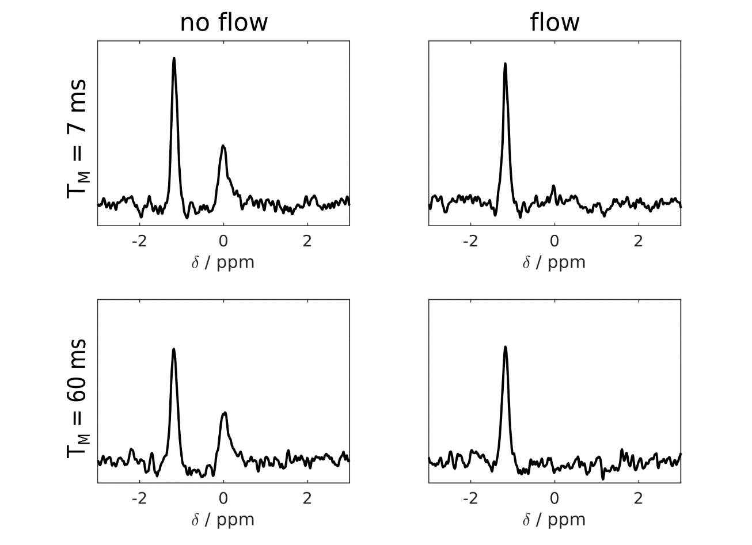
Figure 3.
STEAM-³¹P-MRS sequence for interleaved RF excitation centred at PCr (a: RF excitation centred at 0ppm relative to PCr, TM 7 ms) and Pi (b: RF excitation centred at 4.8 ppm relative to PCr, TM 60 ms). Typical STEAM-31P-MRS voxel placement ([c] horizontal long axis view, [d] short axis view), this was chosen to optimise septal coverage while minimising the potential for skeletal muscle contamination.
Figure 4.
With separate excitations for PCr and Pi, frequency fluctuations had the potential to affect pH estimation. In one data set (128 averages), the individual un-averaged fids were extracted from the raw data and are plotted after apodisation with the fitted line width (a), fluctuations are seen to average toward zero mean frequency offset. The frequency distribution also lies within the fitted line width (65 Hz) (b).
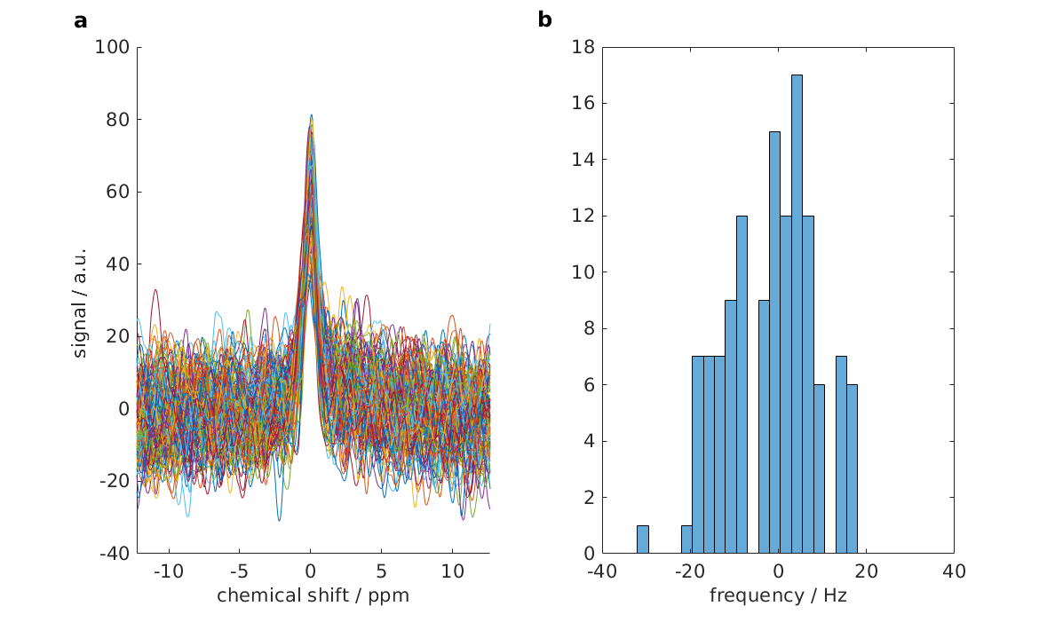

Figure 5.
Bland Altman plots of intra-exam repeated Pi/PCr and pH measurements. Solid lines demonstrate the bias (scan 1 – scan 2, ideally 0). Dashed lines represent the limits of agreement, i.e representing ± 1.96SD. The coefficient of repeatability for Pi/PCr was 0.036, and was for pH 0.12
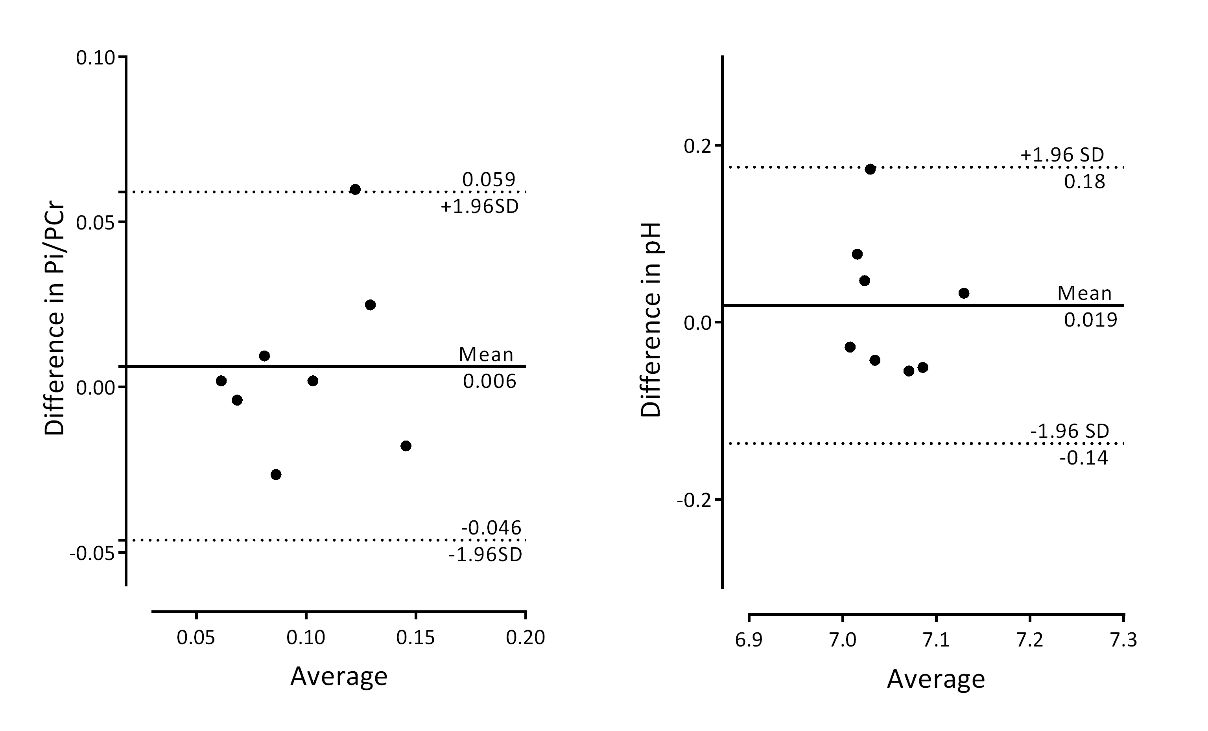
Figure 6.
STEAM-³¹P-MRS spectra from the two interleaved acquisitions from different experiments. Repeatability scan data is shown (A,B) for a healthy volunteer. Rest (C,E) and dobutamine stress (D,F) data of another healthy volunteer (C,D) and the patient with DCM (E,F) are shown. In In each interleave the spectral region to be trusted is that immediately surrounding the metabolite excited marked by bolder lines and green background. Other parts of the spectrum arise from different spatial locations due to strong chemical shift displacement effects and cannot be taken as cardiac. Pi can clearly be resolved with little or no contaminating 2,3-DPG. pH calculations are undertaken from the chemical shift of the Pi peak (taken from the Pi interleaf) relative to that of the PCr peak (taken from the PCr interleaf).

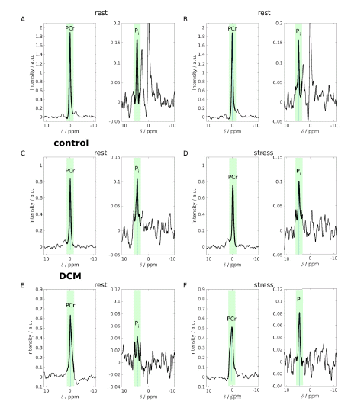
Figure 7.
Myocardial Pi/PCr and pH were maintained in the physiologically normal range during moderate catecholamine stress in this healthy cohort.
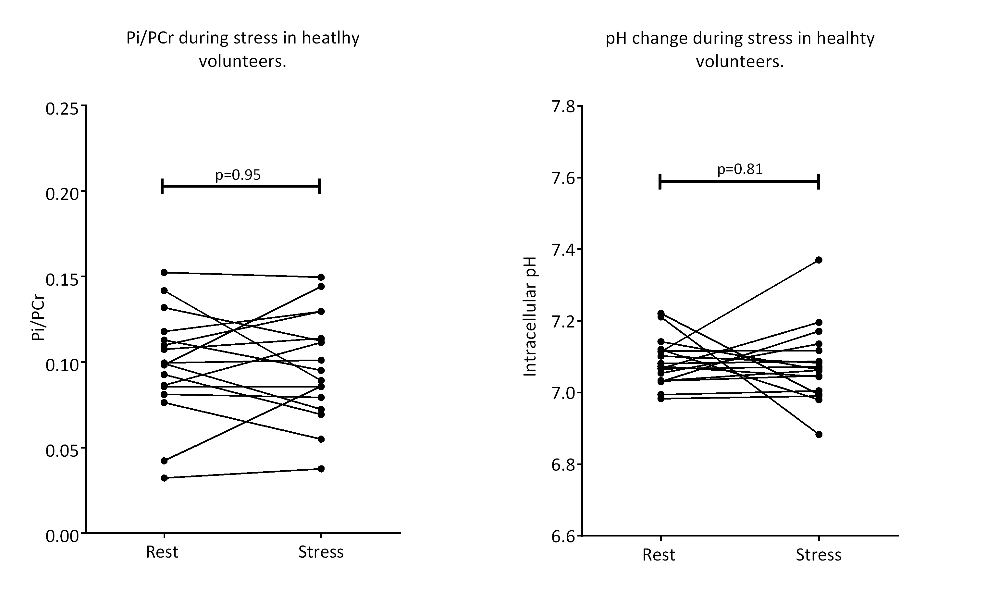

Supporting Information Table S1
Data from all volunteers in our study. Myocardial [Pi] is extremely low, thus poor SNR at rest or any significant loss of SNR as is commonly encountered during dobutamine stress, impacted our ability to see Pi. Data was included for analysis if the Pi peak was clearly resolved (defined as SNR >2.5 and visually obvious). Denotes robust Pi peak (visually obvious and SNR>2.5), × denotes no Pi resonance seen. An example of a case in which we saw a loss of SNR during stress can be seen in the supplementary figure S1.

Repeatability participant ID | Scan 1 Pi | Scan 2 Pi | Pi/PCr  (paired analysis) | pH  (paired analysis)
01
02
03
04
05
06
07
08 | × |  | × | ×
09
Stress Study participant ID | Rest Pi | Stress Pi | Pi/PCr  (paired analysis) | pH  (paired analysis)
01
02
03 | × | × | × | ×
04
05
06
07
08
09 |  | N/A | N/A | N/A
10
11 | × |  | × | ×
12
13
14
15 |  | × | × | ×
16 |  | × | × | ×
17 | × | × | × | ×
18
19
20
21
22
23

Supporting information Figure S1
Fitting of all peaks was performed using the open-source Matlab-based “OXSA” toolbox (42, 43). Here the direct output for fitting the PI peak is shown (left most peak) of the fitting Pi is the leftmost peak. Apodisation is applied for visualisation purposes. There is little left in the residuum (lower panel)
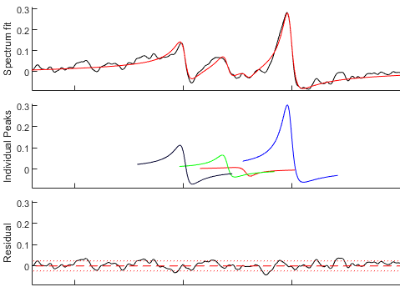

Supporting Information Figure S2
Spectra demonstrating a significant loss of SNR during stress; no quantification of the effect of stress on Pi/PCr can be made, with only the rest data point used (participant 15).
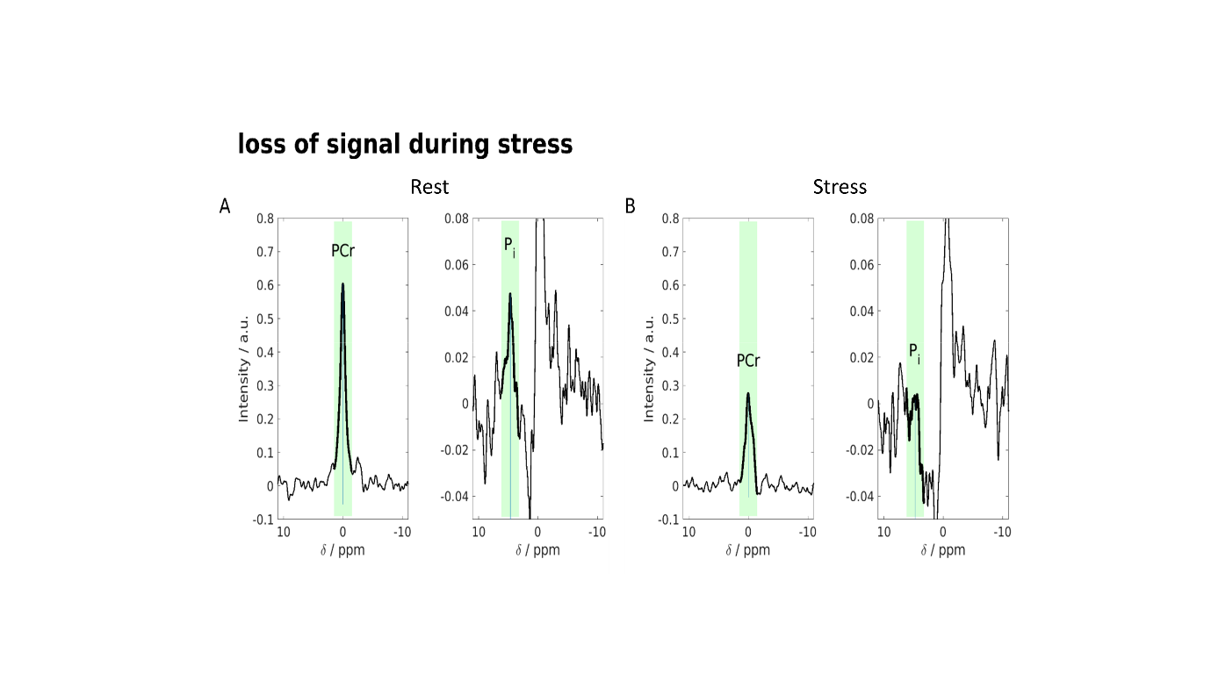

Declarations

Acknowledgements and Funding.

AA [FS/17/18/32449] and MP [FS/15/80/31803] are supported by British Heart Foundation Clinical Research Training Fellowships. OJR is supported by a British Heart Foundation Intermediate Fellowship. DT is supported by a British Heart Foundation Senor Fellowship [FS/14/17/30634]. DT, JL and EMT are supported by the National Institute for Health Research (NIHR) Oxford Biomedical Research Centre. SN acknowledges the support of the Oxford BHF Centre of Research Excellence. CTR and LV are funded by the Wellcome Trust and the Royal Society [098436/Z/12/B]. AIS was supported through the Austrian Science Fund’s (FWF) Schrödinger fellowship (J 4043). LV also acknowledges support of the Slovak Grant Agencies VEGA [2/0003/20] and APVV [#15–0029]. This research was also supported by the NIHR Cambridge Biomedical Research Centre. The views expressed are those of the author(s) and not necessarily those of the NHS, the NIHR or the Department of Health and Social Care.

Author Contribution.

AA, CTR and AIS conceptualised the study. AIS and CTR performed phantom validation experiments and undertook sequence design. AA, AIS, LV, MP, and JE performed all CMR scanning. AA drafted the manuscript, with critical evaluation from DT, OR, JL, EMT, CTR and AIS, and all those above. All authors approved the final manuscript.

Ethics approval and consent to participate.

All subjects provided written, informed consent prior to participation in this study. This research was approved by the National Research Ethics Committee service (3/SC/0376), subsequent local approval was provided by Oxford University Hospitals NHS trust.

Consent for publication.

All subjects were informed and provided written consent prior to participation in this study.

References

1. Ingwall JS. Energy metabolism in heart failure and remodelling. Cardiovascular research. 2008;81(3):412-9.
2. Schlattner U, Tokarska-Schlattner M, Wallimann T. Mitochondrial creatine kinase in human health and disease. Biochimica et Biophysica Acta (BBA)-Molecular Basis of Disease. 2006;1762(2):164-80.
3. Neubauer S, Horn M, Cramer M, Harre K, Newell JB, Peters W, et al. Myocardial phosphocreatine-to-ATP ratio is a predictor of mortality in patients with dilated cardiomyopathy. Circulation. 1997;96(7):2190-6.
4. Stoll VM, Clarke WT, Levelt E, Liu A, Myerson SG, Robson MD, et al. Dilated cardiomyopathy: phosphorus 31 MR spectroscopy at 7 T. Radiology. 2016;281(2):409-17.
5. Rider OJ, Francis JM, Ali MK, Holloway C, Pegg T, Robson MD, et al. Effects of catecholamine stress on diastolic function and myocardial energetics in obesity. Circulation. 2012:CIRCULATIONAHA. 111.069518.
6. Rayner J, Banerjee R, Holloway C, Lewis A, Peterzan M, Francis J, et al. The relative contribution of metabolic and structural abnormalities to diastolic dysfunction in obesity. International Journal of Obesity. 2018;42(3):441.
7. Levelt E, Rodgers CT, Clarke WT, Mahmod M, Ariga R, Francis JM, et al. Cardiac energetics, oxygenation, and perfusion during increased workload in patients with type 2 diabetes mellitus. European heart journal. 2015;37(46):3461-9.
8. Shen W, Asai K, Uechi M, Mathier MA, Shannon RP, Vatner SF, et al. Progressive loss of myocardial ATP due to a loss of total purines during the development of heart failure in dogs: a compensatory role for the parallel loss of creatine. Circulation. 1999;100(20):2113-8.
9. Beer M, Seyfarth T, Sandstede J, Landschütz W, Lipke C, Köstler H, et al. Absolute concentrations of high-energy phosphate metabolites in normal, hypertrophied, and failing human myocardium measured noninvasively with 31P-SLOOP magnetic resonance spectroscopy. Journal of the American College of Cardiology. 2002;40(7):1267-74.
10. Bashore TM, Magorien DJ, Letterio J, Shaffer P, Unverferth DV. Histologic and biochemical correlates of left ventricular chamber dynamics in man. Journal of the American College of Cardiology. 1987;9(4):734-42.
11. Grist T, Kneeland J, Rilling W, Jesmanowicz A, Froncisz W, Hyde J. Gated cardiac MR imaging and P-31 MR spectroscopy in humans at 1.5 T. Work in progress. Radiology. 1989;170(2):357-61.
12. Conway M, Bristow J, Blackledge M, Rajagopalan B, Radda G. Cardiac metabolism during exercise measured by magnetic resonance spectroscopy. The Lancet. 1988;332(8612):692.
13. Dass S, Cochlin LE, Suttie JJ, Holloway CJ, Rider OJ, Carden L, et al. Exacerbation of cardiac energetic impairment during exercise in hypertrophic cardiomyopathy: a potential mechanism for diastolic dysfunction. European heart journal. 2015;36(24):1547-54.
14. Schaefer S, Schwartz GG, Steinman SK, Meyerhoff DJ, Massie BM, Weiner MW. Metabolic response of the human heart to inotropic stimulation: in vivo phosphorus‐31 studies of normal and cardiomyopathic myocardium. Magnetic resonance in medicine. 1992;25(2):260-72.
15. Tian R, Nascimben L, Ingwall JS, Lorell BH. Failure to maintain a low ADP concentration impairs diastolic function in hypertrophied rat hearts. Circulation. 1997;96(4):1313-9.
16. Balaban R. The application of nuclear magnetic resonance to the study of cellular physiology. American Journal of Physiology-Cell Physiology. 1984;246(1):C10-C9.
17. Katz L, Swain J, Portman M, Balaban R. Intracellular pH and inorganic phosphate content of heart in vivo: a 31P-NMR study. American Journal of Physiology-Heart and Circulatory Physiology. 1988;255(1):H189-H96.
18. Lardy HA, Wellman H. Oxidative phosphorylations: role of inorganic phosphate and acceptor systems in control of metabolic rates. Journal of Biological Chemistry. 1952;195(1):215-24.
19. Tran K, Loiselle DS, Crampin EJ. Regulation of cardiac cellular bioenergetics: mechanisms and consequences. Physiological reports. 2015;3(7).
20. Wu F, Zhang EY, Zhang J, Bache RJ, Beard DA. Phosphate metabolite concentrations and ATP hydrolysis potential in normal and ischaemic hearts. The Journal of physiology. 2008;586(17):4193-208.
21. Beard DA, Kushmerick MJ. Strong inference for systems biology. PLoS computational biology. 2009;5(8):e1000459.
22. Hettling H, van Beek JH. Analyzing the functional properties of the creatine kinase system with multiscale ‘sloppy’modeling. PLoS computational biology. 2011;7(8):e1002130.
23. Weiss RG, Gerstenblith G, Bottomley PA. ATP flux through creatine kinase in the normal, stressed, and failing human heart. Proceedings of the National Academy of Sciences. 2005;102(3):808-13.
24. Gabr RE, El-Sharkawy A-MM, Schär M, Panjrath GS, Gerstenblith G, Weiss RG, et al. Cardiac work is related to creatine kinase energy supply in human heart failure: a cardiovascular magnetic resonance spectroscopy study. Journal of Cardiovascular Magnetic Resonance. 2018;20(1):81.
25. Bakermans AJ, Bazil JN, Nederveen AJ, Strijkers GJ, Boekholdt SM, Beard DA, et al. Human cardiac 31P-MR spectroscopy at 3 tesla cannot detect failing myocardial energy homeostasis during exercise. Frontiers in physiology. 2017;8:939.
26. Neubauer S. The failing heart—an engine out of fuel. New England Journal of Medicine. 2007;356(11):1140-51.
27. Neely JR, Morgan HE. Relationship between carbohydrate and lipid metabolism and the energy balance of heart muscle. Annual review of physiology. 1974;36(1):413-59.
28. Nascimben L, Ingwall JS, Lorell BH, Pinz I, Schultz V, Tornheim K, et al. Mechanisms for increased glycolysis in the hypertrophied rat heart. Hypertension. 2004;44(5):662-7.
29. Lamb HJ, Beyerbacht HP, Van Der Laarse A, Stoel BC, Doornbos J, van der Wall EE, et al. Diastolic dysfunction in hypertensive heart disease is associated with altered myocardial metabolism. Circulation. 1999;99(17):2261-7.
30. Bache RJ, Zhang J, Path G, Merkle H, Hendrich K, From A, et al. High-energy phosphate responses to tachycardia and inotropic stimulation in left ventricular hypertrophy. American Journal of Physiology-Heart and Circulatory Physiology. 1994;266(5):H1959-H70.
31. Vaughan-Jones RD, Spitzer KW, Swietach P. Intracellular pH regulation in heart. Journal of molecular and cellular cardiology. 2009;46(3):318-31.
32. Valkovič L, Clarke WT, Schmid AI, Raman B, Ellis J, Watkins H, et al. Measuring inorganic phosphate and intracellular pH in the healthy and hypertrophic cardiomyopathy hearts by in vivo 7T 31 P-cardiovascular magnetic resonance spectroscopy. Journal of Cardiovascular Magnetic Resonance. 2019;21(1):19.
33. Jung W-I, Sieverding L, Breuer J, Hoess T, Widmaier S, Schmidt O, et al. 31P NMR spectroscopy detects metabolic abnormalities in asymptomatic patients with hypertrophic cardiomyopathy. Circulation. 1998;97(25):2536-42.
34. De Roos A, Doornbos J, Luyten PR, Oosterwaal LJ, den Hollander JA, van der Wall EE. Cardiac metabolism in patients with dilated and hypertrophic cardio‐myopathy: Assessment with proton‐decoupled P‐31 MR spectroscopy. Journal of Magnetic Resonance Imaging. 1992;2(6):711-9.
35. Karaus A, Merboldt KD, Graessner J, Frahm J. Black‐blood imaging of the human heart using rapid stimulated echo acquisition mode (STEAM) MRI. Journal of Magnetic Resonance Imaging: An Official Journal of the International Society for Magnetic Resonance in Medicine. 2007;26(6):1666-71.
36. Fischer SE, Stuber M, Scheidegger MB, Boesiger P. Limitations of stimulated echo acquisition mode (STEAM) techniques in cardiac applications. Magnetic resonance in medicine. 1995;34(1):80-91.
37. Valkovič L, Clarke WT, Purvis LA, Schaller B, Robson MD, Rodgers CT. Adiabatic excitation for 31P MR spectroscopy in the human heart at 7 T: A feasibility study. Magnetic resonance in medicine. 2017;78(5):1667-73.
38. Biering-Sørensen T, Mogelvang R, de Knegt MC, Olsen FJ, Galatius S, Jensen JS. Cardiac time intervals by tissue doppler imaging M-mode: normal values and association with established echocardiographic and invasive measures of systolic and diastolic function. PloS one. 2016;11(4).
39. Ellis J, Valkovič L, Purvis LA, Clarke WT, Rodgers CT. Reproducibility of human cardiac phosphorus MRS (31P‐MRS) at 7 T. NMR in biomedicine. 2019.
40. Rodgers CT, Clarke WT, Snyder C, Vaughan JT, Neubauer S, Robson MD. Human cardiac 31P magnetic resonance spectroscopy at 7 Tesla. Magnetic resonance in medicine. 2014;72(2):304-15.
41. Rodgers CT, Robson MD. Coil combination for receive array spectroscopy: Are data‐driven methods superior to methods using computed field maps? Magnetic resonance in medicine. 2016;75(2):473-87.
42. Vanhamme L, van den Boogaart A, Van Huffel S. Improved method for accurate and efficient quantification of MRS data with use of prior knowledge. Journal of magnetic resonance. 1997;129(1):35-43.
43. Purvis LA, Clarke WT, Biasiolli L, Valkovič L, Robson MD, Rodgers CT. OXSA: An open-source magnetic resonance spectroscopy analysis toolbox in MATLAB. PloS one. 2017;12(9):e0185356.
44. Valkovič L SA, Purvis L, Ellis J, Robson MD, Neubauer S, Rodgers CT. Quantification of human cardiac inorganic phosphate content in vivo by ³¹P-MRS at 7T. In proceedings of the 26th Annual Meeting of ISMRM, Paris, France. 2018:3995.
45. Cavassila S, Deval S, Huegen C, Van Ormondt D, Graveron‐Demilly D. Cramér–Rao bounds: an evaluation tool for quantitation. NMR in Biomedicine: An International Journal Devoted to the Development and Application of Magnetic Resonance In Vivo. 2001;14(4):278-83.
46. Bailey IA, Williams SR, Radda GK, Gadian DG. Activity of phosphorylase in total global ischaemia in the rat heart A phosphorus-31 nuclear-magnetic-resonance study. Biochemical Journal. 1981;196(1):171-8.
47. Bartlett J, Frost C. Reliability, repeatability and reproducibility: analysis of measurement errors in continuous variables. Ultrasound in Obstetrics and Gynecology: The Official Journal of the International Society of Ultrasound in Obstetrics and Gynecology. 2008;31(4):466-75.
48. Tyler D, Emmanuel Y, Cochlin L, Hudsmith L, Holloway C, Neubauer S, et al. Reproducibility of 31P cardiac magnetic resonance spectroscopy at 3 T. NMR in Biomedicine: An International Journal Devoted to the Development and Application of Magnetic Resonance In vivo. 2009;22(4):405-13.
49. Hamm LL, Nakhoul N, Hering-Smith KS. Acid-base homeostasis. Clinical Journal of the American Society of Nephrology. 2015;10(12):2232-42.
50. Lamb HJ, Beyerbacht HP, Ouwerkerk R, Doornbos J, Pluim BM, Van Der Wall EE, et al. Metabolic response of normal human myocardium to high-dose atropine-dobutamine stress studied by 31P-MRS. Circulation. 1997;96(9):2969-77.
51. Katz LA, Swain JA, Portman MA, Balaban R. Relation between phosphate metabolites and oxygen consumption of heart in vivo. American Journal of Physiology-Heart and Circulatory Physiology. 1989;256(1):H265-H74.
52. Gong G, Liu J, Liang P, Guo T, Hu Q, Ochiai K, et al. Oxidative capacity in failing hearts. American Journal of Physiology-Heart and Circulatory Physiology. 2003.
53. Wu F, Zhang J, Beard DA. Experimentally observed phenomena on cardiac energetics in heart failure emerge from simulations of cardiac metabolism. Proceedings of the National Academy of Sciences. 2009;106(17):7143-8.
54. Balaban RS. Regulation of oxidative phosphorylation in the mammalian cell. American Journal of Physiology-Cell Physiology. 1990;258(3):C377-C89.
55. Benesch R, Benesch RE. The effect of organic phosphates from the human erythrocyte on the allosteric properties of hemoglobin. Biochemical and biophysical research communications. 1967;26(2):162-7.
56. Von Deuster C, Stoeck CT, Genet M, Atkinson D, Kozerke S. Spin echo versus stimulated echo diffusion tensor imaging of the in vivo human heart. Magnetic resonance in medicine. 2016;76(3):862-72.
57. Bogner W, Chmelik M, Schmid A, Moser E, Trattnig S, Gruber S. Assessment of 31P relaxation times in the human calf muscle: a comparison between 3 T and 7 T in vivo. Magnetic Resonance in Medicine: An Official Journal of the International Society for Magnetic Resonance in Medicine. 2009;62(3):574-82.
58. Valkovič L, Dragonu I, Almujayyaz S, Batzakis A, Young LA, Purvis LA, et al. Using a whole-body 31P birdcage transmit coil and 16-element receive array for human cardiac metabolic imaging at 7T. PloS one. 2017;12(10):e0187153.
59. Valkovič L EJ, Purvis L, Schmid AI, Neubauer S, Robson MD,, Rodgers CT. First assessment of cardiac energy metabolism in the lateral and inferior segments of the left ventrile in vivo at 7T. In proceedings of the 27th Annual Meeting of ISMRM, Monstreal, Canada. 2019:#480.

