SUPPORTING INFORMATION
for
Real-time spectroscopic analysis enabling the full and safe consumption of fluoroform during nucleophilic trifluoromethylation in flow.

Biagia Musio,* Elena Gala,† Steven V. Ley*
Department of Chemistry, University of Cambridge, Lensfield Road, Cambridge, CB2 1EW, U.K.
*bm450@cam.ac.uk, *svl1000cam.ac.uk

Numbers of pages: 35
Numbers of figures: 1 (S1) plus 42 figures containing NMR spectra.

Content
p. 2 S1. General experimental section
p. 3 S2. Spinsolve Benchtop NMR Spectroscopy: Inline and online monitoring carried with benchtop Magritek Spinsolve©.
p. 4 S3. General procedure for the preparation of 3a in flow.
p. 4 S4. General procedure for the preparation of 4a-4f in flow.
p. 4 S5. General procedure for the preparation of 6a-6g in flow.
p. 5 S6. General procedure for the preparation of 8 in flow.
p. 6 S7. Spectral characterization of compounds 3a, 4a-4f, 6a-6g.
p. 34 S8. References.

S1. General experimental section.
1H-NMR spectra were recorded on a Bruker Avance DRX-600 spectrometer with the residual solvent peak as the internal reference (CHCl3 = 7.26 ppm). 1H resonances are reported to the nearest 0.01 ppm. 13C-NMR spectra were recorded on the same spectrometers with the central resonance of the solvent peak as the internal reference (CDCl3 = 77.16 ppm). All 13C resonances are reported to the nearest 0.1 ppm. The multiplicity of 1 H signals are indicated as: s = singlet, d = doublet, t = triplet, m = multiplet, br. = broad, or combinations of thereof. Coupling constants (J) are quoted in Hz and reported to the nearest 0.1 Hz. Where appropriate, averages of the signals from peaks displaying multiplicity were used to calculate the value of the coupling constant. ¹⁹F NMR spectra were recorded on a 43 MHz Magritek Spinsolve Spectrometer. Chemical shifts are reported in ppm with PhCF₃ as the internal standard (PhCF₃: -63.46 ppm). Infrared spectra were recorded neat on a PerkinElmer Spectrum One FT-IR spectrometer using Universal ATR sampling accessories. High resolution mass spectrometry (HRMS) was performed using a Waters Micromass LCT Premier™ spectrometer using time of flight with positive ESI, or conducted by Mr Paul Skelton on a Bruker BioApex 47e FTICR spectrometer using (positive) ESI or EI at 70 eV within a tolerance of 5 ppm of the theoretically calculated value. LC-MS analysis was performed on an Agilent HP 1100 series chromatography (Mercury Luna 3u C18 (2) column) attached to a Waters ZQ2000 mass spectrometer with ESCi ionization source in ESI mode. Elution was carried out at a flow rate of 0.6 mL min-1 using a reverse phase gradient of acetonitrile and water containing 0.1% formic acid. Retention time (Rt) is given in min to the nearest 0.1 min and the m/z value is reported to the nearest mass unit (m.u.). Unless stated otherwise, reagents were obtained from commercial sources and used without purification. The removal of solvent under reduced pressure was carried out on a standard rotary evaporator. Unless otherwise stated, yields of compounds were calculated based on the isolated compounds estimated. Flash column chromatography was performed using high-purity grade silica gel (Merck grade 9385) with a pore size 60 Å and 230–400 mesh particle size under air pressure. Analytical thin layer chromatography (TLC) was performed using silica gel 60 F254 pre-coated glass backed plates and visualized by ultraviolet radiation (254 nm) and/or potassium permanganate solution as appropriate.
All the flow reactions were performed using a Uniqsis FlowSyn module. In-line IR spectroscopy was performed using the Mettler Toledo FlowIR®. The solution of chlorotrimethylsilane was dispensed using a Masterflex peristaltic. Back pressure regulator is indicated as BPR. All gas-flow reactions were performed with a tube-in-tube reactor as described to introduce gases into a continuous flow stream.
S2. Spinsolve Benchtop NMR Spectroscopy: Inline and online monitoring carried with benchtop Magritek Spinsolve©.
1H probe with detection using a solenoid coil at a frequency of 43.62 MHz. 19F probe with detection using a solenoid coil at a frequency of 40.89 MHz. Magnet temperature of 29 °C Resolution at 50% peak height: linewidth < 20Hz. Fast automatic hardware lock using an external lock configuration (allows use of non-deuterated solvent). Automated shimming using a 10% H2O in D2O mixture. NMR data collected automatically with Spinsolve software and processed automatically using MNOVA© software. Reaction Monitoring (RM) protocol, for inline experiment, capture sequence of 1D proton and 1D Fluorine single scans at user selected time intervals. Processing data as stacked spectra in MNOVA. Following the script:
TimeStampFolder = "c:/ReactionMonitor/1H + 19F"
ProtonPhase = "FirstScan"
FluorinePhase = "FirstScan"

# Loop
loop(40, 00:02:00:000)
RunProtocol("1D EXTENDED+", ["Number=4", "RepetitionTime=10", "PulseAngle=90", "AcquisitionTime=6.4"])
wait(00:00:10:000)
RunProtocol("1D FLUORINE+", ["Number=16", "RepetitionTime=4", "PulseAngle=90", "AcquisitionTime=1.64"])
endloop

wait(00:00:10:000)
RunMnovaFile("ScriptUtilities/ReactionMonitor.qs", "process", ["1H"])
wait(00:00:10:000)
RunMnovaFile("ScriptUtilities/ReactionMonitor.qs", "process", ["19F"])
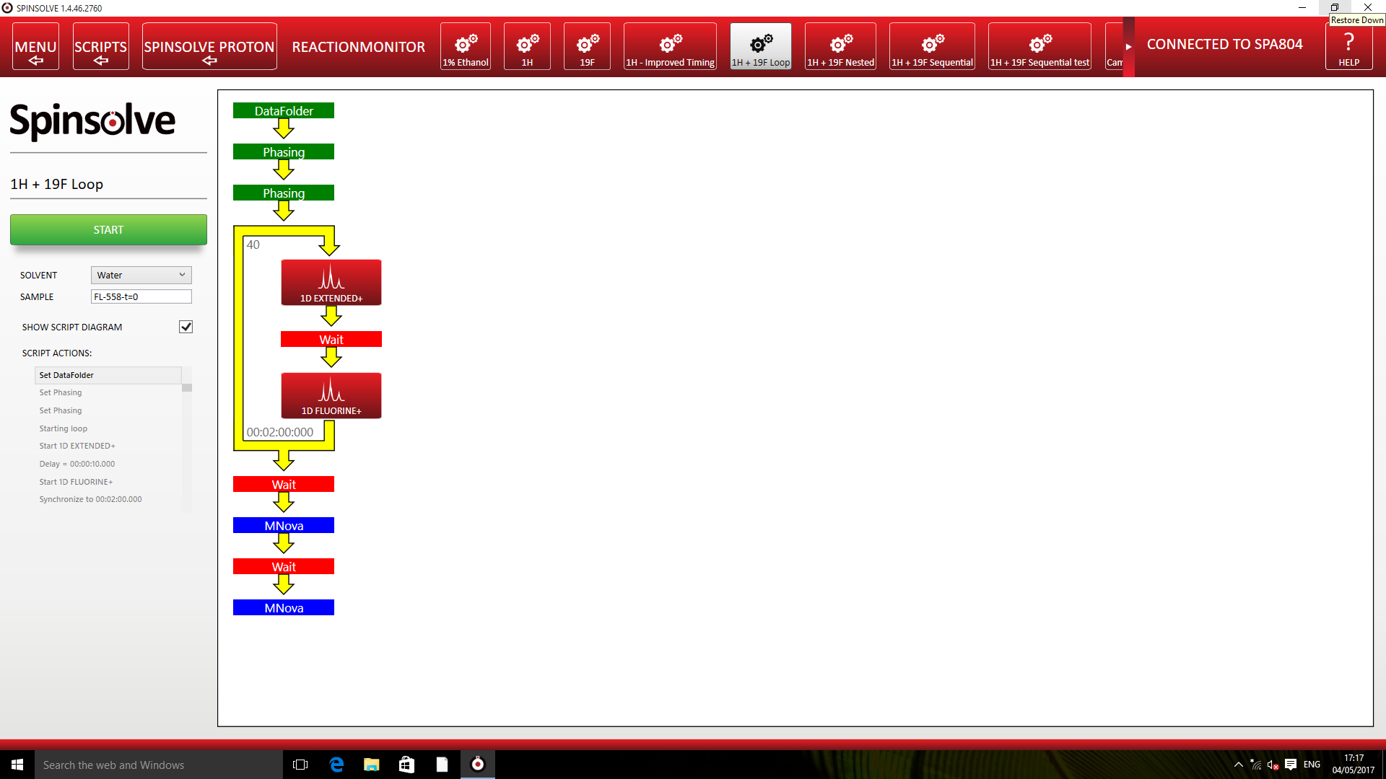
Figure S1. Reaction Monitoring (RM) Script.
S3. General procedure for the preparation of 3a in flow.
A solution of the benzophenone 2a (2.0 mmol) in THF (2.0 mL) was loaded (0.2 ml/min) into a 2.0 mL PTFE sample loop and a solution of KHMDS (1.0 M) in THF (2.0 mL) was loaded (0.2 ml/min) into a second 2.0 mL PTFE sample loop. A third solvent stream (THF) enriched with CF₃H (3 bar) from the tube-in-tube gas-liquid reactor was pumped (0.2 mL/min). These three streams were mixed at a 4-ways cross connection valve for high pressure. The combined substrate, base and enriched CF₃H streams were directed to the cooling PTFE coil (14 mL, -20 °C) of the Polar Bear Plus system. The total residence time in the cooled flow coil was 23.33 min. On exiting the cooling coil, the product flow stream was directed through the FlowIR device and, next, the benchtop NMR machine. A backpressure regulator (75 psi) was placed immediately after the benchtop NMR instrument to prevent out-gassing of the dissolved CF₃H from the solvent mixture. The product stream was then collected into a round bottom flask, containing a saturated solution of NH₄Cl and extracted with Et₂O (10 mL×3). The combined organic phase was dried over Na₂SO₄, after removing the solvent under vacuum, the residue was purified by column chromatography to give the product.
S4. General procedure for the preparation of 4a-4f in flow.
A solution of the ketone 2 (0.6 mmol) in THF (2.0 mL) was loaded (0.2 ml/min) into a 2.0 mL PTFE sample loop and a solution of KHMDS (1.0 M) in THF (2.0 mL) was loaded(0.2 ml/min) into a second 2.0 mL PTFE sample loop. A third solvent stream (THF) enriched with CF₃H (3 bar) from the tube-in-tube gas-liquid reactor was pumped (0.2 mL/min). These three strams were mixed at a 4-ways cross connection valve for high pressure. The combined substrate, base and enriched CF₃H streams were directed to the cooling PTFE coil (14 mL, -20 °C) of the Polar Bear Plus system. The total residence time in the cooled flow coil was 23.33 min. On exiting the cooling coil, the product flow stream was directed through the FlowIR device and, via a T-piece, was mixed with a fourth stream containing a solution of ClSiMe₃ in THF (0.3 M) and directed to a second PTFE coil (16 ml, room temperature). On exiting the coil, the product flow stream was directed through the benchtop NMR machine. A backpressure regulator (75 psi) was placed immediately after the benchtop NMR instrument to prevent out-gassing of the dissolved CF₃H from the solvent mixture. The product stream was then collected into a round bottom flask, containing a saturated solution of NH₄Cl and extracted with Et₂O (10 mL×3). The combined organic phase was dried over Na₂SO₄, after removing the solvent under vacuum, the residue was purified by column chromatography to give the product.
S5. General procedure for the preparation of 6a-6g in flow.
A solution of the aldehyde 5 (0.6 mmol) in DMF (2.0 mL) was loaded (0.2 ml/min) into a 2.0 mL PTFE sample loop and a solution of KOtBu (1.0 M) in THF (2.0 mL) was loaded (0.2 ml/min) into a second 2.0 mL PTFE sample loop. A third solvent stream (THF) enriched with CF₃H (3 bar) from the tube-in-tube gas-liquid reactor was pumped (0.2 mL/min). These three strams were mixed at a 4-ways cross connection valve for high pressure. The combined substrate, base and enriched CF₃H streams were directed to the cooling PTFE coil (16 mL, -20 °C) of the Polar Bear Plus system. The total residence time in the cooled flow coil was 23.33 min. On exiting the cooling coil, the product flow stream was directed through the FlowIR device and, next, the benchtop NMR machine. A backpressure regulator (75 psi) was placed immediately after the benchtop NMR instrument to prevent out-gassing of the dissolved CF₃H from the solvent mixture. The product stream was then collected into a round bottom flask, containing a saturated solution of NH₄Cl and extracted with Et₂O (10 mL×3). The combined organic phase was dried over Na₂SO₄, after removing the solvent under vacuum, the residue was purified by column chromatography to give the product.
S6. General procedure for the preparation of 8 in flow.
A solution of the Et₃SiCl 7 in THF (2.0 M) was loaded (0.1 ml/min) into a 2.0 mL PTFE sample loop and a solution of KHMDS (1.0 M) in THF (2.0 mL) was loaded (0.1 ml/min) into a second 2.0 mL PTFE sample loop. A third solvent stream (THF) enriched with CF₃H (3 bar) from the tube-in-tube gas-liquid reactor was pumped (0.1 mL/min). These three streams were mixed at a 4-ways cross connection valve for high pressure. The combined substrate, base and enriched CF₃H streams were directed to the cooling PTFE coil (14 mL, -40 °C) of the Polar Bear Plus system. The total residence time in the cooled flow coil was 46.66 min. On exiting the cooling coil, the product flow stream was directed through the FlowIR device and, next, the benchtop NMR machine. A backpressure regulator (75 psi) was placed immediately after the benchtop NMR instrument to prevent out-gassing of the dissolved CF₃H from the solvent mixture. The formation of the product 8 was determined by NMR using PhCF₃ as internal standard.

S7. Spectral characterization of compounds 3a, 4a-4f, 6a-6g.
2,2,2-trifluoro-1,1-diphenylethanol, 3a. Isolated by flash chromatography (pentane/acetone 95/5), 97% yield. The NMR spectra are in accordance with the reported data.

(2,2,2-Trifluoro-1,1-diphenylethoxy)trimethylsilane, 4a. Isolated by flash chromatography (hexane/ethyl acetate 90/10), 95% yield. The NMR spectra are in accordance with the reported data.

(1-(4-Chlorophenyl)-2,2,2-trifluoro-1-phenylethoxy)trimethylsilane, 4b. Isolated by flash chromatography (hexane/ethyl acetate 90/10), 90% yield. The NMR spectra are in accordance with the reported data.
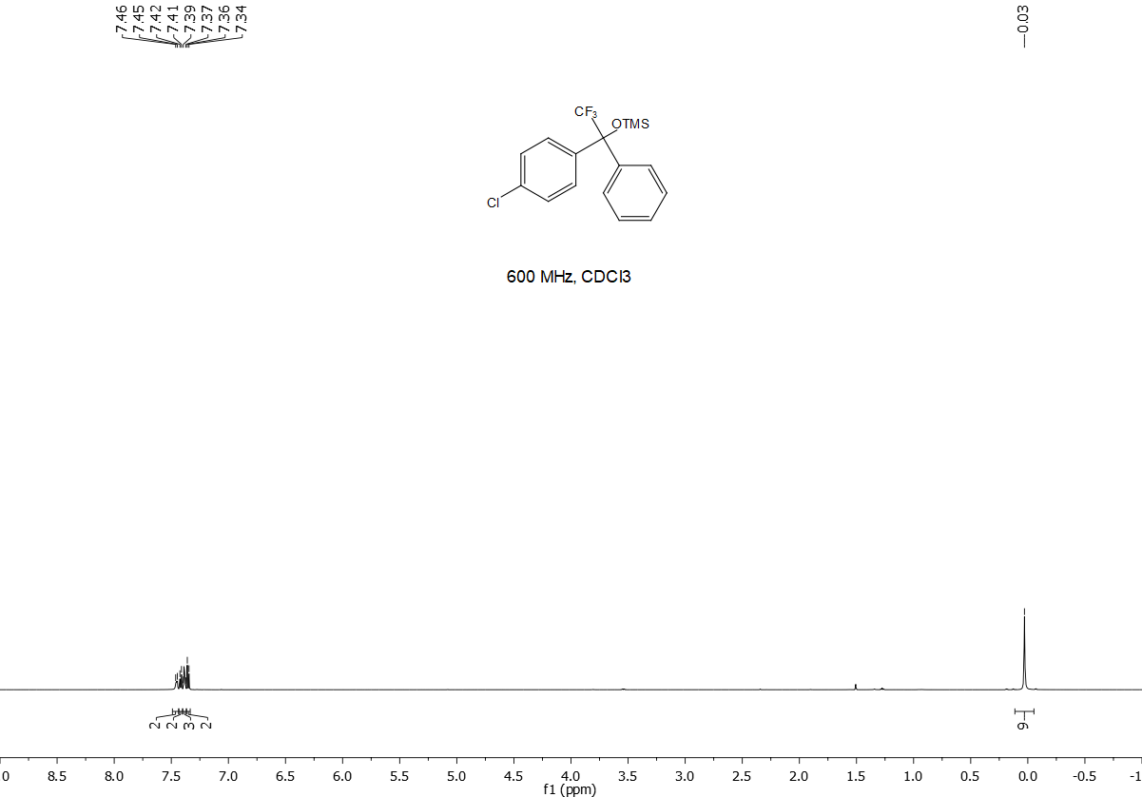

(2,2,2-Trifluoro-1-phenyl-1-p-tolylethoxy)trimethylsilane, 4c. Isolated by flash chromatography (hexane/ethyl acetate 90/10), 88% yield. The NMR spectra are in accordance with the reported data.²
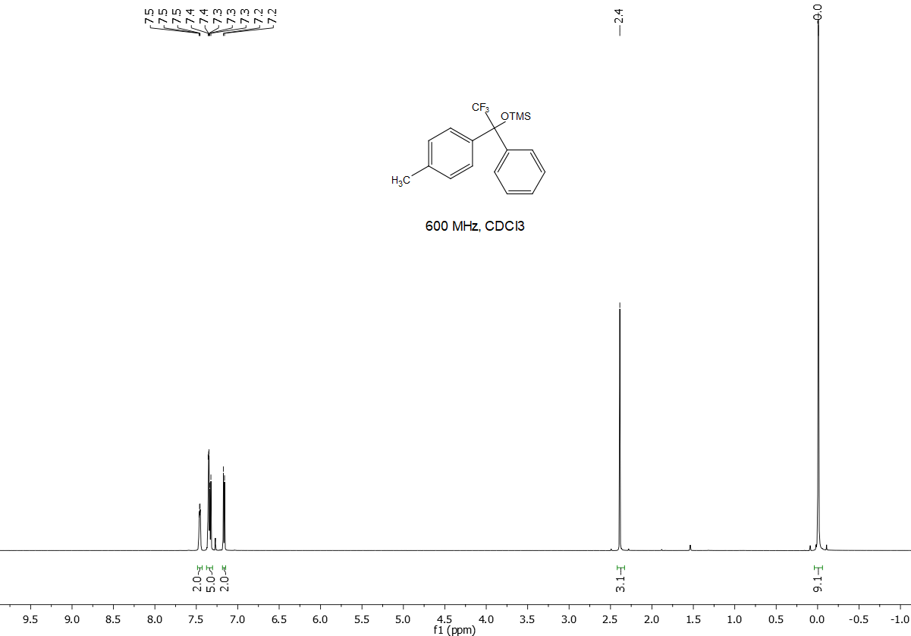

(2,2,2-Trifluoro-1-(4-(trifluoromethyl)phenyl)-1-phenylethoxy)trimethylsilane, 4d. Isolated by flash chromatography (hexane/ethyl acetate 90/10), 71% yield. The NMR spectra are in accordance with the reported data.²
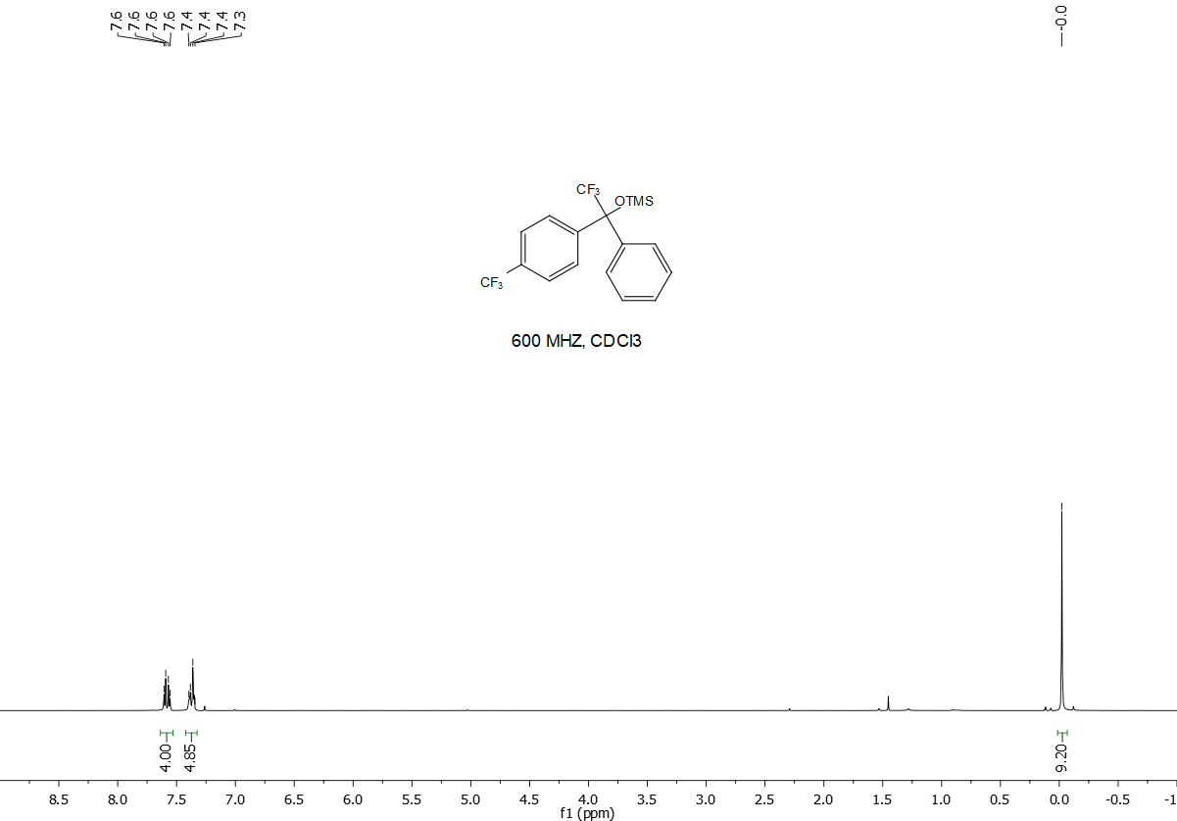

(1-(3-Pyridinyl)-2,2,2-trifluoro-1-phenylethoxy)trimethylsilane, 4e. Isolated by flash chromatography (hexane/ethyl acetate 90/10), 95% yield. Colourless oil. ¹H NMR (600 MHz, CDCl₃) δ -0.07 (s, 9H), 7.24 (dd, J = 8.1, 4.8 Hz, 1H), 7.31 – 7.36 (m, 5H), 7.68 (d, J = 8.1 Hz, 1H), 8.55 (dd, J = 4.8, 1.4 Hz, 1H), 8.62 (d, J = 1.3 Hz, 1H). ¹³C NMR (151 MHz, CDCl₃) δ 1.2, 80.8 (q, J = 29.07 Hz), 122.6, 124.7 (q, J = 287.38 Hz), 127.98 (d, J = 1.6 Hz), 128.2, 128.7, 139.5, 149.2, 149.39 (d, J = 1.4 Hz). ¹⁹F NMR (41 MHz) δ -73.39 (s). HRMS m/z calculated for C₁₆H₁₉F₃NOSi [M + H]⁺ 326.1188 found 326.1173.

(2,2,2-Trifluoro-1-(4-methoxyphenyl)-1-phenylethoxy)trimethylsilane, 4f. Isolated by flash chromatography (hexane/ethyl acetate 90/10), 95% yield. The NMR spectra are in accordance with the reported data.²
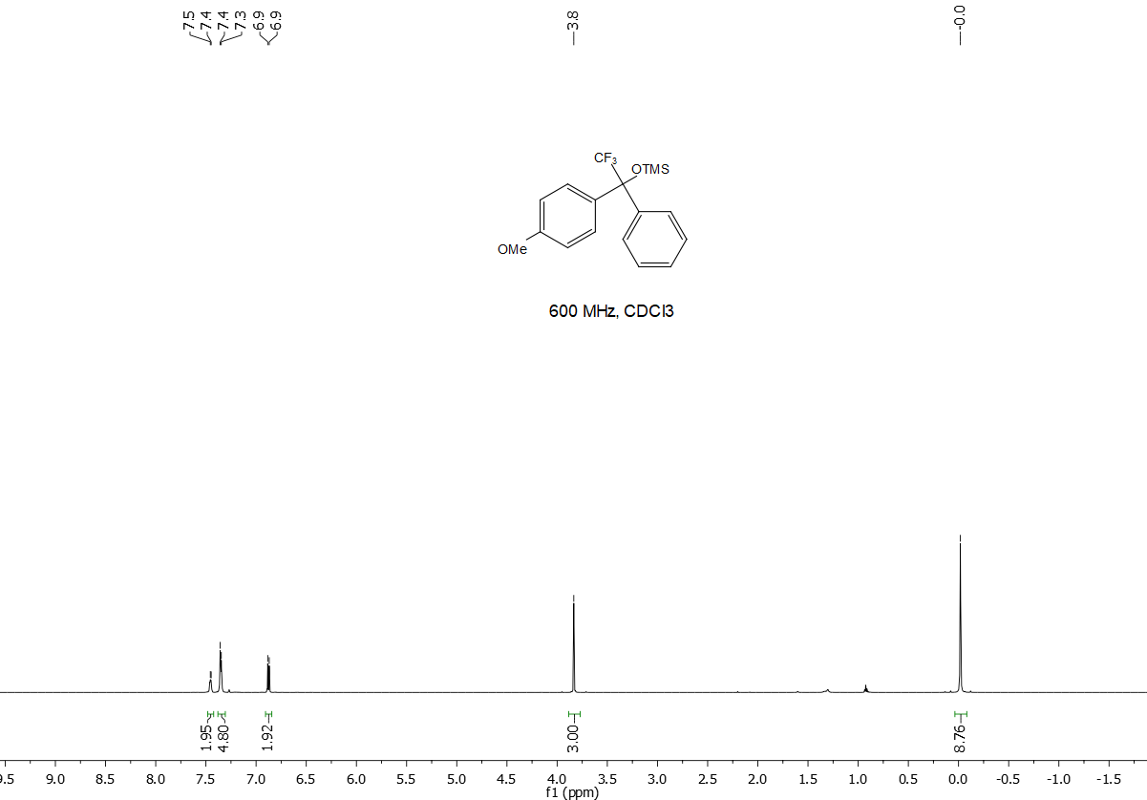

2,2,2-Trifluoro-1-phenylethanol, 6a. Isolated by flash chromatography (hexane/ethyl acetate 90/10), 88% yield. The NMR spectra are in accordance with the reported data.
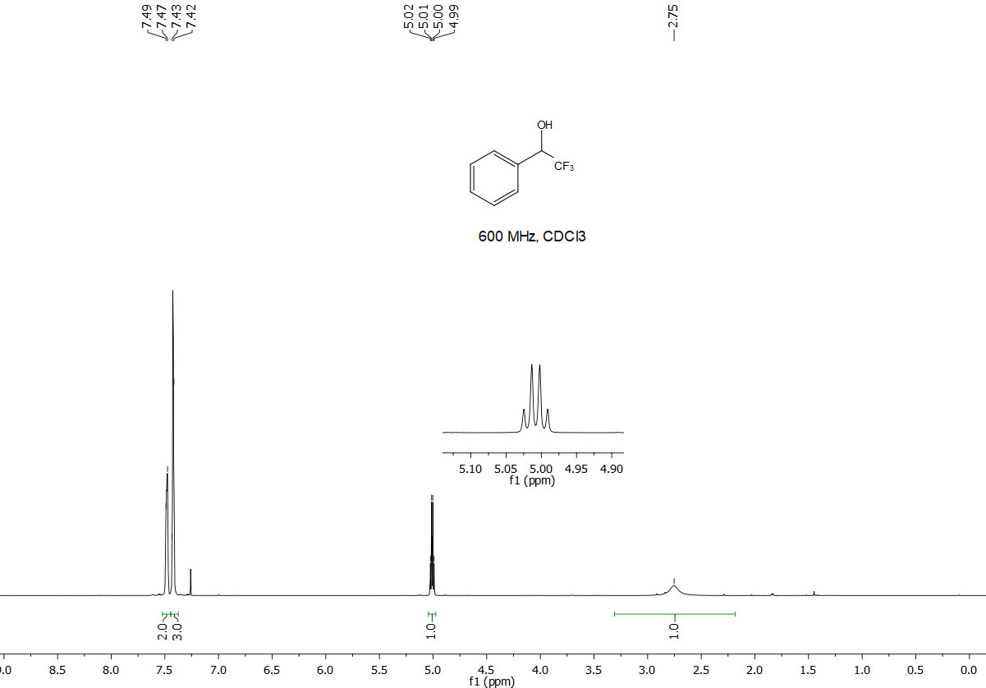

1-(4-Bromophenyl)-2,2,2-trifluoroethanol, 6b. Isolated by flash chromatography (hexane/ethyl acetate 90/10), 88% yield. The NMR spectra are in accordance with the reported data.
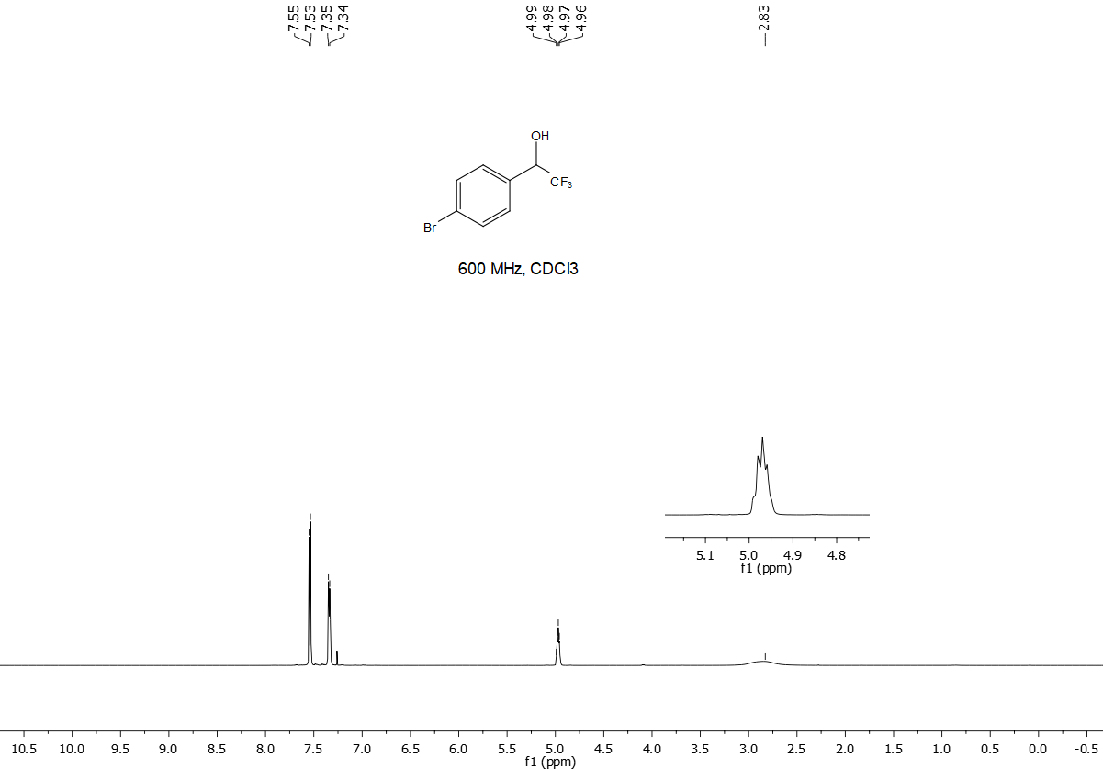

2,2,2-Trifluoro-1-(4-methoxyphenyl)ethanol, 6c. Isolated by flash chromatography (hexane/ethyl acetate 90/10), 95% yield. The NMR spectra are in accordance with the reported data.
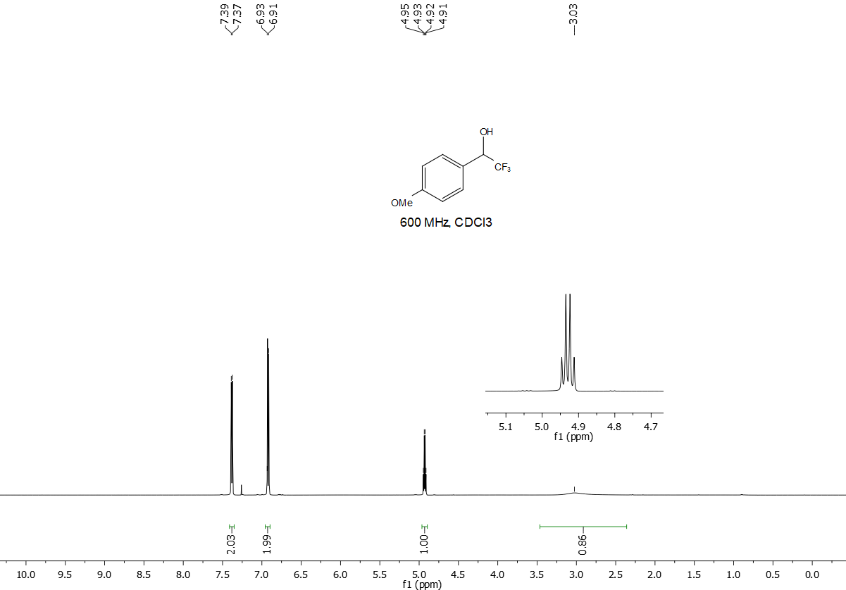

2,2,2-Trifluoro-1-(2,5-dimethoxyphenyl)ethanol, 6d. Isolated by flash chromatography (hexane/ethyl acetate 90/10), 96% yield. Colourless oil. ¹H NMR (600 MHz, CDCl₃) δ 5.27 (q, J = 6.4 Hz, 1H), 7.04 (dd, J = 5.1, 3.6 Hz, 1H), 7.20 (d, J = 3.5 Hz, 1H), 7.39 (dd, J = 5.1, 1.1 Hz, 1H). ¹³C NMR (151 MHz, CDCl₃) δ 55.7, 56.3, 69.2 (q, J = 32.64 Hz), 112.5, 114.8, 115.3, 123.1, 124.6 (q, J = 283.07 Hz),151.7, 153.7. ¹⁹F NMR (41 MHz) δ -78.64 (d, J = 6.9 Hz). HRMS m/z calculated for C₁₀H₁₂F₃NO₃ [M + H]⁺ 237.0738 found 237.0746.
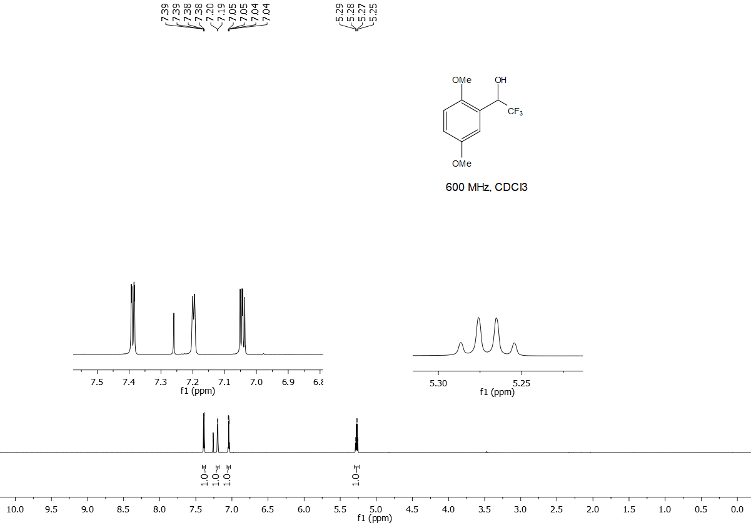

2,2,2-Trifluoro-1-(pyridin-3-yl)ethanol, 6e. Isolated by flash chromatography (hexane/ethyl acetate 90/10), 97% yield. The NMR spectra are in accordance with the reported data.
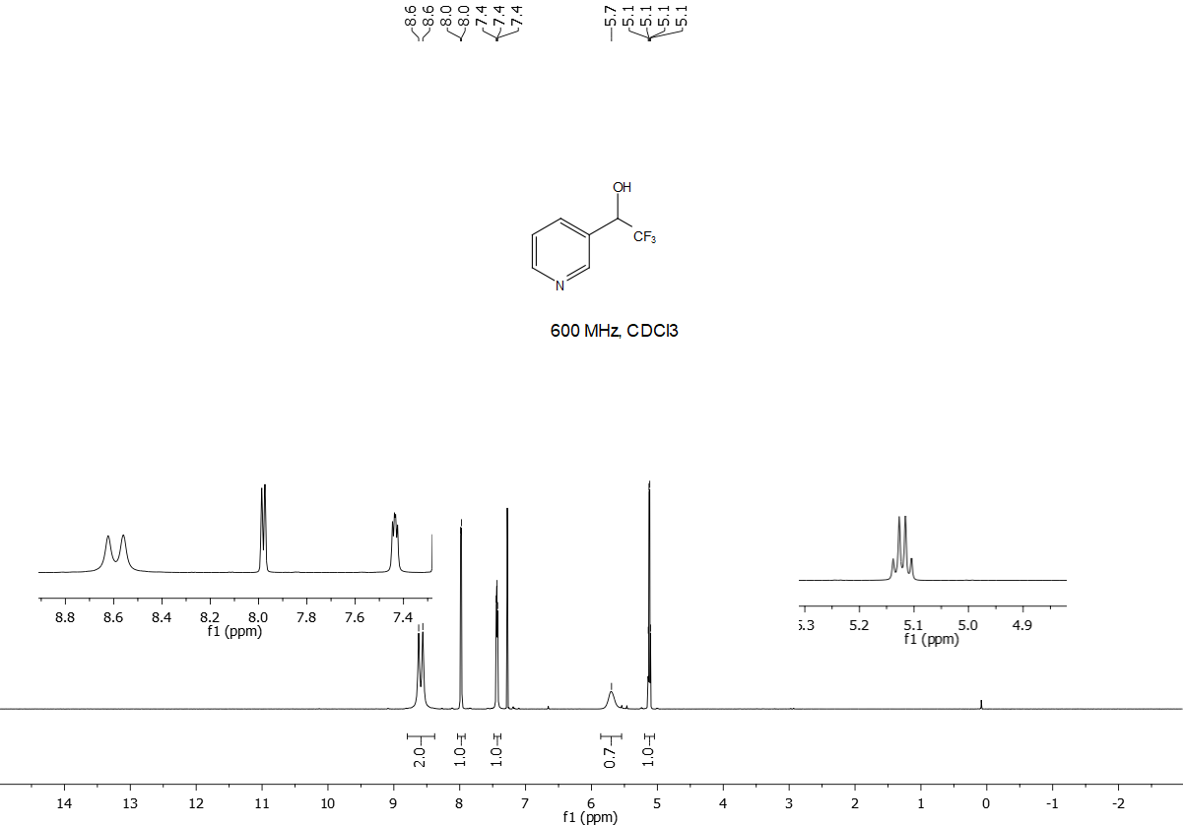

1-(Anthracen-10-yl)-2,2,2-trifluoroethanol, 6f. Isolated by flash chromatography (hexane/ethyl acetate 90/10), 75% yield. The NMR spectra are in accordance with the reported data.⁵

2,2,2-Trifluoro-1-(thiophen-2-yl)ethanol, 6g. Isolated by flash chromatography (hexane/ethyl acetate 90/10), 88% yield. The NMR spectra are in accordance with the reported data.
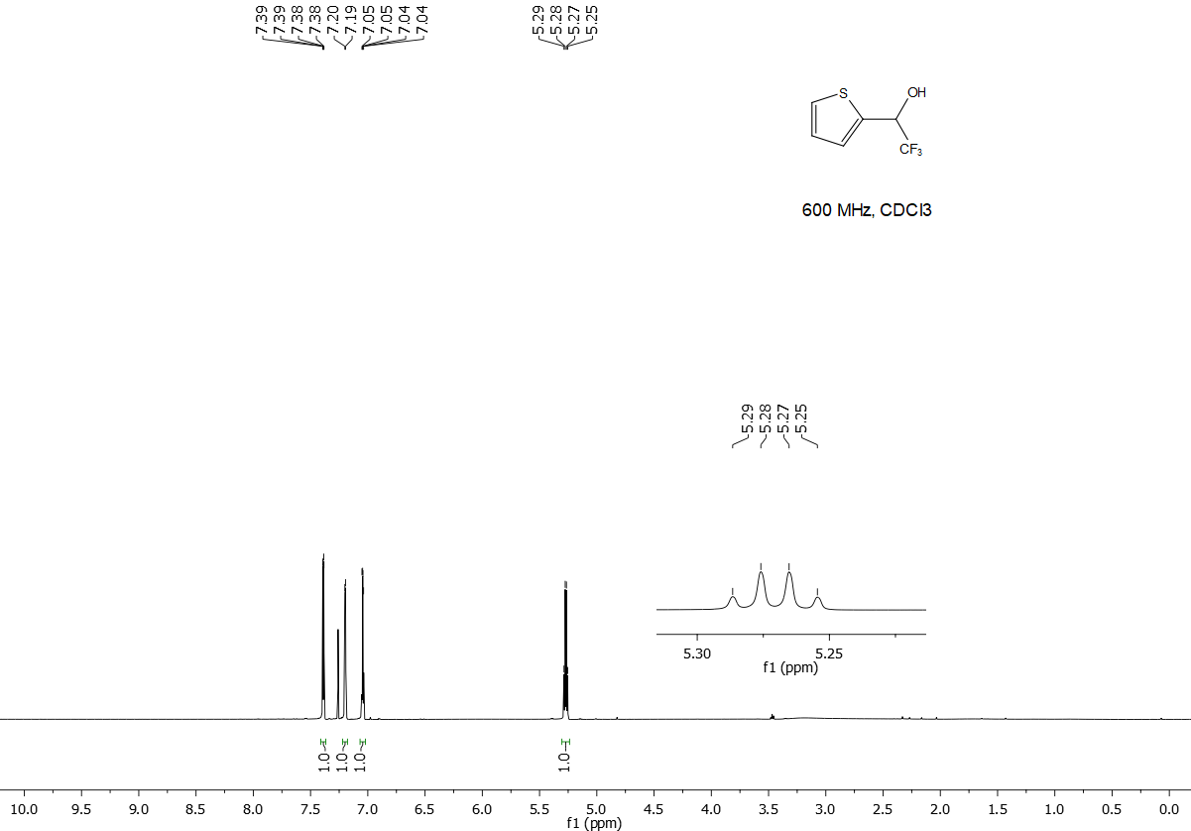

S8. References

(1) Prakash, G. K. S.; Jog, P. V; Batamack, P. T. D.; Olah, G. A. Science 2012, 338, 1324–1327.
(2) Klein, J. E. M. N.; Rommel, S.; Plietker, B. Organometallics 2014, 33 (20), 5802–5810.
(3) Prakash, G. K. S.; Panja, C.; Vaghoo, H.; Surampudi, V.; Kultyshev, R.; Mandal, M.; Rasul, G.; Mathew, T.; Olah, G. A. J. Org. Chem. 2006, 71 (18), 6806–6813.
(4) Bruneau-Voisine, A.; Wang, D.; Dorcet, V.; Roisnel, T.; Darcel, C.; Sortais, J. B. Org. Lett. 2017, 19 (13), 3656–3659.
(5) Vuković, V. D.; Richmond, E.; Wolf, E.; Moran, J. Angew. Chemie - Int. Ed. 2017, 56 (11), 3085–3089.
(6) Aikawa, K.; Toya, W.; Nakamura, Y.; Mikami, K. Org. Lett. 2015, 17 (20), 4996–4999.
(7) Baumann, M.; Baxendale, I. R.; Martin, L. J.; Ley, S. V. Tetrahedron 2009, 65 (33), 6611–6625.
(8) Xu, Q.; Zhou, H.; Geng, X.; Chen, P. Tetrahedron 2009, 65 (11), 2232–2238.

