Expression and purification of membrane proteins in Saccharomyces cerevisiae

Martin S. King and Edmund R.S. Kunji

Medical Research Council Mitochondrial Biology Unit, University of Cambridge, Wellcome Trust / MRC Building, Cambridge Biomedical Campus, Hills Road, Cambridge, CB2 0XY, UK

Author to whom correspondence should be addressed: Edmund R.S. Kunji
Tel.: + 44 1223 252850, Fax.: + 44 1223 252875, e-mail: ek@mrc-mbu.cam.ac.uk

†This research was supported by the Medical Research Council (grant MC_UU_00015/1).

Running Head
Expression of membrane proteins in yeast

Abstract
Saccharomyces cerevisiae is one of the most popular expression systems for eukaryotic membrane proteins. Here, we describe protocols for the expression and purification of mitochondrial membrane proteins developed in our laboratory during the last 15 years. To optimize their expression in a functional form, different promoter systems, as well as codon-optimization and complementation strategies were established. Purification approaches were developed that remove the membrane protein from the affinity column by specific proteolytic cleavage rather than by elution. This strategy has several important advantages, most notably improving the purity of the sample, as contaminants stay bound to the column, thus eliminating the need for a secondary purification step, such as size exclusion chromatography. This strategy also avoids dilution of the sample, which would occur as a consequence of elution, precluding the need for concentration steps, and thus preventing detergent concentration.

Key words
Membrane proteins, mitochondria, protein expression, Saccharomyces cerevisiae, yeast, nickel affinity chromatography, purification by on-column proteolytic cleavage

1 Introduction

Expression of mitochondrial membrane proteins in Saccharomyces cerevisiae
Membrane proteins account for approximately 30% of all open reading frames in sequenced genomes. They have many functions, including transport, maintenance of cellular homeostasis, transmission of signals, and control of cell–cell contacts. Given their central importance in physiology, their dysfunction has been implicated in an increasing range of diseases.
One of the most popular systems for the heterologous expression of membrane proteins is the baker’s yeast Saccharomyces cerevisiae (1). Yeast cells are able to post-translationally process eukaryotic membrane proteins in a way that prokaryotic expression systems cannot (such as Escherichia coli and Lactococcus lactis (2)). The genetics of S. cerevisiae is well understood; consequently, a wide range of techniques and strains have been developed for improved membrane protein production (as reviewed in (1)). Furthermore, expression in yeast has cost benefits compared to insect (3) and mammalian (4) systems. The structural, biophysical and functional characterizations of membrane proteins require a lot of material (5-11). Since the expression levels of membrane proteins can be rather low, large-scale fermentation is required, for which reliable procedures are available (12,13). The protocols described below have been successful in expressing and purifying a wide-range of mitochondrial inner membrane proteins, including members of the mitochondrial carrier family (SLC25), such as the mitochondrial ADP/ATP carrier (5-7), aspartate/glutamate carrier (14), phosphate carrier (15) and ATP-Mg/phosphate carriers (16,17), as well as the mitochondrial pyruvate carrier, and also beta-barrels of the mitochondrial outer membrane, such as Sam50 and Mdm10 (unpublished data).

Materials

Strains and plasmids
- Escherichia coli XL1 blue (Stratagene, order number: 200236).
- Saccharomyces cerevisiae strain W303.1B (MATα leu2-3,112 trp1-1 can1-100 ura3-1 ade2-1 his3-11,15) (ATCC number: 201238) and derivative WB-12, which lacks expression of aac1 and aac2 for complementation studies (18). Other yeast strains are available, most notably protease-deficient strains such as BJ2168 (MATα leu2 trp1 ura3-52 prc1-407 ptb1-1122 pep3-3) and FGY217 (MATα, ura3-52, lys2∆201, pep4∆) (1).
- pYES2/CT expression vector (ThermoFisher scientific, order number: V825120), which uses the pGal promoter. Derivatives that use the promoters of the genes coding for the mitochondrial ADP/ATP carrier and phosphate carrier for constitutive expression of membrane proteins.

Growth media
- LB media (1% tryptone, 0.5% yeast extract, 1% sodium chloride).
- SOC recovery media (2% tryptone, 0.5% yeast extract, 10 mM sodium chloride, 2.5 mM potassium chloride, 10 mM magnesium chloride, 10 mM magnesium sulphate, 20 mM glucose).
- Synthetic-complete uracil-dropout (SC-Ura) medium (Formedium, order number: DSCK1008).
- YPG medium (1% yeast extract, 2% tryptone, 2% glycerol).
- YPD medium (1% yeast extract, 2% tryptone, 2% D-glucose).

Buffers
Prepare all solutions using ultrapure water and analytical grade reagents. Follow all local waste disposal and health and safety regulations.
- 30% glycerol (autoclaved)
- TE/lithium acetate buffer (10 mM tris, pH 8.0, 1 mM EDTA, 100 mM lithium acetate).
- PEG 4000/TE/lithium acetate buffer (40% PEG 4000, 10 mM tris, pH 8.0, 1 mM EDTA, 100 mM lithium acetate).
- Breaking buffer (0.65 M sorbitol, 100 mM tris-HCl, pH 8.0, 0.2 % bovine serum albumin, 5 mM EDTA, 5 mM amino hexanoic acid, 5 mM benzamidine hydrochloride).
- Wash buffer (0.65 M sorbitol, 100 mM tris-HCl, pH 7.4, 5 mM amino hexanoic acid, 5 mM benzamidine hydrochloride).
- Tris-buffered glycerol (TBG) (100 mM tris-HCl, pH 7.4, 10 % glycerol).
- Solubilization buffer (20 mM imidazole, 150 mM NaCl, 20 mM HEPES-NaOH, pH 7.4 and an EDTA-free complete protease inhibitor tablet).
- Buffer A (20 mM HEPES-NaOH pH 7.4, 150 mM NaCl, 20 mM imidazole, 0.1% detergent and 0.1 mg ml⁻¹ lipid).
- Buffer B (20 mM HEPES-NaOH pH 7.4, 50 mM NaCl, 0.1% detergent and 0.1 mg ml⁻¹ lipid).

Reagents
- KOD hot start DNA polymerase kit (Merck-Millipore, order number: 71086-4).
- Agarose (Sigma, order number: A9539).
- SYBR Safe (ThermoFisher scientific, order number: S33102).
- QIAquick PCR purification kit (Qiagen, order number: 28104).
- QIAprep spin miniprep kit (Qiagen, order number: 27104).
- SacI (New England Biolabs, order number: R0156S).
- XhoI (New England Biolabs, order number: R0146S).
- T4 DNA ligase (New England Biolabs, order number: M0202S).
- Electroporation cuvettes (SLS, order number: FRB-102).
- Ampicillin (Sigma, order number: A9393).
- CryoTube (ThermoFisher scientific, order number: 377267).
- Lithium acetate dihydrate (Sigma, order number: L6883).
- 50% (w/v) PEG 4000 (Molecular dimensions, order number: MD2-250-11).
- Salmon sperm DNA (Sigma, order number: D1626).
- Galactose (Formedium, order number: GAL03).
- 4-20% TruPAGE precast gels (Sigma, order number: PCG2004).
- TruPAGE SDS running buffer (Sigma, order number: PCG3001).
- PVDF transfer membrane (Millipore, order number: IPVH00010).
- Methanol (Fisher, order number: M/4056/17).
- Anti-6X his tag primary antibody produced in rabbit (Abcam, order number: ab9108).
- Goat anti-rabbit secondary antibody (Abcam, order number: ab205718).
- ECL Western blotting detection reagents (GE Healthcare, order number: RPN2106).
- Super RX-N X-Ray film (Fuji, order number: 119861).
- Sorbitol (Formedium, order number: SOR03).
- EDTA (Fisher, order number: D/0700/53).
- Trizma base (Sigma, order number: T1503).
- HEPES (Formedium, order number: HEPES10).
- Bovine serum albumin, fatty acid free (Fisher, order number: BP9704).
- Amino hexanoic acid (PanReac, order number: A2266).
- Benzamidine hydrochloride (Sigma, order number: B6506).
- Tetraoleoyl cardiolipin (18:1) (Avanti Polar Lipids, order number: 710335P).
- EDTA-free protease inhibitor tablet (Roche, order number: 11873580001).
- Dodecyl maltoside (Glycon Biochemicals GmbH, order number: D97002).
- Lauryl maltose neopentyl glycol (Anatrace, order number: NG310).
- Decyl maltose neopentyl glycol (Anatrace, order number: NG322).
- Nickel sepharose high performance (Amersham Biosciences, order number: 17-5268-01).
- Imidazole (Sigma, order number: 56749).
- Column PD-10, empty (GE healthcare, order number: 17-0435-01).
- Factor Xa protease (New England BioLabs, order number: P8010L).
- Proteus ‘1-step batch’ midi spin column (Generon, order number: 1SB08).
- BCA assay kit (ThermoFisher scientific, order number: 23225).

Equipment
- PCR thermocycler.
- NanoDrop (ThermoFisher scientific).
- GenePulser II (BioRad).
- Agarose tanks and associated powerpack.
- SDS-PAGE dual run and blot system (Sigma, order number: Z741768).
- Equipment for the development of X-Ray film.
- Applikon 140 Pilot System with an eZ controller (fermentation).
- ÄKTAprime (GE Healthcare) (protein purification).
- 2.5 liter full-baffle TunAir shake flasks (Sigma, order number: Z710822).
- For the disruption of yeast cells, we used mechanical breaking with glass beads of 0.5 – 0.75 mm diameter in a Dyno-Mill (Dyno-Mill, Multi-Lab).

3. Methods

Preparation
A workflow for the protocol, from molecular biology to protein purification, is presented in Figure 1. First, obtain a codon-optimised gene encoding the membrane protein to be expressed, including an N-terminal SacI restriction site, an ‘AAAAA’ Kozak sequence (optimal for expression in S. cerevisiae (19,20)), an octa-his tag and a Factor Xa cleavage site, and C-terminal stop codons, followed by a XhoI restriction site (Figure 2). We use GenScript (www.genscript.com) for gene synthesis. Ensure that the synthesised gene does not contain additional SacI and XhoI restriction sites. In addition to the recognition site of Factor Xa (IEGR), we also include the three amino acids N-terminal to the recognition site (DAA) and the four amino acids C-terminal to the cleavage site (TSED) found in the naturally-occurring substrate of bovine Factor Xa, prothrombin (Uniprot code, P00735) (Figure 2). We have found this increases specific protease activity, probably due to the avoidance of steric hindrance between Factor Xa and the detergent micelle. Factor Xa is particularly useful as the enzyme is very efficient, even at 4 - 10 °C, but can exhibit non-specific proteolytic activity.
Design PCR primers to the N- and C-terminal regions of the codon-optimised gene, including six nucleotides 5’ to the SacI restriction site and six 3’ to the XhoI restriction site to allow for efficient digestion. We try to design primers to have a predicted melting temperature of 65 - 70 °C, which enables us to use an annealing temperature of 60 - 65 °C during PCR. We have found this reduces non-specific priming. We typically clone into the pYES2/CT vector and induce protein expression using galactose. However, other systems, including constitutively active promoters, are available, and their suitability needs to be determined empirically (1,9).

3.1 Cloning the target gene into pYES2/CT and transformation into Escherichia coli XL1 blue
- Set up the PCR reaction as detailed in Table 1 and Table 2.
- Follow the QIAquick PCR purification protocol; elute plasmid with 50 µl EB buffer.
- Run a 1% agarose gel using standard protocols to confirm PCR amplification has been successful.
- Set up the restriction digestion reaction of both the PCR-amplified gene product and pYES2/CT vector as detailed in Table 3.
- Incubate at 37 °C for an hour to ensure complete digestion; inactivate the restriction enzymes by incubation at 80 °C for 10 minutes.
- Follow the QIAquick PCR purification protocol; elute digested gene product with 50 µl EB buffer and determine the DNA concentration.
- Run the digested pYES2 vector on a 1% agarose gel following standard protocols; excise the top band, which represents the digested plasmid, with a sharp scalpel. Follow the QIAquick gel extraction protocol; elute plasmid with 50 µl EB buffer and determine the DNA concentration using the nanodrop.
- Set up the ligation reaction at a 3:1 insert:vector molar ratio; use 100 ng of vector per ligation reaction, and calculate the amount of insert using Equation 1 and Table 4.
- Incubate at room temperature for 1 hour; inactivate the enzyme by incubation at 65 °C for 10 minutes.
- Transform ligated plasmid into E. coli XL1 blue (prepared according to the manufacturer’s protocol) by electroporation. Pre-chill electrophoretic cuvettes on ice; thaw competent cells.
- Transfer 80 µl of cells into the cuvette; add 3 µl ligation product and mix gently by pipetting. Prepare 2 ml sterile Eppendorf tubes with 2 ml SOC media.
- Use the following settings on a GenePulser II: voltage, 2.5 kV; capacitance, 25 uF; low range resistance, 200 ohms; high range resistance, infinite.
- Place the prepared electrophoretic cuvettes into the electroporation chamber and pulse the cells; immediately add 1 ml SOC media to the cuvette and transfer back into 2 ml eppendorf tubes.
- Leave cells to recover at 37 °C for 1 hour (without shaking).
- Plate out 100 µl cells onto pre-warmed LB + 100 µg ml⁻¹ ampicillin plates; incubate at 37 °C overnight.
- Pick individual colonies; inoculate into LB media supplemented with 100 µg ml⁻¹ ampicillin. Incubate overnight at 37 °C with shaking at 225 RPM.
- Add 750 µl 30% autoclaved glycerol and 750 µl E. coli XL1 blue overnight culture in a sterile cyrotube. Mix by inverting 12 times and store at -80 °C.
- Centrifuge (3,000 x g, 10 minutes, 4 °C); discard supernatant.
- Follow the QIAprep miniprep protocol to isolate plasmid DNA. Store DNA at -20 °C for ligation into S. cerevisiae strain W303.1B.
- Confirm cloning has been successful by DNA sequencing.
Reagent Volumes
KOD 10 x buffer^{NB1} 5 µl
25 mM MgSO₄^{NB1} 3 µl
2 mM dNTP ^{NB1} 5 µl
10 µM forward primer 1.5 µl
10 µM reverse primer 1.5 µl
Ultra-pure water 32 µl
KOD DNA polymerase ^{NB1} 1 µl
Template DNA (10 – 50 ng) 1 µl
Final volume 50 µl

Table 1: Reaction mixture for the PCR. ^{NB1}Part of the KOD Hot Start polymerase kit.

Step Time Temp
Initial denaturation/ activation 2 minutes 95 °C
Denaturation 20 seconds 95 °C
Annealing^{NB1} 20 seconds 60 - 65 °C
Elongation 40 seconds 70 °C
Final elongation 10 minutes 70 °C

Table 2: The PCR program. We use 30 cycles of denaturation, annealing and elongation. ^{NB1}Annealing temperature chosen according to the lowest T_{m} of the primers. Length of elongation is chosen according to the size of the expected PCR product; we use 40 seconds per 1,000 bases.

Reagent Volumes
CutSmart buffer 5 µl
PCR product 30 µl
SacI (10,000 units ml⁻¹) 2 µl
Xho (20,000 units ml⁻¹) 1 µl
Ultra-pure water 12 µl
Final volume 50 µl

Table 3: Reaction mixture for restriction digests of the PCR amplified gene insert.

Amount of insert (ng) = 3 x (insert length/vector length) x amount of vector (ng)
Equation 1: Calculation of insert required for ligation.

Reagent Volumes
T4 DNA ligase buffer 2 µl
Vector (for 4000 bp vector) 100 ng DNA
Insert (for 1000 bp insert) 75 ng DNA
T4 DNA ligase 1 µl
Ultra-pure water 15 µl
Final volume 20 µl

Table 4: Reaction mixture for the ligation of the carrier genes into yeast vectors. The calculations shown are for a gene product of 1000 bp; the amount of insert DNA needed is calculated from Equation 1.

3.2 Transformation in S. cerevisiae strain W303.1B
- Streak S. cerevisiae strain W303.1B from a glycerol stock onto a YPD plate; incubate at 30 °C for three days.
- Set up a 5 ml culture of S. cerevisiae strain W303.1B in YPD; incubate at overnight at 30 °C with shaking at 225 RPM.
- Inoculate 25 ml pre-warmed YPD media in 250 ml flasks with 1.2 ml overnight culture and incubate at 30 °C with shaking for 4 hours.
- Transfer cells into 50 ml falcon tubes; centrifuge (3,000 x g, 10 minutes, 4 °C); discard the supernatant.
- Resuspend cells in 25 ml ice-cold sterile ultra-pure water by gentle pipetting; centrifuge (3,000 x g, 10 minutes, 4 °C); discard the supernatant.
- Prepare 5 ml TE/LiAc solution; keep on ice (see Note 1).
- Resuspend cells gently in 500 µl ice-cold sterile TE/LiAc solution and keep on ice for transformation (one 25 ml culture will give 5 transformation reactions).
- To a sterile 1.5 ml Eppendorf tube, add 20 µl of 2 mg/ml boiled salmon sperm carrier DNA (100 °C, 10 minutes), 1 µg plasmid DNA (typically 3 µl at 250 – 350 ng µl⁻¹) and 100 µl competent yeast cells (from step 7).
- Incubate at room temperature for ten minutes.
- Prepare 5 ml PEG/TE/LiAc solution; keep on ice.
- Add 500 µl of ice-cold sterile PEG/TE/LiAc solution to the transformation reaction and gently mix by pipetting.
- Leave the mixture at 30 °C for 30 minutes.
- Heat-shock the cells at 42 °C for 20 minutes.
- Centrifuge (3,000 x g, 3 minutes, room temperature); remove the supernatant and resuspend cells in 200 µl sterile water.
- Plate out 100 µl of cells onto selection agar plates (SC-Ura + 2% glucose) and incubate at 30 °C for 48 - 72 hours.
- Pick individual colonies; inoculate into 2 ml SC-Ura + 2% glucose liquid media. Incubate overnight at 30 °C with shaking at 225 RPM.
- Add 750 µl 30% autoclaved glycerol and 750 µl transformed S. cerevisiae overnight culture in a sterile cyrotube. Mix by inverting 12 times and store at -80 °C.

3.3 Small scale expression and solubilization trials
- Streak the transformed S. cerevisiae from a glycerol stock onto a SC-Ura + 2% glucose plate; incubate at 30 °C for three days (see Note 2).
- Set up a 10 ml culture in SC-Ura + 2% glucose; incubate overnight at 30 °C with shaking at 225 RPM.
- Inoculate overnight culture into 100 ml YPG + 0.1% glucose to a starting OD₆₀₀ of 0.2; incubate at overnight at 30 °C with shaking at 225 RPM.
- After 16 – 20 hours of growth, induce with galactose. Typically, we test two different concentrations (0.4 and 2.0% final galactose), each at four time-points (4, 6, 8 and 24 hours) (see Note 3).
- Transfer culture to a 50 ml falcon, and centrifuge (4,000 x g, 10 minutes, 4 °C); discard the supernatant; add remaining culture to build-up the pellet, and centrifuge (4,000 x g, 10 minutes, 4 °C). Resuspend the pellet to a final volume of 30 ml MilliQ. Harvest cells as before.
- Prepare breaking buffer (without bovine serum albumin) with added protease inhibitor tablet; use 1 tablet per 50 ml buffer. Add breaking buffer to each pellet to a total volume of 20 ml; add glass beads to a volume of 25 ml.
- In the cold room, vortex cells with the glass beads for 2 minutes; rest on ice for 2 minutes and repeat three times (six minutes total vortexing).
- Remove cell debris and glass beads by centrifugation (4,000 x g, 10 minutes, 4 °C).
- Remove the supernatant; harvest mitochondria by centrifugation (45,000 x g, 30 minutes, 4 °C).
- Remove the supernatant; resuspend the pellet in 2 ml TBG buffer using a homogeniser. Determine protein concentration using the BCA assay.
- To a final volume of 500 µl, add 150 mM NaCl, 0.5 mg total protein and 2% dodecyl maltoside, 2% decyl maltose neopentyl glycol or 1% lauryl maltose neopentyl glycol (see Note 4).
- Incubate for 1 hour with rotation at 4 °C.
- Withdraw 30 µl sample (total fraction) for SDS-PAGE analysis.
- Transfer the remaining sample into MLA130 tubes; centrifuge (150,000 x g, 45 minutes, 4 °C).
- Withdraw 30 µl supernatant (solubilisate) for SDS-PAGE analysis.
- Ascertain expression and solubilisation efficiency by Western blot using standard protocols. We load 10 – 20 µg total protein per lane, using an anti-His antibody (see Note 5).

3.4 Large scale yeast growth using fermentation
- Set up 5 x 50 ml cultures in SC-Ura + 2% glucose; incubate overnight at 30 °C with shaking at 225 RPM (see Note 6).
- Inoculate overnight cultures in 5 x 1 liter SC-Ura + 2% glucose; incubate overnight at 30 °C with shaking at 225 RPM.
- Inoculate 5 x 1 liter secondary overnight cultures into 50 liter of YPG + 0.1 glucose medium in the fermenter; incubate for 16 – 24 hours at 30 °C with shaking at 225 RPM before induction with optimal galactose, determined from the expression trials.

3.5 Mitochondrial preparation
- Resuspend yeast cell pellets in 1 liter of breaking buffer per 500 g of cells.
- Lyse cells by passage through a Dyno-Mill at a flow rate of 3 litres per hour.
- Centrifuge (3,000 x g, 20 minutes, 4 °C); pool supernatant and discard pellet.
- Harvest mitochondria by centrifugation (25,000 x g, 1 hour, 4 °C); discard supernatant, and resuspend pellets in wash buffer.
- Harvest mitochondria by centrifugation (25,000 x g, 1 hour, 4 °C); discard supernatant, and resuspend pellets in TBG.
- Harvest mitochondria by centrifugation (25,000 x g, 1 hour, 4 °C); discard supernatant, and resuspend pellet to a final total protein concentration of 20 mg ml⁻¹.
- Flash freeze mitochondria in liquid nitrogen; store at -80 °C.

3.6 Lipid preparation
- Tetraoleoyl cardiolipin (18:1) is supplied as a powder in 100 mg aliquots (see Note 7).
- Solubilise 100 mg lipid in 10 ml of 10% (w/v) detergent by vortexing for 2 - 3 h at room temperature to give 10 mg ml⁻¹ lipid in a 10% detergent stock. Snap-freeze and store in liquid nitrogen until use (see Note 8).

3.7 Mitochondrial membrane protein purification
- Solubilise 1 gram of yeast mitochondria in 1 - 2% detergent by mixing with solubilization buffer at 4 °C for one hour (see Note 9).
- Ultracentrifugation (140,000 x g, 45 min, 4 °C); take a sample of the solubilised fraction for SDS-PAGE/Western blot analysis (Figure 3, soluble), and resuspend the pellet to an equal volume for analysis by SDS-PAGE/Western blot (Figure 3, pellet).
- Load the soluble fraction onto a nickel-sepharose column at 1 ml min⁻¹ on an ÄKTA prime (see Note 10); wash with 40 column volumes of buffer A, followed by 20 column volumes of buffer B, each at 3 ml min⁻¹ (see Note 11). Alternatively, use batch binding: incubate the soluble fraction from step 2 with nickel-sepharose for one hour. Dispense into an empty PD-10 column, and collect flow-through for SDS-PAGE/Western blot analysis (Figure 3, flow). Wash with 40 column volumes of buffer A, followed by 20 column volumes of buffer B by gravity flow; collect wash for SDS-PAGE/Western blot analysis (Figure 3, wash).
- Re-suspend the column material with an equal volume of buffer B. Transfer to a vial containing 5 mM CaCl₂ and 10 μg Factor Xa and vortex thoroughly; incubate at 4 °C overnight with rotation (see Note 12).
- Separate the cleaved protein from the resin by centrifugation (500 x g, 3 min, 4 °C) using a Proteus one-step purification column. Add an equal volume of buffer B as a chase, and centrifuge again. Take a sample of the flow-through for SDS-PAGE/Western blot analysis (Figure 3, cut). Resuspend the nickel resin to an equal volume for analysis by SDS-PAGE/Western blot (Figure 3, bound and see Note 13).
- Determine the protein concentration using the BCA assay or nanodrop; snap freeze and store protein in liquid nitrogen (see Note 14).

4. Notes
Note 1: To transform pYES2/CT into S. cerevisiae strain W303.1B, we use a protocol based on the lithium acetate/single-stranded carrier DNA/PEG method (21,22). This method is also applicable to other S. cerevisiae strains, including protease-deficient strains such as FGY217 and BJ2168 (1).
Note 2: Before large-scale yeast growth and protein expression, it is important to optimise both the induction time and galactose concentration in small-scale expression trials. We have found large variations in expression levels between different conditions.
Note 3: For proteins expressed under the control of a constitutive promoter, cells are harvested directly after approximately 18 - 20 hours growth in YPG + 0.1% glucose.
Note 4: It is important to ascertain whether protein can be solubilised from the mitochondrial membrane; insoluble protein is often indicative of protein-misfolding and aggregation. Typically, we test three detergents in solubilization assays: dodecyl maltoside, decyl maltose neopentyl glycol and lauryl maltose neopentyl glycol (23). We have found that the neopentyl glycol detergents are particularly stabilizing for small, alpha-helical membrane proteins, such as the mitochondrial carriers (5,24). The concentration of detergent needed for efficient solubilisation is determined empirically.
Note 5: If the protein is not expressed, many variables can be tested, as reviewed in (1).
Note 6: After optimization of expression, we use fermentation to scale-up yeast growth. We typically get about 700 - 900 grams of yeast cells from a 50-liter fermenter run after 20 - 24 hours growth (including a four-hour induction with 0.4% galactose final concentration) when grown in YPG + 0.1% glucose. From this, we routinely get approximately 1 gram of an enriched mitochondrial fraction per 100 grams of yeast cells, and approximately 1 - 3 mg purified protein per gram of enriched mitochondrial fraction.
Note 7: We have found that lipid addition to the purification buffers is critical to ensure high yields of functional protein. Cardiolipin supplementation is especially important during the purification of mitochondrial carriers. The structure of the ADP/ATP carrier has shown cardiolipin is tightly bound (6,7), and it is thought that cardiolipin is an important structural and functional element of all mitochondrial carriers (25), including uncoupling protein (26). Other mitochondrial membrane proteins may have different lipid requirements (27); these need to be determined empirically. Lipids supplied as a powder are extremely hygroscopic; we use an entire aliquot to prepare stocks. Lipids solubilized in chloroform are also available, and are preferred when using small amounts.
Note 8: Prepare lipids in the detergent to be used for protein purification.
Note 9: Suitable detergents need to be empirically determined for each protein tested; we typically use either dodecyl maltoside or lauryl maltose neopentyl glycol for initial purification trials. Increasing the concentration of imidazole in the solubilization buffer reduces contaminant binding but may also reduce binding of the target protein.
Note 10: In order to increase purity and yield, it is important to ‘match’ the amount of nickel resin used during binding with the amount of target protein. Too much nickel resin may increase contaminant-binding; too little may result in incomplete binding.
Note 11: The concentration of imidazole used in both the solubilization and wash buffers can be further optimised.
Note 12: Cleavage conditions need to be determined empirically. For example, addition of 10 – 20 mM imidazole to the cleavage reaction increases efficiency of cleavage, as Factor Xa can loosely associate with the resin. Depending on protein stability, the cleavage time and temperature may need to be optimised further. We have also used other proteases with great success, most notably TEV protease, which has the recognition site ENLYFQS. TEV protease is more specific than Factor Xa and is our protease of choice when Factor Xa non-specifically cleaves the gene product.
Note 13: It is important to use SDS-PAGE/Western blotting to ascertain if the protein is being cleaved efficiently by the protease, and if protein is bound to the resin after cleavage and separation by centrifugation, which is indicative of protein unfolding.

Note 14: After optimization, protein purified using this protocol is typically 90 - 95% pure (Figure 3); additional steps, such as size exclusion chromatography, can increase purity further.

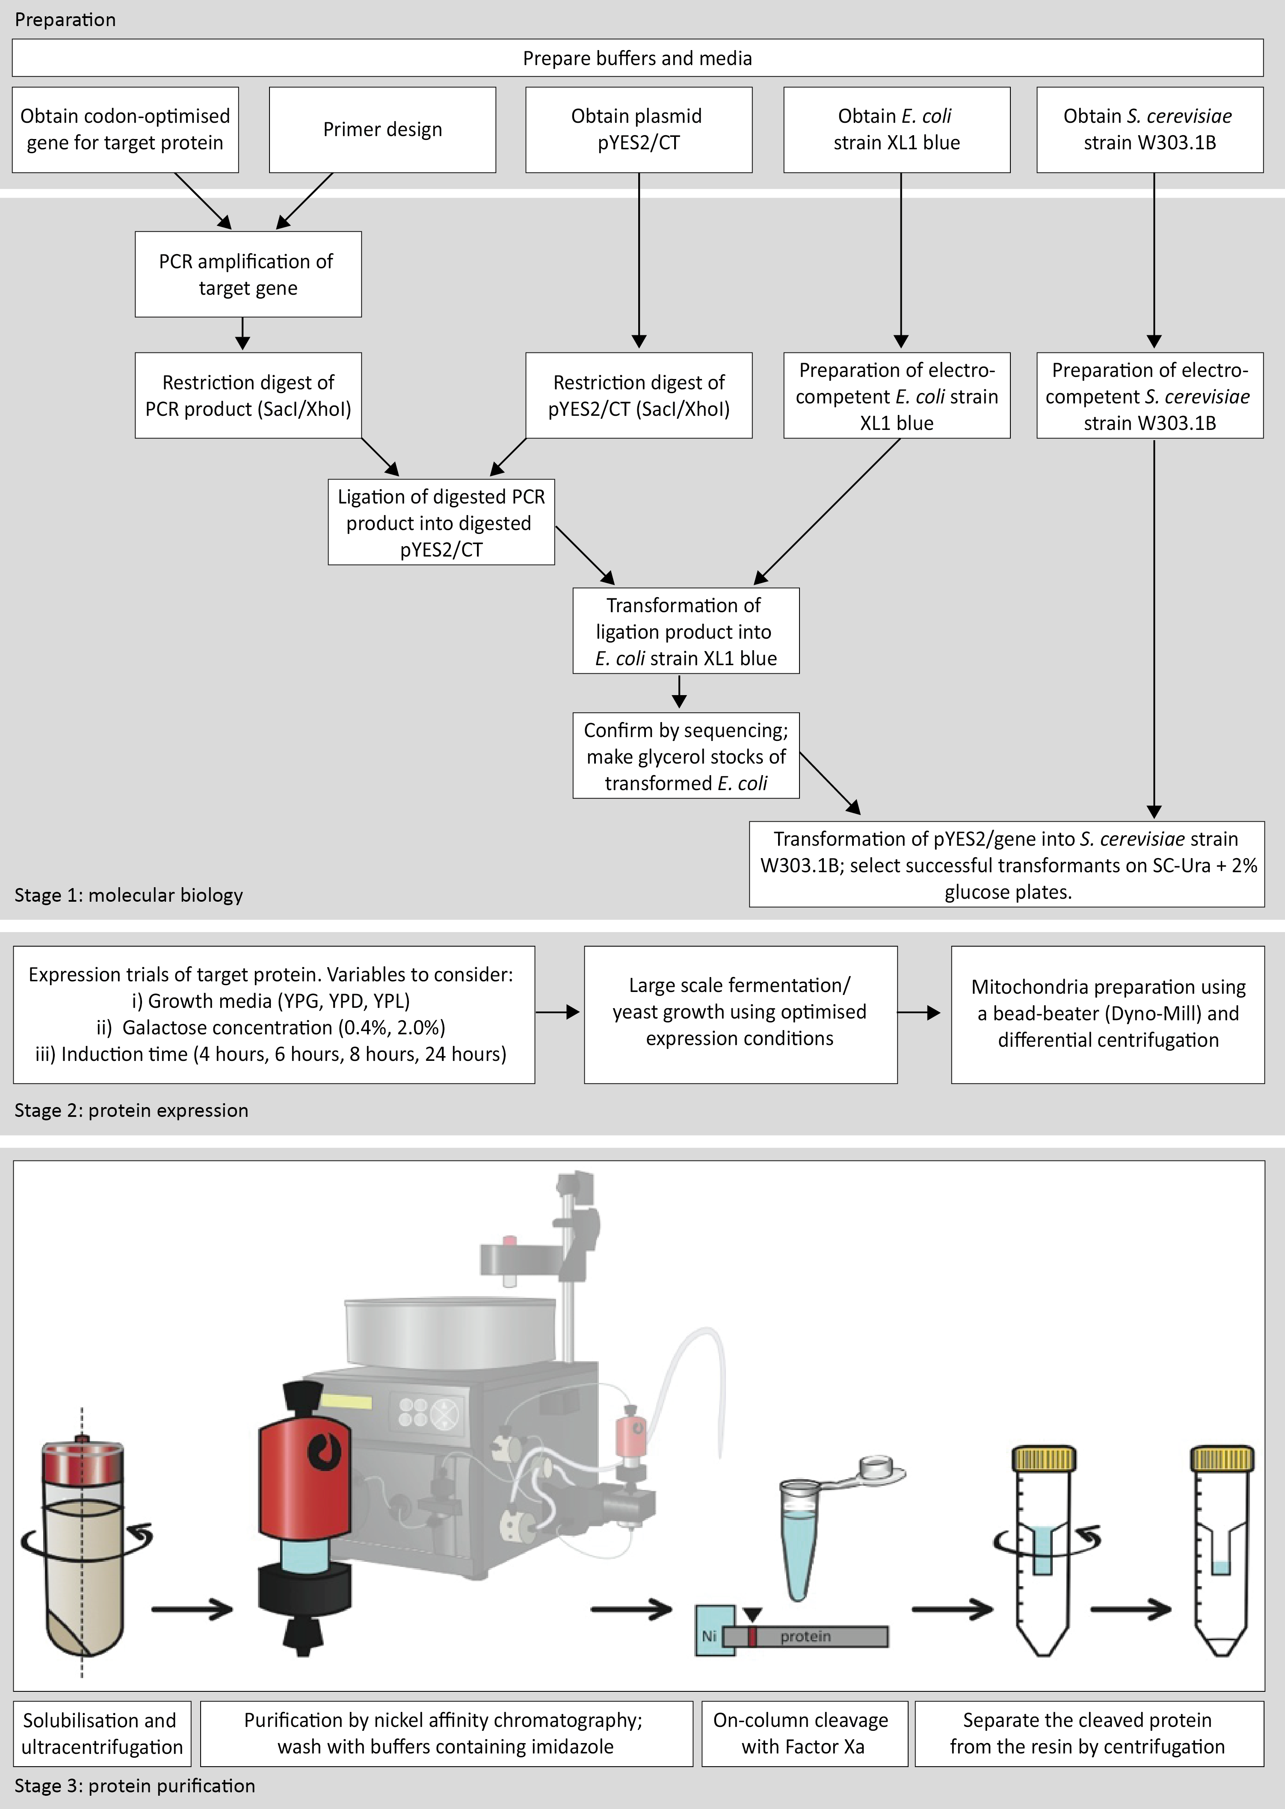

Figure 1: Workflow.

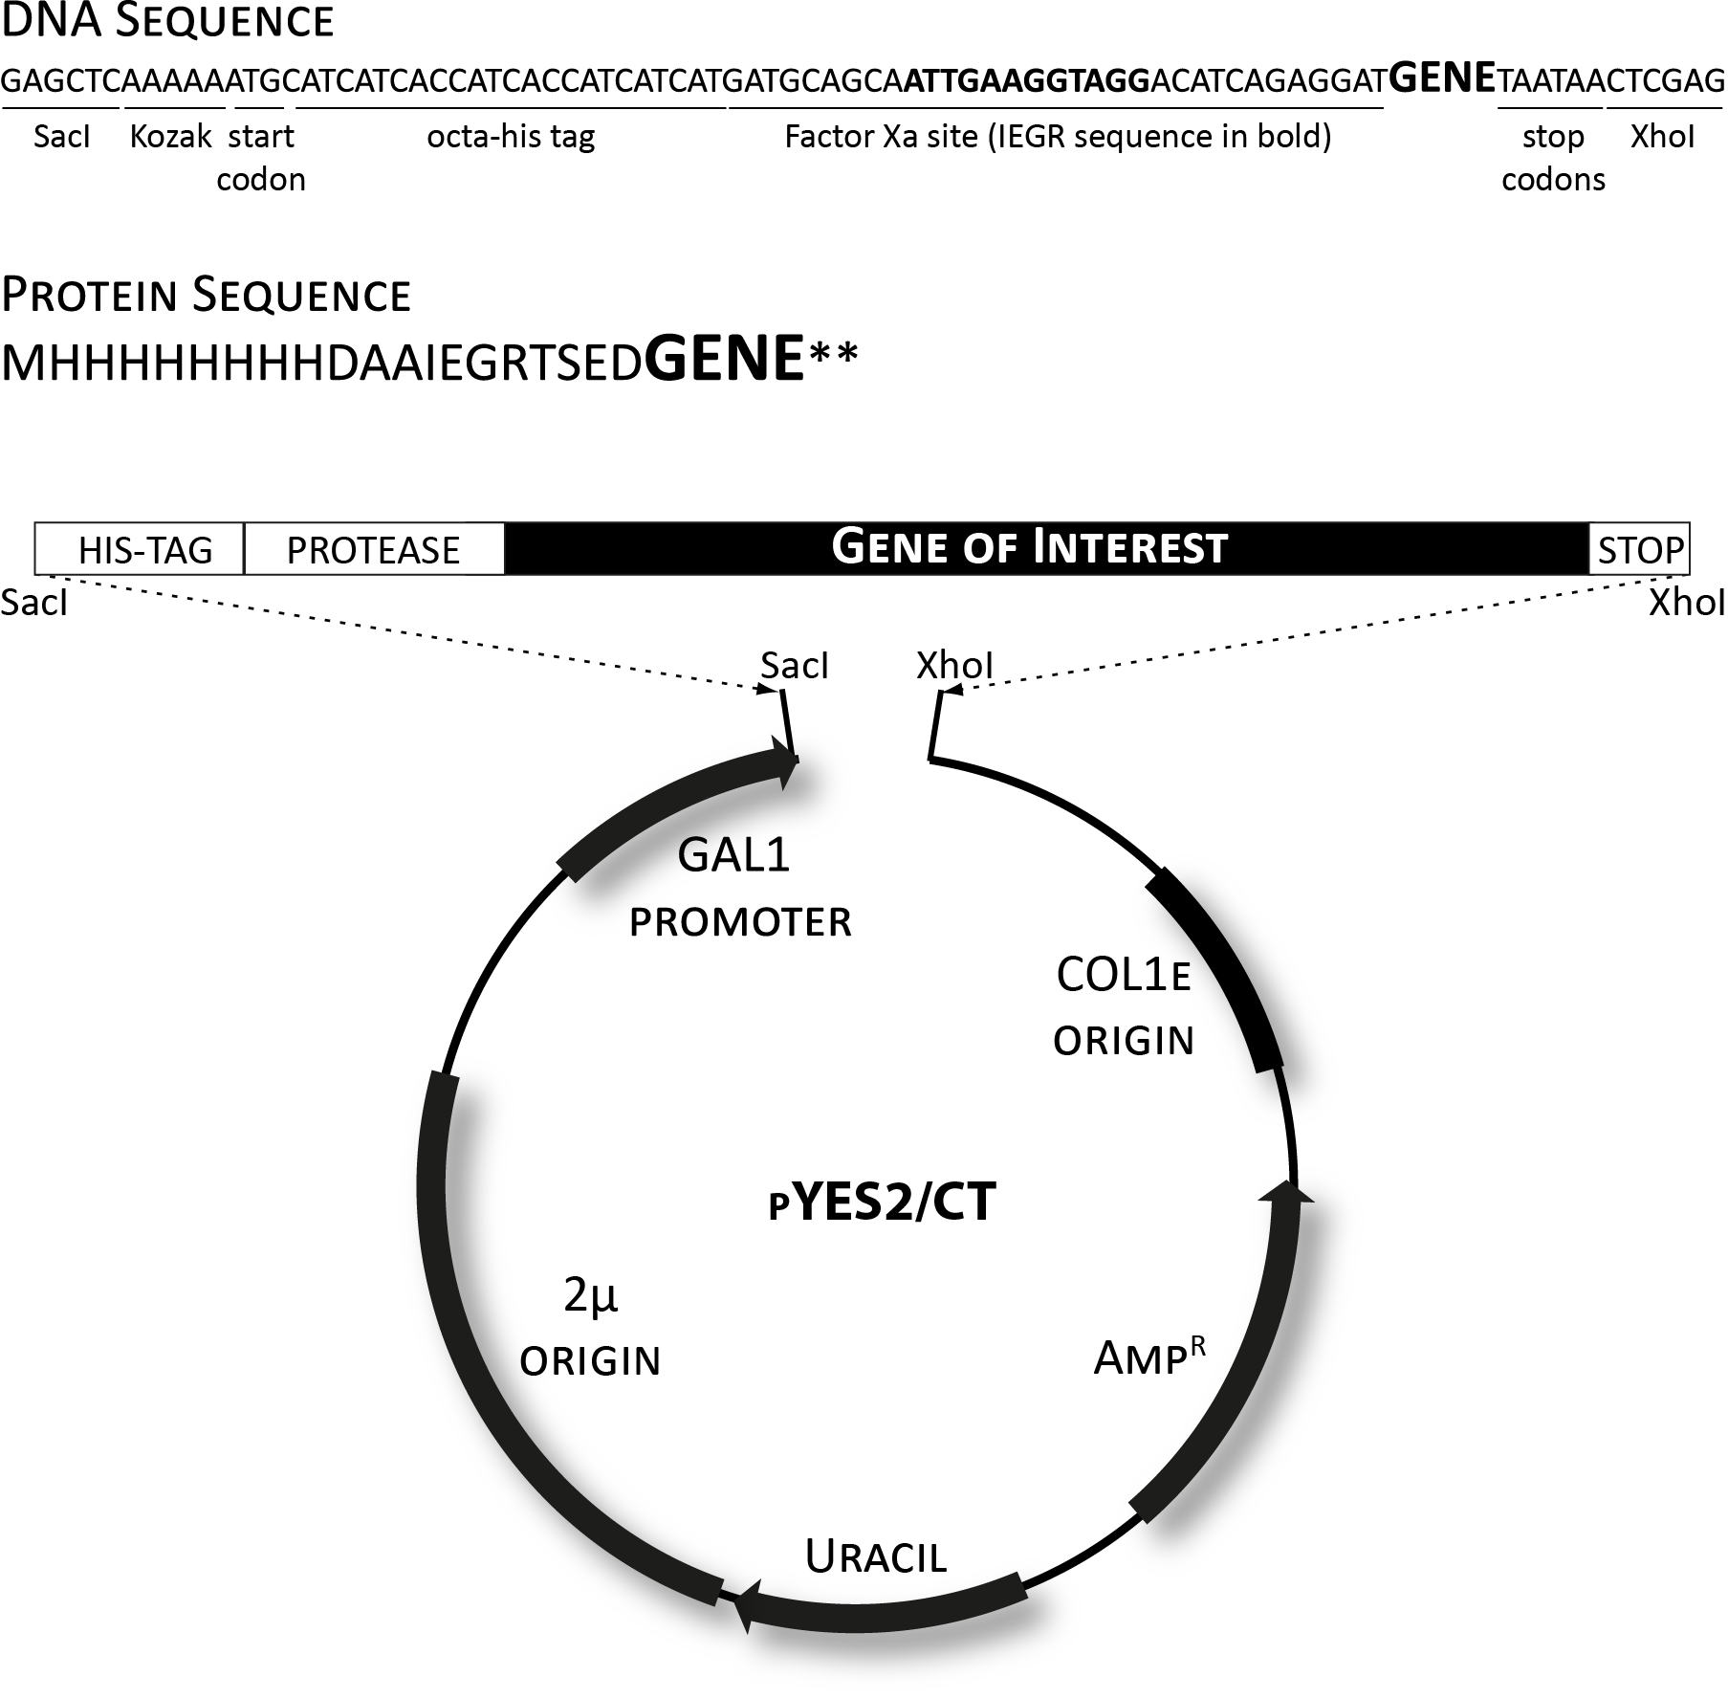

Figure 2: Construct design. We synthesise our gene product of interest with an N-terminal extension that includes a SacI restriction site, an AAAAA Kozak sequence for optimal expression in S. cerevisiae (19,20), an octa-his tag for nickel-affinity purification, and a Factor Xa recognition site for on-column cleavage. C-terminal to the gene, we include two stop codons and a XhoI restriction site.

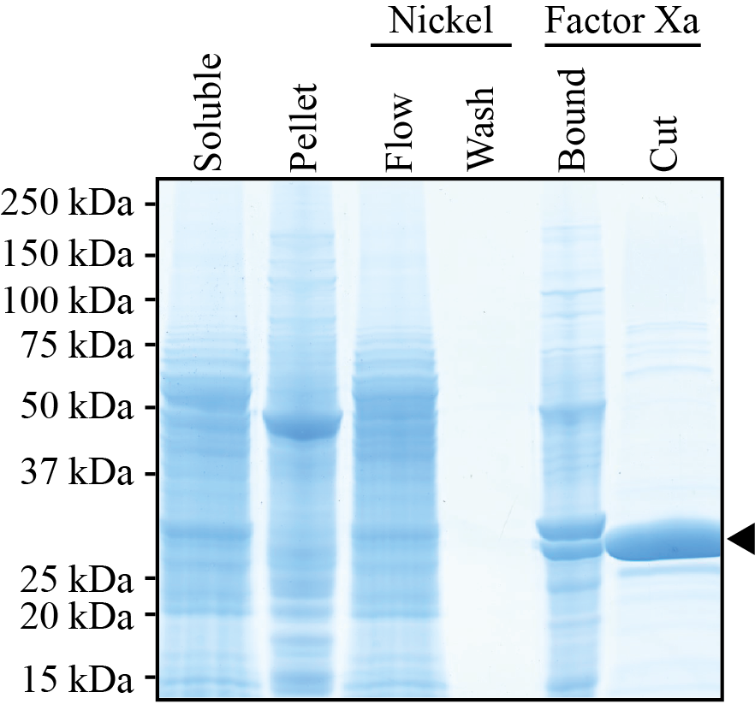

Figure 3: SDS-PAGE analysis of the purification of a mitochondrial carrier protein. The protein (33 kDa; marked with an arrow) was heterologously expressed in Saccharomyces cerevisiae, and purified using nickel affinity chromatography as described in section 3.7. Mitochondria were solubilised in 2% dodecyl maltoside, and buffers contained 0.1 mg ml⁻¹ tetraoleoyl cardiolipin. The band under the purified protein is a degradation product of the carrier, identified by mass spectrometry.

References
1. Routledge, S. J., Mikaliunaite, L., Patel, A., Clare, M., Cartwright, S. P., Bawa, Z., Wilks, M. D. B., Low, F., Hardy, D., Rothnie, A. J., and Bill, R. M. (2016) The synthesis of recombinant membrane proteins in yeast for structural studies. Methods 95, 26-37
2. King, M. S., Boes, C., and Kunji, E. R. (2015) Membrane protein expression in Lactococcus lactis. Methods in enzymology 556, 77-97
3. Contreras-Gomez, A., Sanchez-Miron, A., Garcia-Camacho, F., Molina-Grima, E., and Chisti, Y. (2014) Protein production using the baculovirus-insect cell expression system. Biotechnology Progress 30, 1-18
4. Goehring, A., Lee, C.-H., Wang, K. H., Michel, J. C., Claxton, D. P., Baconguis, I., Althoff, T., Fischer, S., Garcia, K. C., and Gouaux, E. (2014) Screening and large-scale expression of membrane proteins in mammalian cells for structural studies. Nat. Protocols 9, 2574-2585
5. King, M. S., Kerr, M., Crichton, P. G., Springett, R., and Kunji, E. R. (2016) Formation of a cytoplasmic salt bridge network in the matrix state is a fundamental step in the transport mechanism of the mitochondrial ADP/ATP carrier. Biochimica et biophysica acta 1857, 14-22
6. Ruprecht, J. J., Hellawell, A. M., Harding, M., Crichton, P. G., Mccoy, A. J., and Kunji, E. R. S. (2014) Structures of yeast mitochondrial ADP/ATP carriers support a domain-based alternating-access transport mechanism. Proc Natl Acad Sci U S A 111, E426-E434
7. Ruprecht, J. J., King, M. S., Zogg, T., Aleksandrova, A. A., Pardon, E., Crichton, P. G., Steyaert, J., and Kunji, E. R. S. (2019) The molecular mechanism of transport by the mitochondrial ADP/ATP carrier. Cell 176, 435-447
8. Bamber, L., Harding, M., Butler, P. J. G., and Kunji, E. R. S. (2006) Yeast mitochondrial ADP/ATP carriers are monomeric in detergents. Proc. Natl. Acad. Sci. U.S.A. 103, 16224-16229
9. Bamber, L., Harding, M., Monné, M., Slotboom, D. J., and Kunji, E. R. S. (2007) The yeast mitochondrial ADP/ATP carrier functions as a monomer in mitochondrial membranes. Proc. Natl. Acad. Sci. U.S.A. 104, 10830-10834
10. Bamber, L., Slotboom, D. J., and Kunji, E. R. S. (2007) Yeast mitochondrial ADP/ATP carriers are monomeric in detergents as demonstrated by differential affinity purification. J. Mol. Biol. 371, 388-395
11. Crichton, P. G., Harding, M., Ruprecht, J. J., Lee, Y., and Kunji, E. R. S. (2013) Lipid, detergent, and Coomassie Blue G-250 affect the migration of small membrane proteins in blue native gels; mitochondrial carriers migrate as monomers not dimers. J. Biol. Chem. 288, 22163-22173
12. Palmer, S. M., and Kunji, E. R. S. (2012) Online monitoring of biomass accumulation in recombinant yeast cultures. Meth. Mol. Biol. 866, 165-179
13. Palmer, S. M., and Kunji, E. R. S. (2012) Online analysis and process control in recombinant protein production (review). Meth. Mol. Biol. 866, 129-155
14. Thangaratnarajah, C., Ruprecht, J. J., and Kunji, E. R. S. (2014) Calcium-induced conformational changes of the regulatory domain of human mitochondrial aspartate/glutamate carriers. Nat Commun 5
15. Majd, H., King, M. S., Palmer, S. M., Smith, A. C., Elbourne, L. D., Paulsen, I. T., Sharples, D., Henderson, P. J., and Kunji, E. R. (2018) Screening of candidate substrates and coupling ions of transporters by thermostability shift assays. Elife 7
16. Harborne, S. P. D., King, M. S., Crichton, P. G., and Kunji, E. R. S. (2017) Calcium regulation of the human mitochondrial ATP-Mg/Pi carrier SLC25A24 uses a locking pin mechanism. Sci Rep-Uk 7
17. Hofherr, A., Seger, C., Fitzpatrick, F., Busch, T., Michel, E., Luan, J. T., Osterried, L., Linden, F., Kramer-Zucker, A., Wakimoto, B., Schutze, C., Wiedemann, N., Artati, A., Adamski, J., Walz, G., Kunji, E. R. S., Montell, C., Watnick, T., and Kottgen, M. (2018) The mitochondrial transporter SLC25A25 links ciliary TRPP2 signaling and cellular metabolism. Plos Biol 16
18. Hashimoto, M., Shinohara, Y., Majima, E., Hatanaka, T., Yamazaki, N., and Terada, H. (1999) Expression of the bovine heart mitochondrial ADP/ATP carrier in yeast mitochondria: significantly enhanced expression by replacement of the N-terminal region of the bovine carrier by the corresponding regions of the yeast carriers. Biochim Biophys Acta-Bioenergetics 1409, 113-124
19. Dvir, S., Velten, L., Sharon, E., Zeevi, D., Carey, L. B., Weinberger, A., and Segal, E. (2013) Deciphering the rules by which 5'-UTR sequences affect protein expression in yeast. Proc Natl Acad Sci U S A 110, E2792-2801
20. Hamilton, R., Watanabe, C. K., and de Boer, H. A. (1987) Compilation and comparison of the sequence context around the AUG startcodons in Saccharomyces cerevisiae mRNAs. Nucleic acids research 15, 3581-3593
21. Gietz, R. D., and Schiestl, R. H. (2007) High-efficiency yeast transformation using the LiAc/SS carrier DNA/PEG method. Nat Protoc 2, 31-34
22. Gietz, R. D., and Woods, R. A. (2002) Transformation of yeast by lithium acetate/single-stranded carrier DNA/polyethylene glycol method. Guide to Yeast Genetics and Molecular and Cell Biology, Pt B 350, 87-96
23. Chae, P. S., Rasmussen, S. G., Rana, R. R., Gotfryd, K., Chandra, R., Goren, M. A., Kruse, A. C., Nurva, S., Loland, C. J., Pierre, Y., Drew, D., Popot, J. L., Picot, D., Fox, B. G., Guan, L., Gether, U., Byrne, B., Kobilka, B., and Gellman, S. H. (2010) Maltose-neopentyl glycol (MNG) amphiphiles for solubilization, stabilization and crystallization of membrane proteins. Nat Methods 7, 1003-1008
24. Crichton, P. G., Lee, Y., Ruprecht, J. J., Cerson, E., Thangaratnarajah, C., King, M. S., and Kunji, E. R. (2015) Trends in thermostability provide information on the nature of substrate, inhibitor, and lipid interactions with mitochondrial carriers. J Biol Chem 290, 8206-8217
25. Klingenberg, M. (2009) Cardiolipin and mitochondrial carriers. Biochimica et biophysica acta 1788, 2048-2058
26. Lee, Y., Willers, C., Kunji, E. R., and Crichton, P. G. (2015) Uncoupling protein 1 binds one nucleotide per monomer and is stabilized by tightly bound cardiolipin. Proc Natl Acad Sci U S A 112, 6973-6978
27. Horvath, S. E., and Daum, G. (2013) Lipids of mitochondria. Prog Lipid Res 52, 590-614

