The evolving role of multiparametric MRI in prostate cancer work-up

Tristan Barrett^{1,2,}
1) Department of Radiology, University of Cambridge, Cambridge, UK
2) CamPARI Clinic, Addenbrooke’s Hospital and University of Cambridge, Cambridge, UK

Corresponding author:
Tristan Barrett (email: tb507@medschl.cam.ac.uk, phone: +441223 336895, fax: +441223 330915)
Department of Radiology, Addenbrooke’s Hospital and University of Cambridge, Cambridge, CB2 0QQ, UK

Abstract
Prostate cancer is the leading cause of cancer death in men after skin cancer, with an incidence expected to double by 2030 mainly due to the ageing population. However, many more men die with prostate cancer rather than from the disease, highlighting the indolent nature of many tumours.
Recently, multiparametric MRI has revolutionised the work-up of prostate cancer, becoming a routine part of clinical practice and migrating earlier in the diagnostic pathway. However, the technique remains challenging, with patient-related factors, intrinsic insensitivity of MRI, protocol differences, and radiologist experienced all combining to limit its overall accuracy. Anatomical T2-weighted imaging is limited by the non-specific nature of its findings and improvements have mainly been driven by the addition of functional sequences such as diffusion-weighted imaging, dynamic contrast-enhanced MRI and spectroscopy. In the absence of validated circulating biomarkers, only functional imaging currently offers the potential for further improvements in lesion detection and characterisation, with the additional advantages of providing whole gland coverage of the prostate and being non-invasive. An overview of the evolving role of prostate multiparametric MRI is provided, along with its strengths and weaknesses and an exploration of how it can help overcome limitations in the traditional work-up of patients.

Epidemiology of prostate cancer
Prostate cancer (PCa) is the most common non-cutaneous malignancy in men worldwide, and accounts for almost 1-in-5 of all new male cancer diagnoses [1]. In 2015 there were 46,690 new cases in the UK, with the global incidence of the disease expected to double by 2030 in part due to the ageing population [2, 3]. Despite the high incidence overall prognosis is good, with the cancer-specific survival being 84% at 10 years [2].
In 1986 the US Food and Drug Administration (FDA) approved the prostate-specific antigen (PSA) test for monitoring PCa progression, and in 1994 approved its use alongside digital rectum examination (DRE) to test asymptomatic men. This introduction led to a spike in incidence in the early 1990s (Figure 1.) due to a surge in the detection of asymptomatic disease [4]. The name PSA is a misnomer as it is not specific to the prostate and is known to be produced in the lung and salivary glands, and may even be expressed by breast, ovarian and endometrial tumours [5]. Moreover, it is not specific to cancer of the prostate and can be raised in benign prostatic hypertrophy (BPH), inflammation, infection, and trauma.
Several screening studies have attempted to quantify the benefit of PSA as a screening test, the largest being the USA Prostate, Lung, Colorectal and Ovarian (PLCO) cancer screening trial and the European Randomized Study of Screening for Prostate Cancer (ERSPC). The PLCO study reported more diagnoses of PCa in the screened group at 10 years, but with a similar death-rate in each arm [6]. Although an upper limit of normal PSA is quoted as 4.0 ng/ml for men aged over 60 years, many men with PSA below this threshold will have cancer, and PSA therefore represents a continuum of risk at all values [7]. The sensitivity and specificity of a raised PSA at >4.1 ng/ml is 20% and 94%, respectively [8]; this low sensitivity arguably means PSA fails the primary goal of a screening test, namely detecting cancer. Current European and US guidelines from the Preventive Services Task Force (USPSTF) therefore do not recommend population screening for prostate cancer [9]. More recently the incidence of prostate cancer in the US has declined dramatically and by more than 10% annually from 2010 to 2013, which likely relates directly to the USPSTF recommending against routine use of PSA for screening purposes [1].
1.2 Potential for over-diagnosis
While 1-in-6 men are diagnosed with prostate cancer, only 1-in-36 will die from the disease [10]. This highlights the indolent nature of many of the tumours currently diagnosed and it remains true that many more men will die with prostate cancer than directly because of the disease.
The introduction of PSA testing dramatically changed the profile of patients presenting with prostate cancer. The average age at presentation reduced from 64 to 59 years, index lesion volume reduced by more than 50% with fewer tumours therefore detectable by DRE, and the majority now present with low risk rather than high risk disease [11]. Additionally, soon after widespread PSA use, the average PSA level at presentation had reduced from 25 to 8 ng/ml, whilst the average gland volume increased from 44 to 53 cm³, meaning that a raised PSA at baseline shifted from being indicative of cancer to being more likely to be due to BPH [12]; Figure 2. The implication is that this practice has led to the over-diagnosis of clinically insignificant cancer that would not otherwise have resulted in symptoms or cancer-related death [13]. Indeed, whilst the overall incidence of prostate cancer has declined over the last 10 years, the rates for higher stage and distant disease have remained stable in the same period [14], suggesting that the tempered use of PSA screening has helped to reduce the diagnosis of indolent disease. However, there remains the risk that current urological practice may serve to exacerbate the problem of over-diagnosis. Repeating PSA tests, using a lower PSA threshold for performing prostatic biopsy, taking more cores at biopsy, and repeating a biopsy after initial negative results, are all factors which are likely to lead to a further increase in the incidence of lower grade, smaller volume, and relatively indolent cancer [11].
1.3 Risk of over-treatment
Over-diagnosis in itself is not a problem, but this potentially leads to over-treatment of indolent disease, which is an issue due to the associated risk of significant morbidity. The traditional radical treatment of prostate cancer with either prostatectomy or external beam radiation therapy carries with it a 50-60% risk of erectile dysfunction and, although the rates of severe urinary incontinence are low, as many as 30% continue to report some symptoms at long-term follow-up [15-17].
It is estimated that in screen-detected populations, 48 men will need to undergo treatment to prevent 1 prostate cancer death [18]; this ratio compares unfavourably with breast cancer screening programs where 3 patients need treatment to prevent 1 death [19]. Indeed, the USPSTF recommendations against PSA for screening purposes are mainly based on t m hese growing concerns about over-treatment [9]. Active surveillance (AS) has recently emerged as a means of addressing such over-treatment and is now recommended as the management strategy of choice in men with low-risk localized prostate cancer for whom radical therapy remains a suitable option [20]. This approach is supported by emerging Level 1 evidence that not all men diagnosed with prostate cancer need active treatment, and that radical curative therapy only benefits those with more aggressive, high-risk disease [21, 22].
Risk of under-treatment
Prostate cancer is almost unique amongst solid organ tumours in that it is predominantly diagnosed by an indirect, non-targeted method. The standard diagnostic test for clinically suspected prostate cancer remains transrectal ultrasound (TRUS) guided biopsy. The biopsy needle is “guided”, but only to the prostate gland rather than to a tumour and systematically under-samples the anteriorly gland, the midline and the extreme apex. Ultimately only 1% of the gland is sampled and therefore TRUS biopsy is unsurprisingly prone to sampling error [23]. It is well established that TRUS biopsy underestimates aggressiveness in approximately one-third of cases [24], underestimates volume in around one-half of cases, and may miss up to 50% of clinically significant tumours [25]. Therefore, whilst over-treatment is a concern there is also a real risk of traditional diagnostic pathways resulting in under-treatment due to misclassifying cancers as being less aggressive or incorrectly categorizing patients as being tumour free.
Role of Imaging in Prostate Cancer
Given this potential for both under- and over-treatment, there needs to be a rethink in how we diagnostically work-up patients. Aside from PSA< there are several blood tests available that may serve as indicators of prostate cancer including PCA-3, the 4K score test, and the Prostate health index, and with increasing excitement about a potential role for circulating tumour DNA [26]. However, there are currently no blood or urine-based biomarkers that can reliably detect the presence of a high-grade aggressive tumour in the prostate [27]. Realistically, imaging offers the greatest potential of differentiating these more aggressive, lethal cancers. Imaging has traditionally performed a limited role of in the staging of higher risk tumours, with MRI being used for local staging and CT or bone scintigraphy for more distal nodal and bone metastases. However, multi-parametric MRI (mp-MRI), incorporating multi-planar T₂-weighted, and functional diffusion-weighted imaging, has now been validated as a means of detecting prostate tumours [28, 29].
Alongside accurate risk stratification of prostate tumours, another driver to improved tumour detection and localisation is to aid biopsy targeting. A recent meta-analysis demonstrated that in the re-biopsy population, mpMRI increased the detection rates of significant cancers by 54% and reduced insignificant (indolent) cancer detection by 18% [30]. As a result, some authors even suggest that MRI should replace TRUS biopsy as the initial diagnostic test for prostate cancer to enable guidance of subsequent biopsy [31]. However, the data is less convincing in biopsy naïve patients, where mpMRI-guided prostate biopsy only marginally increases the detection rates of significant disease by 10%, although it remains of benefit in reducing detection of insignificant cancer by 49% [30].
The diagnostic gain of pre-biopsy MRI also has to be balanced against the restrictions of cancer diagnosis targets and the difficulty in obtaining MRI slots at short notice. Reserved MRI slots may be difficult to justify if (even occasionally) they are left unfilled, given that MRI is a relatively scarce resource. However, the recently published Prostate MRI Imaging Study (PROMIS) supports the practice of MRI prior to biopsy and is likely to influence future management guidelines [32]. PROMIS demonstrated that mpMRI in biopsy-naïve patients outperforms systematic TRUS biopsy, the current standard of care, diagnosing up to 18% more cases of clinically significant cancer and 5% fewer clinically insignificant cancers. Performing mpMRI as a triage test could potentially avoid unnecessary biopsy in 27% of patients. Clearly the increased use of MRI in biopsy naïve patients brings additional challenges, with the emphasis of radiological interpretation shifting from one of basic staging to lesion detection and characterisation, in order to direct subsequent sampling.
What is prostate multiparametric MRI?
Multiparametric (mp) MRI of the prostate is the addition of functional imaging to standard anatomical T1 and T2-weighted imaging [33]. The available functional sequences include diffusion-weighted imaging (DWI) with calculation of apparent diffusion co-efficient (ADC) maps, dynamic contrast-enhanced (DCE) MRI, and spectroscopy.
Anatomical T2 weighted imaging was the earliest available sequence and remains the optimal sequence for assessment of the transition zone (TZ). Its value in the peripheral zone (PZ) where tumour appears as low signal intensity is more limited due to a number of benign conditions which mimic this appearance, including prostatic intraepithelial neoplasia (PIN), prostatitis, haemorrhage, atrophy, scarring, and post-treatment change [34-36].
DWI is an MR technique that images the diffusivity of water molecules and does not require administration of an exogenous contrast agent. Tumours will typically demonstrate restricted diffusion due to increased cellularity preventing extracellular diffusion of water and an increased nuclear:cytoplasmic ratio, which limits intracellular diffusion.
DCE-MRI requires intravenous administration of a low molecular weight Gadolinium chelate. Tumours form their own blood vessels once they grow above a certain size, however, this neo-angiogenesis is disorganised. The resulting porous endothelia allow low molecular weight Gadolinium agents to rapidly wash into the tumour interstitium, visualised as early contrast-enhancement, and subsequently rapidly washes-out. Analysis of DCE MRI curves is effective in breast disease as the pattern can differentiate benign and malignant lesions - a Type I curve (slow, continuous enhancement) is rarely associated with malignancy (~9%), whereas a Type 3 pattern (early enhancement with subsequent wash-out) has 90.4% specificity for cancer [37]. However, DCE-curvology does not work well in the prostate because benign conditions such as prostatitis and hypervascular BPH nodules can have a Type 3 curve, and it is more common for tumours to demonstrate a Type 2 curve (early enhancement and plateau) making it difficult to accurately differentiate malignancy [38]. As a result, the role of DCE-MRI has been significantly downplayed in the Prostate Imaging Reporting and Data System (PI-RADS) guidelines, version 2 [39].
MR spectroscopic imaging is challenging, often requiring significant post-processing and additional input from physicists. The paradigm for MR spectroscopy is based on tumour cell proliferation and cell membrane turnover leading to an increased amount of choline, with a corresponding reduction in citrate levels, a metabolite produced by normal prostatic tissue and therefore a marker of benign tissue. The low sensitivity (16%) makes spectroscopy poor for lesion detection, and although it has an excellent specificity (approaching 100%) and can improve lesion characterisation, the incremental benefit is comparatively small [40], in particular relative to the step-wise increase in costs incurred [41]. As a result, the most recent version of the PI-RADS guidelines have dropped spectroscopy and “mpMRI” therefore should incorporate T2-weighted imaging, DWI and DCE-MRI [42]; Figure 3.
Limitations of mpMRI
MR imaging quality is in general less reproducible between centres than CT, plain film or ultrasound. The reasons are multifactorial and include magnet strength, coil employed (endorectal coil versus body coil, number of elements), software version being run and protocol set-up (e.g., choice of b-values for DWI). This makes inter-centre comparison challenging, particularly for quantifiable measurements derived from the functional sequences of DWI and DCE-MRI. Other inter-patient factors that may be difficult to control include artefact due to prior biopsy, hip metalwork, or rectal loading and tumour-specific factors, including a sparse growth pattern [43]. Another variable to consider is the experience of the radiologist, with there being a known learning curve for radiologists to acquire sub-specialist interpretation skills [44, 45]. There is no data on how many prostate mpMRIs should be reported to reach the top of this learning curve, but anecdotally 100-150 reports need to second reported by an experienced reader, with additional direct pathology feedback in order to achieve an appropriate competence [46]. In order to maintain competency levels, it is recommended that radiologists report at least 50 mpMRIs per year, audit their outcomes, and regularly attend tumour board meetings in which pathology results are discussed [32]. It is with these MRI protocol-related and radiologist-specific factors in mind that the European Society of Urogenital Radiology (ESUR) devised the PI-RADS recommendations, first published in 2012 and subsequently updated in late 2014, in order to standardise the acquisition, interpretation and reporting of prostate MRI [42].
How good is prostate mpMRI?
Although anatomical T2-weighted imaging complemented by functional diffusion-weighted imaging can be used for lesion detection, current mpMRI has inherent limitations, and the technique performs particularly poorly for detection of lower grade lesions, or those <0.5 cm³ in size [47]. Studies report considerable variability, with sensitivity for cancer detection ranging from 53-100% and specificity 32-97%, and being dependant on the composition of the cohort selected, the gold standard employed, and technical factors [48, 49].
A systematic review incorporating studies published up to February 2012, and therefore prior to the introduction of PI-RADS, showed MRI to have a pooled sensitivity of 74% and specificity of 88% [50]. An updated review incorporating PI-RADS version 1 suggested a pooled sensitivity of 82% and specificity of 82% in studies with the correct use of PI-RADS [51]. A more recent PI-RADS era review of 21 studies (3,857 patients) published in 2015-2016, with all patients being imaged after 2010, showed mpMRI to have a sensitivity of 89% and specificity 74% for high probability lesions [48]. In studies directly comparing PI-RADS versions 1 and 2, it is noteworthy that version 2 resulted in an increased sensitivity (95% compared to 88%), without a reduction in specificity, which may relate to the improved inter-observer agreement demonstrated with PI-RADS version 2, particularly in the PZ [52, 53]. This progressive increase in sensitivity at the expense of specificity is beneficial clinically, particularly if MRI is to be used to avoid biopsy. To this end, the negative predictive value of mpMRI as a rule-out test in a systematic review of 48 studies (9,613 patients) was reported to be 82.4% for any cancer and 88.1% for Gleason ≥3+4 cancer [54]. This compares favourably to the current “gold standard” of systematic TRUS biopsy with an NPV of around 75% for clinically significant cancer [32]. It should be noted, however, that NPV is not intrinsic to the test itself and will vary depending on the cancer prevalence within the cohort. The same review reported NPV to range 68.4-100%, with a close inverse correlation to cancer prevalence of 13-74.7% [54], and Woo et al [48] noted a specificity for cancer detection of only 65% in studies where cancer prevalence was below 50%, but rising to 86% when >50%. In should also be remembered that studies within the literature need to also be considered in terms of heterogeneity of the patient population, the gold standard employed (a surgical cohort will introduce bias such as operative suitability), and the exclusion criteria applied, such as presence of MRI artefact, haemorrhage or metalwork, meaning these may not necessarily be reflective of a standard clinical reporting list.
Despite the strengths of mpMRI, the inherent limitations in special resolution and technical susceptibility of the current functional sequences highlight the need for further improvement, or the development of novel functional sequences. Indeed, the most recent version of the PI-RADS guidelines strongly supports the continued development of novel sequences including diffusion tensor (DTI), diffusional kurtosis imaging (DKI), multiple b-value assessment of fractional ADC, and intravoxel incoherent motion (IVIM) [42]. The pressures of clinical throughput, however, mean that new MRI sequences cannot necessarily be added to every study performed, unless they provide a significant step-wise improvement over the existing clinical protocols.
Summary
PSA testing has dramatically changed the profile of men presenting with prostate cancer which brings the risk of over-diagnosing and over-treatment of relatively indolent disease. Contrary to this there is a real risk of under-treatment due to the limitations of the traditional diagnostic pathway resulting in under-grading or missing tumours. Imaging with mpMRI has a potential role to play in mitigating these risks and, in the absence of reliable blood or urine markers biomarkers, realistically offers the greatest potential for differentiating more aggressive, lethal cancers.
Prostate MRI has evolved from morphological staging to more accurate localisation of tumours and is being used earlier in the diagnostic pathway. Although it is a difficult technique to perform and interpret, good performance can be attained in practise when the quality of the diagnostic process can be assured (including PI-RADS compliant MR imaging protocols, image interpretation, reporting and communication, and biopsy procedures), backed up by the robust training of radiologists and urologists working jointly within multidisciplinary teams. In this context, mpMRI can detect the majority of tumours capable of causing harm, with the test performance being independent of the exact criteria used to define clinically significant disease.

References
[1] Siegel RL, et al. Cancer Statistics, 2017. CA Cancer J Clin. 2017; 67(1):7-30
[2] Cancer Research UK Cancer Statistics, 2016: http://www.cancerresearchuk.org/
Last accessed January 12, 2018
[3] Maddams J, et al. Projections of cancer prevalence in the United Kingdom, 2010– 2040. Br J Cancer 2012; 107:1195–1202
[4] Potosky AL, et al. The role of increasing detection in the rising incidence of prostate cancer. JAMA. 1995; 273:548-552
[5] Zarghami N, et al. Expression of the prostate specific antigen gene by lung tissue. Clin Cancer Res. 1997; 3(7):1201-6
[6] Grubb RL 3rd, et al. Prostate cancer screening in the Prostate, Lung, Colorectal and Ovarian cancer screening trial: update on findings from the initial four rounds of screening in a randomized trial. BJU Int. 2008;102(11):1524-30
[7] Thompson IM, et al. Operating characteristics of prostate-specific antigen in men with an initial PSA level of 3.0 ng/ml or lower. JAMA. 2005; 294(1):66-70
[8] Thompson IM, et al. Prevalence of prostate cancer among men with a prostate-specific antigen level < or =4.0 ng per milliliter. NEJM 2004;350:2239-46
[9] Moyer VA; US Preventive Services Task Force. Screening for prostate cancer: U.S. Preventive Services Task Force recommendation statement. Ann Intern Med. 2012; 157:120-134
[10] American Cancer Society: Cancer Facts and Figures 2013. Atlanta, Ga. Available at: https://www.cancer.org/research/cancer-facts-statistics/all-cancer-facts-figures/cancer-facts-figures-2017.html
Last accessed January 12, 2018
[11] Welch HG, Albertsen PC. Prostate cancer diagnosis and treatment after the introduction of prostate-specific antigen screening: 1986-2005. J Natl Cancer Inst. 2009; 101(19):1325-9
[12] Stamey TA, et al. The prostate specific antigen era in the United States is over for prostate cancer: what happened in the last 20 years? J Urol 2004; 172:1297-301
[13] Klotz L. Prostate cancer overdiagnosis and overtreatment. Curr Opin Endocrinol Diabetes Obes 2013; 20:204–209
[14] Surveillance, Epidemiology, and End Results (SEER) Program. SEER*Stat Database: Incidence-SEER 9 Regs Research Data with Delay-Adjustment, Malignant Only, Nov. 2015 Sub (1975-2013) <Katrina/Rita Population Adjustment>-Linked To County Attributes-Total US, 1969-2014 Counties. Bethesda, MD: National Cancer Institute, Division of Cancer Control and Population Sciences, Surveillance Research Program, Surveillance Systems Branch; 2016
[15] Ficarra V, et al. Retropubic, laparoscopic, and robot-assisted radical prostatectomy: a systematic review and cumulative analysis of comparative studies. Eur Urol. 2009; 55(5):1037-63
[16] Locally advanced prostate cancer: effective treatments, but many adverse effects. Prescrire Int. 2013; 22(134):18-20, 22-3
[17] Mendenhall WM, et al. Erectile dysfunction after radiotherapy for prostate cancer. Am J Clin Oncol. 2009; 32(4):443-7
[18] Schröder FH, et al; ERSPC Investigators. Screening and prostate-cancer mortality in a randomized European study. N Engl J Med 2009; 360:1320–1328
[19] Independent UK Panel on Breast Cancer Screening. The benefits and harms of breast cancer screening: an independent review. Lancet 2012; 380:1778–1786
[20] Barrett T, Haider MA. The Emerging Role of MRI in Prostate Cancer Active Surveillance and Ongoing Challenges. AJR Am J Roentgenol. 2017; 208(1):131-139
[21] Wilt TJ, et al. Prostate Cancer Intervention versus Observation Trial (PIVOT) Study Group. Radical prostatectomy versus observation for localized prostate cancer. N Engl J Med. 2012; 367(3):203-13
[22] Hamdy FC, et al. 10-Year Outcomes after Monitoring, Surgery, or Radiotherapy for Localized Prostate Cancer. N Engl J Med. 2016; 375(15):1415-1424
[23] Murphy G, et al. The expanding role of MRI in prostate cancer. AJR 2013; 201:1229–1238
[24] Kvåle R, et al. Concordance between Gleason scores of needle biopsies and radical prostatectomy specimens: a population-based study. BJU Int. 2009; 103(12):1647-54
[25] Hu Y, et al. A biopsy simulation study to assess the accuracy of several transrectal ultrasonography (TRUS)-biopsy strategies compared with template prostate mapping biopsies in patients who have undergone radical prostatectomy. BJU Int 2012; 110:812–820
[26] Gnanapragasam VJ, Burling K, George A, Stearn S, Warren A, Barrett T, et al. The Prostate Health Index adds predictive value to multi-parametric MRI in detecting significant prostate cancers in a repeat biopsy population. Sci Rep. 2016; 6:35364
[27] Wadhwa K, Barrett T, Kastner C. The post PSA era: new developments in biomarkers, imaging and biopsy techniques in prostate cancer detection. Trends in Urology & Men's Health. 2015; 6(4):25-29. doi: 10.1002/tre.470
[28] Siddiqui MM, et al. Comparison of MR/ultrasound fusion-guided biopsy with ultrasound-guided biopsy for the diagnosis of prostate cancer. JAMA. 2015; 313(4):390-7
[29] Lawrence EM, et al. The emerging role of diffusion-weighted MRI in prostate cancer management. Nat Rev Urol 2012; 9(2):94-101
[30] Schoots IG, et al. Magnetic resonance imaging-targeted biopsy may enhance the diagnostic accuracy of significant prostate cancer detection compared to standard transrectal ultrasound-guided biopsy: a systematic review and meta-analysis. Eur Urol. 2015; 68(3):438-50
[31] Kirkham AP, et al. Prostate MRI: who, when, and how? Report from a UK consensus meeting. Clin Radiol. 2013; 68(10):1016-23
[32] Ahmed HU, et al. Diagnostic accuracy of multi-parametric MRI and TRUS biopsy in prostate cancer (PROMIS): a paired validating confirmatory study. Lancet 2017; 389(10071): 815-22
[33] Barrett T. What is Multiparametric-MRI of the Prostate and Why Do We Need It? J Imag Int Rad. 2016; 1(2):1-5
[34] De Visschere PJ, et al. Multiparametric magnetic resonance imaging characteristics of normal, benign and malignant conditions in the prostate. Eur Radiol. 2017; 27(5):2095-2109
[35] Barrett T, et al. Value of the hemorrhage exclusion sign on T1-weighted prostate MR images for the detection of prostate cancer. Radiology. 2012; 263(3):751-7
[36] Xu Y, et al. The benign mimickers of prostatic acinar adenocarcinoma. Chin J Cancer Res. 2016; 28(1):72-9
[37] Macura KJ, et al. Patterns of enhancement on breast MR images: interpretation and imaging pitfalls. Radiographics. 2006; 26(6):1719-34
[38] Hansford BG, et al. Dynamic Contrast-enhanced MR Imaging Curve-type Analysis: Is It Helpful in the Differentiation of Prostate Cancer from Healthy Peripheral Zone? Radiology. 2015; 275(2):448-57
[39] Barrett T, et al. PI-RADS version 2: what you need to know. Clin Radiol. 2015; 70(11):1165-76
[40] Turkbey B, et al. Multiparametric 3T prostate magnetic resonance imaging to detect cancer: histopathological correlation using prostatectomy specimens processed in customized magnetic resonance imaging based molds. J Urol. 2011; 186(5):1818-24
[41] Mowatt G, et al. The diagnostic accuracy and cost-effectiveness of magnetic resonance spectroscopy and enhanced magnetic resonance imaging techniques in aiding the localisation of prostate abnormalities for biopsy: a systematic review and economic evaluation. Health Technol Assess. 2013; 17(20):vii-xix, 1-281
[42] Barentsz JO, et al; European Society of Urogenital Radiology ESUR prostate MR guidelines 2012. Eur Radiol. 2012; 22(4):746-57
[43] Langer DL, et al. Intermixed normal tissue within prostate cancer: effect on MR imaging measurements of apparent diffusion coefficient and T2-sparse versus dense cancers. Radiology. 2008; 249(3):900-8
[44] Rosenkrantz AB, et al. The Learning Curve in Prostate MRI Interpretation: Self-Directed Learning Versus Continual Reader Feedback. AJR Am J Roentgenol. 2017; 208(3):W92-W100
[45] Gaziev G, Wadhwa K, Barrett T, et al. Defining the learning curve for multiparametric magnetic resonance imaging (MRI) of the prostate using MRI-transrectal ultrasonography (TRUS) fusion-guided transperineal prostate biopsies as a validation tool. BJU Int. 2016; 117(1):80-6
[46] Puech P, et al. How are we going to train a generation of radiologists (and urologists) to read prostate MRI? Curr Opin Urol. 2015; 25(6):522-35
[47] Lemaitre L, et al. Dynamic contrast-enhanced MRI of anterior prostate cancer: Morphometric assessment and correlation with radical prostatectomy findings. Eur Radiol. 2009; 19:470–8
[48] Woo S, et al. Diagnostic Performance of Prostate Imaging Reporting and Data System Version 2 for Detection of Prostate Cancer: A Systematic Review and Diagnostic Meta-analysis. Eur Urol. 2017; 72(2):177-188
[49] Turkbey B, et al. Imaging localized prostate cancer: current approaches and new developments. AJR Am J Roentgenol. 2009; 192(6):1471-80
[50] de Rooij M, et al. Accuracy of multiparametric MRI for prostate cancer detection: a meta-analysis. AJR Am J Roentgenol. 2014; 202(2):343-51
[51] Hamoen EHJ, et al. Use of the Prostate Imaging Reporting and Data System (PI-RADS) for Prostate Cancer Detection with Multiparametric Magnetic Resonance Imaging: A Diagnostic Meta-analysis. Eur Urol. 2015; 67(6):1112-1121
[52] Rosenkrantz AB, et al. Interobserver Reproducibility of the PI-RADS Version 2 Lexicon: A Multicenter Study of Six Experienced Prostate Radiologists. Radiology 2016; 280:793–804
[53] Muller BG, et al. Prostate Cancer: Interobserver Agreement and Accuracy with the Revised Prostate Imaging Reporting and Data System at Multiparametric MR Imaging. Radiology. 2015; 277(3):741-50
[54] Moldovan, et al. What Is the Negative Predictive Value of Multiparametric Magnetic Resonance Imaging in Excluding Prostate Cancer at Biopsy? A Systematic Review and Meta-analysis from the European Association of Urology Prostate Cancer Guidelines Panel. Eur Urol. 2017; 72(2):250-266

Figure Legends
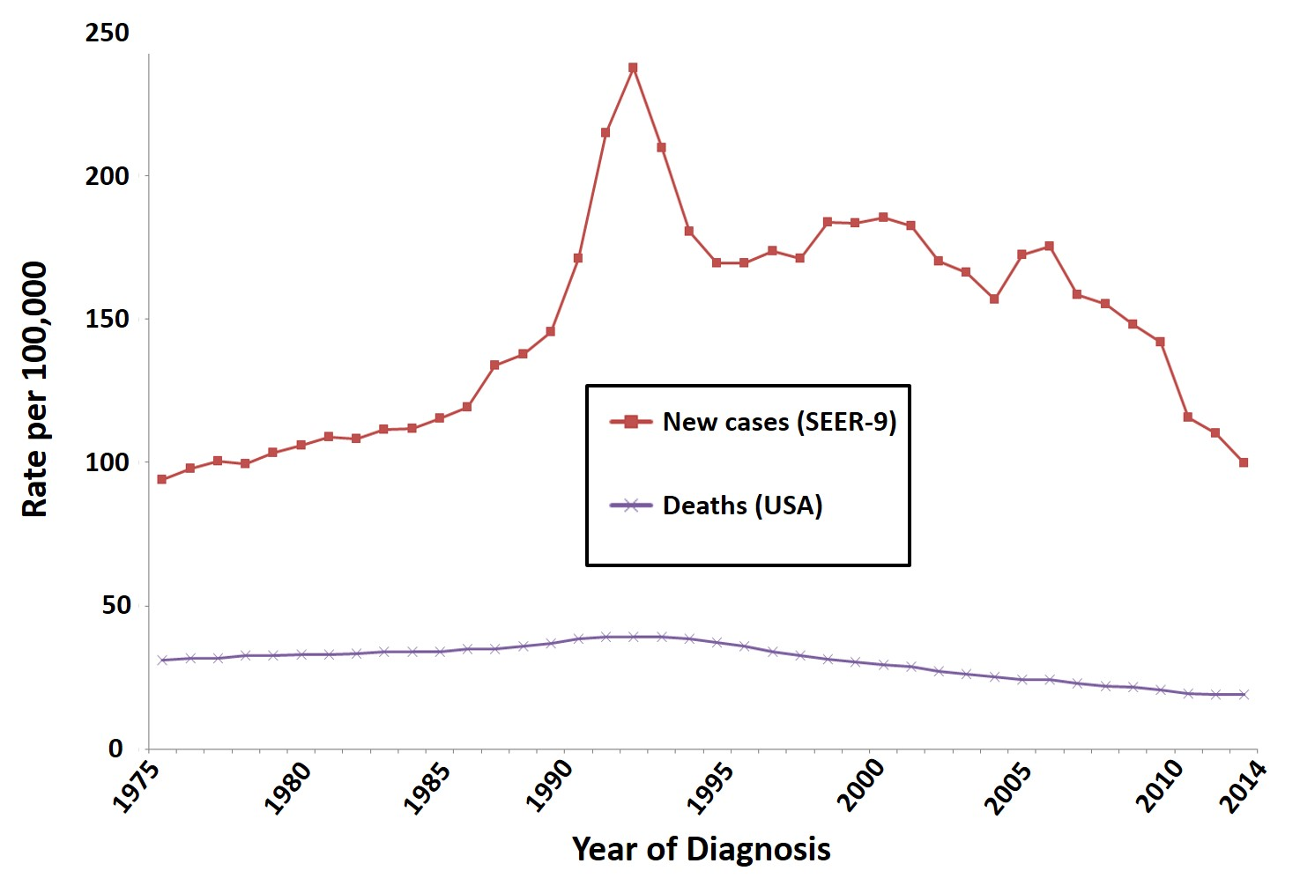Figure 1. Surveillance, Epidemiology, and End Results (SEER) program: US men prostate cancer incidence and mortality [14]

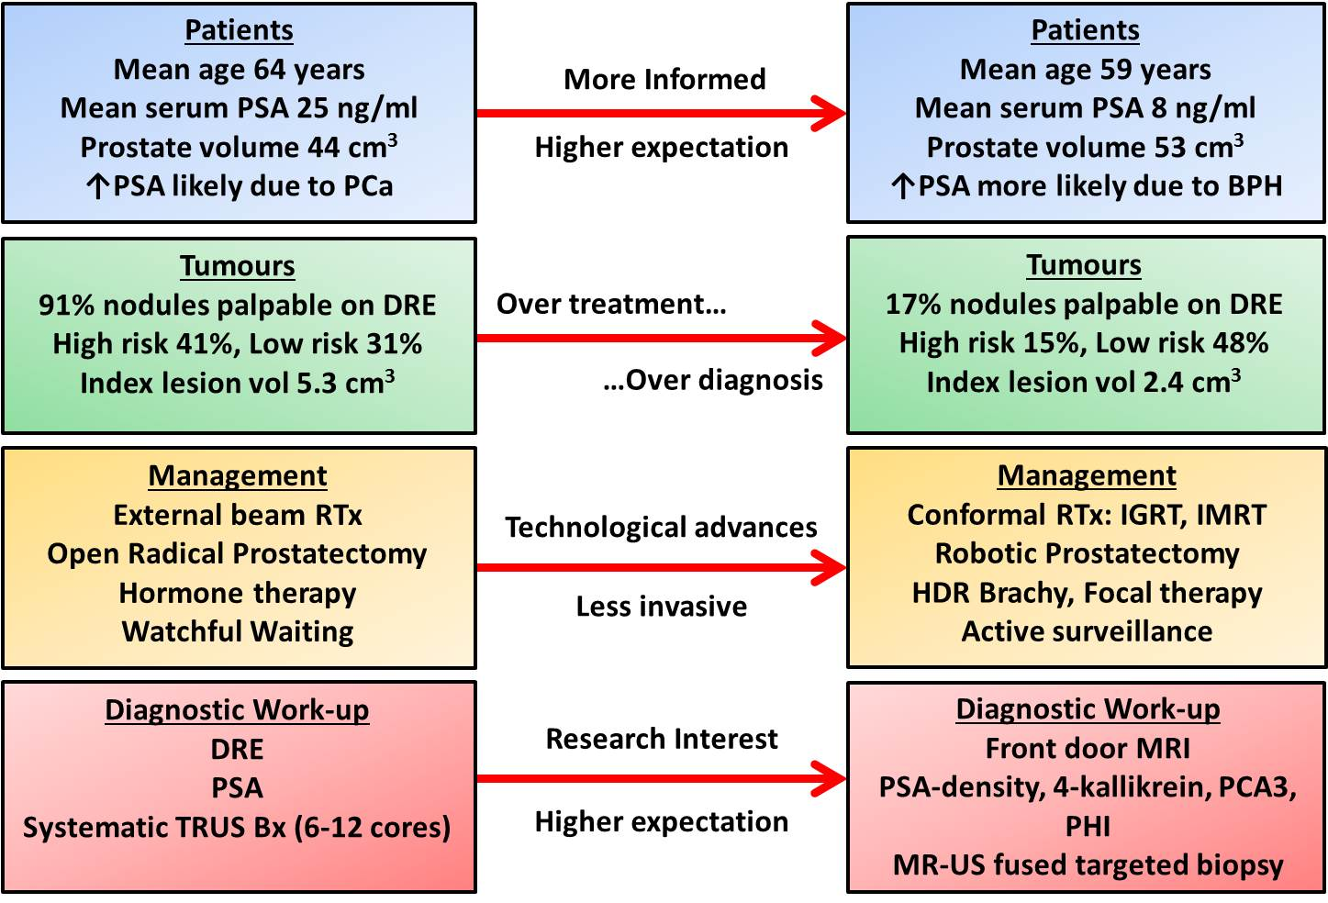
Figure 2. Evolution in prostate cancer management.
Schema representing from left to right the shifting expectations and ways of managing prostate cancer patients over the last 15 – 20 years.

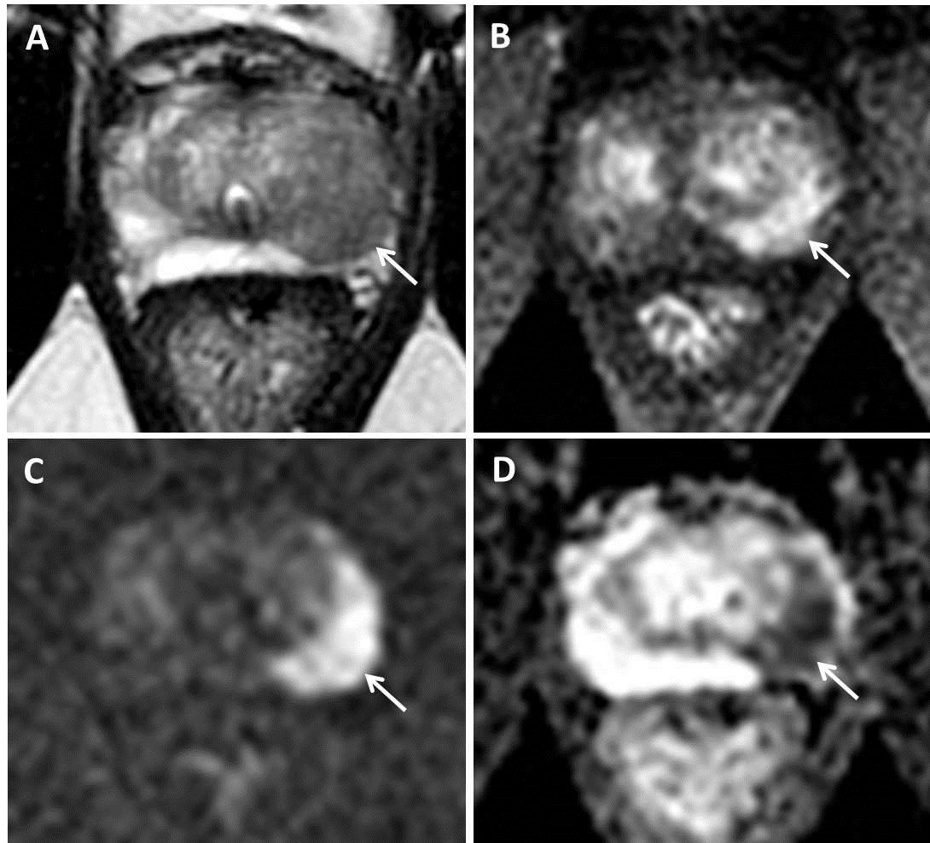Figure 3. Standard clinical mpMRI diagnostic sequences.
73 year old patient, PSA 9.85 ng/ml, MRI performed pre-biopsy. High probability (PI-RADS 5) 19×10 mm lesion in the left mid PZ (arrows). Lesion demonstrates focal low T2 signal (A), early enhancement on DCE compared to contralateral PZ (B), high signal on b-2000 DWI (C), and low signal on ADC maps (D). Targeted biopsy revealed Gleason 3+4 disease in 50% and 13 mm of all 3 cores, maximum tumour length 9 mm.

