Investigating Bénard-Marangoni Migration at the Air-Water Interface in the Time Domain using Sum Frequency Generation (SFG) Spectroscopy of Palmitic Acid Monolayers

A. P. Fellows*, M. T. L. Casford and P. B. Davies

Department of Chemistry, University of Cambridge, Lensfield Road, Cambridge, CB2 1EW, UK
*Corresponding Author: apf36@cam.ac.uk; +44 (0)1223 334663

Keywords: Sum-Frequency Generation, Bénard-Marangoni Convection, Laser-Induced Heating, Palmitic Acid, Langmuir Monolayer

Abstract
Sum-frequency generation (SFG) spectroscopy is frequently used to investigate the structure of monolayer films of long-chain fatty acids at the air-water interface. Although labelled as a non-invasive technique, introducing intense SFG lasers onto liquid interfaces has the potential to perturb them. In the present work, narrowband picosecond SFG is used to study the structural changes that occur in palmitic acid and per-deuterated palmitic acid monolayers at the air-water interface in response to the high field strengths inherent to SFG spectroscopy. In order to determine structural changes and identify measurement artefacts, the changes in specific resonance intensities were measured in real-time and over a broad range of surface concentrations from films spread onto a stationary Langmuir trough. Using narrowband instead of broadband SFG minimises the overlap of the incident IR beam in the lipid C-H stretching region with resonances from the water sub-phase. Nevertheless, narrowband SFG still generates a thermal gradient at the surface which produces a significant decrease in local concentration in the area of the laser spot caused by Bérnard-Marangoni convection originating in the sub-phase. The decrease in concentration results in an increase in conformational disorder and a decrease in the tilt angle of the lipid tails. Crucially, it is shown that, even at the highest monolayer concentrations, this gives rise to a measurement effect which manifests itself as a dependence on the spectral acquisition time. This effect should be taken into account when interpreting the structure of monolayer films on liquid surfaces deduced from their SFG spectra.

Introduction

The surface specific non-linear optical technique of Sum Frequency Generation (SFG) vibrational spectroscopy has become an invaluable tool for investigating surfaces and interfacial structures.^{1–8} Specifically, it has been used to understand the structure of, and interactions within, Langmuir monolayers and molecular films of fatty acids.^{9–12} Palmitic acid (C16 saturated chain) monolayers at the air-water interface have been widely studied by SFG and other techniques as examples of model Langmuir films, yielding important insights into their interfacial structure.^{13–18} The monolayer is in the liquid expanded phase at low surface concentrations i.e., >~27 Å² per molecule, and forms a liquid condensed phase at higher surface concentrations between ~20 and 27 Å² per molecule that causes a drop in surface tension. Theoretical calculations of the molecular packing densities for both free rotation and a completely restricted movement of the alkyl tail-groups of long fatty acids chains suggest that, as the surface pressure is gradually increased, there is a transition between the two phases resulting in an increasing restriction of chain rotation implying an increase in intermolecular interaction between the tail groups.^{18,19}

Monolayers at the air-water interface are inherently mobile and hence susceptible to any externally induced currents in the sub-phase such as the local heating that can be generated by the large energy fluxes used in SFG spectroscopy. Inhomogeneity in surfactant concentrations or temperature profiles, such as that caused by local heating, can lead to surface tension gradients. The non-equilibrium produced requires movement of material to restore the equilibrium (the Marangoni effect). Generally, at high surface concentrations corresponding to well-packed films in the liquid condensed phase, monolayers are more resistant to laser-induced heating due to the stronger intermolecular interactions, and only minor structural changes are anticipated. At lower concentrations corresponding to the liquid expanded phase, however, monolayers are much less rigid and the laser fluence may be high enough to completely ablate the monolayer because the restoring force is insufficient to replenish the surface.²⁰

The effect of high SFG light fluxes on monolayers of the phospholipid DPPC, palmitic acid and 1-dodecanol, was investigated by Backus et al..²⁰ They studied the step-like change in the recorded SFG intensity observed at very low surface pressures for both the C-H stretching modes of the monolayer tail-groups and the O-H stretching modes of interfacial water. This effect was only present when the surface was stationary and absent when a rotating Langmuir trough was used, being attributed to laser-induced heating of the water sub-phase by the IR laser beam causing complete dispersal of the film due to the generation of a Bénard-Marangoni convection cell. A similar effect was considered earlier by Casson et al. who studied a temperature-dependent phase transition in decanol using SFG.²¹ They found that, as expected, increasing the IR focus spot size reduced the SFG intensity. However, there was no apparent change in the observed phase transition temperature leading them to conclude that any laser-induced heating effect on the monolayer was very small.

Investigations using broadband femtosecond SFG to probe the C-H stretching region uses intense IR beams that are unavoidably resonant with the main O-H stretching modes of water. This results in significant absorption of the incident IR by the sub-phase which potentially can produce substantial heating. However, it is not known whether narrowband SFG, where the resonant overlap with the sub-phase O-H stretching modes is minimal in the C-H stretching region, will exhibit the same thermal migration effects. Furthermore, the extent to which these effects perturb lipid monolayers at different concentrations is also unknown. Answers to these questions are necessary due to the widespread use of SFG to study monolayers at the air-water interface that could potentially be subject to inherent measurement effects. Here, we present the results of investigating laser-induced heating of palmitic acid and per-deuterated palmitic acid monolayers on static air-water interfaces over a wide range of concentrations using narrowband picosecond SFG spectroscopy in real-time.

Theoretical background

Local heating in the sub-phase causes the surface tension within the laser spot to drop, resulting in a potential gradient which induces Bénard-Marangoni migration away from the illuminated area. This is compensated for by a convection cell in the sub-phase that replenishes the sub-phase molecules that have been depleted at the surface. The equilibrium surfactant concentration in the laser illuminated spot is, therefore, determined by the balance between the opposing thermal and concentration gradients. This is analogous to thermophoretic behaviour in bulk mixtures where the movement of particles is determined by their Soret coefficient, S_{T}, (i.e., the ratio between their thermodiffusion coefficient, D_{T}, and diffusion coefficient, D) and where their relative concentration, N, is given by Eq. 1.

$$\begin{aligned}\frac{∂N}{∂t}=∇∙\left(D∇N+D_{T}N\left(1-N\right)∇T\right)\#\left(1\right)\end{aligned}$$

Although this equation accounts only for the migration of particles due to the absorbed heat rather than changes in surface tension, both thermophoresis and the Bénard-Marangoni effect originate from similar stimuli i.e., the thermal gradient itself and a thermally induced concentration gradient.²² Hence, to a first approximation, any observed migration behaviour in the temporal domain can be modelled by solving the time-dependent contribution to Eq. 1.

The coefficients in Eq. 1 are constant to a good approximation over the relatively small temperature changes involved which enables Eq. 1 to be rewritten and expanded giving Eq. 2.

$$\begin{aligned}\frac{∂N}{∂t}=D∇^{2}N+D_{T}\left[\left(1-2N\right)∇N∙∇T+N\left(1-N\right)∇^{2}T\right]\#\left(2\right)\end{aligned}$$

It is reasonable to assume a spherical Gaussian laser spot and an isotropic surface concentration at any instant so that Eq. 2 can be reduced to one dimension in r, the distance from the origin in plane-polar coordinates, as shown in Eq. 3. It is also assumed that the temperature function is time independent.

$$\begin{aligned}=D\frac{1}{r}\frac{∂}{∂r}\left(r\frac{∂N}{∂r}\right)+D_{T}\left[\left(1-2N\right)\frac{∂N}{∂r}\frac{dT}{dr}+N\left(1-N\right)\frac{1}{r}\frac{∂}{∂r}\left(r\frac{dT}{dr}\right)\right]\#\left(3\right)\end{aligned}$$

This may then be expanded to yield Eq. 4.

$$\begin{aligned}=D\frac{∂^{2}N}{∂r^{2}}+\frac{D}{r}\frac{∂N}{∂r}+D_{T}\left(1-2N\right)\frac{∂N}{∂r}\frac{dT}{dr}+D_{T}N\left(1-N\right)\frac{d^{2}T}{dr^{2}}+D_{T}\frac{N\left(1-N\right)}{r}\frac{dT}{dr}\#\left(4\right)\end{aligned}$$

In order to solve Eq. 4, it is assumed that the concentration can be separated into spatial and temporal components, R(r) and τ(t), respectively, as in Eq. 5. The validity of this assumption is discussed in Appendix 1.

$$\begin{aligned}N\left(r,t\right)=R\left(r\right)τ\left(t\right)\#(5)\end{aligned}$$

As shown in Appendix 1, the incorporation of Eq. 5 into Eq. 4 leads to the concentration function given in Eq. 6 where R(r) represents the radial spatial distribution function of the concentration in the surface plane. The temporal component of the concentration has the general form of a logistic function with constants A, B, and C.

$$\begin{aligned}N\left(r,t\right)=R\left(r\right)\frac{A}{1+Be^{Ct}}\#\left(6\right)\end{aligned}$$

Given that the concentration must always be non-negative and decrease with time, the constants of the logistic function in Eq. 6 must follow the following constraints: A, B, C > 0; A < 0, B < -1 and C > 0; or A > 0, -1 < B < 0, and C < 0. The first two sets of constraints both result in the concentration decaying to 0 as time increases whereas the third yields a non-zero equilibrium concentration after the migration. Therefore, given the competition between thermal migration and back-diffusion, the latter set of constraints must be applied to this behaviour.

For very low concentrations and relatively high laser fluences, the thermal gradient may be high enough to completely ablate the surface in the vicinity of the laser spot, as reported by Backus et al. Under these conditions the magnitude of the laser fluence determines the concentration at which total loss of SFG signal occurs.²⁰ Higher surfactant concentrations, however, make back-diffusion relatively more important, compensating for changes to the monolayer coverage caused by the thermal gradient and yielding a significant, non-zero equilibrium concentration. Nevertheless, a residual dependence on the fluence of the incident laser beam still remains. It cannot be discounted since it too will alter the local concentrations and potentially the structure at the interface, inevitably changing the SFG spectra.

Experimental

Palmitic acid (>99% purity) and perdeuterated (D₃₁) palmitic acid (>98% D; >99% purity) from Sigma Aldrich were used as received. 1 mg ml⁻¹ in chloroform solutions were spread on Millipore water (18 MΩ cm⁻¹, < 2ppb TOC) contained in a bespoke Teflon Langmuir trough designed for simultaneous measurement of SFG spectra in close proximity to a NIMA Type PS4 surface pressure sensor fitted with a paper Wilhelmy plate. An electrically driven Teflon barrier was used to compress the surface to the desired pressure. The trough was cleaned by wiping with Millipore water and chloroform-soaked tissue, and the surface repeatedly aspirated until the surface pressure was less than 0.1 mN m⁻¹ at full compression. Typically, a palmitic acid in chloroform solution was first cast onto the water surface and after solvent evaporation (~30 mins) the film was compressed to the chosen surface pressure at a barrier speed of ~10 cm² min⁻¹ (~4.3 Å² molecule⁻¹ min⁻¹) and then allowed to reach equilibrium (~ 30 mins). All measurements were taken in a climate-controlled room at 18 ± 1°C.

SFG spectra at the air-water interface were recorded in either the SSP or PPP polarisation combinations (sum frequency, visible, infrared) in a co-propagating geometry on a picosecond spectrometer (EKSPLA, Vilnius, Lithuania). The visible beam at 532 nm (29 ps pulses at 50 Hz) was provided by the second harmonic of a mode-locked Nd:YAG laser and tuneable infrared radiation in the 2000-4000 cm⁻¹ region produced by an optical parametric generator. The input beams of the IR and visible lasers were set at angles to the surface normal of 55º and 60º respectively. The IR pulse energy used was ~300 µJ at 2900 cm⁻¹, roughly the centre of the C-H stretching region, with a spot diameter of ~400 µm at the surface. Acquisitions (numbers of single laser pulses at 50 Hz) between 25 (0.5 s) and 800 (16 s) per spectral frequency point were co-averaged every 2 cm⁻¹ for spectral scans. Between the periods of acquisitions at a specific wavenumber the input IR beam is automatically shuttered for ~ 2-3 s to allow the monochromator position to change and OPO frequency to be shifted. This sequence results in a total acquisition time of ~6-30 mins for a single spectrum of between 25 and 800 acquisitions per spectral frequency across the C-H stretching region of 2800-3000 cm⁻¹. To improve the signal-to-noise ratios, multiple spectra were co-averaged, with the co-averaged number depending on the number of acquisitions per point, varying between 3 spectra at 800 and 8 spectra at 25 acquisitions.

For temporal studies at fixed frequencies, 10 acquisitions per temporal point were used, corresponding to 0.2s temporal resolution. To investigate the effects of laser-induced heating, the input laser beams were periodically blocked and unblocked every 30 seconds whilst recording the SFG intensity (every 0.2s). This procedure hence measures the changes in the intensity for a period of 30s before allowing the monolayer to recover for 30s prior to the next measurement when the input laser beams are re-introduced to the surface. By measuring the initial SFG response when the beams are unblocked after different recovery periods ranging from 1-30 seconds, it was found that a 30 second blocked period was more than sufficient to allow the film to recover.

SFG simulations and tilt angle calculations were performed using an in-house MATLAB script applying the underlying theory which is based on Hirose’s bond additivity model and using the parameters given in Table A2.1, Appendix 2.^{23–26} C_{S} methyl symmetry is assumed for the r⁻ stretching mode in PPP polarisation and is assigned to the out-of-plane antisymmetric stretching mode rather than to the in-plane mode. (The latter only yields significant intensity in the SPS and PSS polarisation combinations.²⁷)

Results

Temporal Decay in SFG Intensity

In a likewise manner to the earlier broadband femtosecond experiments, the picosecond narrowband lasers employed here also lead to complete removal of palmitic acid films at the lowest concentrations (~0.1-0.2 mN m⁻¹).²⁰ Therefore, for temporal studies, a higher surface pressure of 1 mN m⁻¹ was chosen to balance the thermal gradient-induced migration and back-diffusion effects. Previous studies have shown that this surface pressure corresponds to the liquid-condensed region of the isotherm and supports a well-ordered monolayer at the interface.¹⁸ This is confirmed by the SFG spectra (Figure 1a) in which the methyl resonances (r⁺: 2880 cm⁻¹; r⁺_{FR}: 2940 cm⁻¹; r⁻: 2970 cm⁻¹) are the most prominent with only small methylene d resonances from gauche defects in the chain e.g. the low intensity d⁺ resonance at ~2850 cm⁻¹. The temporal thinning of the film with extended exposure is shown in Figure 1, firstly by recording spectra with increasing numbers of spectral acquisitions (Figure 1a), and secondly by temporally monitoring (with 0.2s resolution, corresponding to 10 co-averaged laser pulses) the intensity at a specific lipid C-H frequency as the incident beams are periodically blocked and unblocked every 30 seconds (Figure 1b).

The spectra in Figure 1a show that there is a reduction in intensity with increasing numbers of acquisitions (co-averaged laser pulses), from 25 (0.5 s) to 800 (16 s) per spectral frequency point. Specifically, as the acquisition time increases, corresponding to increasingly long exposure to the laser beams, the average SFG intensity drops. The time taken to accumulate between 25 and 800 acquisitions at a specific frequency as the frequency is changed stepwise through the C-H stretching region from 2800 cm⁻¹ to ~ 2880 cm⁻¹ was found to be significantly longer than the timescale associated with migration at the interface. This implies that, for the majority of the spectral acquisition period, the monolayer should have already undergone migration and be at equilibrium. Hence, no change in SFG intensity with increasing number of acquisitions would be expected, contrary to what is observed experimentally (Figure1a). The origin of this apparent contradiction is accounted for later.

The SFG intensity at 2880 cm⁻¹ (methyl symmetric stretching resonance) shows a pronounced, sharp initial signal when the beams are first unblocked, subsequently decaying until the beams are blocked again and all intensities drop to their background values (Figure 1b). It should be noted that comparing the ten ‘on’ periods shown in Figure 1b there is clearly a progressive decrease in SFG intensity between each initial ‘on’ period implying incomplete recovery of the film during the dark periods. However, this effect is shown later to be minute when using a 30 second recovery time. A more likely explanation is a change in spectrometer alignment caused either by a drift in the laser / optical path, or by water evaporation from the trough. The SFG temporal decay during the 30 second illuminated period is more clearly emphasized in Figure 1c which is an average of 50 individual 30 second illumination periods. As mentioned above, it is important to note that at a surface concentration of 1 mN m⁻¹, an SFG signal is still detectable even after long time periods, so although the film has ‘thinned’, a structured monolayer is still present. This indicates an effective balance between the thermally induced migration and back-diffusion.
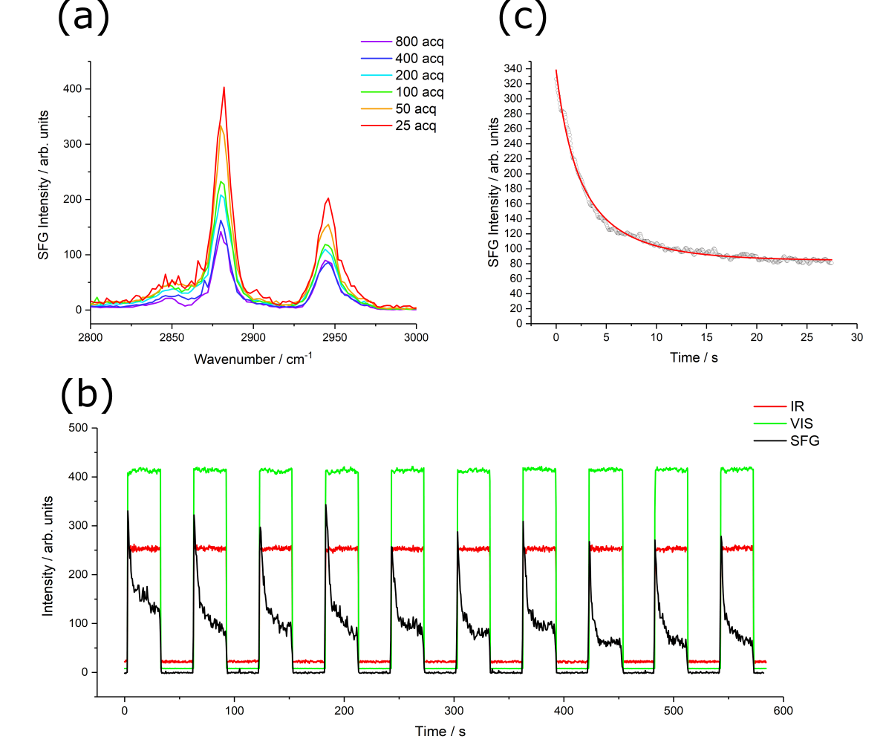
Figure 1: SFG spectroscopy of a 1 mN m⁻¹ palmitic acid monolayer showing (a) spectra in the SSP polarisation combination in the C-H stretching region for different numbers of acquisitions (co-averaged laser pulses) from 25-800 acquisitions per spectral frequency point (b) temporal plot of the SFG intensity at 2880 cm⁻¹ ( r⁺ methyl symmetric stretch resonance) with consecutive blocking and unblocking of the incident beams every 30 seconds repeated 10 times and showing the decaying SFG intensity over each 30 second period (c) SFG intensity at 2880 cm⁻¹ averaged over 50 individual 30 second time interval periods with the input beams unblocked as shown in (b) fitted to the square of a logistic function (temporal component of Eq. 6).

It is clear that the shape of the SFG temporal intensity decay shown in Figure 1c does not follow an exponential profile but instead appears closely similar to a logistic-type function. This can be explained by comparing the Bénard-Marangoni effect to the thermophoretic behaviour as mentioned above where it is shown that the solution to the thermophoresis equation (Eq. 1) for a two-dimensional system is of the form given in Eq. 6. It is well known that the SFG intensity is proportional to the square of the χ⁽²⁾, the second order susceptibility, which is linearly dependent on the surface concentration so, incorporating this dependence, the temporal change should fit the square of a logistic function.^{1,25,26,28} This is, however, assuming that no changes to χ⁽²⁾ occur other than due to the surface concentration. Given that χ⁽²⁾ incorporates the structural information of the monolayer, it is hence assuming no change in structure of the film. The square of a logistic function is, however, shown to be a good fit to the experimental SFG decay in Figure 1c, suggesting that the major source of loss of SFG intensity arises due to the decrease in surface concentration rather than any structural changes. The presence of detectable methyl group SFG intensity (Figure 1a) points to the system retaining structural order despite any induced heating effects. This is not surprising because in well-ordered monolayers changes to chain tilt angles due to concentration changes are known to be relatively small.^{27,29} To a first approximation then, it is reasonable to neglect any significant time-dependent changes in the hyperpolarizabilities and to assume that the temporal decrease in χ⁽²⁾ is dominated by the surface concentration. It is important to note, however, that structural changes can still be observed, as shown later, and thus changes to the molecular hyperpolarizability contributions to χ⁽²⁾ cannot be ignored, despite them not being the major contribution to the observed changes in SFG intensities.

Origin of Thermal Migration and Timescale of Monolayer Recovery

To conclusively demonstrate that the thermal migration of the monolayer begins by IR absorption in the water sub-phase, per-deuterated palmitic acid monolayers were investigated. Per-deuterated palmitic acid has IR resonances in the C-D stretching region between 2000 and 2300 cm⁻¹ that are well shifted from the main water bands (~1500-1800 cm⁻¹ bending modes, 2700-3700 cm⁻¹ stretching modes).³⁰ Figure 2a shows the temporal behaviour of a 1 mNm⁻¹ per-deuterated palmitic acid monolayer analogous to that shown in Figure 1b for a protonated palmitic acid monolayer. The absolute SFG intensities are considerably lower because the C-D resonances have smaller extinction coefficients and there is lower IR laser output power at this frequency. There is no distinct decay of the SFG intensity during the recording period, Figure 2a, unlike in Figure 1b. This shows unambiguously that the effect observed in the C-H region does not arise from absorption by the monolayer or by the incident visible laser beam, but from absorption by the water sub-phase, consistent with earlier conclusions.²⁰

However, in the C-D stretching region there is coincidence with the weak bending + libration combination band of water [19] and so there must be a non-negligible extinction coefficient for the sub-phase in this frequency region. The extinction coefficient for water at 2075 cm⁻¹ (at the CD₃ r⁺ frequency) is ~4.0 x 10⁵ m⁻¹, compared to 5.5 x 10⁴ m⁻¹ at 2880 cm⁻¹ (at the CH₃ r⁺ frequency) so similar behaviour might be anticipated at both C-H and C-D frequencies.^{31,32} However, estimates of the temperature rise per pulse (Appendix 3) show that the combination of a lower extinction coefficient and considerably less IR power at 2075 cm⁻¹ (cf. 2880 cm⁻¹) results in a much smaller increase in temperature (~11K vs. 31K). Consequently, the migratory force due to the thermal gradient is weaker and back-diffusion counteracting it is more effective. Nevertheless, the extinction coefficient of water in the C-H stretching region is still sufficient to disrupt the surface film even when using narrowband picosecond IR. Overall then, the migration behaviour is determined by a combination of the extinction coefficient, IR laser fluence, and monolayer concentration. The last of these is investigated in detail later.

Further spectroscopic evidence for the source of the observed Bénard-Marangoni effect is presented in Figure 2b which shows the temporal SFG intensity at 2880 cm⁻¹ for a protonated palmitic acid monolayer with either the incident IR beam or the visible beam blocked prior to measurement. When only the IR beam is blocked there is a clear decay in intensity like that observed in Figure 1, indicating that blocking the IR allows the monolayer to recover. However, when only the visible beam is blocked during the recovery period, the SFG intensity remains constant and at the same level as the limiting value when just the IR beam is blocked. This reconfirms that the migration is caused by the incident IR beam and not the visible beam and that its origin is in a resonant effect as previously suggested.^{20,21}

The monolayer recovery cannot be directly measured by SFG in the same way as the decay process is because using SFG induces the measurement effect, as described above. Nevertheless, it can still be measured indirectly using SFG by comparing the intensity of the initial SFG signal on exposure to the incident beams after a defined recovery period to the initial intensity obtained after a very long recovery time has elapsed. Figure 2c shows the initial SFG intensity of the methyl symmetric stretching resonance for recovery times ranging from 1-30 seconds compared to the recovery intensity after 60 seconds. It is clear that the recovery takes place over the order of seconds and becomes constant after 5-10 seconds. The data in Figure 2c has been fitted with an exponential association function which is the solution to the diffusion equation (i.e., Eq. 1 where the thermal gradient vanishes). However, this is an approximation for the actual recovery curve because it assumes that there is an immediate loss in the induced thermal gradient on blocking the incident beams i.e., the recovery is solely due to the concentration gradient re-establishing equilibrium. In reality, the diffusivity of water (~0.143 mm² s⁻¹ ³³) cannot be ignored and would produce a finite decay of the thermal gradient after blocking the incident beams and consequently a delay in film recovery.

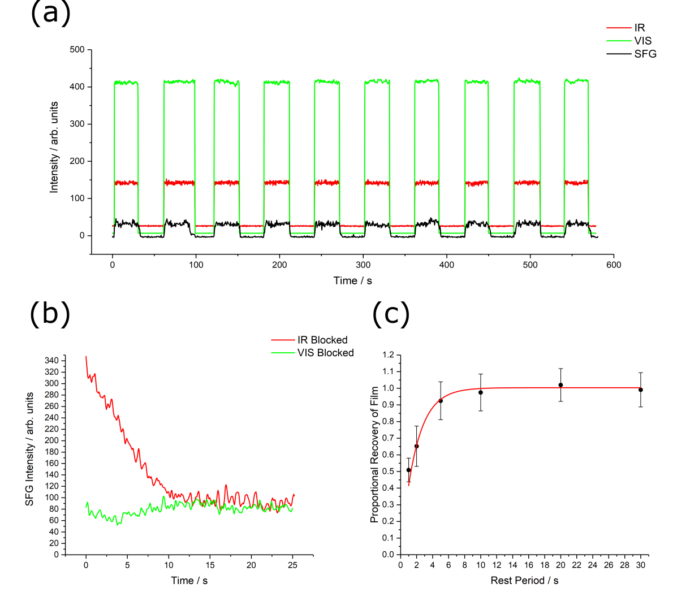
Figure 2: Analysis of the SFG intensity decay from a 1 mN m⁻¹ d₃₁- palmitic acid monolayer showing (a) the temporal SFG intensity of the monolayer at 2075 cm⁻¹ (methyl symmetric stretching mode) with sequential blocking and unblocking of the incident beams every 30 seconds analogous to the data shown in Figure 1b,(b) temporal SFG intensity for a protonated palmitic acid monolayer at 2880 cm⁻¹, averaged over 10 individual 30-second periods where one of the incident beams (IR or VIS) was blocked during the 30-second recovery periods (c) normalised recovery of the 2880 cm⁻¹ SFG intensity for a protonated palmitic acid monolayer for different recovery periods, determined by comparing the initial SFG intensity after introducing the incident beams with the initial intensity after a 60-second recovery period. In each case the data comes from averages of 50 separate measurements. (Uncertainties are the standard deviations in the initial SFG intensities).

Structural Changes in the Time Domain

Thermal migration causes changes in surface concentration and therefore potentially also in the monolayer conformational structure. Structural changes can be determined by measuring the ratio of the d⁺ (methylene symmetric) to r⁺ (methyl symmetric) intensities, as a measure of relative conformational disorder²⁸, and/or from the intensities of the methyl stretching modes in different polarisation combinations to calculate an average chain tilt angle²⁵. In close packed monolayers the SSP combination favours strong symmetric stretching resonances while the PPP polarisation favours strong antisymmetric stretching resonances.²⁵ Figure 3 shows the temporal decays of the stretching d⁺ (2855 cm⁻¹) and r⁺ (2880 cm⁻¹) resonances in the SSP polarisation combination (Figure 3a and b, respectively) and the r⁻ (out-of-plane) resonance (2968 cm⁻¹) in the PPP polarisation combination (Figure 3c). To minimise the uncertainties generally associated with the use of intensity ratios, the SSP d⁺ to r⁺ intensity ratio was used to determine the monolayer conformational order, and the r⁺ to r⁻ intensity ratio from the SSP and PPP polarisations, respectively, to deduce changes in the tilt angle. The plots in Figure 3d and 3e show an unambiguous temporal increase in the d⁺ to r⁺ ratio with time, i.e., increased conformational disorder, as well as a decrease in the r⁺ to r⁻ ratio, indicating an increase in the chain tilt angle, respectively. To complement and confirm the r⁺ to r⁻ ratio found experimentally, Figure 3f shows the simulated χ⁽²⁾ ratio for the r⁺ (SSP) to r⁻ (PPP) resonances as a function of the methyl tilt angle for a range of possible values of the single bond polarizability derivative ratio, r.^{25,27} The simulations support the temporally increasing average tilt angles found experimentally but with the caveat that reflective losses in each polarisation combination can lead to erroneous absolute tilt angle calculations when using the r⁺ (SSP) to r⁻ (PPP) ratio unless the reflective losses are accounted for. Nevertheless, a decreasing ratio is still indicative of an increasing tilt angle.

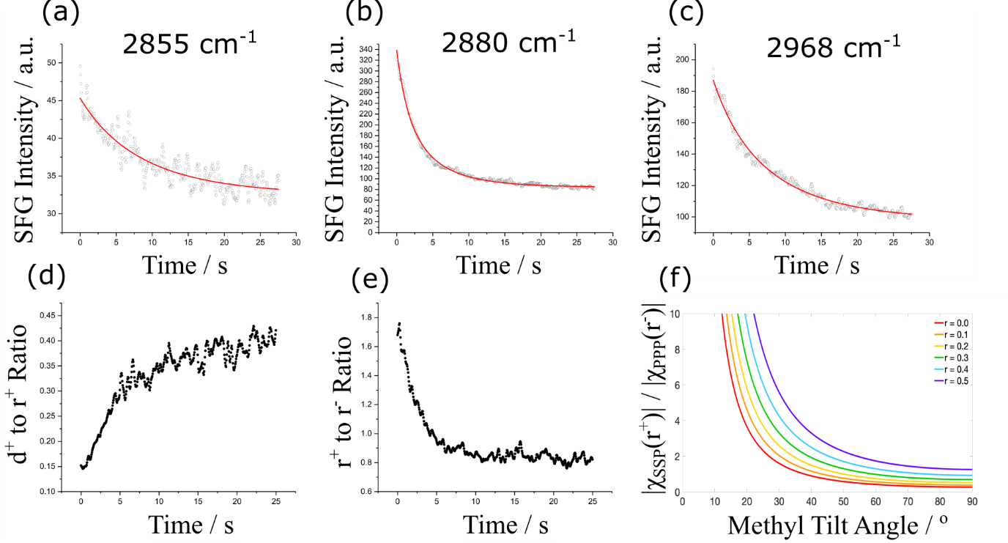
Figure 3: Top panels: Temporal SFG intensities recorded for a 1 mN m⁻¹ protonated palmitic acid monolayer at resonant frequencies corresponding to (a) d⁺ (2855 cm⁻¹, SSP), (b) r⁺ (2880 cm⁻¹, SSP), and (c) r⁻ (2968 cm⁻¹, PPP), each averaged over 50 individual 30-second decay periods and fitted to the square of a logistic function (temporal component of Eq. 6). Bottom panels: the SFG intensity ratios of (d) d⁺ to r⁺ and (e) r⁺ to r⁻, along with the simulated ratio of the bulk susceptibility components for r⁺ (SSP) to r⁻ (PPP) as a function of the methyl tilt angle and for values of r, the single bond polarizability derivative ratio, from 0.0-0.5 (red-purple).
The increasing conformational disorder of the monolayer and the increase in the average tilt angle of the methyl group is consistent with a temporal decrease in surface concentration.³⁴ However, it is important to note that increased conformational disorder must correspond to a greater deviation from a delta function distribution that is assumed when simulating the ratios in Figure 3f. An increase in the number of gauche defects will produce an increased width distribution and consequently a greater uncertainty in the calculated tilt angle, in the limit tending to the magic angle.^{25,35} Nevertheless, the large methyl SFG intensities show that significant conformational order remains in the monolayer after migration, and hence that the observed decreasing r⁺ to r⁻ ratio is still a valid pointer to an increasing average methyl tilt angle.

Surface Pressure and Monolayer Stability

The most efficient packing of the alkyl tails in the monolayer occurs at a molecular area of ~20 Å².¹⁹ Further compression results in a steep increase in the slope of the surface pressure (Figure 4a) and is determined by the compressibility of the head-group, leading ultimately to a ‘buckling’ of the planar structure.¹⁸ Between 27-20 Å² per molecule, then, the monolayer is in the liquid condensed region tending toward the optimum chain packing. It is therefore reasonable to assume that the monolayer becomes less mobile in the liquid condensed phase with correspondingly reduced migration. In response to a thermal gradient, this would manifest itself as a decreasing rate of decay of concentration due to slower migration and a higher equilibrium concentration due to the greater diffusive force opposing the thermal migration. These effects are modelled separately in Figure 4b and c, respectively, for the expected changes to the SFG intensity (ignoring any structural changes to the film). The former shows the simulated decay function given by the square of a logistic function (temporal component of Eq. 6) as the exponential constant, C, is varied to represent a varying resistance to decay. Figure 4c shows the decay function as the pre-exponential constant, B, is varied (with a commensurate variation in A to maintain the normalisation to the initial value), representing a change in the equilibrium SFG intensity.

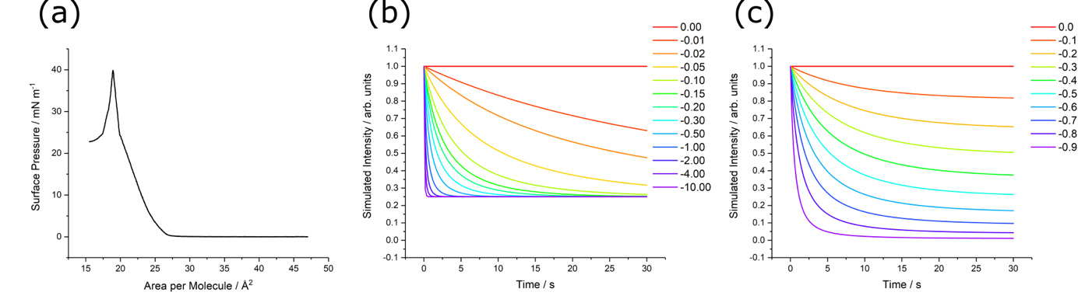
Figure 4. (a) Π-A isotherm for palmitic acid. (b), (c) simulated decay profiles based on the square of the temporal part of Eq. 6 by (b) varying the exponential constant, C, with fixed proportionality constant, A=0.5, and pre-exponential constant, B=-0.5, and (c) varying the constant B with fixed C=-0.1 and commensurate variations in A to maintain the same initial value at t=0.
The two effects postulated above, are supported experimentally by the data presented in Figure 5. Figure 5a shows the temporal r⁺ intensity profiles for surface pressures in the range 0.2 to 20 mN m⁻¹. At the lowest surface pressure, 0.2 mN m⁻¹, the monolayer exhibits little resistance to the thermal gradient causing a rapid temporal intensity decay which approaches zero at equilibrium i.e., the monolayer has been thermally removed. As the surface pressure increases, however, the initial rate of intensity decay diminishes and leads to a high equilibrium intensity which, at the highest surface pressure, 20 mN m⁻¹, shows only minor temporal change. The proportional decrease in r⁺ intensity for each initial surface pressure (from fitting each profile to the square of Eq. 6) is shown in Figure 5b. As expected, at lower surface pressures the monolayers are significantly affected by the IR beam, with the monolayer at 0.2 mN m⁻¹ effectively showing complete loss of intensity. This result aligns completely with the findings reported by Backus et al. at low surface pressures.²⁰ In contrast, at higher surface pressures, the response to the thermal gradient significantly diminishes, manifesting only as a minimum reduction in intensity. This demonstrates the high stability of the monolayer when exposed to laser-induced heating.
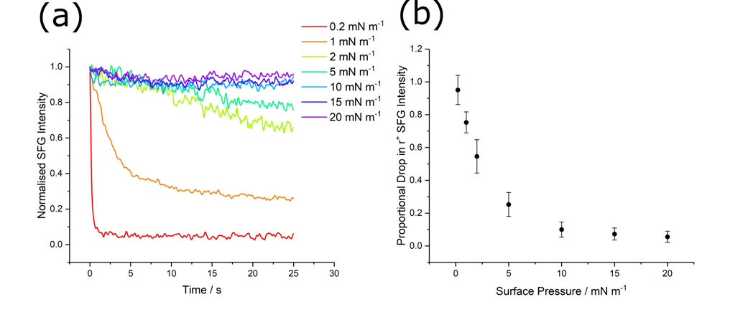
Figure 5: Intensity of the r⁺ resonance of palmitic acid at 2880 cm⁻¹ at the air-water interface in the SSP polarisation combination showing (a) normalised temporal decay plots averaged over 50 30-second periods for surface pressures between 0.2 and 20 mN m⁻¹, and (b) the proportional drop in SFG intensity as a function of surface pressure, calculated from fitting the profiles in (a) with the square of a logistic function (temporal component of Eq. 6).

Discussion

The step-like gain/loss of broadband SFG intensity at low concentrations under static conditions observed in earlier studies showed that the use of SFG spectroscopy to probe fluid monolayers can be influenced by Bénard-Marangoni migration.²⁰ It was also demonstrated that this can be avoided by using a dynamic i.e., a rotating Langmuir trough. The current work further investigates this effect to ascertain its significance for higher monolayer concentrations and when using narrowband SFG spectroscopy. This is achieved through an alternative approach, namely, probing the surfactant migration in real time in a stationary trough by monitoring the temporal changes in SFG intensities over a wide concentration range. Under these conditions an inherent SFG measurement effect was revealed which, although diminishing at higher surface concentrations, must nevertheless be considered when SFG is used to study structure at fluid interfaces.

In particular, it should be noted that the narrowband picosecond laser system used here showed analogous migration effects to those previously reported for a broadband femtosecond system.²⁰ Even though the two systems have greatly different pulse widths, and the narrowband IR beam has little overlap with the main water bands from the sub-phase, significant local heating occurs. For broadband spectrometers, although the incident IR covers a wide frequency range leading to significant frequency overlap with the sub-phase, the pulse energies commonly used are considerably lower and at higher repetition rates (e.g., 300 µJ per pulse at 50 Hz for a narrowband system compared to ~5 µJ per pulse at 1 kHz for a broadband system). Although these lower pulse energies induce lower temperature rises, the interval between pulses is shorter, resulting in less time for thermal diffusion to occur compared to narrowband systems. Hence, for a more accurate assessment of the resulting heating effects, it is important to consider factors other than the pulse energies such as the repetition rate and the effects of thermal diffusion within the substrate.

The effect of changing the monolayer surface pressure between 0.2 and 20 mN m⁻¹ was investigated by following the temporal decay of the r⁺ resonance intensity as shown in Figure 5. At very low surface pressures there is only weak intermolecular bonding between the palmitic acid molecules (or they are unbound) and consequently most of the SFG intensity rapidly diminishes with time on exposure to the IR laser beam. In contrast, at moderate to high surface pressures i.e., more akin to monolayers that are commonly investigated, only minor reductions in the SFG intensity are observed because the molecules are in a more strongly bound state which provides greater resistance to the effect of the thermal gradient. It should be noted, however, that even at high surface pressures it is still possible to detect a small, finite temporal effect after exposure to IR for 30 seconds.

Confirmatory evidence that resonant IR absorption by the water sub-phase is responsible for the thermal gradient, and hence the observed migration effects, was provided by investigating the methyl symmetric stretching resonance intensity from both a protonated and per-deuterated palmitic acid monolayer at 1 mN m⁻¹. The protonated monolayer yielded a significant temporal decay in SFG intensity during measurement (Figure 1b) which was not observed for the per-deuterated layer (Figure 2a). This reflects the different calculated temperature increases at the two interfaces (31K vs. 11K respectively, Appendix 3) that result from differences in the water extinction coefficient and IR fluence at the different resonant frequencies. This conclusion was strongly supported by examining the decay in SFG intensity for the protonated monolayer when either the IR or VIS beams were individually blocked during the recovery period (Figure 2b). The monolayer only recovered if the IR beam was blocked, indicating that it is the IR laser that is the source of the thermal effect.

Because the narrowband SFG used here inevitably limits temporal resolution, the approach adopted in this work was to measure the response of selected resonances. This achieves high temporal resolution and retains flexibility in the time range chosen for the recovery period. The intensity of the methyl symmetric stretching resonance (Figure 1b) was found to decay to an equilibrium value when exposed to the incident beams. The profile of this decay, shown in Figure 1c, is a good fit to the square of a logistic function as predicted for temporal changes in surface concentration determined by the balance between thermally induced migration and back-diffusion. This shows that the dominant contribution to the decrease in SFG intensity at 1 mN m⁻¹ results from migration of material rather than structural changes to the monolayer, likely caused by the quadratic dependence on concentration. This does not, however, indicate that no structural changes are occurring.

Showing how the structures of the monolayer changed with time due to their diminishing surface concentration, averaged over the area illuminated by the laser spot, was achieved by measuring the decay profiles of the d⁺, r⁺ and r⁻ C-H resonances, and their selected ratios (Figure 3). All resonance intensities were observed to decrease with time, as expected, due to the diminishing concentration. This is the main contribution to the changing SFG intensity. The increasing d⁺/r⁺ ratio (Figure 3d) and decreasing r⁺/r⁻ ratio (Figure 3e) shows that there is a definite decrease in conformational order with time, with a concurrent increase in the methyl tilt angle. These structural changes are to be expected at the lower concentrations appearing at longer times which lead to increased molecular spacing, weaker inter chain van der Waals’ interactions, and thus more degrees of freedom.

It is worth noting that the extent of local heating in the sub-phase, and hence the impact on the monolayer, is highly dependent on the extinction coefficient of water at the incident IR frequency. This was clearly demonstrated when comparing the temporal r⁺ SFG intensity for a per-deuterated and protonated palmitic acid film as mentioned previously. Hence, the decay profiles of the different C-H stretching modes mentioned above (d⁺, r⁺ and r⁻) are expected to be inherently different due to the different extinction coefficients at the frequencies corresponding to their band centres. Therefore, even in the absence of any structural changes, it would be expected that the proportional loss in SFG intensity should increase with increasing frequency in the C-H stretching region. This would result in increasing d⁺/r⁺ and r⁺/r⁻ ratios with time. However, this is not what is observed experimentally, likely due to the relatively small changes in extinction coefficient over this frequency range. Hence, it is safe to conclude that, as proposed, the observed shifts in the ratios arise from structural changes in the monolayer.

Since narrowband SFG spectra record a temporally averaged intensity at a specific frequency, the structural changes occurring in the thinning film will lead to an inherent measurement effect that is dependent on the acquisition time. This is clearly shown in the decreasing intensities with increasing numbers of acquisitions in Figure 1a. If disregarded, this could lead to inaccurate conclusions about the structure of the interfacial film under investigation. This dilemma can be minimised by opting for an increased numbers of co-averaged spectra with shorter acquisition times instead of fewer spectra with longer acquisitions.

The decreasing SFG spectral intensities with increasing numbers of acquisitions (Figure 1a) would not be expected for a stepped frequency sweep since the monolayer would have been exposed to IR intensity for a sufficiently long period by the time the peak of the C-H resonances had been reached i.e. equilibrium would have already been achieved. However, as mentioned in the experimental section, as the IR frequency is stepped, the monochromator position moves and the OPO frequency shifts, temporarily blocking the input beams for approximately 2-3 seconds. The recovery time of the film deduced from Figure 2c shows that this is sufficient time for the SFG intensity to recover ~60-80% of its value after the film has been exposed to the IR beam for 30 seconds (1500 acquisitions). For the 25-800 acquisitions used to record the spectra in Figure 1a, the SFG intensity will have decayed to a lesser extent and a recovery interval of 2-3 seconds is therefore sufficient to achieve significant recovery of the film. Thus, the intensity dependence on number of acquisitions observed in Figure 1a can be attributed to the recovery period required on stepping between spectral frequencies. This imposes an unavoidable limit on the accuracy of SFG spectra recorded with increasing acquisition times. It is concluded then that more accurate signal-to-noise ratios can be achieved by co-averaging multiple, short-acquisition spectra rather than by increasing the number of acquisitions, as suggested above.

The extent of local heating in SFG experiments is related to the incident energy density, comprising the laser power and spot size, as well as the extinction coefficient, density, and heat capacity of the substrate (as shown in Appendix 3). The significant influence of energy density was clearly demonstrated here by comparing the migration effects for protonated and per-deuterated palmitic acid. The sub-phase has similar extinction coefficients at the C-H and C-D IR frequencies, but the IR power in the C-D region is lower (hence lower energy density) resulting in less local heating and no significant migration effects for the per-deuterated monolayer. It is important to distinguish between the ‘extent’ and ‘effect’ of local heating, which as shown in the present study, are not equivalent. While it is generally true that more tightly packed monolayers at the air-water interface are less affected by the temperature increases than those at lower concentrations, the cross over between these two extremes is strongly dependent on the laser power used to investigate them.

Conclusion
SFG spectroscopy has been used to study the concentration dependence, structure, and time evolution of palmitic acid monolayer films at the air-water interface in response to the applied laser fields inherent to SFG measurements. SFG induced surfactant migration within the area illuminated by the input lasers results in surface material migrating away from the area, yielding changes in the interfacial concentration of the surfactant and the accompanying SFG spectra. When broadband SFG is used there is an abrupt step-like dependence of the SFG signal on monolayer concentration, with the signal disappearing at low concentrations due to film migration. In the present study, a narrowband picosecond SFG spectrometer was used to investigate migration effects in films of palmitic acid in real time and over a wide concentration range. Unlike broadband SFG, in picosecond SFG there is only minor overlap with the water bands. Nevertheless, the high fluences result in significant local temperature rises and accompanying monolayer migration. By sequentially blocking and unblocking the IR and visible input lasers, it was shown unambiguously that the thermal gradient at the surface is caused by absorption of the IR rather than the visible laser light in the sub-phase, confirming earlier results. The migration was followed temporally by monitoring structural changes in real time through measuring the intensity of selected resonances within the laser spot at different monolayer concentrations. It was found that there is a temporal increase in tilt angle and decreasing conformational order of the palmitic acid alkyl chains as the film thins during measurement. This shows that time-averaged SFG spectra are dependent on the spectral acquisition time. This effect, which should always be considered when using SFG to study films on liquid surfaces, became less prominent and less dependent on acquisition time at higher concentrations. The dependence on acquisition time can be mitigated by minimising the acquisition time by co-averaging multiple short spectra and/or increasing the stability of the film by studying higher surface concentrations, as an alternative to using a dynamic Langmuir trough to continually change the surface. To conclude, the effects observed and investigated in this work have significant, wider implications for interpreting the SFG spectra of lipid monolayers at the air-water interface and deriving meaningful structural conclusions from them. Therefore, it is imperative that all future SFG investigations consider local heating effects, as well as how to mitigate them, and are fully transparent with the rationale for the chosen IR power.

Appendix 1 – Theoretical Treatment of Thermophoretic Migration

Thermophoretic migration represents the response of a species to a thermal gradient and the induced concentration gradient, balancing thermal migration with back-diffusion in three dimensions. As mentioned in the theoretical section, this can, to a first approximation, be analogised to Bénard-Marangoni migration of surfactants at the air-water interface which results from the same stimuli. Considering the thermophoresis equation for an isotropic surface film yields Eq. 4 in the main text which can be solved by the separation of variables to segregate the temporal and spatial components of the concentration, as shown in Eq. 5. This approximation is not an accurate representation since the film transforms from a homogeneous monolayer to an inhomogeneous one, indicating a clear convolution of the temporal and spatial dependence of concentration. However, the equilibrium concentration will spatially mimic the thermal gradient and is also expected to show the same form as it close to equilibrium. Therefore, it is reasonable to conclude that the time dependence of the concentration function follows a similar spatial form to the temperature profile i.e., similar dependence on r throughout. The validity of this approximation improves as the intramolecular forces between the surface molecules become stronger, reducing the response to the induced thermal gradient. Hence, as an approximation to the observed behaviour in well-packed surfactant films, this assumption can be applied with reasonable confidence.

On substituting Eq.5 into Eq.4 and dividing both sides by N (=Rτ), we generate Eq. A.1.

$$\begin{aligned}\frac{τ'}{τ}=D\frac{R''}{R}+\frac{D}{r}\frac{R'}{R}+D_{T}\left(1-2Rτ\right)\frac{R'}{R}T^{'}+D_{T}\left(1-Rτ\right)T^{''}+D_{T}\frac{\left(1-Rτ\right)}{r}T^{'}\#(A.1)\end{aligned}$$

Differentiating both sides with respect to t and dividing by τ’ yields Eq. A.2, resulting in a separation of variables such that the LHS is purely a function of time and the RHS purely a function of space.

$$\begin{aligned}\frac{1}{τ^{'}}\frac{d}{dt}\left(\frac{τ^{'}}{τ}\right)=-2D_{T}R^{'}T^{'}-D_{T}RT^{''}-D_{T}\frac{1}{r}RT^{'}\#\left(A.2\right)\end{aligned}$$

This, therefore, allows for both sides of Eq. A.2 to be equated to a constant, λ, where subsequent rearrangement and integration in Eq. A.3-7 (introducing two further constants, ε and δ, through integration) yields the temporal function to be of the form shown in Eq. A.8 which is the general form of a logistic function (with redefined constants A, B, and C).

$$\begin{aligned}\frac{1}{τ^{'}}\frac{d}{dt}\left(\frac{τ^{'}}{τ}\right)=λ\#\left(A.3\right)\end{aligned}$$
$$\begin{aligned}\frac{τ^{'}}{τ}=λτ+ϵ\#\left(A.4\right)\end{aligned}$$
$$\begin{aligned}\frac{τ^{'}}{τ^{2}}-\frac{ϵ}{τ}=λ\#\left(A.5\right)\end{aligned}$$
$$\begin{aligned}\frac{d}{dt}\left(\frac{e^{ϵt}}{τ}\right)=λe^{ϵt}\#\left(A.6\right)\end{aligned}$$
$$\begin{aligned}\frac{1}{τ}=\frac{λ}{ϵ}+δe^{-ϵt}\#\left(A.7\right)\end{aligned}$$
$$\begin{aligned}τ=\frac{A}{1+Be^{Ct}}\#\left(A.8\right)\end{aligned}$$

Appendix 2 – SFG Simulation Parameters

Table A2.1: SFG simulation parameters used for tilt angle calculations.
Parameter | Description | Value
R | Single bond polarizability derivative ratio | 0.0-0.5
θ_{IR} | Incident IR beam angle | 55°
θ_{VIS} | Incident visible beam angle | 60°
λ_{VIS} | Visible beam wavelength | 532 nm
n₁^{IR} | Refractive index of IR in air-phase | 1.00
n₁^{VIS} | Refractive index of visible in air-phase | 1.00
n₁^{SFG} | Refractive index of SFG in air-phase | 1.00
n₂^{IR} | Refractive index of IR in sub-phase | 1.33
n₂^{VIS} | Refractive index of visible in sub-phase | 1.33
n₂^{SFG} | Refractive index of SFG in sub-phase | 1.33
n_{layer} | Refractive index of surfactant monolayer | 1.18

Appendix 3 – Temperature Increase in the Sub-phase

The temperature increase in the sub-phase due absorption by the incident IR beam can be estimated using the Beer-Lambert law, Eq. A3.1, relating the intensity, I, at a given depth through the sub-phase, z, to the initial intensity, I₀, and the frequency-dependent extinction coefficient for water, α.

$$\begin{aligned}I=I_{0}e^{-αz}\#\left(A3.1\right)\end{aligned}$$

The decrease of intensity corresponds to the absorption of energy by the sub-phase causing an increase in temperature which can be calculated using the known heat capacity of water, C, (assumed constant within the associated temperature range). This yields Eq. A3.2 where the increment of mass, dm, can be converted into a function of depth given the known density of water, ρ, and IR spot size, A.

$$\begin{aligned}∆T=-\frac{1}{C}\frac{dI}{dm}=-\frac{1}{ρAC}\frac{dI}{dz}=\frac{αI_{0}}{ρAC}e^{-αz}\#\left(A3.2\right)\end{aligned}$$

Eq. A3.2 enables the change in temperature at a specific depth in the sub-phase to be calculated given the constants in Table A3.1 for input IR frequencies of 2880 and 2075 cm⁻¹, corresponding to the methyl symmetric stretching vibrations for a protonated and per-deuterated palmitic acid monolayer, respectively. This temperature increase, as a function of depth, is shown in Figure A3.1 for both incident IR frequencies used (2880 cm⁻¹, black trace; 2075 cm⁻¹, red trace).

Table A3.1: Constants relating the incident IR beam (P-polarised) to the temperature increase in the water sub-phase at two IR frequencies: 2880 and 2075 cm⁻¹, corresponding to the methyl symmetric stretch for protonated and per-deuterated palmitic acid, respectively.
 | 2880 cm⁻¹ | 2075 cm⁻¹
IR Pulse Energy, I₀ / J | 3x10⁻⁴ | 1.4x10⁻⁴
Extinction Coefficient, α / m⁻¹ | 5.5x10⁴ | 4.0x10⁴
Heat Capacity, C / J kg⁻¹ K⁻¹ | 4.2x10³
Density, ρ / kg m⁻³ | 1000
Spot Area, A / m² | 1.26x10⁻⁷
Transmission Coefficient, T | 0.9997

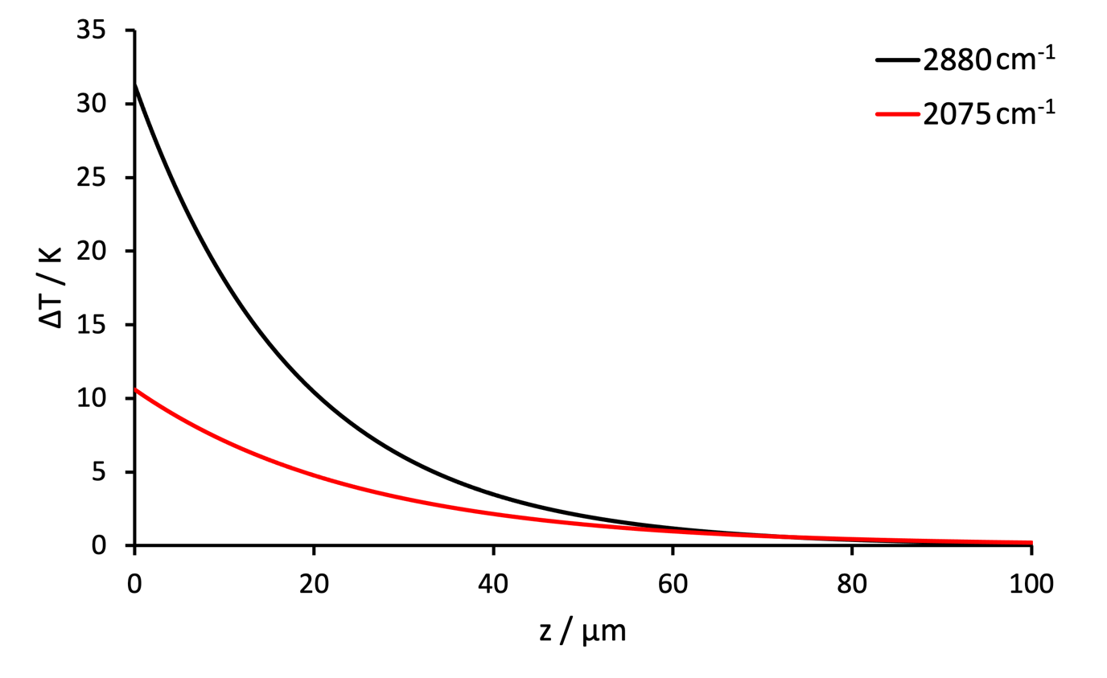
Figure A3.1: Estimated increases in temperature, ΔT, due to absorption of the incident IR in the sub-phase as a function of depth, z, for incident IR frequencies at 2880 cm⁻¹ (black trace) and 2075 cm⁻¹(red trace), corresponding to the methyl symmetric stretching mode for protonated and per-deuterated palmitic acid, respectively.

Acknowledgements
This research was funded in whole or in part by the EPSRC and Unilever on Grant EP/R511870/1. For the purpose of Open Access, the author has applied a CC BY public copyright licence to any Author Accepted Manuscript (AAM) version arising from this submission.

Data Availability
The data that support the findings of this study are available from the corresponding author upon reasonable request.

References
¹ Y.R. Shen, Fundamentals of Sum-Frequency Spectroscopy (2016).
² C.S. Tian and Y.R. Shen, Surface Science Reports 69, 105 (2014).
³ C.D. Bain, Journal of the Chemical Society, Faraday Transactions 91, 1281 (1995).
⁴ P.B. Miranda and Y.R. Shen, Journal of Physical Chemistry B 103, 3292 (1999).
⁵ Y.R. Shen, Nature 337, 519 (1989).
⁶ Z. Chen, Y.R. Shen, and G.A. Somorjai, Annual Review of Physical Chemistry 53, 437 (2002).
⁷ N. Ji, V. Ostroverkhov, C.Y. Chen, and Y.R. Shen, J Am Chem Soc 129, 10056 (2007).
⁸ Q. Sun and Y. Guo, Journal of Molecular Liquids 213, 28 (2016).
⁹ S. Ye, H. Noda, S. Morita, K. Uosaki, and M. Osawa, Langmuir 19, 2238 (2003).
¹⁰ S. Ye, H. Noda, T. Nishida, S. Morita, and M. Osawa, Langmuir 20, 357 (2004).
¹¹ E. Tyrode, P. Niga, M. Johnson, and M.W. Rutland, Langmuir 26, 14024 (2010).
¹² H. Koshima, Y. Iyotani, Q. Peng, and S. Ye, Tribology Letters 64, 34 (2016).
¹³ M. Shrestha, M. Luo, Y. Li, B. Xiang, W. Xiong, and V.H. Grassian, Chemical Science 9, 5716 (2018).
¹⁴ C.Y. Tang, Z. Huang, and H.C. Allen, Journal of Physical Chemistry B 114, 17068 (2010).
¹⁵ C.Y. Tang and H.C. Allen, Journal of Physical Chemistry A 113, 7383 (2009).
¹⁶ G. Ma and H.C. Allen, Langmuir 23, 589 (2007).
¹⁷ L.F. Voss, C.M. Hadad, and H.C. Allen, Journal of Physical Chemistry B 110, 19487 (2006).
¹⁸ W. Rabinovitch, R.F. Robertson, and S.G. Mason, Canadian Journal of Chemistry 38, 1881 (1960).
¹⁹ M.J. Vold, Journal of Colloid Science 7, 196 (1952).
²⁰ E.H.G. Backus, D. Bonn, S. Cantin, S. Roke, and M. Bonn, Journal of Physical Chemistry B 116, 2703 (2012).
²¹ B.D. Casson, R. Braun, and C.D. Bain, Faraday Discussions 104, 209 (1996).
²² B.W. Li, M.C. Zhong, and F. Ji, Applied Sciences 10, 7795 (2020).
²³ C. Hirose, N. Akamatsu, and K. Domen, The Journal of Chemical Physics 96, 997 (1992).
²⁴ C. Hirose, H. Yamamoto, N. Akamatsu, and K. Domen, Journal of Physical Chemistry 97, 10064 (1993).
²⁵ H.F. Wang, W. Gan, R. Lu, Y. Rao, and B.H. Wu, International Reviews in Physical Chemistry 24, 191 (2005).
²⁶ H.-F. Wang, L. Velarde, W. Gan, and L. Fu, Annual Review of Physical Chemistry 66, 189 (2015).
²⁷ R.J. Feng, X. Li, Z. Zhang, Z. Lu, and Y. Guo, Journal of Chemical Physics 145, 244707 (2016).
²⁸ A.G. Lambert, P.B. Davies, and D.J. Neivandt, Applied Spectroscopy Reviews 40, 103 (2005).
²⁹ G. Ma and H.C. Allen, Langmuir 22, 5341 (2006).
³⁰ M. Falk and T.A. Ford, Canadian Journal of Chemistry 44, 1699 (1966).
³¹ W.M. Irvine and J.B. Pollack, Icarus 8, 324 (1968).
³² V.M. Zolotarev, B.A. Mikhailov, L.I. Alperovitch, and S.I. Popova, Optics Communications 1, 301 (1970).
³³ J. Blumm and A. Lindemann, High Temperatures - High Pressures 35–36, 627 (2003).
³⁴ P.B. Miranda, V. Pflumio, H. Saijo, and Y.R. Shen, Thin Solid Films 327–329, 161 (1998).
³⁵ G.J. Simpson and K.L. Rowlen, J Am Chem Soc 121, 2635 (1999).

