TITLE

A multi-centre assessment of prostate MRI quality and compliance with UK and international standards

Authors names and affiliations

P R Burn¹
S J Freeman²
A Andreou³
N Burns-Cox⁴
R Prasad⁵
T Barrett⁶

¹P R Burn MRCP FRCR (corresponding author)
Consultant Radiologist
Department of Diagnostic Imaging,
Musgrove Park Hospital,
Taunton and Somerset NHS Foundation Trust,
Taunton TA1 5DA
Paul.Burn@tst.nhs.uk

²S J Freeman MRCP FRCR
Consultant Radiologist
University Hospitals Plymouth NHS Trust
simonfreeman@nhs.net

³A Andreou FRCR
Consultant Radiologist
Royal United Hospital Bath NHS Foundation Trust
adrian.andreou@nhs.net

⁴N Burns-Cox FRCS
Consultant Urologist
Taunton and Somerset NHS Trust
Nick.Burns-Cox@tst.nhs.uk

⁵R Persad FRCS (Urol)
Professor of Urology
North Bristol NHS Trust
Raj.Persad@nbt.nhs.uk

⁶T Barrett FRCR
Consultant Radiologist
Cambridge University Hospitals NHS Foundation Trust
tb507@medschl.cam.ac.uk

Author Contributions

1 guarantor of integrity of the entire study - PB
2 study concepts and design – PB, AA, SF, TB
3 literature research – PB, TB
4 clinical studies – PB, AA, TB
5 experimental studies / data analysis – N/A
6 statistical analysis – N/A
7 manuscript preparation – PB, TB
8 manuscript editing PB, NB, SF, AA, RP, TB

Authors declaration of interest

P R Burn
Employed by one of the sites assessed in the audit.

S F Freeman
Employed by one of the sites assessed in the audit.

A Andreou
Employed by one of the sites assessed in the audit.

N Burns-Cox
Employed by one of the sites assessed in the audit.

R Persad
Employed by one of the sites assessed in the audit.

T Barrett
Acknowledges support from Cancer Research UK, National Institute of Health Research Cambridge Biomedical Research Centre, Cancer Research UK and the Engineering and Physical Sciences Research Council Imaging Centre in Cambridge and Manchester and the Cambridge Experimental Cancer Medicine Centre.

Submission declaration
We declare that the work has not published previously, that it is not under consideration for publication elsewhere, that its publication is approved by all authors and tacitly or explicitly by the responsible authorities where the work was carried out, and that, if accepted, it will not be published elsewhere in the same form, in English or in any other language, including electronically without the written consent of the copyright-holder.

Acknowledgements

Sarah-Jane Davies
Transformation Project Manager
South West Cancer Alliances (Peninsula and SWAG)
With thanks for assistance with coordination and communication with sites.

Professor Paul Ewings
Visiting Professor
University of Exeter
With thanks for assistance with statistical analysis.

Additional Material

Financial support for the audit received from the south west Cancer Alliances.
The sponsors had no involvement in study design, the collection, analysis nor interpretation of data, nor writing the manuscript, nor the decision to submit for publication.
ABSTRACT

Aim
To assess prostate MRI image quality and compliance with technical standards between centres in the southwest region of the UK.

Methods
15 imaging departments in the region submitted 7 consecutive anonymized MRI studies. These were assessed by two experienced radiologists in consensus. Overall subjective image quality for T2 weighted imaging) T2W, diffusion weighted imaging (DWI) and dynamic contrast enhancement (DCE) were scored on a 5 point Likert scale. Five additional parameters were also visually assessed, including image noise, motion, artifact and distortion. The degree of compliance by each site with 21 published technical standards was also assessed.

Results
94 MRIs were reviewed from across all sites (mean 6.3 scans per site, range 5-7). Compliance with technical standards: mean 63% (range 38-86%). 47% of sites did not perform DCE. One site used a 3T scanner. Percentage of patients with overall quality scores of ≥3 (diagnostically acceptable): T2W 68%, DWI 81%, for both T2W and DWI 60%. 93% of the 45 patients who underwent DCE had diagnostically acceptable studies. By scanner age, percentage of patients with diagnostically acceptable T2W scores was 53% for scanners ≥7 years and 80% when <7 years (p=0.006). Comparing individual sites, the mean overall quality scores were T2W, 2.9 (range 2.2-4.2), DWI 3.2 (1.8-4.7), DCE 3.4 (2.5-4.7).

Conclusion
There is wide variation in compliance with recognized technical standards and image quality across sites, which correlates to scanner age. If MRI is to replace biopsy in select low-risk patients, improvements in image quality may be required.

Key Words
Magnetic Resonance Imaging
Prostate Cancer
Image quality
Audit

Highlights
1) There was a large variation in image quality and guideline compliance between sites
2) At least 40% of patients had non-diagnostic quality scans
3) Scanner age inversely correlated with T2W image quality
4) DCE scored highest for image quality, but was only used in 53% of sites
5) Image quality needs optimization if MRI is used to rule out cancer or avoid biopsy

INTRODUCTION
Prostate cancer is the second leading cause of male cancer mortality worldwide, with incidence expected to double due to the ageing population [1]. Several recent prospective studies have highlighted the ability of pre-biopsy MRI to both improve the yield of clinically significant cancer and reduce the over-diagnosis of indolent disease [2-6].
The PROMIS and PRECISION trials were set up as multicenter “real world” studies performed predominantly using 1.5T magnets, with reporters of varying experience, and suggested than biopsy could safely be avoided in 27-28% of men on the basis of a negative MRI [2, 3]. More recent studies suggest the biopsy avoidance rate could be as high 41-49% in the context of clinical risk stratification, optimizing the quality of MRI protocols and with experienced radiologists reporting at high-throughput centres [4, 6].
Head-to-head cost analysis suggests an increase cost of mpMRI-led pathways compared to the traditional transrectal (TRUS) systematic biopsy approach [7], however, the avoidance of biopsy in a subset of patients will mitigate these excess costs. The pathway therefore relies on biopsy avoidance in a percentage of low-risk patients with negative MRI results, thus necessitating optimal quality. Upfront MRI can also reduce diagnostic times by up to a third [7], which may help avoid financial penalties in the UK system of timed cancer targets. Positive MRI calls offer the additional advantage of “getting it right first time” with subsequent targeted biopsies, potentially saving additional patient anxiety and healthcare costs. MRI pre-biopsy has therefore become an attractive concept, with up to 73% of trusts in England offering this as part of a prostate diagnostic service, despite this exceeding the recommendations of current national guidelines [8].
It is noteworthy that even in the “real world” PROMIS study, mpMRI scans from all sites underwent quality control checks and studies deemed of insufficient quality were repeated prior to biopsy. Furthermore, it has been suggested that the quality of MRI acquisition and reporting should be ensured and audited before pre-biopsy MRI initiation, particularly if used as a means of avoiding biopsy [9]. This clearly brings into focus the quality of the technique, particularly outside large academic centres and without access to latest generation high quality scanners and with limited scanner time. The aim of this study was therefore to assess the technical quality of prostate MRI across multiple hospitals in the southwest region of the UK and compliance with guideline recommendations.

MATERIALS AND METHODS
This audit [10] was carried out through the Prostate Cancer Diagnostic Pathway Steering Group, a group consisting of 3 radiologists and 2 urologists, set up by the two south west Cancer Alliances (Peninsula and SWAG) to evaluate prostate diagnostic pathways in the southwest region. The audit consisted of two parts, firstly an objective assessment of compliance with recognized technical standards and secondly, a subjective assessment of image quality.

The radiology departments of all 14 hospitals offering prostate services within two Cancer Alliance regions were contacted: Peninsula (representing Cornwall and Devon) and SWAG (representing Somerset, Wiltshire, Avon and Gloucestershire). The 14 hospitals comprised 3 teaching hospitals, 8 medium-sized community hospitals, and 3 smaller community hospitals. One hospital submitted 2 data sets (representative of their two scanning sites). Each department was asked to provide anonymized versions of their first 7 prostate MRIs (irrespective of clinical indication or specific protocol) scanned consecutively from 1st July 2018. Departments were also asked to indicate scanner age.
MRI interpretation
The MRIs were reviewed by 2 experienced body fellowship trained radiologists, one, with 10 years’ experience in an academic centre (>3000 prostate MRIs reported), the other, with 15 years reading experience in a district general hospital. Studies were read over two days with both readers blinded to clinical information, hospital site and scanner make, model and magnetic strength. MRIs were excluded from the audit in cases of prior prostatectomy, obvious radiotherapy changes, and/or hip replacement(s).

Technical Standards
21 technical standards were determined, derived from two documents: Prostate Imaging Reporting and Data System (PI-RADS) guidelines, version 2 (11) and the UK consensus paper on prostate MRI (9); where discordant, the standard from the latter more recent document was adopted. Compliance with standards was assessed for each site by either interrogation of DICOM data fields or by visual review of images (in the case of choice of image planes and for measurement of field of view).

Image Quality
Image quality was assessed visually and in consensus by allocating a score for each parameter. Three sequences were evaluated; high resolution T2W axial, axial DWI and axial dynamic post contrast DCE. For each sequence, overall subjective image quality was assessed using a 5 point Likert scale (with 1= very poor; 3= just acceptable diagnostically; 5 = very good). The following additional parameters were assessed using a 4 point Likert scale; T2W: noise (1=marked, 4=nil), motion artefact (1=very blurred, 4=sharp) and degree of rectal distension (on sagittal T2W sequence, 1= empty, 4=significantly distended), DWI; distortion (1=significant warping, 4= none) and other artefact (1=marked, 4=nil) (see supplementary material). For DCE, the percentage of corrupt data-points on a region of interest enhancement curve were recorded (corrupt points were defined as more than 10% difference in value between adjacent data-points, after the initial upstroke of the curve) [10, 11].
Statistical Analysis
Means are presented based on the Likert scales for the various quality measures, but the comparative analyses are based on dichotomising the scores as described elsewhere. Since data refer to patients within hospital sites, a multilevel model was used, with some variables (eg image quality, rectal distension) at the level of the patient, and others at the level of the site (eg age of scanner). Mixed-effects logistic regression models were fitted to assess the effect of variables of interest on the various quality measures, including site as a random effect. The results of these models are presented in the form of odds ratios with 95% confidence intervals and associated p-values.
RESULTS
105 scans were received, 11 were excluded (7 due to prior hip replacement(s), 1 with obvious radiotherapy change, 1 prostatectomy, and 2 with incomplete datasets). 94 MRIs were therefore included in the audit. The mean number of MRI scans assessed per site was 6.3 (range 5-7).

Compliance with Technical Standards
Two sites had incomplete data and were excluded from this analysis. Overall compliance with the 21 standards across 13 sites was mean 63% (range 38-86%), (Table 1). 7/15 (47%) sites did not include DCE sequences, which significantly affected their overall compliance results, as 7 of the standards related directly to DCE. Compliance with the 14 standards unrelated to DCE: mean 73% (range 50-93%). 4/15 sites (27%) did not scan axial to the patient, instead scanning approximately axial to the prostatic urethra; Figure 1. Although not a listed standard, it was noted that only 1/15 sites used a 3T scanner.

Image Quality
A diagnostically acceptable score of ≥3 was seen in 64/94 scans (68%) for T2W, 76/94 (81%) for DWI and 42/45 (93%) for DCE. The number of patients with overall quality scores ≥3 for both T2W and DWI (diagnostic biparametric study) was 56/94 (60%) and for T2W, DWI and DCE (diagnostic multiparametric study), 25/45 (56%). Examples of images with high and low overall quality scores are given in Figures 2-4.
The mean scores for all scans from each site were calculated for all 9 parameters (Table 2). Average overall quality score was 2.9 (range 2.2-4.2) for T2, 3.2 (1.8-4.7) for DWI, and 3.4 (2.5-4.7) for DCE. The same site provided the highest mean overall quality scores across all 3 sequences. Mean overall quality scores per site are shown in Figures 5.
Effect of rectal distension
We assessed the effect of rectal distension on image quality, comparing two groups, less distended (scores 1-2, 52 patients) and more distended (scores 3-4, 42 patients) and dichotomizing image quality into diagnostic (image quality score ≥3) or non-diagnostic (image quality score ≤2). For T2W in the less distended group, 67% were diagnostic versus 69% in the more distended group; applying a mixed-effects logistic regression, odds ratio =1.1 (0.4 to 2.8), p=0.8. For DWI, for the less distended group, 92% were diagnostic versus 67% in the more distended group; odds ratio=0.08 (0.02 to 0.43), p=0.003.

Effect of scanner age
We assessed the influence of scanner age on image quality, comparing two groups: MRIs performed on scanners <7 years old (54 patients) and MRIs performed on scanners ≥7 years old (40 patients) and dichotomizing image quality into diagnostic (image quality score ≥3) and non-diagnostic (score ≤2). For T2W, 80% were diagnostic in the newer scanner group, compared to 53% in the older scanner group; odds ratio 3.5 (1.4 to 8.8), p=0.006. For DWI, for the newer scanner group, 81% were diagnostic and in the older scanner group, 80% were diagnostic; odds ratio=1.2 (0.3 to 5.9), p=0.8. The relationship between scanner age for each site and mean T2W overall quality score is shown in Figure 6), demonstrating an inverse correlation.
Comparing mpMRI to bpMRI sites
We compared two further groups, those who had DCE (multipametric MRI: 45 patients) and those who did not (biparametric MRI: 49 patients), to determine if sites that give contrast also have better overall quality scores for T2W and DWI. Again, we dichotomized image quality into diagnostic (image quality score ≥3) and non-diagnostic (score ≤2). For T2W in the DCE group, 64% were diagnostic and for the non-DCE group, 71% were diagnostic; odds ratio=0.73 (0.27 to 1.94), p=0.52. For DWI in the DCE group, 76% were diagnostic, and for the non-DCE group, 86% were diagnostic; odds ratio=0.52 (0.14 to 1.97), p=0.33.

DISCUSSION

Our results show that at least 40% of patients in our region are not having a full diagnostic quality prostate MRI study. To our knowledge, this is the first published comprehensive audit of prostate MRI image quality. Although lesion detection and pathological outcomes were not assessed as part of this study, it is likely that good image quality is equally, if not more, important for confidently excluding disease, as for detecting tumours. These findings may, therefore, have implications for the development of policies centred around biopsy avoidance in low-risk patients with a negative MRI.

There was a wide inter-site variation in compliance with recognized standards (38-86%). It is noteworthy that only 47% of sites performed DCE, despite this being clearly recommended within both sets of assessed guidelines [9, 11]. However, the guidelines do downplay the role of DCE and somewhat undermine its value with statements such as ‘the added value is modest’ [11] and DCE should be used as a ‘safety-net’ or a ‘back-up sequence’ [9]. It may be that with limited resources, sites have made a cost/benefit judgement and decided against contrast administration. Nevertheless, in our audit, DCE was the sequence with the highest overall quality score (93% of patients score ≥3) and contrast might be a useful adjunct sequence for departments struggling with ageing scanners. It is also noteworthy that DCE use was not associated with higher T2 or DWI scores, suggesting its use is not simply a reflection of use in centres that provide more optimized, fully comprehensive protocols. In fact, centres using DCE showed a non-significant trend towards lower T2 and DWI scores, suggesting that its use is likely to provide added benefit. Furthermore, our audit excluded patients with hip replacements and post treatment cases, in whom DCE may be of most benefit.

A standard specific to the UK consensus paper [9], is a requirement to scan axial sequences in a plane axial to the patient, which was failed by 27% of sites. This standard allows both improved anatomical correlation between sequences and consistency between multiple MRIs in the same patient; in addition we noted in our audit that alternative planes chosen tended to transect the rectum more obliquely (Figure 1b) and we speculate that this might predispose to increased gas/motion artifact from the rectum.

Our audit found wide variation in overall image quality scores across sites. For T2W, there are 3 sites with a low mean score of 2.2, compared to the highest mean score in our audit of 4.2. Review of local sequence protocols and support from manufacturers’ applications specialists may be considered appropriate at some sites to facilitate improvements in image quality.

We found that scanner age was a significant factor influencing T2W image quality and that 40% of scanners were ≥7 years of age. We used this as a cut-off for defining ‘older’ scanners, as this is in line with our regional guidelines that recommend use of a scanner <7 years of age. Lack of investment in new scanners would may prove a major obstacle to improving the quality of prostate MRI, with significant funding challenges likely to be encountered nationally. We also note that only one site in our audit used a 3T scanner; although this is not a PIRADS 2 recommendation, it is clearly the committee’s strong preference.

We also assessed the effect of rectal distension on image quality, and found an inverse relationship with overall DWI quality, in concordance with the findings of Caglic et al [12]. There was no significant relationship with T2W image quality, which is less prone than DWI to air-induced susceptibility artefact. Interestingly, the site with the overall lowest mean rectal distension score (1.5 compared to group mean of 2.4) administered oral senna as bowel preparation the evening prior to scanning and also had the highest overall image quality scores across all three parameters. However, the bowel preparation policy of the other sites is unknown.

Our audit is limited by a relatively small sample size. Patient motion, size, or rectal distension may influence image quality, additionally other extraneous factors such as radiographer experienced or technical issues may affect results, however, it is hoped these factors will average out, given a minimum of 5 cases per site were assessed. Interpretation of image quality is largely a subjective exercise, and the results may not be directly comparable to other audits. Although we assessed 5 parameters relating to image quality, we did not combine these to provide an overall quality score; in practice we instinctively preferred to do this subjectively; however, by firstly reviewing the specific parameters we felt better able to give an appropriate overall assessment.
In summary, we found significant challenges across the region in delivering diagnostic prostate MRI scans, with wide variation across sites in both compliance with technical standards and image quality. This is of particular importance given proposals for widespread adoption of MRI as a first-line investigation for people with suspected clinically localised prostate cancer. It is hoped that this audit will help inform the development of a more standardized national audit process for prostate MRI.

RERFERENCES

1. Siegel RL, Miller KD, Jemal A. Cancer Statistics, 2017. CA Cancer J Clin. 2017; 67(1):7-30.doi: 10.3322/caac.21387

2. Ahmed HU, El-Shater Bosaily A, Brown LC, et al. Diagnostic accuracy of multi-parametric MRI and TRUS biopsy in prostate cancer (PROMIS): a paired validating confirmatory study. Lancet. 2017; 389(10071):815-822.
doi: 10.1016/S0140-6736(16)32401-1

3 . Kasivisvanathan V, Rannikko AS, Borghi M, et al. MRI-targeted or standard biopsy for prostate-cancer diagnosis. N Engl J Med 2018; 378: 1767–77. doi: 10.1056/NEJMoa1801993
4. Boesen L, Nørgaard N, Løgager V, et al. Prebiopsy Biparametric Magnetic Resonance Imaging Combined with Prostate-specific Antigen Density in Detecting and Ruling out Gleason 7–10 Prostate Cancer in Biopsy-naïve Men. Eur Urol. 2018; DOI: https://doi.org/10.1016/j.euo.2018.09.001
5. Rouvière O, Puech P, Renard-Penna R, et al. Use of prostate systematic and targeted biopsy on the basis of multiparametric MRI in biopsy-naive patients (MRI-FIRST): a prospective, multicentre, paired diagnostic study. Lancet Oncol. 2018 Nov 20. pii: S1470-2045(18)30569-2. doi: http://dx.doi.org/10.1016/S1470-2045(18)30569-2

6. van der Leest M, Cornel E, Israel B, et al. Head-to head Comparison of Transrectal Ultrasound guided Prostate Biopsy Versus Multiparametric Prostate Resonance Imaging with Subsequent Magnetic Resonance-guided Biopsy in Biopsy-naïve Men with Elevated Prostate-specific Antigen: A Large Prospective Multicenter Clinical Study. Eur Urol. 2018 Nov 23. pii: S0302-2838(18)30880-7.
doi: 10.1016/j.eururo.2018.11.023. [Epub ahead of print]

7. Panebianco V, Valerio MC, Giuliani A, et al. Clinical Utility of Multiparametric Magnetic Resonance Imaging as the First-line Tool for Men with High Clinical Suspicion of Prostate Cancer. Eur Urol Oncol 2018; 1(3):208-14. DOI: https://doi.org/10.1016/j.euo.2018.03.008

8. National Institute for Health and Care Excellence. Prostate cancer: diagnosis and treatment. Clinical guideline 175. 2014.
https://www.npca.org.uk/content/uploads/2018/02/NPCA-2017-Annual-Report_final_211117.pdf
9. Brizmohun Appayya M, Adshead J, Ahmed HU et al. National implementation of multi-parametric magnetic resonance imaging for prostate cancer detection - recommendations from a UK consensus meeting. BJU Int. 2018; 122(1):13-25. doi: 10.1111/bju.14361

10. Registered as clinical audit by Taunton and Somerset NHS Foundation Trust (A regional audit of prostate MRI image quality - code DIAG1819_7)

11. Weinreb JC, Barentsz JO, Choyke PL et al. PI-RADS Prostate Imaging - Reporting and Data System: 2015, Version 2. Eur Urol. 2016; 69(1):16-40.
doi: 10.1016/j.eururo.2015.08.052

12. Caglic I, Hansen NL, Slough RA, Patterson AJ et al. Evaluating the effect of rectal distension on prostate multiparametric MRI image quality. Eur J Radiol. 2017; 90:174-180. doi: 10.1016/j.ejrad.2017.02.029

FIGURE LEGENDS

Figure 1

Example of non-compliance with technical standards – axial T2W sequence (A) is not aligned perpendicular to long axis of patient, as demonstrated on sagittal T2W sequence (B).

Figure 2

Mean overall image quality score per site, for T2W, DWI and DCE (ordered by ascending DWI score).

Figure 3

T2W images: overall quality score 5 (A) with low noise, no blurring and good resolution and score 1 (B) with very high noise levels.

Figure 4
DWI images: overall quality score 5 (A) with reasonable resolution, low artifact and distortion and score 1 (B), very high noise levels and no anatomical detail whatsoever.

Figure 5

DCE images: overall quality score 5 (A) with low noise and good resolution and score 1(B) with blurring artifact right side of gland.

Figure 6

Overall T2W image quality versus scanner age

TABLES

Table 1

Compliance with 21 technical standards across 15 sites (y=compliant, n= not compliant, NA=data not available).

Parameter | Standard | Hospital Site |  |  |  |  |  |  |  |  |  |  |  |  |  |  | %  Compliance
 |  | A | B | C | D | E | F | G | H | I | J | K | L | M | N | O
T2w axial plane axial to patient | Axial to patient | N | Y | N | Y | Y | Y | Y | Y | Y | Y | Y | N | Y | Y | N | 73
DWI axial to patient | Axial to patient | Y | Y | N | Y | Y | Y | Y | Y | Y | Y | Y | N | Y | Y | N | 80
DCE axial to patient | Axial to patient | N | Y | N | N | Y | N | Y | Y | Y | Y | Y | N | N | N | N | 47
3 planes small FOV T2W | Present | Y | Y | Y | N | N | Y | Y | Y | Y | Y | Y | Y | Y | Y | Y | 87
T2W axial slice thickness | 3mm | Y | N | Y | N | Y | Y | Y | N | Y | Y | Y | N | N | Y | N | 60
T2W axial slice gap | No gap | N | N | N | Y | N | N | N | Y | N | Y | Y | Y | Y | Y | Y | 53
T2W axial field of view | 12-20cm | Y | N | Y | Y | N | Y | Y | Y | Y | N | Y | Y | Y | Y | Y | 80
T2W axial in plane resolution | ≤0.7mm | N | Y | Y | Y | Y | Y | N | Y | Y | Y | Y | Y | Y | Y | Y | 87
DWI sequence included | Present | Y | Y | Y | Y | Y | Y | Y | Y | Y | Y | Y | Y | Y | Y | Y | 100
DWI slice thickness | ≤4mm | N | Y | Y | Y | Y | N | Y | Y | Y | Y | Y | Y | Y | Y | Y | 87
DWI slice gap | No gap | Y | N | N | Y | N | N | Y | N | N | N | N | N | Y | Y | Y | 40
DWI field of view | 16-22cm | N | N | Y | Y | N | N | N | Y | Y | N | Y | N | N | Y | Y | 47
DWI in plane resolution | ≤ 2mm | Y | Y | Y | Y | Y | Y | Y | Y | Y | Y | Y | Y | Y | Y | Y | 100
Lowest b value/s/mm² | >/=50 | Y | N | N | Y | Y | Y | Y | N | N | N | Y | Y | NA | N | Y | 57
Highest b value/s/mm² | >/=1400 for 1.5T, >/= 2000 for 3T | Y | N | Y | Y | Y | Y | Y | Y | Y | Y | N | N | NA | Y | Y | 79
DCE sequence included | Present | N | Y | Y | N | Y | N | Y | Y | Y | Y | Y | N | N | N | N | 53
DCE slice thickness | 3mm | N | N | N | N | N | N | N | N | Y | N | N | N | N | N | N | 7
DCE slice gap | No gap | N | Y | Y | N | Y | N | Y | Y | Y | Y | Y | N | N | N | N | 53
DCE in plane resolution size | ≤2mm | N | Y | Y | N | Y | N | Y | Y | Y | Y | Y | N | N | N | N | 53
DCE temporal resolution | ≤15s | N | N | Y | N | N | N | Y | Y | Y | NA | Y | N | N | N | N | 36
DCE duration | ≥2min | N | Y | Y | N | N | N | Y | Y | Y | NA | Y | N | N | N | N | 43
% Compliance |  | 43 | 57 | 67 | 57 | 62 | 48 | 81 | 81 | 86 | NA | 86 | 38 | NA | 62 | 52

Table 2
Mean scores (of all scans) for each hospital site (A-N) for all parameters.

 | Hospital Site (mean scores per site, (range in parentheses))
PARAMETER | A | B | C | D | E | F | G | H | I | J | K | L | M | N | O
T2W Overall Quality Score | 3  (2-4) | 2.5  (2-3) | 3.4  (2-4) | 3  (2-4) | 4.2  (4-5) | 2.8  (2-4) | 2.2  (1-4) | 2.2  (1-3) | 3.3  (2-5) | 2.6  (2-4) | 2.2  (1-3) | 3.8  (3-4) | 3.3  (3-4) | 2.7  (2-4) | 3  (2-4)
DWI Overall Quality Score | 3.5  (1-5) | 3.1  (2-4) | 2.8  (2-4) | 3.8  (3-4) | 4.7  (4-5) | 3  (2-4) | 2.5  (1-4) | 2.8  (2-4) | 3.3  (3-4) | 3.3  (3-4) | 1.8  (1-3) | 2.8  (1-4) | 4  (4-4) | 3.1  (3-4) | 3.7  (2-5)
DCE Overall Quality Score | NA | 2.5  (1-3) | 4.1  (3-5) | NA | 4.7  (4-5) | NA | 3  (3-4) | 3.2  (3-4) | 3.6  (3-4) | 3  (3-3) | 3  (3-3) | NA | NA | NA | NA
T2W Noise | 2.7 | 2.8 | 2.8 | 2.4 | 3.1 | 3.2 | 1.8 | 2.2 | 3.1 | 2.1 | 2 | 3.2 | 3 | 2.4 | 3
T2W Motion | 2.4 | 2.3 | 2.4 | 2.4 | 3.2 | 2.2 | 2.7 | 2.2 | 2.6 | 2.3 | 1.7 | 3 | 2.8 | 2.4 | 2.7
DWI Distortion | 2.5 | 3 | 2.5 | 2.6 | 3.7 | 3.2 | 3.2 | 2.8 | 2.8 | 3.1 | 2.5 | 2.6 | 3.3 | 3.4 | 2.8
DWI Artifact | 2.8 | 3 | 2.1 | 3.2 | 3.2 | 2.6 | 2.5 | 2.4 | 2.5 | 2.5 | 2.1 | 2.6 | 3 | 3.4 | 3.5
Corrupt Datapoints | NA | 12% | 10% | NA | 6% | NA | 28% | 15% | 14% | 36% | 20% | NA | NA | NA | NA
Rectal Distension | 2.7 | 2.1 | 3.1 | 2.6 | 1.5 | 2.2 | 2.2 | 2.1 | 2.5 | 3.1 | 2.2 | 3 | 1.6 | 2.2 | 2.7

FIGURES

Figure 1a

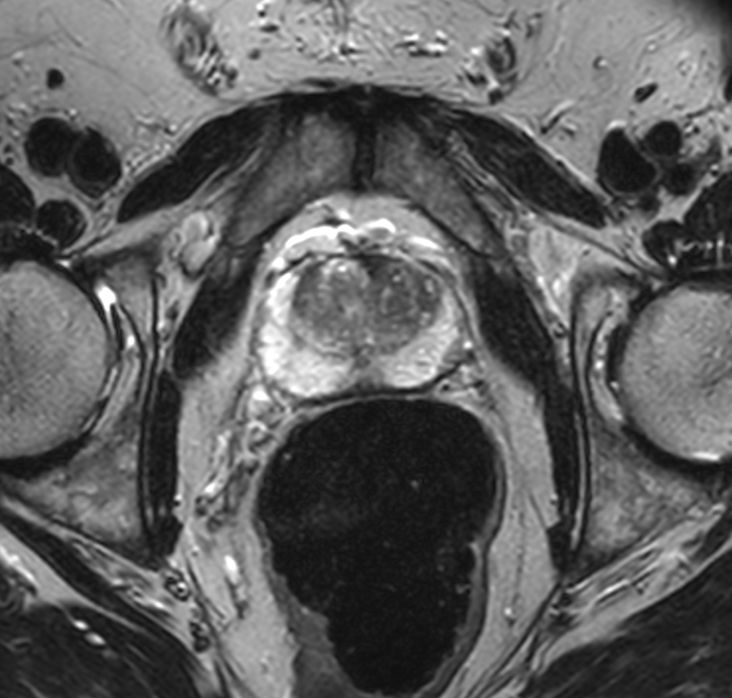

Figure 1b

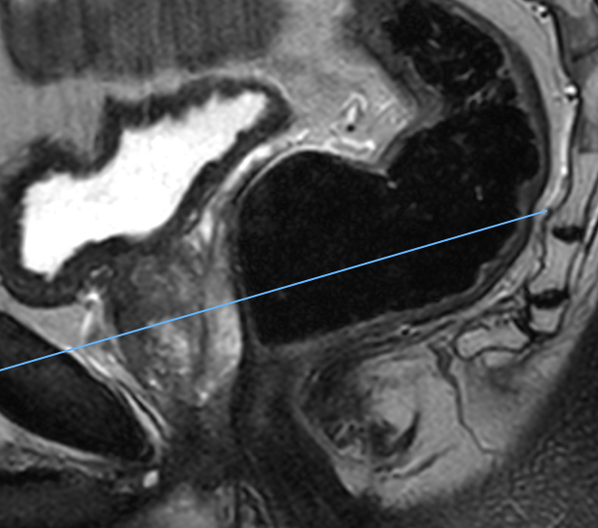

Figure 2

Figure 3a

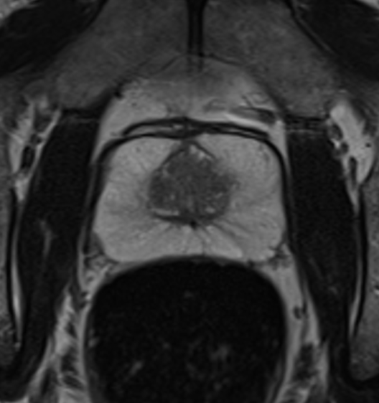

Figure 3b

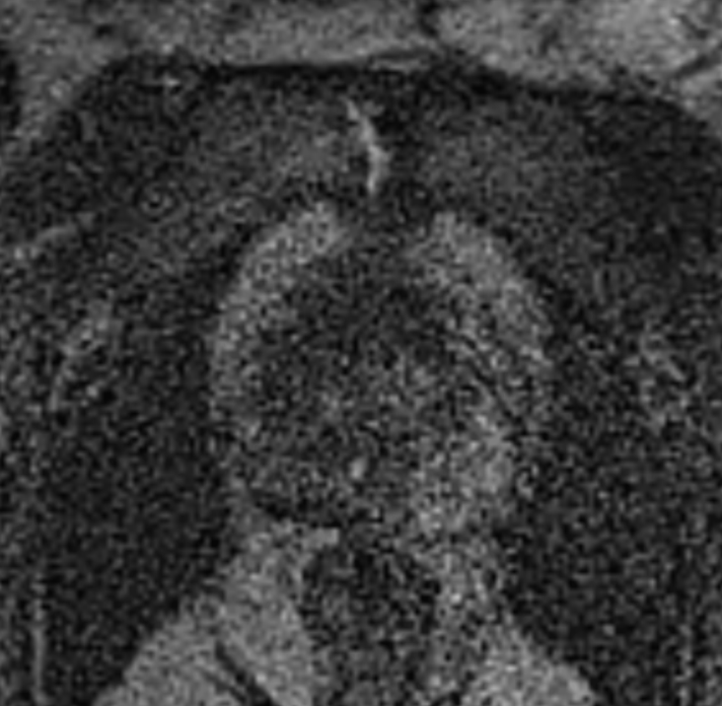
Figure 4a

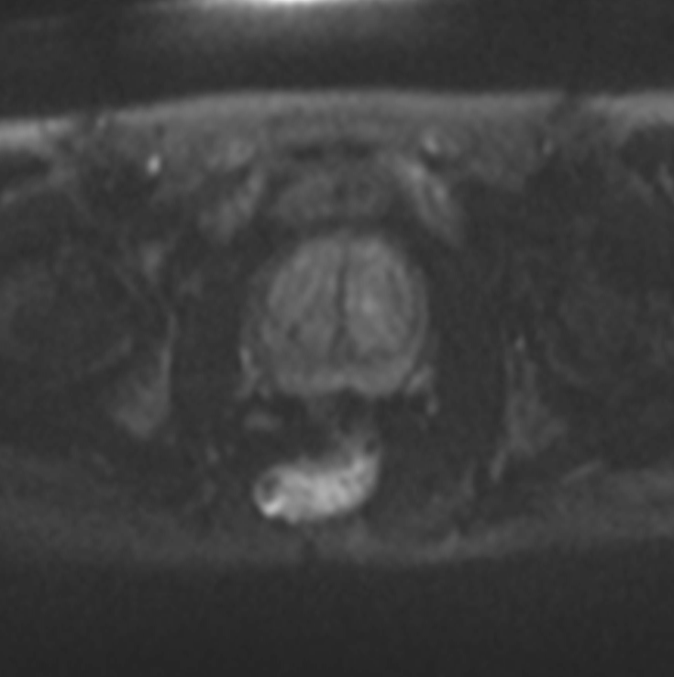

Figure 4b
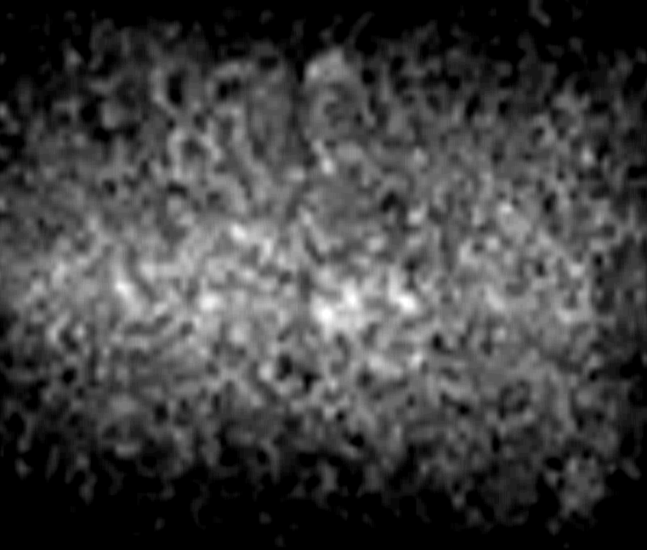

Figure 5a

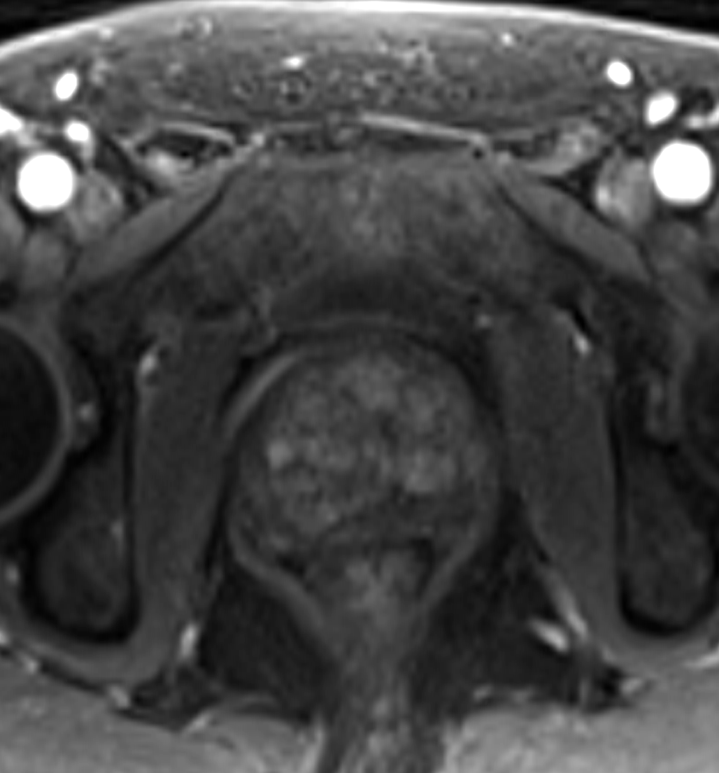

Figure 5b

