Reliable single grain growth of (RE)BCO bulk superconductors with enhanced superconducting properties

David A Cardwell, Yunhua Shi and Devendra K Numburi

Department of Engineering, University of Cambridge, Trumpington Street, Cambridge CB2 1PZ, United Kingdom

E-mail: dc135@cam.ac.uk

Abstract
We review recent progress in the successful and reliable fabrication of large grain (RE)BCO and (RE)BCO-Ag bulk high temperature superconductors by three primary processing methodologies: top-seeded melt growth (TSMG), top-seeded infiltration growth (TSIG) and a combined processing route comprising both TSMG and TSIG. Several significant and useful modifications have been made to these processing routes over the recent years in order to grow (RE)BCO single grains reliably and to enhance their superconducting properties. With respect to the reliable growth of (RE)BCO single grains, we have further developed the so-called buffer technique for reliable seeding, which includes identifying and providing an appropriate liquid-rich phase at the bottom of pellet. This modification has proved to be critical to the success of the newly-developed fabrication techniques presented here. In addition, we have addressed existing and significant challenges in the context of improving the superconducting properties of the bulk samples by controlling the microstructures of single grain materials (porosity and the RE-211 distribution, in particular) and by suppressing the extent of RE/Ba substitution during grain growth. Finally, we provide a short summary of the potential pathways towards realising practical applications of these technologically important materials in the near future.

Key words: reliable growth, buffer technique, liquid rich phase, porosity, microstructure, RE-211, REBCO(Ag)(RE=Sm, Gd and Y)

- Introduction
Single grain, (RE)-Ba-Cu-O [(RE)BCO), where RE is a rare-earth element such as Gd, Nd, Sm and including Y] bulk high temperature superconductors have significant potential for application in a relatively wide range of engineering devices, based principally on magnetic levitation. The processing of single (RE)BCO grains, however, is not straight forward due mainly to the complexity of the growth process, and particularly when the sample diameter exceeds 25 mm. The so-called top seeded melt growth (TSMG) process is a well-established route for the fabrication of bulk (RE)BCO superconductors, and is based on a process where the seed is placed on the precursor arrangement at room temperature (so-called cold-seeding) to yield bulk samples that can carry large critical current densities (J_{c}’s) and generate relatively large trapped magnetic fields [1, 2]. It is well-known that these materials exhibit a self-field J_{c} [J_{c}(0)], as large as 10 – 50 kA/cm² within an individual single grain, even at temperatures as high as 77 K (the boiling point of liquid nitrogen) [3].

It has been established that the presence of grain boundaries, unfortunately, has an adverse effect on the applied superconducting properties of (RE)BCO bulk superconductors, and results typically in a reduction of J_{c} by orders of magnitude. It is essential, therefore, to eliminate grain boundaries from the bulk (RE)BCO microstructure if these materials are to support large supercurrent loops that flow over the entire volume of the single grain to generate a large magnetic moment, and hence to produce an associated large trapped magnetic field. The trapped field, B_{t}, achieved in bulk (RE)BCO single grain superconductors depends critically on two parameters: J_{c} and the size of the size of the supercurrent loop, with $B_{t}∝ J_{c}*r$. Hence, it is highly desirable to fabricate bulk (RE)BCO superconducting materials in the form of large, single grains that exhibit high J_{c}.

The growth of the superconducting REBa₂Cu₃O_{7-δ} (RE-123) phase is relatively complicated and depends on various growth parameters. RE-123 melts incongruently when heated above its peritectic temperature, ‘T_{p}’ (1005 °C for YBCO, in air, for example), at which point it decomposes into a solid RE₂BaCuO₅ (RE-211) phase and a barium- and copper-rich liquid phase comprised of BaCuO₂ and CuO. These phases recombine to form the RE-123 phase on subsequent cooling of the partially molten material below T_{p}. In general, this process often generates multiple grain nucleation sites, which results, undesirably, in the formation of multi-grain (RE)BCO sample. T_{p}‘s of different (RE)BCO compounds are listed in Table-1.

Table 1. Peritectic temperature (T_{p}) in air of various (RE)BCO compounds [2]
RE in (REBa₂Cu₃O_{7-δ}) | Peritectic Temperature T_{p} (ºC) in air  (Error: ±5 ºC)
Yb | 960
Er | 990
Y | 1005
Ho | 1005
Dy | 1010
Gd | 1030
Eu | 1046
Sm | 1054
Nd | 1068

Epitaxial single grains of (RE)BCO can now be fabricated routinely via melt growth techniques that employing a suitable seed crystal (i.e. possessing similar crystal structure to the material being seeded, having phase stability with the melt composition and possessing a higher melting temperature). However, this is an involved process and the optimisation of many critical parameters, such as choice of seed crystal, homogeneity of the precursor powders, the use of second phase refiners and heat treatment conditions, is fundamental to the single grain growth process and require careful investigation. Any small disturbance in the growth conditions in the vicinity of the growth front, for example, can affect adversely the single grain growth process itself, and result in incomplete or multi-grain growth. This has been the primary reason for the relatively low success rate (~ 20-30%) of the single grain growth of (RE)BCO materials fabricated to date [4]. Growth failures can still occur even for an optimum heating profile due to issues with the seeding process, resulting in the nucleation and growth of sub-grains at the bottom of the precursor pellet. The present paper focuses on two important aspects of the growth optimisation process: (1) increasing the success rate of single grain growth and making the growth process robust and hence more reliable via both seeding and the provision of extra liquid phase (including recycling) during the growth process, and (2) improving the superconducting properties of bulk single grain (RE)BCO superconductors by investigating key microstructural parameters such as porosity and RE-211 control in the matrix of RE-123) and via suppressing the extent of RE/Ba substitution. Various single grain (RE)BCO and (RE)BCO systems containing Ag have been studied systematically and a relatively large quantity of data is presented in this study to derive the conditions required for reliable growth. A detailed investigation of sample microstructure and related properties are used to propose the pathways for improving the superconducting properties required for the employment of bulk single grain samples in practical applications.

- Experimental
The samples described in this study were fabricated employing one of the following fabrication techniques: (i) Top Seeded Melt Growth (TSMG), as illustrated in Figure 1(a), (ii) Liquid-assisted TSMG, as s illustrated in Figure 1(b) and (iii) Top-seeded Infiltration Growth (TSIG), as illustrated in Figure 1(c). In the arrangement such as that depicted in Figure 1(a), the pre-form consists of a compacted mixture of RE-123 and RE-211 powder with either a thin coating of Yb₂O₃ or no special layer added to the bottom of the pre-form prior to placing the arrangement on a substrate in preparation for TSMG. In the TSIG arrangement such as that depicted in Figure 1(c), the pre-form consists of two pellets: the RE-211 pre-form pellet supported by a liquid phase reservoir substrate that supplies liquid phase (Ba₃Cu₅O₈) to the RE-211 pre-form pellet at high temperature (in the range 900 - 1050 ºC), which reacts subsequently with RE-211 to form RE-123 below the T_{p} of the RE-123 phase. If the pre-form consists of a mixture of RE-123 and RE-211 phases with a liquid-rich phase of composition that both inhibits the growth of sub-grains at the bottom of the samples and provides a small amount of liquid (Ba₃Cu₅O₈) to the principal mixture of RE-123 and RE-211, then the process is called liquid-assisted TSMG or a combination of TSMG and TSIG (TSMGIG). This process has been developed recently by the Cambridge Bulk Superconductivity Group.

In each of these processes, precursor powders were prepared from mixtures of RE-123, RE-211, and second phase refiners (such as Pt and or CeO₂). The raw RE-123 and RE-211 powders (where RE = Sm, Gd and Y) were sourced from Toshima, 99.9% purity (grain size: RE-123, 2-3 μm; RE-211, 1-2 μm). Appropriate amounts of BaO₂ were added to the GdBCO or SmBCO precursor composition to suppress the substitution of the RE element for Ba during the single grain growth process. An appropriate amount of Ag₂O (10 wt%) was further added to the precursor powders for the fabrication of (RE)BCO-Ag bulk superconductors. In each case the precursor powders were mixed thoroughly using an automixer and a Turbula mixer for approximately 3 hours. The mixed powders were then pressed either uniaxially in a steel die or isostatically to obtain pellets with dimensions in the range of 16 mm to 60 mm in diameter for use in different experiments. The sample assemblies prepared for each configuration are shown schematically in Figure 1.

A generic [5], thin film seed [6] or other seed, such as NdBCO or SmBCO, which has a peritectic temperature that is at least 40 °C higher peritectic than the pellet to be seeded, was placed at the centre of a buffer layer on the top surface of the compacted pellet [7] [8]. Insertion of the buffer between the seed and the main precursor pellet is key to achieving a reliable seeding process, which, subsequently, enables the fabrication of a large single grain. A region of liquid-rich phase (usually Yb₂O₃-added Ba₃Cu₅O₈ or Y₂O₃ added Ba₃Cu₅O₈) [4, 9] was employed to prevent the formation of sub-grains at the bottom of the sample in each fabrication process. TSMG [10], TSIG or TS(MG+IG) techniques have been adopted for the growth of all the single grains under an air processing atmosphere in this investigation.

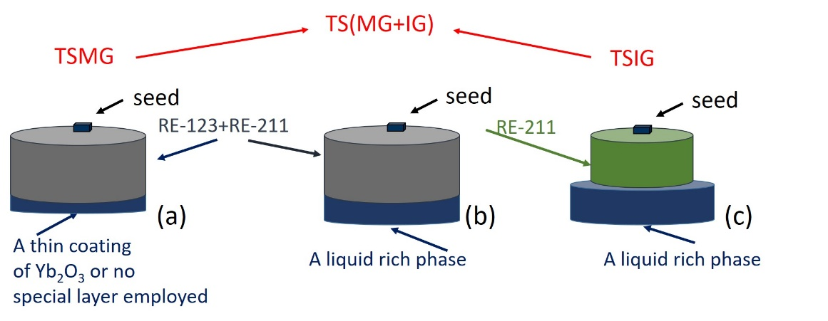

Figure 1 Schematic illustration of the sample assembly arrangement used for (a) standard TSMG, (b) TSIG and (c) intermediate/combined TS (MG+IG) techniques.

2.1 Buffer seeding
The buffer seeding process [11] has been developed significantly by the Cambridge Bulk Superconductivity Group over recent years [7, 11-15]. The buffer is a small cylindrical pellet, introduced between the seed crystal and the pressed pellet to be seeded, as shown in Figure 2(b). The buffer layers used in this modified process are usually between 2 and 4 mm in diameter and between 2 and 3 mm in height. The optimum composition of the buffer layer is the same as the pellet to be seeded, but without the addition of any dopants, additives, Ag or second phase refiners. For example, the composition of the buffer layer for pellets of composition of 75wt% Sm-123 + 25wt% Sm-211 +2wt% BaO₂ + 1wt% CeO₂ + 10wt% AgO₂ is 75wt% Sm-123 + 25wt% Sm-211. Systematic research on developing an understanding of the buffering technique has been carried out in different (RE)BCO systems, including YBCO, GdBCO and SmBCO, and their equivalent silver containing systems [7, 8, 15, 16].

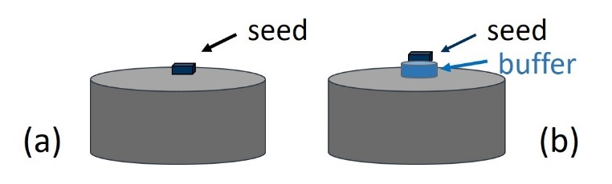
Figure 2. Schematic illustration of the sample assembly arrangement for the fabrication of (RE)BCO bulk superconductors employing a (a) Standard TSMG and (b) Buffer-assisted TSMG process.

2.2 Introducing a liquid-rich phase to the bottom of pressed pellet
Further explanation of the novelty and need to introduce a suitable liquid-rich phase at the bottom of the pressed precursor pellet is provided in this section. Several potential liquid phase components such as Yb₂O₃: CuO: BaCuO₂ = 1:6:10 [17, 18], Yb₂O₃: Ba₃Cu₅O₈ = 1: 3.3, Y₂O₃: CuO: BaCuO₂ = 1:6:10, Y₂O₃: Ba₃Cu₅O₈ = 1: 3.3, Ba₃Cu₅O₈ only and different mixtures of Y-123 and Ba₃Cu₅O₈ were investigated systematically as suitable liquid phase reservoir components for the various melt processes. Ultimately, a Yb-based liquid phase emerged as the best composition for the liquid phase component since it addressed successfully problems of poor stability of the pellet during growth and minimised the nucleation and growth of sub-grains from the bottom of the samples due primarily to the lower thermal kinematics associated with the reduced lower T_{p} of Yb-123 (as evidenced from Table-1). The same Yb-based liquid phase was also employed successfully both for the recycling process and in the TSIG process. This liquid-rich phase has a lower melting temperature than all the (RE)BCO systems studied in the present work (Nd, Sm, Gd and Y) due to the presence of Yb and a large quantity of liquid phase Ba₃Cu₅O₈, which delays solidification of the liquid phase reservoir composition until the entire melt-process is complete, thereby avoiding the formation of sub-grains in the main (RE)BCO material. The relative amounts of Yb-based liquid-rich phase employed for the recycling and TSIG processes are very different. For example, 11 g of liquid-rich phase was used for recycling a failed YBCO sample of diameter 25 mm [4], whereas 35 g of liquid-rich phase was used for the infiltration growth of a 20 g Y-211 pre-form of diameter 20 mm [9].

New approaches to achieving reliable melt processing of (RE)BCO have also been developed by including a liquid-rich phase to the bottom of the precursor sample arrangement to both help prevent the formation of sub-grains at the bottom of the sample at the growth temperature and to enable a small amount of liquid to infiltrate the sample to reduce pore formation and the local concentration of RE-211. This combined TSMG and TSIG method is referred to as TS(MG+IG) in this investigation. Key to selecting the composition of the liquid-rich phase is that its melting temperature should be at least 40°C lower than that of the target (RE)BCO system so that the liquid-rich phase decomposes but inhibits the nucleation of sub-grains during the crystal growth process. In the primary growth of YBCO or YBCO(Ag) single grains, for example, an appropriate liquid-rich phase is Yb₂O₃: Ba₃Cu₅O₈ = 1: 3.3 or Yb₂O₃ : Ba₃Cu₅O₈ : BaO₂ = 5.0 : 5.6 : 1.0 [19]. On the other hand, liquid for GdBCO and SmBCO (both undoped and silver-containing) can be sourced from commercial Y-123 powder, which decomposes to form Y-211 and Ba₃Cu₅O₈ during the primary growth process. In all cases, Ba₃Cu₅O₈ can infiltrate-back to at least partially fill the pores that form as oxygen is released, as in the TSIG process [13, 20]. For a GdBCO sample of diameter 25 mm after processing, 5 g of Y-123 can be added to the bottom of the pressed pellet, which will then act as a stable and potential liquid-rich phase during the growth process.

The fully processed, successfully grown single grain samples were oxygenated within the temperature range of 400 – 450 ºC in a tube furnace for almost 200 hours in flowing oxygen. The process of oxygenation transforms the RE-123 crystal structure from the non-superconducting tetragonal to the superconducting orthorhombic phase.

The top surfaces of the oxygenated samples were polished prior to trapped field measurement at 77 K. This involved cooling each sample in liquid nitrogen (77 K) in an applied external magnetic field, generated by an electromagnet, of 1.4 T. The external field was withdrawn following the field-cooling process and the trapped magnetic field in the (RE)BCO sample was mapped using a rotating Hall sensor assembly. The samples were sliced using a diamond saw and then polished with an auto-polisher using SiC papers and 1-micron diamond paste prior to microstructural analysis. Critical current density J_{c} was determined from the measured magnetic hysteresis (M-H) loops using a SQUID magnetometer for sub- specimens cut from different locations of the parent single grain, as illustrated schematically in Figure 3.

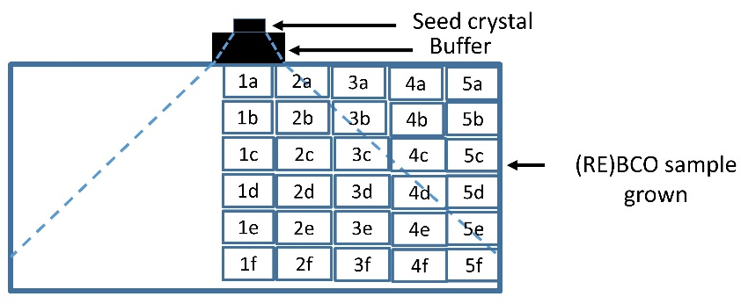
Figure 3. Classification scheme for the extraction of sub-specimens from different locations in the parent (RE)BCO single grain.

- Results and discussion
3.1 Improvement in Growth reliability
3.1.1 Seeding via Buffer
Seeding is a critical step for achieving heterogeneous nucleation and subsequent single-grain growth in (RE)BCO bulk superconductors. Despite employing seed crystals with good texture and higher T_{p} than the target (RE)BCO composition, the probability that single grain growth process will fail has, to date, been relatively high. In this context, the use of a buffer technique, as proposed originally for the fabrication of bulk materials by Li et al. [11], was chosen and developed further in order to address the problem of relatively growth failure rate.

The incorporation of a buffer technique in the melt growth and infiltration growth fabrication processes has four advantages: 1) It increases significantly the success rate of seeding and; and 2) it reduces contamination of the single grain from the seed crystal. The latter is illustrated in Figure 4(a), which shows that the seed crystal RE element (Nd in this case) has diffused to a depth of ∼1 mm from the seed/YBCO interface in sample A (a standard YBCO sample with no buffer pellet employed), resulting in a high Nd concentration (red colour) in the region within the blue dashed lines, corresponding to the zone within which solid solution formation occurs. In the latter case, the concentration of the Nd-element decreases rapidly with distance in sample B (a sample fabricated with buffer pellet) equivalent to the region within the blue dashed lines, on the other hand, and disappears completely at the bottom surface of the buffer layer to yield bulk YBCO sample free from solid solution formation (i.e. with Nd present as a trace element and below the sensitivity level of the compositional measurement). Further, the lattice mismatch between the seed and the sample often creates macro-cracks, which are absorbed into the buffer layer, as can be seen from Figure 4(b).
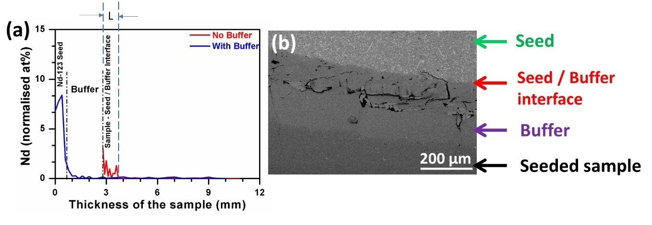

Figure 4. (a) Nd concentration measured using EDX analysis through the thickness of two YBCO samples, Sample-A (fabricated with no buffer, shown in Red) and Sample-B (fabricated with a buffer, shown in blue). (b) The occurrence of macro-cracks at the seed/buffer interface due to lattice mismatch can be observed in the seed-buffer-sample cross-sectional image. [14]

3) The third advantage of the use of the buffer technique is the reduction in damage to the seed from the material to be seeded. This can include Ag or the large quantity of liquid phase (Ba₃Cu₅O₈), as in the case of infiltration and growth. Figure 5 compares the growth of SmBCO(Ag) bulk samples fabricated with and without a buffer pellet. Figure 5(b) shows the microstructure of the cross-section of the sample without a buffer in the vicinity of the failed seed. It can be seen from the inset that silver (white in contrast in the micrograph) has diffused into the seed which has consequently failed to retain its shape and has even lost partial contact with the seeded pellet during the melt process. As a result, the seeding mechanism has obviously failed and has not functioned in this configuration. It can be seen from figure 5(a) that Ag (white in contrast in the photograph) is distributed throughout the sample and is present mainly within the pores left by the residual porosity from the melt process. The Ag permeates into the buffer layer during melt processing, but terminates before it reaches the interface between the seed and the buffer pellet.

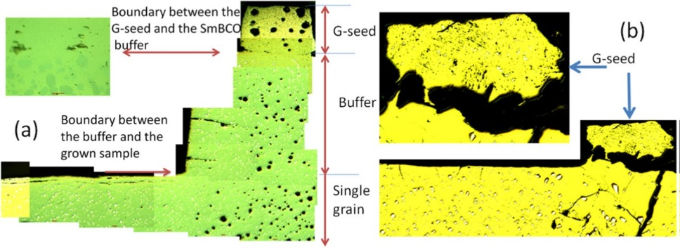
Figure 5. (a) The microstructures of the cross–section of SmBCO(Ag) single grain samples along the crystallographic c-direction (i.e. through the pellet thickness) in samples grown using a buffer pellet. (b) The microstructures of the cross–section of SmBCO(Ag) single grain samples close to seeding area (G-seed is the generic seed) [7]

4) Another striking advantage obtained by employing the buffer technique is the enhanced c-growth region, as can be seen both in the schematic and actual sample cross-sections shown in Figure 6. Furthermore, this suggests that even small-sized seed crystals (typically 2 mm x 2 mm) can be used to grow relatively large sized samples (40 -50 mm in diameter) for similar heat treatments and time duration as those used to obtain samples of 20 -25 mm in diameter. This is due partly to the use of a suitable buffer pellet assembly. These features of the buffer-assisted melt process can be observed clearly in Figure 6, and particularly in Figure 6(e). The buffer acts effectively as a larger seed [21] during the seeding process, which increases the size of c-growth region, given that the size of epitaxial nucleus for the main bulk single grain is the same as that of the large (buffer) seed [22]. Furthermore, buffers also minimise the effects of “particle pushing” in the vicinity of seeded area, so that the distribution of RE-211 is relatively uniform across the entire single grain [21].

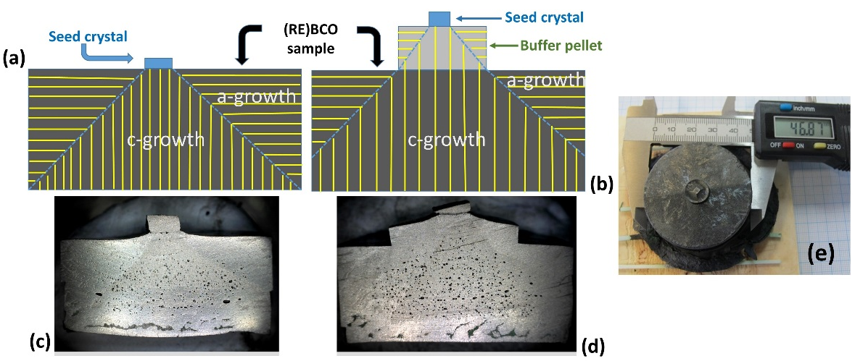
Figure 6. (a) and (b) show schematic illustrations of single grain growth (in both the a-growth ad c-growth regions) in standard and buffer-aided TSMG grown (RE)BCO samples. Corresponding YBCO sample cross-sections illustrating an enhanced c-growth region in YBCO as obtained in a buffer-aided TSMG sample can be seen in (d) [in contrast to (c)]. A 2 mm x 2 mm seed crystal enabling single grain growth via a buffer pellet resulting in a 46 mm diameter YBCO sample for a similar heat treatment and processing time duration for a typical 25 mm diameter sample can be seen in (e) [14].

3.1.2. Reliable recycling of failed (RE)BCO(Ag) samples
The key feature of the recycling process developed by the Cambridge Bulk Superconductivity Group is associated with the reintroduction of the liquid phase into the melt process of the failed sample, which is lost normally during the primary peritectic processing of these materials [4]. This replenishment of liquid phase enables the direct re-growth of failed samples from a solid form without the need for re-grinding into powder. The Yb-based liquid-rich phase (Yb₂O₃: CuO: BaCuO₂ = 1:6:10, as discussed above) is employed in the recycling process. This phase has a lower melting temperature (of about 970 °C) than the melt-processing temperatures (1000 °C to 1100 °C) of any (RE)BCO (RE = Nd, Sm, Gd and Y) system, so that the formation of sub-grains at the bottom surface of the pellet in the recycling process is inhibited. Another advantage of employing this liquid-rich phase is that it decomposes a large quantity of liquid phase Ba₃Cu₅O₈, which infiltrates back into the failed samples. Sixty-four failed bulk samples, with diameters up to 31 mm, have been recycled with a yield better than 90% by this process. Figure 7 shows examples of the recycled (RE)-Ba-Cu-O-Ag (RE: Y, Gd, Sm) single grains. Figure 7(a) shows the top views of one batch of eight recycled Gd-Ba-Cu-O-Ag single grains of diameter 25 mm; Figure 7 (b) shows the top views of eight Sm-Ba-Cu-O-Ag single grains of diameter 25 mm. Combined with the buffer technique, the recycling process enables a relatively high sample fabrication success rate compared to previous recycling methods [23, 24] due directly to the use of a liquid-rich phase of optimum composition. We have also demonstrated elsewhere [25] that the superconducting performance and microstructure of the recycled samples is typically about 85% of the primary grown samples, which is adequate for a range of practical applications.

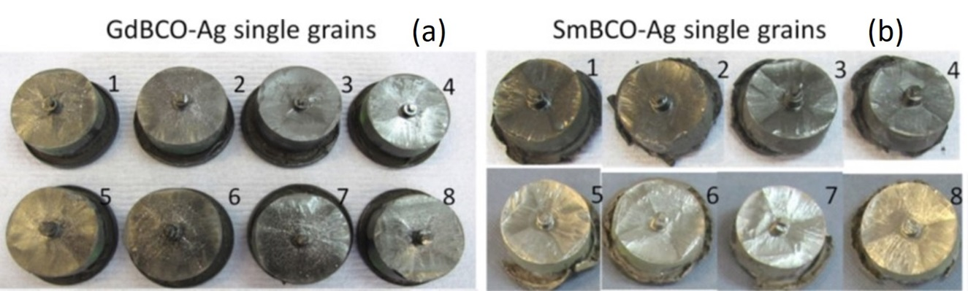
Figure 7. Recycled (RE)-Ba-Cu-O-Ag (RE: Y, Gd, Sm) single grains of diameter 25 mm [4]: Top views of (a) A batch of eight recycled Gd-Ba-Cu-O-Ag single grains and (b) eight recycled Sm-Ba-Cu-O-Ag single grains

3.1.3 Reliable TSIG

The Infiltration and growth (IG) technique, despite being used for nearly two decades [26-35], has never been applied as widely as the TSMG approach because of two major limitations: (i) The poor success rate of single grain fabrication and; (ii) the superconducting properties of the (RE)BCO material obtained by the IG approach are significantly inferior compared to their TSMG counterparts. Only recently, systematic studies have been carried out that have led to the fabrication of (RE)BCO bulk superconductors by IG that are now almost comparable with those processed by TSMG.

The choice of an appropriate liquid phase component is a critical step in the IG process to enabling appropriate liquid phase infiltration and subsequent successful single grain growth of bulk (RE)BCO single grains. Work reported earlier [12] discusses the significance of various potential liquid phase components (including Y-123, Ba₃Cu₅O₈, a mixture of Y-123 and Ba₃Cu₅O₈, Yb-based liquid phase and Y-based liquid phase) on the effectiveness of infiltration and subsequent single grain growth. Furthermore, it has been identified that a Yb-based liquid phase mixture (comprising of BaCuO₂, CuO and Yb₂O₃ resulting to Yb₂O₃: BaCuO₂= 1: 1.313) as an optimum composition. YBCO samples grown employing the Yb-based liquid phase reservoir enable not only good infiltration of liquid phase into the Y-211 pre-form with subsequent single grain growth, but also eliminate the nucleation of unwanted sub-grains in the material at the supporting plate/substrate. It has also been observed from optimisation studies that a RE-211: liquid phase weight ratio of 1: 1.5 is sufficient to infiltrate fully into the RE-211 pre-form placed in contact with the liquid phase reservoir pellet. In addition, sintering the Y-211 pre-form prior to infiltration has been found to be advantageous, and to lead to near-net shape processing of these materials [12]. Figure 8 shows both the sample assembly for the TSIG process and illustrates the reliability of the single grain growth process specifically for the fabrication of YBCO samples via buffer-aided TSIG using the liquid-rich phase described above. A second, significant contribution to process development has been the introduction of a 2-step TSIG approach, which has enabled control of the RE-211 distribution in the single grain microstructure (discussed in detail in section 3.2.1).

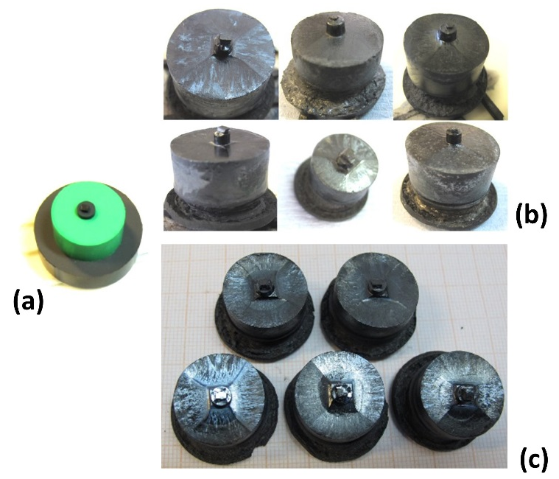
Figure 8. (a) Sample assembly arrangement for the BA-TSIG process. Reliable fabrication of single grain bulk YBCO and GdBCO superconductors by buffer-aided TSIG (using Yb-based liquid-rich phase) are shown in (b) and (c), respectively.

3.1.4 Success in TS(MG+IG) in (RE)BCO(Ag) systems
The increase in success rate of the recycling and TSIG processes to > 90% due directly to the employment of suitable liquid-rich phase has motivated the extension of this technique to the primary growth process for improving grain growth reliability more generally. A different type and optimum quantity of suitable liquid-rich phase was used at the bottom of the primary grown pellets for the different RE-based compositions. For example, commercial Y-123 powder was used as the liquid-rich phase for SmBCO and GdBCO and their silver containing systems [20, 36], given that Y-123 is commercially available, which saves the time and cost associated in preparing a bespoke, separate liquid-rich phase. Most importantly, Y-123 decomposes to Y-211 and Ba₃Cu₅O₈ at a lower temperature than the growth temperature during the melt-processing of SmBCO and GdBCO and their silver containing compositions, so that an appropriate amount of Ba₃Cu₅O₈ is able to infiltrate up into the main pellet to reduce the porosity without forming any sub-grains from the bottom of the sample. This enables SmBCO(Ag) to be batch-processed [7] in the form of single grains as large as a 40 mm in diameter [37]. Figure 9 illustrates a large quantity of cylindrical GdBCO(Ag) single grains of diameter 25 mm grown by adding liquid-rich phase. GdBCO(Ag) has been batch-processed since 2010 [38], although the introduction of the buffer technique, together and the addition of liquid-rich phase at the bottom of each of the sample assembly prior to melt-processing, constitutes a major step in the grain growth process, making the growth of GdBCO(Ag) single grains much easier, more practical and more reliable. YBCO samples of 25 mm in diameter can now be grown via the TSIG technique using the same heat profile, as can be seen in Figure 9(b).

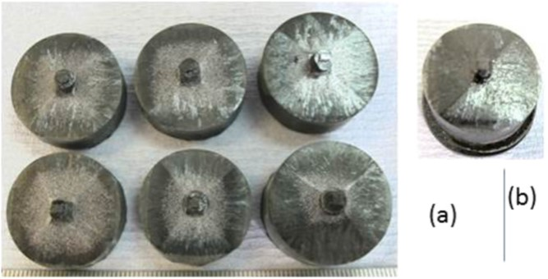
Figure 9. (a) Six GdBCO–Ag single grains grown using the buffer aided top seeded melt growth process with additional liquid phase layer placed at the bottom surface and (b) a YBCO single grain of diameter 25 mm grown using the buffer-aided infiltration growth technique.[21]

The growth of YBCO(Ag) on a large scale has been limited to date by its very low growth rate, suggesting that the driving force for this process is weak. As a result, it is generally difficult to grow single grain YBCO(Ag) on a large scale by either TSMG or TSIG, and reports of such processes are relatively few [39, 40]. The recent introduction of the liquid-rich phase to the bottom of the pressed precursor pellets and the optimisation of the composition of the liquid-rich phase has enabled the growth YBCO(Ag) on a large scale.

The growth rate of a given (RE)BCO system provides very useful information and aids the selection of an appropriate window for the heat treatment profile in order to grow single grains successfully and reliably. The growth rate of the YBCO system was understood as early as 1996 [41], although the growth rate of YBCO(Ag) has not generally been reported. One of the difficulties in understanding the growth rate of YBCO(Ag) is that multi-grains usually form quickly once the pellet is cooled rapidly from an isothermal holding time. Figure 10 shows how the growth rate was measured in the present study [42]. Figure 10(a) shows the as-grown YBCO(Ag) single grains prior to measurement of the growth lengths for different conditions of under-cooling and holding time. The growth rate of single grains in the YBCO-Ag system has been studied in detail using a new method based on continuous cooling and isothermal hold (CCIH), which differs significantly from previous studies (as shown by the red dashed lines). Figure 10(b) illustrates schematically the seeding (as indicated by the arrow) and growth initiation period prior to the isothermal growth stage in this process. The calculation of the growth rates is based on the assumption that the growth rate of YBCO(Ag) is controlled by the diffusion of Y in the liquid phase [43]. The addition of the liquid-rich phase increases the driving force for the single grain growth process, which makes the growth rate measurements possible. Based on the understanding of the growth rates of YBCO(Ag) at different temperatures, the heating profiles were tuned and optimised to enable the growth of a large number of YBCO(Ag) single grains of different sample sizes, reliably, as shown in Figure 11. The resulting growth rate along the c-axis is faster than that along the a-axis, with a maximum growth rate at an under-cooling ΔT, of 18°C of only 0.3 mm/hour [42], which is half the maximum growth rate of 0.6 mm/ hour observed for the YBCO system without Ag [44].

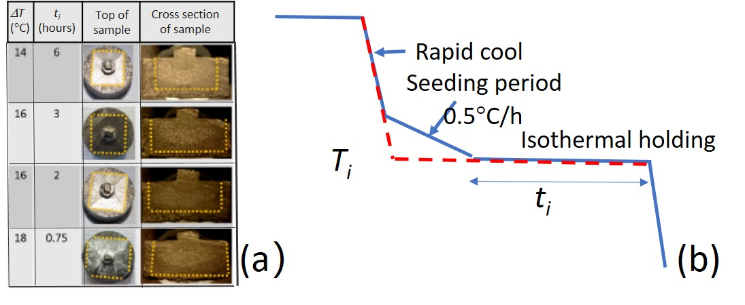

Figure 10. (a) YBCO(Ag) single grains used for measuring the growth rates and (b) schematic illustration of the new continuous cooling and isothermal hold (CCIH) heating profile for growing the single grains used to measure the growth rates [42]

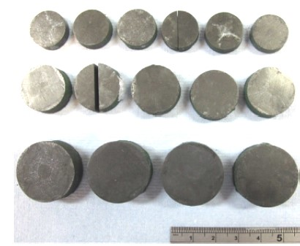
Figure 11. YBCO-Ag single grains of diameter 17 mm (top row), 21mm (middle row) and 26mm (bottom row) [45].

3.2 The improvement of the superconductivity
3.2.1 Microstructure (Porosity and RE-211 content and distribution)
Large pores (in the size range 10 - 100 μm in diameter, with an average value of around 50 μm) are typically present in the microstructure of single grain (RE)BCO samples. The peritectic decomposition in the melt growth process results in incongruent melting of the RE-123 phase above the T_{p} of the compound in the melt growth process, accompanied by the formation of gas.

The infiltration and growth process developed further by the Cambridge Group described previously enables the liquid phase to infiltrate into RE-211 pre-form then fill the pores that form during compaction of the precursor powder. The resulting microstructures exhibit fewer pores in the TSIG processed sample compared to that of its TSMG counterpart. The tendency to form pores/cracks is minimized to a large extent, since there is no peritectic decomposition occurring in the infiltration grown sample, as can be seen in Figure 12(b).

Figure 12. Optical micrographs recorded under low magnification (50x) in (a) Melt grown and (b) Infiltration grown YBCO samples [9].

It is well-known that RE-123 phase, when heated above its peritectic temperature, undergoes incongruent melting by giving rise to the formation of RE-211 and a residual liquid phase. Slow-cooling the peritectically decomposed sample through T_{p} leaves some residual RE-211 phase inclusions in the sample microstructure, and these often act as a primary source for magnetic flux pinning. This, in turn, results in enhanced current densities, even in the presence of applied magnetic field. Hence, by adding extra RE-211 phase to the precursor powder not only enhances the growth rate of (RE)BCO but also aids flux pinning and hence J_{c}(H). It is well known that J_{c} is proportional to the number of effective pinning centres [46], which, optimally, consist of nano-sized non-superconducting phase inclusions in the superconducting RE-123 phase matrix, given that the coherence lengths of these materials are typically ~ 2-4 nm (i.e. for YBCO at 77 K) [47, 48]. Hence, the engineering of defects of this size within the RE-123 matrix to enhance the flux pinning strength would be ideal from both a processing and properties perspective. Hari Babu et al. reported an effective, non-superconducting flux pinning phase of general composition RE₂Ba₄Cu₁M₁O_{y} (RE = Nd, Sm, Gd and Y) (where M is a metal) [49, 50] that naturally form nano-sized particles within (RE)BCO single grains. Figure 13(a) shows a homogeneous distribution of RE-2411, Y-2411(W) in bulk Y-123. This research demonstrated that J_{c} varies in proportional to the volume fraction of RE-2411 present in the RE-123 phase matrix. J_{c} (0) (also called self-field J_{c}) can be as high as 10⁵ A/cm² at 77 K in these composite samples [49]. Various equivalents to the RE-2411(M) phase have been attempted in the processing of (RE)BCO systems over the years and a number of positive effects have been obtained, although adding too much RE-2411 inhibits the growth of the single grain.

J_{c} is proportional to the volume fraction of RE-211 in single grains [51, 52], although the size of RE-211 (1 to 8 μm) is generally too large to work as effective pinning centres. As a result, for a fixed weight percentage of RE-211, reducing the size of RE-211 in single grain invariably improves J_{c} [52]. With this in mind, Carbon Nanotube Templates (CNT) were added to pre-synthesised YBa₂Cu₃O_{7-δ} and Y₂BaCuO₅ nanocrystalline powders, mixed thoroughly and processed into single grains. The resulting Y-211 particles observed using optical microscopy were significantly smaller [figure 12(b)] than those achieved using commercial Y-211, as shown in the figure 13(c). Subsequently, the trapped field for a standard YBCO sample (16 mm in diameter) was found to increase from 465 mT to 563 mT at 77 K, due solely to the addition of CNT to the precursor sample [52].

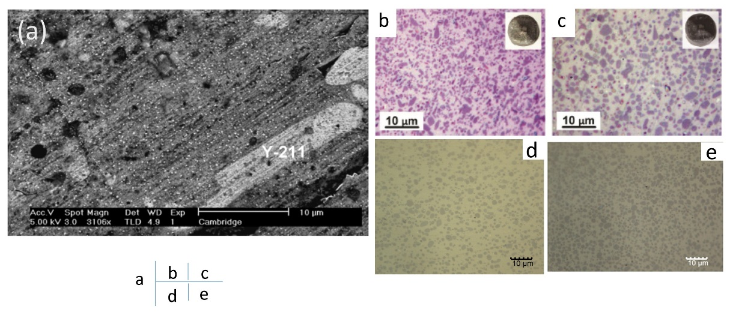
Figure 13. (a) SEM micrograph illustrating the size and distribution of RE-2411 (W) inclusions in the matrix of Y-123. These nano-sized inclusions were found to be distributed uniformly in the Y-123 matrix. (b)-(d) optical micrographs indicating the presence of Y-211 in the matrix of Y-123. (b) Y-211 distribution using carbon nanotube templates, (c) commercial Y-211 (d) two-step BA-TSIG and (e) conventional BA-TSIG fabrication techniques.[53] [50, 52]

There is an optimum amount of RE-211 that should exist in the RE-123 matrix for achieving good J_{c}. It has been found that the trapped field of the single grains grown by TSIG were substantially inferior compared to those produced by conventional TSMG, however, for similar concentrations of RE-211. It was observed in a careful and systematic study that the primary reason for this relates to the presence of a very large fraction (~ 41%) of RE-211 in the end product microstructure of IG processed bulk single grains, as illustrated in Figure 13(e). It is difficult to control the amount of residual RE-211 in IG-processed bulk samples partly because it is not trivial to control how much liquid phase can be infiltrated, and subsequently reacted, with the RE-211 phase during the processing stage. This aspect of controlling the RE-211 content in the IG processed microstructure was investigated via two different and novel approaches: (i) By tuning and optimizing the infiltration temperature and time and; (ii) by adding extra liquid phase components to the RE-211 pre-form during the powder compaction stage. Both approaches have enabled the successful control and tuning of the RE-211 content in the microstructure of the as-processed bulk (RE)BCO sample. However, careful and detailed microstructural observations revealed that first approach enabled the fabrication of bulk superconductors with dense microstructures while simultaneously enabling the formation of a controlled amount of RE-211 content in the bulk sample [54].
A novel, two-step buffer-aid top-seeded infiltration growth, referred as 2-step BA-TSIG, has been developed by Kumar et al. [55], in which the infiltration and growth steps are separated and carried out one sequentially, as shown in Figure 14(a). As a result, the success rate of fabrication of single grain (RE)BCO samples has been improved significantly. In the first step, the arrangement consists only of a RE-211 pre-form and a liquid phase reservoir pellet support and no seed. This assembly is then heated to 1050 °C for infiltration of liquid phase and then quenched to room temperature. In the second stage, a seed supported with a buffer pellet is placed at the top of the quenched arrangement and then subjected to melt processing in a box furnace, as shown in Figure 14 (a). This heat treatment methodology enables sufficient time for the liquid phase to come into contact with the RE-211 phase and undergo further reaction to form the final single grain with a controlled amount of RE-211. Figure 14(b) shows how YBCO single grains have been fabricated successfully and reliably by employing the 2-step BA-TSIG [55]. It can be seen from the optical micrograph in figure 13(d) that the Y-211 concentration is very similar as that observed in TSMG processed samples [figure 13(c)]. The trapped field of single grains grown by BA-TSIG has also been improved significantly, and 0.9 T has been achieved for a YBCO sample of 25 mm in diameter at 77 K [55] and a trapped field of 14.3 T at 29 K in a two sample stack [56].

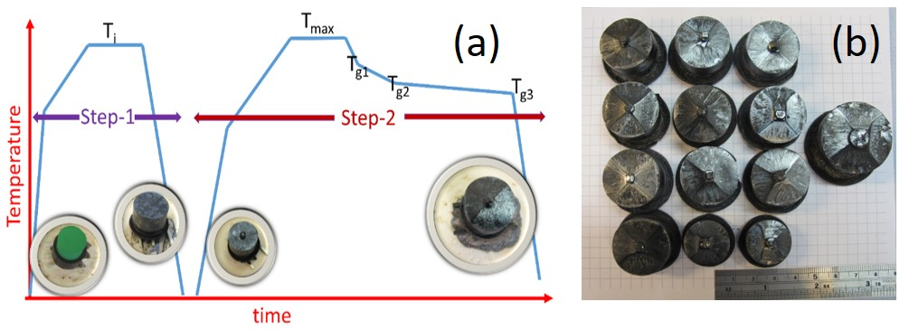
Figure 14. (a) Schematic illustration of the fabrication steps involved in the novel, 2-step buffer aided TSIG melt process. (b) Reliability in fabricating YBCO single grain samples by the 2-step BA-TSIG [55]

3.2.2 Suppressing RE/Ba substitution
An issue with superconducting properties of (RE)BCO single grains grown in air is the RE/Ba substitution effect, which decreases T_{c}, and hence J_{c}, significantly [57]. This substitution is severe when the (RE)BCO (where RE is Nd or Sm) bulk sample is melt-processed in air. The superconducting properties of a SmBCO(Ag) single grain fabricated in air are shown in figure 15 (a) and (b). It can be seen that the T_{c} transitions are broad and the onset of T_{c} occurs at different positions, even within one single grain (1b to 1e are the positions immediately beneath the buffer along the c growth direction, as illustrated in figure 3), when the single grain was grown without using added liquid-rich phase at the bottom. This has introduced further difficulty to the suppression of substitution effects, given that the severity of these at different locations within a single grain cannot be suppressed simultaneously, despite the use of additives, such as BaO₂. However, when Y-123 is used as a liquid-rich phase at the bottom of the sample as shown in figure 15 (c) and (d), the resulting single grains exhibit a sharp T_{c} transition with similar onset values of T_{c}. This suggests that the inhomogeneous RE/Ba substitution is suppressed by the presence of Ba₃Cu₅O₈ in the Y-123 liquid-rich phase. Amazingly, the J_{c}-B curves are almost coincident for the sub-specimen positions presented here [20]. Electron Probe Micro-Analysis (EPMA) indicates that the compositions of Sm, Ba and Cu are constant along the c direction under the seed/buffer [20], which suggests the gradual infiltration of the liquid phase Ba₃Cu₅O₈ suppresses Sm/Ba substitution at different levels at the same time. However, it is entirely possible that the Sm-123 and Sm-211 precursor powders used in this study might contain a different intrinsic level Sm/Ba [58], in which case the quantity of liquid-rich phase would need to be adjusted further.

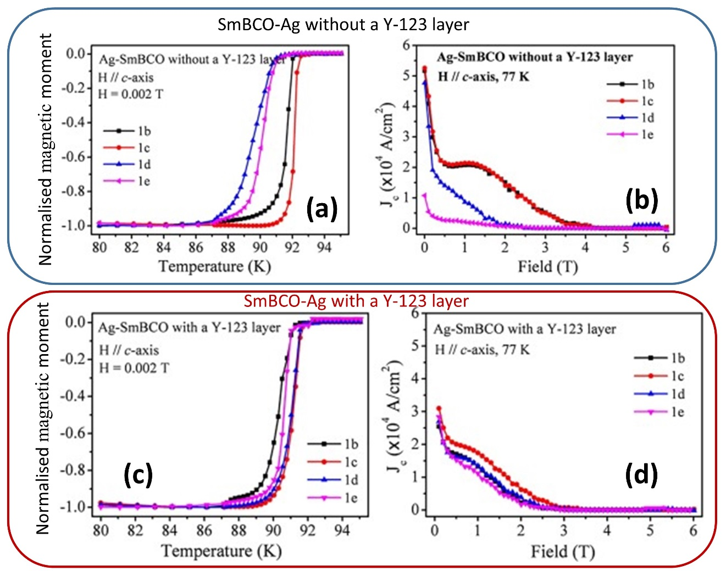
Figure 15 (a) Normalised magnetic moment as a function of temperature and (b) critical current density, J_{c}, as a function of magnetic field for Ag-SmBCO processed without a Y-123 liquid-rich layer, (c) normalised magnetic moment as a function of temperature and (d) critical current density, J_{c}, as a function of magnetic field for Ag-SmBCO processed with a Y-123 liquid-rich layer.[20]

Application of the buffer technique combined with the addition of a liquid-rich phase to the bottom of the pre-forms enables the reliable growth all (RE)BCO(Ag) single grains of up to 48 mm in diameter as shown in figure 16, which exhibit good trapped fields. Figure 16 shows the trapped fields of GdBCO(Ag) single grains of different sizes, measured at 77 K, which tend towards the existing world record at 77 K (3 T in 65 mm diameter GdBCO-Ag bulk sample [59]). A new, record trapped fields of 17.6 T [60] at 26 K has been already achieved in GdBCO(Ag) bulk stack comprising two samples each of 24.1 mm in diameter, which demonstrates clearly the impact of recent development in melt processing on applied potential of these technologically important materials.
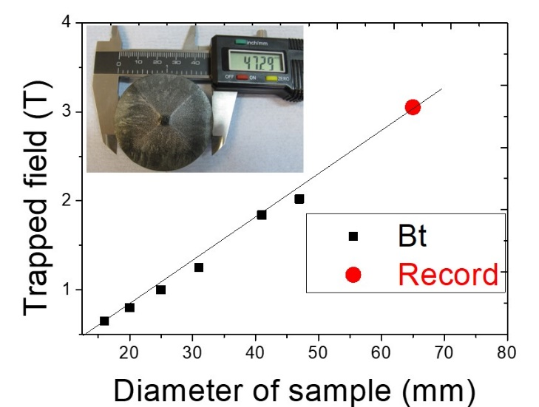

Figure 16. Trapped fields (B_{t}) at 77 K of the GdBCO(Ag) single grains grown by the Cambridge Bulk Superconductivity Group (shown as black squares). The Inset shows a photograph of a GdBCO(Ag) single grain of ~41 mm in diameter. The figure also shows B_{t} reported for a 65 mm diameter GdBCO-Ag sample (red circle), which is a record for B_{t} at 77 K.

(RE)BCO single grains, fabricated in different sizes and shapes have significant potential for use in levitation, rotating machines and other prototypes of superconducting devices. A composite structure consisting of a laminated GdBCO(Ag) and stainless steel has recently matched the world record trapped field of 17.6 T [61] and is proving to be a promising architecture for the use of bulk (RE)BCO superconductors in several practical and niche applications.

Conclusions
Significant recent changes and subsequent improvements to existing melt-processed techniques for the fabrication of bulk (RE)BCO single grain superconductors, such as TSMG and TSIG, have been achieved by enhancing the seeding process via the introduction of a buffer methodology and by employing suitable liquid-rich phase components at the base of the precursor sample. These recent improvements have led to pathways for reliably fabricating (RE)BCO and (RE)BCO(Ag) single grain superconductors (RE = Sm, Gd and Y) of up to 60 mm in diameter that exhibit competitive values of trapped field and critical current density. The superconducting properties of bulk samples have been improved, in general, by appropriate control of the single grain microstructures (reducing pores and cracks, in particular), introducing a controlled amount of RE-211 inclusions in the RE-123 phase matrix via the addition of nano-dopants to the precursor powder and by suppressing the extent of RE/Ba substitution in (RE)BCO systems based on Gd and Sm. Critical current densities as high as 100 kA/cm² have been achieved at 77 K as a result of these improvements in processing. Finally, a record trapped field of 17.6 T at 26 K has been achieved in a GdBCO(Ag) stack comprising two samples, each of diameter 24.1 mm.

Multi-seeded and conformal-shaped samples designed specifically to achieve higher trapped field have been fabricated and tested. Robust, composite laminar structures have been assembled to improve the mechanical and thermal properties of bulk superconductors, which have already matched the world record for trapped field. Single grain (RE)BCO(Ag) materials are now ready for a variety of applications based on the recent improvements to the process technology. As a result, application-oriented material research is making significant progress and will have a growing impact on emerging devices in the near future.

Acknowledgements
The authors acknowledge the financial support received in the form of a research project [EPSRC, grant number EP/P00962X/1] from the Engineering and Physical Sciences Research Council. Additional data related to this publication are available at the University of Cambridge data repository (https://doi.org/10.17863/CAM. 45104)

References
[1] S. Jin, T. H. Tiefel, R. C. Sherwood, M. E. Davis, R. B. van Dover, G. W. Kammlott, et al., "High critical currents in Y‐Ba‐Cu‐O superconductors," Applied Physics Letters, vol. 52, pp. 2074-2076, 1988.
[2] M. Murakami, Melt Processed High Temperature Superconductors. Singapore: World Scientific Publishing Co. Pte. Ltd., 1992
[3] W. Zhai, Y. Shi, J. H. Durrell, A. R. Dennis, Z. Zhang, and D. A. Cardwell, "Processing and Properties of Bulk Y–Ba–Cu–O Superconductors Fabricated by Top Seeded Melt Growth from Precursor Pellets Containing a Graded CeO2 Composition," Crystal Growth & Design, vol. 15, pp. 907-914, 2015/02/04 2015.
[4] Y. Shi, D. K. Namburi, M. Wang, J. Durrell, A. Dennis, and D. Cardwell, "A Reliable Method for Recycling (RE)-Ba-Cu-O (RE: Sm, Gd, Y) Bulk Superconductors," Journal of the American Ceramic Society, pp. 2760-2766, 2015.
[5] Y. Shi, N. H. Babu, and D. A. Cardwell, "Development of a generic seed crystal for the fabrication of large grain (RE)–Ba–Cu–O bulk superconductors," Superconductor Science and Technology, vol. 18, p. L13, 2005.
[6] Y. Chen, X. Cui, and X. Yao, "Peritectic melting of thin films, superheating and applications in growth of REBCO superconductors," Progress in Materials Science, vol. 68, pp. 97-159, 3// 2015.
[7] Y. H. Shi, A. R. Dennis, and D. A. Cardwell, "A new seeding technique for the reliable fabrication of large, SmBCO single grains containing silver using top seeded melt growth," Superconductor Science and Technology, vol. 28, p. 035014, 2015.
[8] S. Yunhua, N. Devendra Kumar, Z. Wen, H. D. John, R. D. Anthony, and A. C. David, "The use of buffer pellets to pseudo hot seed (RE)–Ba–Cu–O–(Ag) single grain bulk superconductors," Superconductor Science and Technology, vol. 29, p. 015010, 2016.
[9] D. K. Namburi, Y. Shi, K. G. Palmer, A. R. Dennis, J. H. Durrell, and D. A. Cardwell, "An improved top seeded infiltration growth method for the fabrication of Y–Ba–Cu–O bulk superconductors," Journal of the European Ceramic Society, vol. 36, pp. 615-624, 2// 2016.
[10] D. A. Cardwell, "Processing and properties of large grain (RE)BCO," Mater. Sci. Eng. B, vol. 53, pp. 1-10, // 1998.
[11] T. Y. Li, L. Cheng, S. B. Yan, L. J. Sun, X. Yao, Y. Yoshida, et al., "Growth and superconductivity of REBCO bulk processed by a seed/buffer layer/precursor construction," Superconductor Science and Technology, vol. 23, p. 125002, 2010.
[12] J. H. Lee, S. D. Park, B. H. Jun, J. S. Lee, S. C. Han, Y. H. Han, et al., "A buffer bridge process for growing multiple YBa 2 Cu 3 O 7 − y grains from one top seed," Superconductor Science and Technology, vol. 24, p. 055019, 2011.
[13] Z. Difan, X. Kun, H. Shogo, L. Beizhan, D. Zigang, T. Keita, et al., "MgO buffer-layer-induced texture growth of RE–Ba–Cu–O bulk," Superconductor Science and Technology, vol. 25, p. 025022, 2012.
[14] N. Devendra Kumar, Y. Shi, W. Zhai, A. R. Dennis, J. H. Durrell, and D. A. Cardwell, "Buffer Pellets for High-Yield, Top-Seeded Melt Growth of Large Grain Y–Ba–Cu–O Superconductors," Crystal Growth & Design, vol. 15, pp. 1472-1480, 2015/03/04 2015.
[15] W. Zhao, Y. Shi, A. R. Dennis, and D. A. Cardwell, "Use of Sm-123 + Sm-211 Mixed-Powder Buffers to Assist the Growth of SmBCO and ZrO2 doped SmBCO Single Grain, Bulk Superconductors," Applied Superconductivity, IEEE Transactions on, vol. 25, pp. 1-5, 2015.
[16] J. V. J. Congreve, Y. Shi, K. Y. Huang, A. R. Dennis, J. H. Durrell, and D. A. Cardwell, "Improving Mechanical Strength of YBCO Bulk Superconductors by Addition of Ag," IEEE Transactions on Applied Superconductivity, vol. 29, pp. 1-5, 2019.
[17] G.-Z. Li, W.-M. Yang, X.-F. Cheng, J. Fan, and X.-D. Guo, "A modified TSIG technique for simplifying the fabrication process of single-domain GdBCO bulks with a new kind of liquid source," Journal of Materials Science, vol. 44, pp. 6423-6426, 2009/12/01 2009.
[18] G.-Z. Li and W.-M. Yang, "A Novel Configuration for Infiltration and Growth of Single-Domain Gd–Ba–Cu–O Bulk Superconductor," Journal of the American Ceramic Society, vol. 93, pp. 4033-4035, 2010/12/01 2010.
[19] J. V. J. Congreve, Y. Shi, A. R. Dennis, J. H. Durrell, and D. A. Cardwell, "Improvements in the processing of large grain, bulk Y–Ba–Cu–O superconductors via the use of additional liquid phase," Superconductor Science and Technology, vol. 30, p. 015017, 2016/11/18 2016.
[20] W. Zhao, Y. H. Shi, D. F. Zhou, A. R. Dennis, and D. A. Cardwell, "Quantification of the level of samarium/barium substitution in the Ag-Sm1+xBa2-xCu3O7-delta system," Journal of the European Ceramic Society, vol. 38, pp. 5036-5042, Dec 2018.
[21] Y. Shi, D. Kumar Namburi, W. Zhao, J. H. Durrell, A. R. Dennis, and D. A. Cardwell, "The use of buffer pellets to pseudo hot seed (RE)–Ba–Cu–O–(Ag) single grain bulk superconductors," Superconductor Science and Technology, vol. 29, p. 015010, 2015/12/01 2015.
[22] E. S. Reddy, N. H. Babu, K. Iida, T. D. Withnell, Y. Shi, and D. A. Cardwell, "The effect of size, morphology and crystallinity of seed crystals on the nucleation and growth of Y–Ba–Cu–O single-grain superconductors," Superconductor Science and Technology, vol. 18, pp. 64-72, 2004/11/17 2004.
[23] S. K. Pathak, N. H. Babu, A. R. Dennis, K. Iida, M. Strasik, and D. A. Cardwell, "Recycling of multi-grain, melt processed bulk (RE)BCO superconductors (vol 23, 065012, 2010)," Superconductor Science & Technology, vol. 23, Oct 2010.
[24] Y. Shi, A. R. Dennis, F. Hengstberger, N. Hari Babu, D. A. Cardwell, and M. Strasik, "A simple method for recycling GdBCO–Ag single grain bulk superconductors," Superconductor Science and Technology, vol. 24, p. 075010, 2011/05/18 2011.
[25] J. V. J. Congreve, Y. H. Shi, A. R. Dennis, J. H. Durrell, and D. A. Cardwell, "Microstructure and Composition of Primary and Recycled Single Grains of YBCO, GdBCO-Ag, and SmBCO-Ag Bulk Superconductors," Journal of the American Ceramic Society, vol. 99, pp. 3111-3119, 2016.
[26] Y. L. Chen, H. M. Chan, M. P. Harmer, V. R. Todt, S. Sengupta, and D. Shi, "A new method for net-shape forming of large, single-domain YBa2Cu3O6 + x," Physica C: Superconductivity, vol. 234, pp. 232-236, 12/15/ 1994.
[27] R. Cloots, T. Koutzarova, J. P. Mathieu, and M. Ausloos, "From RE-211 to RE-123. How to control the final microstructure of superconducting single-domains," Superconductor Science and Technology, vol. 18, p. R9, 2005.
[28] E. S. Reddy and T. Rajasekharan, "Fabrication of textured REBa2Cu3O7/RE2Ba2CuO5 (RE = Y, Gd) composites by infiltration and growth of RE2BaCuO5 preforms by liquid phases," Superconductor Science and Technology, vol. 11, p. 523, 1998.
[29] N. D. Kumar, T. Rajasekharan, K. Muraleedharan, A. Banerjee, and V. Seshubai, "Unprecedented current density to high fields in YBa 2 Cu 3 O 7 − δ superconductor through nano-defects generated by preform optimization in infiltration growth process," Superconductor Science and Technology, vol. 23, p. 105020, 2010.
[30] N. Devendra Kumar, T. Rajasekharan, and V. Seshubai, "Preform optimization in infiltration growth process: An efficient method to improve the superconducting properties of YBa2Cu3O7−δ," Physica C: Superconductivity, vol. 495, pp. 55-65, 12/15/ 2013.
[31] N. Hari Babu, M. Kambara, P. J. Smith, D. A. Cardwell, and Y. Shi, "Fabrication of Large Single-grain Y–Ba–Cu–O Through Infiltration and Seeded Growth Processing," Journal of Materials Research, vol. 15, pp. 1235-1238, 2011.
[32] N. H. Babu, Y. Shi, K. Iida, and D. A. Cardwell, "A practical route for the fabrication of large single-crystal (RE)–Ba–Cu–O superconductors," Nature Materials, vol. 4, pp. 476-480, 2005/06/01 2005.
[33] N. H. Babu, K. Iida, Y. Shi, and D. A. Cardwell, "Fabrication of high performance light rare earth based single-grain superconductors in air," Applied Physics Letters, vol. 87, p. 202506, 2005/11/14 2005.
[34] K. Iida, N. H. Babu, Y. Shi, and D. A. Cardwell, "Seeded infiltration and growth of large, single domain Y–Ba–Cu–O bulk superconductors with very high critical current densities," Superconductor Science and Technology, vol. 18, p. 1421, 2005.
[35] J. G. Noudem, S. Meslin, D. Horvath, C. Harnois, D. Chateigner, B. Ouladdiaf, et al., "Infiltration and Top Seed Growth-Textured YBCO Bulks With Multiple Holes," Journal of the American Ceramic Society, vol. 90, pp. 2784-2790, 2007/09/01 2007.
[36] Y. Shi, A. R. Dennis, J. H. Durrell, and D. A. Cardwell, "The effect of size and aspect ratio on the trapped field properties of single grain, Y–Ba–Cu–O bulk superconductors," Superconductor Science and Technology, vol. 32, p. 025005, 2019/01/07 2019.
[37] W. Zhao, Improvement in the Growth and Superconducting Properties of Bulk Sm-Ba-Cu-O Superconductors Fabricated in Air. Cambridge, UK: Ph.D. Thesis, University of Cambridge, 2017.
[38] Y. Shi, N. Hari Babu, K. Iida, W. K. Yeoh, A. R. Dennis, S. K. Pathak, et al., "Batch-processed GdBCO–Ag bulk superconductors fabricated using generic seeds with high trapped fields," Physica C: Superconductivity, vol. 470, pp. 685-688, 9/1/ 2010.
[39] K. Iida, N. H. Babu, S. Pathak, Y. Shi, W. K. Yeoh, T. Miyazaki, et al., "Optimum processing conditions for the fabrication of large, single grain Ag-doped YBCO bulk superconductors," Materials Science and Engineering: B, vol. 151, pp. 2-6, 2008/06/15/ 2008.
[40] Y. Nakamura, K. Tachibana, S. Kato, T. Ban, S. I. Yoo, and H. Fujimoto, "Phase relation in Y211–Y123–Ag system and morphology of silver in Y123 crystal," Physica C: Superconductivity, vol. 294, pp. 302-315, 1998/01/01/ 1998.
[41] A. Endo, H. S. Chauhan, Y. Nakamura, and Y. Shiohara, "Relationship between growth rate and undercooling in Pt-added Y1Ba2Cu3O7−x," Journal of Materials Research, vol. 11, pp. 1114-1119, 1996.
[42] J. V. J. Congreve, Y. H. Shi, A. R. Dennis, J. H. Durrell, and D. A. Cardwell, "Growth rate of YBCO-Ag superconducting single grains," IOP Conference Series: Materials Science and Engineering, vol. 279, p. 012027, 2017/12 2017.
[43] T. Izumi, Y. Nakamura, and Y. Shiohara, "Diffusion solidification model on Y-system superconductors," Journal of Materials Research, vol. 7, pp. 1621-1628, 1992.
[44] W. Zhai, Y. Shi, J. H. Durrell, A. R. Dennis, and D. A. Cardwell, "The Influence of Y-211 Content on the Growth Rate and Y-211 Distribution in Y–Ba–Cu–O Single Grains Fabricated by Top Seeded Melt Growth," Crystal Growth & Design, vol. 14, pp. 6367-6375, 2014/12/03 2014.
[45] J. V. J. Congreve, Y. Shi, A. R. Dennis, J. H. Durrell, and D. A. Cardwell, "The successful incorporation of Ag into single grain, Y–Ba–Cu–O bulk superconductors," Superconductor Science and Technology, vol. 31, p. 035008, 2018/02/07 2018.
[46] A. M. Campbell, "Factors limiting current densities in oxide superconductors," Physica B: Condensed Matter, vol. 216, pp. 266-268, 1996/01/01/ 1996.
[47] J. Wu and J. Shi, "Interactive modeling-synthesis-characterization approach towards controllable in situ self-assembly of artificial pinning centers in RE-123 films," Superconductor Science and Technology, vol. 30, p. 103002, 2017/09/04 2017.
[48] J. Wang, Q. Zhang, C. Liu, and X. Zhang, "Improvement of the pinning property in YBa2Cu3O7−x films below 35 K by doping with graphene oxide," AIP Advances, vol. 9, p. 015118, 2019/01/01 2019.
[49] N. H. Babu, T. D. Withnell, K. Iida, and D. A. Cardwell, "Strongly Coupled Artificial Bulk HTS Grain Boundaries With High Critical Current Densities," IEEE Transactions on Applied Superconductivity, vol. 17, pp. 2949-2952, 2007.
[50] N. H. Babu, L. Cheng, K. Iida, and D. A. Cardwell, "Nano-composite single grain YBa 2 Cu 3 O 7-δ /Y 2 Ba 4 CuBiO y bulk superconductors," Journal of Physics: Conference Series, vol. 43, p. 377, 2006.
[51] S. Nariki, N. Sakai, M. Murakami, and I. Hirabayashi, "High critical current density in RE–Ba–Cu–O bulk superconductors with very fine RE2BaCuO5 particles," Physica C: Superconductivity, vol. 412–414, Part 1, pp. 557-565, 10// 2004.
[52] Y. Shi, T. Hasan, N. H. Babu, F. Torrisi, S. Milana, A. C. Ferrari, et al., "Synthesis of YBa2Cu3O7−δ and Y2BaCuO5 Nanocrystalline Powders for YBCO Superconductors Using Carbon Nanotube Templates," ACS Nano, vol. 6, pp. 5395-5403, 2012/06/26 2012.
[53] N. H. Babu, K. Iida, Y. Shi, T. D. Withnell, and D. A. Cardwell, "YBa2Cu3O7−δ/Y2Ba4CuMOysingle grain nanocomposite superconductors with high critical current densities," Superconductor Science and Technology, vol. 19, pp. S461-S465, 2006/04/11 2006.
[54] K. N. Devendra, S. Yunhua, G. P. Kysen, R. D. Anthony, H. D. John, and A. C. David, "Control of Y-211 content in bulk YBCO superconductors fabricated by a buffer-aided, top seeded infiltration and growth melt process," Superconductor Science and Technology, vol. 29, p. 034007, 2016.
[55] D. K. Namburi, Y. Shi, K. G. Palmer, A. R. Dennis, J. H. Durrell, and D. A. Cardwell, "A novel, two-step top seeded infiltration and growth process for the fabrication of single grain, bulk (RE)BCO superconductors," Superconductor Science and Technology, vol. 29, p. 095010, 2016/07/27 2016.
[56] D. K. Namburi, J. H. Durrell, J. Jaroszynski, Y. Shi, M. Ainslie, K. Huang, et al., "A trapped field of 14.3 T in Y–Ba–Cu–O bulk superconductors fabricated by buffer-assisted seeded infiltration and growth," Superconductor Science and Technology, vol. 31, p. 125004, 2018/10/22 2018.
[57] M. Murakami, "Processing and Applications of Bulk RE–Ba–Cu–O Superconductors," International Journal of Applied Ceramic Technology, vol. 4, pp. 225-241, 2007.
[58] Y. Shi, M. Desmedt, J. Durrell, A. R. Dennis, and D. A. Cardwell, "Improving the superconducting properties of single grain Sm–Ba–Cu–O bulk superconductors fabricated in air by increased control of Sm/Ba substitution effects," Superconductor Science and Technology, vol. 26, p. 095012, 2013.
[59] S. Nariki, N. Sakai, and M. Murakami, "Melt-processed Gd–Ba–Cu–O superconductor with trapped field of 3 T at 77 K," Superconductor Science and Technology, vol. 18, p. S126, 2005.
[60] J. H. Durrell, A. R. Dennis, J. Jaroszynski, M. D. Ainslie, K. G. B. Palmer, Y. H. Shi, et al., "A trapped field of 17.6 T in melt-processed, bulk Gd-Ba-Cu-O reinforced with shrink-fit steel," Superconductor Science and Technology, vol. 27, p. 082001, 2014.
[61] K. Huang, Y. Shi, J. Srpčič, M. Ainslie, D. Namburi, A. Dennis, et al., "Composite stacks for reliable > 17 T trapped fields in bulk superconductor magnets," Supercond. Sci. Technol. Letter, vol. Accepted 2019.

