Quantitative Measures of Lexical Complexity in Modern Prose Fiction

Ewan Jones and Paul Nulty

From at least as early as William Empson’s The Structure of Complex Words (1951), complexity has come to be viewed as one of the essential distinguishing factors of literary language. Empson’s study charts several examples of where a single word can communicate a ‘compacted doctrine’, through its various senses, its historical associations, and through the nuances and ambiguities that arise within the context of the broader linguistic unit (sentence, poetic line, etc.). Such features are not unique to literature (ordinary language of course also contains such complexity); yet insofar as they prove central rather than incidental to its operations, literature raises complexity to a new level. This general statement can also be interpreted in a diachronic manner: for the identification of complexity with literature becomes all the stronger from the modernist period, in which the perception that literature is especially or even uniquely ‘difficult’ becomes widespread. Empson’s own poems prove a representative modernist example, in this respect, accompanied as they are by pages of detailed explanatory notes.
Given the variegated nature of literary complexity, even the powerful computational tools that now exist can come to seem like blunt instruments. It would not be difficult to devise statistical measures that distinguish Finnegan’s Wake from the vast majority of literary precursors; yet such measures are unlikely to tell us very much about the subjective experience of Joyce’s work. The problem is twofold: a ‘full’ measure of complexity would need to grasp not only the daunting variety of the proponents of ambiguity nted above, but also the fact that complexity itself is a moving target: what at first feels forbiddingly new can come to seem familiar to the reader of tomorrow. Faced with both absolute and historically contingent difficulties, computation runs a double danger: its measures threaten to travesty complexity, and by so doing, to confirm the negative bias that many literary scholars continue to harbor regarding computation in general. The French post-structuralist Jacques Derrida gives a representative example of this suspicion, when he dismisses out of hand the suggestion that any computer could possible adequate to, or come close to understanding, what with characteristic playfulness he terms ‘Joyceware’. ‘You can say nothing’, Derrida sniffs, ‘that is not programmed on this 1000th generation computer—Ulysses, Finnegans Wake—beside which the current technology of our computers and our microcomputerified archives and our translating machines remains a bricolage of a prehistoric child’s toys’ (Lernout et al 1991); Derrida did not live to see the widespread application of neural networks; such advances were unlikely to have changed his mind.
This paper argues that we can usefully model literary complexity, notwithstanding these significant challenges. More specifically, we hold that computational resources can shed light upon exactly the dual character of complexity sketched above: its absolute and its historically contingent nature. Indeed—to phrase the matter more strongly—any computational measure (or combination of computational measures) that does not seek in some way to account for both these factors will invariably tell only a small fraction of the whole story. We do not believe that our own suggestions—which develop a new measure, and bring it into contact with existing approaches—tell the whole story; far from it. But we do believe that our methodology might usefully signpost future possible work in the field. The issue is important, insofar as the question as to how to model complexity without simplifying it extends well beyond the narrow channels of literary criticism.

I: Extant Measures

The question of literary complexity itself has a long (if largely overlooked) history. As stated above, literary modernism represented the first major artistic moment in which (at least a certain subset of) literature became synonymous with difficulty. Appropriately, the first rigorously formalized approaches to the study of English emerge at this historical juncture. Their aims included the attempt to identify what is variously known as complexity, readability or difficulty. (For the time being, we treat these three terms as interchangeable; later we will attempt not to disambiguate them, but rather to show how their intersection might prove useful.) In The Analytics of Literature: A Manual for the Objective Study of English Prose and Poetry (1882), Lucius Sherman presents perhaps the earliest precursor to what digital humanities now familiarly calls ‘distant reading’: among several statistical measures, Sherman compares mean sentence length in works ranging from Chaucer to Ralph Waldo Emerson. Across the twentieth century, however, the empirical study of readability has more commonly occurred within the fields of psychology, education, and corpus linguistics (Pitler and Nenkova 2008, Nagy et al 1987)
Rather than attempting to conduct an extensive review of literature on lexical complexity, however, we will pave the way for our substantive argument through the application of a range of existing measures upon a range of literary works. By targeting these methods upon a bespoke corpus, selected for its historical and generic variety, we intend to demonstrate both what such established resources can reveal, and what they are liable to omit. It is significant that a large number of these approaches extend and standardize Sherman’s own procedure: the most significant marker of perceived complexity remains sentence length. Perhaps the most commonly used of such measures is the Flesch-Kincaid readability index, which uses sentence length and syllable count to estimate the position of a text on a complexity scale. The score is a sum of the number of words per sentence, and syllables per word, multiplied by constants to calibrate with the reading ability of US high school students at different grades (Flesch, 1948). Figure 1 shows the complexity of a number of prose works according to this measure. As with subsequent comparisons, we have selected literary texts that are diverse in terms of historical range (early nineteenth century to late twentieth century), generic affiliation (comedy, realism, children’s literature), and register (Joyce’s avant garde experiments, versus the generally perceived accessibility of Anthony Trollope)[1].

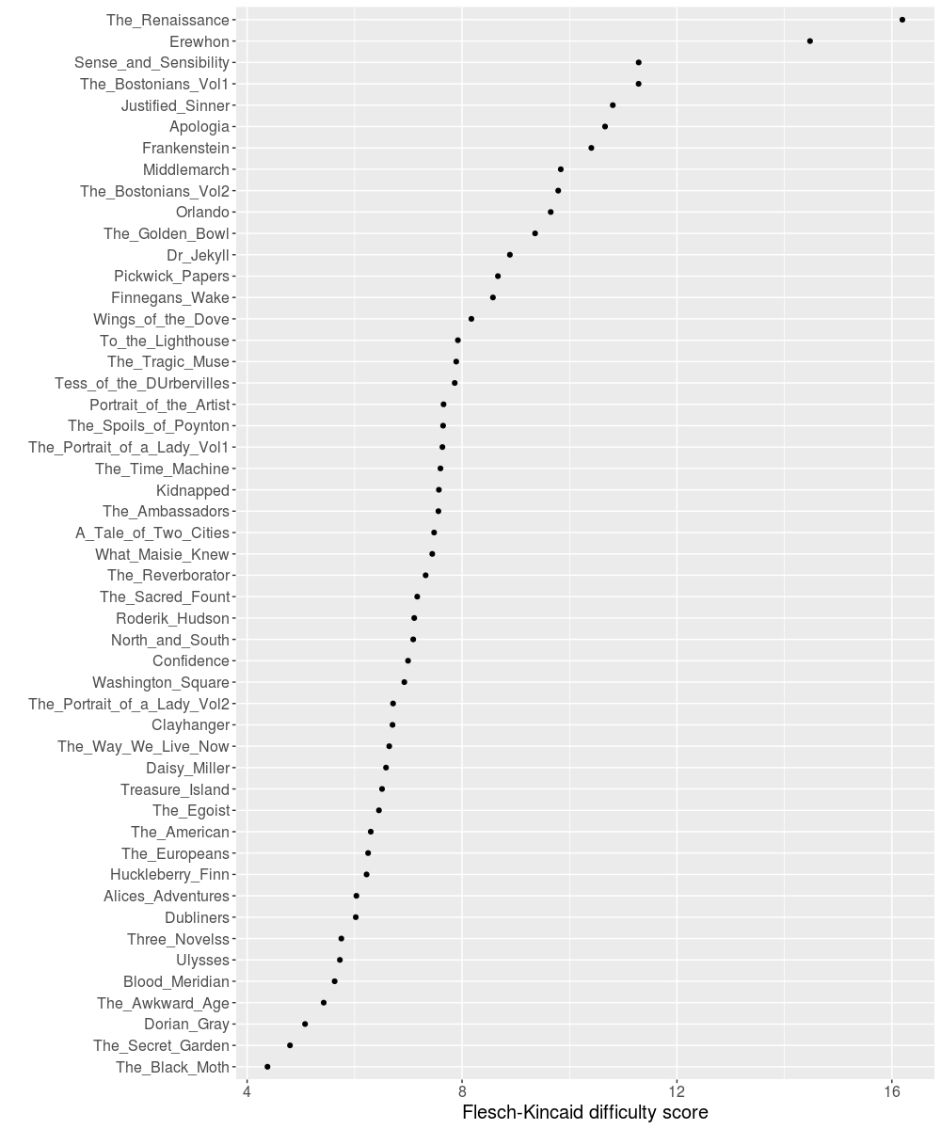
Fig 1: Flesch Kincaid readability score (reading grade level) for a range of late-nineteenth to early twentieth century works.
The Flesch-Kincaid index immediately discloses several trends. Despite the common understanding of modernist literature as being more expansive than what becomes before it (with such factors as the rise of the ‘stream of consciousness’), it is noticeable that both early and later nineteenth-century texts (Austen, Hogg, Pater, Butler) tend, on the whole, to score most highly. In the case of self-evidently difficult work such as Ulysses and Finnegans Wake, the relatively middling positions on the Flesch-Kincaid measure can be explained by the comparatively large numbers of both very short and very long sentences (Molly Bloom’s concluding monologue being an example of the latter). The standard deviation for sentence length of Ulysses (115) and Finnegans Wake (46) far outstrips all other texts (The Renaissance 27, Confessions of a Justified Sinner 25). Other established readability measures (SMOG, Bormuth), being similarly dependent to a large extent upon sentence-length, show very similar patterns. Even in the Dale-Chall readability measure (Chall and Dale, 1995), which combines sentence-length with some sense of the relative frequency of words (computing the percentage of terms outside of a predefined dictionary of 3000 familiar words), the pattern remains substantially unchanged, with Pater again leading the way. There are, of course, other ways to measure complexity than the rather crude criterion of sentence length. The relative distribution of parts of speech are often taken as an index of stylistic sophistication; to this end, Figure 2 compares adverbial usage across the same texts. Such results may not tell us anything particularly surprising, though they are powerfully illustrative. Henry James memorably declared that ‘adjectives are the sugar of literature and adverbs the salt’. Based on the trends in this figure, we can conclusively confirm what many readers have long known: that James salts his meat.
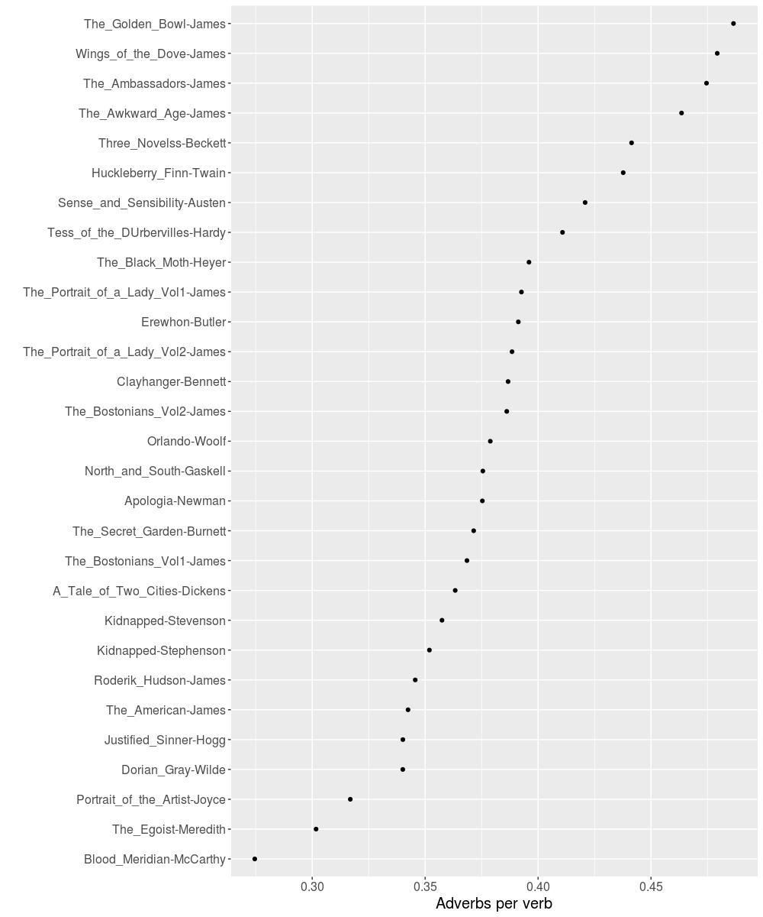
Fig. 2: Ratio of adverbs to verbs.

Finally, a large number of discursive traditions have frequently taken abstractness as an indicator of lexical complexity. The German intellectual historian Reinhart Koselleck, for instance, sees the increasing tendency for humans to form abstractions—at both the lexical and philosophical level—to be a defining tendency of modernity. Figure 3 plots the same prose works according to a recently compiled measure set of ratings for human judgements of lexical concreteness. Brysbaert et al (2014) compile 37,058 judgement of English native speakers, asking participants to rate each word on a concrete-abstract scale. Here again there are some striking results, which this time include a few surprises. We score the text with the average concreteness rating of its words. It feels intuitive enough to see Cormac McCarthy’s Blood Meridian—a work taken as emblematic of its author’s clipped, exact style—as being by some distance the most concrete work. Nor does it surprise us to see Henry James dominating the abstract end of the scale, where he is surrounded by other sophisticated works of psychological realism (Austen) or autobiographical reflection (Newman’s Apologia Pro Vita Sua). Of more interest (or puzzlement) to literary historians, however, is the relative concreteness of apparently very different works, such as Joyce’s Ulysses, and Stevenson’s adventure novel Treasure Island. It is of interest that while so much otherwise changes in Joyce’s work (between the realist short stories of Dubliners and the experimentation of Finnegans Wake), his concreteness remains. Paradoxically, this measure therefore brings to light a trend that calls the very use of concreteness as an index for complexity into question: both concrete and abstract language can produce simplicity or complexity.
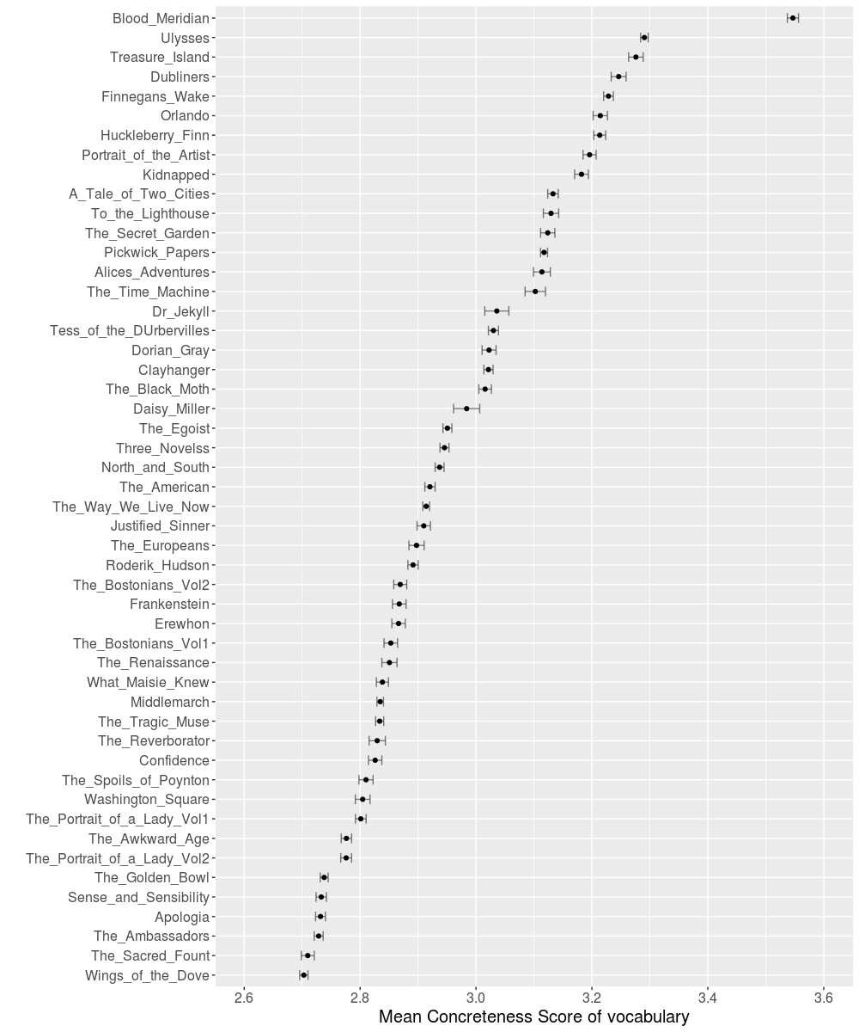
Figure 3: Mean concreteness score of vocabulary of each work.

It should by now be clear that we feel that these separate measures (sentence-length, adverbial usage, abstractness) reveal useful trends, while also suggesting possible overlaps or contrasts (James, for instance, is both abstract and adverbial; Woolf’s Orlando, unusually, is both concrete and with long sentences). It is helpful, for example, to learn that The Golden Bowl has far shorter sentences than Pater, despite James having by far a greater reputation for prolixity than Pater. Such uses, notwithstanding, these measures remain extremely crude, if we seek to uncover something more than local trends—if we seek to gain a better insight, that is to say, into the nature and experience of complexity itself. Pater serves as a convenient example of the limitations of such approaches. His The Reniassance, as we have seen, scores most highly on the Flesch-Kincaid index and other related measures. Its very longest sentence runs as follows:
But, although the number of Giorgione's extant works has been thus limited by recent criticism, all is not done when the real and the traditional elements in what concerns him have been discriminated; for, in what is connected with a great name, much that is not real is often very stimulating; and, for the aesthetic philosopher, over and above the real Giorgione and his authentic extant works, there remains the Giorgionesque also—an influence, a spirit or type in art, active in men so different as those to whom many of his supposed works are really assignable—a veritable school, which grew together out of all those fascinating works rightly or wrongly attributed to him; out of many copies from, or variations on him, by unknown or uncertain workmen, whose drawings and designs were, for various reasons, prized as his; out of the immediate impression he made upon his contemporaries, and with which he continued in men's minds; out of many traditions of subject and treatment, which really descend from him to our own time, and by retracing which we fill out the original image; Giorgione thus becoming a sort of impersonation of Venice itself, its projected reflex or ideal, all that was intense or desirable in it thus crystallising about the memory of this wonderful young man.

This is not, whatever Flesch-Kincaid might have to say on the matter, a difficult sentence. Pater here makes characteristically full use of hypotaxis, parallelism and lexical repetition so as to set up both a structure and a rhythm to his discussion. Perhaps most significantly, there is a natural affinity between the pile-up of Pater’s successive clauses, whose actual content often borders on tautology, and the crux of his discussion, namely, the voluminous imitators of Giorgeone. We are far, that is to say, from the syntactical obliquity of James, or the more wholesale assault on grammar that we find in late Joyce. So far from impeding our comprehension of the text, Pater’s syntactical expansiveness provides an enabling scaffold for it.
We could certainly fit such observations into a broader intellectual narrative, according to which the prose tradition of the seventeenth century (Thomas Browne, Robert Burton, John Milton), whose characteristic style is both expansive (long sentences) and heavily regulated (with meticulous attention to syntactical relation), gradually shades into a modernism whose own extensions (as with the ‘stream of consciousness; style of Woolf) are characterized rather by purposeful syntactical obliquity. Yet these are historical considerations for which the off-the-shelf measures surveyed above cannot account. If such extant measures are therefore found wanting, what might be a better way to begin to model complexity? In what follows, we propose a novel method, which aims to take into account the historical cultural context in which a work is embedded. In order to demonstrate the affordances of such an approach, we propose also to train our attention upon one of the authors surveyed above: Henry James.

II: Relative Complexity

This section focuses more narrowly upon the prose fiction of Henry James, for two interrelated reasons: firstly, as we have already seen, James’s work has a particularly striking profile according to several of the statistical measures of complexity surveyed above; secondly (and perhaps as a direct result of this fact), because James’s work has inspired quantitative work in both literary criticism, corpus linguistics and stylometrics, perhaps more than any other single author. His extensive body of work therefore serves as a particularly useful sounding-board for our own method.
Given the above, James’s output has often represented a rare sustained intersection between literary criticism and computational or corpus-based approaches. Examples here are too numerous to cite in full: the most significant work in this respect remains the structuralist critic Seymour Chatman’s The Late Style of Henry James (1972), and David W. Smit’s ‘The Later Style of Henry James’, which conducts a more thoroughgoing quantitative analysis of James’s prose fiction and letters[2]. As the titles of both works suggest, one of the principal motivations for subjecting James’s work to quantitative analysis is that, in addition to having a writing style that differs strongly from other authors, James increasingly comes to differ from himself. Given the famous alterations from ‘early James’ to ‘late James’, this proper name effectively becomes his own corpus.
For the specific purposes of this paper, we wish to dwell on one of the most comprehensive and impressive stylometric approaches to James’s work, namely, David L. Hoover’s 2007 article ‘Corpus Stylistics, Stylometry, and the Styles of Henry James’. This analysis builds upon the pioneering work of John F. Burrows, who devised or applied a variety of measures of textual difference (Delta, Delta-Lz, Cluster Analysis), which accurately identify whether a given novel falls into James’s early or late period. Via the use of a Distinctiveness Ratio (which simply calculates the rate of occurrence in one text, divided by its rate of occurrence in another), coupled with two recent stylometric analysis (Zeta and Iota), Hoover drills down into the details of these works, so as to identify i), the specific lexis that proves particularly characteristic of early or late James; and ii), those passages that serve as particularly distilled instances of these two periods.
The result is a treasure-trove of insights: we learn, for example, that there is a strong linguistic or semantic connection between those words whose relative frequency increases or decreases dramatically that James (in keeping with the overall trends in abstractness that we observed above) tends to use increasingly abstract rather than concrete words as his writing evolves, a process that is particularly observable in his noun-choice; and that despite the widespread perception of his increasing difficulty (‘blinked, brisk, chap, chuck, dodge, funny, fuss […]’), a large number of slang or informal words prove increasingly prevalent. Using such measures enables Hoover to focus upon specifically representative passages such as the following extract from the late novel The Ambassadors (here the words that Zeta has identified as characteristically ‘late’ are marked in bold):

It was on this pleasant basis of costly disorder, consequently, that they eventually seated themselves, on either side of a small table, at a window adjusted to the busy quay and the shining barge-burdened Seine; where, for an hour, in the matter of letting himself go, of diving deep, Strether was to feel he had touched bottom. He was to feel many things on this occasion, and one of the first of them was that he had travelled far since that evening in London, before the theatre, when his dinner with Maria Gostrey, between the pink-shaded candles, had struck him as requiring so many explanations.

In what way are such passages representative of James’s late style? In a quantitative manner, clearly, insofar as they feature words that are relatively frequent in those mature works. But how might we characterize the nature or the experience of that style? In general, and for quite understandable reasons (having already enough on his plate), Hoover skirts around these questions. The increasing turn towards abstraction has often been read as an index of complexity, though not, as we have seen, without difficulties. And while Hoover at one point does venture the observation that ‘the unusual combination of increased slang and colloquialism and increasingly convoluted and difficult syntax seem to me a hallmark of the later James’, he does not claim to have captured complexity itself; rather, the specific measure (here Zeta) leads to a passage in which such syntactical convolution happens to appear. There is a broader ambiguity here: to what extent does the reproduction of extracts, such as the passage from The Ambassadors, serve merely to provide a local instance of the large-scale data patterns previously observed; to what extent does it purport to capture something of the qualitative experience of reading late James?
Such questions compel us to address the distinction between two terms that we have previously treated interchangeably: ‘difficulty’, as a property that inheres in the aesthetic object under consideration, and ‘readability’, as an experience that inheres in the cognitive apparatus of the language-user. We contend that these two factors are at once both distinct and inseparable: any analysis of complexity must find some way to address both. We cannot comment upon the complexity of Shakespeare, for instance, without acknowledging that the Bard’s texts are at once more and less difficult for us, as twenty-first century reading subjects, relative to the sixteenth- and seventeenth-century precursors who first consumed his works. More difficult, because much of Shakespeare’s language has become anachronistic; less difficult, because words or formulations that might once have struck an observer as surprising or uncharacteristic (‘all the world’s a stage’) have now devolved into cliché. Hoover’s work thus provides an invaluable way into a question that exceeds the terms of his discussion, a fact that becomes clear when he observes of increasingly rare words in James’s work that ‘coquetry, coquette, suitor, deportment, and tresses seem old fashioned and almost precious in tone.’ Does James’s relative abandonment of such lexis say more about his authorial singularity, or about broader cultural trends? (We note in passing that the established method of ‘close reading’ is often taken to be diametrically opposed to more computational approaches to literary works; yet both, in the case of James, have the effect of isolating the work from its broader cultural context.)
We take this conundrum as our way in. In the following section, we present a new method for measuring the complexity of a given text, which, unlike all those surveyed above, measures the lexical matter of individual texts against the broader culture at large. Like Hoover, we believe that the relative frequency of words provides an excellent resource; where he compares James to himself, we compare James (or for that matter any other author) against a far larger pattern of lexical usage. How on earth could we hope to grasp something so amorphous as ‘the broader culture at large’? Only in a provisional and hedging way, naturally—yet the recent and widespread availability of large-scale datasets makes this a less daunting challenge that it would have been in the past. In the following pages, we set out a series of complexity measurements that compare the relative frequency of a given work’s words, as measured against the Google Books Fiction dataset. While this dataset, like any others, brings specific problems of scope and representativeness (for a thorough account of such challenges, see Pechenick, 2015), it nonetheless represents a remarkable resource, with the English fiction section of the English Google Books corpus in the period 1800–1915, containing approximately 7.1 billion tokens (Michel et al., 2011). Pechenick et al, 2015, in characterising the “strong limitations” of this corpus as a whole, notably finds that the English Fiction section of the second version of this corpus does not suffer from the biases and limitations of the corpus as a whole, and recommends its use in future works. We use one grams from this portion of the corpus [3]. This corpus has the advantage of providing a very large volume of text from which to estimate word frequency, even after extracting specific periods and genres, and allows us to estimate the frequency or rarity of a word in the time period that a text was written. In recent work, Benoit et al. (2017) use the Google Books corpus to measure estimate difficulty in historical political speeches. Such an approach is, however, yet to be attempted in the context of literary texts.
Unadjusted word counts depend on the size of the corpus used. Relative word frequency (count divided by the size of the corpus) may be numerically inconvenient, and both raw and relative counts follow a power law scale that does not map directly onto a linear score for human judgment of familiarity. The word frequency index most predictive of lexical access time in the experiments of (Whaley, 1978) is the Standard Frequency Index of (Carroll, 1970), using the log transform of the rate per million words in a corpus to give a standard score to each word. This type of logarithmic word frequency measure has also been shown to correlate strongly with word gaze time during reading comprehension (Just and Carpenter, 1980). This form of measure is adapted by (Van Heuven et al., 2014) to produce a new unit of word frequency, which they call the Zipf, defined as the base ten log of the frequency per billion words in the corpus of interest. The Zipf scale has an approximately normal distribution and a convenient numerical range — approximately zero to seven. To determine a Zipf score or a sentence, passage of text, or whole text, we use the mean of the Zipf score of all the tokens in the text.
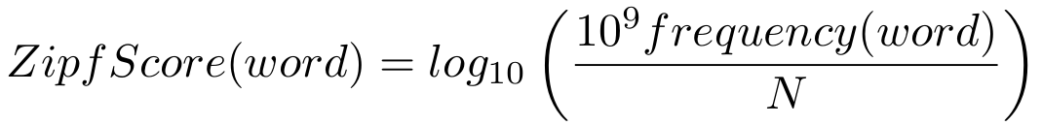

Figure 4 plots the very same texts that we analyzed earlier, now measuring the relative frequency of their tokens against those in the Google Books fiction corpus 1800--1915 using the Zipf score. The calculation only includes words that were found both in the novel and in the corpus from the period. The two extremes of this plot (Finnegans Wake and Wings of the Dove) demonstrate those texts that feature, respectively, the least and most common lexis, relative to the corpus. There is a natural inclination to understand such a graph marking the ‘representativeness’ of a given text, where Joyce’s work is very unalike the culture at large, while James’s novel is very like it. But this would be a mistake. Simplicity and representativeness are here crucially distinct: the novel most ‘like’ the entire corpus of fiction from the period, in terms of mean token frequency, is in fact Dickens’s first novel, The Pickwick Papers, whose Zipf score of 5.65 is closest to the overall mean figure for the corpus as a whole of 5.59. The Wings of the Dove, by contrast, presents us with something of a paradox: by featuring such a large proportion of common words, that novel actually ends up being less typical of the corpus at least in terms of mean Zipf score. Instead of a unidirectional scale that has ‘unexpected’ language at one end, and ‘expected language’ at the other, expectation in fact resides towards the centre; the extremes both of commonness and uncommonness both prove unexpected. To summarise: if complexity is complex, simplicity is no less so.
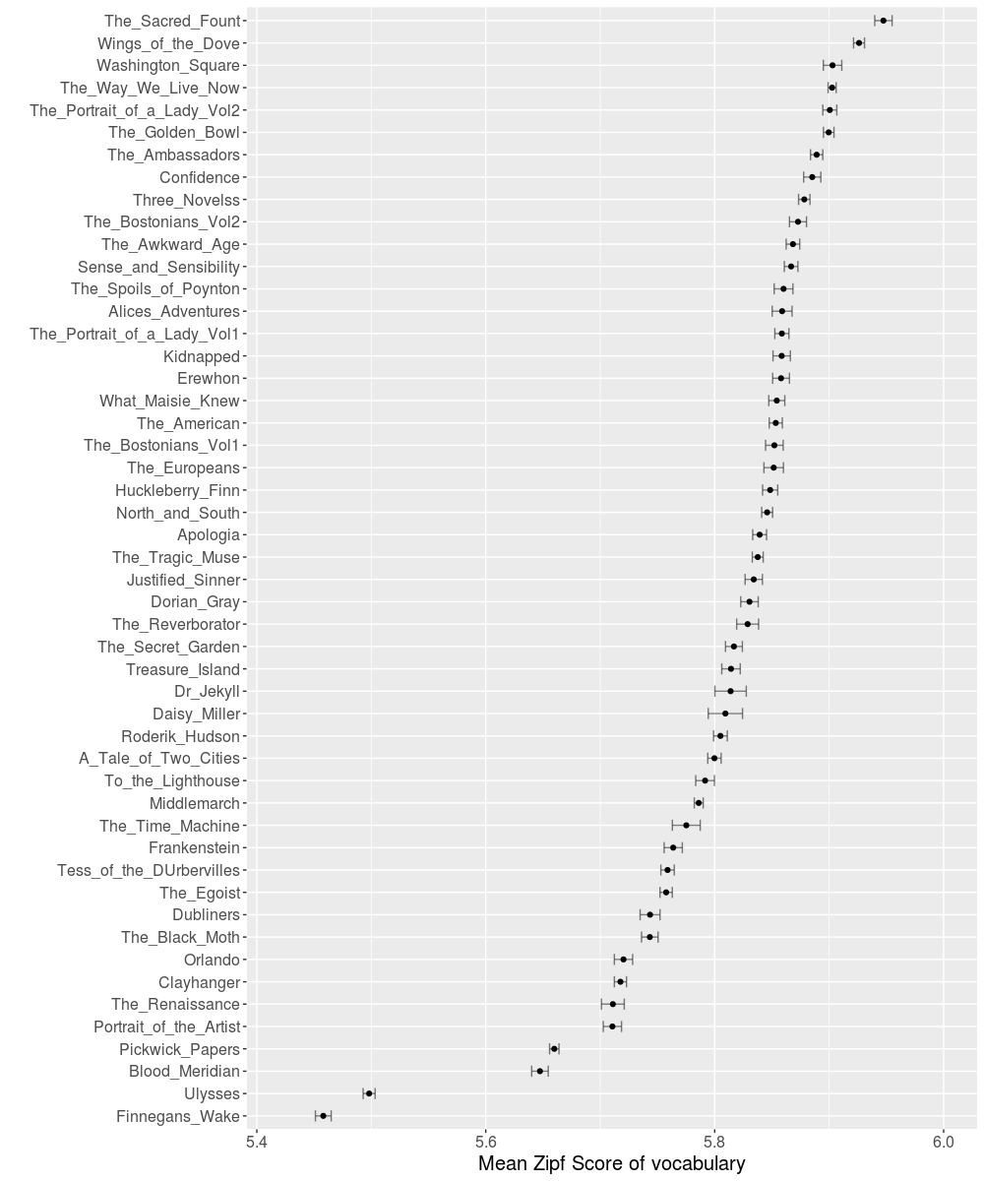
Fig 4: Mean Zipf score of tokens from each novel, as measured using frequency in the Google Books Fiction corpus 1800-1915.

This fact leads us to the most striking aspect of these statistics: that Henry James, a writer who is generally agreed to be difficult, prolix or recondite, should in fact employ language that is more common (relative to the culture at large) than any other texts. Even allowing for James’s famous use of circumlocutory and idiomatic expressions, it comes as a great surprise to learn not only that in this respect his works surpass popular children’s literature such as The Secret Garden, in addition to work, such as Beckett’s Three Novels, that purposefully adopts a stripped-down, repetitive style. More surprising still, perhaps, is that the relative commonness of James’s vocabulary only increases in the late works (Wings of the Dove, The Golden Bowl), which critics have agreed to be the most ‘difficult’ of his whole output. As we have seen, Hoover’s analysis of these late works trains attention upon distinctive and often-recherché constructions (‘barge-burdened’, ‘pinks-shaded’). Such features undoubtedly matter; but perhaps they so not for their novelty, taken in isolation, but for their significant contrast with a broader and more significant trend towards lexical commonness. Finally, fig. 5 adds a more fine-grained diachronic sense to James’s status as a significant outlier, by plotting the measures described above against the date of composition of the works in question. We observe a dense bunching of nineteenth-century texts, which tend to have a Zipf Score of 5.75–5.86. While our dataset is clearly far from comprehensive, we clearly perceive the tendency for later canonical works to have significantly lower scores (Woolf and Joyce stand as cases in point; Finnegans Wake is here omitted, being so extreme a case in this respect that it would render the graph illegible). The most sustained exception to this general historical tendency is, once again, James.

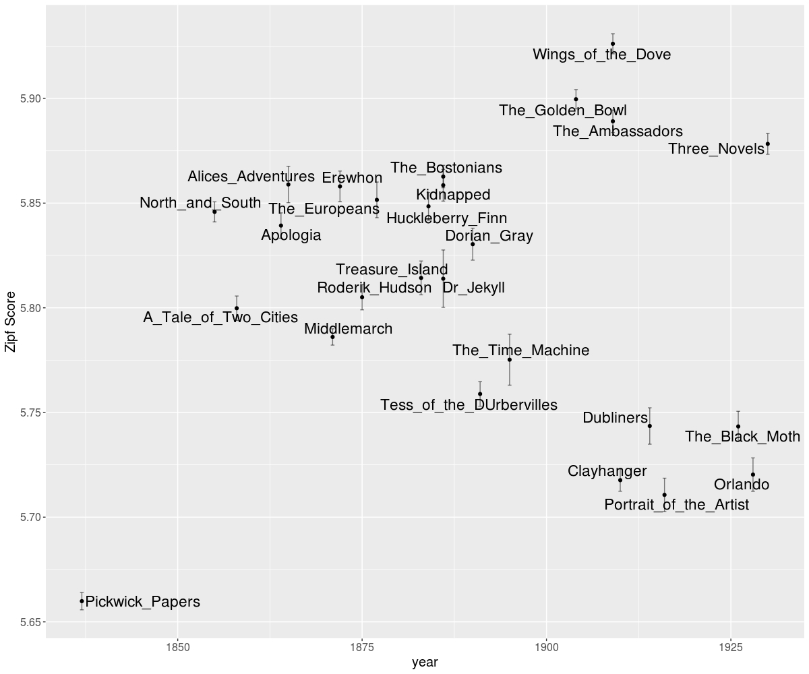Figure 5: Zipf Score by year for selected novels.

III: James’s Easiness

‘Easiness’ and its cognates are not often taken as a positive quality in literary analysis. We often use a term such as ‘unremarkable’ in an evaluative (which is to say pejorative) sense; but perhaps the same word can also be meant strongly, which is to say as a description of textual properties that resist conventional analysis. We contend that the computational method that we have outlined above permits us to attend to the positively simple or strongly unremarkable features of a text. But to commence this work, we have to find the adequate unit. If we move from the large-scale measurement of whole texts to the individual sentences that comprise them, we do not find very much of interest. Of the sequences that are common to the text at large, Samuel Beckett dominates: sentences such as ‘You think no more about it and you go on’ (with a Zipf Score of 6.51) gives a good feel for the pithiness of Beckett’s style, but hardly tells us anything very surprising.
That Beckett prevails at the micro-level of the sentence suggests that James’s lexical commonness (given his own prevalence of the measure at the macro-level of complete work) must emerge at some larger level. This comes clearly into view when we move from the sentence to the paragraph level, where James emerges as the clear frontrunner [3]. Of the many thousands of paragraphs that comprise our sample novels, the single most lexically common sequence arrives in James’s late work The Golden Bowl. Given the nature of the enquiry, we cite that lengthy passage in full:

“I don't care what you make of it, and I don't ask anything whatever of you—anything but this. I want to have said it—that's all; I want not to have failed to say it. To see you once and be with you, to be as we are now and as we used to be, for one small hour--or say for two--that's what I have had for weeks in my head. I mean, of course, to get it BEFORE—before what you're going to do. So, all the while, you see,” she went on with her eyes on him, “it was a question for me if I should be able to manage it in time. If I couldn't have come now I probably shouldn't have come at all—perhaps even ever. Now that I'm here I shall stay, but there were moments, over there, when I despaired. It wasn't easy—there were reasons; but it was either this or nothing. So I didn't struggle, you see, in vain. AFTER—oh, I didn't want that! I don't mean,” she smiled, “that it wouldn't have been delightful to see you even then—to see you at any time; but I would never have come for it. This is different. This is what I wanted. This is what I've got. This is what I shall always have. This is what I should have missed, of course,” she pursued, “if you had chosen to make me miss it. If you had thought me horrid, had refused to come, I should, naturally, have been immensely ‘sold’ I had to take the risk. Well, you’re all I could have hoped. That's what I was to have said. I didn't want simply to get my time with you, but I wanted you to know. I wanted you”—she kept it up, slowly, softly, with a small tremor of voice, but without the least failure of sense or sequence—“I wanted you to understand. I wanted you, that is, to hear. I don't care, I think, whether you understand or not. If I ask nothing of you I don’t—I mayn’t—ask even so much as that. What you may think of me—that doesn't in the least matter. What I want is that it shall always be with you—so that you'll never be able quite to get rid of it—that I DID. I won't say that you did—you may make as little of that as you like. But that I was here with you where we are and as we are—I just saying this. Giving myself, in other words, away—and perfectly willing to do it for nothing. That's all.”

Where Hoover’s extracts served primarily as an empirical demonstration of what his computational methods had already uncovered, we believe that the above extract permits a rather more dynamic relation between large-scale patterns and the phenomenology of reading. This language extract would have slipped through the cracks of any of the other methods described above: it is not (despite James’s reputation) syntactically obscure, nor does it feature a large number of long sentences or adverbial constructions. At the same time, our subjective experience of the passage is unlikely to alight on any particularly unusual details (lexis, imagery, metaphor, etc.). That is precisely the point: the commonness of James’s prose is here at its most remarkable. Rather than telling us what we already knew, such extracts might—once revealed by computation—surprise us into an aesthetic appreciation of what habitually escaped our notice.
We should begin, in adding a little flesh to this general description of a reader’s experience, by noting the significance of this passage within the broader drama of The Golden Bowl. It takes place at a pivotal early moment, when Charlotte Stant has crossed the Atlantic to spend a brief moment of time with her ex-lover, Prince Amerigo, just as he is about to marry a rich American heiress. The passage is characteristically Jamesian in its admixture of reticence and emotional directness, signalled by Charlotte’s emphatic use of simple verbs and adverbs (‘BEFORE’, ‘AFTER’, ‘DID’). (Our measure does not code for italicisations or uppercase: it is a ticklish question whether ‘BEFORE’ should count as ‘before’ in a calculation of relative frequency.) These are characters that use an excess of language because they cannot speak what they truly feel; or because they cannot but speak of it through even the most banal of words. These are characters that know one another perfectly while we, readers at this early stage of the novel, remain ignorant. It seems obvious, once we think about this extract for any length of time, yet perhaps we required computation to give us the eyes to see it: the ostentatiousness commonness of James’s prose both reveals and conceals.
Constraints of space and time, press upon us, and so we can no more than suggest the ways in which such powerfully unremarkable passages possess a distinct aesthetic force. Part of our conviction in this respect derives from the frankly uncanny manner in which our measure identifies moments within novels that can rightly be considered climactic, yet about whose language there frequently seems very little to say. James, as noted before, features prominently, often at moments of great emotional intensity: we find, for example, the feminist Verena’s passionate declaration to Ransom, who immediately notes that ‘She had evidently given up everything now’, and comparable passages in The Ambassadors and The Awkward Age. Also present within the top twenty sentences, measured by culture-relative word frequency, are Thomas Hardy’s Tess of the d’Urbervilles, at the very moment that the eponymous heroine confesses the murder of her ex-lover to her estranged husband Alex (6.19); and the moment in Huckleberry Finn where the eponymous protagonist finds himself unable to pray, having not revealed the departure of a fugitive slave (6.14). Literary historians are naturally alert to the exceptional passages of those artworks that they study: Wordsworth’s ‘spots of time’, Joyce’s epiphanies, elevated language in general. But perhaps they should pay greater heed to those unusually common passages, which both enable such elevation to take flight and possess a distinct (if fugitive) aesthetic merit in their own right.

Conclusion

In 1976, Philip Glass and Robert Wilson took the calculated but spectacular financial risk of renting the Metropolitan Opera for two nights, in order to stage their opera Einstein on the Beach. The pair were moved to such desperate lengths, because the serialism that continued to predominate left little room for what would come to be known as minimalism. These opposed musical idioms demonstrate the difficulty of talking about artistic complexity: serialism pushed the limits of its expressive medium to their extreme, and can therefore be called (on the model of Joyce) entropic; yet by the time that Glass rented the Met, such avowed estrangements had become to appear increasingly unsurprising. Einstein on the Beach, by contrast, shocked precisely through what we could call its redundancy: highly repetitive and melodically simple music, which shocked its audience precisely on account of its lack of variation.
The preceding discussion suggests that Einstein on the Beach is a useful means of understanding the peculiarity of James’s (late) style, in addition to the treacherous question of literary complexity more broadly. We have argued that any real attempt to understand such difficulty need measure itself against the culture at large. Of course, we can never fully model the subject’s subjective experience of a work of art. For what would that definite article denote? The audience that heard Glass’s opera on the first night of its performance, and were shocked by its resistance to harmonic or rhythmic development? A contemporary listener for whom minimalism has become just one more accepted cultural idiom? No algorithm could ever compute such cultural variability. What we can do, by contrast, is utilize the ever-growing indicators of the culture at large (of which Google Books is but one), whose historical specificity can actually prove—once recognized as such—a positive attribute. Much work remains to be done, so as to show how complexity and simplicity—in the strongest sense of both terms—intersect. We hope to have shown not only that James’s easiness is a surprisingly complex phenomenon in its own right, but also that our culture-relative frequency measures can—indeed must—be supplemented by other approaches. The commonness of James’s vocabulary should not be considered in isolation from his syntactical obliquity; this combination does much to create the sense, familiar to many readers of James, that all the usual furniture is in the room, but in the places that one would least expect.

Notes:
[1] The text versions used are the Project Gutenberg plain text files of the novels, with the preamble, preface, introduction, credits, and license removed where appropriate. In the case that multiple versions were available, the later edition was used.

[2] Style, 21. 1, Rhythm, Rhetoric, Revision (Spring 1987), pp. 95-106.
[3] http://storage.googleapis.com/books/ngrams/books/datasetsv2.html. At the download site, the fiction section is described as being ‘extracted from books predominantly in the English language that a library or publisher identified as fiction’. The supplementary material of Michel et al. (2011) states that fiction was identified by Book Industry Study Group (BISAC) code. Pechenick et al. (2015) find that the subsequent 2012 fiction section is more selective, and only this section escapes the influence of scientific text on the rest of the corpus.
[4] We measured the score of paragraphs as delimited by double line breaks in the corpus, retaining those sections with between 250 and 1000 words.

References
Benoit, K., Munger, K., Spirling, A., 2017. Measuring and explaining political sophistication through textual complexity. SSRN preprint.
Brysbaert, M., Keuleers, E., New, B., 2011. Assessing the usefulness of google books’ word frequencies for psycholinguistic research on word processing. Frontiers in Psychology 2, 27.
Brysbaert, M., Warriner, A.B. and Kuperman, V., 2014. Concreteness ratings for 40 thousand generally known English word lemmas. Behavior research methods, 46(3), pp.904-911.
Carroll, J.B., 1970. An alternative to juilland’s usage coefficient for lexical frequencies, and a proposal for a standard frequency index (sfi). Computer Studies in the Humanities and Verbal Behavior 3, 61–65.
Chall, J.S., Dale, E., 1995. Readability revisited: The new dale-chall readability formula. Brookline Books.
Empson, W., 1951. The structure of complex words. Chatto & Windus.
Flesch, R., 1948. A new readability yardstick. Journal of applied psychology 32, 221.
Just, M.A., Carpenter, P.A., 1980. A theory of reading: From eye fixations to comprehension. Psychological review 87, 329.
Keuleers, E., Stevens, M., Mandera, P., Brysbaert, M., 2015. Word knowledge in the crowd: Measuring vocabulary size and word prevalence in a massive online experiment. The Quarterly Journal of Experimental Psychology 68, 1665–1692.
Lernout, Geert. "Post-Structuralist Joyce. Essays from the French. Derek Attridge and Daniel Ferrer (eds.) Genèse et métamorphoses du texte joycien. Claude Jacquet (ed.)." Revue belge de Philologie et d'Histoire 69, no. 3 (1991): 782-785.
Michel, J.-B., Shen, Y.K., Aiden, A.P., Veres, A., Gray, M.K., Pickett, J.P., Hoiberg, D., Clancy, D., Norvig, P., Orwant, J., others, 2011. Quantitative analysis of culture using millions of digitized books. science 331, 176–182.
Nagy, William E., Richard C. Anderson, and Patricia A. Herman. Learning word meanings from context during normal reading. American educational research journal 24, no. 2 (1987): 237-270.

Pechenick, E.A., Danforth, C.M., Dodds, P.S., 2015. Characterizing the google books corpus: Strong limits to inferences of socio-cultural and linguistic evolution. PloS one 10, e0137041.
Piantadosi, S.T., Tily, H., Gibson, E., 2011. Word lengths are optimized for efficient communication. Proceedings of the National Academy of Sciences 108, 3526–3529.
Pitler, E., Nenkova, A., 2008. Revisiting readability: A unified framework for predicting text quality, in: Proceedings of the Conference on Empirical Methods in Natural Language Processing. Association for Computational Linguistics, pp. 186–195.
Sherman, L.A., 1893. Analytics of literature: A manual for the objective study of english prose and poetry. Ginn.
Van Heuven, W.J., Mandera, P., Keuleers, E., Brysbaert, M., 2014. SUBTLEX-uk: A new and improved word frequency database for british english. The Quarterly Journal of Experimental Psychology 67, 1176–1190.
Whaley, C.P., 1978. Word-nonword classification time. Journal of Memory and Language 17, 143.

Appendix

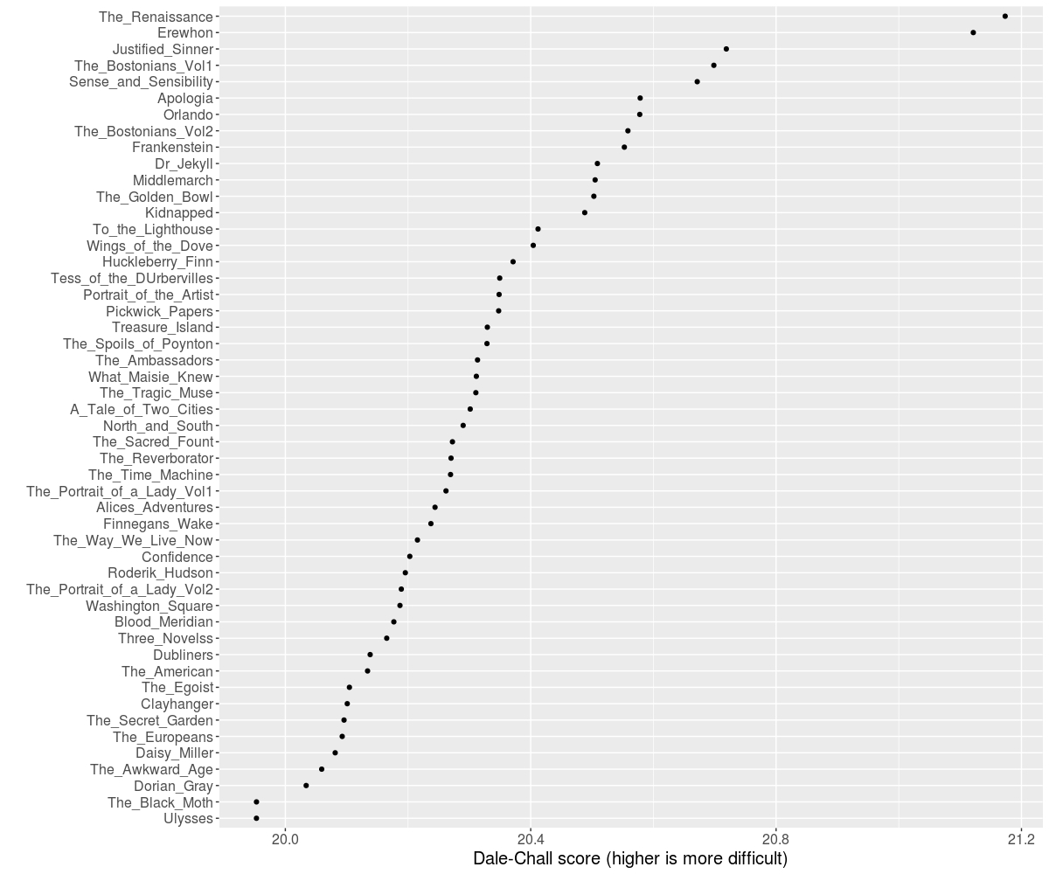
Appendix i: Dale Chall Scores

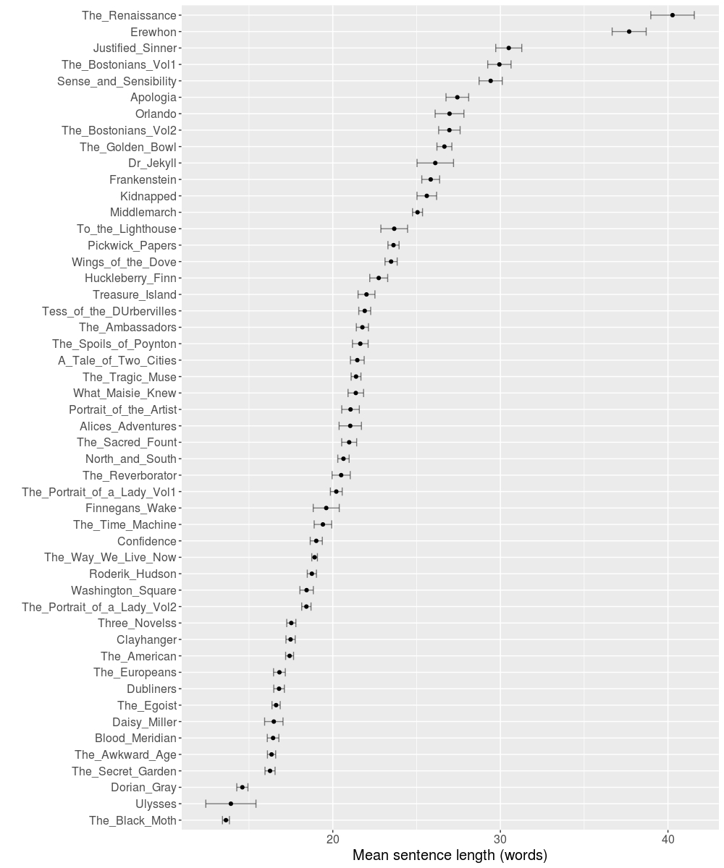
Appendix ii: Mean Sentence length

Appendix iii) Examples of twenty paragraphs with highest mean Zipf score.

6.3099942707 | The_Golden_Bowl-James-1904.txt.42 | "I don't care what you make of it, and I don't ask anything whatever of  you--anything but this. I want to have said it--that's all; I want not  to have failed to say it. To see you once and be with you, to be as we  are now and as we used to be, for one small hour--or say for two--that's  what I have had for weeks in my head. I mean, of course, to get it  BEFORE--before what you're going to do. So, all the while, you see," she  went on with her eyes on him, "it was a question for me if I should  be able to manage it in time. If I couldn't have come now I probably  shouldn't have come at all--perhaps even ever. Now that I'm here I shall  stay, but there were moments, over there, when I despaired. It wasn't  easy--there were reasons; but it was either this or nothing. So I didn't  struggle, you see, in vain. AFTER--oh, I didn't want that! I don't  mean," she smiled, "that it wouldn't have been delightful to see you  even then--to see you at any time; but I would never have come for it.  This is different. This is what I wanted. This is what I've got. This is  what I shall always have. This is what I should have missed, of course,"  she pursued, "if you had chosen to make me miss it. If you had thought  me horrid, had refused to come, I should, naturally, have been immensely  'sold.' I had to take the risk. Well, you're all I could have hoped.  That's what I was to have said. I didn't want simply to get my time with  you, but I wanted you to know. I wanted you"--she kept it up, slowly,  softly, with a small tremor of voice, but without the least failure of  sense or sequence--"I wanted you to understand. I wanted you, that is,  to hear. I don't care, I think, whether you understand or not. If I ask  nothing of you I don't--I mayn't--ask even so much as that. What you may  think of me--that doesn't in the least matter. What I want is that it  shall always be with you--so that you'll never be able quite to get rid  of it--that I DID. I won't say that you did--you may make as little of  that as you like. But that I was here with you where we are and as  we are--I just saying this. Giving myself, in other words, away--and  perfectly willing to do it for nothing. That's all."
6.2073999992 | The_Bostonians_Vol2-James-1886.txt.134 | "I didn't know--it was terrible--it's awful! I saw you in your place, in  the house, when you came. As soon as we got here I went out to those  steps that go up to the stage and I looked out, with my father--from  behind him--and saw you in a minute. Then I felt too nervous to speak! I  could never, never, if you were there! My father didn't know you, and I  said nothing, but Olive guessed as soon as I came back. She rushed at  me, and she looked at me--oh, how she looked! and she guessed. She  didn't need to go out to see for herself, and when she saw how I was  trembling she began to tremble herself, to believe, as I believed, we  were lost. Listen to them, listen to them, in the house! Now I want you  to go away--I will see you to-morrow, as long as you wish. That's all I  want now; if you will only go away it's not too late, and everything  will be all right!"
6.1957494864 | The_Way_We_Live_Now-Trollope-1875.txt.231 | I think you hardly understand my position. Of course you  have cut me. Haven't you? And of course I must feel it  very much. You did not use to be ill-natured, and I hardly  think you can have become so now when you have everything  pleasant around you. I do not think that I have done  anything that should make an old friend treat me in this  way, and therefore I write to ask you to let me see you.  Of course it is because I am staying here. You know me  well enough to be sure that it can't be my own choice.  Papa arranged it all. If there is anything against these  people, I suppose papa does not know it. Of course they  are not nice. Of course they are not like anything that  I have been used to. But when papa told me that the house  in Bruton Street was to be shut up and that I was to come  here, of course I did as I was bid. I don't think an  old friend like you, whom I have always liked more than  anybody else, ought to cut me for it. It's not about the  parties, but about yourself that I mind. I don't ask  you to come here, but if you will see me I can have the  carriage and will go to you.
6.1924917774 | The_Ambassadors-James-1909.txt.226 | Strether lightly shook his head. "There I stop. Oh, odd as it may  appear to you, there ARE things I don't know. I only got the sense  from her of something very sharp, and yet very deep down, that she was  keeping all to herself. That is I had begun with the belief that she  HAD kept it to herself; but face to face with her there I soon made out  that there was a person with whom she would have shared it. I had  thought she possibly might with ME--but I saw then that I was only half  in her confidence. When, turning to me to greet me--for she was on the  balcony and I had come in without her knowing it--she showed me she had  been expecting YOU and was proportionately disappointed, I got hold of  the tail of my conviction. Half an hour later I was in possession of  all the rest of it. You know what has happened." He looked at his  young friend hard--then he felt sure. "For all you say, you're up to  your eyes. So there you are."
6.1917186683 | Tess_of_the_DUrbervilles-Hardy-1891.txt.114 | "I have done it--I don't know how," she continued. "Still, I owed it  to you, and to myself, Angel. I feared long ago, when I struck him  on the mouth with my glove, that I might do it some day for the trap  he set for me in my simple youth, and his wrong to you through me.  He has come between us and ruined us, and now he can never do it any  more. I never loved him at all, Angel, as I loved you. You know it,  don't you? You believe it? You didn't come back to me, and I was  obliged to go back to him. Why did you go away--why did you--when I  loved you so? I can't think why you did it. But I don't blame you;  only, Angel, will you forgive me my sin against you, now I have  killed him? I thought as I ran along that you would be sure to  forgive me now I have done that. It came to me as a shining light  that I should get you back that way. I could not bear the loss of  you any longer--you don't know how entirely I was unable to bear your  not loving me! Say you do now, dear, dear husband; say you do, now I  have killed him!"
6.1885175209 | The_Golden_Bowl-James-1904.txt.119 | "Yes--for once in a way; in those few words we had after you had watched  them come up you told me something of what you had seen. You didn't  tell me very much--THAT you couldn't for your life; but I saw for myself  that, strange to say, you had received your impression, and I felt  therefore that there must indeed have been something out of the way for  you so to betray it." She was fully upon him now, and she confronted him  with his proved sensibility to the occasion--confronted him because of  her own uneasy need to profit by it. It came over her still more than at  the time, it came over her that he had been struck with something, even  HE, poor dear man; and that for this to have occurred there must have  been much to be struck with. She tried in fact to corner him, to  pack him insistently down, in the truth of his plain vision, the very  plainness of which was its value; for so recorded, she felt, none of  it would escape--she should have it at hand for reference. "Come, my  dear--you thought what you thought: in the presence of what you saw you  couldn't resist thinking. I don't ask more of it than that. And your  idea is worth, this time, quite as much as any of mine--so that you  can't pretend, as usual, that mine has run away with me. I haven't  caught up with you. I stay where I am. But I see," she concluded, "where  you are, and I'm much obliged to you for letting me. You give me a point  de repere outside myself--which is where I like it. Now I can work round  you."
6.1842654873 | The_Way_We_Live_Now-Trollope-1875.txt.432 | "Do you? Oh! I wish you did. I should so like to be loved by you.  Nobody loves me, I think. That man there wants to marry me. Do you  know him? He is Lord Nidderdale. He is very nice; but he does not  love me any more than he loves you. That's the way with men. It isn't  the way with me. I would go with Felix and slave for him if he were  poor. Is it all to be over then? You will give him a message from  me?" Hetta, doubting as to the propriety of the promise, promised  that she would. "Just tell him I want to know; that's all. I want to  know. You'll understand. I want to know the real truth. I suppose I  do know it now. Then I shall not care what happens to me. It will be  all the same. I suppose I shall marry that young man, though it will  be very bad. I shall just be as if I hadn't any self of my own at  all. But he ought to send me word after all that has passed. Do not  you think he ought to send me word?"
6.1825940635 | Confidence-James-1880.txt.68 | "I hope it does n't offend you. I don't say it lightly--it 's not a  piece of gallantry. It 's the very truth of my being. I did n't know it  till lately--strange as that may seem. I loved you long before I knew  it--before I ventured or presumed to know it. I was thinking of you  when I seemed to myself to be thinking of other things. It is very  strange--there are things in it I don't understand. I travelled over  the world, I tried to interest, to divert myself; but at bottom it was  a perfect failure. To see you again--that was what I wanted. When I saw  you last month at Blanquais I knew it; then everything became clear. It  was the answer to the riddle. I wished to read it very clearly--I wished  to be sure; therefore I did n't follow you immediately. I questioned my  heart--I cross-questioned it. It has borne the examination, and now I am  sure. I am very sure. I love you as my life--I beg you to listen to me!"
6.1613557057 | The_Awkward_Age-James-1899.txt.113 | "Oh," said Nanda very simply, "it isn't a 'career' exactly, is  it--keeping hold of an old friend? but it may console a little, mayn't  it, for the absence of one? At all events I didn't want not to have  spoken before it's too late. Of course I don't know what's the matter  between you, or if anything's really the matter at all. I don't care  at any rate WHAT is--it can't be anything very bad. Make it up, make it  up--forget it. I don't pretend that's a career for YOU any more than for  her; but there it is. I know how I sound--most patronising and pushing;  but nothing venture nothing have. You CAN'T know how much you are to  her. You're more to her, I verily believe, than any one EVER was. I hate  to have the appearance of plotting anything about her behind her back;  so I'll just say it once for all. She said once, in speaking of it to  a person who repeated it to me, that you had done more for her than any  one, because it was you who had really brought her out. It WAS. You  did. I saw it at the time myself. I was very small, but I COULD see it.  You'll say I must have been a most uncanny little wretch, and I dare  say I was and am keeping now the pleasant promise. That doesn't prevent  one's feeling that when a person has brought a person out--"
6.1612766837 | The_Portrait_of_a_Lady_Vol2-James-1881.txt.45 | He checked her; he was a little disconcerted at the quick effect of his  words. "I don't mean I thought so to-night. On the contrary, to-day,  in the train, he seemed particularly well; the idea of our reaching  Rome--he's very fond of Rome, you know--gave him strength. An hour ago,  when I bade him good-night, he told me he was very tired, but very happy.  Go to him in the morning; that's all I mean. I didn't tell him I was  coming here; I didn't decide to till after we had separated. Then I  remembered he had told me you had an evening, and that it was this very  Thursday. It occurred to me to come in and tell you he's here, and let  you know you had perhaps better not wait for him to call. I think he  said he hadn't written to you." There was no need of Isabel's declaring  that she would act upon Lord Warburton's information; she looked, as she  sat there, like a winged creature held back. "Let alone that I wanted to  see you for myself," her visitor gallantly added.
6.1559029491 | The_Sacred_Fount-James-1901.txt.29 | "From what she was when she sat to me? Well, a part of it is that she  can't keep still. She was as still then as if she had been paid for it.  Now she's all over the place." But he came back to something else. "I  like your talking, my dear man, of what you 'don't perceive.' I've yet  to find out what that remarkable quantity is. What you do perceive has  at all events given me so much to think about that it doubtless ought to  serve me for the present. I feel I ought to let you know that you've  made me also perceive the Brissendens." I of course remembered what I  had said to him, but it was just this that now touched my uneasiness,  and I only echoed the name, a little blankly, with the instinct of  gaining time. "You put me on them wonderfully," Obert continued, "though  of course I've kept your idea to myself. All the same it sheds a great  light."
6.1533216328 | Wings_of_the_Dove-James-1909.txt.154 | Kate looked at him hard again, disappointed at his want of consistency; but it appeared to determine in her something better than a mere complaint. "Then I can! Leave it to me." With which she came to him under the compulsion, again, that had united them shortly before, and took hold of him in her urgency to the same tender purpose. It was her form of entreaty renewed and repeated, which made after all, as he met it, their great fact clear. And it somehow clarified all things so to possess each other. The effect of it was that, once more, on these terms, he could only be generous. He had so on the spot then left everything to her that she reverted in the course of a few moments to one of her previous-and as positively seemed-her most precious ideas. "You accused me just now of saying that Milly's in love with you. Well, if you come to that, I do say it. So there you are. That's the good she'll do us. It makes a basis for her seeing you-so that she'll help us to go on."
6.1520930648 | The_Sacred_Fount-James-1901.txt.63 | "Yes, my dear man, I do understand you--quite perfectly now, and (by I  know not what miracle) I've really done so to some extent from the  first. Deep is the rest of feeling with you, in this way, that I'm  watched, for the time, only as you watch me. It has all stopped, and _I_  can stop. How can I make you understand what it is for me that there  isn't at last a creature any more in sight, that the wood darkens about  me, that the sounds drop and the relief goes on; what can it mean for  you even that I've given myself up to not caring whether or no, amongst  others, I'm missed and spoken of? It does help my strange case, in fine,  as you see, to let you keep me here; but I should have found still more  what I was in need of if I had only found, instead of you, him whom I  had in mind. He is as much better than you as you are than everyone  else." I finally felt, in a word, so qualified to attribute to my  companion some such mute address as that, that it could only have, as  the next consequence, a determining effect on me--an effect under the  influence of which I spoke. "I parted with him, some way from here, some  time ago. I had found him in one of the gardens with Lady John; after  which we came away from her together. We strolled a little and talked,  but I knew what he really wanted. He wanted to find you, and I told him  he would probably do so at tea on the terrace. It was visibly with that  idea--to return to the house--that he left me."
6.1516626094 | Washington_Square-James-1881.txt.61 | "Is it you, then, that have changed him and made him so unnatural?"  Catherine cried. "Is it you that have worked on him and taken him from  me? He doesn't belong to you, and I don't see how you have anything to  do with what is between us! Is it you that have made this plot and told  him to leave me? How could you be so wicked, so cruel? What have I ever  done to you; why can't you leave me alone? I was afraid you would spoil  everything; for you _do_ spoil everything you touch; I was afraid of you  all the time we were abroad; I had no rest when I thought that you were  always talking to him." Catherine went on with growing vehemence,  pouring out in her bitterness and in the clairvoyance of her passion  (which suddenly, jumping all processes, made her judge her aunt finally  and without appeal) the uneasiness which had lain for so many months upon  her heart.
6.1500629434 | The_Sacred_Fount-James-1901.txt.110 | I should perhaps have wondered more what she proposed to do in a minute  had I not felt it as already more or less done. Yes, she might have been  twenty-five, and it was a short time for _that_ to have taken. However,  what I clutched at, what I clung to, was that it was a nervous  twenty-five. I might pay for her assurance, but wasn't there something  of mine for which _she_ might pay? I was nervous also, but, as I took in  again, with a glance through our great chain of chambers, the wonderful  conditions that protected us, I did my best to feel sure that it was  only because I was so amused. That--in so high a form--was what it came  to in the end. "I supposed," I replied, "that you'd have arranged; for,  in spite of the way things were going, I hadn't given you up. I haven't  understood, I confess," I went on, "why you've preferred a conference so  intensely nocturnal--of which I quite feel, however, that, if it has  happened to suit you, it isn't for me to complain. But I felt sure of  you--that was the great thing--from the moment, half an hour ago, you so  kindly spoke to me. I gave you, you see," I laughed, "what's called  'rope.'"
6.1455132504 | The_Golden_Bowl-James-1904.txt.257 | She could verily, out of all her smothered soreness, almost have smiled:  his question so affected her as giving the whole thing up to her. But  it left her only to go the straighter. "She has had to do with it that  I immediately sent for her and that she immediately came. She was the  first person I wanted to see--because I knew she would know. Know more  about what I had learned, I mean, than I could make out for myself. I  made out as much as I could for myself--that I also wanted to have done;  but it didn't, in spite of everything, take me very far, and she has  really been a help. Not so much as she would like to be--not so much as,  poor dear, she just now tried to be; yet she has done her very best for  you--never forget that!--and has kept me along immeasurably better than  I should have been able to come without her. She has gained me time; and  that, these three months, don't you see? has been everything."
6.1450121744 | Washington_Square-James-1881.txt.46 | "You were angry last year that I wouldn't marry immediately, and now you  talk about my winning my father over. You told me it would serve him  right if he should take me to Europe for nothing. Well, he has taken me  for nothing, and you ought to be satisfied. Nothing is changed-nothing  but my feeling about father. I don't mind nearly so much now. I have  been as good as I could, but he doesn't care. Now I don't care either.  I don't know whether I have grown bad; perhaps I have. But I don't care  for that. I have come home to be married-that's all I know. That ought  to please you, unless you have taken up some new idea; you are so  strange. You may do as you please; but you must never speak to me again  about pleading with father. I shall never plead with him for anything;  that is all over. He has put me off. I am come home to be married."
6.1429009361 | Huckleberry_Finn-Twain-1884.txt.136 | It made me shiver. And I about made up my mind to pray, and see if I  couldn't try to quit being the kind of a boy I was and be better. So  I kneeled down. But the words wouldn't come. Why wouldn't they? It  warn't no use to try and hide it from Him. Nor from _me_, neither. I  knowed very well why they wouldn't come. It was because my heart warn't  right; it was because I warn't square; it was because I was playing  double. I was letting _on_ to give up sin, but away inside of me I was  holding on to the biggest one of all. I was trying to make my mouth  _say_ I would do the right thing and the clean thing, and go and write  to that nigger's owner and tell where he was; but deep down in me I  knowed it was a lie, and He knowed it. You can't pray a lie--I found  that out.
6.1423626755 | The_Way_We_Live_Now-Trollope-1875.txt.503 | Hetta as she heard the story hardly knew whether her cousin, in his  manner of telling the story, was speaking of that other man, of that  stranger of whom she had never heard, or of himself. He would have  made her his wife and have been good to her. He had a home to offer  her. He was an honest man with whom she would have been safe and  respected and happy! He had looked at her while speaking as though it  were her own case of which he spoke. And then, when he talked of the  old-fashioned way, of being off with the old love before you are on  with the new, had he not alluded to Paul Montague and this story of  the American woman? But, if so, it was not for Hetta to notice it  by words. He must speak more plainly than that before she could be  supposed to know that he alluded to her own condition. "It is very  shocking," she said.

