Figure 1
Consort Diagram Showing CALM Study Referral Routes
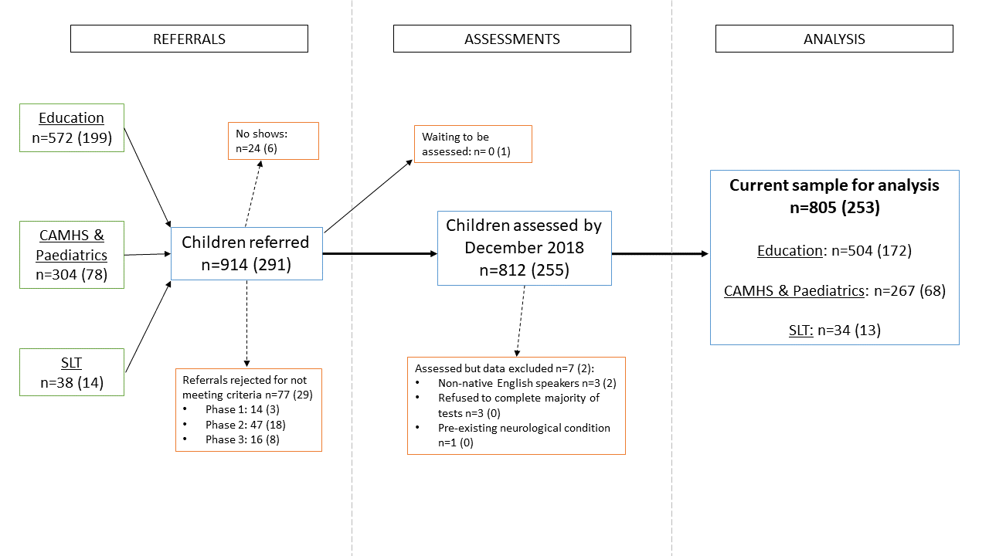
Note. n (female). M and SD are ages in years. CAMHS = Child and Adolescent Mental Health Services. SLT = Speech and Language Therapists.

Figure 2
Three-Factor Confirmatory Factor Analysis Model for the Whole CALM sample (All Ages)

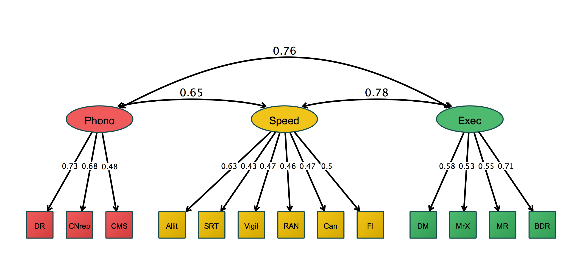
Note. Latent variables phonological processing (phono), speed, and executive functions (exec) are represented in ovals. Cognitive measures are shown as observed variables in squares. Variable names are: CNrep = Nonword Repetition, DR = Digit Recall, CMS = Delayed Recall, SRT = Simple Reaction Time, Allit = Alliteration, RAN = Rapid Automatic Naming, FI = Following Instructions, Can= Cancellation, MR= Matrix Reasoning, DM = Dot Matrix, BDR = Backward Digit Recall, MrX = Mr X. Parameter estimates are fully standardized. Residual variances are freely estimated but not shown for visual clarity.

Figure 3
Path Models Predicting Learning from Cognitive Factors for the Whole Sample, All Ages
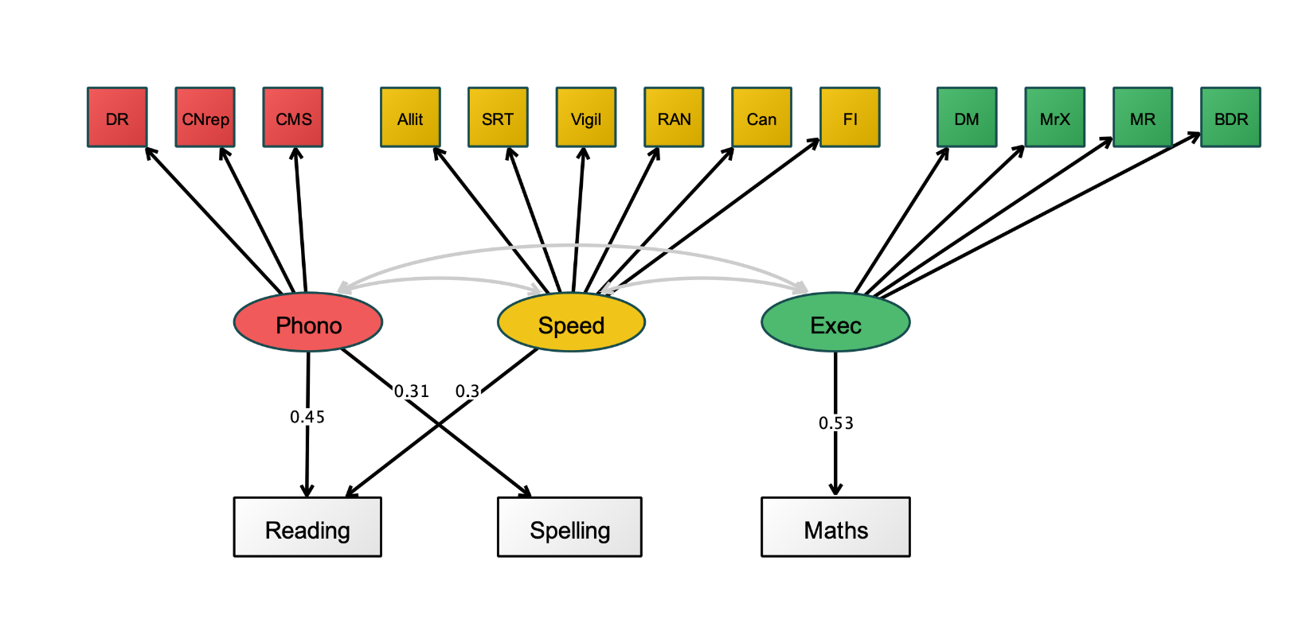Note. N=805; Learning outcomes (reading, spelling, and maths) are regressed on phonological processing, speed, and executive factors. Parameter estimates are fully standardized. Factor loadings and covariances are not shown for simplicity. Variable names are: CNrep = Nonword Repetition, DR = Digit Recall, CMS = Delayed Recall, SRT = Simple Reaction Time, Allit = Alliteration, RAN = Rapid Automatic Naming, FI = Following Instructions, Can= Cancellation, MR= Matrix Reasoning, DM = Dot Matrix, BDR = Backward Digit Recall, MrX = Mr X. Residual variances are freely estimated but not shown for visual clarity.

Figure 4
Three-Factor Confirmatory Factor Analysis for Children Aged 8 Years and Older

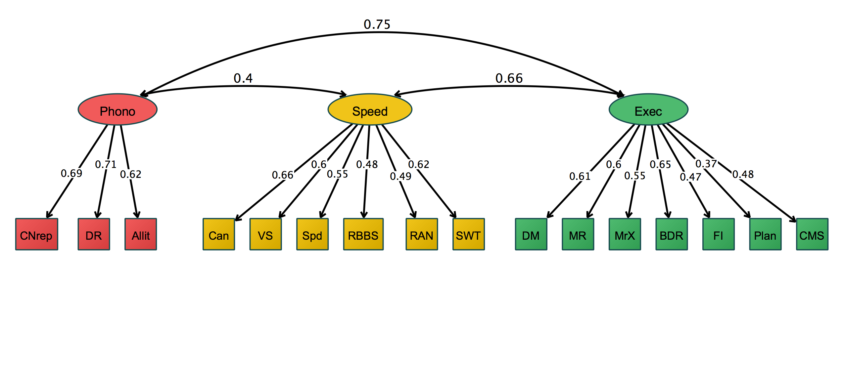
Note. Latent variables executive functions (exec), processing speed (speed), and phonological processing (phono) are represented in ovals. Cognitive measures are shown as observed variables in squares. DM = Dot matrix, BDR = Backward Digit Recall, MrX = Mr X, FI = Following Instructions, CMS = Delayed Recall, Plan = planning, MR= Matrix Reasoning, RAN = Rapid Automatic Naming,VS = Visual Scanning, Spd = Motor Speed, SWT = Number-Letter Switching, Can= Cancellation, RBBS= Reds, Blues, Bags and Shoes Switching, Allit = Alliteration, CNrep = Nonword Repetition, DR = Digit Recall. Parameter estimates are fully standardized. Residual variances are freely estimated but not shown for visual clarity.

Figure 5
Path Models Predicting Learning from Cognitive Factors for Children 8 Years and Older
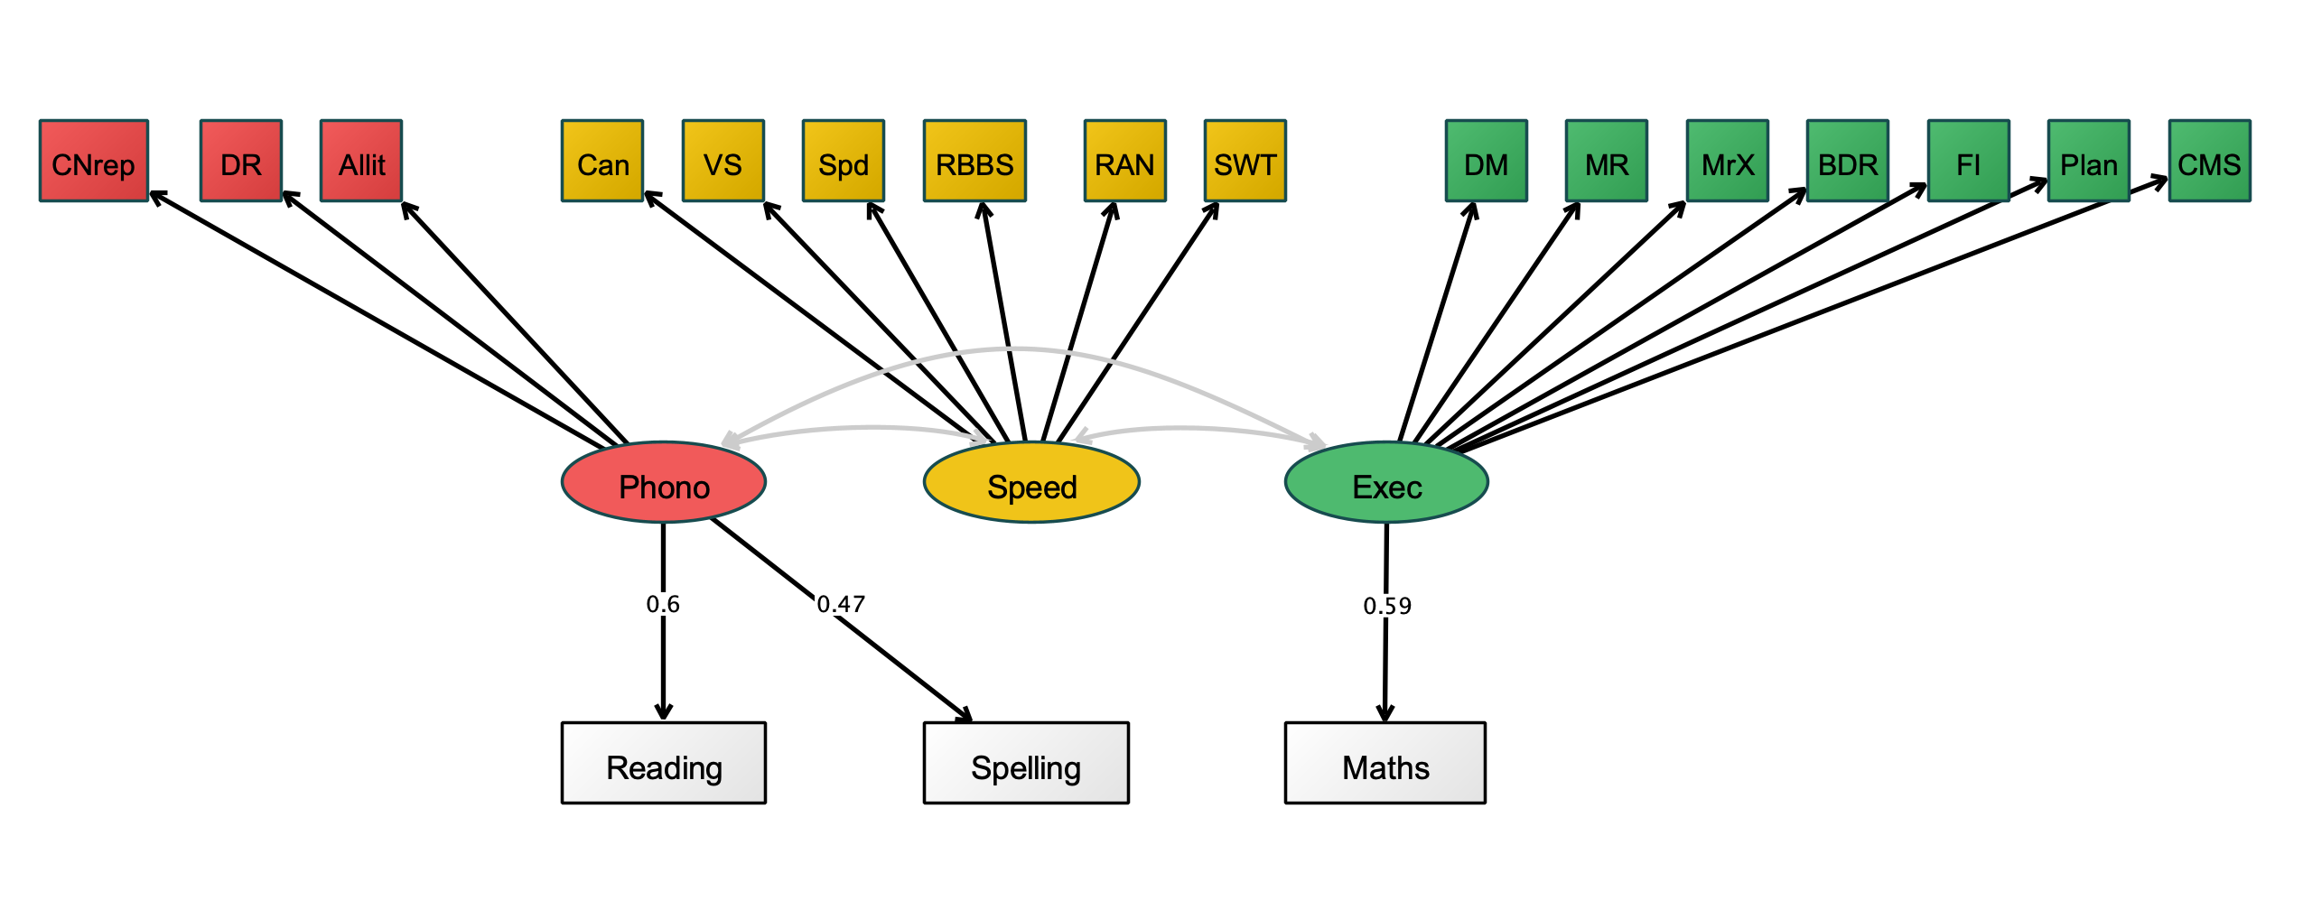
Note. N=566; Learning outcomes (reading, spelling, and maths) are regressed on phonological processing, speed, and executive factors. Parameter estimates are fully standardized. Factor loadings are not shown for simplicity.

