Vertical Strain-Driven Antiferromagnetic to Ferromagnetic Phase Transition in EuTiO₃ Nanocomposite Thin Films
Yisong Lin,^{1,†} Eun-Mi Choi,^{1,†} Ping Lu,³ Xing Sun,² Rui Wu,¹ Chao Yun,¹ Bonan Zhu,¹ Haiyan Wang,² Weiwei Li,^{1,*} Tuhin Maity,^{1,*}Judith MacManus-Driscoll ^{1,*}
1. Department of Materials Science & Metallurgy, University of Cambridge, CB3 0FS, United Kingdom.
2. Materials Engineering, Purdue University, West Lafayette, IN, 47907, United States.
3. Sandia National Laboratories, Albuquerque, New Mexico 87185, United States.

† Y. L. and E.C. contributed equally to this work.
E-mail (*): wl337@cam.ac.uk; tsm38@cam.ac.uk; jld35@cam.ac.uk
Keywords: nanocomposite, multiferroics, self-assembled nanostructures, thin films, spintronics

Abstract
Three-dimensional (3D) strain induced in self-assembled vertically aligned nanocomposite (VAN) epitaxial films provides an unrivaled method to induce very large strains in thin films. Here, by growing VAN films of EuTiO₃ (ETO)- Eu₂O₃ (EO) with different EO fractions, the vertical strain was systematically increased in ETO, up to 3.15%, and the Eu-Ti-Eu bond angle along <111> decreased by up to 1°, leading to a weakening of the antiferromagnetic interactions, and switching from antiferromagnetic to ferromagnetic behaviour. Our work has shown for the first time that Eu-Ti-Eu superexchange interactions play a key role in determining the magnetic ground state of ETO. More broadly, our work serves as an exemplar to show that multifunctionalities in strong spin-lattice coupling perovskite oxides can be uniquely tuned at the atomic scale using simple VAN structures.

1. Introduction
Transition metal ABO₃ perovskite oxides possess many fascinating and technologically relevant phenomena such as, multiferroicity, magnetoresistivity, superconductivity, and photovoltaics.^{1–4} Owing to strong correlations between structural degrees of freedom and order parameters, a very wide range of fundamental phenomena can be obtained and readily modified using composition and strain. Engineering strain by isostatic pressure,⁵ chemical pressure^{6–8} and biaxial strain^{9–14} have all been widely applied to manipulate the spin, charge and orbital orderings. However, these methods do not permit engineering of strain independently along the three crystal directions and yet this is essential for fully tuning the different correlations. Isostatic pressure shrinks the structural simultaneously in all three directions of the crystals.¹⁵ Chemical pressure via doping has similar effects. Although it also allows expansion along all crystallographic directions, it has drawbacks of chemical effects of the dopant ions.^{16,17} Thin film epitaxial biaxial strain is limited by the kinds of commercial substrates¹² and does not enable independent exploration of strain along the 3 directions because of Poisson effects.
Perovskite EuTiO₃ (ETO) is a paraelectric (PE) and antiferromagnetic (AF)¹⁸ with a strong spin-lattice coupling and has attracted intensive attention for achieving enhanced ferromagnetic (FM)-ferroelectric (FE) properties and magnetoelectric coupling via strain engineering.^{19,20} Hence, ETO could be a promising candidate for novel storage devices.^{21–23} Density functional theory (DFT) calculations have proposed that by applying epitaxial substrate compressive strain in films (> 1.2%), ETO can be changed from a PE-AF phase into a FM (spontaneous magnetization, ~7 μ_{B}/Eu) - FE (spontaneous polarization, ~10 μC/cm²).¹⁹ These values are orders of magnitude higher than any known FE or FM materials and are at the same level as for materials that are solely FE or FM, which makes ETO one of the most promising candidates for strain-tuned physical properties.
Experimentally, by applying biaxial tensile strain (+1.1%), a FM-FE phase has indeed been realized in 22 nm ETO films grown on (110)-oriented DyScO₃ substrate²⁰ but at a very low temperature (T_{C,FM} = 4.24K). Further, the electrical field control of magnetism to show magneto-electric coupling has not yet been demonstrated.
To fully understand and control the mechanisms of electrical field control of magnetism via the spin-lattice coupling, it is important to explore the magnetic interactions and underlying mechanisms of emergent FM in strained ETO films.²⁴ Previous work has reported that the magnetic ground state of ETO could be switched from AF to FM by biaxial tensile strain,^{20,25} volume expansion²⁶ and electric fields.²⁷ For a 1.1% biaxial tensile strain on (110)-oriented DyScO₃ substrate,²⁰ a spin-phonon-driven destabilization of the lattice induces a FE-FM phase in ETO with a low-lying state competing with a PE-AF phase.¹⁹ Also, substrate induced large lattice volume expansions of 1.56% (LaAlO₃), 2.41% (SrTiO₃) and 3.92% (DyScO₃) caused by the lattice mismatch between ETO and the substrates²⁶ have been shown to change the magnetic phase of ETO from AF to FM. The result was explained by the exchange coupling constant variations with the change of lattice volume.²⁸ In addition, under moderate compressive strain, in ETO films grown on (001)-oriented LSAT substrates an applied electric field was found to eliminate long-range AF order, inducing a magnetic state with nanometre-sized FM clusters. This was explained by the modification of local exchange coupling via the electric field.²⁷ DFT calculations were carried out to explain and understand these phenomena.^{19,27–30} All the above works were focused on biaxially strained ETO films with a thickness ˂ 25nm. Different scenarios were used for explaining the FM phase obtained, but there has been no clear consensus of its origin.
As shown in Fig. 1(a), three major magnetic interactions²⁷ co-exist in unstrained-ETO: 1st nearest neighbour (1st NN) which refers to AF interactions, 2nd nearest neighbour (2nd NN) which refers to FM interactions (Eu²⁺ -Eu²⁺ indirect exchange), and 3rd nearest neighbour (3rd NN) interactions which refers to AF interactions (Eu²⁺-Ti-Eu²⁺ superexchange via Ti 3d⁰ states). DFT calculations have proposed that the AF interactions can originate from superexchange interactions between Eu²⁺ ions via Ti⁴⁺ ions which play a crucial role in switching ETO from AF to FM by strain.²⁸ Inspired by DFT calculations, it was further suggested that the 3rd NN interactions play a non-negligible role in determining the magnetic ground state and that the strength of the superexchange interaction relies upon the bond angle and the bond length of Eu-Ti-Eu along the [111] direction. Based on such a scenario, the switching of magnetism from AF to FM by the application of an electric field was realised.²⁷
According to the Goodenough-Kanamori-Anderson rules,^{31–34} the superexchange interaction J depends strongly on the bond angle rather than on the bond length. A tiny modification of the Eu-Ti-Eu bond angle along the [111] direction would significantly influence the Eu-Ti-Eu superexchange and then change the magnetic ground state in ETO. However, to the best of our knowledge, experimental investigations of the Eu-Ti-Eu bond angle and its influence on the magnetic properties of ETO have not been reported. The key reason for this is that in standard epitaxial ETO films, in-plane (IP) biaxial tension (compression) along [001]/[010] leads to out-of-plane (OOP) compression (tension) along [100] via the Poisson effect, which means that the [111] bond length cannot be expanded (compressed) to any great extent, and hence the Eu-Ti-Eu superexchange coupling cannot be tuned significantly.
To systematically tune the strain along the [111] direction, and hence to understand the critical role of the Eu²⁺-Ti⁴⁺-Eu²⁺ superexchange coupling in controlling the magnetic ground states, the VAN approach is ideal as the vertical out-of-plane strain is tuned independently from the in-plane strain. Also, the strain is not diminished in films of large thickness (up to μm),^{35–37} and so any spurious effects arising from substrate-induced dead layers in very thin (˂ 10 nm) coherently strained films is eliminated. Furthermore, systematic strain tuning is enabled simply by changing the ratios of the phases.^{38–41} This has been shown in many other functional systems, e.g. through varying the percentage of Sm₂O₃ in Ba_{0.6}Sr_{0.4}TiO₃ VAN films, the strain state was systematically tuned and hence so were the ferroelectric properties.³⁹ Similarly by varying the RE₂O₃ (RE = Sm, Eu, Gd, Dy and Er) in SrZrO₃ VAN films, the vertical tensile strain was systematically increased in SrZrO₃ to enhance ion conductivity.⁴⁰
Here we investigate vertically aligned nanocomposites (VAN) of ETO- Eu₂O₃ (EO). As shown schematically in Fig. 1(b), in VAN thin films of ETO_{1-x}-EuO_{x} (x = 0.2, 0.25, 0.33, 0.5) grown on (001)-oriented SrTiO₃ (STO), the vertical strain is tuned by vertical epitaxy with EO. STO is a non-magnetic material with the same structure and lattice parameter as bulk ETO (a = 3.905 Å for bulk STO;⁴² a = 3.905 Å for bulk ETO¹⁸), and so is ideal for the epitaxial growth of high quality ETO thin films.
Non-magnetic EO⁴³ is the ideal secondary phase in the VAN films to induce vertical strain on ETO because:
- it will not poison or modify the composition of ETO as it has the same elemental constituents.
- it is mechanically stiffer than ETO (EO elastic modulus: 150GPa⁴⁴, ETO elastic modulus: 76 GPa⁴⁵).
- it has a cubic structure with a larger lattice parameter (a = 10.859 Å for bulk Eu₂O₃⁴⁶) and so, assuming that EO nanopillars form in an ETO matrix with [001] direction, EO should stretch ETO out-of-plane by applying a vertical tensile strain. With increasing fractions of EO, the distance between nanopillars will decrease and so more of the ETO will be vertically strained (i.e. less in-plane relaxation of the ETO lattice). Hence, larger fractions of EO added to ETO are expected to produce larger out-of-plane strain in the ETO. At the same time, the in-plane strain is not modified as the films are all grown coherently on STO.
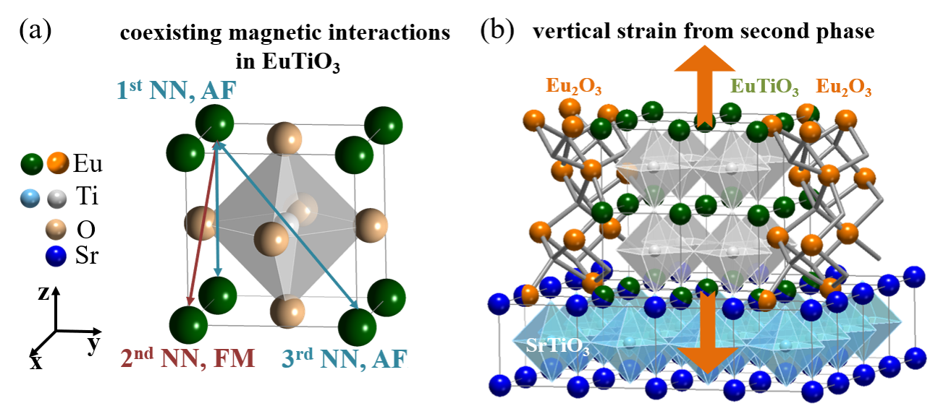
Figure 1. Schematic of (a) magnetic interactions in EuTiO₃. 1st nearest neighbour (1st NN) refers to AF interaction, 2nd nearest neighbour (2nd NN) refers to Eu²⁺-Eu²⁺ indirect exchange (FM interaction), 3rd nearest neighbour (3rd NN) refers to Eu²⁺-Ti⁴⁺--Eu²⁺ superexchange via Ti 3d⁰ band (AF interaction), and (b) self-assembled EuTiO₃-Eu₂O₃ nanocomposite thin films. Eu₂O₃ serves as a second phase in nanopillar form to provide out-of-plane tensile strain in EuTiO₃.
We demonstrate that with an increase of EO in the VAN films, the out-of-plane strain and tetragonality are systematically increased. The Eu-Ti-Eu bond angle along [111] is reduced by up to 0.7% (more than 1°). This produces a switch in the magnetic state from AF to FM. Additionally, we show for the first time the coexistence of both FM and AF in ETO (for x = 0.2). Our results provide direct evidence that Eu-Ti-Eu superexchange plays an important role in determining the magnetic ground state of ETO and serves to demonstrate the importance of 3D strain control in strong spin-lattice coupled perovskite oxides.
2. Results and discussion
Table 1. Structural and Magnetic information of (EuTiO₃)_{1-x}-(Eu₂O₃)_{x} VAN films
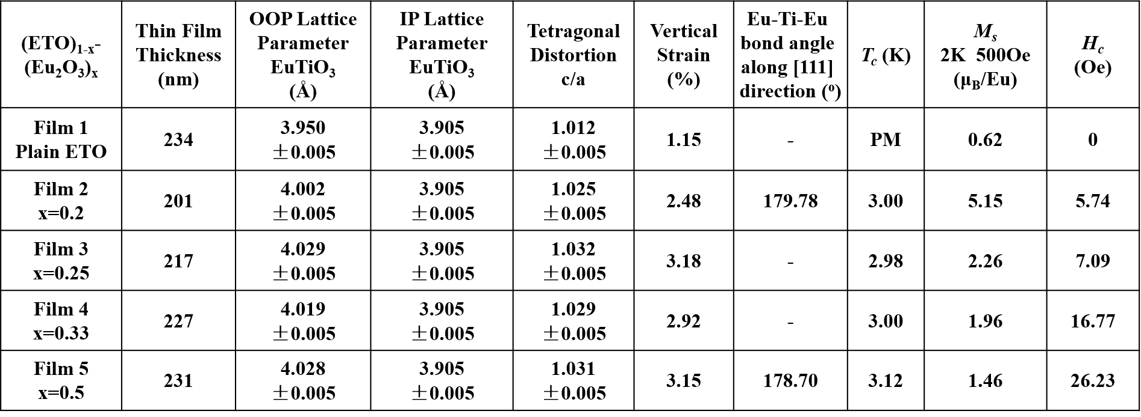
The OOP lattice parameter first increases and then decreases with the increase of EO. The IP lattice parameter does not change. With the increase of molar ratio (x) of EO the saturation magnetization (M_{S}) decreases whereas coercivity (H_{C}) increases.

As shown in Fig. 2(a), the XRD 2θ-ω scans of plain ETO (x = 0), and ETO-Eu₂O₃ VAN nanocomposite films (x = 0.2, 0.25, 0.33, 0.5) show only (00l) peaks from ETO, Eu₂O₃ and the STO substrate, indicating the epitaxial growth of ETO and Eu₂O₃ phases in the VAN thin films. The position of the (00l) peaks for ETO show a trend of decreasing 2θ (increasing d spacing, and hence larger ‘c’) with larger EO fraction which saturates when the EO fraction reaches x=0.25, as summarized in Table 1.
To determine the IP and OOP lattice parameters, reciprocal space maps (RSMs) of plain ETO (x = 0) and ETO-Eu₂O₃ VAN films (x = 0.2, 0.25, 0.33, 0.5) near the STO (103) peak were measured, as shown in Fig. 2(b). For both the plain ETO and the VAN ETO-EO films, the ETO (103) peaks have the same Q_{in} values as the STO (103) peaks, indicating that the IP lattice parameters of ETO are the same as that for the STO substrate (a_{STO} = a_{ETO} = b_{STO} = b_{ETO} = 3.905 Å). The OOP lattice parameter for ETO is indicated by the dashed lines in the RSMs of Fig. 2(b). With increasing EO fraction, the OOP lattice parameter of ETO is increased from c_{ETO} = 3.950 Å (film 1, x = 0) to c_{ETO} = 4.028 Å (film 5, x = 0.5). As shown in Table 1, the OOP lattice constant is saturated when the EO fraction reaches x = 0.25.
If we compare the lateral width of the ETO between the embedded EO nanofeatures for the x = 0.2 and 0.5 films in the TEM images of Figure 2(c), the values are up to ~ 50 nm, and ~5-30 nm, respectively. These values are estimated and averaged from multiple STEM images. The latter spacings of ETO in the x = 0.5 sample are certainly small enough that the ETO c-parameter cannot relax in the lateral direction, because it is always in close proximity to the EO. This explains the flattening of the c-parameter rise with increasing x (see Table 1 and Fig. 2(b)) which will take place when the spacing of the ETO between pillars is below around 20 nm. ³⁹
Comparing the STEM images further for the x = 0.2 and x = 0.5 samples (Fig 2c), we observe the ETO nucleates and grows first on the STO substrate as expected because of lower interfacial energy of the two crystallographically identical structures. The ETO appears as a lighter contrast phase (as expected for the lower atomic weight). Both the EO and ETO phases are highly crystalline and the interfaces between the phases are very clean. The columns of EO embedded in the ETO are not fully continuous in the x = 0.2 sample but become more continuous for the x = 0.5 sample. We therefore label the composite types as 0-3 ⁴⁷ and 1-3 (Fig. 2d),⁴⁸ for x = 0.2 and 0.5, respectively.
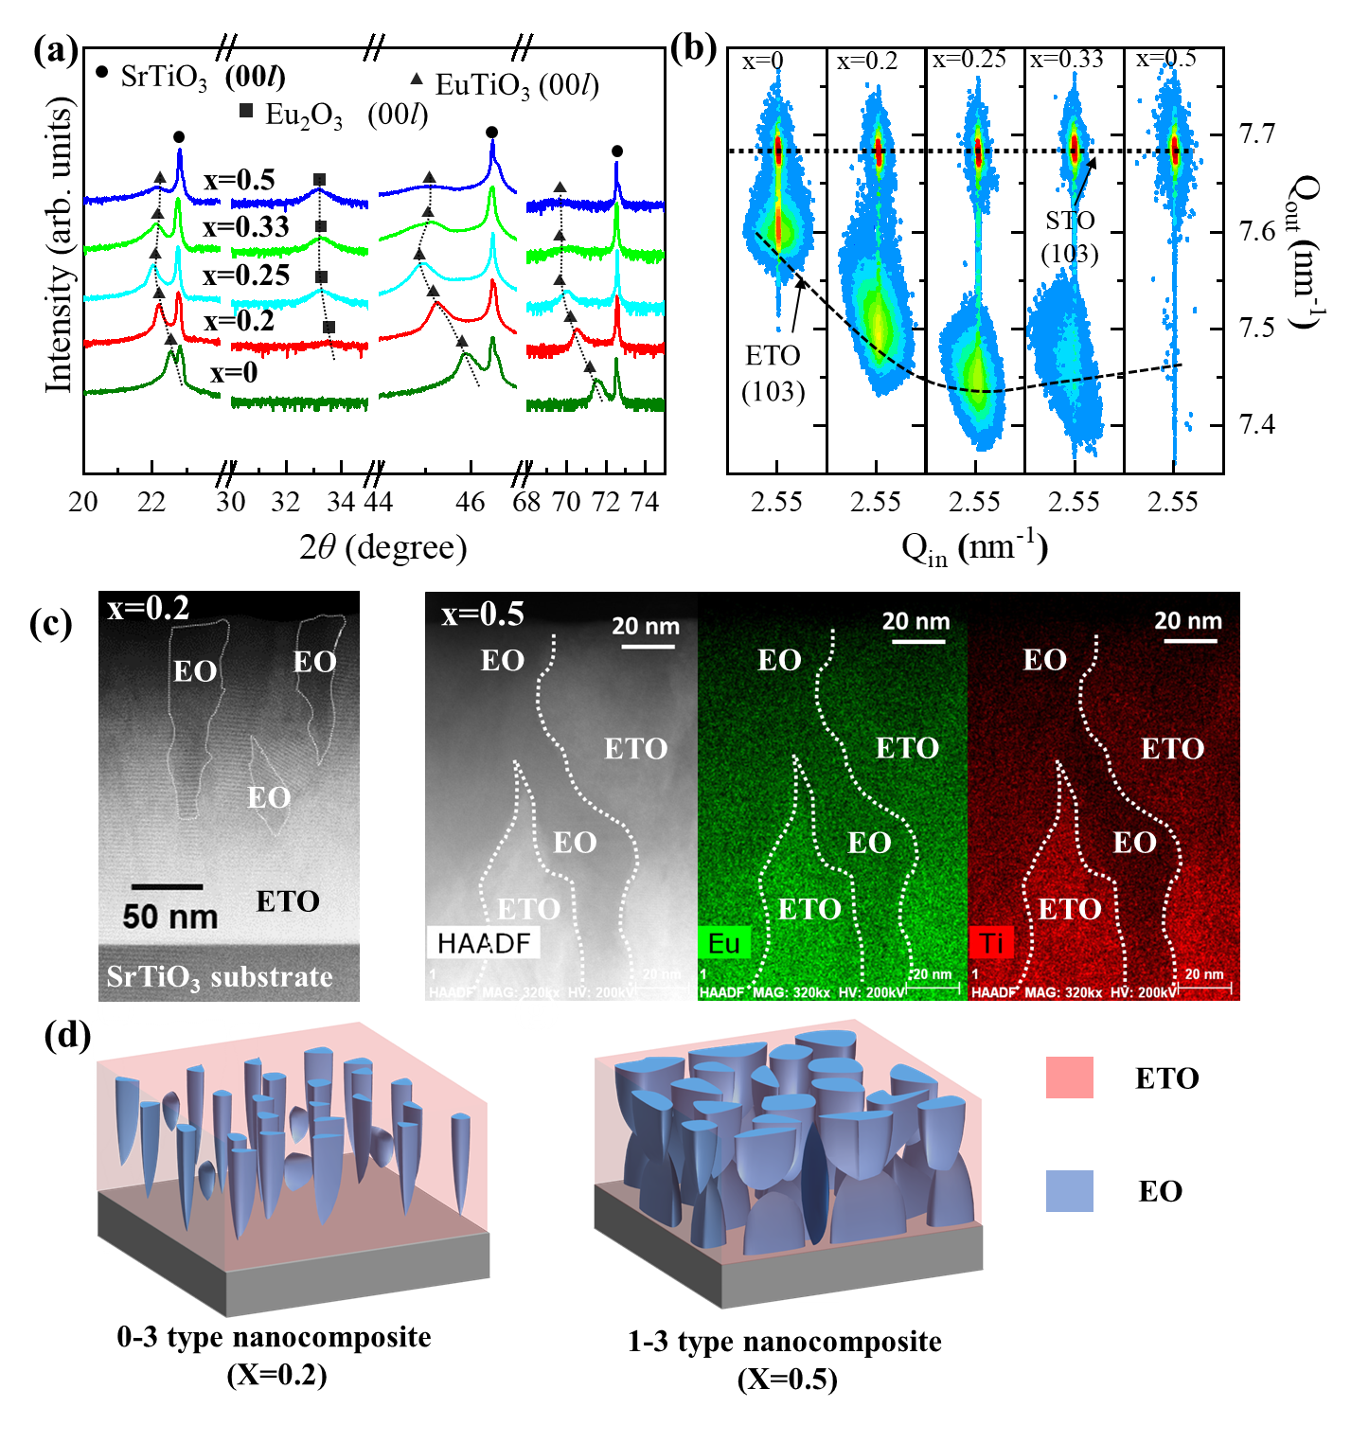 Figure 2. Structural Characterization (High Resolution XRD and STEM). (a) 2θ-ω scans of plain ETO film (x = 0), nanocomposite films (x = 0.2, 0.25, 0.33, 0.5). (b) Reciprocal space mappings of plain ETO and nanocomposite films around STO (103) and ETO (103) peaks. (c) STEM HAADF images of the film 2 (x = 0.2) and film 5 (x = 0.5) as well as EDS maps of the film 5. (d) Schematic nanocomposite types of film 2 and film 5.
To exclude the possible existence of Eu-rich phases such as, Eu₂Ti₂O₇, Eu₂TiO₅, Eu₂TiO₄, Eu₃Ti₂O₇ ^{49,50} which could possibly form, we investigated several different regions of the VAN films by high-resolution STEM. Fig. S1 shows an example of HR-STEM image along with a FFT pattern obtained from the selected area for the x = 0.2 film near an ETO/EO boundary. The imaging and FFT pattern analysis from several regions confirm that only EO is formed and no other phase other than EO and ETO are present in the film. Hence, the magnetic properties measured later must originate only from ETO (EO is non-magnetic).

M-T curves obtained by field-cooling under 100 Oe are shown in Fig. 3(a). Since there is no magnetization contribution from Eu³⁺, the measured magnetization is ascribed to Eu²⁺ from the ETO phase.⁵¹⁻⁵⁴ FM-like behaviour is observed for all VAN films (x = 0.2, 0.25, 0.33, and 0.5) but not the plain film (x = 0). The x = 0 film result agrees with the literature, i.e. the ETO films grown on STO are AF. On the other hand, the VAN film results are in sharp contrast as the films are all FM. There is only one exception in the literature (Fig. 3d) where the OOP lattice parameter is reduced and FM behavior has been observed.²⁰ We discuss this point later (when discussing Fig. 3d).
By taking the 1st derivate of M-T curves, transition temperature (T_{c}) values of around 3 K were obtained (listed in Table 1). Tc is independent of the vertical strain. Magnetic hysteresis loops (magnetization vs. magnetic field, M-H) were measured along the a-b plane of ETO at 2 K as shown in Fig. 3(b). The values of saturation moment (M_{s}) obtained at 2K and 500 Oe field, as well as the coercivity fields (H_{c}) are summarized in Table 1. Fig. 3(c) shows these parameters plotted versus EO molar ratio x. M_{s} decreases from 5.15 μ_{B}/Eu to 1.46 μ_{B}/Eu on going from c/a = 1.025 (x = 0.2) to 1.031 (x = 0.5). The results contrast with H_{c} which increases continuously from ~6 Oe to ~26 Oe.
We compare our results to previous experimental works ^{18,20,26} and theoretical calculations,^{19,20} in a diagram showing OOP lattice parameter versus IP parameter for ETO films with magnetic properties indicated (Fig. 3d). We also show lines of constant c/a. Theoretically,^{19,20} due to spin-lattice coupling effect in single phase ETO, the boundaries of ferromagnetism for ETO lie at above the value of c/a = 1.02 (vertical strain case) or below the value of 0.99 (horizonal strain case) as shown in Figure 3(d). Our x = 0.2 VAN film has c/a (1.025±0.005). This is very close to the theoretical boundary, so both AF and FM interactions would be expected in the film. This would explain why H_{c} is rather small (~6 Oe), since in un-strained or bulk ETO ²⁰ (purely AF), H_{c} would be 0 Oe. For the x = 0.5 VAN film, c/a is 1.031, far higher than the boundary value (1.02), so FM interactions dominate (FM interactions are stabilized in the ETO). This explains the high H_{c} value of ~26 Oe (measured at 2K), since in strained ETO²⁰ (ETO on DyScO₃), H_{c} is around 50 Oe (measured at 1.8K). In addition, the very high c/a values were achievable using VAN structures to induce this level of tetragonality into plain films without external pressure. Hence, we confirm clearly the theoretical predictions of the FM zone being at high c/a.
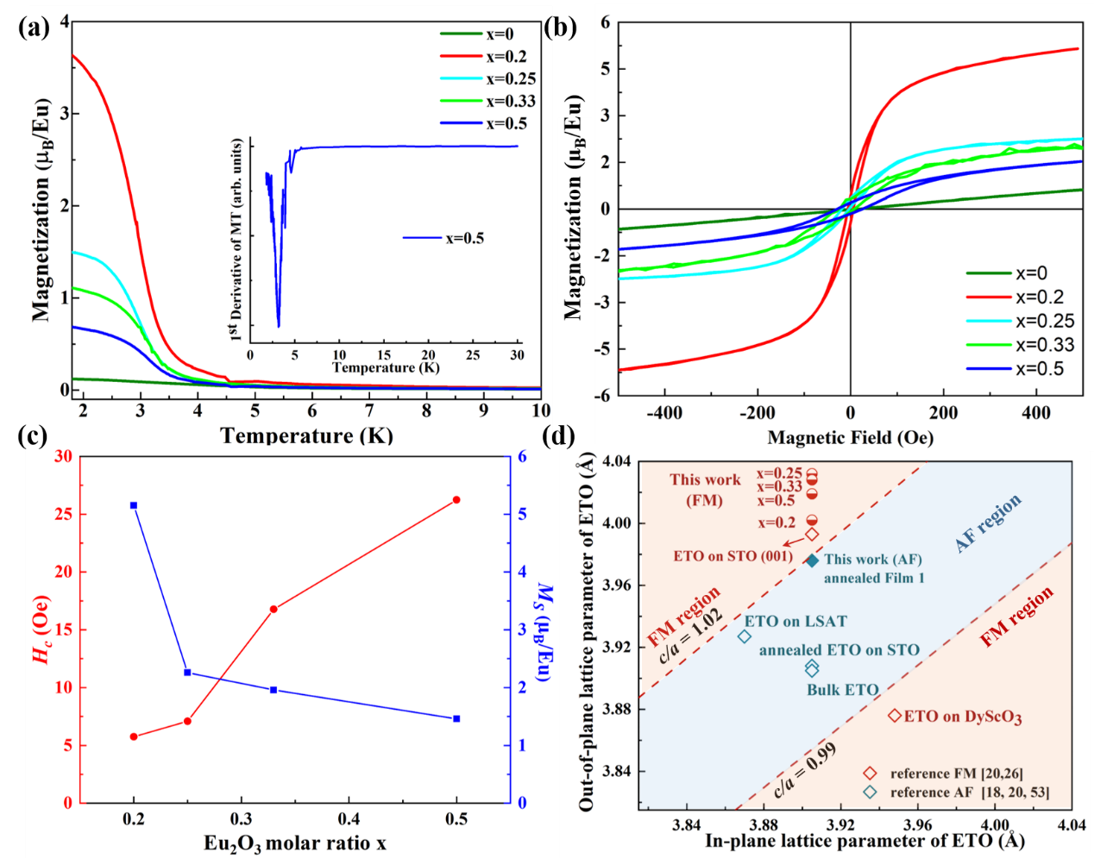
Figure 3. Magnetic Properties and phase diagram of VAN ETO-EO films. (a) Temperature-dependent magnetization measured from 1.8K to 30K of plain film (x=0) and nanocomposite films (x = 0.2, 0.25, 0.33, 0.5) (field-cool under 100 Oe). The inset shows 1st derivation M-T of x = 0.5 film. (b) Magnetic hysteresis loops of plain film and nanocomposite films measured at 2K. (c) Saturation magnetization at 500 Oe and coercivity field at 2K are plotted as a function of Eu₂O₃ molar ratio. (d) Phase diagram for both strained and unstrained-ETO (strain induced using different substrate) showing the relationship between tetragonal distortion and magnetic properties. Bulk material is also included for reference.
Previous works reported that the exchange coupling constant J₁ (1st NN Eu) monotonically increased as the lattice volume of EuTiO₃ increased and that J₁ changes sign from negative to positive (from AF to FM) when the increase in lattice volume of EuTiO₃ exceeds about 5% (the out-of-plane lattice constant is over 4.100 Å ) ^{[26,28,54]}. While volume expansion certainly can be a factor for the transition to FM, in our ETO-EO VAN films the effect may be limited, since the maximum out-of-plane lattice constant of the films is around 4.029 Å (Table 1) and hence the increase in lattice volume does not exceed 5%. The vertical strain is likely to induce polar displacements of the Ti atoms. Such displacements cause the magnetic interactions in the 3rd NN Eu, resulting in the emergence of FM in only moderately biaxially compressed ETO (the case of ETO grown on LSAT).
As discussed above, the magnetic ground states of ETO are influenced by the Eu-Ti-Eu superexchange interactions along the [111] directions.²⁷ To understand evolution of the magnetic behavior in ETO in the VAN films, in particular the reason for the switch from AF to FM behaviour, with increasing EO fraction (increasing c/a), for the x = 0.2 and x = 0.5 films the atomic column positions of Eu and Ti ion along [001]/[010] direction in STEM images were extracted. This was done using Atomap software.⁵⁵ The x = 0.2 and x = 0.5 compositions were chosen as they represent the two extremes of behaviour. The ETO phase region was analysed in the areas adjacent to the EO regions, as shown in Figs. S2 (a) (x = 0.2) and (b) (x = 0.5). The Eu and Ti columns are shown as red and blue dots in the inset figures in Figs. S2 (a) and (b). The statistical Ti shift along [001] was determined and is shown in Figure 4(a) and (b). The shift is measured by the ratio between distances from Ti to the upper Eu planes and the separation of the two adjacent Eu planes, assuming no displacement in the latter. Hence, the systematic error on absolute distance measurement caused by sample drift during image acquisition can be minimized. The red dots indicate where the ratios are larger than 0.5 while blue ones are for those less than 0.5. The mean value (statistically) of Ti shift in x = 0.2 VAN film is 0.498 (with standard deviation of 0.018) while the mean value of Ti shift for the x = 0.5 VAN film is 0.488 (with standard deviation of 0.021). Based on these two values and combined with lattice parameters obtained from XRD, the Ti position can be determined. In 3D, if the shift only occurs along the z axis, then combining this information with lattice parameters obtained from the XRD analysis, the Ti positions around the tetragonal center can be calculated.
The Eu-Ti-Eu bond angle along [111] was calculated to be 179.78º ± 0.80º for x = 0.2 (Fig. 4c). It is lower for x = 0.5, i.e. 178.70º ± 0.83º (Fig. 4c). The error bars are calculated from the standard deviation of the measurements. Hence, while for both films the Eu-Ti-Eu bond angle is < 180º, on average, it is more than 1º lower in the x = 0.5 film, and only ~0.2° lower in the x = 0.2 film. A lower bond angle corresponds to a weaker AF interaction because of the Goodenough-Kanamori-Anderson rules^{31–34}. This explains the observed larger H_{c} value (Fig. 3b) in the x = 0.5 film. This is the first experimental determination of the influence of the Eu-Ti-Eu bond angle in ETO on the resulting magnetic properties.
An underlying mechanism to explain the observed experimental data is proposed in Fig. 4(d) and (e). As mentioned above, there are three major interactions coexisting in ETO. ^{27–30} In its bulk form^{29,56} (or post-annealed ETO thin film), ETO has a cubic structure and the AF interaction is dominant, as shown in Fig. 4(d). In the VAN films, with increasing vertical strain (while maintaining a constant IP lattice parameter), the Eu-Ti-Eu bond angle along [111] increasingly deviates from 180º. As a result, the AF interactions which occur for both 1st (when the lattice expansion is small^{28,30}) and 3rd NN Eu²⁺ ions (via Ti 3d band) decrease rapidly with increasing vertical (OOP) strain while the FM interaction which occurs for the 2nd NN Eu²⁺ ions decreases at a much slower rate, as shown in Fig. 4(e). However, the AF interactions become weaker at a greater rate than do the FM interactions. This is because the distance of Eu-Ti-Eu length (larger OOP lattice parameter) and deviation of Eu-Ti-Eu bond angle along the [111] direction is increased simultaneously. Consequently, the FM interaction is dominant over the AFM interaction in the most highly-strained ETO film (film 5, x = 0.5). Hence, M_{s} decreases and H_{C} increases with an increase of x (or c/a). The possible local magnetic inhomogeneities at the interface of ETO and EO could increases with increasing EO fraction which also can affect increasing H_{C}. While the increasement of x decreases ETO fraction could lead to decreasing M_{s}. While theoretical works ^{30,57} have shown that octahedral rotations are likely in strained films and thus enhance FM ordering, our uniaxial vertical strain (stretching vertically while maintaining the same in-plane lattice constant) is different to that in plain epitaxial films where there is biaxial strain and volume conservation as a result of Poisson effects. Hence, the octahedral rotations are less likely, although this requires further detailed investigation.

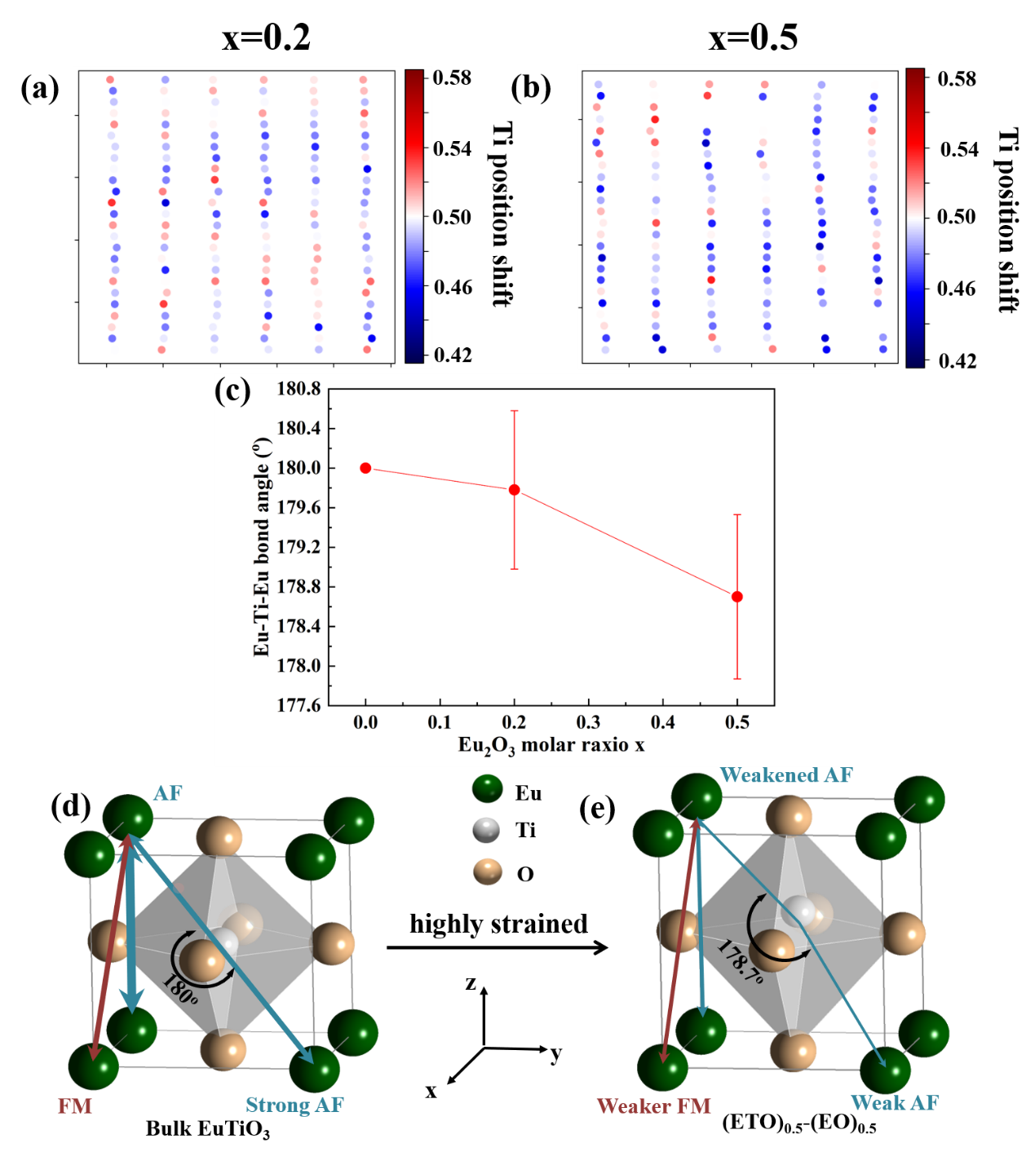
Figure 4. Local atomic structure of VAN ETO-EO films and schematic showing the strength of the magnetic interactions. (a, b) Atomic column positions inside an ETO region adjacent to EO for x = 0.2 and 0.5 VAN films, respectively. (c) Schematic bond angle determined from atomic position for x = 0.2 and 0.5 VAN films. (d, e) Schematic of the changing magnetic interactions strength in ETO upon inducing a large vertical strain, explaining the change of Eu-Ti-Eu bond angle along [111] direction caused by vertical strain.
3. Conclusions
Using self-assembled, epitaxial vertically aligned nanocomposite (VAN) films of EuTiO₃-Eu₂O₃ with increasing Eu₂O₃ fractions, grown on STO, we progressively increased the vertical out-of-plane strain in the EuTiO₃ films without modifying the in-plane strain which is normally the case in plain epitaxial films. Hence, increasing the Eu₂O₃ fractions in the films concomitantly increased the tetragonality in the EuTiO₃ component in the films. This increased tetragonality results in significant changes in the Eu-Ti-Eu bond angles and Eu-Eu interactions. All the films were ferromagnetic which contrasts with standard plain films of EuTiO₃ which are antiferromagnetic. Our work has shown for the first time that Eu-Ti-Eu superexchange interactions play a key role in determining the magnetic ground state of EuTiO₃. Indeed, the importance of, and means of delicately and systematically controlling and tuning antiferromagnetic and ferromagnetic correlations, has been demonstrated. More broadly, the work demonstrates that multifunctionalities in strong spin-lattice coupling perovskite oxides can be uniquely tuned at the atomic scale using simple VAN structures.

4. Experimental details
Sample fabrication: The EuTiO₃-Eu₂O₃ VAN films were fabricated with pulsed laser deposition (PLD) using a KrF laser (λ = 248 nm) with a fluence of 2 J cm⁻² and a repetition rate of 3Hz. During the deposition, the temperature of substrate was kept at 710°C and the background vacuum was 1-2*10⁻⁶ Torr, i.e. a low background pressure to minimise oxygen content, so as to prevent unwanted second phases from forming. The polycrystalline composite target of (ETO)_{1-x}-(Eu₂O₃)_{x} (x = 0.2, 0.25, 0.33, 0.5) were sintered from Eu₂O₃ and TiO₂ powders at about 1400 ⁰C for 24 hours. (001)-oriented single crystal SrTiO₃ (STO) substrates from CrysTec were employed. In the VAN thin films with x< 0.2 the Eu₂O₃ phases were not detected in the XRD 2θ-ω scan which is due to the possible growth of EO as less-well-aligned nanoclusters form instead of nanopillars.
Sample characterization: The crystallinities, out-of-plane (OOP) and in-plane (IP) lattice parameters of the thin films were investigated by 2θ-ω scans and asymmetric XRD performed on a PANalytical Empyrean High-resolution X-ray diffractometer using Cu-Ka radiation (λ = 1.5406 Å). The phi scans were performed on ETO (1 1 1) and STO (1 1 1) to confirm the epitaxial growth of ETO on STO substrate. The reciprocal space mapping (RSM) characterization around STO (103) and ETO (103) was carried out using this platform again to study the IP lattice parameters of ETO and confirmed the OOP lattice parameters as well. Thin film thickness was measured using the stylus profilometer Dektak 6M. All the film thicknesses were 210 nm ± 20 nm. In order to understand the influence of the VAN induced OOP strain without change of IP strain on the magnetic properties of ETO, temperature and field-dependent magnetization plots were measured using superconducting quantum interference device (SQUID) magnetometer.
Structural analysis by transmission electron microscopy (TEM): High-resolution transmission electron microscopy (HRTEM) and scanning transmission electron microscopy (STEM) were conducted on the x = 0.2 and x = 0.5 VAN films. A FEI TitanTM G2 80-200 STEM with a Cs probe corrector and ChemiSTEMTM technology (X-FEGTM and SuperXTM EDS with four windowless silicon drift detectors) operated at 200 kV was used in this study. The film microstructure was studied by STEM imaging using high-angle annular dark-field (HAADF) detector, and elemental mapping by energy-dispersive x-ray spectroscopy. Atomic column positions s on local STEM images were analysed using the Atomap⁵⁵ software tool. The Eu and Ti atomic columns were recognized using the centre-of-mass method and were refined with nearest neighbours and using 2D Gaussian Fitting in the Atomap tool after removing image background noises.
Supporting Information: Detail Atomic column simulation from HRTEM images is supplied as Supporting Information.

Author Information
Acknowledgements
Y. L. and B.Z. acknowledge the support from China Scholarship Council and Cambridge Commonwealth, European and International Trust. W. L. and J. L. M.-D. acknowledge the support from EPSRC grant EP/L011700/1, EP/N004272/1, the Isaac Newton Trust (Minute 13.38(k)) and the Royal Academy of Engineering Grant CiET1819_24. T.M. and J.L.M-D. also acknowledge funding from EU grant H2020-MSCA-IF-2016 745886 MuStMAM and Isaac Newton Trust (RG96474). Sandia National Laboratories is a multi-program laboratory managed and operated by National Technology and Engineering Solutions of Sandia, LLC., a wholly owned subsidiary of Honeywell International, Inc., for the U.S. Department of Energy’s National Nuclear Security Administration under contract DE-NA0003525. This paper describes objective technical results and analysis. Any subjective views or opinions that might be expressed in the paper do not necessarily represent the views of the U.S. Department of Energy or the United States Government. X. S. and H. W. acknowledge the support from the US National Science Foundation (DMR-1565822) for the TEM work at Purdue University.

Competing financial interests
The authors declare that they have no competing financial interests.

References
(1) Cava, R. J.; Batlogg, B.; Van Dover, R. B.; Murphy, D. W.; Sunshine, S.; Siegrist, T.; Remeika, J. P.; Rietman, E. A.; Zahurak, S.; Espinosa, G. P., Bulk Superconductivity at 91 K in Single-Phase Oxygen-Deficient Perovskite Ba₂YCu₃O_{9-δ}. Phys. Rev. Lett. 1987, 58 (16), 1676–1679. DOI: 10.1103/PhysRevLett.58.1676.
(2) Wang, J.; Neaton, J. B.; Zheng, H.; Nagarajan, V.; Ogale, S. B.; Liu, B.; Viehland, D.; Vaithyanathan, V.; Schlom, D. G.; Waghmare, U. V.; Spaldin, N. A.; Rabe, K. M.; Wuttig, M.; Ramesh, R., Epitaxial BiFeO₃ Multiferroic Thin Film Heterostructures. Science 2003, 299, 1719-1722. DOI: 10.1126/science.1080615.
(3) Jin, S.; Tiefel, T. H.; McCormack, M.; Fastnacht, R. A.; Ramesh, R.; Chen, L. H., Thousandfold Change in Resistivity in Magnetoresistive La-Ca-Mn-O Films. Science 1994, 264, 413-415. DOI: 10.1126/science.264.5157.413.
(4) Xing, G.; Mathews, N.; Sun, S.; Lim, S. S.; Lam, Y. M.; Graẗzel, M.; Mhaisalkar, S.; Sum, T. C., Long-Range Balanced Electron-and Hole-Transport Lengths in Organic-Inorganic CH₃NH₃PbI₃. Science 2013, 342, 322-347. DOI: 10.1126/science.1243167.
(5) Itoh, M.; Shimura, T.; Yu, J. D.; Hayashi, T.; Inaguma, Y., Structure Dependence of the Ferromagnetic Transition Temperature in Rhombohedral La_{1-x}A_{x}MnO₃ (A=Na, K, Rb, and Sr). Phys. Rev. B 1995, 52 (17), 12522–12525.DOI: 10.1103/PhysRevB.52.12522.
(6) Ishihara, T.; Matsuda, H.; Takita, Y., Doped LaGaO₃ Perovskite Type Oxide as a New Oxide Ionic Conductor. J. Am. Chem. Soc. 1994, 116, 3801-3803. DOI: 10.1021/ja00088a016.
(7) Radaelli, P. G.; Iannone, G.; Marezio, M.; Hwang, H. Y.; Cheong, S. W.; Jorgensen, J. D.; Argyriou, D. N., Structural Effects on the Magnetic and Transport Properties of Perovskite A_{1-X}A'_{x}MnO₃ (x=0.25, 0.30). Phys. Rev. B 1997, 15 (13), 8265-8276. DOI: 10.1103/PhysRevB.56.8265.
(8) Uehara, M.; Mori, S.; Chen, C. H.; Cheong, S. W., Percolative Phase Separation Underlies Colossal Magnetoresistance in Mixed-Valent Manganites. Nature 1999, 399, 560-563. DOI: 10.1038/21142.
(9) Haeni, J. H.; Irvin, P.; Chang, W.; Uecker, R.; Reiche, P.; Li, Y. L.; Choudhury, S.; Tian, W.; Hawley, M. E.; Craigo, B.; Tagantsev, A.K.; Pan, X. Q.; Streiffer, S. K.; Chen, L. Q.; Kirchoefer, S. W.; Levy, J.; Schlom, D. G., Room-Temperature Ferroelectricity in Strained SrTiO₃. Nature 2004, 430, 758-761. DOI: 10.1038/nature02773.
(10) Choi, K. J.; Biegalski, M.; Li, Y. L.; Sharan, A.; Schubert, J.; Uecker, R.; Reiche, P.; Chen, Y. B.; Pan, X. Q.; Gopalan, V.; Chen, L. Q.; Schlom, D. G.; Eom, C. B., Enhancement of Ferroelectricity in Strained BaTiO₃ thin Films. Science 2004, 306, 1005-1009. DOI: 10.1126/science.1103218.
(11) Chu, M. W.; Szafraniak, I.; Scholz, R.; Harnagea, C.; Hesse, D.; Alexe, M.; Gösele, U., Impact of Misfit Dislocation on the Polarization Instability of Epitaxial Nanostructured Ferroelectric Perovskites. Nature Materials 2004, 3, 87-90. DOI: 10.1038/nmat1057.
(12) Schlom, D. G.; Chen, L. Q.; Eom, C. B.; Rabe, K. M.; Streiffer, S. K.; Triscone, J.-M., Strain Tuning of Ferroelectric Thin Films. Annu. Rev. Mater. Res. 2007, 37, 589-626. DOI: 10.1146/annurev.matsci.37.061206.113016.
(13) Schlom, D. G.; Chen, L. Q.; Fennie, C. J.; Gopalan, V.; Muller, D. A.; Pan, X.; Ramesh, R.; Uecker, R., Elastic Strain Engineering of Ferroic Oxides. MRS Bull. 2014, 39,118-130. DOI: 10.1557/mrs.2014.1.
(14) Yokoyama, Y.; Yamasaki, Y.; Taguchi, M.; Hirata, Y.; Takubo, K.; Miyawaki, J.; Harada, Y.; Asakura, D.; Fujioka, J.; Nakamura, M.; Daimon, H.; Kawasaki, M.; Tokura, Y.; Wadati, H., Tensile-Strain-Dependent Spin States in Epitaxial LaCoO₃ Thin Films. Phys. Rev. Lett. 2018, 120, 206402. DOI: 10.1103/PhysRevLett.120.206402.
(15) Shikano, M.; Huang, T. K.; Inaguma, Y.; Itoh, M.; Nakamura, T., Pressure Dependence of the Magnetic Transition Temperature for Ferromagnetic SrRuO₃. Solid State Commun. 1994, 90, 115-119. DOI: 10.1016/0038-1098(94)90942-3.
(16) Mefford, J. T.; Rong, X.; Abakumov, A. M.; Hardin, W. G.; Dai, S.; Kolpak, A. M.; Johnston, K. P.; Stevenson, K. J.,Water Electrolysis on La_{1-X}Sr_{x}CoO_{3-δ} Perovskite Electrocatalysts. Nat. Commun. 2016, 7, 11053. DOI: 10.1038/ncomms11053.
(17) Coey, J. M. D.; Viret, M.; Von Molnár, S., Mixed-Valence Manganites. Adv. Phys. 2009, 48, 167-293. DOI: 10.1080/00018730903363184.
(18) Katsufuji, T.; Takagi, H., Coupling between Magnetism and Dielectric Properties in Quantum Paraelectric EuTiO₃. Phys. Rev. B 2001, 64, 054415. DOI: 10.1103/PhysRevB.64.054415.
(19) Fennie, C. J.; Rabe, K. M., Magnetic and Electric Phase Control in Epitaxial EuTiO₃ from First Principles. Phys. Rev. Lett. 2006, 97 (26), 267602. DOI: 10.1103/PhysRevLett.97.267602.
(20) Lee, J. H.; Fang, L.; Vlahos, E.; Ke, X.; Jung, Y. W.; Kourkoutis, L. F.; Kim, J. W.; Ryan, P. J.; Heeg, T.; Roeckerath, M.; Goian, V.; Bernhagen, M.; Uecker, R.; Hammel, P. C.; Rebe, K. M.; Kamba, S.; Schubert, J.; Freeland, J. W.; Muller, D. A.; Fennie, C. J.; Schiffer, P.; Gopalan, V.; Johnston-Halperin, E.; Schlom, D. G., A Strong Ferroelectric Ferromagnet Created by Means of Spin-Lattice Coupling. Nature 2010, 466 (7309), 954–958. DOI: 10.1038/nature09331.
(21) Fiebig, M. Revival of the Magnetoelectric Effect. Journal of Physics D: Applied Physics. 2005, 38, 123-152. DOI: 10.1088/0022-3727/38/8/R01.
(22) Bibes, M.; Barthélémy, A., Multiferroics: Towards a Magnetoelectric Memory. Nature Materials. 2008, 7, 425-426. DOI: 10.1038/nmat2189.
(23) Ma, J.; Hu, J.; Li, Z.; Nan, C. W., Recent Progress in Multiferroic Magnetoelectric Composites: From Bulk to Thin Films. Adv. Mater. 2011, 23, 1062-1087. DOI: 10.1002/adma.201003636.
(24) Birol, T.; Fennie, C. J., Origin of Giant Spin-Lattice Coupling and the Suppression of Ferroelectricity in EuTiO₃ from First Principles. Phys. Rev. B 2013, 88, 094103. DOI:10.1103/PhysRevB.88.094103.
(25) Geng, Y. N.; Lee, J. H.; Schlom, D. G.; Freeland, J. W.; Wu, W. D., Magnetic Inhomogeneity in a Multiferroic EuTiO₃ Thin Film. Phys. Rev. B 2013, 87, 121109. DOI:10.1103/PhysRevB.87.121109.
(26) Tanaka, K.; Fujita, K.; Maruyama, Y.; Kususe, Y.; Murakami, H.; Akamatsu, H.; Zong, Y.; Murai, S., Ferromagnetism Induced by Lattice Volume Expansion and Amorphization in EuTiO₃ Thin Films. J. Mater. Res. 2013, 28, 1031-1041. DOI: 10.1557/jmr.2013.60.
(27) Ryan, P. J.; Kim, J. W.; Birol, T.; Thompson, P.; Lee, J. H.; Ke, X.; Normile, P. S.; Karapetrova, E.; Schiffer, P.; Brown, S. D.; Fennie, C. J.; Scholm, D. G., Reversible Control of Magnetic Interactions by Electric Field in a Single-Phase Material. Nat. Commun. 2013, 4, 1334. DOI:10.1038/ncomms2329.
(28) Akamatsu, H.; Kumagai, Y.; Oba, F.; Fujita, K.; Murakami, H.; Tanaka, K.; Tanaka, I., Antiferromagnetic Superexchange via 3d States of Titanium in EuTiO₃ as Seen from Hybrid Hartree-Fock Density Functional Calculations. Phys. Rev. B 2011, 83, 214421. DOI: 10.1103/PhysRevB.83.214421.
(29) Akamatsu, H.; Fujita, K.; Hayashi, H.; Kawamoto, T.; Kumagai, Y.; Zong, Y.; Iwata, K.; Oba, F.; Tanaka, I.; Tanaka, K., Crystal and Electronic Structure and Magnetic Properties of Divalent Europium Perovskite Oxides EuMO₃ (M = Ti, Zr, and Hf): Experimental and First-Principles Approaches. Inorg. Chem. 2012, 51, 4560-4567. DOI: 10.1021/ic2024567.
(30) Akamatsu, H.; Kumagai, Y.; Oba, F.; Fujita, K.; Tanaka, K.; Tanaka, I., Strong Spin-Lattice Coupling through Oxygen Octahedral Rotation in Divalent Europium Perovskites. Adv. Funct. Mater. 2013, 23, 1864-1872. DOI: 10.1002/adfm.201202477.
(31) Anderson, P. W., Antiferromagnetism. Theory of Superexchange Interaction. Phys. Rev. 1950, 79, 350-356. DOI: 10.1103/PhysRev.79.350.
(32) Goodenough, J. B., Theory of the Role of Covalence in the Perovskite-Type Manganites [La,M(II)]MnO₃. Phys. Rev. 1955, 100, 564-573. DOI: 10.1103/PhysRev.100.564.
(33) Kanamori, J., Superexchange Interaction and Symmetry Properties of Electron Orbitals. J. Phys. Chem. Solids 1959, 10, 87-98. DOI: 10.1016/0022-3697(59)90061-7.
(34) Andersen, P. W., Theory of Magnetic Exchange Interactions: Exchange in Insulators and Semiconductors. Solid State Physics 1963, 14, 99-214. DOI: 10.1016/S0081-1947(08)60260-X.
(35) Lebedev, O.; Verbeeck, J.; Van Tendeloo, G.; Shapoval, O.; Belenchuk, a.; Moshnyaga, V.; Damashcke, B.; Samwer, K., Structural Phase Transitions and Stress Accommodation in (La_{0.67}Ca_{0.33}MnO₃)_{1-x}:(MgO)_{x} Composite Films. Phys. Rev. B 2002, 66, 104421. DOI: 10.1103/PhysRevB.66.104421.
(36) Zheng, H.; Wang, J. Lofland, S. E.; Ma, Z.; Mohaddes- Ardabili, L.; Zhao, T.; Salamanca-Riba, L.; Shinde, S. R.; Ogale, S. B.; Bai, F.; Viehland, D.; Jia, Y.; Schlom, D. G.; Wuttig, M.; Roybturd, A.; Ramesh, R., Multiferroic BaTiO₃-CoFe₂O₄ Nanostructures. Science 2004, 303, 661-663. DOI: 10.1126/science.1094207.
(37) MacManus-Driscoll, J. L.; MacManus-Driscoll, J. L.; Zerrer, P.; Zerrer, P.; Wang, H.; Wang, H.; Yang, H.; Yang, H.; Yoon, J.; Yoon, J.; Fouchet, A.; Yu, R.; Blamire, M. G.; Jia, Q. X., Strain Control and Spontaneous Phase Ordering in Vertical Nanocomposite Heteroepitaxial Thin Films. Nat. Mater. 2008, 7, 314-320. DOI: 10.1038/nmat2124.
(38) Kursumovic, A.; Defay, E.; Lee, O. J.; Tsai, C. F.; Bi, Z.; Wang, H.; MacManus-Driscoll, J. L., A New Material for High-Temperature Lead-Free Actuators. Adv. Funct. Mater. 2013, 23, 5881-5886. DOI: 10.1002/adfm.201300899.
(39) MacManus-Driscoll, J.; Suwardi, A.; Kursumovic, A.; Bi, Z.; Tsai, C. F.; Wang, H.; Jia, Q.; Lee, O. J., New Strain States and Radical Property Tuning of Metal Oxides Using a Nanocomposite Thin Film Approach. APL Mater. 2015, 3, 062507. DOI: 10.1063/1.4919059.
(40) Lee, S.; Zhang, W.; Khatkhatay, F.; Jia, Q.; Wang, H.; Macmanus-Driscoll, J. L., Strain Tuning and Strong Enhancement of Ionic Conductivity in SrZrO₃-RE₂O₃(RE = Sm, Eu, Gd, Dy, and Er) Nanocomposite Films. Adv. Funct. Mater. 2015, 25, 4328-4333. DOI: 10.1002/adfm.201404420.
(41) MacManus-Driscoll, J. L.; Suwardi, A.; Wang, H., Composite Epitaxial Thin Films: A New Platform for Tuning, Probing, and Exploiting Mesoscale Oxides. MRS Bulletin 2015, 40, 933-942. DOI: 10.1557/mrs.2015.258.
(42) Lytle, F. W., X-Ray Diffractometry of Low-Temperature Phase Transformations in Strontium Titanate. J. Appl. Phys. 1964, 35, 2212-2215. DOI: 10.1063/1.1702820.
(43) Watson, S. M.; Santos, T. S.; Borchers, J. A.; Moodera, J. S., Relationship between Tunnel Magnetoresistance and Magnetic Layer Structure in EuO-Based Tunnel Junctions Investigated Using Polarized Neutron Reflectivity. J. Appl. Phys. 2008, 103, 07A719. DOI: 10.1063/1.2837873.
(44) Phani, K. K.; Niyogi, S. K., Elastic Modulus‐Porosity Relation in Polycrystalline Rare‐Earth Oxides. J. Am. Ceram. Soc. 1987, 70, 362-366. DOI: 10.1111/j.1151-2916.1987.tb04920.x.
(45) Bessas, D.; Rushchanskii, K. Z.; Kachlik, M.; Disch, S.; Gourdon, O.; Bednarcik, J.; Maca, K.; Sergueev, I.; Kamba, S.; Ležaić, M.; Hermann, R. P., Lattice Instabilities in Bulk EuTiO₃. Phys. Rev. B 2013, 88, 144308. DOI: 10.1103/PhysRevB.88.144308.
(46) Concas, G.; Dewhurst, J. K.; Sanna, A.; Sharma, S.; Massidda, S., Anisotropic Exchange Interaction between Nonmagnetic Europium Cations in Eu₂O₃. Phys. Rev. B 2011, 84, 014427. DOI: 10.1103/PhysRevB.84.014427.
(47) Llordés, A.; Palau, A.; Gázquez, J.; Coll, M.; Vlad, R.; Pomar, A.; Arbiol, J.; Guzmán, R.; Ye, S.; Rouco, V.; Sandiumenge, F.; Ricart, S.; Puig, T.; Verela, M.; Chateigner, D.; Vanacken, J.; Gutierrez, J.; Moshchalkov, V.; Deuscher, G.; Magen, C.; Obradors, X., Nanoscale Strain-Induced Pair Suppression as a Vortex-Pinning Mechanism in High-Temperature Superconductors. Nat. Mater. 2012, 11, 329-336. DOI: 10.1038/nmat3247.
(48) Harrington, S. A.; Zhai, J.; Denev, S.; Gopalan, V.; Wang, H.; Bi, Z.; Redfern, S. A. T.; Baek, S. H.; Bark, C. W.; Eom, C. B.; Jia, Q. X.; Vickers, M. E.; MacManus-Driscoll, J. L., Thick Lead-Free Ferroelectric Films with High Curie Temperatures through Nanocomposite-Induced Strain. Nat. Nanotechnol. 2011, 6, 491-495. DOI: 10.1038/nnano.2011.98.
(49) Orihashi, T.; Nakamura, T.; Adachi, S., Synthesis and Unique Photoluminescence Properties of Eu₂Ti₂O₇ and Eu₂TiO₅. J. Am. Ceram. Soc. 2016, 99, 3039-3046. DOI: 10.1111/jace.14318.
(50) Chien, C. L.; DeBenedetti, S.; Barros, F. D. S., Magnetic Properties of EuTiO3, Eu₂TiO₄, and Eu₃Ti₂O₇. Phys. Rev. B 1974, 10, 3913-3922. DOI: 10.1103/PhysRevB.10.3913.
(51) Li, W. W.; Zhao, R.; Wang, L.; Tang, R.; Zhu, Y.; Lee, J. H.; Cao, H.; Cai, T.; Guo, H.; Wang, C.; Ling, L. S.; Pi, L.; Jin, K. J.; Zhang, Y. H.; Wang, H. Y.; Wang, Y. Q.; Ju, S.; Yang, H., Oxygen-Vacancy-Induced Antiferromagnetism to Ferromagnetism Transformation in Eu_{0.5}Ba_{0.5}TiO_{3-δ} multiferroic Thin Films. Sci. Rep. 2013, 3, 2618. DOI: 10.1038/srep02618.
(52) Li, W. W.; He, Q.; Wang, L.; Zeng, H.; Bowlan, J.; Ling, L.; Yarotski, D. A.; Zhang, W.; Zhao, R.; Dai, J. H.; Gu, J. X.; Shen, S. P.; Guo, H. Z; Pi, L.; Wang, H. Y.; Wang, Y. Q.; Velasco-Davalos, I. A.; Wu, Y. J.; Hu, Z. J.; Chen, B.; Li, R. W; Sun, Y.; Jin, K. J.; Zhang, Y. H.; Chen, H. T.; Ju, S.; Ruediger, A.; Shi, D. H.; Borisevich, A. Y.; Yang, H., Manipulating Multiple Order Parameters via Oxygen Vacancies: The Case of Eu_{0.5}Ba_{0.5}TiO_{3-δ}. Phys. Rev. B 2017, 96, 115105. DOI: 10.1103/PhysRevB.96.115105.
(53) Fujita, K.; Wakasugi, N.; Murai, S.; Zong, Y.; Tanaka, K., High-Quality Antiferromagnetic EuTiO₃ Epitaxial Thin Films on SrTiO₃ Prepared by Pulsed Laser Deposition and Postannealing. Appl. Phys. Lett. 2009, 94, 062512. DOI: 10.1063/1.3072598.
(54) Ranjan, R.; Sadat Nabi, H.; Pentcheva, R., Electronic Structure and Magnetism of EuTiO₃: A First-Principles Study. J. Phys. Condens. Matter 2007, 19, 406217. DOI: 10.1088/0953-8984/19/40/406217.
(55) Nord, M.; Vullum, P. E.; MacLaren, I.; Tybell, T.; Holmestad, R., Atomap: A New Software Tool for the Automated Analysis of Atomic Resolution Images Using Two-Dimensional Gaussian Fitting. Adv. Struct. Chem. Imaging 2017, 3, 9. DOI: 10.1186/s40679-017-0042-5.
(56) McGuire, T. R.; Shafer, M. W.; Joenk, R. J.; Alperin, H. A.; Pickart, S. J., Magnetic Structure of EuTiO₃. J. Appl. Phys. 1966, 37, 981-982. DOI: 10.1063/1.1708549.
(57) Rushchanskii, K. Z.; Spaldin, N. A.; Leaić, M., First-Principles Prediction of Oxygen Octahedral Rotations in Perovskite-Structure EuTiO₃. Phys. Rev. B - Condens. Matter Mater. Phys. 2012, 85, 104109. DOI: 10.1103/PhysRevB.85.104109.

For Table of Contents Only
