S1 - Supplemental methods

S1.1 - Methods for Figure 1A
Figure 1A (Figure S1 below) in the manuscript presented the carbon intensity of grey, blue, and electrolytic hydrogen as a function of the carbon footprint of the electricity grid. Here, the carbon intensity of the supply routes includes scope 1 and 2 emissions associated with the production plant – namely, direct emissions from the production facility and indirect emissions associated with the purchase of electricity and natural gas. The indirect emissions associated with the water use is considered negligible for this illustration. The equations used to calculate the carbon intensity in Figure 1A are as follows:

$$\begin{aligned}{CI}_{blue hydrogen}=A_{1}+A_{2}×{CI}_{natural gas} \#\left(S1\right)\end{aligned}$$
$$\begin{aligned}{CI}_{grey hydrogen}=A_{3}+A_{4}×{CI}_{natural gas} \#\left(S2\right)\end{aligned}$$
$$\begin{aligned}{CI}_{electrolytic hydrogen}=A_{5}×{CI}_{electricity} \#\left(S3\right)\end{aligned}$$

Where ${CI}_{blue hydrogen}$, ${CI}_{grey hydrogen}$, and ${CI}_{electrolytic hydrogen}$ denote the carbon intensity of blue hydrogen, grey hydrogen, and electrolytic hydrogen, respectively. The variables and parameters in these equations are as follows:

Variables
${CI}_{blue hydrogen}$ [kg CO₂,eq/MWh H₂ LHV]
${CI}_{grey hydrogen}$ [kg CO₂,eq/MWh H₂ LHV]
${CI}_{electrolytic hydrogen}$ [kg CO₂,eq/MWh H₂ LHV]
${CI}_{natural gas}$ [kg CO₂,eq/MWh LHV] – Carbon intensity of the natural gas supply chain.
${CI}_{electricity}$ [kg CO₂,eq/MWh] – Carbon intensity of the electricity source.

Parameters
$A_{1}$ (Residual emissions – blue hydrogen) = 29.6 kg CO₂,eq/MWh H₂ LHV¹.
$A_{2}$ (Natural gas requirement – blue hydrogen) = 1.45 MWh natural gas LHV/MWh H₂ LHV¹.
$A_{3}$ (Residual emissions – grey hydrogen) = 269 kg CO₂,eq/MWh H₂ LHV¹.
$A_{4}$ (Natural gas requirement – grey hydrogen) = 1.32 MWh natural gas LHV/MWh H₂ LHV¹.
$A_{5}$ (Electricity requirement – electrolytic hydrogen) = 1.67 MWh electricity/MWh H₂ LHV¹.

The variable bounds for ${CI}_{natural gas}$ and ${CI}_{electricity}$are 2.7 – 32.8 kg CO₂,eq/GJ HHV², and 0 – 800 kg CO₂,eq/MWh, respectively. The scatter data used to represent the carbon footprint of electrolytic hydrogen in countries of the EU was based on the carbon intensity of electricity generation data from 2019, sourced from the European Environment Agency³.
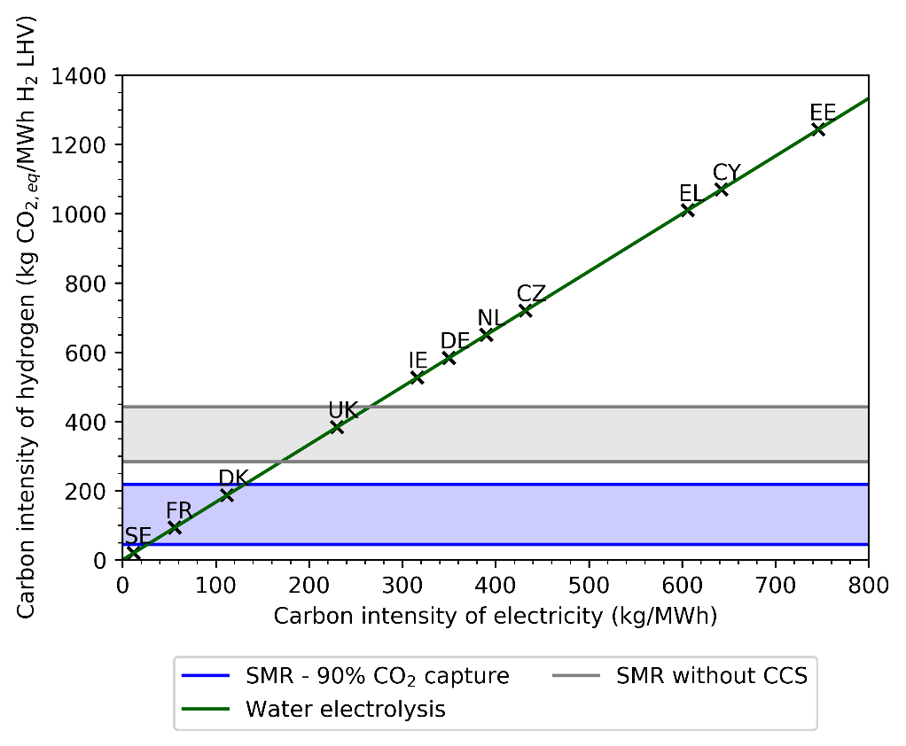
Figure S1: Carbon intensity of hydrogen supply as a function of the carbon footprint of electricity, denoting both blue (SMR-CCS), electrolytic, and grey hydrogen (SMR without CCS), where the bands represent the upper and lower impact estimation based on the interval bounds. The labels on the scatters represent the country codes for European nations – Sweden (SE), France (FR), Denmark (DK), United Kingdom (UK), Ireland (IE), Germany (DE), The Netherlands (NL), Czechia (CZ), Greece (EL), Cyprus (CY), and Estonia (EE).

S1.2 - Methods for Figure 1B
The carbon footprint of wind-based electrolysis found to be 20 kg CO₂,eq/MWh H₂ LHV based on a comprehensive LCA as captured in S1.4. Equation S1 in S1.1 is expanded to describe the carbon intensity of blue hydrogen as a function of the CO₂ capture rate. Note that both $A_{1}$ and $A_{2}$ (i.e., the residual emissions, and the natural gas requirement) are now described as variables and are a function of the overall CO₂ capture rate of the process. The following equations are used to define the overall carbon footprint of blue hydrogen as a function of both the capture rate and the natural gas supply chain footprint:

$$\begin{aligned}dQ=A_{3}×x \#\left(S4\right)\end{aligned}$$
$$\begin{aligned}A_{1}=A_{3}-dQ \#\left(S5\right)\end{aligned}$$
$$\begin{aligned}A_{2}=\frac{ER×dQ}{η} \#\left(S6\right)\end{aligned}$$

where $dQ$ is the amount of original emissions avoided through CO₂ capture, and $x$ is the overall system CO₂ capture rate, accounting for both the original emissions, and the emissions generated from the fuel supply used for the capture facility.
$\frac{ER}{η}$ is the total natural gas requirement to avoid a given quantity of CO₂, assumed to be a constant and composite parameter accounting for a boiler efficiency, $η$, of 90%.
Finally, $A_{1}$ and $A_{2}$ are combined to provide an estimate of ${CI}_{blue hydrogen}$. The model variables and parameters are as follows:

Variables
$dQ$ [kg CO₂,eq/MWh H₂ LHV]
$x$ [-]
$A_{1}$ [kg CO₂,eq/MWh H₂ LHV]
$A_{2}$ [kg CO₂,eq/MWh H₂ LHV]

Parameters
$\frac{ER}{η}$ (Natural gas requirement to avoid a given quantity of CO₂) = 4 GJ/t CO₂.
$A_{3}$ (Residual emissions – grey hydrogen) = 269 kg CO₂,eq/MWh H₂ LHV¹.

The variable bounds for $x$ and ${CI}_{natural gas}$ are 80 – 100%, and 0 – 25 kg CO₂,eq/GJ LHV, respectively. Figure 1B (Figure S2 below) uses vertical lines to denote the gas supply chain footprint for the UK⁵, global average², and EU LNG supplies⁶.
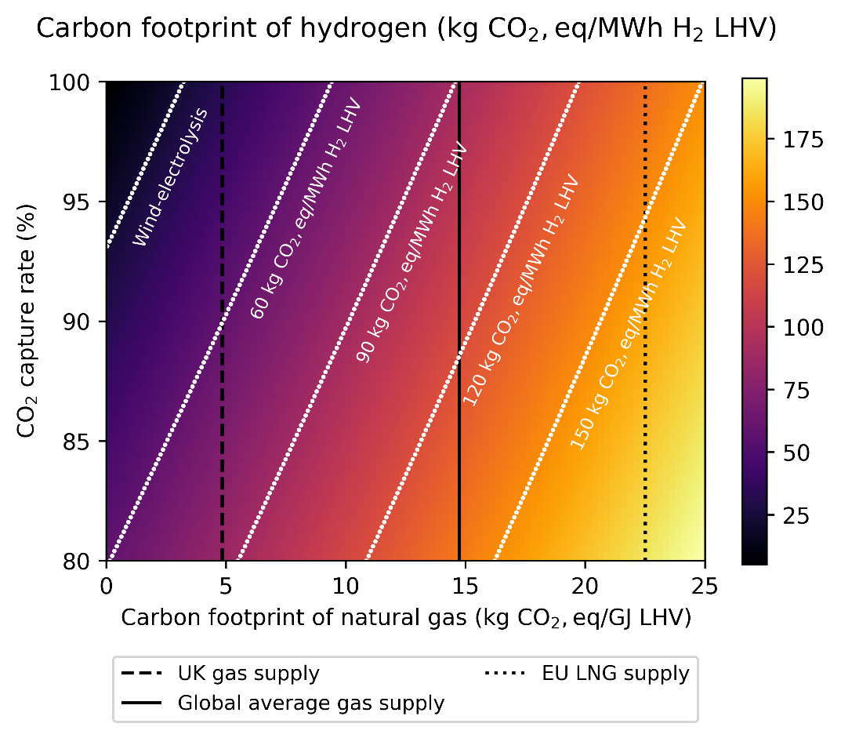
Figure S2:Carbon footprint of the blue hydrogen supply as a function of the desired CO₂ capture rate and the natural gas supply chain footprint, benchmarked against the carbon footprint of water electrolysis using wind power.

S1.3 - Notes on Figures 3A and 3B
Equations S1 and S3 from S1.1 were used to generate both figures 3A and 3B in the article (Figure S3 below). Figure 3B was generated using country-level electricity generation carbon intensity data, together with equation S8. The resulting data was plotted using QGIS Desktop version 2.14.21 using country-level shapefiles. Figure 3A is derived using two additional equations as follows:
$$\begin{aligned}{CA}_{blue hydrogen}={CE}_{natural gas}+{CI}_{natural gas}-{CI}_{blue hydrogen}\#\left(S7\right)\end{aligned}$$
$$\begin{aligned}{CA}_{electrolytic hydrogen}={CE}_{natural gas}+{CI}_{natural gas}-{CI}_{electrolytic hydrogen}\#\left(S8\right)\end{aligned}$$
Where ${CA}_{blue hydrogen}$ and ${CA}_{electrolytic hydrogen}$ represent the carbon avoidance of both blue hydrogen and electrolytic hydrogen options relative to natural gas, respectively. ${CE}_{natural gas}$ is a model parameter which represents the direct emission intensity of natural gas, assumed to be 203.7 kg CO₂,eq/MWh LHV⁷. For Figure 3A, the ${CI}_{electricity}$ variable uses a bound of 0 – 160 kg CO₂,eq/MWh.

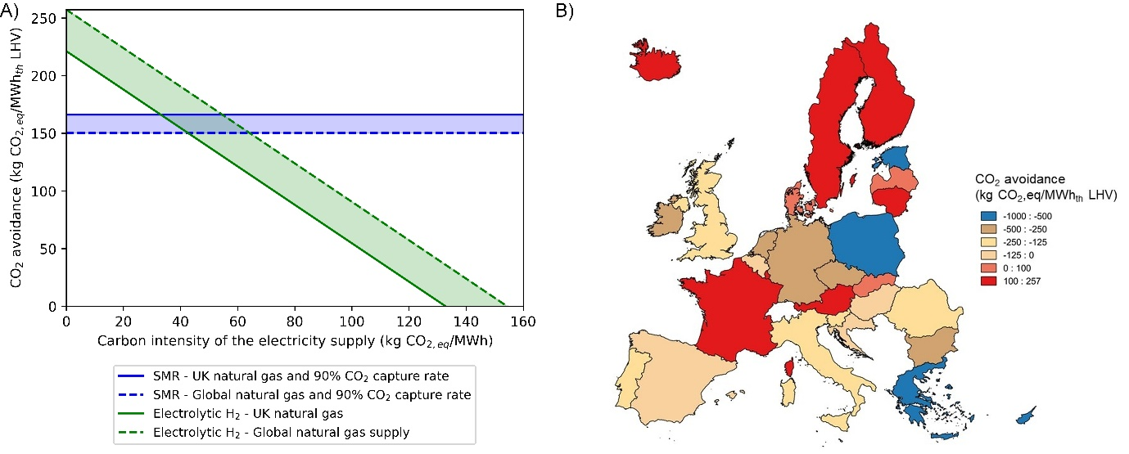
Figure S3: CO₂ avoidance of blue and electrolytic hydrogen as a function of the carbon footprint of electricity (A),and regionally disaggregated based on the electricity grid carbon footprint from the year, 2019.

S1.4 – Design basis for Figures 2A and 2B
Figures 2A and 2B present a cradle-to-gate LCA analysis of different H₂ supply pathways for supplying the variable heating demands in the North of England. The functional unit for all the production pathways is “1 MWh LHV of H₂” and the reference flow is “1 MWh of H₂ LHV with at least 97.5% purity at 80 bar and an ambient temperature of 22 °C”. The cut-off criteria refer to the omission of non-relevant life cycle stages, activities, and elementary flows in the modelling. A cut-off criteria of 5% of process inventory (by mass, energy, and environmental impact flows) is adopted as per the guidelines in “FC-Hy Guide”⁸, with exceptions which represent SMR/ ATR plant emissions of trace substances such as amine emissions, freshwater consumption and wastewater releases for all processes.
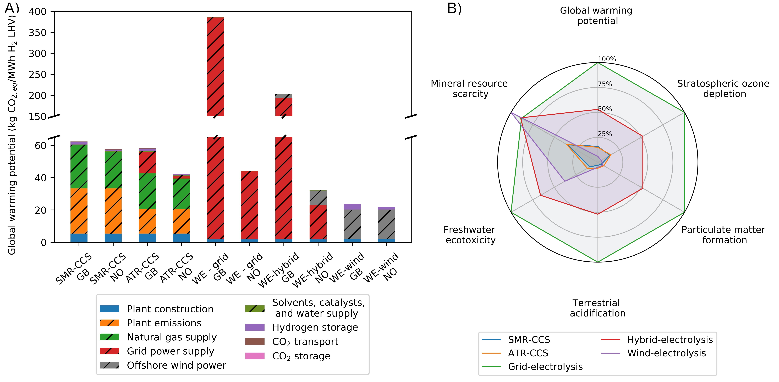
Figure S4: Global warming potential of hydrogen supply routes (A). Abbreviations: Steam methane reforming (SMR), autothermal reforming (ATR), water electrolysis (WE). Two location references are used – Great Britain (GB) and Norway (NO) – which is used to study the impact of using different natural gas and electricity supplies on the overall environmental performance of the supply routes. The textured bars denote both the direct and indirect impacts from operating the production facility. The radar plot (B) summarises the overall performance of the different hydrogen supply routes in Great Britain across other key performance indicators. See Figure S7 for a side-by-side comparison of other key performance indicators for the different supplies in GB and NO.
The production system outlined in the H21 North of England report⁹ is used as the design basis for the LCA - reforming and renewable electrolytic H₂ pathways with 12.15 GW H₂ HHV and 18.4 GW H₂ HHV of production capacity, respectively. Whilst a constant supply of natural gas may reasonably be assumed, the same is not true of wind power. This results in an increase in installed electrolysis capacity relative to SMR or ATR capacity.
The production and storage facilities are assumed to be in the North of England, with H₂ stored as a compressed gas in medium depth salt caverns in Yorkshire (North East), and CO₂ in saline aquifer formations in the North Sea. CO₂ is transported from the plant to the offshore storage facility whereas H₂ is assumed to be distributed through the gas distribution networks. The annual H₂-derived heat supply equals the demand for heat in the region, with significant intra-annual variations. The natural gas required to produce H₂ in reforming pathways is assumed to be sourced from the National Transmission System (NTS) in the UK. Furthermore, the electricity required for the ATR process is assumed to be derived from the electricity grid in the UK, assuming 2019 as the base year of operation. The environmental impact of electrolytic-H₂ is evaluated based on a) renewable offshore wind power, b) grid power, and c) offshore wind power and grid power. The third scenario is assumed to operate without large-scale H₂ storage, i.e., a hybrid scenario, with grid power being used when the dedicated renewable resource is unavailable.
The following five H₂ production pathways are evaluated:
- 12.15 GW HHV of steam methane reforming with CCS operating with a CO₂ capture rate of 91.2%. 8.05 TWh of H₂ storage supports production and provides a buffer to meet the peak demands.
- 12.15 GW HHV of autothermal reforming of methane with CCS with a CO₂ capture rate of 94.1%. 8.05 TWh of H₂ storage supports production and provides a buffer to meet the peak demands.
- 18.4 GW HHV of water electrolysis using electricity sourced entirely from renewable offshore wind farms at a capacity factor of 37.5 % with 19.5 TWh of H₂ storage in salt caverns. Note that capacity factors are a function of the location and higher capacity factors are achievable in some regions of the North Sea, however an average lifetime capacity factor of 37.5% is representative of current North Sea assets¹⁰.
- 17.2 GW HHV of water electrolysis (assuming negligible losses) using electricity sourced entirely from the power grid with no H₂ storage in salt caverns. The production capacity was estimated by the peak demand less linepack storage capacity. A peak hour demand of 42.2 GW was combined with a linepack storage capacity of 25 GWh, as reported in the H21 North of England report, to arrive at a production capacity of 42.2 – 25 = 17.2 GW⁹.
- 17.2 GW HHV of water electrolysis (assuming negligible losses) using electricity sourced partly from the power grid (50%) as well as renewable offshore wind farms (50%) with no H₂ storage in salt caverns. A capacity factor of 37.5% is also used for wind-based generation. The production capacity was calculated using a peak hour demand of 42.2 GW and a linepack storage capacity of 25 GWh as reported in the H21 North of England report⁹.
The impact assessments were generated using version 1.1 of the ReCiPe 2016 impact assessment method as implemented in SimaPro, the lifecycle assessment software, using a time horizon of 100 years. The midpoint impact categories of interest are:
- Global warming potential – to consider the impact of greenhouse gas emissions with a time horizon of 100 years.
- Stratospheric ozone depletion potential – to evaluate the potential to release ozone depleting substances that increase the UVB radiation reaching the Earth’s surface.
- Particulate matter formation – to analyse the potential for both organic and inorganic matter to be formed from the processes along the H₂ supply chain.
- Terrestrial acidification – to assess the potential to increase soil acidity and impact terrestrial systems.
- Freshwater ecotoxicity – to estimate the potential to increase toxicity levels in freshwater systems.
- Mineral resource scarcity – to quantify the potential for the production pathway to deplete finite resources.

S2 – Supplemental figures

S2.1 – System boundary for LCA analysis
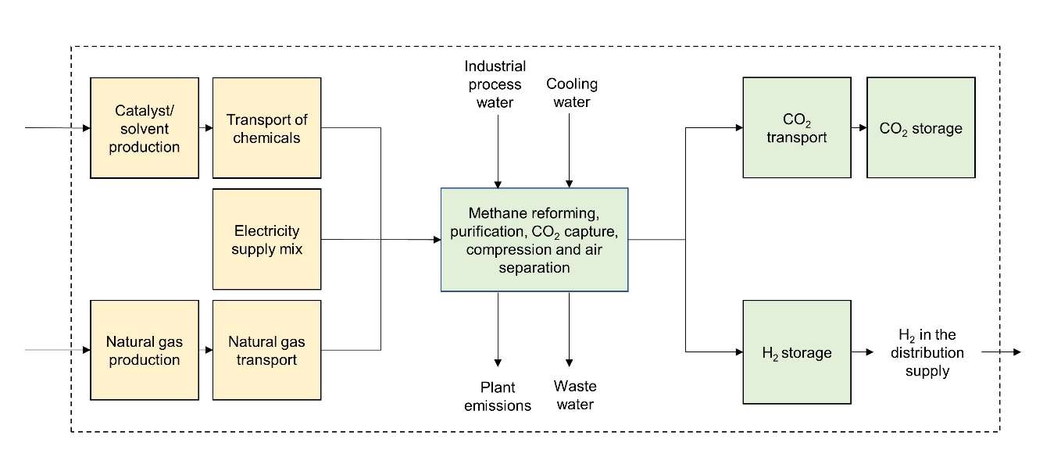
Figure S5: The processes included within the system boundary for the lifecycle assessment of blue hydrogen technologies – SMR and ATR with CCS. Note that the boxes highlighted in yellow represent processes which use background data from the ecoinvent database, whereas the others are modelled using primary inventory data augmented to complete data gaps.
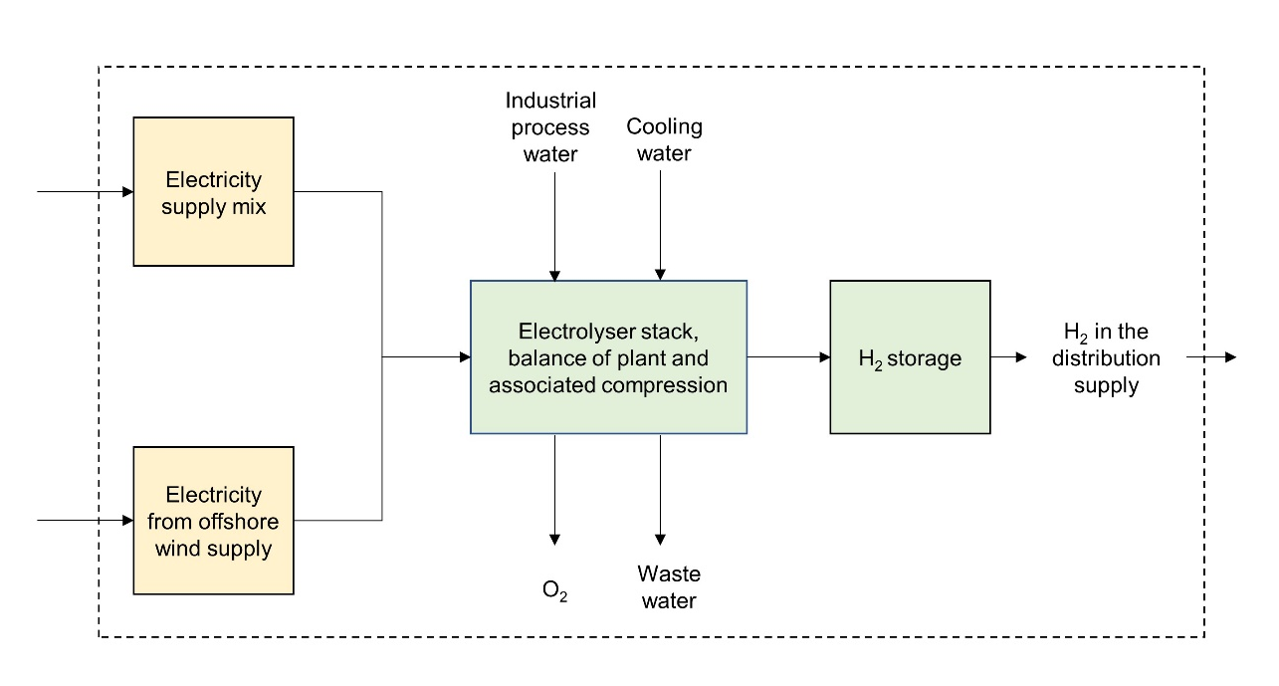
Figure S6: The processes included within the system boundary for the lifecycle assessment of electrolytic hydrogen production. Storage infrastructure is captured for the wind-based electrolysis assessments. Note that the boxes highlighted in yellow represent processes which use background data from the ecoinvent database, whereas the others are modelled using primary inventory data augmented to complete data gaps.

S2.2 – Midpoint impact assessment of H₂ supply pathways

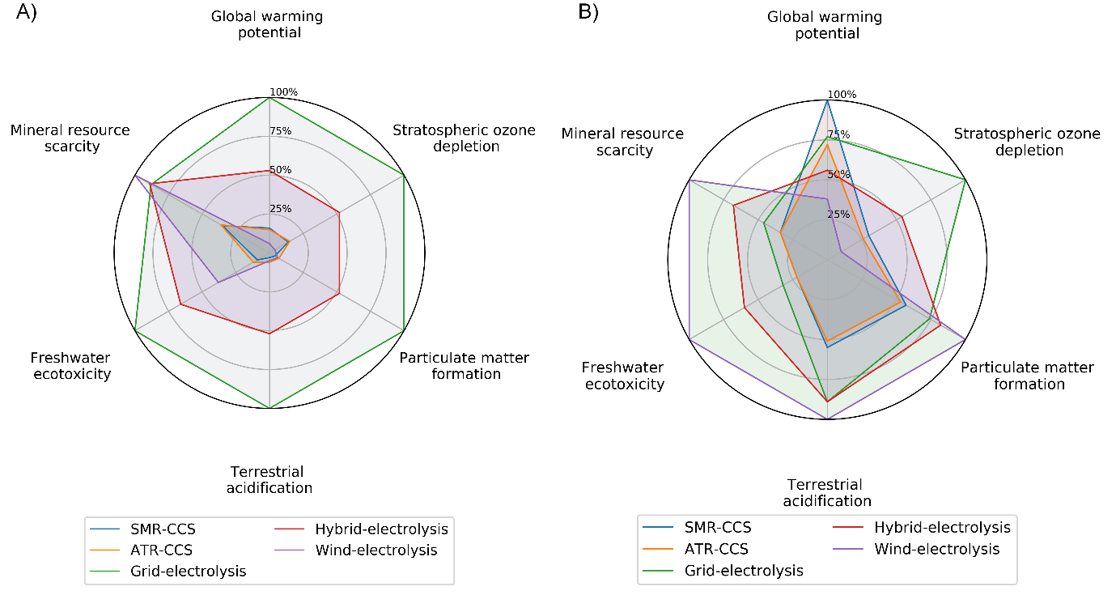
Figure S7: Environmental performance of different H₂ supply options assuming the supply of both electricity and natural gas from Great Britain (A) and Norway (B). The design assumes operation in North of England. Grid and hybrid-electrolysis performs poorly in Great Britain in comparison to Norway. Importantly, no single supply pathway is dominant across all indicators, leading to the observation that there is potential for environmental burden shifting from solely focusing on one technology.

S3 – Supplemental tables
This section summarises the primary inventory data used to model the various processes along the H₂ supply chain as part of the LCA presented in Figures 2A and 2B. Note that the LCA model uses both primary data and background data from databases such as ecoinvent⁵, hence a complete description of every model component is not provided here.
Table S1: Estimates of material and processing requirements for a 220 MW HHV methane reforming plant with CCS.
Material | Quantity (ton)
Concrete – SMR plant | 10,242¹¹
Steel – SMR plant | 3,272¹¹
Aluminium – SMR plant | 27¹¹
Iron – SMR plant | 40¹¹
Carbon steel – CCS plant | 1,456¹²
Stainless steel – CCS plant | 374¹²
Process – casting steel | 5,132^{11,12}
Process – casting aluminium | 27^{11,12}

Table S2: Natural gas consumption used in the methane reforming processes in this study in comparison to that used in gas boilers for delivering heat. A volumetric energy density of 39.7 MJ/m³ is assumed for natural gas.
Process | Natural gas consumption  (m³/MJ heat supply) | Efficiency (% HHV)
Natural gas heating | 0.0252 | -
H₂ heating – SMR CCS | 0.0366⁹ | 68.8
H₂ heating – ATR CCS | 0.0303⁹ | 79.9

Table S3: List of emission components and their mass fractions based on a kg of H₂ produced through SMR-CCS at a CO₂ capture rate of 91.1% as used in this study, based on outputs presented in Antonini et al ¹³.
Chemical | Quantity emitted (kg/MJ H₂)
Carbon dioxide | 0.00668⁹
Acetaldehyde | 3.38 x 10⁻¹¹
Acetic acid | 5.07 x 10⁻⁹
Benzene | 1.35 x 10⁻⁸
Benzopyrene | 3.40 x 10⁻¹³
Butane | 2.37 x 10⁻⁸
Carbon monoxide | 7.10 x 10⁻⁸
Dinitrogen monoxide | 3.38 x 10⁻⁹
Formaldehyde | 3.38 x 10⁻⁹
Mercury | 1.01 x 10⁻¹²
Methane | 6.76 x 10⁻⁸
Nitrogen oxides | 6.05 x 10⁻⁷
Polycyclic aromatic hydrocarbons | 3.38 x 10⁻¹⁰
Particulates | 6.76 x 10⁻⁹
Pentane | 4.06 x 10⁻⁸
Propane | 6.76 x 10⁻⁹
Propionic acid | 6.76 x 10⁻¹⁰
Sulphur dioxide | 1.86 x 10⁻⁸
Toluene | 6.76 x 10⁻⁹
Monoethanolamine | 2.05 x 10⁻⁶

Table S4: Materials for a current and potential future 1 MW PEM stack with the current estimates used to parametrise the LCA model in this study. Source: Bareiß et al. ¹⁴.
Material | Mass of current system (kg) | Mass of possible future system (kg)
Titanium | 528 | 37
Aluminium | 27 | 54
Stainless steel | 100 | 40
Copper | 4.5 | 9
Nafion® | 16 | 2
Activated carbon | 9 | 4.5
Iridium | 0.75 | 0.037
Platinum | 0.075 | 0.01

Table S5: Material requirements for Balance of Plant (BOP) to house a 1 MW PEM stack. Source: Bareiß et al. ¹⁴.
Material | Mass of the BOP (ton)
Low alloyed steel | 4.8
High alloyed steel | 1.9
Aluminium | < 0.1
Copper | < 0.1
Plastic | 0.3
Electronic control (power, control) | 1.1
Process material (adsorbent, lubricant) | 0.2
Concrete | 5.6

Table S6: Material and energy inputs to establish 19.5 TWh of cavern-based H₂ storage for wind-based electrolysis.
Material/ energy input-outputs | Quantity
Water input (m³) | 3.12 x 10^{8 (Ref 15)}
Occupation of industrial area (m²) | 261,500⁹
Transformation to industrial area (m²) | 261,500⁹
Pipeline for water inlet and brine outlet (km) | 10¹⁶
Compressor size (3 x 15.02 GW) | 45.06
Cushion gas requirement (TWh) | 10.14
Electricity requirement for compression (GWh/yr) | 608
Wastewater output (Mton) | 312¹⁵
Salt discharge in brine outlet (Mton) | 88.9¹⁵

Table S7: Material and energy inputs to establish 8.05 TWh of H₂ storage for both SMR-CCS and ATR-CCS.
Material/ energy input-outputs | Quantity
Water input (m³) | 1.34 x 10⁸
Occupation of industrial area (m²) | 108,000
Transformation to industrial area (m²) | 108,000
Pipeline for water inlet and brine outlet (km) | 10
Compressor size (3 x 6.2 GW) | 18.6
Cushion gas requirement (TWh) | 4.37
Electricity requirement for compression (GWh/yr) | 262
Wastewater output (Mton) | 134
Salt discharge in brine outlet (Mton) | 38.3

References
1. Collodi, G., Azzaro, G., Ferrari, N., and Santos, S. (2017). Techno-economic Evaluation of Deploying CCS in SMR Based Merchant H₂ Production with NG as Feedstock and Fuel. Energy Procedia 114, 2690–2712.
2. Balcombe, P., Anderson, K., Speirs, J., Brandon, N., and Hawkes, A. (2015). Methane and CO₂ emissions from the natural gas supply chain: an evidence assessment.
3. European Environment Agency (2021). Greenhouse gas emission intensity of electricity generation. https://www.eea.europa.eu/data-and-maps/daviz/co2-emission-intensity-6#tab-googlechartid_googlechartid_googlechartid_googlechartid_chart_11111.
4. Cetinkaya, E., Dincer, I., and Naterer, G.F. (2012). Life cycle assessment of various hydrogen production methods. Int. J. Hydrogen Energy 37, 2071–2080.
5. Wernet, G., Bauer, C., Steubing, B., Reinhard, J., Moreno-Ruiz, E., and Weidema, B. (2016). The ecoinvent database version 3 (part I): overview and methodology. Int. J. Life Cycle Assess. 21, 1218–1230.
6. Schuller, O., Kupferschmid, S., Hengstler, J., and Whitehouse, S. (2019). Life Cycle GHG Emission Study on the Use of LNG as Marine Fuel - Final Report.
7. Department for Business Energy & Industrial Stratergy (2020). Greenhouse gas reporting: conversion factors 2020. https://www.gov.uk/government/publications/greenhouse-gas-reporting-conversion-factors-2020.
8. Masoni, P., and Zamagni, A. (2011). Guidance Document for performing LCAs on Fuel Cells and H₂ Technologies.
9. Northern Gas Networks & Equinor & Cadent (2018). H21 North of England Report.
10. Smith, A.Z. (2021). UK offshore wind capacity factors. https://energynumbers.info/uk-offshore-wind-capacity-factors.
11. Spath, P.L., and Mann, M.K. (2001). Life Cycle Assessment of Hydrogen Production via Natural Gas Steam Reforming.
12. Kleijn, R., van der Voet, E., Kramer, G.J., van Oers, L., and van der Giesen, C. (2011). Metal requirements of low-carbon power generation. Energy 36, 5640–5648.
13. Antonini, C., Treyer, K., Streb, A., Van Der Spek, M., Bauer, C., and Mazzotti, M. (2020). Hydrogen production from natural gas and biomethane with carbon capture and storage-A techno-environmental analysis †. Sustain. Energy Fuels.
14. Bareiß, K., de la Rua, C., Möckl, M., and Hamacher, T. (2019). Life cycle assessment of hydrogen from proton exchange membrane water electrolysis in future energy systems. Appl. Energy 237, 862–872.
15. Chabrelie, M.F., Dussaud, M., Bourjas, D., and Hugout, B. (1988). Underground Gas Storage: Technological Innovation for Increased Efficiency. In 17th World Energy Congress held in Houston, Texas, USA, September.
16. Energy Technologies Institute (2015). The role of hydrogen storage in a clean responsive power system.

The ability to repurpose existing natural gas distribution networks for the transport of hydrogen is currently being assessed in the UK through safety trials and testing through projects such as H100 to arrive at a policy decision by 2030.
The compressor sizes were estimated by scaling the size of the H₂ storage system for the wind-based electrolysis system relative to SMRs/ ATRs.
The annual compression requirement is based on a single fill and discharge cycle for the salt caverns.
The H21 North of England study reported 54 GWh/yr. This study estimates an annual single fill and discharge cycle with a higher compression requirement of 262 GWh/yr.

