Integrating demography and distribution modelling for the iconic Leontopodium alpinum Colm. in the Romanian Carpathians

Lăcrămioara M. Maghiar,^{1,2}*, Ilie A. Stoica¹, Andrew J. Tanentzap²
¹Institute of Biological Research, Branch of the National Institute of Research and Development for Biological Sciences, 48 Republicii Street, 400015, Cluj-Napoca, Romania; ²Ecosystems and Global Change Group, Department of Plant Sciences, University of Cambridge, Downing Street, Cambridge, CB2 3EA, UK
* Author for correspondence: lacramioara.maghiar@gmail.com

Abstract:
1. Both climate change and human exploitation are major threats to plant life in mountain environments. One species that may be particularly sensitive to both of these stressors is the iconic alpine flower edelweiss (Leontopodium alpinum Colm.). Its populations have declined across Europe due to over-collection for its highly prized flowers. Edelweiss is still subject to harvesting across the Romanian Carpathians but no study has measured to what extent populations are vulnerable to anthropogenic change.
2. Here we estimated the effects of climate and human disturbance on the fitness of edelweiss. We combined demographic measurements with predictions of future range distribution under climate change to assess the viability of populations across Romania.
3. We found that per-capita and per-area seed number and seed mass were similarly promoted by both favourable environmental conditions, represented by rugged landscapes with relatively cold winters and wet summers, and reduced exposure to harvesting, represented by the distance of plants from hiking trails. Modelling these responses under future climate scenarios suggested a slight increase in per-area fitness. However, we found plant ranges contracted by between 14 to 35% by 2050, with plants pushed into high elevation sites.
4. Synthesis. Both total seed number and seed mass are expected to decline across Romania despite individual edelweiss fitness benefiting from a warmer and wetter climate. More generally, our approach of coupling species distribution models with demographic measurements may better inform conservation strategies of ways to protect alpine life in a changing world.

Keywords: biotic interactions, climate change, global change ecology, human exploitation, long-term population persistence, plant fitness, species distribution models

1. Introduction
Climate change threatens many alpine plants, especially those with relatively narrow environmental niches (Gottfried et al., 2012; Pauli et al., 2012). At the European level, warm-adapted species have been found to expand their range to higher altitudes to the detriment of cold-adapted neighbours (Gottfried et al., 2012). Consequently, both the composition and structure of high-mountain plant communities are changing across several European countries (Erschbamer et al., 2011; Evangelista et al., 2016; Fernández Calzado et al., 2012; Pauli et al., 2007). Many studies have also observed an increase in species richness at high altitudes in several mountain ranges, likely increasing inter-specific competition (Britton et al., 2009; Erschbamer et al., 2011; Holzinger et al., 2008; Matteodo et al., 2013; Pauli et al., 2007).

Adding to the impacts of a changing climate, human disturbance is also a major threat to plant life in populated mountain ranges, such as those found across Europe. Many mountain plants are harvested by humans, such as for food, medicinal, ornamental and cultural purposes (Allen et al., 2014; Hinsley et al., 2018). For example, use of Gentiana lutea roots in traditional medicine has led to this species being classed as endangered across parts of Europe (Catorci et al., 2014). Similarly, harvesting for medicinal purposes, predation by herbivores and low genetic variability among populations of Artemisia granatensis, an endangered alpine species endemic to the Sierra Nevadas in Spain, has decreased the number of mature adults of this species by more than 50% between 1994 and 2003 (Hernández-Bermejo et al., 2011). In all cases, long-term population persistence will depend on what plant tissues are lost and how plant reproductive strategies respond to disturbance. Removal of flowers may be particularly harmful for the persistence of plants that only reproduce once in their lifetime and die thereafter, i.e. those that are monocarpic (Law and Salick, 2005). Polycarpic or clonal species may in contrast compensate for flower loss by reallocating resources into remaining seeds or future reproduction (Ehrlén and Van Groenendael, 2001; Gómez and Fuentes, 2001; Olejniczak, 2011). For example, Lehtilä and Ehrlén (2005) found that experimental flower removal from Primula veris in its late flowering stage increased seed size by 33% compared to the control plants.

Species distribution models (SDMs) can help predict how climate change and other human-induced threats will impact the future range dynamics of alpine plants (Bakkenes et al., 2002; Casalegno et al., 2010; Thuiller et al., 2005), but these approaches rarely consider the capacity of populations to regenerate and persist in space. SDMs typically focus on delineating the potential distribution of species based on associations between species occurrences and environmental conditions, mostly climate (Guisan and Zimmermann, 2000). Few studies have included human disturbance alongside climate projections, despite the former being a more immediate and larger cause of extinction (Maxwell et al., 2016). In one study that did, Pearson et al. (2004) found that the availability of suitable land cover restricted the range of Erica tetralix in Britain within otherwise climatically suitable habitat. Even accounting for conditions other than climate, different fecundity or survival rates across populations of a species might generate different responses to environmental change (Swab et al., 2015). Thus, SDMs can produce biased estimates of future extinction risk if they only consider environmental tolerances and omit measures relating to fitness. In the European Alps, habitats were identified as suitable for occupancy of alpine plant species under future climate change despite dispersal and demography being poorly adapted to the new conditions in some sites (Dullinger et al., 2012). Ultimately, combining SDMs with demographic information can improve our understanding of the relative importance of climate versus other human-induced threats to the persistence of alpine plant species.

Here we focus on identifying the relative importance of climate and human disturbance for the persistence of edelweiss (Leontopodium alpinum, Asteraceae), one of the most iconic flowers of Europe's mountains. We surveyed both seed mass and seed number at seven sites along a 275 km transect across Romania. Both seed mass and number are fitness-related traits that are important for ensuring long-term population persistence (Adler et al., 2014; Cochrane et al., 2015). Although short-term population viability may also depend on other vital rates, such as adult survival and growth (Keller and Vittoz 2015), sexual reproduction can enhance the ability of plants to track future climate change by promoting genetic variation, dispersal, and colonization, especially compared to vegetative organs (Weppler et al., 2006). Higher seed number may connect naturally fragmented, isolated, and small populations of edelweiss while larger seeds may withstand better environmental stressors such as deep shade or drought (Bruun and Ten Brink, 2008). We consequently predicted that climate change would reduce the probability of occurrence of edelweiss across Romania and that both fitness measures would decrease with climate change and human disturbance, thereby threatening future population persistence. Our work builds upon an emerging consensus for the need to link projections of future species distributions with key demographic processes to forecast better the potential impact of global change on species distributions (Fordham et al., 2013; Normand et al., 2014; Swab et al., 2015).

2. Materials and Methods
2.1. Study species
Edelweiss is a small (ca. 10 to 50 cm tall) herbaceous perennial with a widespread disjunct distribution across Eurasia. The plant reproduces both clonally by rhizomes and sexually by seeds when rosettes have accumulated sufficient resources for flowering (Keller and Vittoz, 2015). After reproduction, the apical meristem dies, but clonal growth ensures genets can persist and produce new ramets and eventual flowers (Keller and Vittoz, 2015).

Over-collection of edelweiss from its natural habitat led to early conservation measures in European countries such as Switzerland and Austria, where it has been protected since 1878 and 1887, respectively (Pop, 1939). Although edelweiss is listed as being of least concern across the whole of Europe according to the IUCN Red List (Khela, 2013), it is critically endangered in Albania (Red List of Wild Flora and Fauna Albania, 2013), regionally endangered in Austria (Niklfeld and Schratt-Ehrendorfer, 1999), endangered in Bulgaria (Petrova and Vladimirova, 2009), endangered in Germany (Bundesamt für Naturschutz, 2012), near-threatened in Slovakia (Eliáš et al., 2015), least concern in Switzerland but listed as critically endangered and near threatened in some regions (Moser et. al, 2002), and critically endangered in Ukraine (Chorney and Kyyak, 2009). In the Carpathian List of Endangered Species, edelweiss is listed as vulnerable (Tasenkevich, 2003). The species is protected in Romania and included as vulnerable and rare on the Romanian Red List of Vascular Plants (Oltean et al., 1994). Currently, there has not been any national-level assessment of edelweiss in Romania despite the potentially large area of available habitat in the relatively sparsely populated Carpathians, with studies undertaken at a local level highlighting its vulnerability to harvesting (Oprea and Sîrbu, 2008).

2.2. Study sites and seed collection
We established 45 1m x 1m plots in areas with known edelweiss populations across the Carpathian Mountains, Romania. The plots were nested within seven massifs with altitudes ranging between 394 m a.s.l. (Doabra Valley – Lotru Mountains) and 2286 m a.s.l. (Bucegi Mountains) and in areas with varying levels of disturbance (Fig. 1). Human disturbance was estimated for each plot as the distance to the nearest marked hiking trail. Hiking trails provide accessibility to edelweiss and should elevate the risk of harvesting immediately along the trail. The impact of human disturbance should therefore decrease with increasing distance from trails (Huang et al., 2015; Kutiel et al., 1999). Approximately 753 marked hiking trails were used for calculating distances. Trails were digitized from airborne imagery and obtained as KMZ, KML or GPX files from the Romanian Mountain Rescue websites, websites of natural and national parks, directly from the administration of natural and national parks, and two popular enthusiast websites http://muntii-nostri.ro/ and https://gis.modulo.ro/.

Between August and September 2015, when the achene fruits of edelweiss were ripe, we surveyed seed production. To minimize our impacts on local populations, we subsampled diaspores (hereafter called seeds) at the level of individual flowering heads (i.e. anthodiums). In each plot, we collected five anthodiums from each of three randomly chosen inflorescences and recorded the heights of the inflorescences. Seed number per inflorescence was derived by multiplying the average number of seeds per anthodium by counts of all the anthodiums in an inflorescence. We could then multiply the average seed number per inflorescence by the total number of inflorescences to scale seed production to the plot-level. Similarly, seed mass per inflorescence was derived by multiplying the average fresh seed mass per anthodium by anthodium counts per inflorescence and then converted to dry masses using the formula: dry mass = 0.89 × fresh mass (R2 = 0.97, n = 37). We could then multiply the average dry seed mass per inflorescence by the total number of inflorescences to scale seed production to the plot-level.

In each plot, we also recorded the ground cover of (semi-)woody plants, hemiparasites and cushion plants (Table A1). These three functional groups can have both positive and negative impacts on alpine plant communities (Antonsson et al., 2009; Gabay et al., 2012; Kröpfl et al., 2002; Liczner and Lortie, 2014; Spasojevic and Suding, 2011), and so could contribute to variation in seed production among plots. We estimated the abundance of these groups from traditional Braun-Blanquet ranks (+, 1, 2, 3, 4, 5) that we replaced with their mean percentage cover (0.5%, 5%, 17.5%, 37.5%, 62.5% and 87.5% respectively), after Tüxen and Ellenberg (1937).
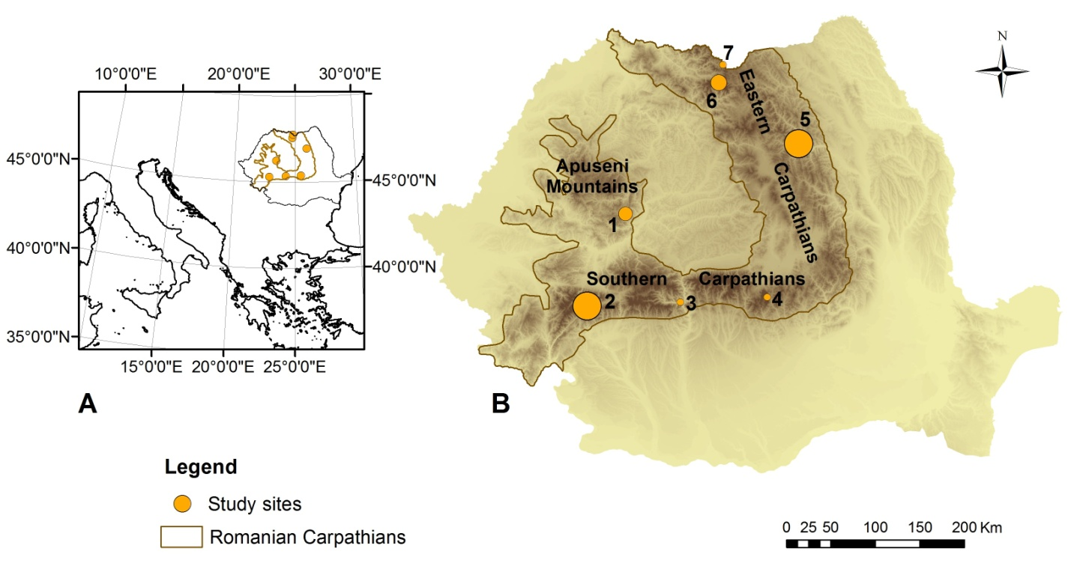
Fig. 1. Location of study area in Europe (A) and study sites within the study area (B): 1 – Întregalde Gorges;
2 – Piule-Iorgovanu Mountains; 3 – Doabra Valley; 4 – Bucegi Mountains; 5- Ceahlau Mountains; 6 – Rodna Mountains; 7 – Coman Valley. The size of the symbols in panel B is proportional to the number of plots. N = 3-13 plots per site.

2.3. Species occurrence data
To model the environmental niche of edelweiss, we first assembled a database with known occurrences across the Romanian Carpathians A total of 443 presence points were amassed: 424 points that we had personally collected since 2012 and 19 additional points from published sources and local collaborators (Frink, 2015; Frink et al., 2015; Iancu and Decei, 1964; Mihăilescu, 2001; Pușcaru-Soroceanu, 1971; Resmeriță, 1973). As we later worked with predictors that had a spatial resolution of 30 arc-seconds (ca. 1 km), more than one presence point was possible within the same raster cell. Duplicates were removed to minimize spatial autocorrelation and therefore our total number of occurrence records decreased from 424 to 47.

Given the lack of true absence data, pseudo-absences were generated using the biomod2 package with the sre strategy. This approach generates a surface range envelope model using 95% of presence data and generates pseudo-absences outside these broadly defined environmental conditions (Barbet-Massin et al., 2012). Ten times more absences than presences were created after Chefaoui and Lobo (2008).

2.4. Bioclimatic and environmental data
Initially, we prepared 25 climatic and topographic predictors (Table A2) with a gridded spatial resolution of 30 arc-seconds (ca. 1 km). 19 bioclimatic variables were acquired from the WorldClim database, while 6 topographic variables (slope, aspect, surface roughness, Terrain Ruggedness Index, Topographic Position Index, Topographic Wetness Index) computed from WorldClim’s altitude data (Hijmans et al., 2005). The importance of each variable was tested by fitting univariate generalized linear models with the variable as a predictor and species presence as the response. Goodness of fit for each model was calculated as 1 – residual variance/null variance. Predictors with a variable importance <0.30 were excluded as these had relatively flat response curves and so made little difference to model predictions. To reduce multicollinearity, we further retained the predictors with the highest goodness of fit when variables were inter-correlated, as determined by a Spearman’s correlation coefficient ≥ 0.70 (Gomes et al., 2018). Four variables were retained following this process: (i) mean temperature of the coldest quarter, (ii) precipitation of the warmest quarter, (iii) Terrain Ruggedness Index (TRI), which is the is the mean of the absolute differences between the elevation of a 30 arc-second grid cell and its 8 surrounding cells (Hijmans et al., 2016). TRI values between roughly 160 to 500 m are considered intermediately/moderately rugged, with values from 500 to 960 m indicating high ruggedness (Riley et al. 1999). Although the spatial scale of the TRI measurements greatly exceeds that of our focal plants, it provides a general indicator of mountainous terrain and thus habitat where edelweiss is commonly found (Resmeriță, 1973).

We also projected future distributions under two scenarios developed by the Intergovernmental Panel on Climate Change: Representative Concentration Pathway (RCP) 4.5 and 6.0 (van Vuuren et al., 2011). We chose these scenarios because future climate conditions are likely to lie somewhere between them by the year 2100 (Hausfather and Peters, 2020). For the two scenarios, we used three Global Circulation Models (GCMs): the Met Office climate model (HadGEM2-ES), the Model for Interdisciplinary Research on Climate Change (MIROC5) and the Norwegian Earth System Model (NorESM1-M). These models were chosen because of their different future trends regarding our chosen predictors in the study area: HadGEM2-ES predicts a high increase in air temperature and a moderate decrease in precipitation, MIROC5 predicts a high increase in both air temperature and precipitation, and NorESM1-M predicts a high increase in air temperature and moderate decreases in precipitation. Rasters for future conditions in 2050 were also acquired from WorldClim and represent downscaled global projections from the 5th phase of the Coupled Model Intercomparison Project. The warmest quarter was consistent across time in the Romanian Carpathians.

2.5. Niche model fitting and evaluation
We estimated the environmental favourability for edelweiss across the Romanian Carpathians using our four climatic and topographic predictors within the biomod2 framework (Thuillier et al., 2014) using R v.2.9 (R Core Team, 2015). The models were fitted using ten techniques: (1) generalized linear modelling, (2) generalized boosting modelling, (3) generalized additive modelling (GAM), (4) classification tree analysis, (5) artificial neural networks, (6) surface range envelopes, (7) discriminant analysis, (8) multivariate adaptive regression splines, (9) random forests and (10) maximum entropy. We used a repeated split-sample procedure where 80% of the initial data were used to calibrate the models and 20% to evaluate them, repeating this process 10 times (Thuillier et al., 2009). Ten models without splitting the data were also fitted. Of the 110 resulting models, 84 were considered further as they had a true skill statistic (TSS) above 0.80, indicating a high predictive performance (Allouche et al. 2006). Given the high TSS values, all the 84 individual models had an identical weight of 0.01, so we simply averaged across their predictions to produce a single ensemble model. The ensemble also fitted the data very well with a TSS = 0.99. Variable importance was determined within the BIOMOD2 framework as one minus the correlation score between the original prediction and the prediction made with a permuted variable, and ranges between 0 (no importance) and 1 (high importance) (Thuillier et al., 2014). We used this ensemble to map the potential distribution of edelweiss under current and future (2050) conditions. Maps were output as a continuous probability of occurrence between 0 and 1.

As edelweiss can be found almost exclusively on a base-rich substrate, we used an existing geology map for Romania (Ovejanu et al., 2011) to constrain all predicted occurrences. The substrates we considered were purely calcareous bedrocks and mixed bedrocks with limestone. We also removed unsuitable areas for edelweiss, such as forests, waterbodies, artificial surfaces and agricultural areas using CORINE Land Cover 2018, v.20 (European Environment Agency, 2018) and airborne imagery. Finally, we retained only altitudes higher than 394 m a.s.l. because no current occurrence is officially reported at lower altitudes.

2.6. Statistical models of seed production
We tested how each of seed mass and number both per plot and per inflorescence varied with environmental favourability and human disturbance using generalized mixed effects models fitted with the lmer function in R (Bates et al., 2015). Environmental favourability corresponded with the predicted present-day probability of occurrence at a 1 km² scale from the ensemble species distribution model in which each plot was located. Values were logit-transformed to be approximately normally distributed. Hiking trail distances were used as a proxy for human disturbance. We hypothesized that the relationship between edelweiss fitness and environmental favourability would also weaken as plants were closer to the hiking trails because edelweiss is more exposed to harvest irrespective of how favourable the environment is for reproduction. Therefore, we included a statistical interaction between environmental favourability and hiking trail distance in the models. We accounted for greater potential seed production in taller plants with more access to light by including the mean height of inflorescences per plot in the plot-level analysis. In the inflorescence-level analysis, we only modelled the first 3 individuals in a plot from which we collected seeds, so included their actual heights in the models. We also accounted for the impact of hemiparasites, cushion plants and woody plants on seed production through competition and/or facilitation by including their abundances as additional covariates. Finally, we accounted for repeated measurements of the same plot and study site by including these factors as random effects in our models. All predictors were scaled to a mean of 0 and a standard deviation of 1 so that their effects were directly comparable. Seed mass was cube-root transformed to reduce the skewness of the data. For models of seed number, we used a Poisson error structure and included a plot-level random effect in the plot model and an observation-level random effect in the inflorescence model to account for overdispersion. Estimated effects were considered statistically significant when 95% confidence intervals (CIs) excluded zero.
We used backwards stepwise selection for model simplification. Models were compared using the Akaike information criterion (AIC). We sequentially removed predictors that resulted in the largest decrease in AIC, ensuring the more parsimonious models never had AIC values that were more than 2 units higher than the lowest observed value across the model set (Table A3). We stopped removing predictors when AIC values increased by more than 2 units. Main effects were only dropped after their interactions. Only the simplified model was reported in the Results.
We used the simplified statistical models to forecast seed number and mass per km² given 2050 climate projections. We inputted the 2050 predictions of environmental favourability from the ensemble model into the fitted mixed effects models. All predictions were at the mean vegetation cover of the functional types and mean height of inflorescences, while using the present-day trail network. This approach allowed us to isolate the direct effect of environmental change on future edelweiss persistence.

3. Results
3.1. Environmental predictors of edelweiss distribution
We found the edelweiss was most likely to occur in moderately and highly rugged landscapes that had cold winters and wet summers. The most important variable for the distribution of edelweiss was the Terrain Ruggedness Index (TRI), followed by the mean temperature of coldest quarter, and, to a much lesser extent, precipitation of the warmest quarter (Fig. A1). Response curves from the ensemble model showed that the probability of occurrence increased strongly as landforms became moderately and highly rugged with TRI above 383 m (Fig. 2A). Mean temperatures of the coldest quarter beneath -2 °C, corresponding to altitudes above 130 m a.s.l. in the Romanian Carpathians, also maximised the probability of occurrence (Fig. 2B). Finally, plants had a high probability of occurrence when total precipitation during the warmest quarter was above 292 mm (Fig. 2C).
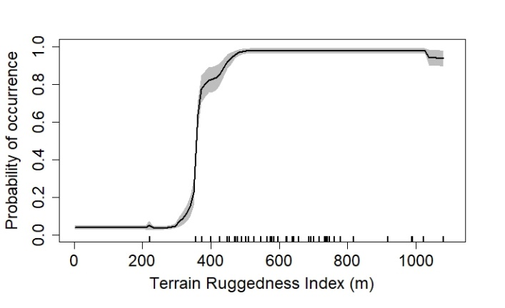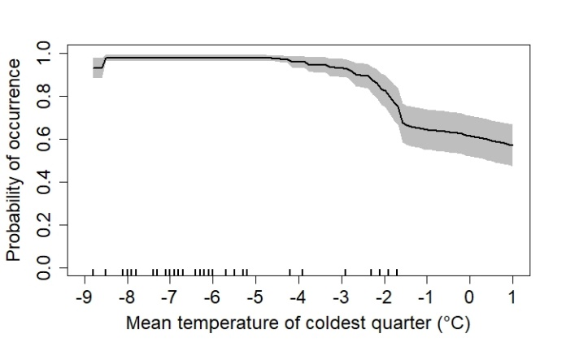
B)
A)
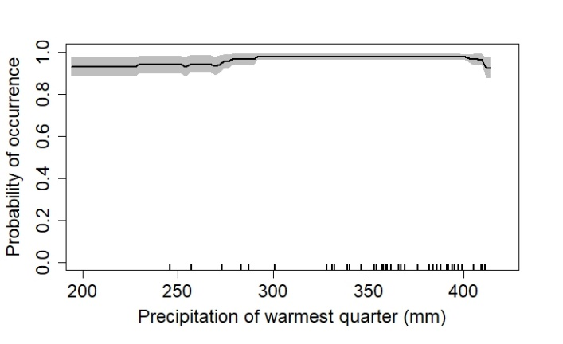
C)
Fig. 2. Mean response curves for Leontopodium alpinum for the four variables used in the species distribution models: (A) Terrain Ruggedness Index (m); (B) Mean temperature of coldest quarter (°C); (C) Precipitation of warmest quarter (mm). The distribution of observations was indicated by the vertical marks along the x-axis. 95% confidence intervals are shown by the grey area.

Future climatic conditions have the potential to reduce edelweiss’ range. Specifically, the mean temperature of coldest quarter (°C) is expected to increase under all GCMs in edelweiss’ suitable habitat in Romania (Fig. A2). For example, the mean temperature of the coldest quarter is predicted to increase from -5.16 ± 0.06 °C (mean ± SE) to -2.37 ± 0.05 °C according to HadGEM2-ES under RCP 4.5 (Fig. A2). These increases will reduce the probability of occurrence for edelweiss (Fig. 2A) by pushing distributions into higher and cooler elevations (Fig. A3). We consequently estimated a potential net loss of between 17.2 and 35.1% of edelweiss’ habitat with a probability of occurrence >50% under future climate change (Table 1). Net loss was similar under the RCP 6.0 scenario, with 14.3 and 30.0% of grid cells currently favourable for edelweiss’ predicted to disappear (Table 1).

Table 1 Favourable habitat lost in Romania by 2050. Values are the net loss in the percentage of habitat with a probability of edelweiss occurrence >50%. Estimates were generated for three GCMs under each of two RCP scenarios.
 | RCP 4.5 | RCP 6.0
HadGEM2-ES | 35.1 | 30.0
MIROC5 | 17.2 | 14.3
NorESM1-M | 24.7 | 16.4

3.2. Current and future seed production
We found that both environmental favourability and human disturbance impacted plant fitness, though the former had relatively larger effects. As expected, seed number and seed mass both per plot and per inflorescence increased with more favourable environmental conditions (Table 2). For example, at the plot level, a 1 standard deviation (SD) increase in environmental favourability of 4% above the mean value of 95% increased the mean ± standard error (SE) seed number from 658.7 ± 99.8 to 994.6 ± 150.6 seeds m⁻² and seed mass from 91.5 ± 12.9 to 142.7 ± 20.2 mg m⁻². We also found that plants that were located far from the hiking trails had greater fitness. For example, a 1 SD increase in hiking trail distance of 6.9 m above the mean value of 137.9 m increased seed number from 658.7 ± 99.8 to 988 ± 149.6 seeds m⁻² and seed mass from 91.5 ± 12.9 to 140.9 ± 19.9 mg m⁻².

Other biological variables also predictably influenced plant fitness. Hemi-parasites were positively associated with both seed number and seed mass both per plot and per inflorescence, while a greater coverage of (semi-)woody plants had negative effects in all cases except on seed mass per plot (Table 2). For example, a 1 SD increase in the cover of hemi-parasites of 1.3% above its mean value of 0.6% increased seed number from 92.7 ± 6.2 to 136.3 ± 9.1 seeds and seed mass from 12.5 ± 0.9 to 16.8 ± 1.2 mg per inflorescence. By contrast, a 1 SD increase in the cover of (semi-)woody plants of 17.4% above its mean of 14.1% had the reverse effect, decreasing mean seed number to 40.8 ± 2.7 seeds and seed mass to 7.7 ± 0.5 mg per inflorescence. Overall, the models fitted the data moderately well, with conditional R² values between 0.21 and 0.61 (Table 2).

Table 2 Estimated effects and 95% confidence intervals of model predictors for present-day seed number and seed mass both per plot and per inflorescence. Predictors retained in the simplified models included environmental favourability (Env), which was the probability of occurrence in a wider 1 km² grid cell estimated by the SDMs, distance to the nearest hiking trail (Trail), and the percentage ground cover of two functional groups. Bolded values indicate statistically significant effects, i.e. confidence intervals that excluded zero. We report the marginal R²_{m} and conditional R²_{c} for each model, which respectively consider fixed effects only and both fixed and random effects. Plot, study site, and inflorescence identity were used as random effects.
 | Fixed effects
Response variable | Env | Trail | Hemiparasites | (Semi) Woody plants |  | R²m | R²c | Random  effects
number#/plot | 0.51 | 0.50 | 0.49 | -0.49 |  | 0.23 | 0.23 | site, plot
 | [0.02, 1.00] | [0.03, 0.98] | [0.04, 0.95] | [-0.97, -0.02]
 |  |  |  |  |  |  |  | plot, inflorescence, site
number#/inflorescence | 0.33 | 0.23 | 0.47 | -0.56 |  | 0.31 | 0.59 | plot, inflorescence, site
 | [0.05, 0.62] | [-0.03, 0.50] | [0.20, 0.74] | [-0.85, -0.29] |  |  |  | plot, inflorescence, site
mass/plot | 0.56 | 0.54 | 0.50 | -0.47 |  | 0.21 | 0.21 | site
 | [0.07, 1.04] | [0.06, 1.01] | [0.05, 0.96] | [-0.94, <0.01]
mass/inflorescence | 0.25 | 0.21 | 0.35 | -0.38 |  | 0.31 | 0.61 | site, plot
 | [0.06, 0.44] | [0.03, 0.39] | [0.17, 0.54] | [-0.56, -0.20]

All future scenarios estimated slight increases in the average seed number km⁻² and seed mass km⁻² across the habitat area with a probability of edelweiss occurrence >50% in 2050. Using HadGEM2-ES run with RCP 4.5, the estimated average ± SE of seed number km⁻² slightly increased from a mean ± SE of 3.5 × 10⁸ ± 6.5 × 10⁶ to 3.7 × 10⁸ ± 1 × 10⁷, while the estimated seed mass slightly increased from 65.0 ± 1.0 to 65.7 ± 1.4 kg km⁻² (Fig. 3). However, under present conditions, plants mostly occur above 456 m a.s.l, where edelweiss has a >50% probability of occurrence. As the available habitat area at higher elevations decreases with future climate change (Table 1), plants will encounter favourable conditions at altitudes over 641 m a.s.l according to HadGEM2-ES, RCP 4.5 (Fig. A3B). Therefore, seed number and seed mass will be mainly restricted to the mountains, such as Făgăraș, Bucegi or Ceahlău massifs (Fig. A4), and total seed output in Romania will decline by 12 to 33% (Fig. 3). These results were effectively identical with the different GCMs and RCPs (Fig. A5).

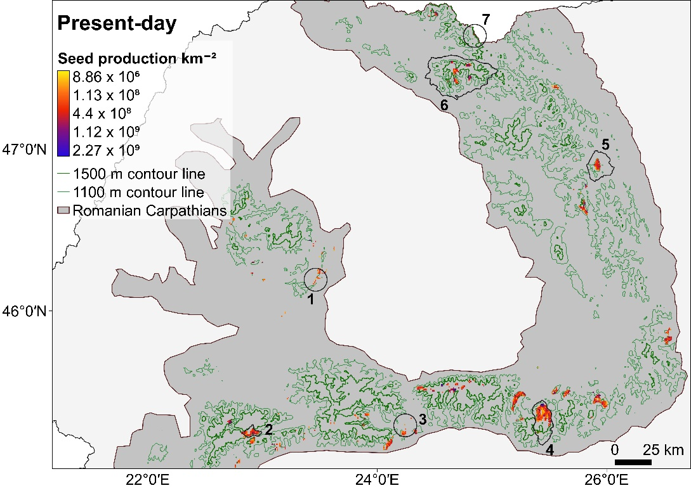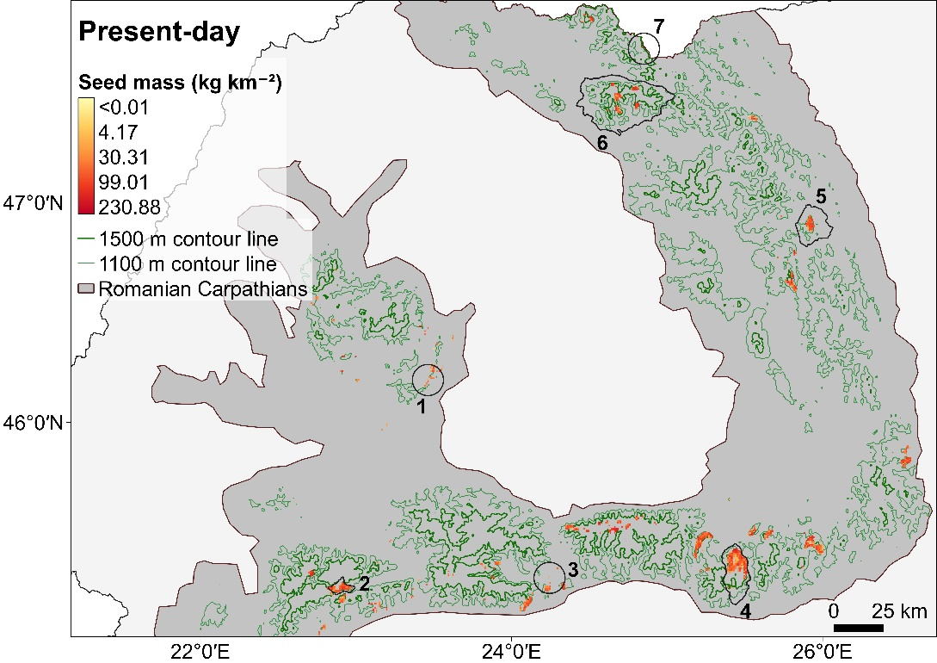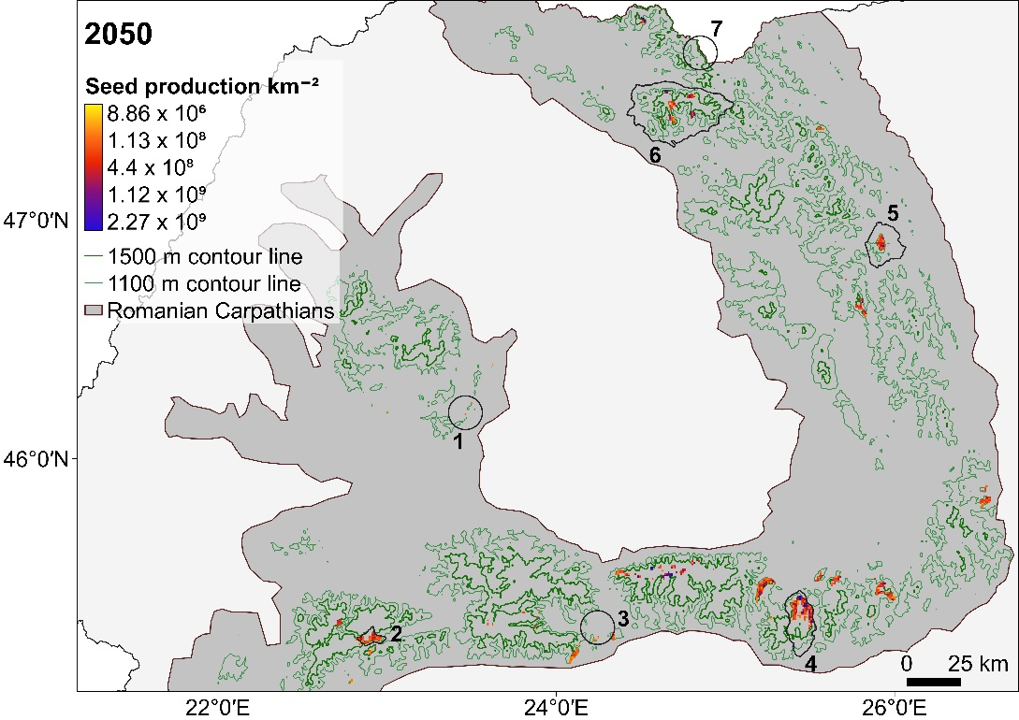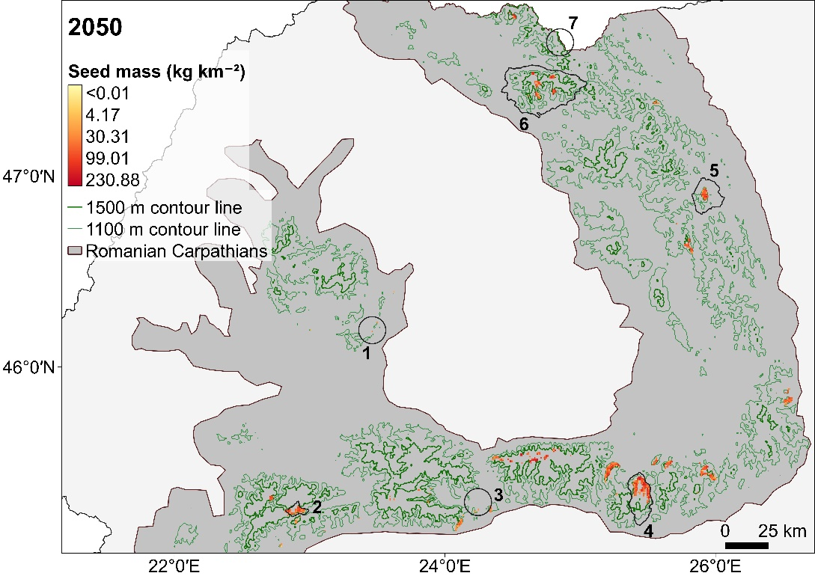
B
A

Fig. 3. Seed number and mass for present-day (A) and estimated in 2050 (B) using the HadGEM2-ES, RCP 4.5 model across the suitable habitat area with a probability of edelweiss occurrence >50%. 1 – Întregalde Gorges; 2 – Piule-Iorgovanu Mountains; 3 – Doabra Valley; 4 – Bucegi Mountains; 5- Ceahlău Mountains; 6 – Rodna Mountains; 7 – Coman Valley.
4. Discussion
By combining species distribution modelling with demographic measurements, we found that climate change may have more negative effects on alpine plant populations than human disturbances. Our results therefore support widespread evidence that alpine plant life is threatened by climate change (Dullinger et al., 2012; Engler et al., 2011; Gottfried et al., 2012), and highlight how other human activities, such as harvesting and fragmentation, can add to these impacts. One limitation of our study is that we did not consider that local microclimatic variation created by topographic heterogeneity can buffer the effects of climate change in alpine habitats (Ohler et al., 2020; Scherrer and Körner, 2011; Suggitt et al., 2018). However, macroclimate is still informative over the large spatial extent of our study, and local measurements may only improve the explained variation of our SDMs rather than change our regional predictions (Lembrechts et al. 2019). More broadly, our results showcase how demographic information can extend species distribution models beyond probabilities of occurrence to measures more directly related to long-term population persistence, such as sexual reproduction (Dullinger et al., 2012; Fordham et al., 2013; Keith et al., 2008). Predicting seed production in the present-day and future from SDMs respectively improves predictions of population dynamics and helps identify sites where plants are failing to recruit even if they are persisting. For these reasons, we can recover more information about future risks to populations than using a SDM alone. Our approach can therefore be used more generally across species and regions and complement more mechanistic demographic models that may be inapplicable in the absence of multi-year data that are required to estimate many vital rates (Merow et al. 2014).

4.1. The persistence of edelweiss is impacted by climate and harvest
We found that environmental favourability and potential exposure to harvesting were individually associated with edelweiss fitness. Many studies have reported that warm temperatures and abundant rainfall correlate with seed mass and seed number by directly enhancing somatic and reproductive development (Buechling et al., 2016; Day et al., 1999; Klady et al., 2011; Kudernatsch et al. 2008; Moles et al., 2005) and indirectly increasing nutrient availability, e.g. nitrogen mineralization (Smaill et al. 2011; Tanentzap et al. 2012). In edelweiss, like many other alpine plants, the growing season is too short to accumulate resources (i.e. carbohydrates and mineral nutrients) for reproduction and develop flowers (Billings and Mooney 1968). For this reason, plants grow as rosettes for at least 1 year before flowering (Keller and Vittoz 2015). Favourable climatic conditions would thus allow plants to accumulate more resources for reproduction, consistent with trends seen in other hapaxanthic plants whose reproductive output increases with size (Kuss et al., 2008; Metcalf et al., 2003). However, warmer future conditions contracted edelweiss’ range despite the potential benefit to fitness. Taller, shade-casting shrubs that are favored under a warming climate can outcompete the short-statured, light-demanding edelweiss (Gottfried et al. 2012), consistent with the negative effect of woody plants we observed on plant fitness. This interpretation would also explain the positive effect of the Terrain Ruggedness Index, represented by high altitude cliffs and rocky grasslands, which can benefit fitness by providing drier conditions that limit competition for light (Ischer et al., 2014). As many studies have only forecast range shifts to predict the responses of species to climate change (Hao et al., 2019), our work suggests they may overestimate future risks where individual fitness benefits from warmer conditions. Integrating fitness estimates into range forecasts may predict more accurately the responses of species to future environmental change.

Edelweiss’ fitness also increased as plants were less accessible to harvesting, i.e. further from hiking trails. This effect was remarkably strong. Only 7 m of additional distance to the average hiking trail was enough to increase both seed number and seed mass per area by nearly 50%. Others have similarly found plant fitness to be negatively impacted by trails (Chardon et al., 2018; Fenu et al., 2013). For example, the fruit density of Silene acaulis declined along hiking trails in Switzerland because of human trampling (Chardon et al., 2018). Few studies, however, have explicitly used the distance to hiking trails, villages or roads as proxies for the impacts of human harvesting on plant fitness like we do here (Dhillion and Gustad, 2004; Schumann et al., 2010). The fitness impacts of harvesting will also depend on the part of the plant being removed (Ticktin and Nantel, 2004). Harvesters may selectively collect larger more apparent individuals of edelweiss that are more likely to contain seeds, subsequently reducing population regeneration. Similar effects have been purported to comprise the fitness of the American ginseng, Panax quinquefolius (Mooney and McGraw, 2007). Nonetheless, the weaker effect on plant fitness of harvesting than climate change may have arisen because removal of inflorescences induced the compensatory allocation of stored resources towards future reproduction (Lehtilä and Ehrlén, 2005). Experimental clipping of inflorescences while monitoring reproductive output over several seasons in relation to underground rhizome connections could help inform the design of sustainable harvesting practices that supported local communities whilst simultaneously promoting conservation.

4.2. Effects of biological variables on seed production
We found that other biological variables predictably influenced edelweiss fitness. For example, (semi-)woody plants affect smaller herbaceous plants by shading, reducing soil moisture, and increasing soil acidity (Gabay et al., 2012; Kröpfl et al., 2002; Makarov et al., 2019), and these effects can explain their negative association with the light-demanding edelweiss that grows mostly on base-rich soils. Hemi-parasites, none of which infect edelweiss, may have also had a facilitative effect by infecting co-occurring species, especially belonging to the Poaceae, Rosaceae and Fabaceae families (Bao et al., 2015; Ren et al., 2010; Suetsugu et al., 2008). For example, Rhinanthus spp., one of the genera identified in our plots, prefers grasses and legumes in favour of non-leguminous forbs, likely due to the high root densities of dominant species (Ameloot et al., 2005). Finally, nutrients released during the decomposition of hemi-parasites can stimulate the primary production of host and non-host species (Demey et al., 2013; Spasojevic and Suding, 2011), ultimately increasing seed production.

4.3. Conservation implications
Alpine plant life is particularly susceptible to warming temperatures (Gottfried et al., 2012; Pauli et al., 2012). Traits such as low dispersal ability, geographic isolation, small population size, and limited range size coupled with human disturbance may only exacerbate this threat and challenge conservation efforts (Rossi et al., 2009). Although edelweiss is widespread in the Romanian Carpathians, most of its populations are restricted to a few individuals, a pattern also observed in the Swiss Alps (Ischer et al., 2014). Moreover, there is already poor connectivity among populations as the distribution of basic soils in the Romanian Carpathians is fragmented. This situation may limit the exchange of seeds and pollen among populations and their long-term persistence. Future conservation of edelweiss could focus on high-altitude areas with large base-rich substrates such as the Piatra-Craiului Mountains. For an effective conservation strategy under present climate conditions, human harvesting should also be limited by tightening sanctions against the collection of protected plant species like edelweiss, increasing conservation awareness within local communities, and monitoring and educating tourists. However, our study also shows that the effects of present-day disturbances, and thus their corresponding interventions, may change with future climate conditions. Conservation efforts therefore need to consider how the impacts of human disturbances may be modified by future environmental change (Solár and Janiga, 2013) and our study provides a general approach for doing so.

Acknowledgments
We thank the Rațiu Family Charitable Foundation for financial support, and Cornel Alexandru Buduleci and József Pál Frink for providing presence points of edelweiss. We are also grateful to Ana Coste and Dorina Podar for laboratory help. Finally, we thank the two anonymous reviewers whose suggestions helped improve this manuscript.

Data availability statement
The dataset will be made available on figshare upon acceptance.

References
Adler, P.B., Salguero-Gómez, R., Compagnoni, A., Hsu, J.S., Ray-Mukherjee, J., Mbeau-Ache, C., Franco, M., 2014. Functional traits explain variation in plant life history strategies. Proc. Natl. Acad. Sci. U.S.A. 111, 740–745. https://doi.org/10.1073/pnas.1315179111.
Allen, D., Bilz, M., Leaman, D.J., Miller, R.M., Timoshyna, A., Window, J., 2014. European Red List of Medicinal Plants. Luxembourg: Publications Office of the European Union.
Allouche, O., Tsoar, A., Kadmon, R., 2006. Assessing the accuracy of species distribution models: prevalence, kappa and the true skill statistic (TSS). J. Appl. Ecol. 43, 1223–1232. https://doi.org/10.1111/j.1365-2664.2006.01214.x.
Ameloot, E., Verheyen, K., Hermy, M., 2005. Meta-analysis of standing crop reduction by Rhinanthus spp. and its effect on vegetation structure. Folia Geobot. 40, 289–310. https://doi.org/10.1007/BF02803241.
Antonsson, H., Björk, R.G., Molau, U., 2009. Nurse plant effect of the cushion plant Silene acaulis (L.) Jacq. in an alpine environment in the subarctic Scandes, Sweden. Plant Ecol. Divers. 2, 17–25. https://doi.org/10.1080/17550870902926504.
Bakkenes, M., Alkemade, J.R.M., Ihle, F., Leemans, R., Latour, J.B., 2002. Assessing effects of forecasted climate change on the diversity and distribution of European higher plants for 2050. Glob. Chang. Biol. 8, 390–407. https://doi.org/10.1046/j.1354-1013.2001.00467.x.
Bao, G., Suetsugu, K., Wang, H., Yao, X., Liu, L., Ou, J., Li, C., 2015. Effects of the hemiparasitic plant Pedicularis kansuensis on plant community structure in a degraded grassland. Ecol. Res. 30, 507–515. https://doi.org/10.1007/s11284-015-1248-4.
Barbet-Massin, M., Jiguet, F., Albert, C.H., Thuiller, W., 2012. Selecting pseudo-absences for species distribution models: how, where and how many? Methods Ecol. Evol. 3, 327–338. https://doi.org/10.1111/j.2041-210X.2011.00172.x.
Bates, D., Maechler, M., Bolker, B., Walker, S., 2015. lme4: Linear mixed-effects models using Eigen and S4. R package version 1.1-8. http://cran.rproject.org/package=lme4.
Billings, W.D., Mooney, H.A., 1968. The ecology of arctic and alpine plants. Biol. Rev. 43, 481–529. https://doi.org/10.1111/j.1469-185X.1968.tb00968.x.
Britton, A.J., Beale, C.M., Towers, W., Hewison, R.L., 2009. Biodiversity gains and losses: Evidence for homogenisation of Scottish alpine vegetation. Biol. Conserv. 142, 1728–1739. https://doi.org/10.1016/j.biocon.2009.03.010.
Bruun, H.H., Ten Brink, D-J., 2008. Recruitment advantage of large seeds isgreater in shaded habitats. Écoscience 15, 498–507. https://doi.org/10.2980/15-4-3147.
Buechling, A., Martin, P. H., Canham, C. D., Shepperd, W. D., Battaglia, M. A., 2016. Climate drivers of seed production in Picea engelmannii and response to warming temperatures in the southern Rocky Mountains. J. Ecol. 104, 1051-1062. https://doi.org/10.1111/1365-2745.12572
Bundesamt für Naturschutz, 2012. FloraWeb. Bonn. http://www.floraweb.de/pflanzenarten/artenhome.xsql?suchnr=3358& (accessed 15 September 2019).
Casalegno, S., Amatulli, G., Camia, A., Nelson, A., Pekkarinen, A., 2010. Vulnerability of Pinus cembra L. in the Alps and the Carpathian mountains under present and future climates. For. Ecol. Manage. 259, 750–761. https://doi.org/10.1016/j.foreco.2009.10.001.
Catorci, A., Piermarteri, K., Tardella, F.M., 2014. Pedo-climatic and land use preferences of Gentiana lutea subsp. lutea in central Italy. Plant Ecol. Evol. 147, 176–186. http://dx.doi.org/10.5091/plecevo.2014.962.
Chardon, N.I., Wipf, S., Rixen, C., Beilstein, A., Doak, D.F., 2018. Local trampling disturbance effects on alpine plant populations and communities: Negative implications for climate change vulnerability. Ecol. Evoution 8, 7921–7935. https://doi.org/10.1002/ece3.4276.
Chefaoui, R.M., Lobo, J.M., 2008. Assessing the effects of pseudo-absences on predictive distribution model performance. Ecol. Modell. 210, 478–486. https://doi.org/10.1016/j.ecolmodel.2007.08.010.
Chorney, I.I., Kyyak, V.G., 2009. Leontopodium alpinum Cass., in: Didukh, Y.P. (Ed.), Red Data Book of Ukraine. Vegetable Kingdom. Globalconsulting, Kiev, pp. 328.
Cochrane, A., Yates, C.J., Hoyle, G.L., Nicotra, A.B., 2015. Will among-population variation in seed traits improve the chance of species persistence under climate change? Glob. Ecol. Biogeogr. 24, 12–24. https://doi.org/10.1111/geb.12234.
Day, T. A., Ruhland, C. T., Grobe, C. W., Xiong, F., 1999. Growth and reproduction of Antarctic vascular plants in response to warming and UV radiation reductions in the field. Oecologia 119, 24-35. https://doi.org/10.1007/s004420050757.
Demey, A., Ameloot, E., Staelens, J., De Schrijver, A., Verstraeten, G., Boeckx, P., Hermy, M., Verheyen, K., 2013. Effects of two contrasting hemiparasitic plant species on biomass production and nitrogen availability. Oecologia 173, 293–303. https://doi.org/10.1007/s00442-013-2602-2.
Dhillion, S.S., Gustad, G., 2004. Local management practices influence the viability of the baobab (Adansonia digitata Linn.) in different land use types, Cinzana, Mali. Agric. Ecosyst. Environ. 101, 85–103. https://doi.org/10.1016/S0167-8809(03)00170-1.
Dullinger, S., Gattringer, A., Thuiller, W., Moser, D., Zimmermann, N.E., Guisan, A., Willner, W., Plutzar, C., Leitner, M., Mang, T., Caccianiga, M., Dirnböck, T., Ertl, S., Fischer, A., Lenoir, J., Svenning, J.C., Psomas, A., Schmatz, D.R., Silc, U., Vittoz, P., Hülber, K., 2012. Extinction debt of high-mountain plants under twenty-first-century climate change. Nat. Clim. Chang. 2, 619–622. https://doi.org/10.1038/nclimate1514.
Ehrlén, J., Van Groenendael, J., 2001. Storage and the delayed costs of reproduction in the understorey perennial Lathyrus vernus. J. Ecol. 89, 237–246. https://doi.org/10.1046/j.1365-2745.2001.00546.x.
Eliáš, P., Díte, D., Kliment, J., Hrivnák, R., Feráková, V., 2015. Red list of ferns and flowering plants of Slovakia, 5th edition (October 2014). Biol. 70, 218–228. https://doi.org/10.1515/biolog-2015-0018.
Engler, R., Randin, C.F., Thuiller, W., Dullinger, S., Zimmermann, N.E., Araújo, M.B., Pearman, P.B., Le Lay, G., Piedallu, C., Albert, C.H., Choler, P., Coldea, G., De Lamo, X., Dirnböck, T., Gégout, J.C., Gómez-García, D., Grytnes, J.A., Heegaard, E., Høistad, F., Nogués-Bravo, D., Normand, S., Pușcaș, M., Sebastià, M.T., Stanisci, A., Theurillat, J.P., Trivedi, M.R., Vittoz, P., Guisan, A., 2011. 21st century climate change threatens mountain flora unequally across Europe. Glob. Chang. Biol. 17, 2330–2341. https://doi.org/10.1111/j.1365-2486.2010.02393.x.
Erschbamer, B., Unterluggauer, P., Winkler, E., Mallaun, M., 2011. Changes in plant species diversity revealed by long-term monitoring on mountain summits in the Dolomites (northern Italy). Preslia 83, 387–401.
European Environment Agency, 2018. Corine Land Cover European seamless vector database (RELEASE v20). https://www.eea.europa.eu/data-and-maps/data/copernicus-land-monitoring-service-corine. [dataset]
Evangelista, A., Frate, L., Carranza, M.L., Attorre, F., Pelino, G., Stanisci, A., 2016. Changes in composition, ecology and structure of high-mountain vegetation: a re-visitation study over 42 years. AoB Plants 8, 1–11. https://doi.org/10.1093/aobpla/plw004.
Fenu, G., Cogoni, D., Ulian, T., Bacchetta, G., 2013. The impact of human trampling on a threatened coastal Mediterranean plant: The case of Anchusa littorea Moris (Boraginaceae). Flora 208, 104–110. https://doi.org/10.1016/j.flora.2013.02.003.
Fernández Calzado, M.R., Molero Mesa, J., Merzouki, A., Casares Porcel, M., 2012. Vascular plant diversity and climate change in the upper zone of Sierra Nevada, Spain. Plant Biosyst. 146, 1044–1053. https://doi.org/10.1080/11263504.2012.710273.
Fordham, D.A., Akçakaya, H.R., Araújo, M.B., Keith, D.A., Brook, B.W., 2013. Tools for integrating range change, extinction risk and climate change information into conservation management. Ecography 36, 956–964. https://doi.org/10.1111/j.1600-0587.2013.00147.x.
Frink J.P., 2015. Inventarierea și cartarea, evaluarea impactului antropic și stării de conservare a speciilor de plante de interes comunitar din ROSCI0027 Cheile Bicazului-Hăşmaş şi Parcul Naţional Cheile Bicazului-Hăşmaş, POS Mediu Project „Plan de Management Integrat revizuit pe principii N2000 pentru Parcul Naţional Cheile Bicazului-Hăşmaş, ROSCI0027, ROSPA0018”.
Frink, J.P., Kuhn, T., Magyari-Sáska, Z., 2015. Speciile de plante de interes comunitar din Parcul Naţional Cheile Bicazului-Hăşmaş şi ROSCI0027 Cheile Bicazului-Hăşmaş: inventarierea şi distribuția spațială a populațiilor. Natura 2000 în România conference, Cluj Napoca, Romania, 10 December.
Gabay, O., Perevolotsky, A., Shachak, M., 2012. How landscape modulators function: woody plant impact on seed dispersal and abiotic filtering. Plant Ecol. 213, 685–693. https://doi.org/10.1007/s11258-012-0033-5.
Gomes, V. H., IJff, S. D., Raes, N., Amaral, I. L., Salomão, R. P., de Souza Coelho, L., … López, D. C., 2018. Species distribution modelling: Contrasting presence‐only models with plot abundance data. Scientific Reports, 8(1), 1003.
Gómez, J.M., Fuentes, M., 2001. Compensatory responses of an arid land crucifer, Chorispora tenella (Brassicaceae), to experimental flower removal. J. Arid Environ. 49, 855–863. https://doi.org/10.1006/jare.2001.0798.
Gottfried, M., Pauli, H., Futschik, A., Akhalkatsi, M., Barančok, P., Benito Alonso, J.L., Coldea, G., Dick, J., Erschbamer, B., Fernández Calzado, M.R., Kazakis, G., Krajči, J., Larsson, P., Mallaun, M., Michelsen, O., Moiseev, D., Moiseev, P., Molau, U., Merzouki, A., Nagy, L., Nakhutsrishvili, G., Pedersen, B., Pelino, G., Pușcaș, M., Rossi, G., Stanisci, A., Theurillat, J.P., Tomaselli, M., Villar, L., Vittoz, P., Vogiatzakis, I., Grabherr, G., 2012. Continent-wide response of mountain vegetation to climate change. Nat. Clim. Chang. 2, 111–115. https://doi.org/10.1038/nclimate1329.
Guisan, A., Zimmermann, N.E., 2000. Predictive habitat distribution models in ecology. Ecol. Modell. 135, 147–186. https://doi.org/10.1016/S0304-3800(00)00354-9.
Hao, T., Elith, J., Guillera‐Arroita, G., Lahoz‐Monfort, J. J., 2019. A review of evidence about use and performance of species distribution modelling ensembles like BIOMOD. Divers. Distrib. 25, 839-852. https://doi.org/10.1111/ddi.12892.
Hausfather, Z., Peters, G., 2020. Emissions – the ‘business as usual’ story is misleading. Nature 577, 618-620. https://doi.org/10.1038/d41586-020-00177-3.
Hernández-Bermejo, J.E., Contreras, P., Clemente, M., Prados, J. 2011. Artemisia granatensis. The
IUCN Red List of Threatened Species 2011: e.T162057A5526184. http://dx.doi.org/10.2305/IUCN.UK.2011-1.RLTS.T162057A5526184.en (accessed 13 August 2019).
Hijmans, R.J., Cameron, S.E., Parra, J.L., Jones, P.G., Jarvis, A., 2005. Very high resolution interpolated climate surfaces fot global land areas. Int. J. Climatol. 25, 1965–1978. https://doi.org/10.1002/joc.1276.
Hijmans, R.J., 2016. raster: Geographic Data Analysis and Modeling. R package version 2.5-8. https://CRAN.R-project.org/package=raster.
Hinsley, A., de Boer, H.J., Fay, M.F., Gale, S.W., Gardiner, L.M., Gunasekara, R.S., Kumar, P., Masters, S., Metusala, D., Roberts, D.L., Veldman, S., Wong, S., Phelps, J., 2018. A review of the trade in orchids and its implications for conservation. Bot. J. Linn. Soc. 186, 435–455. https://doi.org/10.1093/botlinnean/box083.
Holzinger, B., Hülber, K., Camenisch, M., Grabherr, G., 2008. Changes in plant species richness over the last century in the eastern Swiss Alps: elevational gradient, bedrock effects and migration rates. Plant Ecol. 195, 179-196. https://doi.org/10.1007/s11258-007-9314-9.
Huang, X., Sheng, Z., Zhang, Y., Ding, J., He, K., 2015. Impacts of trails on plants, soil and their interactions in the subalpine meadows of Mount Jade Dragon, Northwestern Yunnan of China. Grassl. Sci. 61, 204–216. https://doi.org/10.1111/grs.12100.
Iancu, S., Decei, P., 1964. Floarea de colți (Leontopodium alpinum (L.) Cass) în Republica Populară Română. Ocrotirea Naturii 8, 249–256.
Ischer, M., Dubuis, A., Keller, R., Vittoz, P., 2014. A better understanding of the ecological conditions for Leontopodium alpinum Cassini in the Swiss Alps. Folia Geobot. 49, 541–558. https://doi.org/10.1007/s12224-014-9190-8.
Keith, D.A., Akçakaya, H.R., Thuiller, W., Midgley, G.F., Pearson, R.G., Steven, J.P., Regan, H.M., Araújo, M.B., Rebelo, T.G., 2008. Predicting extinction risks under climate change: coupling stochastic population models with dynamic bioclimatic habitat models. Biol. Lett. 4, 560–563. https://doi.org/10.1098/rsbl.2008.0049.
Keller, R., Vittoz, P., 2015. Clonal growth and demography of a hemicryptophyte alpine plant: Leontopodium alpinum Cassini. Alp. Botany 125, 31-40. https://doi.org/10.1007/s00035-014-0142-y.
Khela, S. 2013. Leontopodium alpinum. The IUCN Red List of Threatened Species 2013: e.T202984A2758405. http://dx.doi.org/10.2305/IUCN.UK.2013-2.RLTS.T202984A2758405.en (accessed 13 August 2019).
Klady, R. A., Henry, G. H., Lemay, V., 2011. Changes in high arctic tundra plant reproduction in response to long‐term experimental warming. Glob. Chang. Biol. 17, 1611-1624.
https://doi.org/10.1111/j.1365-2486.2010.02319.x.
Kröpfl, A.I., Cecchi, G.A., Villasuso, N.M., Distel, R.A., 2002. The influence of Larrea divaricata on soil moisture and on water status and growth of Stipa tenuis in southern Argentina. J. Arid Environ. 52, 29–35. https://doi.org/10.1006/jare.2002.0992.
Kudernatsch, T., Fischer, A., Bernhardt-Römermann, M., Abs, C., 2008. Short-term effects of temperature enhancement on growth and reproduction of alpine grassland species. Basic Appl. Ecol. 9, 263-274. https://doi.org/10.1016/j.baae.2007.02.005.
Kuss, P., Rees, M., Ægisdóttir, H. H., Ellner, S. P., Stöcklin, J., 2008. Evolutionary demography of long‐lived monocarpic perennials: a time‐lagged integral projection model. J. Ecol. 96, 821-832. https://doi.org/10.1111/j.1365-2745.2008.01374.x.
Kutiel, P., Zhevelev, H., Harrison, R., 1999. The effect of recreational impacts on soil and vegetation of stabilised coastal dunes in the Sharon Park, Israel. Ocean Coast. Manag. 42, 1041–1060. https://doi.org/10.1016/S0964-5691(99)00060-5.
Law, W., Salick, J., 2005. Human-induced dwarfing of Himalayan snow lotus, Saussurea laniceps (Asteraceae). Proc. Natl. Acad. Sci. U.S.A. 102, 10218-10220. https://doi.org/10.1073/pnas.0502931102.
Lehtilä, K., Ehrlén, J., 2005. Seed size as an indicator of seed quality: a case study of Primula veris. Acta Oecologica 28, 207–212. https://doi.org/10.1016/j.actao.2005.04.004.
Lembrechts, J.J., Lenoir, J., Roth, N., Hattab, T., Milbau, A., Haider, S., Pellissier, L., Pauchard, A., Ratier Backes, A., Dimarco, R.D., Nuñez, M.A., Aalto, J., Nijs, I., 2019. Comparing temperature data sources for use in species distribution models: from in-situ logging to remote sensing
Glob. Ecol. Biogeogr. 28, 1578-1596, https://doi.org/10.1111/geb.12974.
Liczner, A.R., Lortie, C.J., 2014. A global meta-analytic contrast of cushion-plant effects on plants and on arthropods. PeerJ 2, e265. https://doi.org/10.7717/peerj.265.
Makarov, M. I., Kadulin, M. S., Turchin, S. R., Malysheva, T. I., Aksenova, A. A., Onipchenko, V. G., Menyailo, O. V., 2019. The effect of Vaccinium vitis-idaea on properties of mountain-meadow soil under alpine lichen heath. Russ. J. Ecol. 50, 337-342. https://doi.org/10.1134/S1067413619040118.
Matteodo, M., Wipf, S., Stöckli, V., Rixen, C., Vittoz, P., 2013. Elevation gradient of successful plant traits for colonizing alpine summits under climate change. Environ. Res. Lett. 8, 024043. https://doi.org/10.1088/1748-9326/8/2/024043.
Maxwell, S. L., Fuller, R. A., Brooks, T. M., Watson, J.E.M., 2016. The ravages of guns, nets and bulldozers. Nature 536, 143–145. https://doi.org/10.1038/536143a.
Metcalf, J. C., Rose, K. E., Rees, M., 2003. Evolutionary demography of monocarpic perennials. Trends Ecol. Evol. 18, 471-480. https://doi.org/10.1016/S0169-5347(03)00162-9.
Merow, C., Latimer, A.M., Wilson, A.M., McMahon, S.M., Rebelo, A.G.& Silander, J.A. Jr, 2014. On using Integral Projection Models togenerate demographically driven predictions of species’ distributions:development and validation using sparse data. Ecography 37, 1167–1183, https://doi.org/10.1111/ecog.00839.
Mihăilescu, S., 2001. Flora și vegetația Masivului Piatra Craiului, Vergiliu, București.
Moles, A.T., Ackerly, D.D., Webb, C.O., Tweddle, J.C., Dickie, J.B., Pitman, A.J., Westoby, M., 2005. Factors that shape seed mass evolution. Proc. Natl. Acad. Sci. U.S.A. 102, 10540–10544. https://doi.org/10.1073/pnas.0501473102.
Mooney, E.H., McGraw, J.B., 2007. Alteration of selection regime resulting from harvest of American ginseng, Panax quinquefolius. Conserv. Genet. 8, 57–67. https://doi.org/10.1007/s10592-006-9148-3.
Moser, D., Gygax, A., Bäumler, B., Wyler, N., Raoul, P., 2002. Rote Liste der gefährdeten Farn- und Blütenpflanzen der Schweiz, BUWAL, Bern.
Niklfeld, H., Schratt-Ehrendorfer, L., 1999. Rote Liste gefährdeter Farn- und Blütenpflanzen (Pteridophyta und Spermatophyta) Österreichs. 2. Fassung, in: Niklfeld, H. (Ed.), Rote Listen gefährdeter Pflanzen Österreichs, 2 Auflage. Grüne Reihe, vol. 10, pp. 33–151.
Normand, S., Zimmermann, N.E., Schurr, F.M., Lischke, H., 2014. Demography as the basis for understanding and predicting range dynamics. Ecography 37, 1149–1154. https://doi.org/10.1111/ecog.01490.
Ohler, L.M., Lechleitner, M., Junker, R.R., 2020. Microclimatic effects on alpine plant communities and flower-visitor interactions. Sci Rep 10, 1366. https://doi.org/10.1038/s41598-020-58388-7.
Olejniczak, P., 2011. Overcompensation in response to simulated herbivory in the perennial herb Sedum maximum. Plant Ecol. 212, 1927–1935. https://doi.org/10.1007/s11258-011-9985-0.
Oltean M., Negrean, G., Popescu, A., Roman, N., Dihoru, G., Sanda, V., Mihăilescu, S., 1994. Lista roşie a plantelor superioare din România. Stud. Sint. Doc. Ecol. 1, 1–52.
Oprea, A., Sîrbu, C., 2008. Rare plants in Stânişoara Mountains (Eastern Carpathians). J. Plant Develop. 15: 47-61.
Ovejanu, I., Candrea, B., Crǎciunescu, V., 2011. Harta Geologică a României scara 1:200000.
http://www.geo-spatial.org/file_download/27833. [dataset]
Pauli, H., Gottfried, M., Dullinger, S., Abdaladze, O., Akhalkatsi, M., Alonso, J.L.B., Coldea, G., Dick, J., Erschbamer, B., Calzado, R.F., Ghosn, D., Holten, J.I., Kanka, R., Kazakis, G., Kollár, J., Larsson, P., Moiseev, P., Moiseev, D., Molau, U., Mesa, J.M., Nagy, L., Pelino, G., Puşcaş, M., Rossi, G., Stanisci, A., Syverhuset, A.O., Theurillat, J.P., Tomaselli, M., Unterluggauer, P., Villar, L., Vittoz, P., Grabherr, G., 2012. Recent plant diversity changes on Europe’s mountain summits. Science 336, 353–355. https://doi.org/10.1126/science.1219033.
Pauli, H., Gottfried, M., Reiter, K., Klettner, C., Grabherr, G., 2007. Signals of range expansions and contractions of vascular plants in the high Alps: observations (1994-2004) at the GLORIA master site Schrankogel, Tyrol, Austria. Glob. Chang. Biol. 13, 147–156. https://doi.org/10.1111/j.1365-2486.2006.01282.x.
Pearson, R.G., Dawson, T.P., Liu, C., 2004. Modelling species distributions in Britain: a hierarchical integration of climate and land-cover data. Ecography 27, 285–298. https://doi.org/10.1111/j.0906-7590.2004.03740.x.
Petrova, A., Vladimirov, V., Anchev, M., Apostolova, I., Assyov, B., Bancheva, S., Denchev, C.M., Dimitrov, D., Dimitrova, D., Evstatieva, L., Genova., E., Georgiev, V., Goranova, V., Gussev, C., Ignatova, P., Ivanova, D., Meshinev, T., Peev, D., Petrova, A., Petrova, A.S., Sopotlieva, D., Stanev, S., Stoeva, M., Stoyanov, S., Tashev, A., Tosheva, A., Tsoneva, S., Tzonev, R., Vitkova, A., Vladimirov, V., 2009. Red List of Bulgarian vascular plants. Phytol. Balc. 15, 63–94.
Pop, E., 1939. Floarea reginei: Leontopodium alpinum. Bul. Alp. al Asoc. Drumeților din Munții României 4, 2–4.
Pușcaru-Soroceanu E., Pușcaru, D., 1971. Excursii în munții Făgărașului, Editura Didactică și Pedagogică, București.
R Core Team, 2015. R: A language and environment for statistical computing. Vienna, Austria. Available at http://www.r-project.org/.
Red List of Wild Flora and Fauna Albania, 2013. Approved by ministerial order 1280, 20.11.2013. http://www.nationalredlist.org/files/2015/06/Red-list-of-Albanian-flora-and-fauna-2013-MO-1280-20-11-2013.pdf (accessed 18 July 2019).
Ren, Y.Q., Guan, K.Y., Li, A.R., Hu, X.J., Zhang, L., 2010. Host dependence and preference of the root hemiparasite, Pedicularis cephalantha Franch. (Orobanchaceae). Folia Geobot. 45, 443–455. https://doi.org/10.1007/s12224-010-9081-6.
Resmeriță, I., 1973. Cartarea speciei Leontopodium alpinum Cass. din Carpații Românești. Stud. și Cercet. Biol. Ser. Bot. 25, 385–398.
Riley, S.J., DeGloria, S.D., Elliot, R., 1999. A terrain ruggedness index that quantifies topographic heterogeneity, Intermt. J. Sci. 5(1-4), 23-27.
Rossi, G., Parolo, G., Ulian, T., 2009. Human trampling as a threat factor for the conservation of peripheral plant populations. Plant Biosyst. 143, 104–113. https://doi.org/10.1080/11263500802633725.
Scherrer, D., Körner, C., 2011. Topographically controlled thermal‐habitat differentiation buffers alpine plant diversity against climate warming, J. Biogeogr. 38, 406-416. https://doi.org/10.1111/j.1365-2699.2010.02407.x.
Schumann, K., Wittig, R., Thiombiano, A., Becker, U., Hahn, K., 2010. Impact of land-use type and bark- and leaf-harvesting on population structure and fruit production of the baobab tree (Adansonia digitata L.) in a semi-arid savanna, West Africa. For. Ecol. Manage. 260, 2035–2044. https://doi.org/10.1016/j.foreco.2010.09.009.
Smaill, S. J., Clinton, P. W., Allen, R. B., Davis, M. R., 2011. Climate cues and resources interact to determine seed production by a masting species. J. Ecol. 99, 870-877.
https://doi.org/10.1111/j.1365-2745.2011.01803.x
Solár, J., Janiga, M., 2013. Long-term changes in Dwarf Pine (Pinus mugo) cover in the High Tatra Mountains, Slovakia. Mt. Res. Dev. 33, 51–62. https://doi.org/http://dx.doi.org/10.1659/MRD-JOURNAL-D-12-00079.1.
Spasojevic, M.J., Suding, K.N., 2011. Contrasting effects of hemiparasites on ecosystem processes: can positive litter effects offset the negative effects of parasitism? Oecologia 165, 193–200. https://doi.org/10.1007/s00442-010-1726-x.
Suetsugu, K., Kawakita, A., Kato, M., 2008. Host range and selectivity of the hemiparasitic plant Thesium chinense (Santalaceae). Ann. Bot. 102, 49–55. https://doi.org/10.1093/aob/mcn065.
Suggitt, A.J., Wilson, R.J., Isaac, N.J.B., Beale, C.M., Auffret, A.G., August, T., Bennie, J.J., Crick, H.Q.P., Duffield, S., Fox, R., Hopkins, J.J., Macgregor, N.A., Morecroft, M.D., Walker, K.J., Maclean, I.M.D., 2018. Extinction risk from climate change is reduced by microclimatic buffering. Nat. Clim. Change 8, 713–717. https://doi.org/10.1038/s41558-018-0231-9.
Swab, R.M., Regan, H.M., Matthies, D., Becker, U., Bruun, H.H., 2015. The role of demography, intra-species variation, and species distribution models in species’ projections under climate change. Ecography 38, 221–230. https://doi.org/10.1111/ecog.00585.
Tanentzap, A.J., Lee, W. G., Coomes, D. A., 2012. Soil nutrient supply modulates temperature‐induction cues in mast‐seeding grasses. Ecology 93, 462-469. https://doi.org/10.1890/11-1750.1
Tasenkevich, L., 2003. Vascular plants, in: Witkowski, Z.J., Król, W., Solarz, W. (Eds.), Carpathian List of Endangered Species. WWF and Institute of Nature Conservation, Polish Academy of Sciences, Vienna-Krakow, pp. 6–19.
Thuiller, W., Georges, D., Engler, R., 2014. biomod2: Ensemble platform for species distribution modeling. R package version 3.3-7.
http://cran.r-project.org/package=biomod2.
Thuiller, W., Lafourcade, B., Engler, R., Araújo, M.B., 2009. BIOMOD - A platform for ensemble forecasting of species distributions. Ecography 32, 369–373. https://doi.org/10.1111/j.1600-0587.2008.05742.x.
Thuiller, W., Lavorel, S., Araújo, M.B., Sykes, M.T., Prentice, I.C., 2005. Climate change threats to plant diversity in Europe. Proc. Natl. Acad. Sci. U.S.A. 102, 8245–8250. https://doi.org/10.1073/pnas.0409902102.
Ticktin, T., Nantel, P., 2004. Dynamics of harvested populations of the tropical understory herb Aechmea magdalenae in old-growth versus secondary forests. Biol. Conserv. 120, 461–470. https://doi.org/10.1016/j.biocon.2004.03.019.
Tüxen, R., Ellenberg, H., 1937. Der systematische und ökologische Gruppenwert. Ein Beitrag zur Begriffsbildung und Methodik der Pfl anzensoziologie. Mitt. Flor.-Soz. Arbeitsgem. 3, 171-184.
van Vuuren, D.P., Edmonds, J., Kainuma, M., Riahi, K., Thomson, A., Hibbard, K., Hurtt, G.C., Kram, T., Krey, V., Lamarque, J.-F., Matsui, T., Meinshausen, M., Nakicenovic, N., Smith, S.J., Rose, S.K., 2011. The representative concentration pathways: An overview. Clim. Change 109, 5–31. https://doi.org/10.1007/s10584-011-0148-z.
Weppler, T., Stoll, P., Stöcklin, J., 2006. The relative importance of sexual and clonal reproduction for population growth in the long-lived alpine plant Geum reptans. J. Ecol. 94, 869-879. https://doi.org/10.1111/j.1365-2745.2006.01134.x.

