The effect of different drinking and voiding preparations on MRI bladder distention in normal volunteers and patients
Short title: Patient preparation vs MRI bladder distention

Nikita Sushentsev^{a,*}

ªInternational School ‘Medicine of the Future’

Sechenov First Moscow State Medical University

8-2 Trubetskaya st., Moscow, 119991, Russia

Telephone: +79150490902; Fax number: +74956229643

Email: sushentsev.na@1msmu.ru (corresponding author*)

James Tanner^{b}, MB BChir

^{b}Department of Radiology

Addenbrooke’s Hospital
Box 218, Hills Road, Cambridge, CB2 0QQ, United Kingdom
Email: jamestanner1@gmail.com Tel: 01223 746438

Rhys A Slough^{b}, BSc

^{b}Department of Radiology

Addenbrooke’s Hospital
Box 218, Hills Road, Cambridge, CB2 0QQ, United Kingdom

Email: rhys.slough@gmail.com Tel: 01223 746438

Vasily Kozlov^{c}, PhD

^{c}Department of Public Health and Healthcare Organization
Sechenov First Moscow State Medical University

8-2 Trubetskaya st., Moscow, 119991, Russia
Email: kvv.doc@gmail.com Tel: +79163768808

Andrew B Gill^{b}, PhD

^{b}Department of Radiology

Addenbrooke’s Hospital
Box 218, Hills Road, Cambridge, CB2 0QQ, United Kingdom

Email: abg28@cam.ac.uk Tel: 01223 746438

Tristan Barrett^{a,b,d}, MB BS, MD

ªInternational School ‘Medicine of the Future’

Sechenov First Moscow State Medical University

8-2 Trubetskaya st., Moscow, 119991, Russia

^{b}Department of Radiology

Addenbrooke’s Hospital
Box 218, Hills Road, Cambridge, CB2 0QQ, United Kingdom

^{d}CamPARI Clinic
Addenbrooke’s Hospital and University of Cambridge

Cambridge Biomedical Campus, Cambridge, CB2 0QQ, United Kingdom

Email: tb507@medschl.cam.ac.uk Tel: 01223 746438

Keywords: MRI bladder, patient preparation, diagnostic quality, bladder distention, artefact

Funding: The authors acknowledge grant support from the Royal College of Radiologists UK and research support from Cancer Research UK, National Institute of Health Research Cambridge Biomedical Research Centre, Cancer Research UK and the Engineering and Physical Sciences Research Council Imaging Centre in Cambridge and Manchester and the Cambridge Experimental Cancer Medicine Centre.
Abstract
Purpose: To evaluate the effect of drinking and voiding preparations on bladder distention (BD) in normal volunteers (NVs) and patients to establish an evidence-based preparation routine prior to diagnostic bladder MRI.
Methods: This prospective study included 15 male NVs, undergoing 3T-MRI on four separate days, after completing each of the following preparations: preparations 1 and 2 involved passing urine 2 and 1 hour prior to the scan, respectively. Preparations 3 and 4 required passing urine 1 hour prior to scanning and drinking 250 mL and 500 mL water, respectively. In an additional questionnaire study, 94 patients were divided into four groups to match the NVs study. BD was evaluated using a five-point Likert scale; 3 = optimal distention, 1 = collapsed, 5 = over-distention including motion. After initial scoring, wherein 1=5=1, 2=4=2, 3=3; sub-analysis of the best preparations was performed by time of day; for correlation analysis, Spearman’s test was used.
Results: In NVs, preparation 1 led to the highest average BD score (2.4) in late day and showed the overall strongest positive correlation with BD score (r_{s} = 0.470; P < 0.001). In early morning, preparation 3 achieved the best BD score (1.8), however, the correlation was non-significant (r_{s} = 0.461; P = 0.06). No significant effects of any preparations on BD score were observed in patients.
Conclusions: Voiding with no drinking 2 hours prior to MRI achieves the best BD score. However, extra fluid may be necessary to achieve optimal BD in morning scans.
Introduction
Bladder cancer is the ninth most common cancer worldwide, with three-quarters of the total burden occurring in men [1]. Cystoscopy is typically performed to achieve both diagnosis and staging via deep biopsy of suspicious lesions to additionally sample the underlying muscle layer. However, clinical staging is reported to be inaccurate in 30–50% of cases of high grade non-muscle invasive bladder cancer (NMIBC) [2, 3], thus current guidelines recommend repeat assessment for such tumours, even if muscle was present in the original specimen [4, 5]. These procedures require theatre time, general anaesthesia and have a complication rate of 4–6% which is significant due to the high frequency with which they are performed [6, 7]. Over the past decade, imaging studies, in particular magnetic resonance imaging (MRI), have become essential for detection, staging and follow-up of bladder cancer [8].
While computed tomography (CT) is the primary technique for detecting distant metastatic disease, advances in MRI technology have made MRI feasible for accurate local staging and identifying local recurrence, primarily due to increased soft tissue differentiation [9]. Accurate T-staging is essential in order to direct clinical management. Patients with pathology (p)T1 stage have mucosal confined, NMIBC and undergo local therapy either with a transurethral resection of bladder tumour (TURBT), intravesical immunotherapy (with bacille Calmette-Guerin) or chemotherapy. Stage pT2 involves the muscles layer, and so-called muscle-invasive bladder cancers (MIBC) are treated with cystectomy or gland-sparing radiotherapy [10]. Stage pT3 involves extravesicular extension of tumour and typically necessitates systematic therapy. Although CT and MRI are considered equivalent for assessment of ≥pT3b-stage tumours, MRI has shown better performance in differentiating T1- versus T2-staged tumours [11, 12].
Having optimal bladder distention is key for the adequate assessment of bladder tumours on MRI [13]. In under-distended bladders, collapsed mucosa may mimic tumour infiltration, while thickened detrusor muscle can limit the detection of small tumours. Over-distension is uncomfortable for patients, leads to bladder wall spasm, and resultant motion artefact can significantly compromise image quality. In addition, thinning of the bladder wall may reduce sensitivity for detecting flat plaque-like lesions. Despite the importance of optimal bladder distension, there is a lack of consensus in the literature on what drinking and/or voiding preparation should be employed to achieve this. Some centres claim that optimal distention can be achieved by instructing the patient to void two hours before the examination [14], while other studies suggest that voiding one hour before the scan is sufficient for a diagnostic scan [13].
The aim of our study was to establish an evidence-based preparation routine prior to bladder MRI. The study comprised two elements; first, we investigated the effect of four different drinking/voiding preparations on bladder distention in normal volunteers. Subsequently, we undertook a questionnaire study in men undergoing pelvic MRI to assess whether similar results were reflected in patients undergoing MRI with no prior instruction. Methods
Normal volunteers study
The local institutional review board and ethics committee granted approval for this prospective study (Reference: anonymised), with all participants signing written informed consent. The study included 15 healthy male volunteers (mean age 35.9 years, median 34, range 29–39). MRI was performed on four consecutive days after the subjects completed each of the following preparations:
Preparation 1. Pass urine, no drinking 2 hours prior to scanning;
Preparation 2. Pass urine, no drinking 1 hour prior to scanning;
Preparation 3. Pass urine and drink 250 mL water 1 hour prior to scanning;
Preparation 4. Pass urine and drink 500 mL water 1 hour prior to scanning.
For each imaging study, participants were contacted at the respective time before scanning with a reminder of the voiding and/or drinking preparation required.
Questionnaire study
This prospective questionnaire-based study was approved by the institutional review board (Reference: anonymised). The study included 94 men undergoing prostate MRI for any clinical indication (mean age 64.5 years, median 65.5, range 59–70). Data collection included information on time of last voiding, time since last drink and approximate volume consumed. Patients with glomerular filtration rate (GFR) < 60 mL/min/1.73 m² were excluded from this study.
Based on their answers, patients were divided into four groups in order to match the NVs study as closely as possible (Table 1).
Magnetic resonance imaging
For both studies, MR imaging was performed on a 3-T MR750 magnet (General Electric Healthcare, Waukesha, USA) using a 32-channel phased array body coil. Sequences included high resolution axial T2-weighted fast recovery fast spin echo (FRFSE) imaging, TR/TE of 3663/102 ms field of view (FOV) 22 × 22 cm, 3 mm slice thickness with no gap, in-plane resolution 0.85 × 0.57 mm, and 3 signal averages; sagittal T2 cube sequence, 1 mm slice thickness with no gap, in-plane resolution 1.0 × 0.8 mm. Axial diffusion-weighted imaging (DWI) was matched to the T2 axial sequence, using a dual spin-echo planar pulse sequence with TR/TE of 3775/70 ms, FOV 28 × 28 cm, resolution 2.2 × 2.2 mm, 6 signal averages and b values of 150, 750, 1000 and 1400 from which automated ADC maps were generated. Clinical studies additionally incorporated small FOV DWI and dynamic contrast-enhanced MRI and were not assessed as part of this study.
Bladder distention assessment
Bladder volumes were calculated using whole volume segmentation on T2-weighted images using in-house software programmed in Matlab (MathWorks, Natick, USA). Overall volumes were automatically calculated from a sum of the drawn regions of interest (ROIs) (in mm²) multiplied by the spacing between acquired slices (in mm). The results are presented as the median (IQR) where IQR is the interquartile range.
Bladder distention was assessed using a 5-point Likert scale: scores 1 and 2 represented severe and moderate bladder wall thickening and in-folding, respectively; 3 = optimal bladder distention; 4 = minor to moderate bladder wall thinning and motion; score 5 implied severe motion artefact with anterior bladder extending beyond the iliac vessels (Fig. 1).
All outlining and scoring was performed by a single fellowship trained uro-radiologist with 7 years’ experience reporting bladder MRI. Image series were reviewed in a random order and blinded to the clinical information of study number and drinking preparation.
Statistics
Shapiro-Wilk test was performed to assess the distribution of the bladder volumes of subjects from different BD scoring groups. Mann-Whitney U test was used to compare the bladder volumes of subjects from different BD scoring groups. Spearman’s correlation was performed to assess the relationship between the preparation type and BD score. As severely under- and over-distended bladders (scores 1 and 5, respectively) have the same negative influence on MR’s diagnostic utility, we assumed that 1 = 5 = 1; for the same reason we assumed that 2 = 4 = 2. As initial results from the volunteer study suggested preparations resulted in differing volumes between early morning and evening studies, scans were therefore divided into before or after 11.00 am for both studies. This time was chosen to represent a mid-morning cut-off, and was selected a priori for analysis and independent of patient numbers per group. Data were analysed using GraphPad Prism (GraphPad Software, La Jolla, USA).
Results
Normal volunteers study
The median bladder volumes for the bladder distension scores were: 91.9 (75.4–97.8) mm³, 134.2 (94.3–163.0) mm³, 202.4 (157.0–317.0) mm³, 350.6 (328.6–414.2) mm³, and 454.2 (415.8–539.1) mm³ for scores 1, 2, 3, 4 and 5, respectively. There was a significant difference in the bladder volumes in NVs between all scoring groups when compared to each other (p < 0.05 for all) (Fig. 2).
Distribution of BD scores depending on scan order and corresponding preparation is summarised in Table 2. The overall mean BD scores were: 2.2 (±0.9), 1.7 (±0.7), 1.6 (±0.5), and 1.4 (±0.5) for preparations 1, 2, 3 and 4, respectively. However, when patients were subdivided into those who underwent scanning before 11.00am (early morning scans) and after 11.00am (afternoon scans), the mean BD scores in early morning scans were: 1 (±0), 1 (±0), 1.8 (±0.5), and 1.4 (±0.5), with volumes of 175.1 (49.9–300.3) mm³, 75.4 (61.6–97.8) mm³, 90.9 (82.4–351.3) mm³, and 106.5 (80.1–361.0) mm³, respectively. In afternoon scans, BD scores became: 2.4 (±0.8), 1.8 (±0.7), 1.6 (±0.5), and 1.4 (±0.5), with volumes of 170.6 (123.4–333.4) mm³, 136.8 (109.6–245.9) mm³, 344.0 (170.5–433.1) mm³, and 451.7 (328.6–531.5) mm³. Although there was no significant difference between the original and subdivided scores (P > 0.05 for all), it is of note that in early morning scans the highest average BD score was observed in preparation 3 (drink 250 mL and void 1 hour prior) while in the afternoon scans it was preparation 1 (void 2 hours prior) that led to the highest average score. Overall, preparation 1 showed the strongest positive correlation with the BD score (r_{s}=0.470; P < 0.001) and led to 7 out of 9 scores of “3” (all in the afternoon scans). Preparation 3, in turn, had no significant impact on BD score (r_{s}=0.461; P = 0.06).
Questionnaire study
The median age of patients enrolled in this study was 65.5 (59.0–70.0) years; the median prostate volume and serum creatinine level were 49.6 (33.0–71.8) mm³ and 84 (71.8–94.0) µmol/L, respectively. In patients with different bladder distention scores, the median bladder volumes were: 59.0 (42.7–60.1) (n = 3), 95.4 (78.3–117.0) mm³ (n = 36), 170.3 (137.9–202.3) mm³ (n = 41), 253.4 (224.2–284.4) mm³ (n = 9), and 273.2 (236.5–309.6) mm³ (n = 5) for scores 1, 2, 3, 4 and 5, respectively. There was a significant difference in the bladder volumes in patients with scores 1-4 when compared to each other (p < 0.05 for all); no significant difference was found between the bladder volumes in patients with scores 4 and 5 (P = 0.3) (Fig. 3). Comparison of the mean bladder volumes in different scoring groups between NVs and patients showed significant difference between all scoring groups (p < 0.05) except scores of “3” (P = 0.06) (Fig. 4). Therefore, in order to calculate a target bladder volume which could be used for optimal assessment in both cohorts, the assumption was made that NVs and patients were of the same cohort; the median bladder volume was 173.0 (142.5–210.9) mm³ then.
The median fluid volumes consumed by patients of the four groups matched to the NVs study were: 200.0 (187.5–275.0), 250.0 (187.5–375.0), 200.0 (187.5–250.0) and 500.0 (350.0–500.0) for groups 1 (n=18), 2 (n=5), 3 (n=49) and 4 (n=22), respectively. In each of these groups, the number of morning scans was: 8, 0, 29, and 13, respectively. The overall mean BD scores were: 2.3 (±0.7), 2.6 (±0.6), 2.3 (±0.6), and 2.5 (±0.6). In early morning scans, the mean BD scores were: 2 (±0.5), 2.3 (±0.7), and 2.6 (±0.5), with median bladder volumes of 95.4 (67.3–115.8) mm³, 139.7 (100.4–216.3) mm³, and 179.7 (152.2–203.4) mm³, respectively. In afternoon scans, the mean BD scores were: 2.5 (±0.7), 2.6 (±0.5), 2.3 (±0.6), 2.3 (±0.7), with bladder volumes of 123.9 (96.0–196.2) mm³, 105.9 (80.9–161.9) mm³, 153.8 (108.2–230.3) mm³, and 135.8 (80.2–206.6) mm³, respectively (Table 3). None of the preparations both in the morning and afternoon showed significant correlation with the BD score.
Discussion
This study demonstrates the effects of four different drinking/voiding preparations on bladder distension scores in normal volunteers and in patients undergoing pelvic MRI. The results suggest that to achieve optimal bladder distension, different preparations are required for early morning and afternoon scans. Moreover, our findings suggest that the bladder volume of 140–210 mm³ corresponds to an optimal distension score in both cohorts.
Both in the NVs and questionnaire studies, the mean bladder volumes of subjects with different BD scores showed a significant difference between each other. We also show a significant correlation between the BD score and bladder volumes both in NVs and patients, which serves as a validation of the scoring system employed. Noticeably, in the patient group, the average bladder volumes were significantly lower compared to NVs. This may relate to the loss of functional bladder capacity that occurs with increasing age, primarily due to fibrosis of its wall [15]. Nevertheless, no difference was observed between ‘score-3’ bladders in both cohorts. This allowed us to recalculate the median bladder volume for all subjects as if they were of the same cohort. The results suggested 140–210 mm³ to be the target bladder volume in both age groups. A recent study by Fujioka et al. showed that optimal bladder volumes at treatment planning in prostate cancer patients undergoing external beam radiotherapy are between 100 and 250 mL, corroborating our results [16]. Improving radiotherapy planning could be another important application of our results, which help establish preparations that help achieve an optimal bladder volume.
In normal volunteers, preparation 1, which involved emptying the bladder 2 hours prior to scanning with no further drinking, significantly increased BD score and led to 7 out of 9 ‘score-3’ bladders. This is physiologically sound as with normal GFR is >60 mL/min/1.73m² the target bladder volume of 140–210 mm³ can be achieved with this preparation by the time of scanning. However, voiding 2 hours prior to scanning led to score-3s only in scans performed after 11:00 while voiding and drinking 250 mL water 1 hour prior to scanning resulted in higher average BD score in earlier scans. This trend lacked statistical significance, possibly relating to the small number of scans, however, the findings would be physiologically consistent. In part, the rationale may be based on differences in hydration status at these times, and in addition, the known impact of different preparations on diuresis rate. In early morning, the diuresis rate remains under the influence of the renal nocturnal antidiuretic activity, which is lower than in the afternoon [17]. In order to facilitate a physiological increase of diuresis rate, extra fluid would be necessary to fill the bladder to an optimal distention state.
The questionnaire study results did not show any significant impact of preparations on the BD scores; the mean BD scores were almost similar in all preparations. This discrepancy is more likely due to the lack of a controlled preparation may be affected by recall bias and hinder the process of accurately matching patient preparations to those of NVs. As patients were asked to mention only the details of their last drink, we could not assess the volume and frequency of anything drunk leading up to this time point, furthermore caffeine intake was not controlled for and both these factors may have additionally influenced bladder filling. Conversely, early morning drinking preparation may not be as effective in an older population as nocturnal antidiuretic hormone secretion decreases with age [18]; in this case, early morning and nocturnal diuresis may show only subtle differences from each other. These findings warrant further investigation for clarification.
There were several limitations to our study. The study included only males; this was justified by the fact that 75% of patients suffering from bladder cancer are men [1]. The NVs study population was a small cohort of healthy volunteers who were of a younger age than typical patients with bladder cancer. However, the median age of patients enrolled in the questionnaire study was similar to that of patients with bladder cancer who undergo MR imaging [19]. In the clinical study, all subjects had normal GFR, which allowed us to ensure that bladder filling had not been impaired by poor renal function. However, these results cannot necessarily be applied to patients with impaired kidney function; larger studies are warranted to clarify the need for introducing different preparations for such patients and define specific GFR cut-offs. As mentioned, for the questionnaire study, patient preparation prior to scanning was uncontrolled, so the process of matching them to those of the NVs study could have been compromised by recall bias. Larger studies in both male and female patients of different age groups, ideally incorporating patients with bladder cancer, would serve to overcome these limitations and would also help prove whether the proposed preparations improve the diagnostic ability of bladder MRI.
In conclusion, we have shown that the bladder volume required for optimal assessment is 140–210 mm³. Evidence has been provided that passing urine 2 hours prior to bladder MRI with no further drinking is the best overall preparation which helps to achieve the highest BD score. However, early morning scans may require a drinking preparation in addition to voiding; this is the subject for further investigation in prospective patient cohorts.
Declarations of interest: none.
Figures
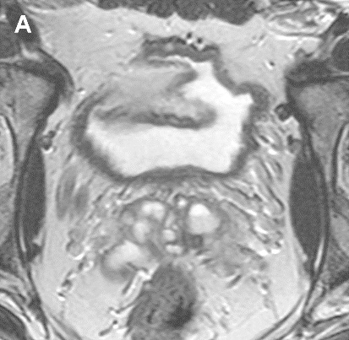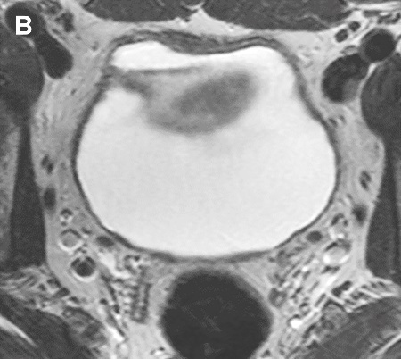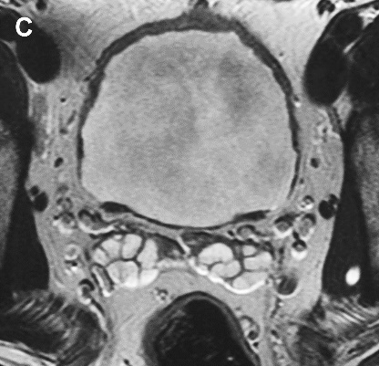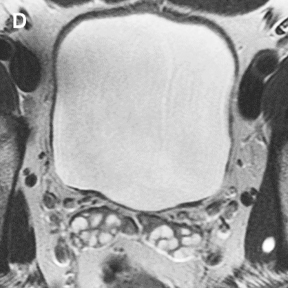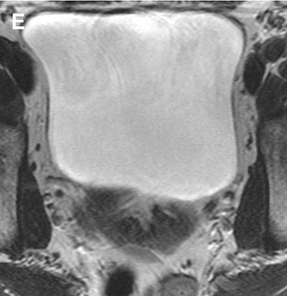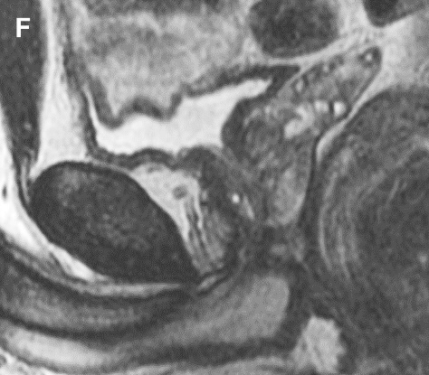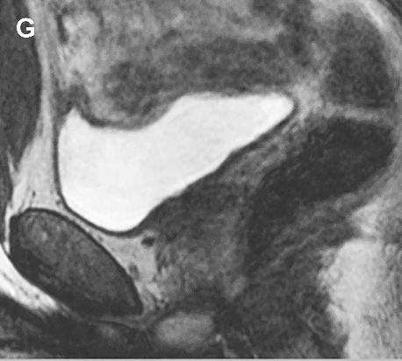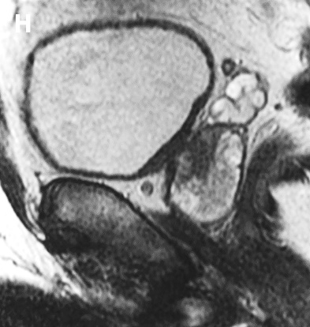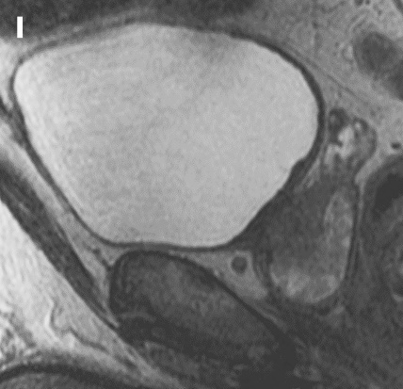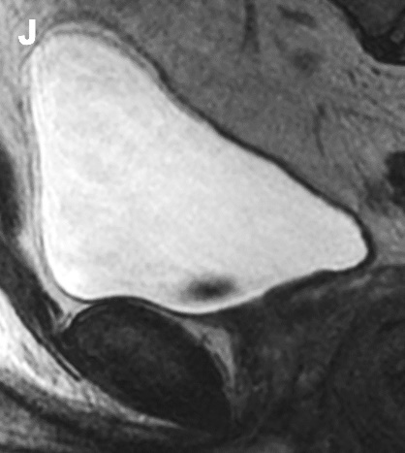
Figure 1. a-j. Axial (a-e) and sagittal (f-j) T2WI MR images representing bladder distention (BD) scores 1 (a, f), 2 (b, g), 3 (c, h) 4 (d, i), and 5 (e, j).
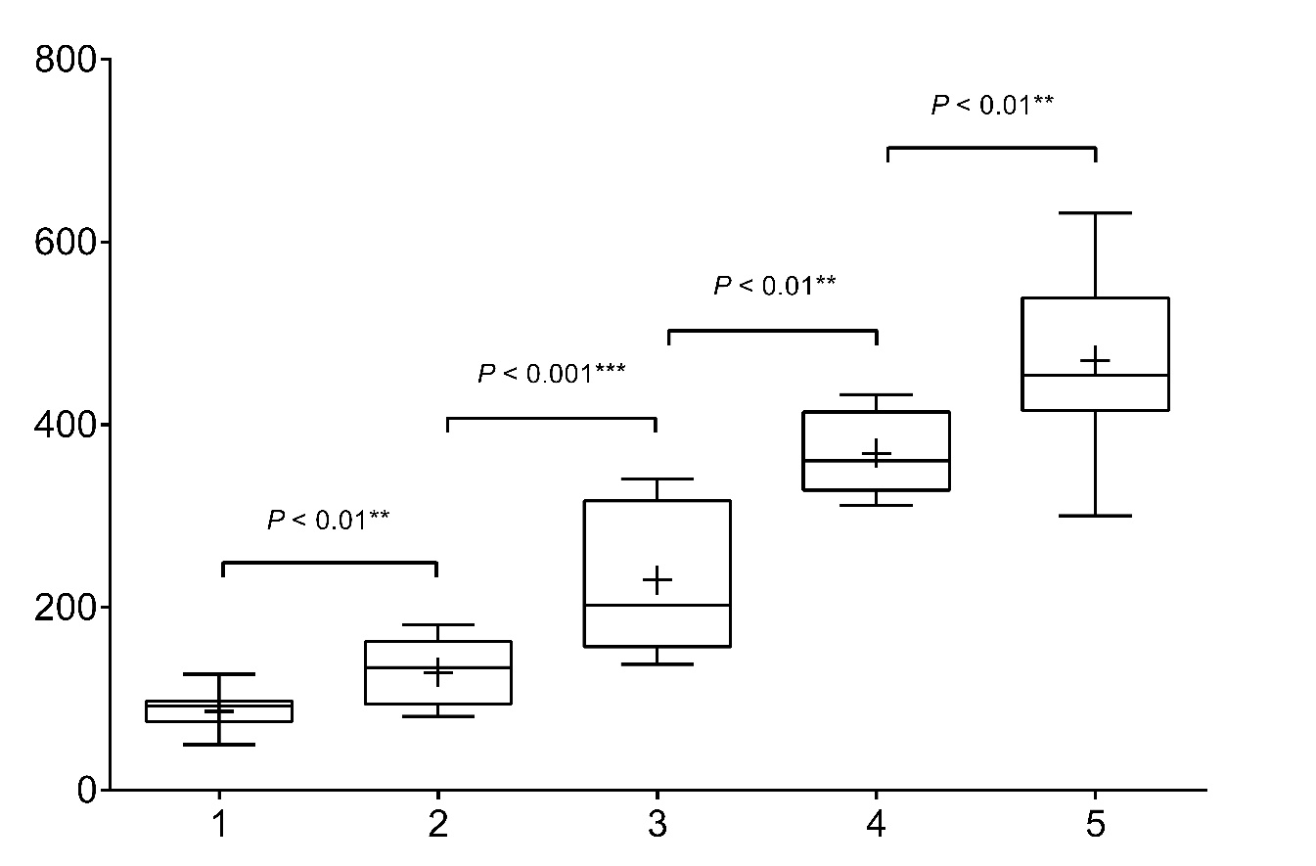
Figure 2. Box and whisker plots of bladder volumes in each of the five score groups in the normal volunteers study. Top and bottom of boxes represent 25th and 75th percentiles of data, X in boxes represents mean, with line representing median value and bars representing data within minimal to maximal values. p values are shown for intergroup comparisons, *P < 0.05, **P < 0.01, ***P < 0.001.
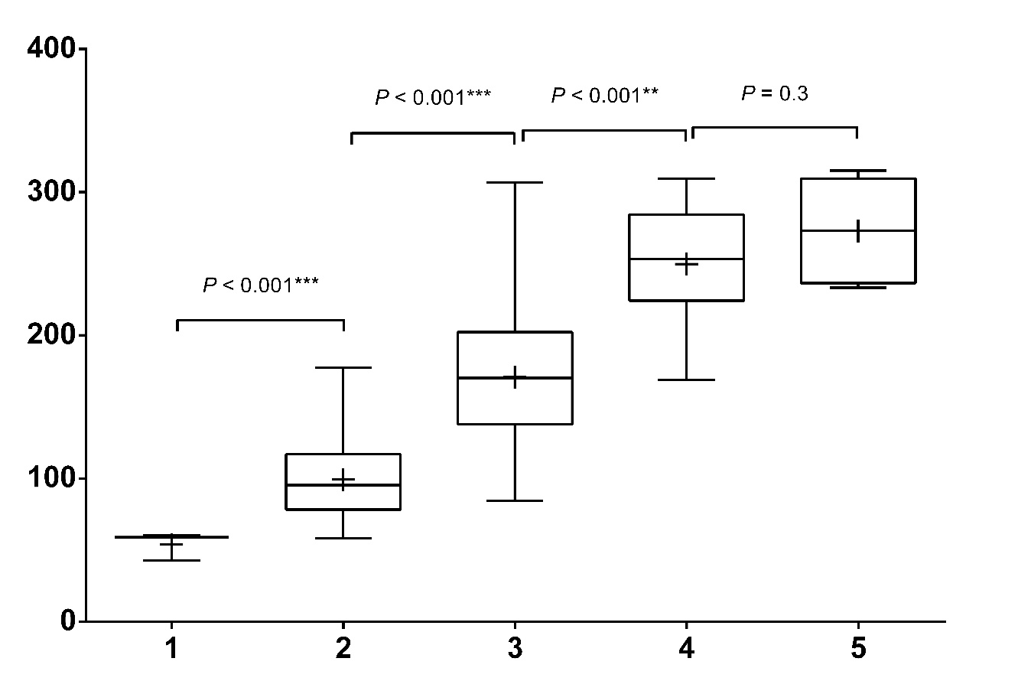
Figure 3. Box and whisker plots of bladder volumes in each of the five score groups in the questionnaire study. Top and bottom of boxes represent 25th and 75th percentiles of data, X in boxes represents mean, with line representing median value and bars representing data within minimal to maximal values. p values are shown for intergroup comparisons, *P < 0.05, **P < 0.01, ***P < 0.001.
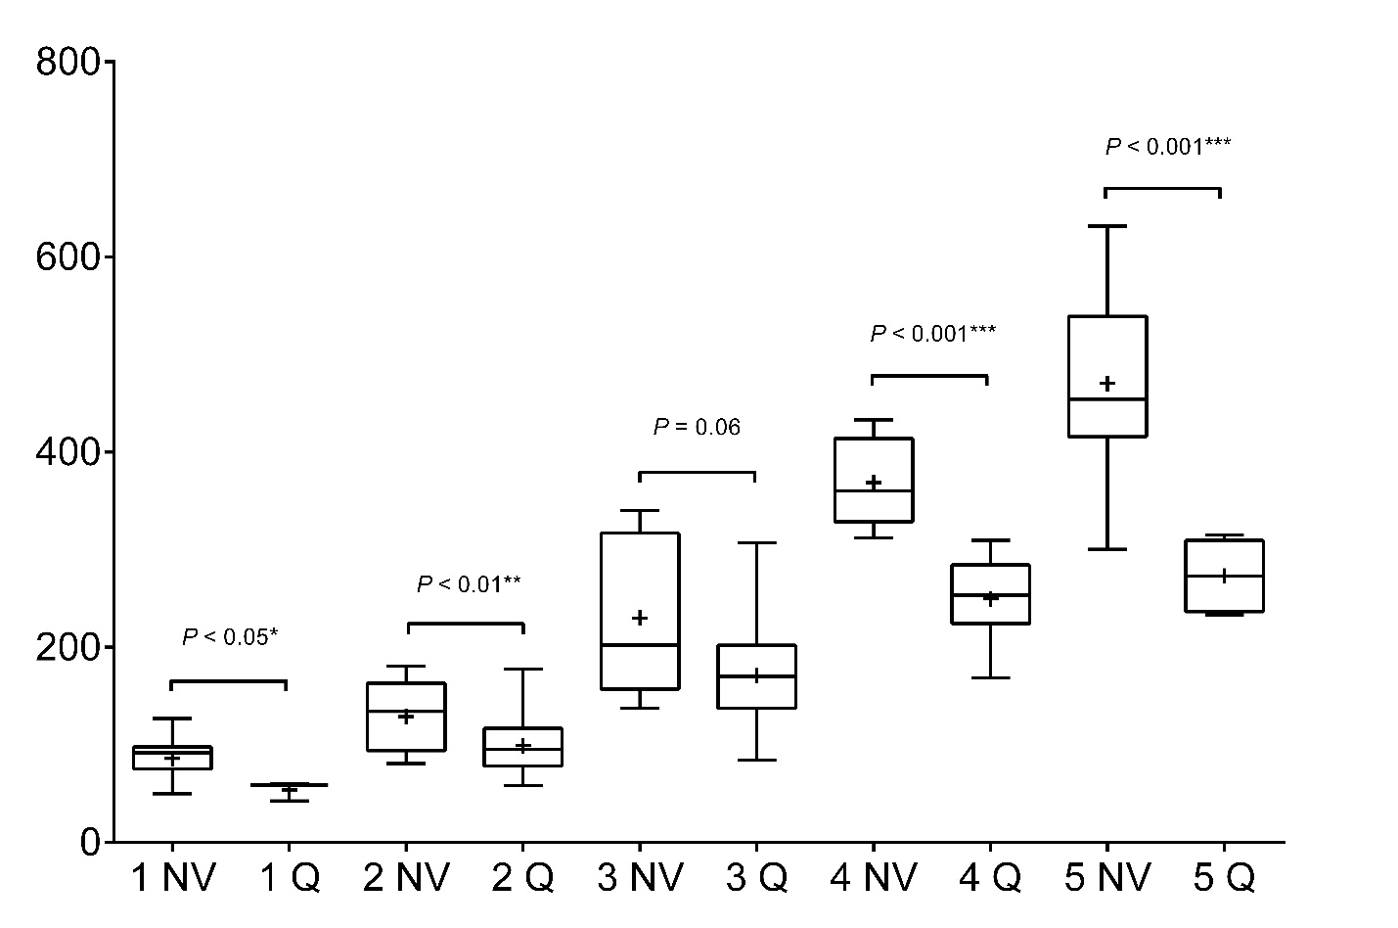
Figure 4. Box and whisker plots of bladder volumes in each of the score groups in both normal volunteers (NVs) and questionnaire (Q) studies. Top and bottom of boxes represent 25th and 75th percentiles of data, X in boxes represents mean, with line representing median value and bars representing data within minimal to maximal values. p values are shown for intergroup comparisons, *P < 0.05, **P < 0.01, ***P < 0.001.

Tables
Table 1. Summary of patients enrolled in the questionnaire study.
Group | Last voiding, hours | Last drink, hours | Corresponding preparation in the normal volunteers study
1 | 2 | 2 | 1
2 | 1 | 2–4 | 2
3 | 1 | 1–2 | 3
4 | 1 | 1–2 | 4

Table 2. Summary of the bladder distention scores in the normal volunteers subjected to different drinking/voiding preparations. Scores of patients whose scans were performed before 11am (early morning) are highlighted in grey. The mean bladder distention scores were calculated assuming that 1 = 5 = 1, 2 = 4 =2, 3 = 3.
Patient | All |  |  |  | Early morning |  |  |  | After 11.00 am
Patient | Prep 1 | Prep 2 | Prep 3 | Prep 4 | Prep 1 | Prep 2 | Prep 3 | Prep 4 | Prep 1 | Prep 2 | Prep 3 | Prep 4
1 | 2 | 1 | 2 | 1 |  |  |  | 1 | 2 | 1 | 2
2 | 2 | 1 | 2 | 5 |  | 1 | 2 | 5 | 2
3 | 1 | 2 | 1 | 1 |  |  |  | 1 | 1 | 2 | 1
4 | 3 | 2 | 5 | 2 |  |  |  | 2 | 3 | 2 | 5
5 | 1 | 2 | 2 | 1 | 1 |  | 2 | 1 |  | 2
6 | 3 | 1 | 5 | 4 |  | 1 | 5 |  | 3 |  |  | 4
7 | 2 | 1 | 2 | 4 |  |  |  |  | 2 | 1 | 2 | 4
8 | 3 | 2 | 5 | 5 |  |  |  |  | 3 | 2 | 5 | 5
9 | 3 | 4 | 4 | 5 |  |  |  |  | 3 | 4 | 4 | 5
10 | 3 | 1 | 2 | 2 |  |  |  | 2 | 3 | 1 | 2
11 | 3 | 2 | 4 | 4 |  |  |  |  | 3 | 2 | 4 | 4
12 | 4 | 3 | 5 | 5 |  |  |  |  | 4 | 3 | 5 | 5
13 | 5 | 3 | 2 | 5 |  |  |  | 5 | 5 | 3 | 2
14 | 5 | 1 | 2 | 2 | 5 | 1 | 2 | 2
15 | 3 | 5 | 5 | 5 |  |  |  |  | 3 | 5 | 5 | 5
Score, mean (±SD) | 2.2 (±0.9) | 1.7 (±0.7) | 1.6 (±0.5) | 1.4 (±0.5) | 1  (±0) | 1  (±0) | 1.8 (±0.5) | 1.4 (±0.5) | 2.4 (±0.8) | 1.8 (±0.7) | 1.6 (±0.5) | 1.4 (±0.5)

SD – standard deviation.

Table 3. Summary of the bladder distention scores and bladder volumes in the normal volunteers and patients subjected to different drinking/voiding preparations at different times of the day. The bladder distention scores are presented as the mean (± SD); the bladder volumes (mm³) are presented as the median (IQR) where IQR is the interquartile range.
Subjects | Normal volunteers |  |  |  |  |  |  | Patients
BD score | 1 | 2 | 3 |  | 4 |  | 5 | 1 | 2 |  | 3 |  | 4 |  | 5
Overall bladder volume | 91.9  (75.4–  97.8) | 134.2  (94.3–163.0) | 202.4  (157.0–317.0) |  | 350.6 (328.6–414.2) |  | 454.2 (415.8–539.1) | 59.0  (42.7–60.1) | 95.4  (78.3–117.0) |  | 170.3  (137.9–202.3) |  | 253.4  (224.2–284.4) |  | 273.2 (236.5–309.6)
Preparation type | 1 | 2 |  | 3 |  | 4 |  | 1 |  | 2 |  | 3 |  | 4
Overall BD score | 2.2 (±0.9) | 1.7 (±0.7) |  | 1.6 (±0.5) |  | 1.4 (±0.5) |  | 2.3 (±0.7) |  | 2.6 (±0.6) |  | 2.3 (±0.6) |  | 2.5 (±0.6)
BD score,  early  morning | 1 (±0) | 1 (±0) |  | 1.8 (±0.5) |  | 1.4 (±0.5) |  | 2 (±0.5) |  | N/A |  | 2.3 (±0.7) |  | 2.6 (±0.5)
Bladder volume,  early  morning | 175.1  (49.9–300.3) | 75.4  (61.6–97.8) |  | 90.9  (82.4–351.3) |  | 106.5  (80.1–361.0) |  | 95.4  (67.3–115.8) |  | N/A |  | 139.7  (100.4–216.3) |  | 179.7  (152.2–203.4)
BD score, afternoon | 2.4 (±0.8) | 1.8 (±0.7) |  | 1.6 (±0.5) |  | 1.4 (±0.5) |  | 2.5 (±0.7) |  | 2.6 (±0.5) |  | 2.3 (±0.6) |  | 2.3 (±0.7)
Bladder volume, afternoon | 170.6  (123.4–333.4) | 136.8  (109.6–245.9) |  | 344.0  (170.5–433.1) |  | 451.7  (328.6–531.5) |  | 123.9  (96.0–196.2) |  | 105.9  (80.9–161.9) |  | 153.8  (108.2–230.3) |  | 135.8  (80.2–206.6)

SD – standard deviation; BD – bladder distention.

References
[1] Antoni S, Ferlay J, Soerjomataram I, Znaor A, Jemal A, Bray F. Bladder Cancer Incidence and Mortality: A Global Overview and Recent Trends. Eur Urol 2017;71(1):96–108.
[2] Ficarra V, Dalpiaz O, Alrabi N, Novara G, Galfano A, Artibani W. Correlation between clinical and pathological staging in a series of radical cystectomies for bladder carcinoma. BJU Int 2005;95(6):786–90.
[3] Svatek RS, Shariat SF, Novara G, Skinner EC, Fradet Y, Bastian PJ, et al. Discrepancy between clinical and pathological stage: external validation of the impact on prognosis in an international radical cystectomy cohort. BJU Int 2011;107(6):898–904.
[4] Woldu SL, Bagrodia A, Lotan Y. Guideline of guidelines: non-muscle-invasive bladder cancer. BJU Int 2017;119(3):371–80.
[5] Babjuk M, Bohle A, Burger M, Capoun O, Cohen D, Comperat EM, et al. EAU Guidelines on Non-Muscle-invasive Urothelial Carcinoma of the Bladder: Update 2016. Eur Urol 2017;71(3):447–61.
[6] Matulewicz RS, Sharma V, McGuire BB, Oberlin DT, Perry KT, Nadler RB. The effect of surgical duration of transurethral resection of bladder tumors on postoperative complications: An analysis of ACS NSQIP data. Urol Oncol 2015;33(8):338.e19–24.
[7] Zainfeld D, Daneshmand S. Transurethral Resection of Bladder Tumors: Improving Quality Through New Techniques and Technologies. Curr Urol Rep 2017;18(5):34.
[8] de Haas RJ, Steyvers MJ, Futterer JJ. Multiparametric MRI of the bladder: ready for clinical routine? AJR Am J Roentgenol 2014;202(6):1187–95.
[9] Abraham MK, Viswanath N, Ramakrishnan P, Bindu S, Kedari P, Naaz A, et al. Intravesical pressure: A new prognostic indicator in congenital diaphragmatic hernia. J Indian Assoc Pediatr Surg 2011;16(4):129–31.
[10] Verma S, Rajesh A, Prasad SR, Gaitonde K, Lall CG, Mouraviev V, et al. Urinary bladder cancer: role of MR imaging. Radiographics 2012;32(2):371–87.
[11] Green DA, Durand M, Gumpeni N, Rink M, Cha EK, Karakiewicz PI, et al. Role of magnetic resonance imaging in bladder cancer: current status and emerging techniques. BJU Int 2012;110(10):1463–70.
[12] Woo S, Suh CH, Kim SY, Cho JY, Kim SH. Diagnostic performance of MRI for prediction of muscle-invasiveness of bladder cancer: A systematic review and meta-analysis. Eur J Radiol 2017;95:46–55.
[13] Panebianco V, Barchetti F, de Haas RJ, Pearson RA, Kennish SJ, Giannarini G, et al. Improving Staging in Bladder Cancer: The Increasing Role of Multiparametric Magnetic Resonance Imaging. Eur Urol Focus 2016;2(2):113–21.
[14] Barentsz JO, Ruijs SH, Strijk SP. The role of MR imaging in carcinoma of the urinary bladder. AJR Am J Roentgenol 1993;160(5):937–47.
[15] Siroky MB. The Aging Bladder. Rev Urol 2004;6(Suppl 1):S3–7.
[16] Fujioka C, Ishii K, Yamanaga T, Ogino R, Kishimoto S, Kawamorita R, et al. Optimal bladder volume at treatment planning for prostate cancer patients receiving volumetric modulated arc therapy. Pract Radiat Oncol 2016;6(6):395–401.
[17] Bottin JH, Lemetais G, Poupin M, Jimenez L, Perrier ET. Equivalence of afternoon spot and 24-h urinary hydration biomarkers in free-living healthy adults. Eur J Clin Nutr 702016. p. 904–7.
[18] Asplund R, Aberg H. Diurnal variation in the levels of antidiuretic hormone in the elderly. J Intern Med 1991;229(2):131–4.
[19] Erlich A, Zlotta AR. Treatment of bladder cancer in the elderly. Investig Clin Urol
2016;57(Suppl 1):S26–35.

