High-Throughput and Consistent Production of Aqueous Suspensions of Single-Wall Carbon Nanotubes
Nicolò Chiodarelli*, Michael De Volder*
Department of Engineering, Institute for Manufacturing, University of Cambridge
17, Charles Babbage Road, CB3 0FS, Cambridge (UK)
KEYWORDS: Carbon Nanotubes, Suspensions, Colloids, Continuous Flow, nanoparticle ink.
ABSTRACT
Understanding how to produce concentrated Carbon Nanotube (CNT) suspensions at high-throughput is key for the production of CNT-based products, as these allow for a straightforward integration of CNT powders in a variety of applications. In this work, we present three important developments for the production of aqueous suspensions using Single-Wall CNT and sodium dodecyl sulfate (SDS) as a dispersing surfactant: a reliable protocol to improve the reproducibility of CNT-SDS suspensions; a model describing how the CNT concentration evolves during sonication; a continuous-flow system allowing to upscale the production of suspensions. Combined, these findings pave the way for a deterministic production of CNT suspensions at high-volume, which is important for the manufacturing of advanced CNT devices.

- INTRODUCTION
With the development of scalable and cost-effective manufacturing processes for Carbon Nanotubes (CNT), the transition from proof-of-concept CNT-based devices and materials to their adoption in large volume applications is advancing rapidly^{1,2}. To date, the uptake of CNT in industrial applications is mainly relying on classic manufacturing equipment¹, as these are well-understood, scalable, and allow leveraging existing capital investments. One particularly successful strategy for CNT integration is to suspend mass-produced commercial CNT powders in liquids, as it allows using conventional low-cost processes such as: ink-jet printing, spray coating, spin coating, and screen printing⁵. However, on the one hand a wide adoption of this approach has been hindered by the lack of reliable large volume suspensions production. On the other hand, the CNT coatings produced by this method consist of tangled networks, thus exhibit performances far below those achievable if the CNT were aligned and densely-packed. Nevertheless, recent scientific insights^{10,11,12} have shown that CNT can be aligned in suspension, for instance by increasing their concentration to induce a liquid crystalline aligned phases^{13,14}. We therefore believe that gaining better understanding on the production of concentrated CNT suspensions at large-scale offers benefits for both existing CNT manufacturing processes and future applications requiring better control over the CNT alignment¹⁵.
Ideally, for making dispersions from CNT powders, the powders must be disentangled at the highest rate possible, without damaging the CNT, and using a minimal amount of surfactant. To optimize the surfactant concentration, we initially followed a ‘standard’ CNT dispersion procedure, in which stock CNT powder, surfactant, and water are weighed, mixed, sonicated and centrifuged. Despite care in the preparation, no clear trends were obtained due to inconsistencies and poor reproducibility in our batches of solutions. Therefore, we identified a new protocol that yields reproducible and consistent results, independent from the inherent variability in the CNT stock material (e.g. powders containing CNT clumps that do not disentangle, etc). We focused on sodium dodecyl sulfate (SDS) as a surfactant because it is one of the most-widely used, it is one of the first adopted for making CNT suspensions³³ and, being so well-studied, it provides an excellent reference for comparing the results to the ample literature available although it is known for not being the most effective in terms of its ability to disperse CNT.
Several authors attempted to determine the SDS/CNT phase diagram and to deduce an optimal SDS/CNT weight ratio from it. For instance: the work of Vigolo¹⁹ on spun CNT fibers suggests a ratio of SDS/CNT = 3:1 (0.35wt.% CNT; 1.0wt% SDS). Coleman²⁰ et al. propose a value of SDS/CNT = 4:1 (0.5wt.% CNT; 2wt.% SDS) but for a different CNT source. Grossiord²¹ et al. suggest an optimum at SDS/CNT = 1.7:1 whereas Kornev²² et al. claim having not being able to reproduce the SDS/CNT phase diagram at high loadings. The variety of conditions used to ascertain the phase diagram, and thus the difficulty in identifying an optimal formulation for making SDS/CNT solutions, was captured very clearly by Duan²³ et al. who pointed out that in thirteen publications analyzed the range of CNT/SDS was as wide as 1:1 - 1:2000. What further complicates the comparison of publications is the variability in: the CNT starting material, the equipment used for disentangling it and the methods to assess the quality of the CNT suspension. The later varies from camera pictures or microscope images^{19,20} of CNT clumps, to UV-Vis absorption²¹.
The phase diagram is often correlated to the density of surfactant’s molecules on the surface of a CNT, in analogy to what observed at a microscopic level for SDS on a graphite surface¹⁷. However, the packing configuration is somehow unclear, as ordered hemi-cylindrical micelles²⁴ as well as disordered arrangements²⁵ have been observed, possibly because of the different surfactant’s concentration used in these studies. Nevertheless, the values of coverage reported²⁶ tend to 2 – 3 SDS molecules/nm², which corresponds to a SDS/CNT ratio of 1.2 – 1.8, i.e. in line with some experimental reports.
These studies have led to more robust and well-detailed processing and characterization protocols^{27, 28}, for instance: the introduction of metrics²⁷ to evaluate the quality of CNT dispersions (yet provided CNT with a diameter distribution narrow enough to display peaks in the UV-Vis spectrum) and the adoption of a centrifugation step²⁸ to purify the solution from clumps and large bundles. As a result, a feature common to SDS/CNT suspensions emerged more clearly, such as the sigmoidal shape²⁹ of the CNT/SDS phase diagram for a given CNT loading. More specifically, the CNT concentration (measured by optical absorbance at a specific wavelength) in function of the SDS concentration steeply rises at about 1x the Critical Micelle Concentration (CMC) for then levelling off to a plateau^{20,26 ,29} in the range of 5x – 10x CMC. Strano¹⁶ et al. found that a minimum amount of surfactant must be present in solution to sustain the ‘unzipping’ mechanism that governs the de-bundling of CNT, and indeed located its value close to 1x CMC (for SDS). Interestingly, the amount of SDS needed to coat the surface of a CNT completely is 0.5x CMC according to molecular dynamics³⁰. On the other extreme, SDS concentrations greater than 5x – 10x CMC are often undesirable because the solution tends to destabilize due to depletion interactions^{19,20}.
The sonication time also plays a critical role in the CNT concentration. Indeed, the CNT concentration rapidly increases in the very first minutes of sonication before gradually reaching a plateau²¹ after 5min – 30min, depending on the sonication energy applied. However, the information to reproduce results is almost often never available, as related to the cavitation activity in the solution³². Measuring the cavitation characteristics directly requires a sonotrode^{31,32} and a detailed description of the boundary conditions such as: the geometry of the vessel, the depth and position of the tip, the amplitude of the pressure waves in the container, their frequency, etc. In practice, an exact replica of the sonication condition is out of the scope, and the processing parameters of interest are the duration of sonication, i.e. the time is takes to reach a plateau in the CNT concentration, and the eventual side-effect of damaging the tubes for a given setup.
In this work, we present three important advancements for the production of Single-Wall CNT (SWCNT) suspensions. The first is a protocol to make aqueous SWCNT/surfactant suspensions in a highly reproducible way. The protocol allows reproducing the CNT/SDS phase diagram in a wide range, below and above 1x CMC, and has been optimized to yield reproducible results thus overcoming any inconsistency often observed when dispersing CNT. Secondly, the reliability of the protocol allowed us to obtain very well-defined time-dynamics (i.e. the evolution of CNT concentration vs. time) for different initial process conditions, and thus to describe them through a mathematical model using only two parameters. More specifically, we show that the CNT concentration evolves as a simple exponential equation with a characteristic time that captures the effectiveness of the process. Finally, we transferred our process from small-volumes (tens of milliliters) to a continuous-flow set-up allowing to upscale the production of SWCNT suspensions to larger volumes (hundreds of milliliters). To our knowledge, this is the first time that data on the production of large volumes of CNT/SDS solutions with a continuous-flow system has been reported. When used in combination with our preparation protocol, the system yields predictable trends, confirming the possibility to upscale a production process using a set of simple rules. Combined, these three achievements pave the way for a deterministic production of CNT suspensions at high-volume and yield, which is an important step for manufacturing advanced CNT products at scale.

- MATERIALS AND METHODS
SWCNT (95% purity - TNST) powders are purchased from Timesnano Chengdu Organic Chemicals. According to the datasheet, these CNT have diameters <2nm, lengths of 5 – 30um and few impurities (98% Carbon, 0.89% Oxygen, 0.03% Molybdenum, 0.11% Cobalt). Sodium Dodecyl Sulfate (SDS) >98% GC is purchased from Sigma-Aldrich. All chemicals have been employed as supplied, using DI water of analytical grade (Fisher Chemical).
The experimental conditions have been selected to yield isolated data points, thus clear trends. Specifically, the SDS concentration spans from 0.125mg/ml to 10mg/ml, which is well centered around the CMC of the surfactant^{[17]} (CMC_{SDS}=2.36mg/ml or 8.1mM, which is within the range specified by the manufacturer: 7mM – 10mM). The CNT loadings vary from 0.025mg/ml to 2.5 mg/ml.
Sonication was performed using a L500 sonicator from Sonic Systems (500 Watts) operating at 20kHz and equipped with a 5mm Titanium tip. Our flow-through glass cell is a custom-made design from Sonic Systems and has a capacity ~100ml. The peristaltic pump is an ISM404B model from Ismatec equipped with a WZ-78002-20 quick-change head, connected to silicon tubes (from Ismatec too). Homogenization was performed on an IKA Ultra-Turrax T25 homogenizer operating at 9500 rpm. Centrifugation was performed in an Allegra centrifuge equipped with a rotor and run at 5000rfp for 2h30.
Thermogravimetric analysis (TGA) was performed using a Perkin Elmer Pyris 1 system connected to a gas bottle of synthetic air consisting of a mixture of pure N₂ and O₂. The measurements were conducted at 3°C/min up to 800°C, i.e. well above the burning point of CNT. Raman spectroscopy was performed with an EZRaman-N-532-B1S spectrometer working at fixed excitation laser wavelength, 532nm, and offering a nominal spectral resolution of 7cm⁻¹.
UV-Vis absorption was measured using a Perkin Elmer Lambda 750 spectrometer in a double-beam configuration. Measurements were in the scanned wavelengths of 300nm-750nm, with a beam slit of 3nm. Disposable cuvettes with light path l=4mm were used. The cuvette containing a sample of CNT solution to test was placed in the path of the main beam, whereas a reference cuvette containing an H₂O/SDS solution at 0.5wt.% was placed in the path of the second beam. In a double-beam configuration all UV-Vis measurements refer to the differential signal between the two beams, so any contribution due to the presence of SDS in solution is subtracted or much reduced.
The protocol to produce our samples is depicted in Figure 1. To explored the effect of varying the surfactant’s concentration over two orders of magnitude, we produced two stocks of SDS/H₂O solution at different concentration: 2wt.% and 0.25wt.%, respectively. In a separate 22ml vial, 10ml of 0.25wt.% SDS solution are added to 50mg of CNT. This raw CNT/SDS mixture is homogenized for 60min at 9500rpm (Figure 1b) to break large CNT clusters into seemingly uniform small particulates. The obtained black solution is then used immediately to produce batches of samples. Each sample in a batch is obtained by mixing aliquots of the homogenized CNT/SDS solution with specific volumes of the 0.25wt.% or 2wt.% SDS stock solutions and DI-water (Fig. 1c) so to adjust the concentration of SDS and CNT independently to the desired level. We found that by using the homogenized CNT/SDS stock solution instead of weighting a specific amount of CNT powder for each sample, we could produce uniform and much more reproducible dispersions. Each sample is then sonicated with a tip-sonicator, the processing time and conditions are discussed further on.
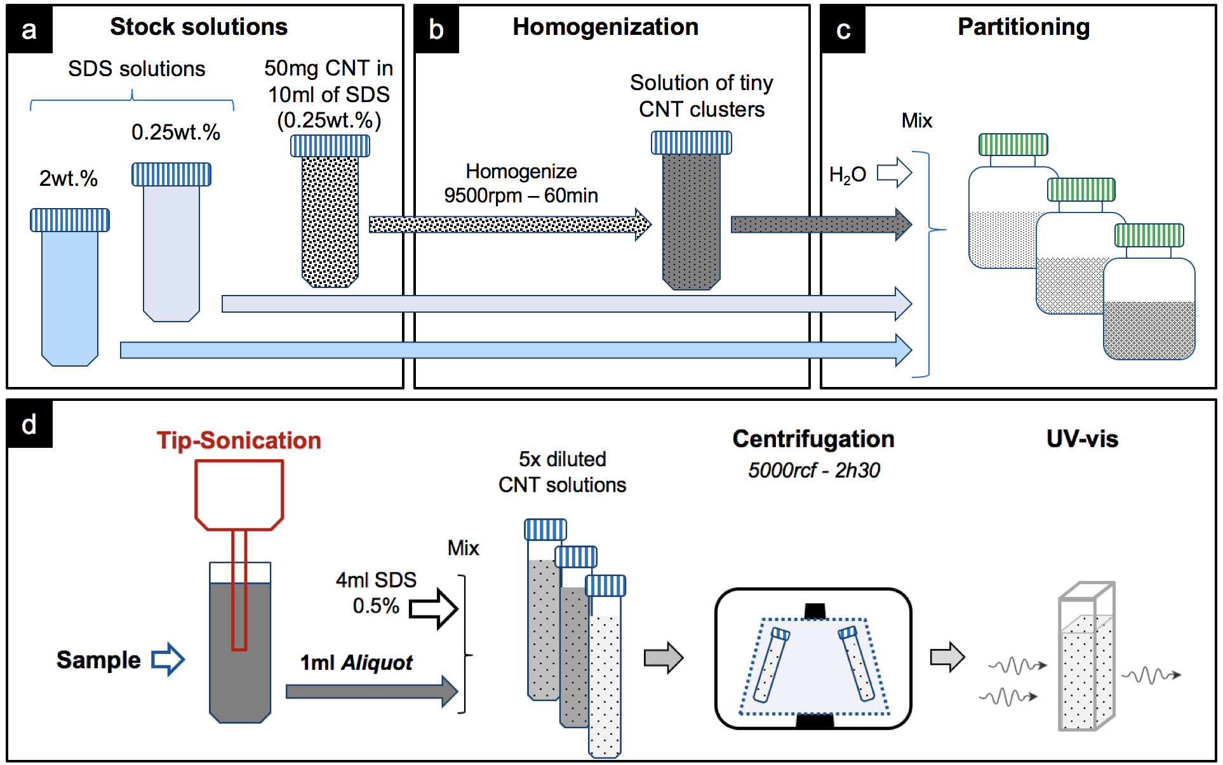
Figure 1: Preparation protocol for repeatable CNT suspensions: a) Formulation of stock solutions at high (2wt.%) and low (0.25wt.%) SDS concentration, and of a 10ml CNT/SDS(0.25wt.%) solution with 50mg of CNT powders; b) Homogenization of the CNT/SDS stick; c) Batch preparation by mixing aliquots of: CNT/solution, the stock SDS solution (either at 2% or 0.25%) and H₂O to tune the concentration of CNT and SDS independently; d) Processing of CNT solutions via tip-sonication and characterization of their supernatant by UV-Vis after dilution and centrifugation.
To characterize the samples, 1ml of sonicated CNT suspension was first diluted five times by adding 4ml of SDS 0.5%, then centrifuged at 5000rcf for 2h30min to remove the largest CNT clusters. Right after completion, 2ml of supernatant were extracted and placed in cuvettes for UV-Vis spectroscopy.
The absorbance of the supernatant at 500nm wavelength is used as a figure to benchmark samples and infer the most effective conditions to exfoliate CNT. According to Beer-Lambert law, light’s absorbance A=e·l·C is related to the concentration of species in solution C, to the extinction coefficient e, and the optical path l. As long as this law holds, i.e. for fairly transparent solutions, the ratio of absorbance of two solutions equals the ratio in their CNT concentration: A₁/A₂ = C_{CNT},₁/C_{CNT,2} ; at least under the assumption that the extinction coefficient is identical for both solutions. These conditions are verified in our case since the samples are all made from the same batch of CNTs and are all diluted for characterization, which keeps the absorbance within the linearity range of Beers-Lambert’s law and of the detector of our spectrometer. We also verified that the contribution of SDS to the measured absorbance is negligible. The absorbance of SDS is well below the reported values for CNTs: only 0.01A for concentrated solution of 2wt.% SDS. Any residual contribution is further reduced as we use a vial with SDS for the reference beam of the spectrometer.

- EXPERIMENTAL RESULTS
To provide the reader a full picture on the quality of CNT feedstock used in this work and on the characteristics of the CNT in solution, we anticipate here our characterization results. The TGA data of the SWCNT powder (i.e. without surfactant) shown in Figure 2a indicate an initial mass loss of 15% before reaching the inset of CNT burning at a temperature of ~520°C. At 400°C we observe a weight reduction of less than 10%, which is in accordance to the 95% purity specified by the supplier. Further, no residual weight was found above 650°C, indicating there is no detectable amount of catalyst particles in the powder.

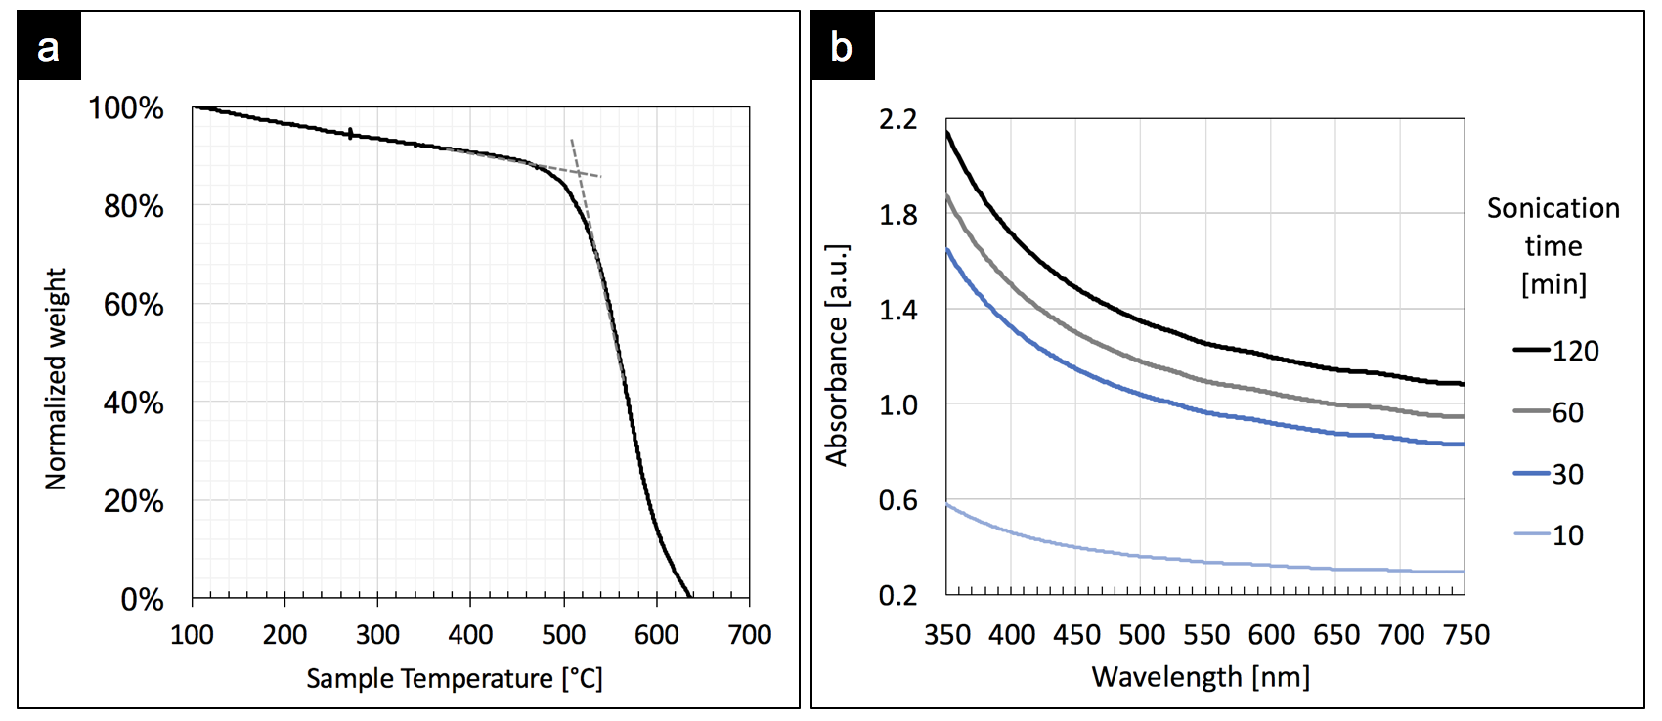
Figure 2: a) TGA of raw SWCNT powder (1.2mg) in air at 3°C/min; b) UV-Vis spectra of the purified SWCNT/SDS solution processed at different sonication time (1mg SWCNT/ml).

Figure 2b shows the typical UV-Vis spectra of the SWCNT/SDS solutions in the 350-750nm wavelength range. The absorbance curves decreasing monotonically and do not exhibit any isolated peak in the 350nm-700nm region due to the S22 and M11 resonant transitions of SWCNT. The lack of distinctive features at any specific wavelength is indicative of the presence of CNT of various sizes and typologies, either as individuals or eventually also as small bundles. Yet, the UV-vis absorbance can still be used as a valid metric representative the total amount of material dispersed in solution^{[20,21,29]}.
At first, we investigated the effect of sonication for solutions containing different surfactant concentrations. The SDS concentration was controlled at the formulation step by diluting samples of the stock SDS solution with aliquots of water up to a final volume of 20ml (Figure 1 - step 3). We prepared three batches corresponding to an initial CNT loading of 0.25mg/ml, 0.125mg/ml and 0.05mg/ml, respectively. For 20ml vials, these values correspond to a CNT mass of 5.0mg, 2.5mg and 1.0mg, respectively. All the samples were sonicated for 10min, centrifuged and characterized as previously described.
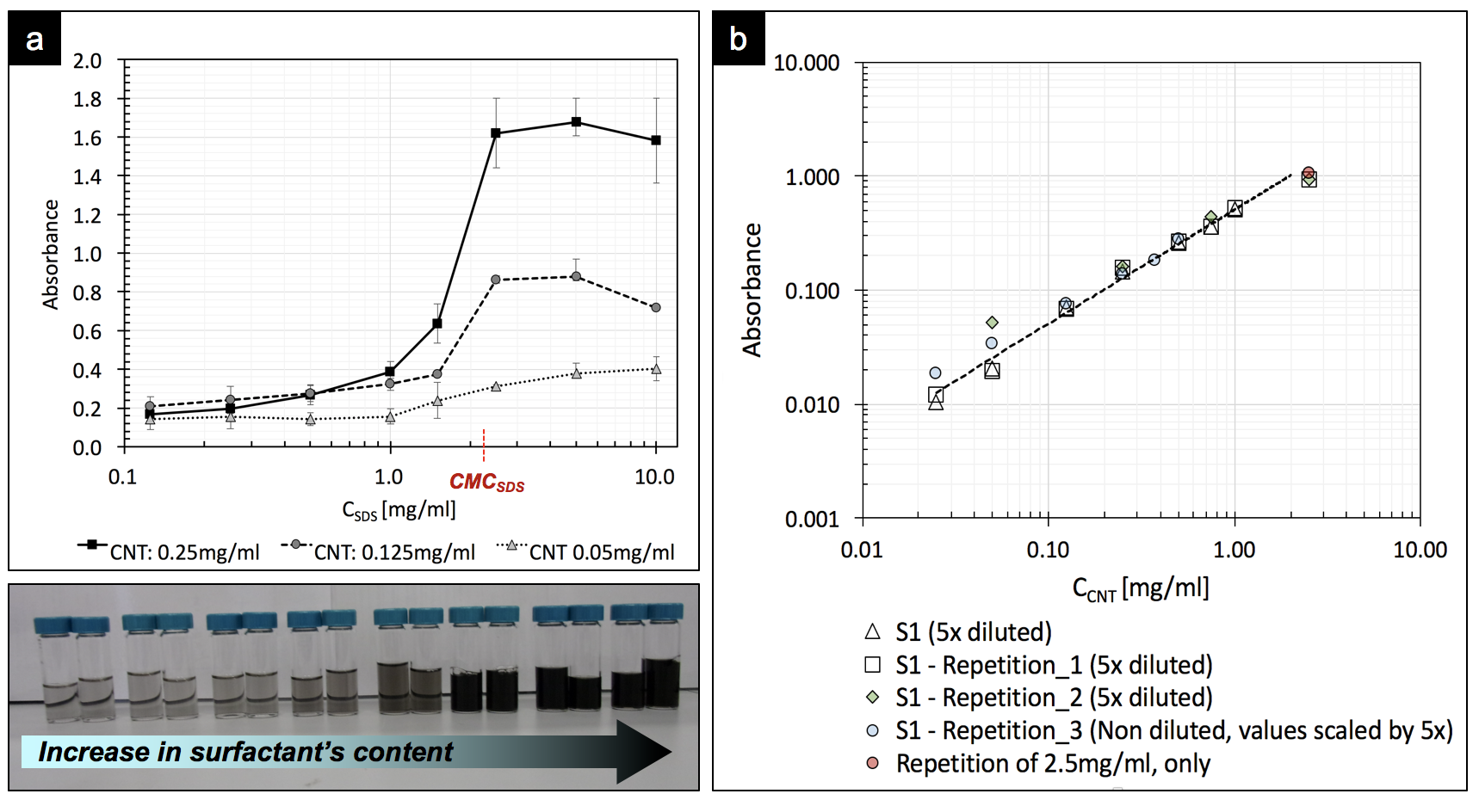
Figure 3: a) Absorbance of the supernatant in function of the initial surfactant concentration for three batches at different CNT loadings. Samples in each batch were prepared independently, and measured.
Error bars represent the max and min absorbance measured for each sample of the batch.
Bottom: visual appearance of the supernatant for 0.25mg/ml CNT loading.
b) Absorbance in function of initial CNT loading for several series of samples, all formulated with identical SDS concentration of 2x CMC. All samples were sonicated for 10min.
Visual inspection (Fig 4a) already indicates that higher surfactant concentrations result in darker, more concentrated CNT suspensions. As shown in Figure 3a, the absorbance curves have a sigmoidal profile, with an onset close to the surfactant CMC. Below this level, the solutions appear transparent, implying low CNT concentration. These features well agree with previously reported models¹⁴ stating that a minimum amount of surfactant is necessary to initiate the exfoliation of CNT, and that the inset for SDS adsorption on graphitic surfaces is at 1/4 of the CMC¹⁷. The onset of increase in absorbance, and thus of effective exfoliation, is near the CMC for all the curves in Figure 3a. As each curve corresponds to a substantially different amount of CNT, this is evidence that the trends are independent on the initial mass ratio of CNT and surfactant. Above the CMC, the absorbance tends to level off. Overall, we can infer that an initial surfactant concentration above the CMC is essential to guarantee a high exfoliation yield for practical uses, regardless of the mass ratio between the surfactant and CNT used for the suspension.
A second batch of experiments was prepared to study the effects of varying the amount of CNT at a given surfactant concentration. Figure 3b shows the absorbance of suspensions formulated using different CNT loadings, identical SDS concentrations equal to 2x CMC, and sonicated for 10min. The data evidence a clear correlation between absorbance and the initial CNT loading, indicating that solutions initially loaded with more CNT also turn out being more concentrated.
Remarkably, the trend in Figure 3b extends over two decades: from an initial CNT loading of 0.025mg/ml up to 2.5mg/ml. This is a wide range, considering that at high loadings the amount of surfactant in solution may become insufficient to sustain the progressive exfoliation of CNT. Indeed, during sonication, the suspension gradually depletes in free surfactant molecules as the fraction of surfactant adsorbed onto the CNT surface increases. For a SDS concentration twice the CMC we observe no evidence of such a limiting step, although this may change if the processing time is extended.
To verify whether this is the case, we extended the sonication time to: 10min, 30min, 60min, 120min in total. After each interval, an aliquot of 1ml was extracted from the sample and characterized accordingly to the protocol already described. As shown in Figure 4, the absorbance, and thus the CNT concentration, increases as sonication proceeds.
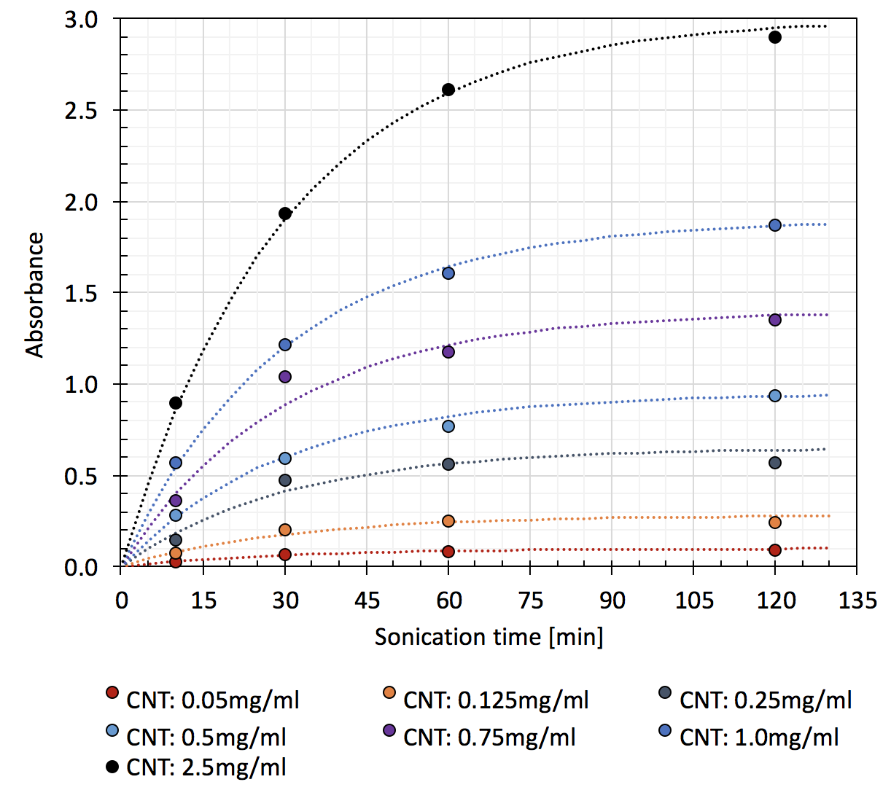
Figure 4: Absorbance of supernatant in function of sonication time. The experimental data (points) have been fitted by curves obtained using eq.1, with $τ$ = 30min and A_{f} values as reported in Figure 5. The legend reports the nominal CNT concentration. All samples contained a SDS concentration of 2x CMC.
We found the measured absorbance has an excellent fitting to eq.1, i.e. a solution of a first order differential equation, which requires only two fitting parameters: the asymptotic value A_{f} and a time constant $τ$ = 30min for all the curves; the latter with a standard deviation of 4min.

Eq.1: $A\left(t\right)=A_{f}\left(1-e^{-\frac{t}{τ}}\right)$

The term $\left(1-e^{-t/τ}\right)$ represents the fraction of suspended CNT after a specific time. This term applies to all the curves, implying that the fraction of exfoliated CNT as processing proceeds is identical, regardless of the mass of CNT used in sample’s formulation. Figure 5 reports the values of the asymptotic concentration A_{f} as a function of the initial CNT concentration. There is a clear linear correlation between the two, except possibly for the right-most point, which is slightly off the trend.
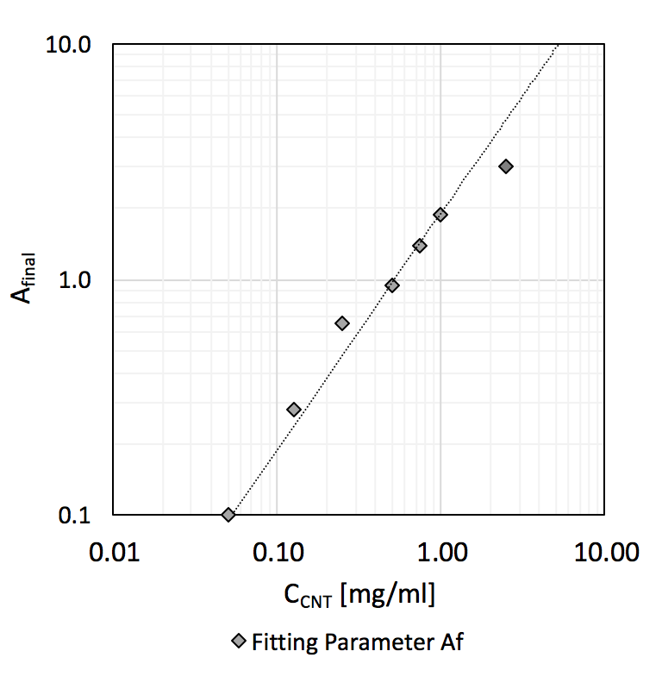
Figure 5: Asymptotical values of absorbance A_{f} for fitting the data in Figure 5 with eq.1 (R² = 0.98).
The impact of processing on the CNT characteristics was investigated by Raman spectroscopy. Specifically, we analyzed the residue left on the surface of a Si chips after drop-casting a droplet of CNT solution (i.e. the 5x diluted supernatant) each one processed for a different time interval.

Figure 6: Raman spectra of purified SWCNT/SDS solution processed at different sonication time. The spectra correspond to the 1mg/ml series in Figure 4. The insets report the G/D ratio and RBM modes in function of the sonication time. Error bars represent the max. and min. G/D value of measurements on three different spots on the supporting Si substrate
Figure 6 reports the Raman spectra for a batch with initial CNT concentration of 1mg/ml and processed for up to 2 hours. The spectra show a broad peak in the RBM region at 262 cm⁻¹ (inset, at the bottom) and no splitting^{[18]} in the G peak at ~1580 cm⁻¹ into two distinctive G+ and G- bands. Since the position of the latter depends on the CNT diameter, it is likely that the observed G peak results from the convolution of several overlapping sub-bands originating from CNT of different diameters. These observations on the RBM and G peaks indicate that the SWCNT have broad diameter’s distribution, ranging between 1nm and 2nm, as specified by the producer.
The possible introduction of damages in the CNT was assessed by monitoring the evolution of the G/D peak ratio for solution processed at different time intervals (top-right inset in Figure 6). Initially, after 10min of processing, the G to D peak ratio^{[18]} is ~45. This value, in combination with a barely visible D peak at 1340cm⁻¹, is indicative of tubes of high quality. Interestingly, the G/D progressively decreases as sonication proceeds, reaching a value of ~30 after two hours of sonication. Such a decreasing trend implies that sonication indeed introduces some additional structural defects in the CNT structure. Yet, we don’t consider such degradation as dramatic, since a final G/D~30 can be considered very acceptable considering, for instance, it is much higher than what one may achieve by growing forests of SWCNT by catalytic CVD under ordinary conditions.
From the above analysis, we conclude that our model perfectly captures the dynamic of a process to suspend SWCNT in a solution of small volume, and offering a low level of invasiveness (i.e. limited additional defects introduced).
The model developed for small volumes of solution in vials (eq.1) suggests that a similar approach could be used also to study the efficiency of the sonication process in the production of much larger quantities of CNT solution, which is important for industrial applications of CNTs.
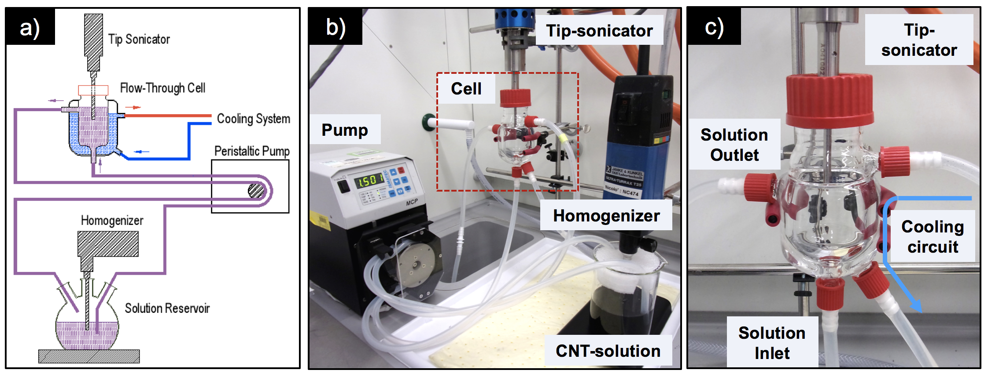
Figure 7: a) Schematic of our flow-through cell setup; b) Implementation of the actual set-up; c) Zoomed view of the flow-through cell.
For the production of CNT solutions at high-volume, we coupled our tip-sonicator to a jacketed flow-thought glass cell as show in Figure 7a and Figure 7b. The cell is connected to a peristaltic pump, which recirculates the solution from the cell to a reservoir at constant flow rate: Q_{pump}. The cell’s jacket is connected to a cooling system to stabilize the cell’s temperature. The setup is designed to work with at least 150ml of liquid, which accounts for the capacity of the cell (~100ml) plus the extra volume needed to fill the pipes and for proper suction and recirculation. Normally it is used at much larger volumes, depending on the reservoir employed. As shown in Figure 7, a homogenizer or stirrer can be used to ensure a good mixing and additional processing of the solution in the reservoir. In the following tests, we only stirred the solution to match the conditions tested in the vials.
We processed three batches of solution at large volume: 100ml 200ml and 500ml, all with a CNT loading of 0.5mg/ml and SDS concentration of 2x CMC. These conditions are representative of one of the curves in Figure 4 and correspond to an up-scaling factor of 10x in the content of SDS and in the mass of CNT: 50mg, 100mg and 250mg, respectively. Following the protocol developed for vials, batches of 10ml CNT/SDS (0.25%) each containing 50mg of CNT powders were homogenized at 9500rpm for 1h and mixed to proper aliquots of stock SDS solution and water so to reach the desired levels of concentration.
The 100ml solution was processed without recirculation, namely without the pump and the pipes connected, because the solution just filled the entire cell’s volume. For larger volumes, the pump was connected and operated at a flow-rate Q_{pump}=1000ml/min. Throughout the sonication process, 1ml aliquots of CNT solution were sampled from the reservoir at different intervals, then diluted, centrifuged and characterized accordingly to the procedure already described.
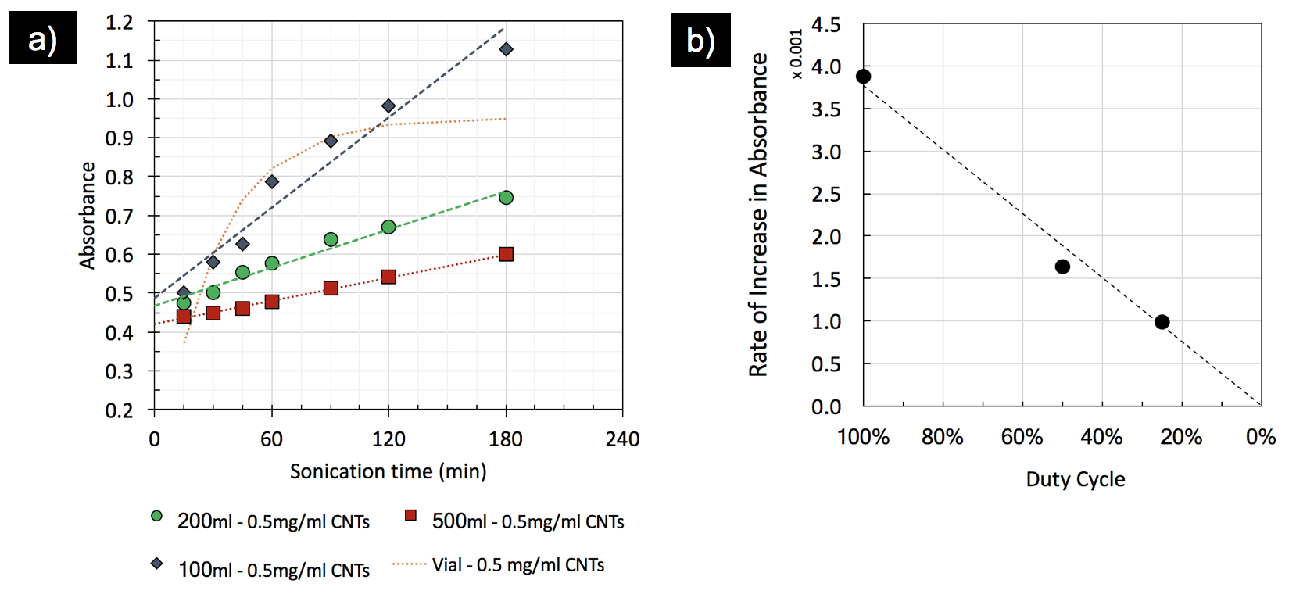
Figure 8: a) Experimental results for 100ml, 200ml and 500ml of CNT solution processed in the continuous-flow setup; the dotted line is representative of the process for vials with the same CNT concentration: 0.5mg/ml; b) Slope of the fitting lines in figure 5a in in function of the process’s duty cycle.
The curves in Figure 8a show the absorbance of the supernatant in function of the sonication time for the three solutions. The absorbance curves, thus the CNT concentration, evolve quite linearly as the sonication process proceeds. Their slope reduces as the solution’s volume increases, as expected from the fact that, in case of a greater volumes, the solution circulates for a longer time in the reservoir than through the cell, where sonication takes place. We estimate the time (T_{cycle}) it takes to recirculate the volume of solution (V_{soln}) over the whole circuit at the set flow rate, Q_{pump}:
T_{cycle} = V_{soln}/Q_{pump}
We assume the time a small control volume of solution is exposed to sonication (T_{sonic}), as the time it takes to transit through the cell, which can be estimated as the ratio between the capacity of the cell V_{cell}, and the pump’s flow rate:
T_{sonic} = V_{cell}/Q_{pump}
Combining the two equations above, we define the duty-cycle D as:
D = T_{sonic} / T_{cycle} = V_{cell} / V_{soln}
Since the 100ml solution was processed without recirculation, it is representative of a process with duty-cycle equal to 100%. This is also the case of the process on vials, where the solution is sonicated all the time. The duty-cycle for the 200ml and 500ml solutions is 50% and 25%, respectively. Figure 8b reports the rate of increase in absorbance, namely the slope of the curves in Figure 8a, in function of the calculated duty-cycle for the three solutions. A linear correlation is found, which allows for straightforward estimation of the processing time based on the volume of suspension needed.
The exponential trend observed in vials (dotted curve in Figure 8a) no longer holds for the continuous-flow setup. In particular, the curve of the 100ml solution (100% duty-cycle) does not level-off to a plateau and exhibits higher absorbance after 2 – 3 hours of processing compared to the sample in a vial. Possibly, this is an indication that the geometry of the container in which the sonication takes place (the 100ml flow-through cell or the 22ml vial) is also an important parameter which has not been investigated in this study.

- CONCLUSIONS
In conclusion, this work presents three achievements that are key for the future development of large volume SWCNT suspensions at high CNT concentration. First, we presented a robust protocol for producing SWCNT suspensions, resulting in consistent and reproducible results. Second, we identified a simple model for the evolution of the CNT concentration in solutions after purification by centrifugation. Finally, we scaled up our process by implementing a continuous-flow setup which yields results comparable to those achieved on small samples, using a set of simple scaling rules. This approach allows for the deterministic high volume production of CNT-suspensions, which is important for up-scaling the manufacturing of advanced CNT devices.

CONFLICT OF INTEREST
There are no conflicts of interest to declare.

ACKNOWLEDGEMNTS
This project has received funding from the European Union’s Horizon 2020 research and innovation programme under the Marie Sklodowska-Curie grant agreement No 659001, the ERC Starting Grant HIENA and the ERC-PoC grant ARENA.

REFERENCES
- Pirard S.L.; Douven S.; Pirard J-P. Large-scale industrial manufacturing of carbon nanotubes in a continuous inclined mobile-bed rotating reactor via the catalytic chemical vapor deposition process. Front. Chem. Sci. Eng. 2017, 11, 2, 280–289.
- De Volder M.; Tawfick S. H.; Baughman R. H.; Hart A. J. Carbon nanotubes: Present and future commercial applications. Science 2013, 339, 6119, 535-539.
- Zhou Y.; Azumi R. Carbon nanotube based transparent conductive materials: progress, challenges, and perspectives. Sci. and Tech. of adv. Mater, 2016, 17, 1, 493–516.
- Mirri F.; Orloff N. D.; Forster A. M.; Ashkar R.; Headrick R. J.; Bengio E. A.; Long C. et al. Lightweight, Flexible, High-Performance Carbon Nanotube Cables Made by Scalable Flow Coating. ACS Appl. Mater. Interfaces 2016, 8, 4903−4910.
- Menon H.; Aiswarya R.; Surendran K.P. Screen printable MWCNT inks for printed electronics. RSC Adv., 2017, 7, 44076.
- Zhang M.; Atkinson K. R.; Baughman R. H. Multifunctional Carbon Nanotube Yarns by Downsizing an Ancient Technology. Science 2004, 306, 5700, 1358-1361.
- Koziol K.; Vilatela J.; Moisala A.; Motta M.; Cunniff P.; Sennett M. et al. High-Performance Carbon Nanotube Fiber. Science 2007, 318, 1892-1895.
- Lewicki J. P.; Rodriguez J. N.; Zhu C.; Worsley M. A.; Wu A. S.; Kanarska Y. et al. 3D-Printing of Meso-structurally Ordered Carbon Fiber/Polymer Composites with Unprecedented Orthotropic Physical Properties. Nat. Scientific Reports 2017, 7, 43401.
- Liu L.; Ma W.; Zhang Z. Macroscopic Carbon Nanotube Assemblies: Preparation, Properties, and Potential Applications. Small 2011, 7, 1504–1520.
- Davis V. A.; Parra-Vasquez A. N. G.; Green M. J.; Rai P. K.; Behabtu N.; Prieto V. et al. M. True solutions of single-walled carbon nanotubes for assembly into macroscopic materials. Nat. Nanotechnol. 2009, 4, 830-834.
- Tune D. D.; Blanch A. J.; Shearer C. J.; Moore K. E.; Pfohl M.; Shapter J. G. et al. Aligned Carbon Nanotube Thin Films from Liquid Crystal Polyelectrolyte Inks. ACS Appl. Mater. Interfaces 2015, 7, 25857−25864.
- Moulton S. E.; Maugey M.; Poulin P.; Wallace G. G.; Liquid Crystal Behavior of Single-Walled Carbon Nanotubes Dispersed in Biological Hyaluronic Acid Solutions. J. Am. Chem. Soc. 2007, 129, 9452-9457.
- Green M. J.; Parra-Vasquez A. N. G.; Behabtu N.; Pasquali M. Modeling the phase behavior of polydisperse rigid rods with attractive interactions with applications to single-walled carbon nanotubes in superacids. J. Chem Phys. 2009, 131, 084901-1 - 084901-10.
- Song W.; Kinloch I. A.; Windle A. H. Nematic Liquid Crystallinity of Multiwall Carbon Nanotubes. Science 2003, 302, 1363.
- Cao Q.; Han S. J.; Tulevski G. S.; Zhu Y.; Lu D. D. ; Haensch W. Arrays of single-walled carbon nanotubes with full surface coverage for high-performance electronics. Nature Nanotech. 2013, 8, 180-186.
- Strano M. S.; Moore V. C. ; Miller M. K.; Allen M. J. ; Haroz E. H. ; Kittrell C. et al. The Role of Surfactant Adsorption during Ultrasonication in the Dispersion of Single-Walled Carbon Nanotubes. J. Nanosci. Nanotechnol. 2003, 3, 81-86.
- Wanless E. J.; William A. Ducker W.A. Organization of Sodium Dodecyl Sulfate at the Graphite-Solution Interface. J. Phys. Chem. 1996, 100, 3207-3214.
- Dresselhaus M.S.; Dresselhaus G.; Saito R.; Jorio A. Raman Spectroscopy of Carbon Nanotubes. Phys. Reports 2005, 409, 47–99.
- Vigolo B.; Penicaud A.; Coulon C.; Sauder C.; Pailler R.; Journet C.; Bernier P.; Poulin P. Macroscopic Fibers and Ribbons of Oriented Carbon Nanotubes. Science 2000, 290, 1331-1334.
- Sun Z.; Nicolosi V.; Rickard D.; Bergin S. D. ; Aherne D.; Coleman J. N. Quantitative Evaluation of Surfactant-stabilized Single-walled Carbon Nanotubes: Dispersion Quality and Its Correlation with Zeta Potential. J. Phys. Chem. C 2008, 112, 10692–10699.
- Grossiord N; Regev O.; Loos J.; Meuldijk J.; Koning C. E. Time-Dependent Study of the Exfoliation Process of Carbon Nanotubes in Aqueous Dispersions by Using UV-Visible Spectroscopy. Anal Chem 2005, 77, 5135-5139.
- Sa V.; Kornev K. G. Analysis of Stability of Nanotube Dispersions Using Surface Tension Isotherms. Langmuir 2011, 27, 13451–13460.
- Duan W. H.; Wang Q.; Collins F. Dispersion of carbon nanotubes with SDS surfactants: a study from a binding energy perspective. Chem. Sci. 2011, 2, 1407-1413.
- Richard C.; Balavoine F.; Schultz P.; Ebbesen T. W.; Mioskowski C. Supramolecular Self-Assembly of Lipid Derivatives on Carbon Nanotubes. Science 2003, 300, 775-778.
- Yurekli K.; Mitchell C. A.; Krishnamoorti R. Small-Angle Neutron Scattering from Surfactant-Assisted Aqueous Dispersions of Carbon Nanotubes. J. Am. Chem. Soc. 2004, 126, 9902-9903.
- Grossiord N.; Van der Schoot P.; Meuldijk J.; Koning C. E. Determination of the Surface Coverage of Exfoliated Carbon Nanotubes by Surfactant Molecules in Aqueous Solution. Langmuir 2007, 23, 3646-3653.
- Tan Y. and Resasco D. E. Dispersion of Single-Walled Carbon Nanotubes of Narrow Diameter Distribution. J. Phys. Chem. B 2005, 109, 14454-14460.
- O'Connell M. J.; Bachilo S. M.; Huffman C. B.; Moore V. C.; Strano M. S.; Haroz E. H.; Rialon K. L.; Boul P. J.; Noon W. H.; Kittrell C.; Ma J.; Hauge R. H.; Weisman R. B.; Smalley R. E. Band Gap Fluorescence from Individual Single-Walled Carbon Nanotubes. Science 2002, 297, 5581, 593-596.
- Fernandes R. M. F.; Abreu B.; Claro B.; Buzaglo M.; Regev O.; Furó I.; and Marques E. F. Dispersing Carbon Nanotubes with Ionic Surfactants under Controlled Conditions: Comparisons and Insight. Langmuir 2015, 31, 10955−10965.
- Angelikopoulos P.; Gromov A.; Leen A.; Nerushev O.; Bock H.; and Campbell E. E. B.. Dispersing Individual Single-Wall Carbon Nanotubes in Aqueous Surfactant Solutions below the cmc. J. Phys. Chem. C 2010, 114, 2–9.
- Dassios K G.; Alafogianni P.; Antiohos S. K.; Leptokaridis C.; Barkoula N-M.; Matikas T. E. Optimization of Sonication Parameters for Homogeneous Surfactant-Assisted Dispersion of Multiwalled Carbon Nanotubes in Aqueous Solutions. J. Phys. Chem. C 2015, 119, 7506−751.
- Alafogianni P. On the efficiency of UV-vis spectroscopy in asssessing the dispersion quality in sonicated acqueous suspensions of CNTs. Colloids and Surfaces A: Physicochem. Eng. Aspects, 2016, 495, 118-124.
- Bonard J-M.; Stora T.; Salvetat J-P.; Maier F.; Stockli T.; Duschl C.; Forro L.; de Heer W. A.; Chatelain A. Purification and Size-Selection of Carbon. Adv. Mater. 1997, 9, 10, 827.

