The influence of the Belt and Road Initiative in Europe

Author information
Franziska Sielker, University of Cambridge, Department of Land Economy, fs421@cam.ac.k
Elisabeth Kaufmann, TU Dortmund University, Faculty of Spatial Planning, Elisabeth.kaufmann@tu-dortmund.de

Abstract
This article contributes to the growing body of literature aiming to understand the wide-ranging implications of the Belt and Road Initiative (BRI) by displaying the variety of contractual, formal and informal arrangements that China has entered with European states on a bilateral basis. Almost all European states have entered into one or another form of formal cooperation under the disguise of the BRI. In general, Eastern European states tend to have the highest degree of formal cooperation as official BRI-Members, whereas the picture is more diverse in the North-West of Europe. Cooperation ranges from investment-based infrastructure projects, to joint financial investments as well as projects in education or health. This complicated puzzle of arrangements ultimately favours China’s influence and will change Europe’s interconnectedness with China beyond transport connectivity.
Keywords
Europe, Belt and Road Initiative, the New Silk Road, China, Spatial Planning, Memorandum of Understanding, Connectivity, Transport Geography
JEL Classifications:
02, R0, R1, R4, R5,

In 2013, the Chinese President Xi Jinping announced a major undertaking, named initially as the One Belt and One Road Initiative and later referred to as Belt and Road Initiative (BRI), to support better connectivity of the Asian, European and African continents. Often referred to as the ‘New Silk Road’, the BRI revives the idea of the ancient Silk Road, which describes traditional trading routes spanning across China’s far east, the Asian continent, the Middle East and Europe (Zhou et al. 2019). Speaking at the University of Astana, Kazakhstan in 2013, Jinping suggested that ‘[to] forge closer economic ties, deepen cooperation and expand development space in the Eurasian region we should take an innovative approach and jointly build an “economic belt along the Silk Road”’ (taken from Brakman et al. 2019, p. 3).
The BRI consists of the Silk Road Economic Belt, which (in its core) is a combination of six corridors across land, and the 21st Century Maritime Belt (see figure 2 in the supplementary material). Further, China’s Arctic Policy sets out the ambition to develop a Polar Silk Road, which would connect to Europe via the North Sea (SCIOPRC 2018, Bennet 2016, Zhan 2020). It is these corridors in which China focusses its investments and cooperation with states to increase infrastructure connectivity and economic activity via a diversity of projects. The BRI is, hence, not a single mega-project but a continuously growing initiative with a large portfolio of projects for (1) rail, road, sea and airport infrastructure, (2) power and water infrastructure, (3) real estate contracts and more recently, (4) digital infrastructure. For these projects to be realised, the BRI builds on an increasing institutionalized, contractual and structured cooperation between China and other states.
The research provides a comprehensive overview of the influence the BRI already has in Europe, and the diversity of these bilateral relationships. The regional graphic (figure 1) illustrates these bilateral contractual arrangements and informal or formal agreements between China and European states. It therefore sheds light on the influence of the BRI in Europe beyond individual projects and geopolitical debates (Maçães 2018) often in the focus of the public eye. The BRI reflects China’s global power as much as it represents China’s attempts to solidify relations with countries (Liu & Dunford 2016), and, as we argue here, it presents a grand strategy based on an incremental rise of overlapping contractual arrangements, cooperations and memberships.
The information was collected through desk research between January 2019 and March 2020 of each state’s governmental webpages as well as communications and publications of European institutions (e.g. European Parliament 2018a, European Commission 2019).
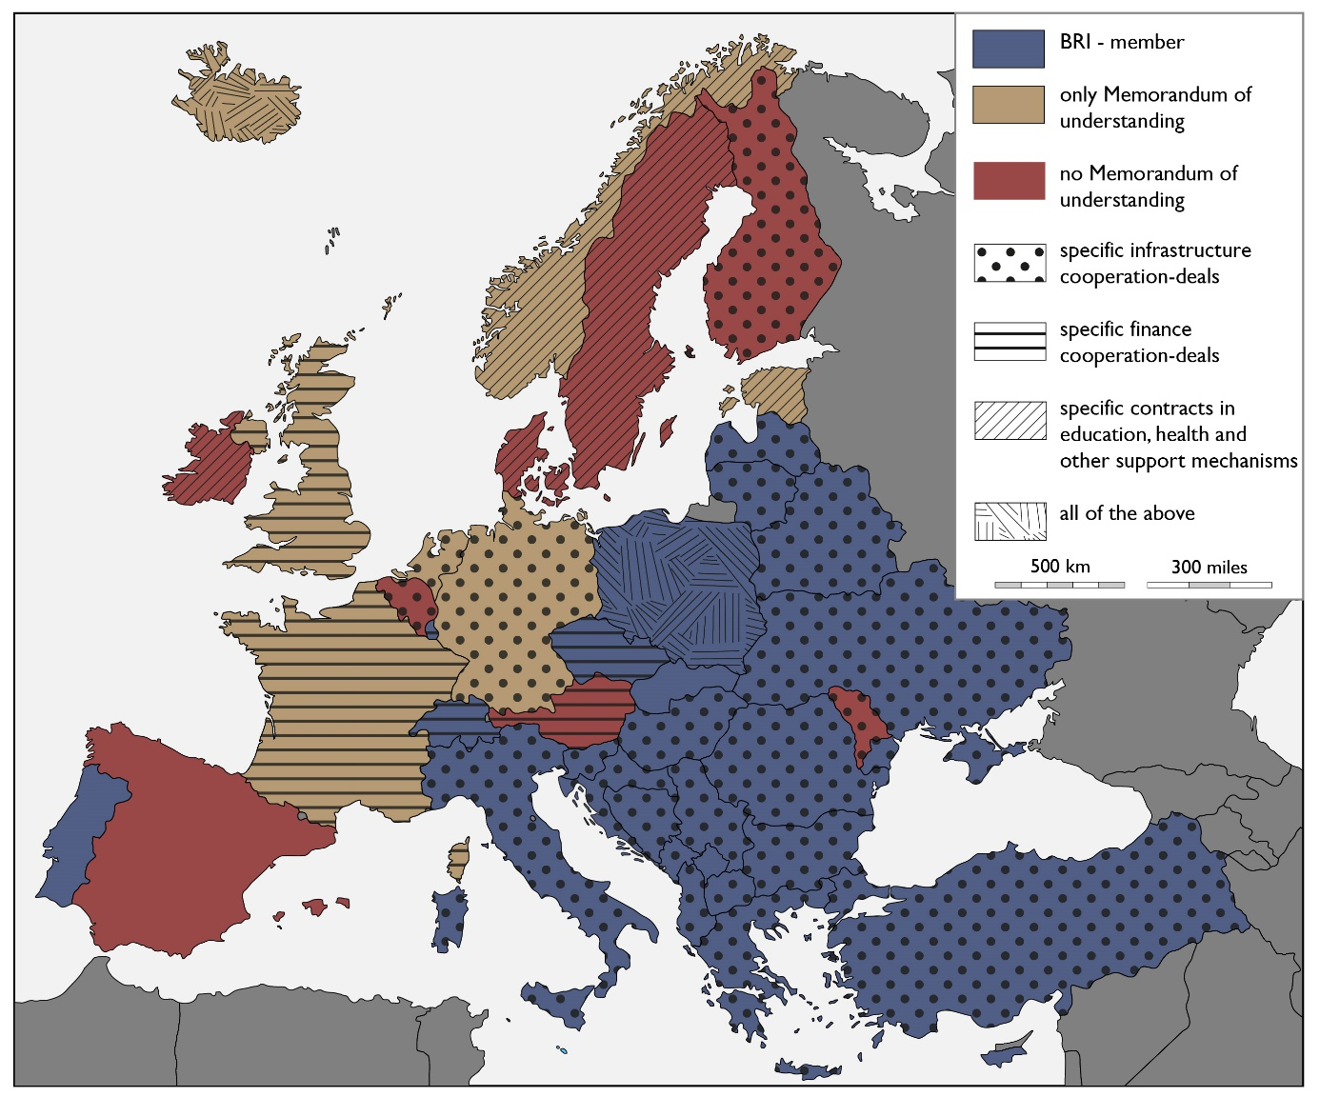
Figure 1: Contractual Arrangements and other informal or formal agreements. March 2020. Own elaboration.
Source base map: https://d-maps.com/carte.php?num_car=2233&lang=en
Figure 1 illustrates first, the complexity of contractual arrangements that China has sought on a bilateral basis with European states to date (for detailed description see supplementary material). Instead of seeking a ‘block-based’ approach with the whole of Europe, China develops multiple arrangements and MoUs resulting in a certain east-west divide, with more Eastern European countries being BRI Members. This can partly be explained by joint historic roots as well as by the entry points of the BRI to Europe (see figure 2 in the supplementary material). Second, the graphic illustrates the constructive fuzziness of the Chinese approach with a focus on topics that are in the interest of individual states. Newspaper articles often display the fear that the BRI with its geopolitical ambitions may undermine “European integrity”. While the calls for a joint-up European response are increasing, the graphic shows that formal arrangements are already far more common than publicly recognised. This complicated puzzle of bilateral arrangements ultimately favours a hidden growth of Chinese continuous influence in Europe.

For further information on the 6 economic corridors see the following pages: - New Eurasia Land Bridge Economic Corridor (NELB): The New Eurasia Land Bridge (NELB), also known as the Second Eurasia Land Bridge https://eng.yidaiyilu.gov.cn/ - China-Pakistan Economic Corridor (CPEC): http://cpec.gov.pk/ - China-Mongolia-Russia Economic Corridor: https://eng.yidaiyilu.gov.cn/ - China-Central Asia and West Asia Economic Corridor (CCWAEC) https://eng.yidaiyilu.gov.cn/ - China-Indochina Peninsula Economic Corridor (CICPEC), https://eng.yidaiyilu.gov.cn/ - Bangladesh-China-India-Myanmar Economic Corridor: https://eng.yidaiyilu.gov.cn/ Supplementary Material and Explanation In preparation of the regional graphic, figure 1 we analysed the diversity of institutionalised forms of cooperation with different degrees of formality. We have come to differentiate between (1) the content and existence of a Memorandum of Understanding, as well as the (2) existence of other contractual arrangements. 1) BRI Membership The regional graphic (figure 1) differentiates whether the cooperation is based on - BRI Membership, which means that a Memorandum of Understanding (MoU) contains the phrase of “officially promoting” the BRI (displayed in blue) - on the existence of a MoU which can focus on infrastructure but also other topics (displayed in beige) or - on no MoU (displayed in red). With the exception of Portugal, we see a certain East-West divide. Most of the Eastern European States apart from Moldova are BRI-Members. Further Italy, Switzerland and Liechtenstein became BRI-Members. Others, such as Estonia, Iceland or the Netherlands remained with a MoU. The contents of MoU’s are not necessarily targeted to the BRI as an infrastructure endeavour, but indicate a much broader geopolitical cooperation (European Parliament 2018a). Exemplary is a MoU between France and China establishing a Small and Medium-sized Enterprise Fund, while France in general views the BRI with scepticism. This picture reflects the strategy routes from China. For Europe the New Eurasia Land Bridge Economic Corridor and the Maritime Silk Road are most important (see figure 2). The Maritime Silk Route enters into Europe through the Southeast (e.g. Piraeus and Triest), and the land-based route from the East (see figure 2). We suggest that path dependency and a joint history during UDSSR times played a role in facilitating more formal cooperation in Eastern Europe, and for states to become members earlier. China initiated the 16+1 cooperation with central Eastern European countries to build strategic relationships and initiate joint projects. With Greece joining, it became the 17+1 cooperation (see figure 3). Notably the less affluent countries within the EU seemed to be in general more open to receiving additional FDIs. 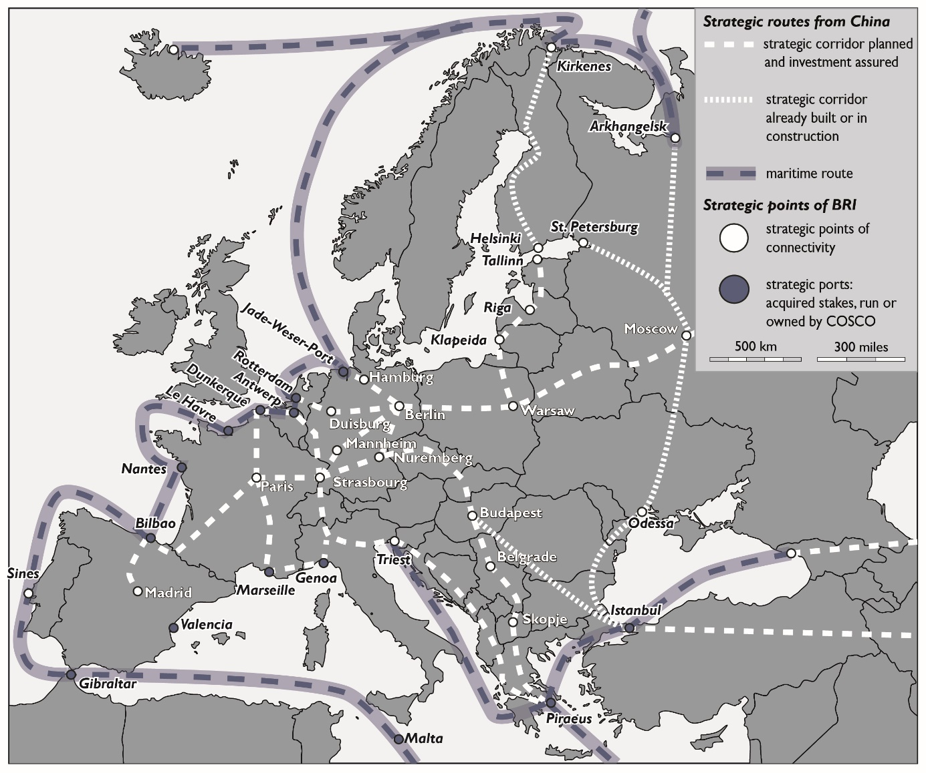 Figure 2: Entry points and roads to Europe from China. March 2020. Own elaboration. Among many other sources based on Merics 2019, European Parliament 2018a and 2018b. Source base map: https://d-maps.com/carte.php?num_car=2233&lang=en 2) Other contractual arrangements States that do not have formal endorsements of the BRI, still signed other contractual arrangements. Therefore, the regional graphic displays the existence of (further) specific deals and contracts for cooperation categorized by three types: a) infrastructure cooperation deals (displayed with dotted hatchings), b) finance cooperation deals (displayed with horizontal parallel lines), c) contracts for education health or other support mechanisms (displayed with skewed parallel lines), and d) the existence of all types of contracts (displayed with mixed parallel lines). a) Most Eastern European states and Germany, the Netherlands, Belgium and Finland cooperate on specific infrastructure projects. Examples are the Peljesac-Bridge in Croatia, the railway line Budapest-Belgrad or the Skopje-Shtip section of a highway in Macedonia. In addition, in nearly all major European ports the China Ocean Shipping Company (COSCO) has acquired stakes, e.g. in the Rotterdam Euromax Terminal or runs and owns them, as in the case of Piraeus harbour (see figure 2). Exemplary for a country where the state has not signed a formal MoU or contract (see figure 1), but harbour companies cooperate with and receive investments from COSCO is Spain with e.g. the ports of Valencia or Bilbao (see figure 2). Yet, Spain has so far favoured a common European approach by suggesting a Europe-Asia Connectivity Strategy, while indicating its willingness to actively participate in the joint construction of the BRI. b) The second type of cooperation is built on financial cooperations, in which European countries invest in projects in their own countries as well as around the globe connected to the BRI. Austria, Czechia, Luxembourg, the United Kingdom and Switzerland have a focus on financial cooperations. In addition, it is to be noted that almost all Western European states are partners of the Asian Infrastructure Investment Bank, whereas the Eastern European states cooperate with China in the 17+1 cooperation, in which China invests in collaboration efforts (see figure 3). Disclosure Statement No potential conflict of interest was reported by the authors. ORCID Franziska Sielker https://orcid.org/0000-0001-6391-983X Notes and Acknowledgements The authors thank the Faculty of Spatial Planning of TU Dortmund for funding the Miniproject “Towards an Asianisation of European Cooperation and Planning? - Evidence from the Belt and Road Initiative” while Franziska Sielker was Interim Head of the Chair of “International Planning Studies”. This articles partly builds on research undertaken in the context of this Miniproject. The authors further thank the Department of Land Economy at the University of Cambridge for funding a research visit of Elisabeth Kaufmann at the University of Cambridge in March 2020. 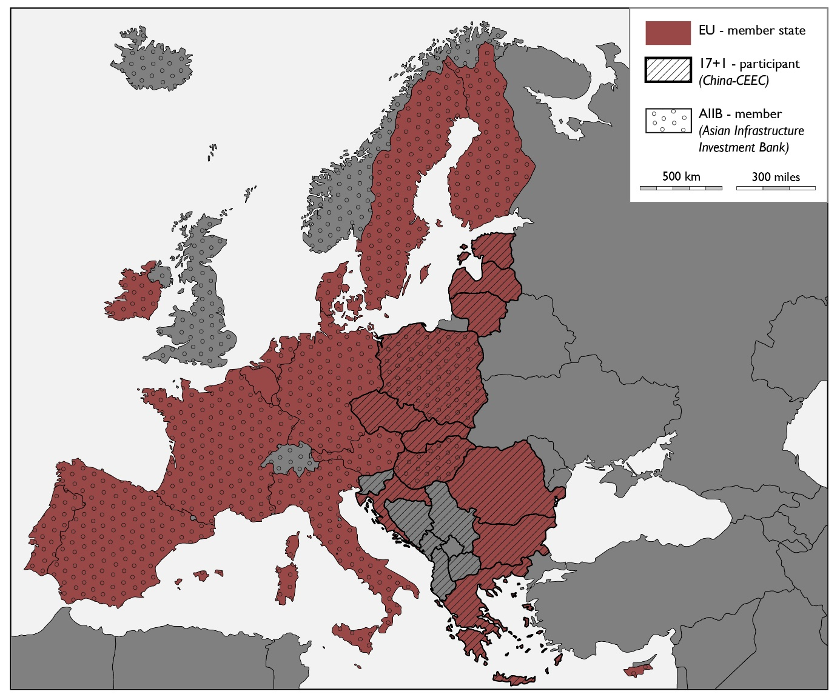 Figure 3: Institutional Frameworks and membership in international cooperation. March 2020. Own elaboration. Sources: China-CEEC (2019), AIIB (2019), European Union (2020). Source base map: https://d-maps.com/carte.php?num_car=2233&lang=en c) The third type are cooperations in health, education or other support mechanisms, primarily to be found in Scandinavia and Ireland. d) The fourth category refers to the use of all forms of cooperation. Poland and Iceland are unique as they cooperate in all areas. References Brakman, Steven; Frankopan,Peter; Garretsen Harry & Van Marrewijk, Charles (2019): The New Silk Roads: an introduction to China’s Belt and Road Initiative, Cambridge Journal of Regions, Economy and Society, Volume 12, Issue 1, pp 3–16, https://doi.org/10.1093/cjres/rsy037 Bennett, Mia M. (2016): The Silk Road goes north: Russia’s role within China’s Belt and Road Initiative, Area Development and Policy, Volume 1, Issue 3, pp.341-351, DOI: 10.1080/23792949.2016.1239508 European Commission (2019): China: Challenges and Prospects from an Industrial and Innovation Powerhouse. Retrieved from https://ec.europa.eu/jrc/en/publication/china-challenges-and-prospects-industrial-and-innovation-powerhouse European Parliament (2018a): Research for TRAN Committee: The new Silk Route - opportunities and challenges for EU transport, p. 100; Retrieved from https://www.europarl.europa.eu/RegData/etudes/STUD/2018/585907/IPOL_STU(2018)585907_EN.pdf Liu, Weidong & Michael Dunford (2016): Inclusive globalization: unpacking China's Belt and Road Initiative, Area Development and Policy, Volume 1, Issue 3, pp. 323-340, DOI:10.1080/23792949.2016.1232598 Maçães, Bruno (2018): Belt and Road: a Chinese world order. Hurst SCIOPRC (State Council Information Office of the People’s Republic of China) (2018): China’s Arctic Policy. Retrieved from http://english.www.gov.cn/archive/white_paper/2018/01/26/content_281476026660336.htm Zhan, Chung (2020): China's "Arctic Silk Road". In Maritime Executive. Retrieved from https://www.maritime-executive.com/editorials/china-s-arctic-silk-road Zhou, Jiangping, Yuling Yang & Chris Webster (2019): Legacies of European ‘Belt and Road’? Visualizing transport accessibility and its impacts on population distribution, Regional Studies, Regional Science, 6:1, 451-454. References Supplementary Material AIIB (2019): Members of Bank. Retrieved from https://www.aiib.org/en/about-aiib/governance/members-of-bank/index.html China CEEC (2019): Cooperation between Central and Eastern European Countries. Retrieved from http://www.china-ceec.org/eng/ European Parliament (2018b): China's Maritime Silk Road initiative increasingly touches the EU – Briefing March 2018. Retrieved from https://www.europarl.europa.eu/RegData/etudes/BRIE/2018/614767/EPRS_BRI(2018)614767_EN.pdf European Union (2020): Countries – The 27 member countries of the EU. Retrieved from https://europa.eu/european-union/about-eu/countries_en Merics (2019): Interactive Map of the Belt and Road Initiative. Retrieved from https://www.merics.org/en/bri-tracker/interactive-map

