A Continuous Multistep Process for the Preparation of 3-Bromo-2-Oxopropanal O-methyl Oxime as a Precursor to Access C₄-Oxime-Substituted Thiazoles
Edouard Godineau,¹*‡ Claudio Battilocchio,^{1,2}*‡ Matthias Lehmann,¹ Steven V. Ley,² Ricardo Labes,² Letitia Birnoschi,² Srinivas Subramanian,³ C.S Prasanna,³ Amol Gorde,³ Mahesh Kalbagh,³ Vivek Khade,³ Anton Scherrer, ¹ Tony O’Sullivan¹
¹ Syngenta Crop Protection, Process Research, Schaffhauserstrasse 101, CH-4332, Switzerland
² Innovative Technology Centre, Department of Chemistry, University of Cambridge, Lensfield Road, CB2 1EW, UK
³ Syngenta Research and Technology Centre, Santa Monica Works, Corlim, Goa India-403110

KEYWORDS. Bromination, Continuous Processing, Hazardous Chemistry, Multistep synthesis, Thiazole synthesis.

ABSTRACT. We report a strategy designed for the rapid and convergent assembly of C4-oxime substituted thiazoles. Our approach relied and focused on 3-bromo-2-oxopropanal O-methyl oxime as a key building block. In particular, we describe a multistep continuous synthesis of this intermediate and demonstrate the advantages of our set-up upon scaling up.
Imidazoles and thiazoles substituted with N-alkoxy oxime ethers moieties at C₅ and C₄, respectively, are generally regarded as privileged motif present in a number of biologically active substances (Figure 1).
Figure 1. Biologically active imidazoles and thiazoles bearing a methoxy oxime moiety.
For instance, compound 1 possesses interesting herbicidal properties.ª Similarly, C₄-methoxyoxime-substitued thiazoles 2 and 3 express insecticidal activity,^{2b} whilst substrates such as 4 have been associated to fungicidal activity.^{2c} Heterocycles such as 3 are conventionally prepared using a linear sequence such as the one shown below (Scheme 1, top).
Scheme 1. Conventional and convergent approaches to thiazoles heterocycles using 3-bromo-2-oxopropanal O-methyl oxime 7, as new intermediate of synthesis.
Although this sequence works reasonably well, the preparation of analogs represented by the generic structure 6 is not very efficient and requires iterative sequential synthesis. To streamline the preparation of such derivatives, we conceived an approach whereby thiourea 5 would be condensed directly with 3-bromo-2-oxopropanal O-methyl oxime 7 (Scheme 1). This approach is not only convergent, but also pragmatic for the rapid and flexible production of thiazole-containing analogs. To satisfy the need for these exploratory programs, we required a robust access to oxime 7, on scale and quality.
Scheme 2. Retrosynthetic approch towards the novel synthesis of pivotal intermediate 7.
The approach was based on the use of hydroxyiminoacetone 9, as the primary building block, which can be prepared from three cheap feedstocks (Scheme 2); O-methylation of 9 would afford methoxyimino derivative 10 and a selective bromination of this intermediate would generate the final desired compound 7. It was soon evident how this sequence of chemical reactions would benefit from the implementation of a continuous process, due to both safety and handling of potentially hazardous materials (vide infra).
In this report, we disclose our work towards a robust and scalable preparation of intermediate 7, and its later use in the convergent synthesis of the thiazole lead candidate 3. We also describe the initial challenges, faced during the early batch scale-up campaigns and how the use of continuous flow technologies has subsequently addressed the production of 7, on a significant laboratory scale.

Step 1: Synthesis of 2-Oxopropanal oxime 9
Three different batch routes were investigated towards intermediate 9 (Scheme 2). A first approach started from pyruvaldehyde (Route A). A regioselectivity issue could be identified in the planning stage, since it is known that the aldehyde moiety is substantially hydrated in aqueous solution. This turned out to be the case, however, we were unable to find conditions providing a fully selective access to intermediate 9, and byproducts 11 and 12 were always inevitably competitively observed (at best 70:30 9:(11+12) selectivity, see SI for further discussion). Given the difficulty in purifying any of the intermediates, we rapidly concluded this approach not to be optimal (Note 1). Route B was also very attractive, because concise and starting from commodity raw materials. However, significant safety hurdles precluded us to first deliver 9 via this route in batch mode. Route C was therefore selected for our initial deliveries of 9. Ethyl acetoacetate was therefore nitrosylated, to give 8 (not isolated), and upon treatment with sulfuric acid, a spontaneous release of CO₂ and EtOH occurred to provide 9 in very good yield.
Scheme 2. Potential approaches to the synthesis of 2-oxopropanal oxime 9

Differential scanning calorimetry analysis of intermediate 9 highlights an exothermic activity between 140°C and 275°C with a heat output of ca. 2450 J/g which, under adiabatic conditions, has the potential to result in a temperature rise greater than 1400 K. 2-Oxopropanal oxime 9 was therefore handled at a temperature lower than 50-60°C. Isolation, further purification and storage as a pure solid on large scale (>200g) was also deemed to be unsafe. In addition, we observed that intermediate 9 had the tendency to isomerize, upon storage at rt, to a mixture of oxime and bis-oxime byproducts 11 and 12 (Scheme 3a; see SI). For these reasons, we avoided further manipulations and purification of 9, which was always used as such in the next steps. For further scale-up, a continuous flow process to preparation of 9 would represent an advantage to overcome the significant safety concerns.
Scheme 3. a) Byproducts 11 and 12, observed upon storage of 9 and b) synthesis of 9 using ethyl acetoacetate.
Route C, while acceptable to afford large quantities of 9, was not an ideal starting point for a continuous process. The reaction mixture indeed appeared to gradually become triphasic because of CO₂ evolution and precipitation of solids. We foresaw such observations to be potentially problems for the translation into a flow process. We therefore re-considered Route B. This alternative approach entailed the use of acetone reacting together with tert-butyl nitrite (Scheme 4). We developed a continuous flow set-up where tert-butyl nitrite and catalytic quantities of HCl are combined, leading to the in-situ formation of nitrosyl chloride as a nitrosylating species. This intermediate immediately reacts with acetone to generate the α-nitrosylated acetone which readily isomerizes to 9. The reactor output was then directed towards a Y-piece where it was combined with a concentrated aqueous ammonia solution to quench the reaction.

Scheme 4. Flow synthesis of hydroximinoacetone 9.

Both mixing and temperature where found to be crucial parameters in order to produce high quality material, with the ideal temperature of the reactor set at 10 ºC. A relative stoichiometry between acetone, tert-butyl nitrite and HCl of 4.5:1.0:0.3 resulted in a robust protocol. Acetone was initially pumped at 2.00 mL/min and combined at a T-piece with tert-butyl nitrite, delivered neat at 0.8 mL/min, and the mixture was combined with HCl (12M aqueous solution, preloaded in a perfluoroalkoxy – PFA - loop and pumped at 0.16 mL/min) using an interdigital mixing unit.⁷ The reagents mixture was directed to a reactor coil (PFA, 1/16’, 2 mL volume) kept at 10 ºC and the output was then combined at a Y-piece with concentrated aqueous ammonia solution (14M aqueous solution, preloaded in a PFA loop and pumped at 0.15 mL/min). The solution was collected in a flask cooled at 10 ºC. Analysis of the collected material for this initial run indicated intermediate 9 was obtained with 88% yield (94% purity). Under the conditions shown, the reaction productivity reached 316 mmol/h, which equates to 7.6 mol/day.

Step 2: Synthesis of 2-oxopropanal O-methyl oxime 10
Intermediate 9 is easily converted to methoxyimino derivative 10 in good yield using dimethylsulfate in the presence of sodium hydroxide as the base. However, careful reaction control is required since 10 is not stable under basic conditions. In addition, byproducts 13 and 14 are deemed to be equally unstable under basic conditions. (Scheme 5). Obtaining 10 in a suitable quality was not a straightforward process and could only be realized by a multiple purification operation (see SI). Such purification steps were made more problematic by a strong suspicion of potential exothermic decomposition of 14 (see SI).
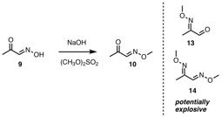
Scheme 5. Synthesis of intermediate 10 (from 9) and by-products 13 and 14

Calorimetry analysis on intermediate 10 showed it to have slightly reduced safety concerns, compared to 9. However, a complex exothermic activity (likely 3 consecutive exothermic events) had been detected between 184°C and ca. 345°C, with a heat release of ca. 1870 J/g. Under adiabatic conditions, this would result in a temperature rise greater than 1100K. During this study, it was also pointed out that the decomposition pattern of this compound follows the generation of gaseous byproducts. This set of information underlines, once again, the necessity of adopting continuous flow to mitigate the handling of these intermediates, especially on scale.
It was reasoned that implementing a suitable continuous flow reaction set-up for this step would: a) mitigate the safety risks; b) improve selectivity and yield, by minimizing exposure of 10 to basic conditions and rapidly process the material in a telescoped fashion, and c) avoid any purification stage.
Our initial flow screening was based on a system comprising 4 pumping units, a reaction zone and a downstream zone (Scheme 6).

Scheme 6. Reaction setup for the preparation of intermediate 10.

It was soon clear that the use of a diluted stream of dimethyl sulfate (up to 1 M) did not yield more than 7-10% of the desired product 10, and this could be argued to be attributed to an unfavorable mass transfer due to the biphasic nature of the reaction (Scheme 6). Indeed, it was noticed that increasing the concentration of dimethyl sulfate feed significantly influenced the conversion to desired product 10 (as detected by LC-MS), with yield being highest when using neat dimethyl sulfate as reagent. However, this changes did not affect the extraction process.
On the other hand, the use of high concentration of the aqueous feedstocks of NaOH and hydroxyiminoacetone 9 were found to be crucial for the successful extraction of the product. The yield of extracted intermediate 10 increased from 6%, using aqueous NaOH 2 M, and aqueous 9 1 M to 38.5% when using aqueous NaOH 4 M, and aqueous 9 3 M. In all cases, the purity of resulting methoxyoxime 10 was found to be much improved over the batch process, further highlighting the benefits of the continuous approach over the batch process.
Our optimized protocol was as follows (Scheme 7): an aqueous solution of intermediate 9 (4.3 M) and an aqueous solution of NaOH (4.7 M) were pumped at 1.00 mL/min flow rate for each channel and combined within a mixing element. The generated stream was passed through a conductivity cell, so as to monitor steady state, and next merged within an interdigital mixer, with a dimethyl sulfate feed, introduced neat and continuously at a flow rate of 0.55 mL/min. The reaction mixture was reacted further in a 14-mL reactor coil (PFA, 1/16’ o.d.) at 70 ºC, before reaching a mixing Tee-piece, where chlorobenzene was combined with the reaction stream to perform an extraction step. This operation was aided by the use of a “static mixer coil”. The output of the reaction system was directed towards a liquid/liquid separator. The organic phase was analyzed via ¹H-NMR (against an internal standard, see SI) and indicated a 72.5% yield of intermediate 10 (0.81 M solution in PhCl), with almost no detectable traces of any impurities.

Scheme 7. Continuous flow synthesis of 10.

Under the conditions described, the output of the reactor was calculated to be 187 mmol/h (equating to 4.49 mol/day).

Step 3: Synthesis of 3-bromo-2-oxopropanal O-methyl oxime (7)
The next bromination step to convert 10 into 7 was investigated. This step proved to be very difficult to control, and poorly reproducible during scaling-up operations. Selectivity in the bromination (mono- vs di-bromination, e.g. 7 vs 15) was the main issue encountered. Methanol helped to improve the selectivity towards 7, presumably via a selective in situ protection of compound 7 into its corresponding dimethoxyacetal. Compound 7 could be isolated after distillation under reduced pressure, on a 40g scale in up to 58% yield, as a 95:5 mixture together with 14. Methanol as an additive, while providing a selectivity benefit introduced the undesired generation of gaseous MeBr as a byproduct. On larger scale, this technical drawback annihilated the selectivity benefit brought by the alcoholic additive. We did not investigate other heavier alcohols as additives. More importantly, we also observed a clear gradual erosion of the yield of the reaction on scaling up, such that on >200g scales, the yield was now 25-35%. We strongly suspected this lack of reproducibility on scale-up to be related to mass and/or heat transfer issues.
Safety evaluation for the intermediate 7 (see SI) indicated an onset decomposition temperature at 232 °C, but with a slightly reduced heat release when compared to 10. Overall, DSC investigations indicate exothermic activity between 170°C and ca. 278°C with a heat output of ca. 1350 J/g which, under adiabatic conditions, has the potential to cause a temperature rise greater than 800K; gas evolution was also observed on decomposition of 9 and 10. Finally, we observed gradual decomposition (color change, strength erosion) of compound 7 over time, which led us to always generate it as fresh as possible.
Altogether this batch process, although suitable for the first deliveries of material, was therefore not satisfactory for sustainably providing 7.
We recognized here another opportunity to take advantage of continuous technology to overcome these challenges. To achieve specific stoichiometry of reagents, we chose to use syringe pumps. Solutions of methoxyoxime 10 and bromine (both in chlorobenzene) were combined through an Innovia interdigital mixer.⁵ The reaction was then directed to a residence time coil, prior to analyzing the reaction output using an in-line NMR [REF].
Scheme 8. Continuous flow synthesis of 7.

A 0.81 M solution of 10 in chlorobenezene (directly from step 2) was pumped at a flow rate of 1.25 mL/min and combined with a 0.81 M solution of Br₂ pumped at 1.25 mL/min, before reacting in a PFA coil reactor, heated at 40 ºC, to provide 7 in 89 % yield with just 2% of the dibrominated byproduct 15 also present. This confirmed our hypotheses that improved mixing and heat transfer management would result in improved yield and selectivity for 7. In order to refine out setup, we integrated a work-up process to quench in-line any remaining Br₂ and neutralize the acidity of the post-reactor stream (Scheme 9). To this end, the reaction output was merged with am aqueous feed containing a phosphate buffer (2 M) and sodium bisulfite (0.5 M) (Scheme 9a). A standard work-up of the reaction flow stream afforded 7 in 85% yield.
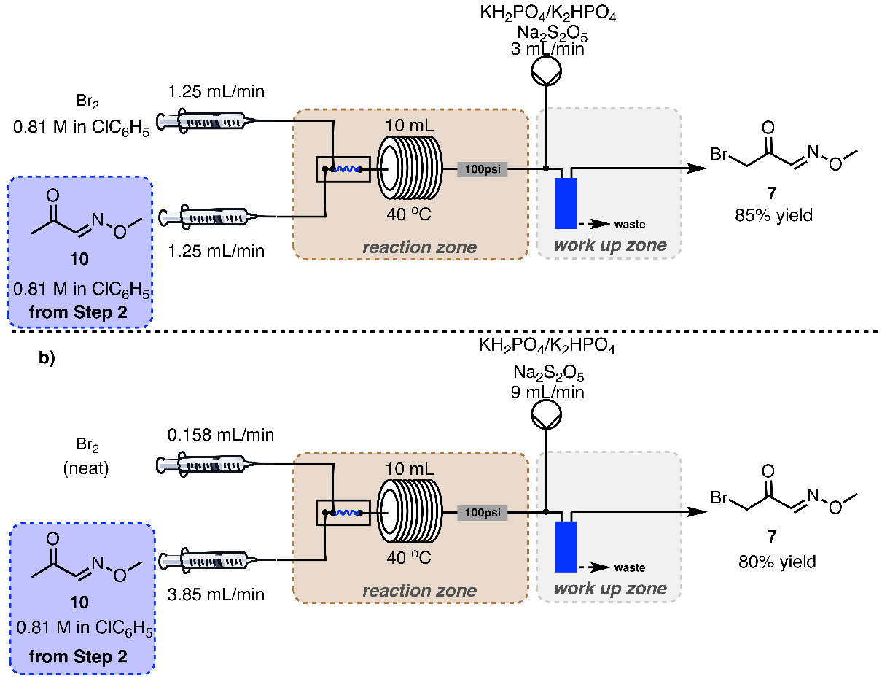

Scheme 9. a) Continuous flow synthesis of 7, with integrated work-up and b) using neat bromine.

In order to increase the throughput of this step, we decided to use neat Br₂ (Scheme 9b). A change in flow parameters led to an intensified process, with minimal configurational disruption of our previously designed platform. In particular, the solution of 10 (0.81 M) was delivered at 3.85 mL/min and combined using an interdigital mixer⁷ with neat Br₂, delivered at 0.158 mL/min. The resulting stream was next sent into a 10 mL reactor coil (PFA, 1/16’ o.d.) heated at 40 ºC (2.5 min residence time). The output was quenched in-line using the same technique described above (aqueous quench delivered at 9 mL/min) and then analyzed. This afforded 7 in 80% yield, with a high degree selectivity (20:1). Pleasingly, this intensified process produced an output of 149 mmol/h (26.9 g/h), equating to 3.59 mol/day (646 g/day).
Step 4 and 5: synthesis of thiazole 3
As mentioned above, intermediate 7 cannot be stored for long period of time. We further demonstrated that 7, generated on-demand in a continuous manner, can be immediately elaborated into the targeted thiazoles. Such a generation and consumption on demand greatly mitigates any decomposition of 7 over time. We demonstrated this conceptual approach by preparing showcase thiazole 3. In order to do so, we adopted the strategy whereby we would use the corresponding isothiocyanate (16) to perform a reaction with amonia, and then a final condensation with 7 to attain the thiazole product. Our group has previous experience with amination reactions of this type [REF], thus making the process rather straightforward.
In practice, a solution of isothiocyanate (0.5 M in MeOH) was combined with a concentrated solution of amonia (2 M in MeOH) and reacted in a 10 mL reactor coil (PFA, 1/16’ o.d., residence time 4 min 40 sec), heated at 100 ºC, and then analyzed in-line with the use of an IR system; the reactor output was then directed to a T-piece where the thiourea intermediate was combined with a stream of 7 (0.35 M in chlorobenzene, flow rate 2.7 mL/min) and further reacted in a 20 mL reactor⁸ (4 min residence time), heated at 60 ºC, and the output collected to produce 3 (as the HBr salt) in 89% yield (Schem 10).

Scheme 10. Flow synthesis of the thiazole target, with stage 4 (synthesis of 17) and 5 (synthesis of 3).

The process provided 3 (as HBr salt) with a productivity of 48.6 mmol/h (11.4 g/h), equating to 1.17 mol/day (273 g/day) which represents a good level of productivity for further implementations.
To further exemplify the potential streamlining of the whole sequence we demonstrated that each step could be telecoped into an effective sequence, as shown in Scheme 11.

Scheme 11. Fully telescoped synthesis of the thiazole target 3.

In conclusion we have reported a multistep continuous synthesis of a new brominated building block (7) which we have applied for the synthesis of thiazole 3. The sequence shows the flexibility of continuous processing techniques when dealing with hazardous and volatile intermediates, mitigating the safety risks associated to these chemistries. Further work is ongoing to define a complete telescoped sequence for the synthesis, on scale, of such derivatives.

Notes

We have also attempted to cut through the sequence, with the use of pyruvaldehyde and O-methyl hydroxylamine. The various investigations led us to the conclusion that also in this case, due to the fully hydration of the aldehyde group, is not possible to achieve the desired selectivity towards 10 (see below).

ASSOCIATED CONTENT
Supporting Information. The following files are available free of charge.
Compounds characterization, and data (.pdf)
Reaction setup and videos (.jpeg, .mov)

AUTHOR INFORMATION

Corresponding Author
* Dr Edouard Godineau, email: edouard.godineau@syngenta.com
* Dr Claudio Battilocchio, email: claudio.battilocchio@syngenta.com

Author Contributions
The manuscript was written through contributions of all authors. All authors have given approval to the final version of the manuscript.
‡These authors contributed equally.

ACKNOWLEDGMENT
We would like to thank Syngenta Crop Protection AG and the EPSRC (SVL, grant # EP/K009494/1, EP/M004120/1 and EP/K039520/1) for financial support.

REFERENCES

For an example of C₄-functionalized thiazole ring, prepared from 1,3-dichloroacetone: Mahmoodi, M.; Aliabadi, A.; Emami, S.; Safavi, M.; Rajabalian, S.; Mohagheghi, M.-A.; Khoshzaban, A.; Samzadeh-Kermani, A.; Lamei, N.; Shafiee, A.; Foroumadi, A., Arch. Pharm. 2010, 343, 411-416; b) Hayashisaka, N. 2009, JP2009256247A; c) C₄-functionalized thiazoles from bromination/debromination sequence: Uzelac, E. J.; Rasmussen, S.C. J.Org.Chem. 2017, 82, 5947; d) from condensation of 1-Bromo-3,3-dimethoxyacetone with thioformamide: CN101906078; e) functionalization of C4-methylthiazoles: Yuasa, Y.; Tsuruta, H.; Yuasa, Y., Heterocycles 2004, 63, 2385; f) C₄-functionalized thiazoles via oxidation of thiazolidine derivatives: Mensching, S.; Kalesse, M., J. Prakt. Chem./Chem.- Ztg. 1997, 339, 96; g) from condensation of bromopyruvic acid and thioamide: Kumar, S.; Pearson, A. L.; Pratt, R. F., Bioorg. Med. Chem. 2001, 9, Copyright (C) 2018 American Chemical Society (ACS). All Rights Reserved., 2035; h) from condensation of ethoxycarbonylmethyl isocyanide and (Dimethylamino)dimethoxymethane : Bloom, J. D.; Digrandi, M. J.; Dushin, R. G.; Lang, S. A.; O'Hara, B. M. 2000, WO2000034269A1; i) from condensation of 3-oxetanone and thioamides: Banerjee, A. 3-Oxetanone, in e-EROS Encyclopedia of Reagents for Organic Synthesis (Eds. John Wiley & Sons, Ltd) 2014, 1-6
For some examples: a) EP289066; b) WO2015124606; c) WO2015060461
Chari, R. V. J.; Kozarich, J. W. J. Org. Chem. 1982, 47, 2355
a) Freon, P., Ann. Chim. Appl. 1939, 11, 453; b) Zhang, C. Y.; Tour, J. M., J. Am. Chem. Soc. 1999, 121, 8783; c) Sheremetev, A. B.; Shamshina, Y. L.; Dmitriev, D. E. Russ. Chem. Bull. 2005, 54, 1032
Leis, J. R.; Pena, M. E.; Williams, D. L. H., J. Chem. Soc., Chem. Comm. 1987, 2, 45
Slit interdigital micromixer SIMM-V2, Institut für Microtechnik, Mainz GmBH, Mainz, Germany. Channels 40μm, 200μm depth, internal volume, approxiamtely 8μL
UniCond Sensor available from Mettler Toledo: https://www.mt.com/us/en/home/products/Process-Analytics/conductivity-sensor/conductivity-resistivity-cell-water/Unicond-2e.html
MMH-040T interdigital mixer available from Invenios Europe GmBH, now Corning
The static mixer coil available from Vapourtec : https://www.vapourtec.com/products/flow-reactors/large-diameter-tubular-reactor-for-rapid-mixing-features/
a) Bourne, J. R.; Rys, P.; Suter, K., Chem. Eng. Sci. 1977, 32, 7, 711; b) Bourne, J. R., Org. Proc. Res. Dev. 2003, 7, 471
a) Pastre, J. C.; Browne, D. L.; O’Brien, M.; Ley, S. V., Org. Proc. Res. Dev. 2013, 17, 1183; b) Browne, D. L.; O’Brien, M.; Koos, P.; Cranwell, P. B.; Polyzos, A.; Ley, S. V. Synlett 2012, 23, 1402; c) Cranwell, P. B.; O’Brien, M.; Browne, D. L.; Koos, P.; Polyzos, A.; Peña-López, M.; Ley, S. V. Org. Biomol. Chem. 2012, 10, 5774.

