Foraging behaviour alters with social environment in a juvenile songbird

Victoria R. Franks^{1,2 *}, John G. Ewen², Mhairi McCready^{2,3}, Rose Thorogood^{1,4,5}

¹ Department of Zoology, University of Cambridge, Downing Street, Cambridge, CB2 3EJ, U.K.;
² Institute of Zoology, Zoological Society of London, Regent’s Park, London, NW1 4RY, U.K.;
³ Hihi Conservation Charitable Trust, Rotorua, New Zealand
⁴ Helsinki Institute of Life Science (HiLIFE), University of Helsinki, Helsinki 00014, Finland;
⁵ Research program in Organismal and Evolutionary Biology, Faculty of Biological and Environmental Sciences, University of Helsinki, Helsinki 00014, Finland.

*Corresponding author email: vix_franks@live.com

Abstract

Early independence from parents is a critical period where social information acquired vertically may become outdated, or conflict with new information. However, across natural populations it is unclear if newly-independent young persist in using information from parents, or if group-level effects of conformity override previous behaviours. Here we test if wild juvenile hihi (Notiomystis cincta, a New Zealand passerine) retain a foraging behaviour from parents, or if they change in response to the behaviour of peers. We provided feeding stations to parents during chick-rearing to seed alternative access routes, and then tracked their offspring’s behaviour. Once independent, juveniles formed mixed-treatment social groups, where they did not retain preferences from their time with parents. Instead, juvenile groups converged over time to use one access route per group, and juveniles that moved between groups switched to copy the locally-favoured option. Juvenile hihi did not copy specific individuals, even if they were more familiar with the preceding bird. Our study shows that early social experiences with parents affect initial foraging decisions, but social environments encountered later on can update transmission of arbitrary behaviours. This suggests that conformity may be widespread in animal groups, with potential cultural, ecological, and evolutionary consequences.

Keywords: social information; horizontal transmission; vertical transmission; conformity; passerine

Background

From cultural transmission of long-distance migration routes in ungulate herds [1] to more localised foraging decisions of bird flocks [2,3], there are numerous examples in nature where animals adjust their behaviour after observing others and acquiring information [4,5]. Theoretically, using social information is a low-cost way that individuals can update behaviour, compared to personal trial and error [6,7]. However, social information can vary in reliability across space and time as both social and abiotic environments change and animals (re-)encounter different stimuli while associating with others [8]. Gregarious animals encounter multiple sources of social information when associations change throughout a lifetime (e.g. fission-fusion groups [9]), but these sources are not necessarily equal in their potential to reduce uncertainty [10]. Furthermore, new information may conflict with prior knowledge [11]. Therefore, using social information is non-trivial and animals face information trade-offs in both when to copy others and who information should be obtained from [6,12,13]. Despite theoretical and empirical work, how social information use develops or how conflicting information is integrated throughout life in complex natural environments remains poorly understood [14].

For many altricial animals, parents provide the first opportunity to observe others. During rearing, young are exposed to a raft of behavioural cues from their parents (or carers) that may provide social information intentionally (i.e. teaching [15]) or unintentionally (e.g. inadvertent cues [16]). Learning opportunities are thought to be one of the major benefits of prolonged parental care [17], especially in long-lived species with complex social systems. Further, vertical transmission (across generations) of behavioural traditions may be essential in establishing long-lived stable animal cultures (including arbitrary behavioural traits [13]). For example, matrilineal transmission in killer whales (Orcinus orca) establishes localised cultural traditions in feeding preferences [18], and young vervet monkeys (Chlorocebus aethiops) copy the food preferences of their mothers [19]. Social experiences with parents may shape behavioural strategies in later life, as variation in parental environment influences individuals’ tendency to associate and learn from others [20,21]. However, the importance of experiences with parents in comparison to other sources has received little attention, particularly in species with briefer periods of dependency or shorter lifespans, where the influence of parents may be weaker (but see: [22]).

Once juveniles become independent, they encounter further social information from their peers. Young animals are often more social than adults [23] and may use peer-provided information more readily to buffer their inexperience [14,24–26]; such reliance on social learning could lead groups of juveniles to converge (conform) on one behavioural type [2,27]. Although social information from peers could be crucial for developing behavioural repertoires [22,28], the information they provide can vary with relatedness [29], or age [30] and may also conflict with information previously gathered from parents. As responses to social information are now thought key to the evolution of culture [31–33], they may even have potential to exert selection pressure that results in genetic change [34] and influences population stability under changing environmental conditions [35,36]. Thus, understanding how and when juveniles begin to use information from parents or peers is critical to uncover how both individual- and population-level behavioural responses arise throughout life. However, there are few explicit empirical tests of the effects of social experiences on the behaviour of young wild animals [20,22,37]. A major unanswered question during this important developmental transition is: how likely are young to retain a behavioural preference seeded by parents, versus copying the behaviour of their peers?

Here we introduce arbitrary foraging behaviours to wild hihi (Notiomystis cincta, a threatened passerine from New Zealand) to test how behaviour during early independence is influenced by experiences from time with parents, or from encountering peers. Despite the species’ threatened status and small population size, hihi provide an excellent opportunity to investigate how different early-life social environments contribute to behaviour [38]: young spend up to two weeks with their parents after fledging, but once independent they congregate in groups for approximately three months [39]. Studying the behaviour of these groups is tractable due to their stability and fidelity [39]. Groups centre around a consistent fixed location (often a water source) and most juveniles remain faithful to one group-site. Consequently, the same individuals are re-sighted within a relatively small area (~300m²) from late summer to early autumn. Additionally, these groups are juvenile-dominated with few associations with adults, and relatives do not group together [39]. The reason for group formation remains unknown, but they may serve as an information centre or provide refuge from predators or competition [39]. We therefore investigated 1) if social information from parents continues to influence juvenile behaviour once independent, or if social information in groups is more important; and 2) if behaviour depends on specific relationships. Finally, to highlight how social information use strategies may change with age and associated lifetime experience, we tested if 3) juvenile hihi respond to social information more than adults.

Methods

Study population

We conducted our experiment during one breeding season (October 2015 – April 2016) on Tiritiri Matangi Island (36°36'00.7"S, 174°53'21.7"E). The wild population of hihi numbered approximately 88 adults and 132 juveniles (juveniles: any fledgling from the 2015-2016 breeding season, adults: all other birds). Each individual was identifiable from a unique combination of coloured leg rings and carried a Radio Frequency Identification (RFID) Passive Integrated Transponder (PIT) tag integrated into one leg ring (IB Technology). This enabled remote recording of visits to feeding stations fitted with antenna and data-loggers (IB Technology model EM4102).

(1) Seeding different experiences with parents

Experimental procedure

Hihi raise their altricial chicks in monitored nest-boxes in territories between September-February. Fledglings are cared for in the natal territory by parents for two weeks before dispersing. Hihi are supplementary fed for conservation management, and readily visit artificial feeding stations. Thus, at different nests we seeded alternative foraging experiences in parents and their offspring during chick-rearing and post-fledge care (Figure 1a): (1) a “naïve” treatment, where no feeding station was presented and fledglings gained no experience before becoming independent; (2) an “open” treatment, where we presented a feeding station (feeding bottle surrounded by a mesh cage, from here: “feeder”) which could be entered from any direction. This allowed hihi to learn to associate the feeder with a reward, thereby controlling for neophobia but giving no information about specific access routes; (3) a “side-choice” treatment where the feeder cage was split into two sides, with one point of entrance for each side and only one side containing a food source (left, LHS or right, RHS, alternated equally among 12 nests). In this third treatment, hihi could access food but it required a side-choice between the rewarding and non-rewarding option. To ensure that parents were habituated and using the feeders before their young fledged (28 days after hatching), feeders were set up 10 metres from nest-boxes two weeks before the anticipated date of fledging. They remained in situ throughout post-fledge care and until fledglings became independent and dispersed (10-13 days post-fledge; determined when fledglings were not seen or heard at their natal territory for two consecutive days). To ensure we knew what conditions each juvenile experienced, we recorded different levels of feeder experience for later analysis (parent use, fledgling use, side used at side-choice feeder nests: see Supplementary Information). All food (sugar water) was provided in semi-opaque brown bottles attached to Perky Pet® feeder bases (213 Pop Bottle Hummingbird Feeder) which did not provide visual information about contents. Treatments were balanced for rearing conditions (surrounding forest maturity) and number of fledglings (Figure 1a), and their locations limited movement between different treatments. At this stage, we only included first-clutch nests to avoid juveniles encountering different feeders near later second-clutch nests.

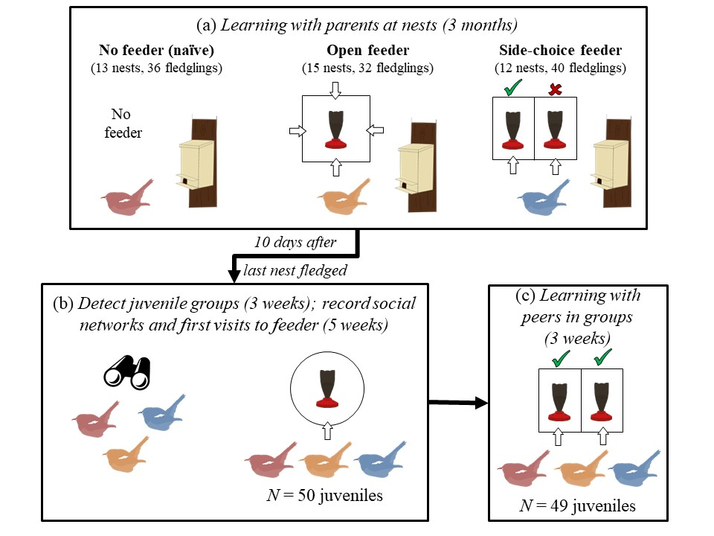 Figure 1. The stages of the experiment: (a) learning with parents at nests, showing treatments, number of nests and fledglings; (b) social network recording at juvenile group-sites (containing a mixture of juveniles from each nest treatment); (c) learning with peers at group-sites. For stage (c), 42/49 juveniles had been present in stage (b).

(2) Social effects on behaviour once independent

Recording group presence and familiarity

During our study, juvenile hihi formed two groups in two separate sites (see [39] for details). We identified groups by recording ring combinations in six forested gullies during three weeks of daily one-hour observational surveys (see [39]). The group-sites (“Site 1” and “Site 2”) were located c. 300m apart in separate latitudinally-orientated valleys containing mature remnant forest, and were separated by a ridge of open pasture [39]. Groups contained a mix of juvenile birds from different nest treatments (Figure 1b).

Before testing for behavioural effects of experiences with parents and peers, we recorded a social network to determine familiarity. We set up a feeder with one entry point at each group-site for five weeks (Figure 1b) and recorded time-stamped visits with an RFID data-logger (11928 visits by 50 juveniles). We calculated likely associations based on similarities in timings across recorded visits to construct a weighted social network (using the “gmmevents” function in the R package asnipe [40]). Our network used a Simple Ratio Index, so the association strength between a pair of individuals represented a ratio of the number of times they were recorded together versus the number of times they were separate (1 = always together; 0 = never together). We recorded the network before testing side-choices because we wanted to (i) habituate individuals from different treatments to group-site feeders, and (ii) establish the baseline level of familiarity prior to the next stage [3,41]. Nevertheless, the network during stage (b) likely reflected associations during experiment stage (c) due to the stability of juvenile hihi aggregations at this time of year. Firstly, the rate of arrival of new juveniles decreased across network recording (Supplementary Figure 3) until no new individuals were recorded after five weeks. Secondly, juvenile feeder usage remained consistent throughout the experiment: 42/49 birds from the later experiment stage visited the network feeder (median number of days recorded in the network = 18/37, IQR = 20). Thirdly, the rate of reassociation did not change across time during network recording (Supplementary Figure 4).

Recording side-choice behaviour in groups

To test for effects of social experiences on side-choice in newly-independent juveniles, we replaced network feeders with side-choice feeders; however, now both sides contained equal food (Figure 1c; Supplementary Figure 5). Over three weeks, we recorded all visits to both sides at each feeder using an RFID data-logger at each entry point (at Site 2, no visits were recorded for days 14 and 15 because of problems with the data-logger). During set-up, we ensured that both feeders were surrounded by similar vegetation structure, to limit external influences on side-choice. As we had two replicates of the feeder set-up due to there being two juvenile group-sites, we also explored possible alternative explanations for side-choice during analyses (see below) to disentangle socially-mediated and environment effects. There was no difference in the proportion of fledglings recorded from nests with or without feeders (Fisher’s exact test of fledglings detected at group-sites; from nests with feeders = 47/74; from nests without feeders = 15/29; P = 0.37). We also recorded 9 extra second-clutch juveniles, which we added to the naïve treatment as they did not appear at group-sites later than naïve first-clutch juveniles (compared ranked order of arrival; Wilcoxon rank sum test: W = 30, P = 0.12). In total, we recorded 5521 visits made by 38 juveniles and 14 adults in Site 1, and 4528 visits by 43 juveniles and 12 adults in Site 2.

Data analysis

Analyses were conducted in R (version 3.5.0 [42]). When using Generalised Linear Models (GLMs) or Generalised Linear Mixed Effect Models (GLMMs) (see below), we used a model selection approach [43,44] (R package AICcmodavg [45]) to better understand the relative contributions of different variables to explaining hihi behaviour. We ranked candidate models including all possible combinations of relevant predictors by their corrected Akaike Information Criterion (AICc). For all models within 2 AICc units of the top-ranked model, we calculated averaged effect sizes (±95% confidence intervals) of included predictors [43,46]; any effect where confidence intervals did not span 0.00 was considered significant. GLMMs were implemented using the lme4 package [47].

Did juveniles retain behaviour from experiences with parents?

We explored if having a feeder during post-fledge care made juveniles interact more readily with feeders once independent (N = 58: naïve = 21; open feeder = 16; side-choice feeder = 21). We ranked the time of each bird’s first visit to group-site feeders (latency in seconds from the very first birds’ visit) between 0 (earliest) and 1 (latest). We used beta-regression (package betareg, version 3.1-1) [48] to analyse variation in first visit rank depending on whether a feeder was present or absent at nests, and for juveniles from nests with feeders, whether they or their parents had used feeders (binary yes = 1, no = 0; see Supplementary Information) and the feeder type (side-choice or open). Most juveniles were present in group-sites before feeders were set up (37/58), but to account for the few that arrived later, we specified whether juveniles arrived for the first time before feeder set-up or after in both model sets.

To explore if newly-independent juveniles retained a side preference from experiences with parents, we used a binomial sign test to analyse if juveniles from side-choice nests chose their nest reward side more often than by random chance (50% of visits). We then used GLMMs to investigate if juveniles from side-choice nests maintained a side preference across all their visits to group-site feeders, using side chosen (LHS or RHS) per visit as the response and experiment day as a predictor. As change of preference might differ if side-choice resulted from nest treatment, we also included an interaction between experiment day and nest treatment side (RHS or LHS). As this analysis included repeated visits from the same individuals, we included a random intercept of bird ID.

Did juveniles copy peers?

We investigated how social environment with peers affected side-choice at group-site feeders. We explored changes in first visits and ongoing visits, as the importance of social environment may vary with personal experience or increasing exposure to peer’s behaviour. For first visits, we determined there was no starting side-choice bias (for example, due to feeder set-up, or parental effects) by analysing the number of juveniles that visited the LHS or RHS in both sites using a Fisher’s exact test. We then assessed whether juveniles copied the preceding bird on their first visit (yes = 1, no = 0), using a binomial GLM with time since preceding bird as a predictor (log₁₀-transformed seconds because times were not normally distributed).

Next, we investigated if side-choices changed in response to (i) the social behaviour of the group as a whole or (ii) the behaviour of individuals within the group. We investigated how side-choice changed across the experiment using binomial GLMMs with each individual’s side-choice per visit (left = 1, right = 0) as the response and experiment day and group-site as predictors. We included experiment day as a second-order polynomial term to account for non-linearity in the acquisition rate of side-preferences: visual inspection of the data suggested that preferences for one side increased more rapidly earlier in the experiment. We also included an interaction between group-site and experiment day, because the relationship between side-choice and day could differ between the two sites. Side-choices did converge on a locally-preferred side within each group-site (see Results), so we then analysed (i) if the strength of local group preference in all preceding visits made by other birds on that same day predicted an individual’s likelihood that they would use that same side. Using binomial GLMMs, we analysed if an individual’s side-choice on each visit matched the locally-preferred side (yes = 1, no = 0), depending on the proportion of other birds’ preceding visits to the locally-preferred side. Proportion of visits correlated with the proportion of individuals visiting a side (Pearson correlation: r = 0.81, P < 0.001), meaning that group preference was not biased by a few individuals visiting many times [2,33]. Thus, overall group preference during the preceding visits each day represented the social environment in each juvenile’s resident group before each visit, because juveniles are temporally and spatially resident in group-sites [39] (median number of days each bird was recorded in stage (c) by RFID = 16, IQR = 8.5, also see Supplementary Information) so had opportunities to observe others using the feeder within and across days, and accumulate social information across this period. As further predictors, we included experiment day (1-21) to assess if side-choice depended more on social environment or personal learning [2,33,49], and time of day (hours) because individuals visiting later had more opportunity to observe visits. Finally, some adults also visited group-sites (49 juveniles, 25 adults). We included these older individuals in our models, to use age (adult or juvenile) as a predictor in interaction with group preference and experiment day to investigate whether juveniles’ responses to peers differed from adults.

To explore if (ii) hihi copied specific individuals, we used a binomial GLMM to analyse if copying side-choice of the preceding visitor (yes = 1, no = 0) was more likely when a visit occurred soon after another bird (predictor = time since the preceding bird’s visit in log₁₀-transformed seconds to account for non-normally distributed times). Here, we only considered visits under 15 minutes apart (see Supplementary Information). Next, we used binomial GLMMs to assess how copying was affected by familiarity (association strength in our social network), and the age of the preceding bird (some juveniles followed adults). We included group preference per visit to assess the effect of specific individuals in addition to effects from the broader social environment. In this second set of models, we only included visits less than the median length of time juveniles remained continuously in the vicinity of the feeder per visit (60s, see Supplementary Information). We also only considered juveniles that visited >15 days during network recording (N = 28), because network metrics stabilised by this time. Both model sets included individual identity as a random intercept.

Although most individuals were resident within groups, many made visits to the alternate group-site (32/49 juveniles). Visiting juveniles may have observed others using the feeder in the new site before using it themselves: visiting birds predominantly used the new feeder following a resident bird (232/242 occasions), and did so within 50s (median, IQR = 144.5s). Thus, to test if juveniles updated behaviour in their new group, we repeated analyses (i) and (ii) with the 32 individuals that switched between group-sites. We added number of site changes as a predictor, because earlier experiences could affect side-choice. When analysing (i) the effect of group behaviour, we included the proportion of visits each juvenile made to the preferred side at the previous site on the previous day, as individuals with a stronger side preference may have been less likely to switch at their new group-site feeder.

Results

Effects of parents

There was little evidence that experiences with parents affected the behaviour of newly-independent juveniles. Juveniles from feeder nests did not start using group-site feeders more quickly than naïve juveniles, although 9/10 of the first juveniles were from nests with feeders (N = 58; feeder presence was included in models with ΔAICc <2 but had no averaged effect = -0.48±0.34, 95% CI = -1.14 – 0.18; Supplementary Table 2a). Arrival rank was not affected by any particular nest-site experience, including whether parents had used the feeder (parents did not at 6/15 nests; see Supplementary Information), if the nest feeder had been side-choice or open, or whether a juvenile had used it (N fledglings use at nests: open feeder = 7/32; side-choice feeder = 11/40) (Supplementary Table 2b). Juveniles from nests with side-choice feeders did not significantly choose their nest side on first visit to group-site feeders (binomial sign test, 10/16 juveniles chose their nest side, P = 0.46). While some juveniles had not used their nest feeders, we also found no significant tendency to choose the nest side if we only considered juveniles which had visited nest feeders and preferred the rewarding side prior to independence (see Supplementary Information for detail on nest-site feeder use; binomial sign test, 5/7 chose nest option, P = 0.45; we excluded one juvenile that had not visited its reward side at the nest). Side-choice juveniles did not maintain a side preference across all their visits (N visits = 3087; null model ranked highest: Supplementary Table 3), and there was no bias to which group-site feeder they visited (Fisher’s exact test: 1/6 left-side and 1/9 right-side nest juveniles visited Site 1 the most: P = 1.00).

Effects of peers

For first visits to group-site feeders, there was little evidence that peers influenced side-choices. Most juveniles first visited on day 1 or 2 (35/49, 71%), and half were within 2 minutes of another bird (22/47, 47%; excluding the first visitors to each feeder), but they only chose the same side as the previous bird 45% of the time (21/47). They were not more likely to copy when visiting more closely together (Supplementary Table 4). There was no evidence for an immediate side bias across all first visits, and side-choice did not differ between the group-sites (Fisher’s exact test: Site 1 = 14/24 visits to LHS, Site 2 = 10/25 visits to LHS, P = 0.26).

A localised preference for one side developed in each group-site as the experiment progressed, despite both feeder sides remaining equally rewarding. Analysing changes in the overall proportion of visits to each side per day showed that this preference developed in the opposite direction at the two group-sites (N visits = 10049; the only model with ∆AICc <2 included experiment day as a polynomial term in interaction with site; effect = -20.25±4.71, 95% CI = -11.01 – -29.48; Figure 2; Supplementary Table 5). There was evidence that the change in juveniles’ preferences was socially-mediated rather than environmentally-determined. Side preference did not reflect the side hihi chose on their first visit (Fisher’s exact test: Site 1: 23/36 hihi used the side they chose on first visit in >50% of their visits; Site 2: 23/38 maintained a preference; P = 0.81). Instead, when we explored effects on side-choice per visit, we found side-choice in juveniles (N = 49), but not adults (N = 25), was best explained by the strength of preference for the locally-preferred side in the group that day: as other members of the group used one side more frequently, each juvenile became more likely to copy this preference (group preference*age, Table 1a; Figure 3a; Supplementary Table 6a). Social effects had a stronger influence over juveniles’ side-choice than visiting the feeders repeatedly over days, as there was a much weaker effect of experiment day in juveniles than adults (visit day*age, Table 1a; Supplementary Table 6a). The effect on side-choice from the social environment was even stronger after juveniles had changed group-site (Figure 3b, Table 1b, Supplementary Table 6b), while personal experience (visit day, preference for the opposite side at their previous site, the number of times they had changed site) had no effect (Table 1b, Supplementary Table 6b). In neither context did hihi increase their preference for the preferred side later in the day (Table 1a; Supplementary Table 6).

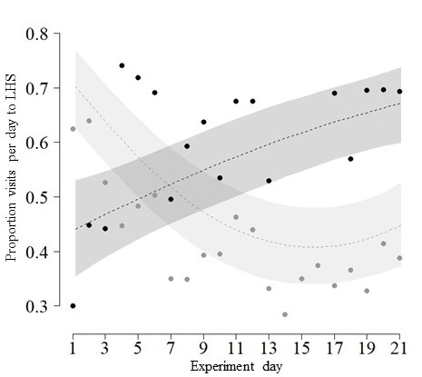
Figure 2. Proportion of visits recorded per day to LHS at group-site feeders (Site 1 = dark grey; Site 2 = light grey), which shows how preference for one side changed between the two sites. Line of best fit and 95% confidence intervals calculated from the top-ranked model; data points are plotted as the raw values from RFID recordings.

Table 1. Effect sizes and 95% confidence intervals for predictors included in the top model set (∆AICc < 2) analysing likelihood that hihi chose the local side for (a) all visits (N = 10049 visits by 49 juveniles and 25 adults) and (b) when juveniles changed group-sites (N = 244 visits by 32 juveniles). Terms that were good predictors after model averaging (i.e. confidence interval did not span 0.00) are highlighted in bold. Group preference = proportion of other birds’ visits to locally-preferred side (see Figure 2).

 | Predictor | Effect | 95% CI
(a) | Group preference*age (juvenile) | 1.66 ± 0.67 | 0.35 – 2.97
(a) | Visit day*age (juvenile) | -0.05 ± 0.02 | -0.08 – -0.02
(a) | Time of day (hours) | 0.01 ± 0.01 | 0.00 – 0.02
(b) | Group preference | 2.84 ± 1.31 | 0.27 – 5.42
(b) | Visit day | 0.04 ± 0.03 | -0.02 – 0. 09
(b) | Time of day (hours) | -0.06 ± 0.05 | -0.16 – 0.03
(b) | Previous day preference | 0.08 ± 0.80 | -1.48 – 1.65

The identity of the previous individual was not important for copying. Most individuals were copied on half their visits (Figure 4c; the mean proportion that hihi who visited >3 times were copied = 0.50; 77% of individuals fell within one standard deviation of the mean). One adult male was never copied, and a juvenile male from the open-feeder treatment was copied on 70% of its visits. The likelihood of juveniles copying another bird depended on how closely they followed that individual, but the relationship was in the opposite direction than expected: copying increased as time between visits increased (Figure 3d; effect size = 0.22±0.04, 95% CI = 0.14 – 0.30, Supplementary Table 7a). Hence, for visits <30s apart, juveniles were less than 50% likely to copy (Figure 3d; this may have been because another hihi was in the feeder: in 345 observations of visits during the experiment, the median time spent in feeder = 30s, IQR = 0). For visits with the greatest opportunity to directly observe another individual (<60s apart), the likelihood of copying under a particular social environment did not increase when juveniles were more familiar with the preceding bird (not included in top model set: Supplementary Table 7b), nor according to the age of that individual (effect size = 0.23±0.14, 95% CI = -0.05 – 0.5; Supplementary Table 7b). These factors also had little effect on copying likelihood when juveniles changed site (effect sizes: familiarity = -2.82±4.87, 95% CI = -12.37 – 6.72; age of preceding individual = -0.62±0.61, -1.83 – 0.58; Supplementary Table 7c,d).

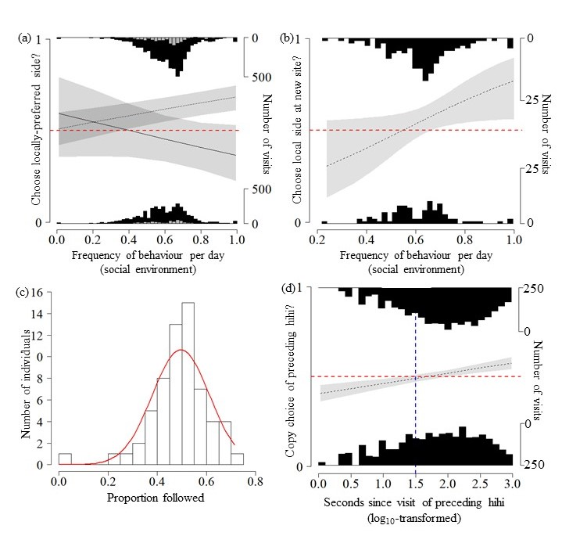Figure 3. (a) likelihood that juveniles (dotted line) and adults (solid line) chose the local side (yes = 1, no = 0), depending on its frequency of use in preceding visits by other hihi that day; (b) likelihood that juvenile hihi chose the local side when they changed sites (yes = 1, no = 0), depending on its frequency of use by other hihi that day; (c) the frequency that individuals’ visits were copied by the following hihi; red line represents normal distribution for reference; (d) likelihood that hihi chose the same side as the previous bird (yes = 1, no = 0), for visits within 15 minutes of each other (dashed blue line represents 30s). All histograms show the number of visits at each x-axis value (black = juveniles; grey = adults). All predicted model estimates and 95% confidence intervals (grey polygons) come from top-ranked models. Dashed red lines indicate 50% likelihood of copying.

Discussion

Here we have shown that social experiences in early life affect the foraging behaviour of juvenile passerine birds. Although fledgling hihi copied parents’ use of a feeder during post-fledge care, once they became independent and grouped with other juvenile hihi they updated their side-choice in response to peers’ behaviour. This side-choice did not appear to result from individual habit or external abiotic environmental effects, because side-choices across first visits per site were random, and these first choices did not determine ongoing preferences. Instead, the behavioural changes were socially-mediated as each birds’ side-choice depended on those of its peers, which led to a group-level preference when the visit frequency at one side of the feeder increased over the experiment. Crucially, the pattern was repeated in two different groups, and individuals showed an even greater tendency to follow social cues when they moved between the groups. Although juveniles were more likely to copy others compared to adults that briefly visited group-sites, they did not prefer to copy familiar peers. Our estimate of the social cues available for hihi was broad (daily preceding side-choices by other group members) and relied on remotely-collected data. However, this method was informed by intensive field observations of hihi, and meant we could track individual-level behaviour over a much larger scope than possible with direct observation. Our results therefore provide insight into how young animals use social information as they transition into independence.

We found little retained effect of experiences with parents during post-fledge parental care on juvenile foraging behaviour. All newly-independent juveniles visited group-site feeders at similar times, irrespective of whether they had encountered a feeder at their nest or whether they had used nest feeders. Some parents did not use their nest feeders, which limited their offspring’s exposure to social information near nests. Although this was unexpected (parents consistently used almost identical feeders in previous studies e.g. [50]) and may have been due to local resource variability, we found no difference in juveniles’ feeder use depending on their parents’ behaviour. Finally, juveniles’ initial side-choice was random, even if they had experienced side access routes previously at nests. Overall, these findings indicate that young passerines may not retain specific preferences from early-life exposure to stimuli with parents. This could be due to the short period of dependency found in many Passeridae (for example, hihi spend approximately two weeks in the natal territory [51]) in comparison to other species which have longer post-fledging association with parents (e.g.: [17]). Thus, while some behaviours are transmitted from parents to offspring through imitation or teaching and are retained throughout life [15,19], other behaviours may be more flexible and can be updated or discarded once young become independent.

By contrast, we found that peers had strong positive effects on the foraging behaviour of newly-independent juvenile hihi. Juvenile hihi may not have observed every single visit before their own, but due to their social behaviour they spent a considerable amount of time living in the group-sites in the vicinity of each feeders over the duration of our experiment. This gave them the opportunity to accrue social information over days and weeks. Previous studies have found similar evidence indicating juveniles may use social information [52] to determine behaviour, rather than their own limited personal information [12,53]. Furthermore, young hihi also altered their choices based on the overall collective behaviour of the group rather than specific individuals, as there was little evidence that individual-level familiarity affected behaviour. Although familiarity is important for information dissemination in some contexts [3,54], it may be less crucial when using information provided collectively by groups, and copying a predominant behaviour rather than specific individuals may help animals overcome some pitfalls of using social information [55,56,but see 57]. If juveniles have limited experience to judge reliability from different sources, then groups may offer a more complete picture of behavioural responses to the current environment [56] and paying attention to whichever individuals are present at the time may provide the most up-to-date information [58].

When paying attention to the collective behaviour of peers, animals may respond to small changes in the frequency of behaviour in groups to alter their own preferences and conform. Although there has been debate surrounding how to define conformity (for discussion, see: [33,59–61]), a general rule is that conforming animals tend to prefer a common behavioural option in a group, even if they have experienced alternative options [62]. Within the past 10 years a widespread tendency for animals to copy the behaviour of others has been suggested across taxa (birds: [2]; non-human primates: [27] but see [49,63]; fish: [64]; humans: [65]). To add support, juvenile hihi developed a preference for one feeder side, which was driven most strongly by the behaviour of others. Previous studies have further suggested animals quickly conform to traditions in new groups [27], and we also found evidence that copying was localised so that juvenile hihi switched their behaviour when moving between groups with opposite preferences. Updating behaviour by using information from current associates instead of maintaining responses from previous experiences may help animals adjust to new conditions [66], but could also trigger abrupt shifts in behaviour when previously-shared information is lost [35]. Overall, our evidence suggested that juvenile hihi paid attention to peers even with prior experience of other equally-profitable options. This led them to copy predominant behaviours, and therefore provides a rare example of conformity to group preferences in wild birds (thus far demonstrated only in wild Parids [2]).

Conforming can perpetuate behavioural biases in populations under certain conditions [67], although emerging evidence indicates that when conforming becomes suboptimal, animals can reduce their tendency to copy [52]. We also found that juveniles were less likely to copy when using feeders at very similar times, and instead used the equally-rewarding alternate option. This could be a way to avoid queuing before feeding themselves, and maintain an optimal foraging intake [68]. Further, we found that adults, who are potentially less reliant on social cues, contrasted with juveniles and appeared to avoid copying group preference. This could suggest they prioritised avoiding competition at crowded resources, and instead used personally-acquired information. Potentially, in natural populations where animals must pay attention to small trade-offs between social information use, competitive interactions, and/or resources of similar payoff (as in our experiment) there may never be a strong sigmoidal relationship between frequency of behaviour and likelihood of copying [2,33]. Flexible use of conformist strategies under different payoffs has only just begun to be considered [52,63], but here we suggest using social information while foraging may particularly benefit naïve young animals in less competitive environments.

Ethics

Ethical approval of the study design was issued through the Zoological Society of London Ethics Committee (UK). Use of RFID tags was approved by the Auckland Zoo Ethics Committee (New Zealand). All research and population management (including nestbox monitoring) was conducted under a New Zealand Department of Conservation Research Permit (44300-FAU).

Data accessibility

Associated datasets and R code file are available from the Dryad Digital repository: https://doi.org/10.5061/dryad.q573n5th3[69].

Acknowledgements

We would like to thank the Department of Conservation and Supporters of Tiritiri Matangi for their assistance during this study. We are grateful to Neeltje Boogert, Lucy Aplin, and Erica van de Waal for helpful discussions on study design and analyses, and two anonymous reviewers whose comments greatly improved the manuscript. VF was supported by a Balfour PhD studentship (Department of Zoology, University of Cambridge); RT was supported by an Independent Research Fellowship from the Natural Environment Research Council UK (NE/K00929X/1) and a start-up grant from the Helsinki Institute of Life Science (HiLIFE), University of Helsinki.

References

1. Jesmer BR et al. 2018 Is ungulate migration culturally transmitted? Evidence of social learning from translocated animals. Science (80-. ). (doi:10.1126/science.aat0985)
2. Aplin LM, Farine DR, Morand-Ferron J, Cockburn A, Thornton A, Sheldon BC. 2015 Experimentally induced innovations lead to persistent culture via conformity in wild birds. Nature 518, 538–541. (doi:10.1038/nature13998)
3. Aplin LM, Farine DR, Morand-Ferron J, Sheldon BC. 2012 Social networks predict patch discovery in a wild population of songbirds. Proc. R. Soc. B Biol. Sci. 279, 4199–4205. (doi:10.1098/rspb.2012.1591)
4. Allen J, Weinrich M, Hoppitt W, Rendell L. 2013 Network-based diffusion analysis reveals cultural transmission of lobtail feeding in humpback whales. Science (80-. ). 340, 485–8. (doi:10.1126/science.1231976)
5. Hoppitt W, Samson J, Laland KN, Thornton A. 2012 Identification of learning mechanisms in a wild Meerkat population. PLoS One 7. (doi:10.1371/journal.pone.0042044)
6. Kendal RL, Coolen I, Laland KN. 2009 Adaptive trade-offs in the use of social and personal information. In Cognitive ecology II, pp. 249–271. Chicago: University of Chicago Press.
7. Dall SRX, Giraldeau L-A, Olsson O, McNamara JM, Stephens DW. 2005 Information and its use by animals in evolutionary ecology. Trends Ecol. Evol. 20, 187–193. (doi:10.1016/j.tree.2005.01.010)
8. Seppänen JT, Forsman JT, Monkkönen M, Thomson RL. 2007 Social information use is a process across time, space, and ecology, reaching heterospecifics. Ecology 88, 1622–1633. (doi:10.1890/06-1757.1)
9. Silk MJ, Croft DP, Tregenza T, Bearhop S. 2014 The importance of fission-fusion social group dynamics in birds. Ibis (Lond. 1859). (doi:10.1111/ibi.12191)
10. Jones TB, Aplin LM, Devost I, Morand-Ferron J. 2017 Individual and ecological determinants of social information transmission in the wild. Anim. Behav. (doi:10.1016/j.anbehav.2017.05.011)
11. Kendal RL. 2004 The role of conformity in foraging when personal and social information conflict. Behav. Ecol. 15, 269–277. (doi:10.1093/beheco/arh008)
12. Kendal RL, Coolen I, van Bergen Y, Laland KN. 2005 Trade‐Offs in the Adaptive Use of Social and Asocial Learning. Adv. Study Behav. 35, 333–379. (doi:10.1016/S0065-3454(05)35008-X)
13. Aplin L. 2016 Understanding the multiple factors governing social learning and the diffusion of innovations. Curr. Opin. Behav. Sci. (doi:10.1016/j.cobeha.2016.09.003)
14. Mesoudi A, Chang L, Dall SRX, Thornton A. 2016 The Evolution of Individual and Cultural Variation in Social Learning. Trends Ecol. Evol. (doi:10.1016/j.tree.2015.12.012)
15. Thornton A. 2006 Teaching in Wild Meerkats. Science (80-. ). 313, 227–229. (doi:10.1126/science.1128727)
16. Danchin É, Giraldeau LA, Valone TJ, Wagner RH. 2004 Public Information: From Nosy Neighbours to Cultural Evolution. Am. Assoc. Adv. Sci. 305, 487–491. (doi:10.1126/science.1098254)
17. Heinsohn RG. 1991 Slow learning of foraging skills and extended parental care in cooperatively breeding white-winged choughs. Am. Nat. 137, 864–881. (doi:10.1086/285198)
18. Whitehead H. 2017 Gene–culture coevolution in whales and dolphins. Proc. Natl. Acad. Sci. (doi:10.1073/pnas.1620736114)
19. van de Waal E, Bshary R, Whiten A. 2014 Wild vervet monkey infants acquire the food-processing variants of their mothers. Anim. Behav. 90, 41–45. (doi:10.1016/j.anbehav.2014.01.015)
20. Farine DR, Spencer KA, Boogert NJ. 2015 Early-life stress triggers juvenile zebra finches to switch social learning strategies. Curr. Biol. 25, 2184–2188. (doi:10.1016/j.cub.2015.06.071)
21. Brandl HB, Farine DR, Funghi C, Schuett W, Griffith SC. 2019 Early-life social environment predicts social network position in wild zebra finches. Proc. R. Soc. B Biol. Sci. 286, 20182579. (doi:10.1098/rspb.2018.2579)
22. Slagsvold T, Wiebe KL. 2011 Social learning in birds and its role in shaping a foraging niche. Philos. Trans. R. Soc. B Biol. Sci. 366, 969–77. (doi:10.1098/rstb.2010.0343)
23. Ward A, Webster M. 2016 Sociality: the Behaviour of Group-Living Animals. New York: Springer, New York. (doi:10.1007/978-3-319-28585-6)
24. Noble DWA, Byrne RW, Whiting MJ. 2014 Age-dependent social learning in a lizard. Biol. Lett. 10, 20140430–20140430. (doi:10.1098/rsbl.2014.0430)
25. Langen T. 1996 Social learning of a novel foraging skill by white- throated magpie-jays (Calocitta formosa, Corvidae): A field experiment. Ethology 102, 157–166. (doi:10.1111/j.1439-0310.1996.tb01113.x)
26. Galef BG, Laland KN. 2005 Social Learning in Animals: Empirical Studies and Theoretical Models. Bioscience 55, 489. (doi:10.1641/0006-3568(2005)055[0489:SLIAES]2.0.CO;2)
27. van de Waal E, Borgeaud C, Whiten A. 2013 Potent Social Learning and Conformity Shape a Wild Primate’s Foraging Decisions. Science (80-. ). 340, 483–485. (doi:10.1126/science.1232769)
28. Sheppard CE et al. 2018 Decoupling of Genetic and Cultural Inheritance in a Wild Mammal. Curr. Biol. (doi:10.1016/j.cub.2018.05.001)
29. Schwab C, Bugnyar T, Schloegl C, Kotrschal K. 2008 Enhanced social learning between siblings in common ravens, Corvus corax. Anim. Behav. 75, 501–508. (doi:10.1016/j.anbehav.2007.06.006)
30. Biondi LM, Bó MS, Vassallo AI. 2010 Inter-individual and age differences in exploration, neophobia and problem-solving ability in a Neotropical raptor (Milvago chimango). Anim. Cogn. (doi:10.1007/s10071-010-0319-8)
31. Seppänen JT, Forsman JT, Mönkkönen M, Krams I, Salmi T. 2011 New behavioural trait adopted or rejected by observing heterospecific tutor fitness. Proc. R. Soc. B Biol. Sci. 278, 1736–1741. (doi:10.1098/rspb.2010.1610)
32. Mesoudi A. 2015 Cultural Evolution: A Review of Theory, Findings and Controversies. Evol. Biol. 43, 481–497. (doi:10.1007/s11692-015-9320-0)
33. Aplin LM, Farine DR, Morand-Ferron J, Cockburn A, Thornton A, Sheldon BC. 2015 Counting conformity: evaluating the units of information in frequency-dependent social learning. Anim. Behav. 110, e5–e8. (doi:10.1016/j.anbehav.2015.09.015)
34. Whitehead H, Laland KN, Rendell L, Thorogood R, Whiten A. 2019 The reach of gene-culture coevolution in animals. Nat. Commun. 10, 2405.
35. Brakes P et al. 2019 Animal cultures matter for conservation. Science (80-. ). 363, 1032 LP – 1034. (doi:10.1126/science.aaw3557)
36. Whitehead H. 2010 Conserving and managing animals that learn socially and share cultures. Learn. Behav. (doi:10.3758/LB.38.3.329)
37. Boogert NJ, Zimmer C, Spencer KA. 2013 Pre- and post-natal stress have opposing effects on social information use. Biol. Lett. 9, 20121088. (doi:10.1098/rsbl.2012.1088)
38. Thorogood R, Armstrong DP, Low M, Brekke P, Ewen JG. 2013 The value of long-term ecological research: integrating knowledge for conservation of hihi on Tiritiri Matangi Island. New Zeal. J. Zool. 37, 298–306.
39. Franks VR, Ewen JG, McCready M, Rowcliffe M, Smith D, Thorogood R. 2020 Analysing age structure, residency and relatedness uncovers social network structure in aggregations of young birds. Anim. Behav. 166, 73–84. (doi:10.1101/456376)
40. Farine DR. 2013 Animal social network inference and permutations for ecologists in R using asnipe. Methods Ecol. Evol. 4, 1187–1194. (doi:10.1111/2041-210X.12121)
41. Boogert NJ, Reader SM, Hoppitt W, Laland KN. 2008 The origin and spread of innovations in starlings. Anim. Behav. 75, 1509–1518. (doi:10.1016/j.anbehav.2007.09.033)
42. R Core Team. 2018 R: A Language and Environment for Statistical Computing.
43. Burnham KP, Anderson DR. 2002 Model Selection and Multimodel Inference: A Practical Information-Theoretic Approach. New York: Springer, New York. (doi:10.1016/j.ecolmodel.2003.11.004)
44. Symonds MR., Moussalli A. 2011 A brief guide to model selection, multimodel inference and model averaging in behavioural ecology using Akaike’s information criterion. Behav. Ecol. Sociobiol. 65, 13–21. (doi:10.1007/s00265-010-1037-6)
45. Mazerolle MJ. 2017 AICcmodavg: model selection and multimodel inference based on (Q)AIC(c).
46. Nakagawa S, Cuthill IC. 2007 Effect size, confidence interval and statistical significance: A practical guide for biologists. Biol. Rev. 82, 591–605. (doi:10.1111/j.1469-185X.2007.00027.x)
47. Bates D, Maechler M, Bolker B, Walker S. 2015 Package lme4. J. Stat. Softw. 67, 1–91. (doi:http://lme4.r-forge.r-project.org)
48. Cribari-Neto F, Zeileis A. 2015 Beta Regression in R. J. Stat. Softw. 34, 1–24. (doi:10.18637/jss.v034.i02)
49. Pesendorfer MB, Gunhold T, Schiel N, Souto A, Huber L, Range F. 2009 The maintenance of traditions in marmosets: Individual habit, not social conformity? A field experiment. PLoS One 4, e4472. (doi:10.1371/journal.pone.0004472)
50. Thorogood R, Ewen JG, Kilner RM. 2011 Sense and sensitivity: responsiveness to offspring signals varies with the parents’ potential to breed again. Proc. R. Soc. B Biol. Sci. 278, 2638–45. (doi:10.1098/rspb.2010.2594)
51. Franks VR, McCready M, Savage JL, Thorogood R. 2019 Time Spent With Parents Varies With Early-Life Condition, but Does Not Predict Survival or Sociality of Juvenile Hihi . Front. Ecol. Evol. . 7, 322.
52. Aplin LM, Sheldon BC, McElreath R. 2017 Conformity does not perpetuate suboptimal traditions in a wild population of songbirds. Proc. Natl. Acad. Sci. 114, 7830–7837. (doi:10.1073/pnas.1621067114)
53. Laland KN. 2004 Social learning strategies. Anim. Learn. Behav. 32, 4–14. (doi:10.3758/BF03196002)
54. Atton N, Galef BJ. 2014 Familiarity affects social network structure and discovery of prey patch locations in foraging stickleback shoals. Proc. R. Soc. B Biol. Sci. 281, 20140579.
55. King AJ, Cowlishaw G. 2007 When to use social information: the advantage of large group size in individual decision making. Biol. Lett. 3, 137–9. (doi:10.1098/rsbl.2007.0017)
56. Conradt L, Roper TJ. 2005 Consensus decision making in animals. Trends Ecol. Evol. 20, 449–456. (doi:10.1016/j.tree.2005.05.008)
57. Giraldeau L-A, Valone TJ, Templeton JJ. 2002 Potential disadvantages of using socially acquired information. Philos. Trans. R. Soc. London B Biol. Sci. 357, 1559–66. (doi:10.1098/rstb.2002.1065)
58. Ramakers JJC, Dechmann DKN, Page RA, O’Mara MT. 2016 Frugivorous bats prefer information from novel social partners. Anim. Behav. 116, 83–87. (doi:10.1016/j.anbehav.2016.03.021)
59. van Leeuwen EJC, Acerbi A, Kendal RL, Tennie C, Haun DBM. 2016 A reappreciation of ‘conformity’. Anim. Behav. 122, e5–e10. (doi:10.1016/j.anbehav.2016.09.010)
60. van Leeuwen EJ., Kendal RL, Tennie C, Haun DBM. 2015 Conformity and its look-a-likes. Anim. Behav. 110, e1–e4. (doi:10.1016/j.anbehav.2015.07.030)
61. Whiten A, van de Waal E. 2016 Identifying and dissecting conformity in animals in the wild: further analysis of primate data. Anim. Behav. 122, e1–e4. (doi:10.1016/j.anbehav.2016.04.002)
62. de Waal FBM. 2013 Animal Conformists. Science (80-. ). 340, 437–438. (doi:10.1126/science.1237521)
63. van Leeuwen EJC, Cronin KA, Schütte S, Call J, Haun DB. 2013 Chimpanzees (Pan troglodytes) flexibly adjust their behaviour in order to maximize payoffs, not to conform to majorities. PLoS One 8, 1–10. (doi:10.1371/journal.pone.0080945)
64. Pike TW, Laland KN. 2010 Conformist learning in nine-spined sticklebacks’ foraging decisions. Biol. Lett. 6, 466–8. (doi:10.1098/rsbl.2009.1014)
65. Haun DBM, Van Leeuwen E. C, Edelson MG. 2013 Majority influence in children and other animals. Dev. Cogn. Neurosci. 3, 61–71. (doi:10.1016/j.dcn.2012.09.003)
66. Teitelbaum CS, Converse SJ, Mueller T. 2018 The importance of early life experience and animal cultures in reintroductions. Conserv. Lett. , e12599. (doi:10.1111/conl.12599)
67. Barrett B, Zepeda E, Pollack L, Munson A, Sih A. 2019 Counter-Culture: Does Social Learning Help or Hinder Adaptive Response to Human-Induced Rapid Environmental Change? Front. Ecol. Evol. 7, 183.
68. Krebs JR, Inman AJ. 1992 Learning and foraging: individuals, groups, and populations. Am. Nat. 140, S63–S84. (doi:10.1086/285397)
69. Franks VR, Ewen JG, McCready M, Thorogood R. 2020 Data from: Foraging behaviour alters with social environment in a juvenile songbird. Dryad Digit. Repos. (doi:10.5061/dryad.q573n5th3)

Supplementary information for: Foraging behaviour alters with social environment in a juvenile songbird

SEEDING DIFFERENT EXPERIENCES AT NESTS: FEEDER USE BY PARENTS AND THEIR FLEDGLINGS

At open feeder nests, we recorded what experiences juveniles had by observing feeders for 45 minutes every two days to determine parents’ use prior to fledging, and then fledglings’ use. Parents did not use open feeders at 6/15 nests despite us following protocols used in previous feeder studies [e.g. 1]. It is unlikely we missed use, due to regular observations of nest feeders and at all nests where we did observe feeding there were multiple visits by parents within each observation session. Finally, we also checked for spots of dried sugar on feeder bases to indicate feeding activity. The reason for the lack of use was unclear but may have been due to local resource availability or variation in individual propensity to use artificial feeders, as some hihi rarely use the permanent supplementary feeding stations on Tiritiri Matangi. However, as their fledglings (N = 13) still had an opportunity to observe the feeder in the nest territory, we retained them in later analyses. Overall, we recorded 7 fledglings using their feeders.

At side-choice feeder nests, we recorded visits using RFID data-loggers at the entrance of each channel. At all of these nests, parents used feeders before chicks fledged; the majority first showed no preference for a side (exactly half of first visits were to the reward option across the 12 nests). They also showed no preference for the reward side across all visits on their first day (Binomial sign test: 40/66 visits to reward side, P = 0.11). However, before chicks fledged, parents developed a preference for the reward side over their successive visits (effect of visit day = 0.42±0.04, 95% CI = 0.34 – 0.50; Supplementary Figure 1, Supplementary Table 1), with males doing so more quickly (effect of being male = 1.92±0.64, 95% CI = 0.67 – 3.18; Supplementary Figure 1, Supplementary Table 1). Once chicks fledged, we recorded 11/40 fledglings visiting their feeders (5 nests); however, in this subset that used the feeders, 9/11 chose the rewarding side that their parents used (binomial sign test of likelihood of choosing same side as parents: P = 0.03). These fledglings continued to visit the rewarding side on 78.0±7.5% of their visits while in the nest territory site (mean number of visits = 12.4±5.62). In the 7 juveniles that visited group-site feeders once they became independent, all these individuals chose the rewarding side when they first visited their nest feeder, and visited it 73.8±8.5% of the time across 14.9±6.9 visits.

Supplementary Table 1. Ranking of Generalised Linear Models used to analyse the likelihood that parent hihi chose reward side. Models are ranked according to ∆AICc values, and the weight indicates the relative likelihood of the respective model. Null model (~1) presented for comparison.
 | AICc | ∆AICc | AICc  weight
~ visit day + sex | 623.00 | 0.00 | 0.74
~ visit day | 625.12 | 2.12 | 0.26
~ sex | 750.07 | 127.08 | 0.00
~ 1 | 752.03 | 129.03 | 0.00

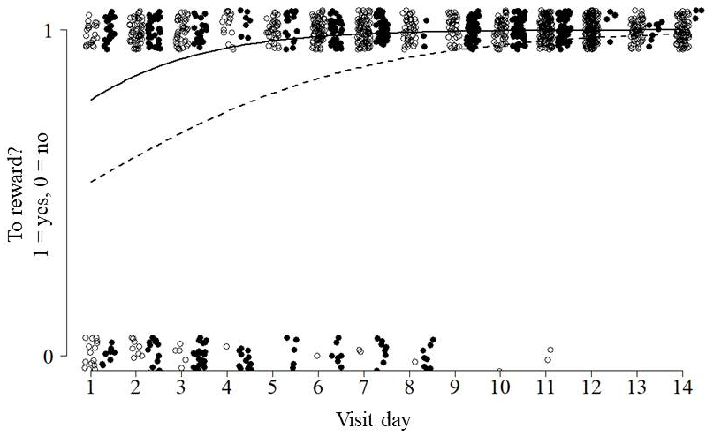
Supplementary Figure 1. The likelihood that parent hihi (males = open circles, solid line; females = closed circles, dashed line) chose the reward side across their visits to nest feeders in the 14 days before chicks fledged. Lines of best fit calculated from the top ranked model in Supplementary Table 1.

DETERMING LENGTH OF TIME HIHI SPENT IN THE VICINITY OF GROUP FEEDERS

During the experiment, the feeders were situated in the core area occupied by the groups. This meant that juvenile hihi had the opportunity to observe others use the feeders, without necessarily being detected by the RFID system (unless they chose to visit the feeder soon after). To estimate these opportunities for observation, we observed hihi for 1 h every two days while the feeders were present in group sites in stages (b) and (c) (2 months). We surveyed an area within 10-metre radius of the feeder, and recorded any colour-ringed individuals seen in 30-second observation windows (i.e. each 1 h survey was divided into 120 time-windows; total of 25h per group site). From these records we calculated (i) the total length of time juveniles were present in the feeder vicinity within a survey, and (ii) the length of time per visit. For (ii), we defined separate visits as any observations that were more than two minutes apart (i.e. not observed in 4 consecutive observation windows). Surveys were conducted throughout the day in both sites, to avoid confounding effects from variation in diurnal activity patterns.

Of the 49 juveniles that used the side-choice feeder, these birds were sighted in a median of 12 surveys (IQR = 9 days) and spent in total a median of 150 s in the vicinity of the feeder during each survey (IQR = 150s; maximum duration = 1140s; Supplementary Figure 2a). Each visit per survey had a median length of 60 s (IQR = 90 s; maximum length = 810s; Supplementary Figure 2b). Assuming surveys captured a sample of behaviour each day, spread throughout a full day (12 hours) juveniles therefore likely spent a median of 30 minutes (IQR = 30 min; maximum = 3.8h; Supplementary Figure 2c) in the area immediately surrounding the feeders, when they could have been observing visits and accruing social information about side choices.
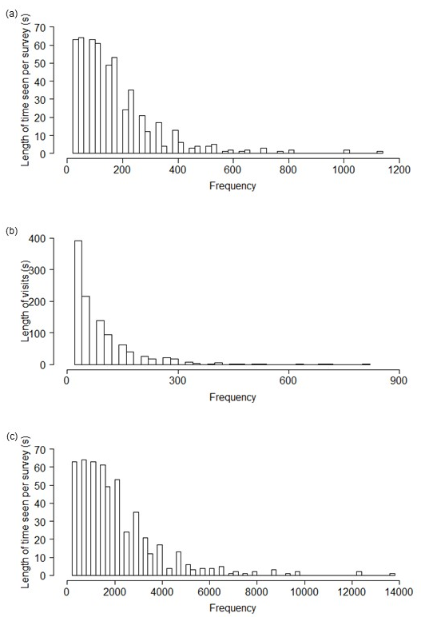
Supplementary Figure 2. (a) Frequencies of the maximum lengths of time juvenile hihi were seen in the area immediately surrounding the feeders during one-hour surveys carried out in group sites during the main experiment; (b) frequency of durations of visits per survey; (c) predicted frequency of the length of time juveniles spent in the vicinity of feeders across an entire day, extrapolated from timings from one-hour surveys. All timings recorded to the nearest 30s.
SUPPLEMENTARY FIGURES AND TABLES
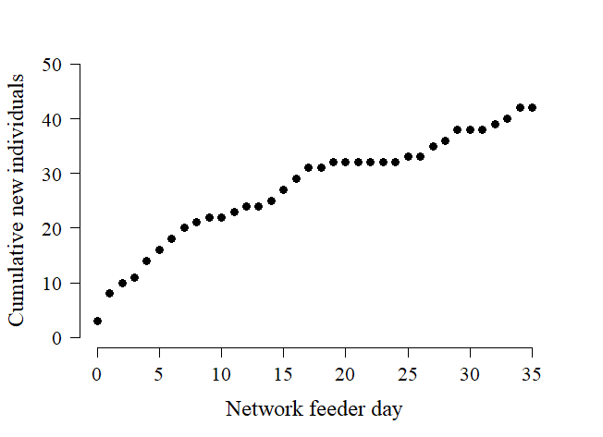
Supplementary Figure 3. Cumulative counts of new individuals during network recording, calculated using each juvenile’s time of first record at the network feeder.
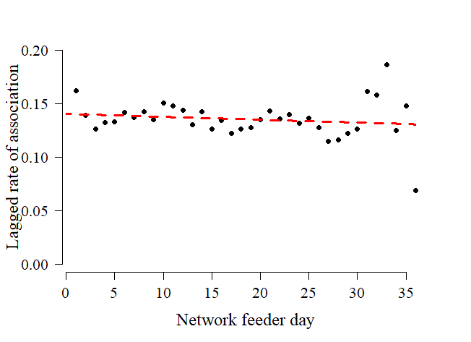
Supplementary Figure 4. Evidence for the temporal stability of associations in juvenile hihi groups, using the Lagged Rate of Association (LRA) to quantify the probability of re-associating across each day of network recording [3]. We calculated LRAs from our recorded network using package asnipe in R, and then explored the change in LRA values across the days of network recording using a linear model. Probability of re-associating did not decline over network recording as the relationship between network recording day and LRA value (red dotted line) did not differ to a null model (Chi-square comparison: d.f. = 1, P = 0.34); therefore, associations in juvenile hihi groups remained relatively stable across time.

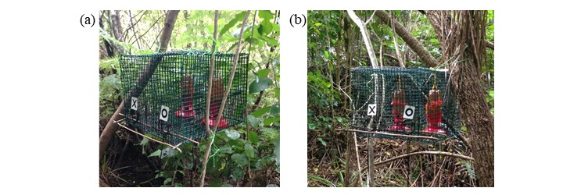
Supplementary Figure 5. Photos of stage (c) feeder set-up for juvenile group in (a) Site 1 and (b) Site 2; “X” and “O” symbols were used for another experiment, but “X” was always left, “O” right.

Supplementary Table 2. Ranking of beta-regression models analysing how arrival rank varied at group site feeders for (a) all juveniles, comparing effect of feeder presence/absence; and (b) nest feeder juveniles, comparing effects of different experiences. Models are ranked according to ∆AICc values, and the weight indicates the relative likelihood of the respective model. Null models (~1) are presented for comparison. Random intercept accounts for which feeder juveniles first visited (network or experiment).
(a) |  | AICc | ∆AICc | AICc  Weight
 | ~ 1 | 2.74 | 0.00 | 0.37
 | ~ feeder presence at nest | 3.03 | 0.30 | 0.32
 | ~ presence in group surveys | 4.11 | 1.37 | 0.18
 | ~ feeder presence at nest + presence in group surveys | 4.74 | 2.00 | 0.13

(b) |  | AICc | ∆AICc | AICc  Weight
 | ~ 1 | 1.84 | 0.00 | 0.30
 | ~ presence in group surveys | 3.23 | 1.38 | 0.15
 | ~ parent use | 4.00 | 2.15 | 0.10
 | ~ used nest feeder | 4.15 | 2.31 | 0.09
 | ~ feeder type | 4.16 | 2.32 | 0.09
 | ~ parent use + presence in group surveys | 5.70 | 3.85 | 0.04
 | ~ feeder type + presence in group surveys | 5.73 | 3.89 | 0.04
 | ~ used nest feeder + presence in group surveys | 5.74 | 3.89 | 0.04
 | ~ parent use + used nest feeder | 6.56 | 4.71 | 0.03
 | ~ feeder type + parent use | 6.58 | 4.73 | 0.03
 | ~ feeder type + used nest feeder | 6.69 | 4.84 | 0.03
 | ~ parent use + presence in group surveys + used nest feeder | 8.44 | 6.60 | 0.01
 | ~ parent use + presence in group surveys + feeder type | 8.46 | 6.61 | 0.01
 | ~ used nest feeder + presence in group surveys + feeder type | 8.46 | 6.62 | 0.01
 | ~ parent use + used nest feeder + feeder type | 9.32 | 7.48 | 0.01
 | ~ feeder type + parent use + used nest feeder + presence in group surveys | 11.40 | 9.56 | 0.00

Supplementary Table 3. Ranking of Generalised Linear Mixed Effect Models analysing side preference in side choice feeder nest juveniles across the experiment. Models are ranked according to change in AICc values (∆AICc), and the AICc weight indicates the relative likelihood of the respective model being the best model from the candidate set. All models contained a random effect term to account for repeated records of individuals (1 | ID). Null model (~1) presented for comparison.
 | AICc | ∆AICc | AICc Weight
~ 1 | 3825.28 | 0.00 | 0.41
~ experiment day | 3825.35 | 0.06 | 0.40
~ nest feeder side | 3827.98 | 2.69 | 0.11
~ experiment day + nest feeder side | 3828.67 | 3.39 | 0.08
~ experiment day x nest feeder side | 3832.71 | 7.43 | 0.01

Supplementary Table 4. Ranking of Generalised Linear Models analysing the likelihood that juveniles copied the previous bird on their first visits, depending on how soon after they followed (lapse in seconds). Models are ranked according to ∆AICc values, and the weight indicates the relative likelihood of the respective model. Null model (~1) presented for comparison.

 | AICc | ∆AICc | AICc Weight
~ lapse from previous hihi | 53.24 | 0.00 | 0.57
~ 1 | 53.81 | 0.58 | 0.43

Supplementary Table 5. Ranking of Generalised Linear Mixed Effect Models used to analyse side preference in groups. Models are ranked according to change in AICc values (∆AICc), and the AICc weight indicates the relative likelihood of the respective model being the best model from the candidate set. Null model (~1) presented for comparison.
(a) |  | AICc | ∆AICc | AICc Weight
 | ~ poly(experiment day,2) x location | 12495.67 | 0.00 | 1.00
 | ~ experiment day x location | 12530.08 | 34.41 | 0.00
 | ~ poly(experiment day,2) + location | 12645.39 | 149.72 | 0.00
 | ~ experiment day + location | 12669.22 | 173.55 | 0.00
 | ~ poly (experiment day,2) | 12673.69 | 174.14 | 0.00
 | ~ location | 12673.69 | 178.02 | 0.00
 | ~ experiment day | 12692.91 | 197.24 | 0.00
 | ~ 1 | 12698.35 | 202.67 | 0.00

Supplementary Table 6. Ranking of Generalised Linear Mixed Effect Models analysing likelihood that hihi chose the locally-preferred side depending on group preference (proportion of preceding visits made by other birds to the locally preferred side that day) for (a) all visits, (b) when juveniles changed sites. Models contain a random intercept accounting for repeated records of individuals (1 | ID) and are ranked according to ∆AICc. Weight indicates the relative likelihood of the respective model; all possible combinations of predictors given in the main text were analysed, but only models with weight > 0.00 are presented. Null model (~1) also presented for comparison.

(a) |  | AICc | ΔAICc | AICc Weight
 | ~ group preference x age + visit day x age | 12362.94 | 0.00 | 0.47
 | ~ group preference x age + visit day x age + time of day | 12363.43 | 0.49 | 0.36
 | ~ group preference + visit day x age | 12366.60 | 3.66 | 0.07
 | ~ group preference + visit day x age + time of day | 12367.18 | 4.24 | 0.06
 | ~ group preference x age + visit day | 12370.34 | 7.40 | 0.01
 | ~ group preference + age + visit day | 12370.37 | 7.43 | 0.01
 | ~ group preference x age + visit day + time of day | 12370.92 | 7.98 | 0.01
 | ~ group preference + age + visit day + time of day | 12370.97 | 8.03 | 0.01
 | ~ 1 | 12645.60 | 282.66 | 0.00

(b) |  | AICc | ΔAICc | AICc Weight
 | ~ group preference + previous preference | 243.24 | 0.00 | 0.24
 | ~ group preference + previous preference + time of day | 243.57 | 0.33 | 0.20
 | ~ group preference + previous preference + visit day | 243.74 | 0.51 | 0.18
 | ~ group preference + previous preference + visit day + site change number | 245.03 | 1.79 | 0.10
 | ~ group preference + previous preference + site change number | 245.51 | 2.27 | 0.08
 | ~ group preference + previous preference + visit day + time of day + site change number | 245.91 | 2.67 | 0.06
 | ~ group preference + previous preference + time of day + site change number | 245.93 | 2.69 | 0.06
 | ~ previous preference + visit day + time of day + site change number | 246.07 | 2.84 | 0.06
 | ~ previous preference | 247.57 | 4.34 | 0.03
 | ~ 1 | 325.52 | 82.29 | 0.00
Supplementary Table 7. Ranking of Generalised Linear Mixed Effect Models analysing short term effects of copying choice of preceding individual for (a) juvenile visits less than 15 minutes from the previous bird (N = 6011 visits, 49 juveniles); (b) juvenile visits less than 60s from the previous bird, only including individuals with >15 records in the social network (N = 1960 visits, 28 juveniles); (c) visits following a group site change (N = 225 visits, 32 juveniles); (d) visits following a group site change that closely followed another bird (<60s apart) (N = 65 visits, 21 juveniles). All models contain a random effect term to account for repeated records of individuals (1 | ID). Models are ranked according to ∆AICc values, and the weight indicates the relative likelihood of the respective model. All possible combinations of predictors given in the main text were analysed, but only models with AICc Weight >0.00 are presented. Null models (~1) also presented for comparison.
(a) |  | AICc | ∆AICc | AICc Weight
 | ~ lapse from previous hihi | 8306.02 | 0.00 | 1.00
 | ~ 1 | 8330.93 | 24.91 | 0.00

(b) |  | AICc | ∆AICc | AICc Weight
 | ~ previous age + group preference | 2714.30 | 0.00 | 0.35
 | ~ group preference | 2714.54 | 0.25 | 0.31
 | ~ previous age + group preference + association strength | 2716.78 | 2.48 | 0.10
 | ~ association strength + group preference | 2716.87 | 2.57 | 0.10
 | ~ 1 | 2717.62 | 3.33 | 0.07
 | ~ previous age | 2717.63 | 3.33 | 0.07
 | ~ association strength | 2719.89 | 5.60 | 0.02

(c) |  | AICc | ∆AICc | AICc Weight
 | ~ 1 | 317.02 | 0.00 | 0.76
 | ~ lapse from previous hihi | 319.34 | 2.33 | 0.24

(d) |  | AICc | ∆AICc | AICc Weight
 | ~ 1 | 93.61 | 0.00 | 0.27
 | ~ group preference | 94.02 | 0.40 | 0.22
 | ~ previous age | 94.76 | 1.14 | 0.15
 | ~ previous age + group preference | 95.51 | 1.90 | 0.11
 | ~ association strength | 95.54 | 1.92 | 0.10
 | ~ association strength + group preference | 95.64 | 2.03 | 0.10
 | ~ previous age + group preference + association strength | 95.40 | 3.78 | 0.04

