Table 1. Animal models of OCD and related disorders (See d'Angelo et al 2014 for references)

Model | Phenotype | Putative mechanism
Genetic
HoxB knock-out mouse | Excessive auto-grooming | Neuronal development, immune involvement
Slitrk5 knockout mouse | Excessive auto-grooming, anxiety | Striatal neuronal differentiation and neurotransmission
Sapap3 knockout mouse | Excessive grooming, anxiety | Postsynaptic scaffolding protein at excitatory synapses highly expressed in the striatum
5-HT2C receptor knock –out mouse | Putative compulsive behaviors but reduced anxiety | Possible 5-HT involvement
Aromatase knockout mouse | Excessive auto-grooming, wheel running in males | Connection between estrogen and low COMT activity
Pharmacological (rats)
Serotonin treatments
5-HT1B agonist (systemic and intra OFC) | Perseverative locomotor patterns | Impaired fronto-striatal function
Mcpp, 8-OHDPAT agonists | Reduced alternation, increased checking
5-HT2C receptor agonist | Increased self-grooming
5-HT2A receptor antagonist | Impaired reversal learning
Neonatal repeated Clomipramine | Reduced alternation, impaired reversal, increased marble burying | Impaired cortico-striatal function and altered 5-HT/DA modulation
Dopamine D2 receptor

Sub-chronic quinpirole | Increased checking | DA-dependent striatal function
Ethological
Canine lick dermatitis (dogs) | Excessive grooming | Putative striatal involvement
Barbering in mice | Excessive grooming
Stress-induced (rat)
Schedule-induced behavior under food restriction | Compulsive drinking and other adjunctive behaviors | Striatal involvements

Table legend: Examples of the main classes of models for OCD. COMT=catechol-O- methyl-transferase

Box 1 Description of the behavioral tasks measuring psychological mechanisms of relevance to OCD manifestation.

Balance between goal-directed and habitual behavior
- The Fabulous Fruit Game task measures whether actions are goal-directed and habitual via the experimental manipulation of outcome devaluation. Initially, if pressing the right key (right for grapes), the subject is rewarded with a specific outcome (cherry). The outcome is then devalued (red cross), so that the subject knows that the specific outcomes (cherry) are no longer worth any points. In the final and crucial test, subjects are asked to press the correct key when a stimulus signals the availability of the still-valuable outcome and refrain from responding if the outcome has been devalued. A supplementary test assesses whether the subject can recall the action-outcome associations, another index of goal-directed behavior (adapted from figure 1, Gillan et al., Am J Psychiatry, 2011). | 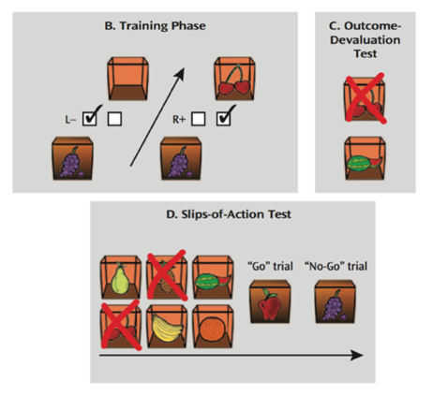
B. The Two-step task is used to assess goal-directed (model-based) learning. In the first stage, subjects choose between two stimuli, which determine common or rare transition to the pink or blue second stage. In the second stage, subjects choose between two stimuli, each of which associated with a distinct probability of reward. A purely habitual (hypothetically, model-free) agent only shows sensitivity to whether or not the trial was rewarded or not reward. A goal-directed (model-based) agent exhibits sensitivity not only to reward but also transition type, as is more likely to repeat the action (e.g., select the same stimulus at the first stage) after reward only if the transition was common (adapted from figure 1, Daw et al., Neuron, 2005). | 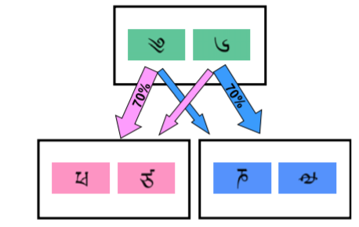
C. The Avoidance task measures goal-directed vs. habitual behavior in avoidance. Subjects are first trained to produce an action to avoid shocks to either the right or left wrist for specific stimuli (blue predicts shock to right wrist; left predicts shock to left wrist). At devaluation the electrodes on one wrist (e.g., right) are disconnected from their connector so that the shock is not delivered anymore. Subjects behaving in a goal-directed manner should not respond to the stimulus that predicted the devalued outcome (e.g., blue), but maintain responding to avoid the valued outcome (e.g., red). (Gillan et al. 2014b). | 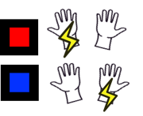
Cognitive control
D. The Reversal learning task measures the ability to learn the best course of action and flexibly alter behavior. For example, visual discrimination tasks can be employed where subjects initially learn to respond to stimuli which are deterministically (i.e. 100:0 reward for the 2 alternatives) or probabilistically (e.g. 80:20) rewarded with positive or negative outcomes. The subject should learn to respond to the stimulus most often correct. At reversal, subject has to adapt to the opposite stimulus-reward pairing. In these situations, subjects have to adapt their behavior and respond to a previously incorrect stimulus, which is now most often rewarded (e.g., Remijnse et al. 2006). | 
E. The Intra/Extra Dimensional Set Shifting task measures the ability to form an attentional set (i.e., selecting the correct stimulus based on one dimension such as shape) and shifting attention to another, previously irrelevant dimension (i.e., line). It is a measure of cognitive flexibility. This construct is also assessed by the category shift in the classic Wisconsin Card Sorting Task. (e.g., Chamberlain et al. 2017). | 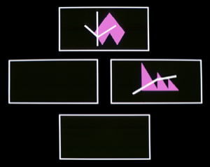
F. The Stop-Signal task (SST) is a version of classic Go/No-Go measuring response inhibition/motor inhibitory control. In the SST, subjects press a left or right hand button when a corresponding arrow pointing to the left or right is presented. On a random selection of the trials, a stop signal is presented after a variable delay and participants have to withhold their response to the stimulus on those trials. Staircase functions are used in the SST to estimate the time that a subject needs to withhold a response providing an estimate of the time needed to a participant to withhold an ongoing response. (e.g. Menzies et al. 2007). | 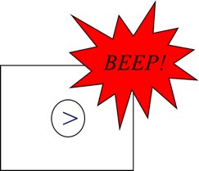
G. The N-back task measures working memory. Participants are presented a sequence of stimuli one-by-one. For each stimulus, they need to remember if the current stimulus is the same as the one presented N trials ago. The N can be 1 trials, 2 trials, 3 trials, etc. The higher the number, the more difficult the task. (e.g. Vries et al. 2014). | 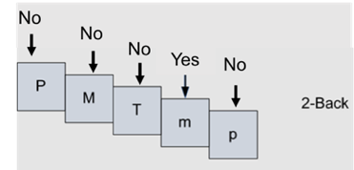
H. The Tower of London task is used to assess high level visuospatial planning. It requires participants to rearrange a set of colored balls to match a target configuration according to specific rules. The aim is to solve each problem in the minimum number of moves. Planning abilities are indexed by the number of correct responses and by latencies to give the answer to a specific problem. Difficulty can be varied parametrically, depending on the number of moves necessary to arrange the balls according to the target or goal display (e.g., Vaghi et al. 2017c). | 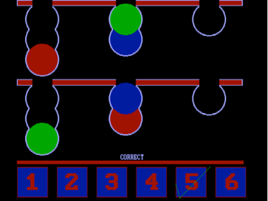
Metacognition
I. The Predictive inference task measures the ability to update action and confidence based on environmental information. On each trial, subjects select a position of the bucket (orange segment) to catch coins flying from the middle of screen and score their confidence in their prediction on a bar appearing thereafter. Subjects are asked to gauge the value of a new piece of information and differentiate periods of time in which unexpected outcome should be ignored as noise and those in which abrupt changes require updating of actions and beliefs. (Vaghi et al. 2017b). | 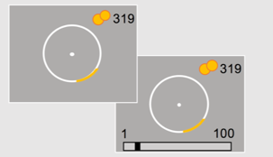
J. The Contingency degradation task measures goal-directed vs. habitual behaviour by reducing the causal link between action and obtained outcome. It also tests subjective accounts of the causal relationship between action and outcome. In some blocks rewards are mostly obtained upon performance of an action (e.g., pressing the space bar). However, when the contingency is degraded, outcomes can also come 'for free', without the action being necessary. A goal-directed agent would press more often when obtaining an outcome is solely dependent on the action. In contrast, behavior persisting even when the causal link is reduced, provides an index of habitual behavior. Subjective accounts of the causal understanding the agent has of their behavior are assessed at the end of each block (adapted from figure 2, Vaghi et al., Biol Psychiatry Cogn Neurosci Neuroimaging 2018). | 