Received 00th January 20xx,
- Institute of Fundamental and Frontier Sciences, University of Electronic Science and Technology of China, Chengdu 610054, P. R. China. Email: dengxu@uestc.edu.cn
- State Key Laboratory of Materials-Oriented Chemical Engineering and College of Chemical Engineering, Nanjing Tech University, Nanjing, 210009, P. R. China.
- Department of Chemistry, University of Cambridge, Lensfield Road, Cambridge CB2 1EW, UK. E-mail: zy251@cam.ac.uk
- Institute of Chemistry and Biochemistry, Freie Universität Berlin, Takustrasse 3, 14195 Berlin, Germany
†Electronic Supplementary Information (ESI) available: Supplementary figures and videos. See DOI: 10.1039/x0xx00000x
Accepted 00th January 20xx
DOI: 10.1039/x0xx00000x
www.rsc.org/
Breath figure lithography for the construction of a hierarchical structure in sponges and their applications in oil/water separation
Jing Zhang,^{a, b} Zhijun Meng,ª Ji Liu,^{c} Christoph Schlaich,^{a,d} Ziyi Yu,^{c}* and Xu Dengª*
Super absorbent materials that are capable of separating oil–water mixtures have received a great deal of interest, because of their promising application in the treatment of oil spillage and industrial discharge of oily wastewater, which have led to severe environmental polution. In this paper, we describe a novel strategy for the fabrication of superhydrophobic polyurethane (PU) sponges by tailoring their structure and composition. Breath figure lithography, coupling with alkylated SiO₂ nanoparticles, was used for the generation of porous nanocomposites that could be immobilized to the PU scaffolds. The obtained PU sponges show a well-defined porous texture ranging from macro-, micro-, and nano- scale and could selectively adsorb oils and/or organic solvents from water. In addition, we show the engineered PU sponges can be magnetically driven to the specific oil pollution locations by introducing magnetic nanoparticles into the PU sponges. Our approach not only demonstrates an effective method to separate oil-water mixtures but also represents an easy way to collect the separation products.

1 Introduction
Pollution from industrial discharge of oily water or accidents during offshore oil production caused dramatically environmental and ecological damage over the last century. The cleanup of oil or organic pollutants from the surface of water requires the development of advanced absorbent materials enabling excellent recyclability and low cost. In 2003, Jiang et al.^{[1]} firstly proposed the idea to use amphiphilic polymers to effectively extract oil from oil–water mixtures. Since then, materials with superhydrophobic but superoleophilic properties have received growing interest, because of their great applications in treatment of severe environmental pollution.^{[2]} To date, various kind of materials, including activated carbon,^{[3]} graphene,^{[4]} carbon nanotubes (CNTs),^{[5]} metal mesh^{[6]} and diverse aerogels,^{[7]} have been used to prepare selectively wettable materials for specific oil/water separation purposes. In this aspect, three dimensional (3D) porous materials with a highly hydrophobic surface and large pore volume, thus oil absorption capacity are ideal candidates for practical industrial uses. Among them, commercially available polyurethane (PU) sponge, as a porous and hydrophilic polymer characterized through low cost production, high absorption capacity, good elasticity and facile scaling up, has undoubtedly become a preferable candidate for these purposes.^{[8]} For example, based on the oxidative self-polymerization of dopamine and the reaction of hydrophilic polydopamine with hydrophobic octadecylamine, Wang et al. successfully fabricated a carbon nanotubes (CNTs) reinforced PU sponge that exhibited superhydrophobic and superoleophilic properties.^{[9]} Zhang et al. reported a superhydrophobic sponge with selective absorption and collection of oil from water via a vapour-phase deposition process.^{[10]} Guo and co-workers presented a strategy to fabricate robust superhydrophobic fabrics and sponges via an in-situ growth of both transition-metal oxides and metallic nanocrystals.^{[11]} More recently, Lei et al. designed an intelligent and robust sponge through an ultrasonic-assisted dip coating method, which shows intelligent reversible and tunable superwettability.^{[12]} Despite of these great advancements, fine control over the microstructure and the surface energy of the 3D porous materials along with desirable durability and recyclability are still challenging.^{[13]}
Breath figure (BF) lithography is a self-assembly method to create honeycomb-like coatings with high surface roughness and tuneable nano/micro structures. Evaporative cooling and the generation of BFs lead to the multilayers of packed water microdroplets that are preserved in the final polymer materials as air bubbles. Since the first report on BF method for fabrication of honeycomb films by Francois et al.,^{[14]} this technique has now been widely used as an effective bottom-up strategy to produce diverse functional porous structures.^{[15]} Compared with the existing top down lithography techniques, the BF method possesses a range of advantages including facile implementation, time saving, and very low cost.^{[16]} Unsurprisingly, the BF lithography has gained a lot of interest in both academic and industrial research in recent years.^{[17]}
In this work, we present for the first time a BF lithography based strategy for the fabrication of hierarchical structure reinforced PU sponge that shows superhydrophobic and superolephilic properties. The approach used takes inspiration from BF process, in which combinations of octadecyl-functionalized silica nanoparticles and polymethyl methacrylate (PMMA) direct the formation of a highly porous sponge. The hierarchical structures are constructed by evaporating solutions of silica nanoparticles and PMMA in a volatile solvent tetrahydrofuran (THF), in the presence of moisture with forced airflow across the surface. This is a method to use condensed water droplets for templates, through which pores would in-situ formed on the wall of the sponges after the evaporation of water droplets. The as-obtained sponge exhibits excellent elasticity and good superhydrophobic stability over a broad range of temperatures and resistance to variant corrosive liquids. It was also capable of absorbing various kinds of oils up to 28 times of its own weight. Furthermore, upon engineering with magnetic iron oxide particles, the sponge can be manually guided to specific contamination locations, showing a promising application as a smart adsorption/collection system.
2 Experimental
2.1 Materials
All chemicals were purchased from Sigma-Aldrich and used as received without further purification unless stated otherwise. Milli-Q water with resistance greater than 18 MΩ·cm⁻¹ was used in all experiments.
2.2 Synthetic procedures
Synthesis of monodispersed silica nanoparticles. Monodispersed SiO₂ nanoparticles were prepared through a sol-gel process according to the modified Stöber method and subsequent seeded growth.^{[18]} The products were concentrated by centrifugation at 3000 rpm for 15 minutes. The remaining water was completely removed in a freeze-dryer and white powders were obtained.
Synthesis of octadecyl-functionalised SiO₂ nanoparticles. First, 0.5 g of SiO₂ powder was dispersed into 35 mL of toluene. Then, upon the mixture was heated to 60 ºC, 200 μL octadecyltrichlorosilane in 15 mL of toluene was added dropwise within 15 minutes. After 2 hours, the resulting products were purified by centrifugation.
Synthesis of octadecyl-functionalised iron oxide nanoparticles. Iron oxide nanoparticles were synthesized according to the previously reported method.^{[19]} Typically, ferrocene (0.5 g) was first dissolved in acetone (50 mL), followed by adding hydrogen peroxide (1.4 mL, 30 wt%). The mixture was transferred into a Teflon-lined autoclave which was placed in oven for 70 hours at 230 °C. The reaction was stopped by cooling down to room temperature, and the iron oxide nanoparticles were purified by rinsing with acetone for five times. Then, 0.1 g of iron oxide nanoparticles was dispersed in 60 mL absolute ethanol, followed by adding 3 mL of 30 wt% ammonia aqueous solution and 0.2 mL tetraethyl orthosilicate (TEOS). The reaction was terminated after 2 hours, yielding the silica-coated iron oxide nanoparticles. The same protocol as taken in preparing octadecyl-functionalised silica nanoparticles was adopted for preparing octadecyl-functionalised silica-coated iron oxide nanoparticles.
Preparation of sponges with hierarchical structures using the BF lithography strategy.
To prepare the SiO₂-PMMA solution, 0.35 g of PMMA (Mw = 120 kDa) and 0.5 g octadecyl-functionalised SiO₂ nanoparticles were dispersed in 35 mL of THF; while for the Fe₃O₄–SiO₂-PMMA solution, 0.1 g octadecyl-functionalised silica-coated iron oxide nanoparticles, 0.35 g of PMMA (Mw = 120 kDa) and 0.5 g octadecyl-functionalised SiO₂ nanoparticles were dispersed in 35 mL of THF.
A piece of PU sponge (ca. 0.05 g) was ultrasonically washed by distilled ethanol for three times. Then, the pre-treated sponge was immersed into the above solution (SiO₂-PMMA solution or Fe₃O₄–SiO₂-PMMA solution) for 15 seconds and then dried under humid environment, forming the SiO₂–PMMA–PU sponge and Fe₃O₄–SiO₂-PMMA–PU sponge, respectively. Upon solvent evaporation, the sponges were baked in oven at 120 ºC for 15 minutes.
2.3 Characterization
Contact angle (CA) measurements were performed on a First Ten Angstroms FT200 using a water droplet or hexadecane droplet at room temperature. All the CA data were averaged from three measurements for each sponge sample. The microstructure of the sponges was characterized by a HITACHI S-4800 scanning electron microscope. Photographs were taken by Dino-Lite digital microscope.
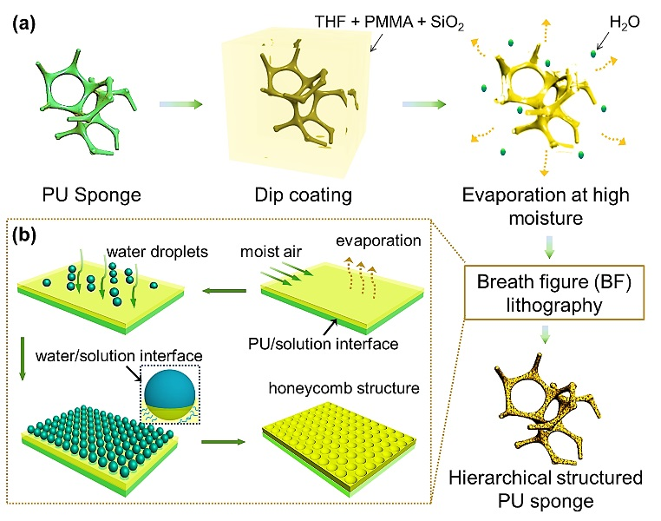
Fig.1 Schematic illustration of the preparation process of superhydrophobic sponges with hierarchical structure through the BF strategy.
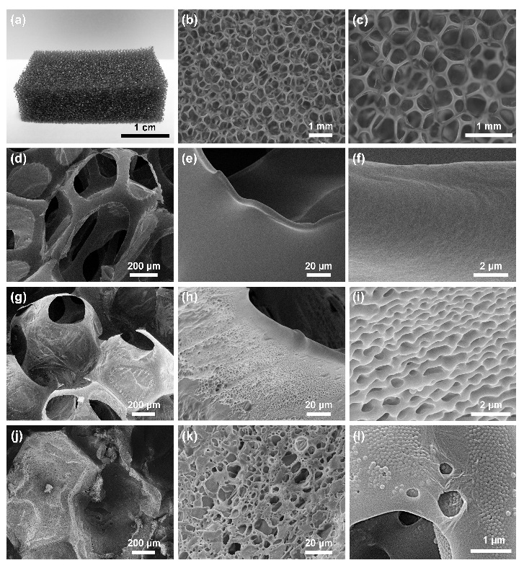
Fig.2 (a) A photograph of the original PU sponge. (b) An optical micrograph and (c) an enlarged optical micrograph of the original PU sponge, showing porous microstructures. (d-f) SEM images of the original PU sponge. (g-i) SEM images of the as-obtained PMMA-PU sponge by immersing the PU sponge into THF solution solely containing PMMA and subsequently drying at a humid air. (j-l) SEM images of the resulting SiO₂–PMMA–PU sponge by immersing the sponge into THF solution containing PMMA and octadecyl-functionalised silica nanoparticles and subsequently drying at a humid environment. The diameter of silica nanoparticles is 110 nm with a PDI of 0.031.
3 Results and discussion
3.1 Proposed breath figure (BF) lithography strategy for preparing sponges with hierarchical structures
The preparation process of the superhydrophobic PU sponges via BF strategy is shown in Fig. 1a. First, a small piece of PU sponge (ca. 0.05 g) was directly immersed into THF solution containing 1.5 wt% octadecyl-functionalised SiO₂ particles and 1 wt% PMMA, and then dried under a humid environment. Due to the evaporative cooling of volatile solvent, water droplets settled on the surface of the sponge and served as a template for the in-situ formed secondary pores after complete evaporation (Fig. 1b). After subsequent heating at 120 ºC for 15 min, the sponge with robust hierarchical structure and superhydrophobic properties was finally obtained.
3.2 Morphology characterization
The surface morphology/structure of the sponge before and after functionalization was characterized using an optical microscopy and a scanning electron microscopy (SEM), respectively. As shown in Fig. 2a-c, the original PU sponge with 3D cage-like structure possessed a micro-scaled interconnected skeleton structure. The corresponding SEM
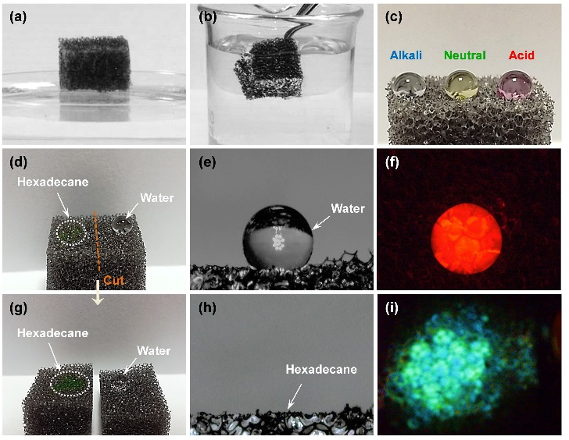
Fig.3 (a) A photograph of the prepared SiO₂–PMMA–PU sponge floating on water owing to its low density, superhydrophobicity and light weight. (b) A photograph of the SiO₂–PMMA–PU sponge immersed into water by an external force, exhibiting a silver mirror-like surface due to the surrounded air bubbles. (c) A photograph of basic (left, borate buffer solution, pH=10), neutral (middle, phosphate buffer solution, pH=7), and acidic (right, phthalate buffer solution, pH=4) droplets settled on the sponge surface, demonstrating stable wettability towards different corrosive liquids. (d) A photograph of water and hexadecane droplets on the SiO₂–PMMA–PU sponge. (e) Water contact-angle image and (f) corresponding fluorescence image, demonstrating superhydrophobicity. (g) A photograph of water and hexadecane droplets on the fresh cut surfaces of the SiO₂–PMMA–PU sponge. (h) Hexadecane contact-angle images and (i) corresponding fluorescence image, demonstrating superoleophilicity.
images revealed that the pristine sponge had a smooth surface and an interpenetrated porous structure with pore sizes in the range of 0.3–1 mm (Fig. 2d-f). After immersing in THF solution containing 1 wt% PMMA and dried at humid environment, the skeleton of the resulting sponge (named as the PMMA-PU sponge) became much rougher than the original one (Fig. 2g). Magnified SEM images in Fig. 2h and 2i show the skeleton surface of the sponge was covered by countless micro–nano-scale protrusions, similar to structures discovered in the lotus leaves.^{[20]} This feature indicates that honeycomb structure have been successfully introduced onto the sponge wall. In comparison to previously reported etching methods, our strategy is characterized by a large increase in surface roughness of the sponge's skeleton under extremely mild conditions without affecting the mechanical properties.^{[9]} However, because both PU and PMMA are hydrophilic polymers, the resulting structures were readily wetted with water (Fig. S1). To create a hydrophobic surface, octadecyl-functionalised SiO₂ nanoparticles were added into the mixture solution and together deposited onto the sponge surface (named as the SiO₂–PMMA–PU sponge). As a result, the wetting property of the as-obtained sponge was completely changed. Corresponding SEM images (Fig. 2j and 2k) reveal that it retains porous structures with two-tier roughness at both the micro and the nano scale. The magnified SEM image (Fig. 2l) shows SiO₂ nanoparticles distribute homogenously on the sponge skeleton, indicating that the air-solid interface has been successfully transformed from PMMA-air to SiO₂-air.
3.3 Superhydrophobicity and superoleophilicity of the resulting SiO₂–PMMA–PU sponge
The prepared SiO₂–PMMA–PU sponge displayed superhydrophobicity and superoleophilicity at the same time. As shown in Fig. 3a, the resultant SiO₂–PMMA–PU sponge was easily floating on the surface of water due to the hydrophobic feature and light weight. When the sponge was forced to immerse into the water, its surface exhibited a silver mirror-like colour, which is because of the strong light scattering effect caused by the high refractive index contrast between the surrounded air bubbles and the water (Fig. 3b). After releasing the external force, the sponge floated immediately back onto the water surface without any water adsorption. In addition to this extreme water repellence, the SiO₂–PMMA–PU sponge also showed good repellence towards corrosive mediums, such as alkaline or acidic aqueous solutions. Fig. 3c shows the optical image of alkaline (left, borate buffer solution, pH=10), neutral (middle, phosphate buffer solution, pH=7), and acidic (right, phthalate buffer solution, pH=4) droplets settled on the sponge surface, respectively. All drops on the surface of the sponge retained their spherical shape and were not wetting the nanostructure.
The photographs of water and hexadecane droplets on top of the SiO₂–PMMA–PU sponge in Fig. 3d remarkably demonstrated the superhydrophobic but superolephilic properties. The contact angle for dye coloured water (containing tiny amount of FITC-Dextran) was 152º (Fig. 3e and 3f). In contrast, when a hexadecane droplet (with BODIPY®505/515) was placed on its surface, it was immediately absorbed by the sponge and showed a contact angle of 0º (Fig. 3h and 3i). When the sponge was cut into two parts, both new surfaces still exhibited superhydrophobic properties and the water repellence was recovered, confirming the full functionalization of the 3D structure (Fig. 3g). The surface wettability transformation from the hydrophilic to superhydrophobic are explained by two main aspects:^{[9, 21]} (1) the attached honeycomb structure on the surface of the sponge significantly increases the surface roughness; (2) the successful introduction of octadecyl-functionalised SiO₂ nanoparticles dramatically lowers the surface energy and endows the SiO₂–PMMA–PU sponge with improved hydrophobicity. The integration of both the chemical compositions and the geometrical structure leads to the superhydrophobic properties of the SiO₂–PMMA–PU sponge.
3.4 Oil/water separation behaviour
In light of the 3D porous structure with a high loading capacity, the light weight, and the superhydrobic properties, the SiO₂–PMMA–PU sponge can serve as a super absorbent material to selectively remove organic solvents from water. Fig. 4a shows the absorption of hexane (with BODIPY®505/515) from the water surface. It should be noted that a drop of aqueous solution containing 0.5 wt% Pluronic®F-127 surfactant was added into the water phase to avoid oil spreading and adhesion onto the inner wall of the petri-dish. Once the SiO₂–PMMA–PU sponge contacted the hexane oil spill on the water surface (the total volume amount of hexane oil is 0.8 mL), it completely absorbed the oil within fifteen seconds (Video S1 and S2), until the water was completely decoloured and was free of any contaminations (Fig. 4c). Similarly, the SiO₂–PMMA–PU sponge separated an oil and water mixture containing hexane and corrosive aqueous including 1.0 M HCl and 1.0 M NaOH (Fig. S2). The absorbed oil was easily collected by a simple squeezing process, which is time-saving and eco-friendly (Fig. S3). The sponge spontaneously absorbed the oil, because of the similar surface energies between the oil and octadecyl chains, while water (with the much higher surface tension) is strongly repelled. Therefore, the oil was drawn through the pores of the sponge into its interior via capillary forces, while water stayed exclusively at the exterior of the sponge. As a result, the sponge exhibited excellent adsorption properties and high selectivity for oil.
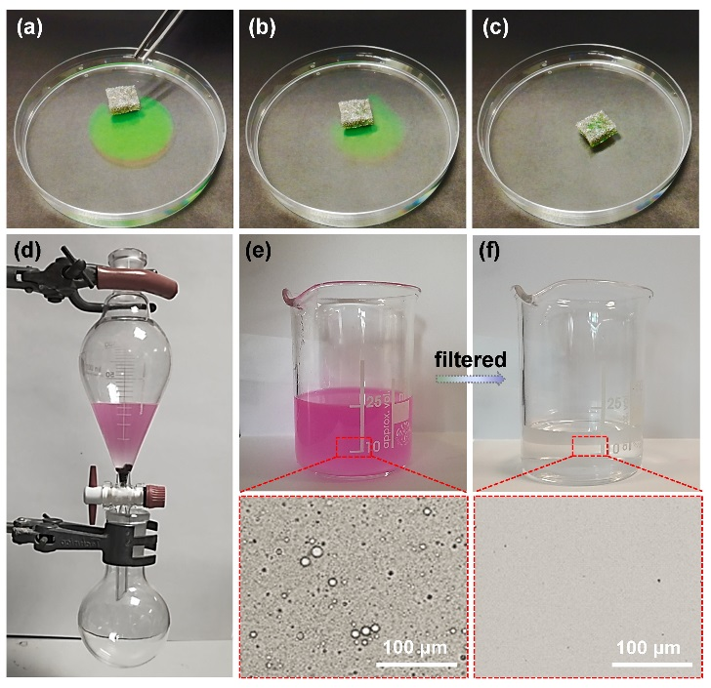
Fig.4 (a-c) A series of photographes demonstrating the process of extracting hexane oil (with BODIPY®505/515) from the water surface. (d) Photograph of 3M™ Novec™ HFE7500 oil /water (dyed red with Eosin Y disodium salt) separation using SiO₂–PMMA–PU superhydrophobic sponges. Photographs and corresponding optical micrographs of water-in-oil emulsions (e)before and (f)after separation.
Further, the SiO₂–PMMA–PU sponge with simultaneous superhydrophobicity and superoleophilicity was used for the separation oil-water emulsions. As shown in Fig. 4d, the SiO₂–PMMA–PU was placed in the narrow neck of a 100 mL separation funnel. Then, an emulsion of oil-water mixture containing 21 mL 3M™ Novec™ HFE7500 oil, 4 mL of water, and 0.05 wt% Pico-SurfTM 1 was poured in the funnel. The 3M™ Novec™ HFE7500 oil (with a higher density than water) penetrated through the sponge and flowed into the flask below, while the water gradually accumulated in the funnel. During the oil/water separation process, no external force was applied and no water was detected in the collected oil (Fig. 4e and 4f), indicating a high separation efficiency. Finally, 18 mL of HFE7500 oil was collected in the flask, and hence the separation efficiency quantified by the mass ratio R (%) was 85.7 %. Obviously, the SiO₂–PMMA–PU sponge maintained its superhydrophobicity and could be easily cleaned using the purified HFE7500 oil or ethanol for reuse.
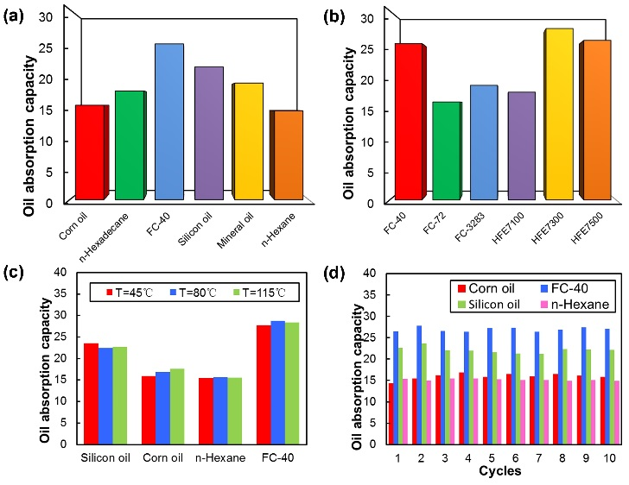
Fig.5 (a) Oil adsorption capacity of SiO₂–PMMA–PU sponges for diverse oil species. (b) Oil adsorption capacity of SiO₂–PMMA–PU sponges for a family of perfluorinated liquids. (c) Effect of heating treatment on the oil adsorption capacity of SiO₂–PMMA–PU sponges. The heating treatment temperatures were set at 45 ºC, 80 ºC and 115 ºC, respectively. The heating time was fixed at 30 min. (d) Effect of absorption/collection cycle on the oil adsorption capacity of the SiO₂–PMMA–PU sponge.
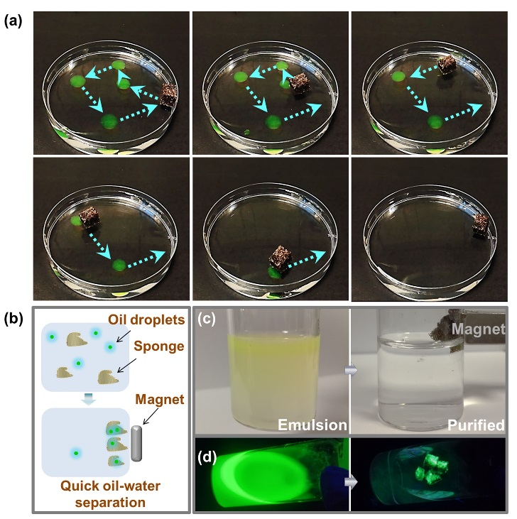
Fig.6 (a) A series photographs of Fe₃O₄–SiO₂-PMMA–PU sponge removing the hexane oil from the water surface manipulated by external magnetic field. (b) Schematic illustration of the separation of oil in water emulsion by Fe₃O₄–SiO₂-PMMA–PU sponge. (c and d) correspond to the digital and fluorescence photos of oil (hexadecane)-in-water emulsions before and after separation by Fe₃O₄–SiO₂-PMMA–PU sponge, respectively.
The absorption capacity k of the SiO₂–PMMA–PU sponge was calculated according to the following Equation 1 for different solvents/oils.
$k=(m_{2}-m_{1})/m_{1}$ (Eq. 1)
where m₁ and m₂ represent the weight of the prepared sponge before and after oil absorption, respectively. Fig. 5a shows that the superhydrophobic SiO₂-PMMA-PU sponge could absorb diverse species of oils and organic solvents. For absorption capacity of a family of perfluorinated liquids, the oil absorption capacity varies because of the different viscosity and density of the liquids but remains high absorption capacities ranging from 15 to 28 times (Fig. 5b).
The stability of the superhydrophobicity of the SiO₂–PMMA–PU sponge was also valued after heating treatment or after several absorption/collection cycles. As shown in Fig. 5c, the SiO₂–PMMA–PU sponge exhibited slight variation on the absorption capacity for different oils, despite of their heating treatment under different temperature, thus excellent thermal stability. The absorption capacity of the SiO₂–PMMA–PU sponge as a function of absorption/collection cycle with different oils is shown in Fig. 5d. The sponge withstood at least 10 cycles of mechanical squeezing without any obvious impact on its oil absorption capacity for all kinds of selected oils. The slight fluctuating of oil absorption values might be due to the residual oil inside the sponge, which could not be completely removed by a simple manual squeezing. The feature reveals the excellent elasticity and recyclability of the resultant PU sponge, which will undoubtedly facilitate its further uses in oil–water separation areas. A novel and continuous oil collection instrument was built up by a pipette attached with the SiO₂–PMMA–PU sponge. As shown in Video S3, continuous collection of hexane oil from a water surface was achieved. Fig. S4 reveals that the purified oil was absorbed into the sponge and flowed into the tips, indicating high efficient capacity of oil/water separation.
3.5 Intelligent collection of organic pollutants driven by magnetic force
To further prepare smart oil/water separation PU sponges, octadecyl-functionalised iron oxide nanoparticles were synthesized and immobilized onto the sponges. After the pristine sponge was immersed into the above infiltration liquid and dried under a humid environment, the superhydrophobic Fe₃O₄–SiO₂-PMMA–PU sponge with magnetically responsive feature was finally obtained. As Fig. 6a shows, with magnetic nanoparticles (Fig. S5) introduced into the PU sponges, the engineered PU sponges remained high absorption capacity (Fig. S6) and could be manually driven to the specific oil pollution location by a magnet, displaying intelligent oil-collection characteristics (Video S4). Significantly, to improve the absorption efficiency, the Fe₃O₄–SiO₂-PMMA–PU sponge was cut into pieces to increase contact interfaces between the oil and the sponge. After mixed with oil (hexadecane)-in-water emulsions, the sponge slices were easily collected and separated from the water phase by a magnet (Fig. 6b). Through this way, 0.8 mL hexadecane mixed with 8 mL water by strong agitation was efficiently collected by the sponge slices (total weight, 0.05 g) in less than 30 second instead of above 10 minutes for the bulk sponge of the same weight (Fig. 6c and 6d). This general strategy will find widespread application in large-scale removal of organic contaminants and contribute to environmental protection and sustainable development.
4 Conclusions
In summary, we have described for the first time a breath figure lithography method for the fabrication of superhydrophobic and superoleophilic PU sponges with tailored structure and compositions. Porous nanocomposites with hierarchical structures in a macro-, micro-, and nano-meter scale were generated and successfully used to engineer the PU 3D scaffold. The as-obtained sponge shows excellent elasticity and good stability regarding broad temperature changes and/or corrosive solutions. Furthermore, the sponge is capable of selectively absorbing oil contamination from water up to 28 times of its own weight. Moreover, by introduction of magnetic nanoparticles into the PU sponge, we show that the coated PU sponges can be manually driven to the specific oil pollution zone via external magnetic field. The presented strategy is characterized not only by the efficient adsorption capability and high selectivity for oil, but also by the simple collection method of the separated products.
Acknowledgements
X.D acknowledges the National Natural Science Foundation of
China (Grant No.21603026 ) and the max planck partner group
grant. J. Z. thanks the Priority Academic Program Development of Jiangsu Higher Education Institutions (PAPD) for financial support.
Notes and references
1 L. Feng, Y. L. Song, J. Zhai, B. Q. Liu, J. Xu, L. Jiang and D. B. Zhu, Angew. Chem., Int. Ed., 2003, 42, 800-802.
2 (a) J. Wu, N. Wang, L. Wang, H. Dong, Y. Zhao and L. Jiang, ACS Appl. Mater. Interfaces, 2012, 4, 3207-3212; (b) X. Y. Zhang, Z. Li, K. S. Liu and L. Jiang, Adv. Funct. Mater., 2013, 23, 2881-2886. (c) J. C. Gu, P. Xiao, P. Chen, L. Zhang, H. L. Wang, L. W. Dai, L. P. Song, Y. J Huang, J. W. Zhang, and T. Chen, ACS Appl. Mater. Interfaces, 2017, 9 (7), 5968-5973 ; (d) J. P. Zhang, B. C. Li, L. Wu and A. Q. Wang, Chem. Commun., 2013, 49, 11509-11511; (e) J. Li, C. Xu, Y. Zhang, R. Wang, F. Zha, H. She, J. Mater. Chem. A, 2016, 4, 15546–15553.
3 S. Gupta and N. H. Tai, J. Mater. Chem. A, 2016, 4, 1550-1565.
4 (a) H. H. Bay, D. Patino, Z. Mutlu, P. Romero, M. Ozkan and C. S. Ozkan, Sci. Rep., 2016, 6; (b) Z. Q. Niu, L. L. Liu, L. Zhang and X. D. Chen, Small, 2014, 10, 3434-3441; (c) R. Tabassian, J. H. Oh, S. Kim, D. Kim, S. Ryu, S. M. Cho, N. Koratkar and I. K. Oh, Nat. Commun., 2016, 7.
5 (a) X. J. Cao, L. L. Zang, Z. P. Bu, L. G. Sun, D. C. Guo and C. Wang, J. Mater. Chem. A, 2016, 4, 10479-10485; (b) J. C. Gu, P. Xiao, Y. J. Huang, J. W. Zhang and T. Chen, J. Mater. Chem. A, 2015, 3, 4124-4128.
6 (a) Z. D. Wang, C. M. Xiao, Z. J. Wu, Y. T. Wang, X. Du, W. Kong, D. H. Pan, G. Q. Guan and X. G. Hao, J. Mater. Chem. A, 2017, 5, 5895-5904; (b) Z. Y. Luo, K. X. Chen, Y. Q. Wang, J. H. Wang, D. C. Mo and S. S. Lyu, J. Phys. Chem. C, 2016, 120, 12685-12692; (c) J. Liu, L. Wang, N. Wang, F. Y. Guo, L. L. Hou, Y. E. Chen, J. C. Liu, Y. Zhao and L. Jiang, Small, 2017, 13.
7 (a) L. M. Xu, G. Y. Xiao, C. B. Chen, R. Li, Y. Y. Mai, G. M. Sun and D. Y. Yan, J. Mater. Chem. A, 2015, 3, 7498-7504.; (b) F. Zhang, H. Ren, J. Dou, G. L. Tong and Y. L. Deng, Sci. Rep., 2017, 7.
8 (a) C. P. Su, H. Yang, S. Song, B. Lu and R. Chen, Chem. Eng. J., 2017, 309, 366-373; (b) S. J. Choi, T. H. Kwon, H. Im, D. I. Moon, D. J. Baek, M. L. Seol, J. P. Duarte and Y. K. Choi, ACS Appl. Mater. Interfaces, 2011, 3, 4552-4556; (c) J. Li, C. C. Xu, Y. Zhang, R. F. Wang, F. Zha and H. D. She, J. Mater. Chem. A, 2016, 4, 15546-15553.; (d) J. Li, L. Yan, X. H. Tang, H. Feng, D. C. Hu and F. Zha, Adv. Mater. Interfaces, 2016, 3, 1500770.
9 H. Y. Wang, E. Q. Wang, Z. J. Liu, D. Gao, R. X. Yuan, L. Y. Sun and Y. J. Zhu, J. Mater. Chem. A, 2015, 3, 266-273.
10 X. Y. Zhou, Z. Z. Zhang, X. H. Xu, X. H. Men and X. T. Zhu, Ind. Eng. Chem. Res., 2013, 52, 9411-9416.
11 B. Wang, J. Li, G. Y. Wang, W. X. Liang, Y. B. Zhang, L. Shi, Z. G. Guo, and W. M. Liu, ACS Appl. Mater. Interfaces, 2013, 5, 1827–1839.
12 L. J. Li, L. Liu, J. L. Lei, J. X. He, N. B. Li and F. S. Pan, J. Mater. Chem. A, 2016, 4, 12334-12340.
13 J. Ge, H. Y. Zhao, H. W. Zhu, J. Huang, L. A. Shi and S. H. Yu, Adv. Mater., 2016, 28, 10459-10490.
14 G. Widawski, M. Rawiso and B. Francois, Nature, 1994, 369, 387-389.
15 (a) H. X. Zhao, J. J. Xu, G. Y. Jing, L. O. Prieto-Lopez, X. Deng and J. X. Cui, Angew. Chem., Int. Ed., 2016, 55, 10681-10685; (b) Y. Y. Dou, M. L. Jin, G. F. Zhou and L. L. Shui, Membranes, 2015, 5, 399-424.
16 A. J. Zhang, H. Bai and L. Li, Chem Rev, 2015, 115, 9801-9868.
17 (a) S. Washizu, H. Yamazaki, J. Yamanouchi, H. Naruse, EP patent 20,060,010,988, 2012; (b) J. Wang, C. F. Wang, H. X. Shen and S. Chen, Chem. Commun., 2010, 46, 7376-7378.; (c) Z. Y. Yu, C. F. Wang and S. Chen, J. Mater. Chem., 2011, 21, 8496-8501.
18 S. S. Liu, C. F. Wang, X. Q. Wang, J. Zhang, Y. Tian, S. N. Yin and S. Chen, J. Mater. Chem. C, 2014, 2, 9431-9438.
19 H. Wang, Y. B. Sun, Q. W. Chen, Y. F. Yu and K. Cheng, Dalton Trans., 2010, 39, 9565-9569.
20 (a) V. Zorba, E. Stratakis, M. Barberoglou, E. Spanakis, P. Tzanetakis, S. H. Anastasiadis and C. Fotakis, Adv. Mater., 2008, 20, 4049-4054; (b) X. D. Shi, R. M. Dou, T. Z. Ma, W. Y. Liu, X. H. Lu, K. J. Shea, Y. L. Song and L. Jiang, ACS Appl. Mater. Interfaces, 2015, 7, 18424-18428.
21 (a) X. Deng, L. Mammen, H. J. Butt and D. Vollmer, Science, 2012, 335, 67-70; (b) X. Deng, L. Mammen, Y. F. Zhao, P. Lellig, K. Mullen, C. Li, H. J. Butt and D. Vollmer, Adv. Mater., 2011, 23, 2962-2965.
The table of contents

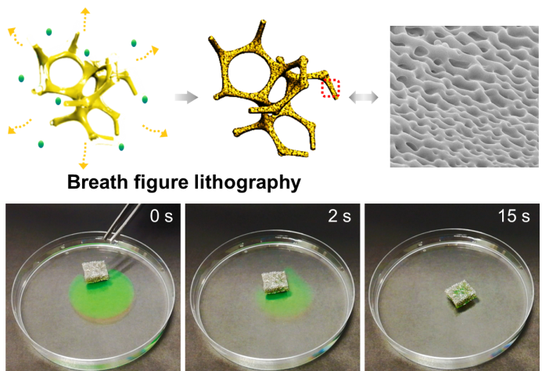
The breath figure lithography shows ability to coat polyurethane sponges with the hierarchical structure for fast oil/water separation.

