Title: Normal tissue clones preceding childhood kidney cancer
One sentence summary: Clonal expansions within normal kidney tissue often precede the most common type of childhood kidney cancer, nephroblastoma.

Authors: Tim HH Coorens¹, Taryn D Treger^{1,2,3}, Reem Al-Saadi⁴, Luiza Moore¹, Maxine GB Tran^{5,6}, Thomas J Mitchell^{1,2,7}, Suzanne Tugnait⁴, Christine Thevanesan⁴, Matthew D Young¹, Thomas RW Oliver^{1,2,8}, Minou Oostveen^{4,7}, Grace Collord^{1,2,3}, Patrick S Tarpey², Alex Cagan¹, Yvette Hooks¹, Mark Brougham¹⁰, Ben C Reynolds¹¹, Giuseppe Barone⁹, John Anderson^{4,9}, Mette Jorgensen⁹, G Amos Burke^{2,3}, Johannes Visser², James C Nicholson^{2,3}, Naima Smeulders⁹, Imran Mushtaq⁹, Grant D Stewart^{2,8}, Peter J Campbell¹, Iñigo Martincorena¹, Dyanne Rampling⁹, Liz Hook^{2,8}, Anne Y Warren^{2,8}, Nicholas Coleman^{2,8}, Tanzina Chowdhury⁹, Neil Sebire^{4,9}, Jarno Drost¹¹, Kourosh Saeb-Parsy^{2,7}, Michael R Stratton¹, Karin Straathof^{4,9}, Kathy Pritchard-Jones^{4,7}, Sam Behjati^{1,2,3*}
*Corresponding author
Affiliations
¹Wellcome Sanger Institute, Hinxton CB10 1SA, UK.
²Cambridge University Hospitals NHS Foundation Trust, Cambridge CB2 0QQ, UK.
³Department of Paediatrics, University of Cambridge, Cambridge CB2 0QQ, UK.
⁴UCL Great Ormond Street Hospital Institute of Child Health, London WC1N 1E, UK.
⁵UCL Division of Surgery and Interventional Science, Royal Free Hospital, London NW3 2PS, UK.
⁶Specialist Centre for Kidney Cancer, Royal Free Hospital, London NW3 2PS, UK.
⁷Department of Surgery, University of Cambridge, Cambridge CB2 0QQ, UK.
⁸Department of Pathology, University of Cambridge, Cambridge CB2 1QP, UK.
⁹Great Ormond Street Hospital for Children NHS Foundation Trust, London WC1N 3JH, UK. ¹⁰Department of Haematology and Oncology, Royal Hospital for Sick Children, Edinburgh EH9 1LF, UK.
¹¹Department of Paediatric Nephrology, Royal Hospital for Children, Glasgow G51 4TF, UK. ¹²Princess Máxima Center for Pediatric Oncology, Oncode Institute, 3584 CT Utrecht, The Netherlands.
Abstract
Some tumors arise from morphologically normal pre-malignant clonal expansions, which are defined by somatic mutations shared between tumor and precursor lesion. Here, we studied the phylogenetic relationship of nephroblastoma (Wilms tumor), the most common kidney cancer of childhood, and paired normal renal tissue. Analyzing 229 whole genome sequences derived from 66 tumors and 163 normal tissues, we discovered clones in morphologically normal kidney tissue of 2/3 children with nephroblastoma, which we validated in an independent cohort (12/20). Clones were discernible by somatic mutations that were absent from blood and shared between tumor and morphologically normal renal tissue. Searching for cancer-causing events amongst DNA variants, in RNA sequences and methylation patterns, revealed hypermethylation of H19, an established oncogenic driver of nephroblastoma, in ~60% of clonal expansions. Phylogenetic analysis of bilateral tumors indicated that clones can evolve before left and right kidney primordia diverge in early embryogenesis. Normal renal tissues derived from kidneys afflicted by adult renal cell carcinoma (n=15) or non-nephroblastoma childhood renal tumours (n=6) did not harbour clones that shared mutations with tumours. Analysis of mutations in microscopically excised portions of nephrons (n=22) indicated that human nephrons were not arranged as monoclonal units. Our findings reveal normal tissue clones, harboring a bona fide driver event of nephroblastoma, from which unilateral and multifocal tumors arise.

Main text
We set out to define, from somatic mutations, the relationship between nephroblastoma, the most common childhood kidney cancer, and surrounding normal kidney tissue. Nephroblastoma is a prototypical embryonal cancer that mainly affects infants and children younger than five years of age¹. It is thought to arise from aberrant embryogenesis, as it resembles fetal nephrogenesis morphologically(1) and transcriptionally(2). It occurs sporadically in isolation, or in the context of bilateral tumors, multifocal lesions, urogenital developmental disorders or overgrowth syndromes(1).

We analyzed a total of 229 whole genome sequences obtained from 54 individuals: 23 children with nephroblastoma, 16 parents of affected children, 3 children with non-nephroblastoma tumors (congenital mesoblastic nephroma, malignant rhabdoid tumour), 10 adults with clear cell renal cell carcinoma, and 2 individuals without renal tumours (ccRCC; Supplementary Table 1). We called base substitutions against the reference human genome. From each set of donor related tissues, we extracted mosaic mutations, defined as mutations present in two or more tissues at a variant allele frequency (VAF) of significantly less than 50% in at least one tissue (Methods). We validated the method for calling mosaic mutations by sequencing parental normal tissue DNA, re-sequencing tissues and inspection of raw data (Methods, Supplementary Figure 2). Based on VAF and distribution of mutations across related tissues, we built phylogenetic trees of tumor development (Methods). We supplemented genomic data with analyses of RNA sequences and genome wide methylation patterns (Supplementary Table 1).

The discovery cohort of this study comprised three children with unilateral nephroblastoma, along with blood and macroscopically and histologically normal kidney tissues (Supplementary Table 1, Supplementary Figure 1). As expected, whole genome sequencing revealed mosaic mutations describing the first few cell divisions of the fertilized egg (Figures 1a-d), i.e. variants present in all normal tissues at VAFs of less than 50% (Supplementary Table 2) (3, 4). Unusually, in two cases, we also detected mosaic mutations in normal kidneys that were absent in blood (Figure 1e-g, Supplementary Table 2). These mutations were shared between normal kidney tissue and tumors.

Several features of these mutations indicated that they defined clones in normal kidney tissue, as illustrated by case PD37272 (Figure 1e-g). The VAFs of mutations in the normal tissue of this kidney, variants 3-5 (Figure 1f), were as high as 44%, suggesting that the mutation was present in 88% of all cells in the biopsy. Mutations 3-5 were significantly present (p<0.001; see Methods) in the two parenchymal biopsies (i.e. cortex and medulla) whilst absent from blood DNA, deeply sequenced to 106X genome-wide (Figure 1g). Similarly, mutations 3-5 were undetectable in renal pelvis, which is embryologically derived from a different lineage than kidney parenchyma⁵. Furthermore, the VAF of early embryonic mutations, variants 1 and 2, was inflated in parenchyma and in tumors (Figure 1f,h). Such inflation of early embryonic mutations is a feature of tissues that contain a sizeable clone derived from a single cell (Figure 1c,d). By contrast, in tissues devoid of a major clone, such as renal pelvis and blood, the VAFs of early embryonic mutations are not inflated (Figure 1b,h). Thus, these normal tissue variants 3-5 delineate a clonal zone within kidney parenchyma, which we termed clonal nephrogenesis, accounting for up to 88% of cells sampled in the cortex.

To further investigate and validate our discovery of clonal nephrogenesis as a common antecedent of nephroblastoma, we studied another 20 cases: 15 unilateral tumors with normal tissue biopsies curated through a British nephroblastoma study, four cases of bilateral nephroblastoma, and one extensively sampled tumor with ten normal tissue biopsies (Supplementary Table 1). Considering the entire cohort of 23 children, we found evidence of clonal nephrogenesis in 10/19 children with unilateral and in 4/4 children with bilateral tumors (Methods, Figure 2a-b). The presence of clonal nephrogenesis in these tumors was further substantiated by the inflation of VAFs of early embryonic variants (Figure 2c). No copy number changes were detected in normal kidney tissues using 3 different methods (Methods). A remarkably large clone expansion was found in PD40735, where a single nephrogenic clone accounted for 75% and 85% of left and right normal kidney samples, respectively (Figure 2d).

An alternative explanation for these findings could be infiltration of normal tissue by tumor cells or cross-contamination of DNAs. This explanation is, however, implausible. Contamination would manifest as shared variants at a low VAF, rather than select mutations at a high VAF. We mathematically excluded possible contribution from tumor infiltration and contamination by employing a binomial mixture model on the observed base counts of tumor mutations in the normal samples (Supplementary Figure 3, Methods).

Next, we investigated whether clonal nephrogenesis might represent the normal clonal architecture of human nephrons by three approaches. First, we directly assessed the clonal architecture of nephrons. Using laser capture microscopy (LCM), we excised glomeruli (n=7), proximal and distal tubules (n=15) from kidneys of three individuals (Figure 2d-f) and subjected these to whole genome sequencing using an established method for generating high fidelity, low input DNA libraries (5, 6). Analyzing somatic mutations across these LCM biopsies revealed in each sample a VAF distribution that is inconsistent with a monoclonal organization (Figure 2f) seen, for example, in endometrial glands or colonic crypts (5, 6). Second, we assessed whether mutations were commonly shared between renal tumours and surrounding normal tissue. To this end, we extended our investigation to childhood congenital mesoblastic nephroma (2 tumors, 6 normal kidney samples), childhood malignant rhabdoid tumor (1 tumor sample and 1 adjacent normal kidney sample) and adult renal cell carcinoma (8 tumours including one bilateral, 15 normal tissues). Applying the same analysis pipeline as utilized for nephroblastoma, we identified early embryonic mutations that were shared between tumor, normal kidney tissues, and blood (Supplementary Figure 4). However, we did not find mutations shared only between tumor and normal tissue (Figure 2d), showing that such mutations were significantly enriched in nephroblastoma (p<0.001; Fisher’s exact test). Of particular relevance in this analysis were renal cell carcinomas which, like nephroblastoma, are derived from nephron cells. If normal embryological clonal dynamics typically had generated large clonal nephron fields, we would have expected to capture mutations in both tumor and normal tissue that are absent from blood. Third, we studied the normal landscape of developmental mutations in all normal kidney tissues listed thus far, supplemented by an additional 18 biopsies obtained from bilateral kidneys declined for transplantation. We analysed somatic mutations present in kidney tissue and absent from non-renal tissue, irrespective of whether they were shared with tumours. Collectively, these analyses of 77 normal kidney biopsies revealed that variants of tissues without clonal nephrogenesis have a significantly lower VAF distribution than clonal nephrogenesis mutations (Figure 2a). Overall, therefore our findings indicate that clonal nephrogenesis is likely to represent aberrant kidney development that may seed nephroblastoma.

A central question that our findings raise is whether distinct cancer-causing (driver) events underpin clonal nephrogenesis. However, clonal nephrogenesis mutations (n=64), presented in detail in Supplementary Figure 5, were non-coding (62/64) or did not generate plausible oncogenic events. Searching further for driver events amongst germline and somatic DNA mutations, in transcriptomes and, where available, methylation patterns, revealed significant hypermethylation of H19 in 7/12 normal tissues with clonal nephrogenesis, but not in blood or in normal tissues without clonal nephrogenesis (Figure 2c,g-h). H19 hypermethylation is an established driver event of nephroblastoma, thought to operate by disrupting the epigenetic regulation of growth promoting genes that reside on 11p15 (7, 8). The degree of hypermethylation of H19 correlated with the VAF of clonal nephrogenesis, indicating that the aberration pervades the entire clone (Figure 2i). In one child with Beckwith-Wiedemann syndrome (PD40738), H19 hypermethylation was present in the germline. Interestingly, methylation of the KvDMR1 locus was unchanged in clonal nephrogenesis. Hypomethylation of KvDMR1 underlies overgrowth syndromes that confer only a minimal predisposition to nephroblastoma compared to H19 hypermethylation(9). We did not find any further driver events that preceded, or were associated with, clonal nephrogenesis. However, hypermethylation of H19 may have evaded discovery in the 5 wildtype samples due to a small clone size (Figure 2i). Re-interrogation of 16/17 tissues by exome sequencing with clonal nephrogenesis did not reveal any addititional driver variants. Gene expression profiles did not differ between normal renal tissues that did, or did not, contain clonal nephrogenesis (Supplementary Figure 5).

Comparing the somatic changes of nephroblastoma with, and without clonal nephrogenesis, revealed a near mutual exclusivity of uniparental disomy of 11p (p=0.009, Fisher’s exact test; Supplementary Figure 6). It is likely that this is due to H19 hypermethylation in clonal nephrogenesis which represents an alternative mechanism to uniparental disomy, to disrupt the epigenetic regulation of 11p15.

The timing of the emergence of clonal nephrogenesis during human development could be defined in three children from whom we obtained bilateral tumors. In two cases, left and right tumors were derived from the same trunk of clonal nephrogenesis (Figure 3a-e). Likewise, clonal nephrogenesis found in normal tissues bilaterally in these two children originated from a common stem (Figure 3a,c). PD36159 is a particularly striking example (Figure 3c-e). Here, three left tumor samples were phylogenetically more closely related to the right normal kidney than to the left. In the third child, PD40378, all four left tumor samples were related to clonal nephrogenesis on the ipsilateral side (Figure 3f). The right neoplasms, a tumor and a nephrogenic rest, were not derived from clonal nephrogenesis on the left. No normal tissue of the right side was available for analysis. Taken together, these findings indicate that in two children with bilateral tumors, clonal nephrogenesis must have arisen before left and right kidney primordia diverged, early in embryogenesis(10). In unilateral tumors, we cannot definitively comment on the timing of the occurrence of clonal nephrogenesis. It may have evolved before the kidney was formed or thereafter, followed by a “clonal sweep” in which clonal nephrogenesis replaced normal kidney tissue.

In the five cases from which we sampled multiple neoplasms of the same kidney, two configurations of tumor development were seen (Figure 3). Tumors were either derived from a shared trunk that had emerged from clonal nephrogenesis (e.g., PD40735, Figure 3a). Or, tumors arose independently and successively from clonal nephrogenesis, alluding to a sustained potential for the latter to foster tumor budding. For example, PD36165 presented with two lesions at opposing poles of the kidney, a nephrogenic rest and a nephroblastoma. Tumor and rest had emerged from the same ancestral clone, yet at different time points, followed by clonal diversification within tumor and rest (Figure 3h,i).

We identified clonal expansions in morphologically normal tissue as an atypical outcome of renal development that commonly antedates unilateral and multifocal nephroblastoma. In the context of H19 hypermethylation as a driver of overgrowth and tumour development, we are able to demonstrate a direct phylogenetic link between discrete clonal expansions, H19 hypermethylation, and cancer formation. Collectively our findings thus portray nephroblastoma as an insurrection on the background of a premalignant tissue bed, rather than a clearly demarcated neoplasm in an otherwise normal, polyclonal kidney. We speculate that embryonal clonal expansion in normal tissue may be a common phenomenon in childhood cancer.

Main figures and legends
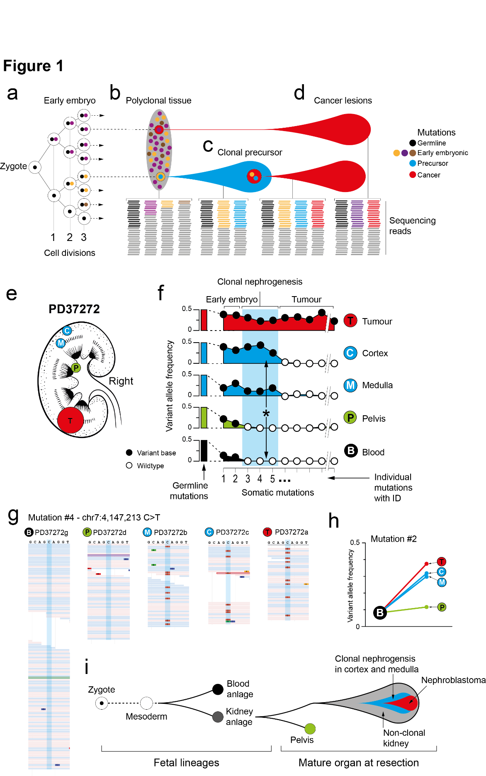
Figure 1. Clones in normal human kidneys.
(a) Schematic tree of early embryogenesis showing that somatic mutations are acquired in post-zygotic divisions and retained by the progeny of the cell. (b) These early embryonic mutations are present in an exponentially decreasing variant allele frequency in polyclonal tissue. The ability to detect these mutations in bulk tissue therefore is limited by the sequencing depth. For example, at a typical depth of 30X genome wide, theoretically only the first four cell divisions can be determined, unless a clonal expansion occurs (c). (d) Tumors, which are clonal outgrowths, can either evolve directly from a single cell within polyclonal tissue or emerge from an expanded clonal precursor. (e) Overview of tissue sampling in the kidney of PD37272. (f) Variants in the trunk of the tumor can be detected in normal tissues. VAFs of germline mutations would be distributed around 0.5 (illustrated by the bars at the start of the track). Somatic mutations can be timed used their VAF across the corresponding normal tissues, which is higher for earlier mutations. If the mutation is present in tumor, kidney, and blood, it is classified as early embryonic (mutation 1-2). If it is present in kidney samples and tumor only, it is clonal nephrogenic (mutations 3-5, marked by asterisk). If it is only in the tumor, it is labelled as such. White and black circles indicate whether the observed VAF is insignificant (white) or significant (black), p < 0.001 (test of presence using beta-binomial overdispersion (Methods). (g) Raw reads showing mutant locus across samples. Blue highlight shows variant locus. (h) The VAF for the last embryonic mutation in kidney samples and tumor compared with blood. (i) Schematic showing the development lineage of blood and kidney, and subsequently the pelvis and kidney parenchyma during early embryogenesis. Afterwards, clonal nephrogenesis occurred within the corticomedullary region from which the nephroblastoma tumor arose.
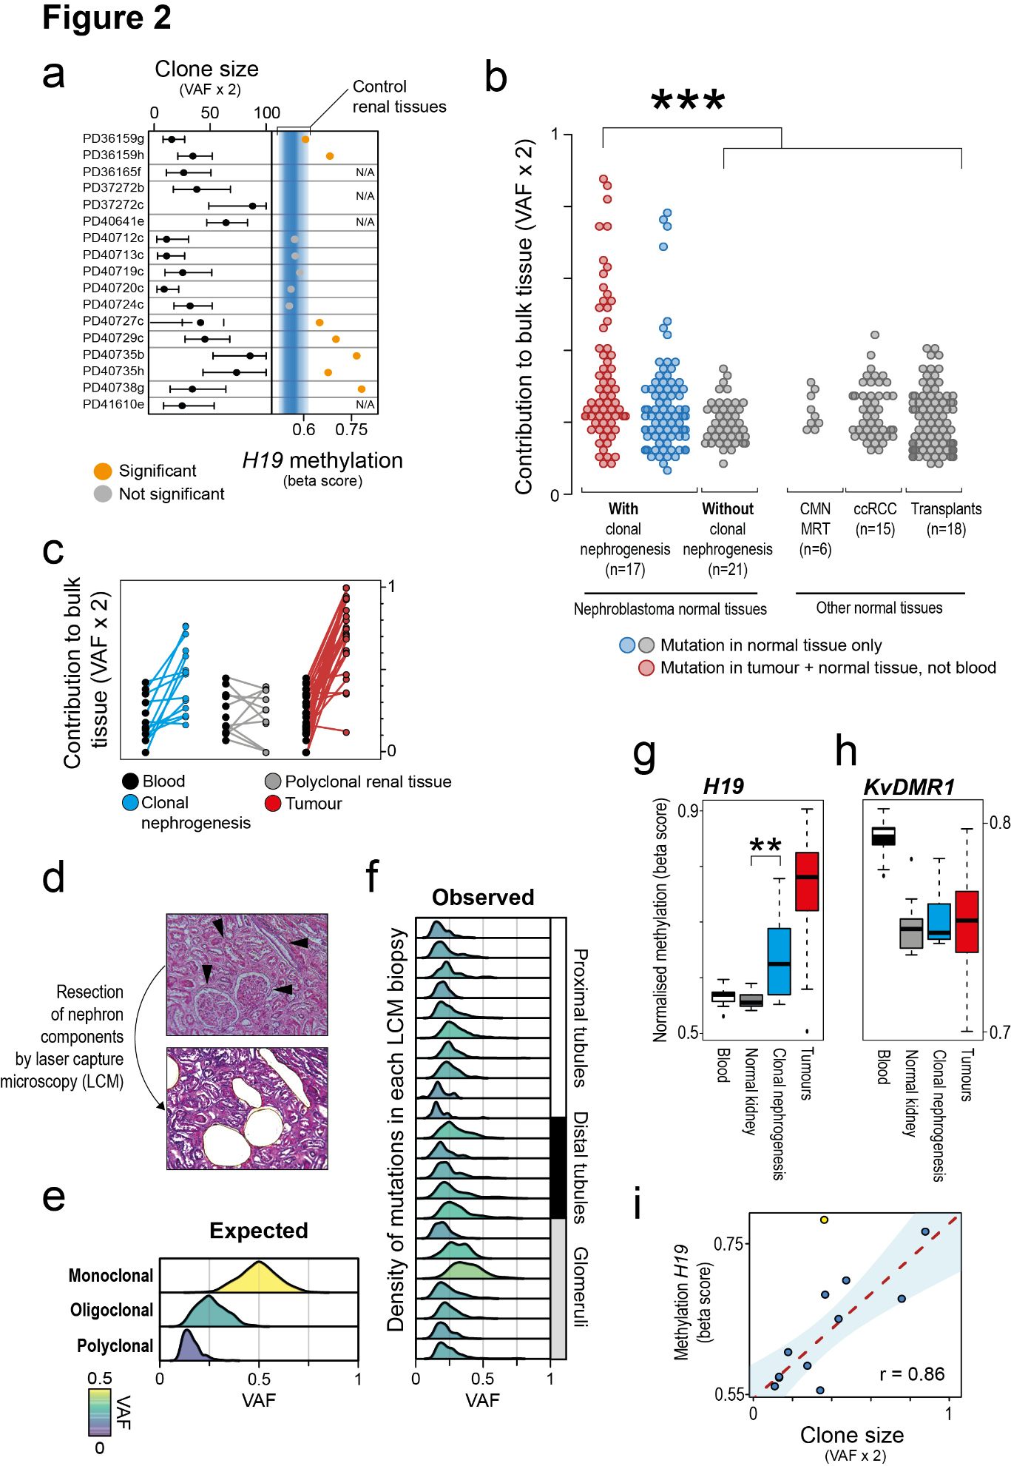

Figure 2. Nephrogenic clones and H19 hypermethylation

(a) Sizes of nephrogenic clones as predicted by twice the VAF of the most prominent nephrogenic mutation alongside corresponding methylation values of the H19 locus. Orange symbols indicates significant deviation (p<0.05, Wilcoxon rank-sum test) from the background methylation distribution as obtained from normal kidney samples not subjected to clonal nephrogenesis.
(b) Mutations present in samples obtained from normal kidneys but absent in matched blood (see Methods). Only in nephroblastoma were some of these mutations shared with the corresponding tumor (***p<0.001, Wilcoxon rank-sum test).
(c) Clones can also be detected using the VAF of the last embryonic variant, i.e. shared between blood and kidney. This plot shows the contribution of the last embryonic mutation in tumor (red) and in samples with (blue) and without clonal nephrogenesis (grey), alongside the contribution to blood (black).
(d) Histology images showing resection (arrow heads) of components of the human nephron by laser capture microscopy.
(e) Simulated VAF distributions reflecting samples with a monoclonal origin ($\sim Bin(n\sim Pois(40),p=0.5)$), oligoclonal origin ($\sim Bin(n\sim Pois(40),p=0.3)$), or polyclonal origin ($\sim Bin(n\sim Pois(40),p=0.1)$).
(f) VAF distributions for 22 microdissected samples (10 proximal tubules, 5 distal tubules, and 7 glomeruli) from three patients. Color indicates the underlying maximum likelihood VAF as predicted by a truncated binomial mixture model (see Methods).
Group-level methylation beta values of KvDMR1 (g) and H19 (h) (**p<0.01, Wilcoxon rank-sum test).
(i) Plot showing the relationship between predicted clone sizes from nephrogenic mutation and the mutation level of H19. Blue shading indicates the 95% confidence interval from a linear regression. The black dot represents PD40738g, which is affected by a germline H19 hypermethylation (omitted from the correlation and linear regression).

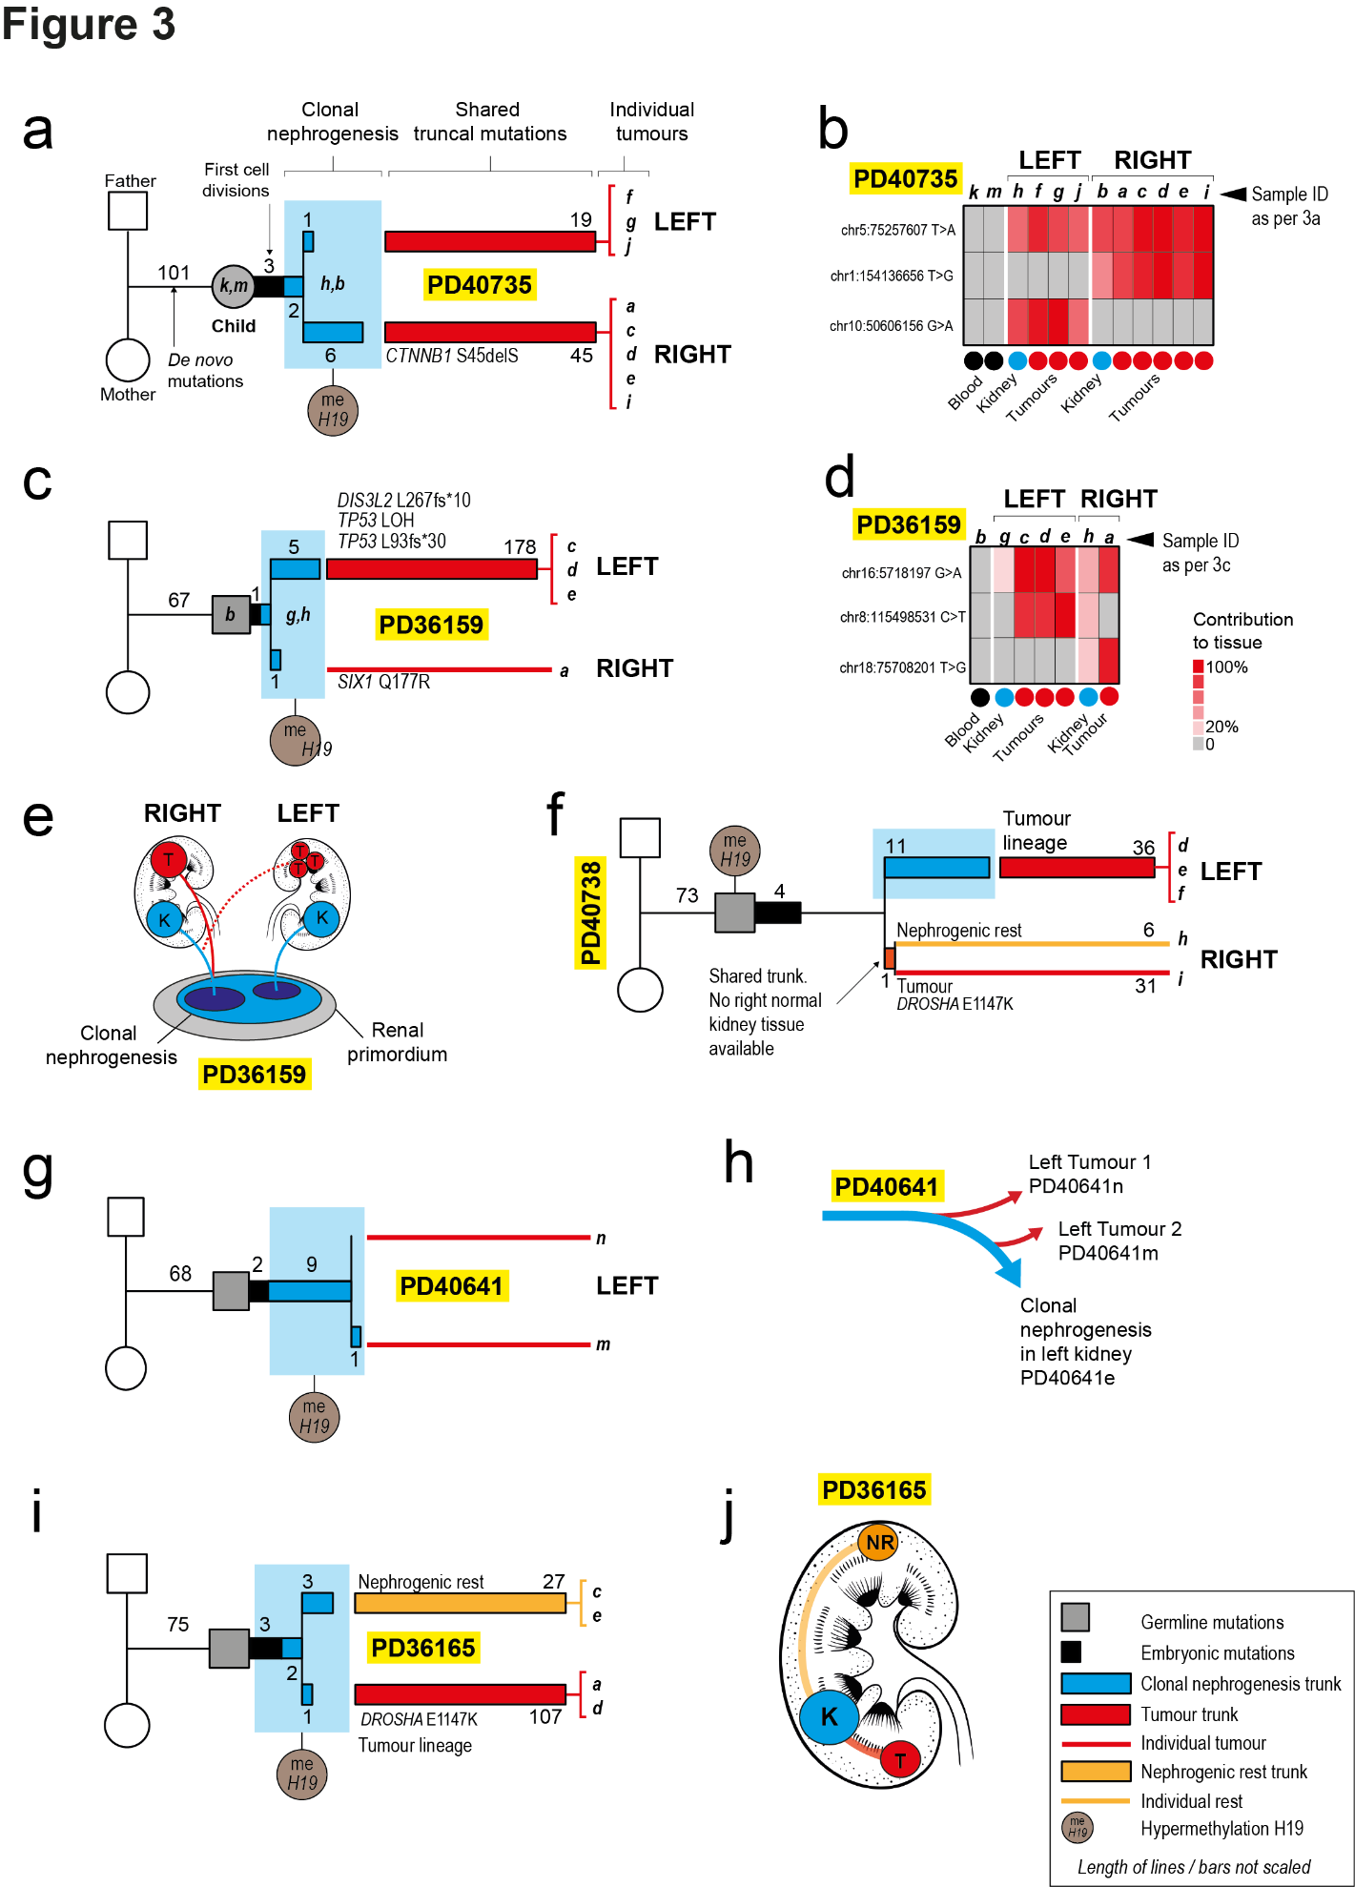
Figure 3. Bilateral and multifocal nephroblastoma.
(a,c,f,g) For each tumor, the phylogeny of shared mutations is shown including de novo germline mutations, embryonic mutations, mutations demarcating clonal nephrogenesis, and tumor mutations. Numbers refer to the number of substitutions defining each developmental segment. Driver mutation in tumor trunk are detailed. Where multiple samples of the same tumor were available, the trunk consists of shared mutations only and is drawn as a thick line. In contrast, when only a single tumor biopsy was sequenced, a thin line represents the tumor lineage. When multiple tumor biopsies were taken, driver mutations present in individual tumor, rather than the trunk, are not shown. Terminal branch lengths are normalized.
Heatmaps (b and d) show the contribution of a mutation to the sample in question (as per legend).
In PD40735 (a), the pattern of mutation sharing reveals a split between left and right kidney, which is obeyed by both tumor and normal samples (b).
As revealed by the pattern of sharing of mutations (d), the left tumor is more closely related to the right branch of clonal nephrogenesis than to the left in PD36159 (e). (f) Phylogenetic tree of tumors and rest in PD40738. Note that the right tumor and rest do not come from the nephrogenic clone that spawned the left tumor.
(g and h) A single (dinucleotide) mutation indicates the independent emergence of tumors at different time points from the nephrogenic clone in PD40641.
(i) Tumor and nephrogenic rest in PD36165 both originated from clonal nephrogenesis despite being situated at opposing kidney poles (j).
References and Notes
1. T. D. Treger, T. Chowdhury, K. Pritchard-Jones, S. Behjati, The genetic changes of Wilms tumour. Nat Rev Nephrol 15, 240-251 (2019).
2. M. D. Young et al., Single-cell transcriptomes from human kidneys reveal the cellular identity of renal tumors. Science 361, 594-599 (2018).
3. S. Behjati et al., Genome sequencing of normal cells reveals developmental lineages and mutational processes. Nature 513, 422-425 (2014).
4. Y. S. Ju et al., Somatic mutations reveal asymmetric cellular dynamics in the early human embryo. Nature 543, 714-718 (2017).
5. H. Lee-Six et al., The landscape of somatic mutation in normal colorectal epithelial cells. bioRxiv, 416800 (2018).
6. L. Moore et al., The mutational landscape of normal human endometrial epithelium. bioRxiv, 505685 (2018).
7. T. Moulton et al., Epigenetic lesions at the H19 locus in Wilms' tumour patients. Nat Genet 7, 440-447 (1994).
8. K. Okamoto, I. M. Morison, T. Taniguchi, A. E. Reeve, Epigenetic changes at the insulin-like growth factor II/H19 locus in developing kidney is an early event in Wilms tumorigenesis. Proc Natl Acad Sci U S A 94, 5367-5371 (1997).
9. W. N. Cooper et al., Molecular subtypes and phenotypic expression of Beckwith-Wiedemann syndrome. Eur J Hum Genet 13, 1025-1032 (2005).
10. K. M. Short, I. M. Smyth, The contribution of branching morphogenesis to kidney development and disease. Nat Rev Nephrol 12, 754-767 (2016).

Acknowledgements: We thank for their help research nursing staff at Cambridge University
Hospitals, the Royal Hospital for Sick Children (Edinburgh), and the Royal Hospital for Children
(Glasgow) as well as all IMPORT investigators. We thank Dr Moritz Gerstung for critical review
of the manuscript. We are indebted to our little and older patients and their families for
participating in our research.

Funding: This experiment was principally funded by The Little Princess Trust, the St. Baldrick’s Foundation (Robert J. Arceci International Award to S.B.) and Wellcome (Fellowship to S.B.; Sanger core funding). Additional funding was received from CRUK (IMPORT study; fellowship to T.J.M.; Cambridge Centre), NIHR (Biomedical Research Centre Great Ormond Street and Cambridge Human Research Tissue Bank), The Royal College of Surgeons of England (Fellowship to T.J.M.). J.D. acknowledges funding from the Alpe d’HuZes foundation / KWF Dutch Cancer Society Bas Mulder Award (#10218) and the Oncode Institute.

Author contributions: S.B. conceived of the experiment. T.C., T.D.T. and S.B. analyzed data. Statistical expertise was provided by M.D.Y and I.M. M.D.Y., T.J.M., G.C., P.S.T., P.J.C., M.R.S., In.M and K.P-J contributed to discussion. L.M. and M.G.B.T. performed laser capture microcopy experiments. Samples were curated and/or experiments were performed by R.A., C.T., S.T., M.O., Y.H., M.B., B.C.R., G.B., J.A., M.J.,G.A.B., J.V., J.D.N., N.S., Im.M., K.S-P., G.D.S., K.S., T.Ch., J.D., and K.P-J. Pathological expertise was provided by L.H., T.R.W.O., D.R., A.Y.W., N.C., and N.S. A.C. created kidney illustrations. T.C., T.D.T., and S.B. wrote the manuscript. S.B. directed the study.

Data and materials availability: Raw sequencing data have been deposited in the European Genome-phenome Archive (EGA) under study ID EGAD00001004774.

Supplementary Materials
Materials and Methods
Table S1 – S5 contained in separate file “Supplementary_Tables_S1-S4.xlsx”
Table S1. Overview of study cohort.
Table S2. Catalogue of mosaic and nephrogenic mutations
Table S3. Driver mutations in 43 neoplastic samples obtained from 23 children.
Table S4. Somatic substitutions and indels found in 43 neoplastic samples obtained from 23 children.
Table S5. Rearrangements found in nephroblastoma and related normal tissues.
Figures S1 – S6 contained in Supplementary Materials file
Figure S1. Histology of clonal nephrogenesis samples.
Figure S2. Validation of mosaic mutation calling.
Figure S3. Binomial mixture modelling.
Figure S4. Early embryonic mutations in non-nephroblastoma tumours.
Figure S5. Characterization of clonal nephrogenesis mutations
Figure S6. Mutual exclusivity of uniparental disomy and H19 hypermethylation

