Supporting Information

Interface Instability in LiFePO₄—Li_{3+x}P_{1−x}Si_{x}O₄ All-Solid-State Batteries
Matthias F. Groh,^{‡,1} Matthew J. Sullivan,^{‡,1} Michael W. Gaultois,¹ Oliver Pecher,¹ Kent J. Griffith,¹ and Clare P. Grey^{*,1}
¹ Department of Chemistry, University of Cambridge, Lensfield Road, Cambridge CB2 1EW, UK
*Email: cpg27@cam.ac.uk
‡ These authors contributed equally.

Table S1. Lattice parameters (in Å) for all components in each Rietveld refinement with respect to literature values. Components with a phase fraction of less than 10 wt-% are greyed due to their higher susceptibility to inaccuracy. In general, all values and especially standard deviations should be taken with a grain of salt due to the abundance of closely related phases (cf. space group types and lattice parameters of references).
 | A (SPS) | B (SPS) | B (Ampoule) | C (SPS) | C (Ampoule) | “Li_{1.9}FeP_{0.1}Si_{0.9}O₄” | reference
Figures of merit | R_{wp}: 2.805  R_{exp}: 6.612  R_{p}: 2.022  GOF: 0.424 | R_{wp}: 1.907  R_{exp}: 1.063  R_{p}: 1.414  GOF: 1.793 | R_{wp}: 2.149  R_{exp}: 1.052  R_{p}: 1.513  GOF: 2.043 | R_{wp}: 1.978  R_{exp}: 1.079  R_{p}: 1.465  GOF: 1.833 | R_{wp}: 3.020  R_{exp}: 1.036  R_{p}: 1.794  GOF: 2.916 | R_{wp}: 1.705  R_{exp}: 0.967  R_{p}: 1.225  GOF: 1.763
LiFePO₄ |  | a = 10.3360(6)  b = 6.0133(3)  c = 4.6970(3)  wt-% = 16.6(2) | a = 10.3772(7)  b = 6.0247(4)  c = 4.7169(3)  wt-% = 21.5(3) | a = 10.321(3)  b = 6.015(1)  c = 4.695(1)  wt-% = 5.7(2) |  |  | a = 10.332(4)  b = 6.010(5)  c = 4.692(2)  Pnma³
Li_{0.6}Fe_{1.4}P_{0.6}Si_{0.4}O₄ | a = 10.474(4)  b = 6.033(3)  c = 4.743(3)  wt-% = 5.5(2) | a = 10.405(1)  b = 6.0297(7)  c = 4.7343(6)  wt-% = 24.1(3) | a = 10.3925(3)  b = 6.0271(2)  c = 4.7310(2)  wt-% = 30.3(3) |  |  |  | a = 10.4240(1)  b = 6.03937(7)  c = 4.75676(7)  Pnma⁴
Fe₂SiO₄ |  |  |  | a = 4.8004(6)  b = 10.475(1)  c = 6.0782(6)  wt-% = 16.8(2) | a = 4.8161(3)  b = 10.4795(6)  c = 6.0877(3)  wt-% = 27.4(2) |  | a = 4.818(1)  b = 10.470(2)  c = 6.086(1)  Pbnm⁵
Li₂FeSiO₄ |  |  |  | a = 6.257(1)  b = 10.680(2)  c = 5.0194(8)  wt-% = 6.7(2) | a = 6.220(4)  b = 10.667(7)  c = 4.941(4)  wt-% = 4.5(4) |  | a = 6.2855(4)  b = 10.6594(6)  c = 5.0368(3)  Pmnb²
Li_{3–x}Fe_{x}P_{1–x}Si_{x}O₄ | a = 6.1772(3)  b = 10.5537(5)  c = 4.9540(2)  x(Fe) = 0.080(2)  wt-% = 61.7(4) |  |  |  |  | a = 6.2602(4)  b = 10.6800(8)  c = 5.0210(3)  x(Fe) = 0.586(7)  wt-% = 56.4(4) | cf. Li₂FeSiO₄  and γ-Li₃PO₄
γ-Li₃PO₄ | a = 4.9306(4)  b = 6.1233(6)  c = 10.4849(8)  wt-% = 32.8(3) | a = 4.9278(3)  b = 6.1226(4)  c = 10.4769(6)  wt-% = 35.1(2) | a = 4.92440(9)  b = 6.1214(1)  c = 10.4805(2)  wt-% = 44.6(3) | a = 4.9283(3)  b = 6.1252(4)  c = 10.4714(7)  wt-% = 49.5(4) | a = 4.9278(2)  b = 6.1234(3)  c = 10.4869(5)  wt-% = 66.4(4) | a = 4.92(1)  b = 6.20(2)  c = 10.48(2)  wt-% = 1.8(4) | a = 4.926(3)  b = 6.129(1)  c = 10.483(4)  Pcmn⁶
Li_{3.75}P_{0.25}Si_{0.75}O₄ |  |  |  | a = 5.030(3)  b = 6.138(4)  c = 5.395(3)  β = 91.76(7)°  wt-% = 7.5(4) |  |  | a = 5.10536(11)  b = 6.11225(12)  c = 5.29671(11)  β = 90.3692(8)°  P2₁/m⁷
Graphite |  | a = 2.4577(5)  c = 6.7176(3)  wt-% = 24.1(2) | a = 2.464(2)  c = 6.701(1)  wt-% = 3.6(2) | a = 2.455(2)  c = 6.7110(7)  wt-% = 8.6(2) | a = 2.455(7)  c = 6.698(3)  wt-% = 1.7(3) | a = 2.4688(7)  c = 6.7175(6)  wt-% = 27.6(3) | a = 2.464(2)  c = 6.711(4)  P6₃/mmc⁸
FeO (Wuestite) |  |  |  | a = 4.2959(5)  wt-% = 1.93(9) |  | a = 4.2625(5)  wt-% = 8.1(2) | a = 4.326(2)  Fm–3m⁹
Li₂SiO₃ |  |  |  | a = 9.398(5)  b = 5.326(5)  c = 4.697(4)  wt-% = 3.3(2) |  | a = 9.392(2)  b = 5.392(2)  c = 4.661(1)  wt-% = 6.1(2) | a = 9.396(1)  b = 5.396(1)  c = 4.661(1)  Cmc2₁¹⁰

In well refined cases such as B (SPS), the derived molar ratios of n(Fe):n’(Si) = 5.4 and n(P):n’(Si) = 8.3 agree with the ratios in the starting materials of 5.9 and 8.9, respectively. However, the abundance of closely related phases with small phase fractions as well as the ambiguity of phosphorus/silicon scattering factors lead to stronger deviations in other cases, especially with unaccounted minor by-phases like for case C (Ampoule). The compositions of the refined solid solutions should be viewed as indication of a trend.

Figure S1. Rietveld refinement of a powder X-ray diffractogram (synchrotron radiation; λ = 49.5178 pm) of a batch of C-LFP.
Figure S2. Rietveld refinement of a powder X-ray diffractogram (synchrotron radiation; λ = 49.5178 pm) of a batch of Li_{3.25}P_{0.75}Si_{0.25}O₄.
Figure S3. Powder X-ray diffractograms (Cu-Kα radiation; λ = 154.06 pm, 154.43 pm) of C-LFP/Li_{3.25}P_{0.75}Si_{0.25}O₄ composites mixed in a 1:2 mass ratio (A) before and after sintering at a range of SPS dwell temperatures. Reference patterns of the starting materials LFP and Li_{3.25}P_{0.75}Si_{0.25}O₄ are depicted beneath.
Figure S4. Powder X-ray diffractograms (Cu-Kα radiation; λ = 154.06 pm, 154.43 pm) of C-LFP/Li_{3.25}P_{0.75}Si_{0.25}O₄ composites mixed in a 2:1 mass ratio (B) before and after sintering at a range of SPS dwell temperatures as well as in a fused silica ampoule. Reference patterns of the starting materials LFP and Li_{3.25}P_{0.75}Si_{0.25}O₄ are depicted beneath. The main Bragg reflection of graphite from the SPS treatment as well from the coating inside the ampoule is marked with an asterisk.
Figure S5. Comparison of PXRD patterns of C-LFP/Li_{3.25}P_{0.75}Si_{0.25}O₄ composites mixed in a 2:1 mass ratio (B), sintered via SPS or annealed in a fused silica ampoule at 800 °C with calculated reference patterns for γ-Li₃PO₄ and Li_{1–y}Fe_{1+y}P_{1–y}Si_{y}O₄ with x = 0.4. Graphite reflections from the SPS dies as well as the coating of the ampoule are denoted with an orange asterisk. Residual C-LFP is not marked. See Rietveld refinements in Figures 5 (main text) and S6.
Figure S6. Rietveld refinement of a powder X-ray diffractogram (Cu-Kα radiation; λ = 154.06 pm, 154.43 pm) of a C-LFP/Li_{3.25}P_{0.75}Si_{0.25}O₄ composite mixed in a 2:1 mass ratio (B) after annealing in a fused silica ampoule at 800 °C. The ratio of refined phases is indicated by weight percentage.

Figure S7. Powder X-ray diffractograms (Cu-Kα radiation; λ = 154.06 pm, 154.43 pm) of C-LFP/Li_{3.75}P_{0.25}Si_{0.75}O₄ composites mixed in a 2:1 mass ratio (C) before and after sintering at a range of SPS dwell temperatures as well as in a fused silica ampoule. Reference patterns of the starting materials LFP and Li_{3.75}P_{0.25}Si_{0.75}O₄ are depicted beneath. The main reflection of graphite from the SPS treatment as well from the coating inside the ampoule is marked with an asterisk.

Figure S8. Comparison of PXRD patterns of C-LFP/Li_{3.75}P_{0.25}Si_{0.75}O₄ composites mixed in a 2:1 mass ratio (C), sintered in an SPS or annealed in a fused silica ampoule at 800 °C with reference patterns for γ-Li₃PO₄ and Fe₂SiO₄, representing the respective solid solutions. Refined phases with small phase fractions omitted. Graphite reflections from the SPS dies as well as the coating of the ampoule are denoted with an orange asterisk. Black crosses mark unknown phase(s). See Rietveld refinements in Figures 6 (main text) and S9.
Figure S9. Rietveld refinement of a powder X-ray diffractogram (Cu-Kα radiation; λ = 154.06 pm, 154.43 pm) of a C-LFP/Li_{3.75}P_{0.25}Si_{0.75}O₄ composite mixed in a 2:1 mass ratio (C) after annealing in a fused silica ampoule at 800 °C. An unrefined, unknown phase is marked with asterisks. The ratio of refined phases is indicated by weight percentage.
Figure S10. Rietveld refinement of a powder X-ray diffractogram (Cu-Kα radiation; λ = 154.06 pm, 154.43 pm) of a SPS-produced (800 °C) sample of the nominal composition of “Li_{1.9}FeP_{0.1}Si_{0.9}O₄”. The ratio of refined phases is indicated by weight percentage.
Figure S11. ³¹P MAS NMR spectra recorded with a recycle delay of 15 ms for phosphorus-substituted Li₂FeSiO₄ synthesised in the SPS according to Arachi et al.¹ (black, cf. Rietveld fit in Figure S10) and m(LFP):m’(Li_{3.25}P_{0.75}Si_{0.25}O₄) = 1:2 (A, red) after sintering at 800 °C. Spinning sidebands are denoted with asterisks. Note the strong signal of the LSPO by-product.
Figure S12. Visualisation of the local environment of the phosphorus atoms in P-doped Li₂FeSiO₄ (Pmnb)² (left) and in LiFePO₄ (right)³. Note the additional iron atom (Fe1, shortest P–Fe distance) in the vicinity of the phosphorus atom in LFP while the overall geometric situation is otherwise closely related. Thus, Fe1 is most likely the cause for the difference in the ³¹P NMR shift of the two compounds and their respective solid solutions.

Figure S13. ³¹P MAS NMR spectra recorded with a recycle delay of 15 ms and offset frequency of ~300 kHz for m(LFP):m’(Li_{3.25}P_{0.75}Si_{0.25}O₄) = 2:1 (red, B) and m(LFP):m’(Li_{3.75}P_{0.25}Si_{0.75}O₄) = 2:1 (blue, C) before and after sintering at 800 °C. The black arrow indicates the carrier frequency. Spinning sidebands are denoted with asterisks.
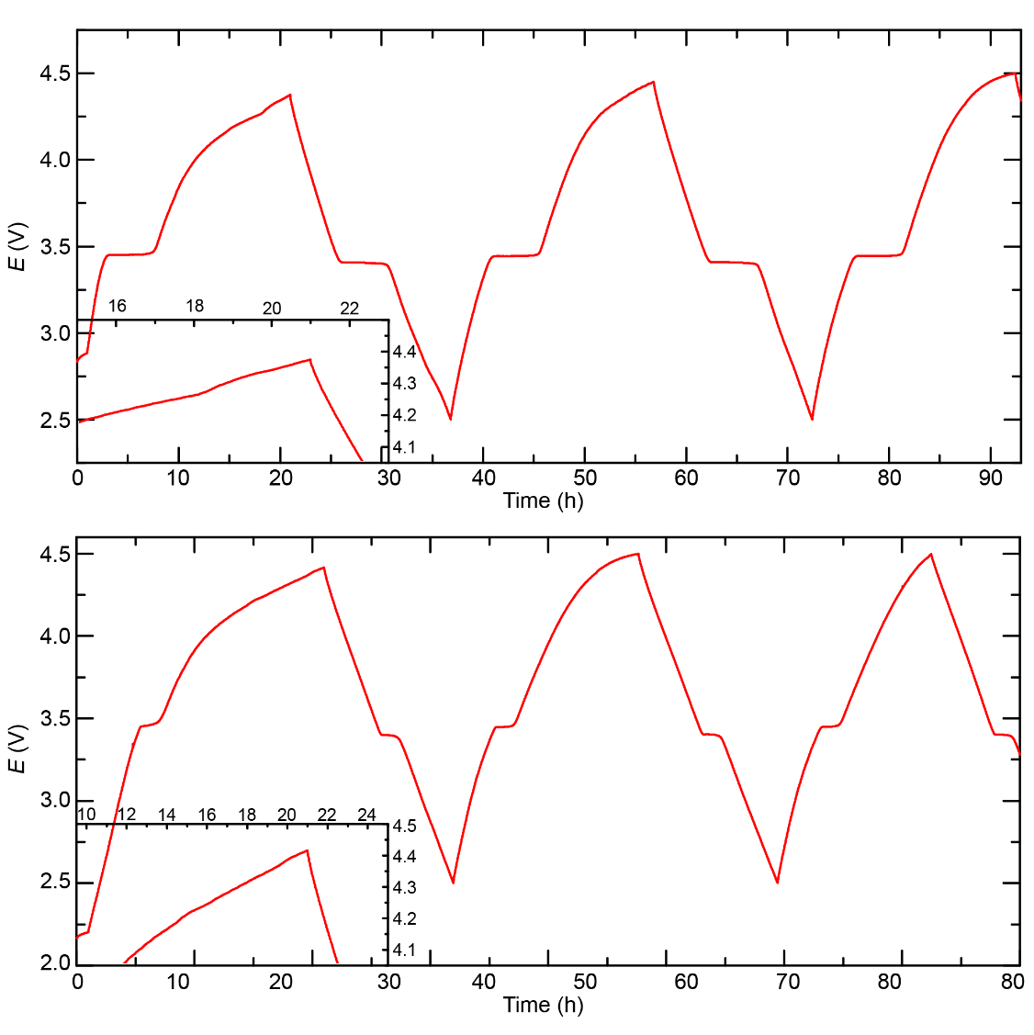
Figure S14. Room temperature galvanostatic cycling profiles for thin pellets of sintered C-LFP Li_{3.25}P_{0.75}Si_{0.25}O₄ composite powders mixed with Ketjen carbon, Super P carbon, and PTFE binder (3:3:3:1 mass ratio). The C-LFP and Li_{3.25}P_{0.75}Si_{0.25}O₄ were mixed in a 1:2 mass ratio prior to sintering at a SPS dwell temperatures of 500 ºC (top; pellet thickness = 260 ± 20 μm) and 600 ºC (bottom; pellet thickness = 220 ± 30 μm). Both samples were cycled at a nominal C/10 cycling rate based on the initial mass of LFP prior to sintering i.e. assuming no reaction. Pellets were cycled against lithium metal anodes using LP30 liquid electrolyte.
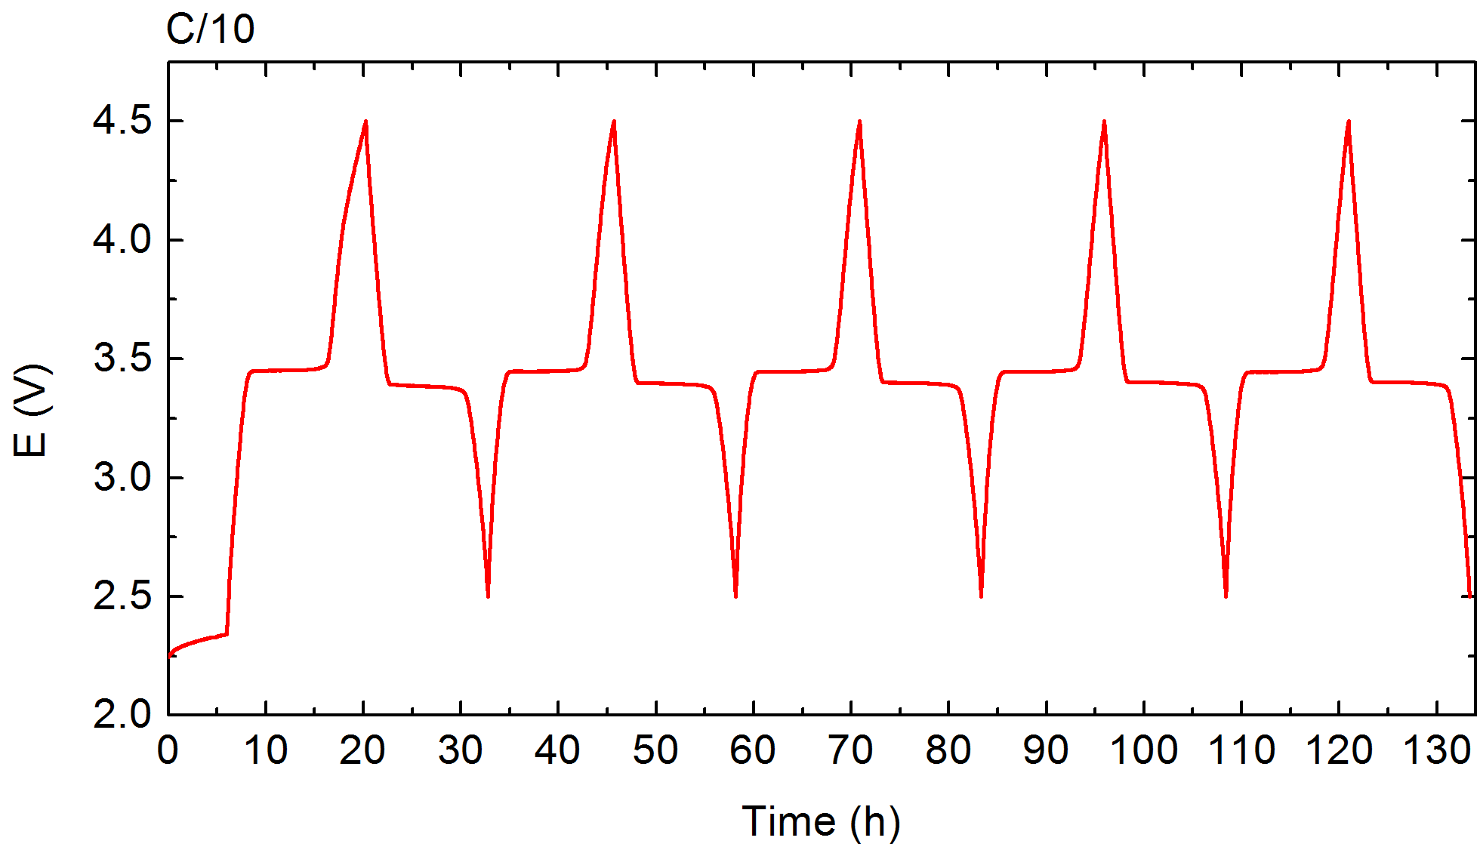
Figure S15. Room temperature galvanostatic cycling profile for a thin pellet (210 μm) of carbon coated LFP mixed with Ketjen carbon, Super P carbon and PTFE binder at a rate of C/10. The pellet was cycled against a lithium metal anode using LP30 liquid electrolyte.
(1) Arachi, Y.; Higuchi, Y.; Nakamura, R.; Takagi, Y.; Tabuchi, M. Synthesis and Electrical Property of Li_{2−x}FeSi_{1−x}P_{x}O₄ as Positive Electrodes by Spark-Plasma-Sintering Process. J. Power Sources 2013, 244, 631–635.
(2) Sirisopanaporn, C.; Masquelier, C.; Bruce, P. G.; Armstrong, A. R.; Dominko, R. Dependence of Li₂FeSiO₄ Electrochemistry on Structure. J. Am. Chem. Soc. 2011, 133, 1263–1265.
(3) Streltsov, V. A.; Belokoneva, E. L.; Tsirelson, V. G.; Hansen, N. K. Multipole Analysis of the Electron Density in Triphylite, LiFePO₄, Using X-Ray Diffraction Data. Acta Crystallogr. B 1993, 49, 147–153.
(4) Recham, N.; Casas-Cabanas, M.; Cabana, J.; Grey, C. P.; Jumas, J.-C.; Dupont, L.; Armand, M.; Tarascon, J.-M. Formation of a Complete Solid Solution between the Triphylite and Fayalite Olivine Structures. Chem. Mater. 2008, 20, 6798–6809.
(5) Della Giusta, A.; Ottonello, G.; Secco, L. Precision Estimates of Interatomic Distances Using Site Occupancies, Ionization Potentials and Polarizability in Pbnm Silicate Olivines. Acta Crystallogr. B 1990, 46, 160–165.
(6) Bondareva, O. S.; Simonov, M. A.; Belov, N. V. Crystal Structure of the Synthetic Analog of Lithiophosphate, γ−LiPO₄. Dokl. Akad. Nauk SSSR 1978, 240, 75–77.
(7) Deng, Y.; Eames, C.; Chotard, J.-N.; Lalère, F.; Seznec, V.; Emge, S.; Pecher, O.; Grey, C. P.; Masquelier, C.; Islam, M. S. Structural and Mechanistic Insights into Fast Lithium-Ion Conduction in Li₄SiO₄–Li₃PO₄ Solid Electrolytes. J. Am. Chem. Soc. 2015, 137, 9136–9145.
(8) Trucano, P.; Chen, R. Structure of Graphite by Neutron Diffraction. Nature 1975, 258, 136–137.
(9) Fjellvåg, H.; Grønvold, F.; Stølen, S.; Hauback, B. On the Crystallographic and Magnetic Structures of Nearly Stoichiometric Iron Monoxide. J. Solid State Chem. 1996, 124, 52–57.
(10) Völlenkle, H. Verfeinerung Der Kristallstrukturen von Li₂SiO₃ und Li₂GeO₃. Z. Für Krist. - Cryst. Mater. 1981, 154, 77–81.

