Polymer Mechanochemistry: Manufacturing is now a Force to be Reckoned with

Niamh Willis-Fox,^{1, 3}* Etienne Rognin,¹ Talal A. Aljohani² and Ronan Daly¹**
1Institute for Manufacturing, Department of Engineering, University of Cambridge, 17 Charles Babbage Road, Cambridge, CB3 0FS, UK.
2Materials Science Institute, National Centre for Corrosion Technology, King Abdulaziz City for Science and Technology, Riyadh 12371, Saudi Arabia.
*Correspondence: ndwf2@cam.ac.uk
**Correspondence: rd439@cam.ac.uk

SUMMARY
Polymer mechanochemistry is an exciting, rapidly developing field however it lacks detailed studies on the link between lab-scale mechanical activation and how the chemistry will translate to the complex flows and forces experienced during fluid-based moulding and additive manufacturing techniques. This is especially important for polymers which are the functional material of choice for applications, such as organic electronics, biological scaffolds and drug delivery coatings, as there is the highest likelihood of mechanical activation. This review examines the most recent development in force-sensitive molecules known as mechanophores, re-categorising them by material phase and method of activation, discussing the forces involved in such flow systems and where activation may occur in relevant manufacturing processes. The overall finding of this review is that for real, practical and scalable industrial applications of these exciting mechanochemical materials, there must be a concurrent study of the forces experienced and their effect on the detailed chemistry.

Keywords: Polymer mechanochemistry, polymer processing technologies, manufacturing, flow fields, mechanical force

The Bigger Picture
Mechanochemistry is the application of mechanical force to drive chemical reactions. It is widely used in industry to activate small molecules (e.g. ball-milling). However, polymer mechanochemistry has not yet transitioned into industry despite lab-based breakthroughs revealing chemical pathways unavailable via traditional thermal or optical activation methods. The research is motivated by potential benefits in green chemistry and smart materials, developing materials for catalysis, drug release technologies and sensors. This aligns closely with UN sustainable development goals of “Responsible consumption and production” and “Sustainable cities and communities”. This review is focused on the goal “Industry, innovation and infrastructure”, creating a link between research into molecular design, flow fields in polymer processing and finally industrial techniques to bring together diverse aspects of mechanochemistry and enable targeted industrial impact.

INTRODUCTION
Mechanical forces can be used to transfer energy to chemical bonds and drive chemical reactions.¹⁻³ Formal studies of mechanochemistry began in the 1800’s with reduction of silver halides by Faraday⁴ and Carey Lea⁵, and a broad review of the history of the overall field has recently been published by Takacs.² Since these first experiments into silver halides the mechanochemistry of inorganic materials has become well-established^{3,6} and is readily transferrable to the industrial-scale, for example via extrusion⁷ and ball-milling^{6,8} . However, in recent years there has been a dramatic increase in research into the mechanochemistry of organic and polymeric materials. There have been excellent reviews on this topic^{9–13} and the surge in interest is often attributed to the advantageous properties of soft matter that are driving future applications in organic electronics and advanced coatings, such as elasticity, tunable functionality, mechanical strength, ease of fabrication and variety of processing techniques. However, while mechanochemistry of inorganic materials has translated to industrial applications, the same cannot yet be said for mechanochemistry of organic or polymeric materials. This indicates there is a link missing between the detailed molecular design and the control of mechanical forces applied during scalable processing techniques. This future challenge for the field of mechanochemistry is also highlighted briefly by Akbulatov and Boulatov in their recent review on polymer mechanochemistry and its interpretational frameworks, where they note that mechanochemistry can limit processing methods and should be examined further with this in mind.¹⁴

The aims of this review are therefore threefold; firstly to examine a selection of the most recent advances in the field of polymer mechanochemistry since the last major review by Li et al.,⁹ while re-categorising the reviewed work into studies on single molecule, dilute solution, melt and solid systems, to enable better comparison with industrial processes. Secondly, to describe how research groups have driven mechanical activation of designed molecules on the lab scale. This includes a review of the material flows and forces reported in the literature, revealing the link between molecular design and the lab-based testing techniques. Thirdly, this review branches out to study specific industrially-relevant soft matter processing technologies to examine a link between the molecular design and forces experienced during manufacturing, e.g. 3D printing. This three-pronged review provides a more coherent approach from which to grow future research, enabling better benchmarking of results and linking the molecular design with lab-based testing techniques and the most relevant industrial processes.

A BRIEF HISTORY: THE BIRTH OF THE MECHANOPHORE
Some of the earliest work on polymer mechanochemistry was carried out by Staudinger in the 1930s who reported the reduction in the molecular weight of polystyrene with mastication.¹⁵⁻¹⁷ The suggestion that such mastication gave rise to bond breakage due to shear was put forward by Kauzmann and Erying, who also suggested that this chain rupture lead to the formation of radical species at the newly broken chain ends.¹⁸ This proposal was later confirmed by Tabata et al. using the technique of electron spin resonance (ESR). It was confirmed here that the main products of polymer cleavage were those caused by homolytic scission of C-C bonds, when studying the main chains of polystyrene and poly(methyl methacrylate) (PMMA) samples.¹⁹

For ease of analysis, the focus of this early work was on dilute solutions of homopolymers. It was shown that mechanochemical processes are activated by transduction of mechanical energy along the polymer backbone causing a chain scission, always in the mid-section of the polymer (Figure 1A).¹³ As the force is transduced along the polymer backbone there is a lower limiting threshold molecular weight (M_{lim}) the polymer chain must possess before enough force builds up to drive chain scission. Above this threshold, it is also found that the rate of chain scission continues to increase and is also dependent on polymer molecular weight.

The evolution of polymer mechanochemistry took a leap forward in 1980 when Encina et al. examined the idea of introducing a ‘weak link’ into the polymer backbone. It was observed that by randomly incorporating weak O-O bonds into the backbone of poly(vinylpyrrolidone) the rate of bond scission was approximately ten times faster when compared to that found for neat poly(vinylpyrrolidone).²⁰ In 2005 the Moore group moved from randomly-inserted ‘weak links’ towards truly site-specific cleavage by inserting a single azo linkage into the centre of the backbone of a polyethylene glycol polymer.²¹ Degradation of this polymer (MW - 40 kDa) via ultrasound gave rise to the appearance of a species with a molecular weight of 20 kDa and a low polydispersity, suggesting that the initial polymer was broken specifically at its azo mid-point. This seminal work introduced the idea that mechanochemistry could deliver directed and selective polymer chemistry. This was a turning point in the history of polymer mechanochemistry as it led the Moore group to introduce the idea of ‘Mechanophores’.⁹ Mechanophores are broadly defined in the literature as chemical species that respond to mechanical perturbation in a controlled manner (Figure 1B).¹¹ Often the weak bond (WB) within these mechanophores is contained within a cyclic system, thus bond rupture leads to ring opening rather than chain scission. This idea was highlighted by Hickenboth et al.²² who, using a benzocyclobutene (BCB) mechanophore placed within a polyethylene glycol (PEG) chain, showed that the cis and trans forms of the 1,2-disubstituted species underwent a formally conrotatory and formally disrotatory process respectively, to give the identical products shown in Figure 1C. This is in direct violation of the Woodward-Hoffman rules which describe thermally and photochemically driven electrocyclic reactions and demonstrates the exciting possibilities for unprecedented reactions and reactivity in polymeric materials through mechanochemistry.
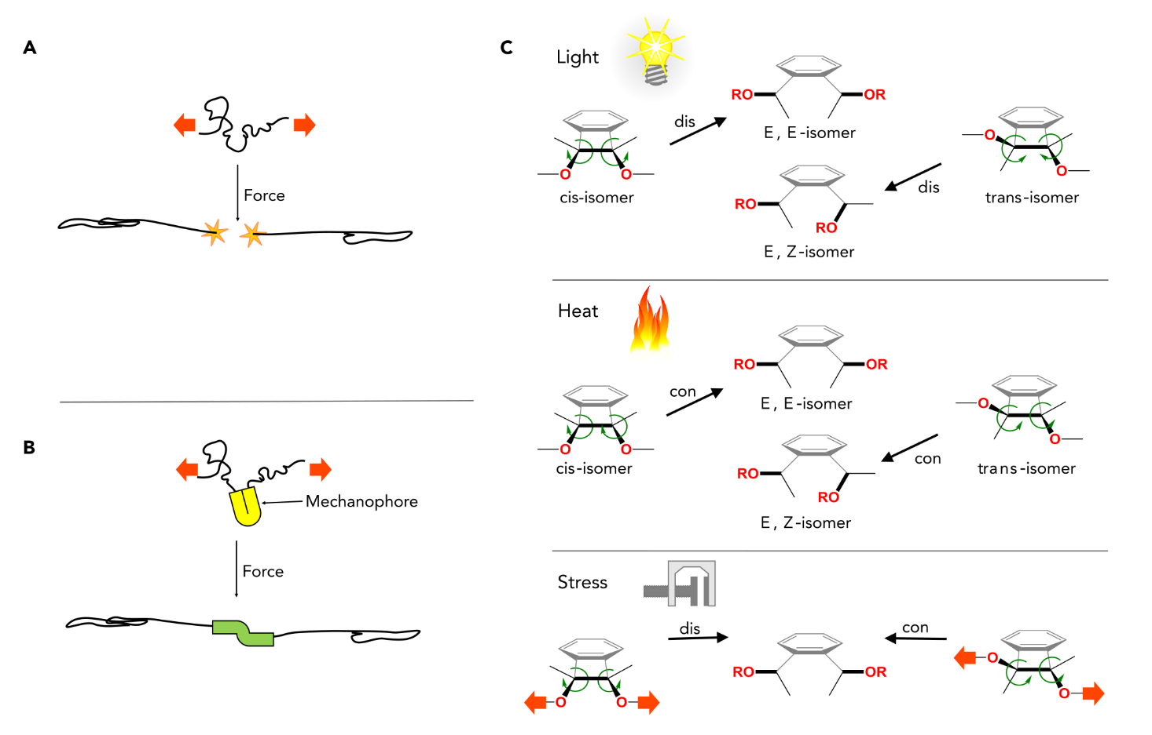
Figure 1. Mechanophore Activation
Schematic representation of (A) chain breakage following application of force to a homopolymer and (B) the change in mechanophore properties following application of force. (C) The expected pathways of photochemically and thermally activated ring opening of BC and the computationally predicted results of mechanically activated ring opening. Adapted by permission from Hickenboth et al.: Springer Nature Hickenboth et al.²² Copyright 2007.

With the birth of the mechanophore concept there has been a windfall of work reporting the rational design of mechanophores for a range of applications from force sensors²³ to mechanically controlled catalytic materials.²⁴ Both the design of these chemical responsive units and the methods to generate mechanical forces in chemical systems have been periodically reviewed.^{10-13, 25} The aim of the next section is to provide an updated review of the work in the field reported since the excellent reviews by Li et al.⁹ and May and Moore in 2013,¹⁰ that clearly outline the move from studying destructive forces to productive mechanochemistry. One of the goals of this review is to improve scalability of polymer mechanochemistry from the lab to the industrial world by linking molecular design to fluid-based manufacturing processes. To aid this, it has proven useful to categorise the latest published work in the next section according to the material phase and the concentration of the polymer being used i.e. single molecule studies, dilute solutions, melts and solid systems. As manufacturing processes are normally designed for specific phases of material, this allows us to link the chemical systems to the mechanical forces experienced during manufacturing processes, discussed in the final section.

SOME RECENT DEVELOPMENTS IN SOFT MATTER MECHANOCHEMISTRY
While polymers are widely used because of their processability, diverse mechanical properties and relatively low cost, there has been recent interest in expanding their applications by chemically incorporating functionality to give ‘smart’, stimuli-responsive properties. This section will examine the new chemical systems used to deliver polymer materials that respond to mechanical stimuli, broadly categorising them by the format and concentration of the polymer used i.e. single molecule, dilute solution, melt and solid systems. What is clear from an examination of the literature is that while there are multitudes of exciting new mechanophores reported, each is developed for a specific polymer system with a particular lab-based method of force application in mind (most common methods are highlighted in Figure 2). This makes it difficult to currently compare results across research groups and scale mechanochemistry towards an industrial process, which will be tackled later in this review.

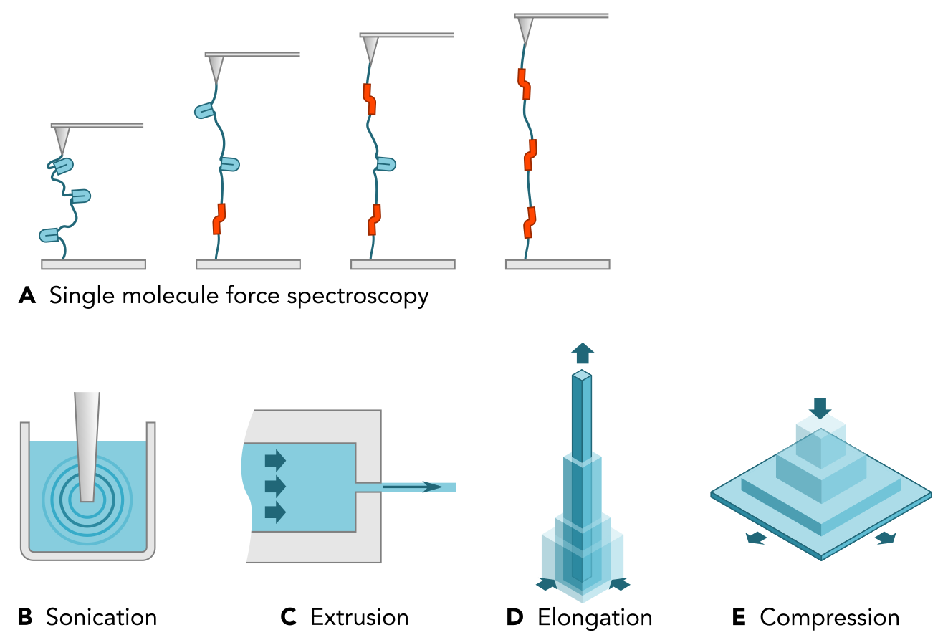
Figure 2. Schematic representation of a selection of different methods of mechanophore activation
(A) Single molecule force spectroscopy, (B) Sonication, (C) Extrusion, (D) Elongation and (E) Compression

At a fundamental level in terms of mechanophore design and understanding, it is important to understand how force affects an individual mechanophore and how the surrounding structure and connectivity affect its activation. While such fundamental understanding is not a focus of this review, it is important to discuss briefly the single-molecule force spectroscopy (SMFS) experiments carried out as the first step towards developing mechano-sensitive moieties for applications. To aid in this discussion the forces required to carry out a range of molecular processes such as DNA unzipping, protein unfolding, mechanophore activation and covalent bond breaking are compared in Figure 3.

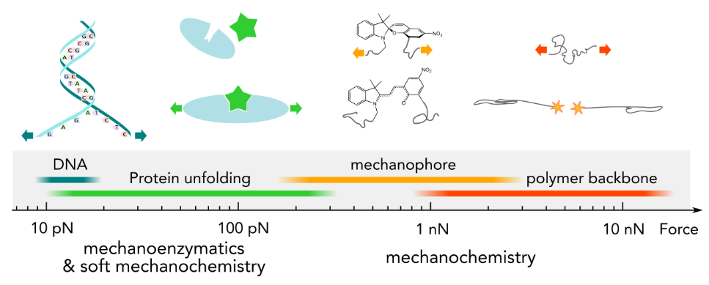
Figure 3. Force-scale for a range of molecular processes
The definition of ‘soft’ mechanochemistry can be found in the review ‘Soft-Mechanochemsitry: Mechanochemsitry Inspired by Nature’ Lavelle et al., Langmuir, 2016, 32, 7265.²⁶

Single Molecule Force Spectroscopy (SMFS)
Atomic force microscopy (AFM) can be used to carry out single-molecule force spectroscopy (SMFS) and examine mechanochemistry at the single molecule level. This technique involves the adsorption of the two ends of the target polymer to a silicone substrate and an AFM tip respectively, as shown in Figure 2A. Retraction of the tip at a constant velocity gives rise to a force-extension curve with a characteristic shape for each polymer. Reaction of individual monomer units are typically undetectable as the change in contour length they cause is indistinguishable from thermal fluctuations of the tip.²⁷ Thus, typically the polymers used in these experiments use hundreds of equivalent mechanophores on a single chain. Activation of these mechanophores gives rise to a plateau in the force-extension curve which is attributed to the activation of the embedded mechanophores.²⁸ Bond rupture has been shown to occur in the nN regime.²⁹ However, SMFS has a resolution in the pN regime allowing investigation into how changes in structure and conformation of the mechanophore itself affect the force required for mechanical activation.
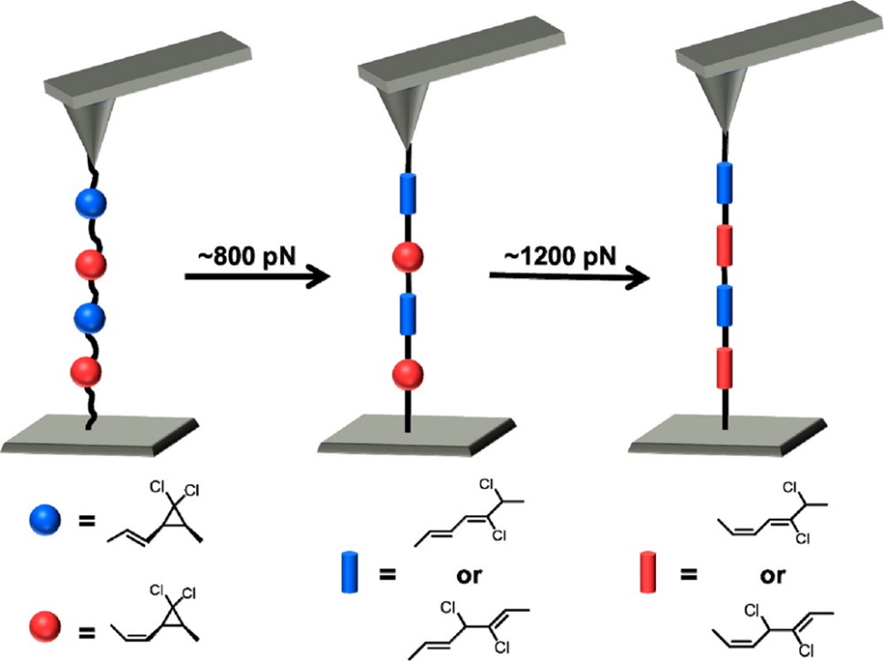
Figure 4. Schematic representation of SMFS experiments with E- and Z-alkene-substituted gDCC mechanophores
During SMFS experiments the E (blue) and Z (red) α-alkene stereoisomers of gDCC open in sequential transitions at ~800 and ~1200 pN, respectively. Reprinted with permission from Wang et al., J. Am. Chem. Soc., 136, 15162.³⁰ Copyright 2014 American Chemical Society.
This allows detailed insights into the fundamentals of mechanochemistry. As a first example of such fundamental findings, recently Wang et al. reported that the force required to open an E-alkene-substituted gem-dichlorocyclopropane (gDCC) mechanophore was 0.4 nN lower than that required for the corresponding Z-alkene-substituted mechanophore at ~800 pN, as shown in Figure 4.³⁰ The extension along the polymer backbone that accompanies the change from ground state to transition state is known as the activation length. Through experiment and molecular modelling these were calculated to be; 1.65 Å and 1.24 Å for the E- and Z-α-alkene-mechanophores via density functional theory and 1.67 ± 0.05 Å and 1.20 ± 0.05 Å calculated from the SMFS experiments. The authors suggest that relative to the Z isomer, the E isomer acts as a ‘lever’ as it provides a greater mechanical advantage for a given applied force. The lever arm effect was first demonstrated for gDCC and gem-dibromocyclopropane (gDBC) mechanophores embedded in poly(butadiene) (PB) and linear poly(norbornene) (PBN) wherein the change in polymer backbone was found to have a greater effect on the plateau force than halogen substitution within the mechanophore.³¹ The cyclopentyl rings in the PNB backbone were found to be aligned in such a way that they more directly couple the motion in the mechanophore ring opening to extension along the backbone. The PNB scaffold acts as a ‘lever arm’ providing enhanced mechanical coupling to the mechanophore when compared to PB. These works highlight that changing the polymer backbone (often believed not to be involved in mechanochemical activation) or changing something as subtle as a stereochemical mutation three bonds removed from the rupturing bond can have serious effects on the torqueing motions that accompany ring opening of the mechanophore.

Figure 5. Mechanophore structures examined via SMFS
(A) Spiropyran mechanophores thethered through the outermost phenyl rings and via the outer phenyl ring and the nitrogen component. The red colour indicates the weak bond. (B) gem-chlorofluorocyclopropane mechanophore which opens in a conrotary fashion under thermal activation but via a disrotary mechanism under mechanical force activation.

Also, using the same SMFS techniques Gossweiler et al. found that the force required to activate two spiropyran (SP) mechanophores was much lower than the gDCC mentioned above at ~240 pN.³² The two SP mechanophores differed in their regiochemistry with the anchoring polymer chains connected at different points in the SP-ring system. The isomer connected through the two outermost phenyl rings was found to open slightly more readily than the isomer connected through one of the outer phenyl rings and the nitrogen species (Figure 5A). Wang et al. have also used SMFS to observe a number of ring opening reactions that are ‘forbidden’ by the Woodward-Hoffmann rules which describe the direction of concerted nuclear motion in electrocyclic reactions.^{28,33} They found that it was possible to use SMFS to pull a gem-chlorofluorocyclopropane species outwards in a disrotatory fashion along the anti-Woodward-Hoffmann-DePuy (WHD) pathway (Figure 5B).³³ However, the process required ~200 pN greater force (1500 pN) than that required for the WHD favoured process (1290 pN). This trend was mirrored when looking at gem-difluorocyclopropane (gDFC) and gem-dicholorocyclopropane (gDCC), which showed lower force of activation for the symmetry-allowed ring opening process compared to the disallowed process (~530 pN and ~1000 pN for gDFC and gDCC, respectively) (Figure 6A, B).²⁸ In comparison, the same study showed a lower plateau in the force-extension curve (1370 pN) for the disrotatary, forbidden ring opening of a cis-benzocyclobutene (BCB) mechanophore compared to the conrotary, allowing ring opening of the trans BCB species at 1500 pN (Figure 6C). This lower plateau was attributed to a greater mechanochemical reactivity of the cis-BCB than the trans-BCB. However, by including an α-alkene to act as a ‘lever’ arm (as discussed above), it was possible to further lower the force required to bring about the anti-WHD ring opening of the cis-BCB (Figure 6D). This ‘lever arm’ reduced the force required for the ‘forbidden’ reaction from 1370 pN in the absence of the alkene to 920 pN on inclusion of the alkene.³⁴ These results highlight that the lever arm effect is a viable mechanism providing increased accessibility to otherwise forbidden, mechanically driven reactions.

Figure 6. Mechanophore structures examined via SMFS
Disrotatory and conrotatory pathways of three mechanically activated reactions. The reactants are ‘pulled’ via tensile force transmitted through the methyl substituents. Depending on the reactant and direction of the applied force, the induced nuclear motion (black arrows) is either allowed or forbidden based on orbital symmetry rules. The mechanophores are (A) cis and trans-gem-difluorocyclopropane (DFC) (B) cis and trans-gem-dichlorocyclopropane (DCC) and (C) cis- and trans-benzocyclobutene (BCB). Adapted with permission from Wang et al.²⁸ (D) Schematic of level arm effect of α-E -alkene in BCB. On a time scale of 0.1 s, the idtroduction of the α-E –alkene decreases the force required for activation the system by ~500 pN. Reprinted with permission from Wang et al. J. Org. Chem., 2015, 80, 11895.³⁴ Copyright 2015 American Chemical Society.

Pill et al. have used SMFS to show the cycloreversion of cyclobutane with attached ethylene glycol chains of specific length to give a defined increase in polymer contour length within the experimentally accessible regime, Figure 8A.³⁵ This concept was further built upon by Wang et al. who used cyclobutane as a mechanochemical molecular gate protecting a cis-gem-dichlorocyclopropane (cis-gDCC) mechanophore within the linking chain.³⁶ Computational predictions state that in the absence of force the order of reactive site of this mechanophore is the cis-gDCC followed by the inner and the outer C-C bonds of the cyclobutane. The application of force does not lower the apparent activation energy of this path but lowers all barriers of the alternative mechanism in which the order of bond dissociation is inverted. This is a result of the sequential loading of the bonds enforced by the mechanophore structure. SMFS and sonication experiments were consistent with gated mechanochemsitry of cis-gDCC within the mechanophore which is shown in Figure 7.

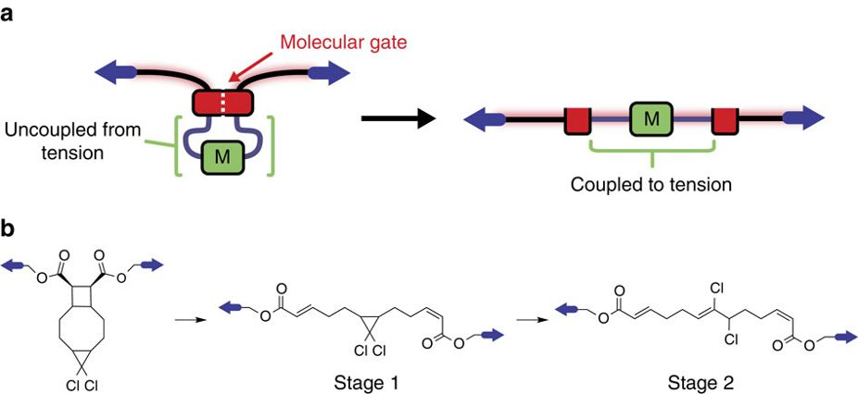
Figure 7. Mechanical gating of a mechanochemical reaction
(A) Cartoon of a molecular gate (red block) which prevents a protected mechanophore substrate (green) from feeling force. Applying sufficiently high force to the gate unlocks it mechanically, allowing the force to be transmitted to the substrate. (B) The cyclobutane mechanophore used as the mechanical gate which undergoes mechanical cycloreversion to unlock the system so that the initially protected cis-gem-dichlorocyclopropane (cis-gDCC) is activated. Reprinted with permission from Wang et al.³⁶

The plateau regions of these force extension curves showed greater saw-tooth texture than previously reported which was attributed to the considerable hidden length of the fully opened mechanophore. Further resolved saw-tooth patterns were discerned in the plateau of macrocyclic cinnamate dimers.³⁷ The measured peak to peak separations of individual mechanochemical transitions were distributed approximately around 2.5 nm which matched the corresponding computational calculations which provided elongation of 2.46 and 2.49 nM for the syn- and anti-cinnamate dimer species, respectively (Figure 8B, C). Using increasingly strained stilbene containing macrocycles the Boulatov group have demonstrated that the micromechanical behavior of polymers can be predicted by examining the distortion of the mechanophore as a function of restoring force applied to appropriate molecular coordinates.³⁸ This is a powerful result as SMFS measurements are limited to reactions that result in elongation of the polymer contour length by a minimum of several nanometers. Using similar stilbene macrocycles Akbulatov et al. have recently shown two mechanochemical phenomena distinct from force-accelerated scission of a loaded bond as described to this point using SMFS. This work highlighted that stretching phosphotriesters accelerates dissociation of the unloaded phosphorus-oxygen bond orthogonal to the pulling axis, whereas stretching organosiloxanes inhibits dissociation of the aligned loaded silicon-oxygen bond.³⁹

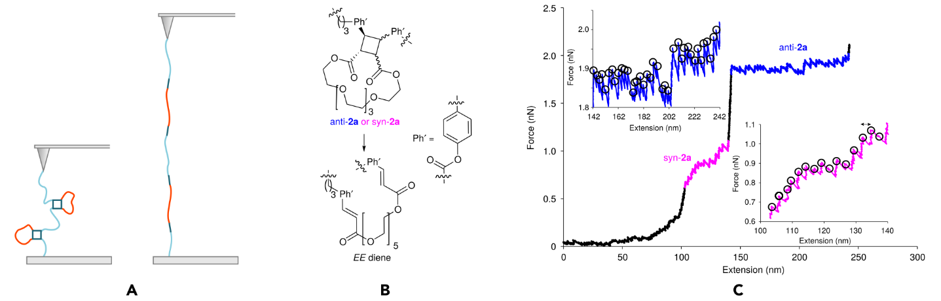

Figure 8. Macrocyclic mechanophore structures examined via SMFS
(A) Cartoon of macrocyclic mechanophores opening following retraction of AFM tip during single molecule force spectroscopy experiments. (B) Chemical structure of the syn- and anti- mechanophores demonstrated by Zhang et al. (C) A representative force extension curve for the cinnamate dimer mechanophore containing polymer. The plateaus, resulting from dissociations of the syn- and anti-mechanphores to E,E diene are highlighted in magenta and blue, respectively. Magnified plateau regions in the insets illustrate the saw-tooth pattern corresponding to dissociation of individual dimers, identified by black circles. Adapted with permission from Zhang et al.³⁷

Overall this SFMS work highlights the possibility to influence the reactivity and selectivity of mechanophores via manipulation of regio-, stereochemical or structural changes in the mechanophore as far away as three bonds from the breaking bond, while also providing a method to quantify the forces required. The above investigations demonstrate that there are copious efforts to examine the force-activation of mechanophores on a single-molecule scale. This has led to new chemical pathways inaccessible via other methods of activation. However, while SMFS is an excellent technique for examining the fundamentals of this relationship for individual mechanophores, we need to study bulk systems to test the ability to apply such forces to a larger quantity of polymers and hence the scalability to industrial purposes. In this review we have chosen to report next the literature on bulk systems in three categories; dilute polymers solutions, melts and solid materials. These categories were chosen to make a clear connection between the mechanochemical systems being developed by research groups and the concentration regimes normally used in a range of manufacturing processes. At the current time the majority of development of mechanophores are investigated initially in solution and so we will begin with the category of dilute polymer solutions and continue in the order of decreasing polymer solvation; polymer melts and finally solid materials.

Dilute Polymer Solutions
The majority of studies of polymer mechanochemistry have been carried out in the solution phase. While the earliest of these solution-based studies used turbulent flow and elongational flow fields to mechanically activate chain scission, presently the most popular method for mechanochemical activation is the application of ultrasound energy via probe sonication. Briefly, this technique brings about activation of mechanophores via imparting solvodynamic shear forces caused by cavitation, noted in Figure 2B and detailed in Figure 9. Cavitation is the nucleation, growth and collapse of bubbles within the solution brought about by the pressure waves created with the application of ultrasound energy. The ends of the polymer chains near the created void are pulled towards the collapsing bubble faster than the ends further away from the bubble. This drives a velocity gradient along the polymer backbone causing elongation and the build-up of force along the backbone which can drive mechanochemical effects, such as chain scission or ring opening. There are clear links, discussed later, between this technique and large scale processes such as printing, in applying a similar scale of strain rates to the polymers. However, as seen from the recent research discussed below, there are still challenges in comparing results across groups and scaling to manufacturing.

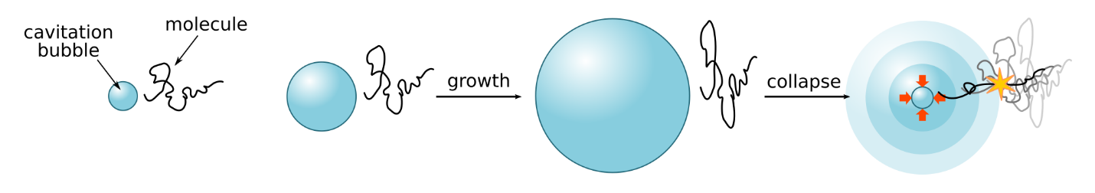
Figure 9. Polymer extension via sonication
Ultrasound causes bubble nucleation, growth and collapse over time. Polymer chain ends near the collapsed bubbles are drawn towards the void and the chains are elongated.

Following on from their single molecule force spectroscopy, the Craig group have also studied the factors governing transduction of mechanical force to the mechanophore during sonication of dilute polymer solutions. They have recently used a coumarin dimer mechanophore embedded in a PMA chain to examine chain scission efficiency during pulsed ultrasound.⁴⁰ The dimer can also be photochemically cleaved in a control solution to create an ‘ideal’ situation where every chain has been broken. By comparison of the GPC traces following sonication to that of the ‘ideal’ situation a percentage efficiency for sonication can be calculated. Using this system it was found that specific chain scission at the mechanophore occurred only 35 – 71% of the time, compared with scission away from the mechanophore. This work correlated the lower than expected scission with the distribution of the position of the mechanophore in the chain away from the centre of the polymer and highlighted two important challenges inherent in the field, firstly that the position of the mechanophore is critical and secondly that the activation efficiency is highly dependent on the particular technique being used to impart extensional forces.

In steps that will help provide good comparisons across research groups, there is significant work attempting to define further the factors that control mechanical activation and scission efficiency. Recently Lee et al. have examined the relative mechanical strength of weak bonds (WB) within the polymer chain.⁴¹ This study allows comparison of the relative strengths of a number of different types of WB; the carbon-nitrogen bond of an azobisdialkylnitrile, the carbon-sulfur bond of a thioether and the carbon-oxygen bond of a benzylphenyl ether. The particular WB of interest is incorporated into a single chain containing multiple non-scissile ring opening mechanophores. Once this polymer is elongated under flow, the force peaks near the mid-chain and decays with distance. This causes the non-scissile mechanophores to open beginning at the centre and continuing out from that point until enough force builds up along the chain causing cleavage of the incorporated WB, as shown in Figure 10. Thus, the more easily the WB breaks, the fewer ring opening events occur, giving a measure of the relative mechanical strength of the WBs. The trends found in mechanical cleavage of the WBs (azobisdialkylnitrile < thioether < benzylphenyl ether) contrast with their thermodynamic strengths (azobisdialkylnitrile < benzylphenyl ether < thioether). This was attributed to the changes in geometry required for the cleavage of the C-O bonds in the benzylphenyl ether. Bond dissociation in this case leads to rehybridisation. However, the length gained as the C-O bond length increases is partially offset by the contraction that comes about from the C-C-O bond angle decreasing to accommodate rehybridisation. Mechanochemical coupling is dictated by the overall change in length explaining the relative lack of mechanochemical activity in the benzyl ether when compared to its thermodynamic bond strength. A similar link between geometry and mechanochemistry was observed when examining retro-Diels-Alder reactions.⁴² On comparison of four furan/maleimide adducts with endo of exo configuration and proximal or distal geometry it was found that the proximal isomers as well as the distal-endo species do indeed follow a retro-Diels-Alder pathway on sonication. However, the thermally active distal-exo adduct is shown to be inert under tension due to poor alignment of the scissile bond with the force vector. Showing that, unlike the thermal situation where reactivity is dictated by stereochemistry, the mechanical activity of these species is mainly dependent on the regiochemistry. A similar finding has also been reported by Zhang et al. when examining cinnamate dimers using SFMS.³⁷ This work showed that by choice of stereoisomer the force at which the dimer dissociates at useful rates is tunable over >1 nN. These studies highlight the concept that changes in geometry, beyond those associated with bond making/breaking, can be used to independently manipulate the mechanical and thermal stability of reagents.

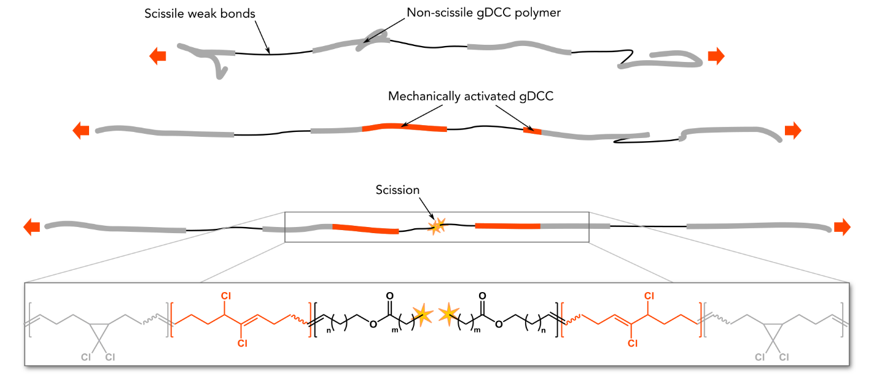
Figure 10. Schematic of the polymer system to examine relative mechanical strengths of WBs
Flow fields caused by pulsed ultrasound stretch the polymer chain. Following this the non-scissile ring opening mechanophores are activated near the midpoint of the chain, radiating outward. This continues until a WB breaks. The extent of non-scissile mechanophore activation provides a measure of the mechanical strength of the WB as weaker bonds break earlier causing activation of fewer non-scissile mechanophores. Adapted with permission from Lee et. al.⁴¹

Similarly interested in the fundamentals of mechanical activation, May et al. have been studying the transduction of forces to the WB along the polymer backbone.⁴³ They tackled the question if it is the molecular weight or degree of polymerisation that governs the rate of polymer chain scission. To do this they looked at the ring opening of SP embedded in a number of different acrylate polymer backbones. The ester substituents of each monomer was varied (methyl, ethyl, n-butyl, iso-butal and tert-butyl) to allow investigation of the effect of polymer composition and side-chain constituents. The authors developed a high-throughput flow system in which the solution was pumped from the sonication vessel to the UV-vis spectrometer and back to the vessel again, allowing monitoring of the absorption of the solution throughout the course of each sonication experiment. An increase in the absorption at 570 nm was observed with increasing sonication time as the SP underwent ring opening to the merocyanine species. The rate constants for mechanochemical activation of SP were measured for each polymer with varying repeat unit substituents. When plotted against molecular weight, the rate of mechanochemical activation of SP was found to depend on the composition of the polymer in question. However, when the same rates were plotted against the degree of polymerisation (M_{n} divided by molecular weight of the repeat unit) no significant difference was observed between the different polymers. This indicates that degree of polymerisation is the fundamental criterion that determines the rate of mechanochemical activation and to increase the range of activation a proportional increase in the number of repeat units is required irrespective of the molecular weight of this repeat unit. This finding was independently corroborated by Schaefer et al. who examined the cleavage of polystyrene and poly(norbornene imide alkyne) polymers.⁴⁴ By adding or removing bulky pendant groups, the molecular weight of the polymer was varied, keeping the contour length of the polymer constant. Identical scission characteristics for heavier and lighter polymers with the same backbone and contour length highlights once again that the rate of mechanochemical cleavage is dependent on degree of polymerization. These are extremely important results as they clarify the molecular weight dependence of mechanochemical activation typically reported in the literature.

This study was built upon by the Craig group and co-workers who used their widely developed gDCC ring opening mechanophore within a polybutadiene (PB) backbone to examine the effects of sonication parameters on scissile and non-scissile zones along the backbone.²⁹ For this work the group examined the competition between ring opening of the incorporated mechanophores and polymer chain scission. They found that, as expected, varying the sonication parameters such as sonication power, solvent, concentration and temperature affected the overall rate of polymer chain scission. However, it was confirmed that these conditions did not affect the maximum force experienced by the polymer chain or the distribution of force along the chain, as shown by a constant percentage of ring-opening normalised per scission event. This was not the case when examining the influence of initial molecular weight. This deviation was attributed to ring-opening occurring without a corresponding chain scission event for MWs close to the limiting molecular weight and to multiple scission events occurring per parent chain for higher MWs. Overall the authors highlight the fact that ‘care should be taken when using casual language to the effect that “force increases with sonication power, decreases with temperature, etc.”, at least under conditions where chain scission occurs’. It can also be seen clearly from this work that both the process imparting mechanical forces and the molecular design have to be carefully controlled and understood to deliver a targeted chemical pathway.

Along with fundamental studies on mechanochemical activation, sonication is also being used to test the design of new mechanophores. This, as noted towards the end of this report, will become more powerful as research developments better link and correlate activation techniques and scaled-up processing. In particular there has been a move to design a mechanochemical activation approach to release a species capable of bringing about a secondary reaction. The group of Sijbesma have recently developed this idea to bring about mechanoluminescence for high-sensitivity detection of small forces.⁴⁵ This work builds on their previously reported mechanoluminescent mechanophore bis(adamantly)dioxetane. Rather than undergoing complex synthetic modification of this mechanophore Clough et al. chose to develop a system in which a highly basic N-heterocyclic carbene species was released upon mechanical activation of a palladium bis-NHC complex which brought about the dissociation of the dioxetane species via deprotonation giving rise to chemiluminescence (Figure 11).⁴⁵ The authors hope that the current system and its future variations may be used to generate light mechanically and thus to probe bond scission processes with much greater sensitivity.

Figure 11. Chemical structures of palladium-NHC coordination polymer and dioxetane based mechanoluminescence system
Mechanical activation of the palladium-NHC coordination polymer produceds a free carbene. This carbene deprotonates the dioxetane substrate, initiating chemiluminescent decomposition.

The idea of using a photochemically active species as the starting point to develop new mechanophores was also exploited by the Moore group to generate a mechanoacid.⁴⁶ The reasoning behind this was that many photoacids exist containing WBs such as C-S, S-O, C-S, S-O and C-I which might be mechanically activated. Moore and co-workers examined an oxime sulfonate species as they theorised that the weaker S-O or N-O bonds might be mechanically sensitive. Pulsed ultrasonication of the mechanophore containing polymer caused the molecular weight to drop to almost half (103.2 kDa) its original value (189.4 kDa) after 30 mins. The rate of chain scission of the mechanophore containing polymer was also found to be almost twice that of a poly(methyl acrylate) (PMA) control of similar molecular weight. pH measurements showed a steady decrease in pH with increasing sonication time which did not occur with the control sample suggesting the generation of acid upon activation of the mechanophore. NMR measurements suggested the cleavage of the S-O bond of the oxime rather than the N-O bond, mirroring Constrained Geometries simulated External Force (CoGEF) calculations. This work highlights the possibility of discovering new mechanoacids through investigation of currently known photoacids and validates the approach more generally of starting with photochemically active species. The possibility of using such mechanoacids for acid-catalysing cross-linking reactions was also emphasised in Moore’s original work on mechanoacids using a gem-dichlorolcyclopropanated indene.⁴⁷ However, the poor thermal stability of the system limits its application particularly compared to the oxime sulfonate discussed above.

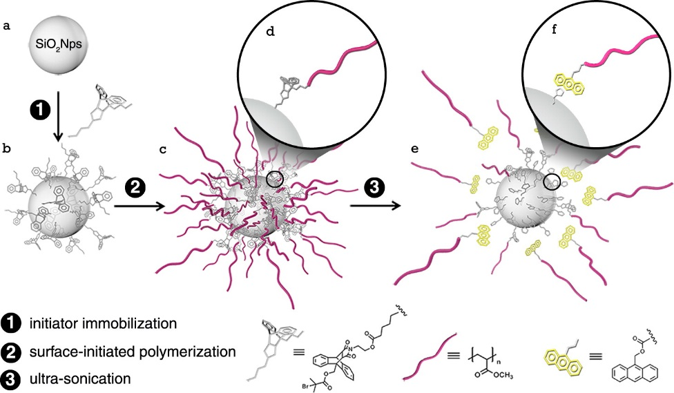
Figure 12. Illustration of the synthetic approach to mechanophore-anchored polymer brush-grafted nanoparticles and its response to mechanical activation
(A) Bare silica nanoparticle, (B) mechanophore-anchored silica nanoparticle, (C, D) silica nanoparticles grafted with PMA chains anchored by the maleimide-anthracene cycloadduct, and (E, F) interfacial retrocycloaddition-induced detachment of PMA chains and generation of anthracene-end-capped PMA. Reprinted with permission from Li et al. J. Am. Chem. Soc. 2014, 136, 15925.⁴⁸ Copyright 2014 American Chemical Society.

The vast majority of dilute polymer solution systems being examined using ultrasound are homopolymers encasing a mechanophore at the centre, where bond scission occurs. Li et al. have recently made an exciting step towards activation of mechanophores held at organic-inorganic interfaces.⁴⁸ They highlight the importance of such systems considering the extensive use of composite materials across industrial applications. For this study they examined PMA grafted onto silica nanoparticles through a maleimide-anthracene (MA) cycloadduct mechanophore, see Figure 12. This mechanophore had previously been demonstrated by the Boydston group to undergo retrocycloaddition.⁴⁹ Following sonication, polymer cleavage was observed, producing an anthracene-capped PMA chain. Activation of the mechanophore at the interface was attributed to stress build up at this point due to its proximity to the centre of mass of the overall nanoparticle system. The same increase in mechanophore activation with increasing molecular weight was observed as with homopolymer systems and a similar threshold molecular weight was determined when compared to the corresponding homopolymer control. The group examined this system further, investigating the effect of grafting density on mechanophore activation.⁵⁰ They found that a lower grafting density enhanced the activation efficiency of the MA mechanophore. Decreasing the grafting density by 37% (from 0.27 to 0.18 chain/nm²) caused an increase in mechanophore activation which was found to be equivalent to increasing the MW of polymer by 10 kDa. It was also noted that the higher grafting density samples exhibited a higher threshold MW. The reduced activation at higher grafting densities was suggested to arise due to the fact that increasing the grafting density leads to stronger interactions between neighbouring chains, inducing interchain entanglements, reducing the force experienced within an individual chain. This is the same behaviour to that noted for increasing concentration in homopolymer solutions¹³ which will be discussed in more detail later in this review. Similar to the work carried out on the transduction of forces to activate a mechanophore, this study highlights the importance of concentration on the efficiency of mechanochemistry. The reviewed work so far focuses on changes within the dilute range but to explore the role of concentration further the next section of this review will examine the recent reports of mechanochemistry occurring within polymer melts.

Polymer Melts
The most commonly reported method used to bring about mechanochemistry within a polymer melt is through the use of extrusion, a technique also used for inorganic mechanochemical processes. Extrusion refers to a group of processing techniques during which materials are forced through a constrained space (Figure 2C). Processing of high polymer concentrations by extrusion is ubiquitous across industry, naturally ensuring the immediate link between fundamental scientific findings and mechanochemistry for applications.

One example of mechanochemistry in polymer melts comes from the Craig group who used a twin screw-extrusion set-up to examine the reactivity of gem-dihalocyclopropanated (DHC) polymers under mechanical force.⁵¹ The dichloro- species leads to roughly half the activation seen for the dibromocyclopropane (DBC) containing polymer. This was attributed to the higher intrinsic reactivity of the dibromomechanophore compared to the dichloromechanophore. To investigate the competition between the two leaving groups a mixed polymer system was synthesised containing gem-bromocholocyclopropane. Extrusion of this polymer showed almost equal leaving of the Cl and Br species, unlike the case of thermal activation which shows almost exclusively bromine migration. Following the confirmation of bond scission and ring opening under shear in these systems the possibility to form bonds in response to these actions was investigated. Extrusion of the dibromo- species in the presence of triethylammoium chloride led to nucleophilic displacement of the allylic bromide produced by ring opening. This work provides a proof-of-concept that the destructive forces that drive bond breakage could be harnessed to bring about positive bond formation, which has important implications for self-healing and self-strengthening systems.

Ramirez et al. showed that it was possible to use mechanochemical activation of the same gDBC system to bring about crosslinking.⁵² To do this they incorporated large numbers of mechanophores into the poly(butadiene) (PB) backbone to increase the number of reactive sites produced by mechanochemical activation. Extrusion of the polymer system shown in Figure 13 led to a decrease in molecular weight from 780 to 560 kDa while the shear forces experienced gave rise to activation of 7% of the incorporated mechanophores. Following this, fresh mechanophore-loaded polymer was extruded with the di-tetrabutylammonium salt of sebacic acid (TBA SA) (Figure 13). This led to the production of a solid polymer which was insoluble in five different solvents and solvent combinations suggesting the occurrence of crosslinking. This was confirmed by infrared spectroscopy which showed the disappearance of the TBA SA carboxylate stretch. The elastic modulus of this solid polymer was measured using a nanoindentation system which showed an increase of nearly two orders of magnitude to a value of 150 ± 85 MPa. Finally, to simplify the system a second polymer was designed in which the crosslinking nucleophile was present on the same backbone as the mechanophore. Sonication of solutions of this polymer only led to crosslinking once above its critical overlap concentration, which is the concentration at which the average volume of a single polymer chain overlaps with the volume of another polymer chain. These systems highlight the intriguing possibility of localised mechanochemical self-strengthening of materials similar to that observed in biological systems.⁵²
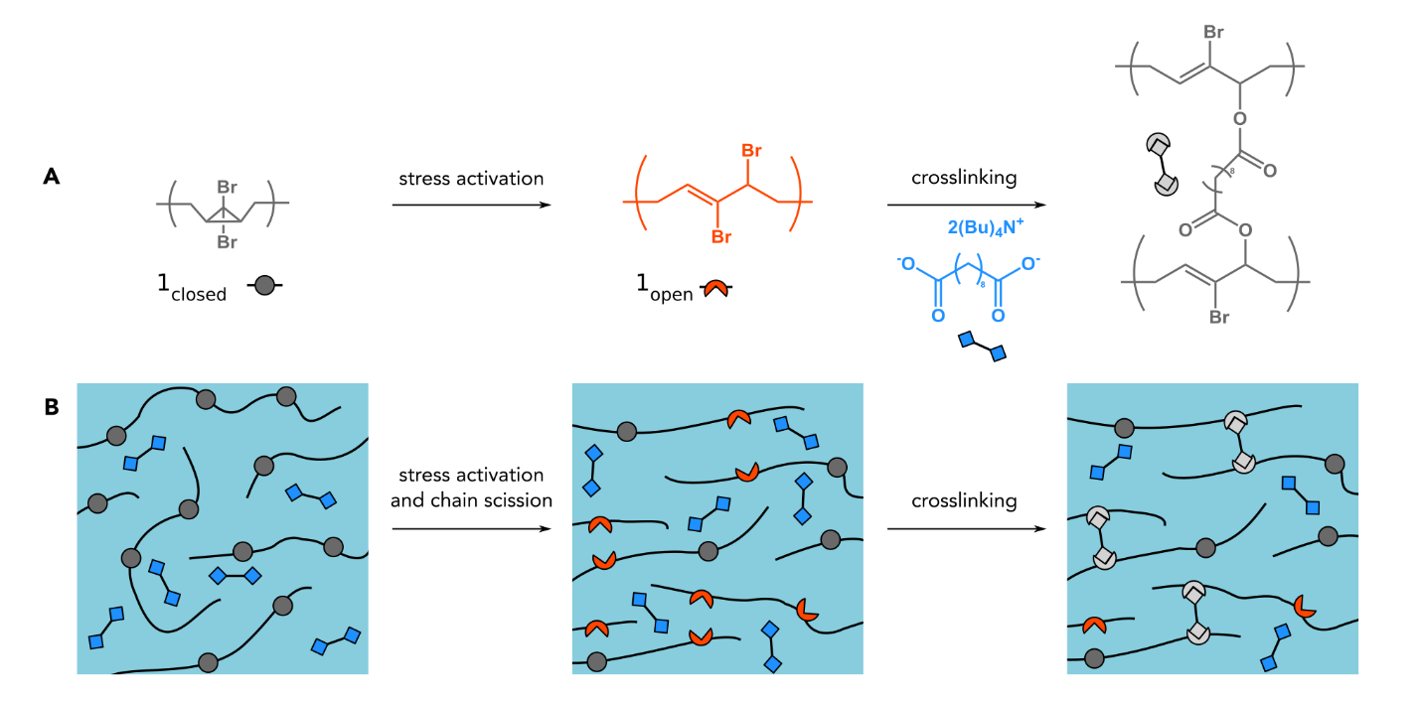
Figure 13. Mechanochemical self-strengthening
(A) Structure of gem-dibromocycloprpoane (gDBC) which ring opens to for a 2,3-dibromoalkene product that is susceptible to nucleophilic substitution in the presence of di-tetrabutylammonium salt of sebacic acid (TBA SA) (B) Schematic representation of the gDBC (drak grey circles) containing polymer undergoing activation to produce the ring open product (red curve) which then reacts with TBA SA (blue diamones) to form an active crosslink (light grey link). Adapted by permission from Rameriz et al.: Springer Nature Rameriz et al.⁵² Copyright 2007.

The Boydston group at the University of Washington have taken another exciting angle, using mechanochemically active polymers in the melt phase and integrating them into additive manufacturing (AM).²³ Fused filament fabrication (FFF) was chosen as the AM technique due to its market-share dominance for entry-level AM and its use of polymeric materials. The mechanophore chosen was spiropyran covalently linked to polycaprolactone (PCL), which is commonly used as a flexible filament for FFF systems. The synthesised mechanophore containing polymer (Figure 14A) was mixed with commercial PCL. The mechanophore was not activated thermally or mechanically during the mixing or printing processes, which involved extrusion through a heated nozzle at 110 ºC. However, subsequent elongation of printed samples showed a vibrant purple colour, confirming the mechanophore activation. It was possible to print this mechano-responsive material as part of a larger dog bone architecture for mechanical testing. When this sample was placed under stress, the mechano-responsive portion appeared blue and became purple and photoluminescent following relaxation of the stress (Figure 14B). Although the mechanophore is not activated within the polymer melt, this work is included in this section as the polymer processing occurs in the melt phase. This is a very exciting piece of work, as it expands the use of mechanochemistry into the rapidly growing area of additive manufacturing allowing the development of complex 3D mechanically responsive structures and highlights the possibility to prevent activation during processing.

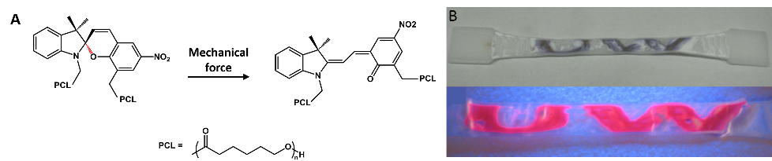

Figure 14. Mechanochemistry in additive manufacturing
(A) Structure of spiropyran mechanophore incorporated within polycaprolactone (PCL) (B) Photographs of 3D printed dogbone sample following tensile stress in ambient conditions and under driect UV irradiation (365 nm). Adapted by permission from Peterson et al.²³ © Emerald Publishing Limited all rights reserved.

These exceptional few examples of mechanophores in polymer melts were the only ones found by the authors, suggesting that there is significant scope for further development of similar mechanochemical systems within polymer melts. This is an area prime for exploitation in terms of scalability due to the heavy use of extrusion and AM within industrial processes. There is a clear indication for melts, as with sonication, that there is no standard approach to testing mechanochemical activation with extrusion. This variation makes benchmarking and comparing across different studies very challenging. The lack of examples of mechanochemistry in polymer melts is also surprising considering the wealth of studies reported in which the mechanophore-bearing polymer is embedded within a solid polymer network. The following section will look at the studies with solid networks and again examine both the chemical systems and also the variety of approaches to mechanically activate the materials.

Solid Materials
As has recently been highlighted in the excellent review by Akbulatov and Boulatov, for six reactions discussed, qualitatively similar results were observed in sonication and bulk amorphous or semicrystalline materials under mechanical loads.¹⁴ While these qualitatively similar results demonstrate that a mechanophore can be versatile and activated in a wide range of physical states of the host matrix (solution and solid-state) it should be highlighted that predicting how load transfers to the mechanophore within the solid-state is extremely complex due to the amorphous structure and polymer chain entanglement. Thus, while demonstration of mechanophore activation under sonication is indeed an indication that the same mechanophore may be activated in the solid-state, further optimisation of the solid-state activation method is necessary. This disconnect again highlights the need to understand the material format when considering final processing and activation method and when scaling to manufacturing and applications. An excellent demonstration was reported by Imato et al. using a diarylbibenzofuranone (DABBF) based mechanophore, see Figure 18.⁵³ The colourless powder of the DABBF monomer mechanophore was shown to be mechanically activated on application of shear on grinding in a mortar by the appearance the blue colour of the cleaved radical species. However, a crosslinked polymer with DABBF linkages could not be activated in response to application of mechanical force via tension, compression, shear loading, cracking and swelling. The authors suggest this probably occurs as the structure was not designed to efficiently transmit macroscopic forces to the mechanophore linkages and as the dissociated radicals re-combined too quickly for a colour change to be noted. To overcome this second point the network was swollen in 1,4-dioxane to form a gel which turned blue on freezing. Thus highlighting the complexity of optimisation of mechanophore activation in the solid-state and the utmost importance of carrying the study of a newly designed mechanophore from the initial screening experiments using sonication right through to the solid-state which is desired for numerous practical applications. With that in mind in the following section we will discuss a selection of the recent literature in which mechanophores are demonstrated in the solid-state.

One of the earliest, and most widely used, mechanophores is the colourless spiropyran (SP) moiety which is widely recognised beyond the mechanochemistry literature due to its ability to undergo light-induced ring opening to produce the purple merocyanine form. One of the first methods used to mechanically activate SP in the solid-state was reported by Davis et. al.⁵⁴ In this work the authors synthesised a poly (methyl acrylate) (PMA) species containing spiropyran which was heat moulded into a ‘dog bone’ shape and mechanically stretched or elongated until breakage. An intense colour change was observed on activation of the mechanophore that was absent from the control samples. Since this first example of activation of a mechanophore in the solid-state there have been a wealth of such reports, detailing established mechanophores and new approaches to imparting force. This has led to a broad range of experimental techniques in the solid-state literature. However, despite this range, reports can be categorised based on whether the mechanophore-bearing polymer is activated by either elongation or compression of the polymeric network. The differences between these two are graphically highlighted in Figure 2D,E.

Elongation
In the time since the first SP experiments the Moore group has developed more exotic techniques to apply force in the solid-state. Recently, using a system in which SP was bound within a cross-linked PMMA network, activation of the mechanophore was achieved via swelling of the polymer in a range of different solvent systems, (Figure 15A).⁵⁵ It was found that high and low polarity solvents such as water and toluene caused very slow or no swelling of the polymer, giving rise to no mechanophore activation. Polar aprotic solvents such as acetone, tetrahydrofuran, acetonitrile and dimethylformamide resulted in slow and controlled polymer swelling, inducing conversion of spiropyran to the coloured merocyanine. This suggests control of the mechanical activation through swelling and not just standard mechanical extension techniques.

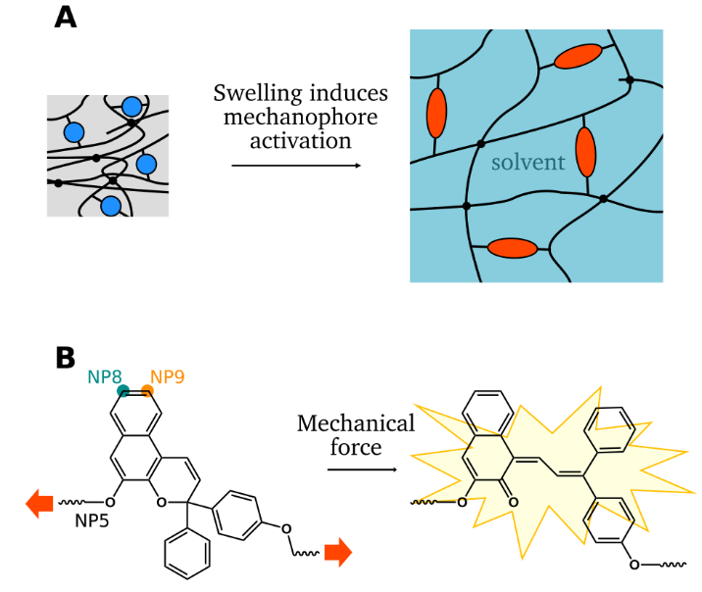
Figure 15. Novel mechanophore activation technique and spiropyran inspired mechanophore
(A) Schematic representation of solvent swelling inducing mechanophore activation. Adapted with permission from Lee et al., Macromolecules, 47, 2690.⁵⁵ Copyright 2014 American Chemical Society. (B) Transformation of naphtopyran into its corresponding orange merocyanine species.

Robb et.al. have reported a naphthopyran mechanophore which has been shown to undergo mechanochemical transformation into a coloured merocyanine in a similar fashion to the SP system noted already (Figure 15B).⁵⁶ In this instance the authors used the established activation technique of mechanically stretching a polymer (PDMS) film in which the mechanophore was covalently incorporated. This study examined three regioisomers of the naphthopyran mechanophore with different positions of the methoxy group on the naphthalene ring. The system containing the methoxy group at the 5-position was the only film to exhibit a colour change. The selectivity of this regioisomer was explained using DFT calculations using the technique of CoGEF to examine the alignment of the weak C-O pyran bond with the coordinates of the applied external force. There was found to be a 31º angle between the C-O bond and the vector of applied tension for NP5 compared to 55 and 65º for NP8 and NP9, respectively. A similar DFT study of the possibility of cycloreversion for a series of triazoles by Jacobs et al. also highlighted the importance of the direction of the applied force and the connectivity of the regioisomer in mechanophore activation.⁵⁷ Overall these studies highlight the use of simulations to link the design of molecules and the directionality of applied force.

Identifying the fact that the mechanical forces required to activate mechanophores are the same as those used for actuation in soft robots, Gossweiler et al. have recently incorporated a functionalised SP into a commercially available PDMS kit (Ecoflex) which can then be moulded into a range of different shapes and structures to produce soft robots.⁵⁸ These are prepared from soft and flexible elastomers. Inflation of the elastomeric channels and shapes contained within such soft robots leads to complex, non-linear macroscopic motion. Inclusion of a spiropyran mechanophore to the PDMS network and, for example, inflation of the soft robots leads to colour change at the most strained portions of the material. This was used to report on the regions of most probable failure (Figure 16). Overinflation of the robot led to rupture at the positions previously indicated as having the highest mechanochemical response. This exciting proof-of-concept leaves the door wide open for the development for a wide range of mechanophores specifically for applications in soft robotics.

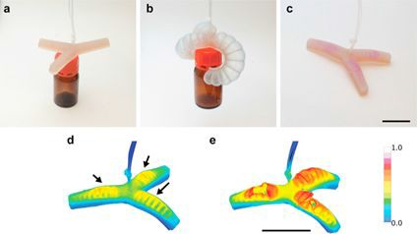
Figure 16. Spiropyran containing soft robot
Inflation of a three-arm gripper robot shows more intense coloration in the regions that experience the largest deformations. Colour images (A) before (B) during and (C) after inflation of the gripper. (D) Fluorescent images of the robot after the deformation with arrows indicating the ‘at risk’ regions. (E) Overinflation of the robot until rupture validates that the indicated regions are ‘at risk’ of failure. Scale bar = 5 cm. Reprinted with permission from Gossweiler et al., ACS Appl. Mater. Interfaces, 7, 22431.⁵⁸ Copyright 2015 American Chemical Society.

Compression
Looking to take advantage of a change in optical properties Göstl and Sijbesma have developed a new π-extended anthracene-based mechanophore that can be released from its maleimide Diels-Alder adduct to produce a species that both absorbs and emits in the visible region.⁵⁹ Anthracene has a fluorescence quantum yield over 10 times that of the SP mechanophores used in the past. In an effort to further enhance the optical properties of anthracene the authors extended the π-network at the 9 position as can be seen in the DA adduct shown in Figure 17A. The extension of the π network at the 9- position alters the optical properties of the mechanophore such that it absorbs in the visible region of the spectrum and its complete emission spectrum also lies in the visible range allowing detection with the naked eye. This mechanophore was tested in the solid-state by directly incorporating it into a poly (hexyl methacrylate) network. Compression of this network with a pellet press caused an immediately visible change in fluorescence, which was confirmed using solid-state fluorescence spectroscopy. In an effort to further bathochromically shift the absorption and emission spectra of the mechanophore, the authors further functionalised the anthracene at the 10- position as shown in Figure 17B. However, the same retro DA reaction observed for the two-armed species was not observed. Despite the optimisation required for the three-armed species, the success of the two-armed polymer shows the possibility to develop a new series of mechanophores with tunable optical properties.

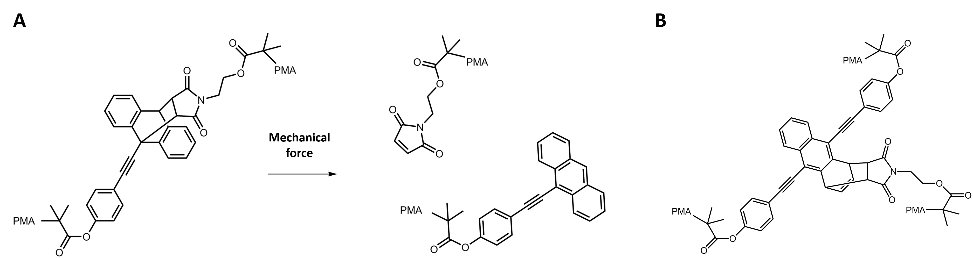

Figure 17. Anthracene-based mechanophores
(A) Structure of anthracene-based mechanophore with π-extended network through the 9-position along with the structures of maleimide and anthracene moieties produced by retro Diels-Alder reaction brought about following the application of force. (B) Structure of three-armed polymer containing an anthracene mechanophore substituted at the 9- and 10-positions.

Similarly interested in eliciting an optical response, the group of Otsuka have been developing mechanochromic polymers containing mechanophores which are homolytically cleaved to produce coloured, stable radical species, see Figure 18. Combinations of these mechanophores can be used in tandem to produce a wide range of colours.⁶⁰ This has recently led to the exciting report of mechanochromic polymer blends that can recognize different mechanical stimuli.⁶¹ These blends were composed of tetraarylsuccinonitrile (TASN) (pink radical, Figure 18B) incorporated into the centre of polystyrene (‘hard’ regions) and diarylbibenzothiophenonyl (DABBT) (green radical, Figure 18C) incorporated into the centre of a star-shaped polystyrene-b-poly(methyl acrylate) (‘soft’ regions). Stretching of films of the polymer blends showed cleavage of the green DABBT mechanophores within the soft section with no activation of the pink TASN within the hard domains. However, the higher shear experienced during mechanical grinding of the same films showed activation of the mechanophores in both the ‘hard’ and ‘soft’ domains leading to a yellow/green colour close to orange. Thus this multicoloured system can discriminate between the mechanical actions of stretching and grinding. Using the method of mechanical grinding the group have also examined the effect of the relationship between polymer architecture and mechanophore activation in the bulk.⁶² The DABBF mechanophore (Figure 18A) was incorporated within linear and 4- and 8-arm star polymers. Corresponding to observations in solution, the ratio of activated mechanophores to unactivated mechanophores increased with increasing molecular weight of the linear polymers. However, in contrast to mechanochemistry in solution, greater activation of the 4-arm and further the 8-arm star polymers was noted. In solution, an increase in the branch number decreases the reactivity, which is attributed to a lower shear force arising from a smaller hydrodynamic radius.⁶³ As is suggested by Oka et al., intermolecular chain entanglements may be responsible for differences in relationship between polymer architecture and mechanoresponsiveness in a solid form versus solution.⁶²

Figure 18. Chemical structures of mechanochromic mechanophores before and after applying mechanical stress.
(A) Diarylbibenzofuranone (DABBF), (B) tetraarylsuccinonitrile (TASN) and (C) diarylbibenzothiophenonyl (DABBT). Reprinted with permission from Ishizuki et al., Chem. Eur. J. 2018, 24, 3170.⁶⁰

The idea of using mechanochemical activation to reveal a vacant site on metal complexes has been beautifully demonstrated over the past 15 years by the group of Sijbesma.^{24, 64-66} Along a similar line, Michael and Binder have recently developed a new Cu-based catalyst capable of activating ‘Click’ reactions both in solution and in the solid state.⁶⁷ This complex contains two N-heterocyclic carbene (NHC) motifs with attached polymer chains bound to a central Cu atom. The activity of this complex was first studied in solution by monitoring the ¹H NMR spectra for the reaction of benzylazide and phenylaceylene. Activation of the mechanophore via sonication leads to triggering of the desired reaction. It was found that the longer the polymer chains grafted onto the carbene ligands the higher the activity achieved. Similarly, more rigid polystyrene chains caused higher activation when compared to more flexible poly(isobutylene) chains of similar and even greater molecular weight. Once the mechanochemical activation of the Cu catalyst was demonstrated in solution the system was transferred to the solid state. To aid the visualisation of the mechanophore activation the authors moved to a fluorogenic ‘Click’ reaction which produced a coumarin dye for their solid state experiments. For these experiments the Cu catalyst was embedded in a poly(tetrahydrofurane) matrix along with the two reactive components for the ‘click’ reaction; phenylacetylene and the non-fluorescent 3-azido-7-hydroxycoumarin. Application of 10 tons of pressure using a hydraulic press to this matrix induces fluorescence that can be monitored at 427 nm.

Sijbesma’s group, along with the group of Stephen Craig, have recently taken advantage of such reversible metal coordination complexes to increase the maximum achievable strain of a covalent polymer gel under pressure.⁶⁸ Inclusion of Pd-based bifunctional pincer complexes which coordinate reversibly on either end to a poly(4-vinylpyridine) (P4VP) network crosslinked using 1,6-dibromohexane allows the Pd complex to reversibly bind to free pyridines along the polymer side chain. Addition of these metal complexes to the polymer networks shows a dramatic increase in the stress and strain at break induced by compression. This was ascribed to the presence of dynamic crosslinks within the network. To probe how the fracture behaviour of the networks changed as a function of the added Pd complexes, the bis(adamantly) dioxetane mechanophore mentioned previously from the Sijbsema group was incorporated into the network as a crosslinker along with the singlet acceptor 9,10-bis(phenylethynyl) anthracene. Upon rupture of the covalent network, the mechanophore breaks to form electronically excited adamantanone motifs.This transfers energy to the acceptor molecule which emits at ~600 nm. Networks bearing increasing concentrations of the Pd complex were compressed and the emission at 600 nm was recorded. With an increase in complex concentration, there is an increase in the strain-at-break, which in turn drives an increase in emission due to failure of the covalent network. This highlights the fact that the reversible interactions produced by the bifunctional pincer complexes, although not necessarily bearing stress themselves, inhibit the scission of the underlying covalent network which is actively bearing greater stress. The high strains achievable in these modified systems, where no extra costs are paid to dissipation, are particularly attractive for soft active devices due to the high range of motion required.

Using the gDBC mechanophore mentioned previously, Lenhardt et al. have probed the comparison between mechanochemical activation under tension and compression.⁶⁹ It was found that the extent of ring opening scaled almost linearly with applied pressure during compression over a range of 36 to 249 MPa. Moving to tensile deformation, polymer films were subjected to direct monotonic tension. Following failure of the film the gauge section was dissolved in CDCl3 and analysed via ¹H NMR, see Figure 19. Unlike the 2.8% conversion achieved during compression, tensile experiments indicated no mechanophore activation despite being carried out at a range of temperatures near and below Tg in an effort to impart higher force to the polymer. Although the mechanophore activation was found to be dependent on strain rather than purely stress, the difference between compression and tensile mechanophore activation was rationalised by considering the magnitude of the stresses during both types of experiments. The tensile testing of the gDBC films reached a maximum stress of 0.2 MPa compared to the minimum stresses of 36 MPa applied during compression. It was acknowledged that any activation achieved during tensile experiments may simply lie below the sensitivity of the NMR measurement used. This work and all of the above examples of solid state materials highlight that established mechanophores are being used to investigate new methods of force application. However it is clear that each of these methods of force generation give a differing mechanical response.

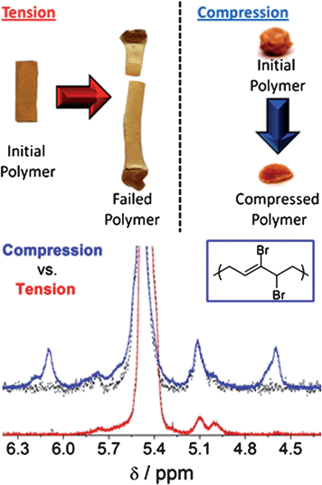
Figure 19. Comparison of gDBC activation under tension vs. compression.
Tensile testing of a gDBC film does not lead to gDBC ring opening (bottom, red ¹H NMR spectrum) while compression activates the gDBC to ring open to the 2,3-dibromoalkene (upper, blue ¹H NMR spectrum. Reprinted with permission from Lenhardt et al. J. Mater. Chem., 2011, 21, 8454.⁶⁹

Throughout the above discussion of both molecular design and methods to drive mechanical activation in dilute polymer solutions, polymer melts and solid materials it is clear that great work is being carried out on the lab scale into the fundamentals of mechanophore activation, examining structure and regiochemistry of the mechanophore and how the changes in these couple with the vector of applied force. However it is also clear that the method of force application has a large effect on the mechanochemistry of the system. Although similar set-ups are used for mechanophore activation in dilute solution (typically: Sonics VCX500 sonicator with a Suslick cell at low temperatures and dilute solutions), it is clear that further factors such as the solvent used, ultrasound intensity and initial molecular weight of the polymer to be activated, play a key role in rate of chain scission/ polymer activation.^{13,29} Thus while it is possible to compare the occurrence of mechanophore activation between separate reports, any rate or quantity of activation is specific to each set of conditions reported e.g. using a mechanophore embedded within a PMA backbone off 100,000 Da in THF at 1 mg/ml. Similarly in the solid-state, due to the large number of activation techniques currently discussed it makes it very difficult to identify a standard testing method or to compare between separate reports. The lack of standard testing methods is an uncertainty that must be addressed if mechanochemical systems are to make the leap to industrial applications where robust standards are paramount. There are a number of groups thinking about what applications may exploit this exciting chemistry such as force sensors²³ or mechanically controlled catalytic materials.²⁴ However, if polymer mechanochemistry is to truly make the leap into use in soft matter processing technologies there needs to be close alignment across the disciplines of molecular design and fluid flow analysis. This review provides a link with an introduction to the main principles, extracted and generalized from the literature on behavior of polymers under flow, as well as a brief review of a selection of the latest literature. This provides the necessary background for the final section linking mechanochemistry to processing technologies.

FORCES EXPERIENCED BY POLYMERS IN FLOW FIELDS
Within the scope of this review, all of the flows described are considered incompressible, conserving volume while being deformed. The kinematics, or the rate of deformation of a fluid is described by its velocity field at a certain time. As examples, Figure 20 illustrates two fundamental velocity fields: the simple shear or Couette flow (Figure 20A), and the uniaxial extension or elongational flow (Figure 20B).

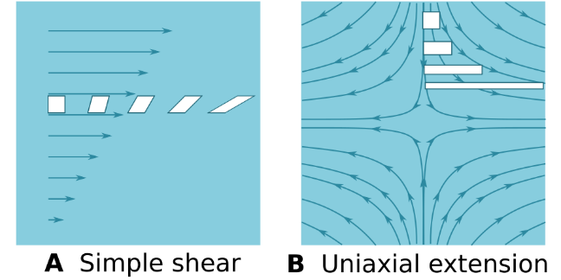
Figure 20. Basic velocity fields and deformation of an initially cubic fluid element as it moves along with the flow
(A) Simple shear (B) Uniaxial extension.

Simple shear is a flow pattern where the velocity of the fluid varies in a direction perpendicular to the direction of the flow. An infinitesimal element of fluid, represented by a white block within Figure 20A, is increasingly sheared as it is conveyed by the flow. The amplitude of velocity gradient is the shear rate, γ̇, and the associated shear stress is denoted as τ. When τ is proportional to γ̇, the fluid is described as Newtonian, and the proportionality coefficient is the shear viscosity, η , (or just viscosity in this review):

τ = ηγ̇ (Eqn. 1)

The uniaxial extension flow, or elongation flow, is an axisymmetric flow, which has a constant velocity gradient along the extension axis. This characteristic strain rate is denoted as ε̇. As represented in Figure 20B, a fluid element is elongated but not sheared as it is convected. The stress is denoted as σ₁₁ along the extension axis and as σ₂₂ along any radial axis. The extensional viscosity, η_{E}, is defined by:

σ₁₁ − σ₂₂ = η_{E} ε̇ (Eqn. 2)
For Newtonian fluids, η_{E} = 3η . However, fluids used in manufacturing, for example polymeric liquids, often exhibit a larger ratio of η_{E} /η. The difference σ₁₁ − σ₂₂ is called the net tensile stress, but suffers from the fact that it is strictly defined only for a uniaxial, axisymmetric elongation. The flow patterns experienced in the mechanochemistry literature noted earlier are a combination of shear and elongation, and are mostly not axisymmetric. This makes it important that for each new molecule, we consider very carefully the role of the techniques used to drive mechanical activation and its influence over the final reaction.

To further demonstrate the role of fundamental physical parameters in mechanochemical activation such as the strain rate, the viscosity of the fluid, the molecular weight and the concentration it is necessary to introduce a simple molecular model, based on the review findings, that provides a global view of current understandings.

A Simple Coarse-Grained Molecular Model
Models of internal tension and chain scission have been reported from the very beginning of the field.^{70–72} There has been recent advances in the modelling and simulation of mechanochemistry via quantum chemistry and molecular dynamics.^{73, 74} These methods have given valuable insights on how the bonds break, what energy is involved and how small molecules respond to stretching. However, modelling high molecular weight molecules still requires coarse-grained approaches. In coarse-grained molecular models, the solvent can be treated as a continuous medium and macromolecules are chains or deformable bodies subject to Brownian motion and fluid friction with the solvent. The internal tension can be computed, either analytically in simple circumstances or by computer simulations, and is compared to the force required to break a covalent bond, usually of the order of several nanoNewtons. The tension, F, in a straight molecule of length, L, aligned in an extensional flow of strain rate, ε̇, can be written as:

F = α ε̇ L² (Eqn. 3)
where α is a coefficient that varies according to models. In slender body theory, α depends only weakly on L and is proportional to the solvent viscosity η_{s}:

$α=\frac{π}{4ln⁡(L/d)}η_{s}$ (Eqn. 4)
where d is the effective diameter of the chain.⁷⁵ In the case of the free-draining bead-rod model, α depends on the friction coefficient, ζ , of the bead and the rod length, b.⁷⁶

$α=\frac{ζ }{8b}$ (Eqn. 5)
The friction coefficient quantifies how much stress the fluid can transfer to the molecule, and vice versa. It is related to the solvent properties by:

$ζ=\frac{36M [η]η_{s} }{N_{A} L^{2}}$ (Eqn. 6)
with M the molecular weight, [η] the intrinsic viscosity, η_{s} the solvent viscosity, N_{A} Avogadros number and L the length of the stretched molecule.

In both cases, the maximum force is found to be proportional to the solvent viscosity. In addition, the contour length of the molecule is proportional to its molecular weight, so that we can write:
F = β η_{s}ε̇M² (Eqn. 7)
with β a coefficient in m²/Da². The product η_{s} × ε̇ gives a viscous stress, but it should not be confused with the extensional stress, as it involves the shear viscosity of the fluid, nor should it be confused with the shear stress, as we take the extensional strain rate. For clarity from this point on, we shall call this quantity the coupling stress, σ :

σ = η_{s}ε̇ (Eqn. 8)
In the light of this simple model, it is possible to review and interpret the results from experimental reports.

The Role of Elongation in Studies of Mechanochemistry
In an effort to bridge polymer damage with recent applications of mechanochemistry, May and Moore¹⁰ published a comprehensive and didactic review analysing the main devices and flows that have been used to break polymers in solution on the laboratory scale.
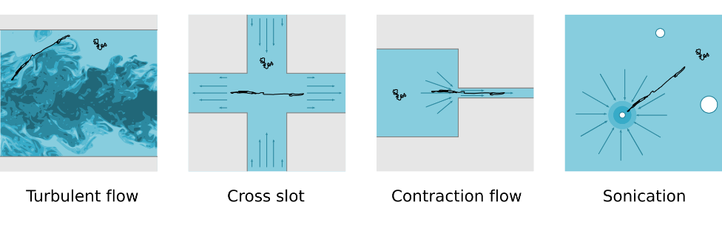
Figure 21. Types of elongational flows used to break polymer chains

May and Moore categorised the experiments into four types, represented in Figure 21: turbulent flows, opposed jets or cross slots (flows possessing a stagnation point), contraction flows and sonication. While macromolecules in solution adopt a random coil configuration at rest, they break near their centre in the majority of mechanochemical experiments. Such an accuracy, even in highly fluctuating flow fields, considering that the backbone of a high molecular weight polymer contains thousands of bonds, has been explained by the fact that they are firstly unravelled and oriented in the direction of the main extensional component of the flow. Tension can then build up along straight segments of the molecule and reach a maximum at its centre where parts of equal length are pulling the molecule in opposite directions.^{76, 77}

Whatever the source of strain, the flow must then have the ability to uncoil the molecules, a phenomenon known in the literature as the coil–stretch transition.⁷⁰ At least for dilute, unentangled solutions, the flow gradient must have an extensional rate component that is greater than the inverse of the longest relaxation time of the molecule. If this condition is not met, then Brownian motion randomly shuffles the molecule and prevents it from stretching and aligning with the flow. On the other hand, for flows of such high gradients, the uncoiling process stops when the molecule is either fully unravelled, or when the flow is switched off. The simple shear of the fluid near a wall has only a minor impact on scission dynamics, as it was demonstrated by early contraction flow experiments (solution entering a straight tube). Polymers were found to be damaged at the entrance of the capillary and not inside, as in the absence of turbulence the scission rate did not depend on the capillary length.⁷⁸ Thus, it is pertinent to focus on high extensional flow features.

The Role of Concentration in Studies of Mechanochemistry
As polymer processes involve a broad range of concentrations, from dilute for polymer additives in inks to melts in moulding techniques, it is important to review the role of concentration in flow-induced chain scission.

The molecular model presented above (Equation 7) is only relevant to isolated molecules. As the number of macromolecules per unit of volume increases, interactions between neighbouring chains become important. Interactions through solvent motion, called hydrodynamic interactions, or entanglement phenomena can no longer be ignored as we move away from the dilute regime (see Figure 22). Although the effect of concentration on scission rate has been systematically studied in polymer damage experiments, interestingly it is difficult to draw a clear trend in the outcomes.

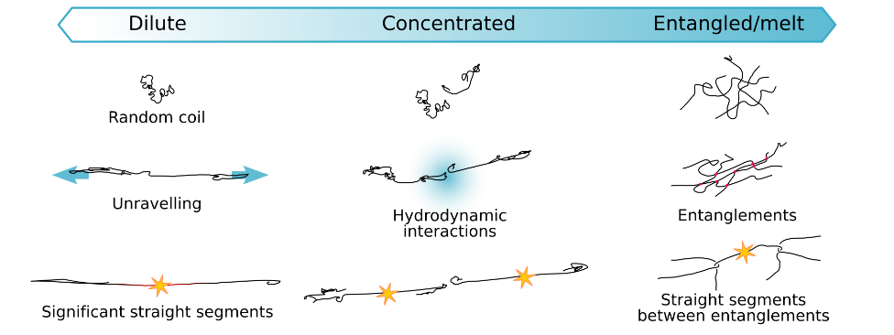
Figure 22. Effect of concentration and entanglement on the dynamics of unravelling and tension buildup.

Experiments carried out with turbulent flows⁷⁹ or sonication^{13, 80} suggest that the scission rate decreases with increasing concentration. Opposite conclusions were drawn in other experimental configurations.^{81 – 84} This discrepancy can be rationalised by the influence of polymer molecules on the flow itself through non-Newtonian effects. Because of the additional viscoelastic stress, the level of strain rate at the scale of the chains cannot be maintained with increasing concentrations in turbulent or sonication flows when using a constant power input (such as a pressure difference or a sonication power). On the other hand, entanglement or hydrodynamic effects can promote scission by increasing the apparent viscosity of the fluid, provided that the characteristic strain rate remains constant. This can be done in laminar flows with controlled flow rates, where an extra pressure input compensates the effect of increasing polymer concentration.

From the development of new mechanophores discussed above, there is a clear requirement for careful molecular design to include WB at the right location within a polymer to produce the required mechanochemical effect. Importantly, the location in the backbone of the scission event is also affected by concentration. When the molecules are strongly entangled, the broken bond is not necessarily located in centre but is randomly distributed along the chain.⁸⁵ These are the key effects of changing concentration, which links closely to the role of viscosity.

The Role of Viscosity in Studies of Mechanochemistry
Traditionally, flows used for mechanochemical activation have been categorised according to their range of strain rates.¹⁰ This is natural when comparing experiments involving fluids of similar viscosities. In addition, laboratory scale or manufacturing processes are generally characterised by a yield rate as a volume or mass per unit of time. For example, an extrusion process is run at a certain exit velocity. From this flow rate and knowing the dimensions of the socket, velocity gradients can be assessed. However, when comparing processes involving fluids with different viscosities, strain rates alone are unlikely to provide the relevant mechanical parameter.

Looking again at the molecular model of Equation 7, the tension in the polymer chain should be proportional to the shear viscosity of the surrounding solvent. The picture, holding for dilute solutions, can be reasonably extended, at least qualitatively, to semi-dilute regimes or unentangled melts, provided that the viscosity taken into account is not that of the solvent alone but the macroscopic viscosity. On the other hand, what occurs in the entangled regime has been studied by Bueche.⁸⁶ The accurate scaling of the tension regarding the molecular length is profoundly different as the main quantity switches to the average chain length between entanglement. However, the maximum tension is still proportional to the product of the segmental friction coefficient and the tensile strain rate, in the same manner as in Equation 7. This discussion suggests that it is reasonable to compare polymer processes with different viscosities according to the maximum coupling stress (η_{s} × ε̇) they produce, and not only based on the strain rate. As a matter of fact, some groups chose to report scission experiments according to the wall shear stress.^{78, 81, 87}

A proportional relation between the force on the molecule backbone and the solvent viscosity also implies that the critical strain rate for the onset of bond scission should scale as η_{s}⁻¹, all other parameters being kept constant. This property has been challenged by experiments by Nguyen et al., ⁸⁸ where they demonstrated a η_{s}^{−0.25} scaling across two orders of magnitudes of solvent viscosities but this contradiction was reconciliated by taking into account the turbulent nature of the flows and rescaling the microscopic strain rate accordingly.⁸⁹ Then the simple linear relationship of Equation 7 is still valid provided that the strain rates within the flow are known accurately. We have begun to address this with the development of a mechanochemistry model coupled with fluid dynamics simulation software.⁹⁰ Closely linked to the polymer concentration and influence on viscosity, is the important parameter of molecular weight.

The Role of Molecular Weight in Studies of Mechanochemistry
Molecular weight is the final parameter that scientists and engineers usually have to tune in macromolecular processing. For polymer rupture, the traditional view is that the critical strain rate is inversely proportional to molecular weight for fast transient flows, such as an abrupt contraction, where the polymer chains are initially in a coil state.⁸⁸ In that situation, the breaking point should be widely distributed along the backbone. On the other hand, for chains breaking in half, such as in turbulent flows (regardless of geometry)⁸⁹ or in a cross-slot or opposite jets devices,⁵⁵ the critical tension depends quadratically on the molecular weight, as in the molecular model presented in Equation 7. As a general consequence, the longer a molecule, the easier it is to break under similar flow conditions. However, it should be noted that, as in our discussion on the effect of concentration, the longer a molecule, the larger is its influence on the non-Newtonian effects of the flow itself. It is clear to see the difficulty in studying individually parameters such as strain rate, the viscosity of the fluid and the molecular weight and concentration of the polymer, because of their strong coupling with the properties of the flow field for elongation or turbulence. Nevertheless, global trends emerge. The scission is promoted by higher strain rates, higher fluid viscosity and higher molecular weights. For solutions, a higher concentration helps if the kinematics of the flow is preserved, otherwise it dampens the rupture dynamics.

This all highlights that for mechanochemistry researchers, it is important to understand the key physical parameters that underpin the transduction of forces during material flow. Coupled with the detailed configuration of reported experiments, this allows benchmarking and comparison across reported mechanochemcial studies. It is also vital to consider the required concentration and molecular weights for a targeted application to ensure a relevant molecular design. With this in mind, it is important to understand the large-scale processes involved in the proposed applications to identify those as useful for the most recent advances in mechanochemistry. It is important to understand these processes both to know how to protect force sensitive moieties to ensure they survive processing but also for the very exciting possibility of using the shear and strain involved in these processes to promote mechanochemical reactions in situ.

SELECTED LARGE-SCALE PROCESSES AND THEIR RELEVANCE TO MECHANOCHEMISTRY
It is important for the field to consider the pathway to large-scale implementation and what forces are currently imparted to polymers during manufacturing. There already exist processes where mechanical chain scission is an important element. Several groups have studied the possibility of using chain scission in a polymer process, for example Buchholz et al.⁹¹ proposed the use of a contraction flow type device to narrow the molecular mass distribution of a polymer solution. In more advanced processing applications, DNA sequencing technologies have also made use of mechanical chain scission. High throughput processes are based on cutting multiple copies of a DNA strand into fragments that are small enough to be sequenced, allowing virtual reconstruction.⁹² Methods to produce DNA fragments include delivering hydrodynamical forces produced by a contraction flow⁹³ or sonication.⁹⁴

However, from this review, we identify that flows likely to trigger mechanochemistry are found in several widespread manufacturing polymer processes. We present here a brief review of the characteristic features of these processes. There are many variants in each family of process and describing them all thoroughly is beyond the scope of this review. The aim of this review is instead to show how, from general considerations, these manufacturing processes could be relevant to recent advances in mechanochemistry.

Dilute and concentrated solution processes – Inkjet printing
Inkjet was developed first as a digital printing technique, but is now employed over a wide range of manufacturing applications.⁹⁵ It can be viewed as a tool for delivering picoliter and nanoliter volumes of ink to very accurate locations on a substrate. As presented in Figure 23A, there are two main approaches, namely continuous inkjet (CIJ) and drop-on-demand (DOD).
In continuous inkjet, a steady overpressure (often with a small amplitude high frequency modulation) is applied in the ink supply and a jet is formed at the exit of a nozzle. Because of surface tension, the jet breaks up after travelling some distance and forms a continuous stream of droplets. Some droplets are selected to hit the substrate, the others are collected and recycled. In a drop-on-demand system, some fluid is ejected in a controlled manner from the ink chamber by a sudden change in pressure and rounds up to form a droplet. The use of macromolecules in inks has been introduced not only to better control the jet break-up and droplet formation, but also to deliver a function to the final products, such as printed electronics and sensors.⁹⁶

Both continuous and drop-on-demand inkjet can be linked to polymer scission experiments, due to a contraction flow through the nozzle. In DOD, there is also a purely extensional flow in the filament when a drop is formed. Small nozzle diameters are typically in the range of 20 µm to 60 µm, and the velocity of the droplet is of the order of 10 m/s. A crude approximation of the characteristic shear rate γ̇ which can be derived from an established Poiseuille flow:

$γ̇ \sim \frac{8V }{D}$ (Eqn. 8)

with V the outlet velocity and D the nozzle diameter. The extensional component of the velocity gradient (ε̇ in previous sections) is typically one order of magnitude lower than this estimate. Taking a velocity of 10 m/s and a diameter of 20 µm, we find γ̇∼4×10⁶ s⁻¹.

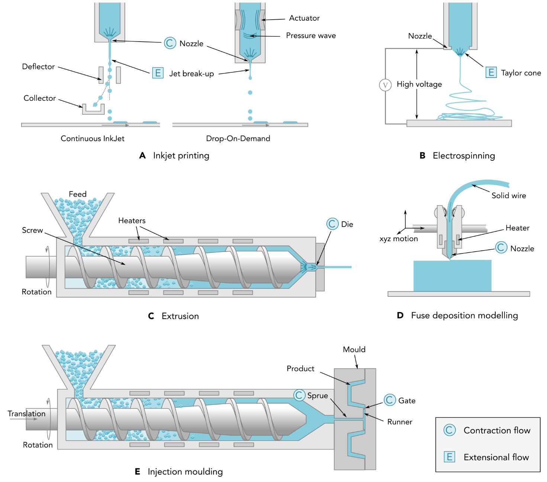
Figure 23. Manufacturing processes where mechanochemistry could be developed

The range of shear rates in inkjet, and in particular in DOD has been discussed in detail.⁹⁷ The maximum magnitude has been confirmed to be around 10⁶ s⁻¹. It occurs as a mix of shear and elongation at the nozzle when a droplet is fired. The purely extensional flow of the ligament produces a lower strain rate of 10⁴ s⁻¹. For a typical solvent viscosity of η_{s}∼10⁻² Pa⋅s, this yields a coupling stress of 10⁴ Pa.

There is recent evidence of polymer scission in inkjet processes. A-Alamry et al.⁹⁸ reported the degradation of PMMA and PS during a DOD print. Molecular weights between 10⁵ Da and 10⁶ Da led to chain scission. McIlroy et al. further analysed this result and showed that the polymer could break only in the nozzle and not in the filament where the extensional rate is too low.⁹⁷ Finally, Wheeler et al. compared CIJ and DOD in terms of polymer degradation.⁹⁹ They concluded that, even though CIJ displayed the same strain rate magnitude, degradation occurred in the recirculation system of the ink and not in the nozzle. With its digital and versatile nature, a growing interest from industries, and direct evidence of polymer scission events, inkjet appears a key technology to deliver patterned mechanochemistry at an industrial scale.

Dilute and concentrated solution processes – Electrospinning
Submicrometer fibres can be drawn from concentrated polymer solutions or melts with electrospinning technology. In this process, a large voltage (several kV) is applied between the outlet of a fluid supply and a substrate (see Figure 23B). Electrostatic forces pull the fluid meniscus towards the substrate and drive a thin fluid jet at its apex, a situation described as the Taylor cone. As it is spun, the fluid dries or solidifies to form a fibre. Electrospinning is characterised by a high extensional flow of up to 10⁴ s⁻¹ in the Taylor cone as the fibre is pulled.¹⁰⁰ The viscosity of the fluids ranges from 0.1 Pa⋅s to 100 Pa⋅s for melts, which leads to a theoretical maximum coupling stress of 10⁶ Pa.

Zhou et al. have studied the electrospinning of polylactic acid (PLA) melts, with a particular emphasis on polymer degradation.¹⁰¹ The experiments were conducted with samples of high molecular weight 186 kDa and high polydispersity. This was found to drive a threefold reduction of the molecular weight within the spun fibres. The authors attributed this degradation both to thermal and mechanical scission, although no additional study was carried out to discriminate between the two causes. A smaller nozzle diameter leading to slightly more scission events suggested a mechanical origin. On the other hand, the overall degradation rate strongly depended on the residence time of the melt in the hot reservoir at 200°C, showing a thermal origin of the chains shortening. A similar degradation was later observed by Li et al. when spinning poly(ϵ-caprolactone) (PCL) of initial molecular weight of 79 kDa.¹⁰² However they correlated this degradation to the heating power of the CO₂ laser used to melt the polymer. In other work, Ramirez et al. used electrospinning to produce a mechanochemical material, but the reaction was triggered at a later stage in a tensile stress test instrument, and not during the spinning process itself.¹⁰³ While the accessible range of strain rate and stress undeniably shows this industrially scalable technique is a candidate for mechanochemical activation, to our knowledge there have been no published systematic studies into mechanical chain scission during electrospinning.

Polymer melt processes – Extrusion
Extrusion is a technique to form slender polymer parts by pushing a melt through a die that shapes the cross section of the product (Figure 23C). A screw (or two screws for twin screw extruders) is used to convey solid polymer pellets from a feed supply through a melting zone and finally to push the melt through the die. Extrusion is usually characterised by a very high throughput, of the order of several tons per hour. Extrusion has the feature of a contraction flow, particularly when the dimensions of the die are small. Shear rates of 10³ s⁻¹, so tensile strain rates of 10² s⁻¹, can be present.¹⁰⁴ The shear viscosity at these levels of shear rate, and at extrusion temperature, can vary between 100 Pa.s and 1000 Pa.s. A coupling stress of 10⁵ Pa could theoretically be achieved in this process.

Throughout this review, extrusion has been highlighted as a technique to bring about activation of mechanophores or self-strengthening of materials.^{7, 51, 52} However, long before this process was used for research in mechanochemistry, thermal and chemical degradation of polymers during extrusion has been a well-established phenomenon, which has led to industrial applications known as reactive extrusions.¹⁰⁵ A mechanical origin of chain scission has been discussed by Ying et al. extruding high molecular weight polypropylene (PP).¹⁰⁶ Gonzalez-Gonzalez et al. also studied mechanical degradation of PP and showed a mid-chain scission behaviour as clear evidence of shear-induced breakage.¹⁰⁷ It is clear that the high values of stresses and broad usage of extrusion make it appealing for more developments and also scale-up in mechanochemistry.

Polymer melt processes – 3D printing by fused deposition modelling
3D printing by dispensing a molten polymer thread can be considered as a variant of the common extrusion technology described above. The main difference is that the shape of the final product is not governed by the form of a die, but by programming the displacement of the nozzle in space to produce a layer-by-layer product (Figure 23D). As a popular and commercially successful digital manufacturing and prototyping technique, it requires special attention here. A solid polymer filament is pushed through a nozzle while being melted at the same time. The exit diameter of the nozzle is typically 400 µm, but can be as small as 100 µm. As 3D printing is an additive manufacturing technique, the flow rate is adjusted according to the travelling speed of the print head and the thickness of a layer in order to deliver the right volume of material. Decreasing the nozzle diameter would not necessarily mean increasing the shear rates, because a smaller nozzle usually requires slower movements of the system, and thus a reduced flow rate. Shear rates can be up to 10³ s⁻¹, leading to elongation rates of the order of 10² s⁻¹.¹⁰⁸ The viscosity is on the order of 10² Pa⋅s, so that a coupling stress of 10⁴ Pa can be attained.

As mentioned previously, Peterson et al.²³ used 3D printing to manufacture mechanochemical devices from spiropyran-PCL/PCL blends. The molecular weights of the mechanochemical sensors were approximately 90 kDa. However, as in the case of electrospinning, the mechanochemical reaction was not activated during the printing process but in the subsequent tensile test. However, due to the reasonably high stresses involved in the 3D printing process, it is clearly necessary to study the effect of increasing the molecular weight of the sensor molecules and how this might affect mechanical activation of the mechanophore.

Polymer melt processes – Injection moulding
Injection moulding is a high throughput process for forming parts from a mould (Figure 23E). First a melt is produced in a screw system similar to what we described above for extrusion. Then the melt is pushed under high pressure into a mould where it solidifies. Finally the part is ejected from the mould and the process can be repeated. The molten polymer exits the melting zone through a contraction flow (nozzle) and enters the mould by a channel called the sprue. Then the material is divided and conveyed to the cavities of the final products through smaller channels called runners. Another contraction called the gate separates the cavity from the runner. The gate is usually of small dimensions as it is the place where the final part has to detach from the runners. A high shear rate flow of the order of 10⁴ s⁻¹ can occur at this location.¹⁰⁴ At process temperatures and at this level of shear rate, the viscosity is up to 100 Pa.s, producing a coupling stress of 10⁵ Pa.

Rex et al. analysed the damage of 75 kDa polyethylene (PE) throughout the injection moulding process, but concluded that the scission was mainly thermal in origin.¹⁰⁹ Although injection moulding seems very similar to extrusion, little can be found in the literature on mechanical polymer scission and so it is an area where additional research will be key both for protection from and promotion of mechanochemical reactions.

Summary
Following examination of the possible extensional strain rates and coupling viscous stresses in the above polymer processing techniques, the question remains, what polymers are suitable for these levels of stress? Of course, the answer depends primarily on the type of mechanochemistry one needs to achieve. For example, regarding the rupture of linear polymer chains, we can compare the maximum coupling stress of each process to the experimental scaling law reported by Odell and Keller for PS in toluene. ⁷² The result is plotted in Figure 24 alongside coupling stresses expected from testing methods. For force spectroscopy, the stress is assumed to be as high as necessary to break the polymer chain, as all of the macroscopic stress passes through the molecule. The boundary between broken and intact chains is only indicative as the critical stress was measured for a dilute solution, and in a particular flow pattern, however, it gives an order of magnitude of what range of molecular weights is worth exploring. Unfortunately, experimental data is scarce, particularly for uncommon polymers or solvents, and we are not aware of any general predictive theory. A starting point could be the coarse-grained molecular model of the stretched chain (Equation 7) and the segmental friction coefficient (Equation 6) that can be assessed from abundant tabulated data.¹¹⁰

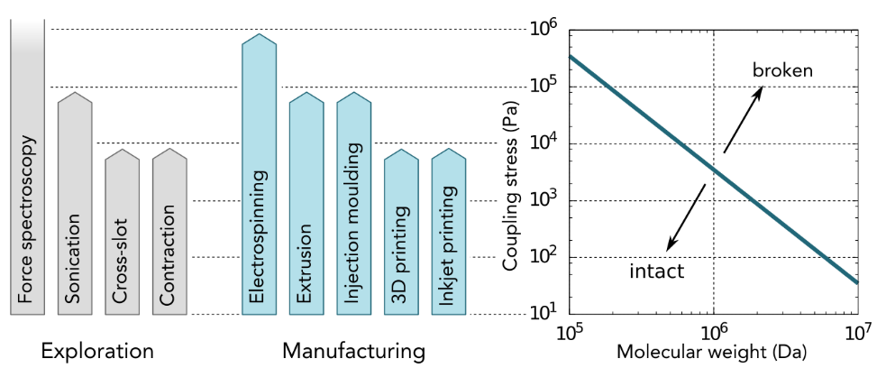
Figure 24. Orders of magnitude of maximum achievable coupling stress in various lab-based exploration techniques and polymer manufacturing processes and critical coupling stress needed to break PS in toluene as a function of molecular weight.⁵⁵

Returning to Figure 24, it is shown that the molecular weights prone to scission are high, and if used in the form of pure melts they would produce entangled fluids for which data is lacking. One way to circumvent this limitation would be to blend high molecular weight molecules at a dilute ratio in a matrix of the same species of low (unentangled) molecular weight.⁵⁹ For example, the transition to entanglement regime for PS melts is around 33 kDa.¹¹¹ A 1 MDa PS molecule diluted in a few kDa PS melt is expected to behave like a viscous version of the same 1 MDa PS in organic solvents, but the blend would be processable by fused deposition modelling or other thermoforming techniques. It should be noted however that additional care is required while designing mechanochemical compounds for polymer melt processes, since their operating temperature can be high enough to activate thermally sensitive mechanophores.

Another point of importance is the time scales over which the maximum force is applied to molecules. For the manufacturing processes explored in this section, the time scale is inversely proportional to the strain rate of interest. For example, in inkjet nozzle flow, a strain rate of 10⁶ s⁻¹ implies that the force would be applied over a few microseconds, a time scale similar to sonication. In contrast, a melt extrusion flow produced by fused deposition modelling, while yielding similar coupling stresses, applies forces on time scales of tens of milliseconds. This dramatic difference is largely due to viscosity values spanning orders of magnitude between dilute solutions and melts, and could be exploited in situations where the kinetics of the reaction play an important role.

This review has found no study directly comparing the activation of a mechanophore on the lab-scale (SMFS, sonication or solid-state activation) to that found in manufacturing processes. However, it is clear from the viscous forces discussed above and the stresses presented in Figure 24 that these lab-scale techniques are capable of predicting the possible occurrence of mechanochemistry during manufacturing. As detailed above, the processing conditions such as concentration, viscosity and molecular weight of the polymer in question, along with the time scales of strain rates applied, all play a vital role in polymer mechanochemistry. This means that the coupling stresses are unique in each scenario and currently lab scale processes are not designed to deliver a standardised quantity or percentage of mechanophore activation that can translate to specific manufacturing techniques. This is highlighted most clearly by the simulation work carried out for SMFS mechanophore activation which demonstrates the importance of coupling the appropriate mechanical force to the correct bonds within a mechanophore. Thus while lab-scale experiments are an excellent indication of activation, further studies are required before any quantitative predictions can be made during translation and scale-up.

One of the main aims of this review has been to highlight that it may be possible to use the stresses imparted during polymer processing techniques to promote particular mechanochemical reactions and that further, depending on the stresses involved, particular processes may be required for activating mechanophores of different strengths, for example the activation of gDBC during extrusion and compression but not tensile tests as mentioned above.^{52, 69} However, the converse situation can also be just as important; a greater knowledge of these processes may aid in the prevention of premature mechanophore activation, either via mechanical or thermal events. One possible solution for prevention of premature mechanical activation could be a system based on the mechanical gate proposed by the Boulatov and Craig groups which was discussed in the SMFS section of this review.³⁶ In this scenario a higher force mechanophore was used as a mechanical gate to shield the activation of a lower force mechanophore (Figure 7).

CONCLUSION
The origins of the scientific study of polymer mechanochemistry grew from an industrial interest in the degradation of rubber and other polymeric materials in flow fields and under mechanical stress. For almost 80 years mechanical forces were viewed purely as destructive processes bringing about chain scission and degradation. With the introduction of the mechanophore by the Moore group ca. 2005, mechanical stress transitioned to be considered as a productive input. This moved research away from fundamental studies of flow fields and towards the design and synthesis of new mechanically responsive moieties. This review aimed to examine some of the most recent advances in the field of polymer mechanochemistry, to describe how these transformations are driven on the lab scale and finally, by studying the forces involved in flow-fields, to draw links between mechanochemistry on the lab scale and relevant industrial-scale polymer processing techniques.

In this review it is noted that the reports on mechanophore design span a range of scales, starting with research on the activity of individual mechanophores using the technique of single molecule force spectroscopy. However while this work is vital for fundamental research and development of novel mechanophores it is not easily translated to the fluid flows experienced during processing at an industrial level. From examining the literature, it was found in this review that new mechanophore design could also be categorised into the format in which the mechanophore was processed, namely (a) dilute polymer solutions, (b) polymer melts and (c) solid materials. While each of these mechanophore designs have been beautifully demonstrated on the lab scale, this review has found that there has yet to be any focus on how these materials will translate to industry and application. Specifically, there is a clear need to standardise the approach to testing rather than using the very wide range of different laboratory setups that are challenging to correlate. This lack of standardised testing methods makes it very challenging to compare mechanophore systems across different reports and predict behaviour when materials are subjected to different forces and fluid flows. While some researchers are certainly starting to suggest potential applications for these materials there is currently no design being carried out specifically for applications or processing

To aid this work a simple, general model is provided from the literature to help researchers start to benchmark and compare results even when using different experimental activation techniques and formats of material. The effects of factors that influence the response of polymers under flow, such as solution viscosity, polymer concentration and polymer molecular weight were examined. Each of these considerations is constrained by the processing technique employed. Thus, this review is able to create a link between mechanophore design and processing by examining the forces imparted by a number of industrially relevant processing techniques and noting the requirements for the occurrence of mechanochemistry. This review will allow the first step towards mapping of newly reported chemistry and molecular design onto possible manufacturing techniques and vice versa.

From this review, effects such as scission and ring opening have clearly graduated from an issue of quality loss to productive chemistry and we suggest that by shifting some of the outlook from the moiety-focused experiments to detailed mapping of larger scale processes, that the science underpinning manufacturing flows can allow us to turn mechanochemistry into a revolutionary and scalable process.

ACKNOWLEDGMENTS
This work was supported by King Abdulaziz City for Science and Technology (KACST). We gratefully acknowledge Prof. Ian Hutchings for his valuable conversations and advice throughout preparation of this review.

AUTHOR CONTRIBUTIONS
Conceptualization, R.D.; Writing – Original draft N.W-.F and E.R.; Writing – Review & Editing N.W-.F, E.R., T.A.A. and R.D.

DECLARATION OF INTERESTS
The authors declare no competing interests.

REFERENCES AND NOTES
- IUPCA Compendium of Chemical Terminology: Gold Book. (IUPAC, 2009).
- Takacs, L. (2013) The historical development of mechanochemistry. Chem. Soc. Rev. 42, 7649-7659.
- Boldyreva, E. (2013) Mechanochemistry of inorganic and organic systems: what is similar, what is different? Chem. Soc. Rev. 42, 7719-7738.
- Faraday, M. (1820) On the decomposition of chloride of silver, by hydrogen, and by zinc. Q. Jl Sci. Lit, Arts, 8, 374-376.
- Carey Lea, M. (1892) Disruption of the silver haloid molecule by mechanical force. Philos. Mag. 34, 46-50.
- James, S.L., Adams, C.J., Blom, C. Braga, D., Collier, P., Friščič, T., Grepioni, F., Harris, K.D.M., Hyett, G., Jones, W., Krebs, A., Mack, L., Maini, L., Guy Orpen, A., Parkin, I.P., Shearouse, W.C., Steed, J.W. and Waddell, D.C. (2012) Mechanochemistry: opportunities for new and cleaner synthesis. 41, 413-447.
- Crawford, D.E. and Casaban, J. (2016) Recent Developments in Mechanochemical Materials Synthesis by Extrusion. Adv. Mater. 28, 5747-5754.
- Ivanov, E. and Suryanarayana, C. (2000) Materials and Process Design through Mechanochemical Routes. J. Mater. Synth. Process. 8, 235-244.
- Li, J., Nagamani, C. and Moore, J.S. (2015) Polymer Mechanochemistry: From Destructive to Productive. Acc. Chem. Res. 48, 2181-2190.
- May, P.A. and Moore, J.S. (2013) Polymer mechanochemistry: techniques to generate molecular force via elongation flows. Chem. Soc. Rev. 42, 7497-7506.
- Brantley, J.N., Wiggins, K.M. and Bielawski, C.W. (2013) Polymer mechanochemistry: the design and study of mechanophores. Polym. Int., 62, 2-12.
- Wiggins, K.M., Brantley, J.N. and Bielawski, C.W. (2013) Methods for activating and characterizing mechanically responsive polymers. Chem. Soc. Rev. 42, 7130-7147.
- Caruso, M.M., Davis, D.A., Shen, Q., Odom, S.A., Sottos, N.R., White, S.R., and Moore, J.S. (2009) Mechanically-Induced Chemical Changes in Polymeric Materials. Chem. Rev. 109, 5755-5798.
- Akbulatov, S. and Boulatov, R. (2017) Experimental Polymer Mechanochemistry and its Interpretational Frameworks. Chem. Phys. Chem. 18, 1422-1450.
- Staudinger, H. and Bondy, H.F. (1930) Über Isopren und Kautschuk, 19. Mitteil.: Über die Molekülgröße des Kautschuks und der Balata. Berichte Dtsch. Chem. Ges. B Ser. 63, 734-736.
- Staudinger, H. and Heuer, W. (1934) Über hochpolymere Verbindungen, 93. Mitteil.: Über das Zerreißen der Faden-Moleküle des Poly-styrols. Berichte Dtsch. Chem. Ges. B Ser. 67, 1159-1164.
- Staudinger, H. and Leupold, E.O. (1930) Über Isopren und Kautschuk, 18. Mitteil.: Viscositäts-Untersuchungen an Balata. Berichte Dtsch. Chem. Ges. B Ser. 63, 730-733.
- Kauzmann, W. and Eyring, H. (1940) The Viscous Flow of Large Molecules. J. Am. Chem. Soc. 62, 3113-3125.
- Tabata, M., Miyazawa, T., Kobayashi, O. and Sohma, J. (1980) Direct Evidence of Main-Chain Scissions Induced by Ultrasonic Irradiation of Benzene Solutions of Polymers. Chem. Phys. Lett. 73, 178-180.
- Encina, M., Lissi, E., Sarasúa, M., Gargallo, L. and Radic, D. (1980) Ultrasonic Degradation of Polyvinylpyrolidone: Effect of Peroxide Linkages. J. Polym. Sci. Polym. Lett. Ed. 18, 757-760.
- Berkowski, K.L., Potisek, S.L., Hickenboth, C.R. and Moore, J.S. (2005) Ultrasound-Induced Site-Specific Cleavage of Azo-Functionalized Poly(ethylene glycol). Macromolecules. 38, 8975-8978.
- Hickenboth, C.R., Moore, J.S., White, S.R., Sottos, N.R., Baudry, J. and Wilson, S.R. (2007) Biasing reaction pathways with mechanical force. Nature 446, 423-427.
- Peterson, G.I., Yortoglu, M., Larsen, M.B., Craig, S.L., Ganter, M.A., Sorti, D.W. and Boydston, A.J. (2015) Additive manufacturing of mechanochromic polycaprolactone on entry-level systems. Rapid Prototyp. J. 21, 520-527.
- Piermattei, A., Karthikeyan, S. and Sijbesma, R.P. (2009) Activating catalysts with mechanical force. Nat. Chem. 1, 113-137.
- Beyer, M.K. and Clausen-Schaumann, H. (2005) Mechanochemistry: The Mechanical Activation of Covalent Bonds. Chem. Rev. 105, 2921-2948.
- Lavalle, P. Boulmedais, F., Schaaf, P. and Jierry, L. (2016) Soft-Mechanochemistry: Mechanochemistry Inspired by Nature. Langmuir, 32, 7265-7276.
- Boulatov, R. (2013) Mechanochemistry: Demonstrated Leverage. Nat. Chem. 5, 84-86.
- Wang, J., Kouznetsova, T.B., Niu, Z., Ong, M.T., Klukovich, H.M., Rheingold, A.L., Martínez, T.J. and Craig, S.L. (2015) Inducing and quantifying forbidden reactivity with single-molecule polymer mechanochemistry. Nat. Chem. 7, 323-327.
- Lenhardt, J.M., Ramirez, A.L.B., Lee, B., Kouznetsova, T.B. and Craig, S.L. (2015) Mechanistic Insights into the Sonochemical Activation of Multimechanophore Cyclopropanated Polybutadiene Polymers. Macromolecules. 48, 6396-6403.
- Wang, J., Kouznetsova, T.B., Kean, Z.S., Fan, L., Mar, B.D., Martínez, T.J. and Craig, S.L. (2014) A Remote Stereochemical Lever Arm Effect in Polymer Mechanochemistry. J. Am. Chem. Soc. 136, 15162-15165.
- Klukovich, H.M., Kouznetsova, T.B., Kean, Z.S., Lenhardt, J.M. and Craig, S.L. (2013) A Backbone Lever-Arm Effect Enhances Polymer Mechanochemistry. Nat. Chem. 5, 110-114.
- Gossweiler, G.R., Kouznetsova, T.B. and Craig, S.L. (2015) Force-Rate Characterization of Two Spiropyran-Based Molecular Force Probes. J. Am. Chem. Soc. 137, 6148-6151.
- Wang, J., Kouznetsova, T.B. and Craig, S.L. (2015) Reactivity and Mechanism of a Mechanically Activated anti-Woodward-Hoffmann-DePuy Reaction. J. Am. Chem. Soc. 137, 11554-11557.
- Wang, J., Kouznetsova, T.B., Niu, Z., Rheingold, A.L. and Craig, S.L. (2015) Accelerating a Mechanically Driven anti-Woodward-Hoffmann Ring Opening with a Polymer Lever Arm Effect. J. Org. Chem. 80, 11895-11898.
- Pill, M.F., Holz, K., Preußke, N., Berger, F., Clausen-Schaumann, H., Lüning, U. and Beyer, M.K. (2016) Mechanochemical Cycloreversion of Cyclobutane Observed at the Single Molecule Level. Chem. Eur. J. 22, 12034-12039.
- Wang, J., Kouznetsova, T.B., Boulatov, R. and Craig, S.L. (2016) Mechanical Gating of a Mechanochemical Reaction Cascade. Nat. Commun. 7, 13433.
- Zhang, H., Li, X., Lin, Y., Gao, F., Tang, Z., Su, P., Zhang, W., Xu, Y., Weng, W. and Boulatov, R. (2017) Multi-Modal Mechanophores Based on Cinnamate Dimers. Nat. Commun. 8, 1147.
- Akbulatov, S., Tian, Y. and Boulatov, R. (2012) Force-Reactivity Property of a Single Monomer is Sufficient to Predict the Micromechanical Behavior of its Polymer. J. Am. Chem. Soc., 134, 7620-7623.
- Akbulatov, S., Tian, Y., Huang, Z., Kucharski, T.J., Yang, Q.-Z. and Boulatov, R. (2017) Experimentally realized Mechanochemistry Distinct from Force-Accelerated Scission of Loaded Bonds. Science, 357, 299-303.
- Kean, Z.S., Gossweiler, G.R., Kouznetsova, T.B., Hewage, G.B. and Craig, S.L. (2015) A coumarin dimer probe of mechanochemical scission efficiency in the sonochemical activation of chain-centered mechanophore polymers. Chem. Commun. 51, 9157-9160.
- Lee, B., Niu, Z., Wang, J., Slebodnick, C. and Craig, S.L. (2015) Relative Mechanical Strengths of Weak Bonds in Sonochemical Polymer Mechanochemistry. J. Am. Chem. Soc. 137, 10826-10832.
- Stevenson, R. and De Bo, G. (2017) Controlling Reactivity by Geometry in Retro-Diels-Alder Reactions under Tension. J. Am. Chem. Soc., 139, 16768-16771.
- May, P.A., Munaretto, N.F., Hamoy, M.B., Robb, M.J. and Moore, J.S. (2016) Is Molecular Weight or Degree of Polymerization a Better Descriptor of Ultrasound-Induced Mechanochemical Transduction? ACS Macro Lett. 5, 177-180.
- Schaefer, M., Icli, B., Weder, C., Lattuada, M., Kilbinger, A.F.M. and Simon, Y.C. (2016) The Role of Mass and Length in the Sonochemistry of Polymers. Macromolecules. 49, 1630-1636.
- Clough, J.M., Balan, A., van Daal, T.L. and Sijbesma, R.P. (2016) Probing Force with Mechanobase-Induced Chemiluminescence. Angew. Chem. Int. Ed. 55, 1445-1449.
- Nagamani, C., Liu, H. and Moore, J.S. (2016) Mechanogeneration of Acid from Oxime Sulfonates. J. Am. Chem. Soc. 138, 2540-2543.
- Diesendruck, C.E., Steinberg, B.D., Sugai, N., Silberstein, M.N., Sottos, N.R., White, S.R., Braun, P.V. and Moore, J.S. (2012) Proton-Coupled Mechanochemical Transduction: A Mechanogenerated Acid. J. Am. Chem. Soc. 134, 12446-12449.
- Li, J., Shiraki, T., Hu, B., Wright, R.A.E., Zhao, B. and Moore, J.S. (2014) Mechanophore Activation at Heterointerfaces. J. Am. Chem. Soc. 136, 15925-15928.
- Larsen, M.B and Boydston, A.J. (2013) “Flex-Activated” Mechanophores: Using Polymer Mechanochemistry to Direct Bond Bending Activation. J. Am. Chem. Soc. 135, 8189-8192.
- Li, J., Hu, B., Yang, K., Zhao, B. and Moore, J.S. (2016) Effect of Polymer Grafting Density on Mechanophore Activation at Heterointerfaces. ACS Macro Lett. 5, 819-822.
- Black, A.L., Orlicki, J.A. and Craig, S. L. (2011) Mechanochemically triggered bond formation in solid-state polymers. J. Mater. Chem. 21, 8460–8465.
- Ramirez, A.L.B., Kean, Z.S., Orlicki, J.A., Champhekar, M., Elsakr, S.M., Krause, W.E. and Craig, S.L. (2013) Mechanochemical strengthening of a synthetic polymer in response to typically destructive shear forces. Nat. Chem. 5, 757–761.
- Imato, K., Irie, A., Kosuge, T., Ohishi, T., Nishihara, M., Takahara, A. and Otsuka, H. (2015) Mechanophores with a Reversible Radical System and Freezing-Induced Mechanochemistry in Polymer Solutions and Gels. Angew. Chem. Int. Ed. 54, 6168-6172.
- Davis, D.A., Hamilton, A., Yang, J., Cremar, L.D., van Gough, D. Potisek, S.L., Ong, M.T., Braun, P.V., Martínez, T.J., White, S.R., Moore, J.S. and Sottos, N. R.(2009) Force-induced activation of covalent bonds in mechanoresponsive polymeric materials. Nature. 459, 68–72.
- Lee, C.K., Diesendruck, C.E., Lu, E., Pickett, A.N., May, P., Moore, J.S. and Braun, P.V. (2014) Solvent Swelling Activation of a Mechanophore in a Polymer Network. Macromolecules, 47, 2690-2694.
- Robb, M.J., Kim, T.A., Halmes, A.J., White, S.R., Sottos, N.R. and Moore, J.S. (2016) Regioisomer-Specific Mechanochromism of Naphthopyran in Polymeric Materials. J. Am. Chem. Soc. 138, 12328–12331.
- Jacobs, M. J., Schneider, G. and Blank, K. G. (2016) Mechanical Reversibility of Strain-Promoted Azide–Alkyne Cycloaddition Reactions. Angew. Chem. Int. Ed. 55, 2899–2902.
- Gossweiler, G.R., Brown, C.L., Hewage, G.B, Sapiro-Gheiler, E., Trautman, W.J., Welshofer, G.W. and Craig, S.L. (2015) Mechanochemically Active Soft Robots, ACS Appl. Mater. Interfaces. 7, 22431-22435.
- Göstl, R. and Sijbesma, R.P. (2015) π-extended anthracenes as sensitive probes for mechanical stress. Chem. Sci. 7, 370–375.
- Ishizuki, K., Oka, H., Aoki, D., Goseki, R. and Otsuka, H. (2018) Mechanochromic Polymers that Turn Green upon the Dissociation of Diarylbibenzothiophenonyl: The Missing Piece toward Rainbow Mechanochromism. Chem. Eur. J. 24, 3170-3173.
- Ishizuki, K., Aoki, D., Goseki, R. and Otsuka, H. (2018) Multicolor Mechanochromic Polymer Blends that can discriminate between Stretching and Grinding. ACS Macro Lett. 7, 556-560.
- Oka, H., Imato, K., Sato, T., Ohishi, T., Goskei, R. and Otsuka, H. (2016) Enhancing Mechanochemical Activation in the Bulk State by Designing Polymer Architectures. ACS Macro Lett. 5, 1124-1127.
- Church, D.C., Peterson, G.I. and Boydston, A.J. (2014) Comparison of Mechanochemical Chain Scission Rates for Linear versus Three-Arm Star Polymers in Strong Acoustic Fields. ACS Macro Lett. 3, 648-651.
- Rooze, J., Groote, R., Jakobs, R.T.M., Sijbesma, R.P., van Iersel, M.M., Rebrov, E.V, Schouten, J.C. and Keurentjes, J.T.F. (2011) Mechanism of Ultrasound Scission of a Silver–Carbene Coordination Polymer. J. Phys. Chem. B 115, 11038–11043.
- Karthikeyan, S., Potisek, S.L., Piermattei, A. and Sijbesma, R.P. (2008) Highly Efficient Mechanochemical Scission of Silver-Carbene Coordination Polymers. J. Am. Chem. Soc. 130, 14968–14969.
- Paulusse, J.M.J. and Sijbesma, R.P. (2004) Reversible Mechanochemistry of a Pd^{II} Coordination Polymer. Angew. Chem. Int. Ed. 43, 4460–4462.
- Michael, P. and Binder, W.H. (2015) A Mechanochemically Triggered ‘Click’ catalyst. Angew. Chem. Int. Ed. 54, 13918-13922.
- Kean, Z.S., Hawk, J.L., Lin. S., Zhao, X., Sijbesma, R.P. and Craig, S.L. (2014) Increasing the Maximum Achievable Strain of a Covalent Polymer Gel Through the Addition of Mechanically Invisible Cross-Links. Adv. Mater. 26, 6013–6018.
- Lenhardt, J.M., Black, A.L., Beiermann, B.A., Steinberg, B.D., Rahman, F., Samborski, T., Elsakr, J. Moore, J.S., Sottos, N.R. and Craig, S.L. (2011) Characterizing the mechanochemically active domains in gem-dihalocyclopropanated polybutadiene under compression and tension. J. Mater. Chem. 21, 8454–8459.
- De Gennes, P.G. (1974) Coil–stretch transition of dilute flexible polymers under ultrahigh velocity gradients. J. Chem. Phys. 60, 5030-5042.
- Hinch E.J. (1977) Mechanical models of dilute polymer solutions in strong flows. Phys. Fluids. 20, S22–S30.
- Odell, J.A. and Keller, A. (1986) Flow-induced chain fracture of isolated linear macromolecules in solution. J. Poly. Sci. B. 24, 1889-1916.
- Stauch, T. and Dreuw, A. (2016) Advances in Quantum Mechanochemistry: Electronic Structure Methods and Force Analysis. Chem. Rev. 116, 14137-14180.
- Ribas-Arino, J. and Marx, D. (2012) Covalent Mechanochemistry: Theoretical Concepts and Computational Tools with Applications to Molecular Nanomechanics. Chem. Rev. 112, 5412-5487.
- Hsieh, C.-C., Li, L. and Larson, R.G. (2003) Modeling hydrodynamic interaction in Brownian dynamics: simulations of extensional flows of dilute solutions of DNA and polystyrene. J. Nonnewton. Fluid Mech. 113, 147–191.
- Sim, H.G., Khomami, B. and Sureshkumar, R. (2007) Flow-induced chain scission in dilute polymer solutions: Algorithm development and results for scission dynamics in elongational flow. J. Rheol. 51, 1223–1251.
- Horn, A.F. and Merrill, E.W. (1984) Midpoint scission of macromolecules in dilute solution in turbulent flow. Nature. 312, 140-141.
- Culter, J.D., Zakin, J.L. and Patterson, G.K. (1975) Mechanical degradation of dilute solutions of high polymers in capillary tube flow. J. Appl. Polym. Sci. 19, 3235–3240.
- Brostow, W. (1983) Drag reduction and mechanical degradation in polymer solutions in flow. Polymer, 24, 631–638.
- Price, G.J. and Smith, P.F. (1993) Ultrasonic degradation of polymer solutions—III. the effect of changing solvent and solution concentration. Eur. Polym. J. 29, 419–424.
- Muller, A.J., Odell, J.A. and Carrington, S. (1922) Degradation of semidilute polymer solutions in elongational flows. Polymer. 33, 2598–2604.
- Clay, J.D. and Koelling, K.W. (1997) Molecular degradation of concentrated polystyrene solutions in a fast transient extensional flow. Polym. Eng. Sci. 37, 789–800.
- Nghe, P., Tabeling, P. and Ajdari, A. (2010) Flow-induced polymer degradation probed by a high throughput microfluidic set-up. J. Nonnewton. Fluid Mech. 165, 313–322.
- Dupas, A., Hénaut, I., Argillier, J.-F. and Aubry, T. (2012) Mechanical Degradation Onset of Polyethylene Oxide Used as a Hydrosoluble Model Polymer for Enhanced Oil Recovery. Oil Gas Sci. Technol. Revue d’IFP Energies Nouvelles. 67, 931–940.
- Odell, J.A., Keller, A. and Miles, M.J. (1985) Assessment of molecular connectedness in semi-dilute polymer solutions by elongational flow. Polymer. 26, 1219–1226.
- Bueche, F. (1960) Mechanical degradation of high polymers. J. Appl. Polym. Sci. 4, 101–106.
- Bestul, A.B. (1957) Evidence for Mechanical Shear Degradation of High Polymers. J. Phys. Chem. 61, 418–421.
- Nguyen, T.Q. and Kausch, H.H. (1990) Effects of solvent viscosity on polystyrene degradation in transient elongational flow. Macromolecules. 23, 5137–5145.
- Vanapalli, S.A., Ceccio, S.L. and Solomon, M.J. (2006) Universal scaling for polymer chain scission in turbulence. Proc. Natl. Acad. Sci. 103, 16660-16665.
- Rognin, E., Willis-Fox, N., Aljohani, T.A. and Daly, R. (2018) A multiscale model for the rupture of linear polymers in strong flows. J. Fluid Mech. 848, 722-742.
- Buchholz, B.A., Zahn, J.M., Kenward, M., Slater, G.W. and Barron, A.E. (2004) Flow-induced chain scission as a physical route to narrowly distributed, high molar mass polymers. Polymer. 45, 1223–1234.
- Shendure, J. and Ji, H. (2008) Next-generation DNA sequencing. Nat Biotechnol. 26, 1135–1145.
- Thorstenson, Y.R., Hunicke-Smith, S.P., Oefner, P.J. and Davis, R.W. (1998) An automated hydrodynamic process for controlled, unbiased DNA shearing. Genome Res. 8, 848–855.
- Grokhovsky, S.L., Il’icheva, I.A., Nechipurenko, D.Y., Golovkin, M.V., Panchenko, L.A., Polozov, R.V. and Nechipurenko, Y.D. (2001) Sequence-Specific Ultrasonic Cleavage of DNA. Biophys. J. 100, 117–125.
- Hoath, S.D. (2016) Fundamentals of Inkjet Printing: The Science of Inkjet and Droplets (Wiley & Sons).
- de Gans, B.-J., Duineveld, P.C. and Schubert, U.S. (2004) Inkjet printing of polymers: State of the art and future developments. Adv. Mater. 16, 203–213.
- McIlroy, C., Harlen, O.G. and Morrison, N.F. (2013) Modelling the jetting of dilute polymer solutions in drop-on-demand inkjet printing. J. Nonnewton. Fluid Mech. 201, 17–28.
- A-Alamry, K., Nixon, K., Hindley, R., Odel, J.A., and Yeates, S.G. (2011) Flow-Induced Polymer Degradation During Ink-Jet Printing. Macromol. Rapid Commun. 32, 316–320.
- Wheeler, J.S.R., Reynolds, S.W., Lancaster, S., Romanguera, V.S. and Yeates, S.G. (2014) Polymer degradation during continuous ink-jet printing. Polym. Degrad. Stab. 105, 116–121.
- Agarwal, S., Burgard, M., Greiner, A. and Wendorff, J. (2016) Electrospinning: A Practical Guide to Nanofibers. (Walter de Gruyter GmbH & Co KG).
- Zhou, H., Green, T.B. and Joo, Y.L. (2006) The thermal effects on electrospinning of polylactic acid melts. Polymer. 47, 7497–7505.
- Li, X., Liu, H., Wang, J. and Li, C. (2012) Preparation and characterization of poly(e-caprolactone) nonwoven mats via melt electrospinning. Polymer. 53, 248–253.
- Ramirez, A.L.B., Schmitt, A.K., Mahanthappa, M.K. and Craig, S.L. (2014) Enhancing covalent mechanochemistry in bulk polymers using electrospun ABA triblock copolymer. Faraday Discuss. 170, 337-344.
- Vlachopoulos, J. and Polychronopoulos, N. (2011) Basic Concepts in Polymer Melt Rheology and Their Importance in Processing. (John Wiley & Sons).
- Capone, C., Di Landro, L., Inzoli, F., Penco, M. and Sartore, L. (2007) Thermal and mechanical degradation during polymer extrusion processing. Polym. Eng. Sci. 47, 1813–1819.
- Ying, Q., Zhao, Y. and Liu, Y. (1991) A study of thermal oxidative and thermal mechanical degradation of polypropylene. Macromol. Chem. Phys. 192, 1041–1058.
- González-González, V.A., Neira-Velázquez, G. and Angulo-Sánchez, J.L. (1998) Polypropylene chain scissions and molecular weight changes in multiple extrusion. Polym. Degrad. Stab. 60, 33–42.
- Turner, B.N., Strong, R. and Gold, S.A. (2014) A review of melt extrusion additive manufacturing processes: I. Process design and modeling. Rapid Prototyp. J. 20, 192–204.
- Rex, I., Graham, B.A. and Thompson, M.R. (2005) Studying single-pass degradation of a high-density polyethylene in an injection molding process. Polym. Degrad. Stab. 90, 136–146.
- Brandrup, J., Immergut, E.H. and Grulke, E.A. (1989) Polymer Handbook. (New York: Wiley).
- Dealy, J. M. and Wang, J. (2013) Melt Rheology and its Applications in the Plastics Industry. (Springer Science & Business Media).

