Understanding and improving decision-making around referral and admissions to intensive care: a mixed methods study
Key words
Intensive care, critical care, decision-making, patient-centred, ethics, ethnography, epistemology, choice experiment,
Authors
Chris Bassford^{1,2}, Frances Griffiths¹, Mia Svantesson⁵, Mandy Ryan³, Nicolas Krucien³, Jeremy Dale¹, Sophie Rees¹, Karen Rees¹, Agnieszka Ignatowicz^{1,6}, Helen Parsons¹, Nadine Flowers¹, Zoe Fritz^{1,7}, Gavin Perkins^{1,4}, Sarah Quinton^{1,4}, Sarah Symons (PPI), Catherine White (PPI), Huayi Huang¹, Jake Turner¹, Mike Brooke¹, Aimee McCreedy¹, Caroline Blake¹, Anne Slowther^{1,2}
¹ Warwick Medical School, University of Warwick, Coventry, UK
² University Hospitals Coventry and Warwickshire NHS Trust, Coventry UK
³ University of Aberdeen, Aberdeen, UK
⁴ Heartlands Hospital, University Hospitals Birmingham, UK
⁵ University Health Care Research Center, Faculty of Medicine and Health, Örebro University, Sweden
⁶ University of Birmingham, Birmingham, UK
⁷ Cambridge University Hospital NHS Trust, Cambridge UK

Corresponding author contact details
Dr C Bassford, University Hospitals Coventry and Warwickshire NHS Trust, Clifford Bridge Road, Coventry CV2 2DX
Email: Christopher.bassford@uhcw.nhs.uk

Competing interests
Dr Bassford reports grants from the National Institute for Health Research (NIHR) during the conduct of the study; Dr Huang reports grants from NIHR Health Services and Delivery Research, during the conduct of the study. Dr Perkins reports grants from the NIHR during the conduct of the study and non-financial support from Intensive Care Foundation outside the submitted work; Dr K Rees reports grants from NIHR during the conduct of the study. Dr Parsons reports grants from NIHR during the conduct of the study. Dr Fritz has received grant funding from the Wellcome Trust outside of this study and is on the executive committee for the Resuscitation Council (UK) - expenses are covered for meetings. Dr Fritz is also chair of the Strategic Steering Group for the ReSPECT (Recommended Summary Plan for Emergency Care and Treatment); expenses are covered for meetings. Ms. Symons is a member of the Bath Clinical Ethics Advisory Group. Dr Slowther is a member of the Board of Trustees of the UK Clinical Ethics Network and the Institute of Medical Ethics. Dr Slowther has received funding in grants from the NIHR as a co-investigator outside this study.

Abstract
Background: Intensive care treatment can be life-saving but is invasive and distressing for patients receiving them, and not always successful. Deciding whether or not a patient will benefit from intensive care is a difficult clinical and ethical challenge.
Objectives: To explore the decision-making process around referral and admission to the intensive care unit (ICU) and develop and test an intervention to improve it.
Methods: A mixed methods study including:
- Two systematic reviews investigating factors associated with decisions to admit to ICU and the experiences of clinicians, patients and families.
- Observation of decisions and interviews with ICU doctors, referring doctors, patients and families in six NHS Trusts in the UK Midlands.
- A Choice Experiment survey distributed to UK ICU consultants and Critical Care Outreach Nurses. Participants eliciting their preferences for factors used in decision-making for ICU admission..
- Development of a Decision Support Intervention (DSI) informed by the previous work streams, including an ethical framework for decision-making, supporting referral and decision support forms and patient and family information leaflets. Implementation feasibility was tested in three NHS Trusts.
- Development and testing of a tool to evaluate the ethical quality of decision-making related to ICU admission, based on assessment of patient records. The tool was tested for inter-rater and inter-site reliability in 120 patient records.

Results:
Influences on decision-making identified in the systematic review and ethnographic study included age, presence of chronic illness, functional status, presence of DNACPR order, referring specialty, referrer seniority, and ICU bed availability. ICU doctors used a gestalt assessment of the patient in making decisions. The CE showed age was the most important factor in consultant and CCOR nurses preferences for admission. The ethnographic study illuminated the complexity of the decision-making process, the importance of inter-professional relationships, and good communication between teams and with patients and families. Doctors found it difficult to articulate and balance benefits and burdens of ICU treatment for a patient. There was low uptake of the DSI although doctors who used it noted that it improved articulation of reasons for decisions and communication with patients.
Limitations:
Limitations existed in each of the component studies: for example we had difficulty in recruiting patient and family in our qualitative work. However, the project benefitted from a mixed method approach which mitigated for potential limitations of the component studies.
Conclusions:
Decision-making surrounding referral and admission to ICU is complex: This study has provided evidence and resources to help clinicians and organisations aiming to improve decision-making for, and ultimately the care of, critically ill patients.
Future Work:
Further research is needed into decision-making practices, particularly in how best to engage with patients and families during the decision process. The development and evaluation of training for clinicians involved in these decisions should be a priority for future work.
Funding details:
This report presents independent research funded by the National Institute for Health Research. (project number 13/10/14). Further information available at: www.journalslibrary.nihr.ac.uk/programmes/hsdr/131014 The University of Aberdeen and the Chief Scientist Office of the Scottish Government Health and Social Care Directorates fund the Health Economics Research Unit.

The views and opinions expressed by authors in this publication are those of the authors and do not necessarily reflect those of the NHS, the NIHR, MRC, CCF, NETSCC, the HSD&R programme or the Department of Health.

Contents
Abstract 3
Contents 5
List of tables 12
List of figures 15
List of abbreviations 17
Plain English summary 19
Scientific summary 20
Background 20
Objectives 20
Investigation 1: Systematic reviews of existing literature 20
Investigation 2: Focused ethnographic study 21
Investigation 3: Choice Experiment (CE) 22
Investigation 4: Feasibility testing of a decision-support intervention (DSI) 23
Investigation 5: Development of an instrument to evaluate ethical decision-making 24
Discussion 25
Funding details: 26
Study Diagram 27
Chapter 1: Introduction 28
Intensive Care 28
Deciding whether to refer and/or admit a patient 28
Assessing the clinical situation 29
Evidence and prognostic indicators 29
Patient’s values and wishes 29
Resources and external influences 30
The views and values of the decision-maker 31
Fair access to intensive care 31
Current guidance on decisions to admit to ICU 32
Decision-making for intensive care admissions: addressing the issue. 32
Ethical considerations 34
Chapter 2: Patient and public involvement (PPI) 35
Introduction 35
Scope of PPI 35
Summary 37
Chapter 3: Systematic literature reviews to explore existing evidence 38
Introduction 38
Methods 38
Study identification 38
Methodological quality assessment: 40
Analysis 40
Results 41
Factors Review 41
Experiences review 52
Summary 57
Chapter 4: Understanding current practice 58
Introduction 58
Methods 58
Results 61
Participants and decisions observed 61
Analysis to inform the design of the Choice Experiment 63
Analysis to inform the design of the decision support framework, accompanying training and patient and family support 69
Summary 87
Chapter 5: ICU consultant and outreach nurses preferences for ICU admissions: a choice experiment 89
Introduction 89
Methods 89
Step 1 - Identifying patients’ features 90
Step 2 - Designing patients’ profiles 94
Step 3 - Creating the choice questionnaire 95
Sampling and recruitment strategy 96
Results: Consultants’ preferences for ICU admission 96
Sample of ICU consultants 96
Analysis of data quality 97
Preferences for ICU admission 97
Preferences heterogeneity among ICU consultants 100
Effect of consultants’ personal characteristics on preferences heterogeneity 101
Influence of type of comorbidity on the effect of comorbidity severity 102
Results: CCOR Nurses’ preferences for ICU admission 103
Sample of outreach nurses 103
Data quality 103
Sample preferences of nurses 103
Preferences heterogeneity among CCOR nurses 105
Effect of nurses’ personal characteristics on preferences heterogeneity 106
Influence of type of comorbidity on the effect of comorbidity severity 109
Comparison of consultants and outreach nurses’ preferences for ICU admission 109
Summary 112
Strengths and weaknesses of the study 113
Chapter 6: Development of an intervention to support decision-making around referral and admission to intensive care 114
Introduction 114
Development of the decision-support intervention (DSI) 114
Initial development of DSI 115
Consensus conference 118
Post consensus conference development of the DSI 119
The Decision-support intervention 120
Guidance for referral for intensive care support 120
A decision support framework to guide ICU doctors when making decisions 121
Patient and family support information 123
Educational resources 123
Summary 123
Chapter 7: Feasibility study to explore implementation of the decision support intervention 124
Introduction 124
Methods 124
Settings and recruitment 124
Pre implementation 124
Data collection 125
Data analysis 126
Results: Study population 126
Results: Assessment of the implementation process including fidelity, reach, and reception of training 128
Implementation strategies 128
Challenges and enablers to implementation at the sites 128
Consistency of form usage 132
Acceptability of intervention to doctors 135
Ease of use 135
Concerns about workload 136
Perceived threat to clinical authority and expertise 137
The particular context of the emergency department (ED) 137
Results: Impact on decision-making 139
Improving articulation and communication of referrals and decisions 139
Considering patient wishes and values 141
Improving documentation 142
Summary 143
Strengths and limitations of the implementation feasibility study 144
Chapter 8: Development and testing of a tool to evaluate ethical decision-making 146
Introduction 146
Systematic literature review 146
Method 146
Results 148
Development of the evaluation tool 150
Introduction 150
Method 151
Testing of the tool 152
Analysis 154
Presence of decision and review 154
Summary 160
Strengths and weaknesses 161
Chapter 9: Discussion and conclusions 162
Discussion 162
The current experience of decision-making around ICU referral and admission 162
Developing an intervention 167
Is it feasible to implement the intervention in an acute NHS Trust? 168
The challenge of involving patients and families in the decision-making process 169
Challenges in evaluating ethical decision-making 170
Strengths, weaknesses and methodological challenges 172
Conclusion 173
Summary of findings 173
Implications for practice 173
Recommendations for future research 174
Acknowledgements 176
References 181
Appendices 193
Appendix 1 Search strategies for systematic reviews 1 and 2 193
Appendix 2 Methodological quality of included studies for systematic reviews 1 and 2 195
Appendix 3 Table of study characteristics systematic review 1 204
Appendix 4 Factors associated with admission or refusal of admission in multivariate analysis (systematic review 1) 291
Appendix 5 Summary of interviews by site 303
Appendix 6 Analysis of the data quality 305
Appendix 7 Comparing preferences between ICU consultants and CCOR nurses 306
Appendix 8 Simulator choice experiment for ICU admission decision-making: Identifying preference patterns 308
Appendix 9 Simulator choice experiment for ICU admission decision-making: Preference calculator 311
Appendix 10 Table of factors informing DSI development 313
Appendix 11 Referral form 318
Appendix 12 Decision form 319
Appendix 13 Family information leaflet 321
Appendix 14 Patient information leaflet 327
Appendix 15 Stakeholder conference delegates 333
Appendix 17 Site implementation schedules 348
Appendix 18 Form usage data analysis 350
Appendix 19 Documentation of referrals and reviews by site 379
Appendix 20 Search strategies for systematic review 3 380
Appendix 21 Included studies for systematic review of evaluation tools for interventions to improve ethical decision-making 386
Appendix 22 Evaluation tool: final version 393
Appendix 23 Scoring system for evaluation tool 400
Appendix 24 Detailed analysis of scoring across reviewers and sites 405
Supplementary material 421
Supplementary Material 1 – Consent Flow chart 1 421
Supplementary Material 2 – Consent flow chart 2 422
Supplementary Material 3 – Family interview schedule 423
Supplementary Material 4 – Patient interview schedule 426
Supplementary Material 5 – Clinician interview schedule 428
Supplementary Material 6 – Observation template 434
Supplementary Material 7 – Choice experiment 1 Consultant questionnaire 435
Supplementary Material 8 – Choice experiment 2 Consultant questionnaire 480
Supplementary Material 9 – Choice experiment 1 CCOR questionnaire 524
Supplementary Material 10 – Choice experiment 2 CCOR questionnaire 572
Supplementary Material 11 – List of participating hospitals 623
Supplementary Material 12 – Search for optimal number of latent classes 628
Supplementary Material 13 – Topic guides for stakeholder conference focus groups 629
Supplementary Material 14 – Educational material for Implementation Champions 649
Supplementary Material 15 – Normalisation process theory toolkit questions 719
Supplementary Material 16 – Implementation champion telephone interview topic guide 731
Supplementary Material 17 – Training session observation guide 734
Supplementary Material 18 – Clinician interview topic guide 737
Supplementary Material 19 – Glossary of terms 740
Supplementary Material 20 – Evaluation tool user FAQs 745

List of tables
Table 1 Number and type of studies reporting specific factors associated with admission or refusal of admission to ICU 42
Table 2 Experiences review study characteristics 53
Table 3 Hospital department/unit and type of hospital where decisions to admit or not to ICU were observed 61
Table 4 Roles and experience of the professionals interviewed 62
Table 5 Observed decisions to admit or not to ICU and the acute medical condition of patient 62
Table 6 Misunderstanding reason for referral: admission or support 74
Table 7 Elements of an ethically justifiable decision-making process 85
Table 8 List of patient-related factors included in the choice experiment 92
Table 9 Personal characteristics of ICU consultants and CCOR nurses 96
Table 10 Quality of choices made by ICU consultants and CCOR nurses 97
Table 11 Preferences of consultants for patient admission to ICU 99
Table 12 Effects of consultants’ personal characteristics on admission decision-making 101
Table 13 Preferences of CCOR nurses for ICU admission 104
Table 14 Effects of nurses’ personal characteristics on admission decision-making 107
Table 15 Draft Decision Support Framework 116
Table 16 Sample characteristics 127
Table 17 Referrals logged 128
Table 18 Form section completion 133
Table 19 Evaluation tool key: elements 152
Table 20 Kappa statistic interpretation 154
Table 21 Decisions identified at each hospital by category 155
Table 22 Section A inter-rater reliability by Hospital 156
Table 23 Section B inter-rater reliability by Hospital. 158
Table 24 Section C inter-rater reliability by Hospital. 159
Table 25 Search Numbers for Systematic Reviews 1 (Factors) and 2 (Experiences) 193
Table 26 Dissertations and Theses & Index to Theses & Open Grey 193
Table 27 Cohort studies 195
Table 28 Cross-sectional studies 196
Table 29 Intervention studies 201
Table 30 Qualitative studies 202
Table 31 Table of study characteristics - systematic review 204
Table 32 Factors associated with admission or refusal of admission in multivariate analysis 291
Table 33 Interviews by site 303
Table 34 Accounting for differences in choice consistency when comparing preferences between ICU consultants and CCOR nurses 306
Table 35 Table of factors informing DSI development 313
Table 36 - Stakeholder conference delegates 333
Table 37 Schedules of implementation at the different sites 348
Table 38 Case descriptive statistics by site 352
Table 39 Referral form usage by site 361
Table 40 Referring details by site 363
Table 41 Decision form usage 367
Table 42 Decision details by site 369
Table 43 Bias in referral form usage 372
Table 44 Bias in decision form usage 374
Table 45 Decision form usage and admission (for those cases where decision form was used) 376
Table 46 Bias in both form used 377
Table 47 Documentation of referrals and reviews by site 379
Table 48 - Search numbers systematic review 3 380
Table 49 Medline: (Draft 8) 21/03/2016 380
Table 50 Embase: (Draft 8) 21/03/2016 381
Table 51 Grey search strategies 383
Table 52 Updated search strategies 383
Table 53 Included studies for systematic review of evaluation tools for interventions to improve ethical decision-making 386
Table 54 Kappa statistic interpretation 404
Table 55 Agreement on the decision category at each Hospital. 407
Table 56 Location of decision by hospital 407
Table 57 Did the decision result in admission to ICU, by Hospital 408
Table 58 Section A total score descriptive statistics. 409
Table 59 Questions in Section A inter-rater reliability for all decisions. 410
Table 60 Section B total score descriptive statistics 411
Table 61 Questions in Section B inter-rater reliability for all decisions 411
Table 62 Section C total score descriptive statistics 412
Table 63 Questions in Section C inter-rater reliability for all decisions 413
Table 64 Section D total score descriptive statistics 415
Table 65 Total score descriptive statistics 416
Table 66 Total score inter-rater reliability by Hospital. 417
Table 67 Total score by outcome of decision 418
Table 68 Location of decision by Hospital. 419
Table 69 Hospitals that responded to the Consultant and/or CCOT DCE questionnaire* 623
Table 70 – Clinician Interview Topic guide 737

List of figures
Figure 1 Study diagram 27
Figure 2 PRISMA diagram for main systematic review 39
Figure 3 Forest plot of studies reporting severity of acute illness scales in multivariate analyses. The pooled effect estimate is suppressed as heterogeneity is considerable (I² 97%) and direction of effect inconsistent between studies. 45
Figure 4 Forest plot of studies reporting severity of chronic illness scales in multivariate analyses. The pooled effect estimate is suppressed as heterogeneity is considerable (I2 95%) and direction of effect inconsistent between studies 46
Figure 5 Forest plot of studies reporting age in multivariate analyses, for each year increase in age and by age bands 48
Figure 6 The ideal decision-making process 83
Figure 7 ICU admission decision-making process 84
Figure 8 Illustration of the choice task format 95
Figure 9 Preference heterogeneity among ICU consultants 101
Figure 10 Interaction between the effects of type and severity of co-morbidity in consultants’ decisions 103
Figure 11 Preferences heterogeneity among critical care outreach nurses 106
Figure 12 Interaction between the effects of type and severity of co-morbidity in nurses’ decisions 109
Figure 13 Comparison of preferences between ICU consultants and CCOR nurses 111
Figure 14 The generic model decision-making process 116
Figure 15 A pocket-sized summary of the cognitive framework to act as an aide memoire 122
Figure 16 PRISMA diagram for evaluation tool systematic review 148
Figure 17 Section A total score by hospital and reviewer 156
Figure 18 Section B total score by hospital and reviewer. Due to the large number decisions given a score of zero, only the outlier scores are visible for Reviewer CB 157
Figure 19 Section C: Total score by hospital and reviewer* 159
Figure 20 Total score by hospital and reviewer 160
Figure 21 Percentage daily ICU bed occupancy 350
Figure 22 ICU daily bed occupancy categories at each site 351
Figure 23 Histogram of age* at assessment by site 354
Figure 24 Time of day of assessment to referral to ICU 355
Figure 25 Time of day of assessment of referral to ICU by site 355
Figure 26 Proportion of assessments of referral to ICU made during daytime 356
Figure 27 Day referral to ICU 356
Figure 28 Proportion of each day of week referral to ICU was made by site 357
Figure 29 Week of data collection when referral to ICU was made 357
Figure 30 Proportion of each day of week referral to ICU was made by site 358
Figure 31 Number of days between admission and when referral to ICU was made 359
Figure 32 Number of days between admission and when referral to ICU was made by site 359
Figure 33 Scatter plot of no. of days between admission and when referral to ICU was made and time of referral 360
Figure 34 Time of day of discussion with ICU team member about possibility of admission 365
Figure 35 Time of day of discussion with ICU team member about possibility of admission by site 366
Figure 36 Date of ICU assessment on form or in notes 371
Figure 37 Date of ICU assessment on form or in notes by site 371
Figure 38 Venn diagram of assessed decisions at Hospital A 405
Figure 39 Venn diagram of the number of assessed decisions by reviewer at Hospital B 406
Figure 40 Venn diagram of the number of assessed decisions by reviewer at Hospital C 406
Figure 41 Venn diagram of decisions red flagged at least once 416
Figure 42 Boxplot of total score and outcome of decision by reviewer 419
Figure 43 Boxplot of total score and location of decision by reviewer 420
Figure 44 Consent flow chart 1 421
Figure 45 Consent flow chart 2 422
Figure 46 ICU Consultants 628
Figure 47 CCOR Nurses 628

List of abbreviations
AFR Accountability for Reasonableness
CCOR Critical Care Outreach
CE Choice Experiment
CI Confidence Interval
COPD Chronic Obstructive Pulmonary Disease
DIT Defining Issues Test
DNR/DNAR/DNACPR Do Not Attempt Cardiopulmonary Resuscitation
DoH Department of Health
DSF Decision Support Framework
DSI Decision Support Intervention
ED Emergency Department
ECQAT Ethics Consultation Quality Assessment Tool
FIL Family Information Leaflet
IC Implementation Champion
ICC Intra class correlation coefficient
ICU/ITU Intensive Care Unit/ Intensive Treatment Unit (synonymous)
IQR Interquartile Range
LCL Latent Class Logit
LOHS Length of Hospital Stay
MET Medical Emergency Team
MNL Multinomial Logit
NEWS National Early Warning System
NPT Normalisation Process Theory
OR Odds Ratio
OSCE Objective Structured Clinical Examination
PIL Patient Information Leaflet
PPAG Patient and Public Advisory Group
PPI Patient and Public Involvement
RI Relative Importance
SBAR Situation, Background, Assessment, and Recommendation
SCCM Society of Critical Care Medicine
VHA Veterans Health Administration
WP Work Package

Throughout this report we have used the term intensive care (rather than critical care) to describe both the physical location (intensive care unit) and the health care professional (intensive care doctor) making decisions about admission to the unit. We consider the terms intensive care and critical care to be synonymous.

Plain English summary
When a person suddenly becomes very unwell, they rely on doctors to decide what treatment is best for them. One decision doctors make is whether they should have treatment in an intensive care unit (ICU). This project was designed to understand and improve the way doctors make decisions about admission to ICU. The project had five stages:
- First, we carried out a review of the previous research about these decisions, and the experiences of the people involved.
- We then studied how decisions are currently being made. A researcher watched how doctors make these decisions in six different hospitals and interviewed the people involved.
- We used what we had learnt to run a type of survey called a choice experiment to see which factors are most important in making these decisions.
- We used all we had learnt from the first 3 stages to develop a tool that would help doctors to make these decisions. We showed this tool to people from organisations representing patients and doctors, and asked their opinion. We used their feedback to improve it. We then used the tool in three hospitals to see whether doctors would be able to use it.
- We developed a way of checking the standard of decision-making so that we would be able to tell whether or not our tool worked.
In this project we have gained a lot of new information about how doctors make decisions about admission to ICU. We found that decision-making is currently not very clear, and that patients and families are often not involved. We have also developed a tool to improve how these decisions are made. This tool could be an important way to make sure that the decisions made about patients are clear and fair for everyone.

Scientific summary

Background
Intensive care can provide lifesaving treatment for some patients. However these treatments can be invasive and distressing, and for those patients who do not survive to leave hospital or who survive with a quality of life they do not value, these treatments will have caused harm rather than benefit. Optimum treatment for these patients may be better provided outside of an ICU and may include a focus on palliative or comfort care. Deciding whether or not a patient might benefit from intensive care is a difficult clinical and ethical challenge. Outcomes of treatment can be uncertain, patients are often too sick to engage in discussion, and there is little professional guidance or training available.

Objectives
This project sought to answer the research question: “What is required for an ethically-justified patient-centred decision-making process surrounding admission to intensive care?” To do this we identified key objectives, which were broadly categorized as:
- Describe current practice and experience of decision-making.
- Develop and test a Decision Support Intervention for decision-makers with support materials for patients and families.
- Develop and test a tool for evaluating the ethical quality of these decisions.
We addressed these objectives through a series of linked investigations.
Ethical approval for the project was obtained from the Coventry and Warwickshire Research Ethics Committee (15/WM/0025).

Investigation 1: Systematic reviews of existing literature
Two systematic reviews were undertaken: one regarding the factors which influence whether or not a patient is admitted to ICU (PROSPERO: CRD42015019711); and one regarding the experiences of patients, their families and clinical staff involved in the referral and decision-making process (PROSPERO: CRD42015019714).
Methods: Electronic databases were searched using search terms related to intensive care, admissions, and professional decision-making. References from key papers were also screened. Quantitative data were combined where possible. Qualitative data was analysed thematically.
Results: Eighty-eight studies were included in the factors review and 12 studies in the experiences review. Overall the quality of studies was moderate or poor.
Factors Review: There was marked heterogeneity of data but the key influences on decision-making were: age; gender; type of illness; presence of chronic illness; functional status; presence of DNACPR order; referring specialty; seniority of referrer; and ICU bed availability. There was no clear association with severity of acute illness.
Experiences review: Experiences were characterised by: the relationships between clinicians; communication between stakeholders; and working within resource constraints. An overarching theme was the experience of all stakeholders of a lack of agency. There was very little literature on patient or family experience of the decision-making process.

Investigation 2: Focused ethnographic study
In order to better understand current practice and experience we carried out a focused ethnographic study.
Methods: The study took place in six NHS acute hospitals sampled for size of ICU, geographical location, and population served. A researcher shadowed the intensive care doctors during a three-week period, observing them in the process of receiving referrals and assessing patients for potential admission to ICU. Those involved in the decision-making process were interviewed about their experience. Interviewees included the ICU doctor, the referring doctor, critical care outreach staff and, where possible, the patient and/or their family. Analysis questions were formulated to inform the development of the Choice Experiment and Decision Support Intervention.
Results: 55 decisions were observed regarding 46 patients (27 female); mean age 61 years; age range 19-94 years). Forty-three ICU doctors and 30 referring doctors were interviewed, and 28 senior doctors who refer to ICU but were not involved in the observed cases were also interviewed. Ten family members were interviewed soon after a decision to admit or not to ICU and four family members were interviewed approximately three months after the decision. Three patients were interviewed at three months.
Analysis to inform the Choice Experiment focused on identifying factors which influenced decision-making. Factors identified included: the prognosis of the patient; the ability to deliver treatment safely on a ward; the patient’s age; the severity of the acute illness; an overall subjective “look”, or “gestalt” assessment of the patient; and the patient’s functional status pre-admission (commonly expressed in terms of exercise tolerance). Some doctors acknowledged that the availability of ICU beds influenced whether or not a patient was admitted. The clinicians seldom sought the patients’ views, or the views of the family, although they valued this information when it was available.
Analysis to inform the DSI explored the contextual and relational aspects of the process, and the values, both implicit and explicit, that informed the decision-making process. It identified poor communication between colleagues, shared misunderstandings of the reason for referral and of what ICU could achieve, and external pressures as contributing to unsatisfactory decision-making processes. However there were many examples of good decision-making processes which included holistic assessment of the patient, and respectful communication with and support for colleagues. Explicit balancing of the benefits and burdens of ICU treatment for the patient was seldom observed. Features of an ideal decision-making process identified by clinicians included: senior involvement; collegiate decision-making; and the presence of decision-makers at the bedside.

Investigation 3: Choice Experiment (CE)
A CE (described below) was used to examine the influence of different patient related factors on ICU consultants’ and Critical Care Outreach (CCOR) nurses’ decisions regarding admission of a patient to ICU.
Methods: The CE was a questionnaire survey in which participants were asked to consider a series of paired patient profiles and indicate whether or not they would admit each patient, and prioritise one for ICU admission. Eight factors, with different descriptors for each factor were identified from the systematic reviews and ethnographic study: age; severity of acute illness National Early Warning Score (NEWS); family preference for admission; functional status; level of ward staffing; subjective assessment by registrar; type and severity of co-morbidity. These factors were combined in hypothetical patient profiles. ICU consultants and CCOR nurses were recruited through regional clinical research networks and emails from national professional organisations.
Results: 303 ICU consultants and 187 CCOR nurses completed the CE. Response quality was high.
All eight patients’ features had a significant effect on both consultants' and CCOR nurses decisions. Patients’ age had the largest influence on consultants’ decisions (Relative influence (RI) = 23.9%). This was followed by family views (RI= 19.9%). The registrar’s assessment of the patient (gestalt) was more influential than the NEWS. For CCOR nurses, patients’ age was again the most influential feature (RI=21.6%) followed by severity of main co-morbidity (RI = 17.1%) and NEWS (RI = 17.4%).
Preferences heterogeneity: We used a latent class logit (LCL) model to investigate preference heterogeneity among participants. This model allows identification of groups who differ in the priority given to each factor. There was considerable heterogeneity in consultant and CCOR nurses preferences with four distinct preferences patterns identified for consultants and five preference patterns for CCOR nurses.
Comparison of consultants and outreach nurses’ preferences: Nurses and consultants appear to hold similar preferences regarding patients’ admission. However, consultants give significantly more weight to families’ views than nurses while nurses give significantly more weight to the NEWS and less to the gestalt assessment.

Investigation 4: Feasibility testing of a decision-support intervention (DSI)
- Development: An intervention was developed to support consistent, transparent, ethically justifiable, patient-centred decision-making.
Methods: Development of the DSI was informed by the systematic reviews, ethnographic study, and CE. An initial draft was developed with input from our PPI co-investigators and advisory group. This was presented at a conference where invited participants included representatives from patient advocate groups and professional organisations, clinicians, lawyers and GMC representative. Focus groups were held to explore views of the different elements of the DSI. The notes of the focus groups were analysed for key themes and the DSI was revised informed by the data.
An implementation-planning meeting used an adapted form of the normalization process theory (NPT) toolkit to identify, and mitigate for, potential difficulties in the implementation of the DSI.
The final DSI included:
- A structured framework describing best practice for decision-making that guided the decision-making process, including the collection of relevant evidence, effective reasoning and implementation. A decision support form based on the framework was provided for clinicians, to guide and document their decision making process.
- Guidance for referral for intensive care support, with a structured referral form.
- Patient and family information leaflets to support discussion between clinicians and the patient or their family.
- Educational resources to support the implementation of the decision-support intervention.

- Implementation feasibility study
Methods: Three intensive care units were purposively sampled by size of unit. Two implementation champions (IC) were identified at each site. The DSI was implemented over an eight-week run-in period, which was followed by a six-week data collection period (during which data was collected from the medical records of patients referred to ICU). Interviews were conducted with clinicians involved in the process to evaluate both acceptability of the intervention and the process of implementation.
Results: Interviews were held with all six implementation champions, 19 referring doctors, 20 ICU doctors, and three CCOR nurses. 227 eligible referrals were logged across the three sites. Data was extracted from 181 patient records.
Analysis of Implementation: Eight weeks was considered to be too short a time for implementation, especially in larger trusts. Facilitators of implementation included implementation across the whole trust, senior clinicians acting as champions in their clinical area, institutional support for the DSI, and established mechanisms for logging referrals to ICU. Difficulties included the perception of additional workload if information was duplicated in the patient’s notes, and misunderstanding of when forms and leaflets should be used.
Analysis of Intervention fidelity: Overall, 28.2% of referrals included a referral and/or decision form. 45 completed referral forms and 36 decision forms were identified, with both forms used in 30 cases. The referral forms were used more often (n=45, 25%) than the decision forms (n=36, 20%). Patient age was associated with use of the referral forms (70.4 vs. 60.4 years p<0.001) and decision forms (71.6 vs. 60.7 years, p<0.001).
Analysis of acceptability: Doctors who used the forms, generally found them easy to use. Some doctors used the framework even where the form was not available. Difficulties were encountered in articulating the benefits and burdens of treatment. Some doctors felt that the intervention simply reflected their usual practice and a requirement to use the framework was questioning their clinical judgment. The patient and family information leaflets were not given out by clinical staff at any of the sites.
Impact on decision-making: Doctors reported that the forms helped them to set out their rationale for a decision and to communicate their reasoning to colleagues. Several referring doctors noted that the forms had prompted them to specifically consider the views of the patient. Both referring and ICU doctors thought the forms improved transparency and accountability.

Investigation 5: Development of an instrument to evaluate ethical decision-making
- Systematic review:
To identify any existing instruments we conducted a systematic review. (PROSPERO: CRD42016039054). Electronic databases and the bibliographies of key papers were searched. 3594 unique records were identified, of which 79 underwent full-text screening. 15 relevant papers were included in the review. All but one of the studies described the use of a tool to assess educational interventions. One study described an instrument developed to evaluate clinical ethics case consultation. No instruments to evaluate interventions to improve ethical decision-making by doctors in clinical practice were identified.
- Development and testing of an evaluation tool:
Methods: A tool was developed to evaluate ethical decision-making in clinical practice that would be applied to the clinical record of a decision. The evaluation tool was based on the ethical framework of Accountability for Reasonableness because of its focus on process, transparency, and review in light of new evidence/information. We used an iterative analysis of anonymised patient records to develop a draft tool that was piloted with clinical members of the research team. The tool allowed scoring of defined domains of decision-making.
The final version was tested with anonymized records from the three implementation feasibility sites. Pairs of reviewers used the tool to score a sample of 40 anonymised patient records from each site. Analysis of the results was used to measure inter-site and inter-user variability.
Results: Identification of the decision was not always possible from the clinical record. Reviewers did not always agree on whether a record of a decision was present and if it was whether there was sufficient documentation to enable assessment. Only 234 actual scores were recorded out of a possible 429 (54.5%). For the recognised and assessed decision-events (those with unambiguous documentation) significant variability existed between sites and between reviewers.
Summary: These results indicate this tool is not yet sufficiently reliable to be used as a summative evaluation of decision-making in clinical practice, however it may be useful formatively in quality improvement or education initiatives.

Discussion
This interdisciplinary mixed methods project provides a unique insight into how decisions around whether or not to refer or admit a patient to intensive care are made and how this decision-making process might be improved. The empirical investigations into current practice identify a complex decision making process influenced by a range of patient related, contextual, and organisational factors. Good communication and relationships of respect and trust between clinical teams are essential requirements for a good decision-making process. Decision-makers have difficulty in articulating and balancing burdens and benefits of ICU, and values – both implicit and explicit – influence the decision. There is a perceived need for support especially for junior doctors and an acknowledgment that decision-making should be more transparent and ethically justifiable.
We developed a decision support intervention grounded in empirical evidence and supported by an ethical framework. The intervention was generally well received in the implementation study, although difficulties in implementation were encountered and lessons learned for future implementation initiatives. Despite the short implementation period there was 28% usage of forms across all sites. Some sites indicated a willingness to implement a version of the intervention as a longer term project within their Trust.
A striking finding of the study was the lack of involvement of patients and families in the decision-making process. Clinicians appear to value information about the patient’s wishes when provided but do not often seek it. In the implementation feasibility study, the specially designed information leaflets were not given to patients or families. Further research is required to understand and overcome the barriers to patient and family involvement in this crucial decision-making.

Funding details:
This report presents independent research funded by the National Institute for Health Research (NIHR). (project number 13/10/14). Further information available at: www.journalslibrary.nihr.ac.uk/programmes/hsdr/131014 The University of Aberdeen and the Chief Scientist Office of the Scottish Government Health and Social Care Directorates fund the Health Economics Research Unit.
The views and opinions expressed by authors in this publication are those of the authors and do not necessarily reflect those of the NHS, the NIHR, MRC, CCF, NETSCC, the HSD&R programme or the Department of Health.

Study Diagram

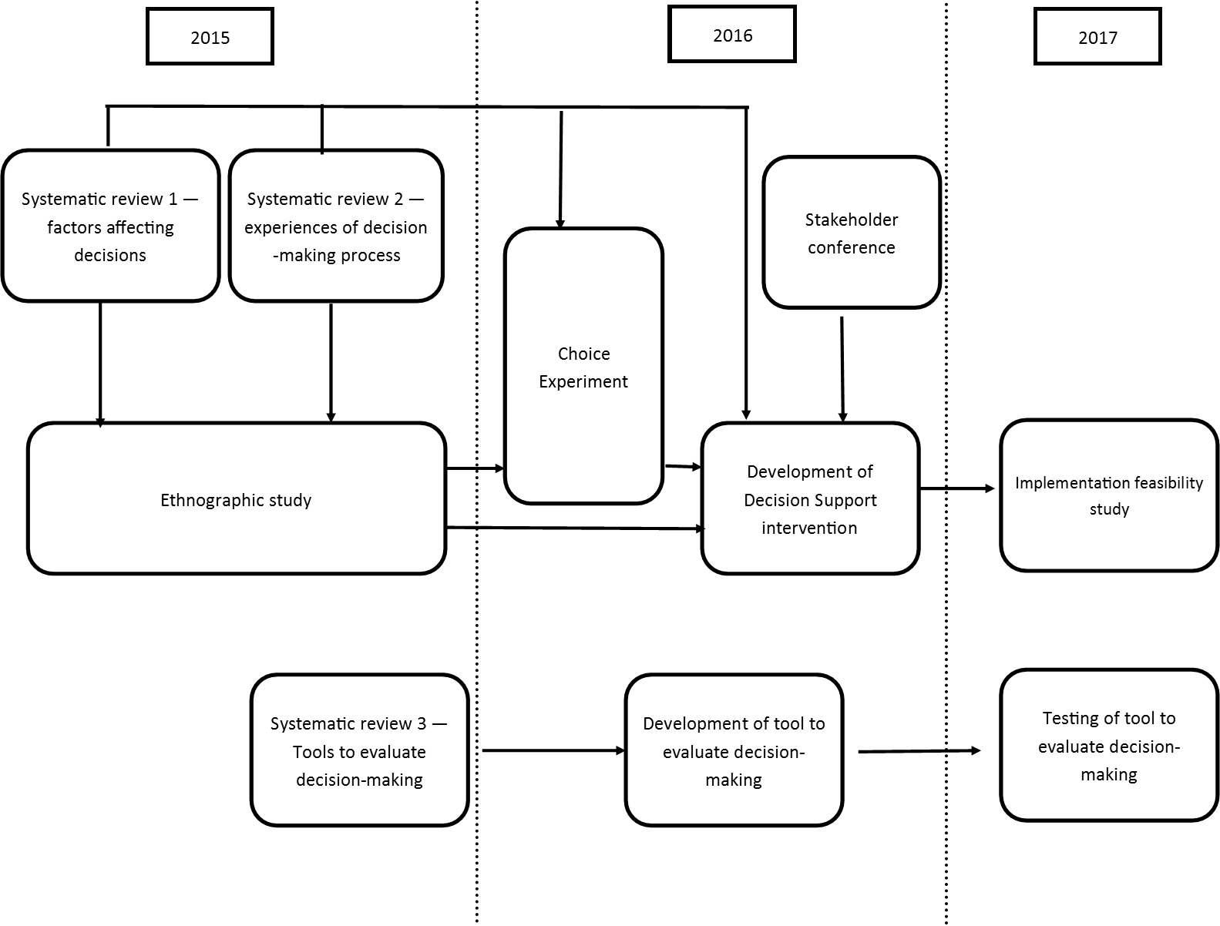
Figure 1 Study diagram

Chapter 1: Introduction

Intensive Care
An intensive care unit (ICU) is ‘a specifically staffed and equipped, separate and self-contained area of a hospital dedicated to the management and monitoring of patients with life-threatening conditions’.¹ Timely admission to the intensive care unit is associated with more favourable outcomes². It is thought that admission to intensive care gives a critically ill patient a 17-23% increase in their chance of surviving their acute illness.³
Treatments delivered in intensive care include invasive monitoring of physiological parameters, renal replacement therapy, cardiovascular support and invasive and non-invasive ventilatory support. These treatments, although potentially life-saving, can place significant burdens on an individual patient. In the UK, mortality rates for patients whose hospital stay involves admission to ICU is around 20% and 10% of those who survive ICU die before leaving hospital.⁴ Following ICU discharge, patients have an increased mortality rate that persists for at least fifteen years.^{5, 6} Additionally, ICU survivors have ongoing morbidity compared to their peers: of patients who require renal replacement therapy on ICU, only 28% survive for one year, and 12% of survivors will require on-going renal dialysis.⁷ Long-term psychological morbidity after ICU admission is also well recognised.⁸
Treatment on intensive care may not always be in the best interests of a critically ill patient. If intensive care does not return a critically ill patient to a life they value then the intervention may have harmed rather than benefitted the patient. For patients who do not survive ICU, an opportunity may have been missed for them to have a peaceful and dignified death.

Deciding whether to refer and/or admit a patient
When a patient is assessed as having a life-threatening illness, an initial decision must be made whether or not they should be referred to ICU. This decision is made by the clinical team caring for the patient. The decision whether or not a patient should be admitted to ICU is usually made by the ICU doctor, although critical care outreach (CCOR) or emergency medical treatment teams may also contribute to the decision. Both the referral and admission decision require clinical teams to consider the benefits and burdens of ICU treatment for the individual patient in question. Treatments delivered on ICU may not be required, or the burdens of ICU treatment, both short and long term, may outweigh any potential benefit. In some cases palliative care may provide the best option for treatment of the patient’s condition. These decisions are not easy and require good clinical and ethical judgement.

Assessing the clinical situation
A patient’s acute clinical condition, and the severity and nature of their past medical history are important considerations in making a decision about admitting him or her to ICU. Our previous scoping review found several studies confirming that these factors have an impact on the decision.⁹⁻¹⁴ However, there is often uncertainty about prognostic indicators and the extent of chronic illness in an acute situation. However, other more value laden factors also appear to influence the assessment of the clinical situation including the age of the patient^{13, 15-17} or the doctor’s assessment of their functional status or quality of life,^{14, 18-20} whether a patient has a medical or a surgical diagnosis^{3, 12, 21} and whether they are assessed by a junior or senior physician.^{10, 16, 22-24}

Evidence and prognostic indicators
While prognostic information from observational studies is available to guide decision-making, it remains difficult to predict with an acceptable degree of certainty the likelihood of death for a critically ill individual. Several prognostic tools for application to critically ill patients have been developed, the most widely used in the UK being the Acute Physiology and Chronic Health Evaluation (APACHE)-II score.²⁵ However this is calculated after admission to ICU so is of limited value for referral or admission decisions. Most prognostic models predict either ICU or hospital mortality, rather than long-term survival (or quality of life). Prognostic models are therefore primarily used to assess ICU quality and performance rather than as a framework for decision-making in individual cases.²⁶
Some individual patient-related factors have been found to be associated with increased mortality in ICU patients after hospital discharge, namely severity of illness, age, and presence of co-morbidities.⁵ This information can inform the risk/benefit analysis when considering admission but it does not provide a definitive prognosis in an individual patient.
There is evidence to suggest that even if clinicians are provided with patient specific prognostic information at the time of decision-making about end-of-life this does not materially alter their clinical decision-making.²⁷

Patient’s values and wishes
The ethical principle of respect for patient autonomy is reflected in legal and professional regulation of clinical decision-making.^{28, 29} A person should be provided with relevant information and given an appropriate time to contribute to a decision about their treatment. However, when the decision is whether to refer or admit a person to ICU, they are often unable to take part in the discussion, and in most cases will lack capacity to consent to, refuse, or request treatment because of the severity of their illness. Guidance on how to use a shared decision-making model in the context of critical illness has been produced³⁰: However, it is still the clinician’s responsibility to operationalise the shared decision-making model within a specific context, including the urgency of the situation and the extent to which the patient and/or their family or surrogate decision-maker are able to participate. In the UK, if a patient lacks capacity it is the responsibility of the clinician caring for them to first determine if there is any relevant advance statement or legal proxy to make decisions on behalf of the patient, and then to make a decision that is in the patient’s best interests, consulting where possible with the patient’s family and those who know the patient well in order to understand what the patient’s wishes might be.²⁸
Critical illness often develops with little warning, and the decision whether to admit a patient to ICU often needs to be made in an emergency situation or when a patient’s condition is deteriorating rapidly. Family members may not be present and there may be little time for extensive discussion with them even if they are. When families are consulted about the patient’s values and wishes they are not always accurate in predicting what the patient might want in this situation. There is evidence that families acting as surrogate decision-makers poorly predict what the patient would wish for themselves, and may prioritise their own values and wishes, rather than those of the patient, when asked their views on future therapy.³¹

Resources and external influences
The safe delivery of intensive care treatments requires a high concentration of staff and resources. On ICU the nurse to patient ratio is 1:1 for a ‘level 3’ patient, or 1:2 for a ‘level 2 patient’^{1, 32} compared with a standard ward where one nurse will look after nine patients.³³ In 2006 in Europe the cost of an intensive care bed was between €1168 and €2025 per day.³⁴ The delivery of this level of nursing for all patients would quickly overwhelm the resources of any healthcare system, and therefore access must be limited.³⁵ The UK has relatively few intensive care beds compared with many other countries,³⁶ and pressure on the UK’s available ICU resources is a regular occurrence. A survey by the Faculty of Intensive care Medicine in 2018 showed that 21% of ICUs were regularly moving patients to other hospitals due to lack of local intensive care resources.³⁷ Surveys and cross-sectional studies of patients admitted to ICU have previously shown that the availability of ICU resources influences whether or not a patient is admitted.^{10, 38-43}
Decision-making within intensive care is set in the context of wider organisational policies and priorities. Some hospitals have specific priority programmes such as transplant surgery or major trauma, and institutional policy may prioritise these patient pathways for intensive care admission.^{44, 45} The behaviour of other clinicians (such as failure to specify end-of-life treatment plans or to secure an ICU bed before elective surgery), and family demands for life support can also create a perceived pressure to admit to ICU.⁴⁶
These organisational and situational pressures add a further ethical dimension to the decision-making, in addition to the difficulty of balancing benefits and burdens of ICU treatment for a particular patient.

The views and values of the decision-maker
Since evidence-based prognostic indicators are seen to be of limited value, and the patients’ views may not be known, it is likely that other values and perceptions will have a bearing on the decision about whether to admit a patient to ICU. Previous experience of treating patients with similar conditions may influence the clinician’s perception of the potential for a patient to benefit from a particular treatment. A phenomenon known as “prognostic pessimism” has been demonstrated in ICU clinicians assessing patients with chronic obstructive airways disease (COPD). Patients with the most severe disease were found to benefit most from ICU treatment, and valued the resultant extension to their life after hospital discharge; contrary to the expectations of clinicians who predicted they would do badly.⁴⁷ Similar findings have also been seen in patients suffering from heart failure.^{48, 49} A large European study of decisions to admit to ICU found that while older people were less likely to be admitted to ICU, the mortality benefit (mortality without ICU compared to with ICU) was greater for older patients than for their younger counterparts. The authors concluded that ‘physicians should consider changing their intensive care triage practices for the elderly’.⁵⁰
Personal moral values and religious values have also been shown to influence clinicians’ decisions on withholding or withdrawing life prolonging treatment, of which intensive care can be considered an example.⁵¹

Fair access to intensive care
Given the diversity of values and external factors that influence decisions to admit to ICU, the lack of an effective prognostic tool, and relative lack of relevant guidance it seems likely that decision-making will vary. Studies have shown variation in ICU admission decisions among individual ICU clinicians,^{47, 52} between ICU staff and referring clinicians,^{9, 53} between institutions in the same country,^{18, 50} and between physicians in different countries.⁴³ While some variation in decision-making is inevitable, this could lead to inequity in the provision of ICU care. Currently in the UK not all patients who would benefit from ICU receive it. The 2012 National Confidential Enquiry into Patient Outcomes and Death (NCEPOD) report ‘Time to Intervene’ noted that 37 of the 392 patients studied who were admitted to a standard ward should have received ICU/HDU care.⁵⁴ There is an ethical requirement to be fair to every patient when making decisions about their care, which means that there should be consistency in the reasons for making the decision and that these reasons should be explicit so that they can be justified if challenged.

Current guidance on decisions to admit to ICU
There is very little specific professional guidance on decision-making around admission to intensive care. In 1996 the UK Department of Health (DoH) published guidelines on the admission and discharge of patients to intensive care and high dependency units.⁵⁵ The main criteria for ICU admission in this guidance are whether the condition is reversible and the absence of a significant co-morbidity, in addition to the need for ventilator or multiple organ support. It does not define the criteria of reversibility or significant co-morbidity. This document, although 22 years old, remains the only national UK guidance concerning admission to ICU. A DoH report⁵⁶ on the organisation of critical care services in the UK published in 2000 did not further develop admission policy for intensive care but called for further guidance to be developed and implemented locally and nationally. While some regional critical care networks have developed admission policies,^{57, 58} the national guidance has not been updated to take into account new evidence or developments in professional guidance and legal frameworks such as the Mental Capacity Act 2005.
In 2016 the Society of Critical Care Medicine (SCCM) in the United States (US) provided definitions of ‘inappropriate’ and ‘futile’ treatments with the aim of resolving disagreement about these terms. They suggested that a treatment should generally be considered to be inappropriate “when there is no reasonable expectation that the patient will improve sufficiently to survive outside the acute care setting, or when there is no reasonable expectation that the patient’s neurologic function will improve sufficiently to allow the patient to perceive the benefits of treatment”. The SCCM also produced administrative guidance for developing services for best practice in ICU admissions.⁵⁹ This guidance highlights the importance of the processes surrounding admission to ICU but offers little guidance for individual decision-making. Also in 2016, the World Federation of Societies of Intensive and Critical Care Medicine produced a summary of available evidence addressing four key questions relevant to decision about intensive care admission: who will benefit from intensive care?; who makes the decision whether or not a patient will be admitted to intensive care?; what in-hospital factors limit patient access to intensive care; and what other factors should influence whether or not a patient is admitted to intensive care?⁶⁰ Their conclusions did not provide specific guidance for decision-makers but more general points about the importance of fair allocation of ICU resources, the need to weigh benefits and burdens of ICU for the individual patient, the importance of multidisciplinary input into decisions, and the limited usefulness of prognostic algorithms.

Decision-making for intensive care admissions: addressing the issue.
Decisions about the provision of potentially lifesaving but extremely burdensome treatment are clinically complex and ethically challenging. The clinicians who make these decisions are faced with clinical uncertainty, limited knowledge of the patient, and external constraints which may preclude their preferred option, as well as being under pressure to make a decision quickly if the patient is deteriorating. They also have an ethical obligation to treat all patients fairly. Critically ill patients and their families may be unaware of how or why the decision has been made and have little opportunity to contribute to or challenge the process, yet the families have to live with the consequences of these decisions and may be very distressed if they feel the decision was the wrong one, especially where the patient does not survive. There is a clear need for guidance and support for both clinicians and patients and their families when faced with these difficult decisions.
This project therefore focusses on understanding the decision-making process around referral and admission to the intensive care unit, in order to develop an intervention to support decision-makers, patients and their families, and improve the decision-making process
The project was designed to answer the research question:
‘What is required for an ethically justifiable, patient-centred decision-making process for unplanned and emergency admissions to adult intensive care?’
The project aims were threefold:
- To explore how decisions on whether to refer or admit a patient to adult intensive care are made in the acute and emergency situation.
- To identify and critically analyse the factors that should inform ICU referral and admission decisions from the perspective of patients and their families and the clinical decision makers.
- To facilitate ethically justifiable, patient and family centred decision-making in these situations.
We sought to achieve these aims through a series of work packages (WPs) addressing specific objectives:
- To describe current practice in decision-making for referral and admission to ICU. (WP1)
- To explore the experience of patients, families, and clinicians involved in the decision-making process and their views on how these decisions should be made. (WP1)
- To determine the influence of different factors on decisions to admit a patient to ICU from the perspective of ICU clinicians and the general public. (WP2)
- To develop and test a decision support framework (DSF) including education and support materials that will facilitate ethically informed decision-making including reasons and process. (WP3)
- To develop information for patients and families to help them understand and contribute to the decision-making process. (WP3)
- To develop and test a tool for assessing the impact of the decision support framework on ICU referral and admission decisions. (WP4)
The project used a mixed methods approach including systematic reviews, a focussed ethnographic study of current practise, a Choice Experiment questionnaire survey of intensive care consultants and outreach nurses, a stakeholder conference, and an implementation feasibility study.

Ethical considerations
This project raised a number of ethical issues particularly around recruitment and consent in our ethnographic study. For the observation process consent from everyone who might be observed was not possible, therefore information was provided in all clinical areas, consent obtained from the ICU doctor being shadowed, and specific agreement was obtained from the patient or family members for individual case observation. Approach to patients and/or family members at the time of decision-making was through the clinical team to minimise distress and protect privacy. A comprehensive system of tracking, recruitment and consent processes was developed to ensure that patients who regained capacity were informed of the study, and gave appropriate consent for participation, and to approach family members for late stage interviews (see supp materials 1 and 2). Site specific contacts for support for patients and families were identified. A protocol for responding to disclosures or observation of unsafe or unethical practice was developed and approved by the research ethics committee. In development of the evaluation tool we accessed sections of anonymised patient records without explicit consent being obtained. We received approval for this from the Confidentiality Advisory Group of the Health Research Authority (15/CAG/0116). The whole project was approved by the Coventry and Warwickshire Research Ethics Committee (15/WM/0025) 18th February 2015).

Chapter 2: Patient and public involvement (PPI)

Introduction
Decisions around referral or admission to intensive care can have life changing implications for patients and their families, and any project investigating these decisions must consider this impact in both the project design and conduct. A project that involves critically ill patients and their families raises challenges for researchers around how to involve them while not adding to their existing distress. Given these two major considerations, the embedding of patient and public involvement at every stage was identified as vital to the successful running and meaningful reporting of the project. We therefore included PPI in the design, development, analysis, reporting and oversight of the project.

Scope of PPI
Project design: Before submission of the application for funding, we held a patient and public engagement meeting Attendees were recruited from a national ICU patient support charity: ICU steps, patients from an NHS post-ICU clinic, and Warwick University’s Teaching and Research Action Partnership (UNTRAP). The purpose of this meeting was to seek input from the group on framing and prioritizing the research questions and identifying appropriate methods for conducting the research that would be acceptable to patients and their families. During the meeting the participants were presented with background information about referrals and admissions to intensive care and why there was a perceived need for a study. The presentation concluded with the proposed broad aim of the research. The group was asked to identify what they saw as important issues for the research to address, what the specific research questions might be, and how to conduct the research in a way that was sensitive to patients and their families.
The group thought that this was an important area of research as it was crucial for patients and families in an extremely vulnerable situation to be able to trust the professionals making these decisions and the decision-making process. Key questions identified by the group included: how are patients and families involved in these decisions and communicated with; who is involved in making the decisions; how are decisions about quality of life made; and are ICU resources important in the decision-making process? The group also offered suggestions on timing and number of interviews with family members to balance the needs of data collection and reducing family distress. These fed into the final project design.
Investigator team: Our investigator team included two PPI co-investigators (CW, SS) who were involved in the design and development of the project, provided guidance on the acceptability of the methods, commented on and amended all patient and family information materials (both study and intervention documents) and contributed to the writing and editing of reports from the different work packages.
Advisory group: We convened a patient and public involvement advisory group (PPIAG) of six members, some of whom had either been patients themselves or had experience of a relative being on an intensive care unit. The group met six monthly throughout the project for updates from the project team and to provide advice on the conduct and findings of the project as it progressed. Individual members of the group also contributed more directly with specific work packages.
Project oversight: The project’s independent steering committee included two PPI members, one of whom had been a patient on an intensive care unit. The committee met at six-monthly intervals throughout the project to provide support and oversight of the project.
Project development: The PPI co-investigators worked closely with the project team on development of information for patient and family participants and recruitment and consent processes in the ethnographic study. Two members of the PPIAG participated in development of the draft Decision Support Intervention, attending project meetings and commenting on each stage of the process. One member led on initial drafting of patient and family information leaflets to be used as part of the intervention. Members of patient representative groups and the PPIAG attended the stakeholder conference and participated in focus groups to refine the content of the DSI. One of our PPI co-investigators (CW) chaired a session at the conference. Following the stakeholder conference, further extensive revision of patient and family information leaflets was overseen by the PPI co-investigators. Translated versions of these documents were checked for cultural acceptability among native speakers of the languages through our PPIAG contacts.
We were unable to obtain sufficient representation at the stakeholder conference for patients with mental health disorders and for elderly patients. We therefore attended local advocate group meetings to seek feedback on the DSI and its implementation.
Analysis: Two members of the PPIAG, and one PPI co-investigator (CW) contributed to the analysis of the qualitative data in our ethnographic study. They attended data analysis meetings, read a selection of interview transcripts and contributed to refinement of interview schedules and development of an analysis framework.
Dissemination: PPI co-investigators, members of the PPIAG and patient organization representatives who attended the stakeholder conference were invited to the Dissemination event at the end of the project. One PPI co-investigator (CW) gave a response to and reflection on the project findings from the patient and family perspective.

Summary
The importance of PPI was recognised at an early stage of development of the project and was integral to its development, conduct, delivery and successful completion. Involving PPI members in analysis raised issues of data protection which were addressed using confidentiality agreements and standard operating procedures. PPI was occasionally challenging, as the involvement of individuals with different experiences and perspectives can create dissonance and disagreement. However, disagreement was always constructive and enriched the overall project development. The presence of PPI throughout the project also helped to ensure that the work retained its focus on the patients at the heart of the decision-making process, and that language and communication was consistently clear and accessible. Without PPI throughout the project the outputs would have been less acceptable and credible as guides for patient centred clinical decision-making. We were fortunate to have such engaged PPI co-investigators and advisory group members so were able to create an environment for meaningful PPI.

Chapter 3: Systematic literature reviews to explore existing evidence

Introduction
To identify what was already known about the subject we carried out two systematic reviews to answer the following research questions:
- What are the patient and clinician-related factors that affect decisions around unplanned admissions to an intensive care unit? – Factors review (PROSPERO 2015:CRD42015019711)
- What are the experiences of clinicians, patients, and families of the process of referral and admission to an intensive care unit? – Experiences review (PROSPERO 2015:CRD42015019714)

Methods

Study identification
Because the focus of both reviews was on the process of decision-making around referral and admission ICU, we used the same search strategy and abstract screening process to avoid duplication between them. At the full paper screening stage, we identified studies relevant to a) factors review, b) experiences review, and c) both reviews. The search strategy was informed by an initial scoping review of the literature, and included three broad areas using a combination of the following MeSH headings and keywords: 1. critical and intensive care, intensive care units and critical illness; 2. patient admission, transfer, triage and refusal to treat; 3. professional decision-making and judgement, professional-family relations, choice behaviour and medical futility. Papers that referred to paediatrics or neonates were excluded. The following databases were searched: Medline, Embase, and ASSIA, all sections of the Cochrane Library, CINAHL, PsychINFO, and Web of Science. ‘Grey literature’ (Dissertation abstracts online, Index to theses, Open Grey) and references from key papers were also screened. We used forward and backward citation tracking from our full text papers to identify further studies our initial search had missed. Our full searches are presented in Appendix 1 (tables 25, 26). We included papers published between 1980 and 2015 describing empirical research that focused on the process of decision-making for referral or admission of adult patients to ICU, and which investigated either factors affecting decision-making or the experiences of clinicians, patients or families. The search was run on 11/5/2015.
We identified 47674 records: 34343 after duplicates were removed. Abstracts were double screened by a team of 13 reviewers (three members of the study team (CB, AS, HH) and ten medical students trained in the process), and 552 records went forward for full text retrieval and formal inclusion/exclusion to the review (Figure 2). Full text papers were also double screened by six members of the research team (CB, AS, ZF, HH, JT, MB).
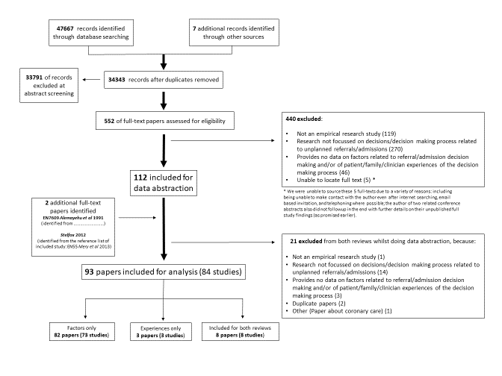
Figure 2 PRISMA diagram for main systematic review
In March 2018, we completed a brief update review to identify any relevant studies that had been published since our initial searches. A re-run of the original searches yielded over 10,000 returns. Given time constraints, we chose not to repeat the full review process. Instead, we adopted a pragmatic approach using the following method:
- We searched Pubmed for papers published between 1st May 2015 and 31st December 2017 using the search terms Critical care/CCU or intensive care/ICU AND decision-making AND admissions OR referrals
- We hand-searched the contents of the six journals that had provided more than one included paper in our original review. We searched all issues published from 1.5.15 to 1.1.18.
- We searched the reference lists of any identified papers to check for further papers, and the reference list of a published review⁶¹
Ten papers were identified at abstract screening stage for full text assessment by two reviewers (AS/KR or AS/CB). Three further papers were identified from the reference list of the published review. Eight studies (seven for factors and one for experiences) were added to the total number of studies included for analysis in the main systematic review.

Methodological quality assessment:
Cohort studies were assessed using the Newcastle Ottowa Scale⁶² (NOS). The majority of studies were cross-sectional and we used an adapted version of NOS to assess quality for this study design.⁶³ Clinical trials were assessed with the Cochrane Risk of Bias tool⁶⁴ and qualitative studies were assessed using May and Pope’s qualitative evaluation criteria.⁶⁵ Each included study was scored for quality by two reviewers (AS/HH, CB/JT, ZF/MB) and any discrepancies referred to a third reviewer for final decision (KR, FG). (Appendix 2, tables 27, 28, 29).
Data extraction
For studies relevant to the factors review we grouped identified factors using the following process. We identified an initial list of factors based on our previous scoping review of the literature and categorised these into patient factors (medical/non-medical), clinician factors, organisational factors, and others. These categories were further sub divided, for example patient-related medical factors included: type of acute illness; severity of acute illness; type of chronic illness etc. During the data abstraction process, we mapped each factor identified in a paper onto our pre-defined sub categories and collected any factors that did not map into a category of ‘other’. Three members of the team (KR, CB, AS) then categorised factors in the ‘other’ category either into existing categories or created additional sub categories. For the experiences review, any relevant qualitative data were copied and pasted into a word document for analysis.

Analysis
The majority of data for the factors review was quantitative but a small number of studies had descriptive qualitative data. Where possible we combined studies statistically using meta-analysis. Due to the potential confounding effects of each of the factors examined on the others, we focused on studies reporting multivariate analyses of independent factors affecting admission decisions. Where these were lacking we explored descriptive associations but were cautious in our interpretation because of biases and confounding.
If there were sufficient studies, effect sizes from multivariate analyses for each factor were pooled using the generic inverse variance method using RevMan software.⁶⁶ Results from cohort studies were pooled together with results from cross-sectional studies as we were not concerned with longitudinal associations but in decisions to admit and the factors affecting these which occur concurrently. The remaining studies were described narratively.
For the experiences review, a thematic analysis of any relevant qualitative data from the identified studies was conducted. Two research team members (SR and AS) read all the data and developed initial codes from which themes were developed during discussion between SR and AS. The themes were tested in a further research meeting with a third member of the team (FG).

Results
From the initial review, eighty four studies (ninety three papers) were included for analysis in both reviews of which eighty one studies (ninety papers) were included in the factors review and eleven studies in the experiences review (see Figure 2). A further eight studies (seven for factors and one for experiences) were included from the brief update review. Overall the quality of studies was moderate or poor with 14/19 cohort studies and 17/61 cross-sectional studies being rated of high quality.

Factors Review
Characteristics of the eighty eight included studies and the factors each investigate are documented in Appendix 3 (table 31). The vast majority were observational in nature.
We report our findings under factor headings grouped as patient-related medical; patient-related non-medical, clinician-related, and organisational-related (Table 1). For each of the factors analysed, results are presented first for multivariate analyses. A summary of multivariate analysis results is presented in Appendix 4 (table 32). For factors where there are no multivariate analyses, we report findings of descriptive studies. If multivariate analyses are present we note the presence of descriptive studies.

Table 1 Number and type of studies reporting specific factors associated with admission or refusal of admission to ICU
Factor category |  | Factor | N studies with multivariate analyses | N studies with univariate analyses | N descriptive studies
Patient-related factors | Medical factors | Type of acute illness | 9 | 1 | 14
Patient-related factors | Medical factors | Severity of acute illness | 8 | 1 | 36
Patient-related factors | Medical factors | Presence of chronic illness | 6 | 1 | 21
Patient-related factors | Medical factors | Severity of chronic illness | 5 | - | 14
Patient-related factors | Medical factors | Functional status/quality of life measures | 14 | - | 25
Patient-related factors | Medical factors | Nutritional status | 1 | - | 1
Patient-related factors | Medical factors | Length of hospital stay | 1 | 1 | 5
Patient-related factors | Medical factors | Trajectory of illness | 3 | - | 4
Patient-related factors | Medical factors | Presence of DNACPR | 3 | - | 6
Patient-related factors | Non-medical factors | Age | 18 | - | 35
Patient-related factors | Non-medical factors | Gender | 7 | 1 | 22
Patient-related factors | Non-medical factors | Ethnicity | 4 | - | 5
Patient-related factors | Non-medical factors | Patient preference | 3 | - | 15
Patient-related factors | Non-medical factors | Family preference | 1 | - | 13
Patient-related factors | Non-medical factors | Health insurance status | 2 | - | 4
Clinician-related factors |  | Seniority of ICU clinician | 2 | - | 10
 |  | Seniority of referring clinician | - | - | 4
 |  | Demography of ICU clinician | - | - | 2
 |  | Physician’s attitude | - | - | 3
 |  | Prognostic pessimism | 2 | - | -
Organisational-related factors |  | ICU bed availability | 12 | - | 27
 |  | Decision maker present | 2
 |  | Specialty of patient | 5 | - | 4
 |  | Time of day | 2 | - | 5
 |  | Experience/expertise of ward team | 1 | - | -
 |  | Hospital characteristics | 2 | - | 3
 |  | Avoid conflict/litigation | - | - | 2
 |  | Other | 3 | - | -

Patient-related medical factors

Type of acute illness
Ten studies report multivariate analyses for type of acute illness as a factor affecting admission decisions to ICU).^{12-14, 16, 41, 67-71} The types of acute illnesses considered between studies varied enormously and precluded meta-analyses. Distinct groupings were possible in the following categories: respiratory; cardiac/vascular; neurological; infections; and emergency surgery. Three studies reported respiratory diagnoses as a factor associated with reduced likelihood of refusal or increased odds of admission,^{14, 16, 68} whereas one found respiratory diagnoses to be associated with an increased odds of refusal.⁶⁹ Cardiac or vascular diseases were reported in six studies, with increased odds of admission reported in four studies.^{12, 16, 68, 71} One study showed less likelihood of refusal to ICU with a diagnosis of cardiac failure compared to respiratory failure.⁷⁰ In another study, cardiac disease was associated with refusal to admit.⁴¹ Four studies reported on neurological disease with inconsistent results. Two showed admission was more likely with a diagnosis of neurological disease,^{16, 68} whereas two showed that it was associated with refusal to admit.^{41, 69} Three studies reported infections as an independent factor associated with ICU admission,^{67, 68, 70} and two studies reported independent effects of emergency surgery on admission decisions.^{12, 70} (Table 1).
Other diagnoses as independent predictors of admission decisions in multivariate models included shock and coma which reduced likelihood of refusal.¹⁴ Haematologic etiology,⁶⁷ injuries/poisonings/toxic effects of drugs,⁶⁸ trauma and haematological malignancy,¹² and "worried",¹⁶ were all associated with increased odds of admission.
One study reported diagnosis as a significant factor in multivariate analyses affecting refusal to ICU but it is unclear which individual diagnoses had most impact.¹³ One further study reported univariate associations between categories of acute illness and odds of ICU refusal in an elderly cohort, but type of acute illness was not an independent predictor in the multivariate model.²⁰ Fourteen further studies reported descriptive associations between types of acute illness and decisions around admission to ICU.10, 11, 18, 19, 24, 72-78, 79, 82

Severity of acute illness
Eight studies report multivariate analyses for severity of acute illness as a factor.^{12, 13, 41, 74, 80-83} A number of different scales were used to assess severity of acute illness (Table 1). Results from individual studies were plotted, but the studies were not combined statistically because of considerable heterogeneity (I² 96%) and inconsistent direction of effect (Figure 3). There were no clear effects of severity of acute illness and decisions to admit patients to ICU (Table 1). It is possible that the heterogeneity and inconsistent direction of effect relates to questions around patients being too ill or too well to benefit from ICU care.
One further study reported a reduced odds of refusal of admission with increasing SOFA score (OR 0.93 (95%CI 0.87, 1.0) in a univariate analysis, although this was not an independent predictor in the multivariate model.²⁰ Thirty six further studies reported descriptive associations between severity of acute illness and decisions around admission to the ICU.10, 19, 21, 22, 24, 42, 44, 70, 71, 73-75, 78, 79, 84-105
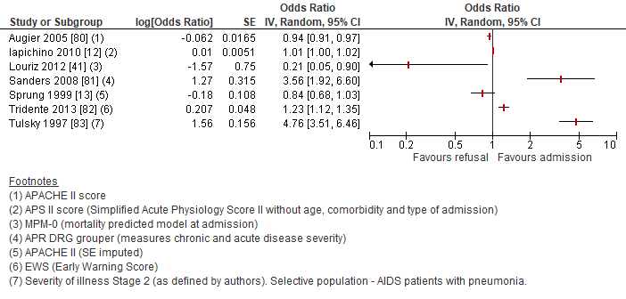
Figure 3 Forest plot of studies reporting severity of acute illness scales in multivariate analyses. The pooled effect estimate is suppressed as heterogeneity is considerable (I² 97%) and direction of effect inconsistent between studies.

Presence of chronic illness
Six studies reported multivariate analyses for presence of chronic illness as a factor.^{10, 14, 18, 69, 74, 106} Chronic illnesses investigated included dementia,¹⁰⁶ metastatic cancer,^{10, 18, 74} mental disorder (psychotropic drug use),¹⁸ a combined category of chronic respiratory or heart failure or metastatic cancer without hope of remission,¹⁴ and a general category of ‘underlying chronic disease’^{69, 107} (Table 1).
One study reported univariate associations between prior cognitive status and odds of ICU refusal where refusal was associated with worse cognitive status but this was not an independent predictor in the multivariate model.²⁰ Twenty-one studies reported descriptive associations between presence of chronic illness and decisions around admission to the ICU.11, 12, 15, 17, 22, 41, 72, 76, 78, 86-89, 91, 96, 99, 103, 104, 108-110

Severity of chronic illness
Five studies reported multivariate analyses for severity of chronic illness as a factor.^{16, 19, 20, 68, 111} Four studies assessed the severity of chronic illness using the Charlson Comorbidity Index. Results from individual studies have been plotted but not combined statistically because of (I² 95%) and inconsistent direction of effect (Figure 4). Sensitivity analyses combining scales of the same type and removing selective populations had no effect on the very high level of heterogeneity. There are no clear effects from multivariate studies of severity of chronic illness and decisions to admit patients to the ICU. Fourteen further studies reported descriptive associations between severity of chronic illness and decisions around admission to the ICU.10, 24, 41, 72, 78, 79, 84, 85, 89, 90, 93, 98, 99, 112
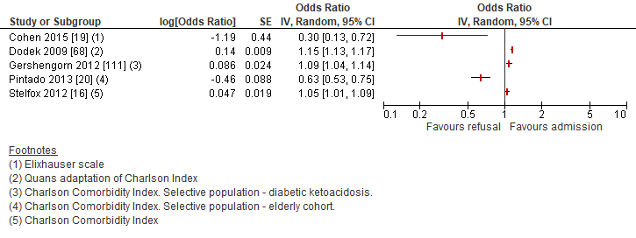
Figure 4 Forest plot of studies reporting severity of chronic illness scales in multivariate analyses. The pooled effect estimate is suppressed as heterogeneity is considerable (I2 95%) and direction of effect inconsistent between studies

Functional status/quality of life
Thirteen studies reported multivariate analyses for functional status/quality of life as a factor using a number of different scales and measures, so we were unable to pool data statistically.10, 12, 14, 15, 17, 18, 20, 21, 67, 69, 74, 82, 113 Most studies reported on patient data from real world settings but three reported either simulation studies,¹⁷ surveys to health care professionals using clinical vignettes,¹¹³ or the theoretical future need of ICU in elderly patients admitted to Emergency Departments.¹⁵
Measures of dependency/self-caring status related independently to admission decisions in the eleven studies in real world settings, in most studies increased dependency was associated with reduced odds of admission (Table 1).
Twenty five further studies reported descriptive associations between functional status/quality of life and decisions around admission to the ICU.11, 22, 24, 42, 46, 72, 74, 76, 78, 79, 85-89, 97-103, 110, 113, 114

Nutritional status
Only one study reported multivariate analyses of nutritional status on admission decisions. In this elderly cohort of patients over 80 years, nutritional status was independently associated with eligibility for ICU admission¹⁸ (Table 1). One descriptive study in patients older than 80 years found no statistically significant differences in nutritional status between those referred and not referred to ICU.⁷⁴

Pre-admission length of Hospital Stay (LOHS)
One study reported multivariate analyses for pre-admission LOHS as a factor.¹⁶ One study reported univariate analyses where LOHS for more than seven days increased the odds of ICU transfer compared to one or two days but this was not an independent predictor in the multivariate model.⁸¹ Five additional descriptive studies reported prior LOHS and admission decisions to the ICU with conflicting results.^{12, 18, 50, 67, 109}

Trajectory of illness
Three studies reported multivariate analyses for trajectory of illness as a factor.^{16, 17, 74} Previous hospitalisation in the last year was associated with reduced odds of admission to the ICU in one study,¹⁷ but hospitalisation in the last 6 months showed no difference in another.⁷⁴ Prior ICU admission during the hospitalisation was associated with increased odds of admission within 2 hours of medical emergency team (MET) activation¹⁶ (Table 1). Four further studies reported descriptive associations between trajectory of illness and ICU admission.^{88, 89, 103, 110}

Presence of DNR order (variously described in studies as DNR/DNAR/DNACPR)
Three studies reported multivariate analyses of Do Not Resuscitate (DNR) orders and admission decisions to the ICU.^{19, 67, 95} All three studies showed that patients were less likely to be admitted with a DNR order.
Six descriptive studies reported associations between presence of DNR order and admission decisions. Three studies found it resulted in significantly fewer ICU admissions.^{87, 115, 116} In the others Do not Attempt Resuscitation (DNAR) status was seen as important⁹⁶ or clinicians said they would comply with a DNAR.^{76, 90}

Patient-related non-medical factors

Age
Eighteen studies examined age as a factor in multivariate analyses.12-18, 20, 21, 68-71, 81, 95, 104, 111, 74 Data on age were inconsistently reported. Six studies reported admission decisions per year increase in age and data were pooled statistically (Figure 5). There was considerable heterogeneity (I² 99%) but magnitude and direction of effect between studies was similar showing an increased odds of refusal to ICU with increasing age (OR 0.95 (95%CI 0.91, 1.0), P=0.05). Five studies were conducted in real world settings and one was theoretical.
Other studies reported specifically on elderly cohorts or similar cut-points and where possible we have pooled these statistically (Figure 5). All multivariate analyses are summarised in Table 1
A further thirty five studies looked at association between age and admission to ICU in descriptive analyses.10-22, 24, 41, 50, 67-76, 78-82, 85-89, 91, 92, 95, 96, 98, 99, 103, 105-107, 109-111, 113, 117-123 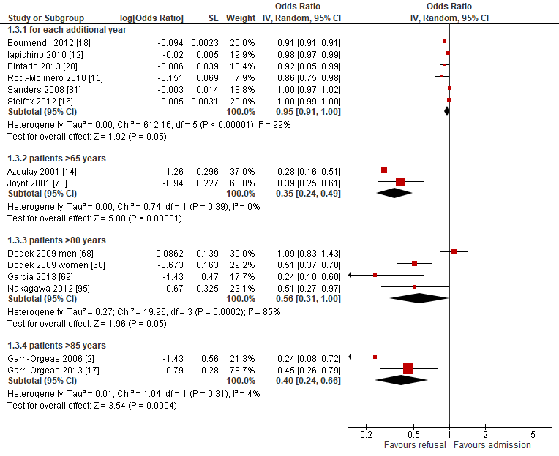
Figure 5 Forest plot of studies reporting age in multivariate analyses, for each year increase in age and by age bands

Gender
Seven studies examined gender as a factor in multivariate analyses.^{68, 70, 71, 81, 111, 124, 125} Results were inconsistent between studies, with different age groups and ethnicity also playing a role.
Three studies reported no difference in admission decisions by gender when controlling for other covariates.^{71, 81, 111} One study found that being female reduced the odds of refusal to ICU compared to being male (the reference) but this did not reach statistical significance.⁷⁰ Three studies found that men were more likely to be admitted than women^{68, 124, 125} (Table 1).
One study reported univariate associations between gender and ICU admission decisions and found no differences between men and women,²⁰ OR 0.83 (95%CI 0.52, 1.43). Twenty two further studies reported descriptive associations between gender and decisions around admission to the ICU.10-13, 18, 19, 21, 24, 41, 50, 67, 69, 72-74, 77, 79, 87, 92, 104, 109, 126

Ethnicity
Four studies reported multivariate analyses for ethnicity as a factor, with inconsistent findings. All were conducted in the US.^{71, 83, 111, 124}
Five additional studies reported the effects of ethnicity on admission decisions in descriptive analyses.^{11, 67, 73, 108, 109} Ethnic origin did not impact on admission decisions in these studies.

Patient preference
Three studies reported multivariate analyses of patient preferences and admission decisions to the ICU.^{16, 17, 113} Two studies of patient cohorts found increased odds of ICU admission where patient preferences for ICU care were considered (resuscitative v comfort care, and I accept v I refuse ICU care)^{16, 17} (Table 1). A survey of health care professionals using a clinical vignette to determine decisions regarding admission to the last available ICU bed found that the prior wishes of the patient were not an independent predictor for either physicians or nurses in predicting choice of patient for admission.¹¹³
No further studies reported the effects of patient preference in univariate analyses, but 15 additional studies reported its effect on admission decisions in descriptive analyses, the majority being questionnaire studies of physician attitudes.22, 76, 78, 79, 85, 88, 98, 99, 103, 105, 107, 110, 115, 127, 128

Family preference
One study reported multivariate analyses of family preferences and admission decisions to the ICU. This study was regarded as being of low methodological quality and did not show family considerations as an independent factor in affecting admission decisions in a clinical vignette study.¹¹³
Thirteen additional studies reported the effects of family preference on admission decisions in descriptive analyses. Of these the majority were questionnaire studies of physician attitudes and perceptions which variably reported the effect of family wishes on decision-making.38, 46, 76, 78, 79, 89, 94, 98, 99, 103, 107, 129, 130

Health insurance
Two cohort studies reported multivariate analyses of health insurance and admission decisions to the ICU, one of which was in a population of patients with diabetic ketoacidosis. Both were US studies and explored differences between different types of health insurance¹¹¹ ⁷¹ (Table 1).
Four additional studies reported the effects of health insurance on admission decisions in descriptive analyses.^{22, 67, 89, 96}

Clinician-related factors

Seniority of ICU clinician
Two studies reported multivariate analyses of clinician seniority and the effects on ICU admission decisions. One found that attending physicians were more likely to admit patients than more junior physicians,¹⁶ while another found less experienced attending physicians (defined as spending <25% of their time in the ICU) were more likely to admit patients to ICU⁶⁷ (Table 1).
Ten additional studies were found with descriptive analyses reporting variable results.10, 21, 22, 24, 41, 72, 74, 76, 115, 129

Seniority of referrer
No studies reported multivariate or univariate analyses of the effects of the seniority of the referrer on ICU admission decisions, but four descriptive studies were found reporting associations between referrer seniority and ICU admissions.^{11, 119, 131, 132}

Personal characteristics/demography of ICU clinician
No multivariate or univariate studies reported on personal characteristics/demography of ICU clinician and their association with ICU admission decisions, but two descriptive studies were found of low methodological quality.^{22, 115} No consistent association was found with physician age, gender and whether they had children in responses to a number of clinical vignettes and importance of a number of criteria when considering admission.²² Country of practice impacted on decision-making with Brazilian and US physicians choosing more aggressive treatment in response to clinical vignettes compared to Australian, Scottish and Welsh physicians.¹¹⁵

Physician’s attitude
Three descriptive studies were found of low methodological quality. In one study, 12% of physicians cited alcohol dependency as a "lifestyle decision" when considering ICU admission.⁸⁴ In the other studies 56% of Israeli physicians and 19% of US physicians thought that their personal attitude was important in deciding admission to the last ICU bed.^{88, 110}

Prognostic pessimism
Two studies reported multivariate analyses of prognostic pessimism and admission decisions to the ICU.^{24, 70} A high chance of mortality from the Mortality Prediction Model was associated with increased odds of refusal to the ICU as was physician expected risk of death of >50% in the coming month. No further studies were found reporting on prognostic pessimism.

Organisational-related factors

ICU resource/bed availability
Twelve studies examined ICU bed availability as a factor. Results were reported variably by number of beds available and unit full/not full, so we were unable to pool data statistically. In eight studies ICU bed availability was associated with likelihood of admission to ICU.¹⁷ 10, 12, 13, 16, 20, 21, 41, 133, 134 Conversely, ICU occupancy levels had no significant effect or were only weakly predictive of likelihood of admission in three studies.^{80, 111, 135, 136} One study found that an increase in use of mechanical ventilation in hospitalised nursing home residents with advanced dementia was associated with increased number of ICU beds in a hospital.¹³⁴ (Table 1).
An additional 27 studies reported the effects of ICU bed availability on admission decisions in descriptive analyses.11, 24, 42, 44, 46, 67, 72, 73, 75, 76, 78, 79, 84-86, 98, 101, 102, 105, 114, 121, 127-129, 133, 137-139

Decision-maker present
Only two studies were found both reporting circumstances of triage, whether by phone or examined, by an ICU clinician.^{10, 21} Both studies found that patients who were refused ICU admission more likely to have been examined by an ICU clinician.

Speciality of patient
Five studies reported multivariate analyses of specialty of patient and admission decisions to the ICU.^{12, 16, 21, 24, 104} These found that patients from medical specialties were less likely to be admitted to ICU than those from surgical specialties.
Four further studies reporting descriptive analyses were found, reporting variable results.^{10, 11, 119}

Time of day
Two studies reported multivariate analyses of time of day and admission decisions to the ICU. These had conflicting results with one reporting increased admissions during the day,¹⁰ and the other reporting increased admissions at night¹⁶ (Table 1).
Five descriptive found no significant association between time of day and admission decisions,^{21, 24, 41, 74, 79} but one study found that patients referred out of hours were more likely to be admitted to the ICU (P=0.005).¹¹⁹

Experience and expertise of ward team
One study reporting multivariate analyses examined the effect of experience and expertise of the ward team on admission decisions. Registered nurse certification in a nursing specialty did not significantly predict ICU transfer after controlling for severity of illness (OR 0.43 (95%CI 0.1, 1.73)).⁸¹

Hospital characteristics
Two studies reporting multivariate analyses examined the effect of hospital characteristics on admission decisions. The number of hospital beds, hospital percentage occupancy, ICU percentage occupancy, location (metropolitan, non-metropolitan) or teaching status of the hospital did not have an effect.¹¹¹ For patients with AIDS, admission was more likely in a Veterans Health Administration (VHA) hospital than a government hospital.⁸³
Three further descriptive studies found associations with characteristics of the hospital and decisions to admit to ICU.^{71, 112, 130}

Avoid conflict/litigation
Two descriptive studies were found reporting the effect of litigation on ICU admission decisions. In a survey of ICU clinicians in Milan exploring reasons for inappropriate admission, 5% cited threat of legal action as a reason. The other study found no association with admission to ICU.^{38, 76}

Other
Three empirical studies reported multivariate analyses of other organisational factors not captured in the categories above (Table 1).^{12, 95, 111}

Experiences review
We identified twelve studies (14 publications) which are presented in Table 2. Eleven used qualitative,44, 46, 90, 114, 127, 129, 140-144 and one used quantitative methods.⁹⁸ Interviews were most commonly used for data collection. Two studies used questionnaires, and four used multiple methods (including interviews, focus groups, observation, and analysis of documents). Five of the studies were carried out in North America, and seven in Europe (including three in the UK). In general, the quality of the studies was mixed (see Appendix 2 for a review of quality assessment of studies). All but two of the qualitative studies were single site or single participant studies.
Of the twelve studies, two looked at patient or relatives experiences (having only one participant each): Fulbrook^{141, 145, 146} and Todres¹⁴³ The other ten explored the experiences of healthcare professionals (HCPs) including: ICU and general ward doctors and nurses; critical care outreach (CCOR) nurses; medical directors; respiratory technicians; hospital administrators; social workers; and bioethicists. One study contained a detailed reflection of how a CCOR nurse made her clinical decisions based on one case, rather than a reflection on the wider process.⁹⁰ We did not find any papers that focused solely on experiences of the process of referral and admission to ICU, but in these twelve we were able to identify data that was relevant to our research question.

Table 2 Experiences review study characteristics
Study | Objective of study | Data collection | Location | Participants | Number of participants | Limitations
Cullati 2014¹²⁹ | Importance of advanced care planning for seriously ill patients | Interviews | Switzerland | Healthcare Professionals | 24 | Single site;  Conference abstract and presentation
Hart 2011¹²⁷ | ICU clinicians’ reasons for bed rationing | Questionnaire  (free text) | USA | Healthcare Professionals | 1086 | Abstract only;  Questionnaire
Santana Cabrera 2008⁹⁸ | Non-ICU doctors’ perceptions of ICU | Questionnaire | Spain | Healthcare Professionals | 116 | Single site;  Questionnaire
Hancock 2007⁹⁰ | A Critical Care Outreach nurse’s decision-making | Reflective piece | UK | Healthcare Professionals | 1 | One participant
Todres 2000¹⁴³ | Being a patient in ICU | Interview | UK | Patient (also an ICU nurse) | 1 | One participant
Oerlemans 2015¹¹⁴ | Ethical dilemmas influencing admission and discharge | Interviews and focus groups | Netherlands | Healthcare Professionals | 44
Mielke 2003⁴⁴ | Priority setting in ICU: evaluated in an ethical framework | Interviews; documents; observations | USA | Healthcare Professionals | 20 interviews | Single site
Fulbrook 1999^{141, 145, 146} | Being a relative of a patient in ICU | Interview | UK | Relative (also an ICU nurse) | 1 | One participant
Cooper 2013⁴⁶ | Scarcity in ICU context | Interviews | Canada | Healthcare Professionals | 22 | Single site
Martin 2003¹⁴² | Neurosurgery patients’ access to ICU in an ethical framework | Interviews; documents; observations | Canada | Healthcare Professionals | 13 interviews | Single site
Danjoux Meth¹⁴⁰ | Conflicts in the ICU | Interviews | Canada | Healthcare Professionals | 42
Charlesworth¹⁴⁴ | ICU doctors’ decision-making practices in response to patient referrals | Ethnography (observations; interviews) | UK | Healthcare Professionals | 71 ICU reviews observed;  10 interviews | Single site

Findings
Thematic analysis of the data from these studies identified three main themes: professional relationships, communication, and working within external constraints. An overarching theme relevant to HCPs patients and relatives was that of lack of agency or control.

Professional relationships
The existing and past relationships with clinical colleagues in the context of referring a patient to ICU had a substantial impact on how HCPs, specifically ICU doctors, referring doctors and ward nurses, experienced the decision-making process. Previous experience of having a patient refused admission made some referrers less likely to refer cases, either because they assumed a referral would be refused again or because the process had made them feel undervalued.^{98, 114, 129}
“And then you think, well as they are always aggressive, you are, you are a little afraid of calling them, yes. A dire consequence is you don’t dare ask for the consultation.” – Medical Doctor 6¹²⁹
One study reported that terms such as ‘arrogant’, ‘ivory tower’, and ‘island’ were used often to describe ICU consultants.¹¹⁴ Inter professional relationships were often strained because of a lack of shared understanding about what ICU could achieve and what life was like caring for patients on a general ward.^{44, 114, 140} This can lead to frustration and resentment. Where professional relationships work well the process runs smoothly.⁴⁴

Communication
Good communication between clinicians was seen as facilitating the referral and decision-making process but poor communication was often described, leading to tensions between staff and harmful consequences for patients.
‘[You] go to see a patient and you don’t know what the therapeutic plan is, the patient is ill and we sometimes bring the patient down to the unit and then discover that actually the patient was for palliative care.’ – ICU team member⁴⁶
Concerns about communication were particularly noted in relation to communication with patients and relatives.44, 46, 114, 141, 143, 145, 146 ICU doctors commented that conversations about treatment goals and what transfer to ICU would mean for the patient were often avoided by referring teams so the ICU team were put in the position of having to initiate the conversation.
However ICU doctors also avoided conversations with relatives about the decision.
“The ICU resident would have come down, done the consult and said to the ward team, 'no.' Or they may have said to the family, en passant, 'Sorry, no,' and then disappeared and then the family would have said, 'Why?” – Nurse Manager¹⁴⁰
In contrast, we found one study¹⁴⁴ which reported a highly collaborative environment at their site, and this was seen as improving the experience of making decisions about ICU.
“The other change that has come on in the last few years that is probably worthy of talking to you about is the collaborative way in which we make the decisions now… It is a supportive thing” – ICU Consultant

Working within resource constraints
Several studies described the need for ICU and referring clinicians to negotiate limited availability of ICU beds, and the impact of this on both clinicians’ decision-making and patient care.^{114, 129, 140, 144} External pressures including unrealistic expectations from the patient’s family,^{46, 129} pressure from referring clinicians,^{46, 142} and hospital policies on priority programme patients.⁴⁴ ICU doctors sometimes stretch ICU resources by reducing the nurse to patient ratio creating conflict with nursing staff.¹⁴⁰
“We all knew that it [ICU treatment] wasn’t gonna make any difference…but the family wanted everything done and the physician, the intensivist at the time, wanted everything done as well. So it was hard for us to understand, given that our resources are very tight…why we were proceeding with the care of this patient” – Nurse Manager¹⁴⁰

Lack of agency
An overarching theme of lack of agency was identified running through the studies. ICU doctors feel constrained by policies and pressure from other clinicians and families,^{44, 46, 142} referring teams feel they are not listened to by ICU colleagues,^{98, 114, 129} and nurses are left caring for the critically ill deteriorating patient with no power to challenge the doctor’s decision.^{140, 141, 143, 145, 146} Patients and relatives are often excluded from the decision-making process.^{44, 141, 143, 145, 146}
The body of literature indicated a major gap in relation to patient and relative experiences, as they were only included in two studies, each of which contained the account of one participant. Furthermore, these participants were both ICU nurses by profession. The data in these two studies indicated that patients/relatives were not adequately involved in the process or referral/admission.

Summary
Our systematic reviews identified a large number of studies exploring a wide range of factors associated with decisions to admit a patient to ICU. There was marked heterogeneity among these studies making it difficult to pool results and many of the studies were of poor quality. The clearest associations identified were with age, gender, type of acute illness, presence of chronic illness, functional status, presence of DNACPR order, referring specialty, seniority of referrer, and ICU bed availability. No clear association across studies was found with severity of acute or chronic illness. Few studies looked at the experience of stakeholders in the decision-making process and none had specifically explored this. Key themes identified in the data related to experience were communication, inter-professional relationships, and perceived loss of control. One study we reviewed reported a positive, collaborative environment for ICU decision-making, in contrast to our overall findings. Very little is known about patients’ and families’ experience of this potentially life-changing decision.

Chapter 4: Understanding current practice

Introduction
This chapter reports a focussed ethnographic study (observation and interviews) to explore current practice and inform subsequent work packages. We chose focused ethnography as this allows observation of what happens in a particular context which for this study is hospitals with intensive care units, and exploration of patterns of practice, ideas, beliefs, norms and values ^{147, 148}
Our research questions were:
- How are decisions about whether to admit a patient to an intensive care unit made?
- What are the experiences of patients, families and doctors involved in the decision-making process, and what are their views on how these decisions should be made?
- What would constitute an ethically justifiable process for these decisions?
We first report the methods of data collection and analysis. We then report the analysis undertaken to inform the Discrete Choice Experiment followed by the analysis undertaken to inform the design of the decision support framework, accompanying training and professional support. We draw the analysis together at the end of the chapter to respond to our research questions.

Methods
In consultation with our PPI co-investigators and PPIAG we designed detailed flow charts of participant recruitment and consent (Supplementary material 1, 2).
We used a focused ethnography technique to observe and describe what happened before and after a decision was made whether or not to admit a patient to ICU.¹⁴⁹ ¹⁴⁹ We chose as our main data collection to observe decision-making events and interview doctors about these specific events as this keeps data collection grounded in what is actually happening and how the doctors think at the time about decisions. The aim was to reduce social desirability bias of self-reported data from health professionals.¹⁵⁰ However, when asking about the ideal process we wanted the doctors to think beyond the constraints of a specific case.
To gain understanding of the decision and what happened from the perspectives of those involved, we interviewed the observed intensive care doctors, patients or family members where possible, and referring doctors (see supplementary material 3-6 for interview schedules and observation template).
Six NHS hospitals across the East and West Midlands of England were sampled for diversity of type of hospital (University/District General) and ICU unit size (bed numbers: up to 20/ 21-40/over 40). The researcher, MS (a qualitative researcher with ethics training and ICU nursing experience in Sweden), undertook observation sessions within a three week period at each site. These were timetabled to include as many different ICU doctors as possible and to cover the whole 24 hour period and all days of the week. MS met the doctor to be shadowed at the start of the observation period and agreed a process that would not interfere with the clinicians other work. Usually MS sat in or next to the ICU, in a place where the doctor would remain aware of her, and when the doctor received a referral they signalled to MS to join them. The period of time spent waiting for referrals ranged from 8-16 hours. MS observed 1-3 decisions each session except for one session when she observed 5. The time spent with the doctor while the decision was made ranged from 10 minutes to 1.5 hours except for one decision where the duration was 3.5 hours. Twelve of the 28 sessions were out of hours (between 17.00 and 24.00 or during a weekend).
Patients/family members seen by the doctor during observation were given the option of asking the researcher to leave the room. The limits we placed on observation minimised burden on the clinical team but allowed sufficient time to include diverse participants and times of day/week, and to reach data saturation.
Interviews with the ICU and referring doctors occurred as soon as possible after the observed decision. Additionally, we interviewed specialist doctors who refer to ICU but did not refer during observation periods. For logistical reasons the interviews with these doctors were undertaken by MS and other team members, FG (a UK General Practitioner and sociologist) and (AMS a UK General Practitioner and ethicist)). Patients with capacity at the time of referral to ICU were given brief information about the study and asked if they agreed to a family member being interviewed. Before leaving hospital, surviving patients with capacity were asked for consent to include data from any family interview already obtained, consent to approach a family member for an interview in three months and consent to be personally contacted three months later for an interview. Family members were approached by a member of the clinical team for interview within 48hours after the observed decision. Early in the study we realised very few family members were approached because of practical reasons such as the family not being available, and because the clinical teams were concerned about causing distress. In consultation with our PPI advisors and with ethical approval, the time-window for approaching family members was extended to 72 hours in an attempt to increase recruitment. If the clinical team thought an approach would cause distress no approach was made. Patient/family member interviews were undertaken by MS. Patients/family members unable to engage in an interview in English were excluded.
Field notes were taken during observation about what was happening and MS’s impressions of whether a process was a good experience or not, for patients/family members and doctors, and what influenced this including underlying values. We used a broad definition of values to include procedural values such as communication, time, and mentoring, as well as ethical/moral values such as respect for persons, minimising harm, honesty, and fairness. MS drew on ethical, professional, and legal frameworks to inform her identification and exploration of ethical/moral values in the field. MS checked her impressions through conversation with the observed doctors. The field notes were typed up and expanded immediately after each observation session. Doctors were asked at interview to describe their decision-making process related to an observed decision to admit or not to ICU (or their most recent decision if not involved in an observed decision) including any communication with the patient/family, what they took into account in the process, and how the process could be improved. The researcher explored what participants thought made a good decision-making process, and what hindered this. Patients/family members were asked at interview (initial and three month interview) to describe what they remembered of the situation they were in, the decision about admission to ICU, and their involvement, and whether they thought the process could be improved. Interviews were audio-recorded, transcribed verbatim and anonymised. Observation and interview guides were refined based on analysis of initial data (supplementary material 3-6). Data collection started in June 2015 and was complete by May 2016.
Data analysis was designed to inform subsequent work-packages. Our project protocol specified analysis questions based on the needs of these work-packages. We used these questions to guide our thematic analysis with constant comparison ^{151, 152} and adjusted the questions as analysis proceeded. We present each analysis question as a section title in the results section. Analysis was led by MS with the rest of the work-package research team (FG, AMS, CB, JD, CW, AM, CB) and PPIAG members reading data and contributing to interpretation at a series of analysis meetings. All research team members and lay advisors read raw data from across the dataset and provided an initial commentary on what they thought was in the data of relevance to our analysis questions. MS then read each transcript line by line and labelled chunks of text that shared meaning, with a code that was a short descriptive condensation.¹⁵³ Coding was facilitated by the software program NVivo 11. Codes were simultaneously grouped into content areas in order to manage the voluminous data, and content areas gradually abstracted into categories relevant to each analysis question.¹⁵³ MS undertook this process for all transcripts and AM and CB for samples of transcripts across the data set.
This process was reviewed by the wider research team during analysis meetings. Working analytical frameworks were created responding to our analysis questions that were shared during these analysis meetings.¹⁵⁴ As far as possible data about a particular decision event was separated from data related to general reflections on ICU referral and decision-making. The latter was only used to understand what doctors consider the ideal process for ICU referral. We critically reviewed our emerging interpretation of the data by bringing our different disciplinary perspectives to the raw data and codes. Analysis was both descriptive, seeking to understand what was happening in relation to decisions to admit or not to ICU, and analytical in understanding how and why the decision was experienced as it was, including the underlying value, In our thematic analysis we use the judgements in the data as stated by the research participants as to whether experiences were good or bad and impressions noted during field-work and checked with participants. However, we went further than this using an empirical ethics approach.¹⁵⁵ The research team sought to identify from the data explicit and implicit ethical values and principles that were informing or framing the decision-making process, or participants’ views of what a good process should entail. We distinguished between ethical values (normative values or principles defining the obligations or duties inherent in both patient doctor and inter professional relationships) and instrumental values (what was important to facilitate enactment of the ethical values. Drawing on ethical theories and frameworks in relation to health care decision-making and the results of our empirical analysis in an iterative process we were able to provide a normative and procedural framework to inform the design of the decision support framework, accompanying training and patient and family support.
We present our results for each of our per-protocol analysis questions and provide illustrative data extracts labelled with the decision event to which the data relates and role of the informant. Where an extract is from field notes [informant:] indicates the text that follows is a verbatim quote noted during observation. Where there is no index event included in the data extract label, the data is from an interview with a doctor who did not refer to ICU during the observation period at their hospital.

Results

Participants and decisions observed
In total, 55 decisions to admit or not to ICU were observed on wards or in emergency departments (Table 3). In total, 55 decisions to admit or not to ICU were observed on wards or in emergency departments (Table 3) over 28 days, of which 6 were weekend days. Of the 55 decisions, for 18 the referral was received after 5pm and before 9am Monday to Friday and 9 were received at weekends (of which one was received after 5pm and before 9am).These decisions involved 46 patients (27 female; mean age 61 years; age range 19-94 years), of which 10 patients had two decisions within two days. In these 10 cases, the first decision was not to admit.
Table 3 Hospital department/unit and type of hospital where decisions to admit or not to ICU were observed
Hospital size | Hospital department/unit
Hospital size | Emergency department | Medical unitª | Surgical unit^{b} | Total N
Small (N =2 ) | 11 | 8 | 5 | 24
Medium (N =2 ) | 4 | 7 | 5 | 16
Large (N =2 ) | 5 | 5 | 5 | 15
Total N | 20 | 20 | 15 | 55
a Clinical decision unit, Diabetic ward, General medicine/ diabetes/infection, Liver unit, Medical - assessment/short stay ward, Medical geriatrics, Respiratory unit, Nephrology unit, Stroke unit, Acute care bay, Cardiac care unit, high dependency unit, Respiratory high care unit
b General surgery, Kidney unit, Neurosurgery theatre, Orthopaedic, Orthopaedic trauma, Rheumatology ward, Surgical ward, Surgical level up
In total 43 different ICU doctors were observed, all of whom were interviewed Thirty referring doctors were interviewed about 31 referrals related to observed decision-making. Twenty eight further specialist doctors who refer to ICU were interviewed (see Table 4). See Appendix 5 (table 33) for further information regarding interviews by site. The acute medical conditions of the patients, as initially reported, are summarised in Table 5.
Table 4 Roles and experience of the professionals interviewed
 |  | Doctors involved in observed decision |  |  | Doctors not involved in observed decision
Specialty | Total  n=108 | Consultant | Registrar | Junior Doctor | Consultant
Intensive care ª | 50 | 23 | 19 | 0 | 1
Medical specialties^{b} | 30 | 7 | 8 | 6 | 15
Surgical specialties^{c} | 11 | 1 | 3 | 0 | 7
Acute/Emergency Medicine^{d} | 11 | 1 | 5 | 0 | 5
Years’ experience in current specialty  mean (range) | 8  (0.1-22) | 10.0  (0.5-22) | 4  (0.1-20) | 2  (0.2-4) | 10  (0.2-22)
Years’ experience since graduation  mean (range) | 17  (1-41) | 23  (10-36) | 10  (4-29) | 4  (1-12) | 22  (8-34)
ª Anaesthesia/Intensive care, Intensive care, Anaesthesia, Acute medicine and intensive care
^{b} General medicine, emergency medicine, clinical oncology, nephrology, respiratory medicine, endocrinology,
cardiology, infection, geriatrics, haematology, high dependency medicine, rheumatology, gastroenterology, hepatology, neurology, medicine
^{c} Orthopedics, colorectal surgery, general surgery, neurosurgery, Urological surgery, renal surgery
^{d} Acute Medicine, Emergency Medicine

Table 5 Observed decisions to admit or not to ICU and the acute medical condition of patient
Acute medical condition reported initially | Number of patients | Admission/non-admission
Respiratory failure | 17 | 7/10
Cardiac arrest | 5 | 1/4
Low blood pressure | 5 | 2/3
Trauma | 3 | 1/2
Bleeding | 3 | 2/1
Pre-post-surgical problems | 3 | 1/2
Pancreatitis | 3 | 0/3
Renal failure | 2 | 1/1
Intoxication | 2 | 1/1
Seizures | 2 | 1/1
Home ventilator, overnight admission | 1 | 1/0
From our observations, family members from 45 patients were identified as being potentially eligible for interview. Seven were not asked for interview as the clinical team thought an approach would cause undue distress, 13 were not available to ask or did not respond to initial information. Fifteen declined to be interviewed. Ten family members were therefore interviewed soon after a decision to admit or not to ICU (two parents, four spouses/partners, five daughters/sons, one daughter-in-law),
We gained consent to approach thirteen family members of patients for a late stage interview approximately three months after the observed decision. Of these, four family members did not wish to be interviewed; contact was lost with one family; one patient was readmitted to ICU and family were not re-contacted; and two patients, after regaining capacity, did not consent for their family to be contacted. One family member was not re-interviewed as their consent for further contact by the research team could not be verified from documentation. Four family members were interviewed about three patients. One family member was interviewed at the time of the decision and three months later.
Of the 45 patients for whom we have observation data, eleven agreed to interview three months after the decision but only three were interviewed; the remainder declined or contact was lost. Of the 34 where we did not obtain consent for interview, 15 died in hospital, two did not regain capacity while in hospital so were not asked, four declined to participate and 13 were not invited to participate.

Analysis to inform the design of the Choice Experiment
For the design of the Choice Experiment (CE) we were specifically interested in factors that influenced the decision-making process. Our analysis questions were as follows

What factors influence decision-making?
For many patients there were multiple factors at play but where doctors mentioned several reasons both for and against admission they rarely expressed them in terms of weighing them up. Sometimes there was a single factor that determined admission or non-admission. Each of the following, were given as the single reason for admission:
- severity of illness
- being young and at risk of decompensating
- uncertain diagnosis or lack of information
- the patient looking more ill than the physiological measures suggest
- lack of patient safety on ward (e.g. insufficient staff for close monitoring of patient).
Each of the following were given as the single reason for non-admission:
- patient not ill enough
- poor prior functional status
- severe premorbid illness
- patient looking less ill than the physiological measures suggest
- in one case, the patient’s advance expressed wish not to be admitted to ICU
Overall the factors that were identified as influencing decisions around admission to ICU could be grouped into different types of information available to and interpreted by the ICU doctor. We explored these categories of information further in our analysis.

What types of information are used in ICU admission decisions and how are they valued by the decision-maker?

Clinical information:
All doctors making a decision about ICU admission considered and valued clinical information about the patient: acute condition and its cause, co-morbidities, duration of illness, current and previous treatment, previous health care contacts including hospital admissions, physiological parameters. For some patients, particularly in the Emergency Department, information about past medical history was not available.

Overall look of patient:
Consistently throughout our observation data we found the ICU doctors placed particular value on the overall look of the patient:
ICU-Registrar: I suspect he will be on a ventilator by the end of day, he looks very tired. If you look at him you’d put money on it being heart failure.
Field notes, Index event 5, Hospital 5
This was considered at least as important as physiological parameters:
ICU-Registrar: I’d already formulated some thoughts in my head as to how she might look based on the numbers he [referring doctor] gave me. Actually she looked better than I thought she would.
Interview, Index event 2, Hospital 2

Functional status of patient:
When assessing patients, ICU doctor almost always asked about functional status – usually how far the patient could walk:
ICU-Consultant [to ICU-Registrar]: What does he do for himself? How far can he walk? ICU-Registrar: Around the house.
Field notes, Index event 6, Hospital 1
One referring doctor referred to this assessment as the ICU doctor’s trade mark but referring doctors also took existing functional status into account:
Referring doctor: …, I mean there’s patients that I’ve seen that, that ordinarily could have benefitted if they were fitter and stronger to begin with but, I would normally work on identifying whether the patient is fit to go to intensive care or not before I would even think about whether they need it.
Hospital 2

Patient safety:
ICU doctors took careful account of the safety on the wards of unwell patients or those at risk of deterioration:
ICU-Registrar: There is not a huge number of staff, especially overnight and we were coming to the end of the day. Although it would be nice to say he’d be constantly encouraged to keep his oxygen on and constantly monitored overnight… on a busy ward overnight, with minimal nursing staff actually picking up any deterioration would be difficult.
Interview Index event 2, Hospital 5

Number of available ICU beds:
Some ICU doctors recognised that the number of ICU beds available influenced their threshold for admission:
ICU-Consultant: The number of beds and nurses that we’ve got on the unit…sets the tone for how you will view the next patient. …(today’s patient) was borderline really so I felt that we should observe her on the ward first but when she deteriorated that tipped the balance, we took her …if we’d got more patients, more sicker patients I would have kept her on the ward a bit longer and tried a few other things.
Interview Index event 2, Hospital 3
However, ICU doctors also talked about creating bed availability through discharging patients from ICU and using other beds with high staff-patient ratios.

Views of patient or family members:
Although taking account of the views of the patient or family members was talked about as something they would ideally do, it was striking in the observation data how infrequently these views were sought. Patients were often in distress and family members were not always available. However, we also observed situations where the patient/family was available and able to give a view if they had been asked.
Where family members were consulted they did not always know about the health of the patient, so had difficulty discussing treatment.
Daughter: I think there’s quite a lot of grey areas with regards to the cancer. … I think that’s partly down to mum not telling us the whole truth!
Interview Index event 3, Hospital 1
Conversely when the family knew the patient’s wishes it helped the doctor make the decision:
Referring Medical Registrar: I was questioning [my decision] until the family said… he (patient) had specifically said, ‘Don’t ever let me go through this’…It’s gold dust when people can actually tell you what they feel that the patient would want.
Interview index event 1, Hospital 1
Family members whom we interviewed expressed frustration that they did not have an opportunity to speak to the clinical team. One family member who did speak to the clinical team commented that it was just luck that they happened to be there at the right time.
Daughter: I don’t think he [doctor] planned to come during visiting hours, I think it was just luck.
Interview Index event 3, Hospital 4

Age:
All doctors, when presenting information about a patient to a colleague would begin with the patient’s age. As this is the standard way to describe a patient, it was difficult to discern whether this was a factor influencing the decision. However, this referring doctor felt that he had to advocate hard for an older person to be admitted:
Referring doctor: So if you had your 80-year-old and you think ‘Oh they’re not going to take somebody whose 80 but they’re fighting fit apart from X’ then you ring up[ICU] and you say, “I’ve got this person they’re…” and then you discuss it and that’s how you have to work with them. You put forward the case, they review them and then if the registrar says, “No,” then you ring the consultant and you put forward the case.
Hospital 6
Our analysis suggested that in addition to clinical information, we should include the following in the CE: the overall look of the patient; functional status; patient safety; number of available ICU beds; views of patient/family members; and age. Analysis of data about the ideal pathway for ICU referral and decision-making (discussed later in this chapter) suggested that the length of experience as an ICU doctor influences a doctor’s approach to decision-making.

For the factors that influence decision-making, what is their range?
To undertake a CE each factor needs levels (or ranges) that are realistic and recognisable by CE respondents. For most of the factors selected for the CE (see chapter 5) we drew on existing demographic and epidemiological data and clinical scoring systems. However for two of the factors identified in our data, patient/family perspective and the gestalt or look of the patient, we used our analysis to provide levels for these factors in the CE.

The range of patient/family perspectives
We have noted that information on patient wishes was often not available and even when patient/family views could have been elicited, the clinical team did not always do so.
Where the decision was to admit a patient to ICU, our interviews with patients/family members suggest they accepted the doctor’s judgement:
Patient: I was just happy to be guided by the professionals, I don’t think I was given any opportunity to make a decision myself…I was in and out of sleep and in pain.
Interview Index event 3, Hospital 4
Daughter: I think he was making the decisions whether she needed to be on intensive care…or whether they could manage it in a ward that wasn’t quite so intensive…he just said she didn’t need to go on intensive care initially.
Interview Index event 3, Hospital 1 (Non-admission)
Patients or family members sometimes requested admission to ICU:
The ICU-consultant kneels by her bed and talks slowly and repeats the information to the patient. He asks her whether she agrees with his decision, but she shakes her head and says she wants treatment.
Field notes, Index event 2, Hospital 6
Occasionally we observed family members being more demanding about ICU.
Son [Interrupts]: I am quite disappointed. There has been no x-ray, if I hadn’t been here…nothing at all would have been done, everything is going too slow. I want my mother to be admitted to ICU straight away…The referral surgeon explains reasons for conservative treatment.
Field notes, Index case 5, Hospital 4

Range of description of the look of the patient
ICU doctors described their subjective assessment of patients using a range of expressions such as ‘holding their own’, tiring, or deteriorating:
ICU-Registrar [Turns to the patient’s three children at the bedside]: Just now she looks remarkably well.
He adds that she might need a HDU bed, but that she doesn’t need it tonight.
ICU-Registrar: She is reasonably comfortable at the moment, but we don’t know which way it will go.
Field notes, Index event 10, Hospital 3
ICU-Registrar: She looked unwell… she was breathing quickly and she was a bit sleepy which was concerning…her GCS was normal… but she was clearly a bit tired… younger patients I find are more difficult to make decisions on because they are young, they have reserve and then they can suddenly fall off their perch.
Interview Index event 2, Hospital 2
Referring Senior House Officer: … deteriorating quite rapidly because of his problems with his spine and neurological problems. … Then struggling with his breathing.
Interview Index event 3, Hospital 6

Analysis to inform the design of the decision support framework, accompanying training and patient and family support
Our analysis questions were designed to capture the whole process of referral and decision-making, including the difficulties encountered and the facilitators for a good decision-making process.

What is the variation in reasons for a referral to the ICU team?
The design of the decision support framework and accompanying training needed to take account of the different reasons for referral to the ICU team. As expected, there were crisis situations when a patient was suddenly deteriorating, and referrals when the ward or emergency teams recognised the need for organ support or intensive monitoring. However, there were many instances where the ICU team was called for other reasons. These included:
- help needed with a procedure: monitoring during endoscopy or ward team struggling to take blood gases
- advice sought when doctors were unsure what was going on with patient or wanted reassurance that they were doing the right thing
Surgical Registrar: I asked the opinion from the ITU guy, the main issue was the breathing. I wanted to make sure that his respiratory function was well treated, that he didn’t need any more invasive treatment. Interview Index event 3, Hospital 4
- pre-emptive planning for a patient, or when the ward team wanted the ICU team to keep an eye on a patient when they knew this might not happen on the ward
Respiratory Consultant: The reason for contacting ITU was to provide appropriate oversight …during the night… cover over night is not great… one or two agency nurses possibly. There is no onsite kidney specialist overnight. Interview Index event 7, Hospital 6

What is the variation in ICU doctors approaches to the decision-making process?
We were concerned to understand the consistency or not of admission decisions between ICU doctors. Both referring and ICU doctors noted that there was variation between ICU doctors in their assessment of a patient’s need for ICU admission.
ICU-Consultant (interview 1, non-admission): I accepted a patient for admission and at 5 o’clock I handed over this patient who was awaiting a scan…he [colleague] reviewed the patient and said admission was not needed…my junior registrar had to go and see the patient overnight…then admitted the patient… I think different people have different thresholds for admitting a patient...
Interview Index case 1, Hospital 5
ICU doctors described differing approaches and attitudes to responding to referrals and requests for ICU admission among their colleagues. They often used the term dove or hawk to characterise themselves or other ICU consultants. Being a dove appeared to mean more easily admitting patients and more responsive to needs other than admission compared to hawks.
ICU-Consultant: So I was fairly clear that I didn’t think the patient would benefit from coming to intensive care but the patient still had needs and the patient in this case had end of life care needs that didn’t seem to be being addressed so I went down to the ward.
Interview Index event 3, Hospital 5
Doctors who described themselves as doves viewed the decision to admit or not to ICU as subjective, and acknowledged that different ICU consultants might make a different decision for the same patient. Those who described themselves as hawks saw themselves as a gatekeeper to a limited resource. Both consultants and registrars were aware of the predisposition of their colleagues in this regard.
ICU-Registrar: It sounds as though he needs to come to ICU.
ICU-Consultant: We don’t take patients who might need ITU, we have only capacity for patients that do need a bed
Field notes, Index event 3, Hospital 6
ICU-Registrar: I thought his answer was heavily influenced by the fact that we were stuck for beds. But I think the particular consultant I was on with will say no very quickly.
Interview Index event 3, Hospital 6
Previous experience influenced the approach taken by ICU doctors as illustrated by the following example:
ICU-Consultant: When I was a junior registrar…the [doctor] seeing the patient with me said to me, ‘This person is not for intensive care,’ thinking that they were going to pass away. About four weeks later, the junior doctor who was on the medical ward where they were being treated bumped into me and said, “Oh remember that patient we saw a month ago? They’ve just been discharged home, absolutely fine!” and I remember thinking…there is a lot more to it… I think I’ve become more willing to get patients into intensive care since then.
Interview Index event 4, Hospital 1
These two approaches to decision making may reflect the weight given to different ethical values by ICU doctors. Being more inclined to admit a patient or support clinicians treating patients on the ward might suggest an emphasis on respect for patient autonomy, in addition to the professional value of collegiality and support for colleagues, while being less inclined could be associated with more emphasis on being fair to all patients who may need ICU and the obligation to use limited resources prudently. Both approaches may be underpinned by the duty to protect patients from harm. Inconsistency of decision making based on the predisposition of the decision-maker or the relative importance given to implicit values is an ethical concern as it may lead to unfairness in access to ICU for patients. To minimise this inconsistency we would need to consider how our support intervention to improve ethical decision making would encourage doctors to recognise the approach they take and to critically reflect on this.

What makes a good decision-making process, as experienced by doctors and patients/family members?
To understand what the decision-support, training package and patient/family support should aim to achieve, this analysis reports on what doctors and patients/family members experience as a good decision-making process within the current NHS context.
Experienced ICU doctors brought a sense of calm and reassurance to situations where a patient was very unwell and the ward or emergency department team were struggling. The sense of calm enabled everyone to work more effectively.
Medical Registrar: It’s a lot easier to do things in a calm environment and I think part of that comes from the intensivists themselves…they’re able to take charge of a situation with ease…even the most stressful situations
Interview Index event 2, Hospital 2
ICU doctors have more time for assessment compared to the doctors working on the wards or in the emergency department. Referring and ICU doctors recognised this as important for a good decision-making process.
Referring Emergency Medicine Registrar: Resus was an exceptionally busy area…Their help with this, particularly to have more time to go through with the patient and their relative…the extra information allowed more…considered decision-making for this patient.
Interview Index event 3, Hospital 1
Comprehensive and trustworthy information about a patient was valued by ICU doctors. This came from the referring doctor’s knowledge of the patient and any prior knowledge from pre-alerts, previous referrals or ICU-admissions, and their own examination of the patient.
Oncologist Consultant: She [the patient] has been known to us for about three years with cancer. She’s been having chemotherapy and has been deteriorating slowly but is still completely fit and was going to work two or three weeks ago, and is keen to have treatment …
Interview index event 2, Hospital 6
Family members sometimes provided very helpful information to the doctors, for example how they patient had been a few days earlier, or providing information about a long term condition. However, family members were often not approached or were not available at the time an ICU doctor was making a decision.
Developing a holistic assessment of the patient was seen as important by some doctors.
ICU-Consultant: So a global view for me isn’t just their acute medical problem. It’s finding out more about how the patient is in their usual life…So this man obviously has a family, he had a job…he’s got social obligations. He has a terminal illness but where is he in his journey towards the grave? The only question is the relative speed…Is this a new diagnosis of cancer and he hasn’t had time to adjust and tell people and make plans?
Interview Index event 3, Hospital 5
Developing a holistic view involved building a relationship with the patient so the patient felt empowered to share information and trust the ICU doctor to truly consider the best course of action for them. We observed examples of ICU doctors exploring patients’ concerns, providing reassurance, and seeking information from the patient and responding in turn to their questions.
Doctors talked about balancing benefits and burdens during the decision-making:
ICU-Consultant: It’s about balancing the burden that you’re going to impose on a patient for the benefit that they’re likely to get.
Interview Index case 2, Hospital 2
However, explicit balancing of factors for and against ICU admission was rarely observed.
Characteristics of ICU doctors that appeared to facilitate good decision-making were: being approachable; non-judgmental towards the referring team; a good listener and mediator; good analytical skills; able to communicate; and prepared to justify their decisions.
Respiratory Consultant: He’s receptive to discussion and the concerns of referring clinician. He doesn’t accept every worry but he has a very receptive approach.
Interview Index event 7, Hospital 6
Junior Medical Referring Doctor: Very helpful…he’s good at explaining why; his rationale…he’s also good at providing advice which is very helpful for us.
Interview Index event 4, Hospital 1
ICU doctors also experienced good collaboration with the referring team.
ICU-Consultant: They [referring team] were providing a good level of care… [They] help with patients stepping down which is not usually the case….
Interview Index event 7, Hospital 3
ICU consultants often provided support to junior doctors. Throughout the hospitals, there seemed to be a tight web of close collaboration between the ICU registrar and the ICU consultants with junior doctors feeling supported by their consultant colleagues.
ICU-Registrar: I was very thankful for my consultant getting involved to a point where he was physically down on the emergency department. I certainly got the feeling from him that he was also of the opinion that if we don’t stop now the next few hours will be in vain.
Interview Index event 4, Hospital 6
There seemed to be closer relationships between junior and senior ICU doctors than in other specialties. Many ICU consultants mentored referring junior doctors who felt abandoned by their consultants, particularly at night.
It was usually the ICU doctor who met with the family to explain a decision once it had been made. Family members appreciated receiving clear information with an opportunity to ask questions.
Daughter: He was brilliant, he was clear, very thorough, he repeated it and then he summarised it at the end. He was good because he gave all the information…He explained that my dad might have had a fall and that can cause some toxins in your body if you’ve been lying there for some time affecting his kidney. I was wondering why they were saying they were functioning so poorly…He explained that he didn’t think that he [patient] needed to go to intensive care and that he just needed lots and lots of fluids, that they would monitor him every 2 hours. It was nice to have some kind of time scale.
Interview Index event 6, Hospital 3
This analysis includes good experiences for doctors and patients/family members of ICU-admission decisions. They include experiences related to individual decision-making processes such as bringing calm to a difficult situation, taking a holistic approach and talking to the family. It also includes experiences about how teams function and collaborate. The different aspects of a good admission decision process were not all present in any one decision.
Our proposed decision support framework, accompanying training and patient and family support needs to consider how to support clinicians to bring these good experiences to more decisions. For example, a decision-support could prompt doctors to explicitly balance reasons for and against admission and of to ask families for their perspective. Family support could include explaining the decision making process.

What contributes to the experience of a poor decision-making process?
Most of the observed decision-making processes were experienced as generally going well, although problems usually arose with some aspects of the process.
- Misunderstanding between the referring team and the ICU team about the reason for contacting the ICU team was observed. We give two examples in Table 6.
Table 6 Misunderstanding reason for referral: admission or support
The ICU doctor thinks referring doctor is demanding a specific treatment  Referring doctor intends to alert ICU team that they might need help | Index case 3, Hospital 5  Field notes: The ICU-registrar talks about a demand to give a general anaesthetic to a patient with a glioblastoma, having seizures, being aggressive and unmanageable on the ward [She frowns and does not seem content with the inquiry]. She says that this is not a good idea due to the cancer.  ICU-Registrar: His exact words were “Can you come and give him a general anaesthetic?” That was exactly the question I got…He’s probably on the ward with an aggressive patient. I think it’s sometimes difficult because it’s very easy to say well that’s a bit odd to admit, odd to request.  Medical Registrar: We had to treat him. He was banging the doors, he was a risk to himself and he was a risk to other people. The nurses gave him some benzodiazepine. Then I thought, what will we do next [if] it doesn’t work for him? So rather than waiting 5 or 10 minutes and then asking the ITU to come - that might delay things - I thought just let them know that we might need help.
The ICU doctor thinks referring doctor is seeking reassurance.  The referring doctor was keen on admission | Index case 10, Hospital 3  ICU-Registrar: They had a patient with pancreatitis, they hadn’t finished scoring her right at that point. They wanted us to review her because they were worried about her breathing potentially deteriorating…He was probably doing the right thing, referring the patient and he was probably reassured there was nothing too worrying going on, he wasn’t insisting on ITU.  Surgical Registrar: I wanted to have careful fluid management in this lady. I thought she would get more goal directed fluid therapy better in ICU than us giving fluids in the ward…I would prefer her to have been in ICU, but I understand the restrictions they have with beds. In ideal circumstances if there was an HDU bed I would have preferred for her to be more carefully monitored there.

- Disagreements between ICU doctors and referring team about whether a patient should be admitted
We observed instances of disagreement between doctors about whether a patient should receive treatment which would take them to ICU. In the Emergency Department (ED) these tensions were exacerbated by the urgency of the situation and the lack of information about the patient. In the following example the ICU registrar was under pressure to intubate the patient but was unsure whether intubation was the right decision.
ICU-Registrar: The ED team were pressing us to intubate her as well, it wasn’t something I wanted to do on my own…It’s very easy for someone to say, ‘Intubate, intubate!’ And I find often that it’s the other teams who are working with their decision, they seem to think intubation is the solution to everything and from experience it’s not!
Interview Index event 4, Hospital 3
In the next example, again in the ED, it is again an ICU registrar feeling pressurised into providing support, this time for the cardiology team, whilst they undertake investigations. The ICU registrar was able to call his consultant for support.
ICU-Registrar: And the fact that cardiology were coming to do an angio. I thought, we should be palliating this person… felt that I was being coerced into moving him there. They were escalating to cardiology and we were going to continue supporting and to admit him to ITU and I felt that that was inappropriate. So I was very thankful for my consultant getting involved to a point where he was physically down in the department.
Interview Index event 4, Hospital 6
However sometimes the referring doctor felt their views about treatment were dismissed by the ICU doctors.
Referring Oncologist Consultant: I thought the ICU registrar was a bit dismissive…they’d already made a decision that they were a cancer patient and that they weren’t going to be appropriate for critical care before they actually came and assessed her’
Interview Index event 2, Hospital 6
The preceding examples provide support for the view that consultant to consultant referrals might help to avoid misunderstanding and facilitate good decision-making. This is recommended in existing guidance for ICU referrals. The oncologist in the above case expressed this view.

Referring Oncologist Consultant: I should have just spoken to the consultant directly rather than speaking to one of the registrars. I quite often find when we speak to the juniors, as a consultant, they come along and they usually reject the patient. Whereas actually if you speak to the consultant you just get a different level of consultation.
Interview Index event 2, Hospital 6
- Chaotic environments make decision –making more difficult
Decision-making was difficult in chaotic situations as the following extracts illustrate:
ICU-Registrar: It was a bit frantic because she was wriggling around and thrashing, a lot of people around, everyone had different opinions, it was very difficult for everyone to get their opinion across rationally and it can seem sometimes the easy thing to do it can be to intubate but is it the right thing to do?…and I had lots of different people telling me…
Interview Index event 4, Hospital 3
ICU-Registrar: It’s very difficult to intubate a patient and ventilate and be thinking about the background at the same time.
Interview Index event 3, Hospital 3
In one case, an ICU registrar said his decision to admit was influenced by not wanting to let the patient die in the environment of the resuscitation room.
- Lack of information about the patient
Lack of information about the patient caused most frustration for ICU doctors trying to make a decision. In the resuscitation room of the emergency department, the lack of information about the patient was expected and accepted. For referrals from the wards, ICU doctors often complained about a lack of up to date information, especially at night. Junior doctors might refer a patient without gathering all relevant information. The ICU registrars often interpreted this as incompetence which led them to mistrust any information that was provided. However, they also acknowledged the referring junior doctors were under pressure with the volume of work.
ICU-Registrar: They are over-loaded with a lot of patients…they don’t have the time or they don’t have the resources…It was not clear who knew the patient best to give me a full handover.
Interview Index event 7, Hospital 3
Lack of information about a patient sometimes influenced the decision whether or not to admit a patient.
ICU-Consultant: Decisions are made later in the night by somebody who doesn’t know the patient and is put in the difficult position of taking this patient to ITU or not. Making the decision not to admit somebody to ITU at 11 o’clock at night, when you’ve never seen the patient before is much harder [than admitting]
Interview Index event 7, Hospital 6
- Poor communication with families
We observed poor communication with families, where the doctors seemed impatient when asking them for information or their views.
Doctors found family members had difficulty taking in how seriously ill their loved ones was.
ICU-Registrar:…she was called out of the blue to come into hospital quite quickly…she certainly did seem distracted, like all of a sudden she had to think about a lot more.
Interview Index event 3, Hospital 6
Family members described difficulty taking in information, feeling blocked by being in shock, being tired or being upset.
Partner: I know he’s got a terminal illness…I just didn’t expect it…it was just what I heard [about DNR]…that’s the only bit I remember…I was tired…I was very upset. I probably didn’t grasp all of it, although it was explained well.
Interview Index event 3, Hospital 5
We identified problems throughout our observations, some of which are difficult to solve, for example, a patient deteriorating rapidly in the emergency department with little information available about them and no family members able to provide relevant information. Our proposed decision support framework, accompanying training and patient and family support is not going to contribute to solving this type of problem. However, these difficult situations are exacerbated by misunderstandings and poor communication between teams and with families, and lack of consultant support especially at night. Our proposed training could therefore include training in communication including how to better articulate reasons for decisions. Appropriate consultant support for junior doctors is likely to reduce their anxiety and improve decision-making for patients.

What is considered an ideal process for decision-making?
In this section we report what doctors told us during interviews about what they thought would make an ideal process for decision-making. Data for this analysis comes from both comments made by doctors when discussing a referral and what they said when asked how the process of admission to ICU could be improved. We mostly summarise what the doctors said, limiting illustrative quotes to issues not already covered in this chapter.
- Improved understanding of what is involved
Ideally there would be understanding in the population generally about what ICU can achieve and what it cannot:
ICU-Consultant: If the population understood that intensive care isn’t magic and that even if you survive intensive care you may not go back to your old self…there might not be so much of a push to refer for intensive care.
Interview Index case 2, Hospital 6
Many ICU doctors said they would like greater understanding among other clinical staff about what ICU can achieve and the burden of treatment:
ICU-Consultant: Sometimes there is a misunderstanding about the rigours of intensive care, what it costs a patient to be put through a level 3 stay and the consequences of that for the patient and the family.
Interview Index case 2, Hospital 2
A few referring doctors wanted more understanding among ICU doctors about what treatments can be delivered on wards.
Referring doctor: In an ideal situation more could be offered outside ITU but we as physicians who don’t work in ITU are very well aware of the limitations of high level care in any other part of the hospital
Interview Index case 1, Hospital 5
Several doctors said decisions about care plans and ceilings of care should be made as early as possible after admission.
- Good communication between teams with relevant information
Both referring doctors and ICU doctors saw good communication between them as important.
Referring doctor: As long as I can have a discussion with the intensivist on the whole I am pretty happy with the outcome.
Hospital 5
Consultant-to-consultant referral was considered ideal for cases that were not straightforward. However, doctors warned that insisting on this could delay referrals. They were also realistic about what was possible given the system in which they worked.
ICU-Consultant: Very rarely do you have a consultant to consultant referral, particularly from the medical teams…it is impossible to achieve because of the way the physicians have their work organised.
Interview Index case 3, Hospital 5
All doctors noted the importance of information about the patient being available as and when needed but several acknowledged that good recording of information did not always occur.

ICU-Registrar: Sometimes they are supplying history that’s just not all the history. It’s not because they’re hiding facts, it’s only because they don’t have the time or they don’t have the resources.
Index case 7, Hospital 3
- Involvement of patients and their family
Most doctors thought that the ideal process would involve patients and their families and that the doctor would maintain an open mind about what the patient might want
ICU-Consultant (second interview, admission): It’s a very interesting and when you start putting it to patients “Do you really want to come down to the intensive unit and have all these tubes and lines?” And actually they generally don’t because if they’re dying, they know it. But you know sometimes they do [want admission] and sometimes I’ll be persuaded by a family [member]. You have to keep an open mind.
Interview Index case 1, Hospital 4
The patient’s own values regarding quality of life would be taken into account by the doctor making the decision, even when they have poor functional status as assessed by the doctor:
ICU-Registrar: We can’t really say that [a patient’s] quality of life would be poor on the simple grounds that people put different value on what quality is. It’s very subjective…I had a patient a few months ago who said, “If I can walk from my bed to the end of the bed I would think I have a good quality of life”. And there’s another one who’d say, “If I can’t go swimming every day I don’t think there’s any reason [to live]”
Interview Index case 1, Hospital 1
Doctors wanted to provide their best possible prediction of outcome for patients/family members yet recognise uncertainty:
ICU-Consultant: What you’ve got to do is refine the probabilities to an extent that you feel you can make a decision but always acknowledge that there is a chance…that it’s wrong…I say to the family, “I think it is likely they’re going to die,” …if they remarkably make a recovery…“I’m very happy!” That’s fine but I suspect I won’t be wrong.
Interview Index case 4, Hospital 2
Several doctors commented on the importance of ensuring the family receives a consistent message from the clinical team after the decision is made and that families should feel involved in the decision but not responsible for it.
ICU-Consultant: We’ll know what the family’s wishes are but we won’t involve them in the decision-making until we’ve got a medical consensus. There’s no point saying to the family, “We would allow it but the neurologists don’t want us to, what do you want us to do?” that doesn’t work. You’ve got to come to the point where you say, “We’re all of the opinion that we continue treatment for 24 hours longer, then review” …it makes it more difficult if the family almost feel like they’ve got to decide.
I Interview Index case 7, Hospital 2
- Holistic assessment of a patient’s needs and willingness to respond to changes in the situation
was also seen as an element of the ideal decision-making process
Doctors commented that ideally each deteriorating patient would have a joint assessment involving the ward and ICU teams before a crisis is reached, although they also reflected that cases are complex and a patient’s illness trajectory uncertain. Doctors with longer experience were more confident in their decision-making: considering the whole person and feeling more able to predict outcome whilst recognising the uncertainty.
ICU-Consultant: The more experienced you get, the more you’ll tend to look at the whole picture so it’s not just a case of pneumonia…Greater experience allows you to predict with more confidence what the likely outcomes are likely to be but not always. So I often think the more I know the less I know because I don’t see the exceptions…Generally I think have a better ability to predict.
Interview Index case 2, Hospital 1
The ideal process was seen as including a willingness and opportunity to review and change a decision providing a safety net for patients.
ICU-Consultant: The most important thing with intensive care is to not go, “No we’re never going to take them” because the situation changes…I’ve been wrong with my gut thinking that someone is on their way to getting better only to see them 24 hours later in a worse state.
Interview Index case 4, Hospital 1
Doctors talked about ideally balancing the benefits and burdens for each patient of admission to ICU including considering other treatment options such as palliative care, although as we have noted this explicit balancing was almost never observed during our field work.
- Adequate resources, monitoring systems and support
All doctors recognised that d ICU doctors described that decision-making is easier where resources (staff, beds, equipment) are available and this has an effect on patient safety. ICU doctors described that ideally wards teams would be willing and able to offer to help with step down from ICU when the unit is full. Doctors recognised that the downside of the ideal situation of always having sufficient ICU beds is that some patients would be admitted who are borderline and may not need ICU treatment.
ICU-Registrar: Patients are sometimes being picked up who may be wouldn’t have been brought up if the unit was full… people who are borderline, who could probably be OK on the ward.
Interview Index case 6, Hospital 3
Some doctors suggested that a system to record referrals would improve patient care by facilitating appropriate review of patients not admitted

ICU-Registrar: There’s a ITU log book which works well…every patient we get called about goes into a log book so can refer back to that book…who’s been referred up and why…[What] I’ve offered them [on ward], I’ll review this patient tomorrow and Sunday if required.
Interview Index case 6, Hospital 3
Doctors suggested that decisions should be made with another doctor, particularly more borderline or complex cases. They noted that collegiate decision-making reduced variation.
ICU-Consultant: During the day time there’s always 2 of us working together so we know how each other works and in the daytimes we discuss cases very freely. So I think there isn’t a huge amount of variation.
Interview Index case 2, Hospital 1
However they recognised the cost implications of this approach, particularly out of hours.
ICU-Consultant: If we could have two people of appropriate seniority around at night it would be great but it’s far too expensive.
Interview Index case 2, Hospital 6
Another suggestion for improving consistency of decision-making was to hold regular consultant (or indeed wider ICU team) meetings to discuss cases and decisions made:
ICU-Consultant (interview 1, non-admission): All intensive care consultants meet once in a month…even though I have come from different hospitals my practice won’t be any different from the people here because we all sit every month and interact with each other, discuss cases…what’s right, what is wrong.
Interview Index case 1, Hospital 5
Both consultants and registrars described the importance of support for junior doctors by consultants during the decision-making process. This may include providing advice and support on the phone, speaking directly to the other team’s consultant when there is misunderstanding or disagreement, stepping in to take over from their juniors:
ICU-Consultant: If I don’t feel the junior doctor has got enough experience, or that they don’t quite grasp what it is that I am concerned about in the decision-making process, then I’ve got to come in and do it myself.
Interview Index case 4, Hospital 5
Figure 6 below illustrates the components of the ideal decision-making process as described in our data.
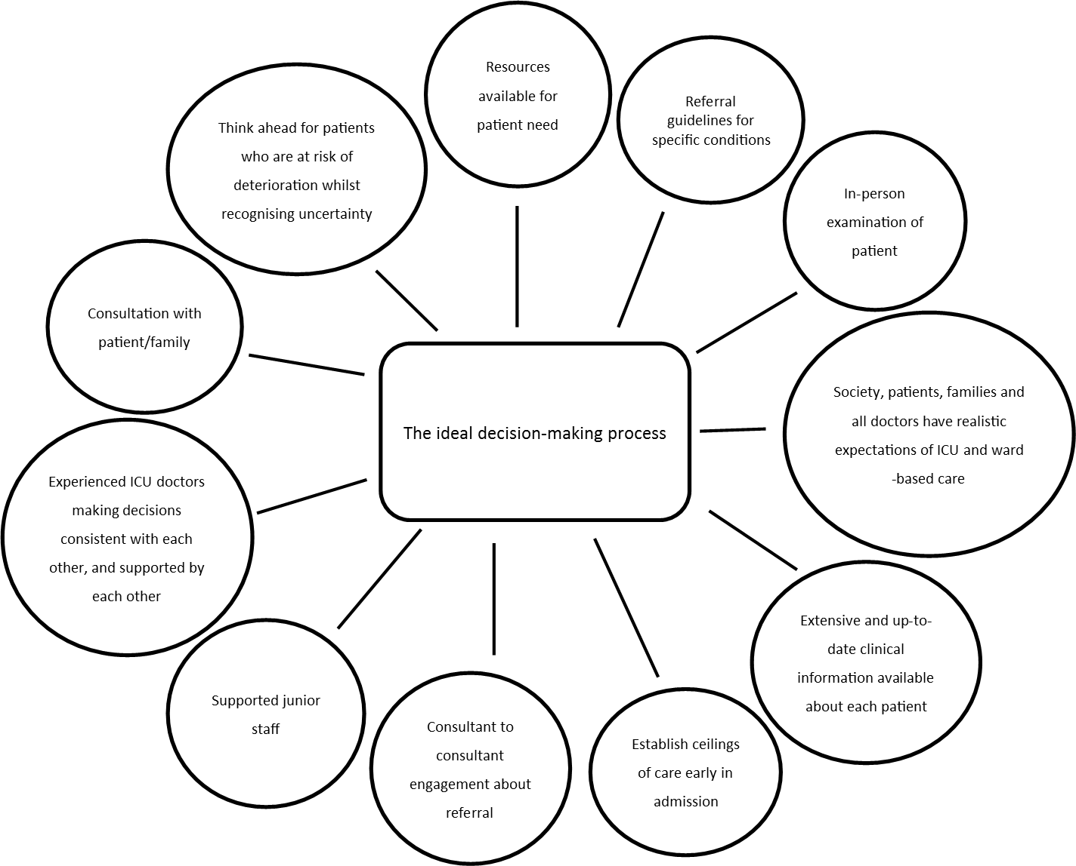
Figure 6 The ideal decision-making process

What is the range values associated with the decision-making process?
The analysis we have reported so far describes the ICU decision-making process and identifies what makes a good, poor or ideal process. In this section we add to this analysis the explicit and implicit values informing and framing the decision-making process identified through our empirical ethics approach. In Figure 7 we summarise the current ICU admission decision-making process (central column) and the values supporting a good decision-making process (left column) and the flaws contributing to a poor process (right column). We identify values that are intrinsic moral values such as respect, honesty, trust, and instrumental values that enable the realisation of intrinsic moral values, for example time, analytical skills, communication, and mentorship.

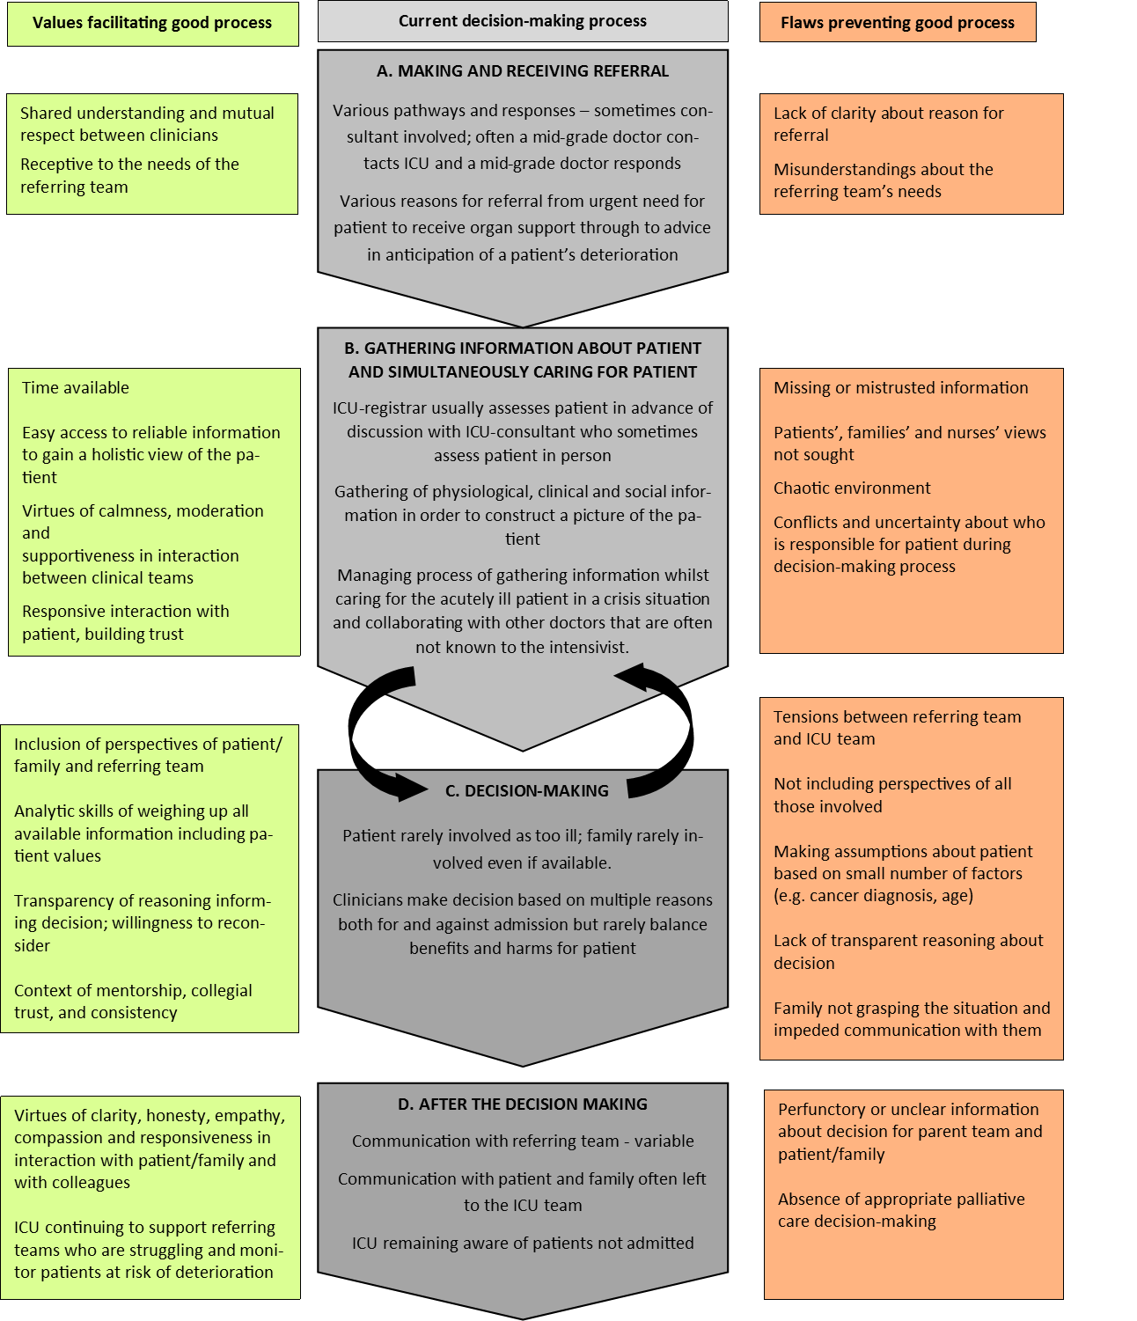
Figure 7 ICU admission decision-making process

What would constitute an ethically justifiable process for ICU admissions?
Our analysis so far shows that the decision making process for referral and admission to ICU is complex, context dependent, and shaped by underpinning ethical/moral values. In order to develop a normative framework in which to conceptualise an ideal decision-making process and to inform an intervention to support clinicians in achieving this we considered two separate but interlinked processes. First there is the decision about whether to refer or whether to admit an individual patient, and the cognitive process that a doctor should go through to make that decision. Second there is the wider process from referral through decision making to reviewing and communicating the decision as described in Figure 7. In identifying a normative framework for making the actual decision to refer or admit we considered common medical ethical frameworks such as the Four Principles approach or the four quadrant approach.^{156, 157} The elements of these frameworks were identified in our thematic and ethical analysis of our data. However we did not think that they captured the complexity of these decisions, the uncertainty of decision-making and the diversity of other values that fed into these decisions. We were also mindful that any framework we recommended should be so far as possible fit easily within usual clinical reasoning frameworks to increase the likelihood that doctors would engage with it. With regard to the wider process of referral and admission decision-making we wanted to capture the key values of communication, shared understanding, and ongoing review. The ethical framework of Accountability for Reasonableness’¹⁵⁸ appears to capture the key normative requirements identified from our analysis for a good decision-making process. The criterion for decisions to be based on reasons acceptable as relevant to all involved reflects the identified importance of holistic care, identifying and respecting patient and family views as well as those of other health care professionals, the criterion of transparency reflects the noted importance of communication and explicit ethical reasoning as well as the need for reflecting on personal biases when making decisions. The criterion of review and opportunity for appeal is also noted to be important in our data. Below we set out what from our analysis we consider the necessary elements for an ethically justifiable decision-making process (table 7), and the contextual and organisational requirements to support such a process. We describe how this normative framework informed the development of our intervention in Chapter six.
Table 7 Elements of an ethically justifiable decision-making process
Elements of decision-making process | Values
Gathering information about the patient’s clinical condition and functional status from as many informants as possible | holistic care
Identifying patient’s wishes, values, and expectations as expressed by the patient themselves or interpreted by their family when possible | person centred care/respect for autonomy
Recording or signposting the gathered information that forms the basis for the decision to refer/admit or not to ICU so it is accessible to others providing care for the patient | transparency
Explicitly identifying the reasons for and against referral/admission to ICU including:  - Need for ICU  - Ability to benefit from ICU  - Patient wishes  - Alternative treatment options (including palliative care) | ethical judgment
Clear communication with colleagues, patients and family, actively listing to their contribution, expressing empathy for their situation, and communicating the decision including any arrangements for review | respect
Being aware of own biases based on personal values/previous experience | honesty and integrity
Opportunity for respectful challenge to a decision | fairness

The context for such decisions should include:
- Understanding of what ICU can and cannot achieve both generally in society and specifically by all referring teams in the hospital
- Early decision-making about ceilings of care for patients
- Established referral pathway that recognises and accommodates the difference between referral during the working day and referral outside of the working day and the working patterns of different clinical teams
- Working culture of honesty and respect between referring and ICU teams taking account of their different pressures and limitations
- Working culture of mentorship for all junior staff so they learn with support and test their decisions with more experienced staff
- Availability of colleagues to discuss decisions, particularly those that are borderline or complex
- Tracking of referrals and regular discussion of cases for ongoing learning
The health care provider organisation needs to recognise the tensions created for their clinical teams when:
- Resources are limited for both ward based care for seriously ill patients and for ICU
- Work load and work patterns of clinical teams reduce availability of senior doctors for consultation by their junior staff

Summary
Our analysis provides a structured account of what will be recognisable to ICU and referring doctors. Our account of the patient/family member experience may be familiar to those with this experience, although our low recruitment rate may mean we have not captured the full diversity of their experience. This account of how ICU admission decisions are made provides a framework for developing an intervention to improve these decisions. The variation in how ICU doctors approach these decisions suggests consistency is an issue that the intervention needs to both tackle and provide a means of evaluating.
Doctors and patients/family members had good experiences of the decision-making processes which we need to preserve. The data on good experiences provides insights as to how and where an intervention could improve the process. When doctors obtained information about the patient’s wishes – whether from the patient or family member – this was highly valued for informing the decision. However, family members, even when available, were not always asked for their perspective. Balancing the reasons for and against admission was considered a good thing to do but was rarely observed in practice.
Poor experiences of decision-making were often linked to the difficult situation in which the doctors were working, for example having little information available about a rapidly deteriorating patient. Poor communication exacerbated these problems, so any intervention would need to support communication between teams and with patients/family members.
From participating doctors we elicited a detailed description of the ideal decision-making process. An intervention targeted at doctors can to tackle some aspects of the decision-making process where the experience falls short of the ideal, for example by encouraging balancing of reasons for and against admission, and talking to the family. Training and support could improve skills in communication between teams and with patients and family and improve understanding among clinicians of what can be achieved on ICU and on the wards. Other aspects of the process are beyond the reach of such an intervention, for example, resource provision and public understanding of what ICU can achieve.
Through elucidating normative values during our analysis we have been able to go beyond a description of the ICU admission decision to suggest what would constitute an ethically justifiable process for these decisions and the context that would support these decisions. This forms the foundation on which we can develop an intervention that aims to achieve a good process of ICU decision-making for as many patients as possible, whilst recognising the intrinsic difficulty of the decision itself.
Strengths and limitations
This project has several strengths. We had well defined research questions and a field-researcher familiar with the observation context which can be an advantage for focused ethnography.¹⁴⁷ Coming from a different European country gave the researcher some degree of an outsider’s perspective considered important for more classical ethnography (Higginbottom). The field-worker’s expertise in ethics meant she was able to draw on relevant frameworks whilst in the field to inform her conversations and interviews. Field-work occurred in a range of sizes of NHS hospitals, and at different times of the day/week providing variety in context for the ICU admission-decisions. Most NHS hospitals work within similar policy guidance and resource constraints so our findings are likely to be transferable to most NHS hospitals which have an ICU. Most doctors involved in observed decisions were willing to be interviewed. Analysis was undertaken by a team with diverse academic, clinical and research backgrounds who were able to challenge each-others assumptions.
Although we achieved some patient/family interviews we were disappointed not to achieve more and this could be seen as a key limitation of the project. This was despite taking extensive advice from the PPIAG. Taking part in research in this context is extremely difficult for patients and family. The patient is usually too sick to engage in a discussion about research and their family too worried about their loved one or too preoccupied with tasks associated with the crisis. More focus on training the clinical and nursing staff in how to support the families to participate in research at such a difficult time may have improved recruitment.¹⁵⁹ We attempted to recruit patients and families from post ICU clinics to increase our number of participants but this was also unsuccessful.
Doctors who did not refer during the observation period were interviewed by three different members of the team. This may mean the data from these doctors may not have been collected as consistently as other data. However, the team members worked on the interview schedule development together and read each-other’s interviews to minimise inconsistency. All members of the analysis team, and the researcher, had a clinical background so we lacked the perspective a non-clinical social scientist or ethicist would have brought to the data.

Chapter 5: ICU consultant and outreach nurses preferences for ICU admissions: a choice experiment

Introduction
Whilst our literature review and ethnographic study identified a range of factors that influence referral decisions, the extent of any influence, and the priority given to different factors, is not fully described. We used a choice experiment (CE) to investigate this issue. Our research questions were:
- What is the influence of patients’ characteristics and ICU admission outcomes on ICU consultants’ and outreach nurses’ decision-making?
- What are the decision rules used by clinicians and nurses to make their ICU decisions?
- What is the variability of the decisions rules and preferences among the clinicians and nurses?
- How do patients’ concerns influence decisions around admissions to ICU?

The specific objectives of this work package were to:
- examine consultants’ preferences for ICU admission (i.e. what is the importance consultants attach to the patient-related factors when making an admission decision and how the probability of admitting a patient to ICU is influenced by changes in the patient-related factors?) addresses research questions 1 and 4
- examine what factors influence critical care outreach (CCOR) nurses’ preferences for ICU admission addresses research question 1
- explore heterogeneity in preferences among consultants and nurses (i.e. do consultants/nurses differ in their preferences for ICU admission and could eventual differences be explained by personal characteristics of the health professionals?) addresses research questions 2 and 3
- compare preferences for ICU admission between CCOR nurses and consultants (i.e. do nurses give more (less) importance to some patient-related factors compared to consultants?) addresses research questions 2 and 3

Methods
We obtained a quantitative assessment of both ICU consultants’ and CCOR nurses’ preferences for ICU admission using the CE methodology.¹⁶⁰ This approach is frequently used in health economic and health services research to investigate patients’, public, and health professionals’ preferences for a range of topics.^{161, 162} In designing and analysing our CE we used the ISPOR guidelines.^{163, 164}.

A CE is an attribute-based survey technique based on the assumption that the extent to which an individual values a healthcare service (in our case ICU admission) depends on its features (in our case patient-related factors). The participants to a CE are typically asked to choose from a limited number of choice options which systematically differ in their composition. Such choices require individuals to make trade-offs among the different features, and this information is then used to estimate the importance given to the features.
Developing the CE questionnaire can be summarised into three main steps:
- identify relevant patients’ features for the ICU admission decision-making process;
- combine these patients’ features into hypothetical patients’ profiles and choice tasks;
- create the choice questionnaire.

Step 1 - Identifying patients’ features
A planned interim analysis of data from the initial systematic review (Chapter 3) and data from two of the six hospitals in our ethnographic study (Chapter 4) was used to identify relevant patient-related factors. The systematic review identified 88 studies that reported empirical research investigating factors associated with decisions to admit or refuse admission to ICU. From these studies we identified a list of factors to map onto the list identified from the ethnographic study. We excluded factors that were not relevant to a UK NHS context (e.g. presence of health insurance). For the ethnographic study, we observed 15 ICU referrals and interviewed the consultants as well as referring clinicians about their decision-making. We interrogated the observation field notes and interview transcripts for data where we could discern an influence on the decision-making process. These data were coded descriptively and the codes categorised into factors influencing the decision-making. These factors were then mapped to the list of factors identified in the systematic review to check for congruence and any additional factors. The resulting factors were grouped into categories of similar meaning to achieve a workable list for potential CE features. The qualitative data was checked to clarify meaning and to inform the decision to include or exclude an identified factor. For example, the data suggested ‘communication with colleagues’ was mainly about process and did not influence the decision itself, so the factor was excluded. The final list of factors included in the CE were all patient-related and covered the key factor categories from both the systematic review and ethnographic data. Clinician and organisational-related factors were reflected in the additional data collected in the choice questionnaire.
Family’s views regarding patient admission did not appear as an important factor in the systematic review. However the ethnographic study showed that this was a relevant factor to understand consultants’ admission decision-making. Moreover, one objective of this study was to determine whether patients’ preferences for ICU admission (as approximated by family’s views) significantly influence the decision-making.
The next step was to identify levels for each attribute. We divided the attributes into those that related to established clinical guidance or scores such as National Electronic Warning Score (NEWS), and those where we needed to draw on the qualitative data for levels. For the latter we re-interrogated the data to ensure we covered the breadth of levels of each attribute. Attribute ‘levels’ were selected to reflect the range of observed clinical situations in our qualitative study. Levels of co-morbidities were selected to reflect roughly comparable stages of disease: peri-diagnosis, established disease and advanced disease with limited survival. Attributes and levels are presented in Table 8.
Table 8 List of patient-related factors included in the choice experiment
Factor | Descriptor of level | Short form *
Age | 89 years | 89
Age | 79 years | 79
Age | 65 years | 65
Age | 39 years | 39
Type of main co-morbidity | Prostate cancer | PCa
Type of main co-morbidity | Ischaemic heart disease | HF
Type of main co-morbidity | Chronic Obstructive Pulmonary Disease | COPD
Type of main co-morbidity | Dementia | Dementia
Severity of main co-morbidity | For Ischaemic heart disease: Echo shows severe LV impairment; Numerous long hospital admissions; Biventricular pacemaker and on spironolactone and b.d. furosemide. | Severe
Severity of main co-morbidity | For Chronic Obstructive Pulmonary Disease: FEV1 28% predicted; 2 hospital admissions for exacerbations in the last year. | Severe
Severity of main co-morbidity | For prostate cancer: A recent CT scan revealed bone metastases. | Severe
Severity of main co-morbidity | For dementia: Forget many recent conversations and needs some help washing and dressing; family say they remain contented. | Severe
Severity of main co-morbidity | For Ischaemic heart disease: Moderate heart failure on echo; on regular furosemide and ramipril. | Moderate
Severity of main co-morbidity | For Chronic Obstructive Pulmonary Disease: FEV1 45% predicted; 3 courses of steroids and antibiotics over the last 12 months. | Moderate
Severity of main co-morbidity | For prostate cancer: Local spread on recent staging CT; on hormonal therapy with planned radiotherapy. | Moderate
Severity of main co-morbidity | For dementia: Started on Aricept in the last month. | Moderate
Severity of main co-morbidity | For Ischaemic heart disease: Previous MI; Recent echo shows LVH and a mildly decreased ejection fraction; on ramipril. | Mild
Severity of main co-morbidity | For Chronic Obstructive Pulmonary Disease: FEV1 65% predicted; 1 course of steroids and antibiotics in the last year. | Mild
Severity of main co-morbidity | For prostate cancer: On hormonal therapy. | Mild
Severity of main co-morbidity | For dementia: Recently referred by GP to memory clinic for suspected diagnosis of dementia; otherwise well. | Mild
Functional status | Mobilises around the ground-floor of their home; cannot manage stairs. Has carers twice a day. | Bad
Functional status | Mobile to shops with family; has to rest climbing stairs. | Intermediate
Functional status | Mobilises independently; walks dog daily. | Good
Severity of acute illness | NEWS score 11 | 11
Severity of acute illness | NEWS Score 8 | 8
Severity of acute illness | NEWS score 5 | 5
‘Look of patient’ as reported by registrar | Registrar saw the patient earlier and says that they look dreadful now. | Bad
‘Look of patient’ as reported by registrar | Registrar saw the patient earlier and tells you that they look like they are tiring. | Intermediate
‘Look of patient’ as reported by registrar | Registrar has seen the patient and tells you that they are stable, and “holding their own”. | Good
Safety (capacity) on referring ward | Patient is on a busy acute ward with 1 trained nurse per 8 patients; The ward sister is worried the ward cannot cope with looking after the patient. | Bad
Safety (capacity) on referring ward | Patient is on a busy acute ward with 1 trained nurse per 4 patients; critical care outreach nurses are available to provide further support. | Good
Family’s views | The patient’s family say that they think the patient would not want to be admitted to ICU. | No
Family’s views | The patient’s family say they have never discussed ICU admission or end-of life care: they will leave all the decisions to the medical team. | Unsure
Family’s views | The patient’s family have already approached the ward doctors and said that they insist on the patient being admitted to ICU. | Yes
* Short forms are used to simplify the presentation of the study results in tables and figures.

Step 2 - Designing patients’ profiles
The eight patients’ features were experimentally combined to form choice tasks following a multi-stage strategy.¹⁶³ First, we created a draft version of the CE questionnaire based on a D-Efficient design optimised for a multinomial logit (MNL) model with null priors (i.e. null a priori information about respondents’ preferences) and sent it to 30 ICU consultants. This quantitative piloting of the questionnaire fulfilled two objectives: to further improve the quality of the questionnaire by identifying wording issues and to obtain a set of preliminary results regarding consultants’ preferences for patients’ admission. We used this knowledge of consultants’ preferences to update the initial design of the experiment. This increased the statistical efficiency of the CE, allowing thus for a more precise measurement of respondents’ preferences.
As we were interested in measuring the main effects of changes in the eight patients’ features (e.g. increase in patient’s age) on admission decisions, and also potential interaction effects between the type and severity of main comorbidity, it was necessary to include a minimum of 24 choice tasks in the questionnaire.¹⁶⁵ Each choice task includes two hypothetical patient profiles (see Figure 8). Participants were asked to answer three choice questions: (i) Would you admit patient A? [Yes/No]; (ii) Would you admit patient B? [Yes/No]; (iii) Which patient should be admitted in priority? [A/B].
To reduce the cognitive burden the 24 choice tasks were divided into two blocks of twelve tasks, leading thus to two versions of the questionnaire. Participants were randomly allocated between these two versions. In addition to the twelve experimental tasks, we manually added a warm-up task (task #1) to familiarise the participants with the format of the choice tasks and two data quality checks (a repeat of the warm-up task (#14) to test stability of participants’ preferences for admission and a logical task (task #15) to check participants’ engagement). (More information about the data quality checks can be found in Appendix 6.) The order of the experimental tasks was randomised across participants to minimise ordering effects which may result from learning/fatigue.
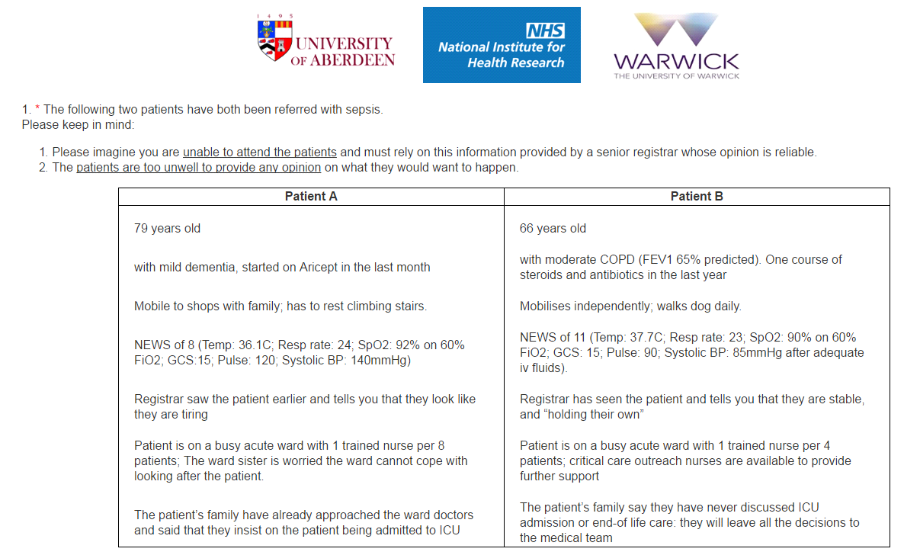
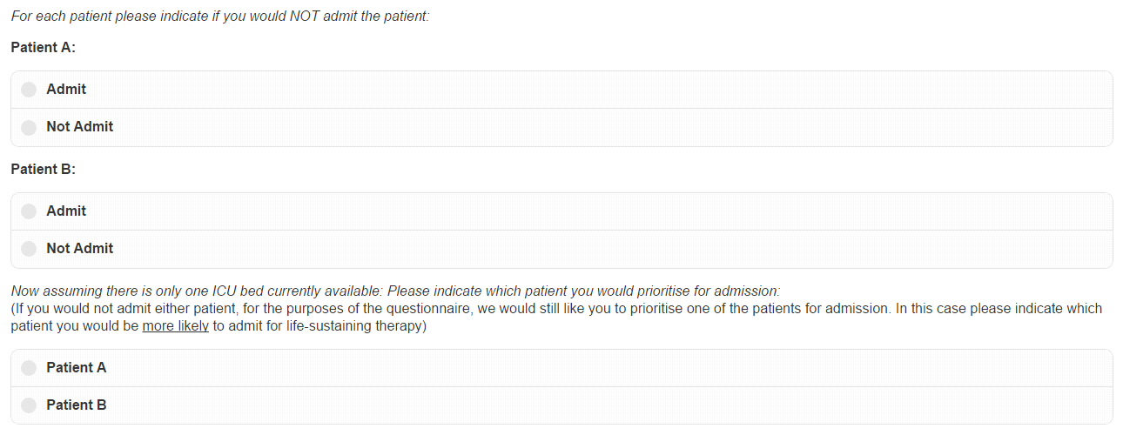
Figure 8 Illustration of the choice task format

Step 3 - Creating the choice questionnaire
In addition to the choice tasks, the questionnaire also included an information section which carefully explained the context of the study. We also collected information on respondent’s socio-demographic characteristics (e.g. age, gender) to ensure generalisability of our results. We worked with a UK based research company (ClinVivo) to develop an electronic version of the questionnaire. The questionnaire was scripted such that participants could respond either on a standard or tablet PC. The questionnaires can be found in Supplementary material 7-10 .

Sampling and recruitment strategy
Following a sample size computation for choice proportions¹⁶⁶, we needed to recruit a minimum of 130 ICU consultants and 130 CCOR nurses. For this sample size, it is possible to estimate a 33% choice probability with 90% accuracy and 95% confidence. However, we aimed to recruit more participants than the minimum needed to compensate for potential data quality issues (e.g. exclusion of participants who do not fully engage with the experiment), and to explore preferences heterogeneity. Therefore, we aimed for 300 consultants (303 obtained). Due to the smaller overall number of CCOR nurses nationally we could not increase the sample size to the same extent, so we aimed for 200 respondents (189 obtained).
ICUs in NHS hospitals were invited to participate through regional clinical research networks. See supplementary material 11 for a list of participating hospitals. An invitation to participate with a link to the CE was distributed to ICU consultants and CCOR nurses in each of the 47 participating hospitals by the local research nurses. In addition, an invitation to participate was emailed to all consultant members of the UK intensive care society and all members of the National Outreach Forum (for CCOR nurses).

Results: Consultants’ preferences for ICU admission

Sample of ICU consultants
The personal characteristics of the ICU consultants are shown in Table 9. The sample mainly included male consultants (79.5%), who do not work for a university hospital (63.7%). 21.1% were aged under 40 and 28.1% aged over 50 years. The majority (76.9%) had been working in ICU for more than ten years.
Table 9 Personal characteristics of ICU consultants and CCOR nurses
 |  | Consultants (N=303) % | Nurses (N=189) %
Gender | Male | 79.5 | 15.9
Gender | Female | 20.5 | 84.1
University Hospital | Yes | 63.7 | 59.8
University Hospital | No | 36.3 | 40.2
Number of ICU beds | <11 | 26.4 | 24.3
Number of ICU beds | 11-19 | 48.5 | 44.4
Number of ICU beds | >19 | 25.1 | 31.2
Years working in ICU | <5 | 4.3 | 40.7
Years working in ICU | 5-9 | 18.8 | 26.5
Years working in ICU | 10-14 | 22.8 | 18.5
Years working in ICU | 15-19 | 22.4 | 9.5
Years working in ICU | >19 | 28.1 | 27
Age | <40 | 21.1 | 32.8
Age | 40-49 | 50.8 | 40.2
Age | >49 | 28.1 | 27

Analysis of data quality
The results are reported in Table 10. The quality of responses was high, with 73.6% of participants meeting all four quality measures. No participants failed more than two tests; thus no respondent was removed from subsequent analyses. Criteria for assessing quality are reported in Appendix 6.
Table 10 Quality of choices made by ICU consultants and CCOR nurses
 |  | Consultants (N=303) % | Nurses (N=189) %
Logical consistency | Fail | 0.7 | 1.6
Logical consistency | Pass | 99.3 | 98.4
Choice stability | Fail | 0 | 1
Choice stability | Pass | 100 | 99
Choice desirability | Fail | 0 | 1
Choice desirability | Pass | 100 | 99
Response time | Fail | 14.2 | 9.5
Response time | Pass | 85.8 | 90.5
Summary –  quality score (no. of fail) | 0 | 73.6 | 71.4
Summary –  quality score (no. of fail) | 1 | 26.1 | 24.9
Summary –  quality score (no. of fail) | 2 | 0.3 | 3.7
Summary –  quality score (no. of fail) | >3 | 0 | 0

Preferences for ICU admission
We modelled consultants’ preferences for ICU admission within the random utility maximisation framework.¹⁶⁷
From responses it is possible to derive a full rank ordering of the choice options (e.g., if patients A and B should be admitted but A is prioritised over B, then it is possible to infer that Patient A > Patient B > No admission). From this implicit ranking it is possible to analyse consultants’ decisions as if they were made among three options (i.e., which option do you prefer among: admit patient A; admit patient B; admit none of them?). To take advantage of this data structure, we jointly analyse the probability of being 1st ranked (i.e., MOST preferred choice option) and last ranked (i.e., LEAST preferred choice option). This approach allows for a more accurate estimate of respondents’ preferences because: (i) a choice from three options generated more information about preferences than a choice between two options, and (ii) jointly modelling the MOST and LEAST preferred choices generate more observations about respondents’ choice behaviour than MOST preferred choices alone. This structure of the data is inspired from the best-worst scaling (BWS) literature.¹⁶⁸ [Lancsar et al, 2013].
For each participant (n), at choice task (t), the probability of the option (j) to be 1st ranked is noted $P_{ntj}^{MOST}$ and its probability of being last ranked is noted $P_{ntj}^{LEAST}$ (These probabilities depend on the subjective values of the choice options (U_{ntj}), determined by a linear additive combination (V_{ntj}) of patients’ features (X_{ntjk}) with consultants’ preferences (β_{nk}) and an error term (ε_{ntj}) that is typically assumed to be identically and independently distributed as type I extreme value, leading thus to a MNL specification.
$U_{ntj}=V_{ntj}+ε_{ntj}$ (Eq. 1)
$V_{ntj}=\sum_{k}{β_{nk}X_{ntjk}}$ (Eq. 2)
$P_{ntj}^{MOST}=\frac{exp\left(V_{ntj}\right)}{\sum_{j}{exp\left(V_{ntj}\right)}}$ (Eq. 3a)
$P_{ntj}^{LEAST}=\frac{exp\left({-V}_{ntj}\right)}{\sum_{j}{exp\left(-V_{ntj}\right)}}$ (Eq. 3b)
The estimated model parameters (β_{nk}) capture the effect of a marginal change in the patients’ features (e.g. “being 66 years old” vs. “being 39 years old”). We report the simulated maximum likelihood estimates (MLEs) of these (β_{nk}) preference parameters. To acount for the panel nature of the data (i.e. multiple choices per participant) we include an individual error term (ω_{n}) which is assumed to be Normal (0;σ_{ω}). Because of this error term, the model log-likelihood needs to be simulated. We used 1,000 Halton draws in addition to 200 draws as a ‘burn-in’ period and tried different sets of starting values to increase the chance of finding a global solution. To ease the interpretation of the results, we also compute odds ratios (ORs) and scores of relative importance (RI).¹⁶⁹
Results are reported in Table 11. All eight patients’ features have a significant effect on consultants' decisions. All three age-related effects are significant and positive, meaning that younger patients are more likely to be admitted into ICU. Patients with good mobility, more severe acute condition, who are not safe in their current (non-ICU) ward, who have a negative subjective assessment by the registrar, and for whom family insist on admission, are more likely to be admitted by the consultants.
Table 11 Preferences of consultants for patient admission to ICU
 |  | MLE (SE) | RI | OR [95% CI]
Constant (No admission) |  | 3.671 (0.131)*** | - | -
Age (Ref: 89 years old) | 39 years | 2.488 (0.074)*** | 23.9% | 12.04 [10.42 - 13.91]
Age (Ref: 89 years old) | 66 years | 1.609 (0.063)*** | 23.9% | 5 [4.42 - 5.65]
Age (Ref: 89 years old) | 79 years | 0.934 (0.066)*** | 23.9% | 2.55 [2.24 - 2.9]
Co-morbidity type (Ref: Prostate cancer) | COPD | -0.04 (0.06) | 3.8% | 0.96 [0.85 - 1.08]
Co-morbidity type (Ref: Prostate cancer) | Dementia | -0.391 (0.06)*** | 3.8% | 0.68 [0.6 - 0.76]
Co-morbidity type (Ref: Prostate cancer) | Heart failure | -0.292 (0.069)*** | 3.8% | 0.75 [0.65 - 0.86]
Co-morbidity severity (Ref: Severe) | Mild | 1.859 (0.063)*** | 17.9% | 6.42 [5.67 - 7.26]
Co-morbidity severity (Ref: Severe) | Moderate | 1.406 (0.062)*** | 17.9% | 4.08 [3.61 - 4.61]
Functional status (Ref: Bad) | Good | 1.489 (0.054)*** | 14.3% | 4.43 [3.99 - 4.92]
Functional status (Ref: Bad) | Intermediate | 0.978 (0.056)*** | 14.3% | 2.66 [2.38 - 2.97]
NEWS (Ref: score = 5) | 11 | 0.784 (0.058)*** | 7.5% | 2.19 [1.96 - 2.45]
NEWS (Ref: score = 5) | 8 | 0.12 (0.053)** | 7.5% | 1.13 [1.02 - 1.25]
Look (Ref: Good) | Bad | 1.055 (0.056)*** | 10.2% | 2.87 [2.57 - 3.21]
Look (Ref: Good) | Intermediate | 0.752 (0.06)*** | 10.2% | 2.12 [1.89 - 2.39]
Safety (Ref: Good) | Bad | 0.26 (0.041)*** | 2.5% | 1.3 [1.2 - 1.41]
Family views (Ref: Unsure) | No | -1.791 (0.061)*** | 19.9% | 0.17 [0.15 - 0.19]
Family views (Ref: Unsure) | Yes | 0.277 (0.051)*** | 19.9% | 1.32 [1.19 - 1.46]
SD Individual errors |  | 0.962 (0.054)*** | - | -
Effect significance: *** at 1%; ** at 5%; * at 10%
Model statistics: Respondents = 303; Observations = 7,272; Log-likelihood = -5,663.4
MLE: Maximum likelihood estimate; SE: Standard error; SD: Standard deviation; OR: Odd ratio; CI: confidence interval; RI: Relative importance

Patients’ age has the largest influence on consultants’ decisions (Relative importance (RI) = 23.9%) with 39-year-old patients 12 times and 66-year-old patients 5 times more likely to be admitted than 89-year-old patients (the reference group). This is followed by family views (RI = 19.9%). When the family is against admission (‘No’), the patient is 6 times less likely to be admitted than when family is unsure about admission. The third most important effect is severity of co-morbidity (RI = 17.9%). Patients with mild co-morbidity are 6.4 times more likely to be admitted than those with severe co-morbidity. Least important are type of main co-morbidity (RI = 3.8%), patient’s safety in non-ICU ward (RI = 2.5%), and the severity of acute condition/NEWS (RI = 7.5%). Patients with COPD, heart failure, or dementia are 1.04, 1.34 and 1.48 times less likely to be admitted than patients with prostate cancer.

Preferences heterogeneity among ICU consultants
We estimated a latent class logit (LCL) model to investigate preference heterogeneity.^{170, 171} This model allows identification of different segments (or classes) of consultants who differ in their preferences for ICU admission. These classes can be thought of as different preference patterns adopted by consultants to decide whether patients should be admitted. The LCL model is a popular approach in the CE literature to investigate preferences heterogeneity. Following the literature, we estimate several LCL models with an increasing number of preferences patterns (or latent classes) and retain the solution that optimises a measure of statistical performance known as Bayesian Information Criteria.
A solution with four preferences patterns provided the best model fit (Appendix 8). Results for these patterns are presented in Figure 9. In all four patterns consultants are more likely to admit younger patients, patients with a good functional status, patients who the registrar reports as ‘tiring’, patients with a less severe co-morbidity and where the family is not opposed to their admission. All four patterns appear to give little consideration to the level of resource in the non-ICU ward (safety factor) and to the type of co-morbidity. However, the four patterns differ in the importance given to the different patient-related factors. A perfectly balanced decision-making process, giving equal weight to all eight patient factors, would be associated with RI scores of 12.5% for each factor (i.e. 100% / 8 factors = 12.5).
We define the first preference pattern as an “Age-oriented” decision-making – whilst consultants in this group consider all patient-related factors (except type of co-morbidity and patient’s safety), they give slightly more weight to the patients’ age (RI = 24%). The second preference pattern describes an “Age-dominated” decision-making because decisions are largely driven by patient’s age (RI = 31%). The third preferences pattern is described as “Balanced” decision-making with consultants giving approximately similar importance to the eight patient-related factors. The last pattern indicates a “Family-dominated” decision-making (RI of family views = 35%). These four patterns represent 31% (“Age-oriented”), 33.2% (“Age-dominated”), 17.4% (“Balanced”) and 18.4% (“Family-dominated”) of the ICU consultants.
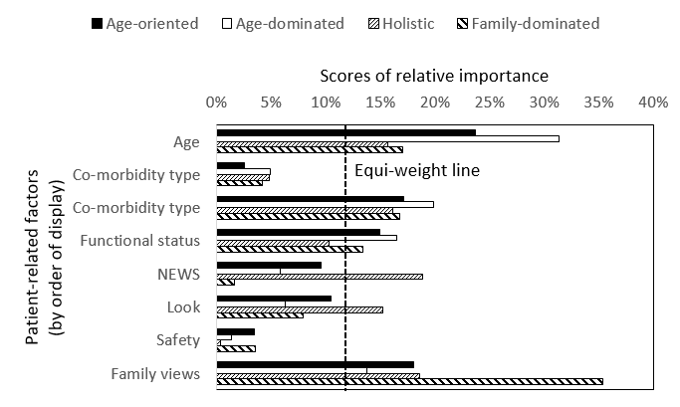
Figure 9 Preference heterogeneity among ICU consultants

Effect of consultants’ personal characteristics on preferences heterogeneity
We examined the effects of personal characteristics (see Table 9) on the probability of belonging to the different preference patterns by re-estimating the LCL model with personal characteristics as predictors of class membership probabilities. To maintain the structure of the LCL model we constrained all preference parameters to remain the same, and then only the effects of the personal characteristics are freely estimated. For mathematical reason, one class preference pattern has to be omitted, serving as a reference. We specified “Family-dominated” as the reference.
From a statistical perspective, the personal characteristics of the consultants explain very little of the variability in the preference patterns. Regression results are presented Regression results are presented in Table 12. Only six effects (out of a possible 30) reach significance at the 5% level. The admission decision-making of consultants older than 40 years is more likely to be “Age-oriented” and “Balanced” than “Family-dominated” compared to younger consultants. This is especially true for consultants older than 50 years (as indicated by relatively large ORs). Consultants working in a medium-size ICU (i.e. 11-19 beds) and university hospital are less likely to adopt “Age-oriented” and “Balanced” decision-making respectively.

Table 12 Effects of consultants’ personal characteristics on admission decision-making
 |  | "Age-oriented" | "Age-dominated" | "Balanced"
 |  | Reference: "Family-dominated"
 |  | OR [95% CI] | OR [95% CI] | OR [95% CI]
Constant |  | 2.11 [0.23 - 19.53] | 1.69 [0.21 - 13.54] | 0.79 [0.09 - 6.91]
Gender (Ref: Male) | Female | 0.77 [0.27 - 2.17] | 1.1 [0.43 - 2.85] | 1.68 [0.59 - 4.79]
Hospital (Ref: Not univ.) | Univ. | 1.07 [0.44 - 2.6] | 0.84 [0.35 - 2.03] | 0.34 [0.12 - 0.96]
Age (Ref: <= 40 years old) | 41-50 years old | 3.71 [1.15 - 12.01] | 2.43 [0.82 - 7.18] | 6.57 [1.47 - 29.4]
Age (Ref: <= 40 years old) | > 50 years old | 16.36 [3.22 - 83.14] | 4.9 [0.97 - 24.66] | 12.72 [1.84 - 88.11]
Experience in ICU (Ref: <= 4 years) | 5-9 years | 0.63 [0.06 - 6.29] | 1 [0.12 - 8.4] | 0.23 [0.02 - 2.24]
Experience in ICU (Ref: <= 4 years) | 10-14 years | 0.89 [0.09 - 8.76] | 1.53 [0.18 - 12.84] | 0.27 [0.03 - 2.63]
Experience in ICU (Ref: <= 4 years) | 15-19 years | 0.29 [0.03 - 3.19] | 0.44 [0.05 - 4.23] | 0.15 [0.01 - 1.6]
Experience in ICU (Ref: <= 4 years) | >= 20 years | 0.19 [0.02 - 2.28] | 0.24 [0.02 - 2.58] | 0.17 [0.02 - 1.99]
ICU size (Ref: <= 10 beds) | 11-19 beds | 0.33 [0.12 - 0.91] | 0.61 [0.22 - 1.66] | 1.15 [0.37 - 3.63]
ICU size (Ref: <= 10 beds) | >= 20 beds | 0.62 [0.17 - 2.2] | 1.26 [0.36 - 4.42] | 2.32 [0.53 - 10.2]
Model statistics: Respondents = 303; Observations = 7,272; Log-likelihood = -5,368.7
OR: Odd ratio; CI: Confidence interval

Influence of type of comorbidity on the effect of comorbidity severity
We re-estimated the model used for estimating consultant’s preferences allowing for interaction effects between preferences for type and severity of main comorbidity. The results are presented in Figure 10. Increasing severity of all co-morbidities is associated with a decreased likelihood of admission to the ICU, however differences are noted across the co-morbidities. For a mild level of severity, patients in all four co-morbidity groups are more likely to be admitted than “patients with severe prostate cancer”. When the level of severity changes from mild to moderate, the probability of ICU admission falls only in patients with COPD. At the most severe level, dementia is the co-morbidity most likely to result in the patient not being admitted to ICU, followed by severe heart failure then severe COPD. This pattern of results indicate that the effects of severity of main comorbidity on consultants’ decisions depend on the type of comorbidity.
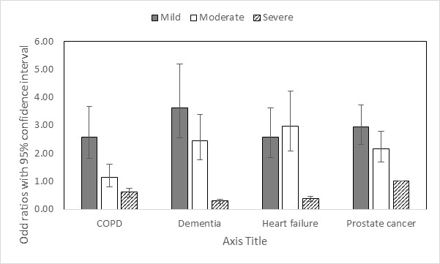
Figure 10 Interaction between the effects of type and severity of co-morbidity in consultants’ decisions
Notes: The dashed line indicates a null effect on consultants’ admission decisions (i.e. odds ratio = 1). There is no confidence interval reported for PCa_Severe because it corresponds to the reference category and then this effect was constrained to be null (odds ratio = 1). All the other effects were estimated relative to this reference category.

Results: CCOR Nurses’ preferences for ICU admission
In this section we analyse the CCOR nurses’ preferences, following the same structure and methods as above for ICU consultants.

Sample of outreach nurses
The personal characteristics of the nurses are shown in Table 9. The sample mainly includes female nurses (84.1%), who don’t work for a university hospital (59.8%) and are 40-49 years old (40.2%).

Data quality
Overall the quality of the choice data was good, with 71.4% of the outreach nurses fully satisfying all four quality criteria and none of them failing more than two tests (see Table 10). Therefore, all the observations are kept for the estimation of admission preferences.

Sample preferences of nurses
Results are reported in Table 13. All eight patients-related factors have a significant effect on nurses’ decisions. The patients’ age is the most influential feature with a score of relative importance (RI) of 21.6%. This is followed by both severity of main co-morbidity (RI = 17.1%) and severity of acute condition (RI = 17.4%). In comparison, two factors appear to have less influence on nurses’ admission decisions, the type of main co-morbidity (RI = 5.4%) and patient’s safety in ordinary (non-ICU) ward (RI = 3.4%). The largest and smallest effects on nurses’ decision are related to age and type of main co-morbidity respectively. On average a 39 year-old patient is 5.36 times more likely to be admitted than an 89 year-old patient everything else being equal. At the opposite, a patient with prostate cancer is only 1.06 times more likely to be admitted than a patient with dementia. The second most influential effect is being critically ill – a patient with a NEWS of 11 is on average 3.86 more likely to be admitted than a patient in a less severe condition (NEWS = 5).
Table 13 Preferences of CCOR nurses for ICU admission
 |  | MLE (SE) | RI | OR [95% CI]
Constant (No admission) |  | 2.944 (0.152)*** | - | -
Age (Ref: 89 years old) | 39 years | 1.679 (0.077)*** | 21.6% | 5.36 [4.61 - 6.23]
Age (Ref: 89 years old) | 66 years | 1.138 (0.072)*** | 21.6% | 3.12 [2.71 - 3.59]
Age (Ref: 89 years old) | 79 years | 0.615 (0.071)*** | 21.6% | 1.85 [1.61 - 2.13]
Co-morbidity type (Ref: Prostate cancer) | COPD | -0.421 (0.069)*** | 5.4% | 0.66 [0.57 - 0.75]
Co-morbidity type (Ref: Prostate cancer) | Dementia | -0.061 (0.073) | 5.4% | 0.94 [0.82 - 1.09]
Co-morbidity type (Ref: Prostate cancer) | Heart failure | -0.092 (0.076) | 5.4% | 0.91 [0.79 - 1.06]
Co-morbidity severity (Ref: Severe) | Mild | 1.328 (0.071)*** | 17.1% | 3.77 [3.28 - 4.34]
Co-morbidity severity (Ref: Severe) | Moderate | 0.831 (0.07)*** | 17.1% | 2.3 [2 - 2.63]
Mobility (Ref: Bad) | Good | 0.884 (0.06)*** | 11.4% | 2.42 [2.15 - 2.72]
Mobility (Ref: Bad) | Intermediate | 0.525 (0.062)*** | 11.4% | 1.69 [1.5 - 1.91]
NEWS (Ref: score = 5) | 11 | 1.352 (0.068)*** | 17.4% | 3.86 [3.38 - 4.41]
NEWS (Ref: score = 5) | 8 | 0.295 (0.061)*** | 17.4% | 1.34 [1.19 - 1.51]
Look (Ref: Good) | Bad | 0.946 (0.065)*** | 12.2% | 2.57 [2.27 - 2.92]
Look (Ref: Good) | Intermediate | 0.65 (0.063)*** | 12.2% | 1.92 [1.69 - 2.17]
Safety (Ref: Good) | Bad | 0.262 (0.046)*** | 3.4% | 1.3 [1.19 - 1.42]
Family views (Ref: Unsure) | No | -0.777 (0.064)*** | 11.5% | 0.46 [0.41 - 0.52]
Family views (Ref: Unsure) | Yes | 0.12 (0.059)** | 11.5% | 1.13 [1 - 1.27]
SD Individual errors |  | 1.104 (0.076)*** | - | -
Effect significance: *** at 1%; ** at 5%; *at 10%
Model statistics: Respondents = 189; Observations = 4,536; Log-likelihood = -3,950.7
MLE: Maximum likelihood estimate; SE: Standard error; SD: Standard deviation; OR: Odd ratio; CI: confidence interval; RI: Relative importance

Preferences heterogeneity among CCOR nurses
Five preference patterns were identified (see Supplementary material 12). For all classes nurses give similar importance to severity of co-morbidity (RI ranges from 14% to 17%) and patient’s safety in a non-ICU ward (RI ranges from 1% to 5%) (see Figure 11). The first preferences pattern gives relatively more importance to family views and functional status, and less importance to type of co-morbidity and severity of acute condition (NEWS). Given the importance given to family views (RI = 20%) we label this pattern as “Family-oriented” decision-making. The second preferences pattern gives relatively more importance to patient’s age and registrar’s assessment, and less importance to acute condition (NEWS). Given the importance given to patient’s age (RI = 27%) we label this pattern as “Age-oriented” decision-making. The third pattern gives relatively more importance to type of co-morbidity, functional status, severity of acute condition (NEWS), family views, and relatively less importance to registrar’s assessment. Given that most factors show a similar level of importance, we label this pattern as “Balanced” decision-making. The fourth pattern gives relatively more importance to severity of acute condition (NEWS) and less importance to functional status and family views. Given the importance given to NEWS (RI = 27%) we label this pattern as “NEWS-oriented” decision-making. The last pattern gives relatively more importance to severity of acute condition (NEWS) and less importance to functional status, family views and type of co-morbidity. This preferences pattern appears to be a more extreme version of the “NEWS-oriented” decision-making giving even more importance to NEWS (RI = 39%), and then is labelled as “NEWS-dominated” decision-making.
The “Family-oriented” decision-making represents 66% (n=125) of the sample; “Age-oriented” 18% (n=34); and “NEWS-dominated” 10% (n=18). The two remaining preference patterns represent very few nurses: 5% (n=10) and 1% (n=2) for “Balanced” and “NEWS-oriented” respectively. Whilst nurses’ decisions reveal more types of decision-making than for ICU consultants, the relatively large market share for “Family-oriented” suggests that CCOR nurses are less heterogeneous in their admission decisions than consultants.
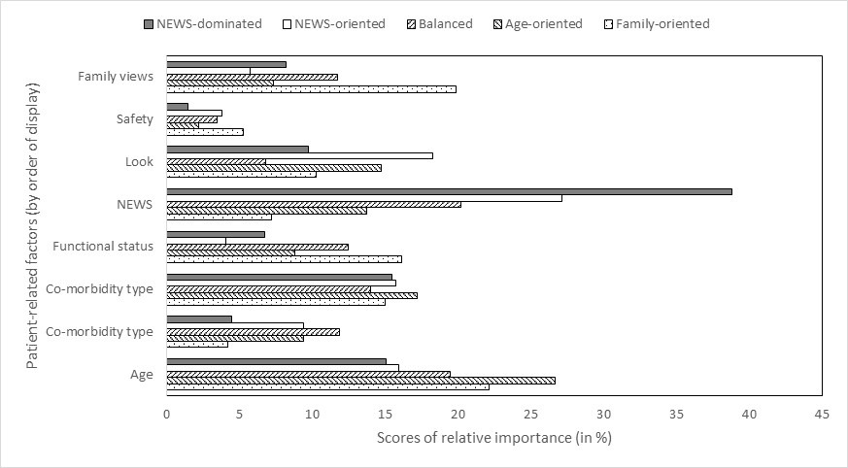
Figure 11 Preferences heterogeneity among critical care outreach nurses

Effect of nurses’ personal characteristics on preferences heterogeneity
Results are presented in Table 14. From a statistical perspective, allowing the personal characteristics of the nurses to predict decision-making styles leads to a minor improvement in performance. Whilst the log-likelihood of the model is improved (-3,681.8 -3,662.9), this comes at the expense of 40 additional model parameters, leading thus to poorer Bayesian information criterion (8,155 8,454). Only four effects (out of a possible 40) reach significance at the 5% level, suggesting thus a limited contribution of personal characteristics to heterogeneity in preferences. Everything else equal, CCOR nurses working in larger ICU (i.e. number of beds >= 20) are more likely to belong to adopt a “NEWS-dominated” decision-making than nurses working in smaller-size ICU.
Table 14 Effects of nurses’ personal characteristics on admission decision-making
 |  | "Family-oriented" | "Age-oriented" | "Balanced" | "NEWS-oriented"
 |  | Reference: "NEWS-dominated"
 |  | OR [95% CI] | OR [95% CI] | OR [95% CI] | OR [95% CI]
Constant |  | 2.57 [0.51 - 13] | 4.22 [0.65 - 27.15] | 0.98 [0.12 - 8.35] | 1.94 [0.28 - 13.47]
Gender (Ref: Male) | Female | 0.81 [0.23 - 2.77] | 0.58 [0.14 - 2.41] | 1.19 [0.23 - 6.18] | 1.11 [0.24 - 5.21]
Hospital (Ref: Not univ.) | Univ. | 1.51 [0.5 - 4.6] | 4.84 [1.29 - 18.19]** | 3.21 [0.8 - 12.88] | 3.14 [0.84 - 11.71]*
Age (Ref: <= 40 years old) | 41-50 years old | 0.81 [0.23 - 2.83] | 0.83 [0.2 - 3.5] | 2.18 [0.44 - 10.75] | 0.41 [0.08 - 1.98]
Age (Ref: <= 40 years old) | > 50 years old | 1.19 [0.24 - 5.83] | 2.85 [0.47 - 17.43] | 5.8 [0.86 - 39.14]* | 1.3 [0.2 - 8.41]
Experience in ICU (Ref: <= 4 years) | 5-9 years | 1.37 [0.38 - 4.97] | 0.36 [0.07 - 1.73] | 0.81 [0.18 - 3.61] | 1.17 [0.25 - 5.53]
Experience in ICU (Ref: <= 4 years) | 10-14 years | 0.81 [0.18 - 3.72] | 0.51 [0.09 - 2.94] | 0.4 [0.07 - 2.37] | 1.02 [0.15 - 6.96]
Experience in ICU (Ref: <= 4 years) | 15-19 years | 1.15 [0.18 - 7.26] | 0.15 [0.01 - 1.97] | 0.15 [0.02 - 1.57] | 0.09 [0 - 11.05]
Experience in ICU (Ref: <= 4 years) | >= 20 years | 1.34 [0.16 - 11] | 0.16 [0.01 - 4.64] | < 0.01 | 1.42 [0.11 - 19.03]
ICU size (Ref: <= 10 beds) | 11-19 beds | 1 [0.27 - 3.7] | 0.42 [0.1 - 1.73] | 0.38 [0.09 - 1.66] | 0.5 [0.11 - 2.2]
ICU size (Ref: <= 10 beds) | >= 20 beds | 0.38 [0.09 - 1.65] | 0.06 [0.01 - 0.38]*** | 0.1 [0.02 - 0.59]** | 0.13 [0.02 - 0.72]**
Effect significance: *** at 1%; ** at 5%; * at 10%
Model statistics: Respondents = 189; Observations = 4,536; Log-likelihood = -3,662.9
OR: Odd ratio; CI: Confidence interval

Influence of type of comorbidity on the effect of comorbidity severity
As with ICU consultants, there is evidence of interaction between type and severity of co-morbidity in CCOR nurses’ admission preferences (Figure 12). As anticipated, patients with mild co-morbidity are more likely to be recommended for admission than those with a severe prostate cancer. However, the magnitude of this effect depends on the type of co-morbidity. Everything else being equal, patients with mild prostate cancer are more likely to be recommended for admission than patients with mild dementia, COPD or heart failure. This pattern tends to be stable across severity levels.
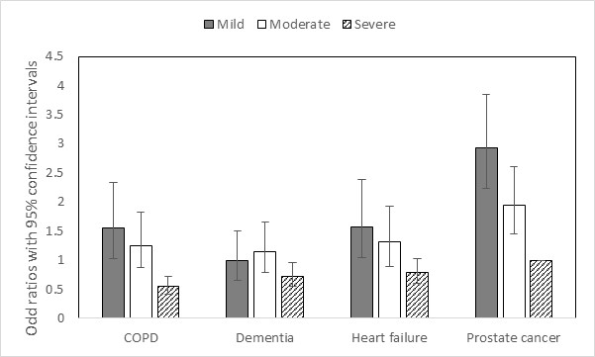
Figure 12 Interaction between the effects of type and severity of co-morbidity in nurses’ decisions
Notes: The dashed line indicates a null effect on nurses’ admission decisions (i.e. odds ratio = 1). There is no confidence interval reported for PCa_Severe because it corresponds to the reference category and then this effect was constrained to be null (odds ratio = 1). All the other effects were estimated relative to this reference category.

Comparison of consultants and outreach nurses’ preferences for ICU admission
Comparing results above suggests differences between ICU consultants and CCOR nurses. Notably we observe a smaller proportion of stable decisions for nurses (79%) compared to the consultants (88%) - this ~10 points difference reaches significance at 5% level (Chi-2 test: statistic = 6.82; DF = 1; P = 0.009). Lower levels of stability may indicate that ICU admission decisions are more difficult for CCOR nurses.
The two groups also differ in the relative importance given to the patient-related factors. Whilst severity of acute condition (NEWS) is ranked as one of the least important factors for consultants (RI = 7.5%; Rank 6/8), it appears to be one of the most important factors for nurses (RI = 17.4%; Rank 2/8). CCOR nurses give less importance to family’s views (RI = 11.5%; Rank 5/8) compared to consultants (RI = 19.9%; Rank 2/8).
It is important to note that the difference in preference patterns (β_{nk}) between nurses and consultants may be caused by differences in true preferences (e.g. consultants would give more (less) weight to family’s views than outreach nurses) and/or differences in consistency of choices (e.g. nurses would be less (more) consistent than consultants in their admission decisions). This is because the estimated parameter, β_{nk}, is the product of a true preference and errors-related parameters. When comparing preferences between ICU consultants and CCOR nurses it thus becomes important to make a distinction between changes in true preferences vs. choices consistency (as approximated by variance in the model errors), as they would have different implications. For example, differences due to changes in the level of choices consistency suggest that outreach nurses are less confident than ICU consultants in making admission decisions, which might reflect their limited participation to the decision-making process in real life situations.
We thus compare consultants’ and nurses’ preferences for patients’ admission following a multi-steps approach. We first test for the existence of a systematic change in choice consistency between nurses’ and consultants’ decisions, estimating a heteroscedastic MNL model. This allows the choice consistency to be a function of type of respondents (i.e. nurse vs. consultant). The results, shown in Figure 13, suggest a negative and significant effect, indicating that on average CCOR nurses are less consistent than ICU consultants in their admission decisions.
We then determine whether this difference in choice consistency would explain all the differences in parameter estimates between the two samples. This is done by comparing the statistical performance (as measured by the log-likelihood value at convergence) of different MNL models. Under the assumption of similar choices consistency but dissimilar preferences (H₁), the joint model log-likelihood for the two samples is -10,057.1. Under the assumption of similar choices consistency and preferences (H₂), we obtain a log-likelihood of -10,295 points. Under the assumption of dissimilar choices consistency but similar preferences (H₃), we obtain a log-likelihood of -10,206.7 points. The comparison of these three values indicates that allowing preferences for patients’ features to differ between the two samples would improve modelling performance more than allowing for changes in choices consistency (H₂-H₁ = -237.9 vs. H₂-H₃ = -88.3). This result suggests that outreach nurses and ICU consultants are likely to differ in their true preferences for patients’ admission in addition to differences in the consistency of their choices.
Given these likely differences, we compare the preferences between the two samples by estimating a MNL model of the trade-offs between patients’ age and the other features. A similar approach has been used to directly estimate how much individuals would be willing to pay for changes in product composition.¹⁷² In our case this approach is technically appealing because it rules out the influence of changes in choices consistency.
Overall nurses and consultants appear to hold similar preferences regarding patients’ admission – for most patients’ features the confidence intervals overlap. However, some significant differences exist. Consultants give significantly more weight to family’s views than nurses. The trade-off between “family insisting for admission” (fami2 parameter) and patients’ age are 37.08 and 24.06 years for the consultants and nurses respectively, indicating thus that “family insisting for admission” is 1.5 times more important for consultants than nurses (i.e. 37.08 / 24.06 = 1.54). Nurses also give significantly more weight to the severity of acute condition (NEWS score). A severe acute condition (new1 parameter) with “NEWS = 11 (Temp: 37.7C; Resp. rate: 23; SpO2: 90% on 60% FiO2; GCS: 15; Pulse: 90; Systolic BP: 85mmHg after adequate iv fluids)” being 2.3 times more influential in nurses’ decisions compared to consultants (i.e. 40.17 / 17.61 = 2.28). Lastly, nurses and consultants differ in terms of importance given to COPD, with almost no impact on consultants’ decisions and a large effect on nurses’ decisions (i.e. Ratio: 13.74 / 0.54 = 25.42). Appendix 7(table 34)
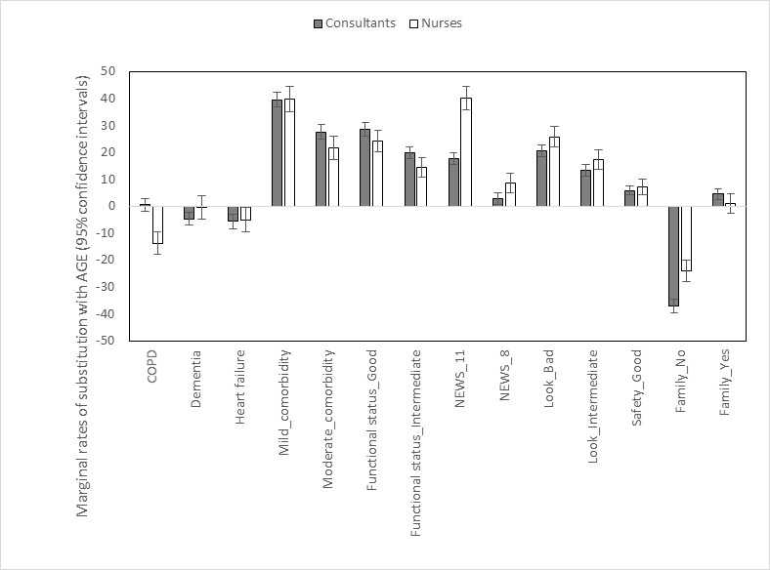
Figure 13 Comparison of preferences between ICU consultants and CCOR nurses
Legends:
MRS - Marginal rate of substitution between patient-related feature and patient’s age.
The patient-related features are: Family’s views: {fami1: No; fami2: Yes}; Registrar assessment: {look1: Bad; look2: Intermediate}; Mobility: {mob1: Good; mob2: Intermediate}; Severity of acute condition: {new1: NEWS=11; new2: NEWS=8}; Safety: {safe1: Bad}; Type of main comorbidity: {type1: COPD; type2: Dementia; type3: Heart failure}; Severity of main comorbidity {sev1: Mild; sev2: Moderate}.

Summary
This study is the first to use a validated economic method to elicit consultants and outreach nurses’ preferences for patient’s admission to ICU.
In terms of relative importance of the patient-related factors, our main study results indicate that: (i) patient’s age is by far the most important determinant of consultants’ admission decisions; (ii) severity of main co-morbidity has more influence on consultants’ decisions than severity of the acute condition (as measured by the NEWS score); (iii) patient assessment by the registrar has more influence than objective clinical assessment (NEWS score).
Our results show considerable heterogeneity in consultants’ preferences. About a third of the consultants give priority to functional status, severity of co-morbidity and age when deciding whether to admit the patients, 31% make admission decisions largely driven by patients’ age, 17% appear to give approximately the same importance to different types of information, and the last group gives more importance to the family views.
Our results also indicate a complex relationship between type and severity of main co-morbidity. As expected, patients presenting a more severe co-morbidity are less likely to be admitted than patients with a less severe condition. Whilst a priori consultants do not appear to discriminate among the four types of co-morbidity (COPD, prostate cancer, heart failure, dementia), this is no longer the case once severity is taken into account. For instance, patients with a moderate COPD are less likely to be admitted than patients with a mild severity of any other condition.
Finally, our results indicate the existence of differences between CCOR nurses and ICU consultants in their admission decision-making. Outreach nurses appear to be less consistent in their admission decisions than consultants, and give more importance to clinical features (e.g. NEWS score).
Our study results can be used to inform ICU consultants about the existence of potential biases in their admission decision-making. In line with this educational purpose and to best communicate our study results to consultants, we have developed two “ICU admission simulators” (https://warwick.ac.uk/fac/med/research/hscience/sssh/research/intensive/ and also see Appendices 8 and 9). The first simulator can be used to see how the probability of ICU admission changes with patient’s characteristics (as described in the CE). The second simulator was developed to explore preferences heterogeneity. The user is asked to answer a limited number of choice questions as presented in the CE. Based on their answers and study results, the simulator predicts their probability of belonging to the four preference patterns identified in the study.

Strengths and weaknesses of the study
The study uses a validated and powerful preferences-elicitation method (namely choice experiment) to understand how consultants and CCOR nurses make admission decisions. Then we recruited a large representative sample of ICU consultants. We achieved a relatively high level of data quality, indicating thus that the preferences-elicitation instrument was well accepted by participants. We used a combination of ethnographic observations and systematic literature reviews to identify the most relevant features. A difficulty with all Choice Experiments, including this one, is that participants are asked to make hypothetical decisions, in this case regarding ICU admission. Whilst the choice tasks were created to mimic real-life situations, we cannot guarantee that ICU consultants and CCOR nurses would have made the same choices if the tasks were real.

Chapter 6: Development of an intervention to support decision-making around referral and admission to intensive care

Introduction
Having investigated what is currently known about the decision-making process in our systematic reviews, and explored current practice and experience in our ethnographic study, we drew on our findings to develop an intervention that would support consistent, transparent and ethically justifiable, patient-centred decision-making. In developing the Decision Support Intervention (DSI) we were aware that it needed to be feasible to implement in daily practice.
Our specific objectives were:
- To develop a decision support framework for decisions around referral and admission to ICU
- To develop support and training materials for clinicians using the framework
- To develop information for patients and families on decisions to refer and admit to ICU
From our preceding work (systematic reviews, ethnography and choice experiment) we identified the key patient-related, situational, and process-related factors that influenced (or were thought should influence) decisions around referral or admission to ICU. Using data from all three sources provided triangulation and strengthened our evaluation of these factors as being relevant to the decision-making process. These factors could then be emphasised, supported, or mitigated for within the intervention. From our ethnographic study, we also mapped the temporal and relational aspects of the decision-making process, the points of conflict, and the implicit and explicit values that informed it. This enabled us to map the DSI to current practice that would be recognisable to clinicians, and to address points of conflict and value positions in the associated educational support. Finally, the analysis in our ethnographic study specifically focussed on what would constitute a good decision-making process and the normative framework to support this. This analysis fed directly into the development of the DSI and the implementation plan. For example, our analysis identified the importance of involving patients and their families in the decision-making process and of explicit balancing of harms and benefits, and the infrequency with which either of these occurred in practice. The choice experiment identified different preference patterns among ICU doctors, and this finding supported the need for explicit articulation of reasons when making a decision. Thus in developing the DSI we needed to include prompts for both patient and family involvement and explicit balancing of reasons.

Development of the decision-support intervention (DSI)
The development of the decision support intervention (DSI) (conceptual framework plus supporting resources) was in four phases:
1. Initial development of a draft DSI (conceptual framework and supporting resources):
2. Presentation of the DSI at a stakeholder conference including focus groups to identify areas for revision and refinement.
3. Post-conference refinement of the DSI based on this feedback:
4. Development of educational materials
5. Refinement of the implementation strategy using Normalisation Process Theory

Initial development of DSI

Developing a conceptual/cognitive framework
The first step was to develop a “best practice” conceptual framework for decision-making, based on our previous work, that encapsulates what is important/essential for patients and clinicians in practice and what is ethically required.
Ethical reasoning is an integral part of clinical decision-making but is often implicit rather than explicit. Findings from our systematic review and ethnographic study show that clinicians’ values influence their decision-making, and that they do not explicitly balance different empirical and normative considerations when making a decision. There are some ethical frameworks and heuristics used in teaching medical ethics, most commonly a principlist approach. However it seems unlikely from our observation work that providing a theoretical ethical framework for use in day-to-day practice would be successful. In seeking to develop a framework that could be embedded in daily practice, be congruent with clinical decision-making, and prompt ethical reasoning, we identified the ‘accountability for reasonableness’ (AFR) framework ¹⁵⁸ as the most useful model on which to build our decision support framework. This is a commonly used ethical framework for considering allocation of limited medical resources and focuses on the process of decision-making rather than relying on a specific moral theory. AFR has four requirements, decisions must be transparent; based on reasons stakeholders can agree are relevant; revisable in the light of new evidence and arguments; and that there should be an appeals process. Other authors have highlighted the requirement for priority setting decisions by clinicians (including ICU admissions) to be transparent (AFR requirement 1) and ethically justifiable (AFR requirements 2 and 3).^{173, 174}Any framework to support decision-making therefore should improve the transparency and ethical justification of decisions regarding referral and admission to ICU. A further ethical requirement is one of equity, which can be interpreted as consistency of process (the factors taken into account and the process of decision-making should be consistent across all patients and all decision makers.

Process of developing the framework
A generic model of the steps in the decision-making process, based on the findings from our ethnographic study was created (Figure 14).
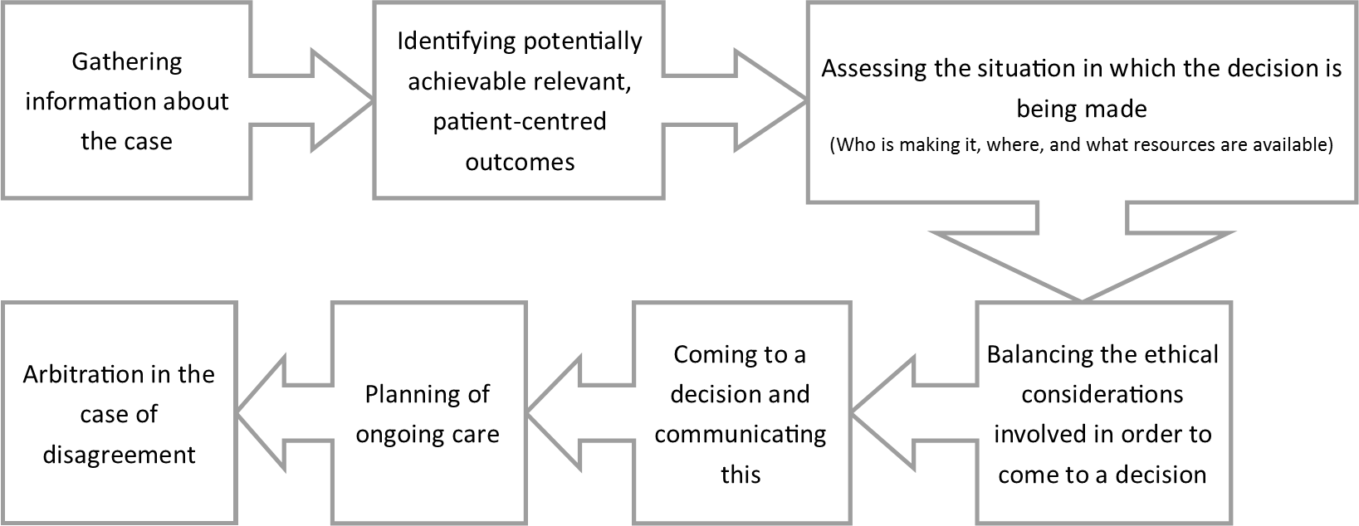
Figure 14 The generic model decision-making process
Clinical and non-clinical members of the research team were then asked to map the factors identified in the qualitative study and systematic reviews (tabulated in Appendix 10) to relevant stages of the process. From this a draft framework was developed specifying content at each stage in the decision-making process and ensuring that overall it was consistent with the AFR ethical requirements. The resulting framework was discussed and refined in a series of meetings involving members of the research team and two members of our PPIAG. The draft framework was then used as a basis for developing the supporting materials (Table 15).
Table 15 Draft Decision Support Framework
Stage in process | Factors to consider
Gathering relevant information | Clinical information about current acute illness and relevant chronic illness  Functional reserve of patient  Patient values, wishes and outcomes relevant to patient  Need to recognise clinician biases in interpretation of information
Assessing and evaluating the situation | Ward situation/resources available  ICU resource availability (beds/nursing staff  Urgency of decision  Experience of clinicians involved in decision
Balancing the ethical considerations in order to come to a decision | Explicit balancing of potential harms and benefits and reason for decision
Making and communicating the decision | Specifically informing medical and nursing staff of decision and reasons for it  Communicating decision and reasons for it to the patient and/or their family
Planning of ongoing care | Specific documentation of plan for review including who, when and in what circumstances
Arbitration in cases of disagreement | System and process in place to support this

Development of supporting resources for clinicians
The supporting resources of the draft decision-support intervention were:
- Documentation to prompt and record best practice in the referral and decision-making process
- Patient and family information leaflets to help them participate in the decision-making process.
- Educational resources to support the implementation of the intervention

Development of the decision support documentation
We developed a referral form (for use by the referring team) and a decision support form (for use by ICU doctors). The aim of the forms was to provide a framework for the clinician within which to structure their decision, and prompt them to include the key steps identified as necessary to ensure an ethically justified decision-making process. A series of drafts were produced and revised at a number of meetings of the research team and members of the PPIAG. Feedback was also sought from clinicians at sites that had participated in the ethnographic study on their format and usability. Final versions, following revisions informed by the stakeholder conference are presented in Appendices 11 and 12.

Electronic format
As part of the development work, we worked with the Health and Social Care Information Centre, now NHS Digital, to develop an electronic version of the referral and decision support forms. Draft electronic copies of the referral and decision-support forms were created in the Lorenzo¹⁷⁵ electronic health record system by collaborators at HSCIC. This team also developed system agnostic criteria for electronic versions of the forms that could be used by individual NHS Trust IT developers to incorporate the forms within local operating systems.

Development of patient and family information leaflets
Draft patient and family information leaflets were initially developed by a member of the study patient and public advisory group (PPAG). This was then refined and expanded by the research team and other members of the PPAG drawing on the findings of the ethnographic study, particularly interviews with patients and families. These were presented at the stakeholder conference. Final versions including revisions following the stakeholder conference can be found in Appendices 13 and 14.

Consensus conference
A one-day conference was held in July 2016 at the University of Warwick to gain the views of a wider stakeholder population regarding the content of the DSI and facilitators and barriers to its implementation.
Delegates were invited from the following stakeholder groups (see Appendix 15 for list of delegate representatives):
- Patients:
  - People who had survived a critical illness
  - Patient groups who may be particularly likely to need intensive care treatment (e.g. heart disease, lung disease)
  - Patient groups who may be disadvantaged in terms of access to health care (e.g. learning disability)
- ICU doctors (including professional body representation)
- ICU nurses and CCOR nurses (including professional body representation)
- Referring specialty clinicians (e.g. cardiology, renal, elderly medicine, respiratory, surgery)
- Regulatory authority, legal, and health care management representation

Method
Meeting sessions were chaired by a PPI co-investigator (CW) and by a senior member of the Faculty of Intensive Care Medicine. Before the event, delegates were sent copies of the draft DSI and a summary of the findings of the research to date. The event included presentations of the research on which the DSI was based and a demonstration of the electronic version of the referral and decision support form. Delegates then participated in focus groups in which they were asked to consider specific elements of the intervention and answer a series of questions relating to these elements (see supplementary material 13 for topic guides). Each focus group included a cross section of delegates to ensure a balance of disciplines and backgrounds within each group. The focus groups were facilitated by a member of the study team and the discussion was captured by a medical student acting as scribe. The discussion was recorded with participants’ consent and recordings used to check accuracy when interpreting the written notes of the discussion. All focus groups were asked to consider the referral form and the decision support form, and either patient or family information leaflet or learning outcomes for educational resources. Two key points from each group on each element considered were transcribed onto flip chart paper and placed around the main meeting room. In a subsequent plenary session all delegates were asked to read the flipcharts and write any further thoughts or suggestions on sticky notes and attach them to the flip charts.

Analysis
Following the conference, the scribes’ notes and points from the sticky notes were circulated to two members of the research team (AS and HH) for analysis. The data was categorised under the headings: referral form and process; decision support framework; patient and family information; education; and barriers and facilitators to implementation. A summary of this analysis was used by the research team to refine the documentation and develop a strategy for implementation of the DSI.

Post consensus conference development of the DSI
A conference report, including the summary of key points and the changes made to the intervention in response, was sent to all delegates with an invitation to provide further comment (see Appendix 16.) The DSI was then finalised for use in the implementation feasibility study. The changes made to the components of the DSI are outlined below.

Refining the components of the intervention
Development of the referral and decision-support documentation: The focus of all of the components of the DSI was broadened to include decision-making regarding all forms of critical care support. The term ‘family member’ was changed to ‘person closest to the patient’. The referral form was modified to be closer to the SBAR (Situation, Background, Assessment, and Recommendation) format. Specific questions related to ICU bed availability and ward capacity were removed and reframed to ask first, what was the optimum treatment for the particular patient, and then to ask where this care could be safely delivered.
Development of the educational package: Key suggestions were incorporated into the development of training materials including: the importance of communication; relevant knowledge of legal and regulatory frameworks; a clear ethical framework; and guidance for using the forms (see supplementary material 14 for copies of educational materials).
Development of the patient and family support material: New drafts of the patient and family information leaflets were written by members of the PPAG and our PPI co-investigators. Notably the use of separate leaflets for patients and family/friends were developed rather than a single combined leaflet. The language was simplified and the layout improved. The finalised leaflets were Crystal marked by the plain English Campaign.¹⁷⁶

Refining implementation of the intervention
To identify potential difficulties in the implementation of the DSI and improve the chances of its successful implementation eight intensive care consultants and CCOR nurses from sites that had been involved in the ethnographic study attended an implementation planning meeting. The meeting used an adapted normalisation process theory (NPT)¹⁷⁷ (see supplementary material 15) toolkit: a way of exploring changes to practice to understand how an innovation is implemented and integrated into the work of an organisation.
The DSI was presented, and how it was perceived was explored using adapted questions from the NPT toolkit. Responses were categorised into the four constructs of NPT: coherence (could they make sense of the intervention); cognitive participation (could they envisage their colleagues and other key stakeholders actively engaging in this process); collective action (could they envisage this working in practice and what might be the barriers and facilitators); and reflexive monitoring (how could they envisage the intervention changing practice and how would they evaluate this) (see supplementary material 15). This analysis revealed particular concerns regarding the active engagement of all stakeholders, and uncertainty around organisational support for the intervention creating difficulties for implementation.
In response to this feedback, we adapted our implementation strategy to include approaching the Medical Directors of each NHS Trust participating in the implementation study to secure organisational support for the intervention and research. We also adapted our educational resources and the train-the trainer sessions to encourage and support stakeholder engagement.

The Decision-support intervention
The final Decision Support Intervention is described briefly below.

Guidance for referral for intensive care support
We developed guidance to improve communication between clinical teams around referral. The guidance is summarised as follows:
- Referral to intensive care should not be delegated to junior members of the clinical team.
- Referring teams should clearly articulate what support they are seeking from the intensive care team.
- Benefits and burdens of intensive care should be considered for each patient.
- Ensure the patient and/or their family has been consulted in the referral process.
- The referral should follow recognised best practice using the SBAR format.
The referral form (Appendix11 ) provides a structured format, format, for information gathering and communication with the intensive care clinicians to facilitate a collaborative decision-making process.

A decision support framework to guide ICU doctors when making decisions
The framework describes best practice for decision-making in three domains: 1. Evidence; the collection of information relevant to the decision. 2. Reasoning; using this evidence to identify relevant outcomes, balance the burdens and benefits of treatments and make recommendations for treatment. 3. Implementation: ensuring that decisions are acted upon and communicated effectively. It aims to integrate ethical reasoning within the decision-making process, in a practical and accessible manner. The decision support form (Appendix 12) enables a record of the decision-making process to be recorded to facilitate transparency and consistency of decision-making.
A pocket-sized aide memoire (Figure 15) which includes the referral guidance on one side and the framework for decision-making on the other was provided to act as a reminder of the referral guidance and decision framework to referring teams and ICU doctors
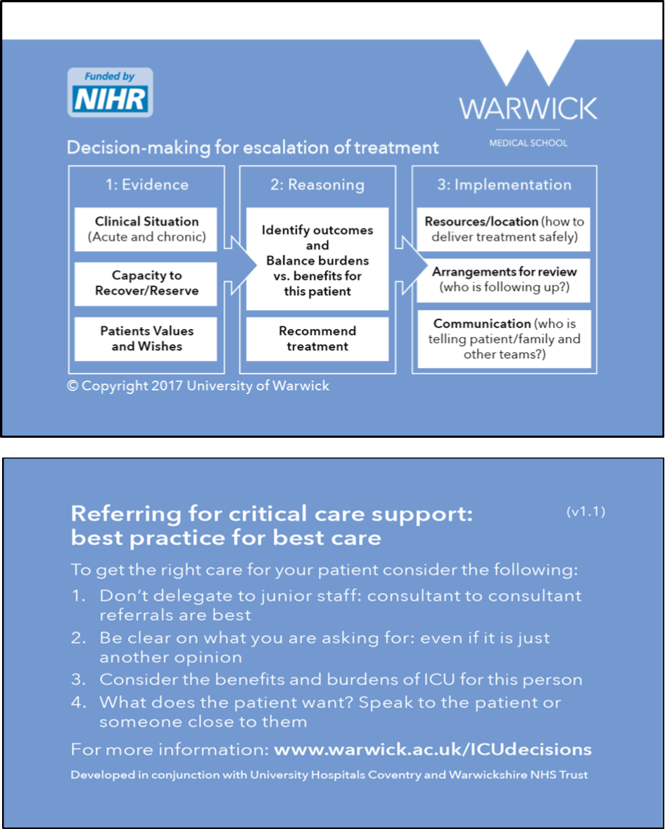
Figure 15 A pocket-sized summary of the cognitive framework to act as an aide memoire

Patient and family support information
Patient and family information leaflets (Appendices13 and 14) to be given to patients and/or their families/someone close to them when they are recognised as being critically unwell and a decision regarding ICU referral is being considered. The leaflets are intended to support discussion between clinicians and the patient/family and not to be given in isolation.

Educational resources
Educational resources to support the implementation of the decision-support intervention included (see supplementary material 14):
- “Train-the-champion” session for implementation champions (including an introductory presentation to the legal and ethical background)
- A presentation of the DSI and its rationale at hospital Grand Rounds or other formal meetings.
- A shorter presentation for use at more informal or smaller departmental meetings, for example Quality Improvement meetings.
- A brief ‘key points’ presentation for opportunistic teaching of individuals or small groups.
- A table-top case based simulation exercise to familiarise clinicians with the intervention.
The final version of all components of the DSI formed the basis of our implementation feasibility study (Chapter 7).

Summary
This chapter has described the development of an intervention to support best practice in decision-making for escalation of treatment and admission to intensive care. The development was informed at each stage by the findings of our preceding work packages and input from our PPI co-investigators and advisory group. Accountability for Reasonableness provided the normative framework for the intervention. It was developed to fit with established clinical practice while offering support for improvement in that practice, and supported by resources to increase the likelihood of successful implementation.

Chapter 7: Feasibility study to explore implementation of the decision support intervention

Introduction
In this chapter we report on an assessment of the feasibility of implementing the DSI in the context of NHS daily practice.
The objectives of the feasibility study were:
- To demonstrate the feasibility of implementing the Decision Support Intervention (DSI) at an organisational level, including its associated materials and training, in the context of a busy NHS trust.
- To explore intervention fidelity reviewing the actual use of the DSI, its impact on decision-making, and how this compares to its intended use.
- To explore the acceptability of the intervention, including the training and DSI materials to referring and ICU doctors.

Methods

Settings and recruitment
A description of the study was circulated to intensive care leads through the NIHR Clinical Research Network. ICU leads were asked to indicate their interest in participating in the study and to state the number of ICU beds in their Trust. We purposively sampled by size of ICU: one small (<20 ICU beds); one medium (20-30 ICU beds); and one large (> 30 ICU beds).
We worked with the Principal Investigator at each selected Trust to identify implementation champions (ICs), who were tasked with planning and running the implementation at their Trust. The identified champions were: site A, an ICU consultant and critical care outreach (CCOR) nurse; site B, two ICU senior trainees (registrars); site C, an ICU consultant and two CCOR nurses sharing the role.

Pre implementation
Prior to implementation at each site we ran a one-day training session for the ICs. The day included:
- Presentations on the background to the study, findings from the early work streams, and an introduction to the ethical and legal considerations in decision-making for the critically ill patient.
- A detailed description and explanation of the intervention with particular focus on the decision support framework, and its documentation, the referral process, and patient and family information leaflets
- An introduction to the range of educational support materials provided for the ICs to use in engaging with staff in their Trust regarding implementation of the intervention
- An interactive discussion on barriers and facilitators to implementation in the specific context of the individual site. The ICs used this to develop a detailed implementation plan appropriate for their Trust which included development of a plan for which referral wards were included, and a timetable.
Each site was provided with copies of DSI documentation. Coloured and clearly labelled boxes including referral forms, decision support forms, and patient and family information leaflets were positioned on ICU and wards identified as being likely referrers. In sites with CCOR nurses, the outreach team also had supplies of the forms to take with them to wards when seeing patients. Patient and family information leaflets were translated into the two most common non-English languages spoken by patients in the relevant Trust. The ICs were given a resource pack (hard copy and electronic) including education materials and presentations for training purposes.

Data collection
An initial eight-week period preceded the main data collection period for the ICs to implement the intervention. During that time, we conducted audio-recorded interviews (telephone or face-to-face) with the ICs at approximately fortnightly intervals (see supplementary material 16). We also observed two training sessions at each hospital (see supplementary material 17) and made field notes.
The subsequent six weeks was the main data collection period. To assess form usage, including consistency of use, we aimed to identify from ICU referral logs, the clinical records of all patients referred to ICU during the data collection period. One site already kept a detailed log of referrals to ICU, but the other two sites had to create a new system for logging all referrals. We did not seek clinical records of logged referrals from wards not included in the study or for planned ICU admissions. From the clinical record of referred patients we extracted the following data: time and date of ICU referral/review; year of birth and gender of patient; the name and role of the person referring/reviewing. If a form was used, the presence or absence of information in each section was recorded. Information on daily ICU bed occupancy was obtained from the ICU manager.
Acceptability of the intervention was assessed through interviews with ICU doctors and doctors who had referred a patient in that period (see supplementary material 18 for topic guide). We used the ICU referral logs and clinical records collected during the data collection period to identify potential participants, purposively sampling to include a mix of grades, specialties of (referring) doctors, and those who had/had not used a form when referring/reviewing a patient. In one hospital it was not possible to reach the desired sample based on the referral log due to the low number of logged referrals, and therefore the local PI identified additional doctors to participate. We conducted a group interview with the CCOR nurses at one site. Interviews were semi-structured. Interviewees were asked their thoughts on the DSI overall. A referral or decision form (either blank or completed by them if available), and details of a specific referral were used in the interview to prompt recollection of using/not using a form in specific cases. Interviews were audio-recorded with written consent from participants. We held a debriefing meeting at each site with the champions, reflecting on the intervention implementation process. This was audio-recorded and field notes were taken.

Data analysis
Quantitative data analysis: Data extracted from the patient records were analysed as counts, percentages and, where there was a continuous variable, means and standard deviation. Informed by the results of our ethnographic study and systematic review we looked for associations between patient, doctor, or organisational factors and completion of the forms. Chi squared tests were used to compare categorical variables, and Student’s t-test was used to compare continuous data. Analyses were carried out in R.¹⁷⁸
Qualitative data analysis: All field notes and interviews were thematically analysed with the aid of NVivoPro 11 software¹⁷⁹ by SR. FG reviewed coding for consistency.^{151, 180, 181} For the IC interviews the researcher (SR) listened to each interview multiple times, took notes, and transcribed key comments. These interviews were coded at the nodes: enablers; obstacles; disagreements; modifications; and rationale for approach. The doctor and CCOR interviews were transcribed verbatim. Initially, data were coded at nodes identified from the protocol: acceptability; experience of using the forms; impact on decision-making. Other emergent nodes were added during coding. Then, within these broad codes further coding was undertaken e.g. data in the ‘acceptability’ node was further coded to nodes – ‘ease of use’ and ‘concerns about workload’. Analysis discussions were held with the whole research team.

Results: Study population
All six ICs were interviewed to investigate implementation. To assess acceptability of the intervention, we approached 61 doctors (25 ICU doctors, and 36 doctors who referred patients to ICU), and three CCOR nurses across the three sites. Of these, twenty ICU doctors, nineteen referring doctors from a range of specialties, and three CCOR nurses were interviewed (see Table 16). A total of 333 referrals were logged across the three sites during the six week data collection phase (see Table 17). We were unable to access 41 records during the study period, and 111 were excluded as ineligible. Data was extracted from 181 patient records.

Table 16 Sample characteristics
Characteristic |  | Hospital |  |  | Total
 |  | A | B | C | Total
Referring doctors
Grade | Consultant | 3 | 4 | 3 | 10
 | Registrar | 3 | 2 | 2 | 7
 | FY1/2 | - | - | 2 | 2
Specialty | Acute medicine | 2 |  | 1 | 3
 | ED | 1 | 2 | 1 | 4
 | Surgery | 1 |  | 1 | 2
 | Haematology/Oncology | - | 3 | 1 | 4
 | Respiratory | 1 | 1 | 1 | 3
 | Hepatology | - | - | 1 | 1
 | Geriatrics | - | - | 1 | 1
 | Medicine | 1 | - | - | 1
Form useª | Used | 5 | 2 | 4 | 11
 | Never used | 1 | 4 | 3 | 8
CCOR nurses
 |  |  |  | 3 | 3
ICU doctors
Grade | Consultant | 3 | 2 | 4 | 9
 | Registrar | 3 | 4 | 4 | 11
Form useª | Used | 6 | 2 | 6 | 14
 | Never used | - | 4 | 2 | 6
ªThe characteristic ‘form use’ refers to participants’ responses when asked whether they had ever used either a referral or decision form (whichever was appropriate to their role).

Table 17 Referrals logged
Hospital | Total referrals logged | Excluded (ineligibleª) | Not assessed  (unable to access notes) | Final number of referrals examined
A | 71 | 8 | 1 | 63
B | 26 | 11 | 1 | 14
C | 236 | 92 | 40 | 104
Total | 333 | 111 | 42 | 181
ªEligibility criteria were defined by each site: Hospital A included all unplanned admissions except for transplants and between-hospital transfers; Hospital B opted to include only referrals from haematology/oncology, respiratory, and ED (exc. Out-of-hospital cardiac arrests); and Hospital C excluded any transplant patients, between-hospital transfers, and patients referred directly from theatre

Results: Assessment of the implementation process including fidelity, reach, and reception of training

Implementation strategies
Each site took a different approach to implementation (see Appendix 17). Hospitals A and C opted to roll out the intervention to the whole site, whereas Hospital B identified three clinical departments: haematology/oncology; respiratory; and ED (excluding out-of-hospital cardiac arrests). Each hospital placed boxes containing study forms in prominent positions on referring wards, and on the ICU. Champions at all three sites used the presentations provided by the research team at Grand Round and departmental meetings, modifying them to make them Trust-specific. The CCOR ICs did not use these resources, preferring to explain the study at team meetings, individually at shift changeovers, and/or utilising a group message service to remind colleagues about the study.

Challenges and enablers to implementation at the sites

Time and Reach
The champions had eight weeks to implement the intervention at their site, a relatively short time period to make such a change. Hospital C was the largest hospital and, despite optimistic expectations, the ICs felt daunted by the task of reaching all referrers in the available time.
Champion 1, Hospital C: It was unrealistic to think we could do it in 8 weeks in a hospital of our size.
Conversely, at hospital A the ICs thought the tight timeframe provided an incentive to achieve maximum reach by the deadline. Throughout the implementation period, the champions at hospital A felt confident they could embed the intervention in the time provided.
Champion 1, Hospital A: It's a small hospital so easy to meet people in corridors and chat to them.
The challenge was to raise enthusiasm amongst not only their own ICU teams, but also potential referrers who could be anywhere throughout the hospital. The ICs hoped to reach their target groups quickly but they struggled to secure a place in the schedule for referring department’s meetings, seminars, or the grand round.
Champion 1, Hospital B: Most of these programmes are set up months in advance…it takes time to break into their timetable of events.
Another problem was the number of locums working at the sites, who were unlikely to have received the training or may have been less motivated to engage with the intervention.
At observed training sessions the champions spent time explaining the rationale behind the study and the reason for needing to improve decision-making about referral/admission to ICU. However, we did not observe how well they explained this during one-to-one opportunistic training which all sites carried out. Given the limited time for each formal session, their focus was on informing rather than explaining the concept.
Champion 1, Hospital B: The background is really important but if the window you have to explain it isn’t very big then you just need to get to the nuts and bolts of what’s needed and the background takes a backseat.
We provided champions with an exercise using a hypothetical case (see supplementary material 14) to use as part of their educational resources, but none of the sites chose to use this exercise. Reasons given were a lack of time, preferring discussion over individual exercises, or that the forms were intuitive enough so it was not needed. However, our interview data indicate that some doctors misunderstood the underlying purpose of the decision support framework, and a more interactive training session may have made this clearer.
Site B decided to only introduce the forms for referrals in three clinical areas to overcome the challenges related to embedding a change in practice in a larger hospital. In practice, however, the involvement of only three clinical areas meant that ICU doctors forgot about the forms in between referrals from these areas.

Selection of champions
The status and credibility of champions within a Trust was important for the success of embedding the intervention. While the consultants at hospitals A and C felt comfortable in the champion role, the registrars at hospital B expressed some uneasiness over their credibility as change agents:
Champion 2, Hospital B: It’s difficult to disagree with people who are our consultants and are signing our feedback form; there’s only so much opposition or contrasting opinion I can vocalise.
The registrars felt confident encouraging other registrars to use the form, but less so with their consultant colleagues. They assumed that in consultant-to-consultant referrals all elements of the decision-making framework would have been covered without using the form as a prompt. They also experienced resistance from senior colleagues who did not see the need for a decision support form. This was reflected in low use of the forms by ICU consultants at hospital B.
Champion 2, Hospital B: The forms are perceived to be superfluous for consultant-to-consultant referrals because all of the information that needs collecting will have been got and the bits of the referral process that the intervention requires will have been done.
Champion 1, Hospital B: I probably wouldn’t ask a consultant to fill in a form because I would assume that everything we needed to discuss we had done.
At Hospitals A and C, the CCOR nurses, led by the CCOR implementation champion, were able to speak to referring doctors early in the process of considering if a patient should be referred to the ICU doctors. They also raised the profile of the intervention on the wards using a potential referral as an opportunity to let all doctors on the ward know about the referral form. Hospital B did not have CCOR, so relied solely on ICU doctors prompting referrers about the form at the time of a referral being made.
At hospital A, the Clinical Director of Acute Medicine took active steps to embed it in the unit’s working processes, uploading the referral form to the Acute Medics’ intranet space and adding a prompt to their admission document. Doctors working in acute medicine were therefore regularly prompted to consider the form and knew how to access it easily. Some referrers in acute medicine at Hospital A used the form without prompting from CCOR or ICU. We did not observe or hear of any other examples of champions emerging in referring teams. One senior referring doctor at Hospital B reflected that this was something they should have done.
Referring doctor 4, Hospital B: We didn’t do very well…I’d have seen myself as one of the people who encouraged people to do this and I’m afraid I’ve failed!
Our findings suggest that identifying champions in the referring teams facilitates embedding of the intervention in practice. A new practice is less likely to be viewed with hostility if it is supported by others within the same department. Even in hospital C where CCOR nurses championed the intervention with referring teams while providing support for treatment of critically ill patients on the wards, there was sometimes a perception that the ICU specialty (including CCOR) were imposing the intervention and thus questioning referring teams’ competence.
However the ICU champions also sometimes struggled to motivate their own team.
Champion 2, Hospital B: [ICU] were less enthusiastic and optimistic than I expected…If I can’t get my own team on board what chance do I have with other teams?
Champion 3, Hospital C: I expected more resistance from [referrers]…it’s the ICU doctors I can’t understand not filling in the forms.
Having an IC who frequently worked night shifts also helped at Hospital A because they were able to encourage form completion overnight when compliance was likely to be lower due to fewer staff.

Structure and process facilitators
Mutual support for the ICs and a system for reminding champions, and in turn doctors, about the intervention appeared to be important facilitators to the implementation process. The CCOR team, RNs, and ICU doctors at hospital A shared an office and had regular conversations about the study. The RN checked the referral log daily to identify which clinical areas were not using referral forms so they could be targeted to encourage uptake. The CCOR champions at hospital C similarly monitored the ICU team’s form usage but only when they were on shift.
In contrast, hospital B did not have anyone pro-actively monitoring the referral log and form usage, and so there were fewer opportunities to remind both ICU and referring doctors to complete the forms. This may account for the recorded drop off in referrals over time in hospital B, and also meant that the referral log was probably less accurate than at the other sites. The referral log appeared to be an important element in facilitating the implementation process by acting as a daily reminder to doctors and champions.

Existing professional relationships and hierarchies
While the main responsibility for driving implementation falls to the ICs, the success of implementation also depends on other professionals in the hospital engaging with, supporting, and promoting the intervention. However this can be challenging when an intervention crosses professional boundaries. In hospitals A and C, the CCOR team were all involved in prompting the use of the form by referring teams whenever they were asked to review a patient on the ward. At hospital A this appeared to work well with only one example of a referring doctor refusing to complete a referral form when asked to do so by the CCOR nurse. However, at hospital C the CCOR team experienced more resistance from referring teams where the suggestion of using the form appeared to trigger a more general expression of frustration and antagonism toward CCOR staff.
Champion 3 CCOR nurse, Hospital C: It’s awful the way we’re spoken to, when they’re not getting the answers they want or things like that.
Some referrers appeared to incorrectly regard the referral forms as a substitute for CCOR involvement or somehow making the CCOR nurses redundant.
CCOR nurse 2, Hospital C: Questioning ‘Well what’s your ability then? I thought you were the Outreach person I thought you were supposed to liaise for us and now you’re asking us to fill a form in’ and creating quite difficult situations.
Champion 3, CCOR nurse, Hospital C: I think when we’re asking them to fill a form in they’re like ‘Well we’ve referred to you’…The ward see referring to us as a referral to ICU.
The experience of encountering stiff resistance from consultants was not evident from the interview data at hospital A, although we did not conduct a group interview with CCOR at this site. It may be that the smaller team at hospital A facilitated a more collaborative environment that was less threatened by the introduction of a new approach to established referral practices.

Consistency of form usage
Form usage varied between sites, with uptake at Hospital A higher than at the other two hospitals (see Appendix 18, figures 21-35, tables 38-46 for further analysis). Forms were used in 44.4% (n=28/63) of Hospital A’s referrals. Hospital B achieved a form usage rate of 21.4% (n=3/14), and Hospital C 19.2% (n=20/104) of examined referrals.
Overall, 28.2% of referrals included a referral and/or decision form. Documentation of the ICU referral and/or review was frequently absent from the patient’s record and if present often did not include the name/role of the referrer or ICU doctor. When these could be found in the notes, the details of the doctor (name, role) were frequently absent (see Appendix 19).
In total, 45 completed referral forms and 36 decision forms were identified across all three sites with both forms being used in 30 cases. The referral forms were used more often (n=45, 25%) than the decision forms (n=36, 20%). If a referral form was present, there was a higher chance of a decision form being present (16.6% vs 3.3% p<0.001).

Factors associated with form use
Age was the only factor with a statistically significantly association with use of the referral and decision forms. The mean age of patients where a referral form was used was 70.4 years, compared with 60.4 years where it was not (p<0.001 t-test). The mean age of patients where a decision form was used was 71.6 years, compared to 60.7 years where it was not (p<0.001 t-test).
Both forms were more likely to be used during the day (8am-8pm) than in the night (referral forms p=0.3289, decision forms p=0.1129) and referral forms were more often used during the week than during the weekend (p=0.5018), although these findings were not statistically significant.
From the available data it appears that registrars used referral forms more often than consultants. Where we could identify that a registrar referred, 66.7% (n=26) used a form, whereas when a consultant made a referral, 38.5% (n=5) used a form. In contrast ICU consultants were more likely to use the decision form than ICU registrars (44.2% (n=19) of consultant reviews compared to 28.9% (n=11) of registrar reviews). However, because of the large amount of missing data these findings are presented cautiously: in 66.9% and 54.7% of cases no details about referrer or ICU reviewer role could be identified.
Patient gender and ICU bed availability did not have significant associations with form use. We were unable to assess whether patient condition impacted on form use because we did not collect this data.

Form completion
We assessed the extent to which referral and decision support forms were completed. In general there were good completion rates for all sections of the forms, although some were completed more frequently than others (Table 18.)
Although the ‘patient values and wishes’ section was mostly completed, the ‘source of this information’ prompt was often not completed. On the decision forms, 27.8% (n=10/36) did not record where the recommended treatment could be delivered, and 44.4% (n=16/36) of forms did not record a decision about ongoing review. The section on patient contribution to the decision was completed on 44.4% (n=16/36) of forms, and relative’s contribution on 27.7% (n=10/36). A referring doctor’s name was documented on 30.5% (n=11/36) decision forms, but referral doctors rarely signed a decision form (8.33%, n=3/36).
Table 18 Form section completion
 |  |  | N completed | % completion
Referral form sections
Situation (reason for referral) |  |  | 45 | 100
Background |  |  | 45 | 100
Patient’s values and wishes |  |  | 42 | 93.3
Source of information re patient’s values and wishes |  |  | 4 | 8.9
Discussed with referring team consultant |  |  | 31 | 68.9
Recommendation | To obtain a review to consider admission |  | 33 | 73.3
Recommendation | To obtain a review but not necessarily to admit |  | 7 | 15.6
Recommendation | For assistance with a specific therapy |  | 0 | 0
Recommendation | To obtain a review to plan care in the event of deterioration |  | 3 | 6.7
Recommendation | Other |  | 0 | 0
Recommendation | No box ticked |  | 2 | 4.4
Decision support form sections
Evidence: Clinical |  |  | 35 | 97.2
Evidence: Ability to recover |  |  | 35 | 97.2
Evidence: Patient values and wishes |  |  | 34 | 94.4
Source of information re patient’s values and wishes |  |  | 9 | 25
Balancing: Benefits |  |  | 31 | 86.1
Balancing: Burdens |  |  | 25 | 69.4
Recommended treatment |  |  | 33 | 91.5
Can care be delivered outside ICU? |  | Only in ICU | 14 | 38.9
 |  | Outside ICU | 12 | 33.3
 |  | Outside ICU but no resources | 0 | 0
 |  | No box ticked | 10 | 27.8
Ongoing care/review |  | Admit to ICU | 11 | 30.6
 |  | Ongoing review | 4 | 11.1
 |  | Review if anything changes | 5 | 13.9
 |  | No box ticked | 16 | 44.4
Patient contributed |  |  | 16 | 44.4
Relative contributed |  |  | 10 | 27.8
Nature of relative involvement |  |  | 8 | 22.2

Acceptability of intervention to doctors

Ease of use
Those doctors who used the form generally felt it was easy to use.
Referring doctor 6, Hospital C: It wasn’t difficult…If we do this for all the patients we send in I don’t have an issue with that.
(Consultant, used form)
ICU doctor 1, Hospital A: The writing on my part is actually relatively straightforward.
(Registrar, used form)
Some doctors described how use or knowledge of the framework and forms informed their decision-making even in cases where the form was not readily available.
Interviewer: Did it prompt you to talk to the patient?
Referring doctor 3, Hospital A: No I already had because I knew what was on the form. So it had prompted me…I already knew what was on the form, what I needed to fill in.
(Consultant, used form)
Difficulties encountered in using the form were largely in relation to the ‘capacity to recover’ and ‘benefits and burdens’ sections of the form. Identifying and articulating the benefits and particularly the burdens of care, was challenging for the ICU doctors.
ICU doctor 3, Hospital B: There are risks of developing all sorts of complications in critical care. Trying to predict what they’re going to be is quite difficult.
(Registrar, never used form)
ICU doctor 2, Hospital C: They’re quite hard to write how you would, how would you write this down?...The burdens are quite hard to articulate, although we know they’re there and we know they’re profound.
(Registrar, used form)
The quantitative data also supported this finding. The benefits were documented more frequently (86.1%, n=31) than the burdens (69.4%, n=25).

Concerns about workload
A common concern about use of the forms was about the creation of extra work and duplication of effort in documenting information twice (in the patient record and on the form), and the consequent effect on the doctor’s time to discharge their other obligations to this and other patients.
Referring doctor 6, Hospital A: It needs to not to be a replication of what we need to document in the notes.
(Acute medical consultant, used form)
Referring doctor 3, Hospital B: Just another form really…Feeling overwhelmed with paperwork.
(Haematology/oncology consultant, never used form)
The intention of the referral and decision support forms was that they would form part of the patient record and hence information would not need to be duplicated, however some doctors were recording it in both because the form was not Trust-approved documentation. Our champions in post-study debrief meetings suggested successful ongoing implementation would require the forms to be an integral part of the Trust’s electronic patient record system to demonstrate Trust approval and facilitate ease of use. ICU doctors interviewed felt it would be easier to direct referrers to an online form than to a box on a ward, and the electronic system could prompt the reviewer to use the decision form.
ICU doctor 8, Hospital C: If you come, sort of come in as a critical care person taking the referral, [and] the form comes up then it would be easier to fill in.
(Consultant, used form)
Linked to concerns over duplication was the view of many doctors that they were already doing what the forms were prompting them to do.
Referring doctor 3, Hospital B: [It’s] pretty similar to what we already do just on a piece of paper.
(Consultant, never used form)
ICU doctor 5, Hospital B: I think it probably err is duplication of the full assessment that we write in the notes anyway.
(Registrar, never used form)
Our sample may have been biased in favour of doctors who already document decisions well given that they were identified through patient records. The quantitative data showed that doctors – particularly at Hospitals B and C – often did not document their referral or ICU reviews in the patient records before admission to ICU, raising some doubt about the perception of doctors regarding their current practice.
A further reason why completion of forms was seen as extra work was that the forms were introduced or used at an inappropriate point in the decision-making process, particularly referral forms. The referring team were usually prompted to use the form by ICU doctors or CCOR nurses following an initial referral of a patient to ICU, thus forms were introduced after a decision had been made to refer rather than being used as part of the process of clarifying the reasons for a referral.
Referring doctor 5, Hospital A: I’d already had to ring up and…hand over everything on the phone and it was all documented in the notes. I just felt like I was kind of copying what I’d already done.
(Registrar, used form)
CCOR Nurse 2, Hospital C: I think if it was to be used long-term then it would be better on the wards because then they would be thinking to do it before calling us.

Perceived threat to clinical authority and expertise
Some doctors saw the introduction of referral or decision support forms as questioning their clinical judgment by either implying that they needed assistance to make a decision or requiring them to provide written evidence of their thought processes.
Referring doctor 7, Hospital C: One could argue it’s intensive care saying: ‘You guys don’t know what you’re talking about, we’ll make the decision for you’.
(Consultant, used form)
ICU doctor 1, Hospital B: I don’t need it to help me make a decision because like otherwise what have I been doing for the last ten years?
(Consultant, never used form)
ICU doctor 2, Hospital B: It’s almost saying y’know: ‘Here’s this thing that you’ve been doing for 20 years, just write down how you do it please?’
(Consultant, never used form)
This sense of having their expertise questioned was only described by consultants, and, with one exception, by those who had never used the form.

The particular context of the emergency department (ED)
At all sites, uptake of the forms in ED was very low. Concerns about lack of time to complete paperwork expressed by many participants were particularly evident among ED physicians.
Referring doctor 4, Hospital A: We are too busy to complete forms, it’s as simple as that.
(ED consultant, never used form)
Referring doctor 4, Hospital C: It’s basically regurgitating my notes that I’ve already done…So I’m not saying it’s not good but it’s not practical.
(Emergency medicine registrar, never used form)
Another feature of the ED context described by participants is that a request for ICU support is one element in a complex web of multiple decisions being made in an emergency situation, something that the ICU referral form could not capture fully. This is in contrast to referrals related to patients on a ward where the referral decision is usually more discrete.
Referring doctor 5, Hospital B: This is only pertinent to referring them to ICU. There is a whole load of other stuff that needs to be in those notes because…our notes involve multiple focusses…it’s not just ICU we interact with…we’re such a junction box.
(ED consultant, used form)
The complexity and urgency of the clinical situation when doctors are dealing with a severely ill patient in ED means that the decision-making process is much more fluid, with doctors taking on new information and revising their treatment plans often within minutes rather than hours. Communication is rapid and verbal rather than written, with formal documentation likely to be done retrospectively once the patient is stable.
Referring doctor 4, Hospital C: If they have anaphylaxis or GCS of 3 with head injury and things how am I meant to know all of this background and things? They just collapsed in front of A&E and I have no medical history and think ‘I want you to be here to tube for me so that you look after the patient until I collate information and look at [electronic records system]’.
(ED registrar, never used form)
Referring doctor 5, Hospital B: I’m constantly scoping for new information if I need to update and revise my decision and that’s, y’know that’s the whole modus operandi we have to be in.
(ED consultant, used form)
ICU doctors were also reluctant to prompt ED doctors to complete a form when making a referral..
Interviewer: What would’ve happened if you’d gone in and asked for their form?
ICU doctor 1, Hospital C: [Laughs] They would’ve said ‘Fine you, you know you be the one to come and do this guy’s breathing for him and I’ll fill out a form’. 10 minutes later…and this guy arrests and dies in front of me then I’m, y’know he’s going to be like ‘Well…?’ So… it’s not appropriate at all.
(ICU Registrar, never used form)
However, not all clinical situations in the ED are so time-critical that a more considered assessment prior to ICU referral is not possible, and once the patient is stabilised in the ED, the decision support form could be helpful to structure a decision on whether admission to ICU was the best next step for the patient. As one ICU registrar commented:
ICU doctor 6, Hospital B: [ED is] like a busy bazaar so it might be sort of particularly adds a little bit of resting quiet normality to an otherwise slightly potentially mad referral with a lot of noise and a lot of things going on in the background.
(Registrar, used form)

Results: Impact on decision-making

Improving articulation and communication of referrals and decisions
Doctors who used the form often reported that it helped them to clearly set out their rationale for their decision and provided reassurance that their decision was sound.
Referring doctor 3, Hospital A: It makes us as the referrers focus on exactly why we’re referring that patient.
(Acute medical consultant, used form)
ICU doctor 6, Hospital B: It just cemented and convinced me that actually I was doing the right thing…It gives you just a bit more err support in your decision-making so you can show…this is what I felt at the time.
(Registrar, used form)
They also found that it helped with communication between doctors and teams, and promoted mutual understanding of decisions.
Referring doctor 2, Hospital A: It helped me frame the conversation I was going to have with the ITU registrar in terms of this patient, OK she’s possibly borderline, she’s elderly, got some other co-morbidities, not your kind of clear-cut ITU case but she’s functioning independent and her family say she’s got a good quality of life and I’ve got some evidence there to say that actually she should be, she’s probably got a reserve that could be managed in ITU.
(Registrar, used form)
ICU doctor 4, Hospital B: I guess it’s just to have better communication with the…patient’s primary team…to understand what our thought process is and why we sometimes would be a bit reluctant to admit a patient.
(Registrar, used form)
Doctors thought the forms were particularly useful for borderline cases where the argument for and against admission to ICU were more nuanced and clear articulation of the reasoning was essential. For more clear-cut decisions, they saw the forms more as a checklist to record that everything had been considered.
Referring doctor 2, Hospital A: I find this most useful for the kind of grey patients…the ones where the decision-making might be quite nuanced…The ones that it’s more obvious to me they should be going to ITU I’d see it as a…tick-box exercise.
(Registrar, used form)
ICU doctor 6, Hospital A: None of that’s relevant because they’re 21 and they’ve taken an overdose so y’know, but then for a 90-year-old from a nursing home that particular box [benefits and burdens] becomes much more crucial.
(Consultant, used form)
Our quantitative data showed that older patient age was associated with higher use of both referral and decision forms and that decision forms were more likely to be used when patients had been in hospital longer than 2 days (p=0.6994). Older patients are more likely to have complex co-morbidities and patients deteriorating following admission may also suggest a more complex situation which would support the interviewees’ views that they were more likely to use the forms in these situations.
Use of forms may facilitate articulation and communication of relevant information and reasoning, but it does not guarantee that this will occur.
ICU doctor 2, Hospital A: I’ve just looked at the e-records, this patient has metastatic cancer. He has got a colostomy, he’s got severe Kyphoscoliosis, he had severe obstructive lung disease and [referrer] called him ‘fit and well’…There are people who are putting the forms like that to me. And I’ve found myself seething in anger.
(Consultant, used form)
ICU doctor B, Hospital C: The fact that this patient is err paranoid and refusing treatment isn’t even mentioned [on the completed referral form]…and that’s the main problem with this patient.
(Consultant, used form)
Failing to provide information or providing inaccurate information on a referral form might provoke more irritation than simply failing to mention it in a telephone call or an entry in the medical record.

Considering patient wishes and values
Involving patients and/or their families in decisions about their care is both a legal and moral requirement.¹⁸² Data from our ethnographic study suggested that this was uncommon in the context of decisions regarding admission to ICU. Several referring doctor participants noted that the forms prompted them to specifically consider and document the views of the patient, something that they would not usually have done in this context.
Referring doctor 6, Hospital B: I think the most important bit was actually speaking to the patient about their wishes. That I wouldn’t automatically think about.
(Registrar, used form)
ICU doctor 7, Hospital C: This form definitely made me write it in this case anyway…It’s a good prompt and something that you should think about documenting every time even if you’re not doing this form.
(Registrar, used form)
ICU doctors often hoped or found that the form would encourage referring doctors to think about this earlier, and this was seen as a major benefit of the referral forms.
ICU doctor 3, Hospital C: Trying to get the referring team in particular to, think more carefully and more sensibly about their patients and what they want for them and what’s in their best interests, and them to document that in advance of the patient falling in a heap would be very useful…I can think of a patient actually downstairs whereby the form prompted them to go and have that discussion. And in fact that patient didn’t come to ICU.
(Consultant, used form)
However, a few participants expressed doubt about the usefulness of seeking the patient’s views in relation to admission to ICU, given the time constraints in emergency situations and the difficulty for patients to have a sufficient understanding of both their condition and the nature of intensive care treatment.
Referring doctor 2, Hospital B: Whether the patient can express coherently and with knowledge their own wishes given the complexity of their cases.
(Consultant never used form)
ICU doctor 2, Hospital C: You [patient] don’t really understand…You don’t know what the pain and suffering of intensive care is.
(Registrar, used form)
Referring doctor 2, Hospital C: If someone is peri-arrest you can’t ask them.
(Registrar, never used form)
The patient and family information leaflets (PIL/FILs) were not implemented successfully at any of our sites, and in general our participants were unaware of them. When asked to comment on them, they thought that the concept was useful but noted practical difficulties around when to provide them to patients and their family.
Referring doctor 4, Hospital A: Seeing it [ICU] can be quite scary and an information leaflet kind of warning them of what to expect is, is helpful.
(Registrar, used form)
Referring doctor 6, Hospital B: I don’t think he would have read it to be honest in that particular situation…I would probably prefer to use them in the less acute situation.
(Registrar, used form)
Referring doctor 6, Hospital A: I think it’s perfectly appropriate but I don’t think it’s going to work in the real world.
(Consultant, used form)
The view that providing PIL/FILs would distress or overwhelm patients and family was reiterated in our debrief discussions with the implementation champions at all sites. A further practical problem, also noted with the referral forms, related to timing of use of the leaflets. We had envisaged these as supporting discussion with patients and/or their family about a decision to refer to ICU. However, as the prompt to use these usually occurred once a referral had been initiated, the usefulness of the leaflets was called into question.
These data indicate that our intervention prompted involvement of patients and family, and the documentation of these discussions but revealed that doctors often struggle to make these conversations meaningful.

Improving documentation
Clear documentation of clinical decisions in a patient’s record is considered a key element of good practice¹⁸², but evidence from our review of patient records shows that this does not always occur in the context of ICU referrals and reviews. Participants reflected that the structured documentation prompted by the forms improved transparency and accountability of decision-making.
Referring doctor 1, Hospital B: Introducing an element of…accountability for that referral conversation is really, really useful.
(Registrar, never used form)
ICU doctor 3, Hospital A: It’s a good way of making sure that everyone documents the same…type of information.
(Registrar, used form)
Although some doctors felt that they already documented their decision-making, most agreed that the form produced better documentation, particularly of the patient’s values and wishes, and of the benefits and burdens of ICU. They commented that documentation varied depending on whether a patient was to be admitted to ICU.
ICU doctor 2, Hospital C: If I know I’m going to accept the patient I won’t justify the decision to accept in the notes because I’ve accepted them. It’s if I have to refuse the patient and then the documentation is different.
(Registrar, used form)
ICU doctor 6, Hospital C: If you go to a ward to see someone and decide to admit them sometimes there’s very little written in the notes on the basis that it’s all going to get repeated…[in] the clerking admission notes.
(Consultant, used form)
However our quantitative data does not support this suggestion. The majority of cases where the decision form was used were admitted (25/36 = 69.4% of cases), which reflects the numbers of cases admitted overall (71.5%).
Even doctors who did not see a need for the form to aid their decision-making acknowledged that the improved documentation facilitated transparency, which could be beneficial for the doctor as well as the patient.
ICU doctor 1, Hospital B: This is what I’ve done my whole life…it’s just a written-down version of what I do every day so…probably the most helpful thing for me is to get me to write it down rather than help me make the decision… [It] might save me from going to jail because I will have written things down in a more thorough format when anything goes wrong.
(Consultant, never used form)

Summary
Uptake and use of the forms varied across sites reflecting different approaches to and environments for implementation. Overall the timescale was too short to establish sustained engagement, particularly in the larger hospitals, and the uptake and engagement may have been greater if Trusts had been committed to longer term use of the forms. A key difficulty, related to the short implementation time, was the limited opportunity to educate doctors about the underlying conceptual framework and purpose of the forms before they were asked to use them. Facilitators to implementation included: existing good relationships between staff within and between teams; enthusiasm and engagement from key people within those teams; opportunities for education and training; and the relative position of champions within Trusts.
Doctors who used the forms were generally supportive of them, with the majority of negative comments coming from doctors who had never used the form. It is not possible to say if these doctors would have a more positive attitude to the forms had they used them, or whether their criticisms of the forms was a reason for their non-use. The key concern expressed by doctors interviewed was of duplication of documentation and increased workload. An electronic version was identified as key to facilitating widespread embedding of the intervention. The referral forms were generally not considered acceptable within the context of ED due to lack of time and information. ICU doctors had particular difficulty explicitly articulating the benefits and burdens of intensive care. An important identified benefit was improving the understanding between referring teams and ICU doctors about each other’s reasoning in a particular case, and the prompt to consult with the patient and/or their family. The DSI was largely perceived as resulting in better documentation.

Strengths and limitations of the implementation feasibility study
Our implementation sites reflected the range of ICU settings in the NHS. The doctors interviewed were diverse in terms of specialty, grade, and use of the intervention documentation. Interviews focussed on specific cases, rather than hypothetical scenarios or generalisations. The position of the researcher as a non-clinician meant that assumptions that might otherwise have been shared with a doctor were probed for clarity and understanding. .
The eight week implementation period was too short for full implementation. Retrieving clinical records during the time-frame of the evaluation was challenging. Many referrers did not write their names clearly in the patient record so we were unable to identify them to request an interview. Although many challenges of its use were raised by participants, it is possible that those willing to take part in the interviews were more positive about the intervention. Poor documentation in patient records resulted in missing data so some of our results should be interpreted with caution. We were nevertheless able to identify differences in form use which were supported and complemented by the qualitative findings. The limited, and variable, uptake of the intervention across sites and the observed and reported challenges of implementing a system wide change in practice, make it difficult to come to a definite conclusion regarding implementation feasibility.
Although we observed formal training given by the champions, we did not observe informal educational opportunities nor did we observe referrals as they happened. We did not involve patients or their families in the feasibility study as participants and so their voices are missing from the data. If the intervention is implemented more widely, future research will need to explore the process from the perspective of patients and families.

Chapter 8: Development and testing of a tool to evaluate ethical decision-making

Introduction
The aim of our Decision Support Intervention was to support ethically justified, person-centred, evidence based decision-making around referral and admission to intensive care. Data from the intervention implementation feasibility study suggest that the intervention had an impact on ICU and referring doctors’ decision-making, particularly around involvement of the patient and articulation of reasons for their decisions. While this is encouraging, more rigorous evaluation is required of whether and to what extent this is reflected in improved quality of the decision-making process in practise. Such an evaluation is likely to be multifaceted. As our project has demonstrated, these decisions are often complex, context dependent, and involve a high degree of uncertainty. There will be reasonable differences of opinion as to whether an individual decision was the right decision. The importance of process in ethical decision-making was identified in our ethnographic study and informed our choice of Accountability for Reasonableness as the ethical framework for our intervention.¹⁸³
Therefore a key element of any future evaluation would need to focus on the decision-making process itself in addition to any specified secondary outcomes. Prior to this project we were not aware of any standard instruments for evaluating the quality of ethical decision-making in clinical practice, therefore we conducted a systematic literature review to identify any instrument that could be used to evaluate the effectiveness of our intervention with regard to ethical decision-making, or to inform he development of an appropriate instrument within the context of this study.

Systematic literature review
Our research question for this review was: ‘What measures or models of evaluation have been used to assess the impact of interventions to improve ethical decision-making in acute medicine and emergency care?’ Early discussions within the investigator team clarified that limiting our review to the context of acute and emergency care was too restrictive so our search strategy was widened to include evaluation of interventions to improve ethical decision-making in clinical care (PROSPERO 2016:CRD42016039054).

Method
We searched MEDLINE, EMBASE, PsycINFO, and Web of Science (SCI and SSCI) via Ovid using specific Medical Subject Heading (MeSH) terms. We combined MeSH terms referring to clinical ethics, and included: ethical decision-making; ethical decision; ethical value; moral deliberation; moral case deliberation; moral value; ethical deliberation; ethics consultation; ethics support; ethics education; ethics framework; ethical framework; evaluation; and outcome. We then combined search results from all databases and removed duplicate articles. In addition, we searched grey literature using the same key terms. Our initial search was run on 21st March 2016. We repeated the search on 21st March 2018 to capture any studies published since that date. See Appendix 20 (table 48-52) for search strategies.
We included empirical studies that evaluated interventions aimed at improving ethical decision-making in clinical care. Articles included also had to describe measures or tools that evaluated one or more components of the intervention(s). The combined searches yielded 4037 papers after deduplication (400 from the updated search in 2018) (see Figure 16). Two primary reviewers (AI, AMS) independently screened all included papers on title and abstract and identified 79 papers for full text review. All full text papers were read by both reviewers and disagreement regarding final inclusion resolved on discussion or by a third reviewer (KR). During the full text review process a further three papers were identified by bibliography search of included papers. 15 papers (13 studies) were included for data abstraction. All included studies were assessed for methodological quality of the evaluation tool development using an adapted version of the COSMIN checklist (see Appendix 21, table 53).¹⁸⁴

Figure 16 PRISMA diagram for evaluation tool systematic review

Results
Overall the quality of identified studies was variable with some studies reporting detailed validity and reliability testing and others not describing any testing of the instrument. All but one of the studies described either the development of an evaluation tool or the use of an existing tool to assess educational interventions to improve ethical decision-making in medical or nursing students. The educational interventions were diverse and included a general medical curriculum with some lectures and discussion relating to ethics¹⁸⁵; ethics course within a medical or nursing curriculum¹⁸⁶⁻¹⁸⁹; integrated ethics thread in a medical curriculum^{190, 191}; specific educational tool for teaching ethics in a nursing curriculum (guided design¹⁹²); and a general medical or nursing undergraduate curriculum.¹⁹³⁻¹⁹⁷ Of these eleven studies, seven described evaluation tools based on written assessments,^{185-192, 195} two described an Objective Structured Clinical Examination (OSCE) station,^{193, 194} and one a combination of performance based assessment with a standardised patient and written assessment of the same case.¹⁹⁶
Of the ten studies describing written evaluation tools, two used the Judging About Nursing Decisions Test¹⁹⁸, which assesses nurses’ ability to judge which course of action in a series of scenarios most closely accords with the American Nursing Association’s code of ethics, and how likely the participant is to follow it.^{192, 197} One study modified the Defining Issues Test (DIT) and combined it with another instrument (Problem Identification Test (PIT)).¹⁸⁵ Both of these tests were questionnaire surveys based on vignettes with participants asked to list the ethical issues in the vignette (PIT) and choose the most suitable action from a list (DIT). The remaining 7 studies describe development of new instruments. Six used case vignettes although the number of cases varied. Three instruments required students to state what they would do in each case vignette and justify their reasons,¹⁸⁶⁻¹⁸⁸ while one instrument asked students to select an action from a pre-specified list for each vignette and then to justify their chosen action.^{190, 191, 195} The final instrument combined written assessment with a performance based assessment of ethical decision-making.¹⁹⁶ One further instrument, the nursing ethical decision-making ability scale, was not clearly enough described in the study to establish whether case vignettes were used.¹⁸⁹
Of the performance based assessments, the two studies evaluating OSCE stations found that interrater reliability was acceptable (intra class correlation coefficient of 0.3-0.89 across six stations in one study and 0.44-0.8 across four in the other) but internal consistency was low.^{193, 194} The authors concluded that the OSCE assessment was not a feasible stand-alone method for evaluation of clinical ethics. In the third performance based assessment study, no report was given of the reliability of the assessment tool.¹⁹⁶ A summary of the studies included in the review can be found in Appendix 21.
Only one study, which was identified in our 2018 updated search, described an instrument for evaluating ethical decision-making in actual clinical practice rather than using hypothetical scenarios.¹⁹⁹ This instrument was developed to evaluate clinical ethics case consultation, which provides advice to clinicians making decisions about patient care rather than ethical decision-making by the responsible clinicians.. However in evaluating ethical reasoning and decision-making in actual clinical cases, it is the most relevant for our project of all studies/tools identified.¹⁹⁹ The instrument (Ethics Consultation Quality Assessment Tool –ECQAT) is used to evaluate written records of case consultations, which then form part of the patient clinical record. It is based on a holistic assessment model covering four key elements: identifying the ethics question; eliciting consultation specific information; ethical analysis; and making practical recommendations. Interrater reliability was 43% for the individual key element scores and 74% for the overall holistic assessment score.
We found no instruments that were designed to evaluate interventions to improve ethical decision-making by clinicians that assessed the quality of their ethical decision-making in actual clinical practice. The ECQAT is a potential model for developing such an instrument but this study had not been published prior to our initial search.

Development of the evaluation tool

Introduction
In the absence of an existing appropriate instrument to evaluate ethical decision-making in clinical practice we developed an evaluation tool that was specific to the decision around admission to ICU and piloted it during the intervention implementation feasibility study. In a series of initial meetings three members of the study team FG, (social scientist and GP), AS (ethicist and GP) and CB (intensive care consultant) agreed the broad framework of the evaluation tool. During these discussions we drew on a range of sources to inform our thinking:
- Initial analysis of our ethnographic study data
- Anonymised extractions of 20 records of patients who had been admitted or referred to ICU from two of the hospitals participating in the ethnographic study
- The findings of our systematic review of factors affecting decisions to admit to ICU
- Our concurrent development of a decision support intervention based on our analysis of what would constitute a good decision-making process
- Existing ethical frameworks for decision-making
It was agreed that the evaluation tool would be applied to the clinical record of a decision. This model of evaluation can be criticised because of the potential disparity between the actual process of decision-making and what is recorded in the patient notes. However an evaluation tool that requires direct observation of the decision-making process, would not be feasible to implement in a real world situation. In addition, there is a more substantive ethical justification for this approach. If a requirement of ethical decision-making in this context is transparency, then it can be argued that having a clear record of the decision-making process – including the reasoning behind the decision – is itself an ethical criterion in any evaluation of the decision.
Key messages from our qualitative study included the importance of communication both between clinicians and with the patient and their family, clarity of process and responsibility for care of the patient, the absence of information about patients’ wishes and values, and a lack of explicit ethical reasoning in terms of weighing relevant factors in making a decision. Considering existing ethical frameworks for potential models we selected Accountability for Reasonableness (AFR) because of its focus on process, transparency, and review in light of new evidence/information).¹⁸³ We considered that frameworks based only on ethical principles, for example ‘the four principles of biomedical ethics’ offered too narrow a model to capture the procedural elements.¹⁵⁶ However, the AFR framework itself does not specify what are relevant reasons or factors that should be taken into account for specific decisions, and for this element of our evaluation tool we drew on our systematic review of factors, our ethnographic study data and our decision support framework.

Method
We first identified the dimensions of decision-making that we wished to capture in an evaluation tool: ethics and values; transparency; consistency of process; and opportunity for review. Consistency of process can be evaluated by looking at performance across decisions at any one time point and is not a substantive element of the evaluation tool itself. Within each dimension we identified elements that should be included, for example within the ethics and values dimension we would expect to see articulation of relevant factors (including clinical benefits and harms, and patient’s wishes), evidence to support these factors, and a reasoned line of argument taking into account the factors.
We next interrogated anonymised patient records of decisions to admit (or not) a patient to ICU from two hospitals participating in the ethnographic study. Research nurses at each hospital selected 10 consecutive admissions to ICU and one hospital, who had a referral logging system in place, also identified five consecutive cases where a decision had been made not to admit the patient. For each record, the section relating to 24 hours before and 24 hours after a referral to ICU had been made was identified and photocopied. All patient and clinician identifiers were then redacted and the redacted copy scanned and sent to the study team via encrypted nhs.net mail. Interrogation of the anonymised records included noting how our identified dimensions were recorded. This initial interrogation resulted in a draft evaluation tool with four sections:
- Factors that are required to inform ethical reasoning
- Evidence of ethical reasoning
- Communication and review of decision
- Factors that should not be present in decision-making without mitigation or explanation (e.g. age, DNACPR status)
Within these sections further sub divisions were identified, for example:
- Factors that are required to inform ethical reasoning
  - Evidence of need for intensive care
  - Evidence of capacity to recover
  - Evidence of what is important to the patient
The iterative process of interrogating the notes using the current version of the tool refining the criteria and developing/refining scoring levels continued for a further four cycles. Concurrently, a non-clinical research fellow (SR) trialled the tool with a sample of records and noted areas that required clarification for a non-clinical scorer and developed a glossary of terms and a user guide of Frequently Asked Questions (supplementary material 19 and 20 ). The penultimate version of the tool was given to four members of the research team from different clinical specialties (GDP intensive care, JD General Practice, ZF acute medicine, SQ critical care outreach) who were each asked to score two sets of notes and provide comments on the scoring system and the tool in general. Each set of notes was scored by two members and the resulting scores compared and discussed with the scorer feedback, at a meeting of all scorers and the core study team. This version was also sent to the Principal Investigators at the six hospitals that took part in our ethnographic study to seek their comments as a further check of face validity. Further changes were made to the tool to clarify scoring criteria, and a finalised version of the tool was drafted. (Appendix 22). The key elements of the tool are presented in Table 19.

Testing of the tool
The tool was used to score a sample of patient records in each of the hospitals in the intervention implementation feasibility study. Each hospital kept a log of all referrals to ICU during the study. At each hospital, research nurses identified 20 consecutive records from eligible referrals (see Chapter 7 for eligibility criteria) at the beginning of the implementation phase and 20 consecutive referrals in the last two weeks of the data collection phase. Records were redacted, scanned, and emailed to the study team according to the protocol described for the development stage. One hospital preferred not to send redacted copies out of the Trust so the researchers scored the sample on site. Four reviewers independently assessed a total of 120 records from across the three sites. Two reviewers, both clinicians, AS and CB reviewed all records; and two reviewers, neither clinically trained assessed a subset. JW checked 40 notes each from Hospitals B and C, whilst SR reviewed 40 notes from Hospital A only. Three reviewers (CB, AS and SR) were members of the study team. Prior to scoring the records they each scored three sets of records from the original 25 records used in the tool development using the final version of the tool and compared their scorings, discussing any disagreements to reduce any differences in approach to use of the tool. JW was an external scorer and prior to scoring the notes from the feasibility study hospitals, had two training sessions in the use of the tool with CB and SR.
Table 19 Evaluation tool key: elements
Question number | Question | Possible score
Evidence of need (or not) for intensive care (Descriptive evidence of system failure)
System
Q1.1 | Cardio-vascular | 0/1
Q1.2 | Respiratory | 0/1
Q1.3 | Renal | 0/1
Q1.4 | Neurology | 0/1
Interpretation of evidence of system failure
Q2.1 | Interpretation of acute clinical situation | 0/1
Q2.2 | Interpretation of acute clinical situation 2 | 0/1
Evidence of capacity to recover
Q3 | Description of factors that might affect capacity to recover | 0-2
Q4 | Interpretation of capacity to recover | 0-2
Evidence of what is important to patient
Q5 | Description of attempts to get data about patient wishes | 0-2
Q6 | Description of information about patient wishes | 0-2 or N/A
Ethical reasoning
Q7 | Balancing of benefits and burdens of intensive care treatments | 0-2
Reference to the factors in the balancing
Q8 | Acute Physiology/system failure (Q1) | 0/1
Q9 | Capacity to recover (Q2) | 0/1
Q10 | Patient wishes (Q3) | 0/1
Q11 | Link of balancing to specific treatment | 0/1
Communication
Q12 | Was the decision communicated to Medical Staff? | 0-2
Q13 | Was the decision communicated to nursing staff? | 0-2
Q14 | Was the decision communicated to Family: | 0-2 or N/A
Q15 | Was the decision communicated to Patient? | 0-2 or N/A
Review:
Q16-1 | Need for review documented | 0/1
Q16-2 | Person or team needed to review specified | 0/1
Q16-3 | Circumstances for review specified | 0/1
RED FLAG ALERT: Factors that should not be present in decision-making without mitigation or other explanation

Q17-1 | Advanced age | 0/1
Q17-2 | Quality of life | 0/1
Q17-3 | Functional status | 0/1
Q17-4 | Previous professional knowledge of patient | 0/1
Q17-5 | Presence of DNACPR order | 0/1

Analysis
A detailed description of the scoring system is set out in Appendix 23. Each section of the tool is scored separately and then scores for sections A to C combined at which point section B (capacity to recover) is weighted to maintain parity with section A (evidence of clinical need). Section D score (red flags) is reported separately.
Descriptive statistics were generated for the total number of decisions and for each set of decisions provided by a reviewer. For continuous variables, the interclass correlation coefficient was calculated with its 95% confidence interval (CI). To allow for generalisation beyond the study reviewers, the single random raters (ICC2)²⁰⁰ variant was used. For categorical data, the unweighted kappa statistic and its 95% CI were calculated for each pairwise comparison between reviewers. A decision was considered eligible to be entered into the reliability analyses if all reviewers had given the decision a valid score. Scores from the non-clinical reviewers (JW and SR) were combined since these reviewers never scored the same decision.
All analyses were computed in R¹⁷⁸ using the “psych” package.²⁰¹ Typically, an outcome measure would require a reliability of at least 0.7 to be considered a reliable instrument for use in a clinical setting.²⁰² However, to assist interpretation of the kappa statistic, Landis and Koch²⁰³ have suggested arbitrary boundaries to classify the value. These categories have been used for both the kappa and ICC statistics throughout the results section and are shown in Table 20 for reference.
Table 20 Kappa statistic interpretation
Kappa statistic | Interpretation
< 0.00 | Poor
0.00 – 0.20 | Slight
0.21 – 0.40 | Fair
0.41 – 0.60 | Moderate
0.61 – 0.80 | Substantial
0.81 – 1.00 | Almost perfect

Presence of decision and review
Reviewers were asked to note any decision about admission to ICU and then to assess that decision using the scoring sheet. However it was not always clear from the record whether a decision had been made. Decisions were categorised as having been identified and assessed. It was possible to identify a decision had been made (for example the patient had clearly been admitted to ICU) but there was no clear record of that decision in the notes so it was not possible to assess it. This would be categorised as identified but not assessed. From the 120 case notes scrutinised (40 from each of the three study hospitals), 143 unique decisions were identified by at least one reviewer, resulting in 429 potential scores. However, only 234 actual scores were recorded (54.5%) as not all decisions were either identified or assessed by all three reviewers. Table 21 shows the categorisation each reviewer gave to each of the decisions identified by each study site.
Table 21 Decisions identified at each hospital by category
Hospital  (No. decisions) | Decision category | Reviewer (No. of decisions)
Hospital  (No. decisions) | Decision category | AS | CB | JW/SR
Aª (46) | Not identified | 1 | 2 | 7
Aª (46) | Not assessed | 22 | 17 | 23
Aª (46) | Assessed | 23 | 27 | 16
B^{b} (44) | Not identified | 3 | 4 | 1
B^{b} (44) | Not assessed | 13 | 13 | 11
B^{b} (44) | Assessed | 28 | 27 | 32
C^{b} (53) | Not identified | 4 | 11 | 9
C^{b} (53) | Not assessed | 18 | 17 | 19
C^{b} (53) | Assessed | 31 | 25 | 25
ªReviewed by SR. ^{b}Reviewed by JW
See Appendix 24 Figures 38-40 for a more detailed analysis of the combinations of reviewers who gave each decision a score at each Hospital.
Agreement varied between reviewers and between Hospitals. All kappa values were significantly better than agreement due to random chance (i.e. the 95% confidence intervals, CIs, did not include zero); however, many values are only “fair” (Appendix 24 Table 54). Agreement was not necessarily dependent on the clinical knowledge of the cases, as sometimes kappa values were higher between nonclinical and clinical reviewers than between clinical reviewers at a Hospital. Hospital B generally had higher agreement levels than Hospitals A and C. This may indicate that some Hospitals had clearer record keeping processes than others.
The location of the decisions are given in Appendix 24 table 56. The majority of identified decisions (54.5%) resulted in the patient being admitted to ICU, however, this was driven by Hospital A only. Both B and C were more balanced with slightly more decisions resulting in not being admitted to ICU (Appendix 24 table 57).

Scores for each section of the tool
Section A: Factors necessary to inform ethical reasoning (Appendix 24 Table 58). The median score across each hospital for this section remained constant, but the interquartile range (IQR) varied considerably. Figure 17 shows boxplots breaking down each hospital by reviewer. Distinct differences by both hospital and reviewer can be seen. However, these patterns do not appear to be systematic.
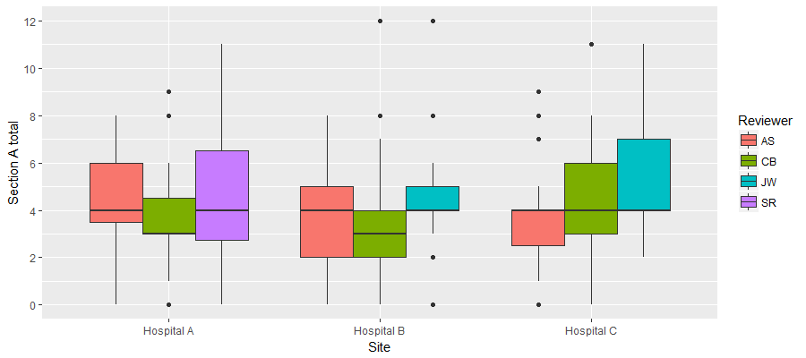
Figure 17 Section A total score by hospital and reviewer
The overall reliability between the reviewers was ‘moderate’. However, at site level, there was a greater variability. The lowest agreement was between AS and JW at Hospital B, which was not significantly different from random chance. All other ICC values observed were calculated to be better than random chance (see Table 22).
Looking at the inter-rater reliability of the individual items of section A Question 2 (“Interpretation of clinical situation”) had the lowest reliability. This item required interpretation of the clinical situation, so it is perhaps unsurprising that there was a marked difference between clinical and non-clinical reviewers for this question. For items 5 and 6 (patient wishes) reliability was generally higher than for the other items. This may be because specialist knowledge is not required to interpret the record with respect to patient wishes. (Appendix24 Table 59)
Table 22 Section A inter-rater reliability by Hospital
Hospital  (N) | Comparison (ICC, 95% CI; N=decisions analysed)
Hospital  (N) | AS v CB  (Clinical v clinical) | AS v SR/JW  (Clinical v non-clinical) | CB v SR/JW  (Clinical v non-clinical) | All reviewers
All Hospitals (103) | 0.60  (0.42 – 0.74)  N=63 | 0.50  (0.28 – 0.66)  N=63 | 0.60  (0.37 – 0.75)  N=60 | 0.57  (0.41 – 0.70)  N=55
Aª (31) | 0.52  (0.11 – 0.78)  N=19 | 0.63  (0.17 – 0.86)  N=15 | 0.65  (0.22 – 0.87)  N=14 | 0.61  (0.30 – 0.84)  N=13
B^{b} (34) | 0.62  (0.30 – 0.82)  N=24 | 0.23  (-0.15 – 0.55)  N=26 | 0.41  (0.06 – 0.68)  N=27 | 0.42  (0.18 – 0.66)  N=24
C^{b} (38) | 0.63  (0.28 – 0.83)  N=20 | 0.65  (0.15- 0.86)  N=22 | 0.75  (0.40 – 0.90)  N=19 | 0.68  (0.41 – 0.85)  N=18
ªReviewed by SR. ^{b}Reviewed by JW
Note: Cells coloured red are not statistically significantly different to random chance
Section B: ethical reasoning. (Appendix 24 Table 60).The median scores across each hospital remained constant at zero, but the IQR varied considerably (see Figure 18). At hospital A, the median score and IQR were zero, implying that the overwhelming majority of the 66 scored decisions were given a zero.
Figure 18 Section B total score by hospital and reviewer. Due to the large number decisions given a score of zero, only the outlier scores are visible for Reviewer CB
As for Section A total score, at least one estimate of inter-rater reliability was not significantly better than random chance (hospital B comparing AS and CB). However, reliability of AS and CB’s scores was otherwise at least moderate. (Table 23). Looking at inter-rater-reliability of each question in Section B, item 9 (“Was capacity to recover included in the balancing?”) had the highest reliability between the reviewers, and item 8 (“was acute physiology/system failure included in the balancing?”) the lowest (Appendix 24 Table 61).
Table 23 Section B inter-rater reliability by Hospital.
Hospital (N) | Comparison (ICC, 95% CI) N=decisions analysed
Hospital (N) | AS v CB  (Clinical v clinical) | AS v SR/JW  (Clinical v non-clinical) | CB v SR/JW  (Clinical v non-clinical) | All reviewers
All Hospitals (103) | 0.55  (0.35 – 0.70)  N=63 | 0.60  (0.42 – 0.74)  N=62 | 0.78  (0.62 – 0.87)  N=60 | 0.66  (0.52 – 0.77)  N=55
Aª (31) | 0.63  (0.25 – 0.84)  N=19 | 0.55  (0.05 – 0.82)  N=15 | 0.94  (0.83 – 0.98)  N=14 | 0.79  (0.56 – 0.92)  N=13
B^{b} (34) | 0.29  (-0.07 – 0.60)  N=24 | 0.48  (0.13 – 0.72)  N=26 | 0.42  (0.07 – 0.68)  N=27 | 0.37  (0.13 – 0.62)  N=24
C^{b} (38) | 0.73  (0.44 – 0.88)  N=20 | 0.74  (0.47 – 0.88)  N=22 | 0.89  (0.74 – 0.96)  N=19 | 0.79  (0.60 – 0.91)  N=18
ªReviewed by SR. ^{b}Reviewed by JW
Note: Cells coloured red are not statistically significantly different to random chance
For Section C (Appendix 24 Table 62) the distribution of scores across each Hospital remained reasonably consistent with the IQR constant at 0 to 3. No Hospitals achieved the maximum theoretical score of 10; and the maximum score of 8 was awarded once (see Figure 19).
Figure 19 Section C: Total score by hospital and reviewer*
*Due to the large number decisions given a score of zero, only the outlier scores are visible for Reviewer JW at Hospital C
Table 24 shows that the inter-rater reliability of Section C at Hospitals A and is high between reviewers AS and SR/JW; with reviewer CB appearing to record very different scores. For individual items in section C inter-rater reliability was generally moderate except for decision communicated to family which was fair (Appendix 23 Table 63)
Table 24 Section C inter-rater reliability by Hospital.
Hospital (N) | Comparison (ICC, 95% CI)
Hospital (N) | AS v CB  (Clinical v clinical) | AS v SR/JW  (Clinical v non-clinical) | CB v SR/JW  (Clinical v non-clinical) | All reviewers
All Hospitals (103) | 0.37  (0.13 – 0.57)  N=63 | 0.34  (0.06 – 0.56)  N=63 | 0.44  (0.21 – 0.62)  N=60 | 0.40  (0.23 – 0.56)  N=55
Aª (31) | 0.41  (-0.06 – 0.72)  N=19 | 0.73  (0.35 – 0.90)  N=15 | 0.50  (-0.04 – 0.81)  N=14 | 0.56  (0.23 – 0.82)  N=13
B^{b} (34) | 0.41  (0.0 – 0.70)  N=24 | 0.44  (0.07 – 0.70)  N=26 | 0.44  (0.01 – 0.70)  N=27 | 0.33  (0.09 – 0.59)  N=24
C^{b} (38) | 0.34  (-0.05 – 0.66)  N=20 | 0.30  (-0.09 – 0.63)  N=22 | 0.32  (-0.11 – 0.66)  N=19 | 0.234  (0.07 – 0.63)  N=18
ªReviewed by SR. ^{b}Reviewed by JW
Note: Cells coloured red are not statistically significantly different to random chance
Section D: Red flags. Only 8 decisions were given any “red flags” in Section D. Of the flagged decisions, 6 were flagged due to functional status; 1 was flagged due to previous knowledge of the patient and 2 were flagged due to the presence of a DNACPR order (Appendix 24 table 64).
Total score (see Figure 20 and Appendix 24 Table 65). The maximum possible score is 36; however, the maximum score awarded to any decision was 30. Nine decisions (2.1% of all decisions) were marked as 0, and 7 (1.6%) were only awarded 1 mark.
Figure 20 Total score by hospital and reviewer
The overall reliability across all decisions was moderate to substantial. However this varied considerably between hospitals (Appendix 24 Table 66). Relation between total score and outcome of decision and location of decision is shown in Appendix 24 (tables 67 and 68, figures 42 and 43)
We did not analyse for differences in score between pre-intervention and post-intervention records to look for responsiveness of the instrument. Given the low uptake of the intervention in the time available for implementation as described in Chapter 7 and confirmed by the small number of records with a referral or decision support form present in our samples we considered it unlikely that any change could be demonstrated. Further work on reliability of the tool is required before this could be attempted (see below).

Summary
Our evaluation tool was grounded in our empirical data and stakeholder views about what was required for a transparent ethically justifiable decision around admission to ICU. Development work demonstrated face validity of the tool among ICU clinicians. However applying the tool to clinical records proved challenging.
When asked to score the records of the decision to admit a patient into ICU; the initial step of identifying a decision is itself non-trivial and subject to disagreement. Out of a total of 429 potential decision scores only 234 were recorded; 153 were identified as a decision but not scored (no data available to score); 42 were unidentified decisions by one or more reviewers. Only 55 unique decisions were scored by all three reviewers at a Hospital.
Of those decisions where scores were given, reliability between both Hospitals and reviewers varied considerably. In particular, Hospital C had very poor reliability. This may indicate that sites have differing processes and standards for recording these decisions.
There were no clear trends in reliability between reviewers. There were questions where agreement between the clinical reviewers was much higher than when compared with the non-clinical reviewers but often one clinical reviewer (AS) did not agree with the other reviewers. This trend was not continued at a total score level where AS and the non-clinical reviewers generally had greater reliability than with CB. These results indicate that the current version of the tool is not sufficiently reliable to be used as a summative evaluation to assess decision-making in clinical practice. In our discussion chapter we reflect on the possible reasons for the lack of reliability, if and how the evaluation tool/process can be modified, and in what situations might it be used.

Strengths and weaknesses
A major limitation of this study is the unanticipated problem of identification of referral decisions. As different reviewers extracted different numbers of decisions from a single set of notes, this made identification of each decision difficult. Where possible, decisions were matched precisely, but it is likely that some decisions were incorrectly matched due to missing data. This in turn reduced the effective sample size for the analysis, and likely overestimated the errors when calculating the reliability. However, this finding is an important one for future evaluation studies using patient records.

Chapter 9: Discussion and conclusions

Discussion
This interdisciplinary mixed methods project provides a unique insight into how decisions around whether or not to refer or admit a patient to intensive care are made and how this decision-making process might be improved. The initial empirical investigation into current practice ensured that the development of any intervention would be grounded in, and relevant, to clinicians working in the NHS. A notable feature of all aspects of this project was the willingness of ICU doctors to participate, to have their practice observed, to complete a lengthy choice experiment, and to engage with the intervention. This suggests that they recognise that not only are these decisions often difficult, but how these decisions are made is important not just to patients and their families but to society as a whole.

The current experience of decision-making around ICU referral and admission

Complexity of factors influencing decisions
Previous work on ICU admission decision-making has predominantly focussed on the factors associated with admission or refusal of admission with less evidence on the actual process. Our systematic review found numerous studies that identified a wide range of factors influencing the decision. Factors included those which are likely to be seen as clinically and ethically justifiable such as severity of co-morbidity and type of acute illness, but also others that suggest personal values and organisational constraints may affect the decisions made (age, functional status as perceived by clinician, time of day, seniority of referrer). The availability of ICU resources (beds or nursing staff) was also identified as an influential factor. Our ethnographic study confirmed many of these factors as having an effect on the decision to admit a patient to ICU or not. It also identified other factors not previously identified in the literature, most notably the subjective assessment of the patient by the ICU clinician (gestalt), and the safety of the ward environment in terms of the resources available to care for the patient.
Doctors in our qualitative study acknowledged that ICU bed availability influenced the type of decisions they made, and also the impact of the admission decision on other patients either already in ICU or potentially needing ICU treatment. They described deferring admission and trying ward based treatment for longer if there was limited ICU capacity, and of creating beds by transferring other patients out of ICU. This phenomenon has been noted in the literature.¹⁶s ICU physicians in our experiences systematic review also referred to limited resources creating ethical difficulties in making these decisions. There is however a general reluctance to be explicit about the impact of limited ICU resource on decision-making and this was reflected in our stakeholder conference. A proposal to prompt ICU doctors to record this in the Decision Support Framework was rejected by stakeholders.
Challenges related to ICU bed availability are not new and not limited to the UK NHS. The external constraint of limited resources creates an ethical dilemma for all doctors working in systems with limited resources; a tension between their duty to an individual patient and their duty to all patients in their care. However this ethical tension is more acute in a situation where the individual patient in need of the resource is critically ill. Perhaps the ethical obligation is best articulated as a duty to provide the best possible treatment for the patient in the circumstances and explicitly state what actions are being taken to mitigate any effect of limited resources. This is the approach we took in our Decision Support Framework.
Our Choice Experiment (CE) gave insight into the relative importance given to factors by ICU consultants and critical care outreach nurses (CCOR) and the preference patterns that contribute to variability in decision-making. A key finding in our ethnographic study, which was mirrored in our CE was the greater importance given to the subjective assessment of the patient compared to the measurement of physiological parameters or standardised physiological scoring systems such as National Early Warning Score (NEWS). The concept of clinical assessment of a critically ill patient as greater than the sum of individual physiological measurements (the gestalt) is recognised by clinicians but has had limited analysis in the literature. A study of consecutive patients assessed by a critical care consult team found weak correlation between the physician’s assessment of respiratory distress and a recognised physiological scoring system (APPACHE II).²⁰⁴ Gestalt has been investigated in the context of severe trauma where it has been found to be unreliable in prediction of massive transfusion²⁰⁵ and overall survival.²⁰⁶ Similar findings have been described with Gestalt in estimating probability of pulmonary embolism.²⁰⁷ However in all these studies Gestalt performed as well as other predictive scores or algorithms highlighting the difficulty of prognostication in severely ill patients. One concern related to Gestalt in relation to ICU admission decisions is the phenomenon of prognostic pessimism. Studies have shown that ICU clinician’s prediction of poor outcome for specific patient groups such as patients with COPD or the elderly do not correlate with actual outcomes in these groups.^{47, 50} In the absence of sensitive prognostic tools decisions about treatment of critically ill patients will continue to include a gestalt assessment. Making the elements of this assessment more transparent will contribute to our understanding of this complex decision-making process and will enable implicit value judgments inherent in the process to be challenged.
An important, although perhaps unsurprising, finding in the systematic review was that increasing age is independently associated with increased odds of refusal of admission to ICU. There was also evidence in the ethnographic study that ICU doctors considered young age a reason to support admission to ICU, and referring doctors’ perception that ICU doctors had to be persuaded to take an elderly patient. The Choice Experiment (CE) supported this finding and also suggested that age has more influence on the admission decision than other factors such as functional status and presence or severity of co-morbidity. The CE also identified a distinct preference pattern categorised as ‘age dominant’ suggesting that some consultants were influenced by the age of the patient more than others. It is not possible from the empirical data to determine why this is the case. It is possible that some ICU consultants consciously or subconsciously discriminate in favour of younger patients, or that they implicitly associate age with reduced capacity to benefit from ICU (prognostic pessimism).^{47, 84} Another explanation could be that consultants use age as a proxy for capacity to recover when other information is unavailable and this heuristic is maintained even when specific information such as physiological reserve or comorbidity is known. The possibility that implicit assumptions affect decisions is one argument in favour of improving transparency of decision-making, making explicit the implicit in order to mitigate against unfair discrimination. This is particularly important in the context of an ageing population and the legal obligations of UK doctors as set out in Equality legislation.²⁰⁸
Variability in decision-making around ICU admission was noted in our systematic review and evident in our ethnographic study and Choice Experiment. Our CE also showed differences between ICU consultants and CCOR nurses in the importance given to different factors in making these decisions. While it is likely that reasons for this variability are multifactorial our CE demonstrated that ICU consultants, and to a lesser extent outreach nurses, have different preference patterns for factors influencing the decision. The reasons for these different preference patterns require further exploration but their existence suggests implicit value positions influence decisions. This is another argument for transparency of the decision-making process and explicit articulation of reasons informing the decision.

Context, relationships and emotions
The wide range of patient-, clinician-, and organisational-related factors influencing decisions to refer or admit a patient to ICU illustrate the complexity of the decision to be made. Our ethnographic study revealed that contextual and relational features of the decision-making process contributed to the challenges faced by clinicians in these situations. These decisions are often time-critical and frequently made in the emergency department (ED) when relevant information may be limited or unavailable, increasing the uncertainty of predicting the consequences of any decision. The ED can be a chaotic environment with multiple decisions being made about an individual patient and multiple patients requiring decisions. The ward environment may be less chaotic but has less immediate senior clinical presence and junior doctors struggle to provide comprehensive assessments for referrals while managing day-to-day tasks for other patients under their care. In these situations the ICU doctor can bring a sense of reassurance and control, as was noted in our ethnographic study
At the heart of these decisions is a web of relationships that need to be maintained for good decision-making to occur. We explore the specific issue of engaging with patients and family later in this chapter. The relationship between ICU doctor and referring team is also crucial. Mutual trust and respect between colleagues facilitates communication and shared understanding of how to achieve the best treatment for the patient. Difficult relationships between teams may lead to poor communication and delay in decision-making. Doctors in our implementation study commented that the requirement to clearly document reasons for their decisions had a positive impact on communication between referring and ICU teams, facilitating mutual understanding.
Managing relationships can be an additional challenge when high stakes complex decisions are being made and can place substantial emotional strain on clinicians. Moral distress is a well-recognised phenomenon in intensive care settings and has been noted to be associated with professional burnout although it has not been specifically explored in the context of decisions around admission to ICU.²⁰⁹ Our experiences systematic review identified some evidence of moral distress in both ICU and referring clinicians, and a recent study across nine ICUs in a publicly funded health system exploring the consequences of ICU capacity strain found that it contributed to moral distress and burnout among staff.²¹⁰ Our study noted the role ICU consultants often took in providing support to junior staff in making these difficult decisions.

Ethical values and ethical reasoning
Our ethnographic study identified a range of ethical values, both implicit and explicit, shaping the decision-making process. Trust, respect and honesty were seen as important in supporting the inter-professional relationships necessary for good decision-making. Professional autonomy was valued by clinicians and perceived lack of autonomy caused frustration. The importance of professional autonomy/agency was also identified in our experiences systematic review. Professional autonomy emerged as an important consideration when implementing our intervention which was perceived by some consultants as questioning their ability to make decisions. Respect for patient autonomy and consideration of patients’ values when making decisions about their treatment and care is both an ethical and a legal requirement.²¹¹ This was something all clinicians in both our observational study and our intervention study identified as important, but there was little evidence that the patient’s views were routinely sought. We discuss this anomaly in more detail below. Most patients who are critically ill will lack capacity to make a decision for themselves and in the UK it is the duty of the doctor responsible for the patient’s care to make a decision in their best interests. Inherent in this duty is the obligation to identify and weigh the burdens and benefits of treatment for that particular patient. We found that while doctors talked about the benefits of ICU treatment and the potential harms in terms of likelihood of survival, they appeared to have great difficulty in explicitly weighing these benefits and burdens in individual cases. We noted only one example of this in our observation study, and even when a framework prompting this process was provided in the intervention study, doctors still described difficulty in articulating burdens and benefits of ICU care, and a reluctance to put these in writing. We have already noted the uncertainty associated with prognostic indicators in individual cases and there is a recognised lack of ICU specific patient relevant outcomes which may explain some of this reluctance.²¹² There is a substantial body of literature on the kinds of ethical issues facing ICU clinicians but little published on how ICU clinicians make ethical decisions, or how they communicate their reasoning. A qualitative study specifically exploring priority setting decisions in a critical care unit found that both medical and non-medical reasons were used but non-medical reasons were less well documented and understood.⁴⁴
Consultants’ concern regarding clinical autonomy coupled with their expressed difficulty in articulating their reasoning and the importance given to an intuitive feel for the ‘look of the patient’, may reflect the complex nature of clinical decision-making. There is an extensive body of literature on clinical decision-making which explores a range of elements in the process including tacit knowledge,²¹³ contextual experience,²¹⁴ and clinical heuristics in addition to empirical evidence and formal reasoning. These implicit elements may be difficult to capture in a decision support framework or to articulate in a written record but may be essential to good patient care particularly in a time pressured context of decision-making for a critically ill patient. However there is a concern that reliance on an intuitive model of clinical reasoning (using clinical heuristics and personal experience) rather than a more analytical model can lead to cognitive biases which may adversely affect decision-making.^{215, 216} The empirical evidence on the relative importance or effectiveness of intuitive (type 1) or analytical (type 2) thinking in clinical decision making is both mixed and limited as are studies of interventions to improve clinical decision-making.²¹⁷ In a review of the causes of error in clinical reasoning, the authors found interventions that encourage clinicians to mobilise and reorganise their knowledge and reflect on the content of the case appeared to have some benefit in reducing error in reasoning,²¹⁸ particularly in complex cases. Presumably knowledge would include knowledge of the patient and their values as well as clinical knowledge.
It is not surprising that well-articulated ethical reasoning is absent in decision-making around intensive care admission. As already noted these decisions are often made in urgent situations when the priority is to act quickly to prevent further significant harm to the patient. As such clinicians will tend to rely on clinical experience, algorithms and implicit values (type 1 thinking) rather than explicit formal reasoning (type 2 thinking).²¹⁵ In some cases this will be entirely reasonable if not morally obligatory in order to save the patient’s life. However not all, or even most, decisions around admission to intensive care require this degree of urgency, and often these decisions are complex with uncertain outcomes. It is these decisions (the grey cases described by doctors in our ethnographic and implementation study) that we suggest require careful deliberation and consideration of the relevant evidence and values. It seems clear from our study that doctors making these decisions require support to do this type of thinking in these cases. We would also argue that explicit articulation of reasoning, including acknowledgment of the use of tacit knowledge and clinical experience, is necessary for transparency and consistency of decision-making. The challenge is to provide a framework that doctors find intuitive or familiar rather than simply adding ethics to their established clinical reasoning processes. Values, both desirable and undesirable, are not absent from their decision-making but are implicit. We are likely to be more successful in embedding improvement in ethical decision-making if we can facilitate a shift from implicit to explicit articulation of values using the language of clinical encounters.

Developing an intervention
At all stages of the development, we sought to create a framework that was recognisable to clinicians, used non-academic language, and could be embedded in established good clinical practice. However it became clear during the stakeholder conference, that education to support implementation of a framework must include more specific engagement with the ethical concepts and principles underpinning it. This was confirmed in our implementation feasibility study when lack of time for champions to explain the underpinning ethical rationale behind the framework was identified as a challenge for successful embedding of the framework in practice.
The initial focus of the research was on the decision whether or not to admit a patient to ICU. However, we observed that the ward teams had a wide range of reasons for seeking the help of the ICU doctor and that intensive care input, when perceived to be working well, focussed on the question of what was the best treatment for the critically ill patient rather than whether they should be admitted to the ICU. This prompted a paradigm shift in how the decision-making process (and therefore the support required) should be conceptualised, made concrete by a PPI participant in the stakeholder conference who suggested the emphasis should not be on where the patient was treated, but how they were treated. This concept of intensive care not constrained to the ICU has informed thinking on the development of critical care outreach teams,²¹⁹ although the concept has been operationalised in a wide variety of ways with inconclusive evidence of effectiveness.²²⁰ If CCOR teams are to be used as an extension of intensive care beyond its boundaries, and CCOR nurses take on responsibility for decisions about admission to the ICU, it is worth noting the findings of our Choice Experiment where differences were found between CCOR nurses and ICU consultant in the importance ascribed to factors such as NEWS when making the decision. Nevertheless the broader message of patient-focussed rather than location focussed decision-making from our empirical work, led to a structuring of the Decision Support Framework that first asked the question: ‘What is the optimal treatment for this critically ill patient?’, and only then asked: ‘Where can or should this treatment be delivered?’
A potential criticism of our intervention is that the process of making these decisions is a clinical skill which ICU doctors and referring teams exercise every day; there is no need for a framework to enable them to do this, a point made by some senior doctors in our implementation study. While it is clear that most healthcare professionals make decisions and treat patients to a high professional standard, standards can be improved and patient care benefit when checklists or prompts are used to support good practice in specific situations. There are numerous examples of checklists used in the ICU context and their presence does not imply a lack of competence.^{221, 222} The recommendation for a checklist often arises from the observation that good practice can be compromised because of a combination of systemic, contextual and human factors.²²³ This was identified in our ethnographic study. Reflecting the complex nature of decision-making for critically ill patients, the referral and decision support frameworks developed in this study are less checklists but rather provide a structure for decision-making with prompts for decision makers to consider. Our referral form was based on the SBAR (Situation, Background, Assessment, and Recommendation) tool which is itself a checklist/framework that is widely used to support good communication between clinician when escalating a problem or transferring care.²²⁴

Is it feasible to implement the intervention in an acute NHS Trust?
All feasibility sites were enthusiastic about implementing the intervention, including support from the Medical Director. Despite the very short implementation period (eight weeks) we achieved an average of 28.2% usage of forms across sites. Following the study, two sites have expressed an interest in taking the intervention or a variation of it forward as a service development. However, implementation was a challenge at all sites and our feasibility study has provided useful data to facilitate future implementation initiatives. By using a mixture of quantitative and qualitative methods, we were able to triangulate our data within the study, and were thus able to understand how often, when, and by whom the referral and decision support forms were used, and also how and why clinicians used or did not use them.²²⁵
The importance of context in successful implementation of interventions in health care is well documented.^{226, 227} The shared context of all sites was that of a busy NHS hospital, but the specific context of each site influenced implementation. Size of organisation and number of staff to reach clearly had an impact, but so too did existing inter-professional relationships and structures (for example presence or absence of CCOR or existing systems for logging ICU referrals). Key difficulties common to all sites included time for implementation, both longitudinally (for embedding the study into practice) and individual champions’ time to devote to promoting it. Linked to this is the challenge of institutional inertia. NHS Trusts are large complex organisations with well-established processes and protocols and cannot respond easily to rapid change (our implementation period was only eight weeks). This represented a challenge for the champions to break into existing training and information-giving opportunities within the Trust to educate clinicians about the intervention. It was also a reason why it was impossible to integrate an electronic version of the forms into the Trust electronic records system, something which all champions agreed would be essential for truly embedding the intervention into routine practice.
At all sites to a greater or lesser extent there was a mismatch between how we envisaged the intervention working and how it actually worked in practice, particularly in the use of the referral forms and the lack of use of patient and family information leaflets. Both of these documents were intended to be used when a decision to refer a patient to ICU was being considered, however in most situations use of the referral form was only prompted at the time a referral was being made leading to frustration on the part of the referring team who perceived the form as an additional burden rather than the intended support. This emphasises the importance of understanding the context in which the intervention will be used and being flexible in how it is implemented.
The nature of flexibility in implementation strategies has been highlighted by May and colleagues, who describe the importance of plasticity of intervention components and the elasticity of the normative and relational structure of the context in which the intervention is being implemented.²²⁶ Our intervention had some flexibility in terms of the educational component but the forms were less flexible. An electronic version would allow Trusts to individualise the forms and process which would increase flexibility and may improve uptake. However, the core structure and content of the referral and decision support forms cannot become so flexible that key elements of the ethical decision-making process are absent. Negotiating the degree of flexibility necessary to maximise uptake while maintaining the integrity of the intervention will be key to successful implementation.
Interventions that involve normative changes in practice, such as introduction of shared decision-making, or decision support frameworks, can be experienced as a threat to the practitioners involved.²²⁷ A few of the clinicians in the feasibility study expressed concerns that their clinical and ethical practice was being questioned by the requirement to complete a form. However, the main barriers to implementation were seen as more practical and related to concern about duplication of work, lack of time, and other organisational and situational pressures on decision-makers. These concrete barriers have been noted in other implementation studies of similar interventions such as surgical check lists,²²⁸ or advance care planning.²²⁹

The challenge of involving patients and families in the decision-making process
Involving patients in decision-making about their medical care is both an ethical and a legal obligation for health professionals. Using a shared decision-making model is considered to be best practice; even on the intensive care unit, where issues with a patient’s mental capacity pose challenges.³⁰ However, a striking finding throughout the project was the low level of involvement of patients and their families in the decision-making process. Clinician interviewees in the ethnographic study suggested that the patient’s views were highly valued when making a decision, and ICU consultants in the Choice Experiment considered the views of the family important. However, our observational data showed that the views of patients or their families were in practice seldom sought, and in the intervention implementation feasibility study the patient and family information leaflets, designed to support and promote their involvement in the decision-making process, were not used at any of the sites.
There are a number of reasons why active involvement of patients and their families may not occur when decisions are being made about a critically ill patient. The decision itself may need to be made quickly and often in an emergency situation where the patient is too sick and their family not available so sometimes it may not be possible to involve them. Clinicians may feel reluctant to engage in a discussion that involves the very real possibility that the patient might die, the uncertainty of outcomes, and the potential distress and harm that ICU interventions might cause. ICU doctors in the implementation study found it difficult to articulate the burdens of ICU on the decision support form. Articulating these in a conversation with a critically ill patient or distressed family member is likely to be even more difficult, and potentially distressing for the clinician. Feedback from site debrief meetings reinforced this concern when discussing the apparent reluctance of referring teams to use the leaflets. This argument against involvement of patients has previously been seen as a barrier to discussions about cardiopulmonary resuscitation,^{230, 231} or decisions to withdraw life-supporting treatment in ICU.^{232, 233}
In other jurisdictions consultation with family members or surrogates is legally mandated for important decisions about a patient who lacks capacity. While surrogates often find this difficult, there is evidence that they prefer to take an active role in decision-making relating to end-of-life care on ICU,^{234, 235} and experience little regret about the decisions they have made..^{235, 236} Patients wish to be involved in such discussions and do not experience undue distress from these conversations.²³⁷ In the context of DNACPR UK law requires consultation with the patient or their family when this decision is being made.²³⁸
Difficult conversations require good communication skills and there is a recognized need for training in this area among ICU clinicians.²³⁹ Furthermore negative attitudes and dysfunctional inter-disciplinary relationships can be a barrier to patient and family involvement in decision-making²⁴⁰. Clarifying the responsibilities and processes involved in making these decisions may help. In end-of-life decisions families can be confused about who is making the decision; which can impact on their ability to participate in the process.²⁴¹ When processes are clear, the family experience is better.²⁴²

Challenges in evaluating ethical decision-making
A striking finding from our work in testing the evaluation tool was the difficulty reviewers had in identifying when a decision whether or not to admit a patient to ICU had been made from scrutinising the clinical record. This was true of clinical as well as the non-clinical reviewers. There are several possible reasons for this finding. Lack of a detailed account of a decision does not in itself mean that a poor decision has been made. In urgent situations clinicians may feel it is more important to make a decision and act on it than spend time recording in detail the reasons for the decision. Lack of clear documentation of this specific decision did not necessarily mean that general documentation in the patient record was poor. One of our sites had very clear, structured ICU records for patients who were admitted which documented some of the information that would have informed the decision. However this record was only for patients admitted and was not a retrospective documentation of the admission decision but the plan for ICU care.
The tool allowed only information and reasoning recorded by the person responsible for the decision to be scored, although explicit reference to previously documented evidence such as physiological status could be included. In some of our sample records detailed notes by the critical care outreach team prior to ICU review of the patient included much of the documentation referred to in the score sheet. It is likely that an ICU doctor would have noted this when making their decision and therefore not recorded it again. However, it was not always clear how the doctor had used this information. The discrepancy between actual decision-making and the record of that decision is a weakness of any evaluation tool that is applied only to patient records. However, as we have stipulated a transparency requirement for ethical decision-making, and considering the potentially life-changing consequences of these decisions it is reasonable to expect that there is an adequate record of how the decision was made, and that this should be part of a standard of good decision-making. Our requirement for documentation of the decision-making process is in line with professional guidance for clinicians¹⁸².
While the overall total score reliability of the evaluation tool was moderate to substantial there was considerable variability across sites with reliability at some sites only fair. Variability was not linked to the clinical background of the reviewers suggesting clinical knowledge is not the main factor. A possible reason for the variability in scoring is the degree to which the scorers are required to interpret what is in the written record. It is not straightforward to assess what counts as evidence of capacity to recover or what demonstrates balancing of burdens and benefits and whether specific evidence has been used in that balancing. It may be that in our attempt to increase the granularity of our scoring system to increase its sensitivity we reduced its reliability. Reliability could be potentially improved with better training of scorers but this might limit its practical use.
The challenge of evaluating written records of complex decision-making processes using multiple criteria was also encountered by Pearlman in developing the ECQAT for assessing clinical ethics consultation records.¹⁹⁹ Their approach was to adopt a holistic rather than analytic scoring system. In this system, raters consider key elements and other factors that work together and give a score based on the total impression of the account rather than scoring individual items. Advantages include reduced likelihood of scorers struggling with interpretation of very specific criteria, and less time required for scoring. Possible disadvantages if assessors are clinicians is that they will over interpret, that is, they will assume the clinician has considered evidence or made a decision based on specific reasoning without clear evidence in the documentation. Critique of holistic scoring models also recognise this concern suggesting that they may mask deviances in how the descriptors for the holistic scores are applied.²⁴³ However it may be easier to give examples of what is considered a satisfactory/unsatisfactory decision-making process using this approach. Future development of the evaluation tool should consider both refining the individual criteria specifications in the current version and/or applying a holistic assessment approach to each section.
While in its current version the tool cannot be recommended for summative evaluation of decision-making around admission to ICU, our experience in developing the tool suggests it would be useful as a formative or educational tool. Applying the tool to a sample of clinical records of patients who have recently been referred to a specific ICU during a quality improvement meeting would enable discussion of what counts as quality in decision-making and documentation, what counts as evidence, what reasons are relevant, and how reasoning should be articulated. Key points and lessons learned could feed back into future decision-making and recording, with the aim of improving overall quality of decision-making.

Strengths, weaknesses and methodological challenges
We have noted the strengths and weaknesses of the individual studies within this project in the relevant chapters. An overall strength of the project is its mixed-method approach which provided triangulation of findings between studies and enabled the development of an intervention firmly grounded in relevant empirical research evidence. We have been able to capture the process of decision-making around referral and admission to intensive care at nine NHS Trusts in the UK (six in the ethnographic study and three in the implementation study) and have been able to capture decision preference patterns across a much wider cohort of intensive care consultants and outreach nurses in our choice experiment. There was strong PPI and stakeholder involvement throughout the project. The difficulty we had in involving patients and families in the project, specifically in the ethnographic study was disappointing. We had anticipated that recruitment of patients and families close to the decision-making event would be challenging and had worked with our PPI colleagues to develop processes to facilitate supportive approaches. Despite this, recruitment was difficult. We had not anticipated the difficulty in tracking patients following discharge from ICU to seek consent for late stage interviews which further reduced potential recruitment. Thus the patient and family perspective is not as strong as we had originally envisaged.
We also experienced challenges in conducting the two primary systematic reviews. The research questions required a broad search strategy resulting in a 34,000 abstracts and 83 included studies. The diverse methodologies of the studies and heterogeneity of results made it difficult to pool data and draw meaningful conclusions. In updating the reviews for this report we adopted a narrative snowballing approach using our existing knowledge of the literature and focussing on key journals that has the greatest number of relevant papers in our original review. The yield from this approach appears to be as productive as the formal systematic approach although we cannot be certain we have not missed a relevant paper. However, it was significantly more cost effective requiring only a maximum of three reviewers compared to a team of 16.

Conclusion

Summary of findings
This project has illuminated the complexity of decision-making around referral and admission to intensive care. Referring teams and ICU doctors making decisions about critically ill patients need to consider multiple sources of information with varying levels of uncertainty about prognosis or likely outcomes, often with little knowledge of the patient’s wishes or values. External constraints increase the pressure on the decision-making process. Our findings suggest that the focus should be, and in current practice often is, on what is the best treatment for the critically ill person, and how this can be delivered, rather than whether or not they should be transferred to ICU. Good decision-making requires communication, between colleagues and with patients and their families, strong inter-professional relationships built on mutual respect and trust, and careful consideration of the benefits and harms of intensive care for the individual patient. While there are many examples of this process working well for patients there is evidence that doctors find it difficult to articulate and explicitly balance the benefits and harms of treatment for patients, that implicit values can inform the decision, and that communication as part of the process of decision-making is often limited. Documentation of the decision to admit or not to intensive care is generally poor making evaluation difficult and raising concerns about transparency of process. Support for junior doctors in making these difficult decisions is often patchy. The patient voice is often lacking in the decision-making process.
Implementing an intervention to support the decision-making process around treatment for a critically ill patient was challenging. Uptake and completion of the forms was low at just under 30%. However doctors who used the forms were generally positive about their use observing that the forms helped them to articulate and communicate their thinking and prompted them to involve patients and their families. There were concerns about duplication of work and time taken to complete documentation distracting from patient care. Where the framework could be incorporated into existing systems it appeared to work well. The implementation period in the feasibility study was in retrospect too short. Further work is needed building on the lessons learned from the feasibility study.

Implications for practice
The concept of a structured intervention to support clinicians who are making decisions around referral or admission to ICU was generally welcomed by key stakeholders. NHS Trusts wishing to implement such an intervention will need to consider how it will be incorporated into current working practices throughout the hospital: Interventions aimed at improving decision-making should engage with the whole process, from the point at which the need for critical care support is first considered. Ensuring system wide change needs senior institutional support, and training for all clinical teams involved in the process. Incorporation into an electronic patient record and referral system will facilitate implementation. . A Quality Improvement approach may be helpful when planning future intervention implementation work
We identified a clear need for improved education of clinicians involved in decisions to refer or admit a patient to ICU, particularly around ethical reasoning and communication. Our project findings and resources may be helpful to professional organisations concerned with curriculum development and post-graduate training. National and international guidelines recommend consultant to consultant communication in these decisions but our study suggests that this does not always occur and junior doctors, particularly in referring teams may feel unsupported. Given resource constraints and changes to team structures and working patterns within the NHS, Trusts may wish to consider how best to support consultant led decision-making and collaborative team working, particularly out of hours.
Involving patients and their families in these difficult decisions appears to be extremely challenging for doctors but the evidence from our study and others is that patients and families wish to be part of decision-making about their care even in distressing and life threatening situations. Further work needs to be done to explore how information can be provided to patients and families to support their involvement. Examples from other areas of practice such as the introduction of the national Recommended Summary Plan for Emergency Care and Treatment (ReSPECT) may be helpful in this regard.

Recommendations for future research
Our study has gone some way to suggesting how decision-making around referral and admission to intensive care can be improved. It has also identified areas where further research is needed to inform future interventions and support evidence based patient centred decision-making. Priorities for research in this area suggested at our dissemination conference included:
- Investigating how to improve meaningful engagement of patients and families in the decision-making process. Difficulties in including patients and families in the decision-making process was evident in all parts of our research. Research to better understand the barriers to this involvement and to develop and test strategies to improve this aspect of the decision-making process is needed.
- Development of patient related outcome measures and investigation of effect of interventions on patient relevant outcomes. Short term survival after a critical illness is a limited metric in judging the quality of care delivered by an intensive care unit. Research to better understand the nature and range of specific outcomes which are important to critically ill patients is required to develop quantifiable metrics that can be used to improve patient care. This will allow more informed conversations with patients and families and inform evaluation and improvement of decision-making
- Development and evaluation of educational interventions to support ICU trainees with regard to decision-making around escalation of treatment decisions including admission to ICU.
- Further development and implementation evaluation of DSI using a Quality Improvement approach.
- Further work on validating the evaluation tool for ethical decision-making and to describe its role in service improvement and clinical research.
- Evaluation of the importance of external influences on medical decision-making for treatment of critically ill patients. We have shown that factors other than direct, patient-related, clinical information influences whether or not a patient is admitted to ICU. How these other, “external” factors impact on the decision-making and to what extent, needs further investigation

Achieving the best outcomes for an individual patient depends on everyone involved making the best possible decisions. Decisions about treatment for critically ill patients have life changing consequences for the patients involved, and doctors making them will always be faced with difficult clinical and ethical challenges. This study has provided evidence and resources that will help clinicians and organisations aiming to improve decision making for, and ultimately the care of, critically ill patients.

Acknowledgements
The study team would like to thank all the patients, family members, and clinicians who participated in this research through being observed and/or interviewed in our ethnographic and implementation feasibility studies, or completing the Choice Experiment questionnaire survey.
We would also like to thank the following:
The members of our Independent Study Steering Committee for their invaluable support and advice: Chair, Carl May, our PPI representatives, Jenny Henderson and Ben Powis, and our specialist contributors Bobbie Farsides, Chris Danbury and Arne Risa-Hole.
From NHS Digital (formerly the Health and Social Care Information Centre), Chris Dickson, clinical informatics lead, and David Baker, business analyst, for their work on developing an electronic version of the referral and decision support forms.
Our Patient and Public Advisory group who contributed substantially to the project at all stages: Sue Tulip, Richard Grant, Elyas Khalifa, Jabeen Chaudhry and Sarah Broom.
The Principal Investigators at our study sites for their support and oversight of the project at their Trust
The Implementation champions at our three implementation sites for their enthusiasm and commitment in supporting the intervention in addition to their demanding clinical workload
Dr Simon Baudouin for chairing the stakeholder conference
Attendees of our Stakeholder conference held in Warwick on July 2016. A list of participants can be found in Appendix D6.
Sam Johnson, Academic support librarian at the University of Warwick for assisting with developing and running the literature searches for the systematic reviews.
Kaja Heidenriech, and Bronwyn Harris for contributing to coding and analysis of data from the ethnographic study
The medical students who carried out abstract screening for our systematic reviews: Alasdair Anderson, Mark Ramsden, Stuart McClure, Stuart O’Connor, Josie Hough, Esther Illman, Martha Pearson and Lauren Sibley.
The research nurses at all of the NHS Trusts who facilitated data collection and supported the research fellows
Our Project Secretary, Louise Hutton, who provided support to the whole team throughout the project.

Author contributions
Chris Bassford (Honorary Associate Professor, ICU consultant), Co-led the project with Anne Slowther, conceived and designed the study, supervised all work packages, data analysis and report writing, drafted study introduction and intervention development chapters, and editorially reviewed all chapters in the report.
Frances Griffiths (Professor of Medicine in Society), Contributed to study design, led WP1 (ethnographic study), supervised data collection and analysis in WP3 (implementation feasibility study) developed evaluation tool with CB and AS, drafted ethnographic study chapter.
Mia Svantessen (Research Fellow) Lead research fellow for ethnographic study responsible for data collection and analysis. Contributed to development of Choice Experiment and decision support intervention and provided early drafts of ethnographic study chapter.
Mandy Ryan (Professor of Health Economics) Led the Choice Experiment (CE) study, designed the CE with Nicolas Krucien, supervised data analysis, contributed to the development of the decision support intervention, and edited the CE chapter.
Nicolas Krucien (Research Fellow) Designed the CE with Mandy Ryan, responsible for CE data analysis, contributed to the development of the decision support intervention and drafted the CE chapter.
Jeremy Dale (Professor of Primary Care) Led the Intervention development and implementation feasibility study, contributed to analysis of data from the ethnographic study and testing of the evaluation tool. Provided editorial review to the feasibility study chapter.
Sophie Rees (Research Fellow) lead research fellow for the implementation feasibility study. Responsible for data collection and analysis, contributed to development and testing of the evaluation tool, analysed qualitative data from the systematic reviews. Drafted the implementation feasibility chapter and the experiences section of the systematic review chapter, collated the report.
Karen Rees (Principal Research Fellow) Lead for all systematic reviews, oversaw protocol development and screening, analysed quantitative data for factors review and provided initial draft of chapter
Agnieszka Ignatowicz (Research Fellow) principal researcher on systematic review for evaluation tools. Drafted protocol, contributed to screening of papers, quality assessment and analysis.
Helen Parsons (Senior Research Fellow) statistical analysis of quantitative data from implementation feasibility study and evaluation tool testing, contributed analysis section of evaluation tool development chapter.
Nadine Flowers (Project Manager) oversaw recruitment and data collection for Choice Experiment and contributed to analysis of data for factors systematic review
Zoe Fritz (Wellcome Fellow in Society and Ethics) Contributed to development of Choice Experiment, development of decision support intervention, screening and analysis of systematic reviews on factors and experiences, and development of the evaluation tool. Contributed to draft versions of ethnographic study chapter and CE chapter
Gavin Perkins (Professor in Critical Care Medicine and ICU consultant) Contributed to development of Choice Experiment, development of decision support intervention, and development of the evaluation tool. Contributed to draft versions of ethnographic study chapter and CE chapter
Sarah Quinton (Honorary Associate Professor and Nurse Consultant) Contributed to development of CE and decision support intervention, facilitated links with critical care outreach nursing community, advised on consent processes for ethnographic study
Sarah Symonds (PPI Co-Investigator) advised on consent and recruitment processes for ethnographic study, edited patient and family information sheets, contributed to the stakeholder conference and development of patient and family information leaflets for the intervention
Catherine White (PPI Co-Investigator) advised on consent and recruitment processes for the ethnographic study and contributed to data analysis, edited patient and family information sheets, co-chaired the stakeholder conference and contributed to development of patient and family information leaflets for the intervention. Speaker at dissemination conference, commented on draft chapters and led writing of a lay report.
Huayi Huang (Research Fellow) co-ordinated abstract screening and data abstraction for the factors and experiences systematic reviews.
Jake Turner (Medical Student) Contributed to abstract screening and analysis of systematic reviews
Mike Brooke (Medical Student) Contributed to abstract screening and analysis of systematic reviews
Aimee McCreedy (Medical Student) Contributed to qualitative data coding and analysis for ethnographic study
Caroline Blake (Medical Student) Contributed to qualitative data coding and analysis for ethnographic study
Anne Slowther (Reader in Clinical Ethics, Clinical Ethicist) Co-led the project with Chris Bassford, conceived and designed the study, supervised all work packages, data analysis and report writing, drafted study discussion, systematic review, and evaluation tool chapters, and editorially reviewed all chapters in the report.

Data sharing statement
All qualitative data generated that can be shared are contained within the report. All data requests should be submitted to the corresponding author for consideration. Please note exclusive use will be retained until the publication of major outputs.

References
1. FICM. Core Standards for Intensive Care Units. London: Faculty of Intensive Care Medicine ICS, 2013.
2. Cardoso LT, Grion CM, Matsuo T, Anami EH, Kauss IA, Seko L, et al. Impact of delayed admission to intensive care units on mortality of critically ill patients: a cohort study. Crit Care. 2011;15(1):R28.
3. Shmueli A, Sprung CL. Assessing the in-hospital survival benefits of intensive care. Int J Technol Assess Health Care. 2005;21(1):66-72.
4. ICNARC. Key statistics from the Case Mix Programme - Adult, general critical care units 1 April 2015 to 31 March 2016. 2017.
5. Brinkman S, de Jonge E, Abu-Hanna A, Arbous MS, de Lange DW, de Keizer NF. Mortality after hospital discharge in ICU patients. Crit Care Med. 2013;41(5):1229-36.
6. Williams TA, Dobb GJ, Finn JC, Knuiman MW, Geelhoed E, Lee K, et al. Determinants of long-term survival after intensive care. Crit Care Med. 2008;36(5):1523-30.
7. Ng K, Chanouzas D, Fallouh B, Baharani J. Short and long-term outcome of patients with severe acute kidney injury requiring renal replacement therapy. QJM: An Int J of Med. 2011;105(1):33-9.
8. Wade DM, Howell DC, Weinman JA, Hardy RJ, Mythen MG, Brewin CR, et al. Investigating risk factors for psychological morbidity three months after intensive care: a prospective cohort study. Crit Care. 2012;16(5):R192.
9. Patel A, Wisniewski M, Tulaimat A, Gonzalez-Carmago C, Khan J, Monti C, et al. Do physicians agree in their subjective assessment of patients evaluated for admission to the medical intensive care unit (MICU)? Chest. 2007;132(4):446B.
10. Garrouste-Orgeas M, Montuclard L, Timsit JF, Reignier J, Desmettre T, Karoubi P, et al. Predictors of intensive care unit refusal in French intensive care units: a multiple-center study. Crit Care Med. 2005;33(4):750-5.
11. Howe DC. Observational study of admission and triage decisions for patients referred to a regional intensive care unit. Anaesth Intensive Care. 2011;39(4):650-8.
12. Iapichino G, Corbella D, Minelli C, Mills GH, Artigas A, Edbooke DL, et al. Reasons for refusal of admission to intensive care and impact on mortality. Intensive Care Med. 2010;36(10):1772-9.
13. Sprung CL, Geber D, Eidelman LA, Baras M, Pizov R, Nimrod A, et al. Evaluation of triage decisions for intensive care admission. Crit Care Med. 1999;27(6):1073-9.
14. Azoulay E, Pochard F, Chevret S, Vinsonneau C, Garrouste M, Cohen Y, et al. Compliance with triage to intensive care recommendations. Crit Care Med. 2001;29(11):2132-6.
15. Rodriguez-Molinero A, Lopez-Dieguez M, Tabuenca AI, de la Cruz JJ, Banegas JR. Physicians' impression on the elders' functionality influences decision making for emergency care. Am J Emerg Med. 2010;28(7):757-65.
16. Stelfox HT, Hemmelgarn BR, Bagshaw SM, Gao S, Doig CJ, Nijssen-Jordan C, et al. Intensive care unit bed availability and outcomes for hospitalized patients with sudden clinical deterioration. Arch Intern Med. 2012;172(6):467-74.
17. Garrouste-Orgeas M, Tabah A, Vesin A, Philippart F, Kpodji A, Bruel C, et al. The ETHICA study (part II): simulation study of determinants and variability of ICU physician decisions in patients aged 80 or over. Intensive Care Med. 2013;39(9):1574-83.
18. Boumendil A, Angus DC, Guitonneau AL, Menn AM, Ginsburg C, Takun K, et al. Variability of intensive care admission decisions for the very elderly. PLoS ONE. 2012;7(4):e34387.
19. Cohen RI, Eichorn A, Motschwiller C, Laktikova V, La Torre G, Ginsberg N, et al. Medical intensive care unit consults occurring within 48 hours of admission: A prospective study. J Crit Care. 2015;30(2):363-8.
20. Pintado MC, Villa P, Gonzalez-Garcia N, Lujan J, Molina R, Trascasa M, et al. Characteristics and outcomes of elderly patients refused to ICU. Sci. World. J. 2013;2013:590837.
21. Garrouste-Orgeas M, Timsit JF, Montuclard L, Colvez A, Gattolliat O, Philippart F, et al. Decision-making process, outcome, and 1-year quality of life of octogenarians referred for intensive care unit admission. Intensive Care Med. 2006;32(7):1045-51.
22. Akpinar A, Ersoy N. Distributive justice and attitudes of intensive care physicians towards distribution of intensive care beds in Turkey. [Turkish]. Konuralp Tip Dergisi. 2013;5(2):4-11.
23. Medow MA, Arkes HR, Shaffer VA. Are residents’ decisions influenced more by a decision aid or a specialist’s opinion? A randomized controlled trial. J Gen Intern Med. 2010;25(4):316-20.
24. Shum HP, Chan KC, Lau CW, Leung AK, Chan KW, Yan WW. Triage decisions and outcomes for patients with Triage Priority 3 on the Society of Critical Care Medicine scale. Crit Care Resusc. 2010;12(1):42-9.
25. Afessa B, Gajic O, Keegan MT. Severity of illness and organ failure assessment in adult intensive care units. Crit Care Clin. 2007;23(3):639-58.
26. Harrison DA, Parry GJ, Carpenter JR, Short A, Rowan K. A new risk prediction model for critical care: the Intensive Care National Audit & Research Centre (ICNARC) model. Crit Care Med. 2007;35(4):1091-8.
27. Connors AF, Dawson NV, Desbiens NA, Fulkerson WJ, Goldman L, Knaus WA, et al. A controlled trial to improve care for seriously iII hospitalized patients: The study to understand prognoses and preferences for outcomes and risks of treatments (SUPPORT). JAMA. 1995;274(20):1591-8.
28. Council GM. Treatment and care towards the end of life: good practice in decision making: General Medical Council; 2010.
29. Mental Capacity Act, (2005).
30. Kon AA, Davidson JE, Morrison W, Danis M, White DB. Shared decision making in intensive care units: an American College of Critical Care Medicine and American Thoracic Society policy statement. Crit Care Med. 2016;44(1):188.
31. Shalowitz DI, Garrett-Mayer E, Wendler D. The accuracy of surrogate decision makers: a systematic review. Arch Intern Med. 2006;166(5):493-7.
32. Bray K, Wren, I., Baldwin, A., St Ledger, U., Gibson, V., Goodman, S., Walsh, D. BACCN Standards for Nurse Staffing in Critical Care. Newcastle Upon Tyne: BACCN, 2009.
33. Ball J PG. Past imperfect, future tense: nurses' employment and morale in 2009. London: Royal College of Nursing, 2009.
34. Tan SS, Bakker J, Hoogendoorn ME, Kapila A, Martin J, Pezzi A, et al. Direct cost analysis of intensive care unit stay in four European countries: applying a standardized costing methodology. Value Health. 2012;15(1):81-6.
35. Truog RD, Brock DW, Cook DJ, Danis M, Luce JM, Rubenfeld GD, et al. Rationing in the intensive care unit. Crit Care Med. 2006;34(4):958-63.
36. Murthy S, Wunsch H. Clinical review: International comparisons in critical care-lessons learned. Crit Care. 2012;16(2):218.
37. FICM. Critical capacity: A short research survey on critical care bed capacity. 2018.
38. Giannini A, Consonni D. Physicians' perceptions and attitudes regarding inappropriate admissions and resource allocation in the intensive care setting. Br J Anaesth. 2006;96(1):57-62.
39. Evans TW, Nava S, Mata GV, Guidet B, Estenssoro E, Fowler R, et al. Critical care rationing: international comparisons. Chest. 2011;140(6):1618-24.
40. Ward NS, Teno JM, Curtis JR, Rubenfeld GD, Levy MM. Perceptions of cost constraints, resource limitations, and rationing in United States intensive care units: results of a national survey. Crit Care Med. 2008;36(2):471-6.
41. Louriz M, Abidi K, Akkaoui M, Madani N, Chater K, Belayachi J, et al. Determinants and outcomes associated with decisions to deny or to delay intensive care unit admission in Morocco. Intensive Care Med. 2012;38(5):830-7.
42. Yap HY, Joynt GM, Gomersall CD. Ethical attitudes of intensive care physicians in Hong Kong: questionnaire survey. Hong Kong Med. 2004;10(4):244-50.
43. Young PJ, Arnold R. Intensive care triage in Australia and New Zealand. N Z Med J (Online). 2010;123(1316).
44. Mielke J, Martin DK, Singer PA. Priority setting in a hospital critical care unit: qualitative case study. Crit Care Med. 2003;31(12):2764-8.
45. Walter KL, Siegler M, Hall JB. How decisions are made to admit patients to medical intensive care units (MICUs): a survey of MICU directors at academic medical centers across the United States. Crit Care Med. 2008;36(2):414-20.
46. Cooper AB, Sibbald R, Scales DC, Rozmovits L, Sinuff T. Scarcity: the context of rationing in an Ontario ICU. Crit Care Med. 2013;41(6):1476-82.
47. Wildman MJ, Sanderson C, Groves J, Reeves BC, Ayres J, Harrison D, et al. Implications of prognostic pessimism in patients with chronic obstructive pulmonary disease (COPD) or asthma admitted to intensive care in the UK within the COPD and asthma outcome study (CAOS): multicentre observational cohort study. BMJ. 2007;335(7630):1132.
48. Poses RM, Smith WR, McClish DK, Huber EC, Clemo FLW, Schmitt BP, et al. Physicians' survival predictions for patients with acute congestive heart failure. Arch Intern Med. 1997;157(9):1001-7.
49. Smith WR, Poses RM, McClish DK, Huber EC, Clemo FLW, Alexander D, et al. Prognostic judgments and triage decisions for patients with acute congestive heart failure. Chest. 2002;121(5):1610-7.
50. Sprung CL, Artigas A, Kesecioglu J, Pezzi A, Wiis J, Pirracchio R, et al. The Eldicus prospective, observational study of triage decision making in European intensive care units. Part II: intensive care benefit for the elderly. Crit Care Med. 2012;40(1):132-8.
51. Bülow H-H, Sprung CL, Baras M, Carmel S, Svantesson M, Benbenishty J, et al. Are religion and religiosity important to end-of-life decisions and patient autonomy in the ICU? The Ethicatt study. Intensive Care Med. 2012;38(7):1126-33.
52. Dahine J, Mardini L, Jayaraman D. The perceived likelihood of outcome of critical care patients and its impact on triage decisions: a case-based survey of intensivists and internists in a Canadian, quaternary care hospital network. PLoS ONE. 2016;11(2):e0149196.
53. Stawicki SP, Pryor JP, Hyams ES, Gupta R, Gracias VH, Schwab CW. The surgeon and the intensivist: reaching consensus in intensive care triage. J Surg Educ. 2007;64(5):289-93.
54. Findlay GP CH, Kelly K, Mason M. A review of patients who underwent cardiopulmonary resusciation as a result of in-hospital cardiac arrest. London: National Confidential Enquiry into Patient Outcome and Death (NCEPOD), 2012.
55. Executive N. Guidelines on Admission to and Discharge from Intensive Care and High Dependency Care Units. Wetherby, UK: Department of Health. 1996.
56. Britain G. Comprehensive critical care: a review of adult critical care services: Department of Health; 2000.
57. Mid Trent Critical Care Network. Admission and Operational Policy. 2014.
58. North West London Critical Care Network. Network admissions policy for adult critical care services 2017.
59. Nates JL, Nunnally M, Kleinpell R, Blosser S, Goldner J, Birriel B, et al. ICU Admission, Discharge, and Triage Guidelines: A Framework to Enhance Clinical Operations, Development of Institutional Policies, and Further Research. Crit Care Med. 2016;44(8):1553-602.
60. Blanch L, Abillama FF, Amin P, Christian M, Joynt GM, Myburgh J, et al. Triage decisions for ICU admission: report from the Task Force of the World Federation of Societies of Intensive and Critical Care Medicine. J Crit Care. 2016;36:301-5.
61. James FR, Power N, Laha S. Decision-making in intensive care medicine – A review. JICS. 2017:1751143717746566.
62. Wells G. Wells GA, Shea B, O'Connell D, Peterson J, Welch V, Losos M, et al. The Newcastle-Ottawa Scale (NOS) for assessing the quality of nonrandomised studies in meta-analyses. 2011.
63. Patra J, Bhatia M, Suraweera W, Morris SK, Patra C, Gupta PC, et al. Exposure to second-hand smoke and the risk of tuberculosis in children and adults: a systematic review and meta-analysis of 18 observational studies. PLoS medicine. 2015;12(6):e1001835.
64. Higgins JP, Altman DG, Gøtzsche PC, Jüni P, Moher D, Oxman AD, et al. The Cochrane Collaboration’s tool for assessing risk of bias in randomised trials. BMJ. 2011;343:d5928.
65. Mays N, Pope C. Qualitative research in health care: Assessing quality in qualitative research. BMJ. 2000;320(7226):50.
66. Higgins JPT, Green, S. , editor. Cochrane Handbook for Systematic Reviews of Interventions. 5.1.0 ed: The Cochrane Collaboration; 2011.
67. Cohen RI, Eichorn A, Silver A. Admission decisions to a medical intensive care unit are based on functional status rather than severity of illness. A single center experience. Minerva Anestesiol. 2012;78(11):1226-33.
68. Dodek P, Kozak JF, Norena M, Wong H. More men than women are admitted to 9 intensive care units in British Columbia. J Crit Care. 2009;24(4):630.e1-8.
69. Garcia E, Suarez R, Fuentes ME, Sanchez-Gonzalez MA, Campos JM, Sanchez M, et al. Predicted factors for ICU-admission refusal in an university tertiary care hospital. Intensive Care Med. 2013;39:S330-S1.
70. Joynt GM, Gomersall CD, Tan P, Lee A, Cheng CA, Wong EL. Prospective evaluation of patients refused admission to an intensive care unit: triage, futility and outcome. Intensive Care Med. 2001;27(9):1459-65.
71. Ohta BM. Determinants of care for medicare recipients at the end of life: utilization and decision making in the acute care hospital: Arizona State University; 2008.
72. Borel M, Veber B, Herve C, Rigaud JP, Moutel G, Rey N, et al. Conditions of decision making of admission or non-admission in surgical intensive care unit. Ann Fr Anesth Reanim. 2012;31(3):203-7.
73. Chen LM, Render M, Sales A, Kennedy EH, Wiitala W, Hofer TP. Intensive care unit admitting patterns in the Veterans Affairs health care system. Arch Intern Med. 2012;172(16):1220-6.
74. Guidet B, Boumendil A, Garrouste-Orgeas M, Pateron D. Admitting elderly patients in intensive-care unit. An emergency-department perspective. [French]. Reanimation. 2008;17(8):790-801.
75. Mohammedi I, Martin O, Argaud L, St Denis M, Ferry T, Robert D. Patients refused in admission to an intensive care unit. Prospective evaluation of the causes and outcome. Presse Med. 2003;32(37 Pt 1):1738-40.
76. Naidoo K, Singh JA, Lalloo UG. Survey of ethical dilemmas facing intensivists in South Africa in the admission of patients with HIV infection requiring intensive care. South Afr J Crit Care. 2013;29(1):28-32.
77. Raine R, Goldfrad C, Rowan K, Black N. Influence of patient gender on admission to intensive care. J Epidemiol Community Health. 2002;56(6):418-23.
78. Tallgren M, Klepstad P, Petersson J, Skram U, Hynninen M. Ethical issues in intensive care--a survey among Scandinavian intensivists. Acta Anaesthesiol Scand. 2005;49(8):1092-100.
79. Toffart AC, Pizarro CA, Schwebel C, Sakhri L, Minet C, Duruisseaux M, et al. Selection criteria for intensive care unit referral of lung cancer patients: A pilot study. Eur Respir J. 2015;45(2):491-500.
80. Augier R, Hambleton IR, Harding H. Triage decisions and outcome among the critically ill at the University Hospital of the West Indies. West Indian Med J. 2005;54(3):181-6.
81. Sanders CL. Clinical antecedents of a medical emergency team response as predictors of ICU transfer: University of Colorado Health Sciences Center; 2008.
82. Tridente A, Chick A, Keep S, Furmanova S, Webber S, Bryden D. Non medical factors influence likelihood of admission to critical care of acutely unwell patients. Intensive Care Med. 2013;39:S401-S2.
83. Tulsky JA, Cassileth BR, Bennett CL. The effect of ethnicity on ICU use and DNR orders in hospitalized AIDS patients. J Clin Ethics. 1997;8(2):150-7.
84. Berry P, Thomson SJ, Peck M, Standley T. A web-based survey to investigate physicians' and intensivists' attitudes to critical care admission for cirrhosis and multiple organ dysfunction. Gut. 2014;63:A95.
85. Borel M, Veber B, Robillard F, Rigaud JP, Dureuil B, Herve C. Admission of elderly in intensive care: does age affect access to care? [French]. Ann Fr Anesth Reanim. 2008;27(6):472-80.
86. Borel M, Veber B, Villette-Baron K, Hariri S, Dureuil B, Herve C. Refusal of care in the intensive care: how makes decision? [French]. Ann Fr Anesth Reanim. 2009;28(11):954-61.
87. Cohen RI, Lisker GN, Eichorn A, Multz AS, Silver A. The impact of do-not-resuscitate order on triage decisions to a medical intensive care unit. J Crit Care. 2009;24(2):311-5.
88. Einav S, Soudry E, Levin PD, Grunfeld GB, Sprung CL. Intensive care physicians' attitudes concerning distribution of intensive care resources. A comparison of Israeli, North American and European cohorts. Intensive Care Med. 2004;30(6):1140-3.
89. Ersoy N, Akpinar A. Turkish nurses' decision making in the distribution of intensive care beds. Nurs Ethics. 2010;17(1):87-98.
90. Hancock HC, Durham L. Critical care outreach: the need for effective decision-making in clinical practice (Part 2). Intensive Crit Care Nurs. 2007;23(2):104-14.
91. Katz MH, Nicholson BW, Singer DE, Kelleher PA, Mulley AG, Thibault GE. The triage decision in pulmonary edema. J Gen Intern Med. 1988;3(6):533-9.
92. Kim SH, Chan CW, Olivares M, Escobar G. ICU Admission Control: An Empirical Study of Capacity Allocation and Its Implication for Patient Outcomes. Management Science. 2015;61(1):19-38.
93. Kostopoulou O, Wildman M. Sources of variability in uncertain medical decisions in the ICU: A process tracing study. Quality and Safety in Health Care. 2004;13(4):272-80.
94. McNarry AF, Goldhill DR. Intensive care admission decisions for a patient with limited survival prospects: a questionnaire and database analysis. Intensive Care Med. 2004;30(2):325-30.
95. Nakagawa K, Vento MA, Seto TB, Asai SM, Koenig MA, Chang CW, et al. Clinical factors impacting triage decision of intracerebral hemorrhage patients in a region with limited neurocritical care capacity. Neurocrit Care. 2012;17:S138.
96. Nuckton TJ, List ND. Age as a factor in critical care unit admissions. Arch Intern Med. 1995;155(10):1087-92.
97. Santana Cabrera L, Gil Hernandez N, Mendez Santana A, Marrero Sosa I, Alayon Cabrera S, Martin Gonzalez JC, et al. Perception of ethical attitudes of intensive care nurses on treatment limitation [Spanish] Enfermeria intensiva / Sociedad Espanola de Enfermeria Intensiva y Unidades Coronarias. 2010;21(4):142-9.
98. Santana Cabrera L, Sanchez-Palacios M, Rodriguez Gonzalez F, Hernandez Medina E, Casamitjana Ortega A, Fernandez Arroyo M. Physicians' attitudes and perceptions regarding the critical care and critical care speciality. [Spanish]. Med. 2008;32(7):319-28.
99. Schmidt M, Demoule A, Deslandes-Boutmy E, Chaize M, de Miranda S, Be`le N, et al. Intensive care unit admission in chronic obstructive pulmonary disease: Patient information and the physician's decision-making process. Critical Care. 2014;18(3).
100. Thet MM, Chong WF, Tay SY, Seow E, Loh SS, Heng BHC. Factors associated with admission to medical intensive care unit high dependency unit from emergency department or death within 24hours. Ann Acad Med Singapore. 2013;1):S241.
101. Vincent JL. European attitudes towards ethical problems in intensive care medicine: results of an ethical questionnaire. Intensive Care Med. 1990;16(4):256-64.
102. Vincent JL. Forgoing life support in western European intensive care units: the results of an ethical questionnaire. Crit Care Med. 1999;27(8):1626-33.
103. Oerlemans AJ, Wollersheim H, van Sluisveld N, van der Hoeven JG, Dekkers WJ, Zegers M. Rationing in the intensive care unit in case of full bed occupancy: a survey among intensive care unit physicians. BMC Anesthesiol. 2016;16(1):25.
104. Caldeira VMH, Silva Júnior JM, Oliveira AMRRd, Rezende S, Araújo LAGd, Santana MRdO, et al. Criteria for patient admissiwwon in the intensive care unit and mortality rate. Rev Assoc Med Bras. 2010;56(5):528-34.
105. Orsini J, Butala A, Ahmad N, Llosa A, Prajapati R, Fishkin E. Factors influencing triage decisions in patients referred for ICU admission. J Clin Med Res. 2013;5(5):343.
106. Richardson SS, Sullivan G, Hill A, Yu W. Use of aggressive medical treatments near the end of life: Differences between patients with and without dementia. Health Serv Res. 2007;42(1):183-200.
107. Garcia E, Suarez R, Fuentes ME, Sanchez-Gonzalez MA, Campos JM, Sanchez M, et al. Icu-admission refusal: A frequent type of limiting lifesustaining therapy in patients with co-morbidity and poor outcome. Intensive Care Med. 2013;39:S330.
108. Barnato AE, Mohan D, Downs J, Bryce CL, Angus DC, Arnold RM. A randomized trial of the effect of patient race on physicians' intensive care unit and life-sustaining treatment decisions for an acutely unstable elder with end-stage cancer. Crit Care Med. 2011;39(7):1663-9.
109. Tridente A, Chick A, Keep S, Furmanova S, Webber S, Bryden DC. Factors affecting critical care admission to a UK university hospital. Crit Care. 2012;16:S180-S1.
110. Committee TSoCCME. Attitudes of critical care medicine professionals concerning distribution of intensive care resources. Crit Care Med. 1994;22(2):358-62.
111. Gershengorn HB, Iwashyna TJ, Cooke CR, Scales DC, Kahn JM, Wunsch H. Variation in use of intensive care for adults with diabetic ketoacidosis. Crit Care Med. 2012;40(7):2009-15.
112. Corona A, Raimondi F. Critical care of HIV-infected patients: still a dilemma for Italian intensivists--results of a multicentre survey. Eur J Anaesthesiol. 2010;27(4):377-82.
113. Levkoff S, Wetle T. Clinical decision making in the care of the aged. J Aging Health. 1989;1(1):83-101.
114. Oerlemans AJM, van Sluisveld N, van Leeuwen ESJ, Wollersheim H, Dekkers WJM, Zegers M. Ethical problems in intensive care unit admission and discharge decisions: A qualitative study among physicians and nurses in the Netherlands. BMC Med Ethics. 2015;16.
115. Alemayehu E, Molloy DW, Guyatt GH, Singer J, Penington G, Basile J, et al. Variability in physicians' decisions on caring for chronically ill elderly patients: an international study. CMAJ. 1991;144(9):1133-8.
116. Beach MC, Morrison RS. The effect of do-not-resuscitate orders on physician decision-making. J Am Geriatr Soc. 2002;50(12):2057-61.
117. Garrouste-Orgeas M, Montesio LLM, Moreau DDM, Reignier JJR, Desmettre TTD, Boussat SSB, et al. Triaging patients to the ICU: a multicenter study of factors influencing admission decisions. Intensive Care Med. 2003;29:S196-S.
118. Garrouste-Orgeas M, Montuclard L, Timsit JF, Misset B, Christias M, Carlet J. Triaging patients to the ICU: a pilot study of factors influencing admission decisions and patient outcomes. Intensive Care Med. 2003;29(5):774-81.
119. McCrossan L, Bickerstaffe W, Mostafa SM, Anderson L, Cheater L, Jayson D, et al. Referrals to intensive care: a region-wide audit. Crit Care. 2007;11(1):403.
120. Piers RD, Benoit DD, Schrauwen WJ, Van Den Noortgate NJ. Factors influencing ICU referral at the end of life in the elderly. Z Gerontol Geriatr. 2010;43(6):376-80.
121. Toffart AC, Lugosi M, Linda S, Pop O, Vesin A, Schwebel C, et al. Lung cancer patients with organ failures: Determinant of ICU admission or palliative care, a hospital-wide prospective study. Intensive Care Med. 2013;39:S328.
122. Tridente A, Chick A, Keep S, Furmanova S, Webber S, Bryden D. Functional status as a predictor of admission to critical care in acutely unwell patients. Intensive Care Med. 2012;38:S119-S20.
123. Docherty AB, Anderson NH, Walsh TS, Lone NI. Equity of access to critical care among elderly patients in Scotland: a national cohort study. Crit Care Med. 2016;44(1):3-13.
124. Barnato AE, Berhane Z, Weissfeld LA, Chang CCH, Linde-Zwirble WT, Angus DC, et al. Racial variation in end-of-life intensive care use: A race or hospital effect? Health Serv Res. 2006;41(6):2219-37.
125. Fowler RA, Sabur N, Li P, Juurlink DN, Pinto R, Hladunewich MA, et al. Sex-and age-based differences in the delivery and outcomes of critical care. CMAJ. 2007;177(12):1513-9.
126. Just E, Casarett DJ, Asch DA, Dai D, Feudtner C. Sex-based differences in end-of-life care among hospitalized adults in the US. J Gen Intern Med. 2013;28:S179-S80.
127. Hart JL, Kohn R, Halpern S. The final bed: A national, qualitative study of intensive care unit clinicians' reasons for rationing. Am J Respir Crit Care Med. 2011;183 (1 MeetingAbstracts).
128. Zubek L, Elo G, Szabo L, Szucs O, Varga C, Gal J. Different point of view in therapy restriction. Comparison of the opinions of hungarian intensive care nurses and physicians. Intensive Care Med. 2012;38:S176.
129. Cullati S, Hudelson P, Ricou B, Nendaz M, Perneger TV, Dayer P, et al. The importance of advance care planning for seriously ill patients. A qualitative study of doctors' experiences about admission to intensive care. Palliat Med. 2014;28 (6):577.
130. Escher M, Perneger TV, Heidegger CP, Chevrolet JC. Admission of incompetent patients to intensive care: doctors' responsiveness to family wishes. Crit Care Med. 2009;37(2):528-32.
131. Dallison M, Jones H, Matthews P. Analysis of critical care referrals. Crit Care. 2010;14:S157.
132. Dunne E, Conrick-Martin I, Colreavy F, Marsh B. Prospective analysis of critical care referral patterns prior to the introduction of a national early warning score (EWS). Intensive Care Med. 2012;38:S298.
133. Orsini J, Blaak C, Yeh A, Fonseca X, Helm T, Butala A, et al. Triage of patients consulted for ICU admission during times of ICU-bed shortage. J Clin Med Res. 2014;6(6):463.
134. Teno JM, Gozalo P, Khandelwal N, Curtis JR, Meltzer D, Engelberg R, et al. Association of increasing use of mechanical ventilation among nursing home residents with advanced dementia and intensive care unit beds. JAMA Intern Med. 2016;176(12):1809-16.
135. Kelly SG, Hawley M, O'Brien J, Jr. Impact of bed availability on requesting and offering in-hospital intensive care unit transfers: a survey study of generalists and intensivists. J Crit Care. 2013;28(4):461-8.
136. Kelly SG, Hawley M, O'Brien JM. In-hospital intensive care unit transfers: Impact of bed availability. Am J Respir Crit Care Med. 2010;181 (1 MeetingAbstracts).
137. Astles T, Cope T, Nagaraja S. Referrals made to critical care; A prospective service evaluation. Intensive Care Med. 2013;39:S225.
138. Strauss MJ, LoGerfo JP, Yeltatzie JA, Temkin N, Hudson LD. Rationing of intensive care unit services. An everyday occurrence. JAMA. 1986;255(9):1143-6.
139. Kim S-H, Chan CW, Olivares M, Escobar GJ. Association among ICU congestion, ICU admission decision, and patient outcomes. Crit Care Med. 2016;44(10):1814-21.
140. Danjoux Meth N, Lawless B, Hawryluck L. Conflicts in the ICU: perspectives of administrators and clinicians. Intensive Care Med. 2009;35(12):2068-77.
141. Fulbrook P, Allan D, Carroll S, Dawson D. On the receiving end: experiences of being a relative in critical care. Part 1. Nurs Crit Care. 1999;4(3):138-45.
142. Martin DK, Singer PA, Bernstein M. Access to intensive care unit beds for neurosurgery patients: a qualitative case study. J Neurol Neurosurg Psychiatry. 2003;74(9):1299-303.
143. Todres L, Fulbrook P, Albarran J. On the receiving end: a hermeneutic-phenomenological analysis of a patient's struggle to cope while going through intensive care. Nurs Crit Care. 2000;5(6):277-87.
144. Charlesworth M, Mort M, Smith AF. An observational study of critical care physicians' assessment and decision‐making practices in response to patient referrals. Anaesthesia. 2017;72(1):80-92.
145. Fulbrook P, Buckley P, Mills C, Smith G. On the receiving end: experiences of being a relative in critical care. Part 2. Nurs Crit Care. 1999;4:179-85.
146. Fulbrook P, Creasey J, Langford D, Manley K. On the receiving end: experiences of being a relative in critical care. Part 3. Nurs Crit Care. 1999;4:222-30.
147. Higginbottom G, Pillay JJ, Boadu NY. Guidance on performing focused ethnographies with an emphasis on healthcare research. The Qualitative Report. 2013;18(9):1-6.
148. Wall SS, editor Focused ethnography: A methodological adaptation for social research in emerging contexts. Forum Qualitative Sozialforschung/Forum: Qualitative Social Research; 2014.
149. Murchison J. Ethnography Essentials: Designing, Conducting and Presenting Your Research. New York: Wiley; 2010.
150. Larson KE, Bradshaw CP. Cultural competence and social desirability among practitioners: A systematic review of the literature. Children and Youth Services Review. 2017;76:100-11.
151. Boyatzis RE. Transforming qualitative information: Thematic analysis and code development: sage; 1998.
152. Braun V, Clarke V. Using thematic analysis in psychology. Qualitative research in psychology. 2006;3(2):77-101.
153. Graneheim U, Lundman B. Qualitative content analysis in nursing research: concepts, prodedures and measures to achieve trustworthiness. Nurse Educ Today. 2004;2:105-12.
154. Gale NK, Heath G, Cameron E, Rashid S, Redwood S. Using the framework method for the analysis of qualitative data in multi-disciplinary health research. BMC Med Res Methodol. 2013;13(1):117.
155. Dunn M, Sheehan M, Hope T, Parker M. Toward methodological innovation in empirical ethics research. Camb Q Healthc Ethics. 2012;21(04):466-80.
156. Beauchamp TC, J. Principles of biomedical ethics. New York: Oxford University Press 2013.
157. Sokol D. The “four quadrants” approach to clinical ethics case analysis; an application and review. J Med Ethics. 2008;34(7):513-6.
158. Daniels N, Sabin J. Limits to health care: fair procedures, democratic deliberation, and the legitimacy problem for insurers. Philosophy & public affairs. 1997;26(4):303-50.
159. Dotolo D, Nielsen EL, Curtis JR, Engelberg RA. Strategies for Enhancing Family Participation in Research in the ICU: Findings From a Qualitative Study. J pain symptom manage. 2017;54(2):226-30. e1.
160. Ryan M, Karen Gerard, and Mabel Amaya-Amaya. Using discrete choice experiments to value health and health care. Dordrecht: Springer; 2008 2008. 254 p.
161. de Bekker-Grob EW, Ryan M, Gerard K. Discrete choice experiments in health economics: a review of the literature. Health Economics. 2012;21(2):145-72.
162. Clark MD, Determann D, Petrou S, Moro D, de Bekker-Grob EW. Discrete Choice Experiments in Health Economics: A Review of the Literature. Pharmacoeconomics. 2014;32(9):883-902.
163. Reed Johnson F, Lancsar E, Marshall D, Kilambi V, Mühlbacher A, Regier DA, et al. Constructing Experimental Designs for Discrete-Choice Experiments: Report of the ISPOR Conjoint Analysis Experimental Design Good Research Practices Task Force. Value Health. 2013;16(1):3-13.
164. Hauber AB, González JM, Groothuis-Oudshoorn CG, Prior T, Marshall DA, Cunningham C, et al. Statistical methods for the analysis of discrete choice experiments: a report of the ISPOR Conjoint Analysis Good Research Practices Task Force. Value Health. 2016;19(4):300-15.
165. Rose JM, Bliemer MCJ. Sample size requirements for stated choice experiments. Transportation. 2013;40(5):1021-41.
166. Louviere JJ, Hensher DA, Swait JD, Adamowicz W. Stated choice methods: analysis and applications. 7th ed. Cambridge: Cambridge Univ. Press; 2000.
167. Train K. Discrete choice methods with simulation. 2nd ed. Cambridge ; New York: Cambridge University Press; 2009.
168. Lancsar E, Louviere J, Donaldson C, Currie G, Burgess L. Best worst discrete choice experiments in health: methods and an application. Soc Sci Med. 2013;76:74-82.
169. Orme BK. Getting started with conjoint analysis: strategies for product design and pricing research. 2nd ed. Madison, Wis: Research Publ; 2010.
170. Greene WH, Hensher DA. A latent class model for discrete choice analysis: contrasts with mixed logit. Transportation Research Part B: Methodological. 2003;37(8):681-98.
171. Mentzakis E, Ryan M, McNamee P. Using discrete choice experiments to value informal care tasks: exploring preference heterogeneity. Health Economics. 2011;20(8):930-44.
172. Train K, Weeks M. Discrete Choice Models in Preference Space and Willingness-to-Pay Space. In: Scarpa R, Alberini A, editors. Applications of Simulation Methods in Environmental and Resource Economics. 6. Berlin/Heidelberg: Springer-Verlag; 2005. p. 1-16.
173. Hurst SA, Danis M. A framework for rationing by clinical judgment. Kennedy Inst Ethics J. 2007;17(3):247-66.
174. Martin DK, Giacomini M, Singer PA. Fairness, accountability for reasonableness, and the views of priority setting decision-makers. Health policy. 2002;61(3):279-90.
175. Technology DXC. Lorenzo [Available from: http://www.dxc.technology/au/ahp/137297-lorenzo Accessed 12th November 2018.]
176. Campaign PE. Plain English Campaign 2018 [Available from: http://www.plainenglish.co.uk/ Accessed 12th November 2018.]
177. May C, Finch T, Mair F, Ballini L, Dowrick C, Eccles M, et al. Understanding the implementation of complex interventions in health care: the normalization process model. BMC Health Serv Res. 2007;7(1):148.
178. Team RDC. A language and environment for statistical computing 2009 [Available from: http://www.R-project.org. Accessed 12th November 2018]
179. QSR International Pty Ltd. NVivo qualitative data analysis software. QSR International Pty Ltd. Stokholm, Sweden; 2008.
180. Guest G, MacQueen KM, Namey EE. Applied thematic analysis: sage; 2011.
181. Fereday J, Muir-Cochrane E. Demonstrating rigor using thematic analysis: A hybrid approach of inductive and deductive coding and theme development. IntJ qualitative methods. 2006;5(1):80-92.
182. Council GM. Good medical practice. London: 2013.
183. Daniels N, Sabin JE. Accountability for reasonableness: an update. BMJ. 2008;337.
184. Mokkink LB, Terwee CB, Patrick DL, Alonso J, Stratford PW, Knol DL, et al. The COSMIN checklist for assessing the methodological quality of studies on measurement properties of health status measurement instruments: an international Delphi study. Qual Life Res2010;19(4):539-49.
185. Akabayashi A, Slingsby BT, Kai I, Nishimura T, Yamagishi A. The development of a brief and objective method for evaluating moral sensitivity and reasoning in medical students. BMC Med Ethics. 2004;5(1):1.
186. Siegler M, Rezler AG, Connell KJ. Using simulated case studies to evaluate a clinical ethics course for junior students. J Med Ed. 1982;57(5):380-5.
187. McAlpine H, Kristjanson L, Poroch D. Development and testing of the ethical reasoning tool (ERT): an instrument to measure the ethical reasoning of nurses. J Adv Nurs. 1997;25(6):1151-61.
188. Savulescu J, Crisp R, Fulford K, Hope T. Evaluating ethics competence in medical education. J Med Ethics. 1999;25(5):367-74.
189. Chao S-Y, Chang Y-C, Yang S, Clark M. Development, implementation, and effects of an integrated web-based teaching model in a nursing ethics course. Nurse Educ Today. 2017;55:31-7.
190. Goldie J, Schwartz L, McConnachie A, Morrison J. The impact of three years' ethics teaching, in an integrated medical curriculum, on students′ proposed behaviour on meeting ethical dilemmas. Med Educ. 2002;36(5):489-97.
191. Goldie J, Schwartz L, McConnachie A, Morrison J. The impact of a modern medical curriculum on students' proposed behaviour on meeting ethical dilemmas. Med Educ. 2004;38(9):942-9.
192. Turner SL, Bechtel GA. The effectiveness of guided design on ethical decision making and moral reasoning among community nursing students. NursingConnections. 1998;11(1):69-74.
193. Singer PA, Robb A, Cohen R, Norman G, Turnbull J. Evaluation of a multicenter ethics objective structured clinical examination. J Gen Intern Med. 1994;9(12):690-2.
194. Singer PA, Robb A, Cohen R, Norman G, Turnbull J. Performance-based assessment of clinical ethics using an objective structured clinical examination. Acad Med. 1996;71(5):495-8.
195. Lohfeld L, Goldie J, Schwartz L, Eva K, Cotton P, Morrison J, et al. Testing the validity of a scenario-based questionnaire to assess the ethical sensitivity of undergraduate medical students. Medical teacher. 2012;34(8):635-42.
196. Smith SR, Balint JA, Krause KC, Moore-West M, Viles PH. Performance-based assessment of moral reasoning and ethical judgment among medical students. Acad Med. 1994;69(5):381-6.
197. Moe CS. Relationship of Ethical Knowledge to Action in Senior Baccalaureate Nursing Students. 2015.
198. Ketefian S. Moral reasoning and ethical practice in nursing. Measurement issues. Nurs Clin North Am. 1989;24(2):509-21.
199. Pearlman RA, Foglia MB, Fox E, Cohen JH, Chanko BL, Berkowitz KA. Ethics consultation quality assessment tool: A novel method for assessing the quality of ethics case consultations based on written records. Am J Bioeth. 2016;16(3):3-14.
200. Shrout PE, Fleiss JL. Intraclass correlations: uses in assessing rater reliability. Psychol bull. 1979;86(2):420.
201. Revelle WR. psych: Procedures for personality and psychological research. 2017.
202. Henrica CW de Vet CBT, Lidwine B. Mokkink, and Dirk L. Knol. Measurement in medicine: a practical guide. In: Stucky BD, Pereira CC, editors.: Springer; 2012.
203. Landis JR, Koch GG. The measurement of observer agreement for categorical data. biometrics. 1977:159-74.
204. Tulaimat A, Gueret RM, Wisniewski MF, Samuel J. Association between rating of respiratory distress and vital signs, severity of illness, intubation, and mortality in acutely ill subjects. Respir Care. 2014;59(9):1338-44.
205. Pommerening MJ, Goodman MD, Holcomb JB, Wade CE, Fox EE, Del Junco DJ, et al. Clinical gestalt and the prediction of massive transfusion after trauma. Injury. 2015;46(5):807-13.
206. Goettler CE, Waibel BH, Goodwin J, Watkins F, Toschlog EA, Sagraves SG, et al. Trauma intensive care unit survival: how good is an educated guess? Journal of Trauma and Acute Care Surgery. 2010;68(6):1279-88.
207. Penaloza A, Verschuren F, Meyer G, Quentin-Georget S, Soulie C, Thys F, et al. Comparison of the unstructured clinician gestalt, the wells score, and the revised Geneva score to estimate pretest probability for suspected pulmonary embolism. Ann Emerg Med. 2013;62(2):117-24. e2.
208. Equality Act, (2010).
209. Fumis RRL, Amarante GAJ, Nascimento AF, Junior JMV. Moral distress and its contribution to the development of burnout syndrome among critical care providers. Ann intensive care. 2017;7(1):71.
210. Bagshaw SM, Opgenorth D, Potestio M, Hastings SE, Hepp SL, Gilfoyle E, et al. Healthcare provider perceptions of causes and consequences of ICU capacity strain in a large publicly funded integrated health region: a qualitative study. Crit Care Med. 2017;45(4):e347-e56.
211. Consent: Patients and doctors making decisions together [press release]. 2008.
212. Lim WC, Black N, Lamping D, Rowan K, Mays N. Conceptualizing and measuring health-related quality of life in critical care. J Crit Care. 2016;31(1):183-93.
213. Henry SG. Recognizing tacit knowledge in medical epistemology. Theoretical medicine and bioethics. 2006;27(3):187-213.
214. Salloch S, Otte I, Reinacher‐Schick A, Vollmann J. What does physicians' clinical expertise contribute to oncologic decision‐making? A qualitative interview study. J Eval Clin Pract. 2018;24(1):180-6.
215. Kahneman D. Thinking, Fast and Slow: Penguin UK; 2012.
216. Dawson NV, Arkes HR. Systematic errors in medical decision making. J Gen Intern Med. 1987;2(3):183-7.
217. Blumenthal-Barby JS, Krieger H. Cognitive biases and heuristics in medical decision making: a critical review using a systematic search strategy. Med Decis Making. 2015;35(4):539-57.
218. Norman GR, Monteiro SD, Sherbino J, Ilgen JS, Schmidt HG, Mamede S. The causes of errors in clinical reasoning: cognitive biases, knowledge deficits, and dual process thinking. Acad Med. 2017;92(1):23-30.
219. Coombs M, Dillon A. Crossing boundaries, re‐defining care: the role of the critical care outreach team. J Clin Nurs. 2002;11(3):387-93.
220. Marsh S, Pittard A. Outreach:‘the past, present, and future’. Continuing Education in Anaesthesia, Critical Care & Pain. 2012;12(2):78-81.
221. Blot K, Bergs J, Vogelaers D, Blot S, Vandijck D. Prevention of central line–associated bloodstream infections through quality improvement interventions: a systematic review and meta-analysis. Clin Infect Dis. 2014;59(1):96-105.
222. Walker I, Reshamwalla S, Wilson I. Surgical safety checklists: do they improve outcomes? Br J Anaesth. 2012;109(1):47-54.
223. Cook T, Woodall N, Frerk C, Project FNA. Major complications of airway management in the UK: results of the Fourth National Audit Project of the Royal College of Anaesthetists and the Difficult Airway Society. Part 1: anaesthesia. Br J Anaesth. 2011;106(5):617-31.
224. Academy A. SBAR Communication Tool.
225. McNulty T, Ferlie E. Reengineering health care: the complexities of organizational transformation: OUP Oxford; 2002.
226. May CR, Johnson M, Finch T. Implementation, context and complexity. Implement Sci. 2016;11(1):141.
227. May C. Agency and implementation: understanding the embedding of healthcare innovations in practice. Soc Sci Med. 2013;78:26-33.
228. Treadwell JR, Lucas S, Tsou AY. Surgical checklists: a systematic review of impacts and implementation. BMJ Qual Saf. 2013:bmjqs-2012-001797.
229. Lund S, Richardson A, May C. Barriers to advance care planning at the end of life: an explanatory systematic review of implementation studies. PLoS ONE. 2015;10(2):e0116629.
230. Perkins GD, Griffiths F, Slowther A-M, George R, Fritz Z, Satherley P, et al. Do-not-attempt-cardiopulmonary-resuscitation decisions: an evidence synthesis. 2016. Southampton (UK): NIHR Journals Library; 2016 Apr.
231. Mentzelopoulos SD, Bossaert L, Raffay V, Askitopoulou H, Perkins GD, Greif R, et al. A survey of key opinion leaders on ethical resuscitation practices in 31 European Countries. Resuscitation. 2016;100:11-7.
232. Kranidiotis G, Gerovasili V, Tasoulis A, Tripodaki E, Vasileiadis I, Magira E, et al. End-of-life decisions in Greek intensive care units: a multicenter cohort study. Crit Care. 2010;14(6):R228.
233. Coombs MA, Addington-Hall J, Long-Sutehall T. Challenges in transition from intervention to end of life care in intensive care: a qualitative study. Int J Nurs Stud. 2012;49(5):519-27.
234. Johnson SK, Bautista CA, Hong SY, Weissfeld L, White DB. An empirical study of surrogates' preferred level of control over value-laden life support decisions in intensive care units. Am J Respir Crit Care Med. 2011;183(7):915-21.
235. Nunez ER, Schenker Y, Joel ID, Reynolds CF, 3rd, Dew MA, Arnold RM, et al. Acutely Bereaved Surrogates' Stories About the Decision to Limit Life Support in the ICU. Crit Care Med. 2015;43(11):2387-93.
236. Miller JJ, Morris P, Files DC, Gower E, Young M. Decision conflict and regret among surrogate decision makers in the medical intensive care unit. J Crit Care. 2016;32:79-84.
237. Sivakumar R, Knight J, Devlin C, Keir P, Ghosh P, Khan S. Communicating information on cardiopulmonary resuscitation to hospitalised patients. J Med Ethics. 2004;30(3):311-2.
238. Tracey v Cambridge University Hospital NHS Foundation Trust, (2014).
239. Nelson JE, Angus DC, Weissfeld LA, Puntillo KA, Danis M, Deal D, et al. End-of-life care for the critically ill: A national intensive care unit survey. Crit Care Med. 2006;34(10):2547-53.
240. Visser M, Deliens L, Houttekier D. Physician-related barriers to communication and patient- and family-centred decision-making towards the end of life in intensive care: a systematic review. Crit Care. 2014;18(6):604.
241. Baggs JG, Schmitt MH, Prendergast TJ, Norton SA, Sellers CR, Quinn JR, et al. Who is attending? End-of-life decision making in the intensive care unit. J Palliat Med. 2012;15(1):56-62.
242. Abbott KH, Sago JG, Breen CM, Abernethy AP, Tulsky JA. Families looking back: one year after discussion of withdrawal or withholding of life-sustaining support. Crit Care Med. 2001;29(1):197-201.
243. Harsch C, Martin G. Comparing holistic and analytic scoring methods: Issues of validity and reliability. Assessment in Education: Principles, Policy & Practice. 2013;20(3):281-307.
244. Beavan JR, Alshathar H. Physician's attitudes towards admitting stroke patients to critical care units (CCU). Cerebrovasc Dis. 2012;33:652-3.
245. Pastori MM, Sarti M, Pons M, Barazzoni F. Assessing the impact of bibliographical support on the quality of medical care in patients admitted to an internal medicine service: A prospective clinical, open, randomised two-arm parallel study. Evidence-Based Medicine. 2014;19(5):163-8.
246. Schmidt M, Similowski T, Chaize M, De Miranda S, Belle N, Roche N, et al. How are patients with chronic obstructive pulmonary disease (COPD) prepared to the eventuality of an intensive care unit (ICU) admission? Intensive Care Med. 2012;38:S11.
247. Fins JJ, Kodish E, Cohn F, Danis M, Derse AR, Dubler NN, et al. A pilot evaluation of portfolios for quality attestation of clinical ethics consultants. Am J Bioeth. 2016;16(3):15-24.

Appendices

Appendix 1 Search strategies for systematic reviews 1 and 2
Table 25 Search Numbers for Systematic Reviews 1 (Factors) and 2 (Experiences)
 | Medline | Embase | WoS | CINAHL | ASSIA | PsycInfo | Cochrane | TOTAL
ICU Draft 5 NOT neonatal etc. | 8,405 | 23, 926 | 6,341 | 3, 298 | 494 | 2238 | 1699 | 46,401
ICU Draft 5 NOT neonatal etc. AFTER DE-DEPULICATION | 8,258 | 18,038 | 2,166 | 1,440 | 130 | 1,804 | 1,332 | 33,168

Table 26 Dissertations and Theses & Index to Theses & Open Grey
 | Initial | After de-duplication
Dissertations & Theses | 728 | 725
Index to Theses | 498 | 438
Open Grey | 40 | 33
TOTAL | 1266 | 1196

Open Grey Search strategy (22/09/15):
("intensive care" OR "intensive care unit*" OR ICU OR ITU OR "critical care" OR "critical illness*" OR "critically ill*") AND (triage* OR admission* OR admit* OR refus* OR deny OR delay OR refer* OR limit* OR transfer*) AND (judgement* OR JUDGMENT* OR decision* OR choice* OR "prognostic pessimism" OR attitude* OR experience* OR futil* OR "professional practice*" OR "professional family relation*")

Appendix 2 Methodological quality of included studies for systematic reviews 1 and 2
Table 27 Cohort studies
Study (First Author and year) | Selection (maximum  4 stars) | Comparability (maximum  2 stars) | Outcomes (maximum  3 stars) | Total number of stars  (maximum 9)
Boumendil et al. 2012 | *** | ** | *** | 8
Caldeira et al. 2010 | **** | * | *** | 8
Chen et al. 2012 | **** | ** | ** | 8
Cohen et al. 2012 | **** | ** | *** | 9
Cohen et al. 2015 | **** | ** | *** | 9
Docherty et al. 2015 | **** | ** | *** | 9
Garrouste-Orgeas et al. 2006 | *** | ** | ** | 7
Guidet et al. 2008 | **** | ** | ** | 8
Joynt et al. 2001 | **** | - | ** | 6
Katz et al. 1988 | *** | - | *** | 6
Orsini et al. 2013 | **** | * | ** | 7
Pintado et al. 2013 | *** | ** | *** | 8
Sanders et al. 2008 | **** | ** | *** | 9
Shum et al. 2010 | **** | - | *** | 7
Sprung et al. 1999 | **** | - | ** | 6
Stelfox et al. 2012 | **** | ** | ** | 8
The Eldicus Study  (Sprung et al. 2012c, Iapichino et al. 2010) | **** | * | *** | 8
Teno et al 2016 | **** | ** | ** | 8
Toffart et al. 2015  (This study also includes Toffart et al 2013) | **** | ** | *** | 9

Table 28 Cross-sectional studies
Study (First Author and year) | Selection (maximum  3 stars) | Comparability (maximum  2 stars) | Outcomes (maximum  1 star) | Total number of stars (maximum 6)
Akpinar et al. 2013 | ** | - | - | 2
Alemayehu et al. 1991 | ** | ** | * | 5
Astles et al. 2013 | *** | - | * | 4
Augier et al. 2005 | *** | ** | * | 6
Azoulay et al. 2001 | *** | ** | * | 6
Barnato et al. 2006 | *** | ** | * | 6
Barnato et al. 2011 | ** | ** | * | 5
Beach et al. 2002 | ** | - | * | 3
Beavan et al. 2012 | * | - | - | 1
Ben-Rehouma et al. 2013 | *** | ** | * | 6
Berry et al. 2014 | ** | - | - | 2
Borel et al. 2008 | ** | - | * | 3
Borel et al. 2009 | *** | - | * | 4
Borel et al. 2012 | *** | - | * | 4
Cohen et al. 2009 | *** | ** | * | 6
Corona et al. 2010 | * | - | - | 1
Dallison 2010 | ** | - | - | 2
Dodek et al. 2009 | *** | ** | * | 6
Dunne et al. 2012 | *** | - | * | 4
Einav et al. 2004 | * | - | - | 1
Ersoy et al. 2010 | ** | - | - | 2
Escher et al. 2009 | ** | - | * | 3
Fowler et al. 2007 | *** | - | * | 4
Garcia et al. 2013 | *** | ** | * | 6
Garrouste-Orgeas et al. 2005 | ** | ** | * | 5
Garrouste-Orgeas et al. 2013 | *** | * | - | 4
Gershengorn et al. 2012 | *** | ** | * | 6
Giannini et al. 2006 | ** | ** | - | 4
Howe et al. 2011 | * | - | - | 1
Just et al. 2013 | *** | ** | * | 6
Kelly et al. 2013 | ** | - | - | 2
Kim et al. 2015, | *** | - | * | 4
Kim et al 2018 | *** | - | * | 4
Levkoff et al. 1989 | ** | * | - | 3
Louriz et al. 2012 | ** | - | * | 3
McCrossan et al 2007 | *** | - | * | 4
McNarry et al. 2004 | *** | - | * | 4
Mohammedi et al. 2003 | ** | - | * | 3
Naidoo et al. 2013 | * | - | - | 1
Nakagawa et al. 2012 | *** | - | * | 4
Nuckton et al. 1995 | ** | - | - | 2
Oerlemans et al 2016 | ** | * | * | 4
Orsini et al 2014 | **** | * | * | 6
Ohta et al. 2008 | *** | ** | * | 6
Piers et al 2010 | ** | - | - | 2
Raine et al. 2002 | *** | * | * | 5
Richardson et al. 2007 | *** | ** | * | 6
Rodriguez-Molinero et al. 2010 | *** | ** | - | 5
Santana Cabrera et al. 2008 | ** | - | - | 2
Santana Cabrera 2010 | ** | - | - | 2
Schmidt et al. 2014  (This study includes Schmidt et al 2012) | ** | - | * | 3
Society of Critical Care Medicine Ethics Committee Special Article (1994) | ** | - | - | 2
Strauss et al. 1986 | *** | - | * | 4
Tallgren et al. 2005 | * | - | - | 1
Thet et al. 2013 | ** | - | * | 3
Tridente et al. 2013  (This study includes Tridente et al 2012, and Tridente et al 2012) | ** | ** |  | 5
Tulsky et al. 1997 | ** | ** |  | 5
Vincent et al. 1990 | ** | - | - | 2
Vincent et al. 1999 | ** | - | - | 2
Yap et al. 2004 | ** | - | - | 2
Zubek et al. 2012 | ** | - | - | 2

Table 29 Intervention studies
Study | Selection Bias |  | Performance bias (blinding of participants and personnel) (high risk/low risk/unclear) | Detection bias (blinding of outcome assessment) (high risk/low risk/unclear) | Attrition bias (incomplete outcome data) (high risk/low risk/unclear) | Selective outcome reporting (high risk/low risk/unclear) | Other sources of bias (high risk/low risk/unclear)
Study | Random sequence generation (high risk/low risk/unclear) | Allocation concealment (high risk/low risk/unclear)
Garrouste-Orgeas et al. 2013 | Low risk | Low risk | Low risk | Low risk | Unclear | Low risk | Unclear
Pastori et al. 2014 | Low risk | Low risk | Unclear | Unclear | Low risk | Low risk | Unclear

Table 30 Qualitative studies
Study (First Author and year) | Worth or relevance yes/no/unclear | Clarity of research question yes/no/unclear | Appropriateness of design to the question  yes/no/unclear | Context  yes/no/unclear | Sampling yes/no/unclear | Data collection and analysis yes/no/unclear | Reflexivity of account  yes/no/unclear
Charlesworth et al 2017 | Yes | Yes | Yes | Yes | Yes | Yes | No
Cooper et al. 2013 | Yes | Yes | Yes | Yes | Yes | Yes | Unclear
Cullati et al. 2014 | Yes | Yes | Yes | Yes | Unclear | Unclear | No
Danjoux Meth et al. 2009 | Yes | Yes | Yes | Yes | Yes | Yes | Yes
Hancock et al. 2007 | Yes | Yes | Yes | Yes | Yes | Yes | Yes
Todres et al 2000 | Yes | Yes | Yes | Yes | Yes | Yes | Yes
Ohta et al. 2008 | Yes | Yes | Yes | Yes | Unclear | Yes | Yes
Mielke et al. 2003 | Yes | Yes | Yes | Yes | Unclear | Yes | Yes
Kostopoulou et al. 2004 | Yes | Yes | Yes | Yes | Yes | Yes | Yes
Oerlemans et al. 2015 | Yes | Yes | Yes | Yes | Yes | Yes | Unclear
Fulbrook et al. 1999 | Yes | Yes | Yes | Yes | Yes | Unclear | No
Massey et al. 2014 | Yes | Yes | Yes | Yes | Yes | Yes | Yes
Martin et al. 2003 | Yes | Yes | Yes | Yes | Yes | Yes | Yes
Hart et al. 2011 | Yes | Yes | Yes | Yes | Unclear | Yes | No

Appendix 3 Table of study characteristics systematic review 1
Table 31 Table of study characteristics - systematic review
Author and Year | Study Design | Participants and number | Study setting | Country | Patient factors | Clinician factors | Organisational Factors | Other
Akpinar et al. 2013²² | Cross-sectional | 228 intensive care physicians from university, state, and private hospitals, as well as training hospitals connected to a university or the Ministry of Health | Two medical congresses | Turkey | Presence of chronic illness  Severity of acute illness  Functional status/quality of life  Age  Patient preference  Health insurance  Other  Whether the patient is under the care of a state institution;  Dependents;  Life style factors contributing to the condition | Seniority of clinician  Religiosity  Personal characteristics/demography of ICU clinician  Age of clinician;  Gender of clinician;  Political views;  Whether clinician had children | No | Cost of treatment to society  Social and economic effect on the family
Alemayehu et al. 1991¹¹⁵ | Cross-sectional | 897 physician respondents | Family practice, medical, and geriatric rounds in academic medical centres (including teaching and community hospitals) | Australia;  Brazil;  Canada;  Scotland;  Sweden,  United States;  Wales | Patient preference  Presence of Detailed Treatment and Resuscitative Effort Chart (DTREC) (documents wishes of family and patient)  Presence of DNACPR order | Seniority of clinician  Personal characteristics/demography of ICU clinician;  country of practice | No | No
Astles et al. 2013a¹³⁷ | Cross-sectional | 1,105 referrals captured over 203 days (40 days missing) | Single University hospital | United Kingdom | No | No | ICU bed availability | No
Augier et al. 2005⁸⁰ | Cohort | Patients / health care professionals (HCPs).  Consecutive sampling of all patients referred to ICU service.  356 requests for ICU admission studied in total (384 – 28 exclusions). | Single centre: 500 bed tertiary referral centre | Jamaica | Age  Severity of acute illness | No | ICU bed availability | No
Azoulay et al.  2001¹⁴ | Cross-sectional | All consecutive patients referred to ICU during the study period in  1,292 patients included | 26 adult ICUs | France | Presence of chronic illness  Type of acute illness  Functional status/quality of life  Age | No | No | No
Barnato et al.  2006¹²⁴ | Cross-sectional | Patient data relating to 192,705 clinical cases. | 674 acute care hospitals across  Florida:  Massachusetts;  New Jersey;  New York;  Virginia | United States | Ethnicity  Gender | No | No | No
Barnato et al.  2011¹⁰⁸ | Randomised factorial simulation | 33 physicians (intensivists, acute physicians and emergency care physicians in one county) | Simulations took place in University of Pittsburgh Peter M. Winter Institute for Simulation Education and Research (WISER). | United States | Ethnicity  Presence of chronic illness  Different type of cancer | No | No | No
Beach et al.  2002¹¹⁶ | Cross-sectional | 241 health care practitioners (attending physicians, medical residents) | Single department of medicine in a large urban academic medical centre | United States | Presence of DNACPR order | No | No | No
Beavan et al.  2012²⁴⁴ | Cross sectional | 210 doctors (intensivists/anaesthetists, stroke, neurologists, geriatricians) | Web based survey through email and specialist society websites | United Kingdom | No | Other  Referring clinician’s base specialty | No | No
Berry et al.  2014⁸⁴ | Cross-sectional | 144 clinicians  (consultant physicians, consultant anaesthetists, and specialist trainees) | NHS Trusts in South of England | United Kingdom  (England) | Severity of chronic illness  Severity of acute illness | Physician’s attitude | ICU bed availability | No
Borel et al.  2008⁸⁵ | Cross-sectional  (Two studies: questionnaire survey and review of patient records) | Questionnaire survey:  19 senior intensivists Response rate 19/34. (13 men, 6 women).  Patient record study:  80 patients refused intensive care admission | Questionnaire study:  general critical care in five hospitals in one region  Patient record study:  one University Hospital surgical ICU | France | Age  Severity of chronic illness  Severity of acute illness  Functional status/quality of life  Patient preference  Other  Non-compliance with treatment plan | No | ICU bed availability | No
Borel et al.  2009⁸⁶ | Cross-sectional | Consecutive referrals to ICU who were denied admission to ICU (150 cases were analysed) | Surgical intensive care unit Rouen University hospital (16 beds) | France | Presence of chronic illness  Severity of acute illness  Acute Physiology and Chronic Health Evaluation (APACHE) score  Age  Functional status/quality of life  Patient capacity/autonomy | No | ICU bed availability | No
Borel et al.  2012⁷² | Cross-sectional | 298 patients (149 admitted patients and 149 non admitted patients) | Surgical intensive care unit Rouen University hospital (16 beds) | France | Severity of chronic illness  Age  Presence of chronic illness  Gender  Type of acute illness  Functional status/quality of life  Limited patient autonomy | Seniority of clinician  Clinician communication skills  Collegial decision | ICU bed availability | No
Boumendil et al. 2012¹⁸ | Cohort | 2,646 patients in total (across both the admitted and non-admitted cohorts) | 15 acute care hospitals in the Paris metropolitan region. | France | Presence of chronic illness  Resp, cardiac, neuro, cancer  Type of acute illness  Medical condition associated with admission  Functional status/quality of life  Age  Gender  Nutritional status  Pre-admission length of hospital stay (recent hospitalization) | No | No | No
Caldeira et al. 2010¹⁰⁴ | Cohort | All patients over 18 for whom an ICU bed was requested between 1st July and 30th Sep 2005. Total included 359 | I tertiary referral hospital | Brazil | Severity of acute illness  APACHE II score  Multiple Organ Dysfunction Score  Presence of chronic disease  Age  Gender | No | Specialty of patient | No
Chen et al.  2012⁷³ | Cohort | 289,310 patients.  All adult nonsurgical admissions to any Veteran Affairs acute care hospital (on-site ICU admissions from the Emergency Department or the outpatient clinic) | 118 Veterans Affairs acute care hospitals | United States | Type of acute illness  Severity of acute illness  Veterans Affairs Intensive Care Unit (VA ICU) severity score  Age  Gender  Ethnicity | No | ICU bed availability | No
Cohen et al.  2009⁸⁷ | Cross-sectional | 179 consecutive critical care consultations for possible admission to the Medical Intensive Care. | University-affiliated teaching hospital in New York City with a 12-bed MICU. | United States | Presence of chronic illness  Severity of acute illness  APACHE score  Functional status/quality of life  Modified Rankin Score (MRS)  Age  Gender  Presence of DNACPR order | No | No | No
Cohen et al.  2012⁶⁷ | Cohort | MICU consultations for 501 patients | A 12-bed MICU, within a 500-bed academic adult hospital | United States | Type of acute illness  Severity of acute illness  Functional status/quality of life  Pre-admission length of hospital stay  Age  Gender  Ethnicity  Caucasian; Hispanic; African; American; other  Health insurance  Type of payer - commercial; managed care; self-pay; other  Presence of DNACPR order | Seniority of clinician  Attending/spending <25% time in Medical Intensive Care Unit (MICU) | ICU bed availability | No
Cohen et al.  2015¹⁹ | Cross- sectional | All patients admitted from the ED to a general medical ward on whom MICU consult was requested within 48 hours of admissions. 134 patients | 600-bed adult academic hospital | United States | Severity of acute illness  APACHE score  Severity of chronic illness  Elixhauser score  Type of acute illness  Functional status/quality of life  Age  Gender  Presence of DNACPR Order | No | No | No
Cooper et al.  2013⁴⁶ | Qualitative (interview study) | 22 ICU clinicians participated, out of 24 invited (12 ICU physicians, 4 ICU fellows, 2 ICU nursing team leaders, and 4 ICU resource nurses) | An ICU of a university-affiliated hospital. | Canada | Functional status/quality of life  Family preference | Clinician’s personal attitude | ICU bed availability  Avoid conflict/litigation  Other  Hospital prioritization programme | Pressure from referring clinicians  Clinical uncertainty
Corona et al.  2010¹¹² | Cross-sectional | 126 ICU physicians, from the 239 in the GiViTI professional/membership network | 440 ICUs, from all types of hospitals within the country | Italy | Severity of chronic illness | No | Hospital characteristics  Presence of infectious disease ward | No
Cullati et al.  2014¹²⁹ | Qualitative (Individual, in-depth interviews, thematic analysis based) | 24 doctors (12 ICU doctors, 12 internal medicine doctors) | University hospitals across Geneva. | Switzerland | Family preference | Seniority of clinician | ICU bed availability | Clinical uncertainty
Dallison et al.  2010¹³¹ | Cross-sectional | All referrals to intensive care service in a six week period | Single hospital | United Kingdom  (Wales) | No | Seniority of referrer | No | No
Docherty et al 2015¹²³ | Cohort | All adult patients (over 16) admitted to ICU between 2005 and 2009 Total 40,142 | Scottish Intensive Care Society audit group database (all ICUs in Scotland) | Scotland | Age | No | No | No
Dodek et al.  2009⁶⁸ | Cross-sectional | Patients admitted to hospital between 1998 and 2008 | Nine tertiary, and community hospitals in one region | Canada | Type of acute illness  Severity of chronic illness  Quans adaptation of Charlson index  Age  Gender | No | No | No
Dunne et al.  2012¹³² | Cross-sectional | 76 patients referred to ICU in a one month period | 500 bed hospital | Ireland | No | Seniority of referrer  Referrer is consultant grade | No | No
Einav et al.  2004⁸⁸ | Cross-sectional | 43 Intensive care  Physicians, who were members of the Israel Society of Critical Care Medicine | Mail survey | Israel | Presence of chronic illness  Severity of acute illness  Functional status/quality of life  Age  Patient preference  Trajectory of illness | Physician’s attitude | No | Cost to society  Social cost to family  Social worth
Ersoy et al.  2010⁸⁹ | Cross-sectional | 136 intensive care nurses | Two ICU congresses in Turkey | Turkey | Severity of acute illness  Severity of chronic illness  Presence of chronic illness  Trajectory of illness  Patient has not made progress during hospitalization  Functional status/quality of life  Age  Family preference  Health insurance | No | No | Cost to society  Patient social contribution  Cost to family
Escher et al.  2009¹³⁰ | Cross sectional | 232, out of 402 certified professional society members (Swiss Society of Intensive Care Medicine) | Mail-survey | Switzerland | Family preference | No | Hospital characteristics  University hospital, or not | No
Fowler et al.  2007¹²⁵ | Cross-sectional | 466, 792 patients admitted consecutively to adult hospitals between 1 Jan 2001 and 31 Dec 2002 | 13 hospitals (4 teaching and 9 community) in one region (Ontario)) | Canada | Gender | No | No | No
Garcia et al.  2013a¹⁰⁷  Garcia et al.  2013b⁶⁹ | Cross-sectional | Garcia 2013b:  803 consecutive patients referred to Intensive Care Service (ICS) during one year  Garcia 2013a:  281 consecutive patients with a decision to limit life sustaining treatment (LST) by an ICU clinician over one year (using ICU refusal as a decision to limit LST). | University tertiary care hospital. | Spain | Age  Gender  Type of acute illness  Presence of chronic illness  Functional status/quality of life  Patient preference  Family preference | No | No | No
Garrouste-Orgeas et al.  2005b Consisting of three research papers  which include:  Garrouste-Orgeas et al. 2005b ¹⁰  Garrouste-Orgeas et al. 2003b ¹¹⁸  Garrouste-Orgeas et al. 2003a ¹¹⁷ | Cross-sectional | Garrouste-Orgeas 2005b:  All 574 adult patients referred to intensive care service (in June 2001).  Garrouste-Orgeas 2003b:  All 334 patients referred to intensive care (over 8-month study period)  Garrouste-Orgeas 2003a:  572 admissions decisions | Garrouste-Orgeas 2005b:  11 ICUs (four medical and seven medical-surgical ICUs)  Garrouste-Orgeas 2003b:  Ten-bed medical-surgical ICU in an acute-care 460-bed, tertiary care hospital.  Garrouste-Orgeas 2003a:  11 Intensive care units | France | Type of acute illness  Presence of chronic illness  Severity of chronic illness  McCabe score  Severity of acute illness  Functional status / quality of life  Age  gender | Seniority of clinician | ICU bed availability  Decision maker present  Time of day  Speciality of patient | No
Garrouste-Orgeas et al.  2006²¹ | Cohort | 180 patients aged 80 years or over who were triaged for admission to ICU. | A 460-bed tertiary non-university hospital for adults | France | Functional status/quality of life  Activities of Daily Living (ADL)  Age  Gender  Severity of acute illness  Mortality prediction model | Seniority of clinician  ICU experience of the triaging physician | ICU bed availability  Speciality of patient  Time of day  Decision maker present  Other  Number of clinicians involved in triage | No
Garrouste-Orgeas et al.  2013¹⁷ | Cross-sectional | 220 physicians from the French Society for Critical Care stratified by geographic area (Paris v others) | Web based survey | France | Presence of chronic illness  Cancer  Functional status/quality of life  Independent Activity of Daily Living (IADL) and ADL scores;  Self-sufficiency;  Quality of life: World Health Organisation Quality of Life BREF questionnaire (WHO QOL-BREF);  Environment  Age  >/85  Patient preference  Trajectory of illness  Patient’s previous ICU admission; hospitalisation in the last year | No | ICU bed availability  (three step)  Other  Geography, Paris area or not | No
Gershengorn et al. 2012¹¹¹ | Cross-sectional | 15,994 patient admissions identified from the Agency for Healthcare Research and Quality’s State Inpatient Database | 159 New York State acute care hospitals. | United States | Severity of chronic illness  Age  Gender  Ethnicity  Health insurance  Other, non-medical  More affluent ZIP code | No | ICU bed availability  Other  Weekend/weekday  Hospital characteristics  % utilization non-diabetic ketoacidosis (DKA) patients;  Location;  Volume DKA;  No. hospital beds;  % hospital beds designated ICU; Teaching status;  Hospital occupancy | No
Giannini et al.  2006³⁸ | Cross-sectional | 225 ICU physicians working in Milan. | 20 ICUs in Milan | Italy | Family preference | Other  Assessment error;  Clinical doubt | Avoid conflict/litigation  Time to make a decision | Pressure from seniors,  Pressure from referring team,  Pressure from management
Guidet et al.  2008⁷⁴ | Cohort | Cohort study:  2,646 patients over 80 years with a condition potentially requiring ICU admission across 15 centres (13 centres sampled across 12 months, 2 centres for less than this).  662 were referred  330 were admitted  Delphi:  Emergency care physicians across France. 30 physicians. No information given about number invited. | Cohort study:  Emergency care departments in 15 hospitals across France | France | Type of acute illness  Severity of acute illness  Presence of chronic illness  Functional status/quality of life  Nutritional status  Age  Gender  Other  Patient had a recent hospitalisation (i.e. within the last 6 months);  Number of medicines | Seniority of clinician | Time of day | No
Hancock et al.  2007⁹⁰ | Qualitative  (reflecting on practice relating to a single clinical case experienced by the study participant) | One Critical Care Nurse-Consultant. | Single acute hospital | United Kingdom | Severity of chronic illness  (nature of renal disease relevant)  Severity of acute illness  (physiological parameters)  Other  Nurses perception of patient’s reserve (patient tiring)  Presence of DNACPR Order | No | No | Clinical uncertainty
Hart et al.  2011¹²⁷ | Qualitative | 648 ICU physicians responded, out of the 2206 invited (31%)  438 ICU nurses responded, out of the 988 invited (44.3%). | Care institutions across the country | United States | Patient preference  Other  perceived probability of benefit from ICU care | No | ICU bed availability  Administrative or legal influences | The need to use the last ICU bed to provide maximal social benefit
Howe et al.  2011¹¹ | Cross-sectional | Data on decision processes relating to 100 consecutive referrals to ICU from non-elective, acute medical inpatients | A closed, mixed medical-surgical and paediatric ICU; within a tertiary referral hospital serving all specialities except organ transplantation. | Australia | Type of acute illness  Functional status/quality of life  Presence of chronic illness  Gender  Age  Ethnicity | Seniority of referrer | ICU bed availability  Speciality of patient | No
The ELDICUS study  (Consisting of:  Sprung et al.  2012c⁵⁰  and  Iapichino et al.  2010¹²) | Cohort | Sprung et al. 2012c:  6796 patients referred/triaged for ICU admission  5602 accepted 1194 rejected  Iapichino et al. 2010:  7,994 patients eligible for the study (patients referred to ICU).  7,877 patients were included in the analysis | Sprung et al. 2012c:  11 closed, general and speciality ICUs in 7 European countries.  Iapichino et al. 2010:  11 Closed ICUs in 7 European countries. | Denmark;  France;  Italy;  Israel;  The Netherlands;  Spain;  United Kingdom | Functional status/quality of life  Age  Gender  Type of acute illness  Severity of acute illness  Pre-admission Length of hospital stay  Presence of chronic illness  co morbidities | No | ICU bed availability  Speciality of patient  Other  Ventilators in ward | > 1 triage during admission
Joynt et al.  2001⁷⁰ | Cohort | 624 adult patients referred to ICU from Dec 1997 to June 1998 | A 22-bed multidisciplinary, adult and paediatric ICU, serving a 1400-bed university referral hospital. | China (Hong Kong) | Severity of acute illness  Mortality probability model score  Type of acute illness  Age  Gender | Prognostic pessimism | No | No
Just et al.  2013¹²⁶ | Cross-sectional | Detailed clinical administrative data on 98,314 hospitalised patients | 458 acute care hospitals | United States | Gender | No | No | No
Katz et al.  1988⁹¹ | Cohort | 216 patients with cardiogenic pulmonary oedema entered into study; analysis on 108 patients who did not develop a complication in the EW | Single emergency ward in general hospital | United States | Presence of chronic illness  Severity of acute illness  physiological parameters, pleural effusion  Age | No | No | No
Kelly et al.  2013¹³⁵  (the other paper relating to this study is Kelly et al. 2010¹³⁶) | Cross-sectional | 44 (out of 112 invited) residents and hospitalist attending physicians, participated in the Generalist ICU Request study (response rate of 39%)  92 (out of 173 invited) intensivists, participated in the second Intensivist ICU Offer study (response rate of 53%) | For the Generalist ICU Request study, data was from an academic medical centre, and a community-based teaching hospital.  For the Intensivist ICU Offer study, data was from intensivists across 17 academic medical centres | United States | No | No | ICU bed availability | No
Kim et al.  2015⁹² | Cross-sectional | Total number of patient records included 70,133 patients admitted to a medical ward from the ED during a 12 month period | 15 hospitals with an ICU of 10 or more beds in an integrated health care system | Not specified | Severity of acute illness  Age  Gender | No | No | No
Kim et al 2016¹³⁹ | Cohort | 70,133 patient admissions of patients admitted via ED to an inpatient unit. During 12 month period 20% eligible for study | 15 hospitals in integrated health system | United States | No | No | ICU bed availability | No
Kostopoulou et al.  2004⁹³ | Qualitative | 14 consultants in total (half respiratory medicine, half anaesthesia and intensive care) | 7 hospitals across the West Midlands region | United Kingdom | Severity of acute illness  Blood gases  Severity of chronic illness  COPD severity suggested by frequent hospital admissions  Functional status  Exercise tolerance  Estimated survival at 6 months | Other  Physician assessment of importance or relevance of clinical information  Physician interpretation of clinical information | No | No
Levkoff et al.  1989¹¹³ | Cross-sectional | Telephone interviews with 251 health care advisors (96 physicians, 121 nurses, 31 social workers, and 3 psychologists). | Two large VA medical centre acute care hospitals and a combined VA acute care and long term care facility. | United States | Functional status/quality of life  Age  Patient preference  Family preference  Other  Cognitive status;  Degree of pain and suffering | No | Other  Rules and practices for admitting older people | No
Louriz et al.  2012⁴¹ | Cross-sectional | 398 adult patients consecutively triaged for admission to ICU | A 12-bed medical ICU, at a 1028-bed tertiary/university Hospital | Morocco | Presence of chronic illness  metastatic cancer  Severity of acute illness  Mortality predicted model at admission  Severity of chronic illness  McCabe score  Type of acute illness  Age  Gender | Seniority of clinician | ICU bed availability  Time of day  8am-6pm or 6pm-8am | No
Martin et al.  2003¹⁴² | Qualitative | 13 key informants interviewed using theoretical sampling | Tertiary and quaternary centre teaching hospital | Canada | Family preference | Other  Pressure applied by referring doctor | Written guidelines  Other  Patients within the hospital rather than those being referred from external sources | No
McCrossan et al.  2007¹¹⁹ | Cross-sectional | All patients referred to ICU (number not stated in abstraction form) | 6 hospitals across one region (Merseyside) | UK | Age | Seniority of referrer | Specialty of patient  surgical patients were more likely to  Time of day | No
McNarry et al.  2004⁹⁴ | Cross-sectional | Number invited not given.  169 clinicians completed a questionnaire, 166 analysed | Questionnaire distributed electronically through the Intensive Care Society | United Kingdom | Severity of acute illness  Family preference | No | No | No
Mielke et al.  2003⁴⁴ | Qualitative  (case-study based) | 20 healthcare professionals | A combined medical-surgical ICU, of a large urban university-affiliated hospital | Canada | Severity of acute illness  Other  Transplant patient  Family preference | No | ICU bed availability  Other  Availability of nursing staff in ICU | No
Mohammedi et al.  2003⁷⁵ | Cross-sectional | Decisions relating to all patients triaged for admission to a medical intensive care unit (251 patients) of which 132 were refused admission | Critical Care Unit (CCU) with 15 beds capacity, from a University hospital with 1,100 beds. | France | Type of acute illness  Severity of acute illness  Age | No | ICU bed availability | No
Naidoo et al.  2013⁷⁶ | Cross-sectional | Questionnaire distributed to conference delegates. 450 questionnaires to eligible participants out of 830 delegates. 90 questionnaires suitable for analysis | National medical conference | South Africa | Age  Type of acute illness  Presence of chronic illness  Functional status/quality of life  Patient preference  Family preference  Presence of DNACPR Order  Other  Ability to contribute to society | Seniority of clinician  Physician experience  Other  Threat/fear of litigation | ICU bed availability  Written guidelines  Avoid conflict / litigation | Human rights
Nakagawa et al.  2012⁹⁵ | Cross-sectional | 397 consecutive patients hospitalized for intra cranial haemorrhage between 2006 and 2010 | A tertiary care centre (the only 8-bed neuroscience intensive care unit for the state) | Not stated | Severity of acute illness  Age  Presence of DNACPR order | No | Other  Transfer from another hospital | No
Nuckton et al.  1995⁹⁶ | Cross-sectional | 114 intensivists in the greater Chicago area | Form of survey (postal/online) not specified | United States | Presence of chronic illness  Severity of acute illness  Age  Health insurance  Ability to pay  Presence of DNACPR order  Other  Ability to contribute to society;  Patient attitude;  Family support;  Current health status (alcohol/smoking/exercise) | No | No | No
Ohta et al.  2008⁷¹ | cross-sectional | For the quantitative study, data on 3409 terminal patient admissions  For the qualitative study, 13 clinicians | For the quantitative study: 28 acute care hospitals in Maricopa County, Arizona.  For the qualitative study: intensive care and medical units of a 400-bed, private, non-profit, community acute care hospital | United States | Severity of acute illness  Acuity upon hospital admission (APR-DRG) level  Type of acute illness  Age  Gender  Ethnicity  Health insurance | No | Hospital characteristics  Hospital bed capacity;  For profit organisation | No
Oerlemans et al.  2015¹¹⁴ | Qualitative | 19 interview participants (ICU physicians)  Focus group participants  5 ICU physicians  5 general ward physicians  7 ICU nurses  8 general ward nurses | General, teaching and academic hospitals | The Netherlands | Functional status/quality of life  Clinician-interpretation of Quality of Life | No | ICU bed availability  Written guidelines | Other  Clinical uncertainty
Oerlemans et al 2016¹⁰³ | Cross sectional | Questionnaire survey sent to 751 members of Dutch Society of Intensive care. 166 respondents (21.8%) |  | The Netherlands | Severity of acute illness  Presence of chronic illness  Quality of life  Perceived by patient  Perceived by clinician  Trajectory of illness  Age  Patient’s wishes  Family wishes | No | Presence of guideline | Other  Cost to society  Social worth of patient  Social and economic impact on family  Pressure from patient or family  Cost effectiveness  Pressure from other physician
Orsini et al. 2013¹⁰⁵ | Cohort | All patients over 18 years referred for ICU admission between 1.8.2012 and 31.10.2012  Total 165 | General Community inner city hospital | United States | Severity of acute illness  APACHE II score  Age  Patient’s preferences  Presence of advance directive | No | ICU bed availability | No
Orsini et al. 2014¹³³ | Cross sectional | Patients aged 18 or over referred to ICU at time of ICU overcrowding during April and May 2014 Total 92 patients | General Community inner city hospital | United States | No | No | ICU bed availability | No
Pastori et al.  2014²⁴⁵ | Intervention | 201 patients hospitalized on internal medicine wards that generated treatment questions (100 in the control group, and 101 in the intervention group) | Internal medicine service of a non-university hospital | Switzerland | No | No | No | Provision of Evidence Based Medicine (EBM) related bibliographical support
Piers et al.  2010¹²⁰ | Cross-sectional | 330 adult patients (over 16) who died in hospital in the study period. (Patients admitted to psychiatry, palliative day hospital and ED were excluded) | A single university-hospital | Belgium | Age | No | No | No
Pintado et al.  2013²⁰ | Cohort | 338 patients  evaluated for ICU admission. Four patients refused ICU care and were excluded from the analysis. | A 14-bed Medical and Surgical ICU in a Hospital | Spain | Presence of chronic illness  Co-morbidity  Type of acute illness  Severity of chronic illness  Charlson Comorbidity Score;  Cruz Roja Mental Scale  Severity of acute illness  Sepsis-Related Organ Failure Assessment (SOFA) and APACHE 2 scores  Functional status/quality of life  Barthel Index  Age  Gender | No | ICU bed availability | No
Raine et al.  2002⁷⁷ | Cross-sectional | 11,074 patients admitted to ICU with a primary diagnosis in one of 10 pre-specified categories. | ICNARC data base (includes 91 units, contributing units across tertiary and secondary hospitals) | United Kingdom  (specifically in England, Wales, and Northern Ireland) | Gender | No | No | No
Richardson et al.  2007¹⁰⁶ | Cross-sectional | 169,036 patients aged over 65 who died between October 1999 and September 2001 and used VHA health care services in the last 2 years of their life | VA databases | United States | Age  Presence of chronic illness  Dementia | No | No | No
Rodriguez-Molinero et al.  2010¹⁵ | Cross-sectional | 101 elderly patients. Randomly selected from those admitted to the emergency department from July to November 2003. All patients older than 80 years, and patients between 65 and 79 years, provided that the latter had at least 2 comorbid chronic conditions.  For each patient the patient’s physician and a family member also participated | Four university teaching hospitals | Spain | Functional status/quality of life  Family assessment of (Katz and Barthel indices)  Functional status/quality of life  physicians assessment (Katz and Barthel indices)  Presence of chronic illness  History of cancer;  Cognitive status  Age | No | No | No
Sanders et al.  2008⁸¹ | Cohort | 140 adult inpatients, who were treated by a Medical Emergency Team (MET) for pre-defined clinical instability criteria | Academic medical centre 417 bed tertiary referral centre | United States | Severity of acute illness  Age  Gender  Pre-admission length of hospital stay | Seniority of referrer  Years of experience of the nurse initiating the Medical Emergency Teams (MET) call  Experience/expertise of ward team | Other  Nurse to bed ratio;  Frequency of vital signs measurements | No
Santana Cabrera et al.  2008⁹⁸ | Cross-sectional | 116 non-intensivist doctors | A tertiary academic hospital | Spain | Age  Severity of chronic illness  Baseline situation  Severity of acute illness  Short term prognosis, divergent professional opinions about this  Functional status/quality of life  Sequela that might remain  Patient preference  Family preference | No | ICU bed availability | No
Santana Cabrera et al.  2010a⁹⁷ | Cross-sectional | 52 intensive care nurses  86.6% of all the intensive care nursing staff at the hospital at the time) | A tertiary university hospital | Spain | Severity of acute illness  Length of life  Functional status/quality of life | No | No | No
Schmidt et al.  2014⁹⁹  (This study also includes Schmidt et al. 2012²⁴⁶) | Cross-sectional | 200 pulmonologists  randomly selected from the French language society of respiratory medicine (‘Société de Pneumologie de Langue Française’) database that comprises about 2,000 names  173 responders (138 with no missing data)  175 ICU physicians derived from the ‘Famirea’ database (no explanation of this database)  (135 responses, 119 with no missing data) | The postal survey was country wide. | France | Age  Presence of chronic illness  Heart failure;  Depression;  (all patients had chronic obstructive pulmonary disease (COPD))  Severity of chronic illness  Number of hospital admissions for ventilation in last year  Functional status/quality of life  Physician’s perception of  Patient preference  Family preference  Other  Smoking cessation;  Non-invasive home ventilation;  Patient has no family | Other  Respiratory nurse’s opinion;  General practitioner’s opinion | No | No
Shum et al.  2010²⁴ | Cohort | 1346 (unique) patient referrals to ICU within the study period January to September 2007 | A ‘closed’, 20-bed, mixed medical-surgical ICU, within a 2,300-bed acute care tertiary hospital | China (Hong Kong) | Functional status/quality of life  Age  Gender  Severity of acute illness  Type of acute illness  Severity of chronic illness | Seniority of clinician  ICU clinician seniority  Prognostic pessimism | ICU bed availability  Time of day  Speciality of patient | No
Society of Critical Care Medicine Ethics Committee Special Article  1994¹¹⁰ | Cross-sectional | 600 returned questionnaires, out of the 1,148 registrants attending the symposium | The Annual Educational and Scientific Symposium of the Society of Critical Care Medicine | United States | Presence of chronic illness  Functional status/quality of life  Self-reported by patient, or as viewed by physician  Age  Trajectory of illness  Patient preference | Physician’s attitude | No | Cost to society;  Social cost to family;  Financial cost benefit analysis;  Social worth
Sprung et al.  1999¹³ | Cohort | All patients triaged for admission to ICU Total 382 patients | (Eight-bed general critical care unit) in a tertiary medical centre with six critical care units | Israel | Severity of acute illness  APACHE score  Age  gender  Type of acute illness | No | ICU bed availability | No
Stelfox et al.  2012¹⁶ | Cohort | 3494 consecutive hospitalized adults with sudden clinical deterioration trigger an Medical Emergency Treatment (MET) activation | Alberta Health Services hospitals (regional clinical and administrative databases) | Canada | Type of acute illness  reason for MET activation (cardiac, respiratory, neurological)  Severity of chronic illness  Charlson index  Age  Trajectory of illness  Previous ICU admission during hospital stay  Pre-admission length of hospital stay  Patient preference  Baseline patient goals of care | Seniority of clinician | ICU bed availability  Time of day  Specialty of patient | No
Strauss et al.  1986¹³⁸ | Cross-sectional | 1,151 ICU consecutive admissions (14% of which were readmissions of the same patients) | An 18-bed ICU, in a 286-bed acute-care university hospital | United States | No | No | ICU bed availability | No
Tallgren et al.  2005⁷⁸ | Cross-sectional | 51 ICU physicians (out of 83 physicians who received the questionnaire) | ICUs in Scandinavia  (data from 51 ICUs) | Scandinavia (Denmark, Finland, Norway, Sweden) | Age  Type of acute illness  Functional status/quality of life  Presence of chronic illness  Severity of chronic illness  Severity of acute illness  Patient preference  Patient wishes  Family wishes | No | ICU bed availability | No
Teno et al 2016¹³⁴ | cohort | Medicare beneficiaries hospitalised with advanced dementia between 1.1.2000 and 31.12.2013  380060 eligible patients | Minimum data set assessments linked with Medicare part A claims | United States | No | No | ICU bed availability | No
Thet et al.  2013¹⁰⁰ | Cross-sectional | 3,795 patients admitted to emergency department | Emergency department of a tertiary hospital | Singapore | Severity of acute illness  Functional status/quality of life  Activities of daily living (ADL), or dependent on others for ADL | No | No | No
Toffart et al.  2015⁷⁹  (This study also includes  Toffart et al. 2013¹²¹) | Cohort | 140 patients with lung cancer presenting with at least one organ dysfunction. | Teaching hospital in Grenoble, France.  Single site | France | Severity of chronic illness  Charlson Index  Severity of acute illness  Logistic Organ Dysfunction System (LODS)  Type of acute illness  Functional status/quality of life  Eastern Cooperative Oncology Group Performance Status (ECOG-PS)  Patient preference  Family preference  Age  Gender | No | ICU bed availability  Time of day  Specialty of patient | No
Tridente et al.  2013⁸²  (This study also includes Tridente et al 2012a¹⁰⁹ and Tridente et al 2012b¹²²) | Cross-sectional | Tridente et al 2012a:  All patients referred to intensive care  total 201 patients (of which 85 were declined)  Tridente et al 2012b:  328 patients referred to intensive care (of which 165 were declined)  Tridente et al.  2013:  402 patients (of which 186 were admitted) | Intensive care unit in a large teaching hospital/university hospital | United Kingdom | Age  Gender  Ethnicity  Type of acute illness  Presence of chronic illness Comorbidity  Severity of acute illness  Modified Early Warning Score (MEWS)/reason for referral  Functional status/quality of life  Pre-admission length of hospital stay | No | Speciality of patient | No
Tulsky et al.  1997⁸³ | Cross-sectional | Random sample of 1,376 from potential sample of 1,812 patients with PCP or HIV admitted to hospital. | Hospitals in the cities of Chicago, Miami and Los Angeles | United States | Ethnicity  Severity of acute illness  stage 3 severity of Pneumocystis Carinii Pneumonia (PCP) or Human Immunodeficiency Virus (HIV)  Other  Intravenous-drug users (IVDU) | No | Hospital characteristics  Type of hospital: Veterans Administration (VA) or government | No
Vincent et al.  1990¹⁰¹ | Cross-sectional | 242 members of the European Society of Intensive Care (590 questionnaires sent) | European Intensive Care Society | Belgium;  France;  Germany;  Italy;  Netherlands;  Portugal;  Scandinavia;  Spain;  Switzerland;  United kingdom | Severity of acute illness  Functional status/quality of life | No | ICU bed availability | No
Vincent et al.  1999¹⁰² | Cross-sectional | 1,272 Western European members of European Society of Intensive Care Medicine of which 504 people responded | Postal questionnaire survey | Austria;  Belgium;  France;  Germany;  Greece;  Italy;  The Netherlands; Portugal; Scandinavia;  Spain;  Switzerland;  United Kingdom | Functional status/quality of life  Including patient assessed quality of life  Severity of acute illness  Limited or poor prognosis | No | ICU bed availability | No
Yap et al.  2004⁴² | Cross-sectional | 95 questionnaires were sent to all intensive care doctors practicing in 11 Hong Kong ICUs.  65 ICU doctors completed the questionnaire. | 11 ICUs in Hong Kong (in hospitals under the Hong Kong Hospital Authority) | China (Hong Kong) | Severity of acute illness  No hope of survival  Functional status/quality of life  Physician and patient assessment | No | ICU bed availability | No
Zubek et al.  2012¹²⁸ | Cross-sectional | 302 completed questionnaires (from 191 ICU physicians and 102 ICU nurses) | Hungarian ICUs | Hungary | Patient preference | No | ICU bed availability | No

Appendix 4 Factors associated with admission or refusal of admission in multivariate analysis (systematic review 1)
Table 32 Factors associated with admission or refusal of admission in multivariate analysis
Factor | Finding | Odds ratios | Studies
Type of acute illness
Respiratory | Reduced odds of refusal | 0.36 (0.23, 0.55) | Azoulay 2001¹⁴***
Respiratory | Increased odds of admission | 4.23 (3.65, 4.91) | Dodek 2009⁶⁸***
Respiratory | Increased odds of refusal | 3.9 (3.17, 4.9) | Stelfox 2012¹⁶***
Respiratory | Increased odds of refusal | 7.25 (2.96, 17.1). | Garcia 2013^{69, 107}***
Cardiovascular | Increased odds of admission | 1.9, P<0.001 | Ohta 2008⁷¹***
Cardiovascular | Increased odds of admission | 2.7 (2.1, 3.48) | Dodek 2009⁶⁸ ***
Cardiovascular | Increased odds of admission | 1.68 (1.26, 2.24) | Iapichino 2010¹²***
Cardiovascular | Increased odds of admission | 1.74 (1.38, 2.19) | Stelfox 2012¹⁶***
Cardiovascular | Reduced odds of refusal compared to reference respiratory failure | 0.53 (0.29, 0.99) | Joynt 2001⁷⁰**
Cardiovascular | Increased odds of refusal | 14.26 (3.95, 51.4) | Louriz 2012⁴¹**
Infections | Increased odds of admission | 9.33 (7.81-11.14) | Dodek 2009⁶⁸***
Infections | Increased odds of admission | 2.33 (1.5-3.63) | Cohen 2012⁶⁷***
Infections | Reduced odds of refusal compared to ref respiratory failure | 0.46 (0.23-0.91)). | Joynt 2001⁷⁰**
Neurological | Increased odds of admission | 2.83 (2.33-3.43) | Dodek 2009⁶⁸***
Neurological | Increased odds of admission | 1.3 (1.07-1.53) | Stelfox 2012¹⁶***
Neurological | Increased odds of refusal | 6.17 (1.99-19.06), | Garcia 2013^{69, 107}***
Neurological | Increased odds of refusal | 4.05 (1.33-12.28) | Louriz 2012⁴¹**
Emergency surgery | Increased odds of admission | 4.44 (3.49-5.64) | Iapichino 2010¹²***
Emergency surgery | Reduced odds of refusal compared to ref respiratory failure | 0.12 (0.04-0.35) | Joynt 2001⁷⁰**
Severity of acute illness
Apache II score | Increased odds of refusal | 0.94 (0.91-0.97) | Augier 2005⁸⁰***
Apache II score | Increased odds of refusal | 0.84 (0.68-1.03) | Sprung 1999¹³**
APS II score | No difference | 1.01 (1.00-1.02) | Iapichino 2010¹²***
Mortality Prediction Model (MPM)-0 | Increased odds of refusal | 0.20 (0.05-0.9) | Louriz 2012⁴¹**
Mortality Prediction Model (MPM)-0 | Increased odds of refusal | 0.6 (0.53, 0.68) | Guidet 2008⁷⁴ ***
APR DRG grouper | Increased odds of admission | 3.56 (1.92-6.6) | Sanders 2008⁸¹***
EWS (early warning score) | Increased odds of admission | 1.23 (1.12-1.35) | Tridente 2013⁸²
Severity of illness (as defined by authors) | Increased odds of admission | 4.76 (3.51-7.46) | Tulsky 1997⁸³**
Presence of chronic illness
Metastatic cancer | Increased odds of refusal | 5.82 (2.22-15.28) | Garrouste-Orgeas 2005¹⁰***
Metastatic cancer | Reduced odds of admission | 1.61 (1.09, 2.38) | Guidet 2008⁷⁴***
Metastatic cancer | Reduced odds of admission | 0.6 (0.33-1.05 | Boumendil 2012^{18***}
Dementia | Reduced likelihood of admission | 7.5 percentage points on probit model (6.9-8.1) | Richardson 2007¹⁰⁶***
Mental disorder (use of psychotropic drugs) | Reduced odds of admission | 0.66 (0.45-0.95), | Boumendil 2012¹⁸***
Chronic resp failure or heart failure or metastatic cancer without hope of remission | Increased odds of refusal | 2.24 (1.38-3.64 | Azoulay 2001¹⁴***
‘underlying chronic disease’ | Increased odds of refusal | 8.9 (4.06-19.6), | Garcia 2013^{69, 107}***
Severity of chronic illness
Charlson co-morbidity index | Increased odds of admission | 1.09 (1.04-1.14) | Gershengorn 2012¹¹¹***
Charlson co-morbidity index | Increased odds of admission | 1.05 (1.10-1.09) | Stelfox 2012¹⁶***
Charlson co-morbidity index | Increased odds of refusal | 0.63 (0.53-0.75) | Pintado 2013²⁰***
Quans adaptation of Charlson | Increased odds of admission | 1.15 (1.13-1.17) | Dodek 2009⁶⁸***
Elixhauser scale | Increased odds of refusal | 0.3 (0.13-0.72) | Cohen 2015¹⁹***
Functional status/quality of life measures
Dependence for daily activities | Increased odds of refusal | 8.03 (3.5-18.4) | Garcia. 2013⁶⁹***
Dependence for daily activities | Increased odds of refusal | 14.2 (5.27-38.25) | Garrouste-Orgeas 2005¹⁰***
Decreasing Barthel Index | Increased odds of refusal | 0.97 (0.96-0.98). | Pintado 2013²⁰***
Loss of functional status according to Katz ADL score | Increased odds of refusal | 0.93 (0.88, 0.99) | Guidet 2008⁷⁴***
Patient living alone | Increased odds of refusal | 1.27 (0.99, 1.62) | Guidet 2008⁷⁴***
Karnovsky performance status above 40 | Increased odds of admission | 2.84 (2.23-3.62) | Iapichino 2010¹²***
Self-caring status | Increased odds of admission | 2.16 (1.03-4.53) | Tridente 2013⁸²**
Self-caring status | Increased odds of admission | 0.04, P<0.001 | Garrouste-Orgeas 2006²¹**
WHOQOL BREF environmental domain >75 | Independent predictor of admission in patient over 80 | 2.14 (1.25-3.65) | Garrouste-Orgeas 2013¹⁷**
Expected quality of life post treatment | Most important determinant of admission | None provided | Levkoff 1989¹¹³*
Physician perception of functional status (Katz Index) | Independent factor affecting admission | 4.09 (1.81-9.25) | Rodriguez-Molinero 2010¹⁵**
Performance status Knaus Scale C or D | Increased odds of refusal | 3.098 (2.05, 4.67) | Azoulay 2001¹⁴***
Katz ADL per 1 point increase | Increased odds of admission | 1.32 (1.19, 1.46) | Boumendil 2012¹⁸***
Modified Rankin Score (MRS): More functional at baseline | Likelihood to admit to ICU | 0.31 (0.19, 0.50) | Cohen 2012⁶⁷***
Modified Rankin Score (MRS): Less functional at time of evaluation for ICU | Likelihood to admit to ICU | 2.38 (1.40 3.26) | Cohen 2012⁶⁷***
Modified Rankin Score (MRS): MRS high (more disability) pre-hospital | Likelihood to admit to ICU | 0.132 (0.042, 0.41) | Cohen 2012¹⁹***
Modified Rankin Score (MRS): MRS high at ICU consultation | Likelihood to admit to ICU | 13.045 (4.74, 35.95) | Cohen 2012¹⁹***
Nutritional status
Normal v emaciated | Increased odds of admission | 0.42 (0.2-0.82) | Boumendil 2012¹⁸***
Somewhat malnourished v emaciated | Increased odds of admission | 1.06 (0.68, 1.6) | Boumendil 2012¹⁸***
Trajectory of illness
Pre admission length of hospital stay | Increased odds of admission for each additional day in hospital prior to medical emergency team activation | 0.99 (0.99, 1.0), | Stelfox 2012¹⁶***
Previous hospitalisation in last year | Reduced odds of admission | 0.51 (0.3, 0.85) | Garrouste-Orgeas 2013¹⁷**
Recent hospitalisation in the last 6 months | No difference | 1.09 (0.84, 1.4) | Guidet 2008⁷⁴***
Prior ICU admission during this hospital admission | Increased odds of admission | 1.88 (1.43, 2.46) | Stelfox 2012¹⁶***
Presence of DNAR order | Reduced odds of admission | 0.42 (0.2-0.89) | Cohen 2012⁶⁷***
Presence of DNAR order | Reduced odds of admission | 0.17 (0.03-0.98) | Cohen 2015¹⁹***
Presence of DNAR order | Reduced odds of admission | 0.34 (0.16-0.72) | Nakagawa 2012⁹⁵**
Age
Admission decisions per year increase in age | Reduced odds of admission | 0.91 (0.91-0.91) | Boumendil 2012¹⁸***
Admission decisions per year increase in age | Reduced odds of admission | 0.98 (0.97-0.99) | Iapichino 2010¹²***
Admission decisions per year increase in age | Reduced odds of admission | 0.92 (0.85-0.99) | Pintado 2013²⁰***
Admission decisions per year increase in age | Reduced odds of admission | 1.00 (0.97-1.02) | Rodriguez-Molinero 2010¹⁵**
Admission decisions per year increase in age | Reduced odds of admission | 0.86 (0.75-0.98) | Sanders 2008⁸¹***
Admission decisions per year increase in age | Reduced odds of admission | 1.00 (0.99-1.00) | Stelfox 2012¹⁶***
Patient >65 years | Reduced odds of admission | 0.28 (0.16-0.51) | Azoulay 2001¹⁴***
Patient >65 years | Reduced odds of admission | 0.39 (0.25-0.61) | Joynt 2001⁷⁰**
Patient > 80 years | Reduced odds of admission | 1.09 (0.83-1.43) | Dodek 2009⁶⁸(men)***
Patient > 80 years | Reduced odds of admission | 0.51 (0.37-0.7) | Dodek 2009⁶⁸(women)***
Patient > 80 years | Reduced odds of admission | 0.24 (0.10-0.60) | Garcia 2013^{69, 107}***
Patient > 80 years | Reduced odds of admission | 0.51 (0.27-0.97) | Nakagawa 2012⁹⁵**
Patient >85 years | Reduced odds of admission | 0.24 (0.08-0.72) | Garrouste-Orgeas 2006²¹**
Patient >85 years | Reduced odds of admission | 0.45 (0.26-0.79) | Garrouste-Orgeas 2013¹⁷**
Studies reporting age but not included in forest plot:
25-49 years | Reduced odds of admission | 0.85 (0.77, 0.94) | Gershengorn 2012¹¹¹***
50+ years | Reduced odds of admission | 0.83 (0.73, 0.93) | Gershengorn 2012¹¹¹***
40-59 years | Increased odds of admission compared to reference of 15-39 years | 1.28 (1.03, 1.58) | Dodek 2009⁶⁸(men)***
40-59 years | Increased odds of admission compared to reference of 15-39 years | 1.26 (1.0, 1.59) | Dodek 2009⁶⁸ (women)***
60-79 years | Increased odds of admission compared to reference of 15-39 years | 1.38 (1.12, 1.71) | Dodek 2009⁶⁸ (men)***
60-79 years | Increased odds of admission compared to reference of 15-39 years | 1.35 (1.07, 1.69) | Dodek 2009⁶⁸*** (women)
Age per decade | Increased odds of refusal | 0.858 (no variance reported) | Guidet 2008⁷⁴***
Unit of analysis not clear | Increased odds of refusal | 1.02 (no variance reported) | Ohta 2008⁷¹***
Unit of analysis not clear | Increased odds of refusal | 1.04 (1.02, 1.07) | Sprung 1999¹³**
Unit of analysis not clear | No difference | 1.01 (0.99, 1.03) | Caldeira 2010¹⁰⁴ ***
Gender
Being female | Reduced odds of refusal | 0.7 (0.47, 1.05) | Joynt 2001⁷⁰**(White men compared to white women)
White men compared to white women | Increased odds of admission | 1.14 (1.12-1.17) | Barnato 2006¹²⁴***
Older women compared to older men | Reduced odds of admission | 0.68 (0.66-0.71) | Fowler 2007¹²⁵**
Men > 80 years compared to women >80 years | Increased odds of admission | 2.14 (1.55-2.94) | Dodek 2009⁶⁸***
Ethnicity
Black women or Hispanic women compared to white women | Increased odds of admission | Black women 1.07 (1.03-1.17); Hispanic women 1.18 (1.0-1.42) | Barnato 2006¹²⁴**
Blacks and other ethnic groups compared to whites in patients with diabetic ketoacidosis | Reduced odds of admission | Black 0.81 (0.73-0.90) other ethnic groups 0.86 (0.76-0.98) | Gershengorn 2012¹¹¹***
Hispanics compared to Caucasians | Increased odds of admission  (no difference for Blacks, Asians, American Indians or other ethnic groups | 1.66 (P=0.05) | Ohta 2008⁷¹***
African Americans and Latino/Latina compared to white patients with Aids | Increased odds of admission | African Americans 1.59 (1.13-2.25); Latino/Latina 1.47 (1.02-2.16) | Tulsky 1997⁸³***
Patient preference
Baseline patient goals for resuscitative v medical or comfort care | Increased odds of admission | 8.25 (5.93-11.46) | Stelfox 2012¹⁶***
Accept v refuse ICU admission | Increased odds of admission | 10.6 (6.17-18.4) | Garrouste-Orgeas 2013¹⁷**
Health insurance status
Medicaid v Medicare | No difference | 0.97 (0.86,1.08) | Gersehengorn¹¹¹
Private pay v Medicare | No difference | 1.00 (0.90,1.12) | Gersehengorn¹¹¹
Self-pay v Medicare | No difference | 0.93 (0.80,1.07) | Gersehengorn¹¹¹
Medicare advantage vs standard Medicare | Increased odds of admission | 1.363 | Ohta 2008⁷¹***
Other (including those coded as no charge) v Medicare | Reduced odds of admission | 0.65 (0.5-0.85) | Gershengorn 2012¹¹¹***
Clinician-related factors
Seniority of ICU clinician
Experience (spending less than 30% of time in ICU) | Increased odds of admission | 2.44 (1.37-4.33) | Cohen 2012⁶⁷***
ICU physician extenders vs ICU attending | Decreased odds of admission | 0.65 (0.44-0.98) | Stelfox 2012¹⁶***
ICU residents vs ICU attending | Decreased odds of admission | 0.69 (0.51-0.96) | Stelfox 2012¹⁶***
ICU Fellows vs ICU attending | No difference | 1.23 (0.87-1.7) | Stelfox 2012¹⁶***
Prognostic pessimism
Mortality prediction model: high chance of mortality | Increased odds of refusal | 2.4 (1.42-4.05) | Joynt 2001⁷⁰**
Physician expected risk of death > 50% | Increased odds of refusal | 11.8 (4.6-30.5) | Shum 2010²⁴**
Organisational-related factors
ICU bed availability
Bed availability | Increased odds of admission | 3.22(0.36-3.75) | Iapichino 2010¹²***
No ICU beds available/full unit | Increased odds of refusal | 0.26 (0.08-0.81) | Pintado 2013²⁰***
No ICU beds available/full unit | Increased odds of refusal | 3.16 91/88-5.81) | Garrouste-Orgeas 2005¹⁰***
No ICU beds available/full unit | Increased odds of refusal | 4.72 (1.37-16.2) | Garrouste-Orgeas 2006²¹**
No ICU beds available/full unit | Increased odds of refusal | 6.26 (4.14-9.46) | Louriz 2012⁴¹**
No ICU beds available/full unit | Increased odds of refusal | 3.2 (P=0.01 | Sprung 1999¹³**
Decreased ICU bed availability | Reduced odds of admission within 2 hours of MET activation | P=0.03 | Stelfox 2012¹⁶***
ICU occupancy | Additional 10% capacity had no effect on admissions | 0.99 (0.94-1.04) | Gershengorn 2012¹¹¹***
ICU bed occupancy level | Weakly predictive of likelihood of admission | 0.81 (0.66-1.00) | Augier 2005⁸⁰***
ICU bed availability | 1 available bed v 0  2 available beds v 0  >2 available beds v 0 | 4.89 (1.99-12.0)  7.92 (3.09-20.30)  12.41 (4.49-34.26) | Garrouste-Orgeas 2013¹⁷**
ICU bed availability | 1 bed available v 7 beds available | 62.5% probability of offering admission v 57.4%  P= .24 | Kelly 2013¹³⁵*
ICU bed availabilty | Increased odds of mechanical ventilation for nursing home residents with dementia per 10 bed increase in ICU availability | 1.06 (1.05, 1.07) | Teno 2016¹³⁴***
Decision maker present
Examined by ICU clinician (patients > 80 years) | Increased odds of refusal | 5.75 (1.21-27.2) | Garrouste-Orgeas 2006²¹***
Phone assessment vs examination by ICU clinician | Reduced odds of refusal | 0.23 (0.14-0.4) | Garrouste-Orgeas 2005¹⁰***
Specialty of patient
Medical specialty | Increased odds of refusal | 5.96 (1.21-28.2) | Garrouste-Orgeas 2006²¹**
Medical specialty | Less likely to be admitted than any other specialty | 0.46 (0.24-0.88) | Tridente 2013⁸²***
Medical specialty | Non post-operative status less likely to be admitted | 26.3 (I 7.6-90.9) | Shum 2010²⁴***
Surgical specialty | Increased odds of admission | 4.4 (3.49-5.64) | Iapichino 2010¹²***
Elective surgical | Reduced odds of refusal | 0.43 (0.15, 1.24) | Caldeira 2010¹⁰⁴***
Emergency surgical | Reduced odds of refusal | 0.52 (0.17, 2.32) | Caldeira 2010¹⁰⁴***
Time of day
Day time | Reduced odds of refusal | 0.52 (.032-0.84) | Garrouste-Orgeas 2003^{10, 117, 118}***
Night time (5pm-8am) | Increased odds of admission | 1.52 (1.20-1.90) | Stelfox 2012¹⁶***
Experience/expertise of ward team
Registered nurse certification | Not associated with ICU transfer | 0.43 (0.10-1.73) | Sanders 2008⁸¹***
Hospital characteristics
Veterans health Administration Hospital (HIV patient) | Increased odds of admission | 1.42, P=0.04 | Tulsky 1997⁸³***
Government Hospital (HIV patients) | Reduced odds of admission | 0.57, P=0.01 | Tulsky 1997⁸³***
Metropolitan v non metropolitan | No difference | 0.46 (0.80-1.34) | Gershengorn 2012¹¹¹***
Number of Hospital beds (over 400 v <100 | No difference | 0.8 (0.43-1.51) | Gershengorn 2012¹¹¹***
Percentage of hospital beds designated as ICU beds (>12.5% v <5%) | No difference | 2.23 (0.97-5.16) | Gershengorn 2012¹¹¹***
Teaching v non-teaching hospital | No difference | 0.78 (0.52-1.18) | Gershengorn 2012¹¹¹***
Other
Weekend compared to week day | Increased odds of admission | 1.14 (1.05, 1.24) | Gershengorn 2012¹¹¹***
Greater than one triage | Reduced odds of admission | 0.69 (0.58, 0.82) | Iapichino 2010¹²***
transferred from another hospital (Patients with intracerebral haemorrhage) | Increased odds of admission | 2.82 (1.51, 5.28) | Nakagawa 2012⁹⁵**
See Appendix A2 for tables of methodological quality. For cohort studies: *low quality (a total of 1-3 stars); **moderate quality (4-6 stars); ***high quality (7-9 stars). For cross-sectional *low (1-2 stars); **moderate (3-4 stars); ***high (5-6 stars)

Appendix 5 Summary of interviews by site

Table 33 Interviews by site
Number of patient cases | Interview codes | Site 1 | Site 2 | Site 3 | Site 4 | Site 5 | Site 6 | Total
Number of patient cases | Interview codes | 6 | 8 | 11 | 6 | 7 | 8 | 46
Number of interviews linked to patient cases |  | 18 | 17 | 32 | 16 | 20 | 18 | 121
Consultant interviews | C | 4 | 7 | 6 | 6 | 6 | 6 | 35
Registrar interviews | R | 6 | 4 | 11 | 3 | 4 | 3 | 31
Outreach Nurse interviews | O | 1 | 2 | 1 | 0 | 2 | 2 | 8
Referring Clinician interviews | D | 5 | 4 | 7 | 4 | 5 | 5 | 30
Family (initial interview) | F | 2 | 0 | 4 | 1 | 3 | 0 | 10
Family (2-3 month follow-up) | F Late | 0 | 0 | 2 | 1 | 0 | 1 | 4
Patient (2-3 month follow-up) | P | 0 | 0 | 1 | 1 | 0 | 1 | 3
Number of interviews not linked to patient cases |  | 3 | 6 | 3 | 6 | 6 | 4 | 28
Non-referring clinicians | nonR | 3 | 6 | 3 | 6 | 5 | 4 | 27
Additional ‘general’ interview with clinician | General | 0 | 0 | 0 | 0 | 1 | 0 | 1
Total number of interviews |  | 21 | 23 | 35 | 22 | 26 | 22 | 149

Appendix 6 Analysis of the data quality
We use four criteria to approximate the quality of the choices made by the consultants and outreach nurses.
- Choice desirability: Task #15 set all eight patient-related features to their best (i.e., most attractive in terms of ICU admission) level and worst level for the patient A and B respectively. The respondent was deemed to fail the desirability test when patient A was not prioritised over B.
- Choice stability: Task #14 was a repetition of task #1, used to test for consistency of responses. The rankings of the different choice options (i.e., patient A, patient B, none of them) are compared between the two tasks. The respondent was deemed to fail the stability test when none of the top and last ranked options were not repeated.
- Logical consistency: If A (B) should be admitted but not B (A), then B (A) should not be prioritised over A (B). This condition was verified for each task and respondent. Then we computed for each respondent the number of tasks in which the condition was satisfied. If this proportion was lower than 80%, the respondent was deemed to fail the logical consistency test.
- Response time: We recorded response times at the task level for each participant. We then identified “speedsters” (i.e., participants who answered the choice questions ‘too quickly’ to make decisions that would accurately reflect their preferences for patient admission). For each choice task, we computed the first quintile of the response time distribution. Then for each participant and each task we determined whether the observed response time was below the quintile value or not. If this proportion of very quick choices was higher than 50%, the respondent was deemed to fail the response time test.

The performance of the four tests is then summarised into a quality score ranging from 0 (when the participant passes the four tests) to 4 (when the participants fails the four tests). It was decided to only exclude participants who provide seemingly low quality data (i.e. quality score >= 3).

Appendix 7 Comparing preferences between ICU consultants and CCOR nurses
Table 34 Accounting for differences in choice consistency when comparing preferences between ICU consultants and CCOR nurses
 |  | MLE | SE | P
1. Model parameters
A. Preference parameters
ASC | NO | 4.667 | 0.140 | < 0.001
Age (Ref: 89 years old) | 39 years | 2.342 | 0.067 | < 0.001
Age (Ref: 89 years old) | 66 years | 1.514 | 0.059 | < 0.001
Age (Ref: 89 years old) | 79 years | 0.883 | 0.056 | < 0.001
Mobility (Ref: Bad) | Good | 1.264 | 0.047 | < 0.001
Mobility (Ref: Bad) | Intermediate | 0.961 | 0.049 | < 0.001
NEWS (Ref: score = 5) | Score = 11 | 1.061 | 0.050 | < 0.001
NEWS (Ref: score = 5) | Score = 8 | 0.209 | 0.047 | < 0.001
Look (Ref: Good) | Bad | 1.029 | 0.048 | < 0.001
Look (Ref: Good) | Intermediate | 0.698 | 0.050 | < 0.001
Safety (Ref: Good) | Bad | 0.246 | 0.034 | < 0.001
Family views (Ref: No) | Unsure | 1.483 | 0.054 | < 0.001
Family views (Ref: No) | Yes | 1.724 | 0.054 | < 0.001
Comorbidity (Ref: Severe prostate cancer) | Mild x COPD | 0.769 | 0.148 | < 0.001
Comorbidity (Ref: Severe prostate cancer) | Moderate x COPD | -0.054 | 0.148 | 0.714
Comorbidity (Ref: Severe prostate cancer) | Severe x COPD | -0.469 | 0.103 | < 0.001
Comorbidity (Ref: Severe prostate cancer) | Mild x Dementia | 0.981 | 0.150 | < 0.001
Comorbidity (Ref: Severe prostate cancer) | Moderate x Dementia | 0.613 | 0.138 | < 0.001
Comorbidity (Ref: Severe prostate cancer) | Severe x Dementia | -0.899 | 0.109 | < 0.001
Comorbidity (Ref: Severe prostate cancer) | Mild x Heart | 0.715 | 0.141 | < 0.001
Comorbidity (Ref: Severe prostate cancer) | Moderate x Heart | 0.729 | 0.148 | < 0.001
Comorbidity (Ref: Severe prostate cancer) | Severe x Heart | -0.741 | 0.101 | < 0.001
Comorbidity (Ref: Severe prostate cancer) | Mild x Prostate | 1.131 | 0.102 | < 0.001
Comorbidity (Ref: Severe prostate cancer) | Moderate x Prostate | 0.848 | 0.109 | < 0.001
B. Heteroscedasticity parameters
Nurse (Ref: Consultant) |  | -0.490 | 0.039 | < 0.001
2. Model statistics
# Individuals |  | 492
# Observations |  | 11,808
# Parameters |  | 25
Log-likelihood |  | -10,206.7
BIC |  | 20,647.9
MLE: Maximum likelihood estimate; SE: Standard error; P: P-value; BIC: Bayesian information criteria

Appendix 8 Simulator choice experiment for ICU admission decision-making: Identifying preference patterns
This simulator has been developed based on the results from the Choice Experiment (CE) conducted as part of the NIHR funded project, “Exploring and Improving the decision making process around referral and admission to intensive care” (HS&DR 13/10/14). The CE requires participants to make a series of choices based on hypothetical patient profiles. Each patient profile includes eight patient related factors with a varying number of levels per factor. In each choice task, two hypothetical patient profiles were presented to the participants and they were asked three related questions: (i) would you admit patient A? (Yes/No); (ii) would you admit patient B? (Yes/No); (iii) which patient should be given priority for admission? (Patient A/B). We asked a sample of 303 ICU consultants to answer these choice questions.
Analysis of the consultants’ decisions identified four distinct patterns of preferences for ICU admission:
- Pattern 1: “Age-oriented decision-making” – Consultants belonging to this group tend to give relatively more weight to patient’s age compared to other factors;
- Pattern 2: “Age-dominated decision-making” – Consultants would base their admission decisions mainly on the patients’ age;
- Pattern 3: “Balanced decision-making” - Consultants would give approximately the same importance to all patient-related factors;
- Pattern 4: “Family-dominated decision-making” – Consultants’ admission decisions would be mainly driven by family’s views regarding patient’s admission (e.g., they insist for admission).
The objective of this simulator exercise is to determine which of these four patterns you are more likely to belong to. You are asked to complete three choice tasks (derived from the choice experiment). Based on your answers to the choice questions and results from the study, the simulator will return (i) the preferences pattern that is the most likely to explain your decisions; (ii) the probably of belonging to this preferences pattern; and (iii) finally the relative importance given to the different patient factors.
Click on the link to access the simulator on the study website: ICU decision-making simulator 1

 | Value_1 | Value_2 | Value_3 | Value_4
Age | 39 years | 66 years | 79 years | 89 years
Type of main co-morbidity | COPD | Heart failure | Dementia | Prostate cancer
Severity of main co-morbidity | Mild | Moderate | Severe | -
Functional status (Mobility) | Good | Bad | Intermediate | -
Severity of acute condition (NEWS) | 5 | 8 | 11 | -
Family’s views | Yes | No | Unsure | -
Subjective assessment by the Registrar | Good | Bad | Intermediate | -
Safety in ordinary ward | Good | Bad | - | -

Appendix 9 Simulator choice experiment for ICU admission decision-making: Preference calculator
This simulator has been developed based on the results from the Choice Experiment (CE) conducted as part of the NIHR funded project, “Exploring and Improving the decision making process around referral and admission to intensive care” (HS&DR 13/10/14). The CE requires participants to make a series of choices based on hypothetical patient profiles. Each patient profile includes eight patient related factors with a varying number of levels per factor. In each choice task, two hypothetical patient profiles were presented to the participants and they were asked three related questions: (i) would you admit patient A? (Yes/No); (ii) would you admit patient B? (Yes/No); (iii) which patient should be given priority for admission? (Patient A/B). We asked a sample of 303 ICU consultants to answer these choice questions.
Analysis of the consultants’ decisions identified four distinct patterns of preferences for ICU admission:
- Pattern 1: “Age-oriented decision-making” – Consultants belonging to this group tend to give relatively more weight to patient’s age compared to other factors;
- Pattern 2: “Age-dominated decision-making” – Consultants would base their admission decisions mainly on the patients’ age;
- Pattern 3: “Balanced decision-making” - Consultants would give approximately the same importance to all patient-related factors;
- Pattern 4: “Family-dominated decision-making” – Consultants’ admission decisions would be mainly driven by family’s views regarding patient’s admission (e.g., they insist for admission).
The objective of this simulator exercise is to determine which of these four patterns you are more likely to belong to. You are asked to complete three choice tasks (derived from the choice experiment). Based on your answers to the choice questions and results from the study, the simulator will return (i) the preferences pattern that is the most likely to explain your decisions; (ii) the probably of belonging to this preferences pattern; and (iii) finally the relative importance given to the different patient factors.
Click on the link to access the simulator on the study website: ICU admission decision making simulator 2

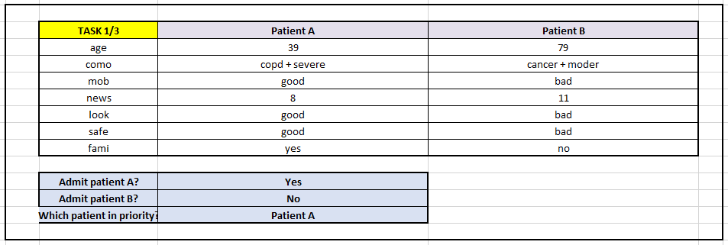

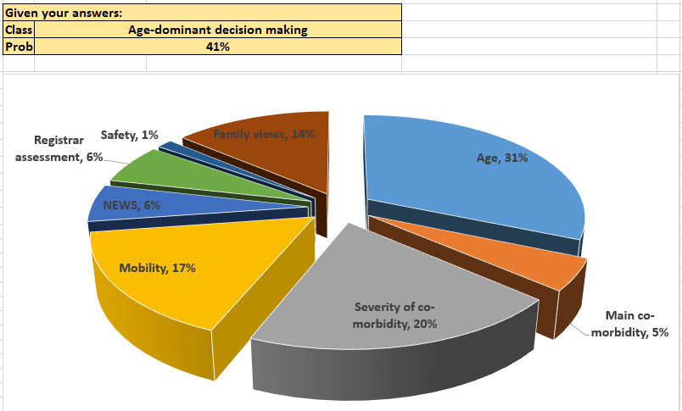

Appendix 10 Table of factors informing DSI development
Table 35 Table of factors informing DSI development
Factor identified: | WP1 | systematic review | Influence on final DSI
Patient dignity | + |  | Addressed in educational resources, included in information for family and patients.
Clinician authority/seniority in both ICU and referring team | + | + | Encourage senior clinicians involvement by naming individuals on both referral and decision-making forms, included in supporting educational material
Clinician personal views/beliefs/experiences | + | + | Use of a standardised process and cognitive framework to guide decision-making to enable clear, transparent and consistent decision-making process to reduce implicit biases
Communication between clinicians | + | + | Use of standardised referral and decision-making forms to clarify communication. Use of an SBAR model in the referral forms. Included in content of educational support material
Perceived competence of involved clinicians | + |  | Educational supporting materials to encourage good dialogue between clinicians and use of a consistent approach Education on the potential harms of ICU. Development of decision-support and referral documents to clarify communication
Family perspective | + | + | Family information sheets developed to help families participate in decision-making process
Functional status and reserve | + | + | Clarified as a potential source of information to guide judgement on the capacity to benefit from life-supporting treatment, and included on decision-support and referral forms
Lack of available information | + |  | Not directly addressed in this intervention. However, this intervention relies on best use of available information, and encourages information gathering from family and patient
Kind of help requested not well communicated | + |  | Referral forms include section to document type of help requested as tick box with free text option.
Likelihood of survival of patient | + |  | Included as part of balancing activity in cognitive framework and the decision-support and referral forms
Likelihood to benefit from ICU care | + |  | Included as part of cognitive framework and in the decision-support and referral forms
Subjective “look” of the patient | + |  | Emphasis on explicit reasoning and justification in the cognitive framework and in referral and decision support forms
Patient's age | + | + | Implicit biases acknowledged within supporting educational material, Explicit reasoning and justification for reasons included in cognitive framework and referral and decision support forms
Personal connection with patient | + |  | Use of a standardised process and cognitive framework to guide decision-making to enable clear, transparent and consistent decision-making process
Premorbid state/ comorbidities | + | + | Included as part of cognitive framework as contributing to judgement over capacity to recover from critical illness and included in the decision-support and referral forms
Acute medical condition | + | + | Included in the cognitive framework, decision-support and referral forms as contributing decision-making as the “need” for intensive care treatment
Patients quality of life as perceived by clinician | + | + | Explicit reasoning and justification for reasons included in cognitive framework and referral and decision support forms
Resource availability/ ICU bed availability | + | + | The sequencing of decision regarding treatment required before considering resources to provide it to minimise the effect of resource availability on ICU admission decision.
Safety concerns | + |  | Specific question about whether required care can be delivered safely on the ward
Illness length and trajectory | + |  | Included as part of cognitive framework as contributing to judgement over capacity to recover from critical illness and included in the decision-support and referral forms
Patient's wishes | + | + | Specifically included in cognitive framework. Patient and family information sheets developed to aid participation in process. Specific requirement on referral and decision-support form to seek out patient wishes. Included specifically in educational support material.
Patients gender |  | + | Not directly addressed in this intervention.
Prognostic pessimism |  | + | Requirement for explicit reasoning and justification of decisions.
Time of day of referral |  | + | Use of a standardised process and cognitive framework to guide decision-making to enable clear, transparent and consistent decision-making process
Presence of key decision-maker at bedside |  | + | Encouraging of consultant to consultant discussion and collegiate decision-making, included in educational supporting material and the documentation of senior involvement on referral and decision-support forms.
Ethnicity of patient |  | + | Patient and Family information leaflets translated into minority ethnic languages
Patient’s cognitive status |  | + | Use of a standardised process and cognitive framework to guide decision-making to enable clear, transparent and consistent decision-making process  Explicit reasoning and justification of decision required on referral and decision support forms
Time available to make decision |  | + | Addressed in supporting educational material.
Clinical doubt |  | + | Addressed in supporting educational material and
Patients health insurance |  | + | Not relevant to UK practice, not addressed within this intervention.
Pressure from hospital hierarchy |  | + | Use of a standardised process and cognitive framework to guide decision-making to enable clear, transparent and consistent decision-making process
Clinicians wish to avoid complaints and litigation |  | + | Use of a standardised process and cognitive framework to guide decision-making to enable clear, transparent and consistent decision-making process
Presence of written guidelines |  | + | Not specifically addressed within this intervention
Clinicians wish to avoid conflict |  | + | Use of a standardised process and cognitive framework to guide decision-making to enable clear, transparent and consistent decision-making process
Specialty discipline of patients acute illness |  | + | Use of a standardised process and cognitive framework to guide decision-making to enable clear, transparent and consistent decision-making process. Included in educational supporting material.
Background discipline of intensive care decision-maker |  | + | Not addressed in this intervention
Presence of a DNACPR order |  | + | Use of a ReSPECT form specifically included in decision-support and referral forms as a source of information. Included in educational material.

Appendix 11 Referral form
INSERT LOGO TO BE COMPLETED BY REFERRING TEAM

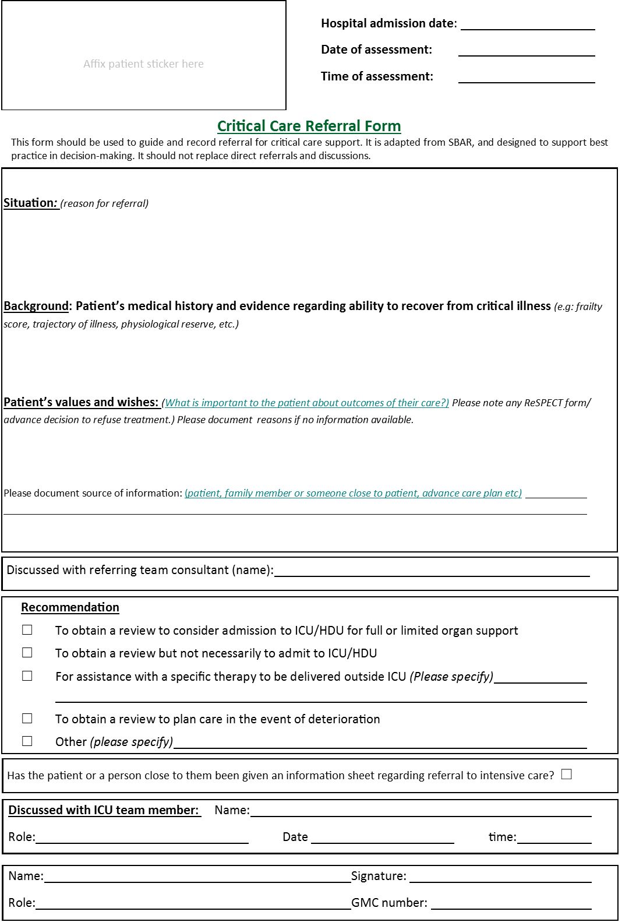
Decision-making for ICU admissions This project was funded by the NIHR HS&DR programme (project number 13/10/14)
Referral form v1.3 25.04.2017 Developed in conjunction with University Hospitals Coventry and Warwickshire NHS Trust © Copyright 2017 University of Warwick

Appendix 12 Decision form
INSERT LOGO TO BE COMPLETED BY ICU TEAM

Evidence: Clinical (factors in patient’s acute condition and long term health relevant to decision about escalating treatment)

Evidence: Ability to recover from this critical illness based on evidence (e.g: functional reserve, trajectory of illness, exercise capacity, dependence, self-reported QoL, frailty score)

Evidence: Patient values and wishes (what is important to the patient with regard to their treatment and the potential out-comes? Please note ReSPECT form/advance decision to refuse treatment if available.) If no information is available please say why.
Please document source of this information: (patient, family or someone close to patient, advance care plan etc)
_____________
Critical Care: Decision-support Form
This form can be used to guide and record the decision-making process regarding the critical care support a critically ill pa-tient should receive. It is designed to support best practice in decision-making.
Affix patient sticker here
Hospital admission date:
Date of assessment:
Time of assessment:
Assessment number (for repeat assessments)
Decision-making for ICU admissions This project was funded by the NIHR HS&DR programme (project number 13/10/14)
Decision form v1.2 10.03.2017 Developed in conjunction with University Hospitals Coventry and Warwickshire NHS Trust © Copyright 2017 University of Warwick
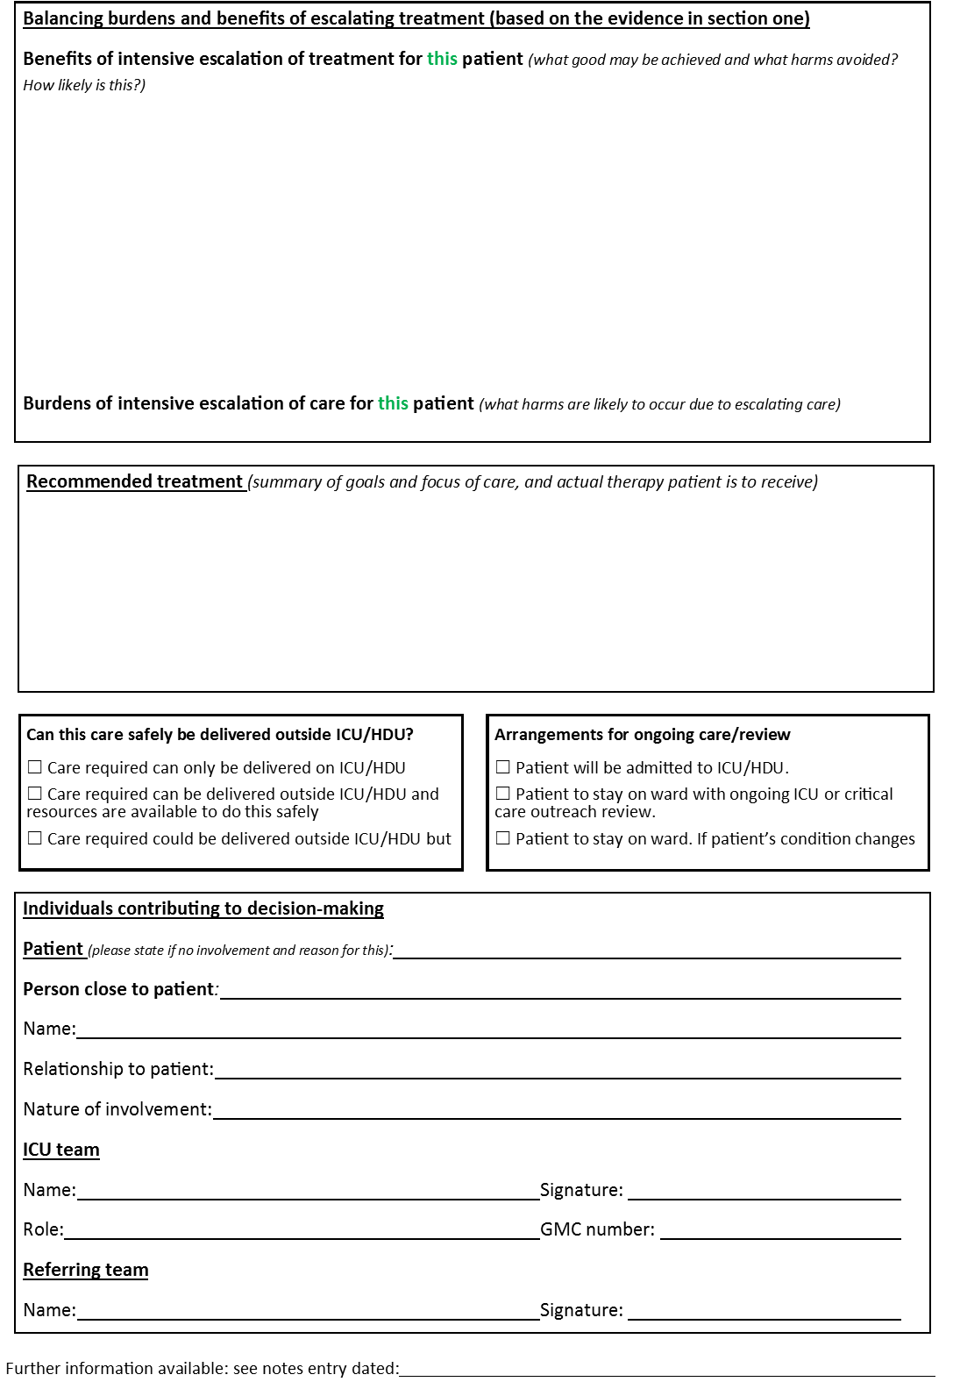
Decision-making for ICU admissions This project was funded by the NIHR HS&DR programme (project number 13/10/14)
Decision form v1.2 10.03.2017 Developed in conjunction with University Hospitals Coventry and Warwickshire NHS Trust © Copyright 2017 University of Warwick

Appendix 13 Family information leaflet
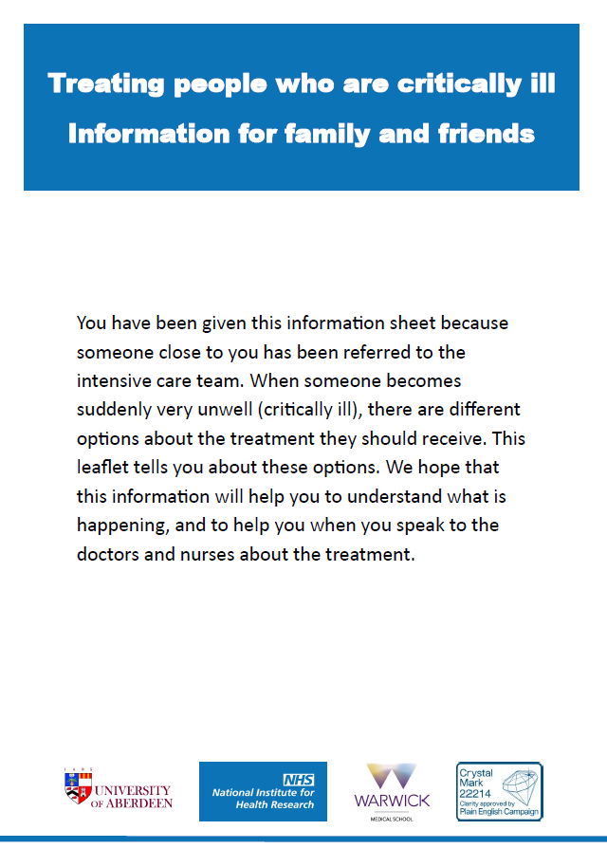

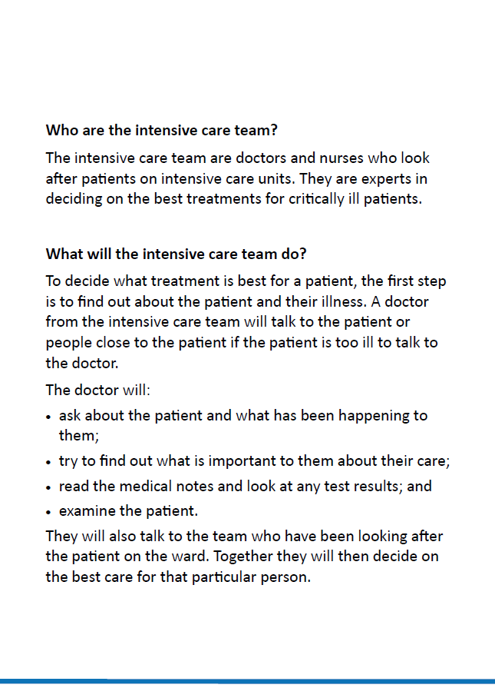

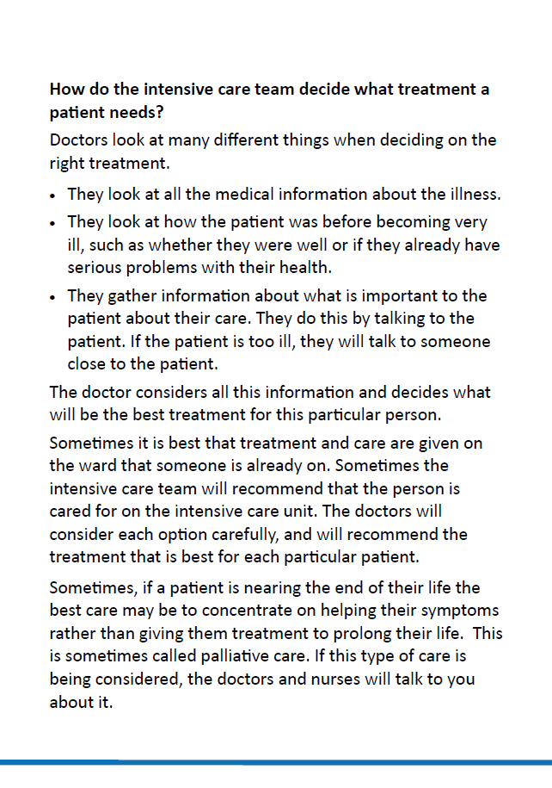

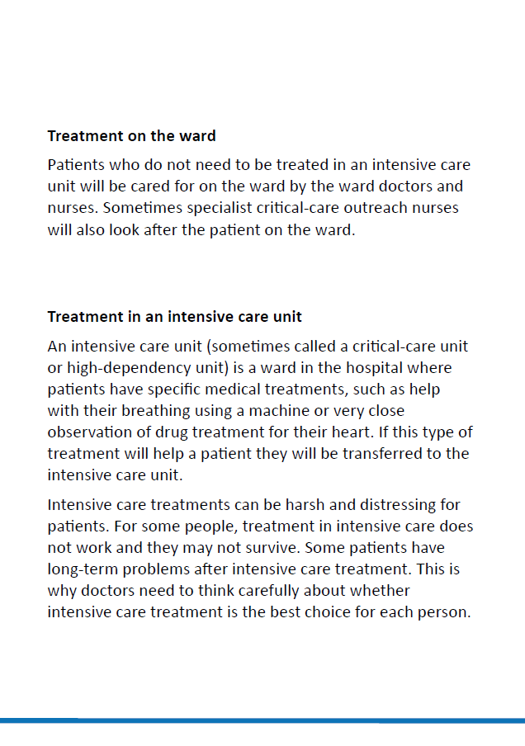

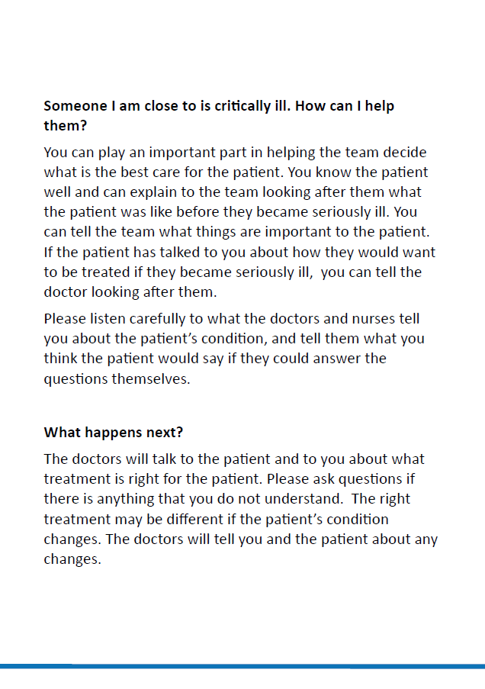

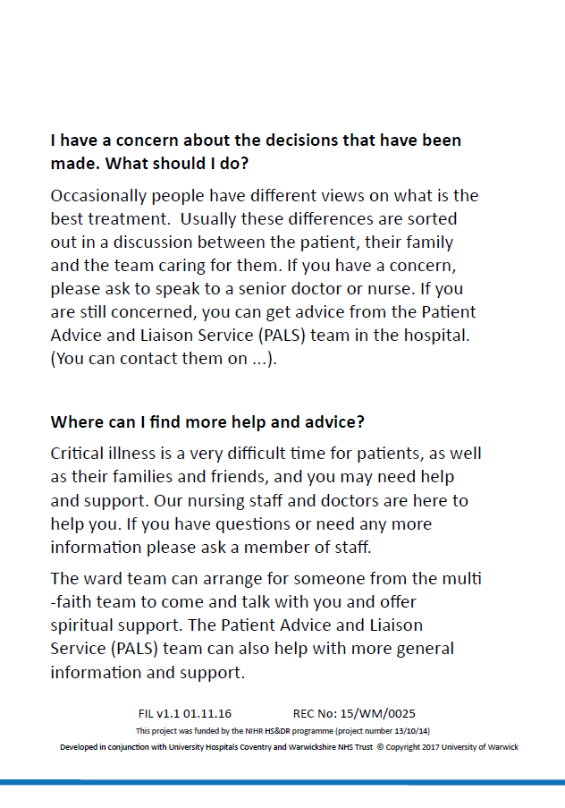

Appendix 14 Patient information leaflet
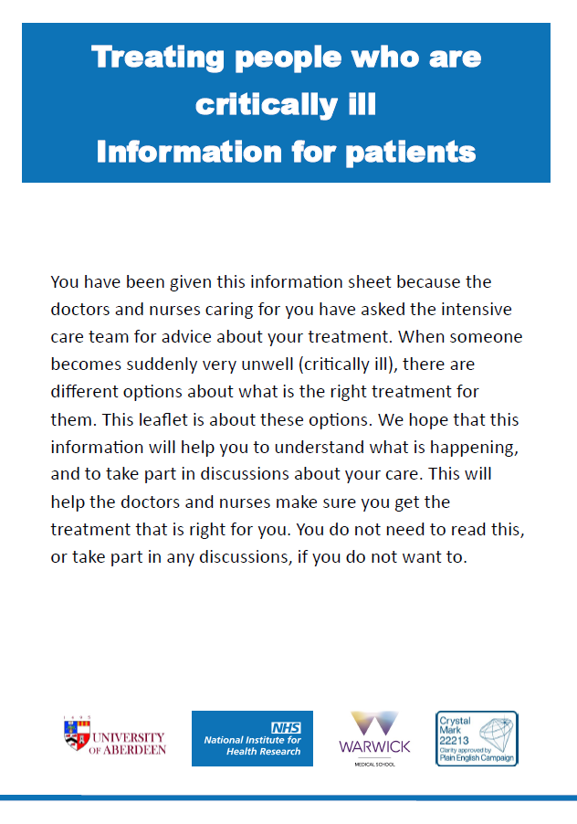

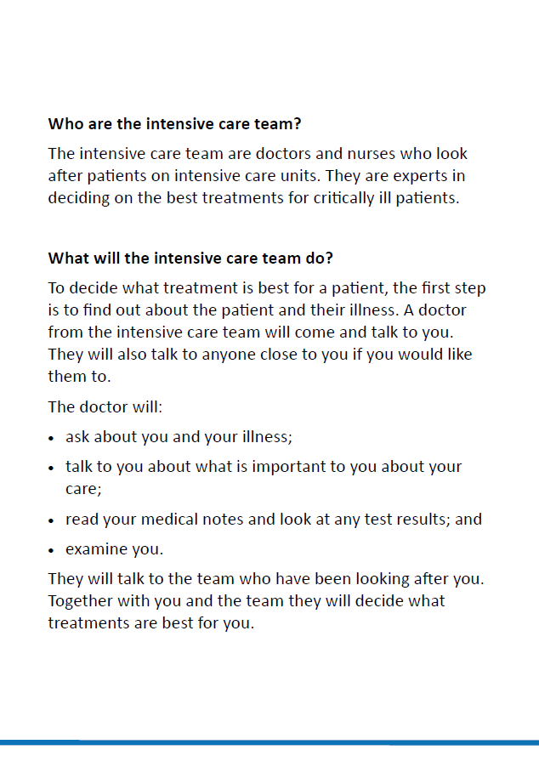

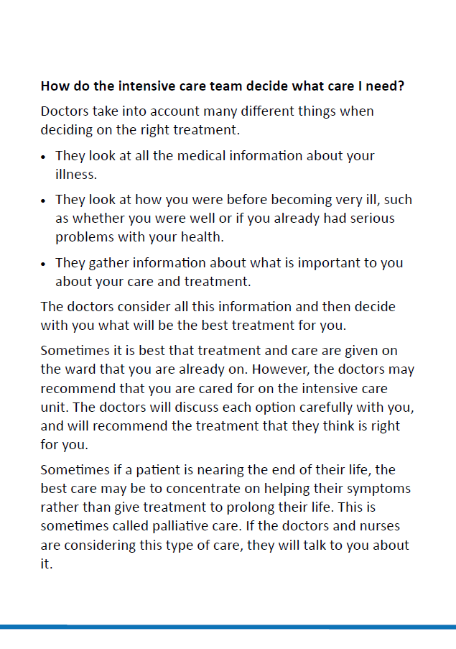

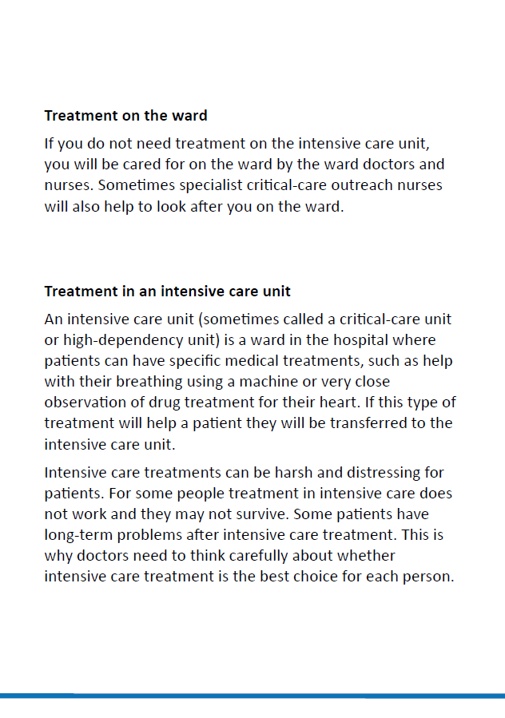

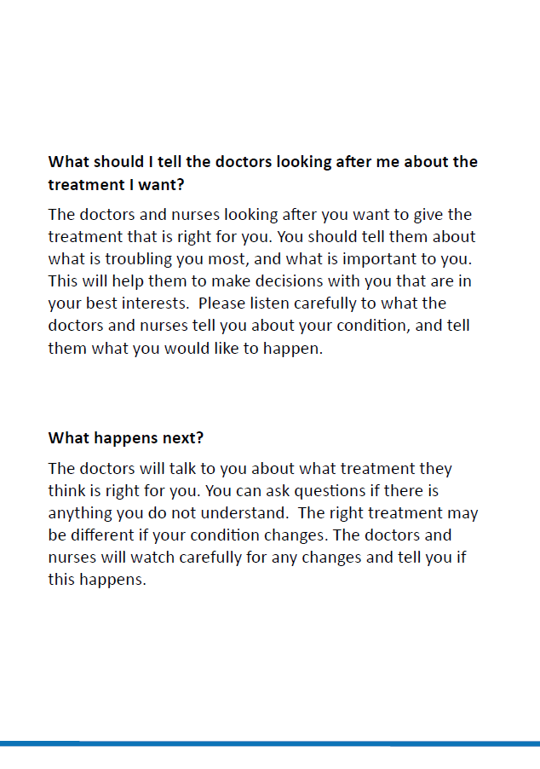

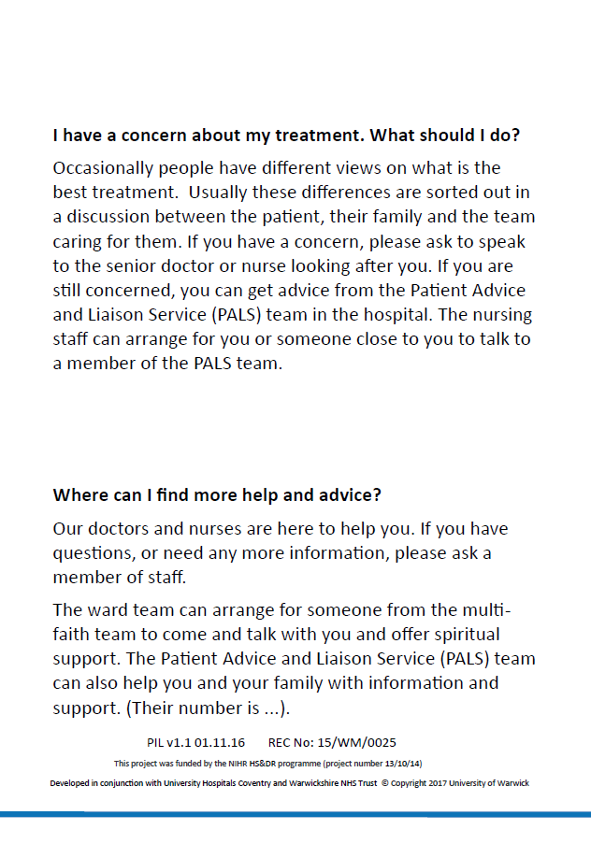

Appendix 15 Stakeholder conference delegates
Table 36 - Stakeholder conference delegates
Title | First Name | Surname | Job role | Organisation name
Dr | Milind | Arolker | Palliative Care Consultant | Heart of England
Dr | Nicky | Ashby |  | University of Nottingham
 | David | Baker | Clinical and Business Informatics Specialist | HSCIC
Dr | Chris | Bassford* | Chief Investigator | UHCW
 | Simon | Baudouin | Project Chair | FICM professional standards committee
Ms | Sarah | Broom⁺ | Lay Advisory Group
 | Daniele | Bryden | Consultant intensive care physician | Faculty of Intensive Care Medicine
 | Sharon | Burton | Head of Standards and Ethics | GMC
 | Elaine | Clarke | Nurse Manager
Rev | Alison | Coles | West Midlands Regional Representative for CHCC/Lead Chaplain for Walsall Healthcare | Walsall Healthcare NHS Trust
Prof | Jeremy | Dale* | Co-Investigator | University of Warwick
Dr | Ron | Daniels | Chief Executive | UK Sepsis Trust
 | Chris | Dickson | Clinical and Business Informatics Specialist | HSCIC
Mr | Roy | Dudley-Southern | NHS Service User and Commissioner
Dr | Nadine | Flowers* | Project Manager | University of Warwick
Dr | Zoe | Fritz* | Co-Investigator | University of Warwick
Dr | Akif | Gani | Consultant Geriatrician
 | Colin | Gelder | Consultant Physician | UHCW
Mr | Richard | Grant | Lay Advisory Group
 | Sarah | Gray | Service Development Manager-Midlands | British Lung Foundation
Prof | Frances | Griffiths* | Co-Investigator | University of Warwick
 | Bridget | Harper | Patient Representative | Age UK Coventry / Coventry Older Voices
 | Dan | Harvey | Consultant intensive care physician | FICM professional standards committee
Dr | Huayi | Huang* | Co-Investigator | University of Warwick
Mrs | Louise | Hutton | Secretary | University of Warwick
 | Philippa | Jones | Associate acute oncology nurse advisor | Macmillan Cancer Support
Mr | Elyas | Khalifa | Lay Advisory Group
 | Zahid | Khan | Consultant intensive care physician | Intensive Care Society
 | Nadia | Khan | Consultant in Palliative Medicine | St. Giles Hospice
Dr | Nicolas | Krucien* | Co-Investigator | University of Aberdeen
 | Peter | McCullough | Consultant Surgeon | University Hospital Coventry
Mr | Sean | McGovern | HM Governor | Coventry
 | Julie | Midgley | NHS Solicitor | UHCW
Dr | Natalie | Pattison | Senior Clinical Nursing Research Fellow | BACCN
Dr | Nick | Scriven | Consultant in Acute Medicine
Dr | Anne | Slowther* | Chief Investigator | University of Warwick
 | David | Spurgeon | Health Watch Coventry Executive (Patients General) | Healthwatch
Dr | Andrew | Stewart | Lead Consultant Haematologist | University Hospitals of North Midlands/NHS England Acute Oncology
 | Ganesh | Suntharalingam | Consultant intensive care physician | Intensive Care Society
Dr | Mia | Svantesson-Sandberg* | Co-Investigator | University of Warwick
Mrs | Sarah | Symons* | Co-Investigator | Royal United Hospitals
 | Robert Mark | Temple | Consultant Physician and Nephrologist RCP | Heart of England Foundation Trust
 | Lloyd | Tingley | Neuro Muscular Outreach Officer | Muscular Dystrophy UK
 | Emerald | Toogood | Legal Services Manager
Mrs | Susan | Tulip | Lay Advisory Group
Dr | Chris | Turner | Consultant in Emergency Medicine | University Hospital Coventry
 | Phil | Watt | ICU Consultant Anaesthetist
Ms | Catherine | White* | Co-Investigator | ICU Steps
*Members of the investigator team
Appendix 16 Report of the stakeholder conference
Decision-making for ICU admissions: Understanding and improving the decision-making process surrounding admission to the intensive care unit
REC: WM/15/0025
Report of the stakeholder conference for conference delegates
Dear [Conference delegate],
Thank you once again for attending and contributing to the decision-making for ICU admissions stakeholder conference on the 1st July 2016 at Warwick University. At this event we described the problems with the way that decisions are currently made regarding admission to the intensive care unit, and we presented a draft intervention (decision-support intervention) to improve this process. The focus groups you participated in helped give us valuable insight and feedback on the intervention.
After the conference the notes taken by the focus group scribes were read by members of the study team: From these notes we identified the issues that participants raised, and the group(s) discussed, resulting in the emergence of agreement within the group(s) of how the issue should be taken forward within the Intervention. All elements of the decision-support intervention were discussed by one or more groups, and we have taken particular note of issues that emerged from more than one focus group. We are now sending you this brief summary of what was said in these focus groups. We have not included everything that was said in the focus groups in this report, as this is intended to remind participants of the discussions, to summarise the key points, and explain potential changes to the intervention. We have revised the decision-support intervention in light of what was said at the conference, and also included new versions of the forms that contain these changes.
We hope that you will find time to read this report, and examine the new drafts of the referral form, the decision-making form, and the patient/family information sheet. Once again we would like your feedback: particularly we would like to know if there are any major issues you think we should consider, whether or not they were raised in the focus groups, or if you disagree strongly with the amendments we propose.
Once you have read the report we would be very happy to hear from you. You can do this by directly replying to this email, contacting us by telephone, or sending us information at the address below.
Thank you once again for participating in this project
Yours Sincerely

Christopher Bassford
Chief Investigator: Decision-making for ICU admissions project
Warwick Medical School
Coventry
CV4 7AL
T +44 (0)24 7652 3583
ICUdecisionmaking@warwick.ac.uk
www.warwick.ac.uk/ICUdecisions

This report is a summary of the focus group discussions at the stakeholder conference on the 1st July 2016 at the Scarman centre at Warwick University. It is a summary of the notes taken in each of the focus groups, which have been analysed to extract the key messages. These have then been used to adapt the draft decision-support intervention presented at the conference, which is intended to improve the process by which the decision whether or not to admit a patient to ICU is made. The report is divided into the following sections:
- Issues related to both referral and decision-support forms
- Issues specific to referral form
- Issues specific to decision-support form
- Issues related to the educational package
- Issues related to family information sheet
- Barriers and facilitators to uptake
Each section ends with a brief description of how we have changed the intervention, in light of the comments made at the conference.
Issues related to both referral and decision-support forms
A concern voiced in some of the groups was that admission to ICU is only one aspect of escalation of care, and the decisions being addressed should reflect all aspects of critical care, including outreach support and high-dependency care. It was suggested that the forms should not be so narrowly related to ICU admission, but should be a referral for general critical care/intensive care support. One suggestion was to list all forms of intensive care service including HDU and ICU outreach
The question re “appropriate monitoring of patient” was challenged. The language was seen as ambiguous and subjective. A suggested rewording from “Is patient being appropriately monitored?” to “Can the patient be monitored on the ward?” was offered.
Another concern was the use of the term “family member” in the documents. It was suggested that this should be changed to reflect the fact that it is not only family members who best know the patient and reflect their views. Changing the wording to ‘outcomes relevant to the patient’ was suggested. Information specifying who has provided information, or who has been contacted should be added to the form.
Changes made:
- The focus of the documents has shifted: rather than being restricted to decision-making regarding admission to the intensive care unit, we have broadened the focus to include decision-making regarding the initiation of all critical care support. This will allow for more nuanced, patient-centred decision-making that is not as limited in scope by its outcome.
- In the section on patient’s values and views the term (what is important to the patient’ has been added.
- Family member has been changed to “person closest to the patient” to reflect the fact that other people may be better placed than family members to reflect the views of the patient. The question re appropriate monitoring of the patient has been removed
Issues specific to referral form
A range of suggestions and comments were made regarding the referral form. Participants suggested some additional sections including:
- a section for recording which other health professionals had been consulted in particular nursing colleagues and members of the immediate multidisciplinary team;
- a section to record the views of the family (other than their views on the patient’s wishes)
- a section to indicate any existing ceiling of care, DNACPR orders, any advance directive or Lasting Power of Attorney known about.
Participants also thought it was important to document on the form whether the referral had been discussed with a consultant and if so the name of the consultant.
Two further additional suggested options for reason for referral were: admission for a “trial of ICU”; and ‘senior opinion’ for patient requiring extra nursing support but not necessarily ICU intervention.
The focus groups questioned whether treatment initiated needed to be on the form and a suggestion made that this would be better worded as treatment already given. It was suggested that a prompt to check if any national or local guidance had been followed could be included in this section. There was also some question about whether the “recommendations for care” box was required and an alternative wording of ‘referring clinician’s recommendations for care’ suggested.
The focus groups suggested that the form should follow the SBAR template as clinicians are familiar with this as a referral mechanism (SBAR is an acronym that is recommended to improve the quality of communication when referring a patient to another clinician. It prompts individuals making a referral to communicate the situation, the background to that situation, their assessment of what is happening, and their recommendations for action). More specific points included clarifying whether multiple boxes could be ticked and that there is a requirement to specify if information is not available (not to leave section blank). Some specific comments on use of language were made including the use of the word appropriate. Finally, there was a reminder that the form should not replace face to face discussion between clinicians.
Changes made:
The referral form has been changed although not all of the suggestions have been included to ensure that the form remains practical, and simple to complete.
- The reference to ICU admissions has been changed in the title to “intensive care support”.
- The form has been modified to be closer to the SBAR format, and this has been directly referenced on the form.
- The name of the consultant with whom the referral has been discussed has been requested.
- The type of help requested options have been modified to include options for review alone, and to reflect the option of full or limited organ support (this would practically include increased nursing care). This section is now called ‘Recommendations’ in line with the SBAR format.
- The previous “recommendations for care” section has been removed to keep the form brief.
- The form has been modified to be closer to the SBAR format, and this has been directly referenced on the form.
- Language has been changed as suggested
- A reminder to engage directly with the ICU team has been added.
- A prompt is included that requires a reason to be given if no information on the patient’s views is recorded.
- A prompt to note any advance directive/lasting power of attorney or ReSPECT form has been included
- Treatment initiated has been removed from the form
Issues specific to decision-making form
A strong message that came out of the focus groups was the concern about recording the number of available ICU beds at the beginning of the form. Participants thought that this shifted the focus for decision making away from patient centred care. There were concerns about the legal implications and impact on a patient’s family’s perception or fear that care would be limited because of resources. One group suggested that there be a prompt to advise clinicians not to think about resources while making a patient centred judgement. There was disagreement within the groups about whether resource limitations did actually affect these decisions in practice. However there was consensus that if this question was on the form it should be at the end not at the beginning, and that the wording should be changed to: “Is there likely to be a delay to admission?” and “What are you doing to ensure patient safety in the interim?”
For the sections on clinical background groups suggested that more prompts, with examples or tick boxes, would be helpful to guide clinicians as to what was required, for example frailty scores, residency, and other scores that are related to prognosis. Tick box prompts were also suggested to assist in balancing of burdens and harms. However some groups thought that this section required a more narrative approach for clinicians to justify their decision. There was a concern that the terms benefits and harms might generate generic rather than patient specific responses.
There was some difficulty in understanding what should go in the “combination of therapies” box. One group pointed out that expertise as well as treatments was important. Some groups thought that this box was unnecessary or could be combined with the burdens and benefits section. Additional options such as care on HDU were suggested. Groups agreed that the outcomes section should include an option for a trial of ICU, and a re-ordering of outcome tick boxes was suggested.
The groups noted that the recording of a patient’s perspective should state the source of information (patient, advance directive, family or someone close to patient). They also suggested an additional text box specifying who was responsible for informing the patient or their family, and recording when this had occurred.
A further suggestion was that there should be space to allow for additions or corrections to the documentation.
Changes made:
- We have changed the text of the box requiring a balancing of benefits and harms, to balancing the benefits and burdens of escalation of care.
- The initial draft had a text box for recommended combination of therapies as well as for plan; these have been changed to a single box for recommended care and arrangements for review. As our qualitative data suggested a shortcoming of current practice was poor planning and communication regarding review of patients not admitted to ICU, this latter element was kept, but free text is not needed. This will also help to shorten the form, a key barrier to implementation.
- We have removed the section of the form relating to the context of decision-making (number of ICU beds and ward safety/monitoring). Although these factors have been seen to influence decision-making, referral to them on the form was thought to potentially adversely impact on relationships with patients and their families, put doctors at risk of complaint and litigation, and decrease uptake of the intervention.
Issues related to the educational package
The focus groups made suggestions about how the education might be delivered and taught. They commented that it would be important for raining to be integrated throughout the NHS and multidisciplinary, with support of professional organisations. Specific suggestions included linking it to multi-disciplinary team meetings and providing an online resource. The scope of the teaching in terms of target audience was not clear.
All focus groups suggested that teaching methods should include practical application of knowledge with case based discussion, sharing of experiences and examples of good practice. The use of simulation based training was identified as very useful for this kind of teaching. The education should be aimed at enhancing and improving quality of decision making, rather than implying that staff are performing poorly.
Suggestions and issues raised regarding the content of any education intervention were wide ranging and could be grouped into the following areas:
- Clarification of how and when to use the referral form and decision support framework..
- Factors that are or should be considered in making decisions. These focussed mainly on age and ability to recover as criteria for admission to ICU. The difficulty and subjectivity in assessing ability to recover was seen as a key problem for clinicians with different views in the groups on the use of disability scores as an aid to decision making.
- All groups identified communication with patient and family as important, for information gathering, understanding and respecting the patient’s wishes, and explaining the limitations of ICU. Concerns about misunderstanding of the precise role of the family in decision making were raised as needing clarification, for both clinicians and families. Communication skills teaching was identified as important, including inter professional communication, including communication with outreach teams, nursing staff, and community staff.
- Knowledge of the law and relevant professional guidance was identified as necessary for good decision making. Clarification of how the referral form and DSF fitted with the ReSPECT form was sought and the need to work within the Mental Capacity Act emphasised. Several groups also highlighted the need to ensure against discriminatory behaviour with specific groups of patients: e.g those with a learning disability or mental health disorder.
- The need to provide an ethical framework for the decision making was identified as a key element of the educational package. The challenges of balancing burdens and benefits of treatment for a particular patient, balancing clinical assessments and patient’s values, prioritising different values such as prolonging life or quality of life, and issues of distributive justice were all identified as difficult for clinicians and where support/education was needed. The importance of being able to make a transparent and justifiable decision was noted.
Changes made:
- All of these suggestions will be taken into account in the development and delivery of the educational package.
Within the study intervention the educational package will of necessity be focussed and tailored to be delivered in a single session for staff. However, the focus group comments on wider aspects of education for health care professionals related to this topic will inform discussions on development of a national educational initiative outside the remit of this project.
Issues specific to the family information sheet
Discussion of the patient /family information sheet provided several helpful suggestions for improvement. A key message from the groups was that the information sheet needed to convey the message that ICU was only one of a range of options of care for a patient; that ICU often had harmful consequences for a patient and that for some seriously ill patients the best option would not be to admit to ICU but to provide good end of life care. A more honest acknowledgement of death as a possible or even likely outcome for the patient was called for. Groups also noted that if a patient is not admitted to ICU they may continue to be monitored by ICU outreach or have other interventions and this also needs to be clear to families who may think that their loved one has been abandoned by the decision not to admit to ICU. The burdens on those close to the patient when their loved one was in ICU were not apparent in the current information leaflet and were seen as important to raise with families.
In general, clearer and less ambiguous language was thought to be required.. Words such as “benefit”, “need” and “appropriate” needed to be explained. Translations into other languages and possibly pictorial information was suggested to ensure that the leaflets were widely accessible. A specific point was made that this information leaflet should not just be for families but for anyone close to the patient, including friends and informal carers.
The focus groups agreed with the need to provide information about where to go and who to talk to if they had any concerns and about the process for resolving disputes. The timing of giving the leaflet to family and friends was discussed. The groups thought it may not be so useful in an acute situation but would be useful in care planning. It was suggested that timing of providing the leaflet would need to be flexible depending on the situation. It was also suggested that there should be a tick box on the referral form to indicate whether the information leaflet had been given.
Changes made:
- The notes from focus groups were read and analysed by lay members of the study team, who led the development of a revised information sheet. A new draft of the patient and family information sheet has been developed. This new draft has tried to balance the need to explain the complex nature of these decisions with clarity, providing sufficient information in a readable way, without becoming overly complex. It has expanded to include the care options for critically ill patients more broadly, but still retain a focus on decision-making for admission to an intensive care unit. The new draft is attached, and we would appreciate feedback.
- A prompt and tick box has been added to the referral form to indicate that an information sheet has been given to the patient or their family.
Barriers and facilitators to uptake
The key barriers to implementation of the intervention related to time and timing of the use of the referral and decision support forms.
Focus group participants were concerned about the time it would take to complete the forms, and that clinicians may avoid completing them. A further concern was whether completion of a form would interfere with decisions being made in a timely manner. These decisions often need to be made urgently, and participants noted that completion of the form should not delay this. There were reminders that the goal is to improve the decision making process, not to complete a form. But the form (or framework) may facilitate improvement in the decision making process.
It was noted that much of the information required should already be documented in the patient notes but that the forms required this in more detail. Duplication of information on the two forms was also seen as a poor use of time and a suggestion to have integration of the forms, or for some information to be only documented on one form might increase their use by clinicians.
A further barrier to implementation noted is the lack of clarity/understanding about the intervention illustrated by questions about who should complete the form and whether an inability to complete a section would mean the form was not completed at all, or that a referral was not made. Participants shared experiences of problems with paperwork in clinical practice. Ensuring the paperwork (forms) is available at the right time and in the right place, and is transferred with the patient between departments is important to facilitate its use.
A major barrier to implementation of the interventions as it stands is the inclusion of the question in ICU bed number and the perceived negative consequences of completing this including: biasing decision making; impact on the relationship with the patient and family; risk of complaint or litigation.
There was a general view that standardised forms to be used across all Trusts would facilitate uptake, although some participants suggested modifications might be needed for different referring departments, with the option for individual Trusts to add to the forms but not omit anything. Colour coding of the forms would make them less likely to be missed. Support from professional bodies was also seen as facilitating uptake of this kind of intervention.
Changes made:
- The forms involved have been shortened and focussed. The use of the forms will be covered in the educational package accompanying their implementation including who should be completing them, and at what point, and the importance of ensuring care is not delayed. Determining whether this method of prompting a process and documenting the decision-making will work in practice is one of the goals of the implementation feasibility study.
The question regarding number of ICU beds available has been removed (please see earlier section on issues relevant to both documents).
Conclusion
Thank you once again for attending the stakeholder conference for the decision-making for ICU admissions project, and for taking time to read this report. Our intention remains to develop methods to improve decision-making on behalf of critically ill patients, and your help is greatly appreciated. If there are any comments you wish to make regarding the report, or suggestions for further development of the intervention we would be very grateful for your feedback. Please contact us using the details below.
Christopher Bassford Anne Slowther
Chief Investigators: Decision-making for ICU admissions project

Contact details:
Nadine Flowers
Project Manager, Decision making for ICU project
Warwick Medical School
Coventry
CV4 7AL
T +44 (0)24 7652 3583
ICUdecisionmaking@warwick.ac.uk
www.warwick.ac.uk/ICUdecisions

Appendix 17 Site implementation schedules
Table 37 Schedules of implementation at the different sites
Week | Hospital A | Hospital B | Hospital C
Week 1 | Emailed all consultants via Med Director;  Spoke to Deteriorating Patients Group;  Informed CCOR nurses about the study;  Emailed ICU colleagues | Training at ICU meeting; ED consultants meeting | Training to acute medicine;  CCOR ICs informed team at staff meeting;  Posters placed on referring wards
Week 2 | Emailed ACCP and CCOR teams |  | Training to anaesthetics and intensivists department meeting; thoracic surgery meeting  Circulated materials to haematology; and to consultants at ED
Week 3 | Training to ACCPs, Grand Round, Anaesthetics and ICU meeting | Delivered training to Haematology-Oncology | Delivered training to acute medics, geriatrics, and haematology departments
Week 4 |  | Delivered training to Junior Doctors at ED | Delivered training to respiratory department and ED registrars
Week 5 |  | Delivered training to Respiratory department | Emails sent out to clinical leads of referring specialties
Week 6
Week 7 | Delivered ‘Goody Bags’ to wards to raise awareness;  Started circulating ‘League Tables’ | Added study to ‘Topic of the Month’ (daily reminder to ITU medical staff)
Week 8
Week 9 |  | Delivered training at Grand Round
Weeks 10-14
Continually over period | Opportunistic one-to-one training;  Raising awareness on referring wards | Mentioned daily at ICU consultant handover | Emails to colleagues (ICU and CCOR);  Mentioned every day at briefings on ICU;  Reminding CCOR every day

Appendix 18 Form usage data analysis

Data cleaning notes
Bed occupancy
Bed occupancy was reported differently across the three sites. So, to make fair comparisons, bed occupancy per day was calculated as the maximum occupancy of the site over one calendar day (midnight to midnight). Hence, at time of assessment more beds may have been available and this represents a “worst case” scenario. Details for each site are given in the section below. A summary graph illustrating the calculated bed capacity at each site over the six weeks of data is shown below in Figure 21.
Figure 21 Percentage daily ICU bed occupancy
Daily bed occupancy was then categorised such that unit was:
- Full/over capacity
- Had one bed available
- Had two beds available
- Had three or more beds available
Figure 22 shows the categorical breakdown of the bed occupancy data at each site. Note that Hospital A did not report bed occupancy data on the first day the site was open (i.e. Study Day 1)
Figure 22 ICU daily bed occupancy categories at each site

Hospital A
The number of beds available at each Nurse shift (early, late and night) was reported. Maximum capacity was given as 7 beds, with no details on L2 and L3. Bed occupancy per day was calculated as the maximum occupancy at any shift, and divided by 7 to create a percentage.
Capacity for day 1 of the study as this site was not reported.
Hospital B
The number of Level 3 (L3) and Level 2 (L2) patients at both day and night were reported. Maximum capacity was reported as 20 beds or 16 Level 3 patients. Figures were highlighted when reaching bed capacity.
Bed occupancy per day was calculated as the maximum number of Level 3 equivalent patients (no. L3 + no. L2/2, rounded upwards) at any shift, and divided by 16 to create a percentage.
Hospital C
A total L3/L2 mix of 21 beds was reported as the maximum ICU capacity. The number of level 3 and level 3 beds available was reported at any point the ward occupancy was changed. This was used to calculate the number and percentage of available beds.

Case descriptive statistics
Table 38 Case descriptive statistics by site
Case variable |  | Hospital A | Hospital B | Hospital C | All sites
N referrals (% of total) |  | 71 (21.3) | 26 (7.8) | 236 (70.9) | 333
Eligible referral: Yes (N, % of total referrals) |  | 63 (88.7) | 14 (53.8) | 104 (44.1) | 181 (54.4)
Reason ineligible  (n, % of site ineligible) | Duplicate referral/review | 4 (50.0) | 1 (8.3) | 1 (0.8) | 6 (3.9)
Reason ineligible  (n, % of site ineligible) | Unclear documentation | 2 (25.0) | 0 | 0 | 2 (1.3)
Reason ineligible  (n, % of site ineligible) | Prior to start date | 1 (12.5) | 0 | 0 | 1 (0.7)
Reason ineligible  (n, % of site ineligible) | Elective procedure | 1 (12.5) | 0 | 0 | 1 (0.7)
Reason ineligible  (n, % of site ineligible) | Unable to access records | 0 | 1 (8.3) | 40 (30.3) | 41 (27.0)
Reason ineligible  (n, % of site ineligible) | Did not meet site eligibility criteria | 0 | 10 (83.3) | 91 (68.9) | 101 (66.4)
Forms used | Both | 18 (28.6) | 1 (7.1) | 11 (10.6) | 30 (16.8)
Forms used | Decision form only | 1 (1.6) | 1 (7.1) | 4 (3.8) | 6 (3.3)
Forms used | Referral form only | 9 (14.3) | 1 (7.1) | 5 (4.8) | 15 (8.3)
Forms used | Neither | 35 (55.6) | 11 (78.6) | 84 (80.8) | 130 (71.8)
Admitted | Missing | 0 | 6 (42.9) | 4 (3.8) | 10 (5.5)
Admitted | No | 14 (22.2) | 4 (28.6) | 33 (31.7) | 51 (28.2)
Admitted | Yes | 49 (77.8) | 4 (28.6) | 67 (64.4) | 120 (66.3)
Patient Age (years) | Mean (SD) | 67.4 (19.1) | 61.1 (17.0) | 60.6 (16.1) | 62.9 (17.4)
Patient Age (years) | Missing (n, %) | 3 (4.8) | 0 | 0 | 3 (1.7)
Patient Age (category) | Under 40 | 6 (9.5) | 2 (14.3) | 12 (11.5) | 20 (11.0)
Patient Age (category) | 40 – 59 | 14 (22.2) | 3 (21.4) | 34 (32.7) | 51 (28.2)
Patient Age (category) | 60 – 79 | 18 (28.6) | 6 (42.9) | 49 (47.1) | 73 (40.3)
Patient Age (category) | 80 and over | 22 (34.9) | 3 (21.4) | 9 (8.7) | 34 (18.8)
Patient Age (category) | Missing | 3 (4.8) | 0 | 0 | 3 (1.7)
Patient Gender | Unknown/missing | 3 (4.8) | 0 | 0 | 3 (1.7)
Patient Gender | Female | 28 (44.4) | 4 (28.6) | 43 (41.3) | 75 (41.4)
Patient Gender | Male | 32 (50.8) | 10 (71.4) | 61 (58.7) | 103 (56.9)
Time of day  (n, %) | No data/No time given | 28 (44.4) | 8 (57.1) | 19 (18.3) | 55 (30.4)
Time of day  (n, %) | Daytime  (08:00 – 19:59) | 20 (31.7) | 4 (28.6) | 42 (40.4) | 66 (36.9)
Time of day  (n, %) | Night time  (20:00 – 07:59) | 15 (23.8) | 2 (14.3) | 43 (41.3) | 59 (30.2)
Day of assessment | Sunday | 6 (9.5) | 2 (14.3) | 8 (7.7) | 16 (8.8)
Day of assessment | Monday | 6 (9.5) | 3 (21.4) | 12 (11.5) | 21 (11.6)
Day of assessment | Tuesday | 12 (19.0) | 1 (7.1) | 18 (17.3) | 31 (17.1)
Day of assessment | Wednesday | 9 (14.3) | 1 (7.1) | 13 (12.5) | 23 (12.7)
Day of assessment | Thursday | 8 (12.7) | 4 (28.6) | 10 (9.6) | 22 (12.2)
Day of assessment | Friday | 15 (23.8) | 1 (7.1) | 23 (22.1) | 39 (21.5)
Day of assessment | Saturday | 7 (11.1) | 2 (14.3) | 20 (19.2) | 29 (16.0)
Week of data collection | Week 1 | 7 (11.1) | 5 (35.7) | 29 (27.9) | 41 (22.7)
Week of data collection | Week 2 | 12 (19.0) | 1 (7.1) | 17 (16.3) | 30 (16.6)
Week of data collection | Week 3 | 11 (17.5) | 3 (21.4) | 9 (8.7) | 23 (12.7)
Week of data collection | Week 4 | 6 (9.5) | 3 (21.4) | 19 (18.3) | 28 (15.5)
Week of data collection | Week 5 | 12 (19.0) | 1 (7.1) | 9 (8.7) | 22 (12.2)
Week of data collection | Week 6 | 15 (23.8) | 1 (7.1) | 21 (20.2) | 37 (20.4)
Days between admission and referral | Mean (SD) | 1.7 (3.6) | 2.5 (2.4) | 5.3 (7.0) | 3.1 (5.2)
Days between admission and referral | Missing (n, %) | 19 (30.2) | 4 (28.6) | 75 (72.1) | 98 (54.1)
Days between admission and referral | 0 – 2 days | 37 (58.7) | 5 (35.7) | 15 (14.4) | 57 (31.5)
Days between admission and referral | More than 2 days | 7 (11.1) | 5 (35.7) | 14 (13.5) | 26 (14.4)
Bed capacity at referral | No data | 2 (1.1) | 0 | 0 | 2 (1.1)
Bed capacity at referral | Full/over capacity | 13 (7.2) | 4 (2.2) | 54 (29.8) | 71 (39.2)
Bed capacity at referral | 1 bed available | 29 (16.0) | 5 (2.8) | 38 (21.0) | 72 (39.8)
Bed capacity at referral | 2 beds available | 16 (8.8) | 2 (1.1) | 12 (6.6) | 30 (16.6)
Bed capacity at referral | 3+ beds available | 3 (1.7) | 3 (1.7) | 0 | 6 (3.3)
Age at assessment
Figure 23 Histogram of age* at assessment by site
* Only approximate patient age was calculated, as only year of birth was recorded for the purposes of patient confidentiality.
Time of day of assessment
Figure 24 Time of day of assessment to referral to ICU
Figure 25 Time of day of assessment of referral to ICU by site
Figure 26 Proportion of assessments of referral to ICU made during daytime
Day of ICU referral assessment
Figure 27 Day referral to ICU

Figure 28 Proportion of each day of week referral to ICU was made by site

Week of data collection

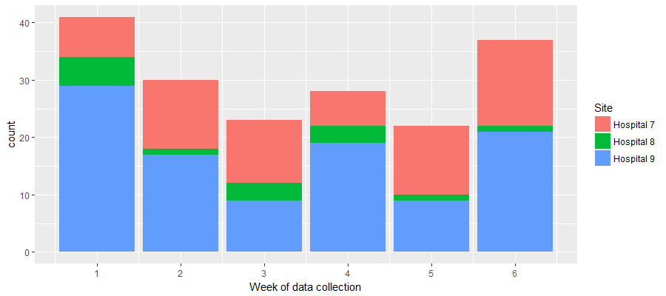
Figure 29 Week of data collection when referral to ICU was made
Figure 30 Proportion of each day of week referral to ICU was made by site

Days between admission and ICU referral assessment
Figure 31 Number of days between admission and when referral to ICU was made
Figure 32 Number of days between admission and when referral to ICU was made by site

There is no evidence to suggest that there is any relationship between the time between admission and ICU referral, and the time that the referral is made. However, note that there is a large amount of missing data for these two variables.
Figure 33 Scatter plot of no. of days between admission and when referral to ICU was made and time of referral

Critical Care Referral Form
Referral form usage
45 of the 181 cases (25%) used the referral form. Table shows how often each section of the form was completed.
Table 39 Referral form usage by site
Form variable |  | Hospital A  N=63 | Hospital B  N=14 | Hospital C  N=104 | All sites  N=181
Cases where referral form was used (n, %) |  | 27 (42.8) | 2 (14.3) | 16 (15.4) | 45 (24.9)
Situation/Reason for referral (n, %) | Details not given | 0 | 0 | 0 | 0
Situation/Reason for referral (n, %) | Details given | 27 (100) | 2 (100) | 16 (100) | 45 (100)
Background (n, %) | Details not given | 0 | 0 | 0 | 0
Background (n, %) | Details given | 27 (100) | 2 (100) | 16 (100) | 45 (100)
Patient’s wishes  (n, %) | Details not given | 1 (3.7) | 0 | 2 (12.5) | 3 (6.7)
Patient’s wishes  (n, %) | Details given | 26 (96.3) | 2 (100) | 14 (87.5) | 42 (93.3)
Source for patient wishes (n, %) | Details not given | 24 (88.9) | 2 (100) | 15 (93.8) | 41 (91.1)
Source for patient wishes (n, %) | Details given | 3 (11.1) | 0 | 1 (6.2) | 4 (8.9)
Discussed with referring team consultant (n, %) | Details not given | 11 (40.7) | 0 | 3 (18.8) | 14 (31.1)
Discussed with referring team consultant (n, %) | Details given | 16 (59.3) | 2 (100) | 13 (81.2) | 31 (68.9)
Recommendation  (n, %) | Details not given | 2 (7.4) | 0 | 0 | 2 (4.4)
Recommendation  (n, %) | 1 – Consider admission | 17 (63.0) | 2 (100) | 14 (87.5) | 33 (73.3)
Recommendation  (n, %) | 2 – Review | 5 (18.5) | 0 | 2 (12.5) | 7 (15.6)
Recommendation  (n, %) | 3 – Therapy outside ICU | 0 | 0 | 0 | 0
Recommendation  (n, %) | 4 – Plan in case of deterioration | 3 (11.1) | 0 | 0 | 3 (6.7)
Recommendation  (n, %) | 5 – Other | 0 | 0 | 0 | 0
Discussed with ICU team:  Clinician role* | Details not given | 6 (22.2) | 0 | 6 (37.5) | 12 (26.7)
Discussed with ICU team:  Clinician role* | Outreach Nurse/ACCP team | 3 (11.1) | 0 | 1 (6.2) | 4 (8.9)
Discussed with ICU team:  Clinician role* | Junior doctor | 2 (7.4) | 0 | 0 | 2 (4.4)
Discussed with ICU team:  Clinician role* | Registrar | 6 (22.2) | 2 (100) | 6 (37.5) | 14 (31.1)
Discussed with ICU team:  Clinician role* | Consultant | 10 (37.0) | 0 | 3 (18.8) | 13 (28.9)
* For clinical role data, four categories from WP1 were used: Outreach Nurse/ACCP team; junior doctor; Registrar; and Consultant. For categories where the role data was uncertain (e.g. “Trainee”), the role was assumed to be a Registrar.
Referral details
For some referral details it was possible to extract this information, such as time of discussion with ICU team or Clinician responsible for referral, from the hospital notes. Hence, data presented in Table 39 may have been collected from the referral forms or from patient notes.

Table 40 Referring details by site
Referring clinician details |  |  |  | Hospital A  N=63 | Hospital B  N=14 | Hospital C  N=104 | All sites  N=181
Cases where referral form was used (n, % of cases) |  |  |  | 27 (42.8) | 2 (14.3) | 16 (15.4) | 45 (24.9)
Discussed with ICU team:  Time |  | Details not given/found |  | 41 (66.1) | 12 (85.7) | 99 (95.2) | 153 (84.5)
 |  | Daytime  (08:00 – 19:59) |  | 15 (23.8) | 2 (14.3) | 1 (1.0) | 18 (9.9)
 |  | Night time  (20:00 – 07:59) |  | 6 (9.5) | 0 | 4 (3.8) | 10 (5.5)
Discussed with ICU team:  Day |  | Details not given/found |  | 41 (65.1) | 12 (85.7) | 95 (91.3) | 148 (81.8)
 |  | Sunday |  | 1 (1.6) | 0 | 0 | 1 (0.6)
 |  | Monday |  | 4 (6.3) | 0 | 3 (2.9) | 7 (3.9)
 |  | Tuesday |  | 3 (4.8) | 0 | 0 | 3 (1.7)
 |  | Wednesday |  | 4 (6.3) | 0 | 1 (1.0) | 5 (2.8)
 |  | Thursday |  | 3 (4.8) | 1 (7.1) | 0 | 4 (2.2)
 |  | Friday |  | 4 (6.3) | 0 | 1 (1.0) | 5 (2.8)
 |  | Saturday |  | 3 (4.8) | 1 (7.1) | 4 (3.8) | 8 (4.4)
Clinician Named in form/found in notes (n, % of cases) |  |  |  | 31 (49.2) | 6 (42.9) | 39 (37.5) | 76 (42.0)
Unique Clinician ID named (n) |  |  |  | 24 | 6 | 33 | 63
Cases per named clinician (n) |  |  | 1 case | 17 | 6 | 27 | 50
 |  |  | 2 cases | 7 | 0 | 6 | 13
 |  |  | 3 cases | 0 | 0 | 0 | 0
Role  (n, % of cases) | Details not given/found |  |  | 35 (55.6) | 7 (50.0) | 79 (76.0) | 121 (66.9)
Role  (n, % of cases) | Outreach Nurse/ACCP team |  |  | 1 (1.6) | 0 | 1 (1.0) | 2 (1.1)
Role  (n, % of cases) | Junior doctor |  |  | 4 (6.3) | 0 | 3 (2.9) | 7 (3.9)
Role  (n, % of cases) | Registrar |  |  | 18 (28.6) | 6 (42.9) | 15 (14.4) | 39 (21.5)
Role  (n, % of cases) | Consultant |  |  | 5 (7.9) | 1 (7.1) | 6 (5.8) | 12 (6.6)
Speciality*  (n, % of cases) | Details not given/found |  |  | 46 (73.0) | 3 (21.4) | 83 (79.8) | 132 (72.9)
Speciality*  (n, % of cases) | Medical specialities |  |  | 8 (12.7) | 6 (42.9) | 8 (7.7) | 22 (12.2)
Speciality*  (n, % of cases) | Surgical specialities |  |  | 2 (3.2) | 0 | 5 (4.8) | 7 (3.9)
Speciality*  (n, % of cases) | Acute/Emergency Medicine |  |  | 7 (11.1) | 5 (35.7) | 8 (7.7) | 20 (11.0)
* For clinical speciality data, the categories from WP1 were used: intensive care; medical specialities; surgical specialities; acute medicine; emergency medicine; training post. Miscellaneous categories not found in WP1 were classed as follows: “GPST1” was as “Training post”

Referral figures
Figure 34 Time of day of discussion with ICU team member about possibility of admission

Figure 35 Time of day of discussion with ICU team member about possibility of admission by site

Decision form
Decision form usage
36 of the 181 cases (20%) used the referral form. Table 41 shows how often each section of the form was completed.
Table 41 Decision form usage
Form variable |  | Hospital A  N=63 | Hospital B  N=14 | Hospital C  N=104 | All sites  N=181
Cases where Decision form was used (n, %) |  | 19 (30.2) | 2 (14.3) | 15 (14.4) | 36 (19.9)
Evidence: clinical (n, %) | Not given | 1 (5.3) | 0 | 0 | 1 (2.8)
Evidence: clinical (n, %) | Details given | 18 (94.7) | 2 (100) | 15 (100) | 35 (97.2)
Evidence: ability to recover (n, %) | Not given | 1 (5.3) | 0 | 0 | 1 (2.8)
Evidence: ability to recover (n, %) | Details given | 18 (94.7) | 2 (100) | 15 (100) | 35 (97.2)
Evidence: Patient’s wishes (n, %) | Not given | 2 (10.5) | 0 | 0 | 2 (5.6)
Evidence: Patient’s wishes (n, %) | Details given | 17 (89.5) | 2 (100) | 15 (100) | 34 (94.4)
Source of patient wishes (n, %) | Not given | 12 (63.2) | 2 (100) | 13 (86.7) | 27 (75.0)
Source of patient wishes (n, %) | Details given | 7 (36.8) | 0 | 2 (13.3) | 9 (25.0)
Balancing: Benefits (n, %) | Not given | 3 (15.8) | 0 | 2 (13.3) | 5 (13.9)
Balancing: Benefits (n, %) | Details given | 16 (84.2) | 2 (100) | 13 (86.7) | 31 (86.1)
Balancing: Burdens (n, %) | Not given | 4 (21.1) | 1 (50.0) | 6 (40.0) | 11 (30.6)
Balancing: Burdens (n, %) | Details given | 15 (78.9) | 1 (50.0) | 9 (60.0) | 25 (69.4)
Recommended treatment (n, %) | Not given | 2 (10.5) | 0 | 1 (6.7) | 3 (8.3)
Recommended treatment (n, %) | Details given | 17 (89.5) | 2 (100) | 14 (93.3) | 33 (91.5)
Can care be delivered outside ICU? (n, %) | Not given | 4 (21.1) | 1 (50.0) | 5 (33.3) | 10 (27.8)
Can care be delivered outside ICU? (n, %) | 1 – only in ICU | 9 (47.4) | 0 | 5 (33.3) | 14 (38.9)
Can care be delivered outside ICU? (n, %) | 2 – outside ICU | 6 (31.6) | 1 (50.0) | 5 (33.3) | 12 (33.3)
Can care be delivered outside ICU? (n, %) | 3 – outside ICU, but no resource | 0 | 0 | 0 | 0
Ongoing care/review  (n, %) | Not given | 11 (57.9) | 0 | 5 (33.3) | 16 (44.4)
Ongoing care/review  (n, %) | 1 – admit to ICU | 6 (31.6) | 1 (50.0) | 4 (26.7) | 11 (30.6)
Ongoing care/review  (n, %) | 2 – ongoing review | 2 (10.5) | 1 (50.0) | 1 (6.7) | 4 (11.1)
Ongoing care/review  (n, %) | 3 – review if changes | 0 | 0 | 5 (33.3) | 5 (13.9)
Patient contributed | Not given | 8 (42.1) | 1 (50.0) | 11 (73.3) | 20 (55.6)
Patient contributed | Details given | 11 (57.9) | 1 (50.0) | 4 (26.7) | 16 (44.4)
Relative contributed | Not given | 11 (57.9) | 2 (100) | 13 (86.7) | 26 (72.2)
Relative contributed | Details given | 8 (42.1) | 0 | 2 (13.3) | 10 (27.8)
Nature of relative involvement | Not given | 12 (63.2) | 2 (100) | 14 (93.3) | 28 (77.8)
Nature of relative involvement | Details given | 7 (36.8) | 0 | 1 (6.7) | 8 (22.2)
Repeated assessment no.  (n, %) | No data/not given | 8 (42.1) | 1 (50.0) | 11 (73.3) | 20 (55.6)
Repeated assessment no.  (n, %) | 1st | 11 (57.9) | 1 (50.0) | 4 (26.7) | 16 (44.4)
Referring team name (n, %) | No data/not given | 12 (63.2) | 2 (100) | 11 (73.3) | 25 (69.4)
Referring team name (n, %) | Details given | 7 (36.8) | 0 | 4 (26.7) | 11 (30.6)
Referring Clinician signed decision form | No data/not given | 18 (94.7) | 2 (100) | 13 (86.7) | 33 (91.7)
Referring Clinician signed decision form | Details given | 1 (5.3) | 0 | 2 (13.3) | 3 (8.3)

Decision details
Again, for some details of the decision process, it was possible to extract information from the hospital notes. Hence, data presented in Table 42 may have been collected from the referral forms or from patient notes.
Table 42 Decision details by site
Form variable |  | Hospital A  N=63 | Hospital B  N=14 | Hospital C  N=104 | All sites  N=181
Cases where Decision form was used (n, %) |  | 19 (30.2) | 2 (14.3) | 15 (14.4) | 36 (19.9)
Day of ICU assessment (n, %) | No data/not given | 38 (60.3) | 6 (42.9) | 84 (80.8) | 128 (70.7)
Day of ICU assessment (n, %) | Sunday | 4 (6.3) | 2 (14.3) | 3 (2.9) | 9 (5.0)
Day of ICU assessment (n, %) | Monday | 5 (7.9) | 0 | 3 (2.9) | 8 (4.4)
Day of ICU assessment (n, %) | Tuesday | 3 (4.8) | 1 (7.1) | 5 (4.8) | 9 (5.0)
Day of ICU assessment (n, %) | Wednesday | 2 (3.2) | 2 (14.3) | 2 (1.9) | 6 (3.3)
Day of ICU assessment (n, %) | Thursday | 6 (9.5) | 1 (7.1) | 1 (1.0) | 8 (4.4)
Day of ICU assessment (n, %) | Friday | 0 | 0 | 3 (2.9) | 3 (1.7)
Day of ICU assessment (n, %) | Saturday | 5 (7.9) | 2 (14.3) | 3 (2.9) | 10 (5.5)
Time of ICU assessment (n, %) | No data/not given | 39 (61.9) | 6 (42.9) | 84 (80.8) | 129 (71.3)
Time of ICU assessment (n, %) | Daytime  (08:00 – 19:59) | 18 (28.6) | 3 (21.4) | 13 (12.5) | 34 (18.8)
Time of ICU assessment (n, %) | Night time  (20:00 – 07:59) | 6 (9.5) | 5 (35.7) | 7 (6.7) | 18 (9.9)
ICU team named in form/notes (n, % of cases) |  | 32 (50.8) | 9 (64.3) | 40 (38.5) | 81 (44.8)
Unique ICU team* named (n) |  | 16 | 8 | 21 | 45
Cases per ICU team (n) | 1 case | 9 | 7 | 13 | 29
Cases per ICU team (n) | 2 cases | 2 | 1 | 2 | 5
Cases per ICU team (n) | 3 cases | 3 | 0 | 2 | 5
Cases per ICU team (n) | 4 cases | 1 | 0 | 3 | 4
Cases per ICU team (n) | 5 cases | 0 | 0 | 1 | 1
Cases per ICU team (n) | 6 cases | 1 | 0 | 0 | 1
ICU team role  (n, % of cases) | Details not given/found | 31 (49.2) | 5 (35.7) | 63 (60.6) | 99 (54.7)
ICU team role  (n, % of cases) | Outreach Nurse/ACCP team | 1 (1.6) | 0 | 0 | 1 (0.6)
ICU team role  (n, % of cases) | Registrar | 13 (20.6) | 5 (35.7) | 20 (19.2) | 38 (21.0)
ICU team role  (n, % of cases) | Consultant | 18 (28.6) | 4 (28.6) | 21 (20.2) | 43 (23.8)
*ICU team represents clinician or pair of clinicians who signed form/notes

Decision form Figures
Figure 36 Date of ICU assessment on form or in notes

Figure 37 Date of ICU assessment on form or in notes by site

Factors associated with form usage
Table 43 below illustrates potential descriptive statistics of each referral by site. Unless indicated, the number of each category and the percentages of category of the row have been calculated. It should be noted that these analyses are exploratory only as no formal power calculation was employed a priori.
Table 43 Bias in referral form usage
Case variable |  | Ref Form used (n, % of row) |  | P-value
 |  | Yes | No | P-value
Eligible referral: Yes  (N, % of known form use) |  | 45 (24.9) | 136 (75.1) | -
Admitted | No | 13 (25.5) | 38 (74.5) | 1
Admitted | Yes | 31 (25.8) | 89 (74.2) | 1
Patient age (yrs) | Mean (SD) | 70.4 (16.3) | 60.4 (17.1) | p<0.001†
Patient age category | Under 40 | 3 (15.0) | 17 (85.0) | p<0.001
Patient age category | 40 – 59 | 5 (9.8) | 46 (90.2) | p<0.001
Patient age category | 60 – 79 | 21 (28.8) | 52 (71.2) | p<0.001
Patient age category | 80 and over | 16 (47.1) | 18 (52.9) | p<0.001
Patient Gender | Female | 21 (28.0) | 54 (72.0) | 0.5908
Patient Gender | Male | 24 (23.3) | 79 (76.7) | 0.5908
Day of assessment | Weekend (Sat or Sun) | 9 (20.0) | 36 (80.0) | 0.5018
Day of assessment | Weekday (Mon – Fri) | 36 (26.5) | 100 (73.5) | 0.5018
Time of assessment | Daytime (8am – 8pm) | 24 (36.4) | 42 (63.6) | 0.3289
Time of assessment | Night time (8pm – 8am) | 16 (27.7) | 44 (73.3) | 0.3289
Week of data collection | Week 1 | 8 (19.5) | 33 (80.5) | 0.8411
Week of data collection | Week 2 | 8 (26.7) | 22 (73.3) | 0.8411
Week of data collection | Week 3 | 7 (30.4) | 16 (69.6) | 0.8411
Week of data collection | Week 4 | 7 (25.0) | 21 (75.0) | 0.8411
Week of data collection | Week 5 | 4 (18.2) | 18 (81.8) | 0.8411
Week of data collection | Week 6 | 11 (29.7) | 26 (70.3) | 0.8411
Days between admission and assessment | 0 – 2 days | 31 (54.4) | 26 (45.6) | 0.8932
Days between admission and assessment | More than 2 days | 13 (50.0) | 13 (50.0) | 0.8932
ICU bed availability at assessment | Full/over capacity | 20 (28.2) | 51 (71.8) | 0.4240
ICU bed availability at assessment | 1 bed available | 14 (19.4) | 58 (80.6) | 0.4240
ICU bed availability at assessment | 2+ beds available | 10 (27.8) | 26 (72.2) | 0.4240
Referring clinician | ID given/found | 40 (52.6) | 36 (47.4) | p<0.001
Referring clinician | ID not given/found | 5 (4.8) | 100 (85.2) | p<0.001
Referring clinician: Speciality | Medical speciality | 12 (54.5) | 10 (45.5) | ‡
Referring clinician: Speciality | Surgical specialities | 4 (57.1) | 3 (42.9) | ‡
Referring clinician: Speciality | Acute medicine | 1 (33.3) | 2 (66.7) | ‡
Referring clinician: Speciality | Emergency medicine | 5 (29.4) | 12 (70.6) | ‡
Referring clinician: Grade | Outreach Nurse/ACCP team | 1 (50.0) | 1 (50.0) | ‡
Referring clinician: Grade | Junior doctor | 5 (55.6) | 4 (44.4) | ‡
Referring clinician: Grade | Registrar | 26 (66.7) | 13 (33.3) | ‡
Referring clinician: Grade | Consultant | 5 (38.5) | 8 (61.5) | ‡
†Indicates t-test used to calculate p-value instead
‡Indicates data does not meet chi-squared test assumptions

Table 44 Bias in decision form usage
Case variable |  | Decision form used  (n, % of row) |  | P-value
 |  | Yes | No | P-value
Eligible referral: Yes  (N, % of known form use) |  | 36 (19.9) | 145 (80.1) | -
Use Referral form | Yes | 30 (16.6) | 15 (8.3) | p<0.001
Use Referral form | No | 6 (3.3) | 130 (71.8) | p<0.001
Admitted | No | 11 (21.6) | 40 (78.4) | 1
Admitted | Yes | 25 (20.8) | 95 (79.2) | 1
Patient Age (years) | Mean (SD) | 71.6 (13.9) | 60.7 (17.6) | p<0.001†
Age category | Under 40 | 1 (5.0) | 19 (95.0) | ‡
Age category | 40 – 59 | 5 (9.8) | 46 (90.2) | ‡
Age category | 60 – 79 | 19 (26.0) | 54 (74.0) | ‡
Age category | 80 and over | 11 (32.4) | 23 (67.6) | ‡
Patient Gender | Female | 14 (18.7) | 61 (81.3) | 0.8005
Patient Gender | Male | 22 (21.4) | 81 (78.6) | 0.8005
Day of assessment | Weekend (Sat or Sun) | 9 (20.0) | 36 (80.0) | 1
Day of assessment | Weekday (Mon – Fri) | 27 (19.9) | 109 (80.1) | 1
Time of assessment | Daytime (8am – 8pm) | 20 (30.3) | 46 (69.7) | 0.1129
Time of assessment | Night time (8pm – 8am) | 10 (16.7) | 50 (83.3) | 0.1129
Week of data collection | Week 1 | 7 (17.1) | 34 (82.9) | ‡
Week of data collection | Week 2 | 8 (26.7) | 22 (73.3) | ‡
Week of data collection | Week 3 | 5 (21.7) | 18 (78.3) | ‡
Week of data collection | Week 4 | 5 (17.9) | 23 (82.1) | ‡
Week of data collection | Week 5 | 2 (9.1) | 20 (90.9) | ‡
Week of data collection | Week 6 | 9 (24.3) | 28 (75.7) | ‡
Days between admission and assessment | 0 – 2 days | 20 (35.1) | 37 (64.9) | 0.6994
Days between admission and assessment | More than 2 days | 11 (42.3) | 15 (57.7) | 0.6994
ICU bed availability at assessment | Full/over capacity | 14 (19.7) | 57 (80.3) | 0.999
ICU bed availability at assessment | 1 bed available | 14 (19.4) | 58 (80.6) | 0.999
ICU bed availability at assessment | 2+ beds available | 7 (19.4) | 29 (80.6) | 0.999
Reviewing clinician | ID given/found | 31 (38.3) | 50 (61.7) | p<0.001
Reviewing clinician | ID not given/found | 5 (5.0) | 95 (95.0) | p<0.001
Reviewing clinician: Grade | Outreach Nurse/ACCP team | 1 (100) | 0 | ‡
Reviewing clinician: Grade | Registrar | 11 (28.9) | 27 (71.1) | ‡
Reviewing clinician: Grade | Consultant | 19 (44.2) | 24 (55.8) | ‡
†Indicates t-test used to calculate p-value instead
‡Indicates data does not meet chi-squared test assumptions

Table 45 Decision form usage and admission (for those cases where decision form was used)
Decision form response‡ |  | Not admitted | Admitted
Used decision form: Yes |  | 11 (30.6) | 25 (69.4)
Ongoing care/review  (n, %) | Not given | 2 (28.6) | 5 (71.4)
Ongoing care/review  (n, %) | 1 – admit to ICU | 0 | 14 (100)
Ongoing care/review  (n, %) | 2 – ongoing review | 6 (54.5) | 5 (45.5)
Ongoing care/review  (n, %) | 3 – review if changes | 3 (75.0) | 1 (25.0)
Balancing: Benefits (n, %) | Not given | 1 (20.0) | 4 (80.0)
Balancing: Benefits (n, %) | Details given | 10 (32.3) | 21 (67.7)
Balancing: Burdens (n, %) | Not given | 1 (9.1) | 10 (90.9)
Balancing: Burdens (n, %) | Details given | 10 (40.0) | 15 (60.0)
‡Data does not meet chi-squared test assumptions for any test here

The majority of cases where the decision form was used were admitted (25/36 = 69.4% of cases). For those cases where the decision form was used, most completed the need for ongoing care/review section (29/36 = 80.6%). All 14 cases which were marked as admit to ICU were admitted, but only 5 of the 11 cases marked as “ongoing review” were admitted (45.5%) and 1 of the 4 cases (25%) given the “review if condition changes” were admitted. Of the 7 cases which did not give a review response 5 (71.4%) were admitted.
When considering the balancing of care, the benefits of care were given more frequently (n=31, 86.1%) than the burdens (n=25, 69.4%). Cases which were subsequently admitted tended to have benefits details (n=21/31, 67.7%) more frequently given than the burdens (n=15/25, 60.0%); but this may be an artefact of the small sample size.

Table 46 Bias in both form used
Case variable |  | Both Forms used  (n, % of row) |  | P-value
 |  | Yes | No | P-value
Eligible referral: Yes  (N, % of known form use) |  | 30 (16.6) | 151 (83.4)-
Admitted | No | 9 (17.6) | 42 (82.4) | 1
Admitted | Yes | 21 (17.5) | 99 (82.5) | 1
Patient Age (years) | Mean (SD) | 71.4 (14.4) | 61.2 (17.5) | 0.0013
Age category | Under 40 | 1 (5.0) | 19 (95.0) | ‡
Age category | 40 – 59 | 4 (7.8) | 47 (92.2) | ‡
Age category | 60 – 79 | 16 (21.9) | 57 (78.1) | ‡
Age category | 80 and over | 9 (26.5) | 25 (73.5) | ‡
Patient Gender | Female | 12 (16.0) | 61 (84.0) | 0.9546
Patient Gender | Male | 18 (17.5) | 85 (82.5) | 0.9546
Day of assessment | Weekend (Sat or Sun) | 6 (13.3) | 37 (86.7) | 0.6575
Day of assessment | Weekday (Mon – Fri) | 24 (17.6) | 112 (82.4) | 0.6575
Time of assessment | Daytime (8am – 8pm) | 19 (28.8) | 47 (71.2) | 0.0314
Time of assessment | Night time (8pm – 8am) | 7 (11.7) | 53 (88.3) | 0.0314
Week of data collection | Week 1 | 6 (14.6) | 35 (85.4) | ‡
Week of data collection | Week 2 | 5 (16.7) | 25 (83.3) | ‡
Week of data collection | Week 3 | 4 (17.4) | 19 (82.6) | ‡
Week of data collection | Week 4 | 4 (14.3) | 24 (85.7) | ‡
Week of data collection | Week 5 | 2 (9.1) | 20 (90.9) | ‡
Week of data collection | Week 6 | 9 (24.3) | 28 (75.7) | ‡
Days between admission and assessment | 0 – 2 days | 19 (33.3) | 38 (66.7) | 0.5871
Days between admission and assessment | More than 2 days | 11 (42.3) | 15 (57.7) | 0.5871
ICU bed availability at assessment | Full/over capacity | 12 (16.9) | 59 (83.1) | 0.9624
ICU bed availability at assessment | 1 bed available | 11 (15.3) | 61 (84.7) | 0.9624
ICU bed availability at assessment | 2+ beds available | 6 (16.7) | 30 (83.3) | 0.9624
‡Indicates data does not meet chi-squared test assumptions

Appendix 19 Documentation of referrals and reviews by site
Table 47 Documentation of referrals and reviews by site
 | Hospital A | Hospital B | Hospital C | All hospitals
No ICU referral documented (n, %) | 4 (6.3) | 1 (7.1) | 28 (26.9) | 33 (18.2)
Referral identified but no doctor name documented (n, %) | 26 (41.2) | 6 (42.9) | 33 (31.7) | 65 (35.3)
No ICU review documented (n, %) | 4 (6.3) | 1 (7.1) | 45 (43.3) | 50 (27.6)
ICU review identified but no doctor name documented (n, %) | 24 (38.1) | 2 (14.3) | 18 (17.3) | 44 (24.3)

Appendix 20 Search strategies for systematic review 3
Table 48 - Search numbers systematic review 3
 | Retrieved | After de-duplication
Medline | 1170 | 1157
Embase | 1375 | 681
Web of science | 545 | 166
Psycinfo | 324 | 143
TOTAL | 3414 | 2147

Table 49 Medline: (Draft 8) 21/03/2016
Results | Search Type | Actions
1 | Ethics, Clinical/ | 2902
2 | ethical decision making.mp. | 965
3 | ethical decision*.mp. | 1407
4 | ethical value*.mp. | 435
5 | moral deliberation*.mp. | 61
6 | moral case deliberation*.mp. | 19
7 | moral value*.mp. | 462
8 | ethical deliberation.mp. | 48
9 | Ethics Consultation/ or ethics consultation*.mp. | 1154
10 | ethics support.mp. | 75
11 | ethics education.mp. | 504
12 | ethics framework*.mp. | 64
13 | ethical framework*.mp. | 616
14 | 1 or 2 or 3 or 4 or 5 or 6 or 7 or 8 or 9 or 10 or 11 or 12 or 13 | 7043
15 | exp Evaluation Studies as Topic/ or evaluat*.mp. or outcome*.mp. | 4054850
16 | exp Program Evaluation/ | 60694
17 | 15 or 16 | 4061053
18 | 14 and 17 | 1170

Table 50 Embase: (Draft 8) 21/03/2016
Results | Search Type | Actions
1 | clinical ethics.mp. | 1216
2 | ethical decision making/ or ethical decision making.mp. | 2144
3 | ethical decision*.mp. | 2645
4 | ethical value*.mp. | 576
5 | moral deliberation*.mp. | 70
6 | moral case deliberation*.mp. | 24
7 | moral value*.mp. | 553
8 | ethical deliberation.mp. | 56
9 | ethics consultation*.mp. | 629
10 | ethics support.mp. | 81
11 | ethics education.mp. | 591
12 | ethics framework*.mp. | 80
13 | ethical framework*.mp. | 829
14 | 1 or 2 or 3 or 4 or 5 or 6 or 7 or 8 or 9 or 10 or 11 or 12 or 13 | 6688
15 | exp evaluation/ or evaluat*.mp. or outcome*.mp. | 5115815
16 | 14 and 15 | 1375

Web of Science: 21/03/2016 Core Collection (SCI and SSCI only) (ICU Ethics Final V2)
TOPIC: ("clinical ethics" or "ethical decision making" or "ethical decision*" or "ethical value*" or "moral deliberation*" or "moral case deliberation*" or "moral value*" or "ethical deliberation" or "ethical consultation*" or "ethics support" or "ethics education" or "ethics framework*" or "ethical framework*")
AND
TOPIC: (evaluat* or outcome*)
AND
TOPIC: (medicine or medical or clinical or health)

PsycInfo: 21/03/2016 (scholarly Journals only)
("clinical ethics" OR "ethical decision making" OR "ethical decision*" OR "ethical value*" OR "moral deliberation*" OR "moral case deliberation*" OR "moral value*" OR "ethical deliberation" OR "ethical consultation*" OR "ethics support" OR "ethics education" OR "ethics framework*" OR "ethical framework*")
AND
(SU.EXACT.EXPLODE("Program Evaluation") OR SU.EXACT.EXPLODE("Evaluation") OR evaluat* OR outcome*)
AND
(medicine OR medical OR clinical OR health)
Open Grey (03/05/16)
(ethic* OR moral) AND (evaluat* OR outcome*) AND (medic* OR clinic* OR health)
146 references
Dissertations and Theses (05/05/16)
all("clinical ethics" OR "ethical decision making" OR "ethical decision*" OR "ethical value*" OR "moral deliberation*" OR "moral case deliberation*" OR "moral value*" OR "ethical deliberation*" OR "ethics consultation*" OR "ethics support" OR "ethics education" OR "ethics framework*" OR "ethical framework*" OR "medical ethics") AND all(evaluat* OR outcome*) AND all(medic* OR health OR clinic* OR nurs* OR doctor* OR physician*)
552 references
Index to Theses. (05/05/2016)
("clinical ethics" OR "ethical decision making" OR "ethical decision*" OR "ethical value*" OR "moral deliberation*" OR "moral case deliberation*" OR "moral value*" OR "ethical deliberation*" OR "ethics consultation*" OR "ethics support" OR "ethics education" OR "ethics framework*" OR "ethical framework*" OR "medical ethics") AND (evaluat* or outcome*) AND (health or medic* or clinic* or nurs* or doctor* or physician*)
411 references
Table 51 Grey search strategies
 | Original number | De-duplicated number
Open Grey | 146 | 146
Dissertations & Theses | 552 | 547
Index to Theses | 411 | 353
TOTAL | 1109 | 1045

Table 52 Updated search strategies
 | References retrieved | Date range | De-duplicated
Medline | 182 | 21/03/16- | 182
Embase | 238 | 21/03-16- | 115
Web of Science | 122 | 2016- | 56
PsycInfo | 55 | 2016- | 24
Dissertations & Theses | 26 | 01/05/16- | 23
Index to Theses | 0 | 01/05/16-
Open Grey | 0 | 2016-
Total | 623 |  | 400

PsycInfo (OVID)
Database: PsycINFO <1806 to March Week 3 2018>
Search Strategy:
--------------------------------------------------------------------------------
1 clinical ethics.mp. (337)
2 ethical decision making.mp. (1960)
3 ethical decision*.mp. (2404)
4 ethical value*.mp. (741)
5 moral deliberation*.mp. (102)
6 moral case deliberation*.mp. (25)
7 moral value*.mp. (1554)
8 ethical deliberation.mp. (53)
9 ethical consultation*.mp. (12)
10 ethics support.mp. (48)
11 ethics education.mp. (536)
12 ethics framework*.mp. (66)
13 ethical framework*.mp. (619)
14 1 or 2 or 3 or 4 or 5 or 6 or 7 or 8 or 9 or 10 or 11 or 12 or 13 (6135)
15 exp Program Evaluation/ (19270)
16 exp EVALUATION/ (101036)
17 evaluat*.mp. (521413)
18 outcome*.mp. (358634)
19 15 or 16 or 17 or 18 (810188)
20 (medicine or medical or clinical or health).mp. [mp=title, abstract, heading word, table of contents, key concepts, original title, tests & measures] (1099046)
21 14 and 19 and 20 (408)
22 limit 21 to yr="2016 -Current" (55)
23 from 22 keep 1-55 (55)

Appendix 21 Included studies for systematic review of evaluation tools for interventions to improve ethical decision-making
Table 53 Included studies for systematic review of evaluation tools for interventions to improve ethical decision-making
Authors and year | Country | Name/brief description of evaluation tool | Target population | Validity testing | Reliability testing | Intervention evaluated | Language of tool | What was measured
Siegler 1982¹⁸⁶ | US | A series of case vignettes with questions related to clinical and ethical dimension of the case; students asked to give reasons for their answers to the individual question. | Medical students | Scoring categorisation of reasons developed by several members of weighting of reasons reflected values of teaching staff. | Two independent scorers each scored 10 students assessments and reached agreement on 88% of responses | Experimental teaching course in ethics | English | Ethical reflectiveness and reasoning
Smith l. 1994¹⁹⁶ | US | Performance based clinical skills assessment; students assessed on performance with standardised patient based on five behaviours and on written element of the assessment which asked students to list the moral conflicts identified and analyse 2 of them; | Medical students | not described | For written portion: the Spearman rank-correlation coefficients for pairs of readers who jointly rated more than ten students | medical curriculum | English | Moral reasoning and ethical judgement
Singer 1994¹⁹³ | Canada | Objective structured clinical examination (OSCE); six ethics OSCE stations; stations based on actual cases described; scoring checklists developed using videotaped encounters between attending physicians and standardized patients. | Medical students and residents | Performance of eight expert clinicians in response to the scenarios | Interrater reliability determined using intra class correlation co-efficient Internal consistency reliability calculated using Cronbach’s alpha | medical curriculum | English | Performance in the OSCE
Singer 1996¹⁹⁴ | US | Four ethics stations on the objective structured clinical examination (OSCE); cases developed based on legal cases; scoring checklists developed by videotaping performances of 4-6 staff physicians on each of the stations, then transcribed and reviewed by the physicians to identify comments most commonly mentioned and consistent with bioethical principles. | Final year medical students | Content validity tested by use of staff physicians in development of station | Interrater reliability scored using inter-class correlation coefficients. | medical curriculum | English | Performance in the OSCE
McAlpine 1997¹⁸⁷ | Australia | Ethical Reasoning Tool (ERT);  Case reflections are scored for each component of ethical reasoning against three professional response levels (traditional/traditional reflective/reflective). And eight components of ethical reasoning: (1) recognition of ethical issue; (2) use of ethical framework; (3) use of personal values; (4) use of professional values; (5) perception of the nurses role; (6) perception of therapeutic nurse-patient relationship; (7) communication patterns; (8) potential action.. | Nursing students | Content validity-assessed by panel  Construct validity Wilcoxon matched pairs signed rank test used to test changes in scores from pre-test to post test. Confirmed by a content analysis of students reflections on completing the post test. | Philosopher not connected with the study used the tool to score a random sample of 25% of papers. At least 75% agreement on level of response was achieved for 11 of 15 students. | ethics study unit in medical curriculum | English | Cognitive reasoning
Turner 1998¹⁹² | US | Ketefian’s Judgment about Nursing Decisions (JAND), six stories with ethical dilemmas in practice; respondents rank which behaviour is most professionally desirable (moral reasoning) and which is most likely to occur (ethical decision making). | Community health nursing students | Content validity of JAND reported as being established with internal consistency measures giving alpha coefficients from 0.66 to 0.73 for ethical decision making. | not described | nursing curricula (nursing students enrolled in the study from three undergraduate programmes) | English | Ethical decision-making and moral reasoning
Savulescu 1999 ¹⁸⁸ | UK | Six vignettes constructed to reflect ethical issues arising in clinical practice; answers to vignettes evaluated by three markers with formal training in philosophy/bioethics and experience of teaching medical ethics and using a set of principles/marking criteria developed for that purpose. | Medical students | Content validity assessed by naïve markers scores compared with marks by primary markers using the marking scheme. | Test retest reliability evaluated by the extent to which the same student answering the same script two months later was given the same mark, from the same rater. | medical ethics course in medical curriculum | English | Ethical awareness and core critical thinking skills
Goldie 2002 ¹⁹⁰and 2004¹⁹¹ | UK | Ethics and health care survey instrument.(EQUAT)  12 case vignettes which include an ethical dimension; nine have consensus opinion regarding preferred answer and 3 where there is reasonable disscensus; participants asked to choose preferred answer and justify their decision. | Medical students | not described | not described | integrated medical curriculum | English | Proposed behaviour in ethical situation
Akabayashi 2004 ¹⁸⁵ | Japan | Two component survey -1. Japanese version of the ethical sensitivity test (Problem Identification Test (PIT) Students are asked to list all the ethical issues related to each case in 3 vignettes. 2. Two vignettes from the Japanese version of the Defining Issues Test (DIT). In the DIT students are asked to choose the most suitable action, list reasons for that action and order four most important reasons. | Medical students and graduates (residents) | referred to validity of the test in other papers | not described | medical curriculum with second year medical ethics lectures | Japanese | Moral sensitivity and reasoning
Lohfeld 2012 ¹⁹⁵ | UK | EHCQ-2 (Ethics in health care questionnaire) version 2 - ethical dilemmas in 12 clinical vignettes; subjects are asked to choose the best option from several pre-set responses; rationale for the choice is also explored by asking subjects to write a short answer that explains their thinking. These explanations are then scored through a formal coding system. | Medical students (final year McMaster University students and final year Glasgow students) | Content validity was ensured by having a team of experts review the cases and reach consensus on the final versions. | Assessment of the performance of medical students on two occasions, separated by 2 weeks, using 2 or 3 trained raters at each site | medical curriculum (McMaster - problem-based programme; Glasgow University - integrated,  problem-based curriculum) | English | Ethical sensitivity
Pearlman 2016 ¹⁹⁹,  Fins 2016²⁴⁷ | US. | A records based assessment using the record of a clinical ethics case consultation. Scoring is based on four key elements of an ethics consultation (ethics question, consultation specific information, ethical analysis, conclusions and recommendations. Each element is scored within 2 categories acceptable/less than acceptable using 4 key descriptors: poor; less than adequate; adequate; and strong. Each element has a set of descriptors about what should be included in the record. | Clinical ethics consultants | Verbal feedback from nine ASBH reviewers who were members of the SBH Quality Attestation Presidents Taskforce | Scoring of a sample of case consultation records as part of an ASBH quality attestation pilot. 43% inter rater agreement between scores and 74% agreement regarding acceptable/not acceptable categories | clinical ethics consultation | English | Identification of ethical issue, relevant information gathering, ethical analysis and ethical decision making
Chao 2017 ¹⁸⁹ | Taiwan | Nursing ethical decision-making ability scale  Questionnaire survey of 30 questions reflecting four dimensions of ethical decision making recognising differences, comparing differences, self-dialogue and identifying implications. Self-assessment. | Nursing students | Not described References validity testing in an unpublished paper | Not described | Web based ethics course | Taiwanese | Self-assessment of ethical decision-making

Appendix 22 Evaluation tool: final version
Guidance (see also FAQs) | No. | Question | Response options | Decision 1
If more than one decision in notes, use separate columns | ID | Notes ID | Site code, notes number, decision number e.g. PG01-1
Record scored must be by person responsible for decision making i.e. ICU consultant/ICU registrar/ICU SHO/ST7 (but can be referencing back to description by referrer)If no record, skip to next pt notes | Date/time | Date/time of review | Enter the date/time of the entry (if provided)
 | Review | Record of ICU review in notes | Yes/No
 | Admitted | Patient admitted to ICU (after this decision) | Yes/No/Unclear
 | Location | Location of patient | Ward/ED/Theatre/Unknown
Factors
Factors that are required to be present in the clinical notes: need for intensive care; capacity to recover; patient wishes
 | Evidence of need (or not) for intensive care
 | Descriptive evidence of system failure
 |  | System | Must include one of more of the following to score 1
 | Q1-1 | Cardio-vascular | Heart rate, blood pressure, lactate
 | Q1-2 | Respiratory | Respiratory rate, oxygen saturation, arterial blood gas
U+Es = Na/K/Cr/U levels (score if recorded at least 1 of these or urine output amount) | Q1-3 | Renal | Urine output, U&E
 | Q1-4 | Neurology | Glasgow Coma Scale, level of consciousness
 | Interpretation of evidence of system failure
e.g. shock, kidney failure, respiratory failure, no need for organ support | Q2-1 | Interpretation of acute clinical situation | Did they interpret or formulate a diagnosis based on an identified system failure? (if yes, score 1)
e.g. monitoring on ward, IV fluids, admit to ITU for vasopressor therapy, trial of CPAP | Q2-2 | Interpretation of acute clinical situation 2 | Did they identify relevant treatment based on identified system failure? (if yes, score 1)
 | Evidence of capacity to recover
 | NB: "evidence" of capacity, not accuracy
e.g. descriptions of illness length and trajectory; physiological reserve; exercise tolerance; premorbid state; severity of chronic illness; nutritional status; frailty score; disease-specific functional classification; NOT quality of life | Q3 | Description of factors that might affect capacity to recover | 0 - No evidence  1 - Single item  2 - Multiple items
 | Q4 | Interpretation of capacity to recover | 0 - No comment on capacity to recover  1 - Judgement about capacity to recover is present but not linked to description items  2 - Linking description items explicitly to judgement about capacity to recover
 | Evidence of what is important to patient
Sources: documentation; people close to patient; nurse who has spoken to patient; GP etc. | Q5 | Description of attempts to get data about patient wishes | 0 - no attempt  1 - attempt to gain one source of information  2 - attempt to gain information from multiple sources OR patient themselves
Specific quotes of patient behaviours must be relevant to attitudes to invasive life sustaining therapy | Q6 | Description of information about patient wishes | 0 - No information presented  1 - simple statement of patient wishes reported from at least one source without supporting evidence  2 - Specific quotes reported by others OR quote from patient OR existence of ADRT/RESPECT form  NA - Documented that no available source of patient wishes
 | Ethical reasoning
Implicit balancing example: list of benefit and list of harm, but no explicit balancing; identification where escalation of treatment is not necessary | Q7 | Balancing of benefits and burdens of intensive care treatments | 0 - no evidence of balancing of burdens and benefits or only benefit/burden is mentioned  1 - Implicit balancing  2- Explicit balancing of benefits and burdens and description of reasoning
 | Reference to the factors in the balancing
Factors here must be in sentence(s) about balancing. | If Q7 = 0; all items in this section score 0. Skip to Q12
 | Q8 | Acute Physiology/system failure (Q1) | 0 - not included in balancing  1 - included in balancing
 | Q9 | Capacity to recover (Q2) | 0 - not included in balancing  1 - included in balancing
If documented that it was not possible to get patient wishes score 1 | Q10 | Patient wishes (Q3) | 0 - not included in balancing  1 - included in balancing OR that there were attempts to get it
Specific treatment mentioned must be more than 'For ICU/not for ICU' | Q11 | Link of balancing to specific treatment | 0 - no specific treatment mentioned  1 - specific treatment recommended (or not) but not linked to balancing  2 - Balancing linked to specific recommended treatment(s)
Communication
Specific staff member must be identified  General alert: trauma or cardiac arrest call, etc | Q12 | Was the decision communicated to Medical Staff? | 0 - no record other than the existence of the entry in clinical notes  1 - note that referring team informed  2 - record of specific staff member communicated with  NA - if general alert of clinical teams
Specific staff member must be identified | Q13 | Was the decision communicated to nursing staff? | 0 - no record other than the existence of the entry in clinical notes  1 - note that nursing team informed  2 - record of specific staff member communicated with
 | Q14 | Was the decision communicated to Family: | 0 - no record of communication  1 - record that family were spoken to  2 - record of what was said to family  NA - if adult conscious patient or if recorded that no family available
Hint: assume unconscious patient if post-cardiac arrest or GCS 8 or below | Q15 | Was the decision communicated to Patient? | 0 - no record of communication  1 - record that patient was spoken to  2 - record of what was said to patient  NA - unconscious patient
 |  | Score 1 for each yes:
 | Q16-1 | Review arrangements made 1 | Need for review documented
 | Q16-2 | Review arrangements made 2 | Person or team needed to review specified
e.g. 'if patient deteriorates'; specific time frame | Q16-3 | Review arrangements made 3 | Circumstances for review specified
 | RED FLAG ALERT
If any of the below are present without mitigation i.e. linking to one of the three required factors in Q8-10 | Factors that should not be present in decision making without mitigation or other explanation
 | Q17-1 | Advanced age | 0 - No  1 - Yes
 | Q17-2 | Quality of life | 0 - No  1 - Yes
Functional status = ability to carry out ADLs e.g. getting dressed, eating, personal care | Q17-3 | Functional status | 0 - No  1 - Yes
 | Q17-4 | Previous professional knowledge of patient | 0 - No  1 - Yes
 | Q17-5 | Presence of DNACPR order | 0 - No  1 - Yes

Appendix 23 Scoring system for evaluation tool
Data preparation
As part of the scoring process, reviewers were asked to note if there was there was a record of a decision to admit the patient to ICU in the notes, then to score any decisions found based on the record given. Reviewers were asked to record the date, time; location of decision and if the patient was admitted to ICU after the decision had been made. If multiple decision were recorded in the notes, reviewers were asked to score each review separately.
Reviewers and data extraction from referrals
Four reviewers independently assessed 120 patient referrals, 40 from each the three study Hospitals. Two reviewers, both clinically trained, AS and CB reviewed all referrals; and two reviewers (JW and SR), both not-clinically trained, assessed only a subset of referrals. JW assessed 80 referrals – those from Hospitals B and C – whilst SR reviewed 40 referrals from Hospital A only.
All reviewers were trained by the study team prior to data extraction.
Presence of ICU decision in notes
Reviewers were asked to mark each decision identified in the referrals as “assessed” or “not assessed”. Decisions were considered present and assessable only if the documentation was made by person responsible for decision making. However, in some cases, reviewers did not mark the same number of decisions in each patient referral. In this case, the decision was considered to be “not identified” by the reviewers who did not find the decision and the ID code added to their scoring sheet. The date, time, admission and location of the identified decisions for each referral was used to best match which decision was not identified by the other reviewer(s). For instance: if reviewer one recorded one decision made for referral X on the Ward (decision X-1), but reviewer two recorded 2 decisions for referral X; one in the ED (decision X-1) and one on the Ward (decision X-2); reviewer 1’s decision was recoded as X-2; and a new “not identified” decision X-1 was added.
Furthermore, any decision was assumed to be “not present” if no items were scored using the instrument. If at least one question was answered, a review decision was assumed to be present and the missing questions were scored as if marked as “0” (see Section 1.1.1.2)
Location of decision
Location of decision has been coded as:
- A&E/ED (including “CT Scan”)
- Cardiac arrest (regardless of other location details; also includes “periarrest” and “OOHCA”)
- Theatre (including “post op” and “elective”)
- Ward (including “RCU”)
- Not given/unclear
Cases labelled as “Transfer” were excluded from analysis, even if only one of each of the three reviewers selected this location.
In cases where locations differed between reviewers, the location which the majority of reviewers gave was used, treating locations not given/unclear as missing. Only decisions where all three reviewers gave the location as “Not given/unclear” were labelled as such
Date and time of decision
Where possible, the date and time of the decision was also recorded. However, this data item was not collected at the first Hospital analysed (7). This was used for matching decisions only.
Admission to ICU
Reviewers were asked to collect the outcome of each decision, that is, if the patient was admitted to ICU. If anything other than a clear yes or no was recorded, this was coded as “Not given/unclear”. However, this data item was not collected at the first Hospital analysed (7) by the first reviewer (SR), as the instrument was amended to include this information after their review.
In the same manner as location data above, in cases where the outcome differed between reviewers, the outcome reported was the one given by majority of reviewers. Outcomes labelled as not given/unclear only when all three reviewers gave this option, and decisions where no majority outcome was given were noted as such.
Scoring
The scoring questionnaire was broken into four separate sections as follows:
- Section A: clinical need (Items 1 – 6)
- Section B: Balancing of benefits and burdens. (Items 7 – 11)
- Section C: Communication. (Items 12 – 16)
- Section D: Red flags. (Item 17)
Each section is scored separately, as detailed below. Note that unless explicitly stated in the answer scheme as a specific response, an NA or blank item was scored as a 0 when a review was noted as assessed.
Section A
This section is marked out of a possible score of 12
- Item 1: Description of evidence of system failure
  - For each of the four systems stated (Cardio-vascular, respiratory, renal and neurology), a mark is awarded if an adequate description is given in the notes up to a maximum score of two. Zero marks are awarded if no system is described in sufficient detail.
  - For example, if a judge marks that the cardio-vascular, respiratory and renal systems were all adequately described (3 systems), two marks are awarded.
- Items 2 – 5:
  - Marked as scored (each max 2)
- Item 6: Information about patient wishes
  - Marked as scored (max 2). However, 2 marks were awarded if it was documented that this was not appropriate, NA (i.e. the patient was unconscious).
Section B
This section is marked out of a possible 7 points.
- Items 7 – 11
  - Marked as scored (items 7 and 11, each max 2; items 8-10, each max 1)
Section C
This section is marked out of a possible 10 points:
- Items 13 and 16:
  - Marked as scored (item 13 max 2, item 16 max 3).
- Items 12, 14 and 15
  - Marked as scored (max 2),
  - If marked as NA (i.e. not appropriate to communicate to patient, as patient unconscious), then 2 points awarded.
Section D
This section is marked out of 5, and is a simple summation of each of the five Q17 sub items
Total score
The total score was calculated as:
Total Score = Section A total + 2 × Section B total + Section C total
Section D is then reported separately.
This results in a maximum total score of 36 + 5.

Statistical methods
Descriptive statistics were generated for the total number of decisions and for each set of decisions provided by a reviewer. Scores given by each reviewer were calculated as stated in Section 0, with each section calculated separately, then the total computed.
For continuous variables, the interclass correlation coefficient was calculated, along with its 95% confidence interval (CI). To allow for generalisation beyond the study reviewers, the single random raters (ICC2) variant was used²⁰⁰. For categorical data, the unweighted kappa statistic and its 95% CI were calculated for each pairwise comparison between reviewers. A decision was considered eligible to be entered into the reliability analyses if all reviewers had given the decision a valid score. At an individual item level, “not appropriate” responses were considered missing to preserve the direct agreement in scoring. Scores from the non-clinical reviewers (JW and SR) were combined since these reviewers never scored the same decision.
All analyses were computed in R¹⁷⁸ using the “psych” package²⁰¹.
Interpretation of reliability
For the measures of reliability used here (ICC and kappa statistic), values typically lie between 0 and 1. A value of 1 can be thought of as perfect agreement: all reviewers produce the same score for the same decision. A value of 0 can be thought of as random chance agreement: the reviewers having not more agreement than would happen if a random number was chosen as the score. Negative values may occur: small negative values for the ICC would represent larger variation occurring between the reviewers than between; small negative values for the kappa represents less agreement than random chance, but larger (near -1) may indicate reversed scoring from one rater.²⁰²
Typically, an outcome measure would require a reliability of at least 0.7 to be considered a reliable instrument for use in a clinical setting.²⁰² However, to help aide interpretation of the kappa statistic, Landis and Koch²⁰³ suggested arbitrary boundaries to classify the value. These categories have been used for both the kappa and ICC statistics throughout the results section and are shown in Table 31 for reference.
Table 54 Kappa statistic interpretation
Kappa statistic | Interpretation
< 0.00 | Poor
0.00 – 0.20 | Slight
0.21 – 0.40 | Fair
0.41 – 0.60 | Moderate
0.61 – 0.80 | Substantial
0.81 – 1.00 | Almost perfect

Appendix 24 Detailed analysis of scoring across reviewers and sites
At Hospital A, a total of 46 unique decisions were identified as eligible for review and scoring, 31 of which were assessed at least once. Figure 38 illustrates which combination of reviewers gave each decision a score (i.e. gave the category as assessed). 8 of these decision records (17%) were not identified by at least 1 reviewer and no one reviewer identified all 46 decisions. Two records (4%) were identified only by one reviewer (1 by AS, 1 by CB), but both of these decisions were indicated as “not assessed” and therefore not scored by the identifying reviewer.
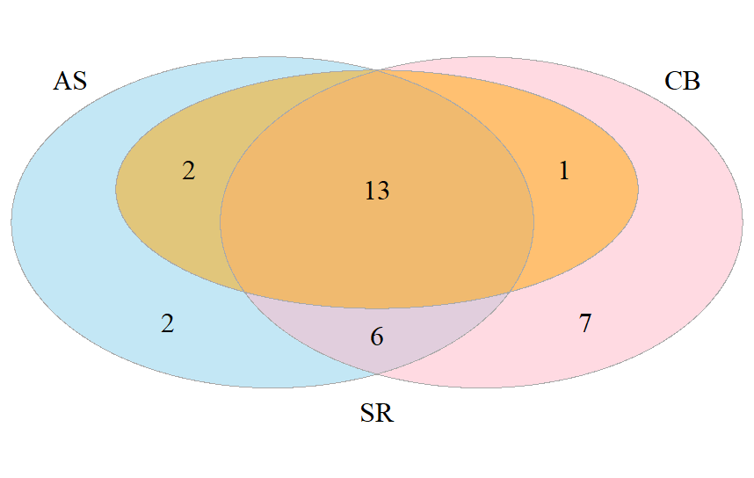
Figure 38 Venn diagram of assessed decisions at Hospital A

As shown in Figure 39, at Hospital B, 34 of the 44 unique decisions were assessed. 5 decisions (11%) were missed by at least one reviewer; of which 3 (7%) were only identified by a single reviewer (2 by JW; 1 by AS).
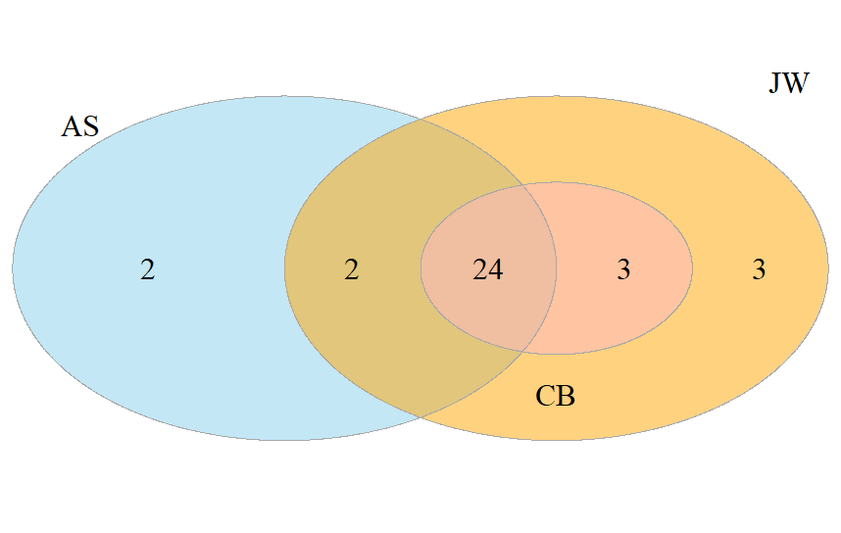
Figure 39 Venn diagram of the number of assessed decisions by reviewer at Hospital B
At Hospital C, 54 distinct decisions were initially identified. However, one reviewer identified that the patient subsequently died after the decision point, hence, this patient was removed from the analysis; leaving 53 eligible decisions, 38 of which were assessed at least once (see Figure 40). 13 decisions (25%) were missed by at least one reviewer of which 11 (21%) were only identified by one reviewer (i.e. not noted by the other two reviewers).

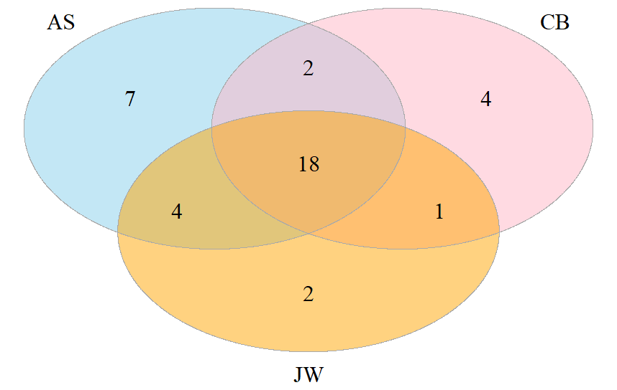
Figure 40 Venn diagram of the number of assessed decisions by reviewer at Hospital C

In Table 55, the agreement between reviewers on the given category of the decision is shown at each Hospital (including not identified). Agreement varied between reviewers and between Hospitals, for instance: AS and CB had a kappa agreement of 0.42 (“moderate”, see Table 55) at Hospital A, but 0.65 (“substantial”) at Hospital B and 0.38 (“fair”) at Hospital C. All kappa values were significantly better than agreement due to random chance (i.e. the 95% confidence intervals, CIs, did not include zero); however, many values are only “fair”.
Agreement was not necessarily dependent on the clinical knowledge of the cases, as the non-clinical reviewers (JW, SR) had sometimes had higher kappa values with one of the clinical reviewers (AS, CB) than between the clinical reviewers at that hospital. However, Hospital B generally had higher agreement levels than 7 and 9. This may indicate that some hospitals had more clear record keeping processes than others, making extraction of the records easier.
Table 55 Agreement on the decision category at each Hospital.
Hospital (N) | Comparison (kappa, 95% CI)
Hospital (N) | AS v CB  (Clinical v clinical) | AS v SR/JW  (Clinical v non-clinical) | CB v SR/JW  (Clinical v non-clinical)
A† (46) | 0.42 (0.19 – 0.66) | 0.55 (0.36 – 0.75) | 0.32 (0.11 – 0.52)
B‡ (44) | 0.65 (0.43 – 0.86) | 0.56 (0.32 – 0.79) | 0.76 (0.57 – 0.95)
C‡ (53) | 0.38 (0.17 – 0.58) | 0.46 (0.28 – 0.65) | 0.49 (0.29 – 0.69)
†Reviewed by SR. ‡Reviewed by JW
Location of review
As shown in Table 56, information concerning the number of locations given by each of the reviewing team is given. As noted, locations given as the decisions given by the majority of reviewers. Decisions given as “disagreement” were those cases with no majority (e.g. each reviewer gave a different response). These cases may be a result of unclear documentation in the patient notes, or of not giving clear guidance on the level of detail required before data extraction.
Table 56 Location of decision by hospital
Location  (no. of decisions, %) | A  (N=46) | B  (N=44) | C  (N=53) | All Hospitals  (N=143)
Unclear/not given | 1 (2.2) | 2 (4.5) | 0 | 3 (2.1)
A&E/ED | 4 (8.7) | 20 (45.5) | 9 (17.0) | 33 (23.1)
Cardiac Arrest | 2 (4.3) | 1 (2.3) | 1 (1.9) | 4 (2.8)
Theatre | 17 (37.0) | 0 | 2 (3.8) | 19 (13.3)
Ward | 19 (41.3) | 16 (36.4) | 37 (69.8) | 72 (50.3)
Disagreement | 3 (6.5) | 5 (11.4) | 4 (7.5) | 12 (8.4)

Outcome of decision
In Table 57 the majority outcome of each of the unique decisions at each hospital are shown. The majority of decisions (54.5%) resulted in the patient being admitted to ICU, however, this was driven by Hospital A only. Both 8 and 9 were more balanced with slightly more decisions resulting in not being admitted to ICU. For 5 decisions there was disagreements between reviewers, which may indicate that decisions have not been matched perfectly in all cases. This is of particular difficulty in Hospital A where reviewer SR did not record outcome data and other descriptive information was not collected.
Table 57 Did the decision result in admission to ICU, by Hospital
Admitted  (no. of decisions, %) | A  (N=46) | B  (N=44) | C  (N=53) | All Hospitals  (N=143)
No | 9 (19.6) | 23 (52.3) | 28 (52.8) | 60 (42.0)
Yes | 35 (76.1) | 19 (43.2) | 24 (45.3) | 78 (54.5)
Disagreement | 2 (4.3) | 2 (4.5) | 1 (1.9) | 5 (3.5)

Section A: Clinical situation
Descriptive statistics of Section A are shown in Table 58 below. Note that the maximum number of possible decisions represents the number of decisions if all unique decisions are assessed at least once were assessed by all reviewers. For example, at Hospital A 46 unique decisions were identified, 31 of which were assessed at least once. This results in a maximum total of 31 × 3 = 93 possible decisions scores for 7. Repeating this for all hospitals leads to a maximum total of 31 + 34 + 38 = 103 unique decisions which were assessed at least once.
Here it can been see that the median score across each hospital remained constant, but the interquartile range (IQR) varied considerably. All hospitals and reviewers used the smallest possible score (0). Of the hospitals, only 8 was given the maximum possible score (12); with both 7 and 9 receiving a maximum of 11. Of the reviewers, CB and JW both gave the possible maximum, but the highest score given by SR was 11 and 9 by AS.
Table 58 Section A total score descriptive statistics.
Decisions | Mean (SD) | Median (IQR) | Range  (0 – 12) | N of decision scores.  (% of max poss.) | Max. possible decision scores.
All decisions | 4.2 (2.4) | 4 (3 – 5) | 0 – 12 | 234 (75.7) | 309
Hospital A† | 4.3 (2.4) | 4 (3 – 6) | 0 – 11 | 66 (71.0) | 93
Hospital B‡ | 3.8 (2.4) | 4 (2 – 5) | 0 – 12 | 87 (85.3) | 102
Hospital C‡ | 4.5 (2.5) | 4 (3 – 6) | 0 – 11 | 81 (71.1) | 104
Reviewer AS | 4.0 (2.2) | 4 (3 – 5) | 0 – 9 | 82 (79.6) | 103
Reviewer CB | 3.8 (2.5) | 3 (2 – 4) | 0 – 12 | 79 (76.7) | 103
Reviewer JW | 4.8 (2.3) | 4 (4 – 6) | 0 – 12 | 57 (79.2) | 72
Reviewer SR | 4.6 (3.2) | 4 (2.75 – 6.5) | 0 – 11 | 16 (51.6) | 31
†Reviewed by SR. ‡Reviewed by JW

Table59 shows the inter-rater reliability of the individual items of section A. Question 2 (“Interpretation of clinical situation”) had the lowest reliability. Unsurprisingly, as this item required interpretation of the clinical situation, there was a marked difference between the clinical and non-clinical reviewers where reliability was no better than random chance. For items 5 and 6, reliability was generally higher than for the other items. This may be due to the fact that no specialist knowledge is required to interpret patient wishes.
Table 59 Questions in Section A inter-rater reliability for all decisions.
Item  (103 possible decisions) | Comparison (ICC, 95% CI; N=decisions analysed)
Item  (103 possible decisions) | AS v CB  (Clinical v clinical) | AS v SR/JW  (Clinical v  non-clinical) | CB v SR/JW  (Clinical v  non-clinical) | All reviewers
Q1: Evidence of system failure | 0.63  (0.46 – 0.76)  N=63 | 0.23  (0.01 – 0.45)  N=63 | 0.33  (0.09 – 0.53)  N=60 | 0.47  (0.31 – 0.63)  N=55
Q2: Interpretation of clinical situation | 0.36  (0.13 – 0.56)  N=63 | -0.08  (-0.32 – 0.17)  N=63 | 0.12  (-0.10 – 0.34)  N=60 | 0.15  (0.01 – 0.33)  N=55
Q3: Description of capacity to recover | 0.34  (0.10 – 0.54)  N=63 | 0.41  (0.18 – 0.60)  N=63 | 0.55  (0.35 – 0.71)  N=60 | 0.44  (0.28 – 0.60)  N=55
Q4: Interpretation of capacity to recover | 0.35  (0.11 – 0.55)  N=63 | 0.42  (0.20 – 0.60)  N=63 | 0.64  (0.47 – 0.77)  N=60 | 0.50  (0.34 – 0.65)  N=54
Q5: Attempts to obtain patient wishes | 0.74  (0.60 – 0.83)  N=63 | 0.56  (0.37 – 0.71)  N=63 | 0.70  (0.54 – 0.81)  N=60 | 0.69  (0.57 – 0.79)  N=55
Q6: Sources of patient wishes | 0.62  (0.44 – 0.75)  N=63 | 0.58  (0.39 – 0.72)  N=63 | 0.52  (0.31 – 0.69)  N=60 | 0.54  (0.39 – 0.68)  N=54
Note: Cells coloured red are not statistically significantly different to random chance
Scores: Section B
Descriptive statistics of Section B are shown in Table 60. Here, the scores are reported as out of 14 (i.e. the multiplication factor has been applied). All hospitals and reviewers used the smallest (0) and the same maximum (12 out of a possible 14) scores; however, the majority of reviewers gave a range of scores greater than zero, apart than CB (who gave only 14 non-zero valid scores).
Table 60 Section B total score descriptive statistics
Decisions | Mean (SD) | Median (IQR) | Range  (0 – 14) | N. decision scores.  (% of max poss.) | Max. possible decision scores.
All decisions | 2.2 (3.7) | 0 (0 – 4) | 0 – 12 | 234 (75.7) | 309
Hospital A† | 1.9 (3.7) | 0 (0 – 0) | 0 – 12 | 66 (71.0) | 93
Hospital B‡ | 2.1 (3.2) | 0 (0 – 4) | 0 – 12 | 87 (85.3) | 102
Hospital C‡ | 2.7 (4.2) | 0 (0 – 4) | 0 – 12 | 81 (71.1) | 104
Reviewer AS | 2.8 (3.8) | 0 (0 – 6) | 0 – 12 | 82 (79.6) | 103
Reviewer CB | 1.4 (3.4) | 0 (0 – 0) | 0 – 12 | 79 (76.7) | 103
Reviewer JW | 2.5 (3.7) | 0 (0 – 4) | 0 – 12 | 57 (79.2) | 72
Reviewer SR | 2.2 (4.3) | 0 (0 – 1) | 0 – 12 | 16 (51.6) | 31
†Reviewed by SR. ‡Reviewed by JW
Table 61 shows the inter-rater reliability of each question in Section B. For question 10 (“Balancing patient wishes”), reviewers CB and JW only differed by the presence or absence of a decision. If both reviewers gave a score, these scores were identical. However, for this item agreement with AS was no better than random chance so resulted in a “fair” reliability overall. Otherwise, item 9 (“Was capacity to recover included in the balancing?”) had the highest reliability between the reviewers, and item 8 (“was acute physiology/system failure included in the balancing?”) the lowest.
Table 61 Questions in Section B inter-rater reliability for all decisions
Item  (103 eligible decisions) | Comparison (ICC, 95% CI; N=eligible decisions)
Item  (103 eligible decisions) | AS v CB  (Clinical v clinical) | AS v SR/JW  (Clinical v  non-clinical) | CB v SR/JW  (Clinical v  non-clinical) | All reviewers
Q7: Balancing: benefits and burdens | 0.48  (0.27 – 0.65)  N=63 | 0.65  (0.49 – 0.77)  N=63 | 0.68  (0.51 – 0.79)  N=60 | 0.60  (0.46 – 0.73)  N=55
Q8: Balancing: physiology | 0.20  (-0.03 – 0.41)  N=63 | 0.39  (0.17 – 0.58)  N=63 | 0.54  (0.31 – 0.70)  N=60 | 0.39  (0.23 – 0.55)  N=55
Q9: Balancing: capacity to recover | 0.72  (0.57 – 0.82)  N=63 | 0.64  (0.46 – 0.76)  N=63 | 0.60  (0.41 – 0.74)  N=60 | 0.62  (0.48 – 0.74)  N=55
Q10: Balancing: patient wishes | -0.03  (-0.28 – 0.22)  N=63 | -0.03  (-0.28 – 0.22)  N=63 | 1  (1 – 1)  N=60 | 0.24  (0.07 – 0.42)  N=55
Q11: Link of balancing with treatment | 0.39  (0.16 – 0.57)  N=63 | 0.40  (0.18 – 0.59)  N=63 | 0.53  (0.32 – 0.69)  N=60 | 0.48  (0.32 – 0.63)  N=55
Note: Cells coloured red are not statistically significantly different to random chance
Scores: Section C
Descriptive statistics of Section C are shown in Table 62Reviewer JW gave low marks when compared to the other reviewers, giving a score of 0 just under half of the time (n=28, 49% of decisions assessed) and a maximum score of 4 (one at each hospital reviewed).
Table 62 Section C total score descriptive statistics
Decisions | Mean (SD) | Median (IQR) | Range  (0 – 10) | N.decision scores.  (% of max poss.) | Max. possible decision scores.
All decisions | 2.2 (1.9) | 2 (0 – 3) | 0 – 8 | 234 (75.7) | 309
Hospital A† | 2.5 (2.1) | 2.5 (1 – 8) | 0 – 8 | 66 (71.0) | 93
Hospital B‡ | 2.4 (1.9) | 2 (1 – 3) | 0 – 7 | 87 (85.3) | 102
Hospital C‡ | 2.0 (1.6) | 2 (0 – 3) | 0 – 6 | 81 (71.1) | 104
Reviewer AS | 3.0 (1.7) | 3 (2 – 4) | 0 – 7 | 82 (79.6) | 103
Reviewer CB | 2.0 (2.1) | 2 (0 – 3) | 0 – 8 | 79 (76.7) | 103
Reviewer JW | 1.6 (1.4) | 2 (0 – 2) | 0 – 6 | 57 (79.2) | 72
Reviewer SR | 2.5 (2.1) | 3 (0 – 4) | 0 – 7 | 16 (51.6) | 31
†Reviewed by SR. ‡Reviewed by JW

Table 63 illustrates the reliability for the individual items in Section C. Reliability for questions 12, 15 and 16 was mostly moderate, however, AS and CB only had fair reliability for q15 (“communication with patient”). For Question 14 (“Communication with family), reliability was fair at best. In particular, agreement between AS and the other reviewers was no better than random chance. For Question 13 (“communication to nursing staff”), no reviewer gave a score of 1 for any decision. Whilst this technically results in perfect agreement, the lack of other scores present means that the ICC cannot be calculated and reliability of the score is difficult to judge. Hence, the kappa statistic comparing the presence v non-present has been reported; where it can been seen the agreement was only slight. AS and CB agreed on 68 decisions (66% of decisions); AS and SR/JW agreed on 74 decisions (72%) and CB and SR/JW agreed on 71 decisions (69%)

Table 63 Questions in Section C inter-rater reliability for all decisions
Item  (n=104) | Comparison (ICC, 95% CI; N= eligible decisions)
Item  (n=104) | AS v CB  (Clinical v clinical) | AS v SR/JW  (Clinical v  non-clinical) | CB v SR/JW  (Clinical v  non-clinical) | All reviewers
Q12: Communication to medical staff | 0.55  (0.35 – 0.70)  N=63 | 0.62  (0.44 – 0.75)  N=63 | 0.55  (0.35 – 0.71)  N=60 | 0.61  (0.46 – 0.73)  N=55
Q13: Communication to nursing staff | -0.01†  (-0.20 – 0.2) | 0.25†  (0.05 – 0.45) | 0.20†  (-0.01 – 0.40) | -
Q14: Communication to family | -0.15  (-0.35 – 0.07)  N=63 | 0.01  (-0.13 – 0.19)  N=63 | 0.31  (0.07 – 0.52)  N=60 | -0.02  (-0.11 – 0.12)  N=55
Q15: Communication to patient | 0.28  (0.05 – 0.49)  N=63 | 0.75  (0.62 – 0.84)  N=63 | 0.37  (0.13 – 0.56)  N=60 | 0.54  (0.38 – 0.68)  N=55
Q16: Review arrangements | 0.59  (0.40 – 0.73)  N=63 | 0.61  (0.43 – 0.74)  N=63 | 0.54  (0.33 – 0.69)  N=60 | 0.56  (0.41 – 0.69)  N=55
†Kappa statistic calculated comparing score of zero v no score.
Note: Cells coloured red for the ICC are not statistically significantly different to random chance.
Scores: Section D
As shown in Table 64, only 8 decisions were given any “red flags” in Section D. The vast majority of decisions were given no warning “red flags”, and only one decision scored multiple flags (2 flags, at Hospital A by reviewer AS. This decision was also flagged once by SR).
Of the flagged decisions, 6 were flagged due to functional status; 1 was flagged due to previous knowledge of the patient and 2 were flagged due to the presence of a DNACPR order. The decision which was twice flagged was due to functional status and the presence of a DNACPR order. No decisions were flagged due to age or quality of life of the patient.
Table 64 Section D total score descriptive statistics
Decisions | Not flagged  (n, % of max poss) | Red flagged  (n, % of max poss) | N. assessed decs.  (% of max poss.) | Max. possible decs.
All decisions | 226 (73.1) | 8 (2.6) | 234 (75.7) | 309
Hospital A† | 60 (90.9) | 6 (6.5) | 66 (71.0) | 93
Hospital B‡ | 86 (98.9) | 1 (1.0) | 87 (85.3) | 102
Hospital C‡ | 80 (98.8) | 1 (0.9) | 81 (71.1) | 104
Reviewer AS | 78 (75.7) | 4 (3.9) | 82 (79.6) | 103
Reviewer CB | 79 (76.7) | 0 | 79 (76.7) | 103
Reviewer JW | 56 (77.8) | 1 (1.4) | 57 (79.2) | 72
Reviewer SR | 13 (41.9) | 3 (9.7) | 16 (51.6) | 31
†Reviewed by SR. ‡Reviewed by JW
With so few “flagged” decisions, calculation of the ICC is not possible. However, reliability between the three possible categories in Section D is possible using kappa: if a decision was “red flagged”, “not flagged” or “missed”. This is shown in Table 64 and pictorially in Figure 40. Here, reliability was generally low between all reviewers at all Hospitals. Many estimates are negative, implying that agreement is no better than random chance.
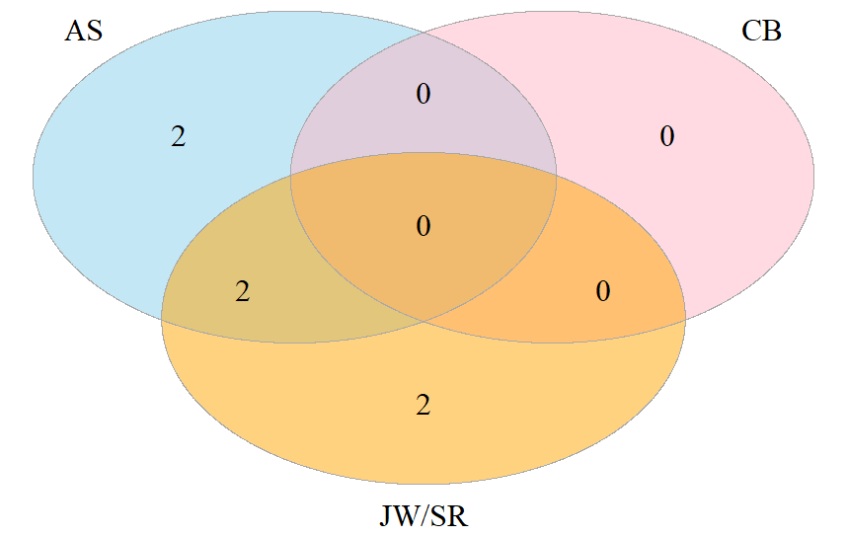
Figure 41 Venn diagram of decisions red flagged at least once

Total score
Table 65 shows the descriptive statistics for the total score (sum of A + 2*B + C). The maximum possible score is 36; however, the maximum score awarded to a decision was 30. 9 decisions (2.1% of all decisions) were given no marks at all, and 7 (1.6%) were only awarded 1 mark.
No clear patterns of responses were evident from description. Both non-clinical reviewers (SR and JW) did not award the minimum possible score and CB gave the greatest range of marks.
Table 65 Total score descriptive statistics
Decisions | Mean (SD) | Median (IQR) | Range  (0 – 36) | N. decision scores.  (% of max poss.) | Max. possible decision scores.
All decisions | 7.9 (6.2) | 6 (4 – 11) | 0 – 30 | 234 (75.7) | 309
Hospital A† | 8.0 (6.5) | 6 (4 – 10.8) | 1 – 27 | 66 (71.0) | 93
Hospital B‡ | 7.5 (5.9) | 5 (4 – 11) | 0 – 30 | 87 (85.3) | 102
Hospital C‡ | 8.1 (6.5) | 6 (4 – 11) | 0 – 24 | 81 (71.1) | 104
Reviewer AS | 8.4 (6.1) | 7 (4 – 12) | 0 – 23 | 82 (79.6) | 103
Reviewer CB | 6.7 (6.2) | 5 (3 – 7) | 0 – 30 | 79 (76.7) | 103
Reviewer JW | 8.4 (5.8) | 6 (4 – 12) | 2 – 25 | 57 (79.2) | 72
Reviewer SR | 9.1 (8.1) | 5 (3.8 – 11.3) | 1 – 25 | 16 (51.6) | 31
†Reviewed by SR. ‡Reviewed by JW
Table 66 shows the inter-rater reliability of the total scores. Whilst the overall reliability across all decisions was moderate to substantial, it varied considerably between Hospitals. Again, reliability at Hospital C was generally worse than the other Hospitals, but Hospital B also had one comparison which was no better than random chance. Reviewer CB appears to have lower reliability when compared with the other reviewers; however, at Hospital B; reliability of CB against AS and SR/JW is higher than for AS against the non-clinical reviewers.

Table 66 Total score inter-rater reliability by Hospital.
Hospital (N) | Comparison (ICC, 95% CI) N=eligible decisions
Hospital (N) | AS v CB  (Clinical v clinical) | AS v SR/JW  (Clinical v non-clinical) | CB v SR/JW  (Clinical v non-clinical) | All reviewers
All Hospitals (103) | 0.66  (0.47 – 0.79)  N=63 | 0.65  (0.49 – 0.78)  N=63 | 0.76  (0.60 – 0.85)  N=60 | 0.69  (0.56 – 0.80)  N=55
A† (31) | 0.41  (-0.06 – 0.72)  N=19 | 0.73  (0.35 – 0.90)  N=15 | 0.50  (-0.04 – 0.81)  N=14 | 0.56  (0.23 – 0.82)  N=13
B‡ (34) | 0.41  (-0.00 – 0.70)  N=24 | 0.13  (-0.14 – 0.43)  N=26 | 0.44  (0.07 – 0.70)  N=27 | 0.33  (0.09 – 0.59)  N=24
C‡ (39) | 0.34  (-0.05 – 0.66)  N=20 | 0.30  (-0.09 – 0.63)  N=22 | 0.32  (-0.11 – 0.66)  N=19 | 0.34  (0.07 – 0.63)  N=18
†Reviewed by SR. ‡Reviewed by JW
Note: Cells coloured red are not statistically significantly different to random chance

Total score and outcome
Table 67 and Figure 41 illustrate the relationship between the outcome of the decision (admitted to ICU, or outcome unknown) and the total score. Care must be given to interpreting these results, as the study was not formally powered to detecting differences between scores for different categories; and that Hospital A one reviewer did not record any admission data. However, the trend indicates that scores where the patient was not admitted to ICU were generally higher than when the patient was admitted.
Table 67 Total score by outcome of decision
Decision resulted in admission to ICU | 7  (N=66) | 8  (N=87) | 9  (N=81) | All Hospitals  (N=234)
Unclear/not given | 9.4 (7.6) | 4.0 (-) | 11.0 (8.8) | 9.5 (7.6)
No | 11.3 (6.8) | 8.8 (4.7) | 11.0 (7.1) | 10.0 (6.1)
Yes | 5.8 (4.0) | 7.7 (7.4) | 6.0 (4.6) | 6.6 (5.8)

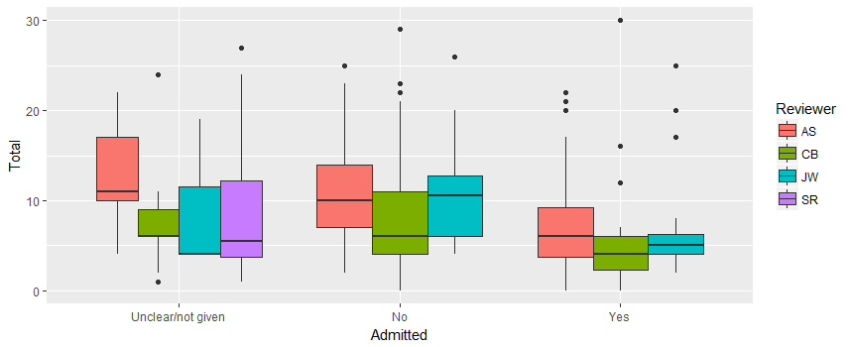
Figure 42 Boxplot of total score and outcome of decision by reviewer
Total score and location
Table 68 and Figure 42 illustrate the relationship between the location of the decision and the total score. As for the admission data, care must be given to interpreting these results. However, in this case, so clear trends are visible between the locations of the decisions.
Table 68 Location of decision by Hospital.
Location  (no. of decisions, %) | 7  (N=66) | 8  (N=87) | 9  (N=81) | All Hospitals  (N=143)
Unclear/not given | 9.1 (7.1) | 6.8 (4.1) | 6.0 (-) | 8.7 (6.7)
A&E/ED | 11.5 (7.7) | 7.7 (5.5) | 4.8 (3.0) | 7.2 (5.4)
Cardiac Arrest | 6.0 (-) | 4.0 (-) | 14.0 (9.9) | 9.5 (7.8)
Theatre | 5.8 (5.8) | 9.5 (6.4) | NA | 6.8 (5.7)
Ward | 8.4 (6.2) | 9.2 (6.7) | 10.0 (7.0) | 9.4 (6.7)

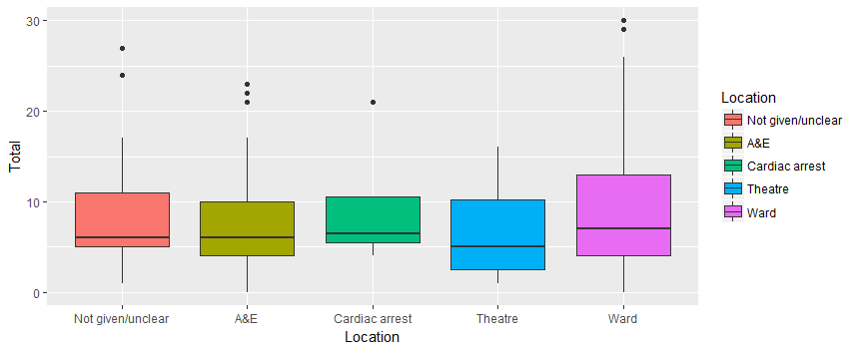
Figure 43 Boxplot of total score and location of decision by reviewer

