On the relationship between oxidation state and temperature of volcanic gas emissions
Yves Moussallam^{1,2}, Clive Oppenheimer¹, Bruno Scaillet³.
¹ Department of Geography, University of Cambridge, Downing Place, Cambridge, CB2 3EN, UK
² Laboratoire Magmas et Volcans, Univ. Blaise Pascale – CNRS – IRD, OPGC, 63000 Clermont-Ferrand, France
³ISTO, 7327 Université d’Orléans-CNRS-BRGM, 1A rue de la Férollerie, 45071 Orléans cedex 2, France

Corresponding author: Yves Moussallam; yves.moussallam@ird.fr
Keywords: oxygen fugacity; volcanic degassing; early Earth; redox; great oxidation event.

abstract
The oxidation state of volcanic gas emissions influences the composition of the exosphere and planetary habitability. It is widely considered to be associated with the oxidation state of the melt from which volatiles exsolve. Here, we present a global synthesis of volcanic gas measurements. We define the mean oxidation state of volcanic gas emissions on Earth today and show that, globally, gas oxidation state, relative to rock buffers, is a strong function of emission temperature, increasing by several orders of magnitude as temperature decreases. The trend is independent of melt composition and geodynamic setting. This observation may explain why the mean oxidation state of volcanic gas emissions on Earth has apparently increased since the Archean, without a corresponding shift in melt oxidation state. We argue that progressive cooling of the mantle and the cessation of komatiite generation should have been accompanied by a substantial increase of the oxidation state of volcanic gases around the onset of the Great Oxidation Event. This may have accelerated or facilitated the transition to an oxygen-rich atmosphere. Overall, our data, along with previous work, show that there is no single nor simple relationships between mantle, magmas and volcanic gas redox states.
- INTRODUCTION
The secondary atmospheres of planetary bodies form and evolve by degassing of volatiles from their interiors (e.g., Kasting, 1993; Elkins-Tanton, 2008; Hirschmann and Dasgupta, 2009). The oxidation state of these emissions strongly influences that of the planet’s exosphere, dictating its habitability (e.g., Gaillard and Scaillet, 2014; Kasting et al., 2003). On Earth, several lines of evidence suggest that both atmosphere and ocean were oxygen poor during the Archean (e.g., Bekker et al., 2004; Canfield et al., 2000; Farquhar et al., 2007), prior to the Great Oxidation Event (between 2.45 and 2.22 Ga ago) (e.g., Canfield, 2005). It has been argued that a change in the oxidation state of volcanic gas emissions during this period might have played a role in the rapid oxidation of the atmosphere (e.g., Kasting et al., 1993; Holland, 2002; Kump and Barley, 2007; Halevy et al., 2010; Gaillard et al., 2011). The underlying processes for such a change remain unclear, however, especially given the lack of evidence for more reducing conditions in the Archean mantle (e.g., Berry et al., 2008; Canil, 1997, 2002; Rollinson et al., 2017).
A first step towards understanding the evolution of volcanic gas oxidation state through time is to constrain the oxidation state of volcanic gas emissions on Earth today. Surprisingly, this quantity and its associated natural variability, have not hitherto been constrained. Direct sampling of volcanic gases has been practised for more than a century, often using tubing inserted into vents to avoid or limit air contamination. Much of the resulting analytical data pertains to point-source fumarole emissions (e.g., Symonds et al., 1994). Latterly, field spectroscopy (e.g., Mori et al., 1993) and electrochemical sensing (e.g., Shinohara, 2005) have facilitated measurement of emissions, notably from open vents (characterized by a magma-air interface), where the volcanic gases are already substantially diluted in air. The wealth of data now available permits investigation of the distribution of oxidation state of volcanic gases emitted to the global atmosphere.
- Method
We compiled a global dataset of high temperature (≥600°C) volcanic gases, for which gas-rock or gas-fluid interactions are minimal (Giggenbach, 1996; Symonds et al., 2001). Data presented in this paper are provided in the Supplementary Information (Tables S1 and S2 together with references). Following established methodology (e.g., Giggenbach, 1980, 1987; 1996; Ohba et al., 1994; Chiodini and Marini, 1998; Moretti et al., 2003; Moretti and Papale, 2004; Aiuppa et al., 2011), the oxygen fugacity (fO₂) of volcanic gases was calculated using gas-phase redox couples that can be expressed by reactions involving oxygen such as:
H₂ + ½O₂ = H₂O (1)
CO₂ = CO + ½O₂ (2)
H₂S + 3/2O₂ = SO₂ + H₂O (3)
3CO + SO₂ = 2CO₂ + OCS (4)
Those can then be translated in terms of fO₂ by introducing the equilibrium constant K, considering that, at near atmospheric pressure, the fugacity of a gas is equal to its partial pressure and using published thermodynamic constants (Chase 1998; Stull et al., 1969):
$log\frac{H_{2}}{H_{2}O}=-\frac{12707}{T}+2.548-\frac{1}{2}logfO_{2}$ (5)
$log\frac{{CO}_{2}}{CO}=\frac{14775}{T}-4.544+\frac{1}{2}logfO_{2}$ (6)
$log\frac{{SO}_{2}}{H_{2}S}=\frac{27377}{T}-3.986+\frac{3}{2}logfO_{2}-logfH_{2}O$ (7)
(8)
Where the pressure (P) and fugacities (f) are in bars and the temperature (T) is in Kelvin. Given two redox couples, the oxygen fugacity and equilibrium temperature can be calculated. Alternatively, if the gas temperature is known (i.e. measured by thermocouple at the vent) the oxygen fugacity can be determined with only one redox couple. Detailed examples of each calculation method are given in the Supplementary Information. When using equation (8), we assume gas emissions have equilibrated to atmospheric pressure.

Here, we define the oxidation state of a volcanic gas mixture as the deviation (in log units) of the oxygen fugacity (fO₂) of the gas mixture relative to a mineral redox buffer at the corresponding temperature. We use the Quartz-Fayalite-Magnetite (QFM) mineral redox buffer as reported in Frost, (1991) throughout the text.

Detailed examples of gas oxygen fugacity and equilibrium temperature calculations
Here we elaborate on each calculation method used in this study. We take the example of volcanic gases measured in 1994 from the then active lava dome of Merapi volcano (Indonesia), in the course of the fifth International Association of Volcanology and Chemistry gas workshop (Giggenbach et al., 2001). Gases were collected directly at the vent (Gendol fumarole) and had an exit temperature of 803°C. Proportions (median of six analyses) of H₂O, CO₂, SO₂, CO, H₂S and H₂ gases were found to be 88.7, 5.56, 0.98, 0.0235, 0.13 and 0.5 mol%, respectively (Giggenbach et al., 2001). We focus on this analysis because species involved in three redox couples were measured along with gas emission temperature (the temperature at which gases are emitted at the fumarole vent). This allows us to demonstrate calculation of gas oxidation state in various ways, pertinent when fewer redox couples are constrained (most other analyses in the database only permit one or two calculation methods).

The H₂/H₂O and T method
Using the H₂/H₂O molar ratio and the gas emission temperature we can calculate the oxygen fugacity following equation 5, which can be re-arranged as follows:
$logfO_{2}=-2(log\frac{H_{2}}{H_{2}O}+\frac{12707}{T}-2.548)$ (9)
For an emission temperature of 1076.15°K (803°C) and an H₂/H₂O molar ratio of 0.0056 (0.5/88.7) the calculated logfO₂ is –14.02.
To express the gas oxidation state as a deviation from the QFM buffer we calculate the logfO₂ of the QFM buffer at the corresponding temperature (803°C) and pressure (1 bar) using the following equation (Frost, 1991):
$logfO_{2}=\frac{A}{T}+B+\frac{C\left(P-1\right)}{T}$ (10)
Given values for parameters A, B and C of –25096.3, 8.735 and 0.11, respectively, we calculate that logfO₂ of the QFM buffer at 1076.15°K and 1 bar is equal to –14.59.
Using the H₂/H₂O and T method, the relative oxidation state is given by the difference between the two values, i.e., QFM+0.56 log units.

The H₂S/SO₂ and T method
Using the H₂S/SO₂ ratio and the gas emission temperature we can calculate the oxygen fugacity following equation 7 which can be re-arranged as follows:
$logfO_{2}=\frac{2}{3}(log\frac{{SO}_{2}}{H_{2}S}-\frac{27377}{T}+3.986+logfH_{2}O)$ (11)
The value of fH₂O used here is 0.887 given that, at 1 bar, the fugacity of a gas is equal to its partial pressure and that P(H₂O) = (P_{tot} × nH₂O)/n_{tot} = [(1 bar)(0.887n_{tot})]/(n_{tot}) = 0.887 bar (where P is the pressure in bar and n_{i} the amount specie i in mol%) .
For an emission temperature of 1076.15°K (803°C) and for an SO₂/H₂S ratio of 7.54 (0.98/0.13) the calculated logfO₂ is –13.75.
Using the H₂S/SO₂ and T method, the relative oxidation state is QFM+0.83 log units.

The H₂/H₂O and H₂S/SO₂ method
Using equations 9 and 11 and using the parameters for H₂, H₂O, SO₂, H₂S and fH₂O defined previously provides two equations with two unknowns:
$logfO_{2}=-2(-2.248+\frac{12707}{T}-2.548)$ (12)
and
$logfO_{2}=\frac{2}{3}(0.877-\frac{27377}{T}+3.986-0.052)$ (13)
Solving these equations yields an equilibrium temperature of 1122°K (849°C) for a logfO₂ of –13.06. Using equation 10 to calculate the logfO₂ of the QFM buffer at the corresponding temperature gives a logfO₂ of –13.64 for QFM. Hence combining H₂/H₂O and H₂S/SO₂ yields an oxidation state of QFM+0.57 log units.

The H₂S/SO₂ and CO/CO₂ method
Using equation 11, and re-arranging equation 6 as follows:
$logfO_{2}=2(log\frac{{CO}_{2}}{CO}-\frac{14775}{T}+4.544)$ (14)
We can then use the parameters for CO₂, CO, SO₂, H₂S and fH₂O defined previously to write two equations with two unknowns:
$logfO_{2}=\frac{2}{3}(0.877-\frac{27377}{T}+3.986-0.052)$ (15)
and
$logfO_{2}=2(2.3739-\frac{14775}{T}+4.544)$ (16)
Solving these equations yields an equilibrium temperature of 1063°K (790°C) for a logfO₂ of –13.96. Using equation 10 to calculate the logfO₂ of the QFM buffer at the corresponding temperature gives a logfO₂ of –14.87 for QFM. Hence using the CO/CO₂ and H₂S/SO₂ method the oxidation state is QFM+0.56 log units.

The CO₂-CO-OCS-SO₂ method
For this example, we cannot use the Merapi gas composition as OCS was not reported. We use instead the composition of the gas emitted during passive degassing from the lava lake of Erebus volcano (Antarctica) (Peters et al., 2014). In this case, neither H₂ nor H₂S were measured, but equilibrium conditions can still be constrained owing to measurement of OCS. Molar proportions of H₂O, CO₂, SO₂, CO, HCl, HF, OCS were 58, 38.4, 1, 1.7, 0.7, 1.3 and 0.009 mol%, respectively.

Using the CO/CO₂ and CO/OCS mixing ratios we can calculate the equilibrium temperature following equation 8, rearranging as follows:
$T=\frac{-15386.45}{logP-9.24403+log\left({\left(\frac{x_{CO}}{x_{{CO}_{2}}}\right)}^{2}\left(\frac{x_{CO}}{x_{OCS}}\right)x_{{SO}_{2}}\right)}$ (16)
Given a XSO₂ of 0.01, a CO/CO₂ molar ratio of 0.043, a CO/OCS molar ratio of 192 and assuming equilibration at atmospheric pressure (~0.6 bar at Erebus) yields an equilibrium temperature of 1292 K (1019 °C).
To determine the oxygen fugacity, we then use equation 16. Given a CO₂/CO ratio of 22.9 and an equilibrium temperature of 1292 K yields a logfO₂ of –11.13. Using equation 3 to calculate the logfO₂ of the QFM buffer at the corresponding temperature gives a logfO₂ of –10.69 for QFM. Hence using the CO₂-CO-OCS method the oxidation state is QFM–0.44 log units.

Sensitivity of oxygen fugacity and equilibrium temperature determinations to instrumental and calculation methods
In cases where two redox couples and the emission temperature have been measured, we can calculate the equilibrium temperature (the temperature at which the gas mixture was last in equilibrium) as recorded by the gas redox couples and compare it with the emission temperature (the temperature at which gases are emitted from the vent) as measured in the field by thermocouples (Fig. S1). This shows that gas equilibrium and emission temperatures are correlated and that, in most cases, the gas last equilibrated at the temperature at which it entered the atmosphere. Fig. S2 shows that the differences between computed gas oxidation state made using either the calculated equilibrium temperature (based on two redox couples) or the measured emission temperature (and one redox couple) are negligible.

As shown above, the choice of calculation method can affect the calculated value of logfO₂. Using the Merapi gas example, the calculated oxygen fugacity varies from QFM+0.56 to QFM+0.83 while the calculated equilibrium temperature varies from 790 to 849°C (compared with a measured emission temperature of 803°C). A very conservative estimate of the error associated with the calculation method would therefore be of ±0.3 log units of the calculated logfO₂ and of ±50°C on the calculated equilibrium temperature. If we consider, too, that the gas ratio measurements themselves have reported errors typically of ±10% this contributes an error of about ±0.15 log units on the calculated logfO₂ (e.g., Moussallam et al., 2017, 2018). Treating these errors sources as independent (a conservative assumption) yields our confidence interval of ±0.45 log units on the computed logfO₂.

One assumption made in all presented calculation is that the oxidation state of the volcanic gases has equilibrated to atmospheric pressure. This is reasonable given that hot volcanic gases will equilibrate very rapidly, at least at temperatures above 800 °C (Gerlach, 2004; Martin et al., 2006).

- RESULTS
Two broad types of observations were used in this study: sensing of the airborne emissions from open-vent volcanoes, and samples collected directly at fumarole vents. We first consider measurements of air-diluted plumes by calculating the equilibrium conditions for reported compositions (Fig. 1A). Persistent degassing dominates the total volcanic volatile flux to the atmosphere (Shinohara, 2013) but detailed gas composition measurements remain sparse, with volcanoes shown in Fig. 1A contributing about a third of the estimated global total volcanic SO₂ outgassing on Earth over the period 2005–2015 (Carn et al., 2017). We identify a strong correlation between the equilibrium temperature – the final temperature at which the gases were equilibrated (Giggenbach, 1987), unperturbed by mixing with the atmosphere (Aiuppa et al., 2011; Martin et al., 2009) – and gas oxidation state (expressed here as the difference, in log units, from the QFM redox buffer (Frost, 1991). A striking pattern emerges: globally, gases recording high equilibrium temperature are more reduced relative to the buffer, while gases with lower equilibrium temperature are more oxidized. Such a pattern is to be expected if considering a single gas mixture (e.g., Giggenbach, 1987; Ohba et al., 1994) as high temperature will favour the reduced state in most redox reactions (e.g., Ottonello et al., 2001; Moretti and Ottonello, 2005), but the fact that globally, unrelated volcanic gases – emitted by volcanoes in distinct geodynamic settings and with distinct melt composition – conform to a single trend is surprising.

We consider next high-temperature volcanic gases sampled directly, at fumaroles or via skylights in lava tubes close to the vent, and analysed in the laboratory (e.g., Symonds et al., 1994) (Fig. 1B). In this case, emission temperatures were measured in situ by thermocouples, and we have calculated corresponding oxidation states from the reported gas compositions. Despite the marked differences in measurement techniques compared with the air-diluted plume dataset (Fig. 1A), we identify a very similar relationship between gas temperature and oxidation state. Worldwide, gases emitted at high temperatures are more reduced relative to the QFM redox buffer than gases emitted at lower temperatures. That two independent datasets display the same trend suggests a fundamental global relationship between the oxidation state and temperature of volcanic gases.

Fig. 2 shows the same data as Fig. 1 but classed according to the instrumental method and to the method used to calculate the oxygen fugacity and, where applicable, the equilibrium temperature. It is clear from these figures that the inverse correlation observed between the gas oxidation state and emission or equilibrium temperature is well-defined regardless of the methodology used to acquire the gas compositional data or the computation method used.

To estimate the mean oxidation state of volcanic gases on Earth at present, we draw on a synthesis of a decade of satellite measurements of SO₂ emissions (Carn et al., 2017). For each volcano represented both in this dataset and our own, we ascribe a mean oxidation state to the gas. We then weight each volcano’s output to the atmosphere according to its SO₂ flux, leading to an estimate of the mean relative oxidation state of volcanic gas emissions on Earth today of QFM+1.0 (Fig. 3). About 80% of observed high-temperature gases fall within one log unit of this value.

- Discussion
Further inspection of Fig. 1 reveals a lack of any systematic differences between arc, rift and hot-spot volcanoes at comparable temperature (notwithstanding limited overlap). This is in stark contrast to the observed variation in the oxidation state of the corresponding lavas, and inferred oxidation states of their mantle sources: arc volcanoes are associated with more oxidised lavas sourced from more oxidised regions of the mantle than hotspot and rift volcanoes (e.g., Carmichael, 1991; Frost and McCammon, 2008). We also find no relationship between gas oxidation state and composition (mafic-intermediate-silicic) of the associated magma.

For as long as they remain in the magma, in direct equilibrium with the melt, volcanic gases will have an oxidation state at equilibrium with that melt (e.g., Moretti et al., 2003; Moretti and Papale, 2004). Our observations, however, imply that, to first order, the oxidation state of volcanic gases is mostly decoupled from that of the melts from which they originate. Further, neither the oxidation state of the mantle source region nor the melts produced determines the oxidation state of the associated volcanic gas emissions to the atmosphere.

The global relationship between gas temperature and oxygen fugacity (fO₂) is shown in Fig. 4A. It appears that volcanic gases do not follow a rock redox buffer involving Fe as previously suggested based on data from Kīlauea (Gerlach, 1993). Instead, the global temperature dependence follows the empirical relation:
$\text{log}\left(fO_{2}\right)=-19100\left(\frac{1}{T}\right)+\text{4}$ (17)
(where T is the temperature in K).
We hypothesize that the underlying mechanism is closed-system cooling of the gas, a process invoked from consideration of gas analyses made at Erebus and Kilauea volcanoes (Burgisser et al., 2012; Oppenheimer et al., 2018). As magmatic gas ascends to the surface and expands it cools unless heat is transferred rapidly enough from melt to gas. Accordingly, the gas mixture will re-equilibrate so that its oxidation state is consistent with its internal temperature. The magmatic gas no longer maintains chemical or thermal equilibrium with the surrounding melt.

Fig. 4A shows the computed oxidation state for closed-system (gas-only) cooling of three representative gas mixtures, indicating a close fit to the observations. In order to assess how much cooling of the volcanic gases has taken place between their escape from the melt and their last retained equilibrium temperature we conducted a review of melt temperature estimates from the literature. The dataset is presented in the supplementary information, Table S4 and in Fig. 5. Where melt temperature was not reported, we estimated it from the melt composition (e.g., 950°C for andesitic magmas). Fig. 5 shows a strong relationship between the amount of cooling and re-equilibration a gas has undergone and its oxidation state.

The observed decoupling between the oxidation states of volcanic gases and their melts undermines the underlying assumption of gas-melt equilibrium in previous estimates of the oxidation state of volcanic gases emitted in Earth’s past or on other planets (e.g., Arculus and Delano, 1980; Gaillard and Scaillet, 2014). It follows that variations in the oxidation state of the Earth’s mantle through time need not influence the oxidation state of volcanic gases emitted to the atmosphere. Similarly, our observations imply that changes in geodynamic environment on a global scale, such as from hotspot-dominated to arc-dominated volcanism, will not affect the oxidation state of the volcanic gases emitted. Surficial processes, such as eruption style should, however, influence the equilibrium and emission temperature of volcanic gases. Explosive activity should always be associated with the emission of gases at lower temperature and hence more oxidized gases as more closed-system cooling and expansion of the gas would have taken place than during passive degassing. This can be seen, for instance, when comparing passive and explosive gas emissions from Erebus volcano (Fig. 1 A) (Oppenheimer et al., 2011; Burgisser et al., 2012).

The dependence of volcanic gas oxidation state on emission temperature helps to reconcile an old paradox. Earth’s atmosphere during the Archean was reduced (Bekker et al., 2004; Canfield et al., 2000; Farquhar et al., 2007), and it has therefore been assumed that volcanic outgassing was correspondingly more reduced (Holland, 2002; Kasting et al., 1993). Yet multiple lines of evidence suggest that the Archean upper mantle and the melts it produced were as oxidised as at present (e.g., Berry et al., 2008; Canil, 1997; Delano, 2001; Li and Lee, 2004) although this conclusion has been disputed (e.g., Aulbach and Stagno, 2016; Nicklas et al., 2016)). Considering that the Archean was characterised by the eruption of komatiitic lava flows erupted at high temperatures of up to 1700°C (e.g., Huppert et al., 1984), the emission temperature of volcanic gases should have been considerably higher than at present. Extrapolating the data trend in Fig. 4 A and B, we suggest that volcanic gases emitted at ∼1600 °C should have oxidation states between QFM–1 and QFM–2.5, even if the associated melt was more oxidized. These estimates are about one log unit more reduced than the average value of the hottest and most reduced gases emitted today, and at least two to three log units more reduced than the average volcanic gas emitted on Earth today (about QFM+1). We also note that the composition of these high-temperature gases should have been much richer in SO₂, H₂ and CO than today’s volcanic emissions, e.g., SO₂/H₂S, H₂O/H₂ and CO₂/CO molar ratios of about 200, 20 and 2.5 respectively at 1600°C, and 40, 120 and 60 at 1000°C (Fig. 6). The effect of these changes in gas composition on the oxidation state of the atmosphere can then be considered using Holland’s criterion (f, defined as the fraction of sulfur in the initial volatiles that is converted to FeS₂, (Holland, 2002)):
$f=\frac{m_{H_{2}}+0.6m_{CO}-0.4m_{CO_{2}}+3m_{H_{2}S}}{3.5\left(m_{SO_{2}}+m_{H_{2}S}\right)}+\frac{1}{3.5}$ (18)
Where m_{i} is the mole fraction of species i in the volcanic gas. If f exceeds 1 then the gas contains sufficient H₂ to reduce 20% of carbon gases to organic matter, and all sulfur to FeS₂. In other words, according to this criterion, a value of f > 1 corresponds to volcanic gases with the capacity to limit the accumulation of O₂ produced by oxygenic photosynthesis. Fig. 7 shows the relationship between f and gas equilibrium temperature for four starting gas compositions representing Erta ‘Ale, Bromo, Satsuma Iwojima and Sabancaya volcanoes. Depending on the gas composition, the effect of emitting gases last equilibrated at 1400°C rather than 1000°C is equivalent to a 40–170% increase in f. Given that volcanic gases at present have average f values of 0.5 (Holland, 2002), f values of ~1 might have prevailed during the Archean. Similar calculations for f based on the inferred gas composition for Mauna Kea (Brounce et al., 2017) suggest that f > 1 would be attained for gas emitted at QFM−2.3, in broad agreement with our calculations.

- conclusions
We have compiled a global dataset of volcanic gas measurements and demonstrated that, relative to rock buffers, gas oxidation state is a strong function of emission temperature. With decreasing temperature, gas oxidation state decreases by up to several orders of magnitude. This trend is confirmed by two independent datasets, one based on measurements of volcanic plumes whose constituent gases are diluted in air, the other synthesizing data from directly-sampled gases emitted from high-temperature fumaroles.

We also find that neither geodynamic setting nor melt composition exerts an influence on the oxidation state of the emitted gases. Together with a strong correlation between the gas oxidation state and the difference between the melt and gas equilibrium temperatures, this suggests that closed-system (gas-only) cooling of the gas is the process explaining our global observations.

The observations enable us to estimate the mean oxidation state of volcanic gases emitted on Earth at present to be approximately QFM+1.0. Extrapolation of our dataset suggests that the equivalent figure for volcanic outgassing in the Archean was two to three log units more reduced that today’s average value.

We further conclude that, globally, closed-system (gas-only) re-equilibration can have a dramatic effect on the influence of gas emissions on the oxidation state of the atmosphere. The cessation of widespread komatiitic volcanism between 2.5 and 2.0 Ga ago (e.g., Dostal, 2008) should therefore have been accompanied by a shift towards more oxidised volcanic gas emissions to the atmosphere, affecting the oxygen abundance in the atmosphere and oceans. This evolution coincides with the major change in the oxidation state of the atmosphere during the Paleo-Proterozoic, i.e., the Great Oxidation Event, 2.4 to 2.2 Ga ago (e.g., Canfield, 2005). We suggest that decline of komatiitic volcanism likely facilitated this transition to an oxygen-rich atmosphere, along with other proposed factors (Gaillard et al., 2011; Kump and Barley, 2007). Our results also show that relating volcanic gas redox states to their mantle source cannot be made in any straightforward manner. Previous work has already shown that decompression alone can significantly alter the redox signature of a magma relative to its source (Moretti and Papale, 2004; Burgisser and Scaillet, 2007; Oppenheimer et al., 2011; Gaillard and Scaillet, 2014; Moussallam et al., 2014, 2016). Our findings suggest further complexity in this relationship by revealing a global relationship between gas emission temperature and disequilibrium with respect to melt redox conditions.

FigureS

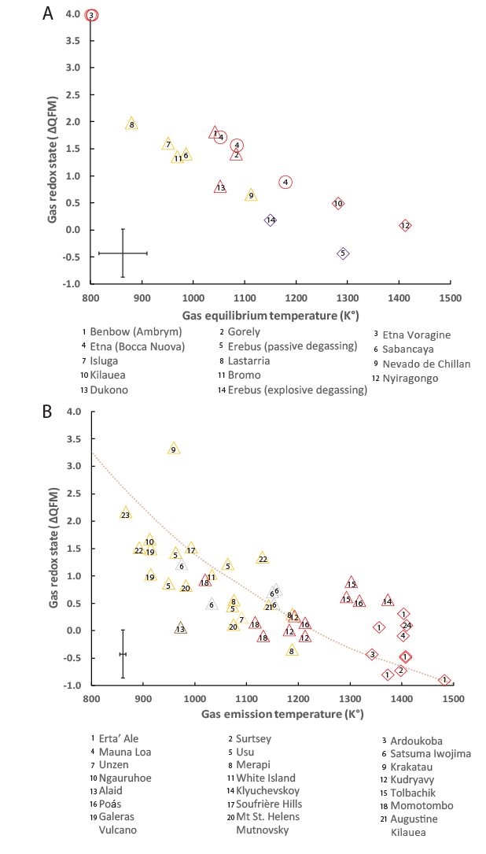
Figure 1: A. Oxidation states of volcanic gases measured in air-diluted plumes (expressed as deviations in log units from the QFM redox buffer) as a function of equilibrium temperature. Triangles: arc volcanoes; diamonds: intraplate volcanoes; circles: Mt. Etna (whose origin is debated). Red borders: volcanoes typically producing mafic magma; orange borders: volcanoes associated with intermediate and silicic magmas (andesite to rhyolite); purple border: Mt. Erebus, which erupts lavas of phonolitic composition. See Supplementary Information for references. Note the strong negative correlation between gas equilibrium temperature and oxidation state (ΔQFM = –0.0067T + 6.7097 with an R² of 0.78 and a P-value of 1 × 10⁻⁶). B. Oxidation state (in log unit deviations from the QFM redox buffer) and measured emission temperature of gas samples collected at accessible vents and analysed in the laboratory. Note the strong negative correlation between gas emission temperature and oxidation state (ΔQFM = – 0.0034T + 3.5536 with an R² of 0.53 and a P-value of 5 × 10⁻⁹). Representative error bars are given. Brown dotted lines represent gas-only cooling trends calculated using gas compositions reported for Erta ‘Ale (Guern et al., 1979) volcano and solving for the reaction $SO_{2}+3H_{2}=H_{2}S+2H_{2}O$ at 1 bar, using thermodynamic parameters given in Ohba et al., (1994).

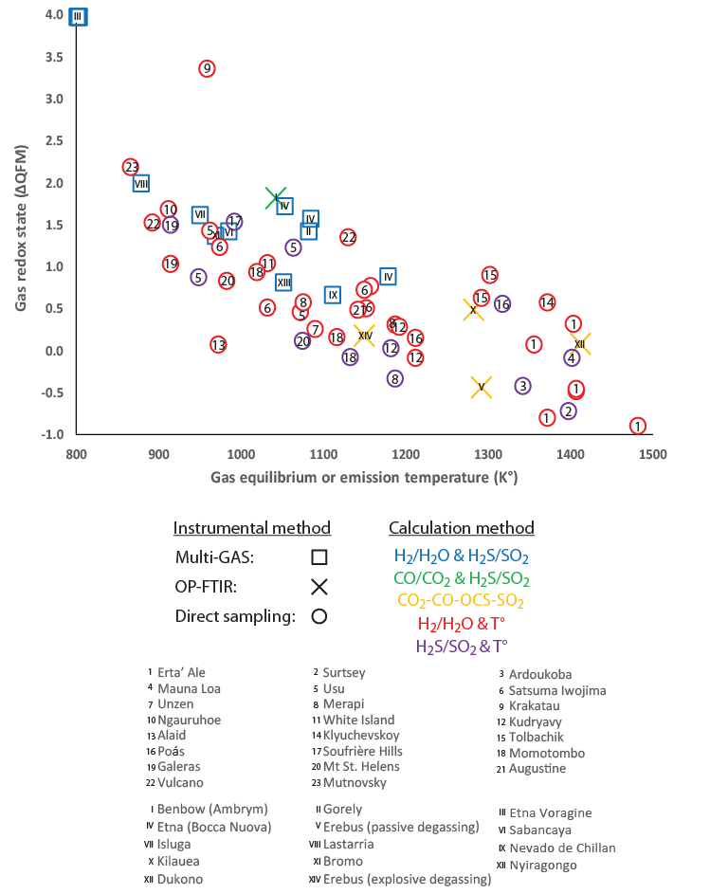
Figure 2: Oxidation state of volcanic gases as a function of emission or equilibrium temperature for all high-temperature volcanic gases in our dataset, grouped by instrumental method used to measure the gas composition (symbol shape) and by calculation method (symbol colour) used to calculate the oxidation state and where applicable the equilibrium temperature.

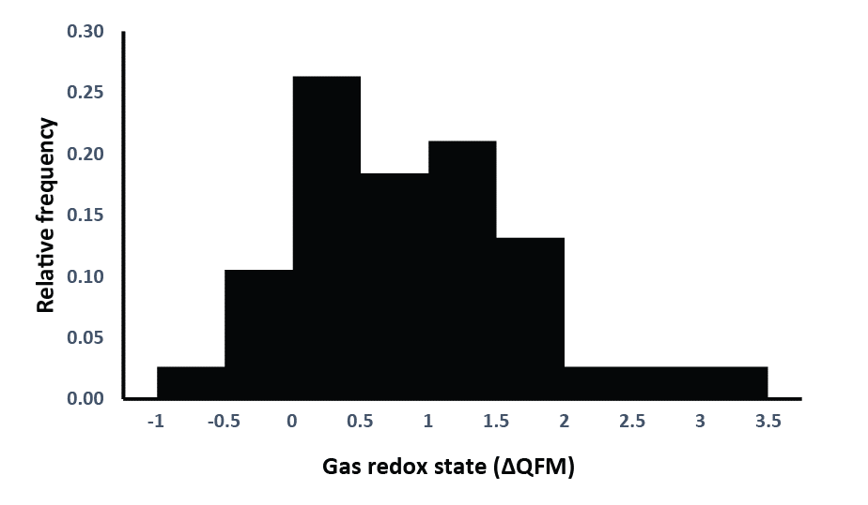
Figure 3: Relative frequency distribution of the oxidation state of high-temperature volcanic gases. The mean oxidation state of volcanic gases on Earth at present is about ∆QFM+1.
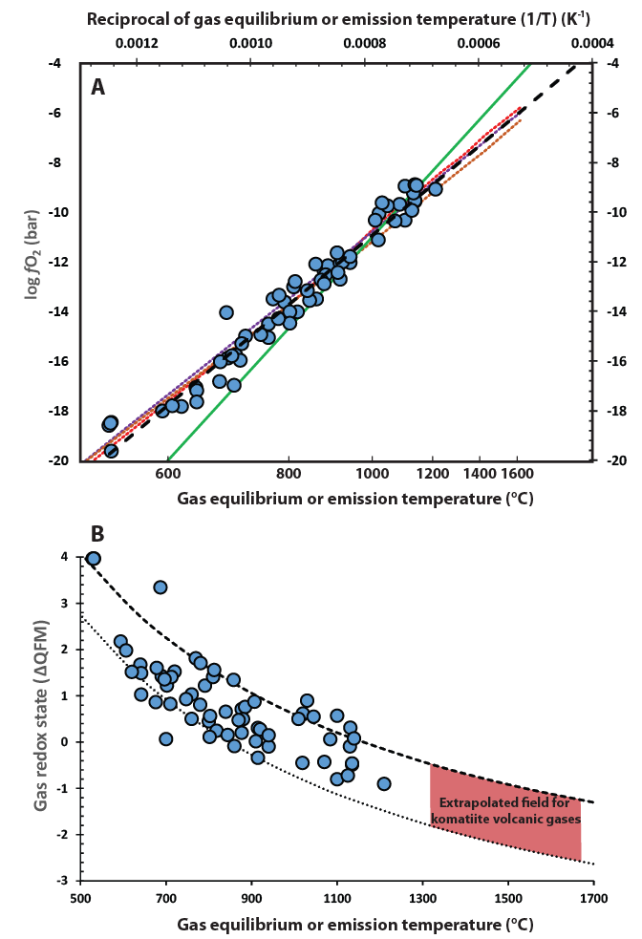
Figure 4: Oxidation state of volcanic gases as a function of emission or equilibrium temperature for our combined dataset. A. Oxidation state expressed as oxygen fugacity. Green line represents the QFM buffer, dashed black line represents a linear fit to the data (log fO₂ = -19093T + 4.081 with R²=0.96 and a P-value of 2 × 10⁻⁴⁶), red, purple and brown dotted lines represent gas-only cooling trends calculated using gas compositions reported for Sabancaya (Moussallam et al., 2017), Satsuma Iwojima (Goff and McMurtry, 2000) and Erta ‘Ale (Guern et al., 1979) volcanoes, respectively and solving for the reaction $SO_{2}+3H_{2}=H_{2}S+2H_{2}O$ at 1 bar, using thermodynamic parameters given in Ohba et al., (1994). Note the difference in slope and intercept between the rock buffer and gas trend, and the close agreement between global observations and closed-system cooling trends for three representative gas compositions. B. Oxidation state expressed as deviation from the QFM buffer and temperature. Dashed and dotted curves show the calculated relationship for a pure SO₂-H₂S gas mixture with SO₂/H₂S ratio of 100 and 1, respectively. Trends are extrapolated to the higher temperatures of komatiite lavas erupted during the Archean, suggesting even more reduced conditions of the associated gas emissions to the atmosphere. Representative error bars are given in Fig. 1.
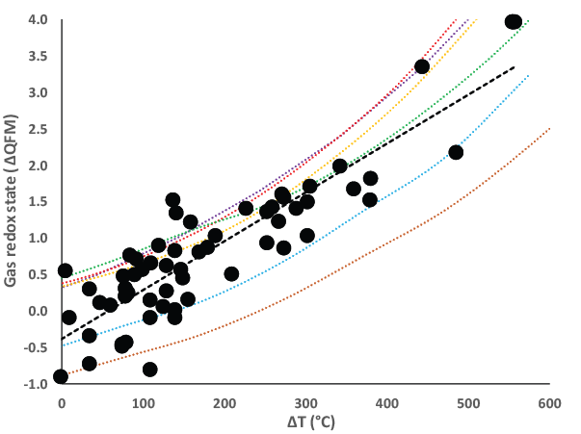
Figure 5: Oxidation state of volcanic gases (expressed as deviation from the QFM buffer) as a function of the difference in gas emission or computed equilibrium temperature and the temperature of the associated melt. Dashed line is a linear regression through the data (ΔQFM = –0.0068ΔT + - 0.4046 with an R² of 0.8 and a P-value of 1 × 10⁻¹⁰). Data and references are reported in Table S3. Red, purple, brown, orange, green and blue dotted lines represent gas-only cooling trends calculated using gas compositions reported for Sabancaya (Moussallam et al., 2017), Satsuma Iwojima (Goff and McMurtry, 2000), Erta ‘Ale (Guern et al., 1979), Bromo (Aiuppa et al., 2015), Etna (Aiuppa et al., 2011) and Momotombo (Giggenbach, 1996) volcanoes, respectively and solving for the reaction $SO_{2}+3H_{2}=H_{2}S+2H_{2}O$ at 1 bar, using thermodynamic parameters given in Ohba et al., (1994).

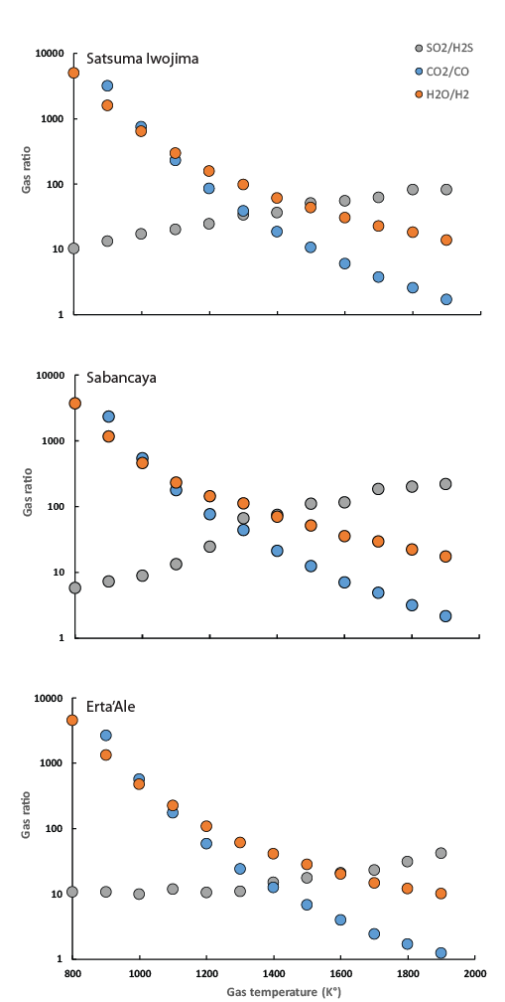
Figure 6: SO₂/H₂S; CO₂/CO and H₂O/H₂ gas ratios as a function of gas equilibrium temperature. Gas compositions were calculated using compositional data for Sabancaya, Satsuma Iwojima and Erta ‘Ale volcanoes as representative starting points, and calculating the equilibrium conditions for each gas mixture as a function of temperature from the equilibrium $SO_{2}+3H_{2}=H_{2}S+2H_{2}O$ and using thermodynamic parameters given in Ohba et al., (1994).
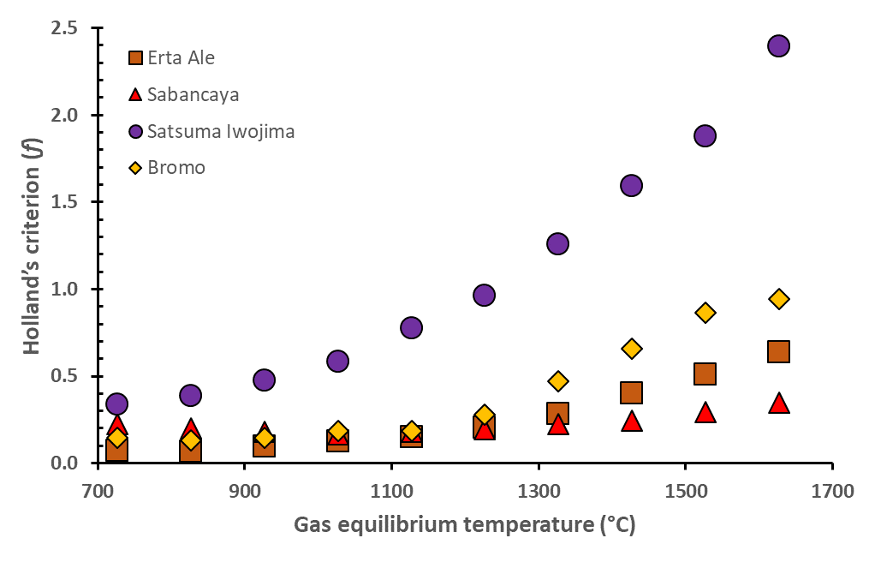
Figure 7: Reducing capacity of volcanic gases, expressed as Holland’s criterion, as a function of gas equilibrium temperature. Reported gas compositions for Sabancaya (Moussallam et al., 2017), Satsuma Iwojima (Goff and McMurtry, 2000), Erta ‘Ale (Guern et al., 1979) and Bromo (Aiuppa et al., 2015) are used in closed-system gas cooling calculations as shown in Fig. 4. Note that, in all cases, increasing gas equilibrium temperature is accompanied by an increase in Holland’s criterion, demonstrating that the capacity of volcanic gases to reduce the atmosphere increases as gas emission temperature increases.

References
Aiuppa, A., Bani, P., Moussallam, Y., Di Napoli, R., Allard, P., Gunawan, H., Hendrasto, M., Tamburello, G., 2015. First determination of magma-derived gas emissions from Bromo volcano, eastern Java (Indonesia). J. Volcanol. Geotherm. Res. 304, 206–213. https://doi.org/10.1016/j.jvolgeores.2015.09.008
Aiuppa, A., Shinohara, H., Tamburello, G., Giudice, G., Liuzzo, M., Moretti, R., 2011. Hydrogen in the gas plume of an open-vent volcano, Mount Etna, Italy. J. Geophys. Res. 116, 8 PP. https://doi.org/201110.1029/2011JB008461
Arculus, R.J., Delano, J.W., 1980. Implications for the primitive atmosphere of the oxidation state of Earth’s upper mantle. Nature 288, 72–74. https://doi.org/10.1038/288072a0
Aulbach, S., Stagno, V., 2016. Evidence for a reducing Archean ambient mantle and its effects on the carbon cycle. Geology 44, 751–754. https://doi.org/10.1130/G38070.1
Bekker, A., Holland, H.D., Wang, P.-L., Rumble, D., Stein, H.J., Hannah, J.L., Coetzee, L.L., Beukes, N.J., 2004. Dating the rise of atmospheric oxygen. Nature 427, 117–120. https://doi.org/10.1038/nature02260
Berry, A.J., Danyushevsky, L.V., O’Neill, H.S.C., Newville, M., Sutton, S.R., 2008. Oxidation state of iron in komatiitic melt inclusions indicates hot Archaean mantle. Nature 455, 960–963. https://doi.org/10.1038/nature07377
Brounce, M., Stolper, E., Eiler, J., 2017. Redox variations in Mauna Kea lavas, the oxygen fugacity of the Hawaiian plume, and the role of volcanic gases in Earth’s oxygenation. Proc. Natl. Acad. Sci. 114, 8997–9002. https://doi.org/10.1073/pnas.1619527114
Burgisser, A., Oppenheimer, C., Alletti, M., Kyle, P., Scaillet, B., Carroll, M., 2012. Backward tracking of gas chemistry measurements at Erebus volcano. Geochem. Geophys. Geosystems 13.
Burgisser, A., Scaillet, B., 2007. Redox evolution of a degassing magma rising to the surface. Nature 445, 194–197.
Canfield, D.E., 2005. The early history of atmospheric oxygen: Homage to Robert M. Garrels. Annu. Rev. Earth Planet. Sci. 33, 1–36. https://doi.org/10.1146/annurev.earth.33.092203.122711
Canfield, D.E., Habicht, K.S., Thamdrup, B., 2000. The Archean Sulfur Cycle and the Early History of Atmospheric Oxygen. Science 288, 658–661. https://doi.org/10.1126/science.288.5466.658
Canil, D., 2002. Vanadium in peridotites, mantle redox and tectonic environments: Archean to present. Earth Planet. Sci. Lett. 195, 75–90. https://doi.org/10.1016/S0012-821X(01)00582-9
Canil, D., 1997. Vanadium partitioning and the oxidation state of Archaean komatiite magmas. Nature 389, 842–845. https://doi.org/10.1038/39860
Carmichael, I.S.., 1991. The redox states of basic and silicic magmas: a reflection of their source regions? Contrib. Mineral. Petrol. 106, 129–141. https://doi.org/10.1007/BF00306429
Carn, S.A., Fioletov, V.E., McLinden, C.A., Li, C., Krotkov, N.A., 2017. A decade of global volcanic SO2 emissions measured from space. Sci. Rep. 7, 44095. https://doi.org/10.1038/srep44095
Chase, M.W., National Institute of Standards and Technology (U.S.), 1998. NIST-JANAF thermochemical tables. American Chemical Society ; American Institute of Physics for the National Institute of Standards and Technology, Washington, D.C.]; Woodbury, N.Y.
Chiodini, G., Marini, L., 1998. Hydrothermal gas equilibria: the H2O-H2-CO2-CO-CH4 system. Geochim. Cosmochim. Acta 62, 2673–2687. https://doi.org/10.1016/S0016-7037(98)00181-1
Delano, J.W., 2001. Redox history of the Earth’s interior since approximately 3900 Ma: implications for prebiotic molecules. Orig. Life Evol. Biosphere J. Int. Soc. Study Orig. Life 31, 311–341.
Dostal, J., 2008. Igneous Rock Associations 10. Komatiites. Geosci. Can. 35.
Elkins-Tanton, L.T., 2008. Linked magma ocean solidification and atmospheric growth for Earth and Mars. Earth Planet. Sci. Lett. 271, 181–191. https://doi.org/10.1016/j.epsl.2008.03.062
Farquhar, J., Peters, M., Johnston, D.T., Strauss, H., Masterson, A., Wiechert, U., Kaufman, A.J., 2007. Isotopic evidence for Mesoarchaean anoxia and changing atmospheric sulphur chemistry. Nature 449, 706–709. https://doi.org/10.1038/nature06202
Frost, B.R., 1991. Introduction to oxygen fugacity and its petrologic importance. Rev. Mineral. Geochem. 25, 1–9.
Frost, D.J., McCammon, C.A., 2008. The Redox State of Earth’s Mantle. Annu. Rev. Earth Planet. Sci. 36, 389–420. https://doi.org/10.1146/annurev.earth.36.031207.124322
Gaillard, F., Scaillet, B., 2014. A theoretical framework for volcanic degassing chemistry in a comparative planetology perspective and implications for planetary atmospheres. Earth Planet. Sci. Lett. 403, 307–316. https://doi.org/10.1016/j.epsl.2014.07.009
Gaillard, F., Scaillet, B., Arndt, N.T., 2011. Atmospheric oxygenation caused by a change in volcanic degassing pressure. Nature 478, 229–232. https://doi.org/10.1038/nature10460
Gerlach, T.M., 2004. Volcanic sources of tropospheric ozone-depleting trace gases. Geochem. Geophys. Geosystems 5, n/a–n/a. https://doi.org/10.1029/2004GC000747
Gerlach, T.M., 1993. Oxygen buffering of Kilauea volcanic gases and the oxygen fugacity of Kilauea basalt 795–814.
Giggenbach, W.., 1996. Chemical composition of volcanic gases. Scarpa R Tilling RI Eds Monit. Mitig. Volcano Hazards 202–226.
Giggenbach, W.F., 1996. Chemical Composition of Volcanic Gases, in: Monitoring and Mitigation of Volcano Hazards. Springer Berlin Heidelberg, pp. 221–256. https://doi.org/10.1007/978-3-642-80087-0_7
Giggenbach, W.F., 1987. Redox processes governing the chemistry of fumarolic gas discharges from White Island, New Zealand. Appl. Geochem. 2, 143–161. https://doi.org/10.1016/0883-2927(87)90030-8
Giggenbach, W.F., 1980. Geothermal gas equilibria. Geochim. Cosmochim. Acta 44, 2021–2032. https://doi.org/10.1016/0016-7037(80)90200-8
Giggenbach, W.F., Tedesco, D., Sulistiyo, Y., Caprai, A., Cioni, R., Favara, R., Fischer, T.P., Hirabayashi, J.-I., Korzhinsky, M., Martini, M., Menyailov, I., Shinohara, H., 2001. Evaluation of results from the fourth and fifth IAVCEI field workshops on volcanic gases, Vulcano island, Italy and Java, Indonesia. J. Volcanol. Geotherm. Res. 108, 157–172. https://doi.org/10.1016/S0377-0273(00)00283-3
Goff, F., McMurtry, G.M., 2000. Tritium and stable isotopes of magmatic waters. J. Volcanol. Geotherm. Res. 97, 347–396. https://doi.org/10.1016/S0377-0273(99)00177-8
Guern, F.L., Carbonnelle, J., Tazieff, H., 1979. Erta’ale lava lake: heat and gas transfer to the atmosphere. J. Volcanol. Geotherm. Res. 6, 27–48. https://doi.org/10.1016/0377-0273(79)90045-3
Halevy, I., Johnston, D.T., Schrag, D.P., 2010. Explaining the Structure of the Archean Mass-Independent Sulfur Isotope Record. Science 329, 204–207. https://doi.org/10.1126/science.1190298
Hirschmann, M.M., Dasgupta, R., 2009. The H/C ratios of Earth’s near-surface and deep reservoirs, and consequences for deep Earth volatile cycles. Chem. Geol., Volatiles and Volatile-Bearing Melts in the Earth’s Interior 262, 4–16. https://doi.org/10.1016/j.chemgeo.2009.02.008
Holland, H.., 2002. Volcanic gases, black smokers, and the great oxidation event. Geochim. Cosmochim. Acta 66, 3811–3826. https://doi.org/10.1016/S0016-7037(02)00950-X
Huppert, H.E., Sparks, R.S.J., Turner, J.S., Arndt, N.T., 1984. Emplacement and cooling of komatiite lavas. Nature 309, 19–22. https://doi.org/10.1038/309019a0
Kasting, J.., Eggler, D.., Raeburn, S.., 1993. Mantle Redox Evolution and the Oxidation State of the Archean Atmosphere. J. Geol. 101, 245–257.
Kasting, J.F., 1993. Earth’s early atmosphere. Science 259, 920–926.
Kasting, J.F., and, Catling, D., 2003. Evolution of a Habitable Planet. Annu. Rev. Astron. Astrophys. 41, 429–463. https://doi.org/10.1146/annurev.astro.41.071601.170049
Kump, L.R., Barley, M.E., 2007. Increased subaerial volcanism and the rise of atmospheric oxygen 2.5 billion years ago. Nature 448, 1033–1036. https://doi.org/10.1038/nature06058
Li, Z., Lee, C., 2004. The constancy of upper mantle fO2 through time inferred from V/Sc ratios in basalts. Earth Planet. Sci. Lett. 228, 483–493. https://doi.org/10.1016/j.epsl.2004.10.006
Martin, R.S., Mather, T.A., Pyle, D.M., 2006. High-temperature mixtures of magmatic and atmospheric gases. Geochem. Geophys. Geosystems 7.
Martin, R.S., Roberts, T.J., Mather, T.A., Pyle, D.M., 2009. The implications of H2S and H2 kinetic stability in high-T mixtures of magmatic and atmospheric gases for the production of oxidized trace species (e.g., BrO and NOx). Chem. Geol. 263, 143–150. https://doi.org/16/j.chemgeo.2008.12.028
Moretti, R., Ottonello, G., 2005. Solubility and speciation of sulfur in silicate melts: The Conjugated Toop-Samis-Flood-Grjotheim (CTSFG) model. Geochim. Cosmochim. Acta 69, 801–823. https://doi.org/10.1016/j.gca.2004.09.006
Moretti, R., Papale, P., 2004. On the oxidation state and volatile behavior in multicomponent gas-melt equilibria. Chem. Geol. 213, 265–280. https://doi.org/10.1016/j.chemgeo.2004.08.048
Moretti, R., Papale, P., Ottonello, G., 2003. A model for the saturation of C-O-H-S fluids in silicate melts. Geol. Soc. Lond. Spec. Publ. 213, 81–101. https://doi.org/10.1144/GSL.SP.2003.213.01.06
Mori, T., Notsu, K., Tohjima, Y., Wakita, H., 1993. Remote detection of HCl and SO2 in volcanic gas from Unzen volcano, Japan. Geophys. Res. Lett. 20, 1355–1358. https://doi.org/10.1029/93GL01065
Moussallam, Y., Bani, P., Schipper, C.I., Cardona, C., Franco, L., Barnie, T., Amigo, Á., Curtis, A., Peters, N., Aiuppa, A., Giudice, G., Oppenheimer, C., 2018. Unrest at the Nevados de Chillán volcanic complex: a failed or yet to unfold magmatic eruption? Volcanica 1, 19–32. https://doi.org/10.30909/vol.01.01.1932
Moussallam, Y., Edmonds, M., Scaillet, B., Peters, N., Gennaro, E., Sides, I., Oppenheimer, C., 2016. The impact of degassing on the oxidation state of basaltic magmas: A case study of Kīlauea volcano. Earth Planet. Sci. Lett. 450, 317–325. https://doi.org/10.1016/j.epsl.2016.06.031
Moussallam, Y., Oppenheimer, C., Scaillet, B., Gaillard, F., Kyle, P., Peters, N., Hartley, M., Berlo, K., Donovan, A., 2014. Tracking the changing oxidation state of Erebus magmas, from mantle to surface, driven by magma ascent and degassing. Earth Planet. Sci. Lett. 393, 200–209. https://doi.org/10.1016/j.epsl.2014.02.055
Moussallam, Y., Tamburello, G., Peters, N., Apaza, F., Schipper, C.I., Curtis, A., Aiuppa, A., Masias, P., Boichu, M., Bauduin, S., Barnie, T., Bani, P., Giudice, G., Moussallam, M., 2017. Volcanic gas emissions and degassing dynamics at Ubinas and Sabancaya volcanoes; implications for the volatile budget of the central volcanic zone. J. Volcanol. Geotherm. Res. https://doi.org/10.1016/j.jvolgeores.2017.06.027
Nicklas, R.W., Puchtel, I.S., Ash, R.D., 2016. High-precision determination of the oxidation state of komatiite lavas using vanadium liquid-mineral partitioning. Chem. Geol. 433, 36–45. https://doi.org/10.1016/j.chemgeo.2016.04.011
Ohba, T., Hirabayashi, J., Yoshida, M., 1994. Equilibrium temperature and redox state of volcanic gas at Unzen volcano, Japan. J. Volcanol. Geotherm. Res. 60, 263–272. https://doi.org/10.1016/0377-0273(94)90055-8
Oppenheimer, C., Moretti, R., Kyle, P.R., Eschenbacher, A., Lowenstern, J.B., Hervig, R.L., Dunbar, N.W., 2011. Mantle to surface degassing of alkalic magmas at Erebus volcano, Antarctica. Earth Planet. Sci. Lett. 306, 261–271. https://doi.org/10.1016/j.epsl.2011.04.005
Oppenheimer, C., Scaillet, B., Woods, A., Sutton, A.J., Elias, T., Moussallam, Y., 2018. Influence of eruptive style on volcanic gas emission chemistry and temperature. Nat. Geosci. 1. https://doi.org/10.1038/s41561-018-0194-5
Ottonello, G., Moretti, R., Marini, L., Vetuschi Zuccolini, M., 2001. Oxidation state of iron in silicate glasses and melts: a thermochemical model. Chem. Geol., 6th International Silicate Melt Workshop 174, 157–179. https://doi.org/10.1016/S0009-2541(00)00314-4
Peters, N., Oppenheimer, C., Killingsworth, D.R., Frechette, J., Kyle, P., 2014. Correlation of cycles in Lava Lake motion and degassing at Erebus Volcano, Antarctica. Geochem. Geophys. Geosystems 15, 3244–3257. https://doi.org/10.1002/2014GC005399
Rollinson, H., Adetunji, J., Lenaz, D., Szilas, K., 2017. Archaean chromitites show constant Fe3+/ΣFe in Earth’s asthenospheric mantle since 3.8Ga. Lithos 282, 316–325. https://doi.org/10.1016/j.lithos.2017.03.020
Shinohara, H., 2013. Volatile flux from subduction zone volcanoes: Insights from a detailed evaluation of the fluxes from volcanoes in Japan. J. Volcanol. Geotherm. Res. 268, 46–63. https://doi.org/10.1016/j.jvolgeores.2013.10.007
Shinohara, H., 2005. A new technique to estimate volcanic gas composition: plume measurements with a portable multi-sensor system. J. Volcanol. Geotherm. Res. 143, 319–333. https://doi.org/16/j.jvolgeores.2004.12.004
Stull, D.R., Westrum, E.F., Sinke, G.C., 1969. The chemical thermodynamics of organic compounds. J. Wiley.
Symonds, R.B., Gerlach, T.M., Reed, M.H., 2001. Magmatic gas scrubbing: implications for volcano monitoring. J. Volcanol. Geotherm. Res. 108, 303–341. https://doi.org/10.1016/S0377-0273(00)00292-4
Symonds, R.B., Rose, W.I., Bluth, G.J.S., Gerlach, T.M., 1994. Volcanic-gas studies; methods, results, and applications. Rev. Mineral. Geochem. 30, 1–66. https://doi.org/<p></p>

Acknowledgements
Y.M. acknowledges support from the Leverhulme Trust. CO receives support from the NERC Centre for Observation and Modelling of Earthquakes, Volcanoes and Tectonics and NERC grant NE/N009312/1. We thank Dr. Roberto Moretti and anonymous referees for constructive and beneficial comments on the original manuscript.

