Artists and Arts-based Method use in Higher Education: a Living Inquiry of an Academic Programme in a School of Education
Pamela Burnard, Carol Holliday, Susanne Jasilek and Afrodita Nikolova
Abstract:
In this chapter our central argument is that we should be promoting the use of arts-based methods as a necessity, not as an option, in re-imagining the academy and enhancing teaching and learning in higher education programmes. How arts-based methods are developed as a pedagogy of possibilities for viewing organizational learning ecologies in higher education remains under-researched and under-theorised. We are told that we need new thinking in the current world crises of economics and global environmental concerns. We are also told that, in higher education, a new critically reflexive form of creative teaching and learning is required in order to address the task of reconciling the need for a stable, safe, ethical and empathetic world with the need for a productive, adaptive and creative workforce. In this chapter we provide compelling evidence of transformative practices - pedagogies of possibility - developed from a funded initiative called Facultartem which featured an artist-in-residence who developed arts-based methods to enhance a Masters programme in a UK university. This chapter explores the opening up and use of a sample of the arts-based methods as a means by which to better understand organizational learning ecologies and prompt re-thinking of pedagogies of possibility in higher education, particularly Masters programmes. We critique the crucial role that arts-based methods have to play in understanding organizational learning in HE. We do this from the perspective of those who journey within the classrooms that, with all their affordances and limitations, remain a location of possibility for teaching and learning as artists.
Keywords:
artists, arts-based methods, living enquiry, Higher Education, transformative organizational learning ecology, pedagogy of possibilities
INTRODUCTION
The performance of teaching and learning in global higher education is volatile, uncertain, complex and ambiguous and it needs to transform (Lemoine et al. 2017). The problems facing contemporary higher education are many. We need to find new ways of delivering an antidote to the paralysing and prohibiting structures of postmodern political agendas (Green 2001), of rethinking notions of power and the disciplining of organizational learning (Braidotti 2014) and high theory (Ellsworth 1997). The ways higher education has been expected to perform its functions for the benefit of the larger society have been: (a) to emphasise the specialised knowledge and skills necessary for the development of a modern, technology based society; and (b) in the practical application of new discoveries to changes in societal demands. Collectively, this demonstrates an urgent need for higher education research which is transformative, participatory, involving academic and non-academic stakeholders during all parts of the process, and which is socially responsible, with the power to transform and emancipate. This is where artists and the application of arts-based methods can find fresh ways of seeing, understanding and shaping the organizational learning ecologies in Higher Education (HE) and can lead us to some of the best tools for a living inquiry.
So, what is ‘organisational learning’? According to Kijpokin Kasemsap (2017:29), in an article that investigates the roles of neuroscience and knowledge management in higher education, it is “a social process in which individuals in organisations enhance decision making and problem solving by improving knowledge and understanding. It is also an organization-wide process that enhances its collective ability to accept, make sense of and respond to internal and external change”.
One of the biggest challenges, working in HE, is finding ways of creating and nurturing organisational learning communities committed to sustained creative futures as global citizens who can work with pluralities, playfulness, possibilities and participatory (research) practices. It is up to us to develop a vision of organisational learning that plays in step with the HE system, currently characterized by rising student fees, increasing student-to-staff ratios and progressive imposed (neoliberal) performativity targets and learning culture. How should organizational learning ecologies cultivate a supportive and open space of possibilities for academics and non-academics co-authoring practices and pedagogies of possibility that nurture aspiring intellectuals and professionals as they seek to fulfil their critical and creative potentials?
One of the imperatives at our institution is to develop practices that actively engage us all in the process of creatively appropriating tools and resources that help us conceive how emergent practices – afforded by arts based methods – might both deviate and affirm, or, put differently, both critique and create organizational learning ecologies – practices and pedagogies – that enable us to work as a living system of knowledge creation, shared knowledge and expertise.
In this chapter, we put forward arts-based methods that break from the idea of art as the knowledge and practice of particular techniques, or the conceptualization of art as communication, but rather advance ways in which art and art making become capable of releasing the potential of HE.
WHAT CAN ART DO AS A RESEARCH TOOL?
What art can do as a research tool, for the construction and acquisition of knowledge and its representation, is being argued by social science researchers and scholars across multiple disciplines. What art can do in pedagogical relations is also guiding new didactics. Arts-based methods are frequently used by arts educators and researchers. Most arts-based researchers have expertise as researchers, artists and educators. In her seminal book Method Meets Art: Arts-Based Research Practice, feminist sociologist Leavy (2009) defines arts-based research practices as:
[…] a set of methodological tools used by researchers across disciplines during all phases of social research, including data generation, analysis, interpretation, and representation. These emerging tools adapt the tenets of the creative arts in order to address social research questions in holistic and engaged ways in which theory and practice are intertwined (2009, p. 2-3).
Leavy’s emphasis on the diverse uses of the arts in social science research, along with the emergence of arts-based research in higher education as distinct from qualitative research practices, forms the basis of an emerging research paradigm (Rolling 2010). Eisner’s collaboration with one of his students, Barone, who used arts in his dissertation, resulted in the seminal book Arts-based Research, expounding the nature, specificities and scope of embodied arts-based research methods (2011). The relationship between art and research embodies how the visual is brought into relation with systems of academic thinking, thought and action. In a seminal critique of arts-based research, Jagodzinski and Wallin, (2013, p.5) make the following claim:
This is, perhaps, the most unique contribution of art to education insofar as it demands of teaching and learning something radically other than the voluntary movement of memory (reflection), the application of representational matrices (transcendence) or the deployment of laws known prior to that which they apply (morality).
Not everyone in the academy (that is, higher education) is open to the possibility or willing to acknowledge and become ‘wide awake’ to the urgent ethical and moral questions of our time, nor are they ready to ask the uncomfortable questions about the ways that we perform and reproduce knowledge through hegemonic structures of organisational learning (Greene 1994, Mackinlay 2016). Yet, for some academics, arts-based methods can offer a way of creating a pedagogical encounter like no other. Stephanie Springgay, Rita Irwin, Carl Leggo and Peter Gouzouasis’s (2008) “Being with A/r/t/ography”, an edited collection of essays, offers a theoretical grounding of a/r/t/ography as a methodological tool and diverse theoretical lenses in considering ethics in arts-based research and methodologies. Figure 1 represents arts-based inquiries located in higher education contexts in which power and knowledge are produced, reproduced and maintained. The catalysts for rethinking and theorizing space and the ways in which such spaces enable and constrain in the changing higher education environment include artist-researchers engaged in a/r/t/ographic (Güler 2017; Mackinlay 2015, 2016), artist-university-school partnerships (Thomson, et al 2012; Burnard and Swann 2006), and doctoral students (Stevenson 2017, 2013) as ‘insiders’ in the academy. More often, these artist/researcher/academics can see and position themselves (as do we) as “complicit neo-liberal subjects…subject to the precarity of academic employment and the increasing time pressures of new managerialism…[in] the contemporary Westernized university” (Mackinlay, 2016:199).

With each act and experience of inquiry, a common purpose resonating across these studies is the use of narrative inquiry for the telling and retelling of participants’ stories as they are living them (Connelly and Clandinin 1990). The storied quality of experience, both personal and social, involves the description and restorying of the narrative as co-constructed meanings, understandings and interpretations, as they are being lived. The experience of performance, the performance of subjectivities, the performativities of knowledge, and the link between embodiment and the performative lies in the way the physical space of a room becomes a space of event and encounter. This ‘fact of embodiment’ as Ellsworth (2005:166) puts it, is central to arts-based methods. Similarly, Gatens (1996:67) argues:
Emphasis on the body and space allows one to consider not simply how discourses and practices create ideologically appropriate subjects but also how these practices construct certain sorts of body with particular kinds of power and capacity; that is, how bodies are turned into individuals of various kinds.

Figure 1: Sample of the field of HE research utilising artists partnerships and arts-based methods

How we ensure practices and pedagogies of possibility and arts-based method underpin enhancement programmes for institutional learning has to do with: (a) adapting the principles and practices of the arts to social research projects; (b) tapping into the unique capabilities of the arts as a way of knowing and doing; and (c) drawing on theories and practices of embodiment as a critical, reflective and analytical act (Leavy 2017). When HE institutional learning becomes a space of event and encounter it can be configured, and therefore experienced, in different ways. The enhancement programme, as with our study of it, aims to identify the way that the body acts and interacts as an inscriptive and discursive surface in HE settings. Even the placement of the chairs and tables in the physical space of a classroom can make it become a space of event and encounter.
THE PROGRAMME, THE STUDY AND THE METHOD
Funds became available to enhance the experience of Masters students across the University setting. Our response to this was to invite multi-media artist, Susanne Jasilek, to establish an artist-residency. The artist residency, framed as a living enquiry, took place over five months in the Faculty of Education. The intention was to enhance the experience of the Masters students. The concept and name given to the residency was FACULT-ART-EM. This is a play on the Latin word ‘facultas’ meaning capability, possibility, opportunity, skill and ability. The aim of FACULT-ART-EM was to create spaces for and by Masters students and staff at the Faculty of Education, University of Cambridge, and for an artist to facilitate reflective artistic creative engagements with students and staff that would enhance their experience of the Masters programme (www facult-art-em.net).
The resident artist, Susanne Jasilek, a distinguished multi-media artist, facilitated a range of workshops, creative reflections, conversations and explorations that offered opportunities to ‘perform’ within, and in response to, a series of diverse art making activities in the form of a call for entries, pop-ups, workshops both within lectures as part of the teaching programme with lecturers, and independent art workshops. Willing participants were invited to take a moment out of the trajectory of their day, sometimes just for a minute, sometimes for an hour or so, to reflect, illustrate and express their journeys of becoming and being educational researchers, using a variety of media including film, sound, clay, collage, paint, poetry, sculpture and drawing.
The precise role of the artist was to create an open ended, fluid, exploratory and non-judgemental space, within a number of different locations in the faculty building (an inbetween space) for others to use artistic forms of self-reflection, self-observation, reflexive investigation and subjectivity to explore the researcher’s experience and processes. Susanne, together with students and staff, explored diverse creative processes and practices, which culminated in creating a vibrant body of reflective work in the form of a film, a sound piece, sculptures and reflective research journeying and mapping by students and staff.
These reflective practices explored a range of themes including happiness, research journeying and connections to wider educational and cultural experiences. The residency was documented on an online ongoing blog, www.facult-art-em.net and culminated in a film installation, open to the faculty community for 2 days, and the launch of the ANABLOG, a beautiful and impressive eight-metre long scroll featuring the activities and work of the art residency that hangs through three floors of the faculty building. These artefacts leave a lasting legacy of this unique and valuable project for future students.
Data generated from the living enquiry programme featured participatory research. This data included collage portraits, happiness films, transcriptions and photographs from pop-up sessions involving ‘self in place’ and wool winder messages. There was a great deal of art making as part of lesson plans, art making in response to lectures, art making in response to research journeys, creative minute taking, field recordings (Can I have a word?), clay work, end-of-year party mandala making (Circles of Influence), documenting feedback and collating material, developing installations, event and pod building, designing the ANABLOG and engaging in mapping journeys.
The space of the institution itself, a modern 3 floor open plan building, inspired multiple possibilities. There were, however, certain spaces which were too disruptive in terms of what could be achieved for the benefit of all.
We describe this programme-research as ‘a living inquiry’ because it makes use of arts-based methods as both methodological and programme/pedagogic tools for promoting reflection through resonance. We use poetic and photographic enquiry tools to position the self, and montage/drawing to interpret learning in ways that Maxine Green (1994) presents as forms of representation which express ‘I am what I am not yet’. Inspired by Patricia Leavy (2017), our hope for this kind of programme-enhancement-research-as-living enquiry is that it presents itself as an exploration of arts-based practices for “‘disrupt[ing]’ stereotypes, ‘cultivating’ empathetic understanding across differences, promot[ing] reflection through resonance, open[ing] up a multiplicity of meanings and extending the reach of our scholarship” (Leavy 2012, 258). We also use visual stimuli to position the self, drawing to interpret learning and film making to make permissible engagement in the borderlands of uncertainty in organizational learning in which we find ourselves. We also develop the use of montage tools which attempt to find new ways of performing pedagogies in higher education for living an enquiry; these engage in new forms of active learning using arts-based forms of research inquiry that playfully and performatively puzzle out improvement in, and development of, a theory of arts-based practice enhancement of organizational learning.
It was important to operate as a collaborative team working with the artist-in-residence. The generation and analysis of observational and verbal data in conjunction with objects has provided rich insight into the relational nexus formed by an artist-in-residence and how willing participants (both academic and non-academic staff and students) critically engage and reflect on the enhancement programme as a living inquiry embedded within the institutional learning contexts.
The data analysis, analytic tools and interpretation developed to address our research questions addressed themes and categories that emerged during this process. From interviews, we analysed the participants’ perspectives using thematic analysis. Working with field texts, journal entries, observation and artefacts, our analysis involved close reading and re-reading, listening and (re-)viewing, dialoguing with our team about what was being revealed, writing analytic memos, keeping a journal, and moving between thematic and content analysis of participant voices, objects made, and events as ‘portraits in miniature’ for each of the inquiry methods.
We moved from a descriptive categorization of the narrative inquiry forms to a more conceptual and interpretive level using a constant comparison inquiry of peer collaboration. This offered triangulation throughout the course-grained (emergent) and then fine-grained (ongoing coding) phases and the categorizing of the process in action, identifying the microanalytic themes and metathemes drawn from the entire body of data (Ely et al 1997:206) and juxtaposing / comparing narratives. The following (Table 1) provides an overview of the sample and set of 4 of the arts-based methods we used in this living enquiry.
Table 1: Overview of the sample and sample of 4 data sets
Inquiry texts | Activity name | An invitation to: | Themes
Film | Happiness | …share how people, who are part of the same workplace, perceive and experience happiness | *Envisioning conceptions of ‘happiness’  *Revelatory  *Being-in-relation  *Balancing self  *Multivocal
Sound/Poetic  Oral/Sonic | Can I have a word? | …share one word, on entering/leaving the faculty building spontaneous response to being in the academy/ this workplace/space and time | *Charge of energy  *A wrestle with self  *Confronting self  *Being-in-relation
Visual | Discover/unveil and share self-understanding and orientations as emerging researchers | …responding to and with art materials, allowing imagery to unfold, evolve on the subject of what constitutes doing a masters/becoming a researcher | *Expressing self experiencing aspects of self in a different way.  *New perspectives  *Self disclosure  *Relational self  *Being-in-relation  *Revelatory  *Inner worlds  *Social worlds  *Dialogic
Mandala (Collage)  Circles of Influence | Draw/express your reflections upon near completion of their masters; work collaboratively as a collective on a single piece of work | …tune themselves and look back on their research journey, the pattern of it , the shape, the colours, the complexity, emotions, The materials themselves were intrinsic to the final work. They did not know what would come out. It’s the working expressively with materials that offers the 'something else' not viewed, not seen before. | *Reflexivity  *Sense of release  *Impetus to change  *Retuning the self  *Writing the self into community  *Revelatory  *arts as the production of knowledge  *Being-in-relation

DATA SET PRESENTATIONS WITH FINDINGS
DATA SET 1: Visual ‘Happiness’ narratives with film text
The first ‘intervention’ by the artist at the beginning of the residency was to request 30 seconds of film on the subject of ‘happiness’. Masters students as well as staff and other non-academic members of the Faculty were invited to take part. A surprising number of willing participants (26) responded to the invitation. The clips of 30 second film, shot from their mobile phones, were a mixture of beauty, nature, calm, humour and the bizarre. This activity opened up possibilities for the reformulation of the relation between the individual and the social and organizational / institutional workplace in which each is inherently involved in the others’ definition. The clips included ones which were expressions of emotion, cheerfulness, playfulness, belonging, freedom, struggle and melancholy. The task of making a 30-minute-film created a unique space for possibilities.
Why ‘happiness’? The artist chose ‘happiness’ on the basis of her assumption that happiness was suitably broad, seemingly straightforward and something that we all share and crave. Not a word she imagined was used much in research and teaching.
The term ‘happiness’ embodies social ideals. It means different things to different people. How happiness holds its place as people’s ultimate desire and end point, reflects a complex engagement with, and construction of, the world. In this study, with this task, the artist’s invitation was unexpected and intellectually stimulating. To film / document our own construction of ‘happiness’ was sure to trigger a great deal of interest. And it did. This was a task which could potentially provoke members of the Faculty into considering what to tell or whether to tell the necessary ‘white lies’ people rely on to make their life stories coherent and bearable. Here, we draw on Sara Ahmed’s (2010) bold critique of the consensus that ‘happiness’ is a searching question, an imperative to be happy; and her conception of “killing joy” suggests a way “to open a life, to make room for life, to make room for possibility, for chance, for alternative ways of living” (p. 20) and working. Perhaps this is why we received so many responses.
Following the receipt of 26 films, and before analysis, the artist, Susanne, collated the individual filmed expressions of ‘Happiness’ into one seamless film from which to unpack the visual, the metaphorical, spoken tropes, ideas, objects and beliefs participants associate with happiness. This curated film formed a collective chorus of academic and non-academic voices sounding their expressions of what ‘happiness’ is for them. We used Ahmed’s analytic frame of “happiness as an horizon of experience”, using the social ideals of objects and ideas that predicate it, to make sense of the film. We analysed how ‘happiness’ manifests in narratives and the extent to which the happiness narrative is or isn’t ingrained in social norms. We also analysed how considering these relations affords a complex appreciation of happiness as construed through the subjectivities of voices curated in the collective happiness narrative.
Rather than taking the analytic approach of coding and categorising each of the separately filmed expressions of ‘happiness’, the artist collated and curated them to produce the ‘Happiness’ film. This screened as an installation over 2 days within a specially created structure called The Happiness Pod, a room (with a unique space) within a room where between 1 and 6 people at a time were able to sit and view the film. The pod was a carefully considered (other/or third) space placed in a teaching room. Visitors responded to and acknowledged the changed feeling of being in The Happiness Pod. That the space itself changed the experience of viewing the film, was significant. The Happiness Pod was seen as a space to come to, to get away from the normal day, to come alone and watch a number of times; to sit in with a stranger and share viewing and coming. The Happiness Pod became a space where a known group could come to enjoy, laugh and talk together in a very carefree way. It allowed a space within a space that was in but somehow separated from the Faculty building that it was placed in. It offered the possibility for new ways of relating to each other and for relating to and with strangers outside the social norms of the Faculty. It changed the dynamics and openness of all those who participated.
Themes emerged about how we story aspects of life, institutional learning, and the workplace. By juxtaposing ideas traditionally associated with ‘happiness’ (emotion in relation to abstract concepts like family) with ‘unhappiness’ (emotion in relation to inanimate objects like shoes as less close or valuable to the social ideal), the conception of ‘happiness’ as cultural theorist Sara Ahmed (2010), in her seminal book The Promise of Happiness contends, raises critical questions about becoming researchers, the workplace, and institutional learning. For example, based on one of the narrative voices in the ‘Happiness’ film, one can argue, love for shoes, as one of several objects of affection, is an expression of happiness. Happiness was also expressed as a space for possibilities for being emotionally and politically evocative, captivating, aesthetically powerful and moving, even a judgement that one is doing well. Happiness was expressed as something we are inclined toward (such as, what makes us happy) but also about what we should be inclined toward (such as, judgements about how our lives are enriched, or how we live well). Enabling this space for possibilities, between the individually and socially valued currency of ideas and objects associated with happiness (and unhappiness) seemed to afford the ability to shift perspectives – which is about being-in-relation with regards to the storying of institutional learning.

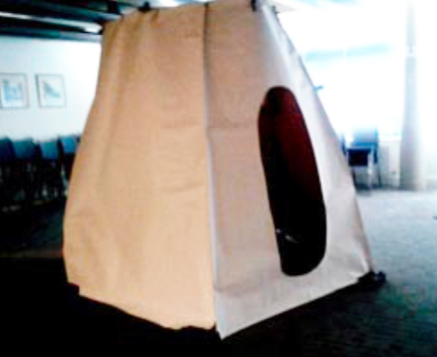
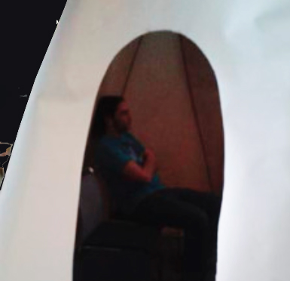
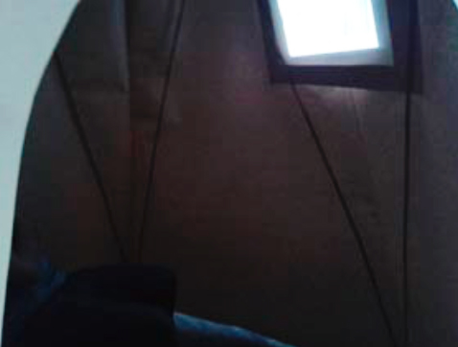
Photo 1: The Happiness Pod
The Happiness Pod was resurrected for the final celebration day and launching of the ANABLOG. It was erected for the purpose of showing Happiness once again. The metathemes embedded in this body of data generated from students and staff is about ‘being-in-relation’ and drawing us into a ‘space of possibilities’.
Table 2: Analysis of the ‘happiness’ curated film viewing: Participants responses
Participants’ Voices | Themes/Metathemes
‘The laughter and doing something fun that brought people together. A sense of community that gave us a shared identity…Being hugged and immersed in happiness pod feeling calm and lost in the moments of the videos.’ | *My/our/their being-in-relation  A dialogic space
‘The provision of an entirely novel space in a familiar building. Seeing so many different perspectives and possibilities on peoples ideas of happiness.’ | *A novel space  *A discursive space
‘The atmosphere inside the ‘tent’. It gave me happiness!’ | *An embodied space
‘This feels different. Taps into emotions. Different perspectives – always illuminating as it shows the richness of human response.’ | *A space of ‘heart thinking’ where emotion becomes entangled with experience and epistemology (Mackinlay 2016:17)
‘It was outside my natural comfort zone, but a very safe way to be stretched.’ | *A safe space  *A vulnerable space  *An ethical space
‘Connection with colleagues I wouldn’t otherwise know anything about. It allowed a gateway to advocating for my needs.’ | *About being-in-relation  *An affective space to rethink dimensions of our learning to become researchers

It was an audacious move to erect a Pod in the teaching and learning space of this institution and, in doing so, provide further musings on the whys and wherefores of ‘happiness’. Yet, it was interesting to note the ways in which academics, non-academics and students dived quickly into the possibilities of the expression of ‘happiness’ and the space of possibilities within the Pod, viewing and re-viewing the novel, discursive, dialogic, heart-thinking, embodied, safe, vulnerable, ethical, and affective dimensions of our teaching and learning selves, and the numerous themes of organizational learning which we unexpectedly stumbled upon. In response, one of our team, Afrodita Nikolova, composed a generated poem which happens “when researchers use their own words to describe an interpretation discovered in research with others” (Butler-Kisber 2010, 91)
The Promise (a generated poem by Afrodita Nikolova)
You smiled in the eye of the dove
lips like a needlе a song mends
the body begins to know
even itself an ocean wave interstitial happiness—
an alarm clock
a glass of water at the night table the past
flickering through the car window we forget
in silence like our tongues
this Friday someone extinguishes
a cigarette for the last time
like a quitter there is a joy-
killing community of the promise
of happiness their bodies
temples of regret happy
knows of it an empty
ice cream bowl, fingers dipped in licorice
making a gin cocktail
cutting up lemon wedges with the hand in the air
music like sunlight
stretching across the width of the walls—as if the horizon ends
here in the living room
remember how happiness is
when it is or
a simple fresh brewed coffee in a white mug too much
do we ask for too much
—running running my dad went into remission today
look at me
the boy says eyes glued to the camera of his smart phone
you arrived here and we were and we were sometimes
inverted shadows on the kitchen table a hum
hollowed out of the light
beaming through the netted blue windows
is this what it’s supposed to feel like
people say happiness is an abstract concept, I know better look at these—aaaaaaahhaaaaaahhaaaaaahh—my shoes so many
and just like that a monarch by the chocolate cake
crumble for breakfast
don’t you understand
in other people’s mind
you can be all
and it’s joy and it’s
fleeting
eat up the last cupcake this heavy custard heart
losing yourself completely in something you care about—
oh and in the snow
oh no we were in the snow, so happy, oh dear, can do it
Carl can do it let the body lose in the snow
Monday morning at work ‘ring ring’— ‘Hello’—
raise my salary raise me—
nature calls out like this and why

People in the faculty came together without realising they were. They were united by thinking about happiness. And even the people who did not take part became part of the happiness as viewers and through meetings and conversations they had with others about the happiness film during the installation day. People, overall, were surprised at the variety, the breadth, the formats of happiness. All these people have roles they play every day, within the faculty, research they are working on every day – often without a break or a moment to step outside. The activity of film making and the viewing of the film in the pod offered a moment and a pause, a non thinking space and a non faculty space, to be their other selves for a moment before returning to the normal day and pressures and requirements. It was a humanising moment: remembering to be oneself – out of context in a known context; the familiar becoming unfamiliar.
The pod became a heterotopia (Foucault 1967), a space in which the ordinary rules of everyday life become suspended and something different can happen. Neither a utopia nor a dystopia but a different place bounded by a particular context. In a heterotopia alternative understandings of self, identity and other can become manifest. There is the possibility of new perceptions, perspectives and thinking. Heterotopias are liminal spaces that can be transgressive, eliciting multifaceted, multilayered puzzlements. The pod was also a relational space in which new bonds between people were forged and old bonds rekindled. The boundaries of time and space contributed to the sense of psychological safety that in turn contributed to the sense of the heterotopia.
DATA SET 2: ‘Can I have a word’: poetic enquiry text
This sound piece was a collaboration between Susanne and the Faculty Audio-Visual team. Susanne invited faculty staff and students to spontaneously speak one word into a microphone as they arrived in the morning and again when they departed in the evening. This elicited 149 voices and the words recorded are shown below as a word cloud (Figure 2).
‘Can I have a word’ is sound piece field recording of 149 Masters staff student’s voices (174 words – some gave more than one) and other members of the Faculty community: morning voices, evening voices and middle of the day voices. Everyone entering the building in the morning and leaving in the evening was asked to give just one word into the voice recorder. In a place where words have such meaning and weight – but in this project the words did not matter – this was a spontaneous exercise – what we captured was the tonal, rhythmic, intonation, gender, note, texture and timbre of sounds of all those who come in and out of the Faculty. This piece became a sound piece that was listened to with headphones alongside the Happiness Pod installation and played aloud to the audience at the Kaleidoscope event (2015 see www.educ.cam.ac.uk/events/conferences/kaleidoscope2015/).

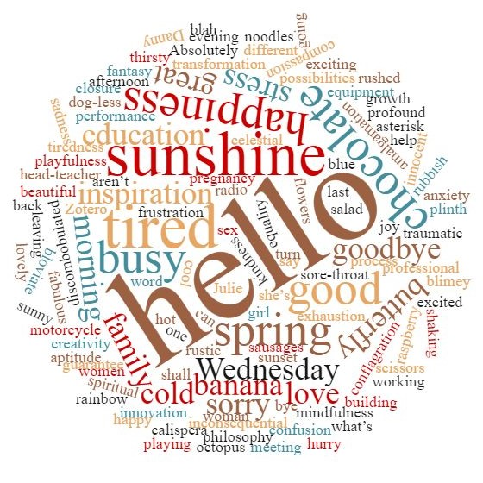
Figure 2: Sonic-poetic enquiry text displayed as a word cloud
Listeners could relish the sensation of sounded words wrapped around / presented as a word cloud and sound file (see www. Facult-art-em.net/blog-2/). Our thematic analysis of the poetic text reveals other forms of expression beyond formal language. Poetic text of teaching and learning selves, as shown in the poem by Afrodita Nikolova, holds hope for reuniting creativity (through the use of arts-based methods) in philosophy, theory and analysis, while, at the same time, foregrounding the role of generated poetry. The following table shows how we classified the themes by building a set of categories. The metatheme is concerned with the process of being-in-relation with organisational learning.
Table 3: A sample of the ‘Sound Piece’ poetic text: the analysis process
Memory | Time | Emotions | Greeting | Self | Body | Nature / Non-human
Spring  sunshine  cold  sunny  rainbow  motorcycle  family  spiritual | morningday sunset  goodbye | anxiety,  love, happiness, confusion, excited, mindfulness, transforming stress, discombobulated,  joy, inspiration, sadness, kindness, fabulous, traumatic, sorry, rubbish, blimey, frustration, blah | hello  hello  hi  morning, what’s going on, noon  evening | Absolute cool  inconsequential, rubbish  great, blimey blah  no  ‘you are playing with equipment  again aren’t you?’  busy  hurrying  working | hot chocolate, chocolate, banana, noodles, octopus, sausages, salad,  thirsty, anxiety, tiredness, exhausted,  stress, shaking  tiredness  tired  exhausted  shaking  thirsty | octopus, butterfly, spring, sunshine, flowers, radio

Not surprisingly, changes in the frames of meaning in the figured worlds where the students and staff enact themselves as teaching and learning selves, are associated with diverse positionings with respect to the community of reference and being-in-relation with organizational learning in this specific higher education space. The following sections describe how the artist-in-residence arts-based programme went on to mediate the dizzying array of Masters programmes and the performance of classroom practices with the enactment of enhancement methods.
DATA SET 3: photographs: becoming researchers / learning as postgraduates
Participants were invited to use paint and paper to represent their research journeys or maps (or with other materials in any way they liked) as a break from their research work and thinking.
Susanne presented examples of artists maps, vintage maps, children’s maps, geological diagrams and other variations on a map theme. She also showed artists’ work that could be read as a map, such as a landscape or an abstract map, and showed different forms and foldings. Participants were asked to imagine a map in the broadest sense of the word.
The students and staff worked with paint and large paper. Their maps were individual. Beautiful paintings emerged from this activity. They were mostly abstract, full of colour and shapes and textures. At the end of the session the artist Susanne spoke to the participants, who described how each element, colour and shape had symbolic resonance directly related to their research.
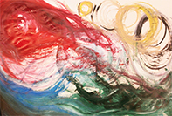
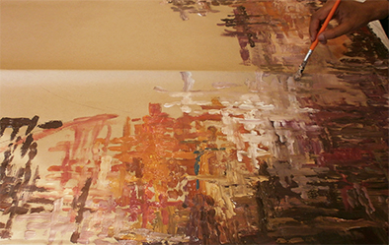
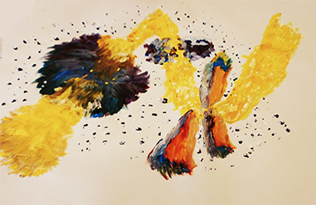
Photo 2: Photographs of paintings made by student researchers
The work was extraordinary and powerful in its own right but with the stories behind them they became journeys and adventures full of obstacles and direction.
Table 4: Visual Art Participatory Methods: Drawings on Living the Journey
Photos: Arts-based Methods | Participants’ Voices (a sample of quotes) | Themes & Meta-themes
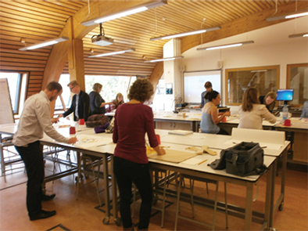 | Dialogic interactions and exchanges occurred with the resources and art making process itself… Drawing became the tool for thinking’ ‘unstructured progress through work responded well with group (lecturer) | Being-in-relation
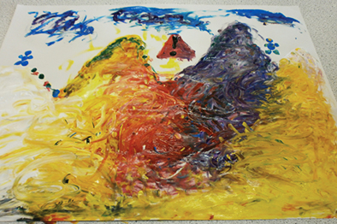 | I’ve never actually liked looking at my own drawings; you’re seeing so may things differently (student)  A super workshop. Creative, thought provoking and fun. Excellent to be creative in art after writing about the benefits of the arts in my thesis (student) | Different web of meanings that arts-based methods brings about
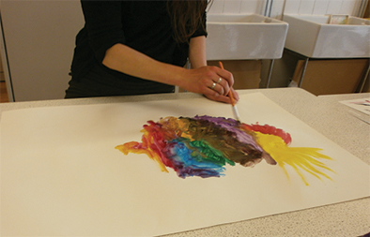 | It helped me to see how other students are engaged in identifying and re-identifying ourselves, representing our journey’..rather than staring into the abyss alone at my desk (student) | Being-in-relation  Shifts in students positioning
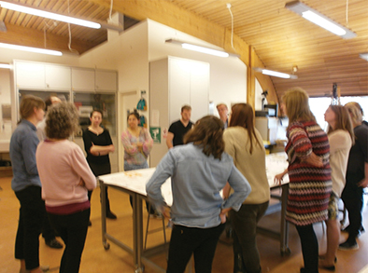 | It brings people uniquely together; connecting with colleagues; a kind of social portrait of our learning journeys and struggles…I love the art making. Such a fun way to think about my research…A map to navigate the next few steps: showing connections, turning points, roundabouts and cul de sacs…a great way to re-imagine an everyday environment’ | Art based methods as mediator of students engagement; meanings change through the students’ engagement in new (arts-based) practices
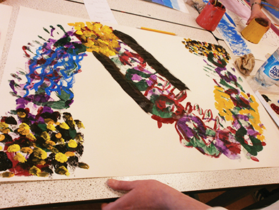 | One of the most powerful revelations for me when working with the lecturers and the students was the way the artwork acted as a short circuit (Third person) to things that really mattered and prompted realisations and ways to talk about research fast. Seemed to bypass reticence and unclear aspects | Not just simply a learning of additional concepts but a ‘relearning’ that occurs in the context of institutional learning

This activity illuminated the way that the arts can be a path to accessing the more tacit and implicit dimensions of life and to how the arts might reveal experience that is non-verbal: “drawing became the tool for thinking”. Reflection on the art-making produced new knowledge and new perspectives that might not otherwise have been elicited. Participants reported this activity to be helpful in creating community by bringing people together and sharing experiences and by developing relationships in a playful and creative manner.
DATA SET 4: Mandala Creation and Inquiry: Circles of Influence, Ripples of Self
An invitation was disseminated to all involved on the masters’ programme. We pointed out that following the highly effective five month artist residency with distinguished specialist Susanne Jasilek in the Faculty of Education, we were inviting a further participatory reflexive response to the students’ and staff’s learning journey. We invited all to individually contribute to a collectively created expression which we called Circles of Influence. Using a variety of media, including paint, poetry, collage, drawing, vignettes and other written forms, we invited all to share some of the unique qualities of their Masters experience. The idea of Circles of Influence was a metaphoric expression of the time, energy, flow of ideas and fluidity of imagination and feeling in the thinking that characterised the many versions of the Master’s research journey. We invited the Masters cohort to respond imaginatively to three questions which we know they were grappling with and working hard to clarify. The three questions were: (i) What is your research (me-search) question? (ii)What does your research design look like? and (iii) What are you finding? Those unable to attend on the day were invited to email their response to neufsusanne@gmail.com for inclusion.

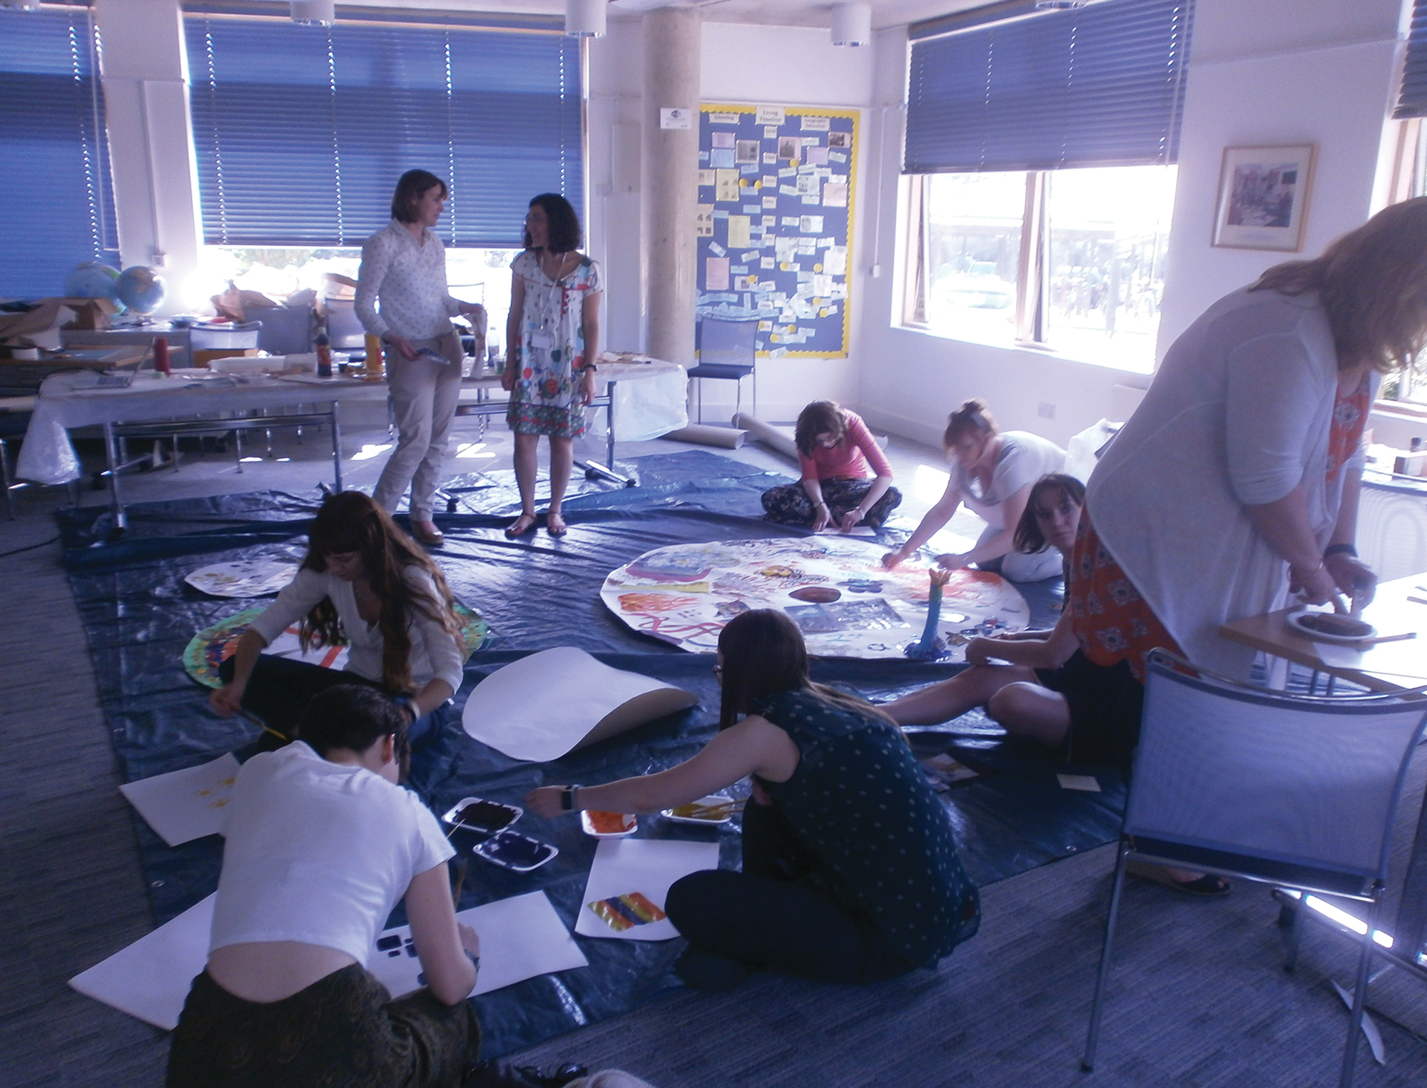
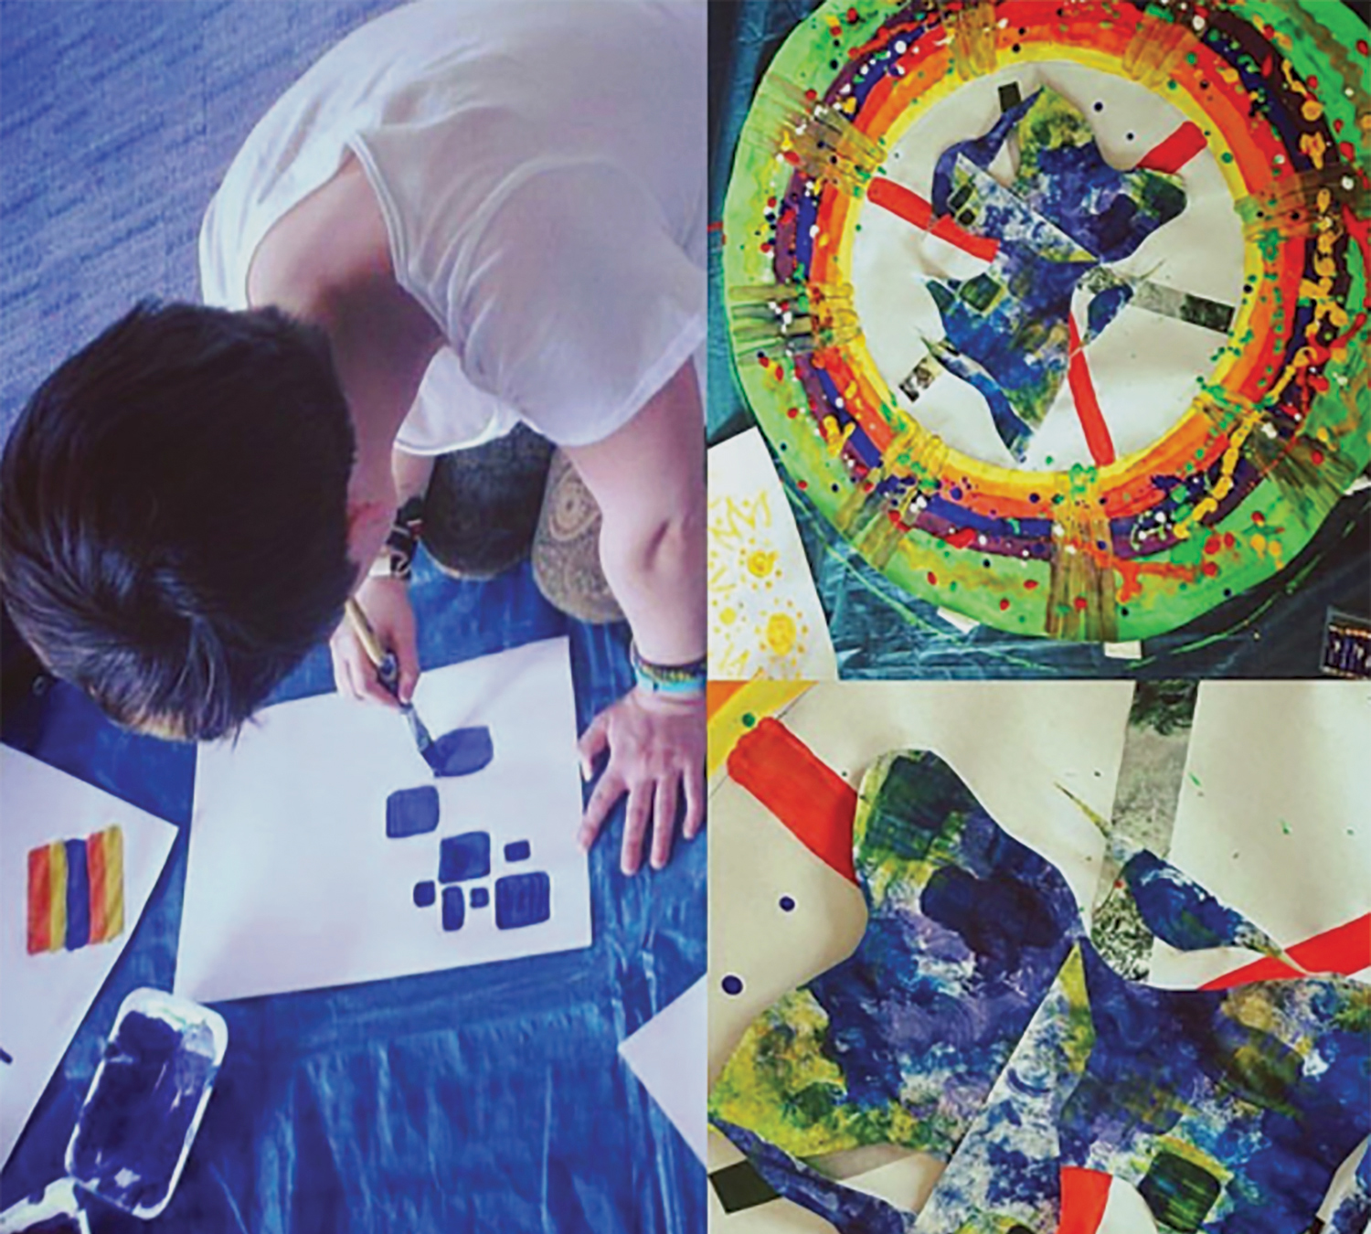
Photos 3: Making the Mandala: ‘Ripples of the Self’ and ‘Circles of Influence’

Table 5 goes some way to showing how the experience of engaging with arts-based methods reveals something cogent about organizational learning.

Table 5: A sample of participant voices (students, academics and non-academics)
Focusing on my research interest and depicting it through art was a reflexive, introspective and creative challenge for me. However, the positioning of my art among other peoples art making and the borrowing and sharing of materials, enabled a meeting of contexts and spaces that was fluid, open ended and collaborative. The art task enabled a platform for meeting and engaging with other students and their interests in a way that seemed truly lateral and open ended. I would sum up the experience as a textured, interactive and fluid. Student

At first I struggled to engage, but as I sat there watching others add to the circles and I reflected on my learning that year and what the future would hold for me I got the sense of being part of something a bit special. All these people, their worlds and their experiences combined on these circles, overlapping and interlinking! It was a lovely, collaborative experience. Student

It looks like a kind of pizza-like reflection of collaborating voices which is what writing the literature looks like. There is an internal logic implicit here. Academic

It felt like we were performing a mutual co-construction, a self-actualisation in dialogue with others. Academic

For the first time, I felt visible, valued, and connected to more than the people in the office where I work. Non-academic

When I look at where I started and then look at myself now, reflecting back and forth like this, I see things differently. Student

There are a lot of different ways you could look at the art work made here. Is it about the use of arts-based activity or arts-based events – with active and dynamic contributions from individuals, their social partners, historical traditions and materials and their transformations – allowing a reformulation of the relation between individual, social and organizational learning? Is it the emphasis on the body and how it allows one to consider how arts-based practices create and construct certain types of learning creatively? Embodiment is performed here. Embodiment is critical. Embodiment is reflective and analytical. Embodiment reveals the way that the body acts and interacts as an inscriptive surface. Embodiment is significant in the way human beings use their agency to interpret their worlds. Here, this is shown to be of great importance. Sitting around this emerging mandala closes the distance between selves and others. It makes space in the room for self and other (in this case the programme) to enter into dialogue. Can we say, then, that using the materials of art and the affective body as an epistemological site can create space for possibilities in higher education? For, here, we see clearly and hear the essence of feeling, playing, sensing and being-in-relation.

The perception and sensibility of the student researchers, academics and non-academics involved in the mandala painting and production embodied responses to a reflective process, an elicitation for thinking about the influences and ripples (impact) that help conceptualize dimensions and understanding (that were previously unconscious) about what becoming a researcher means. For Butler-Kisber (2010,103) mandala or collage creation, as a creative way of making thoughts concrete, facilitating the thinking, writing and talking about the enquiry, is not new. Through embodiment, as Ellsworth (2005:166) puts it, the mandala becomes a space to configure and therefore inhabit and experience institutional learning in different ways.

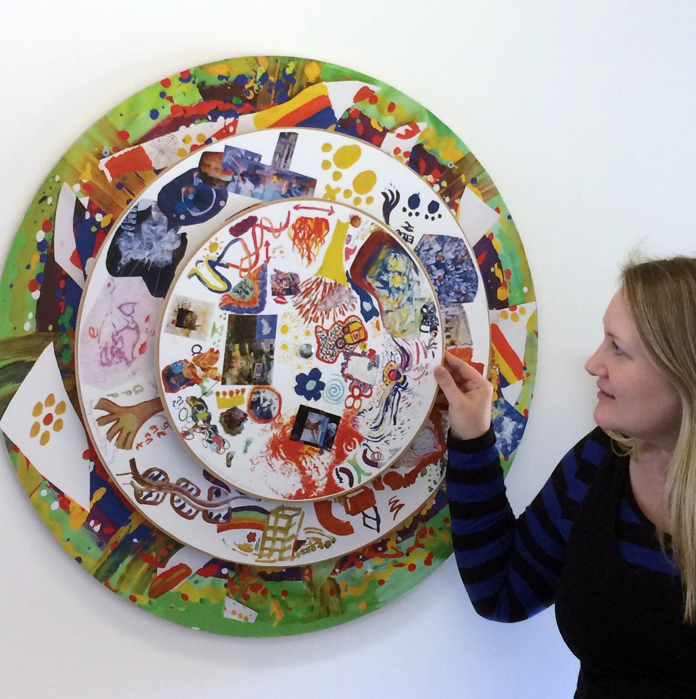
Photo 4: Lisa Zwierzanski (Administrator of the Facultartem Project) Higher Degrees & PPD Office
This type of collective art making, as illustrated by the mandala in Photo 4, holds the potential to produce spaces that are catalysts for rethinking who we are, how we see ourselves and each other. The performativities of arts-based methods, the materiality of experience and reflection in relation to becoming researchers on a Masters programme, for some, seemed essential to how students adopted a mode of being, and a necessary part of that relationship and enactment of institutional learning. Similarly, as Lisa Zwierzanski (see photograph), the artist-in-residency administrator in the Higher Degrees Office of the Faculty of Education, states: “Facultartem had a hugely positive response from all involved in the Faculty – even from those who were initially sceptical about evoking their creative side! I found the experience fun, thought provoking and an opportunity to use my creative skills. I thoroughly enjoyed assisting with all aspects of the residency which brought together a shared sense of Faculty community”.

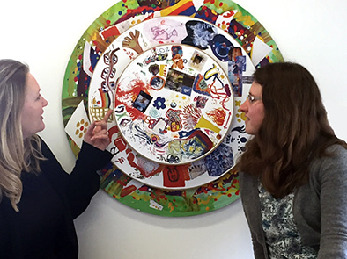
Photo 5: Lieke van Bree (Master of Education (MEd) Administrator) Higher Degrees Office

In Photo 5 we see Lisa with Lieke van Bree the MEd Administrator in discussion and interacting with the mandala which is now a permanent display at the entrance to Higher Degree Office. Lieke’s reflection echoes with a multiplicity of meanings and with the buzz of extending the reach of organisational learning that this living inquiry enabled. “I really enjoyed Susanne's Artist in Residency at the Faculty. It was fascinating and enhancing to see the creation of art move through different steps in the process, especially when the end product was not clear from the start. The project also brought together different people in the Faculty and it was great to interact with students and staff in an unusual and positive way. I think this is invaluable in an institution where hierarchies, patterns and structures dominate”. The mandala is a reminder in full recognition that, as Maxine Green (2001) so aptly expressed, ‘I am what I am not yet’.

Before an elaboration of our conclusions, the nature of the findings is invoked in the following generated poem which incorporates a collective interpretation discovered in research with others.

Ripples on the Selves
Rippling through time
Rippling through space
Rippling through us
Problematising the taken-for-granted
Utilising embodiment, self-knowledge and self-articulation
Sensing inwards: sensing outwards
Ways of understanding and creating community
Recognising concerns
Being-in-relation
Reflexively engaging with (inter-)culture-bound expectations
A non-linear map
Making visible and invisible ruptures and connections
Writing into new and in-between spaces
Outsider/outlier stance; Insider positioning
Inbetween-ness understandings
Being challenged; Being challenging
A liminal space of competing agendas
Offering hospitality to a multiplicity of perspectives
A collective embodiment
Scrutinizing ourselves; Being scrutinized
Ideas building on ideas
Conversations building on conversations
Foundations, bricks and mortar, roof
Conversations building on conversations
Being a research: engaging as a me-searcher
Journeying refreshed
CONCLUDING DISCUSSION
Responses from participants in this project were overwhelmingly positive. This is unsurprising because most of the activities involved opting in. Susanne Jasilek, the artist-in-residence, reported that one or two students found the experience to be exposing and uncomfortable when activities were introduced as part of a lecture or teaching session. This needs to be borne in mind when employing ABM in teaching. Working with the arts is likely to elicit emotion, as several of the responses from participants demonstrate. This places an ethical demand on the artist-teacher or arts-based practitioner. Care must be taken to ensure the wellbeing of those for whom such work might elicit painful feelings of, for example, sorrow, anger, exposure or inadequacy. Practitioners need to meet such feelings with acceptance, authenticity and empathy. In particular they can attempt to establish a working alliance at the outset by clarifying the boundaries of the project and by developing a trust that leads to a sense of psychological safety.
The impact of arts-based methods as living inquiry in this institution is still to be fully understood and realized. We have illustrated the generative capacity of arts-based methods. This is about being-in-relation in classrooms which become spaces for possibilities derived from the alternative approaches employed. These are subjective, interdisciplinary, embodied spaces in which a type of translation occurs, where experience can be deconstructed and where other ways of being can be created; where boundaries can be dissolved between self and other.
We are very conscious of the crucial question that now concerns how these arts based methods can be incorporated without an artist-in-residence or outside experts in an artistic discipline or genre. Creative practitioners, regardless of whether ‘in residence’ or off-site, are usually affiliated with an organisation or neighbourhood cultural institution that can become a formal collaborating or consulting partner. However, the endorsement and determination as to whoever qualifies as an ‘artist’, an ‘artist educator’ or ‘creative practitioner’ does not have to be an assumed responsibility of an official off-site partnering organisation or person. To rethink the place of arts-based pedagogies, (as with creative pedagogies and even play-based pedagogies particularly in higher education settings, as reported recently), if appropriated as inclusive and democratic practices that can be developed in anyone, posit the forces that can help shape, develop and connect human creativities; the process itself has the potential to forge and weld together a relationship connecting and engendering an end vision of organisational learning. All academics are potentially artist-educators and leaders in that all can create arts-based pedagogies and followers by influencing those around them, whether as academics or heads of department we need to actively advocate that all academics are leaders in their occupation. We also need to advocate that all academics can engage students uniquely through the use of arts-based methods as a form of empowerment that empowers and tries to resist hegemonic structures and neo-liberal discourses.
There is a need to re-conceptualise and expand notions of organizational learning through the use of arts-based methods (for tuning the professional self and experiencing happiness as a community narrative in the discourses of organization learning). The task of characterising oneself as professional, educator, research or artist can cause us to hold ourselves at bay. To allow these too-often silenced aspects of the self emerge takes a massive measure of trust as a prerequisite. But it also takes the use and practice of arts-based methods to emphasise the process of lived enquiry and its relationship to traditional scholarly research.

Figure 4: A representation of arts-based methods for enhancing organization learning in higher education
We have argued that aspects of arts-based research present as embodiment, polyvocal, discursive, affective, dialogic ‘spaces’ and dimensions of our teaching and learning selves and are about being-in-relation in HE classrooms as living inquiry. How this played out in the present study was ‘carried off by a poetic rhythm’, as Cixous (Cixous, in O’Grady 1996) contends – as practice enhancement of a programme, informing the relations between institutional learning and higher education (see Figure 4).

- Spaces for possibilities were characterized as spaces in which a type of translation occurs, where experience (and situated knowledge) can be deconstructed and where other ways of being can be created; boundaries are dissolved between self and other.
- Being-in-relation with organizational learning was how we bring ourselves into the pre-dominance of patriarchy in the (con)text of higher education and resonate (or not) with academia in the classroom and how our embodied relationships, between ourselves and with others, were framed differently.
- The fact of embodiment was critical in terms of creating a more responsive teaching and learning approach where rethinking/re-experiencing/re-engaging were emphasized through the relationship between body, knowledge and materiality.
- The artist and artist-residency itself became construed as a heterotopia, interrupting ordinary life, and creating a space in which transcendence and transformation are possible. The present project facilitated the kinds of changes of perspective that can contribute to the nurturing of organisational learning in higher education.
- The arts and art making create, unfold and actualize differently. They produce authentic and situated knowledge of self and one’s own experience because the images that arise in our minds result from our feelings, which, in turn, arise through a process of interoception (Damasio 2012, 110). This means privileging stimuli that originate inside the body. Our feelings, therefore, and their accompanying images, offer us significant information about our internal milieu and ourselves. They tell us what matters to us.

In the Faculty, the display of the mandala creation of ‘Ripples of the self and circles of influence’ is a daily reminder about the importance of embodied ideologies and processes of humanising organisational learning, and the importance of feeling validated and valued; as we are reminded by Marcus (2004,47): “Physical experience, material conditions…are in no way separate from intellectual and creative life, but shape its very possibilities”. A recent report on applicants for UK higher education (UCAS, 2017) showed a 5% decline in applications domestically and a further 7% decline from EU countries. If we are to continue to attract students in an increasingly competitive domestic and international higher education market, it is crucial we listen to and address student concerns and think innovatively using arts-based methods to enhance academic programmes for delivering the best possible student experience.

This project was funded by the School of the Humanities and Social Sciences and Faculty of Education University of Cambridge as an investment to support postgraduate student experience. The project report can be found at www.facult-art-em.net
REFERENCES
Ahmed, Sara. 2010. The Promise of Happiness. Durham, North Carolina, USA: Duke University Press
Barone, Tom, and Elliot Eisner. 2011. Arts Based Research. London: SAGE.
Barrett, Estelle, and Barbara Bolt. 2010. Practice as Research: Approaches to Creative Arts Enquiry. London: I.B.Tauris.
Bragg, Sara, and Helen Manchester. 2011. Creativity, School Ethos and the Creative Partnership Programme. London: Creativity, Culture and Education.
Bragg, Sara, and Helen Manchester, and Dorothy,Faulkner. 2009. Youth Voice in the Work of Creative Partnerships. London: Creativity Culture and Education.
Braidotti, Rosi. 2014. “Writing as a Nomadic Subject.” Comparative Critical Studies 11(2-3):163-184.
Burnard, Pamela, and Mandy Swann. 2010. “Pupil Perception of Learning with Artists: A New Order of Experience?” Thinking Skills and Creativity 5 (2):70–82.
Burnard, Pamela, Carol Holliday, Susanne Jasilek, and Afrodita Nikolova. 2015. “Artists and Higher Education Partnerships: A Living Enquiry.” Education Journal 4 (26):98–105.
Burnard, Pamela, Tatyana Dragovic, Susanen Jasilek, Kristof Fenyvesi, Luke Rolls, Aimee Durning, and James Biddulph. 2017, in review. “The Art of Creating Possibility Spaces for Fostering STE(A)M Practices in Primary Education.” In Arts-based Methods in Education Around the World, edited by Tatiana Chemi and Xiangyun Du, xx-xx. Denmark: River Publishers.
Butler-Kisber, Lynn. 2010. “Qualitative Inquiry: Thematic, Narrative and Arts-Informed Perspectives.” London SAGE.
Connelly, Michael, and D. Jean Clandinin. 1990. “Stories of Experience and Narrative Inquiry.” Educational Researcher 19 (5): 2–14.
Damasio, Antonio. 2012. Self Comes to Mind: Constructing the Conscious Brain. London: Vintage Books.
Ellsworth, Elizabeth. 1997. Teaching Positions: Difference, Pedagogy and the Power of Address. New York, NY: Teachers College Press.
Ellsworth, Elizabeth. 2005. Places of Learning: Media, Architecture, Pedagogy. New York: Routledge.
Ely, Margot, Ruth Vinz, Maryann Downing, Margaret Anzul. 1997. On Writing Qualitative Research: Living by Words. London: The Falmer Press.
Foucault, Michel. 1967. Of Other Spaces, Heterotopias. Available in English at http://foucault.info/documents/heteroTopia/foucault.heteroTopia.en.html [accessed30September2012].
Galton, Maurice. 2009. “Going with the Flow or back to Normal? The Impact of Creative Practitioners in Schools and Classrooms.” Research Papers in Education 25 (4). http://dx.doi/org/10.1080/02671520903082429..
Gatens, Moira. 1996. Imaginary Bodies: Ethics, Power and Corporeality” London: Routledge.
Gouzousais, Peter, Rita Irwin, Emily Miles, and Alexandra Gordon. 2013. “Commitments to a Community of Artistic Inquiry: Becoming Pedagogical through A/r/tography in Teacher Education”. International Journal of Education and the Arts (14). http://www.ijea.org/v14/html
Green, Maxine. 2001. Variations on a Blue Guitar New York, NY: Teachers College Press.
Greene, Maxine. 1994. “Postmodernism and the Crisis of Representation.” English Education 26 (4): 206–19.
Güler, Ara. 2017. “Exploring A/r/tography in an Interdisciplinary Way: Touching Music in Visual Art Practices.” In Building Interdiscipinary and Intercultural Bridges: Where Practice Meets Research and Theory, edited by P Burnard, V Ross, T Dragovic, K Powel, H Minors, and and E. Mackinlay. eBook: BIBACC Publishing.
Irwin, Rita, Ruth Beer, Stephanie Springgay, Kit Grauer, Gu Xiong, and Barbara Bickel. 2006. “The Rhizomatic Relations of A/R/T/ography.” Studies in Art Education. A Journal of Issues and Research 48 (1): 70–88.
Irwin, Rita, and Alex de Cosson. 2004. A/r/t/ography: Rendering Self through Arts-Based Living Inquiry. Vancouver, BC: Pacific Educational Press.
Jagodzinski, Jan, and Jason Wallin. 2013. Arts-Based Research: A Critique and a Proposal. Rotterdam, The Netherlands: Sense Publishers.
Kasemsap, Kijpokin. 2017. “Investigating the Roles of Neuroscience and Knowledge Management in Higher Education.” In Handbook of Research on Administration Policy and Leadership in Higher Education, edited by Siran Mukerji and Purnendu Tripathi, 112–140. Hershey PA, USA:IGIG Global.
Leavy, Patricia. 2009. Method Meets Art: Arts-based Research Practice. New York: Guilford Press.
Leavy, Patricia. 2012. “Fiction and Critical Perspectives on Social Research: A Research Note.” Humanity and Society 36 (3): 251–59.
Leavy, Patricia. 2017. Research Design: Quantitative, Qualitative, Mixed Methods, Arts-Based and Community-Based Participatory Research Approaches. New York: The Guilford Press.
Lemoine, Pamela, P. Thomas Hackett, and Michael Richardson. 2017. “Global Higher Education and VUCA-Volatitlity, Uncertainty, Complexity, Ambiguity.” In Handbook of Research on Administration Policy and Leadership in Higher Education, edited by Siran Mukerji and Purnendu Tripathi, 549–568. Hershey PA, USA:IGIG Global.
Mackinlay, Elizabeth. 2015. “In Danger of Writing: Performing the Poetics and Politics of Autoethnography with Helene Cixous and Virginia Woolf.” Qualitative Research Journal 15 (2): what pages pam?
Mackinlay, Elizabeth. 2016. Teaching and Learning Like a Feminist: Storying Our Experiences in Higher Education. Dordrecht, The Netherlands: Sense Publishers.
Marcus, Jane. 2004. Virginia Woolf (2nd Ed). Tavistock, Devon: Northcote House Publishers.
O’Grady, Kathleen. 1996. “Guardian of Language. An Interview with Helene Cixous.” Womens Education Des Femmes 12 (4): 6–10.
Rolling, James Haywood. 2010. “A Paradigm Analysis of Arts-Based Research and Implications for Education.” Studies in Art Education: A Journal of Issues and Research 51 (2): 102–114.
Springgay, Stephanie, Rita Irwin, and Sylvia Wilson. 2005. “A/R/T/ography as Living Inquiry through Art and Text.” Qualitative Inquiry 11 (6): 897–912.
Springgay, Stephanie, Rita Irwin, Carl Leggo, and Peter Gouzouasis. eds. 2008, Being with A/r/tography. Dordrecht, Netherlands: Sense Publishers.
Stevenson, Kylie. 2013. “Creative River Journeys: Using an A/r/t/ographical Framework for a Multifaceted PhD Project.” UNESCO Observatory Multidisciplinary Journal in the Arts 3 (2): 1–25.
Stevenson, Kylie. 2017. “Mapping the Practice: Reimagining the Creative Process through the Metaphor of a River.” in Building Interdiscipinary and Intercultural Bridges: Where Practice Meets Research and Theory. eBook, edited by Pamela Burnard, Valerie Ross, Tatyana Dragovic, Kimberly Powell, Helen Minors and Elizabeth Mackinlay, 150-158. Cambridge, UK: BIBACC Publishing ISBN 978-0-9957727-0-0
Sullivan, Graeme. 2005, 2010. Art Practice as Research (1st and 2nd Eds.). London: SAGE.
Thomson, Patricia, Christine Hall, Ken Jones, and Julian Sefton-Green. 2012. The Signature Pedagogies Project: Final Report. London: Creativity Culture and Education.
UCAS, Universities Central Admissions System, 2017 https://www.ucas.com Accessed on 1 February, 2017.

ABOUT THE AUTHORS
Pamela Burnard is Professor of Arts, Creativities and Education at the Faculty of Education, University of Cambridge. She co-convenes the British Educational Research Association (BERA) Special Interest Group, Creativities in Education (https://www.bera.ac.uk/group/creativity-in-education) and the biennial international conference, Building Interdisciplinary Bridges Across Cultures and Creativities (www.BIBACC.org). She is an international authority on diverse creativities research and has published widely with 12 books and over 100 articles and invited chapters on bridging the theory-practice gap through research on creative teaching/learning and the expanded conceptualisation of creativities across sectors. Carol Holliday is an Affiliated Lecturer at the Faculty of Education, University of Cambridge where she leads the Child and Adolescent Psychotherapeutic Counselling Programme. She is a UKCP registered Arts Psychotherapist who works therapeutically with children, adolescents and adults, and she has over twenty years experience of clinical practice. Carol has particular interests in the nature of the therapeutic relationship, and in working with images: in therapy, education and research. Her doctoral research explored the contributions of psychotherapy to the teacher/child relationship and employed ABM. Her publications are characterised by being intensely practical and having theoretical depth. They include texts for teachers, therapists and researchers. Susanne Jasilek is an artist and artist educator and formerly Artist-in-Residence at the Faculty of Education, University of Cambridge. She has been involved in ground-breaking programmes working in diverse settings with school children, families, artists, teachers, post graduates and the wider community. A video artist, she has regular art installations in site specific spaces in Cambridge and London with fellow artists and members of NEUF. Afrodita Nikolova is a third year Macedonian PhD student, with an Aromanian background, at the Faculty of Education, University of Cambridge. Her PhD is investigating young offenders’ narrative identity reconstruction through a new culturally relevant Spoken Word Poetry Programme in a Macedonian prison. Her work is based on arts-based research methodologies/practices, the role of the arts in social justice and youth self-development. Her past experience includes working as a teacher and a university lecturer as well as directing creative writing programmes and running spoken word poetry workshops in universities, schools, prisons and the community. Nikolova is an award-winning Macedonian poet, representing the country at the European and World Poetry slam championships, performing across Europe, and is recently a member of the Versopolis platform representing emerging European poets.

Lead contributing author:

Professor Pam Burnard
Faculty of Education
University of Cambridge
184 Hills Rd. Cambridge CB2 2PH
Email: pab61@cam.ac.uk

See the British Educational Research Association (BERA) Research Commission: Reviewing the potential and challenges of developing STEAM education through creative pedagogies for 21st century learning: How can school curricula be broadened towards a more responsive, dynamic and inclusive form of education? https://www.bera.ac.uk/project/bera-research-commissions/reviewing-the-potential-and-challenges-of-developing-steam-education-2

