The challenge of biased evidence in conservation
Alec P. Christie¹ , Tatsuya Amano^{1,3,4} Philip A. Martin^{1,2}, Silviu O. Petrovan¹, Gorm E. Shackelford^{1,2}, Benno I. Simmons^{1,5,6}, Rebecca K. Smith¹, David R. Williams⁷, Claire F. R. Wordley¹ and William J. Sutherland^{1,2}

^{Affiliations}
¹Conservation Science Group, Department of Zoology, University of Cambridge, The David Attenborough Building, Downing Street, Cambridge CB3 3QZ, UK.
²BioRISC (Biosecurity Research Initiative at St Catharine’s),St Catharine’s College, Cambridge CB2 1RL, UK.
³School of Biological Sciences, University of Queensland, Brisbane, 4072 Queensland, Australia.
⁴Centre for Biodiversity and Conservation Science, University of Queensland, Brisbane, 4072 Queensland, Australia
⁵Department of Animal and Plant Sciences, University of Sheffield, Sheffield, S10 2TN United Kingdom.
⁶Centre for Ecology and Conservation, College of Life and Environmental Sciences, University of Exeter, Penryn, UK
⁷Sustainability Research Institute, School of Earth and Environment, University of Leeds. LS2 9JT United Kingdom

Corresponding author
Alec P Christie, apc58@cam.ac.uk, Conservation Science Group, Department of Zoology, University of Cambridge, The David Attenborough Building, Downing Street, Cambridge CB3 3QZ, UK.

Article impact statement
Severe taxonomic and geographic bias in the literature that tests the effectiveness of conservation actions threatens evidence-based conservation efforts.

Keywords
decision-making, study design, evidence-based conservation, conservation research, prioritisation, conservation evidence, bias, synthesis

Abstract

Conservation efforts to tackle the current biodiversity crisis need to be as efficient and effective as possible given the chronic underfunding of conservation. To inform decision-makers of the most effective conservation actions, it is important to identify biases and gaps in the conservation literature to prioritize future evidence generation. We assessed the state of this global literature base on amphibians and birds using the Conservation Evidence database, a comprehensive collection of quantitative tests of conservation actions (interventions) from the published literature. We investigated the spatial and taxonomic spread of studies from this database, as well as the distribution across biomes, effectiveness metrics, and study designs for these two taxonomic groups. Studies were heavily concentrated in Western Europe and North America for birds and particularly for amphibians, while temperate forest and grassland biomes were highly represented relative to the percentage of the Earth’s terrestrial area they covered. Studies that used the most reliable study designs - Before-After Control-Impact and Randomized Controlled Trials - were the most geographically restricted and scarce in the evidence base. Furthermore, there were negative spatial relationships between the numbers of studies and the numbers of threatened and data-deficient species across the world. Taxonomic biases and gaps were apparent for amphibians and birds – some entire orders were absent from the evidence base, while others were poorly represented relative to the proportion of threatened species they contained. The metrics used to evaluate the effectiveness of a given conservation action were often inconsistent between studies, potentially making them less directly comparable, and evidence synthesis more difficult. Future research should prioritize testing conservation actions on threatened species outside of Western Europe, North America and Australasia. Standardizing metrics and improving the rigor of study designs used to test conservation actions would also improve the quality of the evidence base for synthesis and decision-making.
Introduction

Biodiversity conservation receives insufficient funding to effectively combat the biodiversity crisis (Dirzo et al. 2014). This means that conservation researchers and funders must prioritize research effort to maximize its potential to inform conservation efforts. While evidence-based conservation is ultimately likely to lead to more efficient conservation efforts, this approach requires a reliable evidence base. Efforts to summarize the evidence in conservation relating to the effectiveness of different conservation actions (‘interventions’; Sutherland et al. 2004) have produced a substantial evidence base (Sutherland et al. 2019), yet little is known about the biases, gaps and clusters of this evidence. Knowing the current state of the evidence base for conservation is crucial to prioritizing future research efforts (Aranda et al. 2011). In this paper, we focus on studies that test conservation interventions, such as restoring grasslands for birds or creating ponds for amphibians.

The lack of resources in conservation research are likely to lead to several forms of bias in the evidence base for conservation. Such biases may limit our ability to provide relevant evidence-based recommendations to decision-makers, or make the process of evidence synthesis more challenging. For example, geographical and taxonomic biases towards certain regions or groups (e.g. wealthier countries or charismatic species) may lead to little evidence being available for certain local contexts. Alternatively, bias could be useful if research effort is prioritized to where it is needed most in conservation - for example, focusing the majority of studies on threatened species. Wealthier countries (e.g. those in North America, Europe, and Australia) perform the majority of conservation research and so we may expect that patterns of evidence will follow physical proximity to these countries (Reddy and Dávalos 2003), as well as various socio-economic variables (e.g. GDP per capita, affluence, language, security, conflict and infrastructure; Martin, Blossey, and Ellis 2012; Amano and Sutherland 2013; Meyer et al. 2016; Hickisch et al. 2019). These factors are likely to cause publication bias (i.e., underrepresentation of studies from non-English speaking countries; Amano et al. 2016; Nuñez et al. 2019) and affect the representation of different habitats in the evidence base (Fazey et al. 2005). Research effort is also known to vary with taxonomic group (Clark & May 2002; Murray et al. 2015; Donaldson et al. 2016), and to depend on the range size, diet and body size of species (Brooke et al. 2014), contributing to biases towards larger, more detectable species (e.g. Brodie 2009; Cardoso et al. 2011). These forms of bias affect the external validity of studies in the evidence base and are therefore important to help us understand how much evidence is available to inform conservation in different contexts.

Other forms of bias may also complicate the synthesis of evidence. Bias in the usage of different types of metrics to assess the effectiveness of the same conservation intervention may make approaches such as meta-analyses difficult to use. This is because studies are less directly comparable if they use different types of metrics to assess effectiveness, thus reducing the number of studies that can be combined in a meta-analysis. For example, it would be difficult to combine a set of studies measuring reproductive success, reductions in adult mortality, numbers of individuals and species richness of birds using nest boxes in a conventional meta-analysis on the effectiveness of nest boxes. Clearly, different metrics may be useful to assess different aspects of an intervention’s effectiveness, as well as to give greater confidence about the overall effectiveness of an intervention. However, wide variation in metrics used to test the same intervention could cause confusion for decision-makers, especially if studies using different metrics yield different results (Capmourteres & Anand 2016).

Differences in study quality due to different study designs may also make it more difficult to decide which studies to trust over others, particularly if they give conflicting results. Several different study designs are used to assess impacts of threats and interventions in ecology (De Palma et al. 2018; Christie et al. 2019), all of which are affected by different sources and levels of bias and noise. These range from relatively reliable designs such as experimental Randomized Controlled Trials (RCTs) and quasi-experimental Before-After Control-Impact designs (BACI), to less reliable designs such as Control-Impact (CI), Before-After (BA) and After (Table 1). Evidence may also come in the form of systematic reviews and meta-analyses, generally considered reliable depending on their methodology and the reliability of the studies they include. Typically, the conservation literature is thought to have relatively few studies with reliable study designs, due to logistical, funding, and time-based constraints (De Palma et al. 2018; Christie et al. 2019). However, we do not know how this broad pattern varies geographically (i.e., are reliable study designs used more often in certain regions?), or the prevalence of these study designs in the literature that tests conservation interventions. To our knowledge, previous research (Burivalova et al. 2019) has only quantified this in the tropics for evidence on the effectiveness of tropical forest conservation strategies, and not on a global scale for a variety of conservation interventions. Insufficient reliable evidence in certain regions would mandate greater efforts to improve, where possible, the types of study design implemented in those locations.

The aim of this study is to improve our empirical and quantitative understanding of the biases and gaps in the evidence base for conservation. To do this, we present a series of analyses of the Conservation Evidence database (Sutherland et al. 2019), a comprehensive collection of 5,816 publications (as of March 2020) that have quantitatively tested the effectiveness of conservation interventions. To quantify bias in this evidence base we set out to answer several research questions for two taxa (amphibians and birds): 1) what is the geographic distribution of studies?; 2) how does this distribution vary for studies with different designs?; 3) what is the taxonomic distribution of studies?; and for studies on a given conservation intervention, how much variation is there in the use of 4) different study designs, and 5) different metrics? Identifying patterns, biases, and knowledge gaps in the evidence base can help in setting priorities for future research. With a more reliable and complete evidence base, research can better support evidence-based decision-making in conservation and ultimately more effective conservation.

Methods

Conservation Evidence database

The Conservation Evidence project summarizes studies that have quantitatively tested the effect of a conservation intervention (Sutherland et al. 2019). Conservation interventions are defined as “actions that have been or could be used to conserve biodiversity”, and the effect that is quantified can be “on any aspect of biodiversity (e.g. abundance of a focal species, survival rates of translocated individuals, use of nest boxes, extent of habitat) or human behavior related to biodiversity conservation (e.g. levels of hunting, or sales of products detrimental to biodiversity).” (Sutherland et al. 2019, p.3). These studies are found using systematic manual searches of the conservation literature, including over 290 English and 150 non-English language journals (Sutherland et al. 2019). The Conservation Evidence website, as of March 2020, is structured into 2,105 different interventions (e.g. control invasive mammals on islands) contained within 16 synopses (e.g. Bird Conservation) and displays a summary of each study included, or multiple summaries if a study’s results apply to several interventions (e.g. both pond creation and translocation of amphibians). A list of interventions is created for each synopsis through consulting initial literature scans (but before systematic manual searches) and an advisory board (a range of academics, practitioners and policymakers with subject-specific expertise from different parts of the world; Sutherland et al. 2019). Interventions are usually described at a fine scale (for example, “set longlines at the side of the boat to reduce seabird bycatch” is a separate intervention from “set lines underwater to reduce seabird bycatch”).

As we wanted to assess the number of studies per intervention for certain subsets of studies (e.g. by the metric or study design used), we grouped similar interventions that focused on single taxa or habitats (e.g. “create ponds for frogs” and “create ponds for toads” would be grouped into “create ponds”; see Appendix S1). This ensured that the scope of interventions were appropriate for our analysis and did not act as a constraint on the numbers of studies per intervention.

We extracted metadata from the database for every study within the amphibian (n=410; Smith & Sutherland 2014) and bird synopses (n=1,239; Williams et al. 2012), including the latitude and longitude coordinates (mean coordinates where a study used multiple sites). We only considered studies for amphibians and birds as these taxa had the most complete and comprehensive metadata in the database. The literature searches that retrieved these studies (see Sutherland et al. 2019) were last conducted in 2012 for amphibians and 2011 for birds. While these searches are not as recent as we might wish, these data provide the only way to reasonably assess biases using a large number of studies that have tested the effectiveness of conservation interventions. For all analyses we excluded interventions that did not contain any studies (i.e. no studies present regardless of biome, metric or design types; 31 interventions for Amphibians and 56 for birds).

Patterns in evidence for different metrics and designs

A standardized set of keywords are used to describe study design in the Conservation Evidence database (Table 1). A single report or paper summarized in the database may use multiple study designs if several tests are described. Each study design used within a report or paper constitutes an individual study, each of which were counted separately. An individual study can also be assigned to multiple interventions and multiple synopses if it contains relevant information. We used the number of studies per intervention as the major variable of interest. To determine the accuracy of reported study designs, we manually checked the original papers of a random 5% of studies in the database (n=21 for Amphibians; n=62 for Birds). The correct design was reported to 95% of amphibian studies (one study with an After design was misreported as a Before-After design; Appendix S2) and 94% of bird studies (one CI study misreported as After, one BACI study misreported as CI, two RCT studies misreported as CI; Appendix S2). As we were estimating the mean number of studies per intervention that used different study designs across many interventions, and the global geographical distribution of many studies using different designs (see next section), these misclassifications will have made little difference to these overall results.

To identify the metrics used by each study to measure the effectiveness of interventions, we first used web scraping to obtain summaries of studies from the Conservation Evidence website –using the XML package (Lang and CRAN team 2018a) and RCurl package (Lang and CRAN team 2018b) in R statistical software version 3.5.1 (R Core Team 2018). We also used the doParallel package (Microsoft Corporation & Weston 2017) to increase computational performance. Once summaries were obtained, we created and tested a set of regular expression rules (e.g. matching keywords and patterns) to detect the following metric groups used by each study: 1. abundance, density and cover; 2. mortality and survival; 3. diversity and species richness; 4. reproductive success (Appendix S3). This was necessary as this information is currently unavailable in the database and allowed us to quantify the number of studies using each metric, and the number of unique metrics used, in each intervention.

For a random 5% of studies (n=21 amphibians, n=62 birds) we found that the metric groups identified by regular expressions were correct for 90% of amphibian studies and 95% of bird studies (Appendix S4). For amphibians, all misclassifications were false negatives (failure to detect abundance, density and cover in two studies). For birds, there were false positives for two studies (3.2% - one erroneous detection of reproductive success and one of mortality/survival) and a false negative for one study (1.6% - failure to detect diversity and species richness). As we were using this automated classification to gain an overall estimate of the mean number of studies per intervention across a large number of interventions for each metric group, these misclassifications will have made little difference to these overall estimates. Automating the extraction of effectiveness metrics also offers the most feasible and reproducible methodology to analyze the entire evidence base and controls for some potential biases that would affect manual classification.

Patterns in evidence spatially and taxonomically
We mapped the spatial distribution of studies in the database by creating a raster layer with the raster package (Hijmans 2019), summing the number of studies using different study designs for each 4x4 degree cell using longitude and latitude coordinates – we chose a 4x4 degree resolution to aid data visualization for the maps we produced (Figs.1 & 2). We excluded reviews from our analyses as they were often global or regional in scale. To estimate the geographical coverage of studies we counted the number of countries and continents they were present in. We also compared the number of studies in each 2x2 degree cell with the number of species, threatened species and data-deficient species for extant amphibian and bird species using data downloaded from the International Union for Conservation of Nature (IUCN) Red List (IUCN 2019). We chose a 2x2 degree grid cell resolution as this was the maximum appropriate resolution recommended by Hurlbert & Jetz (2007) when using range map data. We excluded grid cells containing zero studies and zero species and normalized the number of studies and species to between 0-1: $studies = (studies – {studies}_{min}) / ({studies}_{max} – {studies}_{min})$. We then quantified the relationship between the normalized number of studies (as the response variable) and species (as the explanatory variable) in each grid cell using a generalized linear model with a binomial error distribution and log link function. We repeated this normalization and modelling separately for the number of threatened species and the number of data deficient species. A square root transformation of the explanatory variable (number of species, threatened species or data deficient species) did not substantially improve model fit (AIC values were not reduced by more than two units and R² values remained unchanged or only marginally increased; Table S1). We therefore chose untransformed models as these were more parsimonious. All modelling assumptions held in terms of no overdispersion, and no substantial patterns between residuals and the explanatory variable or fitted values.

We assessed the relative under or overrepresentation of different biomes in the database by calculating the difference between the percentage of studies conducted in each biome and the percentage of the Earth’s terrestrial area covered by each biome (Dinerstein et al. 2017). We assigned studies to each biome using longitude and latitude coordinates for each study, a shapefile of 14 terrestrial biomes (see Dinerstein et al. 2017), and the sp package in R (Pebesma & Bivand 2005; Bivand et al. 2013). We excluded studies conducted outside terrestrial biomes (e.g. studies considering seabirds over oceans).

To investigate the distribution of evidence taxonomically, we found the percentage of studies that tested an intervention on each of the major bird orders based on a cladogram from Prum et al. (2015). For amphibians, we did the same for the three major amphibian orders using a trimmed cladogram from Pyron & Wiens (2011). To investigate the representation of taxonomic orders in the evidence base, we calculated the difference between the proportion of studies and: 1. the proportion of threatened species in each order (relative to the number of all threatened amphibian or bird species; Fig.4); 2. the proportion of amphibian and bird species in each order (relative to the number of all amphibian or bird species; Fig.S1). We obtained data on the number of species and threatened species (with vulnerable, endangered or critically endangered status) in each order from the IUCN Red List (IUCN 2019).

Results

There was substantial bias in the spatial distribution of evidence on conservation interventions. Approximately 90% of amphibian studies and 84% of bird studies were conducted in either North America, Europe or Australasia. Additionally, 64% of amphibian studies and 63% of bird studies were conducted in just three countries: the United Kingdom, United States and Australia. There were large spatial gaps in evidence in South America, Africa, Asia, and Russia for both amphibians and birds. There were also few studies in the tropics or close to the poles (Figs.1 & 2).

The geographical distribution of studies varied considerably by study design. Amphibian studies with the most reliable study designs, BACI and RCT, were concentrated in North America and Europe; these designs were almost absent from the tropics (Fig.1). No BACI or RCT studies for amphibians were conducted in South America, Africa or Australasia (as well as Asia for RCT studies), and both types of study design were only used in six countries (Table S3; Fig.1). BA studies for amphibians were found in 23 countries (but none from South America), while CI studies were found in fewer countries (18) but were present in all continents where amphibians exist. Amphibian studies using After designs covered the greatest number of countries (31) across all possible continents (Table S3).

The evidence for birds had a greater geographical coverage than for amphibians, particularly in the tropics (Fig.2). No RCT studies were conducted in Antarctica or South America, while studies using other designs were present in all seven continents. RCT and BACI studies were also present in considerably fewer countries than After, CI and BA studies (Table S3).

There was no statistically significant spatial relationship (p > 0.05) between the number of studies and the number of amphibian species, and a marginally positive spatial relationship with the number of bird species (p<0.05; Fig.3; Table S2). Conversely, the number of studies significantly decreased with the number of threatened species (birds: p<0.01; amphibians: p<0.05) and data deficient species (birds: p<0.05; amphibians: p<0.05) – however, the magnitude of this decrease was small for birds (Fig.3; Table S2). For amphibians, the grid cell with the most studies (normalized value of 1; Fig.3) covered central England, while for birds, the two grid cells with the most studies covered central and northern England (normalized values of 0.95 and 1, respectively; Fig.3).

There was also substantial variation in the representation of different amphibian and bird orders in the evidence base relative to the proportion of threatened species each order contained. For birds, the most well represented orders were shorebirds (Charadriiformes), waterfowl (Anseriformes) and falcons (Falconiformes), respectively - i.e. high proportions of studies relative to proportions of threatened species (Fig.4). Songbirds (Passeriformes), parrots (Psittaciformes), pigeons (Columbiformes), and nightjars, hummingbirds and swifts (Caprimulgiformes), were the least well represented bird orders - i.e. low proportions of studies relative to threatened species. No studies were present for several bird orders, such as hornbills and hoopoes (Bucerotiformes; see names in red in Figure 4). For amphibians, frogs (Anura) were the least well represented, while salamanders (Caudata) were the most well represented. There was only a single study for the entire order of Caecilians (Gymnophiona; Fig.4). Patterns were different when considering the proportion of studies relative to the proportion of species in each bird order; most bird orders were relatively well represented apart from songbirds and orders for which there were no studies (Fig.S1). For amphibians, patterns in representation were similar for both the proportion of species and proportion of threatened species (Fig.S1).

Certain biomes were better represented (in terms of the total number of studies conducted in each biome) relative to the percentage of the Earth’s terrestrial area they covered – notably Temperate Broadleaf & Mixed Forests, Temperate Grasslands, Savannas and Shrublands, Temperate Conifer Forests and Mediterranean Forests, Woodlands & Scrub for both amphibians and birds (Fig.5). The three most underrepresented biomes for both amphibians and birds were Deserts & Xeric Shrublands, Tropical & Subtropical Grasslands, Savannas & Shrublands, and Tropical & Subtropical Moist Broadleaf Forests (Fig.5). For amphibians, there were no studies in Tropical & Subtropical Coniferous Forests, Tropical & Subtropical Dry Broadleaf Forests and Tundra (red outlines to circles in Figure 5).

The total number of interventions (containing at least one study) was 243 for birds and 74 for amphibians. On average, there were, more studies per intervention for amphibians than for birds (although the total number of studies was greater for birds than amphibians). There was a higher proportion of interventions for birds that contained one study (34%) than amphibians (24%) – i.e., a more right skewed distribution of studies per intervention for birds than amphibians (Fig.S2).

The most commonly used metrics in amphibian conservation were mortality/survival (3.9 studies per intervention) and reproductive success (3.8 studies per intervention), while for birds, mortality/survival (3.9 studies per intervention) and abundance/density/cover (3.8 studies per intervention; Fig.S3) were the most common. On average, the effectiveness of each intervention was measured using 2.1 different metrics for amphibians and 3.3 metrics for birds.

There was a low number of studies per intervention that used reliable BACI or RCT designs (fewer than 0.3 studies per intervention for both amphibians and birds; Fig.S3). Studies most commonly used the least reliable After design, followed by CI and BA designs, for both amphibians and birds - note declines in number of studies per intervention when excluding studies using certain designs; Fig.S3).

Discussion

Our work demonstrates that the evidence base for amphibian and bird conservation suffers from severe geographical and taxonomic biases that may hamper our ability to make locally relevant evidence-based recommendations to decision-makers. Geographically, studies were concentrated in North America, Europe and Australasia, and there were negative spatial relationships between the number of studies and the number of threatened species and data deficient species for both taxa. That the most well represented biomes in the evidence base were Temperate Broadleaf & Mixed Forests and Temperate Grasslands, Savannas & Shrublands also indicated strong geographic bias. Taxonomically, certain orders were better studied relative to the number of threatened species they contained (e.g. salamanders for amphibians and shorebirds, falcons and waterfowl for birds), while some orders were not studied at all (e.g. hornbills and hoopoes).

These results show even more severe geographic biases than other studies of the wider conservation literature; the clear paucity of evidence from the polar regions (expected for amphibians but concerning for birds), Africa, Russia, the Middle East and South America appear more severe than those shown by Wilson et al. (2016), Di Marco et al. (2017), and Hickisch et al. (2019). The United Kingdom also rivalled the United States as a hotspot of evidence for these two taxonomic groups, which was not as apparent in Wilson et al. (2016) or Hickisch et al. (2019), but was in Di Marco et al. (2017). This hotspot contrasts, particularly for amphibians, with their low species richness in the United Kingdom (only seven native amphibian species). In their review of the effectiveness of terrestrial protected areas, Geldmann et al. (2013) found different geographic biases, away from North America and Europe towards Latin America, Africa and Asia. We believe this is because we considered a different subset of studies, focusing only on studies that had quantitatively tested a variety of conservation interventions, as opposed to the effectiveness of terrestrial protected areas.

That the number of studies testing conservation interventions had a negative relationship with the number of threatened species and data deficient species is also concerning. This pattern has not previously been found by studies of the wider conservation literature, which instead reported positive relationships with the number of threatened species in the tropics (Reboredo Segovia et al. 2020). Such patterns clearly suggest that greater research effort needs to be targeted at testing conservation actions in regions with large numbers of threatened species that urgently require effective conservation.

However, we must acknowledge that some of the geographic bias we found could be attributable to the low number of studies from non-English language journals that are currently included in the Conservation Evidence database. Publications from over 317 journals published in 10 languages are being added to the database through the Transcending Language Barriers to Environmental Sciences project (TRANSLATE). However, language bias is a common problem affecting most scientific evidence syntheses (Neimann Rasmussen & Montgomery 2018) that is often ignored. As researchers conducting evidence synthesis, we must do more to seek out and collate evidence published in non-English languages and the grey literature. This is particularly important given that approximately 36% of the wider conservation literature is found in non-English language journals (Amano et al. 2016). However, where non-English literature was included in Conservation Evidence searches (e.g. relevant ecology and conservation journals in Portuguese and Spanish for the Bat Conservation synopsis), the percentage of studies testing conservation actions was very small at 0.4% (six studies out of 1492 studies systematically searched; Berthinussen et al. 2019). More generally, for all non-English journals searched to date for Conservation Evidence (across all synopses), the verified rate of studies testing conservation actions is smaller at 0.18% or 643 studies out of 345,119 (unpublished data). This suggests that few studies testing conservation actions would be added from the non-English literature – possibly because a substantial proportion of non-English studies may describe conservation threats and ecology, rather than quantitatively test conservation actions. Therefore, language bias is unlikely to have substantially affected the broad patterns in our results. However, non-English studies that test conservation actions are potentially the only available studies for certain species and geographical areas (Berthinussen et al. 2019) and so it is still very important to synthesize these studies to inform future conservation efforts.

Some taxonomic orders were well represented in the evidence on conservation effectiveness relative to the percentage of threatened species in each order, while other orders were very poorly represented (Fig.4) – as found in analyses of the wider conservation literature (Clark and May 2002; Fazey et al. 2005; Murray et al. 2015; Donaldson et al. 2016). Most bird species and thus most threatened bird species were songbirds (Passeriformes; 46% of all threatened bird species) but this order was represented the poorest (31% of studies), followed by parrots (Psittaciformes; 8% of all threatened bird species but only 2% of studies). Conversely, shorebirds (Charadriiformes) and waterfowl (Anseriformes) were the most well represented (3% and 2% of all threatened bird species and 13% and 8% of studies, respectively). These differences in representation probably reflect the relative difficulty in studying threatened songbird species (e.g. small-bodied, forest species with small range sizes) and parrots (often found in less easily accessible tropical locations), compared to shorebirds and waterfowl (with generally larger range sizes that often overlap with hotspots of research effort in North America and Europe).

Among amphibians, salamanders were well represented as they contained only 14% of all threatened amphibian species, but appeared in 30% of studies. This is potentially because certain non-threatened, protected species such as Great Crested Newts (Triturus cristatus) (a European protected species with an IUCN (2019) Red List status of Least Concern) are highly studied in relation to the effectiveness of mitigation interventions and that one third of salamander species exist in North America where research effort is concentrated. Frogs (Anura) were underrepresented (70% of studies versus ~86% of threatened amphibian species) possibly because many threatened frog species exist in less easily accessible tropical locations. Caecilians (Gymnophiona) were only represented by a single study, but this was in proportion to the number of threatened species they represent (only ~0.6% of all threatened amphibian species).

An underrepresentation of threatened species is concerning because information on the effectiveness of interventions targeting threatened species is urgently required – particularly given substantial declines of bird fauna (Rosenberg et al. 2019) and severe threats to amphibians (Grant et al. 2019). While it can be challenging to design reliable studies on rare species, where feasible, conservation scientists should prioritize testing the effectiveness of conservation interventions for threatened species. Equally, the absence of some orders from the literature testing conservation interventions is problematic, because functional and ecological differences between taxonomic groups may make generalization of the effectiveness of interventions difficult or inappropriate. Investigating which interventions are likely to be effective in many local contexts is extremely important to prioritize the most important taxonomic gaps in evidence that need to be addressed.

Types of bias that may complicate the process of evidence synthesis were also present; for example, studies with more reliable designs (e.g. RCT or BACI) tended to be strongly concentrated in North America and Europe (particularly the United Kingdom) compared to less reliable designs (e.g. BA, CI and After designs; Figs.1 & 2). Combined geographic and study design bias has not been previously found (e.g. Burivalova et al. 2019 did not find patterns across continents in the tropical forest conservation literature) and suggests that we do not only lack studies outside of North America and Europe, but also that the few studies that do exist outside these regions are likely to be of low reliability (Christie et al. 2019). This may be because studies conducted outside North America and Europe face greater constraints – e.g. logistical, funding, and time constraints – on the types of study design they can use when assessing the effectiveness of conservation actions. Therefore, funders, journals, and researchers need to facilitate tests of conservation interventions using reliable study designs in these underrepresented regions and the publication of their results.

Amphibian and bird studies also used a variety of metrics to quantify the effectiveness of the same intervention. Although using several metrics may help us better understand the overall effectiveness of an intervention, too many could make evidence hard to synthesize in systematic reviews and meta-analyses (by reducing the number of directly comparable studies), and difficult to interpret for decision-makers. This highlights the need for greater standardization of the sets of metrics used to assess the effectiveness of certain interventions (Capmourteres & Anand 2016; McQuatters-Gollop et al. 2019) to help make studies more directly comparable.

The gaps and biases we have highlighted in the literature on the effectiveness of conservation interventions represents a serious issue for the field of conservation. Although we could only analyze the literature up until 2012 for amphibians and 2011 for birds, these gaps and biases are still likely to persist. However, with limited resources we cannot afford to allocate research effort inefficiently. Our results are therefore extremely important for determining where future research effort on testing the effectiveness of conservation interventions should be invested. Future studies should not only focus on testing conservation interventions on the poorly represented threatened taxa, regions and biomes we identified, using reliable study designs where possible, but also other poorly represented taxa that Conservation Evidence is beginning to, or has yet to, summarize the evidence on (e.g., plants, insects and reptiles). Future work could also identify whether there are system- or species-specific interventions that are not included in the Conservation Evidence database, particularly in relatively poorly studied regions. Interventions are defined by an advisory board before systematic literature searches occur, but are often updated and reframed when studies are found to mention or test additional interventions - listed interventions therefore reflect those described in the conservation literature. While possible bias in interventions does not affect the inclusion of studies in the database (as studies are included in the database if they quantitatively test any conservation intervention), identifying possible interventions that are not listed at www.conservationevidence.com would be useful to prioritize the testing of future interventions, particularly for underrepresented regions or taxa. This work would also benefit from a more systematic, hierarchical classification system for describing interventions.

Future work is needed to identify specific research priorities for testing conservation interventions for taxonomic groups other than amphibians and birds, although the broad biases we identified here are likely to apply to other taxa. We hope that by addressing geographic and taxonomic biases in the evidence base for conservation we can ensure more relevant evidence-based recommendations can be made to decision-makers. Similarly, addressing the geographic bias in the use of reliable study designs, and in the variability in the types of metrics used by studies, will hopefully allow evidence synthesis to be more efficient and effective. A more complete, reliable, and standardized evidence base will enable conservation to become more evidence-based and, ultimately, more effective.

Acknowledgements
We would like to thank Anne-Christine Mupepele for their useful comments on the manuscript and all past and present members of the Conservation Evidence project.

Author funding sources
TA was supported by the Grantham Foundation for the Protection of the Environment, the Kenneth Miller Trust and the Australian Research Council Future Fellowship (FT180100354); WJS, PAM, CFRW, SOP and GES are supported by Arcadia and The David and Claudia Harding Foundation; BIS and APC were supported by the Natural Environment Research Council as part of the Cambridge Earth System Science NERC DTP [NE/L002507/1]. BIS was also supported by the Natural Environment Research Council [NE/S001395/1] and by a Royal Commission for the Exhibition of 1851 Research Fellowship.

Literature cited

Amano, T., Sutherland, W.J. 2013. Four barriers to the global understanding of biodiversity conservation: wealth, language, geographical location and security. Proceedings of the Royal Society B: Biological Sciences, 280: 20122649.

Amano, T., González-Varo, J. P., Sutherland, W. J. 2016. Languages Are Still a Major Barrier to Global Science. PLOS Biology. Public Library of Science, 14(12): e2000933.

Aranda, S.C., Gabriel, R., Borges, P.A. V, Azevedo, E.B., de Lobo, J.M. 2011. Designing a survey protocol to overcome the Wallacean shortfall: a working guide using bryophyte distribution data on Terceira Island (Azores). The Bryologist, 114(3), 611–624.

Bivand, R.S., Pebesma, E., Gomez-Rubio, V. 2013. Applied spatial data analysis with R, Second edition. Springer, NY. http://www.asdar-book.org/

Brodie, J.F. 2009. Is research effort allocated efficiently for conservation? Felidae as a global case study. Biodiversity and Conservation, 18(11): 2927–2939.

Brooke ZM, Bielby J, Nambiar K, Carbone C. 2014. Correlates of Research Effort in Carnivores: Body Size, Range Size and Diet Matter. PLOS ONE 9(4): e93195.

Burivalova, Z., Miteva, D., Salafsky, N., Butler, R.A., Wilcove, D.S. 2019. Evidence Types and Trends in Tropical Forest Conservation Literature. Trends in Ecology & Evolution, 34 (7): 669-679.

Capmourteres, V., Anand, M. 2016. “Conservation value”: a review of the concept and its quantification. Ecosphere, 7(10): e01476.

Cardoso, P., Erwin, T.L., Borges, P.A.V, New, T.R. 2011. The seven impediments in invertebrate conservation and how to overcome them. Biological Conservation, 144 (11): 2647–2655.

Christie, AP, Amano, T, Martin, PA, Shackelford, GE, Simmons, BI, Sutherland, WJ 2019. Simple study designs in ecology produce inaccurate estimates of biodiversity responses. J Appl Ecol., 00: 1– 13.

Clark, J.A., May, R.M. 2002. Taxonomic Bias in Conservation Research. Science, 297 (5579), 191-192.

De Palma, A., Sanchez Ortiz, K., Martin, P.A., Chadwick, A., Gilbert, G., Bates, A.E., Börger, L., Contu, S., Hill, S.L.L., Purvis, A. 2018. Challenges with inferring how land‐use affects terrestrial biodiversity: Study design, time, space and synthesis. Next Generation Biomonitoring, 58: 163–199.

Di Marco, M., Chapman, S., Althor, G., Kearney, S., Besancon, C., Butt, N., Maina, J., Possingham, H., Rogalla von Bieberstein, K., Venter, O. 2017. Changing trends and persisting biases in three decades of conservation science. Global Ecology and Conservation, 10: 32–42.

Dirzo, R., Young, H. S., Galetti, M., Ceballos, G., Isaac, N. J., Collen, B. 2014. Defaunation in the Anthropocene. Science, 345 (6195): 401-406.

Dinerstein, E. et al. 2017. An Ecoregion-Based Approach to Protecting Half the Terrestrial Realm. BioScience, 67(6), 534–545.

Donaldson, M.R., Burnett, N.J., Braun, D.C., Suski, C.D., Hinch, S.G., Cooke, S.J., Kerr, J.T. 2016 Taxonomic bias and international biodiversity conservation research. FACETS, 1(1): 105–113.

Fazey, I., Fischer, J., Lindenmayer, D.B. 2005. What do conservation biologists publish? Biological Conservation, 124(1): 63–73.

Geldmann, J., Barnes, M., Coad, L., Craigie, I. D., Hockings, M., & Burgess, N. D. (2013). Effectiveness of terrestrial protected areas in reducing habitat loss and population declines. Biological Conservation, 161: 230–238.

Grant, E.H.C., Muths, E., Schmidt, B.R., Petrovan, S.O. 2019. Amphibian conservation in the Anthropocene. Biological Conservation, 236: 543–547.

Hickisch, R., Hodgetts, T., Johnson, P.J., Sillero‐Zubiri, C., Tockner, K., Macdonald, D.W. 2019. Effects of publication bias on conservation planning. Conservation Biology, 33: 1151-1163.

Hijmans, R.J. 2017. geosphere: Spherical Trigonometry. R package version 1.5-7.

Hurlbert, A.H., Jetz, W. 2007. Species richness, hotspots, and the scale dependence of range maps in ecology and conservation. Proceedings of the National Academy of Sciences of the United States of America, 104(33): 13384–13389.

IUCN 2019. The IUCN Red List of Threatened Species. Version 2019-2. http://www.iucnredlist.org. Downloaded on 18 July 2019.

Lang, D.T., CRAN team 2018a. RCurl: General Network (HTTP/FTP/...) Client Interface for R. R package version 1.95-4.11.

Lang, D.T., CRAN Team 2018b. XML: Tools for Parsing and Generating XML Within R and S-Plus. R package version 3.98-1.16. https://CRAN.R-project.org/package=XML

Martin, L.J., Blossey, B., Ellis, E. 2012. Mapping where ecologists work: biases in the global distribution of terrestrial ecological observations. Frontiers in Ecology and the Environment, 10(4): 195–201.

McQuatters-Gollop, A. et al. 2019. From Science to Evidence – How Biodiversity Indicators Can Be Used for Effective Marine Conservation Policy and Management. Frontiers in Marine Science, 6(3): 1–16.

Meyer, C. , Jetz, W. , Guralnick, R. P., Fritz, S. A., Kreft, H. 2016. Range geometry and socio‐economics dominate species‐level biases in occurrence information. Global Ecol. Biogeogr., 25: 1181-1193.

Microsoft Corporation, Weston, S. 2017. doParallel: Foreach parallel adaptor for the 'parallel' package. R package version 1.0.11.

Murray, H.J., Green, E.J., Williams, D.R., Burfield, I.J., de Brooke, M.L. 2015. Is research effort associated with the conservation status of European bird species?. Endangered Species Research, 27(3): 193–206.

Nuñez, M.A., Barlow, J., Cadotte, M., Lucas, K., Newton, E., Pettorelli, N. and Stephens, P.A. 2019. Assessing the uneven global distribution of readership, submissions and publications in applied ecology: Obvious problems without obvious solutions. J Appl Ecol, 56: 4-9.

Pebesma, E.J., R.S. Bivand, 2005. Classes and methods for spatial data in R. R News 5 (2), https://cran.r-project.org/doc/Rnews/.

Prum, R.O., Berv, J.S., Dornburg, A., Field, D.J., Townsend, J.P., Lemmon, E.M., Lemmon, A.R. 2015. A comprehensive phylogeny of birds (Aves) using targeted next-generation DNA sequencing. Nature, 526: 569–573.

Pyron, R.A., Wiens, J.J. 2011. A large-scale phylogeny of Amphibia including over 2800 species, and a revised classification of extant frogs, salamanders, and caecilians. Molecular Phylogenetics and Evolution, 61(2): 543–583.

R Core Team. 2018. R: A language and environment for statistical computing. Vienna, Austria: R Foundation for Statistical Computing. Retrieved from https://www.r-project.org/

Reboredo Segovia, A. L., Romano, D., & Armsworth, P. R. (2020). Who studies where? Boosting tropical conservation research where it is most needed. Frontiers in Ecology and the Environment, fee.2146.

Reddy, S., Dávalos, L.M. 2003. Geographical sampling bias and its implications for conservation priorities in Africa: Sampling bias and conservation in Africa. Journal of Biogeography, 30(11): 1719–1727.

Rocchini, D. et al. 2011. Accounting for uncertainty when mapping species distributions: The need for maps of ignorance. Progress in Physical Geography: Earth and Environment, 35(2): 211–226.

Rosenberg, K. V. et al. 2019. Decline of the North American avifauna. Science, eaaw1313.

Smith, R.K., Sutherland, W.J. 2014. Amphibian conservation: Global evidence for the effects of interventions. Pelagic Publishing, Exeter.

Sutherland, W.J., Pullin, A.S., Dolman, P.M., Knight, T.M. 2004. The need for evidence-based conservation. Trends in Ecology & Evolution, 19: 305-308.

Sutherland, W.J. et al. 2019. Building a tool to overcome barriers in research-implementation spaces: The conservation evidence database. Biological Conservation, 238: 108199.

Williams, D.R., Pople, R.G., Showler, D.A., Dicks, L.V., Child, M.F., zu Ermgassen, E.K.H.J., Sutherland, W.J. 2012. Bird Conservation: Global evidence for the effects of interventions. Pelagic Publishing, Exeter.

Wilson, K.A., Auerbach, N.A., Sam, K., Magini, A.G., Moss, A.S.L., Langhans, S.D., Budiharta, S., Terzano, D., Meijaard, E. 2016. Conservation Research Is Not Happening Where It Is Most Needed. PLOS Biology, 14(3): e1002413.

Tables and Figures

Table 1 - Definitions for each study design based on the criteria used to define them, and the keywords used, in the Conservation Evidence database (Sutherland et al. 2019). Experimental designs use randomized allocation of independent experimental units to treatment and control groups (RCT); quasi-experimental designs are not randomized but have a control group (Control-Impact or Before-After Control-Impact); and non-experimental designs lack a control group (Before-After or After).
Design  name | Design acronym | Control? | Sampling before intervention? | Random-ized? | Matching or pairing? | Experimental? | Example
After |  | No | No | No | No | Non-  experimental (no comparison) | Monitoring the number of songbirds feeding in field margins after  sowing wildflower seeds
Before-  After | BA | No | Yes | No | No | Non-experimental (no comparison) | Quantifying amphibian mortality on roads before and after creating road tunnels
Control-Impact | CI | Yes | No | No | Yes or no | Quasi-experimental | Investigating invertebrate diversity in grazed and ungrazed grassland plots
Before-After Control-Impact | BACI | Yes | Yes | No | Yes or no | Quasi-experimental | Comparison of biodiversity before and after the addition of dead wood in streams using an upstream control and downstream treatment
Random-ized Controlled Trial | RCT | Yes | Yes or No | Yes | - | Experimental | Monitoring effect of crop rotation between randomly assigned treatment and control fields

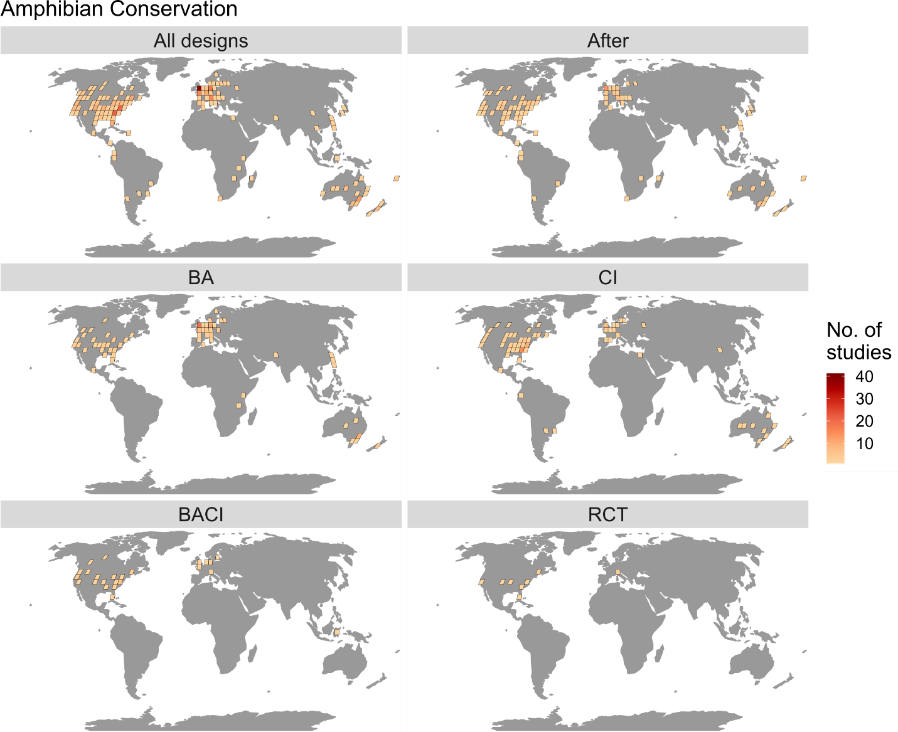
Figure 1 - Spatial distribution of studies for amphibians using a Robinson projection and grid cells at a 4x4 degree resolution. Definitions of design acronyms are as follows: BA = Before-After; CI = Control-Impact; BACI = Before-After Control-Impact; RCT = Randomized Controlled Trial (see Table 1 for details of designs).

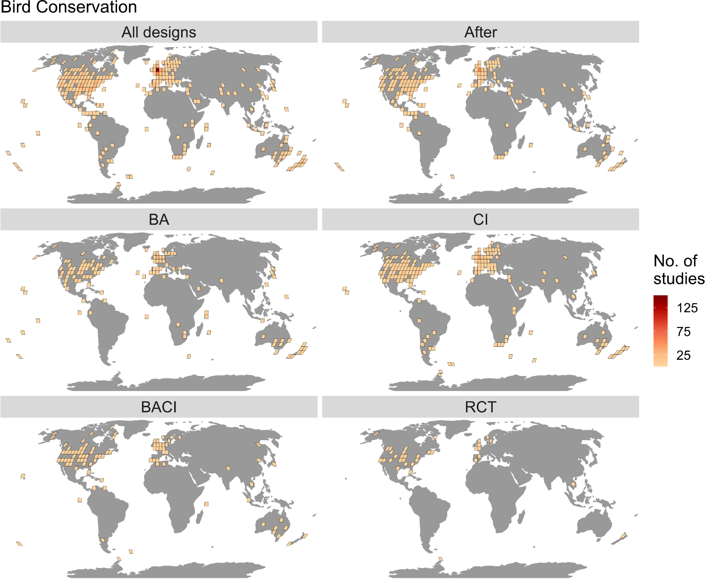
Figure 2 - Spatial distribution of studies for birds using a Robinson projection and grid cells at a 4x4 degree resolution. Definitions of design acronyms are as follows: BA = Before-After; CI = Control-Impact; BACI = Before-After Control-Impact; RCT = Randomized Controlled Trial (see Table 1 for details of designs).

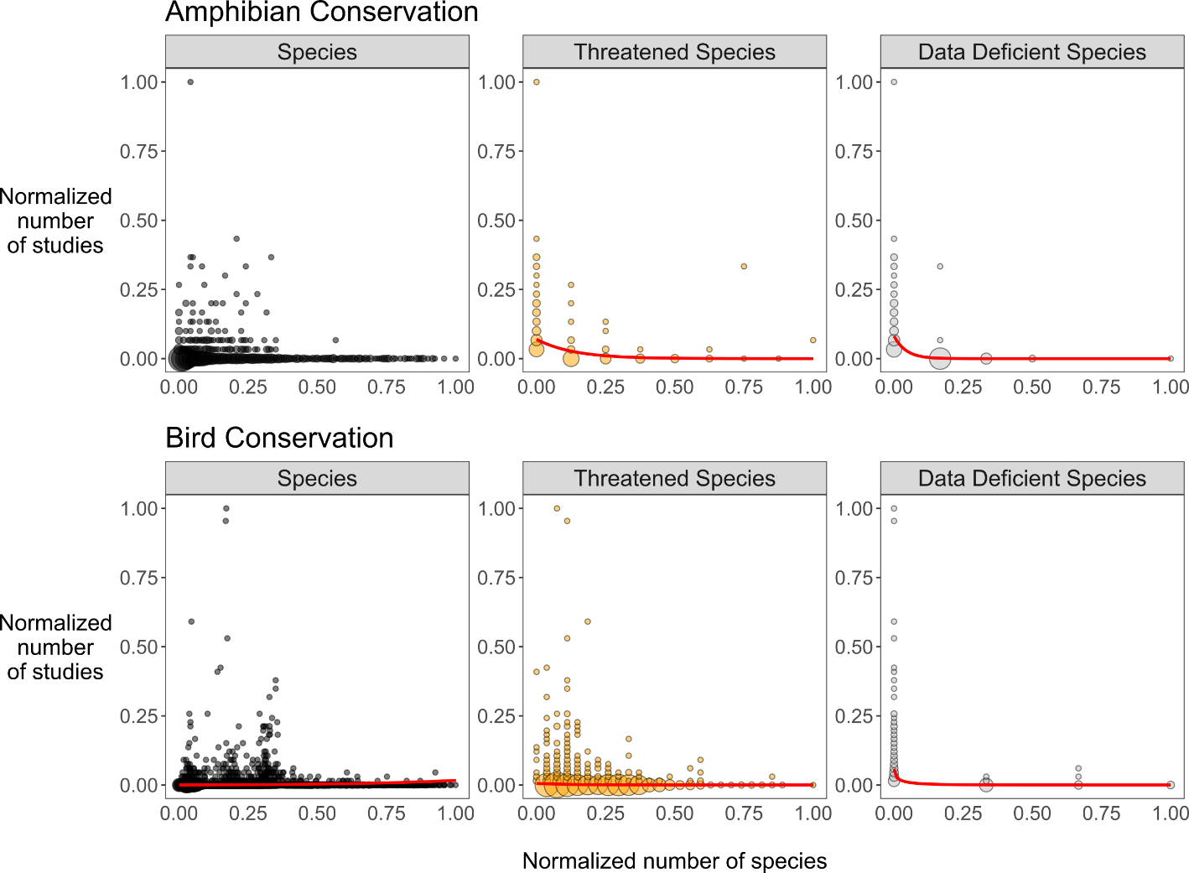
Figure 3 - Comparison of the normalized number of studies and the number of species (all species, threatened species and data deficient species) in 2x2 degree grid cells for amphibians and birds (with one representing the cells with the most studies or species and zero being the fewest). Cells with zero studies and zero species were excluded. Red fitted lines are based on binomial generalized linear models where statistically significant increases or decreases were detected (p<0.05; see Methods for details). Note that the slopes of the regression lines were negative for threatened and data deficient amphibian and bird species. The size of points is proportional to the number of points at that position on the figure to aid visualization. Threatened species are those classified as vulnerable, endangered or critically endangered respectively, according to the IUCN Red List (IUCN 2019).

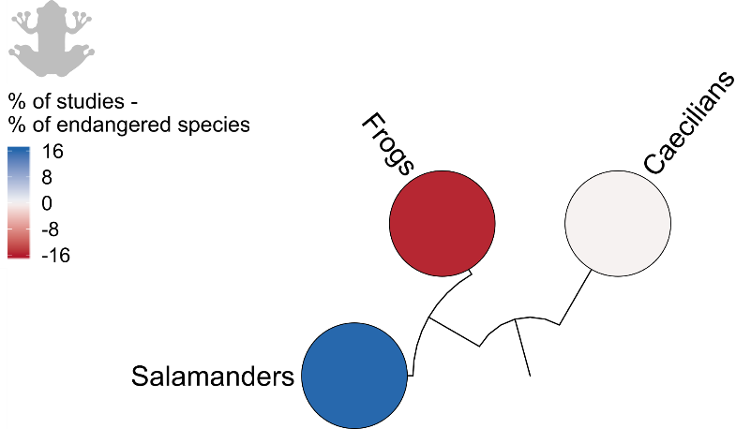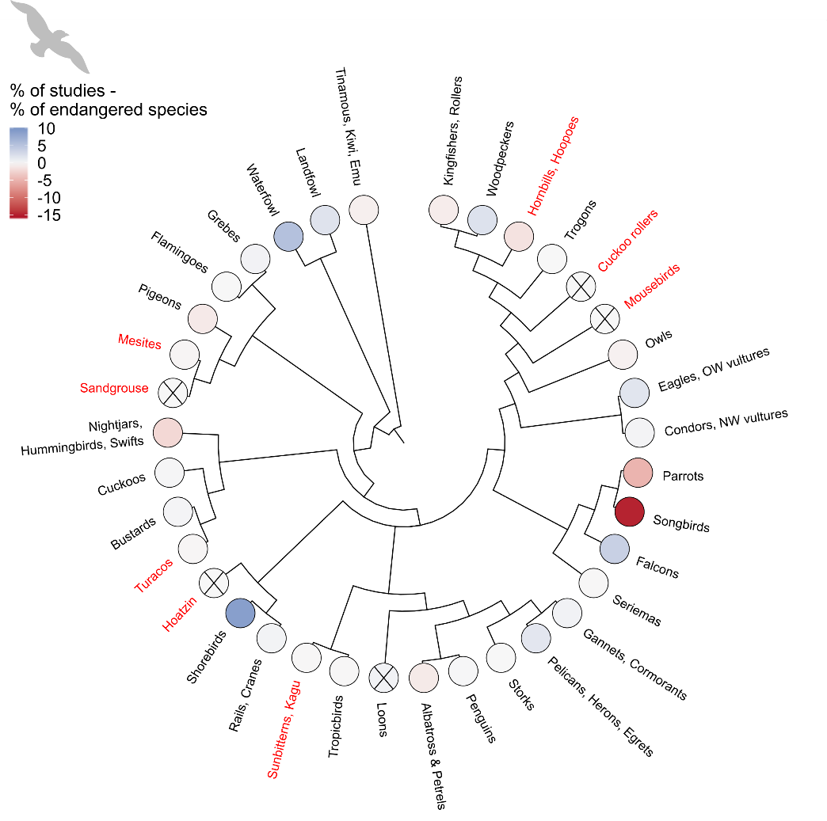
Figure 4 - Percentage of studies minus percentage of threatened species in each order of amphibians and birds - percentages are relative to the total number of amphibian or bird studies and species. Red names indicate zero studies for that order and black crosses indicate that order contains zero threatened species. Darker blue colors represent higher proportions of studies relative to the proportion of threatened species, while darker red colors indicate relatively lower proportions of studies.

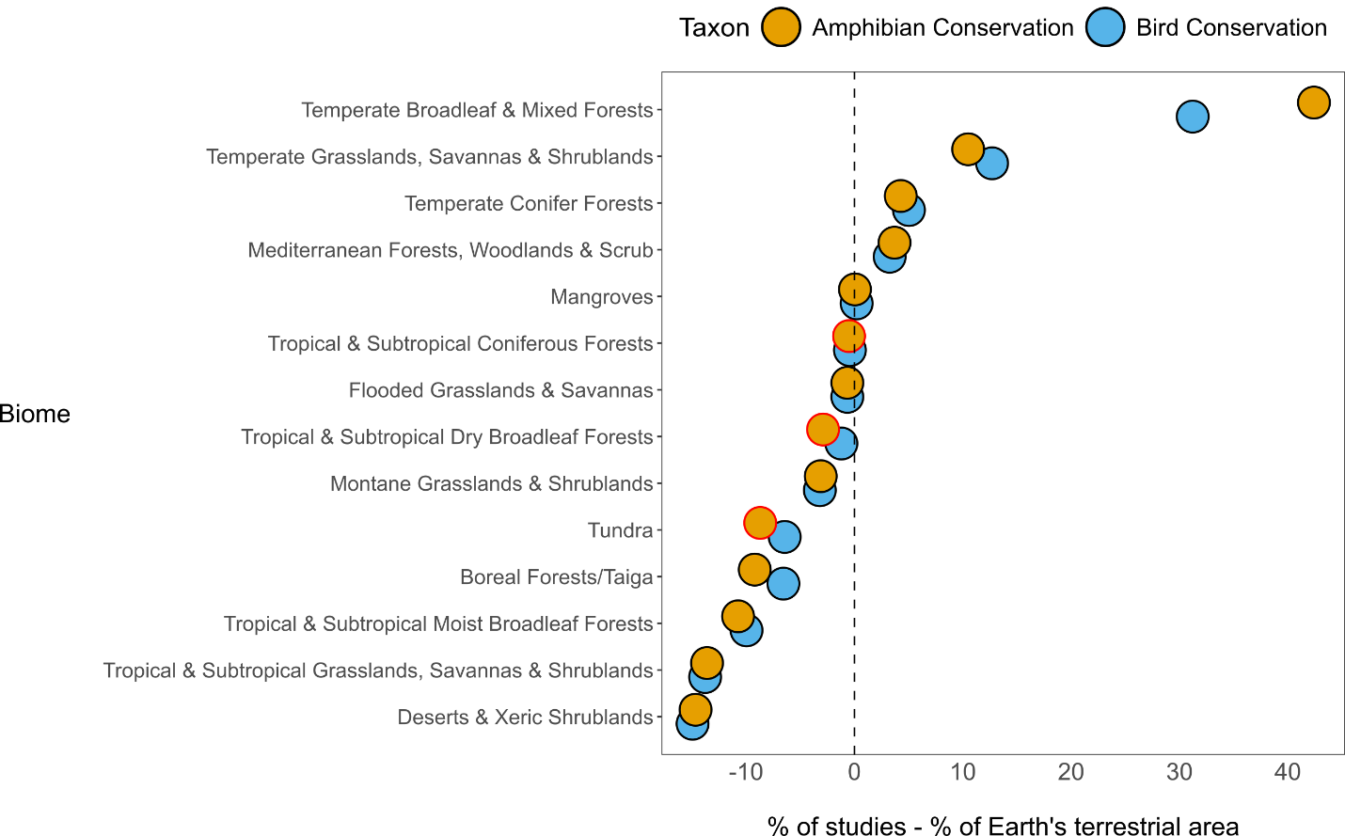Figure 5 – Percentage of amphibian and bird studies conducted in each biome minus the percentage of Earth’s terrestrial area covered by each biome. Red outlines to circles indicate that no studies were conducted in that biome.

