Performance-Based Assessment of CFS Strap-Braced Stud Walls Under Seismic Loading

Ioannis Papargyriou^{a*}, Iman Hajirasoulihaª, Jurgen Becque^{b}, Kypros Pilakoutasª

ª Civil and Structural Engineering Department, The University of Sheffield, S1 3JD, Sheffield, UK
^{b} Department of Engineering, University of Cambridge, CB2 1PZ, Cambridge, UK

* Corresponding author; E-mail: i.papargyriou@sheffield.ac.uk

Abstract
The use of cold-formed steel (CFS) systems has significantly increased in the past few decades, especially in the construction of low to mid-rise buildings. Compared to hot-rolled sections, CFS members are often more economical and efficient due to their low weight, ease and speed of construction and greater flexibility in manufacture. In most conventional CFS buildings, diagonally strap-braced stud walls provide the primary lateral force-resisting system. This study aimed to develop a better understanding of the structural behaviour of CFS strap-braced stud wall systems under seismic loading. To achieve this, a detailed numerical model was developed, accounting for material nonlinearity, initial geometric imperfections, nonlinear behaviour of the connections and secondary moments due to P-Δ effects. This model was validated against previous experimental results on full-scale wall systems. A comprehensive parametric study was then conducted using the validated model to investigate the effect of key design parameters, namely the number of studs, the presence and intensity of vertical loading, the thickness of the structural elements and the steel grade of the straps, on the seismic performance of the system. The lateral load-resisting capacity, deformation capacity, ductility and energy dissipation under lateral loading were investigated and are here discussed. An efficiency index was proposed for each of these variables, allowing design solutions to be rated in terms of their ability to improve the material efficiency of the system, and design recommendations were derived for performance-based design.

Keywords: Cold-formed Steel (CFS); Strap-Braced Walls; Numerical Modelling; Lateral Load-Bearing Capacity; Ductility; Energy dissipation; Performance-Based Design.

Introduction
The use of cold-formed steel (CFS) has gained increased popularity in structural applications in recent years, offering an efficient alternative to hot-rolled steel construction. Structures made of CFS have many advantages compared to their hot-rolled counterparts, such as being lightweight, resilient, sustainable and cost-effective.
CFS buildings typically rely on load-bearing stud walls to transfer gravity loads down to the foundation as line loads. These stud walls are invariably cladded on both sides with various materials (e.g. gypsum board, OSB, plywood) and their behaviour under lateral loading is summarised in a study by Sharafi et al. [1]. This sheathing participates in resisting in-plane lateral forces through its diaphragm stiffness and also increases the axial capacity of the vertical steel elements by increasing their resistance against global, local and distortional buckling [2]. However, current design standards such as Eurocode 3, Part 1-3 [3] do not contain design provisions to account for composite action between the studs and the sheathing, instead necessitating an “all-steel” design approach. In this case, it is necessary to use bracing members to resist lateral forces, for example, in the form of X-shaped strap braces.
Strap-braced stud walls, which are the focus of this study, consist of a steel frame made up of top and bottom tracks, intermediate studs and chord studs, and diagonal straps [4]. Generally, a bridging element is also used at the wall mid-height to reduce the buckling length of the vertical elements. An example is provided in Fig. 1. In this system, the lateral forces are transferred from the straps to the chord studs, and through the hold-down devices to the anchor rods, eventually finding their way into the foundation. The straps experiencing compression are considered to yield no contribution to the lateral resistance, due to their high slenderness and ensuing susceptibility to buckling [5].
Over the past two decades, extensive experimental research has been carried out to study the behaviour of CFS strap-braced stud wall systems under monotonic and cyclic loading. In general, the parameters under investigation have included the lateral load capacity, the lateral stiffness, the deformation capacity (ultimate lateral displacement) and the energy dissipation capacity. Al-Kharat and Rogers [6] conducted 16 experiments on three types of wall configurations, where they employed screwed connections which were chosen without applying any capacity design rules. Their results showed significant strength and stiffness degradation in the wall elements under cyclic loading. In a follow-up study, the same programme was repeated [7], this time following the connection design rules specified by ASCE 7-05 [8]. The design rules proved to be effective in preventing non-ductile modes of failure and significantly improved the lateral performance of the stud walls. This conclusion was independently verified by Velchev [9], based on the results of 30 wall specimens under monotonic and cyclic loading. Following a capacity-based design approach, Kasaeian et al. [10] experimentally tested and evaluated the lateral behaviour of six strap-braced wall configurations with fused straps. The tested specimens exhibited a ductile response, with yielding of the straps being the dominant failure mode.
Strap-braced walls with welded connections were the subject of a study by Comeau [11] and Velchev et al. [12]. The test specimens, designed following the AISI S213 [13] design rules, exhibited ductile behaviour, undergoing large inelastic deformations while maintaining their yield capacity. The dominant mode of failure was strap yielding. In other relevant studies, Mirzaei et al. [5], Comeau [11], and Velchev et al. [12] compared the response of walls with different aspect ratios and showed that walls with aspect ratios of 1:1 and 1:2 generally exhibited a more ductile behaviour compared to those with an aspect ratio of 1:4, in which case the chord studs failed prematurely due to flexure and compression. Tian et al. [14] and Moghimi and Ronagh [15] studied the capacity and stiffness of single-sided versus two-sided braced walls. Lu and Rogers [16] studied the interaction of strap-braced walls with gypsum panel sheathing. They showed that attaching one or two layers of gypsum sheathing significantly increased the lateral capacity of the panels. However, Moghimi and Ronagh [15] concluded that due to the brittle behaviour of gypsum panels, they are unreliable in transferring lateral forces and can lead to an abrupt failure of the system. Kim et al. [17] and Fiorino et al. [18] conducted full-scale shaketable tests on two-storey and three-storey CFS strap-braced walls, respectively, aiming to investigate the dynamic response of these systems. The studies confirmed the adequacy and robustness of strap-braced walls as lateral load resisting systems. The tested systems were able to reach high strength and ductility at lateral displacements exceeding 2% drift, without significant damage.
While it is clear from the above that many studies have investigated the response of CFS stud-walls under lateral loads, few studies have been conducted on the response of these systems under additional vertical loading. Lange and Naujoks [19] tested cement-bonded chipboard sheathed walls under horizontal and vertical loading. Similarly, Accorti et al. [20] tested different types of stud walls under lateral and vertical loading and compared their structural response. Ye et al. [21] also tested a series of sheathed stud walls in compression, to study the effect of various relevant parameters, in particular the type of sheathing, the stud cross-section, the stud spacing and the joint details. However, none of the above studies were conducted on CFS strap-braced walls (i.e. the lateral resistance was provided entirely by sheathing). Moreover, the effects of different levels of vertical loading on the lateral response of the walls were not investigated. In one of the few studies on CFS strap-braced walls subject to vertical loads, Moghimi and Ronagh [15] concluded that if the chord studs can withstand the full load capacity of the straps, then a vertical load equal to 80% of the vertical load capacity of the studs does not affect the lateral capacity of the wall.
The highly nonlinear response of individual wall components poses a significant challenge for the numerical study of CFS systems, requiring detailed numerical models that rely on experimental data for their validation and calibration. Several studies have modelled stud walls sheathed with gypsum panels [22], OSB panels [23,24], glass panes [25], and steel sheets [26,27]. However, detailed numerical studies on the monotonic and cyclic behaviour of unsheathed strap-braced stud walls are limited. Following an experimental programme on CFS walls reinforced with brackets at their corners, Zeynalian and Ronagh [28] developed a numerical model that was validated against the test results. They then carried out a parametric study by varying the bracket length to determine the best arrangement. Gerami et al. [29] studied the nonlinear behaviour of strap braces under monotonic and cyclic loading on the basis of a wall specimen with welded connections taken from the experimental work by Al-Kharat and Rogers [6]. Whilst previous experimental studies on the lateral behaviour of individual CFS strap-braced walls have generally indicated their suitability for seismic applications, only limited information is available on the influence of different design parameters on this performance. Even less so has any knowledge in this regard been translated into practical recommendations and guidelines for seismic design. In conjunction with this, it is of paramount importance to develop reliable numerical tools to predict the structural performance of these complex systems under both monotonic and cyclic loading conditions.
This study aimed to develop a better understanding of the seismic behaviour of CFS strap-braced walls. To achieve this, detailed FE models of single strap-braced stud walls were developed in ABAQUS [30], based on full-scale tests from the literature, while taking into account initial geometric imperfections, material nonlinearity and secondary moments due to P-Δ effects. Available results from shear lap tests on screwed connections were used to develop the model for the nonlinear behaviour of the connections. The numerical models were validated against experimental results pertaining to monotonic as well as cyclic loading and were further employed in a comprehensive parametric study. The key design parameters were identified and were discussed in terms of their impact on critical performance criteria, namely the lateral load-bearing capacity, deformation capacity, ductility and energy dissipation of the system. Based on the definition of an Efficiency Index parameter, design recommendations are proposed to obtain the most efficient design solution, achieving maximum performance with minimum material use.

Description of the reference experimental tests
The numerical models developed in this study were based on wall specimens 25A-M-1 and 31A-M-1, tested under monotonic loading, and specimens 26A-C and 32A-C, tested under cyclic loading, reported by Velchev [9]. These configurations were selected because they were deemed to be representative of typical wall systems used in practice, featuring simple connections. The wall measured 2744 mm in width by 2440 mm in height. Five intermediate studs were evenly spaced between the chord studs at 407 mm, while two additional studs were placed on the outside of the chords, as shown in Fig. 1.
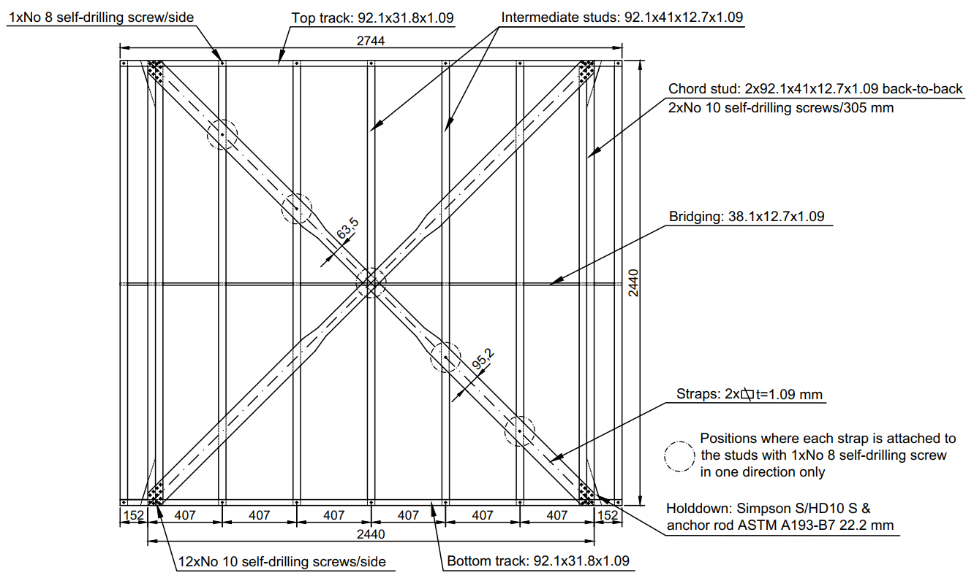
Fig. 1 Configuration of specimen 25A-M, tested by Velchev [9]
The chord studs consisted of two lipped channel cross-sections, connected back-to-back with 2 No.10-3/4” (19mm) wafer head self-drilling screws, placed every 305 mm along their height. The top and bottom tracks were extended by 152 mm beyond the chord studs to transmit the horizontal component of the diagonal strap force through tension [9]. The walls belonged to the “Light” wall series, which featured screwed strap-to-chord stud and stud-to-track connections, without any gusset plates at the corners. The straps had a non-uniform cross-section along their length, with the middle part being of reduced width, forming a “fuse” to protect the connections from premature failure. Both walls shared the same geometric and material properties, apart from the fuse length. This length was 762 mm (short fuse) for the 25A-M-1 and 26A-C specimens and 1524 mm (long fuse) for the 31A-M-1 and 32A-C specimens [9]. At mid-height of the wall, a bridging channel was used to reduce the buckling length of the vertical elements (see Fig. 1).
The hold-downs connecting the wall to the ground (bottom) and to the loading beam (top) were placed on the exterior side of the chords using four ASTM A193-B7 7/8” (22.2 mm) threaded anchor rods. Shear anchors along the top and the bottom tracks were of type ASTM A325 3/4” (19 mm). The straps were connected to the chord studs with 12 No. 10-3/4” (19mm) wafer head self-drilling screws at each end, and the studs were attached to the top and bottom tracks with a total of four No. 8-1/2 (12.7mm) wafer head self-drilling screws, one on each side of each track. One pair of straps, in one direction, was attached to the interior studs with No. 8 self-drilling screws, while the other pair was left unconnected.
The static and dynamic material properties were determined from coupon tests. A cross-head speed of 0.1 mm/min was selected to test the material of the vertical elements and the tracks. The strap material specimens were tested at two different cross-head speeds of 0.1 mm/min and 100 mm/min, representative of the rates in the monotonic and cyclic wall panel tests, respectively.
Table 1 summarises the outer cross-section dimensions and the nominal and base metal thicknesses of the straps, studs and tracks, along with their yield stresses and ultimate tensile strengths.
Table 1 Element thicknesses and material properties
Element | Cross-section dimensions (mm) | Cross-head rate  (mm/min) | Nominal  Thickness (mm) | Base metal  Thickness  (mm) | Yield  stress f_{y}  (MPa) | Ultimate stress f_{u} (MPa)
Straps | 95.2  (63.5 for fuse) | 0.1 | 1.09 | 1.11 | 296 | 366
Straps | 95.2  (63.5 for fuse) | 100 | 1.09 | 1.11 | 314 | 377
Studs/Chords | 92.1×41×12.7 | 0.1 | 1.09 | 1.16 | 325 | 382
Tracks | 92.1×31.8 | 0.1 | 1.09 | 1.11 | 296 | 366

Description of the ABAQUS models
In the analysis and design of complex, nonlinear systems, such as CFS lateral-force resisting systems, detailed numerical simulations provide an invaluable tool to assess their structural behaviour and failure modes [31, 32]. Detailed numerical models of the selected strap-braced walls were developed using the ABAQUS software [30], which has previously proved its effectiveness in accurately simulating the behaviour of CFS elements and structural systems [33–35]. The general model, depicted in Fig. 2, accounted for material and geometric nonlinearity, nonlinear connection behaviour and initial geometric imperfections. The constituent elements of the wall were the top and bottom tracks, the intermediate studs, the chord studs, the bridging element at mid-height, the connections of the studs to the tracks, the connections of the straps to the chord studs, the hold-downs and the anchor rods.
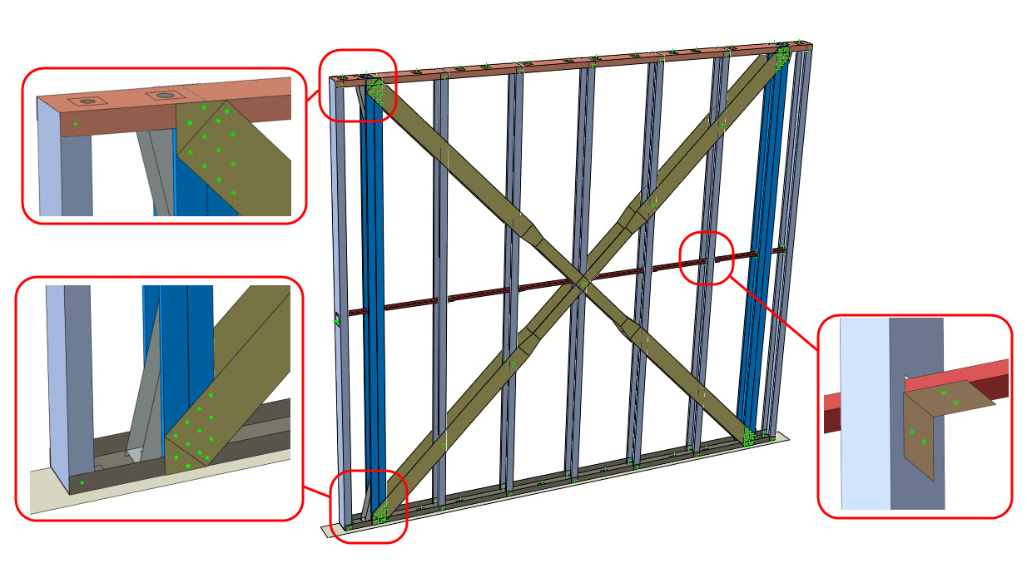
Bridging connection
detail
Bottom connection detail
Top connection detail
Fig. 2 Details of the developed Finite Element model

Material properties
The nominal (engineering) values of the stresses, σ_{nom}, and strains, ε_{nom}, obtained from coupon tests [36] were converted to true stresses and true strains for input into ABAQUS [30]. The modulus of elasticity, E, and the Poisson’s ratio, v, were 203 GPa and 0.3, respectively.
In the monotonic analyses the isotropic hardening rule was implemented, whereas in the cyclic analyses the linear kinematic hardening rule was applied.

Finite element type and mesh-size
The general-purpose, 4-noded “S4R” shell finite element was selected from the ABAQUS element library to model all the structural components of the wall panel. This element with 6 degrees of freedom per node supports reduced integration, hourglass control and finite membrane strains. It has been shown to be suitable for modelling thin-walled components, having yielded accurate results in previous studies [33–35]. For the anchor rods “standard linear beam” elements were employed. The mesh size for all parts was taken as 15×15 mm, apart from the base plate, which had a 20×20 mm mesh. Based on the results of a mesh sensitivity analysis, these mesh sizes were found to provide results of satisfactory accuracy with acceptable computational effort. Fig. 3 depicts the lateral load-displacement curves for different mesh sizes. The difference in ultimate capacity between the 15×15 mesh and the coarser 20×20 mesh was less than 0.5%, leading to the conclusion that the results had converged. Due to the nevertheless substantial computing requirements, the analyses were performed using the High-Performance Computing (HPC) resource at the University of Sheffield.
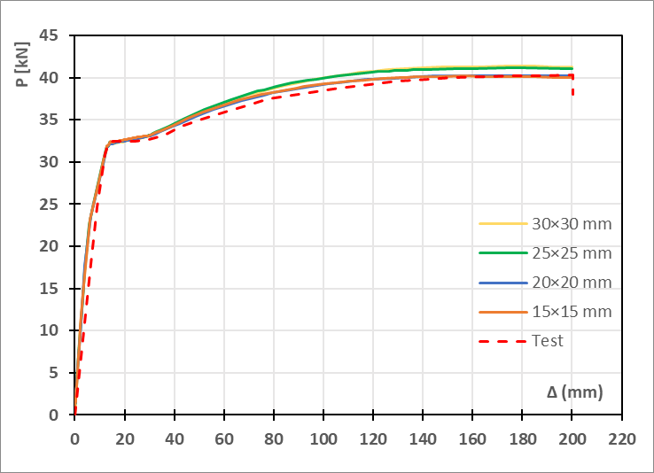
Fig. 3 Lateral load-displacement curves for different mesh sizes

Connection modelling
In general, the strength and stiffness of the strap-to-chord stud connections can significantly affect the response of the strap-braced wall system [6]. In order to prevent non-ductile premature failure in the strap-to-chord connection, it is necessary to follow the relevant design rules to ensure failure develops in the strap elements [37]. The importance of this design approach was proven by Al-Kharat and Rogers [7]. Several research studies have experimentally investigated the structural behaviour and dominant failure modes of strap-to-chord stud connections in strap-braced wall systems e.g. [38–43]. In this study, the equations proposed by Pham and Moen [44] were adopted to define the strength and stiffness characteristics of the connection. These relationships are based on the AISI S100-16 [45] equations but were modified using the results of a series of CFS shear-lap tests for a range of plate thicknesses and screw diameters. The equivalent monotonic response of the connections is described by three points, corresponding to 40%, 80% and 100% of the maximum capacity. Fig. 4 depicts the calculated force-displacement (P-Δ) curves, up to the peak load, of the connections with No. 8 and No. 10 self-drilling screws used in this study.
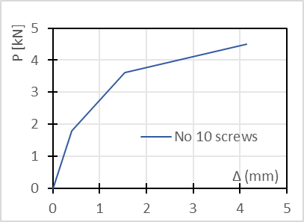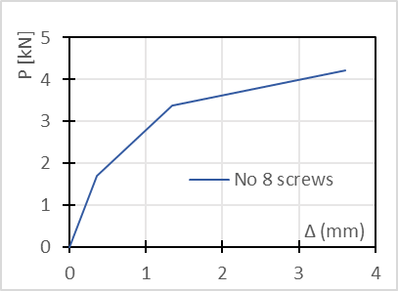
(a)
(b)
Fig. 4 Behaviour of a) No. 8 screws and b) No. 10 screws

To model the screwed connections, the “discrete fastener” capability of ABAQUS was used as a convenient way to connect surfaces (Fig. 5a). Each fastener layer uses a connector element, the nodes of which do not depend on the location of the nodes of the meshes on the connected surfaces. A local coordinate system is defined for each connector, with the z-axis being coincident with the connector axis. The connector has three translational and three rotational degrees of freedom. Fig. 5b depicts the implementation of such a fastener in the developed numerical model. Regarding the translational degrees of freedom, the movement along the z-axis was constrained while the movements along the x- and the y-axes followed the behaviour shown in Fig. 4. Rotations were free about the z-axis, and fully constrained about the x- and y-axes.
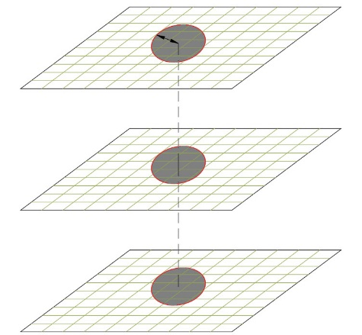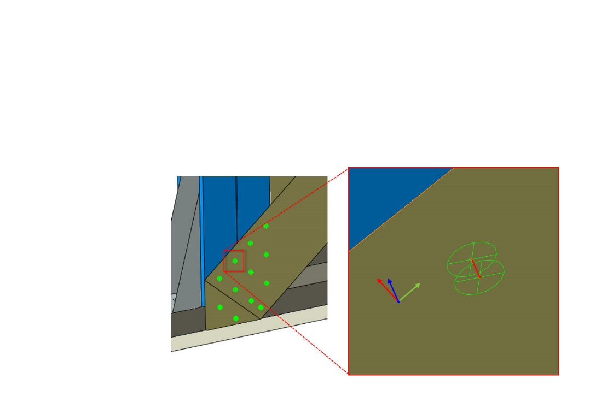
Connector
Connector
Available D.O.F.: Ux Uy Rz
Const. D.O.F.: Uz Rx Ry
x
z
y
Strap
Chord stud
Strap
Chord stud
Physical
radius
Connector
Fastening
point
Fastening
point
Fastening
point
Part 3
Part 1
Part 2
Radius of influence
LCS
a)
b)
Fig. 5 a) ABAQUS fastener configuration, and b) Discrete fastener in the FE model

Validation of the connection model
The numerical model of the connections implemented in ABAQUS was validated against experimental results reported by Meza [46] and Meza and Becque [47]. A series of shear lap tests on bolted and screwed connections were conducted, out of which two tests were selected for validation in this study, both employing No. 12 self-drilling screws [46]. Fig. 6 depicts the adopted test configuration. The plate thicknesses and the material properties are summarised in Table 2.
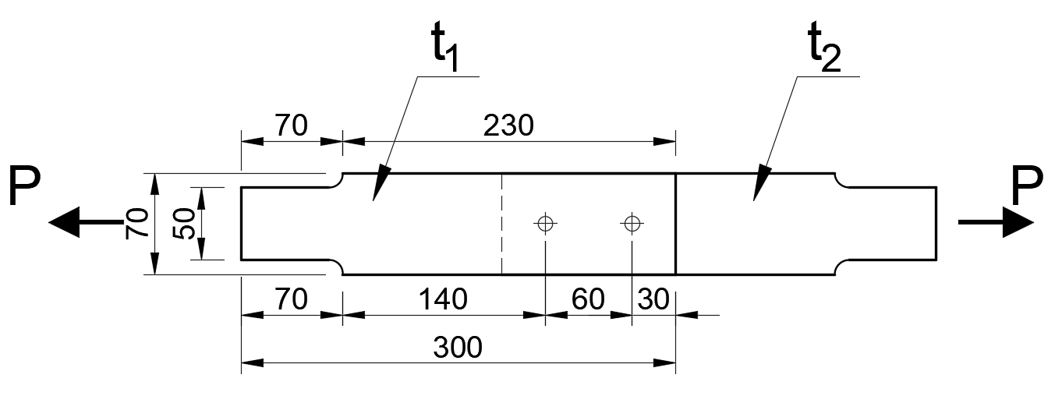
Fig. 6 Configuration of shear-lap tests (adopted from [46])
Table 2 Plate thicknesses and steel properties of the shear lap tests [46]
Test | Element | Nominal  Thickness(mm) | Base metal  Thickness  (mm) | Yield stress f_{y}  (MPa) | Ultimate stress f_{u} (MPa) | Modulus of elasticity E (GPa)
SL14-14c | t₁ | 1.4 | 1.45 | 280 | 341 | 198
SL14-14c | t₂ | 1.4 | 1.4 | 283 | 338 | 184
SL20-14c | t₁ | 1.4 | 1.4 | 277 | 339 | 199
SL20-14c | t₂ | 2.0 | 2.0 | 267 | 421 | 206

The behaviour of the connectors was defined using the relationships proposed by Pham and Moen [44]. The softening part of the connector behaviour was obtained by matching the dissipated energy of the predicted curve with the energy of the test curve. Fig. 7 (a) and (b) compare the numerically predicted behaviour with the corresponding experimental results for the SL14-14c and SL20-14c specimens, respectively. The comparison shows that the predictions of the connection model are in good agreement with the actual shear lap test curves.
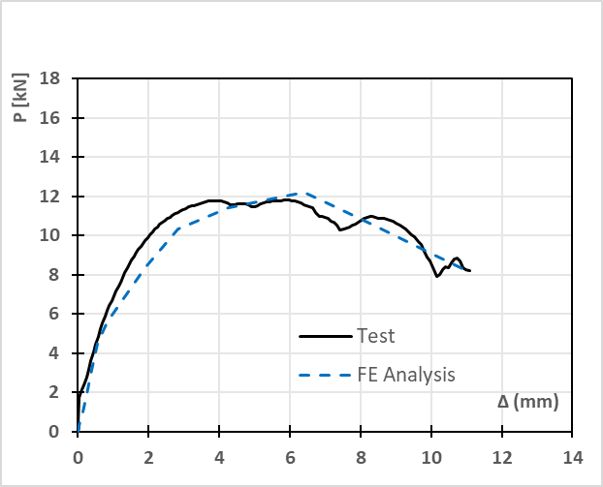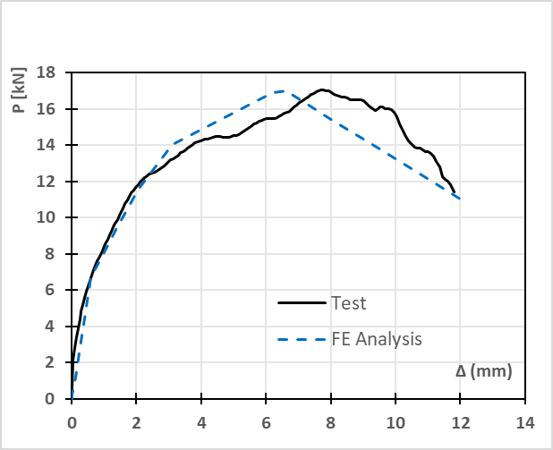
a)
b)
Fig. 7 Predicted and measured load-deformation curves of a) SL14-14c and b) SL20-14c

Boundary conditions
Fig. 8(a) and (b) depict the top and bottom boundary conditions of the stud wall panel for the case of lateral loading. In the reference experiment the top track was connected through a 25.4 mm thick aluminium plate to the loading beam, using shear anchors and anchor rods. Moreover, additional vertical columns constrained the out-of-plane displacements of the wall. To simulate these conditions the horizontal out-of-plane displacement (UX) and the rotations RY and RZ of the end points of the shear anchors and the anchor rods were restrained (UX=RY=RZ=0). Similarly, the connection of the bottom track to the testing frame was provided by shear anchors and anchor rods through an intermediate 25.4 mm thick aluminium plate. A plate consisting of shell elements with a high modulus of elasticity (E=1×10⁶ MPa) was used to simulate these boundary conditions in the FE models. The end points of the anchor rods and the shear anchors were fully fixed. In addition, the translational degrees of freedom of the bottom surface of the aluminium plate were all constrained (UX=UY=UZ=0). For the top plate, all degrees of freedom, apart from the vertical displacement, were constrained during the initial load step when the vertical load was applied (UX=UZ=RX=RY=RZ=0). During the next load step, in which the lateral load was applied, both the displacement along the Z-axis and the rotation about the X-axis were released (Fig. 8c).

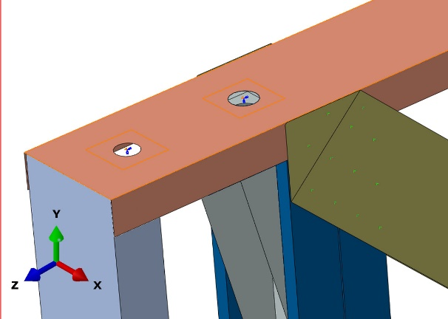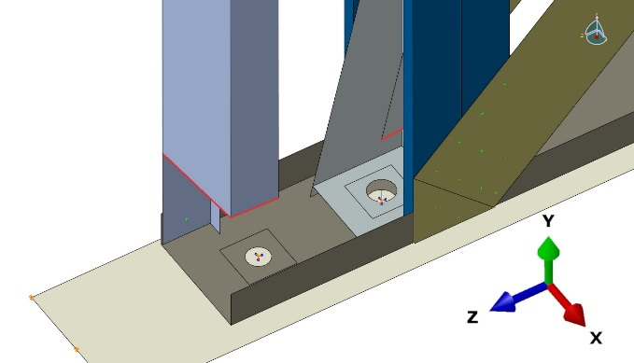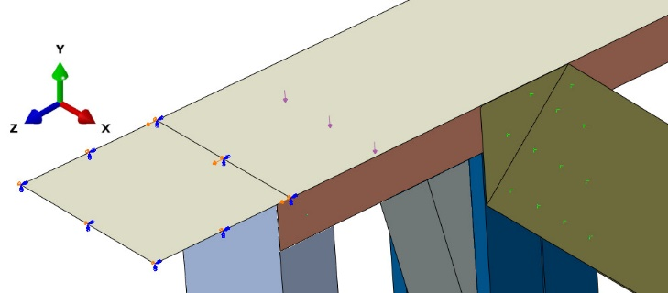
Anchor rod
Vertical loading: constrained DOFs: UX UZ RY RZ
Lateral loading: constrained DOFs: UX RY RZ

Shear anchor
Anchor rod
Constrained DOFs: UX UY UZ RX RY RZ
Shear
anchor
Vertical loading: constrained DOFs: UX UZ RX RY RZ
Lateral loading: constrained DOFs: UX RY RZ

a)
b)
c)
Fig. 8 a) Top track, b) Bottom track and plate and c) Top plate boundary conditions

Component interactions
The ABAQUS interaction module enables the definition of constraints, couplings and contact interactions between different regions of an FE model. Contact occurred in the model between the two channels of the built-up chord studs, which were connected back-to-back with No. 10 self-drilling screws, spaced at 305 mm along the height. Instead of simulating these connections explicitly, which would have increased the complexity of the model, tie constraints were used, as shown in Fig. 9a and Fig. 9b. The same approach was used for the Simpson S/HD10 S hold-down devices, which were connected to the chord studs with screws. It should be noted that these regions did not exhibit any damage in the tests.
The holes in the tracks at the positions of the anchor rods and the shear anchors were modelled explicitly in this study. At their centre, an attachment point was defined, to which boundary conditions and loads were applied. The displacements of this centre point were coupled to those of the surrounding region of the track through ‘continuum distributing’ coupling constraints, as shown in Fig. 9d.
Surface-to-surface contact was defined in the interface between a) the stud flanges and the tracks, b) the L-shaped brackets connecting the bridging and the studs (Fig. 2), and c) the bottom track and the base plate. In the normal direction, “hard” contact was specified, while in the transverse direction “frictionless” contact was employed.
At the centroids of the end cross-sections of the vertical elements (studs and chord studs), a reference point was defined, which was coupled to all nodes in the cross-section. Subsequently, a node-to-surface contact interaction between the end sections and the track surface was created, to allow for the transfer of vertical loads (see Fig. 9c).
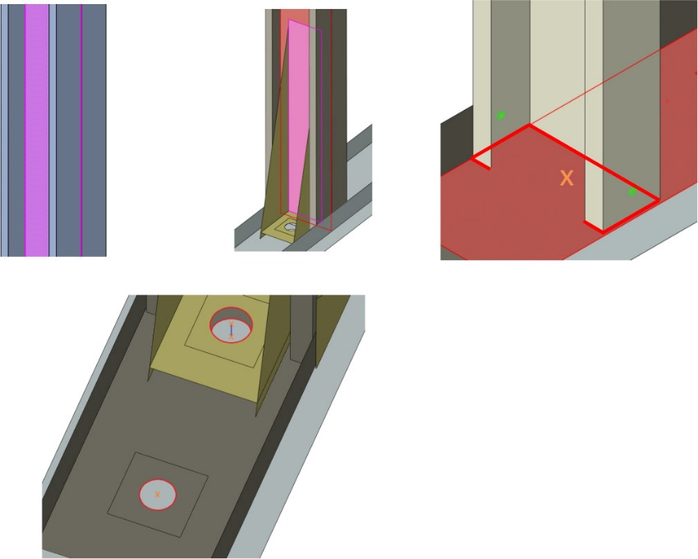
Anchor rod
Shear anchor
Control point
Coupled region
Tie constraint
RP
Coupled region
Contact between RP and track surface
a)
b)
c)
d)
Fig. 9 Component interactions

Loading
The lateral load was applied through an imposed displacement at all nodes corresponding to the top anchor rods and shear anchors. Under monotonic loading, a maximum displacement of 300 mm was defined, whereas cyclic loading followed the reversed cyclic CUREE test protocol adopted in the experiments [9]. The vertical load was applied at the top plate as a surface load, and constituted a certain fraction of the combined axial capacity of all vertical elements P_{w}, calculated according to Eurocode 3, Part 1-3 [3].

Initial Geometric Imperfections
In order to study the effect of geometric imperfections on the response of the wall panel, an eigenvalue buckling analysis was performed in ABAQUS [30] and the first mode was scaled to define the initial geometric imperfections, as recommended by Schafer and Peköz [48]. In this analysis the nodes corresponding to the top anchor rods and shear anchors were given a unit lateral displacement, so that this induced compression in the pair of diagonal straps which experienced tension under monotonic loading or in the first cycle of the cyclic loading case. The rationale behind this was to introduce some slackness into the tension straps. The amplitude of this imperfection was taken equal to one, two and three times the strap thickness in a number of preliminary analyses to assess the effects of an imperfection. However, the system under consideration showed itself to be highly insensitively to geometric imperfections, and no noticeable difference was observed in the ultimate capacity or ultimate displacement of the system (Fig. 10a). Similarly, introducing an imperfection into the chord stud in the shape of its lowest buckling mode with amplitudes of either 0.34t or 0.94t (with t_{s} being the stud thickness) [48] did not noticeably affect the capacity or behaviour of the system in analyses under vertical load levels of 0.3P_{w} and 0.44P_{w} (Fig. 10b).
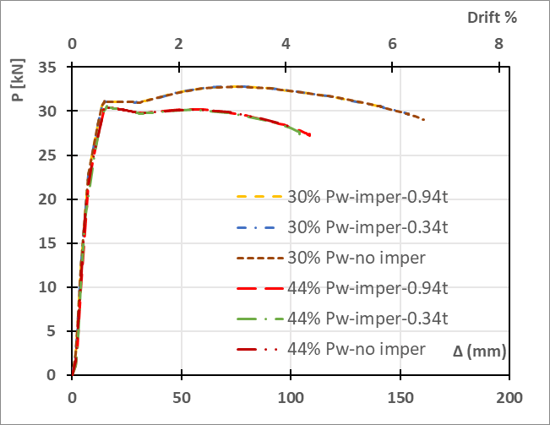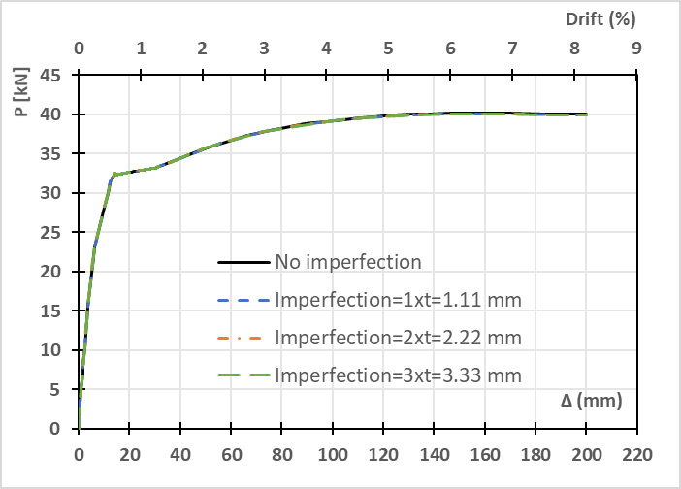
a)
b)
Fig. 10 Effect of a) strap imperfection and b) chord stud imperfection on the lateral response

Model validation
The accuracy of the developed numerical model in predicting the behaviour of the wall panel was first verified against experimental results pertaining to both monotonic and cyclic loading, obtained from [9].

Monotonic analysis
The wall panel specimens in [9] were designed in accordance with AISI S213 [13] and reached a drift of over 8%, ultimately limited by the maximum stroke of the actuator. The main failure mechanisms were yielding of the straps and distortional buckling of the chord flanges [9]. Fig. 11a and Fig. 11b illustrate the lateral load-displacement curves of test specimens 25A-M-1 and 31A-M-1, respectively, and compare them to the FE analysis predictions. It is seen that the numerical model was able to accurately capture the overall experimental response of the walls, as well as critical parameters including the initial stiffness, the yield load P_{y}, and the maximum capacity P_{u}. The latter was predicted with less than 2.5% error.
Fig. 12 depicts the distribution of the von Mises stresses in specimen 25A-M-1 at the ultimate displacement. The numerical model accurately predicted distortional buckling failure at the bottom of the chord studs (circled in red), which is in agreement with the experimental results reported in [9].
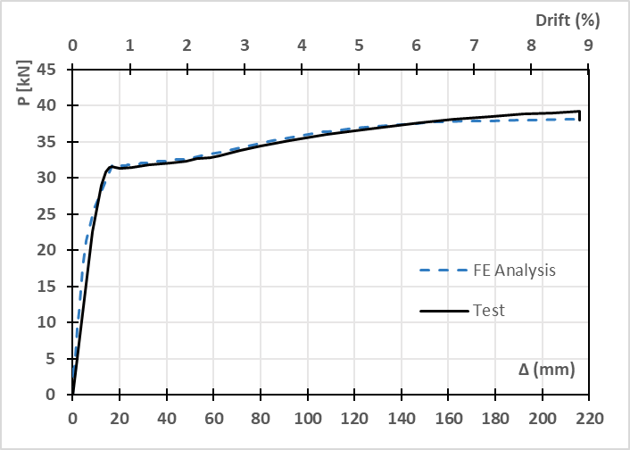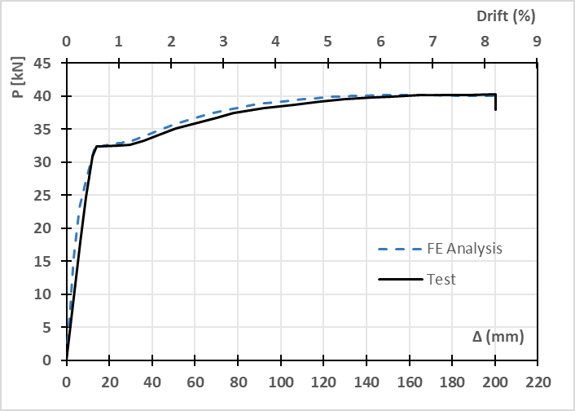
a)
b)
Fig. 11 Lateral load-displacement curves of a) 25A-M-1 and b) 31A-M-1 test specimens and corresponding FE analysis results
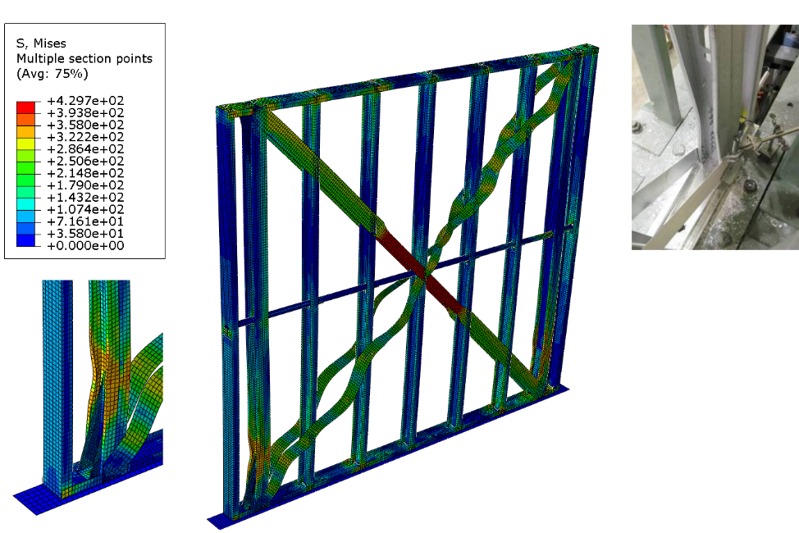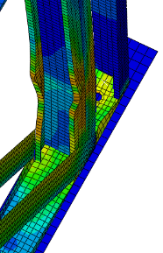
Fig. 12 Distribution of von Mises stresses and failure modes of test specimen 25A-M-1

Cyclic analysis
Test specimens 26A-C and 32A-C [8] were used for the validation of the FE model under cyclic loading. The same modelling techniques were employed as used for the corresponding monotonic test specimens, 25A-M and 31A-M. Fig. 13a and Fig. 13b illustrate the experimentally observed hysteretic behaviour of test specimens 26A-C and 32A-C, alongside the numerical predictions. The hysteretic responses of the walls show significant pinching, without any noticeable strength or stiffness degradation. It can be seen that the FE model matched the experimental response throughout the whole history of repeated loading and unloading. However, after the load reached a maximum value within each cycle, a small drop in load was experimentally observed before unloading commenced, which the FE model did not capture. This response is likely attributed to the difference between the strain rate exercised in the material coupon tests and the higher strain rate experienced by the wall brace elements during the large displacement cycles in the actual tests, as stated in [9]. The lower strain rates in the coupon tests resulted in lower values of the yield stress f_{y} [49].
Both test specimens completed all cycles of the CUREE loading protocol. In the case of specimen 26A-C, the pair of diagonal straps connected to the intermediate studs failed due to net-section fracture at their mid-length at the end of the test. In the case of specimen 32A-C, block shear failure in the bottom track flanges was detected at the end of the loading cycles. For both specimens, however, the global response of the system was adequately captured by the numerical models.
The cumulative dissipated energy is the total area under the lateral load-displacement curve up to a given time in the test procedure and was also used to compare the experimental and numerical responses [50]. The cumulative energy graphs for specimens 26A-C and 32A-C are displayed in Fig. 14a and Fig. 14b, respectively. The average difference between the experimental and the numerical values was 18% for specimen 26A-C and 17% for specimen 32A-C, which confirms the adequacy of the FE models adopted in this study.
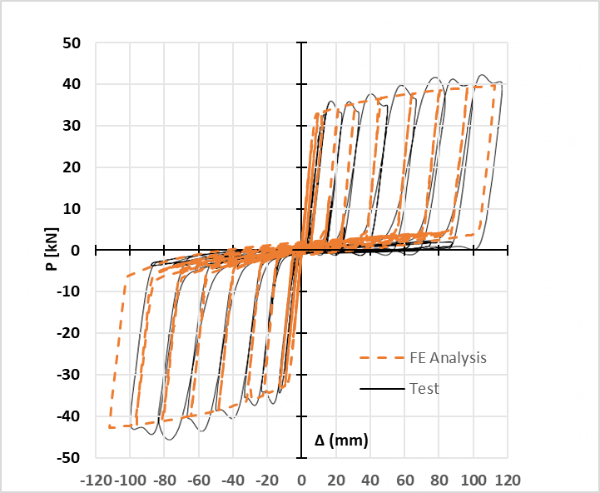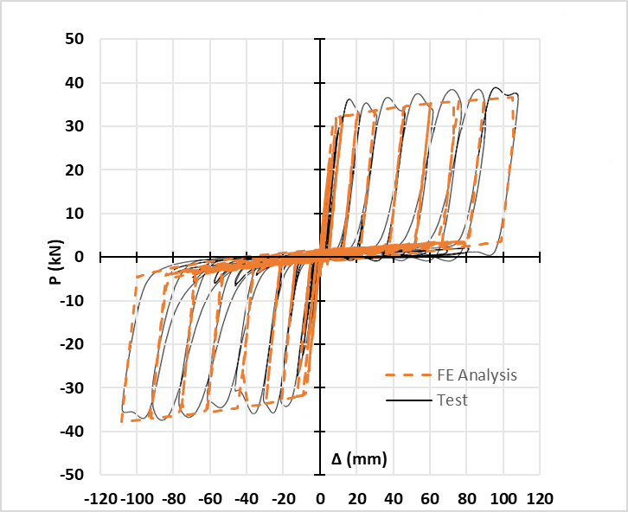
a)
b)
Fig. 13 Lateral load-displacement curves of a) 26A-C, and b) 32A-C test specimens and corresponding FE analysis results
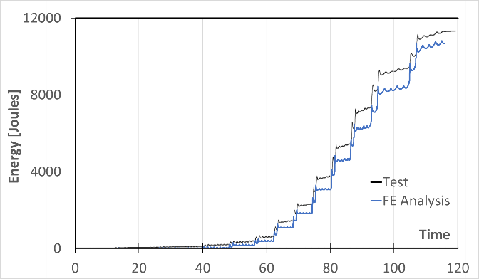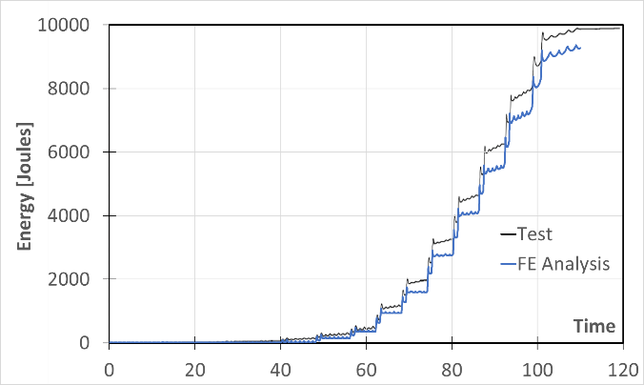
a)
b)
Fig. 14 Cumulative energy-time curves of a) 26A-C, and b) 32A-C test specimens and corresponding FE analysis results
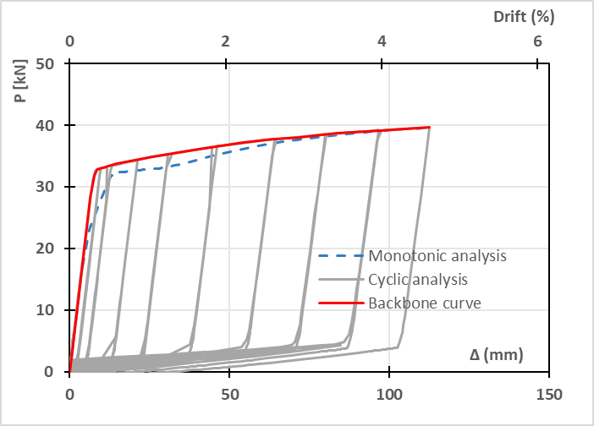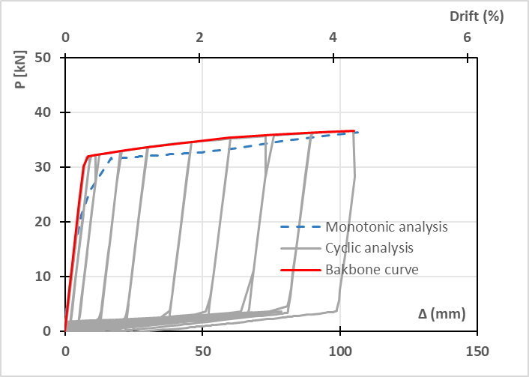
a)
b)
Fig. 15 Comparison of a) 26A-C backbone curve with 25A-M-1 monotonic curve and b) 32A-C backbone curve with 31A-M-1 monotonic curve
Fig. 15a and Fig. 15b compare the cyclic backbone curves of specimens 26A-C and 32A-C with the corresponding monotonic results. The comparison shows that the monotonic responses match the cyclic backbone curve results reasonably well, especially in terms of the initial stiffness, maximum capacity, and ultimate displacement.
To calculate performance parameters such as the energy dissipation capacity and the ductility, it is common practice to convert the load-displacement curves into equivalent bi-linear curves, in accordance with the FEMA 356 [51] recommendations. The secant stiffness of the line intersecting the curve at 60% of the effective yield strength is thereby defined as the effective stiffness. The slope of a second line segment, starting at the yield point and passing through the original curve at the ultimate displacement, is then determined in such a way that the enclosed areas under the equivalent and the actual curves are equal. The ultimate displacement, by definition, corresponds either to failure of the wall or a 20% drop in load from the peak strength (whichever happens first). Fig. 15a and Fig. 15b show that the monotonic response and the backbone curve will lead to almost similar energy dissipation and ductility results.
Based on the above arguments and observations, the monotonic analyses were considered to be sufficient to evaluate the structural performance of the studied CFS walls under lateral loading, offering the advantage of dramatically reducing the amount of computational time, while still accurately predicting the overall response of the wall systems.

Evaluation of the nonlinear performance of strap-braced walls
A series of parametric analyses were conducted to investigate the effect of key design parameters, i.e. (1) the number of vertical studs, (2) the thickness of the structural elements, (3) the diagonal strap material, and (4) different levels of vertical load. Their influence on the following performance parameters was studied:
- The lateral load capacity.
- The deformation capacity, expressed as the ultimate displacement (Δ_{u}), corresponding to failure of the wall (i.e. rupture of the straps or buckling of the chord stud) or a 20% drop relative to the maximum lateral load capacity.
- The ductility, which is the ability of a structure to undergo large plastic deformations without significant reduction in ultimate strength [52]. It is here defined as the ratio Δ_{u}/Δ_{y}, where Δ_{y} and Δ_{u} respectively stand for the yield and ultimate displacements measured at the top of the wall.
- The energy dissipation capacity, defined as the area under the equivalent bi-linear load-displacement curve up to the ultimate displacement (Δ_{u}).
It should be noted that this study did not consider the depth of the stud/chord sections (equivalent to the width of the track sections) as design parameters, as the chosen values are considered typical for practical applications.
The validated numerical model of the 25A-M-1 specimen was used as the reference model in the parametric analyses.
It should be noted that in the actual design of strap-braced walls in multi-storey buildings some of the parameters under investigation are not independent, but become linked. For example, in accordance with the capacity design rules in Eurocode 8 [53] the design compressive force in the chord studs is related to the tensile force in the straps at first yielding. In practical design applications all members should be checked to ensure that they satisfy those requirements.

Effect of vertical load
While several experiments have been conducted to investigate the lateral response of stud wall systems, as previously mentioned, very limited information is available in the literature on the performance of these systems under the simultaneous effects of vertical and lateral loading. In practical applications, nevertheless, stud wall systems are invariably subject to dead and live gravity loads, as well as vertical loading due to overturning moments, which considerably affects their lateral response during an earthquake event. The first part of this parametric study therefore investigated the seismic performance under different levels of gravity loading.
In the analyses the vertical load was applied in the form of a surface load at the top plate, and expressed as a fraction of the total axial load capacity of the wall, P_{w}. Five cases were considered, with vertical loads equal to 7%, 15%, 22%, 30%, 35%, 44% and 50% of the total axial load capacity P_{w}. To obtain P_{w} the individual stud and chord stud capacities were calculated according to EC 3 [3,54]. The buckling coefficients used in this process depend on the boundary conditions, i.e. the degree of restraint provided by the tracks to the stud ends and by the bridging at mid-height. In the present study, it was assumed that K_{x}=1 for out-of-plane buckling and K_{y}=K_{t}=0.5 for in-plane and torsional buckling. For the intermediate studs, these coefficients were applied to the full stud length, while for the chord studs they were applied to the distance between the hold-downs.
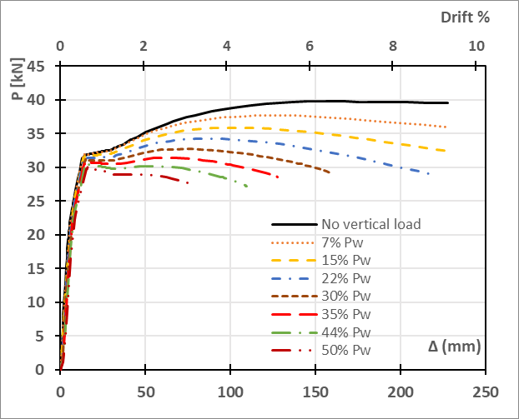
Fig. 16 Lateral load-displacement curves in the presence of vertical loading
The results of this study indicated that the presence of vertical loading has a significant effect on the lateral performance of the walls. It is seen from Fig. 16 that the lateral load capacity gradually decreased as the vertical load increased. Compared to the initial situation without vertical loading, the wall exhibited a significant 24% drop in lateral load capacity under vertical loading equal to 50% P_{w}. Fig. 16 also shows that under low levels of vertical loading (< 15-20 % of P_{w}) the ultimate lateral displacement of the wall remained largely unaffected. However, under a vertical load of 35% to 50% of P_{w} the ultimate displacements amounted to only 56% and 33%, respectively, of that of the original wall without vertical loading. The corresponding reductions in the ductility of the system were 47% and 70%, while the corresponding energy dissipation capacity of the wall dropped by 56% and 77%. These observations can be explained by noting that the lateral load capacity of the wall depends on both the tensile capacity of the straps and the compressive capacity of the chord studs. The chord studs are subjected to the vertical load applied to the model, in addition to carrying the vertical component of the tensile force in the strap. Moreover, the lateral displacements will introduce additional bending moments and compressive forces into the chord studs due to P-Δ effects, which become more substantial at higher vertical load levels. Up to a value of 15% P_{w}, the wall reached a maximum displacement determined by the straps reaching their ultimate strain. For vertical loads in excess of 22% P_{w}, however, the compressive chord stud reached its maximum capacity in distortional buckling before failure of the straps (Fig. 17). This implies that the straps did not reach their maximum strain, and hence, the wall failed prematurely. It should also be taken into account that, provided the intermediate studs have end conditions which can be approximated as hinges, the studs carry pure compressive forces oriented along their axis. As the lateral displacement increases, the straps are required also to resist the horizontal components of these stud forces, which remain axial yet are inclined. Less capacity is therefore available at higher vertical load levels to resist lateral forces.
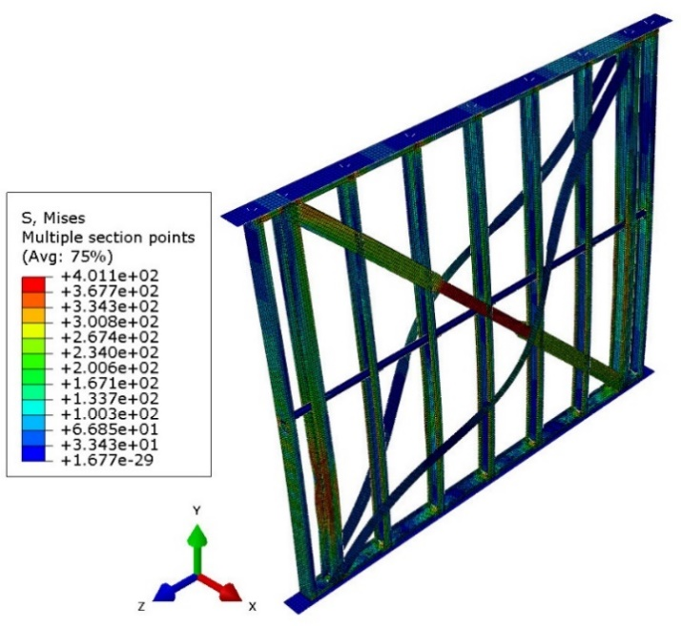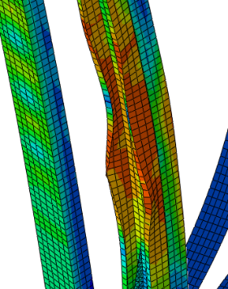
Fig. 17 Failure mode under vertical loading equal to 35% P_{w}

Number of studs
The original wall model featured seven studs: five intermediate ones and two outer chord studs. As part of the parametric analyses, the number of intermediate studs was reduced to four and three. As expected, reducing the number of studs did not affect the lateral load capacity of the wall. The ductility and energy dissipation also remained unaffected. Failure was still governed by the straps reaching their ultimate strain.
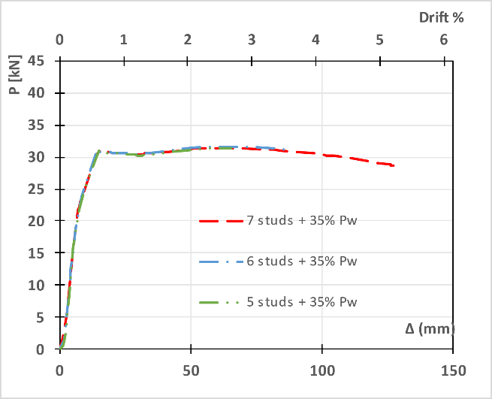
Fig. 18 Lateral load-displacement curves, varying the number of studs with 35% P_{w} vertical load

The responses of these wall panels featuring a different number of stud elements were compared in the presence of vertical loads. A vertical load equal to 35% P_{w} was applied to all wall panels, where P_{w} is the capacity of the original wall. Fig. 18 illustrates the responses of the three cases. It is seen that the lateral load capacity of the walls was virtually unaffected compared to the original wall panel with the same vertical load. The reason is that the increase in the the strap force resulting from the P-Δ effect is the same in both cases, irrespective of the number of studs. Indeed, the sum of the horizontal components of the stud forces equals P × Δ / H, where (P) is the vertical load, (Δ) is the lateral displacement and (H) is the height of the wall. However, the ultimate lateral displacement reduced by 32% and 49% for the wall panels with 6 and 5 studs, respectively, compared to the original wall. The energy dissipation capacities of the wall panels followed the same trend. This can be explained by the fact that the chord studs were required to take a larger portion of the total axial load when the stud spacing increased, alongside a higher secondary moment, promoting their failure.

Thickness of the studs
Additional analyses were carried out where the thickness of all studs was increased to 2.32 mm and 3.48 mm. The results indicated that the stud thickness did not have any notable effect on the lateral response of the wall. The lateral load capacity remained constant in these analyses, whereas the ultimate displacement and the ductility slightly decreased (by 5%) for the case of the 3.48 mm stud thickness. This change was deemed negligible.

Thickness of the diagonal straps
The deformations of the diagonal straps constitute the primary seismic energy dissipation mechanism of the system. To study the effect of the strap thickness, three wall configurations were analysed and compared, employing strap thicknesses of 1.11 mm, 2.22 mm and 3.33 mm. Fig. 19 depicts the corresponding load-displacement curves. Increasing the diagonal strap thickness to 2.22 and 3.33 mm caused 86% and 140% increases in the lateral load capacity, respectively, compared to the original wall.
On the contrary, there was a significant decrease in the ultimate displacement of the wall, which dropped by 30% and 80% for the wall panels with 2.22 and 3.33 mm strap thicknesses, respectively. As a result, the ductility also fell by 39% and 82% in those respective cases. As expected, using an increased cross-sectional area for the straps led to higher compressive forces in the chord studs for the same deformation. Consequently, the reduction of the ultimate displacement in the walls with thicker straps is due to failure of the compression chord stud under the combination of a higher axial load and associated secondary moments due to P-Δ effects. These results imply that increasing the thickness of the straps without considering its implications may eventually lead to very low ductility levels and a brittle type of failure, which is obviously not acceptable in seismic applications.
Analysis of the data presented in Fig. 19 leads to the conclusion that the energy dissipation capacity of the walls increased by 28% when the strap thickness increased to 2.22 mm. However, the energy dissipation capacity dropped considerably (by 57%) compared to the original system when 3.33 mm thick straps were used. This illustrates the point previously conveyed.
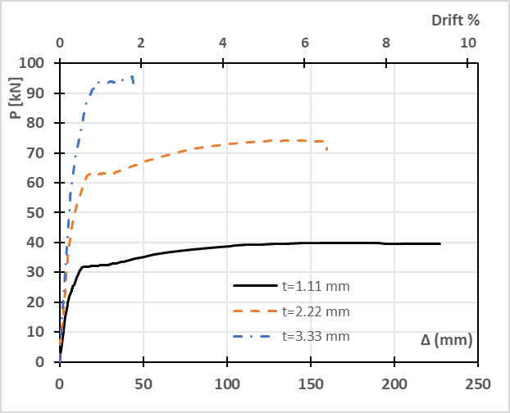
Fig. 19 Lateral load-displacement curves for walls with different diagonal strap thicknesses

Thickness of the wall frame elements
Parametric analyses were conducted in which the thicknesses of the wall elements in the bare frame (i.e. all CFS elements, including the top and bottom tracks, the studs, the chord studs and the bridging element, but excluding the straps) were increased to two and three times the original values shown in Table 1. Fig. 20a depicts the lateral response of the three frames. With the original thicknesses, the ultimate capacity of the bare frame reached 4.0 kN, which constituted approximately 10% of the total wall capacity of 39.8 kN. The capacity of the bare frame was increased to 8.5 kN and 11.9 kN when the thicknesses of the elements were increased by factors of two and three, respectively. It should be noted that the lateral resistance of the bare frame can almost solely be attributed to the hold-downs providing a degree of fixity at the ends of the chord studs, which led to the local development of a yield line mechanism in the advanced stages of loading (see Fig. 21). The intermediate studs, on the other hand, had virtually pinned connections at both ends and provided negligible lateral resistance.
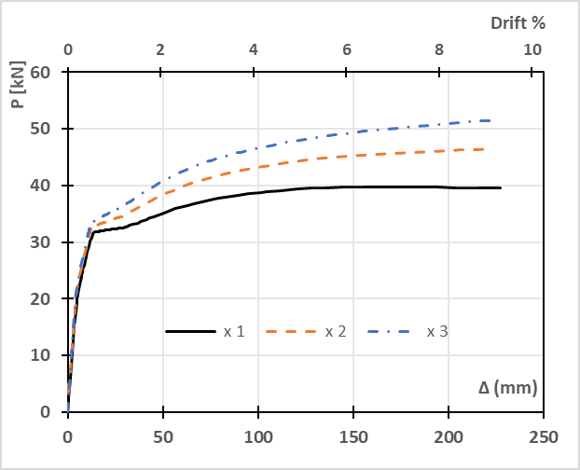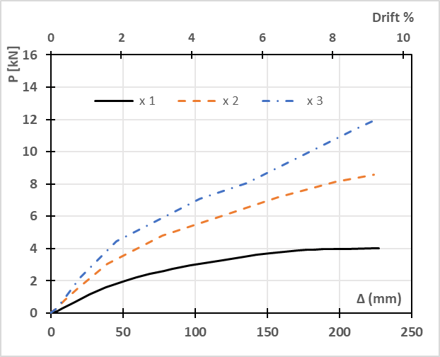
a)
b)
Fig. 20 Lateral load-displacement curves for frames with different thicknesses a) bare frame, b) frame with diagonal straps

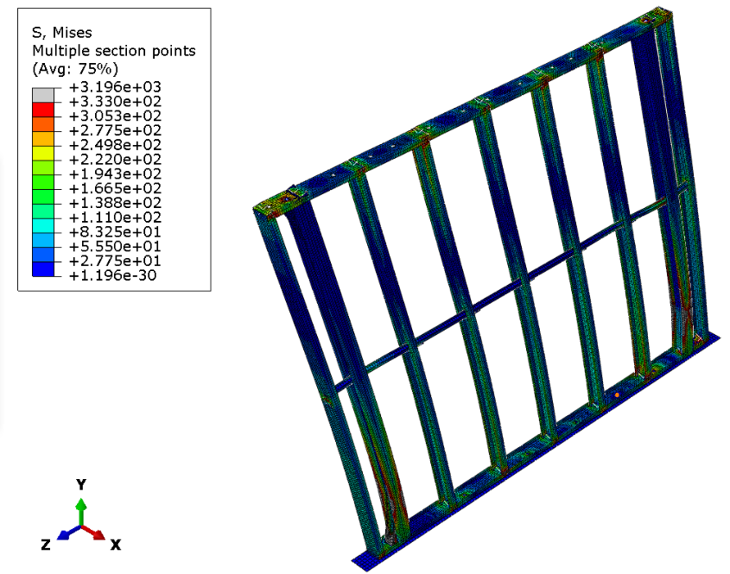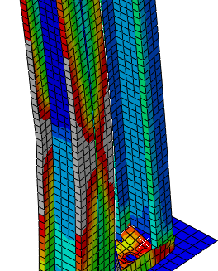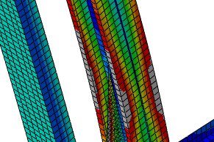
Fig. 21 Yielding of the chord studs in a bare frame with twice the original thickness

Fig. 20b shows the lateral load-displacement curves of the bare frames studied in Fig. 20a, with the addition of strap elements with the original thickness of 1.11 mm. The figure demonstrates that the lateral capacity increased by 17% and 30% when doubling and trebling the frame element thicknesses, whereas the ultimate displacement remained practically unaffected. The ductility also remained virtually unchanged, while the wall dissipated around 11% and 19% more energy in the cases with double and triple wall thicknesses, respectively.

Thickness of the chord studs and the tracks
As illustrated in Fig. 22a, increasing the thickness of the chord studs to 2.32 mm and 3.48 mm (twice and three times the original thickness, respectively) yielded increases in lateral capacity of 5.6% and 8.5%, respectively. Negligible differences of less than 2% were also observed in the ultimate displacement, ductility and dissipated energy of the walls. This indicates that, in the absence of vertical loads, the effect of the chord stud thickness on the structural performance of the wall under lateral loads is small. However, this conclusion is only valid as long as the thickness of the chord elements is above a minimum threshold, so that the straps can reach their ultimate strain before failure of the chord studs occurs.
The effect of the track thickness was also studied. For this purpose, two additional track thicknesses of 2.22 mm and 3.33 mm were investigated. Fig. 22b shows the lateral response of the system for each case. The lateral capacity increased slightly by 2.5% and 6.2%, respectively, compared to the original thickness of 1.11 mm. Meanwhile, the deformation capacity and ductility of the wall system remained unaffected. The energy dissipation capacity of the walls increased marginally by 2.4% and 4.7%, respectively. It can be concluded that, in general, the effect of the track thickness on the structural performance of the wall system is negligible.

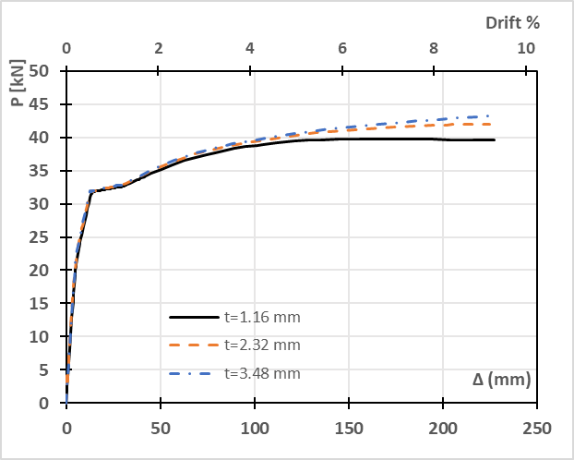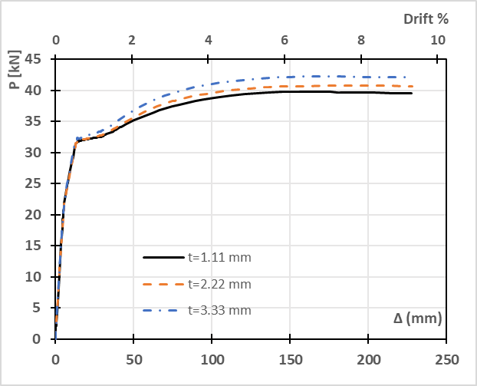
a)
b)
Fig. 22 Lateral load-displacement curves for wall panels with different thickness of a) the chord studs and b) the tracks

Steel grade of the diagonal straps
The structural behaviour of the wall panels was compared when using three different steel grades (S280, S460 and S690) for the diagonal straps. The steel initially used in the validation study and the experiment had a yield stress f_{y}=295 MPa and an ultimate tensile strength f_{u}= 366 MPa, thus classifying as S280 according to Eurocode 3 [3]. For the S460 and S690 grade materials, the stress-strain relationships from the experimental work by Versaillot [55] were adopted. The S460 grade steel had a yield stress f_{y}=487 MPa, an ultimate stress f_{u}=634 MPa and a modulus of elasticity E=205 GPa. The corresponding mechanical properties of the S690 grade steel were f_{y}=800 MPa, f_{u}= 860 MPa and E=202 GPa. The stress-strain curves for the three steel grades are depicted in Fig. 23. The corresponding true stress-strain curves up to the ultimate stress (f_{u}) were inputted into ABAQUS.
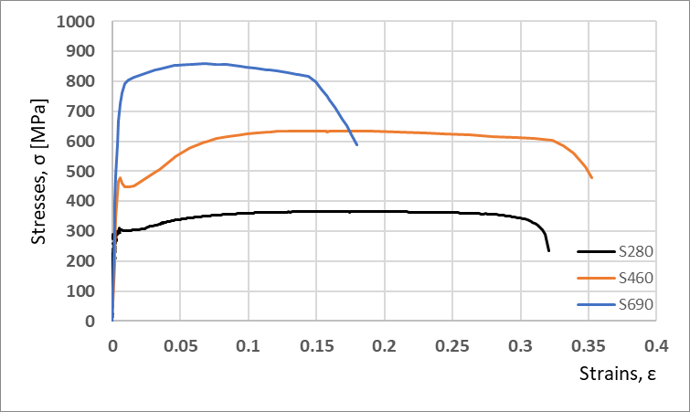
Fig. 23 Stress-strain curves for steel grades S280, S460 and S690
As Fig. 24 shows, the lateral capacity of the wall was considerably affected and increased by 61% for grade S460 and 116% for grade S690, compared to the the original design. The walls with the higher grade steel straps arrived at their ultimate displacement before the straps reached their ultimate strain. This was due to buckling failure of the compressive chord studs as a result of the higher strap force. The ultimate displacement corresponding to the S460 grade straps was 32% lower than for S280, while in the case of the S690 grade straps, it reduced by 60%. The ductility of the wall decreased by 51% in the case of the S460 grade steel and by 81% for the S690 grade steel. Additionally, the energy dissipation capacity remained unaffected for grade S460 and decreased by 21% for S690. These results generally indicate that using higher grade steel for the straps significantly increases the lateral load capacity but may reduce the ductility and energy dissipation capacity.
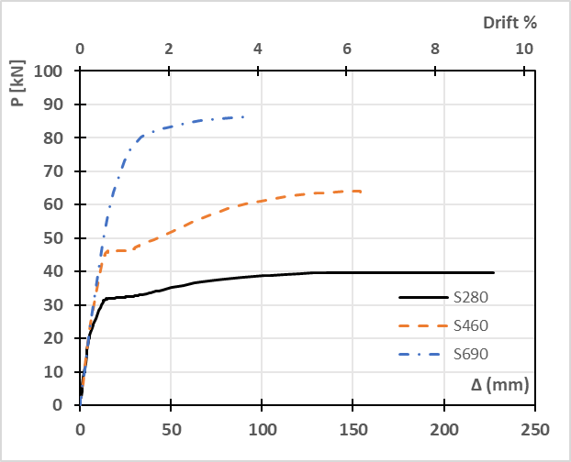
Fig. 24 Lateral load-displacement curves for various steel grades of the diagonal straps

Efficiency assessment of the design solutions
One of the objectives of the present study was to identify which design solutions were most efficient, combining maximum performance with optimal material use. To this end, an “Efficiency Index” (R_{ef}) was defined to evaluate the efficiency of the system with respect to different performance parameters. This index relates the effect that changing a design parameter has on the performance of the system to the corresponding change in material use, according to Eq. (1). “P” stands for the value of the considered performance parameter, while “W” stands for the total weight of the wall. The indices “i” and “v” denote the initial test configuration and the new configuration, respectively.
 | $$Efficiency Index (R_{ef})=\frac{\frac{P_{v}}{P_{i}}}{\frac{W_{v}}{W_{i}}}$$ |  | (1)
(R_{ef}=1) means that the performance of the new design solution relative to its material use is equivalent to that of the original wall. (R_{ef} >1) indicates a better performance-to-weight efficiency, with a higher value indicating a more optimal design solution. On the other hand, (R_{ef} <1) implies an efficiency reduction, with a lower value indicating a less efficient design. The Efficiency Index can be used to rate various design options.
Fig. 25 depicts the Efficiency Index (R_{ef}) for all parametric studies completed in this work (see section 5), considering the following performance parameters: a) the lateral load capacity, b) the deformation capacity, c) the ductility, and d) the energy dissipation. Regarding the lateral load capacity, Fig. 25a shows that increasing the strap thickness yielded a more efficient solution, with R_{ef}=1.83 for the case of a 3.33 mm strap thickness. Choosing S690 steel for the straps led to an even more improved solution, with R_{ef}=2.17. On the other hand, the least efficient result with the lowest R_{ef}=0.48 was obtained when the wall frame thicknesses (excluding the straps) were increased to three times the original thicknesses. The other design solutions did not significantly affect the efficiency linked to the lateral load capacity.
The Efficiency Indices (R_{ef}) for deformation capacity (i.e. ultimate displacement) and ductility are shown in Fig. 25b and Fig. 25c, respectively. In both cases, increasing the thickness of the wall elements and using a higher steel grade for the straps led to lower R_{ef} values, with the maximum value of R_{ef}=1 corresponding to the original configuration. The largest strap thickness proved to have the most adverse effect since it reduced both the deformation capacity and ductility by 80% and increased the steel weight by 31%, leading to an R_{ef}=0.13.
Regarding the energy dissipation (Fig. 25d), the most efficient design solution corresponded to doubling the strap thickness, leading to a maximum R_{ef} value of 1.11. On the other hand, the least efficient solution in terms of energy dissipation occurred for the largest strap thickness of 3.33 mm. Both facts can be explained by the fact that the energy dissipation capacity is equal to the area under the load-displacement curve up to the ultimate point, and when increasing the thickness of the straps, the lateral load capacity increases, while the deformation capacity may decrease.
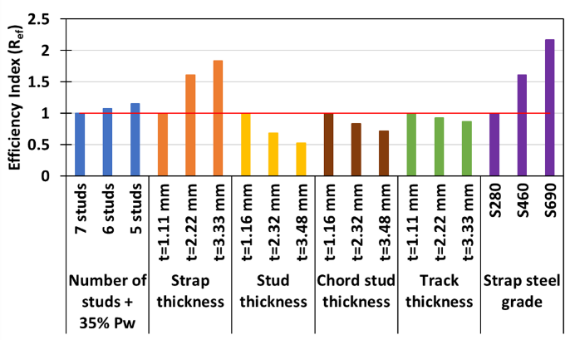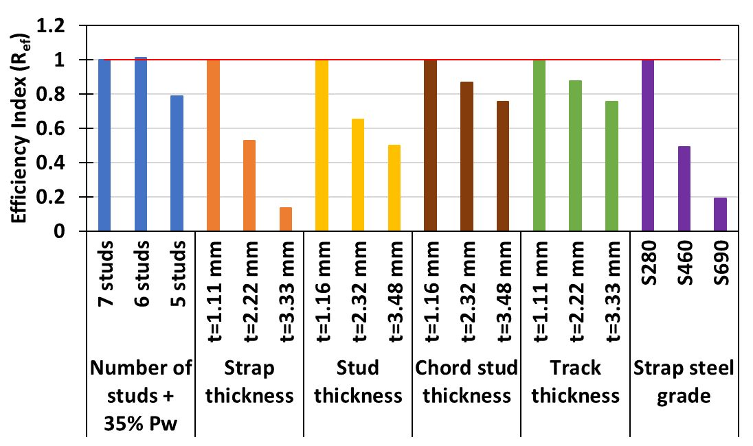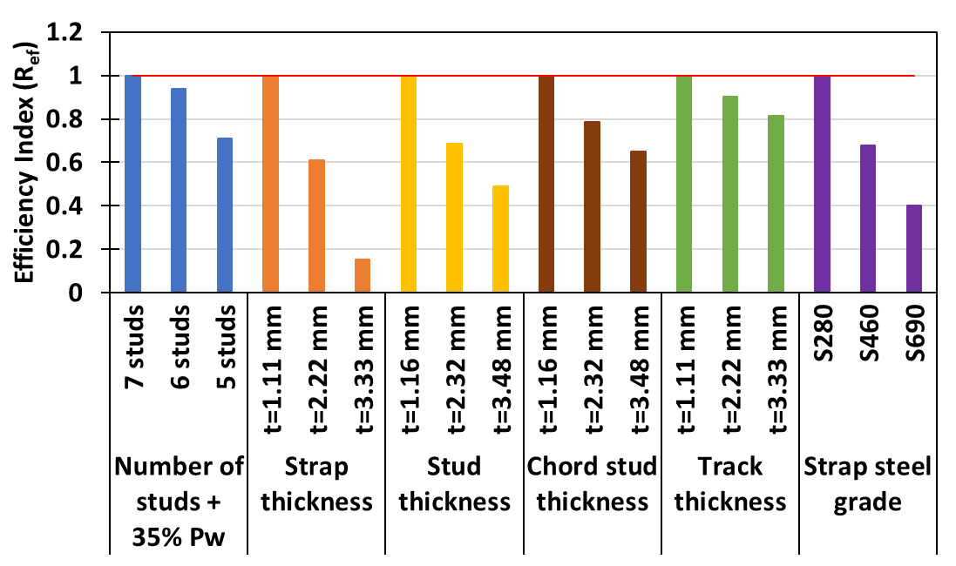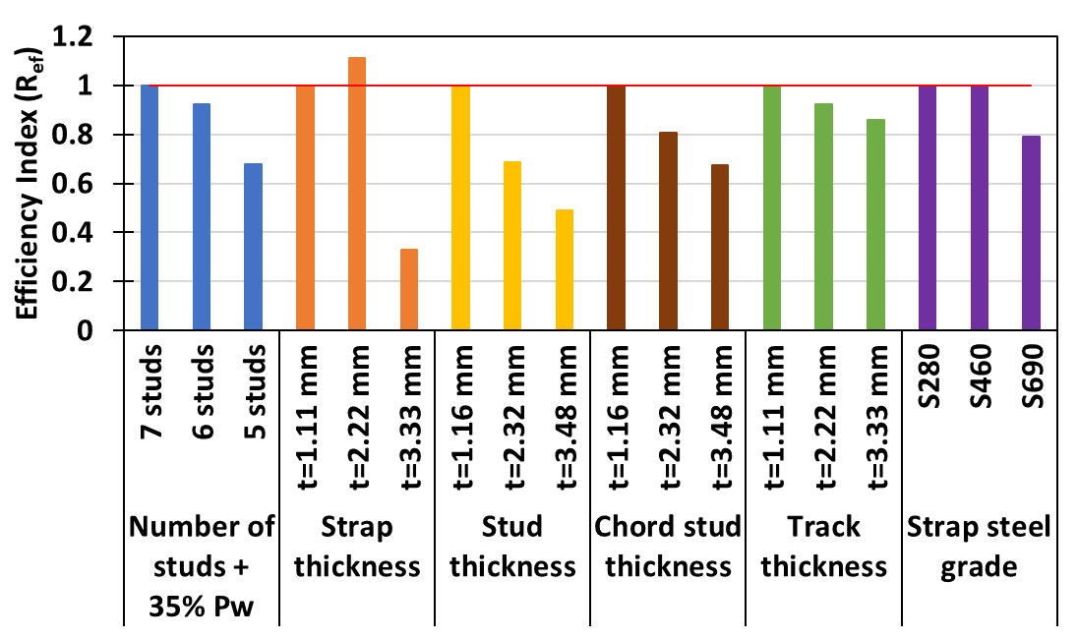
a)
b)
c)
d)
Fig. 25 Efficiency Index (R_{ef}) for a) lateral capacity, b) deformation capacity, c) ductility, and d) energy dissipation

Summary and Conclusions
The work presented in this paper aimed to develop a better understanding of the lateral behaviour of CFS strap-braced stud walls and study the effect of key design parameters, such as the presence of vertical load, the number of studs, the thickness of the structural CFS elements and the steel grade of the straps, on the seismic performance of these systems. To achieve this, a detailed FE model was developed in ABAQUS, accounting for the nonlinear material behaviour of the structural components, initial geometric imperfections, secondary moments due to P-Δ effects and nonlinear behaviour of the connections. The model was validated against previously reported experimental results and shown to be capable of accurately predicting the response of the test specimens regarding stiffness, yield and ultimate displacements, and failure modes. The FE models were further used to conduct parametric studies, investigating the effect of the design parameters on critical performance criteria, such as the lateral load-bearing capacity, deformation capacity, ductility and energy dissipation. An Efficiency Index (R_{ef}) was proposed, which relates the impact of the variation of each design parameter on the strength, deformation capacity, ductility or energy dissipation of the system to the corresponding change in material use, and allows design solutions to be rated. The research work led to the following main conclusions pertaining to CFS strap-braced walls:
- Additional vertical loading has a significant adverse effect on all key performance parameters. In the studied configuration a vertical load level of 50% P_{w} caused a 25 % drop in the lateral load capacity. Both the deformation capacity and the ductility decreased by almost 70%, while the system dissipated 76% less energy.
- The bare CFS frame (without straps) has a small but non-negligible resistance against lateral loads, resulting from the clamping effect provided by the hold-down devices and the resulting bending developing in the chord studs. However, a study of the efficiency indices R_{ef} indicates that increasing the thickness of the chord studs is an inefficient way to increase the lateral load capacity.
- The lateral load-bearing capacity is most significantly affected by the strap thickness and the steel grade of the diagonal straps. As expected, thicker straps and higher grade steel lead to a higher capacity, provided that the chord studs can withstand the increased vertical compressive component of the strap force.
- Increasing the strap thickness and the strap steel grade can also dramatically improve the efficiency of the design, as measured by the Efficiency Index for the lateral load capacity.
- The chord studs need to be designed for the additional compressive force and moment resulting from the P-Δ effects present at the time when the straps reach their required level of strain, corresponding to the target performance levels of ductility and energy dissipation. The increase in the strap force due to strain hardening of the strap material also needs to be accounted for when designing the chord stud.
- The deformation capacity and ductility of the wall can be adversely affected by choosing a larger strap thickness or a higher grade strap if the above point is ignored.
- The energy dissipation capacity strongly depends on the strap thickness since this is the crucial parameter affecting both the ultimate capacity and the deformation capacity. The analyses showed that there exists an optimum strap thickness, beyond which there is a significant drop in energy dissipation capacity due to low deformation capacity caused by chord stud buckling failure.
Declaration of competing interest
The authors declare that they have no known competing financial interests or personal relationships that could have appeared to influence the work reported in this paper.

Acknowledgements
The authors would like to thank Prof. C.A. Rogers at the Department of Civil Engineering and Applied Mechanics, McGill University, for making previous experimental data available, which facilitated the development of the numerical models, and Dr F.J. Ortiz, previously at the Department of Civil and Structural Engineering, The University of Sheffield, for sharing the experimental results of the shear lap tests.

References
[1] P. Sharafi, M. Mortazavi, N. Usefi, K. Kildashti, H. Ronagh, B. Samali, Lateral force resisting systems in lightweight steel frames: Recent research advances, Thin-Walled Struct. 130 (2018) 231–253. https://doi.org/10.1016/j.tws.2018.04.019.
[2] D. Dubina, V. Ungureanu, R. Landolfo, Design of cold-formed steel structures, 1st ed., ECCS, 2012.
[3] CEN, Eurocode 3: Design of steel structures - Part 1-3: General rules - Supplementary rules for cold-formed members and sheeting, European Committee for Standardization, 2006.
[4] O. Iuorio, V. Macillo, M.T. Terracciano, T. Pali, L. Fiorino, R. Landolfo, Seismic response of Cfs strap-braced stud walls: Experimental investigation, Thin-Walled Struct. 85 (2014) 466–480. https://doi.org/10.1016/j.tws.2014.09.008.
[5] A. Mirzaei, R.H. Sangree, K. Velchev, G. Comeau, N. Balh, C.A. Rogers, B.W. Schafer, Seismic capacity-based design of narrow strap-braced cold-formed steel walls, J. Constr. Steel Res. 115 (2015) 81–91. https://doi.org/10.1016/j.jcsr.2015.08.023.
[6] M. Al-Kharat, C.A. Rogers, Inelastic performance of cold-formed steel strap braced walls, J. Constr. Steel Res. 63 (2007) 460–474. https://doi.org/10.1016/j.jcsr.2006.06.040.
[7] M. Al-Kharat, C.A. Rogers, Inelastic performance of screw-connected cold- formed steel strap-braced walls, Can. J. Civ. Eng. 35 (2008) 11–26. https://doi.org/10.1139/L07-081.
[8] ASCE, ASCE 7-05 Minimum design loads for buildings and other structures, ASCE Stand. (2005) 608. https://doi.org/10.1061/9780784412916.
[9] K. Velchev, Inelastic Performance of Screw Connected CFS Strap Braced Walls Research Report RP08-5, 2008. https://scholarsmine.mst.edu/ccfss-aisi-spec/88.
[10] S. Kasaeian, N. Usefi, H. Ronagh, S. Dareshiry, Seismic performance of CFS strap-braced walls using capacity-based design approach, J. Constr. Steel Res. 174 (2020). https://doi.org/10.1016/j.jcsr.2020.106317.
[11] G. Comeau, Inelastic Performance of Welded CFS Strap Braced Walls Research Report RP08-4, 2008. https://scholarsmine.mst.edu/ccfss-aisi-spec/87.
[12] K. Velchev, G. Comeau, N. Balh, C.A. Rogers, Evaluation of the AISI S213 seismic design procedures through testing of strap braced cold-formed steel walls, Thin-Walled Struct. 48 (2010) 846–856. https://doi.org/10.1016/j.tws.2010.01.003.
[13] AISI S213, S213-07/S1-09. North American Standard for Cold-Formed Steel Framing - Lateral Design, 2007 Edition with Supplement No.1, American Iron and Steel Institute, Washington DC, 2012.
[14] Y.S. Tian, J. Wang, T.J. Lu, Racking strength and stiffness of cold-formed steel wall frames, J. Constr. Steel Res. 60 (2004) 1069–1093. https://doi.org/10.1016/j.jcsr.2003.10.002.
[15] H. Moghimi, H.R. Ronagh, Performance of light-gauge cold-formed steel strap-braced stud walls subjected to cyclic loading, Eng. Struct. 31 (2009) 69–83. https://doi.org/10.1016/j.engstruct.2008.07.016.
[16] S. Lu, C.A. Rogers, Influence of gypsum panels on the response of cold-formed steel framed strap-braced walls, in: CCFSS Proc. Int. Spec. Conf. Cold-Formed Steel Struct., 2018: pp. 925–939. https://scholarsmine.mst.edu/isccss/24iccfss/session12/7.
[17] T.W. Kim, J. Wilcoski, D.A. Foutch, M.S. Lee, Shaketable tests of a cold-formed steel shear panel, Eng. Struct. 28 (2006) 1462–1470. https://doi.org/10.1016/j.engstruct.2006.01.014.
[18] L. Fiorino, B. Bucciero, R. Landolfo, Shake table tests of three storey cold-formed steel structures with strap-braced walls, Bull. Earthq. Eng. 17 (2019) 4217–4245. https://doi.org/10.1007/s10518-019-00642-z.
[19] J. Lange, B. Naujoks, Behaviour of cold-formed steel shear walls under horizontal and vertical loads, Thin-Walled Struct. 44 (2007) 1214–1222. https://doi.org/10.1016/j.tws.2007.01.007.
[20] M. Accorti, N. Baldassino, R. Zandonini, F. Scavazza, C.A. Rogers, Response of CFS Sheathed Shear Walls, Structures. 7 (2016) 100–112. https://doi.org/10.1016/j.istruc.2016.06.009.
[21] J. Ye, R. Feng, W. Chen, W. Liu, Behavior of cold-formed steel wall stud with sheathing subjected to compression, J. Constr. Steel Res. 116 (2016) 79–91. https://doi.org/10.1016/j.jcsr.2015.08.028.
[22] L. Fiorino, S. Shakeel, V. Macillo, R. Landolfo, Seismic response of CFS shear walls sheathed with nailed gypsum panels: Numerical modelling, Thin-Walled Struct. 122 (2018) 359–370. https://doi.org/10.1016/j.tws.2017.10.028.
[23] S.G. Buonopane, G. Bian, T.H. Tun, B.W. Schafer, Computationally efficient fastener-based models of cold-formed steel shear walls with wood sheathing, J. Constr. Steel Res. 110 (2015) 137–148. https://doi.org/10.1016/j.jcsr.2015.03.008.
[24] J. Henriques, N. Rosa, H. Gervasio, P. Santos, L.S. da Silva, Structural performance of light steel framing panels using screw connections subjected to lateral loading, Thin-Walled Struct. 121 (2017) 67–88. https://doi.org/10.1016/j.tws.2017.09.024.
[25] B. Van Lancker, D. Sonck, W. De Corte, J. Belis, Lateral stiffness of cold-formed steel shear wall panels braced with glass panes : A numerical study, in: Proc. Annu. Stab. Conf. Struct. Stab. Res. Counc., 2015: pp. 1–14. http://hdl.handle.net/1854/LU-5931744.
[26] N.K.A. Attari, S. Alizadeh, S. Hadidi, Investigation of CFS shear walls with one and two-sided steel sheeting, J. Constr. Steel Res. 122 (2016) 292–307. https://doi.org/10.1016/j.jcsr.2016.03.025.
[27] S.E. Niari, B. Rafezy, K. Abedi, Numerical Modeling and Finite Element Analysis of Steel Sheathed Cold-Formed Steel Shear Walls, 15th World Conf. Earthq. Eng. Lisbon Port. (2012).
[28] M. Zeynalian, H.R. Ronagh, A numerical study on seismic performance of strap-braced cold-formed steel shear walls, Thin-Walled Struct. 60 (2012) 229–238. https://doi.org/10.1016/j.tws.2012.05.012.
[29] M. Gerami, M. Lotfi, R. Nejat, Inelastic behavior of cold-formed braced walls under monotonic and cyclic loading, Int. J. Adv. Struct. Eng. 7 (2015) 181–209. https://doi.org/10.1007/s40091-015-0091-8.
[30] Dassault Systèmes Simulia, Abaqus 6.14 CAE User Guide, 2014.
[31] N. Usefi, P. Sharafi, H. Ronagh, Numerical models for lateral behaviour analysis of cold-formed steel framed walls: State of the art, evaluation and challenges, Thin-Walled Struct. 138 (2019) 252–285. https://doi.org/10.1016/j.tws.2019.02.019.
[32] N. Usefi, H. Ronagh, P. Sharafi, Numerical modelling and design of hybrid cold-formed steel wall panels, Thin-Walled Struct. 157 (2020) 107084. https://doi.org/10.1016/j.tws.2020.107084.
[33] J. Ye, S.M. Mojtabaei, I. Hajirasouliha, P. Shepherd, K. Pilakoutas, Strength and deflection behaviour of cold-formed steel back-to-back channels, Eng. Struct. 177 (2018) 641–654. https://doi.org/10.1016/j.engstruct.2018.09.064.
[34] J. Ye, I. Hajirasouliha, J. Becque, A. Eslami, Optimum design of cold-formed steel beams using Particle Swarm Optimisation method, J. Constr. Steel Res. 122 (2016) 80–93. https://doi.org/10.1016/j.jcsr.2016.02.014.
[35] P. Kyvelou, L. Gardner, D.A. Nethercot, Finite element modelling of composite cold-formed steel flooring systems, Eng. Struct. 158 (2018) 28–42. https://doi.org/10.1016/j.engstruct.2017.12.024.
[36] C.A. Rogers, Personal communication through e-mail, 2018.
[37] L. Fiorino, O. Iuorio, V. Macillo, M.T. Terracciano, T. Pali, R. Landolfo, Seismic Design Method for CFS Diagonal Strap-Braced Stud Walls: Experimental Validation, J. Struct. Eng. 142 (2016) 04015154. https://doi.org/10.1061/(ASCE)ST.1943-541X.0001408.
[38] S. Yan, B. Young, Screwed connections of thin sheet steels at elevated temperatures - Part II: Transient state tests, Eng. Struct. 35 (2012) 228–233. https://doi.org/10.1016/j.engstruct.2011.10.027.
[39] R. Serrette, D. Peyton, Strength of Screw Connections in Cold-Formed Steel Construction, J. Struct. Eng. 135 (2009) 951–958. https://doi.org/10.1061/(ASCE)0733-9445(2009)135:8(951).
[40] M. Casafont, A. Arnedo, F. Roure, A. Rodríguez-Ferran, Experimental testing of joints for seismic design of lightweight structures. Part 2: Bolted joints in straps, Thin-Walled Struct. 44 (2006) 677–691. https://doi.org/10.1016/j.tws.2006.04.006.
[41] M. Casafont, A. Arnedo, F. Roure, A. Rodríguez-Ferran, Experimental testing of joints for seismic design of lightweight structures. Part 3: Gussets, corner joints, x-braced frames, Thin-Walled Struct. 45 (2007) 637–659. https://doi.org/10.1016/j.tws.2007.05.008.
[42] T. Pekoz, Design of Cold-Formed Steel Screw Connections, in: Tenth Int. Spec. Conf. Cold-Formed Steel Stuctures, 1990: pp. 575–588. https://scholarsmine.mst.edu/isccss/10iccfss/10iccfss-session6/1.
[43] A.W. Tomà, J.W.B. Stark, Connections in Cold-formed Sections and Steel, in: - 4th Int. Spec. Conf. Cold-Formed Steel Struct., 1978: pp. 951–987. https://scholarsmine.mst.edu/isccss/4iccfss/4iccfss-session4/5.
[44] H.S. Pham, C.D. Moen, Stiffness and strength of single shear cold-formed steel screw- fastened connections, Report No. CE/VPI-ST-15-07, VirginiaTech, 2015.
[45] A.I. and S. Institute, AISI S100-16 North American Specification for the Design of Cold-Formed Steel Structural Members, 2016.
[46] F.J. Meza, The Behaviour of Cold-Formed Steel Built-up Structural Members, PhD Thesis, The University of Sheffield, 2018.
[47] F. Meza, J. Becque, Experimental and numerical investigation of cold-formed steel built-up stub columns, in: Eurosteel 2017, Copenhagen, 2017. https://doi.org/10.1002/cepa.205.
[48] B.. Schafer, T. Peköz, Computational modeling of cold-formed steel: characterizing geometric imperfections and residual stresses, J. Constr. Steel Res. 47 (1998) 193–210. https://doi.org/10.1016/S0143-974X(98)00007-8.
[49] X. Yun, L. Gardner, Stress-strain curves for hot-rolled steels, J. Constr. Steel Res. 133 (2017) 36–46. https://doi.org/10.1016/j.jcsr.2017.01.024.
[50] V. Macillo, S. Shakeel, L. Fiorino, R. Landolfo, Development and calibration of a hysteretic model for cfs strap braced stud walls, Adv. Steel Constr. 14 (2018) 337–360. https://doi.org/10.18057/IJASC.2018.14.3.2.
[51] FEMA 356, Prestandard and Commentary for the Seismic Rehabilitation of Building, Washington, D.C., 2000.
[52] V. Gioncu, Framed structures. Ductility and seismic response: General Report, J. Constr. Steel Res. 55 (2000) 125–154. https://doi.org/10.1016/S0143-974X(99)00081-4.
[53] CEN, Eurocode 8: Design of structures for earthquake resistance - Part 1: General rules, seismic actions and rules for buildings, European Committee for Standardization, 2004.
[54] CEN, Eurocode 3: Design of steel structures - Part 1-1: General rules and rules for buildings, European Committee for Standardization, 2010.
[55] P. Versaillot, Effects Of Cyclic Loading On The Mechanical Properties Of Steel, Universitatea Politehnica Timisoara, Romania, 2017.

