Glucose-responsive insulin delivery for type 1 diabetes: The artificial pancreas story
Lia Bally^{1,2}, Hood Thabit ^{3,4} and Roman Hovorka^{5,6}
¹Department of Diabetes, Endocrinology, Clinical Nutrition & Metabolism, Inselspital, Bern University Hospital, University of Bern, Switzerland
²Department of General Internal Medicine, Inselspital, Bern University Hospital, University of Bern, Switzerland
³Central Manchester University Hospitals NHS Foundation Trust, Manchester Academic Health Science Centre, Manchester, UK, United Kingdom
⁴Division of Diabetes, Endocrinology and Gastroenterology, Faculty of Biology, Medicine and Health, University of Manchester, UK, United Kingdom
⁵Wellcome Trust-MRC Institute of Metabolic Science, University of Cambridge, Cambridge, United Kingdom
⁶Department of Paediatrics, University of Cambridge, Cambridge, United Kingdom

Correspondence
Lia Bally, MD, PhD
lia.bally@insel.ch, +41 031 632 36 77
Department of Diabetes, Endocrinology, Clinical Nutrition and Metabolism and
Department of General Internal Medicine
Inselspital, Bern University Hospital, University of Bern
Freiburgstrasse, 3010 Bern

Abstract (max 200 words)
Insulin replacement therapy is integral to the management of type 1 diabetes, which is characterised by absolute insulin deficiency. Optimal glycaemic control, as assessed by glycated haemoglobin, and avoidance of hyper- and hypoglycaemic excursions have been shown to prevent diabetes-related complications. Insulin pump use has increased considerably over the past decade with beneficial effects on glycaemic control, quality of life and treatment satisfaction. The advent and progress of ambulatory glucose sensor technology has enabled continuous glucose monitoring based on real-time glucose levels to be integrated with insulin therapy. Low glucose and predictive low glucose suspend systems are currently used in clinical practice to mitigate against hypoglycaemia, and provide the first step towards feedback glucose control. The more advanced technology approach, an artificial pancreas or a closed-loop system, gradually increases and decreases insulin delivery in a glucose-responsive fashion to mitigate against hyper- and hypoglycaemia. Randomised outpatient clinical trials over the past 5 years have demonstrated the feasibility, safety and efficacy of the approach, and the recent FDA approval of the first single hormone closed-loop system establishes a new standard of care for people with type 1 diabetes.

Words: 186

Key words: insulin pump therapy, continuous glucose monitoring, closed-loop, artificial pancreas, control algorithm (max 7)

- Introduction
Type 1 diabetes represents 5-10% of diabetes cases worldwide. The prevalence over the past 20 years however has doubled, increasing the burden of the condition for individuals and society¹. The cause of type 1 diabetes is an absolute insulin deficiency due to autoimmune destruction of beta-cells¹. Thus, the mainstay of type 1 diabetes treatment is insulin replacement therapy with the goal of achieving near normoglycaemia to reduce the risk of diabetes-related micro- and macrovascular complications². However, tight glycaemic control increases the risk of hypoglycaemia with potentially severe acute and long-term sequelae³.
Successful management of type 1 diabetes entails frequent glucose monitoring and insulin dose adjustment. Conventional insulin therapy management is based on the administration of prandial insulin at meal-times, and basal insulin to control glycaemia during fasting and between meals (Figure 1). The introduction of insulin pump therapy and insulin analogues into clinical practice has allowed modern insulin therapy to become more flexible to suit individuals’ lifestyle. Still, the lack of a physiological-like feedback for insulin delivery prevents recommended therapy targets to be achieved as daily insulin requirements can vary widely due to complex interactions between the nutritional intake, physical activity and hormonal milieu⁴.
Advances in diabetes technology over the past decades have led to the development of continuous glucose monitoring (CGM) which measure the real-time interstitial glucose concentration⁵. Conventional CGM sensors are externally worn. Recently however, an implantable CGM with sensor life of up to six months have been developed [http://www.senseonics.com/investor-relations/news-releases/2017/09-12-2017-213230489]. Coupling of CGM to insulin delivery via a control algorithm, known as a closed-loop system or the artificial pancreas, has enabled device-centred automated glucose-responsive insulin delivery to be progressed⁶. This allows modulation of insulin-delivery to address the constantly changing insulin requirements and to reduce the burden of daily self-management.
In this review article, we outline the present landscape of insulin pump therapy and introduce the concept of glucose-responsive automated insulin delivery or closed-loop systems. Current limitations and future developments of closed-loop therapy are also discussed.

- Insulin pump therapy
Continuous subcutaneous insulin infusion, commonly known as “insulin pump therapy”, was introduced in the 1970s⁷. It is increasingly used in clinical practice as an alternative to multiple daily injection (MDI) therapy. The increased uptake of insulin pump therapy is in part due to the Diabetes Control and Complications Trial (DCCT, 1993), which showed significant decrease in microvascular disease risk with intensive insulin therapy². The evidence from clinical studies evaluating the safety, clinical and cost effectiveness of insulin pump therapy has been published⁸. Guidelines and recommendation for insulin pump therapy are available for health care professionals involved in the management of people with type 1 diabetes⁹.

  - Insulin pump features and functionalities
The advantage of insulin pumps over injection therapy is the ability to set different pre-programmed basal rates of insulin delivery throughout the day to match the individual’s varying diurnal insulin needs¹⁰. Moreover, insulin pumps allow for meal insulin to be delivered using different bolus profiles, to suit meals of different macronutrient composition and absorption; insulin boluses can either be delivered immediately (known as standard, immediate or step bolus), or over several hours (square or extended wave bolus), or as a combination of the two (dual wave bolus). Modern insulin pumps have integrated bolus calculators used by the user to determine the appropriate insulin bolus dose, by inputting pre-meal blood glucose levels and estimated carbohydrate intake. The bolus calculator provides the recommended bolus dose by taking into account the pre-programmed target glucose, insulin sensitivity, insulin to carbohydrate ratio and amount of active insulin remaining (known as insulin on board)¹¹. Most insulin pump devices have alarms to alert the user in case of an occlusion or other technical malfunctions to increase safety of the approach. Glucose, insulin and user specific data, such as bolusing behaviour, can be downloaded and used by users and healthcare professionals to identify areas requiring further attention to optimise glycaemic control.
Conventional insulin pump devices deliver insulin via plastic tubing, and teflon or steel cannula changed every 2-3 days and inserted subcutaneously. Disadvantages include the aesthetic concerns and the risk of kinking or disconnection of the tubing. Tubingless or patch pumps have an integrated short infusion cannula and are attached directly to the body with an adhesive patch. However, the remote controller might get lost or forgotten disabling bolus application.
The use of insulin pumps can be augmented by the use of CGM. The approach is known as sensor-augmented pump therapy (SAP). Interstitial glucose is measured every 1-5 min, and glucose values are either sent directly to the pump, or to separate hand-held receiver. User input is needed to manually adjust insulin pump delivery in conventional SAP systems based on CGM or capillary glucose measurements.

  - Clinical evidence in support of insulin pump therapy
A meta-analysis of relatively short-term randomised controlled trials showed a mean reduction in glycated haemoglobin (HbA1c) of 0.3-0.6% (3-6mmol/mol) ^{12,13} during insulin pump therapy compared to MDI. This was accompanied by a 20% reduction in total daily insulin dose. Pooled data from randomised controlled and observational studies, in which users switched from MDI to insulin pump therapy, showed that the greatest improvement in HbA1c occurred in those with the highest baseline HbA1c¹²; those with baseline HbA1c of 9% (75mmol/mol) on MDI showed an HbA1c reduction of approximately 1.5% (16mmol/mol) when switching to insulin pump therapy whilst the reduction was less than 0.5% (5mmol/mol) in those with baseline HbA1c of 7.5% (58mmol/mol).
A further reduction in HbA1c was observed when conventional insulin pump users were switched to SAP with the degree of HbA1c improvement again dependent on baseline HbA1c¹⁴. Regular glucose sensor use was also a determinant factor. An observational study related to long-term outcomes on insulin pump therapy demonstrated sustainability of glycaemic control over prolonged use of insulin pump therapy¹⁵.
The majority of clinical studies have shown that the burden and risk of hypoglycaemia are ameliorated by insulin pump therapy compared to MDI. A meta-analysis of studies evaluating those at increased hypoglycaemia risk showed overall a 75% reduction in severe hypoglycaemia events requiring third party assistance, when users were switched from MDI to insulin pump therapy¹², and the relative risk reduction was at least 10-fold in those with the highest baseline risk. Hypoglycaemia reduction was observed to a lesser extent in children, likely due to the shorter duration of diabetes and a lower baseline frequency of severe hypoglycaemia¹². Hypoglycaemia occurrence has been shown to be related to increased glucose variability¹⁶. Insulin pump therapy has been shown to reduce within-day and between-day glycaemic variability, which may in part contribute towards ameliorating the risk of hypoglycaemia.
A notable difference between older studies such as the Diabetes Control and Complications Trial and more recent studies which compared MDI with insulin pump therapy is the wider use of insulin analogues during the latter. As such, reported outcomes from these studies and meta-analysis may not be directly comparable and need to be interpreted with caution^{12,13,17}. In addition, those with hypoglycaemia-unawareness were often excluded and therefore findings may not be generalizable to those with significant burden of hypoglycaemia¹⁰. The incremental benefits of insulin pump therapy over MDI using novel long-acting insulin analogues which have shown less pharmacodynamics variability, in conjunction with state-of-the-art functional insulin therapy education programmes, remain unclear. Improvements in the quality of life and treatment satisfaction amongst insulin pump users however have been consistently shown¹⁸. A recent study evaluated the glycaemic benefits of insulin pump therapy in adults with type 1 diabetes on MDI regime already using CGM. Participants usedthe G4 sensor (Dexcom, San Diego, CA, USA) and the Insulet OmniPod insulin pump (Insulet, Billerica, MA, USA) during the intervention period. Efficacy endpoints were assessed over a period of 28 weeks and showed a mean reduction in sensor glucose by 0.8mmo/l (14mg/dl), and a 6% or 83min per day increase in time spent with sensor glucose in target range (3.9-10.0mmol/l [70-180mg/dl]), when insulin pump-CGM users werecompared to MDI-CGM. This came at the expense of increased time spent hypoglycaemic¹⁹. HbA1c levels remained unchanged following transition from MDI to insulin pump therapy.

  - Continuous intraperitoneal insulin delivery
Continuous intraperitoneal insulin infusion (CIPII) may confer some advantages due to the more favourable pharmacokinetic profile compared to subcutaneous insulin delivery, with faster absorption rate and restoration of physiological portal-peripheral gradient²⁰. This led to the development of implantable insulin pumps which began in the 1970s. Implantable pumps were initially manufactured by several companies such as Infusaid Inc. (Norwood, MA, USA), MiniMed Inc (Sylmar, CA, USA) and Siemens-Elema (Solna, Sweden). MiniMed Inc. has since merged with Medtronic, and the Minimed 2007 remains the only commercially implantable pump available at present. It is approved for clinical use in Europe, however, it is limited to Medtronic-certified centres in Netherlands, Belgium, Sweden and France.
Despite their theoretical advantages, regulatory approval and implementation of IPI in clinical practice have been limited, due to concerns related to long-term safety, maintenance, costs and regular need of specialist input²¹. Reports and studies evaluating IPI use with surfactant-stabilized U-400 insulin formation and clinical feasibility of IPI have been published, albeit in a small number of users and centres²²⁻²⁴.
The Accu-Chek Diaport system (Roche Diabetes), which involves the use of percutaneous access, is a less invasive approach of CIPII²⁵. It composes of a catheter which is inserted in the peritoneal space and fixed to a surgically implanted metallic body attached to the skin. The outer port (located externally approximately 2-3mm from the skin), is connected to an external insulin pump device (Accu-Chek Spirit Combo pump, Roche Diagnostics, Mannheim, Germany). Infused insulin through the Diaport system is a regular U-100 insulin (Insuman Infusat, Sanofi, Paris, France) as rapid-acting insulin analogues have not been approved for intraperitoneal delivery. In a multi-centre cross-over design study, sixty participants with type 1 diabetes were randomised to intraperitoneal insulin infusion using DiaPort system with regular insulin (Insuman U-100), or subcutaneous insulin pump therapy with lispro for 12 months²⁶. The primary endpoint, incidence of hypoglycaemia, was comparable between both treatments groups (p=0.91), whereas the number of severe hypoglycaemia events was halved during the DiaPort use (34.8 vs. 86.1 events / 100 patient years, p=0.013). The number of participant dropouts however was relatively high (24/30 and 12/30 in the DiaPort and subcutaneous insulin pump group, respectively), which the authors attributed to participants’ fear of potential complications of intraperitoneal delivery, and reluctance to use it. The commonest adverse event is infection around the percutaneous port. The second generation DiaPort was introduced in 2011, re-designed with a Dacron cuff around the percutaneous access port to provide a barrier to infection and better stabilization of the port at the implantation site, which could potentially minimise the incidence of serious or persistent infections. Non-randomised single-arm studies with relatively small number of participants have been performed (i.e. ClinicalTrials.gov NCT01483352); results are yet to be published.

  - Limitations of insulin pump therapy
Modern insulin pumps are provided with alarms for catheter occlusion, pump mechanism failures and low battery. However, if not vigilant or well-trained, pump users could be exposed to clinically significant adverse events due to specific limitations of insulin pump therapy. In contrast to basal bolus MDI regime, the lack of long-acting insulin puts insulin pump users at an increased risk of diabetic ketoacidosis due to insulin deficiency in the event of prolonged catheter displacement, occlusion or kinking. In a cross-sectional survey of pump users, nearly half reported some form of insulin delivery problems, either due to infusion set or pump device issues²⁷. The use of the infusion set longer than 3 days was also associated with insulin delivery and absorption issues. A comparison between steel and teflon catheters found a 15% rate of initial infusion set failure with the latter, due to the catheters kinking on insertion²⁸. This highlights the importance of user and health-care provider adherence to appropriate pump care and guidelines such as sick day rules and set change intervals, to mitigate against common hazards of pump therapy. Post marketing surveillance programmes of pump therapy are needed to ensure safety standards are met and to improve the reliability of pump components by manufacturers. Concerns of potentially higher risk of DKA during insulin pump therapy was recently challenged by a systematic review which reported lower prevalence of DKA in adult insulin pump users compared to MDI²⁹. Likewise, a recent population-based cohort study involving 30,579 individuals aged between 1 and 20 years reported lower risk of ketoacidosis in pump users compared to insulin injection therapy³⁰. This however does not abdicate the need for continuous vigilance and education of insulin pump users.
Health economic analyses have shown that the cost of insulin pump therapy is notably higher than MDI. The annualised cost of pump therapy in the UK, which includes device and consumables expenses over a warranty period, is approximately £1700 greater compared to MDI. In addition, the educational input for pump users is difficult to quantify. Overall, the cost-effectiveness was shown to be in favour of insulin pump therapy relative to MDI, due to an projected 1.2% (2mmol/mol) HbA1c reduction³¹. Others have shown pump therapy to be cost-effective when health economic model such as the Centre for Outcomes Research (CORE), which accounts for the quality of life in addition to HbA1c, was used³². It is important to note that these models currently do not evaluate the burden of hypoglycaemia on the individual and society, such as loss of productivity at work or school, and mental health issues associated with fear of hypoglycaemia.

- Insulin pump therapy with threshold suspend features
SAP has been shown to lead to a significant improvement in diabetes management allowing the user to set personalised alarms. However, users do not always take the appropriate actions following an alert. To reduce the risk of hypoglycaemia, approaches that automatically suspend insulin delivery have been developed and tested in randomised clinical trials (Table 1).

  - Low glucose suspension of insulin delivery
Automatic cessation of insulin delivery at a pre-set threshold sensor glucose value is referred to as low glucose suspend (LGS). A LGS event initiates up to 2 hour suspended insulin delivery; insulin delivery can resumed earlier by the user. The Paradigm VEO system (Medtronic MiniMed, Inc, Northridge, CA, USA) was the first pump with built-in LGS feature and introduced in Europe in 2009. The use of LGS over an extended period of time in hypoglycaemia prone individuals reduced the risk and frequency of nocturnal hypoglycaemia without increasing HbA1c^{33,34}. In 2013, the ASPIRE In-Home Study Group evaluated the effect of SAP with LGS³³ compared to SAP alone, on nocturnal hypoglycaemia and HbA1c levels in participants at increased risk of nocturnal hypoglycaemia (experienced ≥2 nocturnal hypoglycaemic events during the 2-week run-in phase). Mean AUC for nocturnal hypoglycaemic events was significantly decreased by 32% in the LGS group after 3 months compared to control. Time spent hypoglycaemic was also significantly lower in LGS compared to control. Others have shown that the initial excess cost of LGS therapy is balanced by avoidance of hypoglycaemia-related healthcare expenditures ^{35,36}.

  - Predictive low glucose suspension of insulin delivery
Algorithms that suspend insulin delivery before a threshold low glucose value is reached have been developed and are referred to as predictive low glucose suspend (PLGS) systems (i.e. Medtronic MiniMed 640G pump) aiming to reduce further the burden of hypoglycaemia. Briefly, the 640G algorithm suspends insulin delivery when the glucose level is predicted to drop to a level equal to or lower than a pre-set threshold within 30min. Once the predicted glucose is safely above the threshold or after 2h, insulin delivery is resumed (Figure 2). Randomised clinical trials with PLGS have reported reduced nocturnal hypoglycaemia burden compared to SAP. ³⁷PLGS decreased the burden of hypoglycaemia as measured by the median hypoglycaemia area under the curve by 81%, and hypoglycaemia lasting >2h was reduced by 74% in a 42-night randomised trial involving adolescents and adults with type 1 diabetes³⁷. A recent analysis of PLGS use in clinical practice showed reduction of hypo- and hyperglycaemic events during both night and daytime³⁸. Table 1 summarises randomised controlled trials evaluating efficacy of LGS and PLGS in type 1 diabetes.

- Closed-loop Insulin delivery
Closed-loop systems or the artificial pancreas are more advanced than LGS and PLGS system and autonomously and gradually increase and decrease subcutaneous insulin delivery according to real-time sensor glucose levels. Such a glucose-responsive insulin technology aims to mimic physiology of the pancreatic beta cell by providing insulin delivery commensurate with acute individual metabolic needs. Closed-loop insulin delivery has the potential to reduce the burden of diabetes self-management.

  - Closed-loop system components
    - Overview
Closed-loop systems consist of a glucose sensor, an insulin pump and a control algorithm which is either embedded in the pump or residing in a separate device, e.g. a smartphone (Figure 3). These components communicate wirelessly. The key component of a closed-loop system is the control algorithm, which directs insulin delivery according to real-time glucose levels while accounting for inter- and intra-subject variability, inherent sensor and insulin delivery errors as well as kinetic delays. Various algorithms have been developed and the two most commonly used are the proportional-integral-derivative control and the model-predictive control approach³⁹.
    - Proportional-integral-derivative control
The proportional-integral-derivative algorithms adjust insulin delivery by considering deviations from a target glucose level (proportional component), the area under the curve between the measured and target glucose level (integral component), and the rate of change in the measured glucose levels (derivative component).
    - Model predictive control
The model predictive control algorithms employ a mathematical model of glucose regulation to predict glucose excursions. Insulin delivery is calculated by minimizing the difference between model-predicted glucose-concentrations and the target glucose levels over a pre-specified prediction time horizon.
Other clinically evaluated control approaches include the fuzzy logic approach which modulates insulin delivery on the basis of approximate rules to express the empirical knowledge of diabetes practitioners⁴⁰. Most control algorithms include safety modules to constrain insulin delivery, limiting the amount of insulin on board or the maximum rate of insulin delivery, or suspending insulin delivery when glucose levels are low or decreasing.

  - Types of closed-loop systems
    - Overview
The two main approaches are (i) hybrid closed-loop systems that require for optimal performance manual input through user-initiated insulin boluses at meal times and (ii) fully closed-loop systems which operate autonomously without the need for user-initiated prandial insulin boluses. The performance of the latter is limited by the delayed action profile of subcutaneous insulin delivery⁴¹ and is currently not pursued commercially. The hybrid closed-loop system overcomes delays through bolus delivery and announcement to the control algorithm of meals (Figure 4). The hybrid systems are the focus of current translational research.
Closed-loop systems using either single-hormone (insulin only) or dual-hormone (insulin and glucagon) have been studied.
    - Co-delivery of glucagon
Glucagon counteracts insulin action through mobilization of the endogenous glucose production from the liver⁴². The aim of glucagon delivery in closed-loop systems is either to alleviate solely the risk of hypoglycaemia, or to enable insulin to be delivered more aggressively and counteract insulin overdelivery⁴³. The control algorithm of the former is similar to that of a single hormone approach. Glucagon is given intermittently as mini boluses by a separate pump chamber, with daily doses ranging up to 1mg/day⁴³. Currently available glucagon formulations, such as GlucaGen® (Novo Nordisk, Bagsvaerd, Denmark), consist of lyophilized powder that requires daily reconstitution due to protein aggregation and degradation⁴⁴, and as such addition of glucagon to a closed-loop system could therefore impose further burden and complexity to the user.
Co-delivery of
    - incretin-based therapies
Apart from glucagon, use of other hormone-based therapies in combination with closed-loop insulin delivery have been proposed. The adjunctive use of amylin analogues and incretin-based therapies may attenuate peak meal-related glucose appearance and improve postprandial glycaemia by delaying gastric emptying and suppressing meal-induced glucagon response⁴⁵.
Pramlintide is a synthetic analogue of amylin and has been shown to improve postprandial-prandial glucose control when injected pre-meal during single-hormone closed-loop operation⁴⁶. Combining single-hormone closed-loop insulin-delivery with a GLP-1 receptor agonist (liraglutide) was shown to mitigate against meal-induced glycaemic excursions whilst having an insulin-sparing effect, when compared to adjunct use of amylin⁴⁷. The addition of DPP-4 inhibitor to single-hormone closed-loop improved postprandial glycaemic control, compared to closed-loop alone⁴⁸. Despite its benefit however, concerns regarding gastrointestinal side-effects remain.

  - From prototypes to commercial hybrid closed-loop pump
Several closed-loop prototypes have been developed by different academic and commercial entities. Academic prototypes host the control algorithm on a separate device, such as a smartphone, to ease development and regulatory issues (Figure 5A). In September 2016, the US Food and Drug Regulatory Authority approved the first commercial closed-loop system (MiniMed® 670G pump, Medtronic, Northridge, CA) for use in clinical practice, based on a non-randomised safety-focused pivotal clinical trial⁴⁹. 670G pump is a single-hormone hybrid closed-loop system, with the control algorithm integrated in the pump (Figure 5B). It is expected that 670G pump will be available in Europe in 2018/2019. Other groups and manufacturers are also currently developing closed-loop systems for commercialisation. Bigfoot Smartloop™ system and the Omnipod Artificial Pancreas™ system are both undergoing pilot clinical evaluations (NCT02849288 and NCT02897557, respectively). Closed-loop systems developed by Type Zero Inc (http://typezero.com/) and the DIABELOOP consortium are undergoing multicentre pivotal testing (NCT02985866 and NCT02987556, respectively). Commercialisation of a bi-hormonal closed-loop system in Europe is planned⁵⁰. An integrated dual-hormone system (ILet) is currently being tested in a feasibility trial in the US (NCT02701257). Do-it-yourself closed-loop systems are being developed and used by the sizable open-source community (https://openaps.org).

  - Clinical evidence
Over the past decade, clinical studies have progressed from controlled research facility⁵¹ and supervised transitional settings^{52,53} to free-living home studies^{54,55}. Table 2 summarises the findings from key single- and dual-hormone randomised controlled free-living closed-loop studies. The longest randomised study by Thabit et al contrasted day-and-night hybrid closed-loop use with sensor-augmented pump therapy over three months and showed improvements in time in target glucose range, HbA1c and hypoglycaemia⁵⁴.
A meta-analysis including 585 adult and paediatric participants from 24 randomised controlled closed-loop studies showed that closed-loop increased time spent in sensor glucose target range (3.9 – 10.0mmol/l) by approximately 13 percentage points (p<0.0001)⁵⁶. A comparison of time spent hypoglycaemic (sensor glucose<3.9mmol/l) from 463 participants showed that closed-loop reduced time spent hypoglycaemic by 2.5 percentage points or 35min per day (p<0.0001).
The incremental benefits of a single-hormone closed-loop system were reported in a randomised crossover trial by Bally et al involving type 1 diabetes adults with tight glycaemic control (HbA1c<7.5% [58mmol/mol]). A hybrid closed-loop use in adults with baseline HbA1c of 6.9% (52mmol/mol) showed improvement in glucose control whilst reducing the burden of hypoglycaemia⁵⁷. Improvements in time in target and lower mean glucose were also shown using hybrid closed-loop in pregnant women with type 1 diabetes compared to sensor-augmented pump therapy⁵⁸ without increasing the risk of hypoglycaemia.
The largest non-randomised closed-loop study to date by Bergenstal et al involved 124 participants (30 adolescents aged 14-21 years and 94 adults aged 22-75 years) over 3 months with the primary aim being safety rather than efficacy of closed-loop use⁵⁹. In the longest closed-loop study to date, also non-randomised, day-and-night hybrid closed-loop was used in 14 adults over 6 months with median proportion of time in sensor glucose target range [3.9-10.0mmol/l (70-180mg/dl)] of 76% during daytime and 78% during night-time. Closed-loop use declined over time from median values of 87% at the beginning to 70% at the end of the study⁶⁰.
The efficacy and safety of a single-hormone fully closed-loop system with intraperitoneal insulin delivery through the DiaPort system was assessed in a non-randomised parallel design 24-h inpatient study by Dassau et al involving 10 adults with type 1 diabetes⁶¹. Compared to subcutaneous insulin delivery, intraperitoneal insulin delivery with a modified control algorithm led to higher percentage of time with plasma glucose in target range [4.4-7.7mmol/l (79-139mg/dl)] and lower mean plasma glucose (8.4 vs. 10.5mmol/l [151-189mg/dl]) (p=0.03 and p=0.004). In spite of comparable time spent hypoglycaemic (2.5% vs. 4.1%, p=0.42), those receiving intraperitoneal insulin delivery required significantly higher amount of rescue carbohydrates to prevent hypoglycaemia.

  - Limitations
Although a significant progress has been made, further enhancements could improve closed-loop performance. The delayed absorption of present rapid-acting insulin analogues remains a barrier to optimum closed-loop performance⁶² and contributes to a less favourable performance during daytime compared to night-time as meal-related excursions and physical activity induce rapid changes in insulin requirements. As such, the delayed insulin action contributes to the residual risk of hypoglycaemia observed with single-hormone systems in the late post-prandial period and during exercise. Ultrafast insulin analogues with accelerated pharmacokinetics have been developed as a solution to overcome these limitations⁶³. Another approach to enhance the pharmacokinetic profile of subcutaneous insulin delivery comprises local warming devices which accelerates insulin absorption following bolus delivery⁶⁴.
Although the addition of glucagon may confer additional benefits in terms of hypoglycaemia reduction, it also adds to the complexity, cost, and burden of the system to the user. Safety data on the long-term use of subcutaneous glucagon are lacking. A recent qualitative study assessing the psychosocial impact of dual hormone closed-loop system in adults reported a reduction in diabetes-related distress, especially with respect to hypoglycaemia. However, >75% of users highlighted the burden of daily glucagon replacement and carrying multiple devices⁶⁵. Device burden is recognised as an important factor potentially limiting the uptake and sustained use of closed-loop systems, thus highlighting the importance of managing user expectations and needs⁶⁶. Closed-loop users will need to be made aware of the need for associated activities, e.g. the need for sensor calibration, and bolusing for hybrid closed-loop systems, and troubleshooting resilience to resolve, for example, connectivity problems.

- Outlook and conclusion
Closed-loop systems are unique through automated glucose-responsive insulin delivery at hyper- and hypoglycaemia. The FDA approval of the single-hormone hybrid closed-loop system has confirmed closed-loop systems as a realistic therapeutic modality for type 1 diabetes.
Strategies to improve closed-loop technology include the use faster-acting insulin formulations⁶³, local warming devices such as the Insupad⁶⁴, alternative insulin delivery routes⁶¹ and adjunctive incretin-based therapies^{46,47,67}. A further progress in glucose sensor technology may increase sensor accuracy, prolong sensor lifetime and facilitate factory calibration⁶⁸. The Eversense implantable sensor system (Senseonics, Inc., MD, USA), which was recently approved in Europe, allows long-term up to 6 months continuous use of sensor glucose with consistent accuracy throughout its use⁶⁹. The development of stable glucagon formulations⁷⁰ and dual chamber pumps for insulin and glucagon co-delivery may provide incremental benefits to those with increased hypoglycaemia-burden and risk.
Minimising device burden through integration of closed-loop components is likely to enhance user uptake. Cloud-based interface would enable users’ data to be uploaded and viewed by their healthcare professionals, thereby facilitating virtual clinic consultations and remote monitoring by parents and guardians. Personalisation of closed-loop systems can potentially be achieved by more adaptive algorithms³⁹ and the use of input signals related to physical activity and exercise such as heart rate, accelerometry⁷¹.
Longer studies evaluating biomedical and psychosocial outcomes as well as cost-effectiveness are needed to support reimbursement. The immediate impact on existing structured education programmes is unknown and adjustment may be needed. The rapid progress from the bench to bedside has made closed-loop a realistic treatment option and is expected to lead to better care and quality of life for people with type 1 diabetes.

Table 1. Randomised controlled home studies of threshold suspend (low glucose and predictive low glucose)
Reference | Study population | N | intervention | Comparator | Study duration | Primary/co-primary outcome(s)
Bergenstal et al 2013³³ | Adolescents and adults with nocturnal hypoglycaemia. | 147  (121 LGS,  126 SAP) | LGS | SAP | Overnight,  3 months | Nocturnal sensor glucose AUC<3.6mmol/l (65mg/dL). 54.4 vs. 87.0 mmol/lxmin (980 vs. 1568mg/dlxmin), LGS vs. SAP (37.5% lower, p<0.001)
Ly et al 2013³⁴ | Children, adolescents and adults | 95  (46 LGS,  49 pump-only) | LGS | Conventional pump therapy | Day-and-night,  6 months | Combined incidence of severe (seizure or coma) and moderate hypoglycaemia (third party assistance). 9.5 vs. 34.2 events/100 patient months (incidence ratio 3.6, p<0.001), LGS vs. conventional pump therapy
Buckingham et al 2013⁷² | Adolescents | 19 | PLGS | SAP | 21 nights | % of nights with sensor glucose ≤3.9mmol/l (70mg/dl). 16 vs. 30%, PLGS vs. SAP
Buckingham et al 2015⁷³ | Children | 45 | PLGS | SAP | 42 nights | % of time with sensor glucose<3.9mmol/l (70mg/dl). 11-14year-olds: 10.1 vs. 4.6% (54% reduction, p<0.001), 4-10year-olds: 3.1 vs. 6.2% (50% reduction, p<0.001), PLGS vs. SAP.
Maahs et al 2014³⁷ | Adolescents and adults | 45 | PLGS | SAP | 42 nights | % of nights with ≥1 sensor glucose value≤3.3mmol/l (60mg/dl). 21% vs. 33% (OR 0.52, p<0.001), PLGS vs. SAP.
Battelino et al 2017⁷⁴ | Children and adolescents | 100 (50 PLGS, 50 SAP) | PLGS | SAP | Day and night,  2 weeks | Number of hypoglycaemic events<3.6mmol/l (65mg/dl): 4.4 vs.7.4, PLGS vs. SAP (p=0.008).
LGS, Low Glucose Suspend; PLGS, Predictive Low Glucose Suspend; SAP, Sensor-Augmented Pump Therapy

Table 2. Randomised controlled home studies of single-hormone and dual-hormone closed-loop systems
Reference | Study population | N |  | intervention |  | Comparator |  | Study duration and setting | Primary/co-primary outcome(s)
Single hormone closed-loop home studies
Hovorka et al 2014⁷⁵ | Children and adolescents | 16 |  | Single hormone,  hybrid closed-loop |  | SAP |  | Overnight x 3 weeks.  Unsupervised | % of time in sensor target range (3.9-8.0mmol/l [70-144mg/dl]): median 64% vs. 47%, CL vs. SAP (p<0.0001)
Leelarathna et al 2014⁷⁶ | Adults | 17 |  | Single hormone,  hybrid closed-loop |  | SAP |  | Day-and-night  x 7 days. Unsupervised | % of time in target range (3.9-10mmol/l [70-180mg/dl]): median 75% vs. 62%, CL vs. SAP (p=0.005).
Nimri et al 2014⁴⁰ | Adults and adolescents | 19 |  | Single hormone,  hybrid closed-loop |  | SAP |  | Overnight  x 6 weeks. Supervised | % of time below 3.9mmol/l (70mg/dl): median 3% vs. 5%, CL vs. SAP (p=0.02).
Thabit et al 2014⁷⁷ | Adults | 24 |  | Single hormone,  hybrid closed-loop |  | SAP |  | Overnight  x 4 weeks. Unsupervised | % of time in target range (3.9-8.0mmol/l [70-144mg/dl]): mean 53% vs. 39%, CL vs. SAP (p=0.0002).
Nimri et al 2014⁷⁸ | Adults and adolescents | 15 |  | Single hormone,  hybrid closed-loop |  | SAP |  | Overnight  x 4 nights. Unsupervised | % of time below 3.9mmol/l (70mg/dl): median 4% vs. 49%, CL vs. SAP (p=0.0034).
De Bock et al 2015⁷⁹ | Adults and adolescents | 8 |  | Single hormone,  hybrid closed-loop |  | SAP |  | Day-and-night  x 5 days. Supervised | % of time in sensor target range (4.0-9.9mmol/l [72-178mg/dl]): median 67.6% vs. 58.7%, CL vs. SAP+LGS (p =0.233)
Thabit et al 2015⁵⁴ | Adolescents and adults | 58 |  | Single hormone,  hybrid closed-loop |  | SAP |  | Adults: Day-and-night x12weeks. Adolescents: Overnight  x 12 weeks. Unsupervised | % of time in sensor target range (adults 3.0-10mmol/l [54-180mg/dl] adolescents 3.9-8mmol/l [70-144mg/dl]): Adults –mean 67.7% vs. 56.8%, CL vs. SAP (p<0.001). Adolescents – mean 59.7% vs. 34.4% CL vs. SAP (p=0.004).
Kropff J et al⁵⁵ | Adults | 32 |  | Single hormone,  hybrid closed-loop |  | SAP |  | Dinnertime & overnight  x 8 week. Unsupervised | % of time in sensor target range (3.9-10mmol/l [70-180mg/dl]): mean 66.7% vs. 58.1% vs., CL vs. SAP (p <0.001).
Sharifi et al 2016⁸⁰ | Adolescents and adults | 16 |  | Single hormone,  hybrid closed-loop |  | LGS |  | Overnight  x 4 night. Supervised | % of time in sensor target range (4.0-8.0mmol/l [72-144mg/dl]): mean 59.4 vs. 53.1%, CL vs. SAP+LGS (p=0.14).
Tauschmann et al 2016⁸¹ | Adolescents | 12 |  | Single hormone,  hybrid closed-loop |  | SAP |  | Day-and-night  x 3 weeks. Unsupervised. | % of time in target range (3.9-10mmol/l [70-180mg/dl]): mean 66.6% vs. 47.7%, CL vs. SAP (p< 0.001).
Bally et al 2017⁸² | Adults | 29 |  | Single hormone,  hybrid closed-loop |  | Usual pump therapy |  | Day-and-night  x 4 weeks. Unsupervised | % of time in target range (3.9-10mmol/l [70-180mg/dl]): mean 76% vs. 66%., CL vs. pump therapy(p< 0.001).
Forlenza et al 2017⁸³ | Adults | 19 |  | Single hormone,  Hybrid closed-loop |  | SAP |  | Day-and-night  x 2 weeks. Supervised | % time with sensor glucose in target range (3.9-10mmol/l [70-180mg/dl]): 71.6 vs. 65.2%; CL vs. SAP (p= 0.008)
Spaic et al 2017⁸⁴ | Adolescents and adults | 30 |  | Single-hormone  PHHM |  | PLGS |  | Overnight x 42 nights | % time with sensor glucose in target range (3.9-10mmol/l [70-180mg/dl]): 78 vs. 71%, PHHM vs. PLGS nights (p<0.001).
Dual-hormone closed-loop home studies
Haidar et al 2016⁸⁵ | Adolescents and adults | 28 | Dual-hormone,  hybrid closed-loop |  | Single-hormone CL or SAP |  | Overnight x 6 nights. Supervised |  | % time with sensor glucose in target range (4.0-8.0mmol/l [72-144mg/dl]):median 81% vs. 76% vs. 47%, dual-CL vs. single-CL vs. SAP (p =0.5 for dual-CL vs. single CL, p<0.001 for dual-CL vs. SAP, p<0.001 for single-CL vs. SAP)
Blauw et al 2016⁸⁶ | Adults | 16 | Dual-hormone,  fully closed-loop |  | Usual pump therapy |  | 24h at CRF + day-and-night x 3 days at home. Supervised |  | Median glucose: 7.3mmol/l (132mg/dl) vs. 7.7mmol/l (139mg/dl), dual-CL vs. pump therapy (p=0.123).
El Kathib et al 2017⁸⁷ | Adults | 43 | Dual-hormone,  hybrid closed-loop |  | Usual pump with blinded CGM (own CGM use permitted if usual care) |  | Day-and-night x 11 days. Remotely monitored |  | Co-primary outcome (mean glucose and %time with sensor glucose<3.3mmol/l (60mg/dl)): mean glucose 7.8mmol/l (141mg/dl) vs. 9.0mmol/l(162mg/dl) (p<0.0001), 0.6% vs. 1.9% (p<0.0001), dual-CL vs. pump therapy.
Haidar et al 2017⁸⁸ | Adults | 23 | Dual-hormone,  hybrid closed-loop) |  | Single-hormone CL  SAP |  | Day-and-night  x 60h. Supervised |  | %time with sensor glucose<4.0mmol/l (72mg/dl): 3.6% vs. 3.9% vs. 7.9%, dual-CL vs. single CL vs. SAP, p=0.072 for dual-CL vs. single-CL, p=0.002 for dual-CL vs. SAP, p=0.001 for single-CL vs. dual-CL)  P<0.017 considered statistically significant
LGS, Low Glucose Suspend; PLGS, Predictive Low Glucose Suspend; PHHM, Predictive Hyperglycaemia and Hypoglycaemia minimization; SAP, Sensor-Augmented Pump Therapy, CL, Closed-Loop

Declarations
Author contributions: All authors designed the content. LB and HT wrote the manuscript. All authors critically reviewed the report. No writing assistance was provided.
Conflict of interest disclosures: RH reports having received speaker honoraria from Eli Lilly and Novo Nordisk, serving on advisory panel for Eli Lilly and Novo Nordisk, receiving license fees from BBraun and Medtronic; and having served as a consultant to BBraun. LB and HT declare no competing financial interests exist.
Funding/support: LB received support from the Swiss National Science Foundation (P1BEP3_165297). Support for the Artificial Pancreas work by JDRF, National Institute for Health Research Cambridge Biomedical Research Centre, Wellcome Trust Strategic Award (100574/Z/12/Z), EC Horizon 2020 (H2020-SC1-731560), NIDDK (DP3DK112176 and 1UC4DK108520-01).

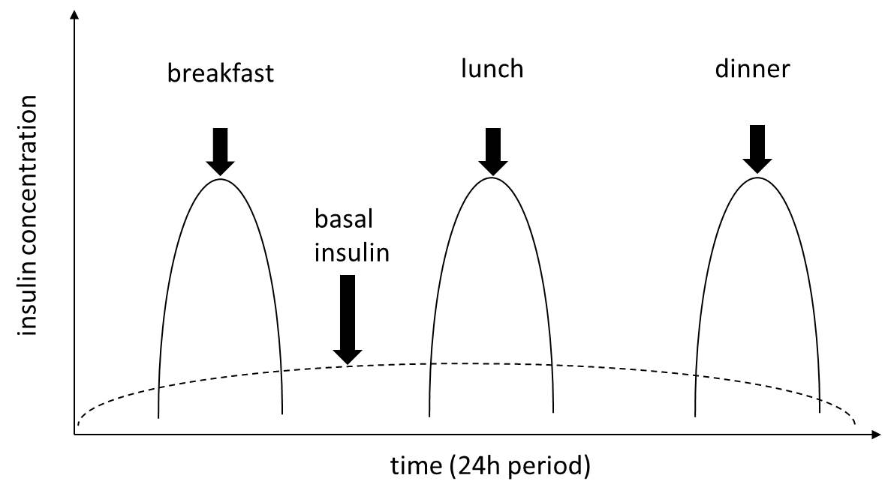
Figure 1. The concept of basal bolus insulin therapy. Basal insulin provides background insulin for periods between meals and overnight. Bolus insulin targets meal-related glucose excursions.

Figure 2. Two predictive low glucose suspend events (including alarms) are shown within the red square. The upper panel shows the sensor glucose profile. Insulin delivery profile is shown in the lower panel.

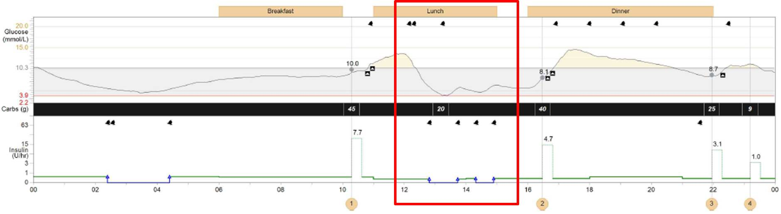

Figure 3. Panel A: A closed-loop system comprising a glucose sensor (black rectangle on the left-hand side of the abdomen), an insulin pump (device in the pocket), and a mobile-sized device containing the control algorithm (in user’s hand). Each component communicates with the other wirelessly (adapted from Hovorka⁸⁹). Panel B: The closed-loop system mimics the physiological feedback normally provided by the β-cell.
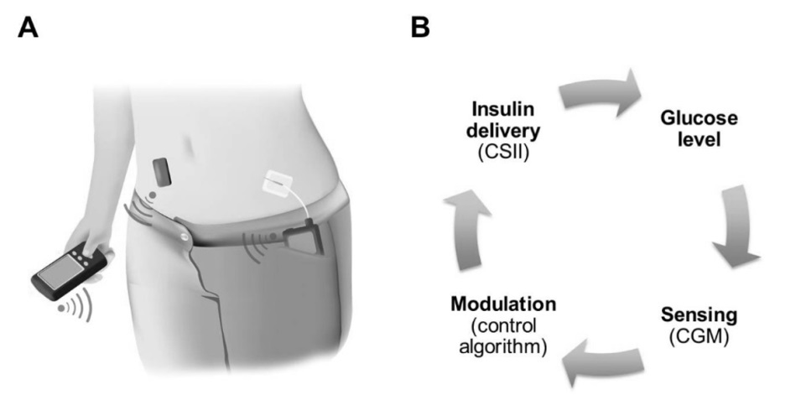

Figure 4. Glucose levels and insulin delivery profiles during a hybrid single hormone closed-loop study⁵⁷. The bold red line shows the continuous subcutaneous glucose trace. Control algorithm-directed insulin infusion rates during closed-loop are denoted by the thick blue line. Vertical arrows indicate meals and snacks (orange arrows) and blue vertical lines illustrate insulin boluses administered by the user at meal times. Horizontal dashed red lines indicate the target glucose range from 3.9 to 10mmol/l.
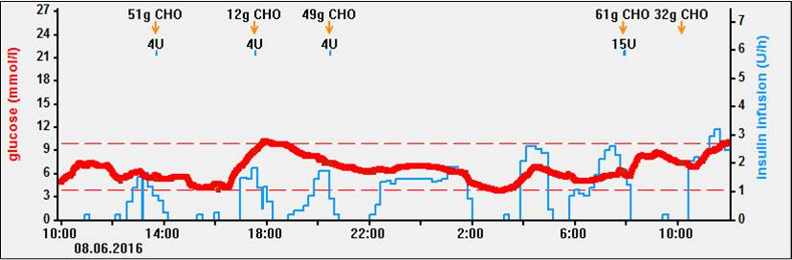
Figure 5. Panel A: FlorenceM hybrid closed-loop prototype (University of Cambridge, Cambridge, UK) using Android phone to host the control algorithm. Panel B: MiniMed 670G hybrid closed-loop pump with embedded control algorithm (Medtronic, Northridge, CA, USA).
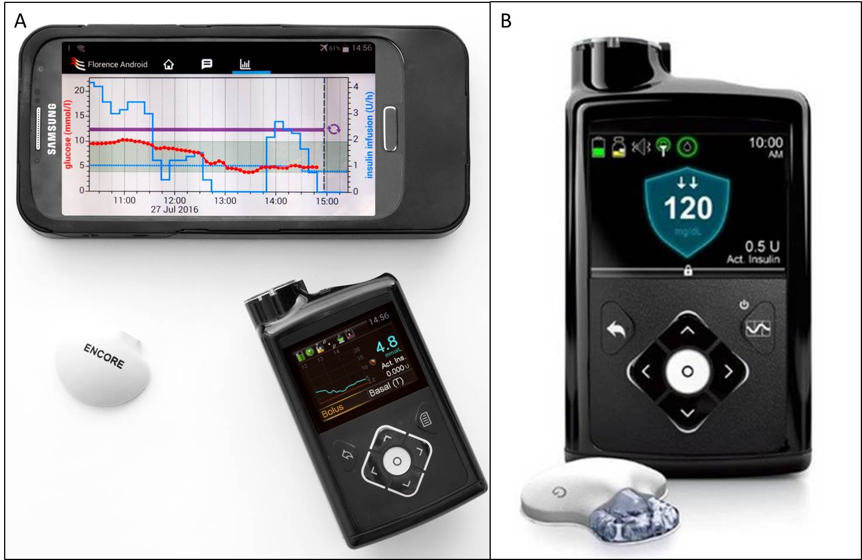

References

1. Atkinson MA, Eisenbarth GS, Michels AW. Type 1 diabetes. Lancet 2014; 383(9911): 69-82.
2. The effect of intensive treatment of diabetes on the development and progression of long-term complications in insulin-dependent diabetes mellitus. The Diabetes Control and Complications Trial Research Group. N Engl J Med 1993; 329(14): 977-86.
3. Frier BM. Hypoglycaemia in diabetes mellitus: epidemiology and clinical implications. Nat Rev Endocrinol 2014; 10(12): 711-22.
4. Ruan Y, Thabit H, Leelarathna L, et al. Variability of insulin requirements over 12 weeks of closed-loop insulin delivery in adults with type 1 diabetes. Diabetes Care 2016; 39(5): 830-2.
5. Rodbard D. Continuous glucose monitoring: A review of successes, challenges, and opportunities. Diabetes Technol Ther 2016; 18 Suppl 2: S23-213.
6. Thabit H, Hovorka R. Coming of age: the artificial pancreas for type 1 diabetes. Diabetologia 2016; 59(9): 1795-805. doi: 10.007/s00125-016-4022-4.
7. Pickup JC, Keen H, Parsons JA, Alberti KG. Continuous subcutaneous insulin infusion: an approach to achieving normoglycaemia. Br Med J 1978; 1(6107): 204-7.
8. Pozzilli P, Battelino T, Danne T, Hovorka R, Jarosz-Chobot P, Renard E. Continuous subcutaneous insulin infusion in diabetes: patient populations, safety, efficacy, and pharmacoeconomics. Diabetes Metab Res Rev 2015; Apr 13. doi: 10.1002/dmrr.2653.
9. Peters AL, Ahmann AJ, Battelino T, et al. Diabetes Technology-Continuous Subcutaneous Insulin Infusion Therapy and Continuous Glucose Monitoring in Adults: An Endocrine Society Clinical Practice Guideline. J Clin Endocrinol Metab 2016; 101(11): 3922-37.
10. Pickup JC. Management of diabetes mellitus: is the pump mightier than the pen? Nat Rev Endocrinol 2012; 8(7): 425-33.
11. Zisser H, Robinson L, Bevier W, et al. Bolus calculator: a review of four "smart" insulin pumps. Diabetes Technol Ther 2008; 10(6): 441-4.
12. Pickup JC, Sutton AJ. Severe hypoglycaemia and glycaemic control in Type 1 diabetes: meta-analysis of multiple daily insulin injections compared with continuous subcutaneous insulin infusion. Diabet Med 2008; 25(7): 765-74.
13. Misso ML, Egberts KJ, Page M, O'Connor D, Shaw J. Continuous subcutaneous insulin infusion (CSII) versus multiple insulin injections for type 1 diabetes mellitus. Cochrane Database Syst Rev 2010; (1): CD005103.
14. Pickup JC, Freeman SC, Sutton AJ. Glycaemic control in type 1 diabetes during real time continuous glucose monitoring compared with self monitoring of blood glucose: meta-analysis of randomised controlled trials using individual patient data. BMJ 2011; 343: d3805.
15. Beato-Víbora P, Yeoh E, Rogers H, Hopkins D, Amiel SA, Choudhary P. Sustained benefit of continuous subcutaneous insulin infusion on glycaemic control and hypoglycaemia in adults with Type 1 diabetes. Diabet Med 2015; 32(11): 1453-9.
16. Kilpatrick ES, Rigby AS, Goode K, Atkin SL. Relating mean blood glucose and glucose variability to the risk of multiple episodes of hypoglycaemia in type 1 diabetes. Diabetologia 2007; 50(12): 2553-61.
17. Weissberg-Benchell J, Antisdel-Lomaglio J, Seshadri R. Insulin pump therapy: a meta-analysis. Diabetes Care 2003; 26(4): 1079-87.
18. DeVries JH, Snoek FJ, Kostense PJ, Masurel N, Heine RJ, Group DIPS. A randomized trial of continuous subcutaneous insulin infusion and intensive injection therapy in type 1 diabetes for patients with long-standing poor glycemic control. Diabetes Care 2002; 25(11): 2074-80.
19. Beck RW, Riddlesworth TD, Ruedy KJ, et al. Effect of initiating use of an insulin pump in adults with type 1 diabetes using multiple daily insulin injections and continuous glucose monitoring (DIAMOND): a multicentre, randomised controlled trial. Lancet Diabetes Endocrinol 2017; 5(9): 700-8.
20. Schade DS, Eaton RP, Davis T, et al. The kinetics of peritoneal insulin absorption. Metabolism 1981; 30(2): 149-55.
21. Bally L, Thabit H, Hovorka R. Finding the right route for insulin delivery - an overview of implantable pump therapy. Expert Opin Drug Deliv 2016: 1-9.
22. Logtenberg SJ, Kleefstra N, Houweling ST, et al. Improved glycemic control with intraperitoneal versus subcutaneous insulin in type 1 diabetes: a randomized controlled trial. Diabetes Care 2009; 32(8): 1372-7.
23. van Dijk PR, Logtenberg SJ, Hendriks SH, et al. Intraperitoneal versus subcutaneous insulin therapy in the treatment of type 1 diabetes mellitus. Neth J Med 2015; 73(9): 399-409.
24. Schaepelynck P, Renard E, Jeandidier N, et al. A recent survey confirms the efficacy and the safety of implanted insulin pumps during long-term use in poorly controlled type 1 diabetes patients. Diabetes Technol Ther 2011; 13(6): 657-60.
25. Liebl A, Frei T. Safety in continuous intraperitoneal insulin infusion CIPII via DiaPort (R): Results from the DiaPort-001-study. Diabetologia 2003; 46. A46-A47.
26. Liebl A, Hoogma R, Renard E, et al. A reduction in severe hypoglycaemia in type 1 diabetes in a randomized crossover study of continuous intraperitoneal compared with subcutaneous insulin infusion. Diabetes Obes Metab 2009; 11(11): 1001-8.
27. Pickup JC, Yemane N, Brackenridge A, Pender S. Nonmetabolic complications of continuous subcutaneous insulin infusion: a patient survey. Diabetes Technol Ther 2014; 16(3): 145-9.
28. Patel PJ, Benasi K, Ferrari G, et al. Randomized trial of infusion set function: steel versus teflon. Diabetes Technol Ther 2014; 16(1): 15-9.
29. Fazeli Farsani S, Brodovicz K, Soleymanlou N, Marquard J, Wissinger E, Maiese BA. Incidence and prevalence of diabetic ketoacidosis (DKA) among adults with type 1 diabetes mellitus (T1D): a systematic literature review. BMJ Open 2017; 7(7): e016587.
30. Karges B, Schwandt A, Heidtmann B, et al. Association of Insulin Pump Therapy vs Insulin Injection Therapy With Severe Hypoglycemia, Ketoacidosis, and Glycemic Control Among Children, Adolescents, and Young Adults With Type 1 Diabetes. JAMA 2017; 318(14): 1358-66.
31. Cummins E, Royle P, Snaith A, et al. Clinical effectiveness and cost-effectiveness of continuous subcutaneous insulin infusion for diabetes: systematic review and economic evaluation. Health Technol Assess 2010; 14(11): iii-iv, xi-xvi, 1-181.
32. Roze S, Smith-Palmer J, Valentine W, de Portu S, Nørgaard K, Pickup JC. Cost-effectiveness of continuous subcutaneous insulin infusion versus multiple daily injections of insulin in Type 1 diabetes: a systematic review. Diabet Med 2015; 32(11): 1415-24.
33. Bergenstal RM, Klonoff DC, Garg SK, et al. Threshold-based insulin-pump interruption for reduction of hypoglycemia. N Engl J Med 2013; 369(3): 224-32.
34. Ly TT, Nicholas JA, Retterath A, Lim EM, Davis EA, Jones TW. Effect of sensor-augmented insulin pump therapy and automated insulin suspension vs standard insulin pump therapy on hypoglycemia in patients with type 1 diabetes: a randomized clinical trial. JAMA 2013; 310(12): 1240-7.
35. Ly TT, Brnabic AJ, Eggleston A, et al. A cost-effectiveness analysis of sensor-augmented insulin pump therapy and automated insulin suspension versus standard pump therapy for hypoglycemic unaware patients with type 1 diabetes. Value Health 2014; 17(5): 561-9.
36. Roze S, Smith-Palmer J, Valentine W, et al. Cost-Effectiveness of Sensor-Augmented Pump Therapy with Low Glucose Suspend Versus Standard Insulin Pump Therapy in Two Different Patient Populations with Type 1 Diabetes in France. Diabetes Technol Ther 2016; 18(2): 75-84.
37. Maahs DM, Calhoun P, Buckingham BA, et al. A randomized trial of a home system to reduce nocturnal hypoglycemia in type 1 diabetes. Diabetes Care 2014; 37(7): 1885-91.
38. Zhong A, Choudhary P, McMahon C, et al. Effectiveness of automated insulin management features of the MiniMed(®) 640G sensor-augmented insulin pump. Diabetes Technol Ther 2016; 18(10): 657-63.
39. Doyle FJ, Huyett LM, Lee JB, Zisser HC, Dassau E. Closed-loop artificial pancreas systems: engineering the algorithms. Diabetes Care 2014; 37(5): 1191-7.
40. Nimri R, Muller I, Atlas E, et al. MD-Logic overnight control for 6 weeks of home use in patients with type 1 diabetes: randomized crossover trial. Diabetes Care 2014; 37(11): 3025-32.
41. Weinzimer SA, Steil GM, Swan KL, Dziura J, Kurtz N, Tamborlane WV. Fully automated closed-loop insulin delivery versus semiautomated hybrid control in pediatric patients with type 1 diabetes using an artificial pancreas. Diabetes Care 2008; 31(5): 934-9.
42. Haidar A, Smaoui MR, Legault L, Rabasa-Lhoret R. The role of glucagon in the artificial pancreas. Lancet Diabetes Endocrinol 2016; 4(6): 476-9. doi: 10.1016/S2213-8587(16)30006-7.
43. Taleb N, Haidar A, Messier V, Gingras V, Legault L, Rabasa-Lhoret R. Glucagon in artificial pancreas systems: Potential benefits and safety profile of future chronic use. Diabetes Obes Metab 2017; 19(1): 13-23.
44. Caputo N, Castle JR, Bergstrom CP, et al. Mechanisms of glucagon degradation at alkaline pH. Peptides 2013; 45: 40-7.
45. Hinshaw L, Dalla Man C, Nandy DK, et al. Diurnal pattern of insulin action in type 1 diabetes: implications for a closed-loop system. Diabetes 2013; 62(7): 2223-9.
46. Weinzimer SA, Sherr JL, Cengiz E, et al. Effect of pramlintide on prandial glycemic excursions during closed-loop control in adolescents and young adults with type 1 diabetes. Diabetes Care 2012; 35(10): 1994-9.
47. Sherr JL, Patel NS, Michaud CI, et al. Mitigating meal-related glycemic excursions in an insulin-sparing manner during closed-loop insulin delivery: the beneficial effects of adjunctive pramlintide and liraglutide. Diabetes Care 2016.
48. Underland LJ, Ilkowitz JT, Katikaneni R, Dowd A, Heptulla RA. Use of Sitagliptin With Closed-Loop Technology to Decrease Postprandial Blood Glucose in Type 1 Diabetes. J Diabetes Sci Technol 2017: 1932296817699847.
49. FDA News Release. FDA approves first automated insulin delivery device for
type 1 diabetes.
http://www.fda.gov/NewsEvents/Newsroom/PressAnnouncements/ucm522974.htm (last
accessed 24 October 2016).
50. Trevitt S, Simpson S, Wood A. Artificial Pancreas Device Systems for the Closed-Loop Control of Type 1 Diabetes: What Systems Are in Development? J Diabetes Sci Technol 2016; 10(3): 714-23. doi: 10.1177/1932296815617968.
51. Hovorka R, Kumareswaran K, Harris J, et al. Overnight closed loop insulin delivery (artificial pancreas) in adults with type 1 diabetes: crossover randomised controlled studies. BMJ 2011; 342: d1855.
52. Del Favero S, Place J, Kropff J, et al. Multicenter outpatient dinner/overnight reduction of hypoglycemia and increased time of glucose in target with a wearable artificial pancreas using modular model predictive control in adults with type 1 diabetes. Diabetes Obes Metab 2015; 17(5): 468-76.
53. Phillip M, Battelino T, Atlas E, et al. Nocturnal glucose control with an artificial pancreas at a diabetes camp. N Engl J Med 2013; 368(9): 824-33.
54. Thabit H, Tauschmann M, Allen JM, et al. Home use of an artificial beta cell in type 1 diabetes. N Engl J Med 2015; 373(22): 2129-40.
55. Kropff J, Del Favero S, Place J, et al. 2 month evening and night closed-loop glucose control in patients with type 1 diabetes under free-living conditions: a randomised crossover trial. Lancet Diabetes Endocrinol 2015; 3(12): 939-47.
56. Weisman A, Bai JW, Cardinez M, Kramer CK, Perkins BA. Effect of artificial pancreas systems on glycaemic control in patients with type 1 diabetes: a systematic review and meta-analysis of outpatient randomised controlled trials. Lancet Diabetes Endocrinol 2017.
57. Bally L, Thabit H, Kojzar H, et al. Day-and-night glycaemic control with closed-loop insulin delivery versus conventional insulin pump therapy in free-living adults with well controlled type 1 diabetes: an open-label, randomised, crossover study. Lancet Diabetes Endocrinol 2017; 5(4): 261-70.
58. Stewart ZA, Wilinska ME, Hartnell S, et al. Closed-Loop Insulin Delivery during Pregnancy in Women with Type 1 Diabetes. N Engl J Med 2016; 375(7): 644-54.
59. Bergenstal RM, Garg S, Weinzimer SA, et al. Safety of a hybrid closed-loop insulin delivery system in patients with type 1 diabetes. JAMA 2016.; 316(13): 1407-8.
60. Kovatchev B, Cheng P, Anderson SM, et al. Feasibility of Long-Term Closed-Loop Control: A Multicenter 6-Month Trial of 24/7 Automated Insulin Delivery. Diabetes Technol Ther 2017; 19(1): 18-24.
61. Dassau E, Renard E, Place J, et al. Intraperitoneal Insulin Delivery Provides Superior Glycemic Regulation to Subcutaneous Insulin Delivery in Model Predictive Control-based Fully-automated Artificial Pancreas in Patients with Type 1 Diabetes: A Pilot Study. Diabetes Obes Metab 2017.
62. Home PD. The pharmacokinetics and pharmacodynamics of rapid-acting insulin analogues and their clinical consequences. Diabetes Obes Metab 2012; 14(9): 780-8.
63. Heise T, Stender-Petersen K, Hövelmann U, et al. Pharmacokinetic and Pharmacodynamic Properties of Faster-Acting Insulin Aspart versus Insulin Aspart Across a Clinically Relevant Dose Range in Subjects with Type 1 Diabetes Mellitus. Clin Pharmacokinet 2017; 56(6): 649-60.
64. El-Laboudi AH, Oliver N. Towards a physiological prandial insulin profile: Enhancement of subcutaneously injected prandial insulin using local warming devices. Diabetes Ther 2015; 6(3): 257-72.
65. Weissberg-Benchell J, Hessler D, Fisher L, Russell SJ, Polonsky WH. Impact of an Automated Bihormonal Delivery System on Psychosocial Outcomes in Adults with Type 1 Diabetes. Diabetes Technol Ther 2017.
66. Iturralde E, Tanenbaum ML, Hanes SJ, et al. Expectations and Attitudes of Individuals With Type 1 Diabetes After Using a Hybrid Closed Loop System. Diabetes Educ 2017; 43(2): 223-32.
67. Renukuntla VS, Ramchandani N, Trast J, Cantwell M, Heptulla RA. Role of glucagon-like peptide-1 analogue versus amylin as an adjuvant therapy in type 1 diabetes in a closed loop setting with ePID algorithm. J Diabetes Sci Technol 2014; 8(5): 1011-7.
68. Bolinder J, Antuna R, Geelhoed-Duijvestijn P, Kröger J, Weitgasser R. Novel glucose-sensing technology and hypoglycaemia in type 1 diabetes: a multicentre, non-masked, randomised controlled trial. Lancet 2016: doi: 10.1016/S0140-6736(16)31535-5.
69. Kropff J, Choudhary P, Neupane S, et al. Accuracy and Longevity of an Implantable Continuous Glucose Sensor in the PRECISE Study: A 180-Day, Prospective, Multicenter, Pivotal Trial. Diabetes Care 2017; 40(1): 63-8.
70. Castle JR, Youssef JE, Branigan D, et al. Comparative pharmacokinetic/pharmacodynamic study of liquid stable glucagon versus lyophilized glucagon in type 1 diabetes subjects. J Diabetes Sci Technol 2016; 10(5): 1101-7. doi: 10.77/1932296816653141.
71. Jacobs PG, Resalat N, El Youssef J, et al. Incorporating an Exercise Detection, Grading, and Hormone Dosing Algorithm Into the Artificial Pancreas Using Accelerometry and Heart Rate. J Diabetes Sci Technol 2015; 9(6): 1175-84.
72. Buckingham BA, Cameron F, Calhoun P, et al. Outpatient safety assessment of an in-home predictive low-glucose suspend system with type 1 diabetes subjects at elevated risk of nocturnal hypoglycemia. Diabetes Technol Ther 2013; 15(8): 622-7.
73. Buckingham BA, Raghinaru D, Cameron F, et al. Predictive Low-Glucose Insulin Suspension Reduces Duration of Nocturnal Hypoglycemia in Children Without Increasing Ketosis. Diabetes Care 2015; 38(7): 1197-204.
74. Battelino T, Nimri R, Dovc K, Phillip M, Bratina N. Prevention of Hypoglycemia With Predictive Low Glucose Insulin Suspension in Children With Type 1 Diabetes: A Randomized Controlled Trial. Diabetes Care 2017; 40(6): 764-70.
75. Hovorka R, Elleri D, Thabit H, et al. Overnight closed-loop insulin delivery in young people with type 1 diabetes: a free-living, randomized clinical trial. Diabetes Care 2014; 37(5): 1204-11.
76. Leelarathna L, Dellweg S, Mader JK, et al. Day and night home closed-loop insulin delivery in adults with type 1 diabetes: three-center randomized crossover study. Diabetes Care 2014; 37(7): 1931-7.
77. Thabit H, Lubina-Solomon A, Stadler M, et al. Home use of closed-loop insulin delivery for overnight glucose control in adults with type 1 diabetes: a 4-week, multicentre, randomised crossover study. Lancet Diabetes Endocrinol 2014; 2(9): 701-9.
78. Nimri R, Muller I, Atlas E, et al. Night glucose control with MD-Logic artificial pancreas in home setting: a single blind, randomized crossover trial-interim analysis. Pediatr Diabetes 2014; 15(2): 91-9.
79. de Bock MI, Roy A, Cooper MN, et al. Feasibility of Outpatient 24-Hour Closed-Loop Insulin Delivery. Diabetes Care 2015; 38(11): e186-7.
80. Sharifi A, De Bock MI, Jayawardene D, et al. Glycemia, Treatment Satisfaction, Cognition, and Sleep Quality in Adults and Adolescents with Type 1 Diabetes When Using a Closed-Loop System Overnight Versus Sensor-Augmented Pump with Low-Glucose Suspend Function: A Randomized Crossover Study. Diabetes Technol Ther 2016; 18(12): 772-83.
81. Tauschmann M, Allen JM, Wilinska ME, et al. Home Use of Day-and-Night Hybrid Closed-Loop Insulin Delivery in Suboptimally Controlled Adolescents With Type 1 Diabetes: A 3-Week, Free-Living, Randomized Crossover Trial. Diabetes Care 2016; 39(11): 2019-25.
82. Bally L, Thabit H, Kojzar H, et al. Closed-loop insulin delivery in well-controlled type 1 diabetes adults: a free-living day-and-night randomised crossover study. Lancet Diabetes Endocrinol 2017. http://dx.doi.org/10.1016/S2213-8587(17)30001-3.
83. Forlenza GP, Deshpande S, Ly TT, et al. Application of Zone Model Predictive Control Artificial Pancreas During Extended Use of Infusion Set and Sensor: A Randomized Crossover-Controlled Home-Use Trial. Diabetes Care 2017; 40(8): 1096-102.
84. Spaic T, Driscoll M, Raghinaru D, et al. Predictive Hyperglycemia and Hypoglycemia Minimization: In-Home Evaluation of Safety, Feasibility, and Efficacy in Overnight Glucose Control in Type 1 Diabetes. Diabetes Care 2017; 40(3): 359-66.
85. Haidar A, Rabasa-Lhoret R, Legault L, et al. Single- and Dual-Hormone Artificial Pancreas for Overnight Glucose Control in Type 1 Diabetes. J Clin Endocrinol Metab 2016; 101(1): 214-23.
86. Blauw H, Keith-Hynes P, Koops R, DeVries JH. A Review of Safety and Design Requirements of the Artificial Pancreas. Ann Biomed Eng 2016; 44(11): 3158-72.
87. El-Khatib FH, Balliro C, Hillard MA, et al. Home use of a bihormonal bionic pancreas versus insulin pump therapy in adults with type 1 diabetes: a multicentre randomised crossover trial. Lancet 2017; 389(10067): 369-80.
88. Haidar A, Messier V, Legault L, Ladouceur M, Rabasa-Lhoret R. Outpatient 60-hour day-and-night glucose control with dual-hormone artificial pancreas, single-hormone artificial pancreas, or sensor-augmented pump therapy in adults with type 1 diabetes: An open-label, randomised, crossover, controlled trial. Diabetes Obes Metab 2017; 19(5): 713-20.
89. Hovorka R. Closed-loop insulin delivery: from bench to clinical practice. Nat Rev Endocrinol 2011; 7(7): 385-95.

