Continuous manufacturing technologies in upstream pharmaceutical supply chains: combining engineering and managerial criteria

AUTHOR PAGE
Parminder Kaur Aulakh (pkaulakh@cantab.net)
University of Cambridge, Department of Engineering, Institute for Manufacturing, Centre for International Manufacturing. Cambridge, UK

Ettore Settanni (e.settanni@eng.cam.ac.uk)
University of Cambridge, Department of Engineering, Institute for Manufacturing, Centre for International Manufacturing. Cambridge, UK

Jagjit Singh Srai (jss46@cam.ac.uk)
University of Cambridge, Department of Engineering, Institute for Manufacturing, Centre for International Manufacturing. Cambridge, UK

Funding acknowledgment: Support from the EPSRC Future Continuous Manufacturing and Advanced Crystallization (CMAC) Research Hub (Grant No. EP/P006965/1) is gratefully acknowledged

Continuous manufacturing technologies in upstream pharmaceutical supply chains: combining engineering and managerial criteria

Abstract
The COVID-19 pandemic exposed vulnerabilities in upstream pharmaceutical supply chains (PSC). One is that the global supply of active pharmaceutical ingredients (APIs) is overly dependent on few locations and large-scale batch manufacturing. Regulators hope to enable more dependable location decisions and improved processing quality with the adoption of advanced technologies such as process intensification through continuous manufacturing (CM). Conceptual work suggests that the benefits of shifting from batch to CM accrue end-to-end across the PSC. Yet detailed quantitative information about CM is limited at an early stage of evaluation, and too specialised to inform managerial decisions about PSC reconfiguration. Supply chain and engineering criteria are rarely combined in the early-stage evaluation of alternative CM technologies. Extant CM research typically overlooks implications for supply chain managers. To address the current gap, this paper evaluates, at an early stage of adoption, alternative CM reactor technologies for the synthesis of APIs in selected therapeutic areas. With evidence from secondary data, relevant technologies and criteria are identified, and their relative importance is evaluated in a semi-quantitative fashion following the Analytical Hierarchy Process (AHP) principles, ensuring that findings are intelligible to both engineers and managers. The proposed empirical work enriches previous conceptual frameworks predicated on volume-variety considerations. Specifically, findings suggest that microreactor technologies outperform alternatives all things considered. However, PSC managerial considerations introduce nuances in specific therapeutic areas e.g., antivirals where a tension between complex chemistry and the need for flexibility in unit operations may favour batch manufacturing. For analgesics the need to exploit the existing manufacturing base whilst addressing inventory reduction favour technologies that incorporate elements of batch and CM. The proposed analysis is in line with real-world decisions that global medicines manufacturers are increasingly facing, as governments seek to develop local health countermeasures to the COVID-19 pandemic in the absence of detailed information.

Keywords: Pharmaceutical supply chains; advanced manufacturing; process intensification; continuous manufacturing; reactor technologies; Analytical Hierarchy Process (AHP)

Introduction
The 2019 coronavirus (COVID-19) pandemic exposed vulnerabilities in upstream portions of pharmaceutical supply chains (PSCs) where Active Pharmaceutical Ingredients (APIs) are manufactured (Economist, 2020; Osterholm and Olshaker, 2020). Like most fine chemicals, API synthesis takes place in centralised, large-scale batch plants (Pollak and Vouillamoz, 2013). To develop future medical countermeasures, regulators are promoting the uptake of advanced manufacturing in PSCs (Hahn and Shah, 2020). Even prior to COVID-19, regulators looked at advanced manufacturing of pharmaceuticals to promote an increase in domestic production, and prevent quality issues commonly associated with medicines shortages and recalls (Woodcock, 2019; Riley et al., 2019). A prominent example of advanced pharmaceutical manufacturing technology is process intensification via continuous manufacturing—CM (Ganesh and Reklaitis, 2020; Hahn and Shah, 2020; Lee et al., 2015). Unlike continuous processing of commodity chemicals, CM is driven by quality rather than economies of scale (Burcham et al., 2018). In principle, applications of CM technologies span ‘end-to-end’ unit operations along the PSC (e.g., Domokos et al., 2020). In practice, CM is most developed for drug product formulations with fewer applications targeting the synthesis, separation/purification of APIs and intermediate chemicals (Burcham et al., 2018).
Making the case for emerging pharmaceutical processing technologies such as CM remains a complicated task (McWilliams et al., 2018). Evaluating alternative processing equipment and unit operations involves multiple, potentially conflicting criteria (Hodgett, 2016; 2014). In early process design stages, reactor technology selection is rarely based on detailed process modelling and analysis, which is usually too complex, costly, and time-consuming (Emenike et al., 2018). Alternatively, equipment selection relies solely on the intuition of experienced practitioners (Double, 2006). Intuition from experience and normative decision-making coexist to some extent, but the role of subjectivity is still debated (e.g., Wenstøp, 2005).
Extant work investigates the engineering merits of CM in depth, but rarely includes supply chain management considerations. Yet, as governments seek to develop local medical countermeasures in the wake of the recent pandemic, medicines manufacturer’s decision on technology adoption and manufacturing network configuration are often interrelated. Hence, there is an unmet need to strike a balance between specialist technical knowledge about CM and strategic managerial insights into supply chain configuration decisions. The former is often inaccessible to the non-specialist. The latter are often unstructured.
To overcome the current gap, this paper provides a cross-disciplinary perspective on evaluating the potential for CM reactor technologies in upstream PSC. It addresses the following research questions:
- RQ1: What are the relevant criteria to evaluate at an early stage the potential of emerging CM reactor technologies for APIs synthesis in upstream PSC?
- RQ2: How does the available evidence on relevant technologies inform equipment selection decisions, when supply chain management criteria are included?
In addressing the RQs we favour well-established, semi-quantitative approaches to Multi-Criteria Decision Analysis (MCDA) that are intelligible to both managers and engineers.
The reminder of this paper is as follows. Section 2 introduces the chosen methodological approach. Section 3 identifies relevant technologies and summarises secondary data for use in the analysis. Section 4 illustrates key findings. In Section 5, findings are discussed in the light of existing theoretical conceptualisations. The closing section summarises key insights, pointing to the limitations of the proposed approach, and avenues for further development.

Materials and methods
The problem of interest for this research is hierarchical in nature. It invovles judgment about technological options according to technical/managerial criteria deemed relevant. Also, it seeks to establish an informed priority structure among such options and criteria. This type of problem lends itself to be formalised using techniques such as the Analytical Hierarchy Process (AHP), a well-established framework to handle multiple, potentially conflicting criteria in decision-making. A comparative overview of AHP in the broader context of MCDA is outside scope. Interested readers are referred to Marttunen et al. (2017). The principles underpinning AHP and its extensions are extensively illustrated in Saaty (2010) and will not be repeated here. Some computational aspects of AHP that are rarely addressed will be discussed in Section 4. Whilst well-established, the original formulation of AHP is not immune from criticism and suggestions for improvement (Alvarez et al., 2021; Saaty, 2010: Ch. 14; Sushil, 2009; Donegan et al., 1992), but it affords a comprehensive theory grounded in transparent algebraic principles, which has favoured its inter-disciplinary implementation.
Technology selection problems informed by MCDA date back to the 1970s (Linstone et al., 1979). Developments in areas of interest for this paper include advanced manufacutring (e.g., Sobota et al., 2021; Sambasivarao and Deshmukh, 1997); healthcare (e.g. Glaize et al., 2019) and chemical processing including pharmaceuticals (Hodgett, 2016; Hodgett et al., 2014).
For chemical reactor technologies, several applications evaluate alternative equipment based on a range of chemistry and processing conditions (e.g. Calabrese and Pissavini, 2011; Krasberg et al., 2014; Lindeque and Woodley, 2019). Few exceptions deploy formalised MCDA approaches such as AHP (Hanratty and Joseph, 1992). Typcally, the focus is on lab-scale API production, with fewer works considering managerial implications beyond equipment aquistion cost (Hall and Stoker, 2004). Peeling and Talford (2020) propose a framework but without disclosing the details in a specific application.
The approach proposed in this paper consists of the following steps: (1) Expert review of key CM technologies for the synthesis of APIs and their use in specific therapeutic areas; (2) Engineering-driven identification of relevant attributes; (3) rank the identified technology options and their contribution to PSC reconfiguration opportunities by analytical multi-criteria reasoning. All steps rely mainly, although not exclusively on secondary data. To keep reasonable scope, research is limited to APIs in the following therapeutic areas: (1) Antivirals, (2) Antimalarials, (3) Antidiabetes, and (4) Analgesics. In these areas, previous frameworks suggest the adoption of CM is beneficial from a PSC (Srai et al., 2015; Harrington et al., 2017). The recent pandemic has revived interest in these families of APIs due to attempts at drug repurposing and shortage issues. A subset of 14 APIs across all therapeutic areas was identified by querying Web of Science for related CM studies. Most of these APIs (~53%) are antivirals. Supplementary Materials (S1) provide details.

Identification of technology options and criteria
This section leverages secondary data to identify relevant options and criteria for use in AHP. The technical literature is synthesised for a wider readership. In line with the chosen scope, the focus is placed on API synthesis operations in upstream PSC.

Reactor technologies
Simplistically put, a reactor fills, holds processing material for the time necessary to complete reactions according to specific kinetics, and then empties, either partly or completely. Batch reactor technology is the benchmark in commercial-scale API synthesis, with production-to-reactor-volumes of 15-30t/m³ year (Pollak and Vouillamoz, 2013). However, the scale of production may vary from milligrams to tons per year, depending on product life cycle stage (e.g. lab; clinical trials; pilot etc.), and manufacturing strategy (Kockmann et al., 2008).
CM technology provides the following alternatives to batch reactors: (1) conventional continuous reactor technologies and their low-volume counterparts, i.e., Plug flow reactors (PFRs), microreactors (μ-R), and Continuous Stirred Tanks (CSTRs), “miniature CSTR cascade” (c-CSTR); (2) Tube-in-tube reactors (TITRs), which allow gas/liquid flow reactions; and (3) Packed bed reactors (PBRs), which allow the use of solid catalysts. For a technical overview see am Ende and am Ende (2019: Ch.16); Mo and Jensen (2016).

Technology evaluation criteria
The following describes the rationale underpinning the formulation of criteria for evaluating the identified technology options. Academic literature provides the necessary evidence.
Hazardous chemistry and process conditions: This set of criteria evaluates how alternative reactor technologies handle the trade-off between operational safety and process optimisation (am Ende and am Ende, 2019). At any step of API synthesis, hazardous reagents may be employed, and highly exothermic reactions may take place; also, the accumulation of heat may cause side-reactions or run-away reactions, with serious threats to safety (Barton and Rogers, 1997). Novel process conditions, typically high temperatures, pressures and concentrations, can reduce the reaction time significantly by accelerating the reaction rates substantially (Hessel et al., 2012).
Reaction reagents and Operational issues Reactor technologies need to handle the so-called heterogeneous reactions in API synthesis i.e., reactions involving different phases – solid, liquid and gases. Solids are present in over 60% of the reactions in the form of catalysts, reactants or products (Roberge et al., 2005). API synthesis may involve gas-liquid reactions, and the use of toxic, flammable or corrosive gases as reagents, especially at larger scales (Brzozowski et al., 2015). In addition to handling different types of reactants, reactors need to function under various operating challenges such as the formation of solids by precipitation, or decomposition of reactants, leading to fouling problems.
Energy Supply Most pharmaceutical processes are designed to run isothermally, requiring effective heat removal/addition during reaction (am Ende and am Ende, 2019: Ch.3). The addition/removal of heat to or from the reaction mixture by heating/cooling agents is a commonplace feature in reaction technology (Kern, 1950). With the increase in energy and process intensification requirements, especially in continuous flow synthesis, innovative approaches to power supply have emerged. These include microwave irradiation; photo irradiation; and inductive heating (Porta et al., 2016). Reactor technologies differ in their ability to accommodate novel energy sources, with implications for processing conditions.
Economics Technical criteria are often complemented by some knowledge of equipment acquisition cost (“CapEx”), which is promptly appraised from the required disbursements. Indeed, capital budgeting for chemical processing is a well-established topic (Brennan, 1998). The reactor technology used also affects unit production costs through the design and management of manufacturing operations. However, API manufacture being often outsourced, unit production costs are typically approximated by purchasing prices in procurement (Friedli, 2006; Hill et al., 2018).
Supply network configuration features Few references consider managerial aspects of technology selection beyond cost (e.g. Hall and Stoker, 2004). However, the benefits of CM extend beyond the ‘four walls’ of individual manfuacturing facilities (Woodcock, 2019). Supply chain-oriented criteria have been proposed in the literature with a focus on improving medicines inventory control, and achieving smaller, more distributed manufacturing footprints (Srai et al., 2015; Harrington et al., 2017). These criteria are agnostic towards reactor technologies, with some exceptions in other fields (e.g., Zolkaffly and Han, 2014).

Findings
The problem of interest is structured consistently with AHP as shown in Figure 1-I. The diagram displays 7 top-level criteria broken down in 22 sub-criteria.
FIGURE 1 ABOUT HERE
In the presence of sub-criteria, AHP is implemented as described in Saaty (2008). Findings are obtained in two stages: (1) Scoring and prioritisation of identified criteria and sub-criteria within each therapeutic areas; (2) Paired comparison of reactor technologies with reference to each sub-criterion. These evaluations are combined to obtain a final priority structure by which technologies are ranked. The below sections provide details.

Assessment of criteria by therapeutic area
As a premise to paired comparisons, insights into the relevance of each criteria for a given therapeutic area were derived from the literature. For example, work listed in Supplementary Materials S1 for antivirals shows that precipitation is likely to take place (e.g., Dolutegravir and Emtricitabine). Solids may also be involved in key synthesis steps (e.g. Atazanavir and Efavirenz). This leads to the conclusion that handling precipitation/fouling is a relevant criteria for reactor technologies targeting antivirals. As a further example, most studies on the synthesis of antmalarial APIs indicate the presence of photo-oxidation. Photo-based reactions seldom occur in other categories, with few exceptions e.g., ibuprofen. This may suggest greater need for photo energy sources in reactor technologies targeting antimalarials.
Figure 1 Hierarchical formulation for reactor technology selection for API synthesis in upstream PSC (I), with insights into specific therapeutic areas (II)
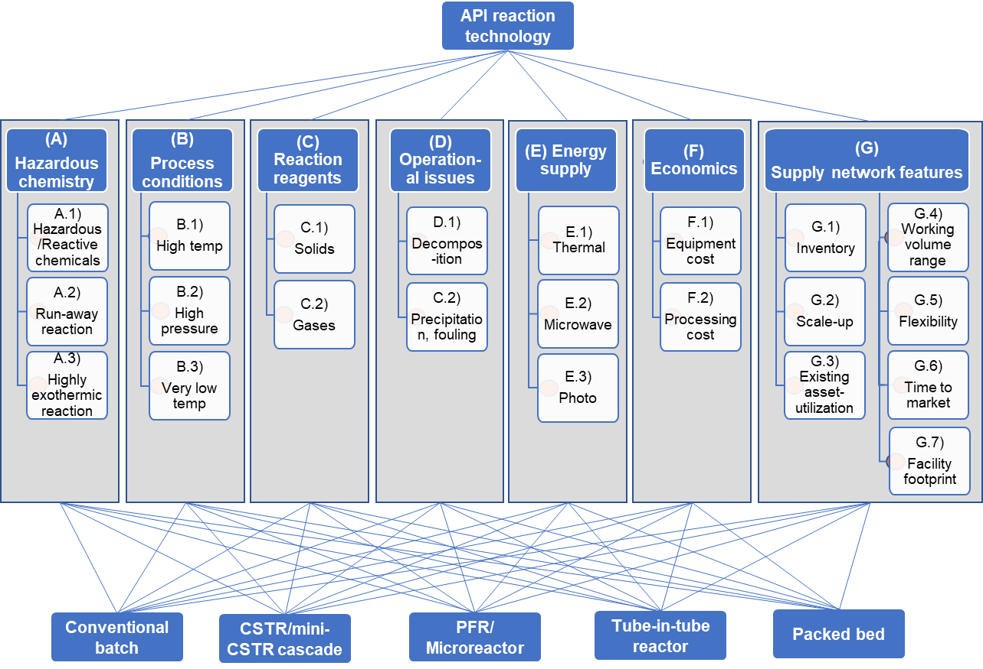
(I)

 | A |  |  |  | B |  |  | C |  |  | D |  | E |  |  | F |  |  |  | G
 | A.1 | A.2 | A.3 | B.1 |  | B.2 | B.3 |  | C.1 | C.2 | D.1 | D.1 | E.1 | E.2 | E.3 |  | F.1 | F.2 | G.1 |  | G.2 | G.3 | G.4 | G.5 | G.6 | G.7
AV | ● |  |  | ● |  |  | ● |  | ● | ● | ● | ● | ● |  |  |  | ● | ● | ○ |  |  | ○ |  |  | ○
AM | ● |  |  |  |  | ● | ● |  | ● | ● |  |  | ● |  | ● |  | ● | ● |  |  |  |  |  | ○
AD | ● | ● | ● |  |  |  |  |  | ● | ● |  |  | ● |  |  |  |  | ● |  |  | ○ |  |  | ○
AN | ● |  | ● |  |  | ● |  |  | ● |  | ● |  | ● | ● | ● |  | ● | ● | ○ |  |  | ○
Notes:
AR: antivirals; AM: antimalarials; AD: antidiabetes; AN: analgesics.
The symbol ● denotes evidence of the relevance for a given attribute in specific therapeutic area in the technical literature. The symbol ○ denotes some evidence from conceptual research.

(II)

Similar evaluations were carried out for each API, yielding the table at the bottom of Figure 1. For top-level criteria, Figure 1-II suggests that analgesics require comparatively simpler synthesis, shifting the emphasis on energy supply and process cost. Antidiabetes drugs are slightly more difficult to manufacture as multiphase reactants are often involved (e.g., Vildagliptin). Antivirals and antimalarials are the most demanding technology-wise, as they involve extreme process conditions, hazardous chemistry and operational challenges.
For supply chain criteria it was not possible to carry out a similar assessment since the literature is sparse. Insights on demand, value, variety and supply uncertainty were obtained from public-domain data on representative pharmaceutical products in the therapeutic areas of interest. These include prescription data from NHS England, and regulatory data on API manufacturers and importers into the UK. Figure S3.1 in Supplementary Materials (S3), provides a visual excerpt for illustration.
Paired comparisons were carried out according to the fundamental semi-numerical scale of AHP, which ranges from 1 (as important) to 9 (extremely more important). The rationale behind this fundamental scale is extensively discussed in Saaty (2010: Ch.4). One of the authors who is a practicing chemical engineer developed the stand-alone insights in Figure 1-II into paired comparisons between technical criteria and sub-criteria. Comparisons between supply chain sub-criteria were performed by another author with extensive experience as supply chain director. The relationship between top-level supply chain and technical criteria was explored by perturbation analysis instead of direct scoring. A hypothetical scenario was chosen such that supply chain features ‘very strongly’ dominate technical criteria. This initial scenario was perturbed at a later stage by changing the initial scores along a reduced range of the fundamental scale (1 to 7) deemed appropriate for the limited evidence available.
Evaluation of criteria and sub-criteria yielded 32 paired comparison matrices. In the interest of space, these are detailed in the Supplementary Materials (S2). Each therapeutic area consists of one matrix of paired comparisons between top-level criteria (Table S2.1), and seven matrices of comparisons between sub-criteria (Tables S2.2 to S2.5). Each matrix of paired comparisons yields a priority vector and a ranking. These results are complemented by measures of consistency of the underpinning judgments (Table S2.6). Figure 2 provides a visual summary of priorities for criteria and sub-criteria, respectively.
FIGURE 2 ABOUT HERE

Figure 2 – Priority vectors by therapeutic area for (I) top-level criteria; and (II) sub-criteria by therapeutic area - under initial scoring assumptions
Analgesics  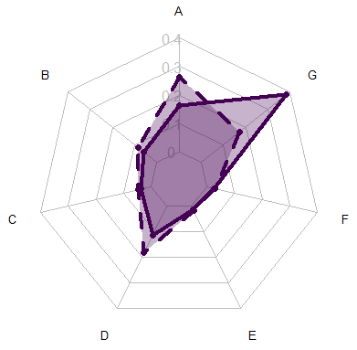 | Antivirals  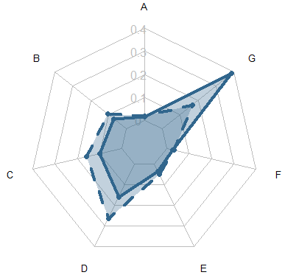 | 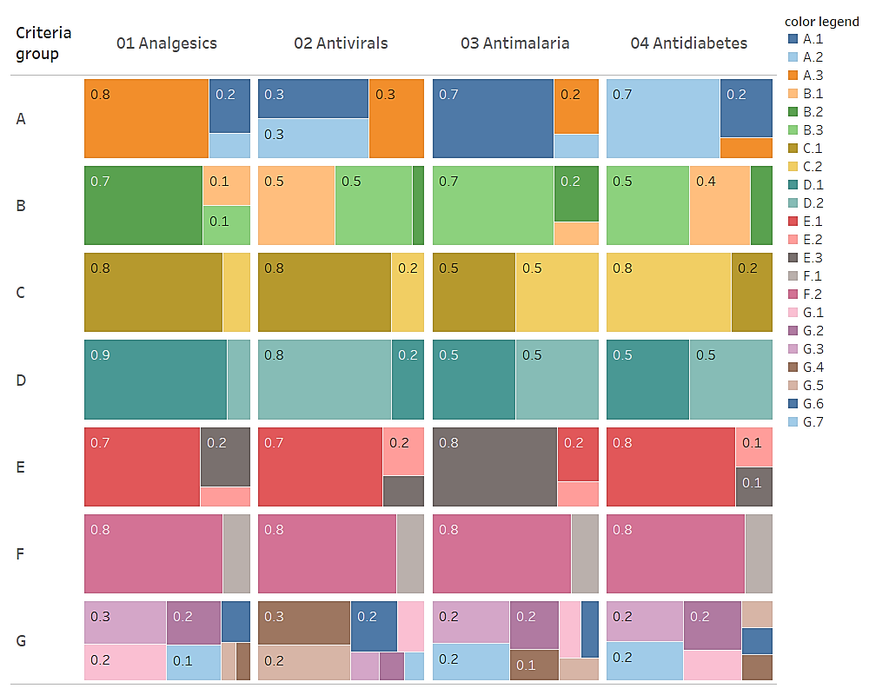
Antimalarials  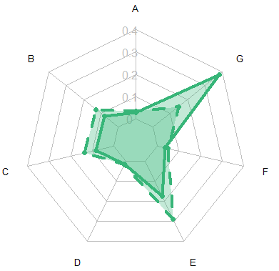 | Antidiabetes  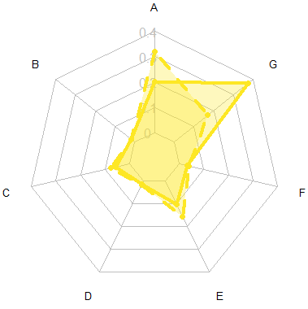
(I) |  | (II)
Notes, left hand side: Solid line: initial scoring; Dashed line: lowest CR alternative identified by perturbation analysis; For consistency statistics please see Table S.6 in the Supplementary Materials.Abbreviations - criteria: A) Hazardous Chemistry ; B) Process conditions; C) Reaction reagents; D) Operational issues; E) Energy supply ; F) Economic; G) Supply network features. For consistency statistics please see Table S.6 in the Supplementary Materials For consistency statistics please see Table S.6 in the Supplementary Materials
Notes, right-hand side: Abbreviations –sub criteria: A.1) Hazardous/Reactive chemicals; A.2) Run-away reaction; A.3) Highly Exothermic reaction; B.1) High temp; B.2) High Pressure; B.3) Very low temp; C.1) Solids; C.2) Gases; D.1) Precipitation/fouling; D.2) decomposition; E.1) Thermal; E.2) Microwave; E.3) Photo; F.1) Equipment cost; F.2) processing cost; G.1) Inventory; G.2) Scale-up; G.3) Existing Asset-utilization; G.4) Working volume range; G.5) Flexibility; G.6) Time to market; G.7) Facility footprint.

For top-level criteria, Figure 2-I shows priorities obtained from the initial scores in Table S2.1 as well as priorities obtained from perturbing the initial supply chain scores that meet the highest consistency criteria. The computation of priorities, consistency measures and perturbations are discussed further in the following sub-section.

Numerical approximation and consistency of results
For each matrix in Tables S2.1 through to S2.5 a principal eigenvector $\text{w}$ is computed by numerical approximation of the dominant eigenvalue problem:
$$\text{Aw}=λ_{\text{max}}\text{w}$$
where $\text{A}$ is a square, reciprocal matrix of AHP paired comparisons. Computing the dominant eigenvalue $λ_{\text{max}}$ and corresponding eigenvector $\text{w}$ is the preferred approach considering the theory underpinning AHP (Saaty, 2010). Yet, shortcut methods are often used in practice, with the literature seldom disclosing detailed computations (Ishizaka and Lusti, 2006). In this paper, the vector $\text{w}$ and scalar $λ_{\text{max}}$ are estimated by the power method approach (Larson and Edwards, 2000: Ch.10) with normalisation. Specifically, as $k→∞$ the vector sequence:
$${\text{q}}_{k}={{\text{A}}^{k}{\text{q}}_{0}}/{\left\|{\text{A}}^{k}{\text{q}}_{0}\right\|} (k=1,2,…)$$
approaches the principal eigenvector $\text{w}$, and the Rayleigh quotient $λ_{k}={{\text{q}}_{k}^{T}\text{A}{\text{q}}_{k}}/{{\text{q}}_{k}^{T}{\text{q}}_{k}}$ approaches the dominant eigenvalue $λ_{\text{max}}$. The initial guess ${\text{q}}_{0}$ corresponds to a unit vector of appropriate dimension; $\left\|\text{∙}\right\|$ is the Forbenius norm; and superscript T denotes transposition. The numerical approximation described above is implemented using the package matlib (Friendly et al., 2020) for the statistical computing software R (R Core Team, 2020). Results shown in Figure 2 refer to a Priority Vector, which corresponds to normalising the relevant principal eigenvector $\text{w}$ so that its entries sum up to 1.
The choice of appropriate consistency measures is another aspect of AHP often overlooked in practical applications. For a given paired comparison matrix it is customary to compare the consistency index $CI={λ_{\text{max}}-n}/{n-1}$, where $n$ is the number of lines in the matrix, with a ‘lookup’ random index (RI) e.g., Saaty (2010: p. 121). Critical reviews of RI lookup values are sporadic, with Donegan and Dodd (1991) providing revised estimates. It is commonly required that the ratio between CI and RI, called consistency ratio (CR), be 0.1 or less - values up to 0.2 are deemed tolerable. Dodd et al. (1993) question the use of a fixed percentage as consistency measure. Instead, they provide an approach to assess the level of confidence that CI values within certain thresholds are not the result of chance.
Table S2.6 shows some instances in which CR > 0.1. However, for scoring matrices larger than $3×3$ the corresponding CI has only a 0.1% chance to come from a random matrix, gives a 99.9% confidence that the result is achieved by virtue of consistent judgment (Dodd et al., 1993). For a small set of $3×3$ paired comparison matrices concerning sub-criteria this alternative approach could not be applied. Instead, minor changes were necessary to achieve CR ≤ 0.1. The corresponding metrics are denoted in Table S2.6 by an asterisk.
As mentioned in section 4.1, priority structures and consistency metrics for top-level criteria were subject to sensitivity analysis. This was achieved by changing the scores given to supply chain features compared to technical criteria in Table S2.1 between the values 1 and 7. Exploration of all permutations ($7^{6}=117,649)$ was deemed impractical, and only10,000 of these were chosen at randomly. The changes observed in priority ranking of each criterion, and consistency metrics are summarised in Supplementary Materials (S3), Figure S3.2.
Results in Figure S3.2 show that the chosen initial solutions in Table S2.1 align well with the median ranking obtained by random perturbation. As expected, given the size of scoring matrices, ‘fixed percentage’ consistency requirement are unlikely met. The options closer to meet such requirements were identified and shown in Figure 2. Depending on the therapeutic area, between 79% and 91% of results obtained by perturbation meet the alternative consistency thresholds with a confidence level of 99% and above.

Attribute-based evaluation of reactor technologies
Comparisons between relevant reactor technologies were carried out for each one of the 22 lower-level criteria discussed in the previous sections. As before, scoring took place in two steps. First, insights into the relevant literature were synthesised as shown in Table 1. Then, paired comparisons informed by these insights were carried out using AHP’s fundamental semi-numerical scale. Results from these steps are further detailed below.
TABLE 1 ABOUT HERE

Hazardous chemistry
The size of a reactor affects its suitability for processes that are dangerous or difficult to control. Miniaturization allows greater efficiency in mass and heat transfer, with benefits in terms of process control, amounts of reagents handled and hence chance of hazard (Movsisyan et al., 2016). Batch reactions involve about 100-1000 kg of materials, whereas continuous reactions 1-5 kg (am Ende and am Ende, 2019: Ch. 8); batch reactors’ volume is about 2,000 to 10,000 L, whereas continuous reactors’ is 0.1 to 3L (Hessel et al., 2012).
Table 1 Summary of secondary data informing the reactor technology selection problem
Sub-Criteria | Spec | Conventional | CSTR/CSTR cascade | PFR/Microreactors | Tube-in-tube reactor | Packed bed
A.1 | Reactor vol. | Large | Medium/Small | Small/very small | Small | Large-Small
 | Head vol. | Free | Free | No | No | Free
A.2 | STV | Low | Low/Medium | High/Highest | High | Low
A.3 | STV | Low | Low/Medium | High/Highest | High | Low
B.1 | Temperature | 200 | 200 | 200-250/500 | 200-250 | 200-250
B.2 | Pressure | 10 | 10 | 30-150/30-150 | 30-150 | 30-150
B.3 | STV | Low | Low/Medium | High/Highest | High | Low
C.1 | Handling solids | Higher | High/Medium | Small/very small | Small | Higher
C.2 | Handling gases | gas-liquid; not gas phase. | gas-liquid; not gas phase. | gas; and gas-liquid | mostly for gas-liquid | gas; and gas-liquid
D.1 | Characteristic dimension | Can handle | Can handle | Cannot handle effectively | Cannot handle effectively | Cannot handle effectively
D.2 | Characteristic dimension | Can handle | Can handle | Cannot handle effectively | Cannot handle effectively | Cannot handle effectively
E.1 | Handling thermal energy supply form | Easy | Easy | Easy | Easy | Easy
E.2 | Using microwave | Possible at very low kg scale | Possible at very low kg scale | Possible at medium kg scale | Challenging | Challenging
E.3 | Using photo energy | Possible at very low kg scale | Possible at very low kg scale | Possible at medium kg scale | Possible at very low kg scale | Possible at very low kg scale
F.1 | Equipment cost | Low | Low/high | low/high | high | low
F.2 | Processing cost | high | low/low | low/low | low/low | low/low
G.1 | Reactor vol | high | medium-high/low | medium/low | medium | medium-high
G.2 | Scaling-up capability | difficult | medium/low | medium/low | medium | medium
G.3 | Utilizing current batch asset | high | high/low | low/low | low | low
G.4 | Availability of various vol sizes | low-high | low-high/low-medium | low-high/low-medium | low-high | low-high
G.5 | Flex in ops | High flexibility | High flexibility | Low flexibility | Low flexibility | Low flexibility
 | Flex in vols | Low flexibility | High flexibility | High flexibility | High flexibility | High flexibility
G.6 | Devel. time | High | Lower | Lower | Lower | Lower
 | Proc. time | High | Lower | Lower | Lower | Lower
G.7 | Size of reactors | Low-high | low-high/low | Medium/Low | Medium | Low-high

CSTRs is medium-small size, with lower conversion rates per unit volume compared to PFRs which, in turn, is small range (Stoessel, 2020), as do c-CSTRs and TITRs. Microreactor volumes do not exceed a few Litres even for applications up to 2000 tons/year (Hessel et al., 2012), whereas PBRs, come in all sizes from lab-scale to commercial scale (Worstell, 2014: Ch.5). The influence of reactor size on hazardous chemistry suggests the following:
R1: {Batch, PBR} < {CSTR} < {PFR, c-CTSR, TITR} < {μ-R}
The presence of headspace above the reaction mixture may also affect safety. For example, reactions involving organic azide or tetrazole formations produce shock sensitive and explosive hydrazoic acid. Without free headspace, the hydrazoic acid formed is kept in the solution, which facilitates its immediate quenching. Batch reactors, CSTRs and PBRs provide free headspace, unlike PFRs/μ-R and TITRs (am Ende and am Ende, 2019: Ch. 3 and 16). Headspace may also affect hazardous chemistry in different reactors, in particular:
R2: {Batch, CSTR, c-CTSR, PBR} < {PFR, μ-R, TITR}
Safety can be substantially improved with better heat transfer: allowing quick dissipation of heat, it prevents temperature from rising to run-away conditions (Barton and Rogers, 1997; Movsisyan et al., 2016). Usually, the higher the surface area-to-volume (STV) ratio in a reactor, the better the heat transfer. STV ratios are highest for μ-R and lowest for batch reactors and CSTRs (am Ende and am Ende, 2019: Ch. 14). TITRs and PFRs are similar due to their cylindrical structure; however, the larger size of TITRs reduces their STV ratios. The position of PBRs depends on diameter: when large, the heat transfer rates are poorer (Sinnott, 2005), placing PBRs closer to CSTRs. However, the presence of solid packing may favour localized elevated temperatures (‘hot spots’) in PBRs (Baxendale et al., 2007). Lower STV ratios make batch reactors less capable to maintain isothermal temperatures during highly exothermic reactions that frequently occur in API synthesis. As different reactors’ STV may affect runaway and highly exothermic reactions one concludes the following:
R3: {Batch} ≤ {CSTRs, PBR} ≤ {c-CSTRs} ≤ {PFRs, TITR} < {μ-R}

Process conditions
Harsh or extreme process conditions enable faster kinetics, speeding up reactions by orders of magnitudes (Hessel et al., 2012). Batch reactors like those used in the pharmaceutical industry allow maximum temperature of 150°C and pressure of 10 bar. Among CM equipment, CSTRs are similar to batch reactors to this regard. PFRs allow conditions (200-250°C, and 30-150 bar) so that the reactions run above the normal boiling points of the solvents, leading to higher concentrations of dissolved gas in liquid phase for gas-liquid reactions (am Ende and am Ende, 2019: Ch. 8). Metallic microreactors operate at a maximum temperature of 500°C whereas ceramic microreactors can reach 1,100°C (Hessel, 2013). The windows of temperature and pressure allowed by different reactor technologies is such that:
R4: {Batch} ≤ {CSTRs, c-CSTRs} ≤ {TITR, PBR} ≤ { PFRs, μ-R}
The ability to achieve lower temperatures is likely affected by a reactor’s efficiency in mass and heat transfer. This aspect was previously discussed in relation to STV ratios concluding the following
R5: {Batch, PBR} ≤ {CSTRs} {c-CSTRs} ≤ {TITR, PFRs} < {μ-R}

Reaction reagents
For some CM reactor technologies issues may arise in the presence of solids (Roberge et al., 2005) and high presseure gas-liquid reactions (Brzozowski et al., 2015) that characterise most large-scale API synthesis. For example, CSTRs and PBRs are particularly suitable for handling solids, whereas PFRs and CSTRs are best deployed for homogeneous liquid-phase reactions. Also, reactor size reduction may be a drawback when using solid particles as reactants or catalyst inside a reactor. This issue is mitigated in the presence of agitation as in batch reactors/CSTRs, or packed beds (Sinnott, 2005). Problems in handling solids may depend on equipment the diameter, with μ-R being most affected (Roberge et al., 2005). The potential repercussions of reactor dimensions on their ability to handle solids suggests that:
R6: {Batch, PBR} > {CSTR} > {c-CSTRs} > {PFRs, TITR} > {μ-R}
Reactors also differ in their ability to handle gas/gas-liquid phases, namely:
R7: {Batch, CSTR, c-CSTRs} < {PFRs, PBR, μ-R, TITR}
Indeed, CSTRs/batch reactors are unsuitable for gas phase reactions. However, these are commonly deployed in gas-liquid reactions where gas is bubbled into the liquid. Conversely, technologies such as PFRs, PBRs, and μ-R/TITRs are suitable for both gas and gas-liquid reactions (Sinnott, 2005).

Operational issues
Reactors with smaller dimensions are more likely exposed to blockage in case of precipitation, and when solid particles form due to decomposition of reagents. Indeed the characteristic dimension of stirred vessels, tubular reactors and micro-structured reactors are in the range 1-10m, 5-50cm and 10μm-1mm, respectively (Bayer et al., 2005). Formation of solids along the walls of the reactor i.e., fouling, may cause pressure to drop, in turn leading to clogging. Also, solids tend to agglomerate into larger particles, clogging the reactors. These issues are alleviated in the presence of mechanical agitation (batch reactors/CSTRs). Miniaturized CSTRs are successfully deployed for small scale synthesis involving solids (Mo and Jensen, 2016). In PBRs leaching of solids into the solution often leads to clogging the catalysts or the void space, causing pressure drop. The influence of reactor dimensions on operational challenges suggests the following:
R8: {Batch, CSTR} > {c-CSTRs} >{PFRs, PBR, μ-R, TITR}

Types of energy supply
The traditional method of heat exchange using heating/cooling agents is successfully utilized in all the reactors. Some reactors, however, due to higher STV ratios have elevated rates of heat transfer and, therefore, can use the thermal energy more efficiently. The trend that can be derived for the conventional energy supply method is:
R9: {Batch, PBR, CSTRs} ≤ {c-CSTRs} ≤ {TITR} ≤ { PFRs, μ-R}
Reactor technologies can also accommodate innovative sources of energy depending on features such as depth of the reactor. For example, microwave irradiation can be beneficial for yield/purity and solvent requirements. However, exceeding the penetration depth of microwaves would prevent uniform heating (Baxendale et al., 2007). This issue may be partially overcome by efficient stirring (Schmink et al., 2010). Smaller scale reactors are more suitable for microwave irradiation, whereas stirred reactors are limited to kilogram scale since the maximum size that can be heated with standard magnetrons is about 2-3L (Lehmann and LaVecchia, 2010). Microwave-assisted processing remains a challenge for TITRs due to their configuration, and for PBRs due to selective absorption in the presence of solids thereby suggesting the following trend:
R10: {Batch, CSTRs} ≤ {c-CSTRs} < {PFRs} < {μ-R}
The depth of a reactor also affects the ability to use light as a source of energy; indeed, light transmittance decreases exponentially with the distance from the light source, causing non-homogeneous irradiation. Photo-irradiation can be challenging in industrial batch reactors/CSTRs/PBRs and in the presence of solids (Sambiagio and Noël, 2020). Exceptions include the use of high-intensity blue laser beam in CSTR operating at kilogram-scale (Harper et al., 2019). Another exception is the synthesis of the antimalarial artemisinin by photogenerated singlet oxygen oxidation of Artemisia annua extracts in small-scale PBRs (Triemer et al., 2018). In general, small scale or miniaturized reactors are more suitable for performing photochemical reactions, namely:
R11: {TITR, PBR} ≤ {Batch, CSTR} < {c-CSTRs, PFRs, μ-R}

Managerial aspects: costs and the supply chain
Throughout the previous sections it was implied that the features contributing to the technology selection problem are built into a physical asset. Extending the analysis to more managerial aspects, whilst desirable is less straightforward. Some managerial aspects of interest (e.g. cost, inventory) are usually expressed in absolute quantitative terms. Here, judgment about these criteria is expressed in relative terms.

Impact on cost, inventory and lead times
A traditional economic advantage of batch equipment consists of low initial setup cost. By analogy, the cost of CSTRs can be expected to be reasonably close to that of batch reactors. The equipment cost of PFRs and PBRs is also assumed to be in the same ballpark, considering that these are widely used in the chemical industry. Despite operating at a smaller scale, μ-R and TITRs are likely to command higher investment costs. Differences in upfront disbursement for equipment acquisition suggest the following:
R12: {Batch, CSTR, PFR, PBR} > {c-CSTR, TITR, μ-R}
Processing costs may be affected by the ability of flow reactors technologies to improve reaction yield; reduce reaction time and energy requirements. In relative terms, we assume that these features drive operating cost reductions compared to batch reactors. Greater cost savings beyond the individual facility can be achieved reducing material handling, quality control and labour between processing steps (Schaber et al., 2011). Differences in direct processing costs associated with reaction efficiency suggests the following:
R13: {Batch}< {CSTRs, c-CSTR, PFR, μ-R, PBRs, TITR}
Inventory is one of the most widely debated and controversial aspect related to the adoption of CM in PSCs. It is estimated that the incumbent approach of manufacturing in batch campaigns generates about 1 to 6 months inventory in the PSC (Shah, 2004). CM were expected to bring that figure down to 70 days or less (Srai et al., 2015). However, the global disruptions in API supply linked to a recent pandemic demonstrated that the merits of cutting down on inventory are not straightforward to demonstrate in the presence of high dependence on a handful of manufacturing locations (Settanni, 2020).
Considering the focus on specific CM technologies, ‘inventory’ is interpreted here as the combination of starting materials, intermediate and final products of API synthesis. Batch reactors are likely to generate a higher build-up of inventory due to their characteristic sequence of operations (i.e. charging, converting, discharging, quality analysis, and storage) and large volumes typically involved at each step. Conversely, continuous reactors are smaller in volumes, thereby requiring lower inventory of starting materials. With synthesis steps performed in flow, and ‘in-line’ process analytical technologies (Rantanen and Khinast, 2015), it seems plausible to assume that less material storage and ‘end of the pipe’ quality controls are required. Preliminary simulation studies also suggest similar conclusions (Srai et al., 2020). Elimination of intermediary holding stages in CM is likely to benefit the overall time required in production. The possible influence of small-volume in-flow synthesis on inventories suggests the following:
R14: {Batch} < {CSTRs, PBRs} < {TITR, PFR} < {c-CSTR, μ-R}

Viability at scale and flexibility
Besides costs and opportunity for lower inventory, a key issue when introducing new technologies in a PSC is their viability at commercial scale. For batch reactor technologies, heat and mass transfer phenomena occurring at lab-scale may not be achieved at larger volumes, and hence demand re-optimization (Gutmann et al., 2015). By contrast, production in flow reactors can be increased by scaling-out or numbering-up instead of scaling-up. Scaling-out involves operating the reactor continuously for longer rather than intermittently. Numbering-up implies that the number of equipment units operating in parallel increases. Unlike scaling-up, these strategies do not require re-optimising the operating conditions with potential savings in terms of development time (Plumb, 2005). Differences in the ease of upscaling to commercial requirements suggests that:
R15: {Batch} < {CSTR, PBR, TITR, PFR} < {c-CSTR, μ-R}
So far it is assumed that reactor technology is consistently deployed at ideal operating conditions and scale. In practice, industry may be reluctant to endorse CM with resources committed in its current asset base. Technologies such as CSTR may provide some of the advantages of CM whilst aligning well with current technologies (Teoh et al., 2016). Reactor technologies may differ in their ability to leverage an existing asset base, specifically:
R16: {Batch, CSTR} > {c-CSTR, PFR, μ-R, PBR, TITR}
As PSCs are tasked with achieving greater responsiveness (e.g., Srai et al., 2015; Woodcock, 2019), flexibility in manufacturing becomes prominent. Flexibility may be understood as either the ability of using a single reactor type for multiple operations; or, the ability to move from one production capacity to another. In the first sense, batch reactors provide higher flexibility than continuous flow reactors (Dunn et al., 2010). However, CM provides greater flexibility in terms of changing production volumes via numbering up or scaling out. An interpretation of flexibility as operations that equipment can carry out suggests that:
R17: {Batch, CSTR} > {c-CSTR, PFR, μ-R, PBR, TITR}
However, reactors differ in their ability to switch up/down production, suggesting that
R18: {Batch} < {c-CSTR, PFR, μ-R, PBR, TITR}
Reducing time-to-market has always been one of the important aspects of PSC. Time-to-market comes from the time required in the development of a drug and after development time required to produce the drug plus time to reach the customer; development plus production time being more relevant to process. As discussed earlier, batch operations involve multiple stages viz. charging, operation, discharging and holding between two consecutive steps and two batches. This considerably increases the overall time required in the production of API and its final dosage form. Continuous flow reactors allow decreasing the time in processing by elimination of intermediary holding stages or manual operations and time between two batches. Intensification of process by continuous flow can lead to reduction in reaction time inherently as well. In addition, the development time in case of continuous flow reactors is lowered by elimination of scale-up step (Plumb, 2005), namely:
R19: {Batch} < {c-CSTR, PFR, μ-R, PBR, TITR}
Lower plant footprint was identified by regulators as one of the important features of advanced technologies (Woodcock, 2019). Continuous reactors usually have lower volumes than batch reactors and therefore, occupy less space than batch reactors. As mentioned earlier, the volume of continuous flow reactor ranges from at least two cubic meters to at most three litters (Hessel et al., 2012). CSTRs and packed beds, however, might also work at similar volumes as that of batch reactors. The miniaturization of dimensions of PFRs/microreactors/miniaturized CSTRs leads to high efficiency in mass and heat transfer in these reactors while reducing the footprint of equipment:
R20: {Batch, CSTR, PBR} < {PFR, PBR, TITR} < {c-CSTR, μ-R}

Overall ranking
The above insights provided a basis for paired comparisons between the selected reactor technologies at each lower-level criterion. Similar to the process described in section 4.1, co-authors with a background in chemical engineering were responsible for the task, and the results were refined through an iterative process involving all co-authors. The process yielded 22 scoring matrices of size $7×7$ capturing, for each sub-criteria the resulting set of paired comparisons between chosen technologies. Due to space constraints, detail is provided in the Supplementary Materials. Specifically, Tables S2.7 through to S2.13 provide the scoring matrices, and priorities based on the corresponding dominant eigenvalues. Table S2.14 specifies consistency metrics for these scoring matrices. Key computational and consistency assessment procedures are as discussed in Section 4.2. Nearly all results meet the standard ‘fixed percentage’ criterion for acceptable CRs. For three values slightly above the acceptable range, application of alternative tolerances (Dodd et al., 1993) suggest a 99.9% confidence that these are achieved by virtue of consistent judgment.
For a given therapeutic area, priority vectors separately obtained for criteria, sub-criteria and reactor technology options are combined into an overall ranking. This is accomplished by matrix multiplication in two steps. For a given a therapeutic area, first we compute:
$$\left[\begin{matrix}ω_{A} & 0 & ⋯ & 0 \\ 0 & ω_{B} & ⋯ & 0 \\ ⋮ & ⋮ & ⋱ & ⋮ \\ 0 & 0 & ⋯ & ω_{G}\end{matrix}\right]×\left[\begin{matrix}ω_{A} \\ ω_{B} \\ ⋮ \\ ω_{G}\end{matrix}\right]=\left[\begin{matrix}υ_{A} \\ υ_{B} \\ ⋮ \\ υ_{G}\end{matrix}\right]$$
where $ω_{A}={\left[\begin{matrix}ω_{A.1} & ω_{A.2} & ω_{A.2}\end{matrix}\right]}^{T}$; $ω_{B}={\left[\begin{matrix}ω_{B.1} & ω_{B.2} & ω_{B.2}\end{matrix}\right]}^{T}$;… ; $ω_{G}={\left[\begin{matrix}ω_{G.1} & ω_{G.2} & ⋯ & ω_{G.7}\end{matrix}\right]}^{T}$ correspond to the appropriate eigenvectors for sub-criteria within A, B,… , G in Tables S.2-S.5. These vectors are normalised so that their entries sum up to 1. Similarly, $ω={\left[\begin{matrix}ω_{A} & ω_{B} & ⋯ & ω_{G}\end{matrix}\right]}^{T}$ corresponds to the appropriate eigenvector in Table S.1, also normalised. Taking antimalarials as an example $ω_{B}={\left[\begin{matrix}0.08 & 0.19 & 0.73\end{matrix}\right]}^{T}$ and $ω={\left[\begin{matrix}0.03 & 0.10 & ⋯ & 0.48\end{matrix}\right]}^{T}$. Next we compute:
$$\left[\begin{matrix}υ_{A} & υ_{B} & ⋯ & υ_{G}\end{matrix}\right]×\left[\begin{matrix}γ_{1,A} & γ_{2,A} & ⋯ & γ_{7,A} \\ γ_{1,B} & γ_{2,B} & ⋯ & γ_{7,B} \\ ⋮ & ⋮ & & ⋮ \\ γ_{1,G} & γ_{2,G} & ⋯ & γ_{7,B}\end{matrix}\right]=\left[\begin{matrix}α_{1} & α_{2} & ⋯ & α_{7}\end{matrix}\right]$$
Where the vector $υ={\left[\begin{matrix}υ_{A} & υ_{B} & ⋯ & υ_{G}\end{matrix}\right]}^{T}$ is an output of the previous step.
The vectors $γ_{j,A}={\left[\begin{matrix}γ_{j,A.1} & γ_{j,A.2} & γ_{j,A.3}\end{matrix}\right]}^{T}$; …;$γ_{j,G}=\left[\begin{matrix}γ_{j,G.1} & γ_{j,G.2} & ⋯ & γ_{j,G.7}\end{matrix}\right]$ are defined for each technology $j=1,2,…,7$ and correspond to the appropriate eigenvectors in Tables S2.7 through to S.13 for sub-criteria within A, B,…,G. As before, the eigenvectors are normalised so that they sum up to 1. For each therapeutic area, the result is an overall priority vector $α={\left[\begin{matrix}α_{1} & α_{2} & ⋯ & α_{7}\end{matrix}\right]}^{ T}$.
For our numerical example, values are visualised in Figure 3.
FIGURE 3 ABOUT HERE
Figure 3 – Overall scoring for CM reactor technologies
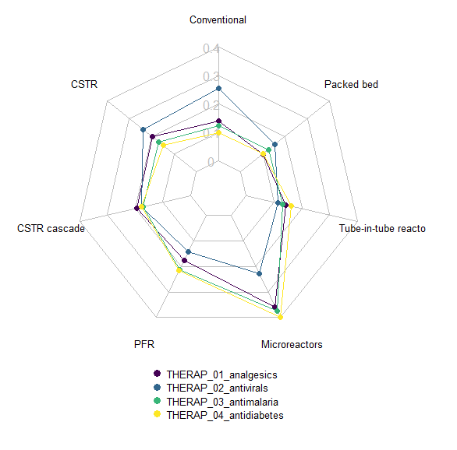 | 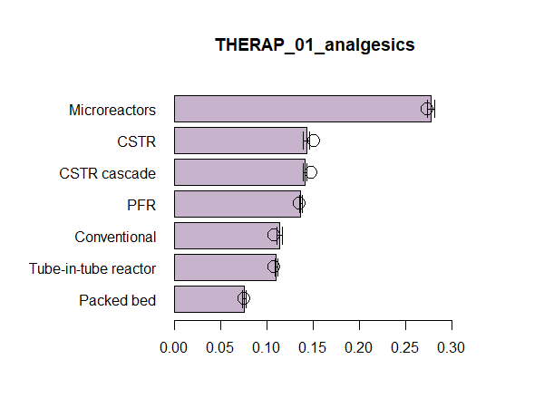 | 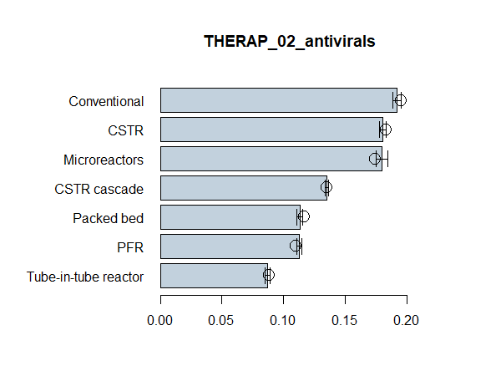
 | 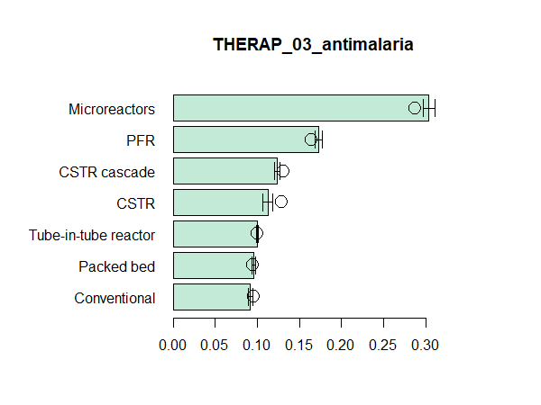 | 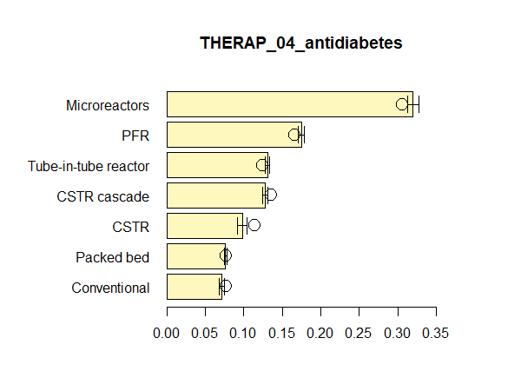
- Overall ranking, initial scoring for SC top-level criteria | - Sensitivity to changes in SC top-level criteria scoring (10,000 rnadom permutations)  Histograms: means; Lines: std deviation; Circles: intial scoring (same as left-hand side)

Discussion
The academic literature has long recognised the challenges of evaluating advanced manufacturing technologies when limited evidence is available to decision-makers (e.g., Sambasivarao and Deshmukh, 1997). For reactor technologies deployed in pharmaceutical supply chains, analysis contributes to an early-on exploration of the performance space in which alternative options may operate. Often, approaches centred on prorietary tools and/or aimed to a specialist audience are deployed for similar tasks (e.g., Peeling and Talford, 2020). However, extant work underplays the need to combine purely technical knowledge with managerially relevant insights supporting strategic supply chain configuration decisions.
Industial innovation policies increasingly require that end-to-end supply chain considerations for advanced manufacutring technologies are expliclity addressed. Examples include research programmes for redistributed manufacturing in healthcare (e.g., Phillips et al., 2020). In the US, pogrammes supporting the implementation of CM technology aim to achieve greateer product quality control and flexibility of manufacturing (Lee et al., 2015).
Findings from the previous sections bridge current disciplinary silos with a view of supporting early-on strategic managerial decisions about upstream PSC reconfiguration opportunities enabled by CM. A hiearchical priority structure was obtained for different therapeutic areas linking relevant criteria and technology options. With regards to the former. eyeball inspection of Figure 3 suggests that hazardous chemistry (criterion A) is dominant (making up in 30%+ of the criteria weight) in analgesics and antidiabetes, mostly due to the possibility of exothermic and run-away reactions even though APIs in these categories required maximum 3 reaction steps. Higher temperatures and pressures (criterion B), which forms an important aspect of process intensification, were used in almost all drug categories, except the API investigated for antidiabetes. Over 60% reactions in API synthesis involve solids which was evident in all drug categories. The ability to handle multi-phase reaction reagents (criterion C) tend to rank 3rd for importance across the board (criterion C), except for analgesics since the APIs involved did not use any gaseous reagents. Operational issues (criterion D) are of major concern in antivirals followed by analgesics (20 to 30% of the criteria weight), majorly due to precipitation of intermediates or final product, although decomposition was also found in one of the antivirals. Energy-supply seems to very important (criterion E) for antimalarials and antidiabetes (also 20 to 30% of weight), with some antimalarials relying on photo assisted synthesis.
With regards to more managerial criteria, cost (criterion F) does not stand out at this level of analysis, although it tends to rank slightly higher for importance in antimalarials and antidiabetes, almost entirely in relation to CapEx. Supply chain features (criterion G) are hypothetically given high priority; however, perturbation analysis reveals that their weight (and rank) nearly halves in the alternative scenario driven by consistency ratio constraints.
For each reactor technology options, Figure 3 combines broader considerations about criteria relevance at the level of therapeutic area, and detailed technology evaluations for each sub-criterion illustrated in Section 4.3 and Tables S2.7-S2.13. Analysis favours microreactors across almost all therapeutic areas. Antivirals provide an exception: whilst complex chemistry favours continuous microreactors, batch manufacturing remains a contender due to the need for flexibility in operations allowed by a single reactor as well as operational challenges due to fouling. In the case of analgesics, the second best option is CSTR, as this technology can help exploit the existing manufacturing base whilst addressing inventory reduction – both important feature amongst supply chain sub-criteria for this therapeutic area. CSTR cascade, PFR stand out as second best in antimalarials and antidiabetes, in line with manufacturing requirements linked to handling photochemical and multiphase reactants whilst addressing inventory reduction and operational flexibility.
To gain a broader theoretical perspective, Figure 4 juxtaposes research findings and an existing framework that conceptualises where CM of pharmaceuticals may be beneficial based on volume-variety considerations (Srai et al., 2015).
FIGURE 4 ABOUT HERE
For each therapeutic area ‘volumes’ were approximated by selecting representative APIs in each category and estimating the amount of APIs dispensed by NHS England in 2019-2020. Variety is approximated by the number of different dosage forms and strengths, also estimated from public domain prescription data. The overall priority weights for batch (conventional) and CM reactor technologies in each therapeutic area serve as a proxy to operationalise the benefits of alternative technologies. The original framework conceptualises these benefits as intersecting ‘bell shaped’ curves, with dominance of a technology being represented by the corresponding curve laying above the other. Unlike our resutls, the original framework is agnostic with respect to specific CM technologies or therapeutic areas. Contrary to what anticipated by the conceptual framework, batch and CSTR prevail on other technologies for releatively low volume, medium variety therapeutic areas such as antiviral.

Figure 4 – Volume-variety representation of CM technology advantages: results vs conceptualisation
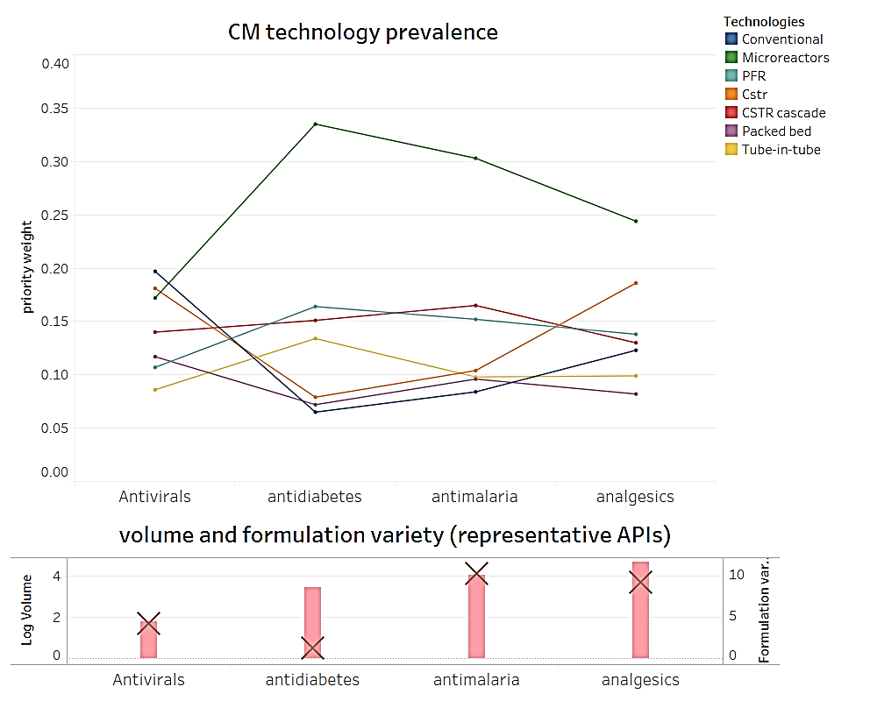 | 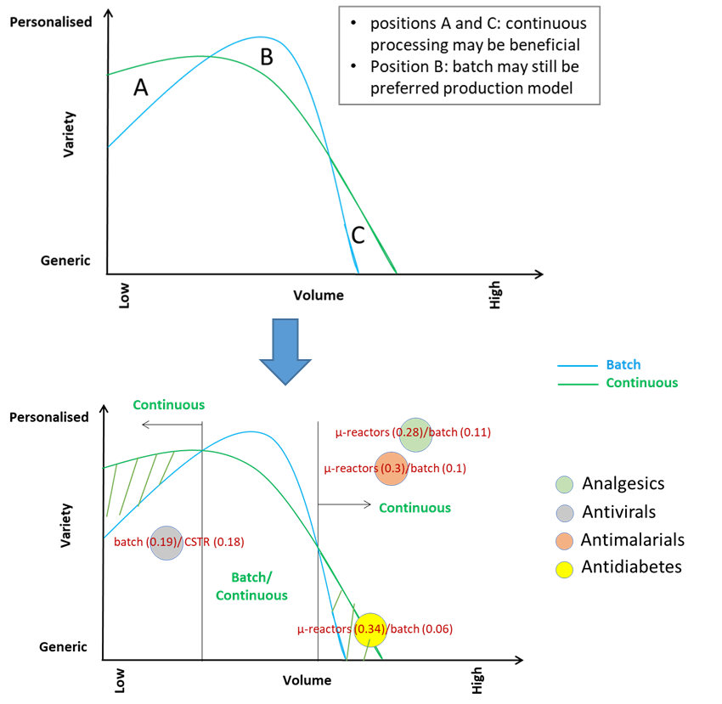
(a) Re-shaped empirical results from this paper | (b) Initial conceptualisation (based on Srai et al., 2015) to current mapping

For middle-range volumes nearly all CM technologies superseed batch (although CSTR and Packed bed closely follow batch in terms of relevance). For high variety and high volumes products such as antimalarials and analgesics, CM technologies, leading with microreactors, gain significance over batch. The next CM technology following microreactors is CSTR for analgesics and PFR for antimalarials.
Although microreactors seem to prevail among CM technologies at high volumes, their deployment may be practical only at small-medium scale (0.1-1000 tons/year) based on the numbering up or scaling out approach. For example, to achieve 10,000 tons/year of production a continuous flow reactor working at 10 kg/day will need around 3,000 units operating 24/7. Such high numbers can reflect negatively on the capital costs of the plant. However, use of microreactors at different scales is still an area of on-going research. This methodology helps to screen technologies at early stages of process development. These results can feed into more detailed analysis of various process options with different reactor technologies.
The above resulthas no ambition of serving as a confirmatory analysis, rather, it is meant to illustrate how insights gained through semi-quantitative techniques such as AHP could provide an operational counterpart to the otherwise complex and multifaceted notion of ‘benefits’ conceptualised in the refernce framework. Also, results may vary depending on the representative products chosen. For example, antidiabetes API such as artemisinin would dwarf analgesics such as ibuprofen in both volumes and variety. However, in this work, the focus was on APIs investigated in the literature on CM. Also, the attributes considered to be relevant for selection can impact the final rankings. If flexibility is not important in a solid-free API manufacturing then, microreactors can out-do batch for antivirals.

Concluding remarks
This paper applies AHP techniques to address both technological and managerial considerations in evaluating upstream PSC reconfiguration opportunities enabled by CM. During early stage PSC configuration design and manufacturing technology selection, detailed technical knowledge is often inaccessible to managers. Furthermore, integrating multiple technical and operational information into strategic managerial decisions is challenging, and has frustrated new technology adoption.
This research contributes an empirical workflow for the multi-faceted evaluation of alternative CM reactor technologies in PSC, enriching a thriving technical literature on CM of pharmaceuticals, with an explicit supply chain management perspective. For selected therapeutic areas, findings provide a priority structure for multiple technical and supply chain criteria, against individual reactor technology options. In particular, research identifies 22 criteria, 13 technical and 9 management-centric, to evaluate emerging CM reactor technologies within upstream PSC. Technologies such as microreactors are particularly promising all things considered. However, supply chain considerations introduce nuances, for example with regards to antivirals where the need for flexibility in unit operations in a single piece of equipment favours batch manufacturing over numbering up CM modules. Also in the case of analgesics the need to exploit the existing manufacturing base whilst addressing inventory reduction favour CSTR, which incorporates elements of both batch and CM.
This paper initiates the task of providing an empirical counterpart to conceptual framework for evaluating the benefits of CM in pharmaceutical supply chains predicated on volume-variety considerations. Priority structures obtained by AHP provide a concise quantification of the relative advantages afforded by alternative technological options. Analysis confirms some broader trends anticipated by the existing framework – e.g. for microreactors the relative advantage of CM resembles a bell-shaped curve as volumes increase. However, analysis provides a more nuanced view than existing frameworks. For instance, due to the tension between operational flexibility requirements and complex chemistry requirements, batch and CM may be equally viable for antivirals despite the lower volumes.
Research limitations include reliance on public domain data, and a focus limited to the upstream portion of PSC. Also, the analysis remains largely deterministic although perturbation analysis was carried out to account for the difficulty of evaluating the relative importance of supply chain over technical criteria. Future developments could extend the analysis to include (1) judgment from a larger group of experienced practitioners; (2) additionally, evaluate CM technologies for use in post-API product formulation; (3) apply this methodology in other industry contexts where both advanced manufacturing technology and supply chain considerations influence potential adoption. Despite its limitations, this resarch contributes a structured approach of integrating technical and managerial insights in the early-stage evaluation of CM technologies. Also, the proposed application emphasises replicability, and addresses explicitly computational aspects of AHP that are often underplayed in practical applications. The emphasis placed on the need to address disciplinary silos, simplifying heuristics and potential biases through a structured approach to decision-making seem sensible as governments seek to develop local medical countermeasures in the wake of the recent COVID-19 pandemic.

References
Alvarez, G. B., de Almeida, Rafael G., Hernández, C. T., & de Sousa, Patrícia A. P. (2021). Some mathematical comments about the analytic hierarchy process: Part I – theoretical analysis. Journal of Multi-Criteria Decision Analysis. doi:10.1002/mcda.1762
am Ende, D. J., & am Ende, M. T. (eds) (2019). Chemical Engineering in the Pharmaceutical Industry: Active Pharmaceutical Ingredients. Wiley. doi:10.1002/9781119600800
Domokos, A., Nagy, B., Gyürkés, M., Farkas, A., Tacsi, K., Pataki, H., . . . Nagy, Z. K. (2020). End-to-end continuous manufacturing of conventional compressed tablets: From flow synthesis to tableting through integrated crystallization and filtration. Int. J. Pharm., 581, 119297. doi:10.1016/j.ijpharm.2020.119297
Economist (2020) The covid-19 virus is teaching the world hard lessons about China-only supply chains. Feb 29th. 434(9183):50.
Barton, J., & Rogers, R. (1997). Chemical Reaction Hazards. IChemE, Rugby.
Baxendale, I. R., Hayward, J. J., & Ley, S. V. (2007). Microwave reactions under continuous flow conditions. Comb Chem High Throughput Screen, 10(10), 802-836. doi:10.2174/138620707783220374
Bayer, T., Jenck, J., & Matlosz, M. (2005). IMPULSE - A new approach to process design. Chem. Eng. Technol., 28(4), 431-438. doi:10.1002/ceat.200407120
Brennan, D. (1998). Process industry economics. Rugby: IChemE
Brzozowski, M., O’Brien, M., Ley, S. V., & Polyzos, A. (2015). Flow Chemistry: Intelligent Processing of Gas−Liquid Transformations Using a Tube-in-Tube Reactor. Acc. Chem. Res., 48(2), 349-362. doi10.1021/ar500359m
Burcham, C. L., Florence, A. J., & Johnson, M. D. (2018). Continuous Manufacturing in Pharmaceutical Process Development and Manufacturing. Annu. Rev. Chem. Biomol. Eng., 9, 253–281. doi:10.1146/annurev-chembioeng-060817-084355
Calabrese, G. S., & Pissavini, S. (2011). From Batch to Continuous Flow Processing in Chemicals Manufacturing. AIChE Journal, 57(4), 828-834. doi:10.1002/aic.12598
Dodd, F. J., Donegan, H. A., & McMaster, T. B. M. (1993). A statistical approach to consistency in AHP. Math. Comput. Model., 18(6), 19–22. doi:10.1016/0895-7177(93)90123-G
Domokos, A., Nagy, B., Gyürkés, M., Farkas, A., Tacsi, K., Pataki, H., . . . Nagy, Z. K. (2020). End-to-end continuous manufacturing of conventional compressed tablets: From flow synthesis to tableting through integrated crystallization and filtration. Int. J. Pharm., 581, doi:10.1016/j.ijpharm.2020.119297
Donegan, H. A., & Dodd, F. J. (1991). A note on Saaty's random indexes. Math. Comput. Model., 15(10), 135–137. doi:10.1016/0895-7177(91)90098-R
Donegan, H., Dodd, F., & McMaster, T. (1992). A New Approach to AHP Decision-Making. J R Stat Soc D (The Statistician), 41(3), 295-302. doi:10.2307/2348551
Double, J. M. (2006). Project IMPULSE: equipment selection methodology. 17th International Congress of Chemical and Process Engineering. Prague, 27-31 August.
Dunn, P. J., Wells, A., & Williams, M. T. (2010). Green Chemistry in the Pharmaceutical Industry. Wiley-VCH. doi:10.1002/9783527629688
Emenike, V. N., Schenkendorf, R., & Krewer, U. (2018). A systematic reactor design approach for the synthesis of active pharmaceutical ingredients. Eur J Pharm Biopharm, 126, 75-88. doi:10.1016/j.ejpb.2017.05.007
Friedli, T. (2006). Operational excellence in the pharmaceutical industry. Cantor-Verl.
Friendly, M., Fox J., & Chalmers P. (2020). matlib: Matrix Functions for Teaching and Learning Linear Algebra and Multivariate Statistics. Retrieved from https://CRAN.R-project.org/package=matlib
Ganesh S., Reklaitis G.V. (2020) Basic Principles of Continuous Manufacturing. In: Nagy Z., El Hagrasy A., Litster J. (eds) Continuous Pharmaceutical Processing. Cham: Springer. doi.org/10.1007/978-3-030-41524-2
Glaize, A., Duenas, A., Di Martinelly, C., & Fagnot, I. (2019). Healthcare decision-making applications using multicriteria decision analysis: A scoping review. Journal of Multi-Criteria Decision Analysis, 26(1-2), 62–83. doi:10.1002/mcda.1659
Gutmann, B., Cantillo, D., & Kappe, C. Oliver. (2015). Continuous-Flow Technology—A Tool for the Safe Manufacturing of Active Pharmaceutical Ingredients, Angew. Chem. Int. Ed., 54(23), 6688 – 6728. doi:10.1002/anie.201409318
Hall, S., & Stoker, A. (2003). API Chemical Synthesis Trends in Reactor System Design APIs: Reactor Considerations. Pharm. Eng., 23(5), 1-9.
Hahn, S.M., & Shah, A. (2020) Investing in Advanced Manufacturing to Support Public Health Preparedness. Retrieved from https://www.fda.gov/news-events/fda-voices/investing-advanced-manufacturing-support-public-health-preparedness
Hanratty, P. J., & Joseph, B. (1992). Decision-making in Chemical Engineering and Expert Systems: Application of the Analytic Hierarchy Process to Reactor Selection. Comput. Chem. Eng, 16(9), 849-860. doi:10.1016/0098-1354(92)80037-A
Harper, K. C., Moschetta, E. G., Bordawekar, S. V., & Wittenberger, S. J. (2019). A Laser Driven Flow Chemistry Platform for Scaling Photochemical Reactions with Visible Light. ACS Cent. Sci., 5, 109−115. Doi: 10.1021/acscentsci.8b00728
Harrington, T. S., Phillips, M. A., & Srai, J. S. (2017). Reconfiguring global pharmaceutical value networks through targeted technology interventions. Int. J. Prod. Res., 55(5), 1471–1487. doi:10.1080/00207543.2016.1221541
Hessel, V., Gürsel, I. V., Wang, Q., Noël, T., & Lang, J. (2012). Potential Analysis of Smart Flow Processing and Micro Process Technology for Fastening Process Development: Use of Chemistry and Process Design as Intensification Fields. Chem. Eng. Technol., 35(7), 1184-1204. doi:10.1002/ceat.201200038
Hessel, V., Renken, A., Schouten, J. C., & Yoshida, J.-i. (2013). Micro process engineering. Vol.1, Wiley-VCH. DOI:10.1002/9783527631445
Hill, A.M., Barber, M.J. & Gotham, D. (2018). Estimated costs of production and potential prices for the WHO Essential Medicines List. BMJ Global Health, 3(1), doi:10.1136/bmjgh-2017-000571
Hodgett, R. E. (2016). Comparison of multi-criteria decision-making methods for equipment selection. Int. J. Adv. Manuf. Technol., 85(5), 1145-1157. doi:10.1007/s00170-015-7993-2
Hodgett, R. E., Martin, E. B., Montague, G., & Talford, M. (2014). Handling uncertain decisions in whole process design. Prod. Plan. Control, 25(12), 1028–1038. doi:10.1080/09537287.2013.798706
Ishizaka, A., & Lusti, M. (2006). How to derive priorities in AHP: a comparative study. Cent. Eur. J. Oper. Res., 14(4), 387–400. doi:10.1007/s10100-006-0012-9
Kern, D. Q. (1950). Process heat transfer. New York: McGraw-Hill.
Kockmann, N., Gottsponer, M., Zimmermann, B., & Roberge, D. M. (2008). Enabling Continuous-Flow Chemistry in Microstructured Devices for Pharmaceutical and Fine-Chemical Production. Chem. Eur. J., 14, 7470–7477. doi:10.1002/chem.200800707
Krasberg, N., Hohmann, L., Bieringer, T., Bramsiepe, C., & Kockmann, N. (2014). Selection of Technical Reactor Equipment for Modular, Continuous Small-Scale Plants Continuous Small-Scale Plants. Processes, 2(1), 265-292. doi:10.3390/pr2010265
Larson, R. & Edwards, B.H. (2000), Elementary linear algebra, 4th ed., Houghton Mifflin.
Lee, S. L., O’Conor, T. F., Yang, X., Cruz, C. N., Chatterjee, S., Madurawe, R. D., . . . Woodcock, J. (2015). Modernizing Pharmaceutical Manufacturing: from Batch to Continuous Production. J. Pharm. Innov, 10(3), 191-199. doi:10.1007/s12247-015-9215-8
Lehmann, H., & La Vecchia, L. (2010). Scale-Up of Organic Reactions in a Pharmaceutical Kilo-Lab Using a Commercial Microwave Reactor. Org. Process Res. Dev., 14(3), 650-656. doi:10.1021/op900269y
Lindeque, R. M., & Woodley, J. M. (2019). Reactor Selection for Effective Continuous Biocatalytic Production of Pharmaceuticals. Catalysts, 9(3). doi:10.3390/catal9030262
Linstone, H. A., Lendaris, G. G., Rogers, S. D., Wakeland, W., & Williams, M. (1979). The use of structural modeling for technology assessment. Technol. Forecast. Soc. Change, 14(4), 291–327. doi:10.1016/0040-1625(79)90032-5.
Marttunen, M., Lienert, J., & Belton, V. (2017). Structuring problems for Multi-Criteria Decision Analysis in practice: A literature review of method combinations. Eur. J. Oper. Res., 263(1), 1–17. doi:10.1016/j.ejor.2017.04.041
McWilliams, J. C., Allian, A. D., Opalka, S. M., May, S. A., Journet, M., & Braden, T. M. (2018). The Evolving State of Continuous Processing in Pharmaceutical API Manufacturing: A Survey of Pharmaceutical Companies and Contract Manufacturing Organizations. Org. Process Res. Dev., 22(9), 1143–1166. doi:10.1021/acs.oprd.8b00160
Mo, Y., & Jensen, K. F. (2016). A miniature CSTR cascade for continuous flow of reactions containing solids. React. Chem. Eng., 1, 501-507. doi:10.1039/C6RE00132G
Movsisyan, M., Delbeke, E., Berton, J., Battilocchio, C., Ley, S., & Stevens, C. (2016). Taming hazardous chemistry by continuous flow technology. Chem. Soc. Rev., 45, 4892-4928. doi:10.1039/C5CS00902B
Osterholm MT, Olshaker M (2020) Why we are so ill-prepared for a possible pandemic like coronavirus. TIME Magazine (Online), Feb 4. www.time.com/57779 23/america-prepared-pandemic-coronavirus/
Peeling, R.H. & Talford, M. (2020). Chemical reactors: whole process based approaches to reactor design and selection. Chem. Today, 38(1), 32-24.
Phillips, W., Kapletia, D., Dalgarno, K., Hunt, P., Bibb, R., Makatsoris, H., . . . Benge, J. (2020). Innovation in healthcare manufacturing: transforming deployed medical care. Proceedings of the XXXI ISPIM Innovation Conference, Berlin, 7-10 June. https://hdl.handle.net/2134/12571010.v1
Plumb, K. (2005). Continuous processing in the pharmaceutical industry changing the mindset. Chem. Eng. Res. Des. 83(6), 730–738. doi:10.1205/cherd.04359
Pollak, P. & Vouillamoz, R. (2013). Fine Chemicals. In Ullmann's Encyclopedia of Industrial Chemistry, Wiley-VCH Verlag. doi:10.1002/14356007.q11_q01
Porta, R., Benaglia, M., & Puglisi, A. (2016). Flow Chemistry: Recent Developments in the Synthesis of Pharmaceutical Products. Org. Process Res. Dev., 20(1), 2-25. doi:10.1021/acs.oprd.5b00325
R Core Team (2020). R: A language and environment for statistical computing. R Foundation for Statistical Computing, Vienna, Austria. https://www.R-project.org/.
Rantanen, J. & Khinast, J. (2015). The Future of Pharmaceutical Manufacturing Sciences. J. Pharm. Sci., 104(11), 3612–3638. doi:10.1002/jps.24594
Riley, D. L., Strydom, I., Chikwamba, R., & Panayides, J.-L. (2019). Landscape and opportunities for active pharmaceutical ingredient manufacturing in developing African economies. React. Chem. Eng., 4(3), 457–489. doi:10.1039/C8RE00236C
Roberge, D. M., Ducry, L., Bieler, N., Cretton, P., & Zimmermann, B. (2005). Microreactor technology: A revolution for the fine chemical and pharmaceutical industries? Chem. Eng. Technol., 28(3), 318-323. . doi:10.1002/ceat.200407128
Saaty, T.L. (2008). Decision making with the analytic hierarchy process. Int. J. Serv. Sci, 1(1), 83-98. doi:10.1504/IJSSci.2008.01759
Saaty, T.L. (2010). Mathematical Principles of Decision Making. Pittsburgh, RWS
Sambasivarao, K. V., & Deshmukh, S. G. (1997). A decision support system for selection and justification of advanced manufacturing technologies. Prod. Plan. Control, 8(3), 270–284. doi:10.1080/095372897235325
Sambiagio, C., & Noël, T. (2020). Flow Photochemistry: Shine Some Light on Those Tubes! Trends Chem., 2(2), 92-106. doi:10.1016/j.trechm.2019.09.003
Schaber, S. D., Gerogiorgis, D. I., Ramachandran, R., Evans, James M. B., Barton, P. I., & Trout, B. L. (2011). Economic Analysis of Integrated Continuous and Batch Pharmaceutical Manufacturing: A Case Study. Ind. Eng. Chem. Res., 50(17), 10083–10092. doi:10.1021/ie2006752
Schmink, J. R., Kormos, C. M., Devine, W. G., & Leadbeater, N. E. (2010). Exploring the Scope for Scale-Up of Organic Chemistry Using a Large Batch Microwave Reactor. Org. Process Res. Dev., 14, 205–214. doi:10.1021/op900287j
Settanni, E. (2020). Those who do not move, do not notice their (supply) chains—inconvenient lessons from disruptions related to COVID-19. AI & Soc, 35, 1065–1071. doi:10.1007/s00146-020-00988-y
Shah, N. (2004). Pharmaceutical supply chains: key issues and strategies for optimisation, Comput Chem Eng, 28(6–7), pp. 929–941. doi:10.1016/j.compchemeng.2003.09.022
Sinnott, R. K. (2005). Chemical Engineering Design. 4th ed. Butterworth.-Heinemann.
Sobota, Vladimir C. M., van de Kaa, Geerten, Luomaranta, T., Martinsuo, M., & Ortt, J. Roland. (2021). Factors for metal additive manufacturing technology selection. J. Manuf. Technol. Manag., 32(9), 26-47. doi:10.1108/JMTM-12-2019-0448
Srai, J., Harrington, T., Alinaghian, L., & Phillips, M. (2015). Evaluating the potential for the continuous processing of pharmaceutical products—a supply network perspective. Chem. Eng. Process., 97, 248-258. doi:10.1016/j.cep.2015.07.018
Srai, J. S., Settanni, E., & Aulakh, P. K. (2020). Evaluating the Business Case for Continuous Manufacturing of Pharmaceuticals: A Supply Network Perspective. In Z. K. Nagy, A. El Hagrasy, & J. Litster (Eds.), Continuous Pharmaceutical Processing (pp. 477–512). Cham: Springer International Publishing. doi:10.1007/978-3-030-41524-2_14
Stoessel, F. (2020). Thermal Safety of Chemical Processes. Wiley-VCH.
Sushil (2009). Interpretive ranking process. Glob. J. Flex. Syst. Manag., 10(4), 1–10. doi:10.1007/BF03396567
Teoh, S. K., Rathi, C., & Sharratt, P. (2016). Practical Assessment Methodology for Converting Fine Chemicals Processes from Batch to Continuous. Org. Process Res. Dev., 20(2), 414−431. doi:10.1021/acs.oprd.5b00001
Triemer, S., Gilmore, K., Vu, G. T., Seeberger, P. H., & Seidel‐Morgenstern, A. (2018). Literally Green Chemical Synthesis of Artemisinin from Plant Extracts. Angew. Chem. Int. Ed., 57(19), 5525–5528. Doi:10.1002/anie.201801424
Wenstøp, F. (2005). Mindsets, rationality and emotion in Multi-criteria Decision Analysis. Journal of Multi-Criteria Decision Analysis, 13(4), 161–172. doi:10.1002/mcda.384
Woodcock J (2019) Safeguarding pharmaceutical supply chains in a global economy. Retrieved from https://www.fda.gov/news-event s/congr essional-testi mony/safeg uardi ng-pharm aceut ical-suppl y-chain s-global-econo my-10302 019
Worstell, J. (2014). Adiabatic Fixed-Bed Reactors. Butterworth-Heinemann.
Zolkaffly, M. Z., Han, K. (2014). Reactor Technology Assessment and Selection Utilizing Systems Engineering Approach. International Nuclear Science, Technology & Engineering Conference, Kuala Lumpur, 30 Sept-2 Oct. doi:10.1063/1.4866099

The author was with the University of Cambridge at the time this research was done.
Corresponding author. Address for correspondence: Alan Reece Building, 17 Charles Babbage Road, Cambridge CB3 0FS, United Kingdom.

