In Silico Guidance for In Vitro Androgen and Glucocorticoid Receptor ToxCast Assays
Timothy E. H. Allen,^{1,2} Mark D. Nelms,^{3,4} Stephen W. Edwards,⁴ Jonathan M. Goodman,*¹ Steve Gutsell,⁵ and Paul J. Russell⁵
¹Centre for Molecular Informatics, Department of Chemistry, University of Cambridge, Lensfield Road, Cambridge, CB2 1EW, United Kingdom
²MRC Toxicology Unit, University of Cambridge, Hodgkin Building, Lancaster Road, Leicester, LE1 7HB, United Kingdom
³Oak Ridge Institute for Science and Education, Oak Ridge, TN 37830, USA
⁴Integrated Systems Toxicology Division, National Health and Environmental Effects Research Laboratory, Office of Research and Development, U.S. Environmental Protection Agency, Research Triangle Park, Durham, NC 27709, USA
⁵Unilever Safety and Environmental Assurance Centre, Colworth Science Park, Sharnbrook, Bedfordshire, MK44 1LQ, United Kingdom

KEYWORDS: Molecular Initiating Event (MIE), Structure Activity Relationship (SAR), Structural Alert, ToxCast Database, Adverse Outcome Pathway (AOP).

Table of Contents Graphic
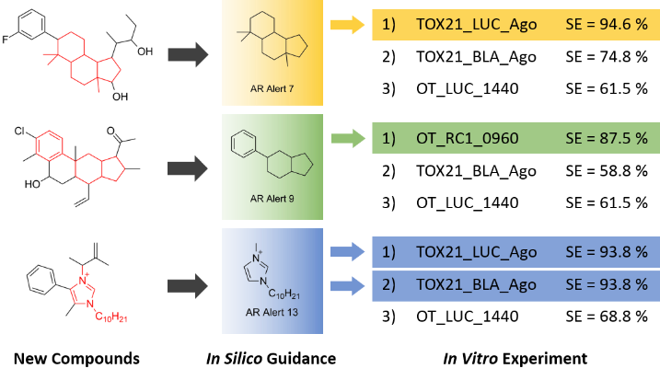

ABSTRACT
Molecular initiating events (MIEs) are key events in adverse outcome pathways (AOPs) that link molecular chemistry to target biology. As they are based in chemistry, these interactions are excellent targets for computational chemistry approaches to in silico modelling. In this work, we aim to link ligand chemical structure to MIEs for androgen receptor (AR) and glucocorticoid receptor (GR) binding using ToxCast data. This has been done using an automated computational algorithm to perform maximal common substructure searches on chemical binders for each target from the ToxCast dataset. The models developed show a high level of accuracy, correctly assigning 87.20% of AR binders and 96.81% of GR binders in a 25% test set using holdout cross-validation. The 2D structural alerts developed can be used as in silico models to predict these MIEs, and as guidance for in vitro ToxCast assays to confirm hits. These models can target such experimental work, reducing the number of assays to be performed to gain required toxicological insight. Development of these models has also allowed some structural alerts to be identified as predictors for agonist or antagonist behavior at the receptor target. This work represents a first step in using computational methods to guide and target experimental approaches.
INTRODUCTION
The adverse outcome pathway (AOP) framework for risk assessment provides structure for chemical and biological information to be collected and used in safety science.^{1,2} The first key event (KE) in an AOP is the molecular initiating event (MIE), which has been defined as the initial interaction between a molecule and a biomolecule or biosystem that can be causally linked to an outcome via a pathway.^{3,4} The chemical-biological interactions captured by the MIE are important for understanding why a chemical is toxic, and the AOP is key to understanding how the perturbation of the system by the chemical leads to toxic outcomes in the organism. By combining biological and chemical information MIEs can be measured and predicted, and AOPs can be constructed and used to understand the likely toxic outcomes for new molecules. In silico methods and in vitro experimental assays play a key role in advancing our understanding and use of MIEs and AOPs in safety science.⁵
The MIE provides a good basis for the construction of in silico models as it focuses on the biological response that is directly tied to the chemical features of a compound. As a result of this, in silico techniques have begun to see use in MIE prediction, given that appropriate data is available. This has included the use of molecular modelling approaches to study the interaction of a toxicant with a specific biological target.⁶ In addition, the use of key concepts in a chemical reaction have led to a better understanding of how and why some chemicals are genotoxic, and models have been constructed to reflect this.⁷ In silico models of large amounts of receptor binding data from open sources have been constructed using 2D structure activity relationships (SARs) for human targets, for use in relatively quick and inexpensive screening procedures.⁸ In addition to the MIE, in silico mathematical modelling utilizing in vitro assay results has been used to link KEs through their key event relationships (KERs) further down the AOP for skin sensitization, allowing a link to be established between molecular concentration of the sensitizer and T cell response.⁹ The establishment of such models and their refinement will be important in the application of AOPs, aiding in making toxicological risk assessment more rapid and less expensive.
The combination of in silico computational models and in vitro assays in toxicology will be a valuable step in the effort to improve mechanistic understanding and scientific rigor, and reduce reliance on in vivo experiments in toxicology. The AOP framework provides a good grounding for this, as once KEs and KERs are identified and characterized, models and assays can be developed to predict and measure them in a manner mutually beneficial to in vitro and in silico science. This is beginning to become a more common theme in toxicology research, including recent efforts to identify complimentary in silico and in vitro approaches for the identification of parent compounds which produce active metabolites in estrogen receptor binding,¹⁰ and comparisons between in silico, in vitro and in vivo approaches in skin sensitization.¹¹
The US EPA Toxicity Forecasting (ToxCast) project has involved the generation of large amount of high throughput in vitro data (Over 4000 chemicals tested in between 100 and 700 assays).^{12,13} This data is generated in a consistent manner, and includes a wide variety of chemicals including industrial and consumer products, food additives, pesticides, and drugs. These chemicals were not chosen because they were expected to be active, resulting in a database containing a balance of positive and negative data points. As such this data is useful for computational model construction. This in vitro data has been used at the EPA and elsewhere in modelling approaches, including computational modelling for specific target binding^{14,15} as biological descriptors for toxicity prediction,^{16,17} and pharmacokinetic modelling of human dose responses.¹⁸
Of interest in this study, the androgen receptor (AR) and glucocorticoid receptor (GR) are nuclear receptors that are important in human toxicology. Both are involved in gene expression in cells, with AR focused on maintenance of the male phenotype and GR on immune response.^{19,20} The AR and GR are indicated as being toxicologically relevant in a number of toxicity pathways, and this is illustrated through a number of AOPs in the AOP Wiki,²¹ including:
- cancerous endpoints and teratogenicity for the AR
- disease susceptibility, decreased male fertility and depression for the GR
Activation of these important targets is measured in ToxCast, with 11 assays for AR activity and 5 for GR activity included in the database.¹²
In this study 2D structural alerts have been developed for the AR and GR using openly available ToxCast data. The protocols used for structural alert generation have been previously developed and validated using ChEMBL data.²² 2D structural alerts have the strength of providing transparent predictions, if a novel molecule contains an alert it is predicted active otherwise it is predicted inactive, and the chemistry tied to the active prediction can be viewed in the alert, the novel molecule and seen in the training data. Because of this, alerts can only provide good predictions for molecules similar in chemistry to the training data and do not pick up 3D features of molecules. Ease of interpretation of these models outweighs these disadvantages in their application for in silico modelling. Each of these structural alerts can be thought of as a specific chemical category, containing a small number of highly similar chemicals. These categories have then been used to target in vitro ToxCast assays, by identifying the ones most likely to be able to confirm a hit that is predicted in silico. The ability of computational methods to support experimental procedures can assist in reducing the number of expensive and time-consuming tests that are required.
MATERIALS AND METHODS
Data Set.
Generation of burst flag hit-call matrix. All analyses in the generation of the burst flag hit-call matrix and extraction of chemicals for the targets in this study (AR and GR) were performed using R v3.3.2²³ and are outlined in more detail in Nelms et al (2018).²⁴ Briefly, the quality control flag, AC50 and cytotoxicity distribution data files from ToxCast¹² were utilized to develop a discretised hit-call matrix that takes the cytotoxicity-associated burst phenomenon into account.²⁵ First, the chemical-specific lower bound of cytotoxicity value was identified for each chemical present within the ToxCast cytotoxicity distribution matrix. The approach used to calculate this lower bound of cytotoxicity is discussed in more detail in Judson et al. (2016).²⁵ Briefly, the concentration threshold at which cytotoxicity was observed for each chemical was calculated using the -log₁₀AC50 value associated with each chemical-assay pair. Chemicals that were inactive within a particular assay were assigned an AC50 of 1,000,000 µM (i.e. a -log₁₀AC50 value of 0). For those chemicals with two or more hits in the cytotoxicity assays both the median(-log₁₀(AC50)) in the cytotoxicity assays and the median absolute deviation (MAD) of the -log₁₀(AC50) in the cytotoxicity assays were calculated. Meanwhile, an arbitrary default value of 1000 µM was set for those chemical with fewer than two hits in the cytotoxicity-related assays. Subsequently, Judson et al. (2016) utilised the distribution of the MAD values across these chemicals to calculate the global MAD of cytotoxicity (0.289 log units). The global MAD value has also been utilised to calculate the lower bound of cytotoxicity. This was achieved by subtracting three times the global MAD from the micromolar concentration of the cytotoxicity value. As such, the lower bound of cytotoxicity gives a measure of the variability of the cytotoxicity point across the entire ToxCast dataset. Thus, providing a range within which activity may, potentially, be confounded by cytotoxicity. This chemical-specific lower bound of cytotoxicity was then compared against the AC50 for each assay in which the chemical was tested. The chemical-assay pairs for which the AC50 was lower than the lower bound of cytotoxicity were considered active (i.e. assigned a value of “1”), whilst chemical-assay pairs with an AC50 above the lower bound of cytotoxicity were considered inactive (i.e. assigned a value of “0”), as illustrated in Figure 1.
Upon generation of the hit-call matrix taking the lower bound of cytotoxicity into consideration an examination of the cytotoxicity assays and their associated specific-target counterparts was conducted. This was conducted using the -log₁₀AC50 (available for download from ToxCast) and the hit-call matrix developed above. Scalar multiplication was utilised so that only the -log₁₀AC50 values for chemical-assay combinations that were active below the lower bound of cytotoxicity (i.e. active below the burst) remained. Subsequently, a scatterplot of the results for the cytotoxicity assays against the target-specific counterparts was produced (Figure 2). Whilst the majority of the points fell on either the x-axis (i.e. the chemical exhibited a target-specific effect prior to cytotoxicity) or the y-axis (i.e. the chemical exhibited cytotoxicity prior to the observation of a target-specific effect) a number of points fell along the diagonal (i.e. target-specific effects and cytotoxicity occur at approximately the same concentration). Investigation of the points along the diagonal led to the identification of four quality control (QC) flags associated with a large proportion of these points, namely:
- Only one concentration above baseline, active
- Borderline active
- Gain AC50 < lowest concentration and loss AC50 < mean concentration
- Hit-call potentially confounded by overfitting
The chemical-assay pairs associated with at least one of these QC flags were identified. This information was used to develop a flag hit-call matrix whereby, chemical-assay pairs with an associated flag were given a score of “0” and chemical-assay pairs without an associated flag were given a score of “1”. This hit-call matrix was generated because this type of investigation can only be performed when both cytotoxicity and associated specific-target assays are present. This is not the case for the vast majority of assays in ToxCast. Therefore, utilising the four QC flags should assist in removing active calls for chemicals potentially confounded by cytotoxicity and further increase confidence that an active call acts via the target specific mechanism.
In the final hit-call matrix (i.e. the burst flag hit-call matrix) used for the extraction of active chemicals within this study a chemical was considered active in an assay only when call a “hit” in both of the previously developed hit-call matrices. This limits active calls to those chemical-assay pairs that were 1) below the lower bound of cytotoxicity, and 2) did not have an associated QC flag.
Extraction of AR and GR data. In order to be as conservative as possible, two separate data files were used to identify chemicals that were active or inactive within assays relating to AR and GR activity. The burst flag hit-call matrix developed above was utilised to identify the active chemicals as there was higher confidence that an active call would be due to a target specific effect. Meanwhile, the original ToxCast hit-call matrix was used to identify the inactive chemicals as these calls also took into consideration possible activity via cytotoxicity; therefore, there was higher confidence that an inactive call was truly inactive. The names of the assays associated with the targets of interest were identified and these assays were extracted from both matrices. For each nuclear receptor, the list of active (i.e. a “1” designation in burst flag matrix) and inactive (i.e. a designation of “0” in original ToxCast matrix) chemicals were ascertained and the associated SMILES strings were gathered. These data were subsequently used in the construction of the models.
Data for each target was randomly split into 75% training set and 25% test set for external validation and duplicate data points were removed. This was performed on the molecular structure of each chemical based on their atomic connectivity, resulting in different tautomers, enantiomers and salts being treated as different data points. In total, data points for 7,027 unique compounds were extracted for the AR and 7,329 unique compounds were extracted for the GR for model construction (Table 1).
Structural Alert Construction. Structural alerts were developed according to principles developed in previous work on ChEMBL data.²² 2D fragment-based structural alerts were generated iteratively using a maximal common substructure algorithm and custom scripting in Pipeline Pilot (Figure 3).²⁶ The use of maximal common substructure searches means no information about the biological target is required for model construction. Structural alerts were coded in SMILES and statistical performance measures on the training and test sets are output for expert interpretation and model construction.
The Pipeline Pilot protocol for constructing structural alerts and using the models, and the training and test data are available through GitHub (https://github.com/teha2/chemical_toxicology).
Structural Alert Validation and Model Construction. Validation of the alerts and model construction was performed in an analogous manner to our previous work.²² The number of true positives (TP), true negatives (TN), false negatives (FN) and false positives (FP) for the test sets were used for each structural alert to calculate sensitivity (SE = TP / (TP + FN)), specificity (SP = TN / (TN + FP)), overall quality (Q = (TP + TN) / (TP + TN + FP + FN)) and Matthews’s correlation coefficient (MCC)²⁷ .
$$MCC=\frac{TP×TN-FP×FN}{\sqrt{(TP+FP)(TP+FN)(TN+FP)(TN+FN)}}$$
To use the structural alerts as in silico models for toxicity evaluation it is important to consider which alerts provide good predictions from two different perspectives. First, for a risk evaluation procedure (RE), the aim is to maximize overall performance of the model, with high sensitivity, specificity and MCC. Second, for the purposes of screening large numbers of chemicals and not missing positives (referred to as Screen), it is important to minimize false negative predictions, getting the highest sensitivity possible, even at the cost of a lower specificity. Screening models require the use of structural alerts with two or more molecules in the training set, as this connects a hit with at least two other experimentally positive molecules in the ToxCast database whose activity is not caused by cytotoxicity. This approach risks overfitting the training data, unless, on average, each structural alert has a high enough number of training set chemicals. In total, there are 10.3 total positive chemicals per structural alert in the AR Screen model and 5.8 per structural alert in the GR Screen model. For the RE models, there are 64.2 total positive chemicals per alert for the AR and 17.0 per alert for the GR. These numbers are all higher than those dictated by the “Topliss and Costello rule”,²⁸ which recommends there should be at least five times as many chemicals as descriptors to minimize the risk of chance correlation and overfitting for simple linear regression QSARs. For risk evaluation (RE), however, specificity is more important than false negatives. Using same criterion for number of molecules per structural alert, and ensuring there are more true positives than false positives in the test set, helps show that a fragment is truly indicative of activity, and not just common among ToxCast chemicals.
RESULTS AND DISCUSSION
2D SARs for ToxCast Assays In total 87 structural alerts were identified for the AR and 57 for the GR. All of these alerts were used in the Screen models. In the RE models 14 alerts were used for the AR and 18 for the GR. The structural alerts coded in SMILES strings and performance statistics against the training and test sets are provided in the supporting information to aid in toxicological decision making. By considering this information carefully, better in silico predictions can be made for novel chemicals, and these decisions can be tailored to the user’s requirements.
The RE model has the highest overall performance across sensitivity, specificity, and MCC. The Screen model aims to correctly predict as many of the positives as possible, getting a high sensitivity at the cost of specificity. All model results for both targets across the training and test sets are included in Table 2.
The difference between the models can be seen when considering the difference in statistical performance for each. For the RE models (AR Test: SE = 23.53%, SP = 96.27%, Q = 87.20%, MCC = 0.281, GR Test: SE = 31.08%, SP = 99.55%, Q = 96.81%, MCC = 0.473) a higher level of SP, Q and MCC was observed. For the Screen models (AR Test: SE = 86.43%, SP = 33.35%, Q = 39.97%, MCC = 0.084, GR Test: SE = 58.11%, SP = 88.36%, Q = 87.15%, MCC = 0.253) SE is considerably higher at the cost of these other statistics, as expected. The overall higher level of performance generally for the GR over the AR is interesting, and suggests there is something in the chemistry of the GR binders which allows them to be more easily differentiated from the non-binders based on their 2D structural chemistry. This is particularly noticeable considering the much higher specificity for the GR screen models, meaning that even with a high number of structural alerts the models are not significantly over-firing. 2D structural alerts are computationally simple, quick, inexpensive, and can be used to screen a large number of chemicals pre-development. These methods can also supplement, and target, further toxicity tests in risk assessment procedures.
The typical binders, testosterone (AR) and dexamethasone (GR), are shown in Figure 4 alongside structural alerts that match their structures. The alerts show that the steroidal backbone of each molecule is key for its binding, as is the positioning of the hydrogen bonding oxygen and hydroxyl groups. These molecules are well represented by the ToxCast data set, as shown through the large overlap between them and their structural alerts, but the alerts do allow us to see why the algorithm considers them to be active. For molecules less well matched to the training data the alerts may be able to point to structural features that could be removed to reduce molecular activity at the biological target. In the cases of testosterone and dexamethasone this would have ben be a considerable change to the steroidal structure, due to its significant match to the structural alerts.

Using 2D SAR based chemical categories to guide in vitro assays
The 2D structural alerts developed can be considered as chemical categories, each containing a small number of highly similar chemicals. As ToxCast utilizes a number of assays for each MIE, these chemical categories can be thought of as defining specific chemical characteristics that align with specific in vitro tests. Can these categories be used to guide in vitro assays, allowing the in silico methodology to dictate which test should be performed first? By identifying which is most likely to show a hit for a given chemical category we can target future in vitro assays. This will result in a reduction in the number of assays required to assess each chemical, making the assessment process more efficient, in line with the aims of AOP frameworks.^{24,29}
To test this hypothesis, the chemical categories defined by the RE models developed above were used to filter compounds and examine their raw ToxCast data. Each alert category was examined in turn, using the in vitro results to calculate sensitivity values for each assay. These sensitivity values were calculated using true and false positives in the same way as the sensitivity values for the in silico models. Where a compound was untested in the assay of interest it was omitted from these calculations. These results are shown for the AR in Table 3 and for GR in Table 4. By calculating the sensitivity for each assay and plotting it against each assay from the target it can be seen which assays tend to show hits for which type of molecules. Graphs showing these values are shown for the AR in Figure 5 and for the GR in Figure 6.
The difference in sensitivity from assay to assay is most notable in the case of the AR as ToxCast contains 11 assays which suggest a molecule is an AR binder. To highlight this, four specific AR chemical category sensitivity values have been plotted in Figure 7. This shows a large amount of variability in the distribution of sensitivities for the chemical categories identified, with each assay showing distinctly different performance for each chemical category. It shows, for example, if a novel compound were to fit within the chemical category for alert 9 the best assay to test first would be OT_AR_ARSRC1_0960, as this assay has the highest sensitivity value. After this a good choice would be TOX21_AR_LUC_MDAKB2_Agonist or NVS_NR_hAR. However, if the novel molecule contained alert 13 TOX21_AR_LUC_MDAKB2_Antagonist or TOX21_AR_LUC_MDAKB2_Antagonist2 would be the best choice, and the best for alerts 6 and 7 would be TOX21_AR_LUC_MDAKB2_Agonist. This methodology allows the chemical categories that are defined by the structural alerts to contribute to in vitro screening.
In addition, it is possible to identify if the structural alerts tend to contain agonists or antagonists of the androgen receptor as ToxCast (specifically Tox21) contains assays which are able to distinguish between them. For example, it would appear that alerts 6 and 7 contain primarily agonists due to the high sensitivity of the assay TOX21_AR_LUC_MDAKB2_Agonist. Alert 13 however has a high proportion of antagonists because of the high TOX21_AR_LUC_MDAKB2_Antagonist and TOX21_AR_LUC_MDAKB2_Antagonist2 sensitivity. Finally, it would appear alert 9 contains both agonists and antagonists as it has both of these assays showing sensitivities around 50%.
MIEs are important chemical-biological interactions, and predicting them for novel molecules using computational tools provides an important contribution to AOP-based risk assessment. In this work we have used ToxCast data and chemical informatics approaches to elucidate 2D structural alerts for the prediction of AR and GR MIEs. These alerts define tight chemical categories of a small number of molecules, which can be used to guide in vitro experimental assays. This would allow for a reduction in the number of in vitro tests required to confirm molecules as hits for the androgen and glucocorticoid receptors, reducing the number of expensive and time-consuming experiments required to identify this, and provides a platform for further research covering high-throughput assays and targets.
ASSOCIATED CONTENT
Supporting Information.
Performance statistics and SMILES strings for the structural alerts developed in this work. This material is available free of charge via the Internet at http://pubs.acs.org.
The Pipeline Pilot protocol for constructing structural alerts and using the models, and the training and test data are available through GitHub (https://github.com/teha2/chemical_toxicology).

AUTHOR INFORMATION
Corresponding Author
*E-mail: jmg11@cam.ac.uk. Phone: 01223 336434.
Author Contributions
The manuscript was written through contributions of all authors. All authors have given approval to the final version of the manuscript.
Funding Sources
The authors acknowledge the financial support of Unilever. M.D.N. was supported by an appointment to the Research Participation Program of the U.S. Environmental Protection Agency, Office of Research and Development, administered by the Oak Ridge Institute for Science and Education through an interagency agreement between the U.S. Department of Energy and the U.S. EPA.
Data Statement
According to the University of Cambridge data management policy, all the data used in this paper is available either in the paper or in the SI. A copy of the data is also available in the University of Cambridge repository at: https://www.repository.cam.ac.uk/

Disclaimer
The information in this document has been funded wholly (or in part) by the U.S. Environmental Protection Agency. It has been subjected to review by the National Center for Computational Toxicology and approved for publication. Approval does not signify that the contents reflect the views of the Agency, nor does mention of trade names or commercial products constitute endorsement or recommendation for use.
ABBREVIATIONS
AOP=adverse outcome pathways, AR=androgen receptor, ATG_AR=ATG_AR_TRANS_up, FN=False Negative, FP=False Positive, GR=glucocorticoid receptor, MCC=Matthews Correlation Coefficient, MCSS=maximal common substructure, MIE=molecular initiating event, NVS_hAR=NVS_NR_hAR, NVS_rAR=NVS_NR_rAR, OT_LUC_1440=OT_AR_ARELUC_AG_1440, OT_RC1_0480=OT_AR_ARSRC1_0480, OT_RC1_0960=OT_AR_ARSRC1_0960, Q=Overall Quality, (Q)SAR=(quantitative) structure activity relationship, RE=risk evaluation, SE=Sensitivity, SP=Specificity, TOX21_BLA_Ago=TOX21_AR_BLA_Agonist_ratio, TOX21_BLA_Ant=TOX21_AR_BLA_Antagonist_ratio, TOX21_LUC_Ago=TOX21_AR_LUC_MDAKB2_Agonist, TOX21_LUC_Ant=TOX21_AR_LUC_MDAKB2_Antagonist, TOX21_LUC_Ant2=TOX21_AR_LUC_MDAKB2_Antagonist2, TN=True Negative, TP=True Positive.
REFERENCES
(1) Ankley, G. T.; Bennett, R. S.; Erickson, R. J.; Hoff, D. J.; Hornung, M. W.; Johnson, R. D.; Mount, D. R.; Nichols, J. W.; Russom, C. L.; Schmieder, P. K.; Serrano, J. A.; Tietge, J. E.; Villeneuve, D. L. Adverse Outcome Pathways: A Conceptual Framework to Support Ecotoxicology Research and Risk Assessment. Environ. Toxicol. Chem. 2010, 29 (3), 730–741. https://doi.org/10.1002/etc.34.
(2) Villeneuve, D. L.; Garcia-Reyero, N. Vision & Strategy: Predictive Ecotoxicology in the 21st Century. Environ. Toxicol. Chem. 2011, 30 (1), 1–8. https://doi.org/10.1002/etc.396.
(3) Allen, T. E. H.; Goodman, J. M.; Gutsell, S.; Russell, P. J. Defining Molecular Initiating Events in the Adverse Outcome Pathway Framework for Risk Assessment. Chem. Res. Toxicol. 2014, 27, 2100–2112.
(4) Allen, T. E. H.; Goodman, J. M.; Gutsell, S.; Russell, P. J. A History of the Molecular Initiating Event. Chem. Res. Toxicol. 2016, 29 (12), 2060–2070. https://doi.org/10.1021/acs.chemrestox.6b00341.
(5) Leist, M.; Hasiwa, N.; Rovida, C.; Daneshian, M.; Basketter, D.; Kimber, I.; Clewell, H.; Gocht, T.; Goldberg, A.; Busquet, F.; Rossi, A. M.; Schwarz, M.; Stephens, M.; Taalman, R.; Knudsen, T. B.; McKim, J.; Harris, G.; Pamies, D.; Hartung, T. Consensus Report on the Future of Animal-Free Systemic Toxicity Testing. ALTEX 2014, 31 (3), 341–356. https://doi.org/10.14573/altex.1406091.
(6) Tsakovska, I.; Al Sharif, M.; Alov, P.; Diukendjieva, A.; Fioravanzo, E.; Cronin, M. T. D.; Pajeva, I. Molecular Modelling Study of the PPARγ Receptor in Relation to the Mode of Action/Adverse Outcome Pathway Framework for Liver Steatosis. Int. J. Mol. Sci. 2014, 15 (5), 7651–7666. https://doi.org/10.3390/ijms15057651.
(7) Enoch, S. J.; Cronin, M. T. D.; Ellison, C. M. The Use of a Chemistry-Based Profiler for Covalent DNA Binding in the Development of Chemical Categories for Read-across for Genotoxicity. ATLA 2011, 39 (2), 131–145.
(8) Allen, T. E. H.; Liggi, S.; Goodman, J. M.; Gutsell, S.; Russell, P. J. Using Molecular Initiating Events to Generate 2D Structure Activity Relationships for Toxicity Screening. Chem. Res. Toxicol. 2016, 29 (10), 2060–2070. https://doi.org/10.1021/acs.chemrestox.6b00101.
(9) MacKay, C.; Davies, M.; Summerfield, V.; Maxwell, G. From Pathways to People: Applying the Adverse Outcome Pathway (AOP) for Skin Sensitization to Risk Assessment. ALTEX 2013, 30 (4), 473–486. https://doi.org/10.14573/altex.2013.4.473.
(10) Leonard, J. A.; Stevens, C.; Mansouri, K.; Chang, D.; Pudukodu, H.; Smith, S.; Tan, Y.-M. A Workflow for Identifying Metabolically Active Chemicals to Complement in Vitro Toxicity Screening. Comput. Toxicol. 2017. https://doi.org/10.1016/j.comtox.2017.10.003.
(11) Kreiling, R.; Gehrke, H.; Broschard, T. H.; Dreeßen, B.; Eigler, D.; Hart, D.; Höpflinger, V.; Kleber, M.; Kupny, J.; Li, Q.; Ungeheuer, P.; Sauer, U. G. In Chemico, in Vitro and in Vivo Comparison of the Skin Sensitizing Potential of Eight Unsaturated and One Saturated Lipid Compounds. Regul. Toxicol. Pharmacol. 2017, 90 (July), 262–276. https://doi.org/10.1016/j.yrtph.2017.09.023.
(12) ToxCast database https://www.epa.gov/chemical-research/toxicity-forecasting.
(13) Richard, A. M.; Judson, R. S.; Houck, K. A.; Grulke, C. M.; Volarath, P.; Thillainadarajah, I.; Yang, C.; Rathman, J.; Martin, M. T.; Wambaugh, J. F.; Knudsen, T. B.; Kancherla, J.; Mansouri, K.; Patlewicz, G.; Williams, A. J.; Little, S. B.; Crofton, K. M.; Thomas, R. S. ToxCast Chemical Landscape: Paving the Road to 21st Century Toxicology. Chem. Res. Toxicol. 2016, 29 (8), 1225–1251. https://doi.org/10.1021/acs.chemrestox.6b00135.
(14) Judson, R. S.; Magpantay, F. M.; Chickarmane, V.; Haskell, C.; Tania, N.; Taylor, J.; Xia, M.; Huang, R.; Rotroff, D. M.; Filer, D. L.; Houck, K.A.; Martin, M. T.; Sipes, N.; Richard, A. M.; Mansouri, K.; Setzer, R. W.; Knudsen, T. B.; Crofton, K. M.; Thomas, R. S. Integrated Model of Chemical Perturbations of a Biological Pathway Using 18 in Vitro High-Throughput Screening Assays for the Estrogen Receptor. Toxicol. Sci. 2015, 148 (1), 137–154. https://doi.org/10.1093/toxsci/kfv168.
(15) Mansouri, K.; Abdelaziz, A.; Rybacka, A.; Roncaglioni, A.; Tropsha, A.; Varnek, A.; Zakharov, A.; Worth, A.; Richard, A. M.; Grulke, C. M.; Trisciuzzi, D.; Fourches, D.; Horvath, D.; Benfenati, E.; Muratov, E.; Wedebye, E. B.; Grisoni, F.; Mangiatordi, G. F.; Incisivo, G. M.; Hong, H.; Ng, H. W.; Tetko, I. V.; Balabin, I.; Kancherla, J.; Shen, J.; Burton, J.; Nicklaus, M.; Cassotti, M,; Nikolov, N. G.; Nicolotti, O.; Andersson, P. L.; Zang, Q.; Politi, R.; Beger, R. D.; Todeschini, Huang, R.; Farang, S.; Rosenberg, S. A.; Slavov, S.; Hu, X.; Judson, R. S. CERAPP: Collaborative Estrogen Receptor Activity Prediction Project. Environ. Health Perspect. 2016, 124 (7), 1023–1033. https://doi.org/10.1289/ehp.1510267.
(16) Martin, M. T.; Knudsen, T. B.; Reif, D. M.; Houck, K. A.; Judson, R. S.; Kavlock, R. J.; Dix, D. J. Predictive Model of Rat Reproductive Toxicity from ToxCast High Throughput Screening. Biol. Reprod. 2011, 85 (2), 327–339. https://doi.org/10.1095/biolreprod.111.090977.
(17) Pradeep, P.; Povinelli, R. J.; Merrill, S. J.; Bozdag, S.; Sem, D. S. Novel Uses of in Vitro Data to Develop Quantitative Biological Activity Relationship Models for in Vivo Carcinogenicity Prediction. Mol. Inform. 2015, 34 (4), 236–245. https://doi.org/10.1002/minf.201400168.
(18) Judson, R. S.; Kavlock, R. J.; Setzer, R. W.; Cohen Hubal, E. A.; Martin, M. T.; Knudsen, T. B.; Houck, K. A.; Thomas, R. S.; Wetmore, B. A.; Dix, D. J. Estimating Toxicity-Related Biological Pathway Altering Doses for High-Throughput Chemical Risk Assessment. Chem. Res. Toxicol. 2011, 24 (4), 451–462. https://doi.org/10.1021/tx100428e.
(19) Mooradian, A. D.; Morley, J. E.; Korenman, S. G. Biological Actions of Androgens. Endocr. Rev. 1987, 8 (1), 1–28.
(20) Hollenberg, S. M.; Weinberger, C.; Ong, E. S.; Cerelli, G.; Oro, A.; Lebo, R.; Thompson, E. B.; Rosenfeld, M. G.; Evans, R. M. Primary Structure and Expression of a Functional Human Glucocorticoid Receptor CDNA. Nature 1985, 318 (19), 635–641.
(21) European Commission Institute for Health and Consumer Protection. AOP Wiki http://ihcp.jrc.ec.europa.eu/our_activities/alt-animal-testing-safety-assessment-chemicals/improved_safety_assessment_chemicals/adverse-outcome-pathways-aop.
(22) Allen, T. E. H.; Goodman, J. M.; Gutsell, S.; Russell, P. J. Using 2D Structural Alerts to Define Chemical Categories for Molecular Initiating Events. Toxicol. Sci. 2018, 165 (1), 213–223.
(23) Team, R. C. R: A Language and Environment for Statistical Computing. R Foundation for Statistical Computing: Vienna, Austria 2017.
(24) Nelms, M. D.; Mellor, C. L.; Enoch, S. J.; Judson, R. S.; Patlewicz, G.; Richard, A. M.; Madden, J. M.; Cronin, M. T. D.; Edwards, S. W. A Mechanistic Framework for Integrating Chemical Structure and High-Throughput Screening Results to Improve Toxicity Predictions. Comput. Toxicol. 2018, 8 (July), 1–12. https://doi.org/10.1016/j.comtox.2018.08.003.
(25) Judson, R.; Houck, K.; Martin, M.; Richard, A. M.; Knudsen, T. B.; Shah, I.; Little, S.; Wambaugh, J.; Setzer, R. W.; Kothya, P.; Phuong, J.; Filer, D.; Smith, D.; Reif, D.; Rotroff, D.; Kleinstreuer, N.; Sipes, N.; Xia, M.; Huang, R.; Crofton, K.; Thomas, R. S. Analysis of the Effects of Cell Stress and Cytotoxicity on in Vitro Assay Activity across a Diverse Chemical and Assay Space. Toxicol. Sci. 2016, 152 (2), 323–339. https://doi.org/10.1093/toxsci/kfw092.
(26) Accelrys Software Inc. Pipeline Pilot v.8.0.1.500.
(27) Matthews, B. W. Comparison of the Predicted and Observed Secondary Structure of T4 Phage Lysozyme. Biochim. Biophys. Acta 1975, 405, 442–451.
(28) Topliss, J. G.; Costello, R. J. Chance Correlations in Structure-Activity Studies Using Multiple Regression Analysis. J. Med. Chem. 1972, 15 (10), 1066–1068.
(29) Tollefsen, K. E.; Scholz, S.; Cronin, M. T.; Edwards, S. W.; de Knecht, J.; Crofton, K.; Garcia-Reyero, N.; Hartung, T.; Worth, A.; Patlewicz, G. Applying Adverse Outcome Pathways (AOPs) to Support Integrated Approaches to Testing and Assessment (IATA). Regul. Toxicol. Pharmacol. 2014, 70 (3), 629–640. https://doi.org/10.1016/j.yrtph.2014.09.009.

FIGURES

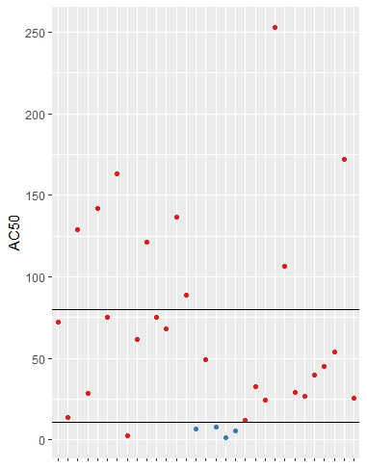

Figure 1 Chart showing AC50 values across a range of assays for a single compound. The top line shows the chemical specific cytotoxicity point and the bottom line is the chemical specific lower bound of cytotoxicity. Points above the bottom line are considered inactive as their response in the specific assay is either weak, or potentially caused by cytotoxicity. Using this approach blue points are considered active and red points are considered inactive. One red point lies below the lower bound of chemical specific cytotoxicity due to at least 1 quality control flag used to further increase confidence that an active call is "true" activity.
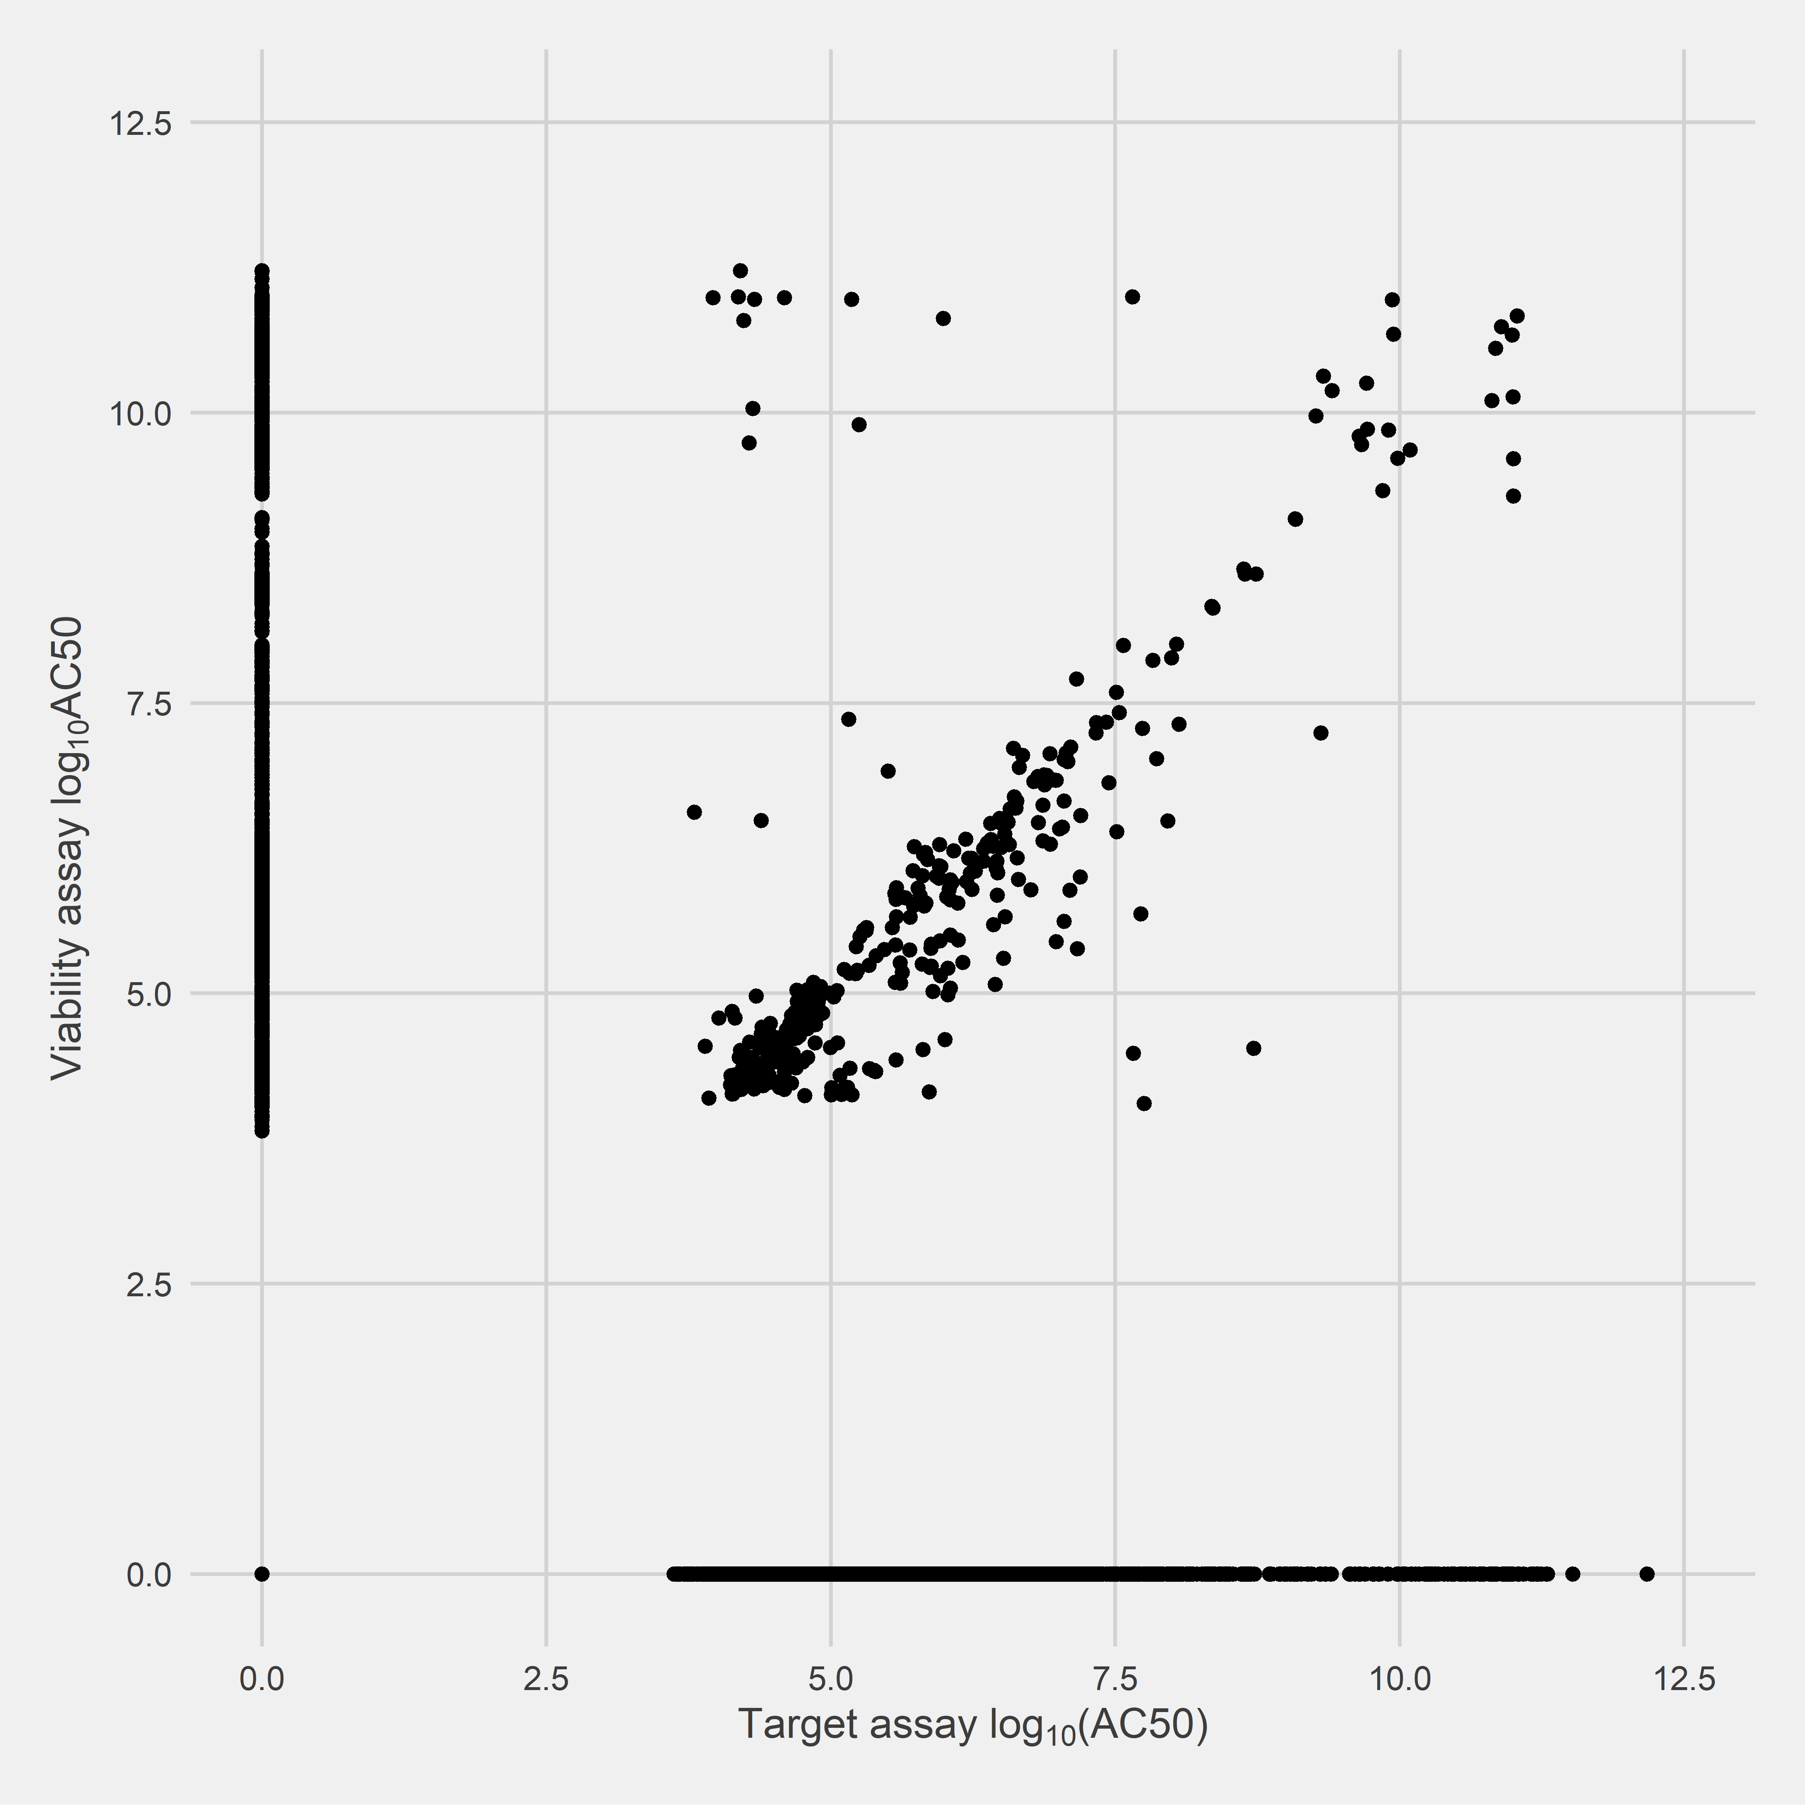

Figure 2 Scatterplot of -logAC50 values for chemicals tested within each cytotoxicity assay against the results for the specific target counterpart assay. Points lying along the diagonal were investigated and it was observed that four quality control flags (“Only one concentration above baseline, active”, “Borderline active”, “Gain AC50 < lowest concentration and loss AC50 < mean concentration”, and “Hit-call potentially confounded by overfitting”) were associated with a large number of these points. These flags were subsequently used to further increase confidence in active calls.

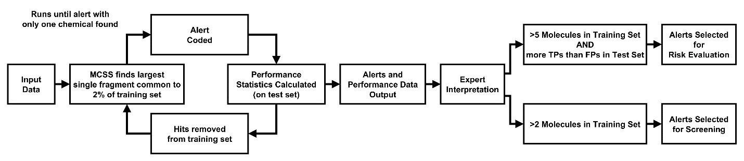
Figure 3. The computational procedure for structural alert generation and the criteria for different models. An iterative process is used to find the largest alert common to 2% of the training set, code the alert in SMILES and calculate its performance statistics. This iterative loop runs until a fragment category is identified containing only one chemical. A human expert can then judge on alert effectiveness. Here we present two models, one for risk evaluation and one for chemical screening. MCSS=Maximal Common Substructure. Allen, T. E. H.; Goodman, J. M.; Gutsell, S.; Russell, P. J. Using 2D Structural Alerts to Define Chemical Categories for Molecular Initiating Events. Toxicol. Sci. 2018, 165 (1), 213–223. by permission of Oxford University Press.

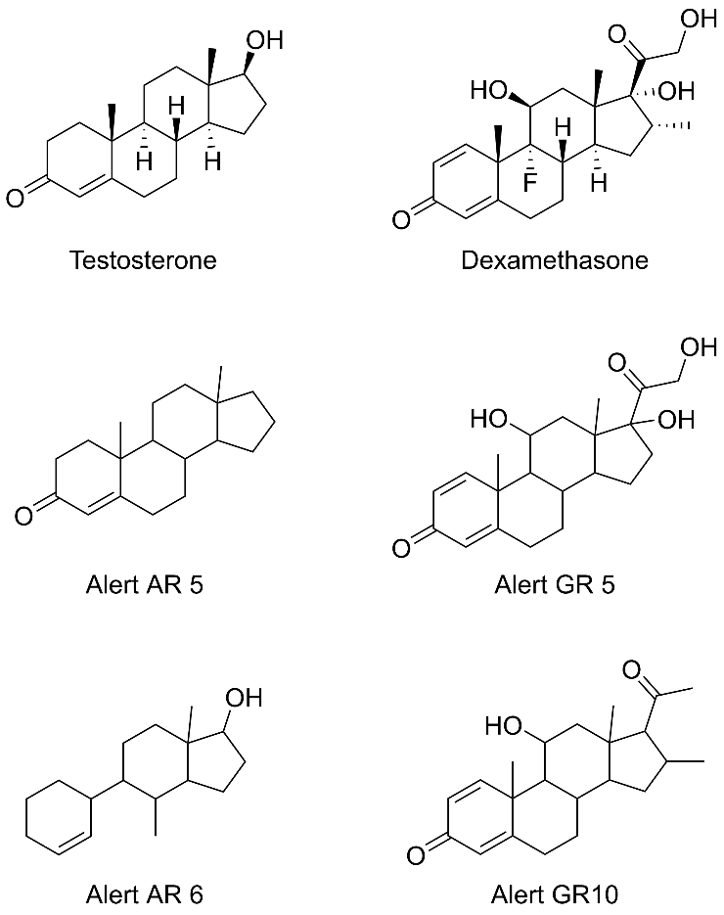
Figure 4. Typical binders for AR (Testosterone) and GR (Dexamethasone) are shown alongside the largest structural alerts contained within their structures. These structures shown the importance of the steroidal shape of the binders and their hydrogen bonding potential.

Figure 5. Sensitivities for each AR ToxCast assay for chemicals in specific chemical categories, shown graphically. Each category is defined by an individual structural alert. Assay names are abbreviated for convenience. Some values are zero due to no chemicals in those categories being tested in that specific assay, these can be identified using Table 3. AR=androgen receptor, ATG_AR=ATG_AR_TRANS_up, NVS_hAR=NVS_NR_hAR, NVS_rAR=NVS_NR_rAR, OT_LUC_1440=OT_AR_ARELUC_AG_1440, OT_RC1_0480=OT_AR_ARSRC1_0480, OT_RC1_0960=OT_AR_ARSRC1_0960, TOX21_BLA_Ago=TOX21_AR_BLA_Agonist_ratio, TOX21_BLA_Ant=TOX21_AR_BLA_Antagonist_ratio, TOX21_LUC_Ago=TOX21_AR_LUC_MDAKB2_Agonist, TOX21_LUC_Ant=TOX21_AR_LUC_MDAKB2_Antagonist, TOX21_LUC_Ant2=TOX21_AR_LUC_MDAKB2_Antagonist2.

Figure 6. Sensitivities for each GR ToxCast assay for chemicals in specific chemical categories, shown graphically. Each category is defined by an individual structural alert. Some values are zero due to no chemicals in those categories being tested in that specific assay, these can be identified using Table 4. GR=glucocorticoid receptor.
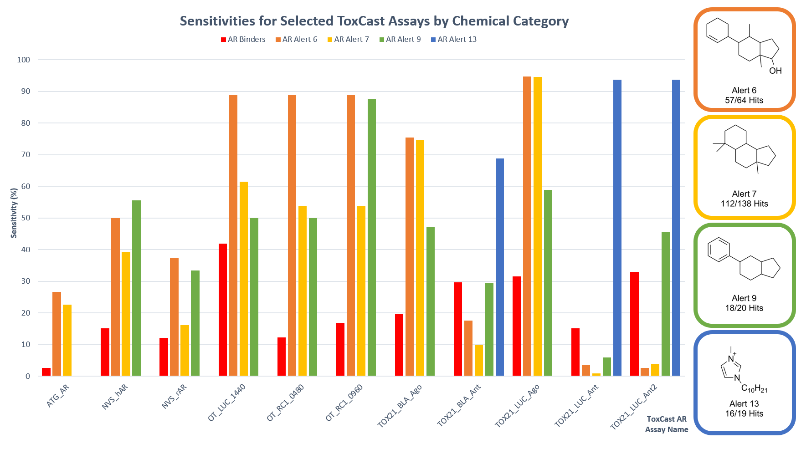

Figure 7. Sensitivities for selected AR ToxCast assays for chemicals in specific chemical categories, shown graphically. Each category is defined by an individual structural alert. Assay names are abbreviated for convenience. Some values are zero due to no chemicals in those categories being tested in that specific assay, these can be identified using Table 3. AR=androgen receptor, ATG_AR=ATG_AR_TRANS_up, NVS_hAR=NVS_NR_hAR, NVS_rAR=NVS_NR_rAR, OT_LUC_1440=OT_AR_ARELUC_AG_1440, OT_RC1_0480=OT_AR_ARSRC1_0480, OT_RC1_0960=OT_AR_ARSRC1_0960, TOX21_BLA_Ago=TOX21_AR_BLA_Agonist_ratio, TOX21_BLA_Ant=TOX21_AR_BLA_Antagonist_ratio, TOX21_LUC_Ago=TOX21_AR_LUC_MDAKB2_Agonist, TOX21_LUC_Ant=TOX21_AR_LUC_MDAKB2_Antagonist, TOX21_LUC_Ant2=TOX21_AR_LUC_MDAKB2_Antagonist2.

TABLES
 | AR |  |  |  | GR
 | Training | Test |  |  | Training | Test
Positive | 678 | 221 |  |  | 249 | 74
Negative | 4575 | 1553 |  |  | 5228 | 1778

Table 1. Data extracted from the ToxCast database for this study shown as divided between positive and negative data points and training and test sets. AR=androgen receptor, GR=glucocorticoid receptor.

 | RE |  |  |  |  |  |  |  |  |  | Screen
Target | TP | FN | TN | FP |  | SE | SP | Q | MCC |  | TP | FN | TN | FP |  | SE | SP | Q | MCC
AR Training Set | 184 | 494 | 4349 | 225 |  | 27.14 | 95.08 | 86.31 | 0.286 |  | 629 | 49 | 1559 | 3015 |  | 92.77 | 34.08 | 41.66 | 0.116
AR Test Set | 52 | 169 | 1495 | 58 |  | 23.53 | 96.27 | 87.20 | 0.281 |  | 191 | 30 | 518 | 1035 |  | 86.43 | 33.35 | 39.97 | 0.084
GR Training Set | 96 | 153 | 5213 | 14 |  | 38.55 | 99.73 | 96.95 | 0.576 |  | 194 | 55 | 4669 | 558 |  | 77.91 | 89.32 | 88.81 | 0.387
GR Test Set | 23 | 51 | 1770 | 8 |  | 31.08 | 99.55 | 96.81 | 0.473 |  | 43 | 31 | 1571 | 207 |  | 58.11 | 88.36 | 87.15 | 0.253

Table 2. Performance data for RE and Screen models for each target for the training and test sets. AR=androgen receptor, GR=glucocorticoid receptor, TP=True Positive, FN=False Negative, TN=True Negative, FP=False Positive, SE=Sensitivity, SP=Specificity, Q=Overall Quality, MCC=Matthews Correlation Coefficient.

 |  | ToxCast AR Assay
Alert Category | Chemicals | ATG_AR | NVS_hAR | NVS_rAR | OT_LUC_1440 | OT_RC1_0480 | OT_RC1_0960 | TOX21_BLA_Ago | TOX21_BLA_Ant | TOX21_LUC_Ago | TOX21_LUC_Ant | TOX21_LUC_Ant2
AR Binders | 899 | 2.65 | 15.09 | 12.10 | 41.96 | 12.24 | 16.78 | 19.59 | 29.73 | 31.55 | 15.15 | 32.98
AR Alert 1 | 23 | N/A | N/A | N/A | N/A | N/A | N/A | 78.26 | 13.04 | 100.00 | 0.00 | 0.00
AR Alert 2 | 41 | 0.00 | 22.22 | 0.00 | 0.00 | 0.00 | 0.00 | 73.17 | 12.20 | 100.00 | 0.00 | 0.00
AR Alert 3 | 18 | 0.00 | 25.00 | 0.00 | 50.00 | 50.00 | 50.00 | 77.78 | 5.56 | 88.89 | 0.00 | 0.00
AR Alert 4 | 75 | 5.26 | 33.33 | 10.53 | 42.86 | 42.86 | 42.86 | 73.33 | 9.33 | 97.33 | 0.00 | 0.00
AR Alert 5 | 40 | 28.57 | 53.85 | 28.57 | 87.50 | 75.00 | 75.00 | 85.00 | 7.50 | 90.00 | 2.50 | 6.45
AR Alert 6 | 57 | 26.67 | 50.00 | 37.50 | 88.89 | 88.89 | 88.89 | 75.44 | 17.54 | 94.74 | 3.51 | 2.63
AR Alert 7 | 112 | 22.58 | 39.29 | 16.13 | 61.54 | 53.85 | 53.85 | 74.77 | 9.91 | 94.59 | 0.90 | 3.95
AR Alert 9 | 18 | 0.00 | 55.56 | 33.33 | 50.00 | 50.00 | 87.50 | 47.06 | 29.41 | 58.82 | 5.88 | 45.45
AR Alert 13 | 16 | N/A | N/A | N/A | N/A | N/A | N/A | 0.00 | 68.75 | 0.00 | 93.75 | 93.75
AR Alert 19 | 156 | 21.95 | 39.47 | 21.43 | 61.90 | 52.38 | 61.90 | 67.53 | 15.58 | 89.61 | 3.25 | 8.57
AR Alert 20 | 178 | 21.28 | 36.36 | 25.00 | 60.00 | 56.00 | 60.00 | 62.50 | 21.02 | 83.52 | 5.68 | 12.90
AR Alert 30 | 214 | 15.87 | 35.00 | 25.00 | 58.97 | 41.03 | 53.85 | 55.92 | 23.70 | 74.88 | 8.53 | 19.21
AR Alert 51 | 181 | 16.98 | 38.78 | 24.07 | 58.62 | 51.72 | 65.52 | 63.48 | 17.98 | 84.83 | 4.49 | 11.57
AR Alert 75 | 93 | 22.58 | 40.00 | 37.50 | 66.67 | 61.90 | 71.43 | 66.30 | 21.74 | 80.43 | 4.35 | 10.14

Table 3. Sensitivities for each AR ToxCast assay for chemicals in specific chemical categories, and all AR binders shown in the first row. These categories are defined by individual structural alerts. Assay names are abbreviated for convenience. N/A is used when none of the chemicals in the category have been tested in that assay. AR=androgen receptor, ATG_AR=ATG_AR_TRANS_up, NVS_hAR=NVS_NR_hAR, NVS_rAR=NVS_NR_rAR, OT_LUC_1440=OT_AR_ARELUC_AG_1440, OT_RC1_0480=OT_AR_ARSRC1_0480, OT_RC1_0960=OT_AR_ARSRC1_0960, TOX21_BLA_Ago=TOX21_AR_BLA_Agonist_ratio, TOX21_BLA_Ant=TOX21_AR_BLA_Antagonist_ratio, TOX21_LUC_Ago=TOX21_AR_LUC_MDAKB2_Agonist, TOX21_LUC_Ant=TOX21_AR_LUC_MDAKB2_Antagonist, TOX21_LUC_Ant2=TOX21_AR_LUC_MDAKB2_Antagonist2.

 |  | ToxCast GR Assay
Alert Category | Chemicals | ATG_GRE_CIS_up | ATG_GR_TRANS_up | NVS_NR_hGR | TOX21_GR_BLA_Agonist_ratio | TOX21_GR_BLA_Antagonist_ratio
GR Binders | 323 | 6.72 | 15.67 | 80.39 | 40.25 | 36.84
GR Alert 1 | 7 | 0.00 | 0.00 | N/A | 100.00 | 0.00
GR Alert 2 | 14 | N/A | N/A | N/A | 100.00 | 0.00
GR Alert 3 | 23 | N/A | N/A | N/A | 100.00 | 0.00
GR Alert 4 | 9 | N/A | N/A | N/A | 100.00 | 0.00
GR Alert 5 | 41 | 33.33 | 66.67 | 100.00 | 100.00 | 0.00
GR Alert 6 | 8 | 0.00 | 0.00 | N/A | 100.00 | 0.00
GR Alert 7 | 8 | 0.00 | 33.33 | 66.67 | 62.50 | 25.00
GR Alert 8 | 6 | 50.00 | 50.00 | 100.00 | 16.67 | 83.33
GR Alert 10 | 26 | 66.67 | 100.00 | 100.00 | 100.00 | 0.00
GR Alert 11 | 16 | 0.00 | 40.00 | 66.67 | 81.25 | 18.75
GR Alert 12 | 10 | 0.00 | 33.33 | 100.00 | 30.00 | 50.00
GR Alert 13 | 56 | 25.00 | 66.67 | 100.00 | 96.43 | 3.57
GR Alert 15 | 26 | 0.00 | 27.27 | 85.71 | 57.69 | 38.46
GR Alert 18 | 36 | 0.00 | 18.18 | 87.50 | 36.11 | 58.33
GR Alert 21 | 90 | 12.50 | 45.83 | 91.67 | 76.67 | 21.11
GR Alert 27 | 87 | 17.39 | 52.17 | 83.33 | 82.76 | 18.39
GR Alert 30 | 11 | 0.00 | 0.00 | 75.00 | 0.00 | 90.91
GR Alert 41 | 42 | 0.00 | 21.43 | 80.00 | 33.33 | 57.14

Table 4. Sensitivities for each GR ToxCast assay for chemicals in specific chemical categories, and all GR binders shown in the first row. These categories are defined by individual structural alerts. N/A is used when none of the chemicals in the category have been tested in that assay. GR=glucocorticoid receptor.

