Visualizing Food Traceability Systems: A novel system architecture for mapping material and information flow

Samantha Islam^{1,} *, Jonathan M Cullen¹ , Louise Manning²
¹Department of Engineering, University of Cambridge, United Kingdom
²Royal Agricultural University, United Kingdom
Email: si313@cam.ac.uk^{1,} *, jmc99@cam.ac.uk¹, louise.manning@rau.ac.uk²

Abstract
Background: Traceability of food products, ingredients and associated operations are important requirements for improving food safety and consumer confidence. Food traceability systems (FTSs) often suffer from inefficiency in either material or information flow within an enterprise or between supply chain partners. Modelling of system architecture is a visualisation approach that allows multiple parties to collaborate in a system design process, identify its inefficiencies and propose improvements. However, there is little academic research on the ability to use a standard visualisation tool that supports collaborative design and considers both material and information flow for a given food traceability system.
Scope & Approach: The aim of this research is to propose a new visualisation approach that allows supply chain operators to collaborate effectively in the design process of FTSs capable of maintaining streamlined information flow, minimising information loss, and improving supply chain performance.
Key findings & Conclusion: Food traceability systems are complex, encompassing processes, material flow, information flow, techniques, infrastructure, people and control strategies. Screening of literature demonstrates that model-based system engineering (MBSE) offers a sound way for visualisation of such complex systems. However, in the food traceability literature, an MBSE-based standardised traceability system modelling approach is absent. This study makes a strong contribution to existing literature by proposing a novel, material and information flow modelling technique (MIFMT), to visualise FTS architecture. MIFMT can support common understanding and iterative implementation of effective FTSs that contextualise food supply chains at multiple levels and provides opportunity to identify points at where inefficiencies can occur so that actions can be taken to mitigate them.
- Introduction
Traceability is the ability to follow the movement of food products throughout food supply chains (ISO, 2005). Efficient traceability is a high priority in global food supply chains where food fraud and safety crises not only hamper consumers well-being and trust, but also cause significant economic loss (Pearson et al., 2019). A food traceability system is a specific setting of data accumulation and data storage enabled by discrete operations that together are capable of maintaining and safeguarding desired product information through all stages of the food supply chain (World Economic Forum, 2019). FTS implementation is influenced by a combination of different drivers including legislation, food safety, sustainability, and/or consumer satisfaction (Islam & Cullen, 2021). For example, following the worldwide outbreak of Bovine Spongiform Encephalopathy (BSE), animal FTSs were enacted by legislations in different regions e.g., the European Union (EU), United Kingdom (UK) and Canada (Charlebois, Sterling, Haratifar, & Naing, 2014).
FTSs deliver value to a range of stakeholders through their wider collation of data which can be used for cold chain environment monitoring (Alfian et al., 2017), brand protection (Patterson, Cardwell, Keeton, & Yelick, 2019), verification of sustainability claims (Norton et al., 2014) and competitive advantage via customer communications (George, Harsh, Ray, & Babu, 2019). Though the fundamentals of FTSs are generic, the product descriptors in individual FTSs may vary. For example, an FTS for decaffeinated coffee would need to communicate specific processing information while recording of price and terms of trade would be mandatory for fair-trade coffee (Olsen & Aschan, 2010; Golan et al., 2004).
Traceability can encompass internal traceability i.e., recording of product descriptors within a single food business operator (FBO), through to external traceability enabled by transmission of information to other organisations in the chain (Moe, 1998). To execute internal traceability, raw materials and products are grouped as batches or lots and assigned discrete identifiers (Olsen & Borit, 2018). ﻿The batches or lots, conceptually defined as traceable resource unit (TRU) (Moe, 1998), go through various transformations involving mixing or splitting e.g., beef segmentation or wheat flour packaging (Fan et al., 2019). FBOs use TRU identifiers to record the product characteristics, the associated transformations and related meta data (e.g., time/location of transformation, environmental parameters) at key information collection points. All or part of the recorded information in individual FBOs, is then transferred to the next link. This creates information trails that assist following product movement within a given FBO and throughout a food supply chain. Eventually, the information is situated with the finished product, enabling full external traceability along the food supply chain.
﻿﻿ Though manual paper-based traceability systems are still widely used, the rapid development of information and communication technologies influences extensive use of digital FTSs (Islam, Manning & Cullen, forthcoming). This evolution is driven by the use of radio frequency identifications (RFIDs) and near field communications (NFCs), which provide higher storage capacity, reading speed and accuracy compared to traditional barcodes (Badia-Melis, Mishra, & Ruiz-García, 2015). These technologies when integrated with electronic product code information service (EPCIS) standards, enable efficient data transfer (Mainetti, Patrono, Stefanizzi, & Vergallo, 2013). If wireless sensors are embedded in internet of things (IoT) systems, this enables real-time product quality monitoring (Thakur & Forås, 2015; Alfian et al., 2020). Moreover, blockchain and smart contract technologies, activating transparency and tamperproof record keeping, are gaining popularity across the world (Pearson et al., 2019).
Despite this emergence of revolutionary technologies, in practice recurrent food crises reveal information loss in FTSs (Badia-Melis et al., 2015; Duan, Miao, Wang, Fu, & Xu, 2017). Information loss in FBOs’ internal FTSs happens when the product information is not systematically recorded or linked at the key information collection points (Zhang & Bhatt, 2014; Karlsen, Donnelly, & Olsen, 2011). This can happen as a result of failure in TRU identification and transformation recording, incompetent recording techniques, absence of an industry specific standard data list, and human error (Karlsen & Olsen, 2016; Zhang & Bhatt, 2014; Bertolini, Bevilacqua, & Massini, 2006). Furthermore, while many FBOs have effective digital FTSs internally, due to the incompatibility and proprietary nature of the respective internal systems, they may lack efficacy in information transmission with their trading partners (Pizzuti, Mirabelli, Sanz-Bobi, & Goméz-Gonzaléz, 2014). This is especially common in multi-tier global supply chains where although one partner may have company specific traceability and data management software, others (e.g., small holders) depend totally on inefficient paper-based FTSs (George et al., 2019; Charlebois et al., 2014). To reduce data loss, supply chain partners are required to build agreements and coordinate in reengineering of FTSs.
However, reengineering to update existing FTSs presents barriers for FBOs (Hardt, Flett, & Howell, 2017). A lack of understanding and expertise in traceability and technology mechanisms hinders practitioners seeking to implement FTSs efficiently (Mattevi & Jones, 2016, Islam & Cullen, 2021). Furthermore, many FBOs perceive improved FTS as an added cost in their production systems due to weak incentives, resource deficiencies and technology scaling issues. Although whole chain traceability improvement presents a favourable cost benefit solution for the overall supply chain (Fritz & Schiefer, 2009), FBOs with diversified technologies, data requirements, interests and policy controls, cannot collaborate in delivering a coherent solution. All these barriers impacting to various degrees for different FBOs, presents a complex decision scenario (World Economic Forum, 2019; Charlebois et al., 2014; Fritz & Schiefer, 2009). Therefore, a holistic approach at the overarching supply chain level is crucial for developing an FTS that is an integration of FBOs, material flow, information flow, techniques, people, capacity and regulatory controls.
Reengineering of complex systems are often considered in model-based system engineering (MBSE) (Rodrigues Da Silva, 2015; Ramos, Ferreira, & Barceló, 2012). MBSE enables successful realisation of an entire system; defines the required functionality; provides means for documenting improvements; and allows design synthesis and system validation while considering the complete problem. In MBSE, systems are often described using standard graphical modelling languages demonstrating various perspectives e.g., people, process and information. The selection of a specific graphical modelling language depends on the primary perspective and characteristics of the system (Clarkson, Ward, Jun, Berman, & Goodman‐Deane, 2018). Despite some adoption of MBSE tools in the food traceability literature (Duan et al., 2017; Karlsen, Dreyer, Olsen, & Elvevoll, 2013), neither of these studies has clearly communicated the MBSE perspective in FTS design, nor do they perform a systematic selection of MBSE techniques. As a result, the comprehensiveness and robustness of FTS design methodologies are compromised and no common, repeatable framework has been identified (Duan et al., 2017; Karlsen et al., 2013).
With these basic premises established, the aim of this research is to propose, a new visualisation approach that allows supply chain operators to collaborate effectively in the design process of an FTS capable of maintaining streamlined information flow, minimising information loss, and improving supply chain performance. This work considers the MBSE context of FTS and proposes a novel graphical tool for modelling FTS. The proposed tool has been named the “Material and information flow modelling technique” (MIFMT). It has been designed by modifying an existing approach, IDEF0, an acronym for "Icam DEFinition for Function Modelling", where ICAM stands for "Integrated Computer Aided Manufacturing". Being capable of showing multiple views of a system through a single model at any level of detail, the MIFMT can present an overall FTS (both internal and external) via different levels of supply chain processes with associated material flow, information flow, mechanisms, resources and controls. In our proposed MIFMT, we have modified the basic IDEF0 so that it can address the temporal relationship between functions and inter-enterprise interactions. MIFMT can facilitate common understanding of how multifaceted FTSs components fit with each other; identify inefficiencies and improvement needs; and perform further system analyses. Thus, by building upon MIFMT, we may ascertain a unique approach leading to a legitimate and recognised FTS implementation framework that can be globally adopted.
- Methodological approach
The objectives of the research are to firstly examine the context of MBSE for an FTS implementation; and then secondly to propose a single modelling technique for designing a multi-faceted FTS. To that end, the search engines Google, Google scholar, iDiscover, and Scopus were searched for relevant materials. The search strings include: ‘System’, ‘System model’, ‘Design of multidisciplinary system’, ‘Model based system engineering’, ‘System view’, ‘Food traceability model’, ‘Food traceability implementation’, ‘IDEF0’, ‘Process flow’, ‘Information flow’ and ‘Resource flow’. We integrated the sets of literature relevant to our research objectives. First, we examined literature to consider whether an MBSE approach would be appropriate for FTSs implementation. Then, the state-of-the-art FTSs modelling studies were drawn iteratively from the literature to identify the existing theoretical gaps in defining the complex FTSs and were not designed to be an exhaustive review. This led us to consider the characteristics and benefits of IDEF0 and how this technique has been adopted in our proposed material and information flow modelling technique (MIFMT). Finally, our proposed technique has been compared and contrasted with some well-established system flow visualisation techniques. This is then supported with a critique of the use of this model in developing effective FTSs.
  - Model based engineering for FTS
A system is an integrated composite of various components and processes which interact with each other to satisfy a stated need or objective (Lightsey, 2001). ﻿The classical systems (i.e., the system-as-machine paradigm) vary from small to large-scale and are relatively stable and predictable without people as a component. However, classical system thinking has evolved into consideration of complex systems-of-systems (SoS). SoS include both technological and societal context, thereby incorporating an extensive set of challenging requirements, viz. interoperability, ﻿flexibility, adaptability, expandability, reliability, usability, and delivery of value at the same time (Ramos et al., 2012). An example of such a complex system is an FTS comprising an ordered sequence of processes that interact via diversified components, namely material, data, resources (e.g., people, techniques, infrastructures), and various control strategies (e.g., legislation, regulations).
Despite being an integrated system, FTS design specifications vary across a food supply chain because: food safety requirements are different throughout an FBO and across the chain; multiple FBOs in a supply chain possess varied levels of resources, techniques, skills and interests; and FTSs design is required to address diverse needs from a wide range of public and private stakeholders (Duan et al., 2017). Due to sudden food recalls or with a view to increasing competitiveness, FTS reengineering projects are carried out incrementally throughout the enterprise lifetime (Wolfert et al., 2010). FTS implementations are cost intensive; and a flaw in any component or system element can cause the entire FTS to fail to perform its required functions (Madni & Sievers, 2018). Development of such complex integrated system necessitates multi-level collaboration among system users such as, FBOs and system designers e.g., software developers (Duan et al., 2017; Ramos et al., 2012; Wolfert, Verdouw, Verloop, & Beulens, 2010).
Therefore, to engineer FTSs a cohesive holistic approach is required, that can enable: collaboration among the multiple parties involved; mutual understanding of the inter-organisational system needs early in the design stage and; maintaining of a rich source of reference about FTS design requirements, that can be updated periodically, to enable continuous improvement (Wolfert et al., 2010; Bechini, Cimino, Marcelloni, & Tomasi, 2008).
To engineer FTSs, a number of studies use as a starting point either the existing FTSs or the related supply chains, and then identify the scope for improvements (Olsen & Aschan, 2010; Wolfert et al., 2010). These studies use interview, observation and document analysis on the targeted supply chains and present the respective proposed FTSs artefacts in terms of a narrative description (Shanahan et al., 2009; Regattieri, Gamberi, & Manzini, 2007). Variable sets of technologies, data requirements and various combinations of drivers being narratively described, results in different random approaches rather than a common FTS design framework (Karlsen et al., 2013). This is because, narrative descriptions are partial where facts can be omitted or forgotten and there are no preconditions to be satisfied for an acceptable description of an FTS (Menzel, Mayer, & Edwards, 1991). To effectively engineer an ﻿FTS, that involves multiple stakeholders, heterogenous components, and requires continuous improvements, word-based documentation is inadequate and inconsistent in translating from a system description (what?) to an implementation toolkit (how?) (Madni & Sievers, 2018). Therefore, it is often recommended to use graphical tools for capturing FTSs description and identifying their improvement needs (Chen, 2017; Thakur, Sørensen, Bjørnson, Forås, & Hurburgh, 2011; Olsen & Aschan, 2010).
Process map, that visually displays a system’s processes, are often recommended in various FTS literature (Olsen & Aschan, 2010; Verdouw, Beulens, Trienekens, & Wolfert, 2010). The method proposed by Olsen and Aschan (2010) consists of using a set of questionnaires to capture data on food supply chain processes, material and information flows, but no specific process mapping tool for presenting the data is recommended.
Some studies (e.g., Karlsen et al., 2011; Karlsen & Olsen, 2011; Karlsen, Olsen, & Donnelly, 2010) adopt similar data collection methodology and organise FTS-centred knowledge by using combinations of narrative description and graphical methods. In these studies, product flows and tracing data loss points are usually shown via random graphical notations while the detail of the process flows, information flows, operators and techniques are only described via text. FTSs descriptions of this nature, captured by non-uniform informal graphics, lack the standardised semantics and logical constructs, and become incompatible with allowing common understanding of FTS design requirements (Madni & Sievers, 2018).
These problems can be solved by an MBSE approach that enables coherent communication of a system description by using a standard graphical model i.e., a simplified visual representation of a given real-world system (Rodrigues Da Silva, 2015; Menzel et al., 1991; Ramos et al., 2012). This allows multiple parties to easily understand how a system works, identify its critical risk factors and clearly document design requirements (Simsekler, Ward, & Clarkson, 2018). This approach is predominantly used for designing complex multidisciplinary systems, such as defence systems (Ramos et al., 2012), space systems (Lee, 2015), information systems (Rodrigues Da Silva, 2015), and healthcare systems (Clarkson, 2018). Therefore, when engineering or redesigning a complex whole chain FTS, the model-based approach is useful to specify its structure and behaviour as well as to document the decisions taken throughout the development lifecycle.
According to MBSE literature (Rodrigues Da Silva, 2015), a successful model has to fulfil these requirements: the object or original phenomenon (of the system) that is represented in the model must be identifiable; the model must be a simplified version of the original; and the model should be able to replace the original for certain purposes. Some specific requirements for FTS models have also been proposed (Bechini et al.,2008; Fritz & Schiefer, 2009), namely: FTS models must be generic enough to represent any product; encompass univocal presentation of products, information, operations, and their relations; provide full comprehension of what happens as the products move along food supply chains; allow the display of flow of products and flow of information; and build upon models of enterprise internal activities and inter-enterprise communication.
  - State-of-the-art FTS models
To visualise architectural blueprints of FTSs, food traceability studies use several existing standard graphical modelling techniques e.g., Unified Modelling Language (UML), entity relationship diagram (ERD) and event-driven process chain (EPC). UML, a developmental modelling language, comprising a set of diagrammatic techniques, provides a standard way to model multiple views of a system (Madni & Sievers, 2018). EPC is used for visualising system processes sequentially (Bevilacqua, Ciarapica, & Giacchetta, 2009) while ERD shows the conceptual databases (Bechini et al., 2008). The range of diagrammatic approaches used for FTS modelling in the literature considered in this research are briefly discussed below and described in Table 1:
Take in Table 1
Bechini et al., (2008) introduce the use of various UML notations for illustrating generic FTS phenomena: information model and supply chain partners’ information exchange. However, FTS modelling approaches become clearer and more comprehensive in the study conducted by Thakur and Hurburgh (2009), who use a combination of standardised and unstandardised illustrative graphics to design usage requirements and information flow in a bulk grain FTS. Whereas Bevilacqua et al. (2009) adopt EPC based process flow diagrams (PFD) to illustrate an existing and prospective FTS. However, the detailed visualisation of internal traceability information is absent in these studies.
Thakur & Donnelly (2010) fill this gap in their soybean FTS case study, where supply chain PFD accompanies tables containing internal FTS data lists. An UML class diagram is adopted for presenting generic internal information systems while information losses are shown in bar charts. A more systematic approach for PFD is used by Thakur et al., (2011) for mackerel and corn supply chains, where processes are modelled in UML state charts. However, none of these studies use any modelling approach for showing the technologies used for recording the data.
Hu et al. (2013) model a prospective vegetable FTS using a series of UML diagrams e.g., a communication diagram for FBOs interaction; a class diagram for an internal traceability data model; and an UML deployment diagram for topology of hardware components. To model a beef FTS, Feng et al., (2013) use: an UML activity diagram for process flow; a use case diagram for interactions between actors and processes; and an ERD for a farm internal database. However, they use only a formulary description for illustrating traceability information transmission. Chen (2017) presents a generic model for a blockchain based FTS using a combination of some informal illustrations and an UML state chart. Salah et al. (2019) redesign another model for soybean FTS where they use an ERD, an UML sequence diagram and multiple conceptual graphics without formal notations.
Overall, in these studies multiple FTS viewpoints namely, process, information, material and actors are presented using combinations of standard and random-design approaches which have weaknesses due to two reasons. First, UML, the mostly used language in these studies, provides suitable and widely used modelling constructs for developing IT systems, but food traceability projects are more broadly scoped than IT system engineering and require solutions to present operations, people and policy controls with associated IT components (Duan et al., 2017; Kim, Weston, Hodgson, & Lee, 2003; Wolfert et al., 2010). Second, when system models from different viewpoints are built independently, various problems may occur (Cheng-Leong, Pheng, & Leng,1999) such as, repeated capture of the same information; difficulty in model maintenance due to incompatibility between the different but interrelated models; and finally, the difficulty for multiple system users and system developers with different purposes and backgrounds to communicate and work together. Therefore, effective FTSs development requires a structured modelling approach, that allows breaking of complex systems into a series of interconnected smaller modules presenting detailed system components while ensuring easier model maintenance (Shen, Wall, Zaremba, Chen, & Browne, 2004). Structured approach-based FTS design can be highly effective for uncovering interconnected processes with corresponding material and information flows which is currently absent from the literature, demonstrating thereby the novelty of this study.
  - Applying the material and information flow modelling technique (MIFMT)
We propose a material and information flow modelling technique (MIFMT) that is based on a formal structured modelling method, IDEF0 that can provide the means of modelling FTSs encompassing both internal and external in their entirety. IDEF0 is a functional modelling method that is designed to develop, reengineer or integrate the functions (e.g., processes, actions, and activities) of an existing or prospective system (Feldmann, 2013; Lightsey, 2001). Comprising a hierarchical set of diagrams, the model helps to visualise any complex system and its components e.g., material, information, resources and control strategies at any level of detail. The language of IDEF0 is well-defined and well-structured with standardised syntax and semantics; and can be easily extended to various situations and conditions (Waissi, Demir, Humble, & Lev, 2015; Povetkin & Isaac, 2020). ﻿ IDEF0 has been used for various system-based studies e.g., process modelling (Eyers & Potter, 2017), waste management (Povetkin & Isaac, 2020), risk assessment (Kikuchi & Hirao, 2009) and system architecture alignment (Rouhani, Mahrin, Nikpay, Ahmad, & Nikfard, 2015).
IDEF0 has also been recommended for modelling traceability systems of various products (Kuo, Hsu, Huang, & Gong, 2014; Dai, Ge, & Zhou 2015; Marconi, Marilungo, Papetti, & Germani, 2017). However, for FTSs IDEF0 has been found to capture the implementation procedure rather than modelling the traceability system itself (Qian et al., 2020). The reasons why IDEF0 is not used for FTS modelling are: it cannot represent the temporal relationships between functions (Thakur & Hurburgh, 2009); and it normally does not cover inter-enterprise interactions (Shunk, Kim, & Nam, 2003).
An FTS is enabled by the recording of relevant information during material flow through various food supply chain processes. These processes can be decomposed into functions and presented by our IDEF0 based MIFMT with the associated material and information flows, control elements (e.g., regulations or legislations) and mechanisms (e.g., people, infrastructure, technology). Using the approach of Shunk et al., (2003), IDEF0 is extended syntactically in the MIFMT to illustrate the external FTS i.e., material and information flow between enterprises. Moreover, the limitations of IDEF0 to present the temporal relationships between processes is resolved by adopting approaches from Cheng-Leong et al. (1999) that helps to uncover the sequential processes corresponds to an FBO’s internal FTS. In the next section of the paper, we discuss different standard forms of flow visualisation techniques for other systems and how our proposed MIFMT can be compared with them.
  - Flow visualisation approaches for other systems
Various well-established flow visualisation techniques for other systems are considered to justify the rationale of adopting MIFMT for visualisation of FTSs. A standard process flow diagram (PFD) is commonly used to describe the general flow of material through plant processes and equipment in industrial systems to enable their coherent understanding, standardisation, communication and improvements (Michalakakis, Cullen, Gonzalez Hernandez, & Hallmark, 2019). Piping and instrumentation diagrams (P&IDs) are used for more detailed design and maintenance of industrial systems (Hassim et al., 2010), highlighting major and minor flows with complete instrumentation.
A similar level of abstraction is also necessary for another class of representations where flows are normally invisible e.g., electricity and information flows. An electrical circuit diagram (ECD) graphically represents electrical flows through simple images of components and interconnections (Tuna & Fidan, 2016). These are used for the design, construction and maintenance of electrical and electronic systems. Information flow diagrams (IFDs) are used to illustrate internal information flows within an organisation and/or external information flows between organisations (Stapel & Schneider, 2014). An example of IFD is the data flow diagram (DFD), which uses hierarchical models to show data inputs, outputs, storage points and the routes between destinations (Chong & Diamantopoulos, 2020).
More simplified forms, material flow diagrams (MFDs) illustrate both visible and invisible flows e.g., material and energy flows. They are applied to trace resource flow to identify inefficiencies, implement increased resource efficiency and improve supply chain planning (Gao & You, 2018; Cullen & Allwood, 2010; Cullen, Allwood, & Bambach, 2012). The flow visualisation techniques discussed above and our proposed MIFMT are compared and rated as High, Medium and Low for various attributes in Table 2.
Take in Table 2
MIFMT can provide a standard way for system communication and analysis as is offered by PFD and IFD. System technical components visualisation is less detailed in MIFMT than P&ID and ECD. MIFMT offers the hierarchical decomposition of complex systems that is also provided by DFD. PFD and MFD are highly suitable for flow inefficiency identification and MIFMT also suits that purpose. The visualisation techniques discussed in this section are only able to show a single type of flow, whereas the MIFMT is able to depict multiple flows in a single diagram. This capability makes it appropriate for FTS visualisation that requires the ability to consider both material and information flows; because information loss occurs when there is inefficiency in handling material flow (e.g., transformation of a TRU) or information recording (Olsen & Aschan, 2010). Therefore, the MIFMT provides a suitable means for visualising FTSs.
  - Summary
Standard model-based system engineering provides the potential to define the multifaceted design requirements of FTSs. Although, a number of studies identified in the FTS literature adopt some system engineering modelling tools with other informal graphics, none of them conceptualise the system approach to FTS design well enough. FTSs are complex constructs and modelling with a combination of formal and informal tools poses difficulties of model compatibility, model maintenance and limited understanding. To fill up these gaps, we propose the MIFMT that can present an entire FTS through sequential functions, material and information flow, resources, and controls at any level of detail. The MIFMT offers various properties and benefits similar to other systems flow visualisation techniques; and supersedes them in enabling visualisation of FTSs. Thus, MIFMT can help practitioners to collaborate more effectively in overall FTSs design and supply chain performance improvement. In the next section, we have explained the proposed MIFMT in detail with a case study.
- Applying the Material and information flow modelling technique (MIFMT) to develop food traceability systems (FTSs)
A basic IDEF0 building block comprises a function box and interface arrows (Figure 1a). A function box is assigned an active verb or verb phrase to present the function which can be an activity, task, process or operation e.g., receiving goods, mixing or being in storage. An interface may be an input, an output, a control, or a mechanism, and is assigned a descriptive noun phrase. Inputs enter the box from the left, are transformed by the function, and exit the box to the right as an output. The input and output from a function can be either information, material or an object. A control enters the top of the box which guides, regulates or constrains the function such as: business logic, rules, legislation, resource constraints etc. A mechanism enters the bottom of the box which can be the physical resource (facility, equipment etc.), or the human resource (experience, skills or knowledge) required for performing the function.
Take in Figure 1
An entire system is represented via a set of basic IDEF0 building blocks in a 0-level diagram while each box on the diagram is decomposed into lower levels of details. For example, the A0 function of Level 0 diagram(Figure 1a) can be decomposed into A1, A2 and A3 functions at level 1 and A2 function can be further decomposed into A21, A22 and A23 in level 2 diagram and so on (Kusiak et al., 1994).
In our proposed MIFMT, the 0-level IDEF0 diagram has been used to visualise the inter-enterprise material and traceability information flow i.e., the external traceability system. Each function box in the 0-level diagram represents an FBO. Every function box can be decomposed into lower-level diagrams to visualise material and traceability information flow within an FBO i.e., the internal traceability system of the respective FBO. The generic building block of the proposed extended IDEF0 modelling for visualising traceability systems has been shown in Figure 1b. The basic elements of this model are defined below:
The Function box presents the function performed by an FBO. Every operator in a supply chain performs a core function and the 0-level diagram comprises these core functions. For example, the 0-level diagram of the soybean supply chain presented in Thakur & Donnelly (2010) can consist of three function boxes: farming, handling and processing. The number of boxes in the 0-level diagram is equal to the number of FBOs considered for the intended study and the diagram portrays the material and information flow between these operators. The core functions are then decomposed into sub-functions in lower-level diagrams. For example, the farming function box in the aforementioned example can be decomposed into multiple function boxes such as ‘receive raw materials’, ‘plant seed’, ‘add chemicals’, ‘harvest’, ‘transport to storage’, ‘store’ and ‘transport to elevator’. The functional decomposition continues until the required detail of material and information flows are obtained. Each function box is assigned with a reference number at its lower right corner to uniquely identify that box within the diagram.
Three types of input flows may enter into a function box: the material flows which can be main products, its ingredients or any supplemental items (e.g., packaging material); intangible information flow e.g., oral information flow between two functions or information created at one function captured at another function; and tangible information flow through carriers e.g., RFID tags, bar code labels or paper forms. To facilitate clear visualisation, material flows are presented via thick lines while dotted thin lines and solid thin lines are used for showing intangible information and information carrier flows respectively.
Three types of output flows may come out of a function box which are: material flow, intangible information flow and tangible information carrier flow. The output flow depends on the function and its input flow. For example, in the aforementioned soybean supply chain, let us consider the ‘receive raw material’ function box accepts seed package in the farm and records its packaging information in a receipt form. Hence, the input material flow ‘seed’ enters to the ‘receive raw material’ function box and come out as two output flows: ‘seed’ and ‘receipt form’. If more detailed visualisation on the information is required, all data elements (e.g., seed name, supplier ID, lot ID) could be shown on a intangible dotted line coming out of ‘receive raw material’ function box and entering as an input to another function box named ‘record information’ whose output could be ‘receipt form’. Two different colours can be used to differentiate between input and output flows. It is also considered that the input or output flows can join or split as is found in the basic IDEF0 modelling approach (IEEE, 1998) (see Table 3).
Mechanisms are the resources e.g., actors, facilities, equipment, techniques, knowledge or experience that are required for execution of the function. There can be multiple mechanisms for enabling execution of a function. In the above example, farmer, farm and receipt form are the mechanisms. Presenting mechanisms in the diagram helps to visualise the available resources or capacity and identify resource gaps or bottle necks.
Various control elements of an FTS include legislation, regulation, standards, certification which outline the requirements for recording of product/process data throughout the food supply chain e.g., EU Food Law 178/2002, ISO 22005:2007, the Codex Alimentarius requirements associated with the application of hazard analysis and critical control point (HACCP), and standards that inform quality testing. A control element in a higher-level diagram can be shown as a function in a lower-level diagram. For example, if ‘quality testing’ is a control element (arrow entering top of the box) for ‘receive raw material’ function, the ‘receive raw material’ function box can further be decomposed into two function boxes: ‘obtain raw material’ and ‘test raw material quality’.
In our proposed methodology, the preceding function/s are also considered as control elements for succeeding function/s. The preceding relationships have been modelled as proposed by Cheng-Leong et al. (1999). An output arrow from the preceding function enters as a control arrow to the subsequent function to show the sequence between these two functions. To present a temporal relationship between more than one preceding function, three types of junction boxes: AND (&), OR (OR), and Exclusive OR (XOR) (see Table 3) are used. Multiple processes converge through an AND (&) junction box and connect as a control element with a subsequent process if all of the former processes must finish before starting the subsequent process and vice versa. When processes have a synchronicity relationship, a synchronous AND junction box is used. When alternative processes have to finish before converging to the subsequent process or vice versa, an OR (OR) or an exclusive OR(OR) junction box is used. This removes the limitation of basic IDEF0 in modelling temporal relationships between processes. All types of junctions or links are discussed in Table 3.
Take in Table 3
To explain the proposed modelling technique, the cattle/beef traceability system described in Feng et al. (2013) has been redesigned using our proposed MIFMT. The cattle/beef supply chain in the study consists of two links: the cattle breeding process and the beef slaughter and beef processing process. The A0 diagram consists of two function boxes (Figure 2). Breeding is the core function of the cattle breeding process, so the first function box is named as ‘Breeding’. Similarly, ‘Processing’ is used for the beef slaughter and processing link. The A0 diagram (Figure 2) shows the material flow and information flow between its two links of the supply chain. The critical traceability information requirement is driven by the Livestock and Poultry Management Legislation Decree No 67(2006) by the Ministry of Agriculture of the People’s Republic of China (MOA, 2006). This legislation is the control element for both the links in the A0 diagram. The ‘Breeding function’ comprises processes e.g., purchasing calves, feeding, immunisation, disinfection, inspection, quarantine, treatment and transfer to slaughter and associated information management activities. An individual animal is the TRU throughout the entire ‘Breeding’ function and various input, mechanism, control and output elements are associated with that TRU when it is passed through the ‘Breeding’ function box. ‘Calf’, ‘Feed’ and ‘Drug’ are the inputs for purchasing calf, feeding and the disinfection/treatment processes and are shown as thick solid line arrows entering the ‘Breeding’ function box.
Take in Figure 2
We consider that the information about these input materials is received at the ‘Breeding’ function box as intangible information i.e., in oral form, as no related data is found in Feng et al. (2013). Hence, this input is shown as dotted line arrows. High frequency (HF) RFID ear tags are used for cattle identification and data recording throughout the ‘Breeding’ function, so the HF RFID ear tag data carrier has also been shown as an input flow. The mechanisms to perform the ‘Breeding’ function include farm actors (e.g., herd keeper, veterinarian), the farm facility and the equipment used in the breeding function. Furthermore, the personal digital assistant (PDA) as the ear tag reader, the computer platform and the farm database management system (DBMS) are also mechanisms associated with the breeding function. The output of the ‘Breeding’ function is ‘cattle’ and its accompanied RFID ear tag that carries the cattle’s information stored throughout the breeding function. Both of these outputs are then input to the ‘Processing’ function box and the TRU during this transfer is still a single animal. Other than the animal and its ear tag, some other RFID tags are shown as inputs to the ‘Processing’ function box for carrying beef information through subsequent processes. The ‘Processing’ function consists of slaughtering, acid decomposition, segmentation and packaging. During these processes the individual animal is split into different parts, so the TRU size changes as different processes occur. The information is transferred from tag to tag to carry the information from the original animal to the final beef product(s).
The ‘Processing’ function (A2) is further decomposed in Figure 3 into twelve sub-functions which are: receive cattle, load data contained in ear tag, slaughter cattle, transfer data to dyad tag, perform acid decomposition, transfer data to tetrad tag, segment beef, transfer data to segment tag, transfer beef through packing line, update segment tag, package beef and transfer data to package barcode. We consider that the control elements shown in top level diagram in Figure 2 is also active in all the subsequent bottom level diagrams, so we do not show the Livestock and Poultry Management Legislation control in Figure 3.
Take in Figure 3
To illustrate the components and flows of a subfunction, the close-up view of the ‘Slaughter cattle’ function box has been shown below in the left of Figure 3. Two preceding functions, ‘Receive cattle’ and ‘Load data in ear tag’ presents two control arrows those are joined by an AND junction box and enters to the top of the ‘Slaughter cattle’ function box. The mechanisms for this function are veterinary, slaughterer, slaughterhouse, PDA and processing equipment. The cattle and its HF RFID ear tag entering as input flows to this function box are shown as two solid lines. This function converts the cattle into two dyads, produces slaughter data and transmits data from cattle ear tag to the next function ‘Transfer data to dyad tag’ (zoomed in the top right corner). No detailed data element has been shown in Figure 3 as this information is not available in Feng et al. (2013). However, showing the detailed data elements e.g., carcass number, processing ID, slaughter date, weight etc. on the output dotted information line of ‘Slaughter cattle’ function box would make this figure more useful, than just saying slaughter data. Similar way, the ‘breeding’ function of Figure 2 can be decomposed to visualise the detailed material and information flow in the cattle breeding.
- Discussion
Design of complex systems requires all system operators and designers to collaborate effectively in the design process and this is often supported by MBSE tools in various disciplines. However, in FTS literature the concept of MBSE has neither been clearly explained, nor has a single standardised design tool been proposed for effective collaboration. This paper discusses the MBSE approach in FTS design and proposes a novel technique MIFMT. Further, it is used to model the architecture of a cattle/beef traceability system in Figure 2 and 3. As is seen from these figures, MIFMT offers standardised visualisation for an FTS including both internal and external in its entirety through interconnected diagrams, and hence, it can support effective collaboration in FTSs design process.
Adopting the approach of Shunk et al. (2003), IDEF0 is extended syntactically in the MIFMT to illustrate an external FTS i.e., material and information flow between enterprises, while the limitations of IDEF0 in presenting sequential processes in an internal FTS is resolved by adopting the approach of Cheng-Leong et al. (1999). As a result, the MIFMT complies with the traceability model requirements proposed by Bechini et al. (2008) and Schiefer (2009). Moreover, the FTS models produced by MIFMT in Figure 2 and 3 demonstrates its compatibility with the standard characteristics proposed in the literature (Rodrigues Da Silva, 2015). Firstly, MIFMT can depict the original FTS phenomena, internal data recording and external data transmission e.g., recording of slaughter data as the cattle (TRU) moves through a supply chain process (or function) “Slaughter cattle” (Figure 3) or transfer of breeding data with cattle from “Breeding” to “Processing” (Figure 2). Secondly, the system architecture created is a simplified version of the complex FTS. Thirdly, the models can be highly useful for multiple purposes for food supply chain practitioners, which are elaborated in the following paragraphs.
Information loss point identification in existing FTSs is a necessary element of FTS reengineering (Karlsen & Olsen, 2016; Bertolini et al., 2006). Information loss can happen through any inefficiency in either material or information flow (Olsen & Aschan, 2010). MIFMT, enabling detailed visualisation of these flows in FTSs, offers practitioners a more systematic methodology for identifying information loss compared to the existing methods based on narrative description and informal graphics (Karlsen et al., 2011; Karlsen & Olsen, 2011).
MIFMT, producing interconnected FTSs diagrams, can help practitioners to build a clear understanding of the relationships between their internal and external FTSs. This enables visualisation of techniques and data sets associated with data capture and integration points and informs improvement scopes in data format, identification or communication technologies to increase interoperability of internal and external FTSs (Bosona & Gebresenbet, 2013; Hu et al., 2013; Donnelly et al., 2012; Bertolini et al., 2006).
Process maps are commonly used for strategic decision making and quality control activities by FBOs ranging from advanced technology users to paper-based small holders. The system model developed by MIFMT can standardise process mapping practices for FBOs. The ability to map current resource levels e.g., existing infrastructure or knowledge levels as mechanisms in MIFMT will allow practitioners to identify the disparity throughout food supply chains and make further decision on resource allocation, capacity building or upgrading of technologies. MIFMT can also help in HACCP implementation by providing the ability to identify where in a food supply chain processes, significant chemical, biological or physical contaminants could occur, establish critical control points and plan preventive measures. The produced model can further be used to verify whether all critical testing data are recorded at the relevant control points of the supply chains to ensure compliance and drive continuous improvement (Tian, 2017).
The MIFMT can help practitioners and public authorities to design a prospective FTS for any particular food supply chain with improved material and information flow, technologies, and future regulations underpinning these changes. This will help to identify what further course of actions could be taken either by the government or the FBOs and inform future policies. Policy intervention e.g., regulations, incentives, information schemes and the provision of infrastructure can strengthen the capacity of FTSs (Charlebois et al., 2014). For example, small and medium scale farmers in developing countries can be supported with incentives for advanced technology adoption (World Economic Forum, 2019).
IDEF0 is used for benefit and uncertainty calculation of prospective systems which can also be applied to proposed FTSs with MIFMT (Saltini & Akkerman, 2012; Bjorkman, Sarkani, & Mazzuchi, 2012; IEEE, 1998). MIFMT can also be used in scoring schemes that informs comparison and benchmarking of multiple FTSs at the same time (Charlebois et al., 2014).
- Conclusion
The aim of this research is to propose a new visualisation approach to allow supply chain operators to collaborate effectively in the design process of FTSs that enable streamlined information flow, reduce information loss, and improve supply chain performance. The study discusses the context of MBSE in FTSs implementation and proposes a novel modelling technique MIFMT to visualise the material and information flow with resources, techniques and control strategies within an FTS architecture. MIFMT can support practitioners in common understanding of FTSs design requirements; identification of information loss points, critical control points, current resource and knowledge levels; new policy development; and iterative system improvement. With a standard design approach, it might be possible to eventually devise a standard FTS implementation framework. In this paper we only discuss the basic modelling of FTS using MIFMT for an existing case study. The lack of detailed information elements in the case study did limit its explanation and is a limitation of this study.
Our future empirical research will explore the use of MIFMT for a primary case study with detailed information elements and more in-depth FTS analysis. Another interesting research approach would be to perform market study and identify distribution channels to commercialize the collaborative design tool, MIFMT for practitioners ranging from large scale FBOs to small holders. Whilst FTS have been the focus of the research described herein, the reengineering of FTSs through evolving design requirements such as traceability from field to fork, greater data sharing, development of data trusts and data governance systems means that this modelling approach could have wider implications and benefits for the entire food supply chains. This too is worthy of further empirical exploration.
Acknowledgement
This research is funded by the Commonwealth Scholarship Commission (CSC), London, UK and the Cambridge Commonwealth, European & International Trust, Cambridge, UK.
Reference:
Alfian, G., Rhee, J., Ahn, H., Lee, J., Farooq, U., Ijaz, M. F., & Syaekhoni, M. A. (2017). Integration of RFID, wireless sensor networks, and data mining in an e-pedigree food traceability system. Journal of Food Engineering, 212, 65–75. https://doi.org/https://doi.org/10.1016/j.jfoodeng.2017.05.008
Alfian, G., Syafrudin, M., Farooq, U., Ma’arif, M. R., Syaekhoni, M. A., Fitriyani, N. L., … Rhee, J. (2020). Improving efficiency of RFID-based traceability system for perishable food by utilizing IoT sensors and machine learning model. Food Control, 110, 107016. https://doi.org/https://doi.org/10.1016/j.foodcont.2019.107016
Badia-Melis, R., Mishra, P., & Ruiz-García, L. (2015). Food traceability: New trends and recent advances. A review. Food Control, 57, 393–401. https://doi.org/https://doi.org/10.1016/j.foodcont.2015.05.005
Bechini, A., Cimino, M. G. C. A., Marcelloni, F., & Tomasi, A. (2008). Patterns and technologies for enabling supply chain traceability through collaborative e-business. Information and Software Technology, 50(4), 342–359. https://doi.org/10.1016/j.infsof.2007.02.017
Bertolini, M., Bevilacqua, M., & Massini, R. (2006). FMECA approach to product traceability in the food industry. Food Control, 17(2), 137–145. https://doi.org/10.1016/j.foodcont.2004.09.013
Bevilacqua, M., Ciarapica, F. E., & Giacchetta, G. (2009). Business process reengineering of a supply chain and a traceability system: A case study. Journal of Food Engineering, 93(1), 13–22. https://doi.org/10.1016/j.jfoodeng.2008.12.020
﻿Bjorkman, E., Sarkani, S., & Mazzuchi, T. (2012). Model Based Systems Engineering with Department of Defense Architectural Framework. Systems Engineering, 14(3), 305–326. https://doi.org/10.1002/sys
Bosona, T., & Gebresenbet, G. (2013). Food traceability as an integral part of logistics management in food and agricultural supply chain. Food Control, 33(1), 32–48. https://doi.org/https://doi.org/10.1016/j.foodcont.2013.02.004
Charlebois, S., Sterling, B., Haratifar, S., & Naing, S. K. (2014). Comparison of Global Food Traceability Regulations and Requirements. Comprehensive Reviews in Food Science and Food Safety, 13(5), 1104–1123. https://doi.org/10.1111/1541-4337.12101
Chen, R. Y. (2017). An intelligent value stream-based approach to collaboration of food traceability cyber physical system by fog computing. Food Control, 71, 124–136. https://doi.org/10.1016/j.foodcont.2016.06.042
﻿Cheng-Leong, A., Pheng, K. L., & Leng, G. R. K. (1999). IDEF: A comprehensive modelling methodology for the development of manufacturing enterprise systems. International Journal of Production Research, 37(17), 3839–3858. https://doi.org/10.1080/002075499189790
Chong, H. Y., & Diamantopoulos, A. (2020). Integrating advanced technologies to uphold security of payment: Data flow diagram. Automation in Construction, 114(November 2019), 103158. https://doi.org/10.1016/j.autcon.2020.103158
Clarkson, P.J. (2018). What has engineering design to say about healthcare improvement? Design Science, 4, e17. https://doi.org/10.1017/dsj.2018.13
Clarkson, J., Ward, J., Jun, T., Berman, J., & Goodman‐Deane, J. (2018). SSA Toolkit: Introduction to describing systems.
Cullen, J. M., & Allwood, J. M. (2010). Theoretical efficiency limits for energy conversion devices. Energy, 35(5), 2059–2069. https://doi.org/https://doi.org/10.1016/j.energy.2010.01.024
Cullen, J. M., Allwood, J. M., & Bambach, M. D. (2012). Mapping the Global Flow of Steel: From Steelmaking to End-Use Goods. Environmental Science & Technology, 46(24), 13048–13055. https://doi.org/10.1021/es302433p
Dai, H., Ge, L., & Zhou, W. (2015). A design method for supply chain traceability systems with aligned interests. International Journal of Production Economics, 170, 14–24. https://doi.org/https://doi.org/10.1016/j.ijpe.2015.08.010
Duan, Y., Miao, M., Wang, R., Fu, Z., & Xu, M. (2017). A framework for the successful implementation of food traceability systems in China. Information Society, 33(4), 226–242. https://doi.org/10.1080/01972243.2017.1318325
Eyers, D. R., & Potter, A. T. (2017). Industrial Additive Manufacturing: A manufacturing systems perspective. Computers in Industry. https://doi.org/10.1016/j.compind.2017.08.002
Fan, B., Qian, J., Wu, X., Du, X., Li, W., Ji, Z., & Xin, X. (2019). Improving continuous traceability of food stuff by using barcode-RFID bidirectional transformation equipment: Two field experiments. Food Control, 98, 449–456. https://doi.org/https://doi.org/10.1016/j.foodcont.2018.12.002
﻿Feng, J., Fu, Z., Wang, Z., Xu, M., & Zhang, X. (2013). Development and evaluation on a RFID-based traceability system for cattle/beef quality safety in China. Food Control, 31(2), 314–325. https://doi.org/10.1016/j.foodcont.2012.10.016
Feldmann, C. (2013). The Practical Guide to Business Process Reengineering using IDEFO. (Addison-Wesley, Ed.), Instrumentation & Control Systems. Radnor: Dorset House Publishing.
Fritz, M., & Schiefer, G. (2009). Tracking, tracing, and business process interests in food commodities: A multi-level decision complexity. International Journal of Production Economics, 117(2), 317–329. https://doi.org/10.1016/j.ijpe.2008.10.015
Gao, J., & You, F. (2018). Dynamic Material Flow Analysis-Based Life Cycle Optimization Framework and Application to Sustainable Design of Shale Gas Energy Systems. ACS Sustainable Chemistry & Engineering, 6(9), 11734–11752. https://doi.org/10.1021/acssuschemeng.8b01983
George, R. V., Harsh, H. O., Ray, P., & Babu, A. K. (2019). Food quality traceability prototype for restaurants using blockchain and food quality data index. Journal of Cleaner Production, 240, 118021. https://doi.org/10.1016/j.jclepro.2019.118021
Golan, E., Krissoff, B., Kuchler, F., Calvin, L., Nelson, K., & Price, G. (2004). Traceability in the U.S. Food Supply: Economic Theory and Industry Studies. Traceability in the U.S. Food Supply: Economic Theory and Industry Studies. https://doi.org/10.1001/jama.1971.03190220052018
Hardt, M. J., Flett, K., & Howell, C. J. (2017). Current Barriers to Large-scale Interoperability of Traceability Technology in the Seafood Sector. Journal of Food Science, 82, A3–A12. https://doi.org/10.1111/1750-3841.13796
Hassim, M. H., Pérez, A. L., & Hurme, M. (2010). Estimation of chemical concentration due to fugitive emissions during chemical process design. Process Safety and Environmental Protection, 88(3), 173–184. https://doi.org/https://doi.org/10.1016/j.psep.2010.01.006
﻿Hu, J., Zhang, X., Moga, L. M., & Neculita, M. (2013). Modeling and implementation of the vegetable supply chain traceability system. Food Control, 30(1), 341–353. https://doi.org/10.1016/j.foodcont.2012.06.037
IEEE. (1998). IEEE Standard for Functional Modeling Language_Syntax and Semantics for IDEF0.pdf.
Islam, S., & Cullen, J. M. (2021). Food traceability: A generic theoretical framework. Food Control, 123, 107848. https://doi.org/10.1016/j.foodcont.2020.107848
Islam, S., Manning, L. & Cullen, J. M. (forthcoming). Advances in traceability systems in agri-food supply chains. In L. Manning (Ed.), Developing smart agri-food supply chains: using technology to improve safety and quality. Cambridge, UK: Burleigh Dodds Science Publishing Ltd.
ISO. (2005). ISO/TC 176/SC 1 22005:2005, Traceability in the feed and food chain – General principles and basic requirements for system design and implementation (2005).
Karlsen, K.M, Dreyer, B., Olsen, P., & Elvevoll, E. O. (2013). Literature review: Does a common theoretical framework to implement food traceability exist? Food Control, 32(2), 409–417. https://doi.org/10.1016/j.foodcont.2012.12.011
Karlsen, K. M., Donnelly, K. A. M., & Olsen, P. (2011). Granularity and its importance for traceability in a farmed salmon supply chain. Journal of Food Engineering, 102(1), 1–8. https://doi.org/10.1016/j.jfoodeng.2010.06.022
Karlsen, K. M., & Olsen, P. (2016). Problems and Implementation Hurdles in Food Traceability. Advances in Food Traceability Techniques and Technologies: Improving Quality Throughout the Food Chain. Elsevier Ltd. https://doi.org/10.1016/B978-0-08-100310-7.00003-X
﻿Karlsen, K. M., & Olsen, P. (2011). Validity of method for analysing critical traceability points. Food Control, 22(8), 1209–1215. https://doi.org/10.1016/j.foodcont.2011.01.020
﻿Karlsen, K. M., Olsen, P., & Donnelly, K. A. M. (2010). Implementing traceability: Practical challenges at a mineral water bottling plant. British Food Journal, 112(2), 187–197. https://doi.org/10.1108/00070701011018860
Kikuchi, Y., & Hirao, M. (2009). Hierarchical Activity Model for Risk-Based Decision Making. Journal of Industrial Ecology, 13(6). https://doi.org/10.1111/j.1530-9290.2009.00180.x
﻿Kim, C. H., Weston, R. H., Hodgson, A., & Lee, K. H. (2003). The complementary use of IDEF and UML modelling approaches. Computers in Industry, 50(1), 35–56. https://doi.org/10.1016/S0166-3615(02)00145-8
Kuo, T. C., Hsu, C. W., Huang, S. H., & Gong, D. C. (2014). Data sharing: A collaborative model for a green textile/clothing supply chain. International Journal of Computer Integrated Manufacturing, 27(3), 266–280. https://doi.org/10.1080/0951192X.2013.814157
Kusiak, A., & Larson, T. N. (1994). Reengineering of design and manufacturing processes. Computers & Industrial Engineering, 26(3), 521-536.
Lee, J. (2015). Examination of the benefits of standardized interfaces on space systems. Naval Postgraduate School Monterey United States.
Lightsey, B. (2001). Systems Engineering Fundamentals. US Department of Defense Systems Management College. Retrieved from http://ocw.mit.edu/courses/aeronautics-and-astronautics/16-885j-aircraft-systems-engineering-fall-2005/readings/sefguide_01_01.pdf
Madni, A. M., & Sievers, M. (2018). Model-based systems engineering: Motivation, current status, and research opportunities. Systems Engineering, 21(3), 172–190. https://doi.org/10.1002/sys.21438
Mainetti, L., Patrono, L., Stefanizzi, M. L., & Vergallo, R. (2013). An innovative and low-cost gapless traceability system of fresh vegetable products using RF technologies and EPCglobal standard. Computers and Electronics in Agriculture, 98, 146–157. https://doi.org/https://doi.org/10.1016/j.compag.2013.07.015
Marconi, M., Marilungo, E., Papetti, A., & Germani, M. (2017). Traceability as a means to investigate supply chain sustainability: The real case of a leather shoe supply chain. International Journal of Production Research, 55(22), 6638–6652. https://doi.org/10.1080/00207543.2017.1332437
Mattevi, M., & Jones, J. A. (2016). Food supply chain: Are UK SMEs aware of concept, drivers, benefits and barriers, and frameworks of traceability? British Food Journal, 118(5), 1107–1128. https://doi.org/10.1108/BFJ-07-2015-0261
Menzel, C. P., Mayer, R. J., & Edwards, D. D. (1991). IDEF3 Formalization Report. https://apps.dtic.mil/dtic/tr/fulltext/u2/a242012.pdf
Michalakakis, C., Cullen, J. M., Gonzalez Hernandez, A., & Hallmark, B. (2019). Exergy and network analysis of chemical sites. Sustainable Production and Consumption, 19, 270–288. https://doi.org/https://doi.org/10.1016/j.spc.2019.07.004
﻿Ministry of Agriculture of the People’s Republic of China (MOA, 2006). Regulation on administration of livestock and poultry identification and the breeding files: No.67. Ministry of Agriculture of the People’s Republic of China (10/06/2009). http:// www.moa.gov.cn/zwllm/tzgg/bl/200606/t20060628_638621.htm.
Moe, T. (1998). Perspectives on traceability in food manufacture. Trends in Food Science & Technology, 9(5), 211–214. https://doi.org/https://doi.org/10.1016/S0924-2244(98)00037-5
Norton, T., Beier, J., Shields, L., Househam, A., Bombis, E., Liew, D., … Fassihi, T. (2014). A guide to traceability. United Nations Global Compact Office, 45. Retrieved from https://www.bsr.org/reports/BSR_UNGC_Guide_to_Traceability.pdf
Olsen, P., & Aschan, M. (2010). Reference method for analyzing material flow, information flow and information loss in food supply chains. Trends in Food Science and Technology, 21(6), 313–320. https://doi.org/10.1016/j.tifs.2010.03.002
Olsen, P., & Borit, M. (2018). The components of a food traceability system. Trends in Food Science and Technology, 77(June 2017), 143–149. https://doi.org/10.1016/j.tifs.2018.05.004
Patterson, D., Cardwell, N., Keeton, K., & Yelick, K. (2019). Brand Protection, Pizzas, and the case for iot traceaBility. IEEE Internet of Things Magazine, 11(March), 1–22.
Pearson, S., May, D., Leontidis, G., Swainson, M., Brewer, S., Bidaut, L., … Zisman, A. (2019). Are Distributed Ledger Technologies the panacea for food traceability? Global Food Security, 20(November 2018), 145–149. https://doi.org/10.1016/j.gfs.2019.02.002
Pizzuti, T., Mirabelli, G., Sanz-Bobi, M. A., & Goméz-Gonzaléz, F. (2014). Food Track & Trace ontology for helping the food traceability control. Journal of Food Engineering, 120(1), 17–30. https://doi.org/10.1016/j.jfoodeng.2013.07.017
Povetkin, K., & Isaac, S. (2020). Identifying and addressing latent causes of construction waste in infrastructure projects. Journal of Cleaner Production, 266, 122024. https://doi.org/10.1016/j.jclepro.2020.122024
Qian, J., Ruiz-Garcia, L., Fan, B., Robla Villalba, J. I., McCarthy, U., Zhang, B., … Wu, W. (2020). Food traceability system from governmental, corporate, and consumer perspectives in the European Union and China: A comparative review. Trends in Food Science & Technology, 99, 402–412. https://doi.org/https://doi.org/10.1016/j.tifs.2020.03.025
Ramos, A. L., Ferreira, J. V., & Barceló, J. (2012). Model-based systems engineering: An emerging approach for modern systems. IEEE Transactions on Systems, Man and Cybernetics Part C: Applications and Reviews, 42(1), 101–111. https://doi.org/10.1109/TSMCC.2011.2106495
Regattieri, A., Gamberi, M., & Manzini, R. (2007). Traceability of food products: General framework and experimental evidence. Journal of Food Engineering, 81(2), 347–356. https://doi.org/10.1016/j.jfoodeng.2006.10.032
Rodrigues Da Silva, A. (2015). Model-driven engineering: A survey supported by the unified conceptual model. Computer Languages, Systems and Structures, 43, 139–155. https://doi.org/10.1016/j.cl.2015.06.001
Rouhani, B. D., Mahrin, M. N., Nikpay, F., Ahmad, R. B., & Nikfard, P. (2015). A systematic literature review on Enterprise Architecture Implementation Methodologies. Information and Software Technology, 62, 1–20. https://doi.org/https://doi.org/10.1016/j.infsof.2015.01.012
Salah, K., Nizamuddin, N., Jayaraman, R., & Omar, M. (2019). Blockchain-Based Soybean Traceability in Agricultural Supply Chain. IEEE Access. https://doi.org/10.1109/ACCESS.2019.2918000
﻿Saltini, R., & Akkerman, R. (2012). Testing improvements in the chocolate traceability system: Impact on product recalls and production efficiency. Food Control, 23(1), 221–226. https://doi.org/10.1016/j.foodcont.2011.07.015
Shanahan, C., Kernan, B., Ayalew, G., McDonnell, K., Butler, F., & Ward, S. (2009). A framework for beef traceability from farm to slaughter using global standards: An Irish perspective. Computers and Electronics in Agriculture, 66(1), 62–69. https://doi.org/10.1016/j.compag.2008.12.002
Shen, H., Wall, B., Zaremba, M., Chen, Y., & Browne, J. (2004). Integration of business modelling methods for enterprise information system analysis and user requirements gathering. Computers in Industry, 54(3), 307–323. https://doi.org/10.1016/j.compind.2003.07.009
Shunk, D., L., Kim, J., & Nam, Y., H. (2003). The application of an integrated enterprise modeling methodology—FIDO—to supply chain integration modelingq .pdf. Computers & Industrial Engineering, 45, 167–193.
Simsekler, M. C. A. N. E., Ward, J. R., & Clarkson, P. J. (2018). Evaluation of system mapping approaches in identifying patient safety risks. International Journal for Quality in Health Care, 30(3), 227–233. https://doi.org/10.1093/intqhc/mzx176
Stapel, K., & Schneider, K. (2014). Managing knowledge on communication and information flow in global software projects. Expert Systems, 31(3), 234–252. https://doi.org/10.1111/exsy.649
﻿Thakur, M., & Donnelly, K. A. M. (2010). Modeling traceability information in soybean value chains. Journal of Food Engineering, 99(1), 98–105. https://doi.org/10.1016/j.jfoodeng.2010.02.004
Thakur, M., & Forås, E. (2015). EPCIS based online temperature monitoring and traceability in a cold meat chain. Computers and Electronics in Agriculture, 117, 22–30. https://doi.org/https://doi.org/10.1016/j.compag.2015.07.006
﻿Thakur, M., & Hurburgh, C. R. (2009). Framework for implementing traceability system in the bulk grain supply chain. Journal of Food Engineering. https://doi.org/10.1016/j.jfoodeng.2009.06.028
﻿Thakur, M., Sørensen, C. F., Bjørnson, F. O., Forås, E., & Hurburgh, C. R. (2011). Managing food traceability information using EPCIS framework. Journal of Food Engineering, 103(4), 417–433. https://doi.org/10.1016/j.jfoodeng.2010.11.012
﻿Tian, F. (2017). A supply chain traceability system for food safety based on HACCP, blockchain & Internet of things. 14th International Conference on Services Systems and Services Management, ICSSSM 2017 - Proceedings. https://doi.org/10.1109/ICSSSM.2017.7996119
Tuna, M., & Fidan, C. B. (2016). Electronic circuit design, implementation and FPGA-based realization of a new 3D chaotic system with single equilibrium point. Optik, 127(24), 11786–11799. https://doi.org/https://doi.org/10.1016/j.ijleo.2016.09.087
Verdouw, C. N., Beulens, A. J. M., Trienekens, J. H., & Wolfert, J. (2010). Process modelling in demand-driven supply chains: A reference model for the fruit industry. Computers and Electronics in Agriculture, 73(2), 174–187. https://doi.org/10.1016/j.compag.2010.05.005
Waissi, G. R., Demir, M., Humble, J. E., & Lev, B. (2015). Automation of strategy using IDEF0 — A proof of concept. Operations Research Perspectives, 2, 106–113. https://doi.org/https://doi.org/10.1016/j.orp.2015.05.001
Wolfert, J., Verdouw, C. N., Verloop, C. M., & Beulens, A. J. M. (2010). Organizing information integration in agri-food-A method based on a service-oriented architecture and living lab approach. Computers and Electronics in Agriculture. https://doi.org/10.1016/j.compag.2009.07.015
World Economic Forum. (2019). Innovation with a purpose: Improving traceability in food value chains through technology innovations.
Zhang, J., & Bhatt, T. (2014). A Guidance Document on the Best Practices in Food Traceability. Comprehensive Reviews in Food Science and Food Safety, 13(5), 1074–1103. https://doi.org/10.1111/1541-4337.12103

Table 1. Diagrammatic approaches used for FTSs in literature

Author | Study | System phenomena | Modelling language | Diagram
Bechini et al. (2008) | Modelling of generic FTS | Internal information model | UML | Class diagram  Object diagram
Bechini et al. (2008) | Modelling of generic FTS | Information exchange in purchase | UML | Sequence diagram
Bechini et al. (2008) | Modelling of generic FTS | Lot transformation | UML | Activity diagram
Bechini et al. (2008) | Modelling of generic FTS | Actors’ interactions with FTS | UML | Communication diagram
Thakur and Hurburgh (2009) | Modelling of bulk grain FTS | Actors’ interactions with FTS | UML | Use case diagram
Thakur and Hurburgh (2009) | Modelling of bulk grain FTS | Information flow among supply chain partners | — | Informal diagram
Thakur and Hurburgh (2009) | Modelling of bulk grain FTS | Information exchange in product recall | UML | Sequence diagram
Thakur and Hurburgh (2009) | Modelling of bulk grain FTS | Internal information model | ERD | Entity relationship diagram
Bevilacqua, Ciarapica, & Giacchetta (2009) | Reengineering of supply chain and FTS | Process flow | EPC | Process flow diagram
Thakur & Donnelly (2010) | Modelling of soybean FTS | Process flow | — | Informal diagram
Thakur & Donnelly (2010) | Modelling of soybean FTS | Process information elements | — | Table
Thakur & Donnelly (2010) | Modelling of soybean FTS | Internal information model | UML | Class diagram
Thakur & Donnelly (2010) | Modelling of soybean FTS | Information loss | — | Bar chart
Thakur et al. (2011) | Modelling of mackarel and corn FTS | Process flow | UML | State transition diagram
Thakur et al. (2011) | Modelling of mackarel and corn FTS | Process information elements | — | Table
Hu, Zhang, Moga, & Neculita (2013) | Modelling of vegetable FTS | Actors interaction in business activity | UML | Communication diagram
Hu, Zhang, Moga, & Neculita (2013) | Modelling of vegetable FTS | Process flow | UML | Activity diagram
Hu, Zhang, Moga, & Neculita (2013) | Modelling of vegetable FTS | Actor’s interactions with FTSs | UML | Use case diagram
Hu, Zhang, Moga, & Neculita (2013) | Modelling of vegetable FTS | Internal information model; critical information | UML | Class diagram
Hu, Zhang, Moga, & Neculita (2013) | Modelling of vegetable FTS | Topology of hardware components | UML | Deployment diagram
Feng, Fu, Wang, Xu, & Zhang (2013) | Designing RFID based beef FTS | Process flow | UML | Activity diagram
Feng, Fu, Wang, Xu, & Zhang (2013) | Designing RFID based beef FTS | Actors’ interaction with supply chain processes | UML | Use case diagram
Feng, Fu, Wang, Xu, & Zhang (2013) | Designing RFID based beef FTS | Internal information model | ERD | Entity relationship diagram
Feng, Fu, Wang, Xu, & Zhang (2013) | Designing RFID based beef FTS | Information transmission | — | Formulary description
Chen (2017) | Modelling generic blockchain based FTS | Generic FTS components | — | Informal diagram
Chen (2017) | Modelling generic blockchain based FTS | Topology of hardware components | — | Informal diagram
Chen (2017) | Modelling generic blockchain based FTS | Actors’ interaction with FTS | — | Informal diagram
Chen (2017) | Modelling generic blockchain based FTS | Key data collection point | UML | State transition diagram
Salah, Nizamuddin, Jayaraman, & Omar (2019) | Modelling blockchain based soybean FTS | Product flow in supply chain | — | Informal diagram
Salah, Nizamuddin, Jayaraman, & Omar (2019) | Modelling blockchain based soybean FTS | User interaction with smart contract | — | Informal diagram
Salah, Nizamuddin, Jayaraman, & Omar (2019) | Modelling blockchain based soybean FTS | Chain FTS information model | ERD | Entity relationship diagram

Table 2. Comparison of MIFMT with flow visualisation techniques for other systems
Attributes  Technique | PFD | P&ID | ECD | DFD | MFD | MIFMT
Process flow visualisation
Material flow visualisation
Information flow visualisation
Energy flow visualisation
Technical component visualisation
Social component visualisation
System communication
Standard notation
Hierarchical system decomposition
Note: Rating for system visualisation techniques for various attributes: High Medium Low

Table 3. Junction type, representation and description for extended IDEF0
Junction type | Representation | Description
Normal join/branch without temporal relationship |  | Join: Combines two or more flows into single flow. The meaning of the root segment is equivalent to the union of the meanings of all arrow segments that join it.  Branch: Splits one flow into two or more flows. The meaning of the branch segments shall be equivalent to the meaning of the root segment.
Join/branch with temporal relationship: AND | &  & | Join: Input flows (arrows) come from different preceding processes which must be completed before preceding forward  Branch: All following process must start
Join/branch with temporal relationship: Synchronous AND | &  & | Join: Input flows (arrows) come from different preceding processes which must be completed simultaneously  Branch: All following processes must start simultaneously
Join/branch with temporal relationship: OR | OR  OR | Join: One or more of the preceding processes will complete before preceding forward.  Branch: One or more of the following processes will start
Join/branch with temporal relationship: Synchronous OR | OR  OR | Join: One or more of the preceding processes will complete simultaneously.  Branch: One or more of the following processes  will start simultaneously
Join/branch with Exclusive OR (XOR) | XOR  XOR | Join: Exactly one of the preceding processes will complete  Branch: Exactly one of the following processes will start

Output (Material, information, object)
Function
Control (Business logic, legislation, resource constraints)
Input (Material, information, object)
Mechanism (Facility, human resource, equipment, experience, knowledge)
A₀

(a) Basic IDEF0 function box and interface arrow

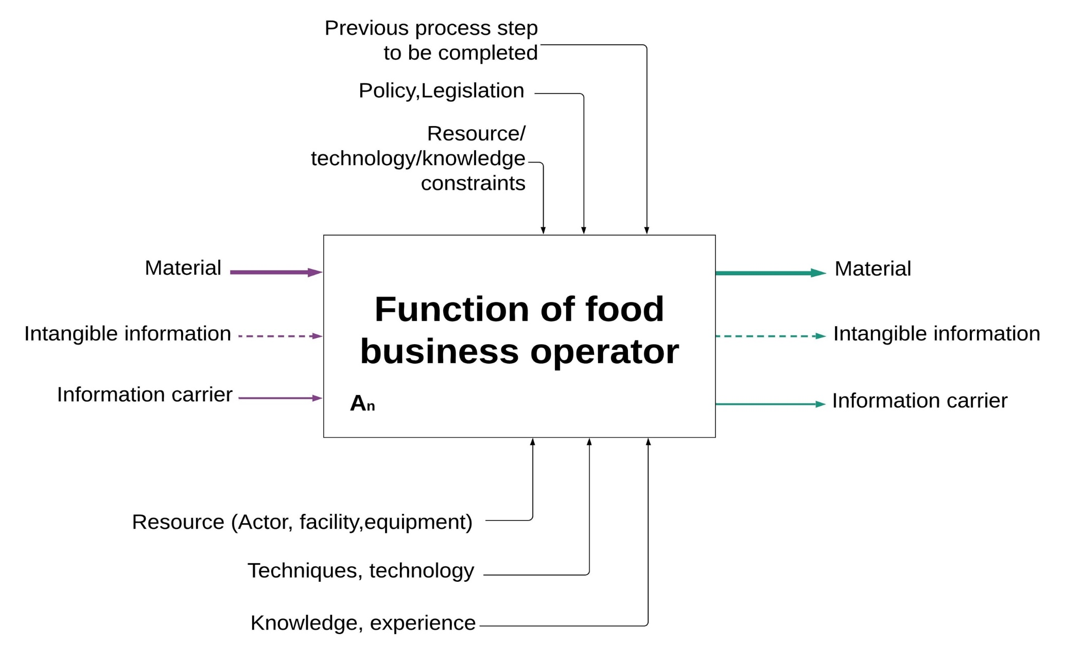
Figure 1. Basic IDEF0 building block and extended IDEF0 for a generic food traceability system

(b) Extended IDEF0 building block for a food traceability system

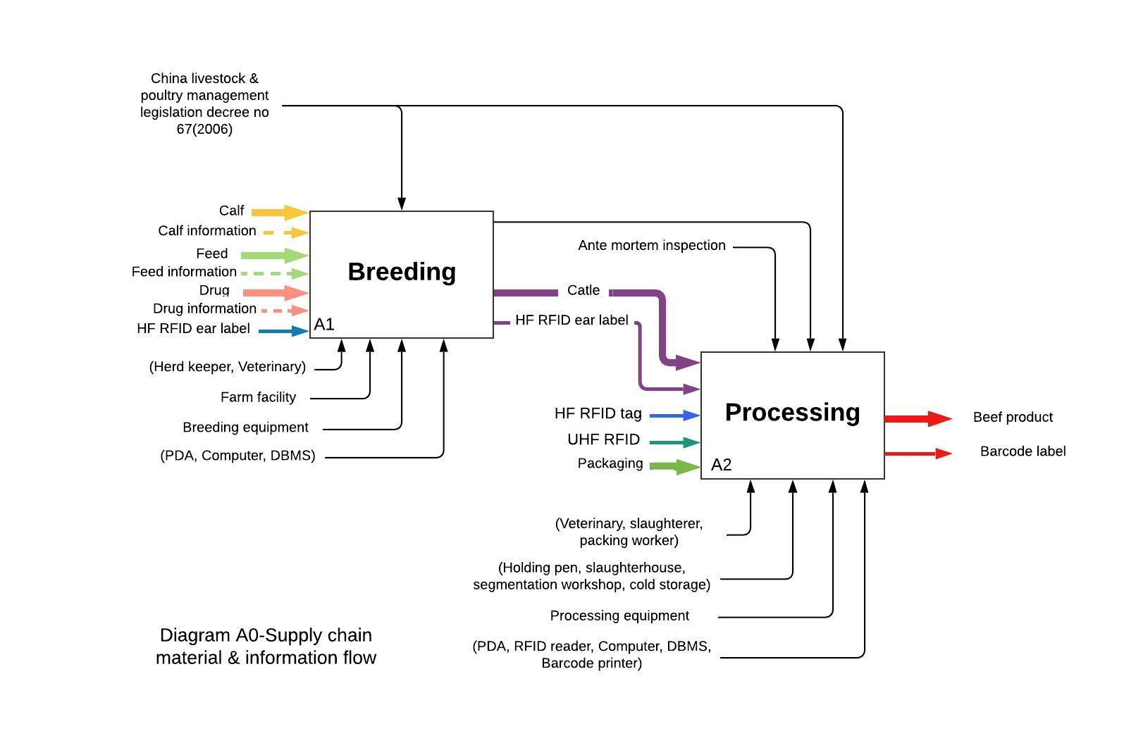
Figure 2. Supply chain material and information flow for case study example
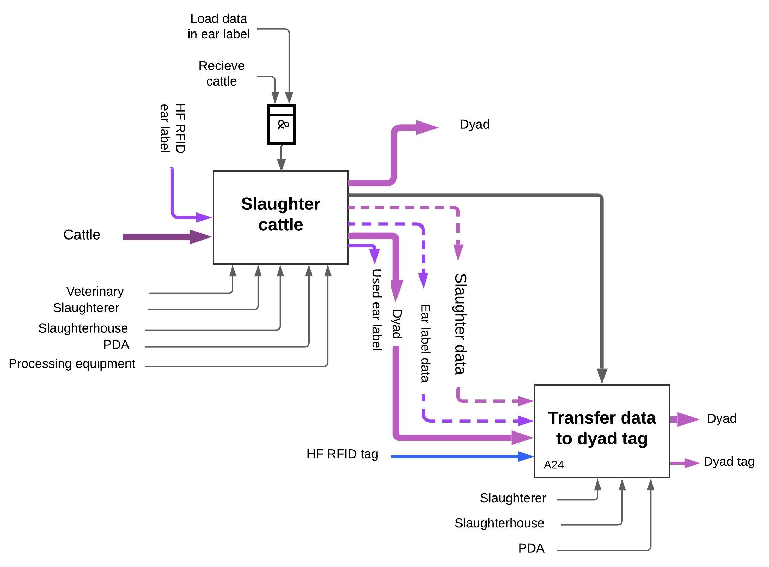
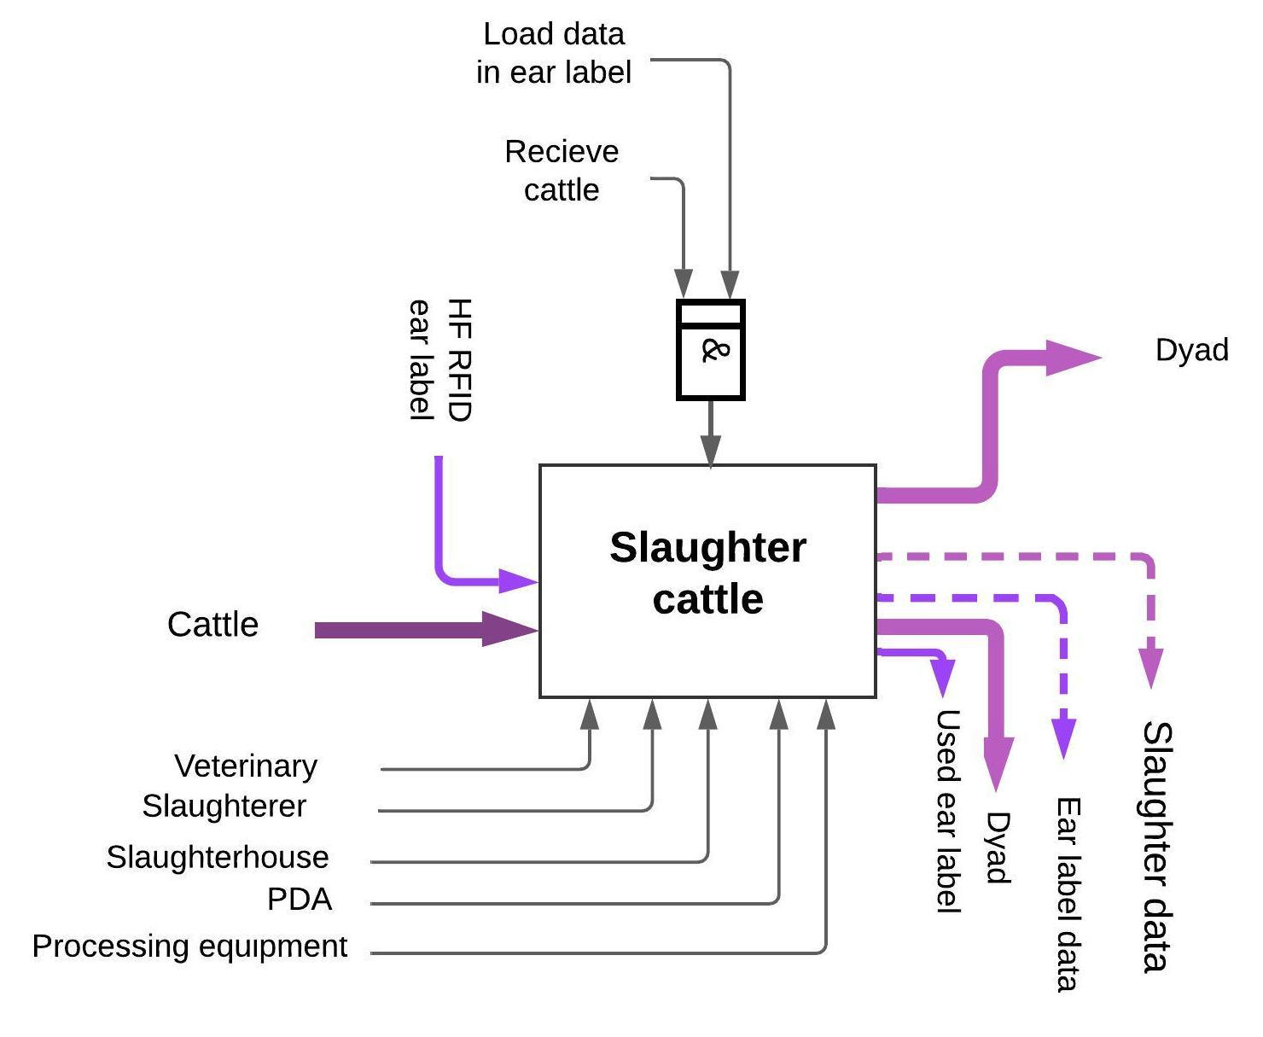
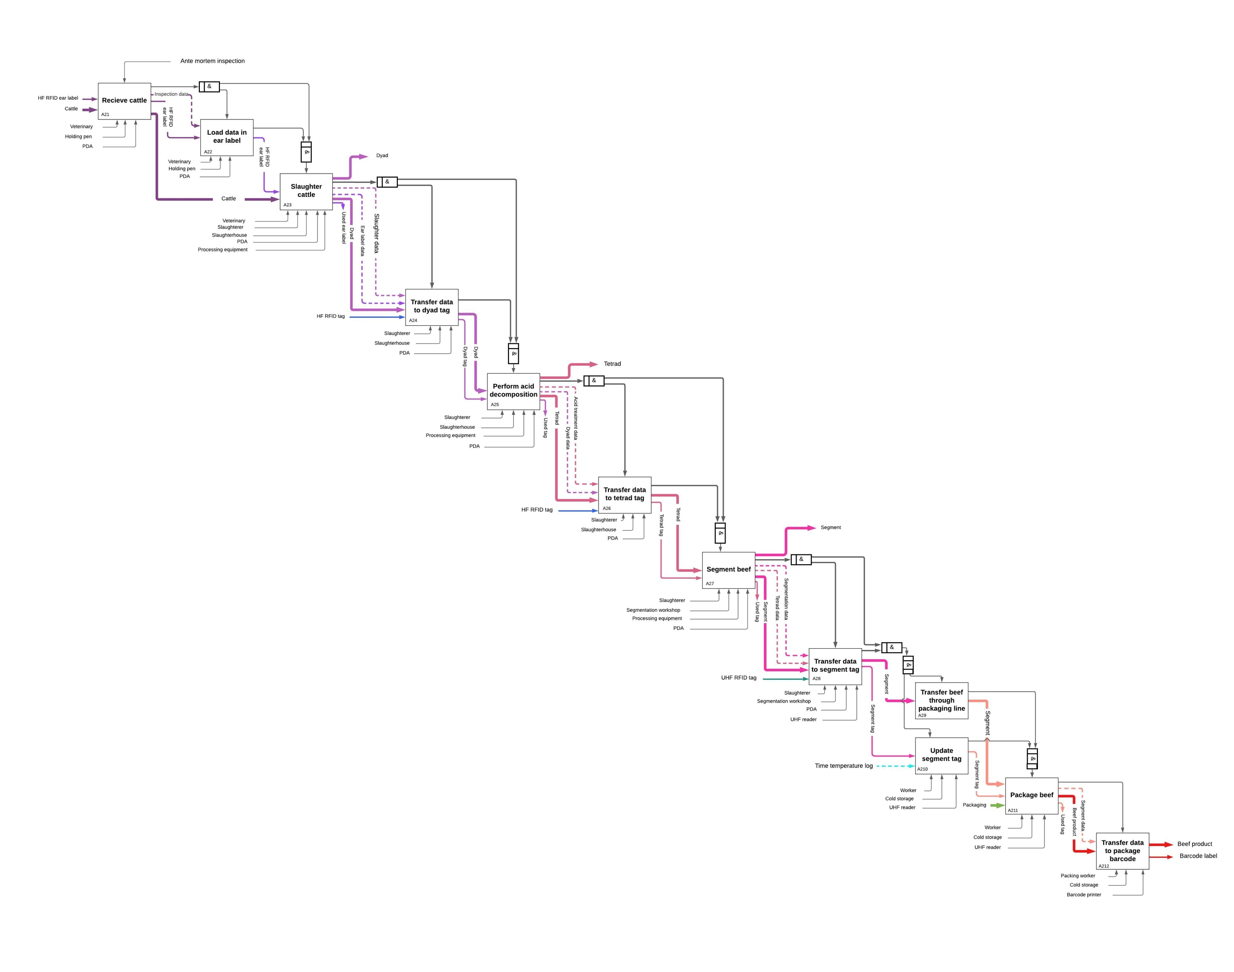
Figure 3. Processing material and information flow for case study example

