Electronic Supplementary Information

Preferential Binding of Unsaturated Hydrocarbons in Aryl–Bisimidazolium•Cucurbit[8]uril Complexes Furbishes Evidence for Small-Molecule π─π Interactions

Steven J. Barrow,ª Khaleel I. Assaf,^{b} Aniello Palma,ª Werner M. Nau,^{b} Oren A. Schermanª

ª Melville Laboratory for Polymer Synthesis, Department of Chemistry, University of Cambridge, Lensfield Road, Cambridge, CB2 1EW, U.K
^{b} Department of Life Sciences and Chemistry, Jacobs University Bremen, Campus Ring 1, D-28759 Bremen, Germany

Table of Contents
1. Materials and Methods 2
2. Packing Coefficient Analysis 3
3. Fluorescence Binding Titrations 4
4. Isothermal Titration Calorimetry Experiments 8
5. Diiodine Binding to the Bis•CB8 11
6. NMR Studies 12
7. DFT Calculations 31
8. References 33

Materials and Methods
Gases of highest commercial purity (≥ 99%) were purchased from Air Liquide, Germany, except for cis- and trans-butene (Sigma-Aldrich, Germany) and neopentane (ChemSampCo, USA). Liquid hydrocarbons were from Sigma-Aldrich, Germany. UV-vis measurements were performed on a Varian Cary 4000 UV-Visible spectrophotometer and fluorescence measurements were done on a Varian Cary Eclipse fluorimeter.
Fluorescence titrations at different gas concentrations (pressures) were performed in custom-made degassable quartz cuvettes attached to a Schlenk line. Our experimental set-up allowed us to perform the fluorescence titrations of the degassed Bis•CB8 solutions (three freeze-pump-thaw cycles), at atmospheric pressure of the hydrocarbon gas, and at 3-4 successively reduced pressures (as adjusted by fixed volume expansions from the reservoir into the cuvette volume) until the partial pressure of the gas fell below the vapor pressure of water (which needed to be subtracted from the measured pressure). Since the aqueous hydrocarbon solubilities are accurately known and can be related to pressure by Henry's law, titrations with good reproducibility resulted even if the accessible data points were restricted to 5-6 equal to and below atmospheric pressure.
¹H NMR spectra were recorded on a JEOL ECX 400 MHz NMR spectrometer. Quantum-chemical calculations were performed with the Gaussian 09 package, utilizing density functional theory (DFT) with dispersion corrected method (wB97xd) in combination with 3-21G* basis set. Isothermal titration calorimetry (ITC) experiment was carried out in water (unbuffered) on a VP-ITC from Microcal, Inc., at 25 °C. The binding equilibria were studied using a cellular Bis•CB8 solution concentration of 0.1 mM for both Bis and CB8, to which hydrocarbon solution was titrated. Typically, 27 consecutive injections were used with 10 μL each, except for the first one which was set to 5 μL; the heat release related to the first injection was not considered in the subsequent fitting, because some diffusion of titrant from the needle tip is unavoidable during the equilibration time preceding the measurement. All solutions were degassed prior to titration. Curve fitting (Origin 7.0 software) was performed according to a one-set-of-sites model (that is, assuming a 1:1 binding stoichiometry between the added guest and the pre-assembled Bis•CB8 receptor). Note that in the instrumental fitting procedures for the ITC titrations the released heat is plotted against the guest molar ratio rather than the guest concentration, such that the absolute concentration of host (Bis•CB8 receptor) is not required to remain constant in the course of the ITC titration, as opposed to conventional optical and NMR titrations.

Packing Coefficient Analysis
Table S1. Guest volume (V) and their packing coefficients (PC) with the different host systems.
guest | V/ Å^{3 [a]} | PC%^{[b]}  PC%^{[c]}  PC%^{[c]}  PC%  PC%
guest | V/ Å^{3 [a]} | Bis1•CB8 | Bis2•CB8 | Bis3•CB8 | CB6 | CB7
methane | 29 | 25 | 23 | 20 | 20 | 12
ethane | 45 | 39 | 36 | 31 | 32 | 19
propane | 63 | 55 | 50 | 43 | 44 | 26
n-butane | 80 | 70 | 63 | 55 | 56 | 33
cis-butene | 74 | 65 | 59 | 51 | 52 | 31
trans-butene | 74 | 65 | 59 | 51 | 52 | 31
isobutane | 79 | 69 | 63 | 54 | 56 | 33
isobutene | 75 | 66 | 60 | 51 | 53 | 31
neopentane | 96 | 84 | 76 | 66 | 68 | 40
cyclopentane | 86 | 75 | 75 | 59 | 61 | 36
cyclopentene | 81 | 71 | 71 | 55 | 57 | 33
cyclohexane | 102 | 89 | 81 | 70 | 72 | 42
benzene | 89 | 78 | 71 | 61 | 62 | 37
I₂ | 71 | 63 | 57 | 49 | 50 | 30
^{[a]} Obtained from AM1-optimized structures by using the QSAR module of Hyperchem. ^{[b]} PC = (guest volume)/(cavity volume); see Table 1 in the main text for the cavity size of the hosts.

Fluorescence Binding Titrations
Figure S1. Fluorescence titration of n-butane (different pressures) with CB8•Bis2 (10 μM) in aqueous solution.
Figure S2. Fluorescence titration of isobutene (different pressures) with CB8•Bis2 (10 μM) in aqueous solution.
Figure S3. Fluorescence titration of neopentane (different pressures) with CB8•Bis2 (10 μM) in aqueous solution.
Figure S4. Fluorescence titration of isobutane (different pressures) with CB8•Bis2 (10 μM) in aqueous solution.
Figure S5. Fluorescence titration of methane (different pressures) with CB8•Bis2 (10 μM) in aqueous solution. Since the plateau region could not be reached in the titration, we also tested significantly lower (100 M⁻¹, blue dashed fitting line) and higher (800 M⁻¹, red dashed line) binding constants to illustrate the robustness of the measurements.
Figure S6. Fluorescence titration of ethane (different pressures) with CB8•Bis2 (10 μM) in aqueous solution. Since the plateau region could not be reached in the titration, we also tested significantly lower (200 M⁻¹, blue dashed fitting line) and higher (900 M⁻¹, red dashed line) binding constants to illustrate the robustness of the measurements.
Figure S7. Fluorescence titration of n-butane (different pressures) with CB8•Bis3 (10 μM) in aqueous solution.
Figure S8. Fluorescence titration of n-butane (different pressures) with CB8•Bis1 (10 μM) in aqueous solution.
Figure S9. Fluorescence titration of neopentane (different pressures) with CB8•Bis3 (10 μM) in aqueous solution. Since the plateau region could not be reached in the titration, we also tested significantly lower (3 × 10³ M⁻¹, blue dashed fitting line) and higher (20 × 10³ M⁻¹, red dashed line) binding constants to illustrate the robustness of the measurements.
Table S2. Relative experimental fluorescence intensities (I_{rel}) obtained upon binding of investigated hydrocarbons to the different Bis•CB8 complexes.
guest | I_{rel}^{[a]}  I_{rel}^{[d]}  I_{ref}^{[d]}
guest | Bis1•CB8 | Bis2•CB8 | Bis3•CB8
methane | 1.5 | 2.2 | 7.3
ethane |  | 5.6
propane |  | 5.0
n-butane | 3.4 | 5.2 | 2.8
cis-butene |  | 2.0
trans-butene |  | 2.4
isobutane | 2.9 | 4.0 | 5.0
isobutene | 0.6 | 3.2 | 0.6
neopentane | 4.1 | 2.7 | 10.7
cyclopentane |  | 1.5
cyclopentene |  | 1.1
cyclohexane |  | 1.4
benzene |  | 1.4
^{[a]} I_{rel} = I_{final}/I_{initial}.

Isothermal Titration Calorimetry Experiments
Table S3. Association constants (K_{a}) of selected hydrocarbons with Bis•CB8 systems and the associated thermodynamic parameters.^{[a]}
guest | Bis1•CB8 |  |  | Bis2•CB8 |  |  | Bis3•CB8
guest | K_{a}/ 10^{3 [b]} | ΔH^{[c]} | TΔS^{[c]} | K_{a}/ 10^{3[b]} | ΔH^{[c]} | TΔS^{[d]} | K_{a}/ 10^{3[b]} | ΔH^{[c]} | TΔS^{[d]}
cyclopentene | 290 | −9.8 | −2.4 | 480 [260]^{[d]} | −11.6 | −3.8 | 960 ± 260 | −7.9 | 0.3
1,3-cyclohexadiene | 88 | −9.9 | −3.2 | 530 | −12.4 | −4.6 | 1900 ± 800 | −7.5 | 1.1
benzene | 85 | −7.6 | −0.9 | 520 [170]^{[d]} | −11.7 | −3.9 | 710 ± 230 | −8.2 | −0.2
cyclopentanol | 2.0 | −5.4 | −0.9 | 6.7 | −7.9 | −2.7 | 5.9 | −7.3 | −2.2
phenol | 3.0 | −8.4 | −3.7 | 32 ± 5 | −8.7 | −2.6 | 18 | −7.7 | −1.9
^{[a]} Measured in water at 25 °C and analyzed for a 1:1 complexation model; 10% errors unless stated differently. ^{[b]} Value in M⁻¹. ^{[c]} Value in kcal mol⁻¹. ^{[d]} Values measured by fluorescence titrations.

Figure S10. Microcalorimetric titration results in neat water: Raw ITC data for sequential injections of hydrocarbons into Bis•CB8 solution (0.1 mM) and apparent reaction heats obtained from the integration of the calorimetric traces.

Table S4. Guest hydration free energy (ΔG_{hydr}, kcal mol⁻¹), binding free energy (ΔG_{a}, kcal mol⁻¹), and guest-desolvation corrected binding free energy for the guests studied by ITC.
guest | ΔG_{hydr}^{[a]} | Bis1•CB8 |  | Bis2•CB8 |  | Bis3•CB8
guest | ΔG_{hydr}^{[a]} | ΔG_{a} | ΔG_{a}' ^{[b]} | ΔG_{a} | ΔG_{a}' ^{[b]} | ΔG_{a} | ΔG_{a}' ^{[b]}
cyclopentene | 0.55 | −7.45 | −6.90 | −7.75 | −7.20 | −8.16 | −7.61
1,3-cyclohexadiene | −0.39 | −6.74 | −7.13 | −7.81 | −8.20 | −8.56 | −8.95
benzene | −0.89 | −6.72 | −7.61 | −7.80 | −8.69 | −7.98 | −8.87
cyclopentanol | −4.88 | −4.50 | −9.38 | −5.22 | −10.1 | −5.14 | −10.0
phenol | −6.46 | −4.74 | −11.20 | −6.15 | −12.6 | −5.80 | −12.3
^{[a]} Calculated from S and p_{vap} according to ΔG_{hydr} = –RTln(S*p⁰/p_{vap}), with p⁰ = 101.325 kPa and p_{vap} is the vapor pressure in kPa. ^{[b]} ΔG_{a}' = ΔG_{a} + ΔG_{hydr}.

Diiodine Binding to the Bis•CB8
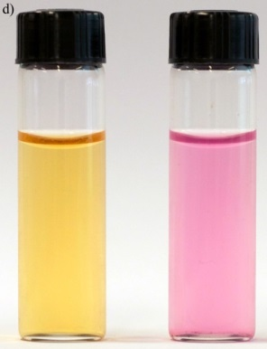
Figure S11. UV-visible titrations of iodine (100-130 µM) with a) Bis1•CB8, b) Bis2•CB8, and c) Bis3•CB8 in aqueous solution. d) Color change of I₂ from yellow-brown (known in water) to violet (known in nonpolar solvents) upon complexation with Bis•CB8 complexes. K_{Bis1•CB8} = (1.7 ± 0.2) × 10⁴ M⁻¹; K _{Bis2•CB8} = (2.1 ± 0.8) × 10⁴ M⁻¹; K_{Bis3•CB8} = (1.9 ± 0.4) × 10⁴ M⁻¹.

NMR Studies
Figure S12. ¹H NMR spectra of bisimidazolium Bis1, Bis1•CB8 (6.25 mM), Bis1•CB8•CH₄, and CH₄ free.
Figure S13. ¹H NMR spectra of bisimidazolium Bis2, Bis2•CB8 (6.25 mM), Bis2•CB8•CH₄, and CH₄ free.
Figure S14. ¹H NMR spectra of bisimidazolium Bis1, Bis1•CB8 (1.25 mM), Bis1•CB8•cis-butene, and cis-butene free.
Figure S15. ¹H NMR spectra of bisimidazolium Bis2, Bis2•CB8 (1.25 mM), Bis2•CB8•cis-butene, and cis-butene free.

Figure S16. ¹H NMR spectra of bisimidazolium Bis3, Bis3•CB8 (1.25 mM), Bis3•CB8•cis-butene, and cis-butene free.

Figure S17. ¹H NMR spectra of bisimidazolium Bis1, Bis1•CB8 (1.25 mM), Bis1•CB8•trans-butene, and trans-butene free.

Figure S18. ¹H NMR spectra of bisimidazolium Bis2, Bis2•CB8 (1.25 mM), Bis2•CB8•trans-butene, and trans-butene free.

Figure S19. ¹H NMR spectra of bisimidazolium Bis3, Bis3•CB8 (1.25 mM), Bis3•CB8•trans-butene, and trans-butene free.

Figure S20. ¹⁹F NMR spectra of (1.25 mM) Bis1•CB8•SF₆, Bis2•CB8•SF₆, Bis3•CB8•SF₆, and SF₆ free. The signal broadening is related to the guest exchange kinetics.

Figure S21. ¹H NMR spectra of (1.25 mM) Bis1•CB8, Bis2•CB8, Bis3•CB8, Bis1•CB8•SF₆, Bis2•CB8•SF₆, and Bis3•CB8•SF₆.

Figure S22. ¹H NMR spectra of (1.25 mM) n-butane, Bis1•CB8•n-butane, Bis2•CB8•n-butane, and Bis3•CB8•n-butane.
Figure S23. ¹H NMR spectra of (1.25 mM) propane, Bis1•CB8•propane, Bis2•CB8•propane, and Bis3•CB8•propane.
Figure S24. ¹H NMR spectra of (1.25 mM) isobutane, Bis1•CB8•isobutane, Bis2•CB8•isobutane, and Bis3•CB8•isobutane.
Figure S25. ¹H NMR spectra of (1.25 mM) ethene, Bis1•CB8•ethene, Bis2•CB8•ethene, and Bis3•CB8•ethene.
Figure S26. ¹H NMR spectra of (1.25 mM) ethane, Bis1•CB8•ethane, Bis2•CB8•ethane, and Bis3•CB8•ethane.

Figure S27. ¹H NMR spectra of (1.25 mM) 1-butene, Bis1•CB8•1-butene, Bis2•CB8•1-butene, and Bis3•CB8•1-butene.

Figure S28. ¹H NMR spectra of (1.25 mM) isobutene, Bis1•CB8•isobutene, Bis2•CB8•isobutene, and Bis3•CB8•isobutene.
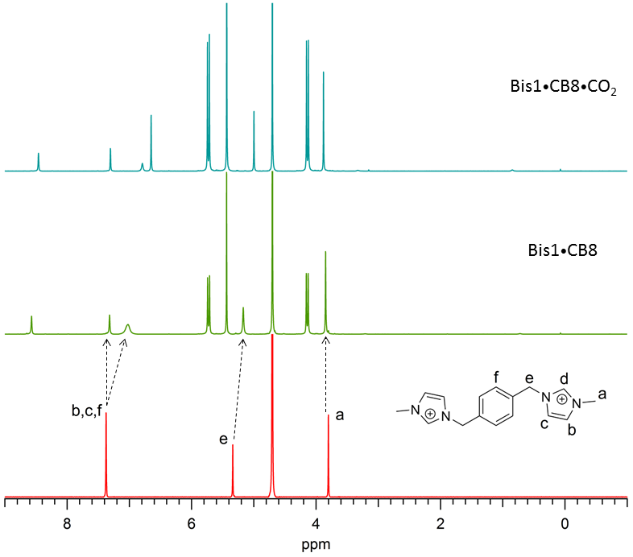
Figure S29. ¹H NMR spectra of bisimidazolium Bis1, Bis1•CB8 and Bis1•CB8•CO₂.
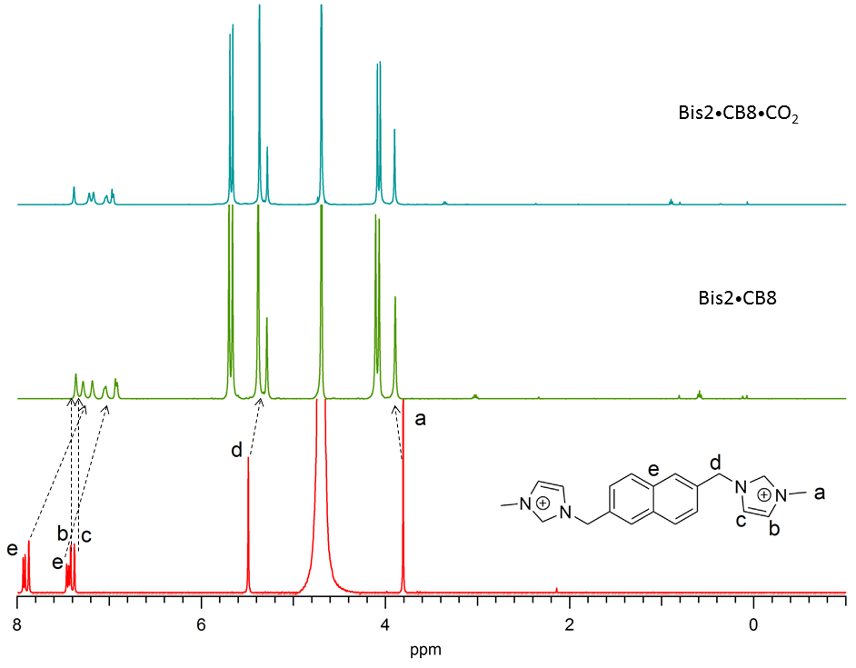
Figure S30. ¹H NMR spectra of bisimidazolium Bis2, Bis2•CB8 and Bis2•CB8•CO₂.
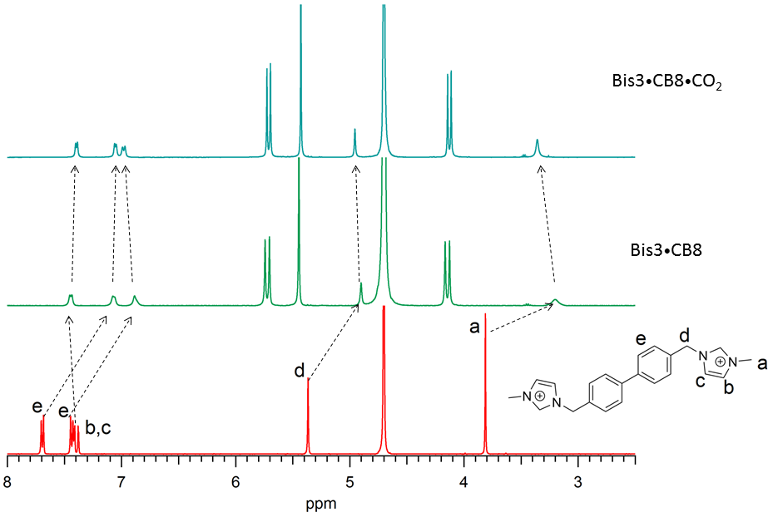
Figure S31. ¹H NMR spectra of bisimidazolium Bis3, Bis3•CB8 and Bis3•CB8•CO₂.
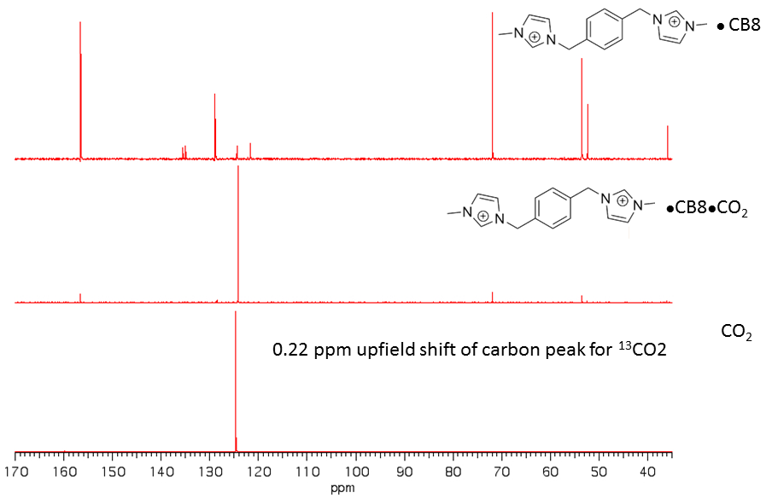
Figure S32. ¹³C NMR spectra of Bis1•CB8, Bis1•CB8•¹³CO₂ and ¹³CO₂.
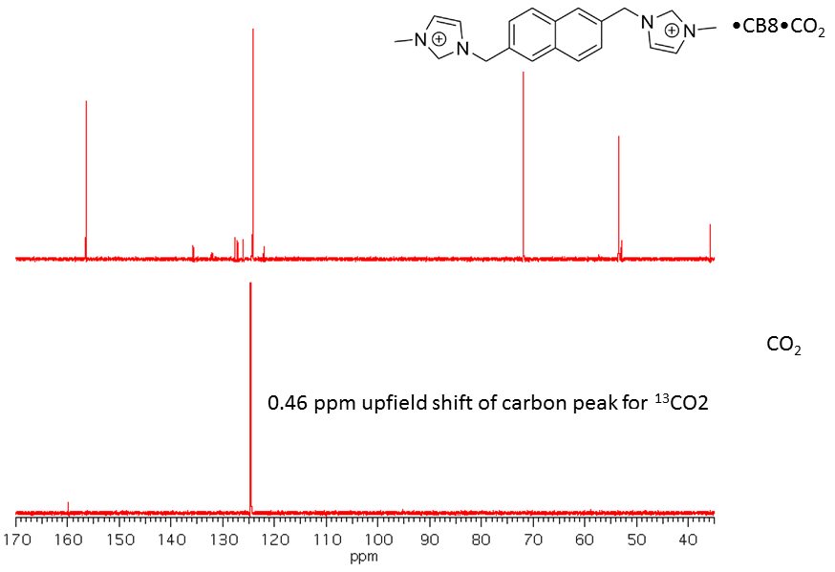
Figure S33. ¹³C NMR spectra of Bis2•CB8, Bis2•CB8•¹³CO₂ and ¹³CO₂.
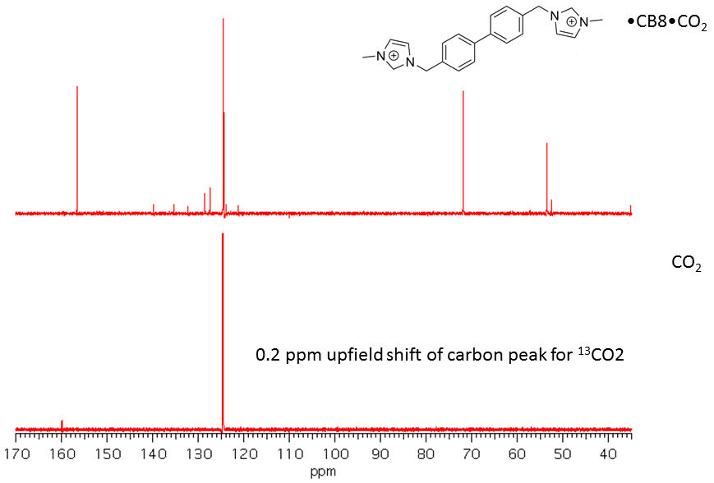
Figure S34. ¹³C NMR spectra of Bis3•CB8, Bis3•CB8•¹³CO₂ and ¹³CO₂.
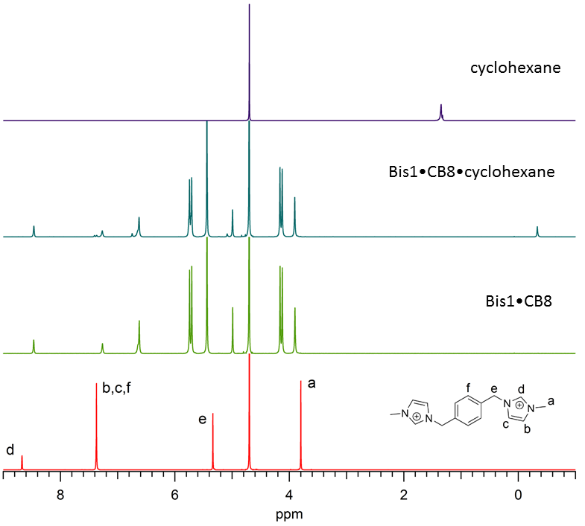
Figure S35. ¹H NMR spectra of bisimidazolium Bis1, Bis1•CB8 (1.25 mM), Bis1•CB8•cyclohexane, and cyclohexane free.
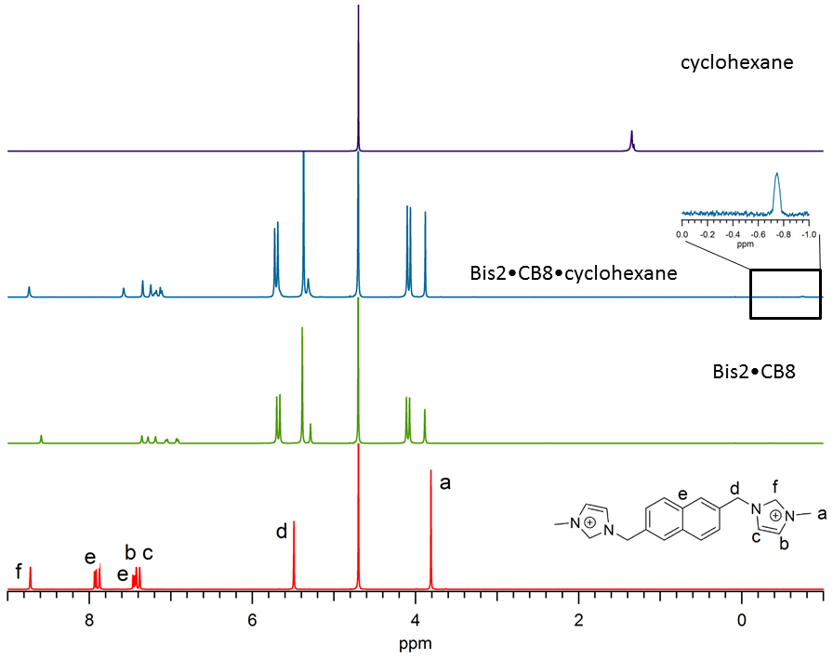
Figure S36. ¹H NMR spectra of bisimidazolium Bis2, Bis2•CB8 (1.25 mM), Bis2•CB8•cyclohexane, and cyclohexane free.
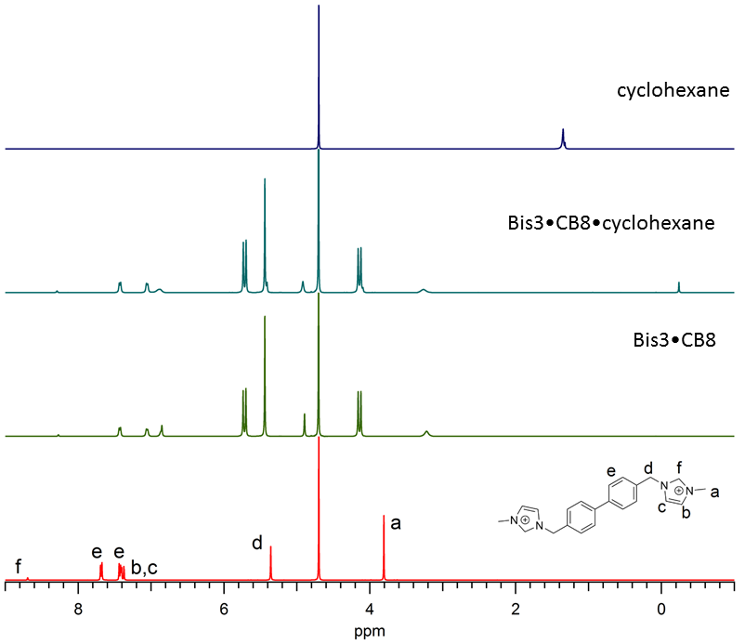
Figure S37. ¹H NMR spectra of bisimidazolium Bis3, Bis3•CB8 (1.25 mM), Bis3•CB8•cyclohexane, and cyclohexane free.
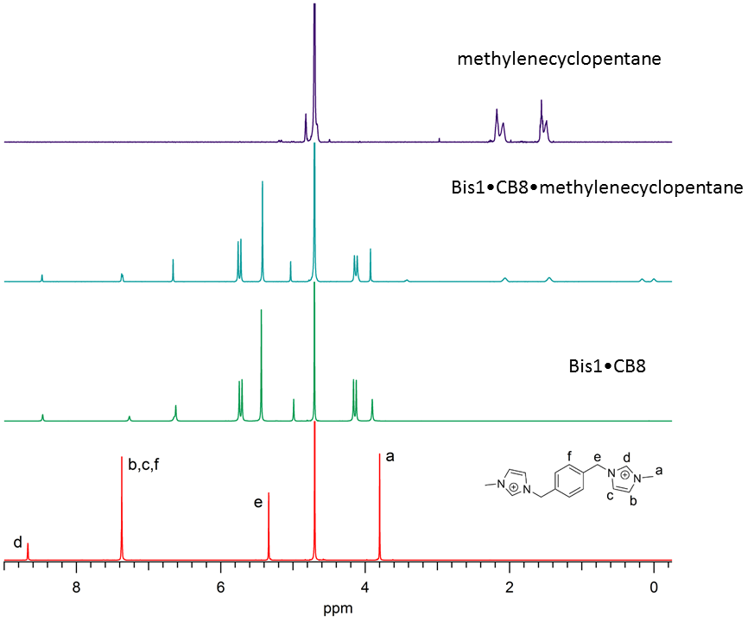
Figure S38. ¹H NMR spectra of bisimidazolium Bis1, Bis1•CB8 (1.25 mM), Bis3•CB8•methylenecyclopentane, and methylenecyclopentane free.
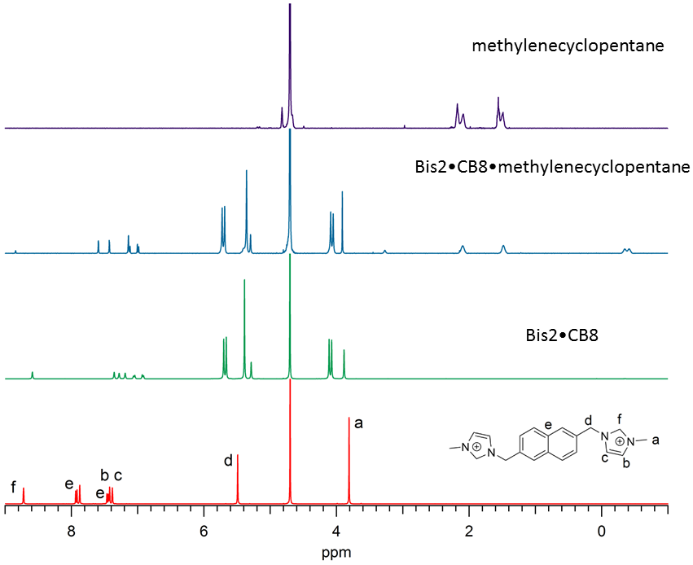
Figure S39. ¹H NMR spectra of bisimidazolium Bis2, Bis2•CB8 (1.25 mM), Bis2•CB8•methylenecyclopentane, and methylenecyclopentane free.
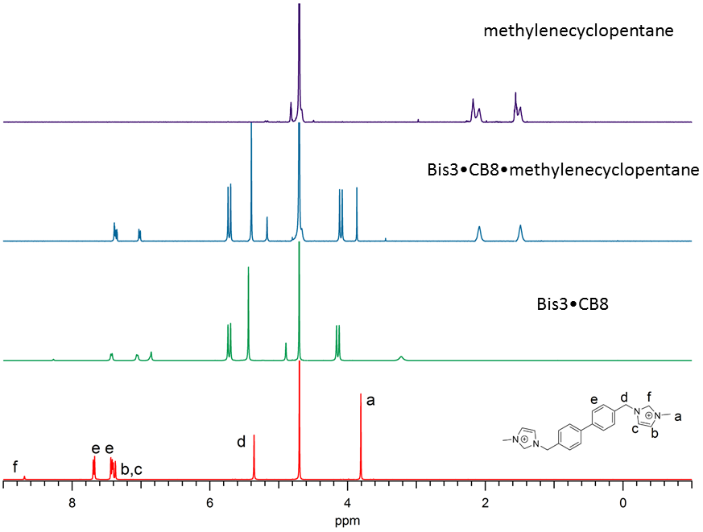
Figure S40. ¹H NMR spectra of bisimidazolium Bis3, Bis3•CB8 (1.25 mM), Bis3•CB8•methylenecyclopentane, and methylenecyclopentane free.
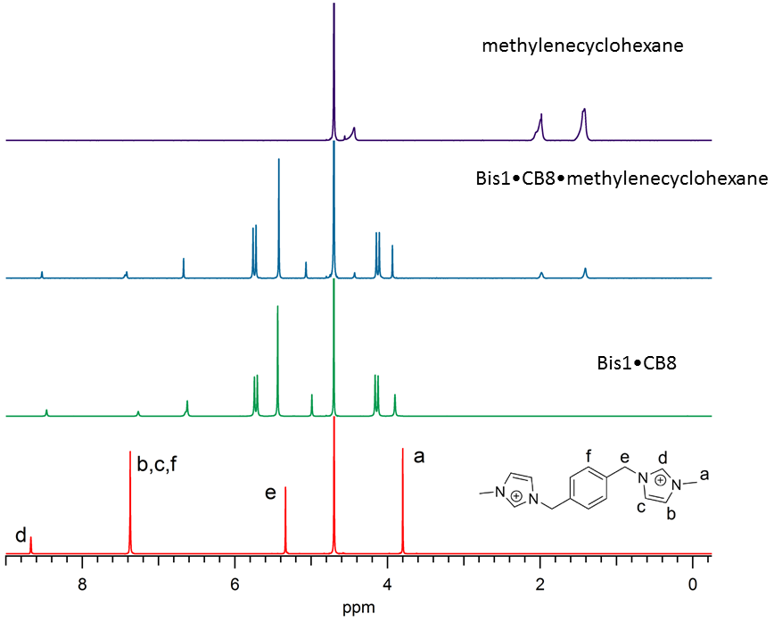
Figure S41. ¹H NMR spectra of bisimidazolium Bis1, Bis1•CB8 (1.25 mM), Bis1•CB8•methylenecyclohexane, and methylenecyclohexane free.
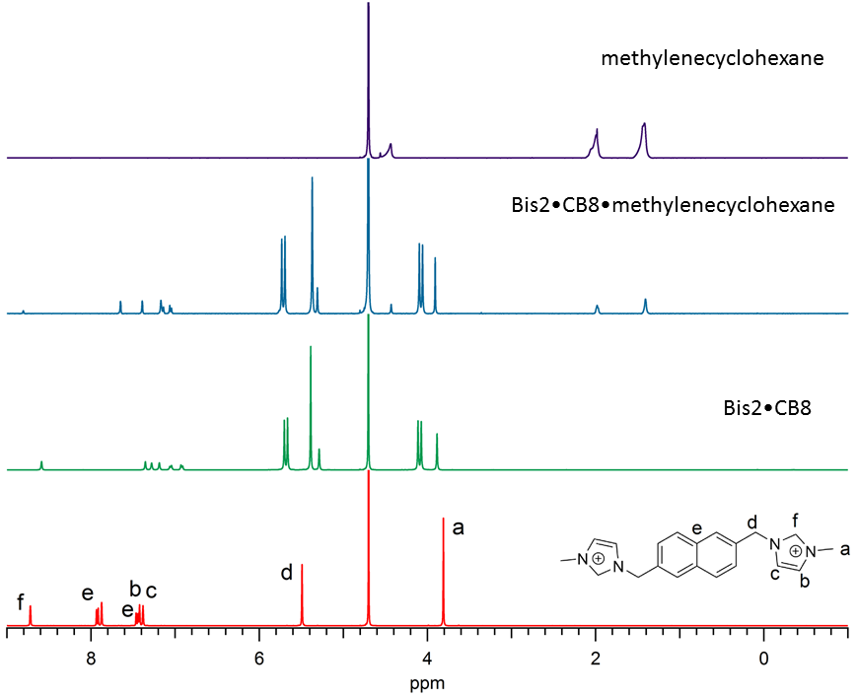
Figure S42. ¹H NMR spectra of bisimidazolium Bis2, Bis2•CB8 (1.25 mM), Bis2•CB8•methylenecyclohexane, and methylenecyclohexane free.
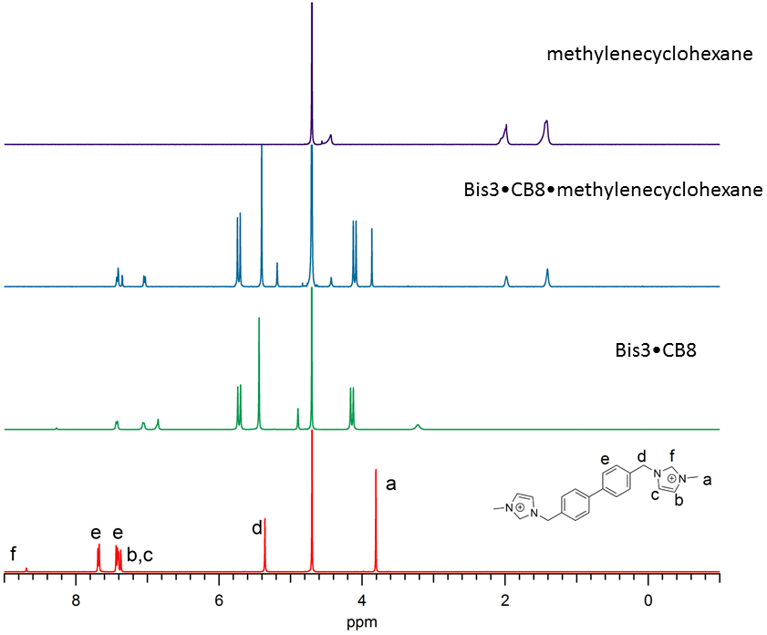
Figure S43. ¹H NMR spectra of bisimidazolium Bis3, Bis3•CB8 (1.25 mM), Bis3•CB8•methylenecyclohexane, and methylenecyclohexane free.
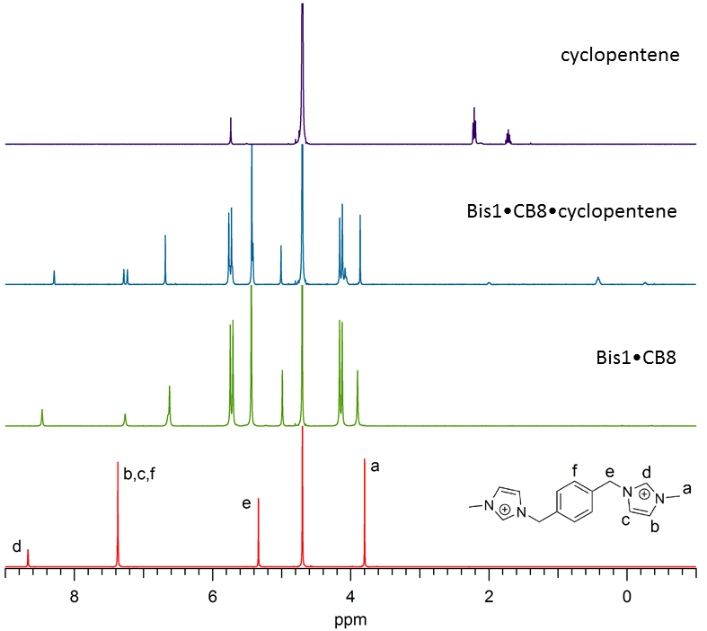
Figure S44. ¹H NMR spectra of bisimidazolium Bis1, Bis1•CB8 (1.25 mM), Bis1•CB8• cyclopentene, and cyclopentene free.
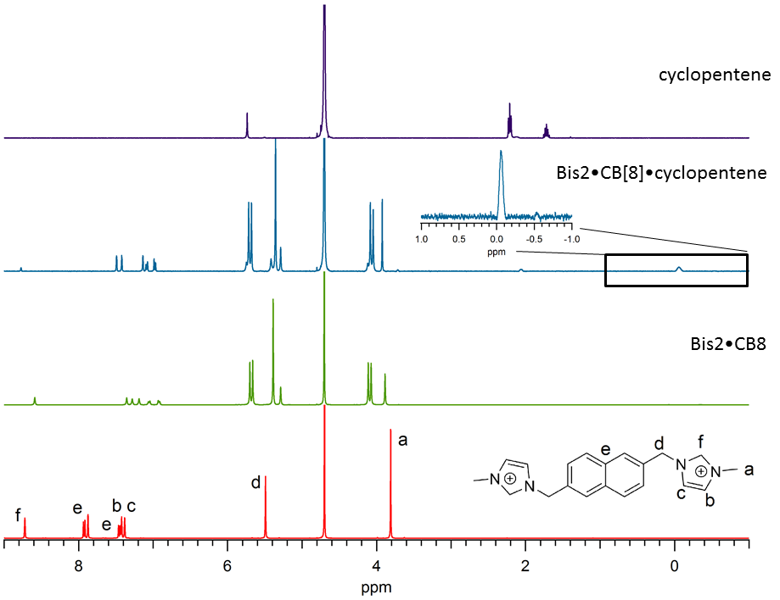
Figure S45. ¹H NMR spectra of bisimidazolium Bis2, Bis2•CB8 (1.25 mM), Bis2•CB8• cyclopentene, and cyclopentene free.
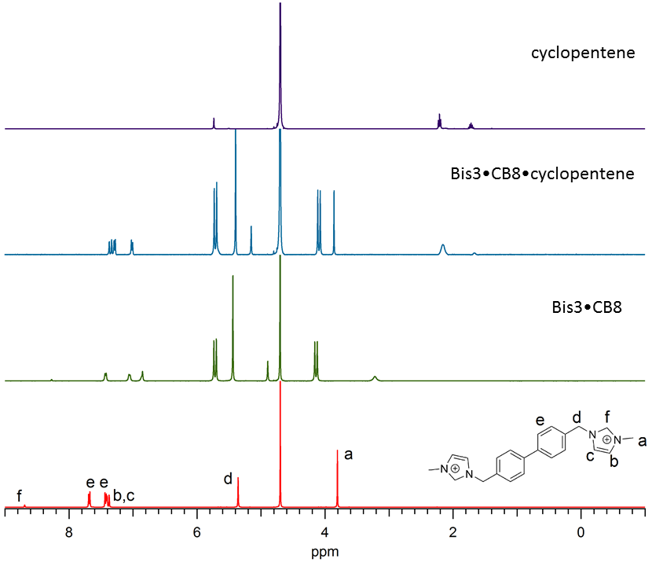
Figure S46. ¹H NMR spectra of bisimidazolium Bis3, Bis3•CB8 (1.25 mM), Bis3•CB8•cyclopentene, and cyclopentene free.
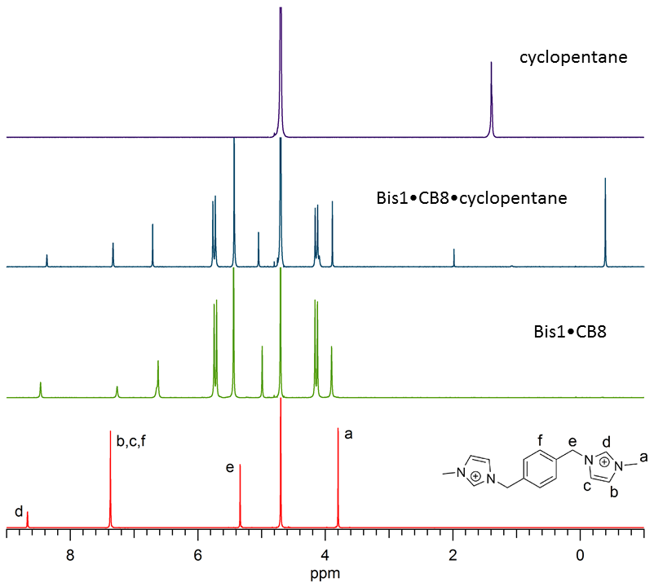
Figure S47. ¹H NMR spectra of bisimidazolium Bis1, Bis1•CB8 (1.25 mM), Bis1•CB8• cyclopentane, and cyclopentane free.
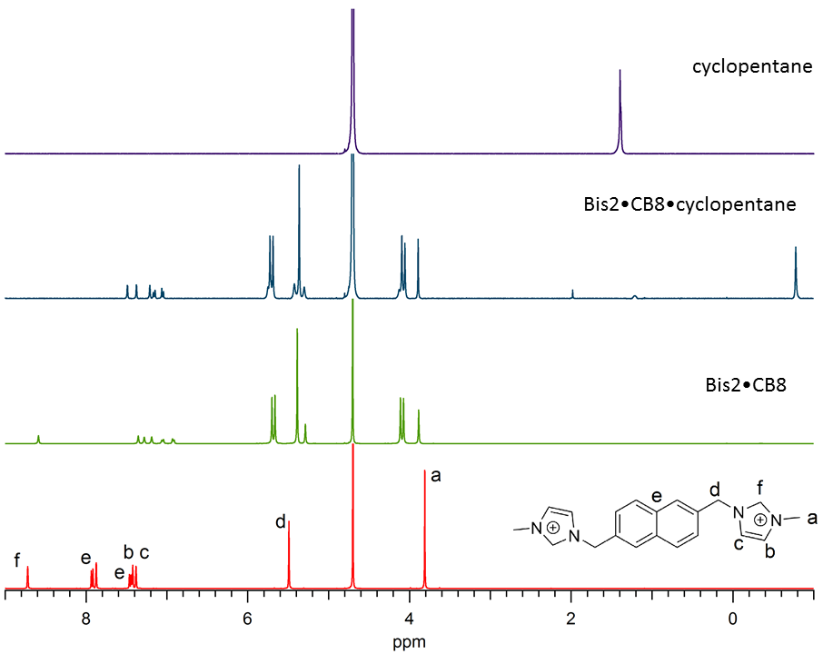
Figure S48. ¹H NMR spectra of bisimidazolium Bis2, Bis2•CB8 (1.25 mM), Bis2•CB8• cyclopentane, and cyclopentane free.
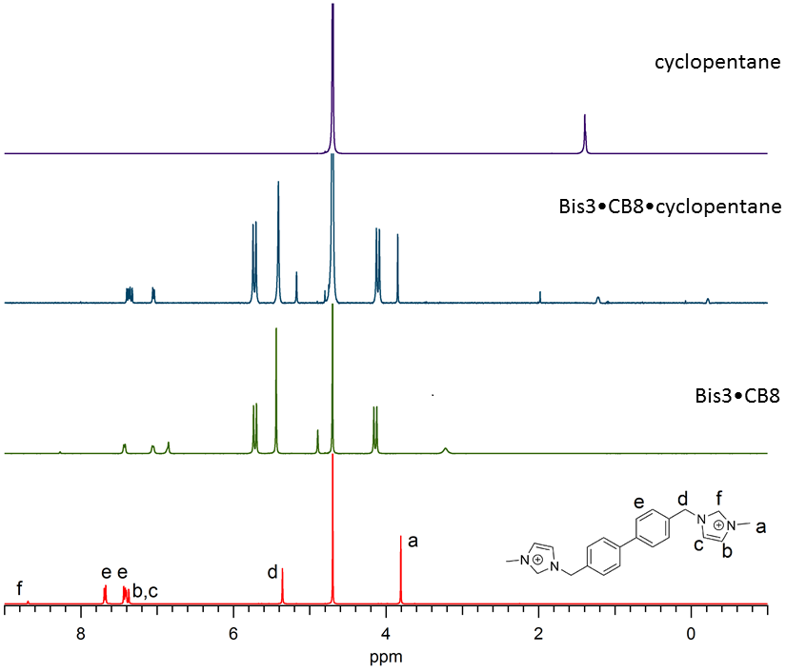
Figure S49. ¹H NMR spectra of bisimidazolium Bis3, Bis3•CB8 (1.25 mM), Bis3•CB8• cyclopentane, and cyclopentane free.

DFT Calculations
All DFT calculations were performed for the gas phase with the Gaussian software package.¹ The polarizabilities of Bis1-Bis3 were calculated with the B3LYP/aug-ccpvdz level of theory and the geometries of the binary complexes shown in Figure 1 at the wB97XD/3-21G* level of theory. In order to evaluate the preferred co-conformations of unsaturated guests inside the Bis2•CB8 complexes, we performed calculations for encapsulated cis-butene, isobutene, and benzene. The corresponding ternary complexes were geometry optimized with three different DFT methods (B3LYP, wB97XD, and M06-2X) by using the 6-31+G* basis set. The geometry optimizations were performed for two different co-conformations, one representing the presumed π-π interaction between the guest and the naphthalene ring of Bis2 (“stacked”), the other one corresponding to C–H---π interactions between the guest and the naphthalene π system (“orthogonal”), see representative optimized structures in Fig. S50. Note that in both conformations additional interactions with the two imidazolium groups apply, which cannot be readily dissected. The combined results, which revealed a clear preference (by 1-15 kcal mol^{–1}) for the stacked co-conformation for all three guests and at all three levels of theory in the gas phase, further support the interpretation of stabilizing π-π interactions between the naphthalene unit and the guests.
Table S5. DFT-calculated energies (in a.u.) and relative energies (in kcal mol⁻¹) for selected Bis2•CB8•guest complexes.ª
guest | co-conformation | B3LYP | wB97XD | M06-2X
cis-butene | stacked (π–π)^{b} | −5965.4412 | −5963.8568 | −5963.3268
 | orthogonal (C–H---π) ^{c} | −5965.4377 | −5963.8508 | −5963.3252
 | relative energy^{d} | −2.2 | −3.8 | −1.0
isobutene | stacked (π–π)^{b} | −5965.4423 | −5963.8485 | −5963.3248
 | orthogonal (C–H---π) ^{c} | −5965.4274 | −5963.8260 | −5963.3138
 | relative energy^{d} | −9.4 | −14.1 | −6.9
benzene | stacked (π–π)^{b} | −6040.4730 | −6038.8672 | −6038.3446
 | orthogonal (C–H---π)^{c} | −6040.4570 | −6038.8496 | −6038.3305
 | relative energy^{d} | −10.0 | −11.1 | −8.9
ª 6-31+G* basis set. ^{b} The second guest is aligned to allow π-π interactions with the naphthalene unit, see Fig. S50. ^{c} The second guest is aligned to allow C-H---π interactions with the naphthalene unit, see Fig. S50. ^{d} Negative relative energy indicates a preference for the stacked (π-π) co-conformation.

Figure S50. DFT-calculated structures (M06-2X/6-31+G*) of selected ternary Bis2•CB8•guest complexes. The structures on the left side represent optimized geometries corresponding to co-conformations that spatially allow π-π interactions with the naphthalene unit, the ones on the right to those that allow C-H---π interactions with the naphthalene unit.

References
- M. J. Frisch, G. W. Trucks, H. B. Schlegel, G. E. Scuseria, M. A. Robb, J. R. Cheeseman, G. Scalmani, V. Barone, B. Mennucci, G. A. Petersson, H. Nakatsuji, M. Caricato, X. Li, H. P. Hratchian, A. F. Izmaylov, J. Bloino, G. Zheng, J. L. Sonnenberg, M. Hada, M. Ehara, K. Toyota, R. Fukuda, J. Hasegawa, M. Ishida, T. Nakajima, Y. Honda, O. Kitao, H. Nakai, T. Vreven, J. A. Montgomery, Jr., J. E. Peralta, F. Ogliaro, M. Bearpark, J. J. Heyd, E. Brothers, K. N. Kudin, V. N. Staroverov, T. Keith, R. Kobayashi, J. Normand, K. Raghavachari, A. Rendell, J. C. Burant, S. S. Iyengar, J. Tomasi, M. Cossi, N. Rega, J. M. Millam, M. Klene, J. E. Knox, J. B. Cross, V. Bakken, C. Adamo, J. Jaramillo, R. Gomperts, R. E. Stratmann, O. Yazyev, A. J. Austin, R. Cammi, C. Pomelli, J. W. Ochterski, R. L. Martin, K. Morokuma, V. G. Zakrzewski, G. A. Voth, P. Salvador, J. J. Dannenberg, S. Dapprich, A. D. Daniels, O. Farkas, J. B. Foresman, J. V. Ortiz, J. Cioslowski and D. J. Fox, Gaussian 09, Revision B.01, Gaussian, Inc., Wallingford CT, 2010.

