Learning Models for Electron Densities with Bayesian Regression

Eric Schmidt, Andrew T. Fowler, James A. Elliott and Paul D. Bristowe
Department of Materials Science & Metallurgy, University of Cambridge,
27 Charles Babbage Road, Cambridge CB3 0FS, United Kingdom
Abstract
The Hohenberg-Kohn theorems posit the ground state electron density as a property of fundamental importance in condensed matter physics, finding widespread application in much of solid state physics in the form of density functional theory (DFT) and, at least in principle, in semi-empirical potentials such as the Embedded Atom Method (EAM). Using machine learning algorithms based on parametric linear models, we propose a systematic approach to developing such potentials for binary alloys based on DFT electron densities, as well as energies and forces. The approach is demonstrated on the technologically important Al-Ni alloy system. We further demonstrate how ground state electron densities, obtained with DFT, can be predicted such that total energies have an accuracy of order meV atom⁻¹ for crystalline structures. The set of crystalline structures includes a range of materials representing different phases and bonding types, from Al structures to single-wall carbon nanotubes.

Introduction
Density functional theory (DFT) exploits the Hohenberg-Kohn theorems by casting the ground state energy of an interacting system in an external field as a unique functional of its electron density [1]. This approach has been successfully used to obtain ground state properties of materials, discover unknown phases via methods such as AIRSS [2] and USPEX [3] and to perform high throughput calculations which systematically scan entire phase diagrams using methods such as AFLOW [4], AiiDA [5] and the materials project [6] among others. In addition to its ubiquitous use in DFT, the ground state electron density, $η_{GS}\left(r\right)$, also finds application in methods like Bader’s atoms-in-molecules analysis and Laplacian-based critical points bond analysis [7]. Pure, or orbital-free (OF), DFT retains functionals of only the electron density, while the Kohn-Sham (KS) approach expresses the kinetic energy functional in terms of non-interacting single particle wave functions [8]. Both OF DFT and KS DFT methods minimize constrained expressions of the total energy until $η_{GS}\left(r\right)$ is found. The improved accuracy of the KS wavefunction-based kinetic energy term, however, comes at a significant computational cost, ultimately limiting the size of any system that can tractably be studied. The method described in this paper aims to circumvent this expensive self-consistent field (SCF) minimization and to approximate $η_{GS}\left(r\right)$ directly from a given a structure. Throughout this work, we use CASTEP [9] and PROFESS [8] for the training and cross validation of linear models reproducing $η_{GS}\left(r\right)$ for KS and OF DFT calculations respectively.
To our knowledge very few attempts to rigorously regress $η_{GS}\left(r\right)$ from ab initio calculations have been made. Recently, Brockherde et al. [10] adopted a kernel-based approach to learn weights for a basis function representation of $η_{GS}\left(r\right)$ for H₂ and H₂O as well as small hydrocarbons. They cast the atomic structures into a scalar field, $v\left(r\right)$, consisting of squared exponentials and learned the basis function coefficients of their representation for $η_{GS}\left(r\right)$ given $v\left(r\right)$. Another attempt was made by Mitev et al. [11] who approximated $η_{GS}\left(r\right)$ using a non-linear parametric model based on the 3s atomic orbitals for fcc Al. Although little quantitative measure of the error in $η_{GS}\left(r\right)$ was given, a surprising transferability was demonstrated in projections of $η_{GS}\left(r\right)$ along high symmetry crystal directions, with the electron density predictions, $η_{pred}\left(r\right)$, closely resembling $η_{GS}\left(r\right)$ of vacancy, divacancy and adatom defects, without these structures being present in the training set. While the EAM potential given by Mitev et al. made reasonable predictions, the contents of its training set were not explicitly given and thus it is unclear if the transferability of the electron density prediction translates to a similar transferability of their EAM potential.
Empirical methods to calculate the total energy of a system rely on forming approximations of the energy per atom $E_{i}\left(R,r_{i},r_{c}\right)$ as some multivariate expression of the positions of the atoms under consideration, $R$, and those surrounding the atom at $r_{i}$ to within some finite distance, $r_{c}$. As might be expected, the more general the multivariate approximation to $E_{i}\left(R,r_{i},r_{c}\right)$, the more accurate it can be, at the risk of overfitting. Rigorous attempts to approximate high-dimensional multivariate expressions for $E_{i}\left(R,r_{i},r_{c}\right)$ have been seen with notable success particularly in the application of kernels which employ Gaussian approximation potentials [12,13] and deep neural networks [14]. Both methods use the atom positions and numbers as features in their map. Consider if instead, one were to use $η_{GS}\left(r\right)$, which we assume is already known. An empirical DFT-like map could be imagined with complete or partial integrals over the crystal cell. This idea in fact, is already embodied in existing classical potentials, such as the embedded atom method (EAM), modified embedded atom method (MEAM) [15] and Angular-Dependent Potentials [16], where usually physical electron densities of complete structures are not approximated explicitly. Mitev et al. noted this too and employ their approximation of $η_{GS}\left(r\right)$ to a novel EAM-like potential for fcc Al.
In this work, we demonstrate how parametric linear models with Bayesian regression can be used to approximate $η_{GS}\left(r\right)$ for a range of crystalline and high symmetry structures with different bonding types including: Al (fcc, bcc and hcp), NaCl, BaTiO₃, $α$-W & W₃O, H₂ crystal, graphite and single-wall carbon nanotubes (SWCNTs). The resulting approximation of $η_{GS}\left(r\right)$ for a range of systems leads to analytical functions that can be used to estimate $η_{GS}\left(r\right)$. Unlike conventional KS DFT, our model complexity scales linearly with the number of atoms and $η_{GS}\left(r\right)$ can straightforwardly be approximated at any arbitrary position $r$. Finally, we demonstrate explicitly for the Al-Ni system that EAM potentials can be developed to accurately reproduce DFT energies and forces based on our regression of $η_{GS}\left(r\right)$ near atom cores.

Theory and Algorithms

Linear Models and $η\left(r\right)$
In the following we show how the “design matrix” $Φ$ can be set up to regress electron densities using parametric linear models. Since the Bayesian treatment of regression provides a theoretical background to regularization and allows for model comparison [17], it will be discussed as well. Relevance vector machines (RVMs) [18] are one of a range of linear Bayesian models used for regression [19]. They are particularly useful since they allow for sparse solutions of large basis sets, scaling linearly in the number of observations, and can themselves be seen as a special case of the expectation-maximization algorithm [20].
At the heart of assuming linear models for the approximation of $η_{GS}\left(r\right)$ is that a linear superposition of functions can be used to describe the electron density in the first place. Specifically, and in contrast to Brockherde et al. [10], we consider multivariate functions of the atomic positions and atom species explicitly. Importantly, we construct multivariate functions that remain invariant to arbitrary rotations and translations of all atom positions that are considered as contributing to $η_{GS}\left(r\right)$.
To remain in keeping with the common style of notation used in machine learning, we consider for now the ground state electron density at $r$ as the $n$th observation $ρ_{n}$ in a larger set of density values. The aim of the regression with linear models is then to obtain a vector of weights $w$, of size $M$, which allows for the calculation of the nth electron density value $ρ_{n}$ given numerical features, $x_{n}$, describing its neighborhood. $x_{n}$ may contain the spatial distances to the respective L neighboring atoms paired with their species or, generally, any other features. Using some basis set of non-linear functions, one can create a map $ϕ\left(x\right):R^{3L}↦R^{M}=\left[ϕ_{1}\left(x\right),…, ϕ_{M}\left(x\right)\right]$ to the M-dimensional feature space. The linear model can then be defined as $ρ_{n}=ϕ\left(x_{n}\right)⋅w$. If one includes uncertainty in the form of a noise parameter $ε$ which is distributed normally as $N\left(0,β\right)$ with noise level $β$, in the following denoted as $ϵ\sim N(0,β)$, we find the Bayesian linear model as:
$$ρ_{n}=ϕ\left(x_{n}\right)⋅w+ϵ$$ | (1)
Considering $N$ observations, we can form the vector $ρ$. The neighboring information together with a chosen basis forms the design matrix $Φ$, where $Φ_{nk}=ϕ_{k}\left(x_{n}\right)$. Distributing the kth weight normally as $w_{k}\sim N\left(0,α_{k}\right)$, we can constrain each basis function individually. This is at the core of the RVM as originally proposed by Tipping and Faul [18,21,22]. The first step in the iterative process is the calculation of the weights, which can be obtained analytically because both the noise and the weight distributions are Gaussians. Given the new weights, the hyperparameters $α$ and $β$ are calculated using the type-II maximum likelihood. It can be shown that unique maxima regarding $α$ can be utilized to update, remove or include basis functions [21,22].
To ensure translational and rotational invariance of $ϕ\left(x\right)$, with respect to the reference frame of $x$, we must choose appropriate values of $ϕ_{k}$. As in classical dynamics, we ensure translational invariance by adopting displacement vectors $Δr_{i}=r_{i}-r$ between the current density point and the ith neighboring atom out of the total L neighboring atoms. $Δr_{i}$ can be used to describe a linear combination of neighboring contributions to calculate the predicted density as:
$η_{pred}\left(r\right)=\underset{2-body}{\underbrace{\sum_{i}^{L}{f_{i}\left(Δr_{i}\right)}}}+\underset{3-body}{\underbrace{\sum_{i}^{L}{\sum_{j>i }^{L}{g_{i,j}\left({Δr}_{i},Δr_{j}\right)}}}}+…$, | (2)

where $g_{i,j}$ is symmetric with respect to permutation of $i$ and $j$. Note that “n-body” here refers to $n-1$ atoms and a single density point.
A first approximation with $η_{pred}\left(r\right)$ that is also invariant to rotation of the reference frame is to consider only isotropic or 2-body contributions from neighboring atoms using the magnitude of the displacement $Δr=r$. To introduce rotationally invariant 3-body contributions, a map $\left(Δr_{i},Δr_{j}\right):R^{6}↦R^{3}$ is adopted, where $\left(Δr_{i},Δr_{j}\right)=\left(r_{i},r_{j},θ_{ij}\right)$ and $θ_{ij}=\cos^{-1}{\frac{r_{i}⋅r_{j}}{r_{i}⋅r_{j}}}$. With this we formulate $η_{pred}\left(r\right)$ with $η_{i}^{2-body}\left(r_{i}\right)$ and $η_{i,j}^{3-body}\left(r_{i},r_{j},θ_{ij}\right)$ as:
$η_{pred}\left(r\right)≈\underset{ρ^{2-body}}{\underbrace{\sum_{i}^{L}{η_{i}^{2-body}\left(r_{i}\right)}}}+\underset{ρ^{3-body}}{\underbrace{\sum_{i,j>i}^{L,L}{η_{i,j}^{3-body}\left(r_{i},r_{j},θ_{ij}\right)}}}$. | (3)
With a small modification for small distances where $r_{i}≈0$, the $ρ^{2-body}$ part is exactly the approximation made with the embedding density in the EAM. Adopting a cosine basis for $η_{i}^{2-body}\left(r_{i}\right)$ we have:
$ρ^{2-body}=\sum_{i}^{L}{\sum_{k=0}^{{M_{el}}_{i}-1}{w_{{el}_{i},k}\cos\left(\frac{πk}{r_{c}}r_{i}\right)}}$, | (4)

where ${M_{el}}_{i}$ is the number of basis functions for element el corresponding to the ith neighbor, $w_{{el}_{i},k}$ is the weight for that kth basis function and $r_{c}$ is the 2-body cutoff distance. $ρ^{2-body}$ can be re-written grouping contributions by atom elements, denoting the neighboring atoms for element “el” as “$\text{neigh(el)}$”. Re-arranging eq. (4) we find:
$$ρ^{2-body}=\sum_{el∈element types}{\sum_{k=0}^{M_{el}-1}{w_{el,k}\underset{≡ϕ_{k}\left(x_{el}\right)}{\underbrace{\sum_{i∈\text{neigh(el)}}{\cos\left(\frac{πk}{r_{c}}r_{i}\right)}}}}}$$ | (5)

which, with $Φ_{nk}=ϕ_{k}\left(x_{n}\right)$ for $ϕ_{k}\left(x_{el}\right)$ leads to recovering the form of the linear models with $w_{el}=\left[w_{el,0},…,w_{el,M_{el}}\right]$
$ρ^{2-body}=\sum_{el∈\text{element types}}{ϕ\left(x_{el}\right)⋅w_{el}^{}}$. | (6)

Stacking all elements and basis function types together we recover the original linear model. The 3-body part $ρ^{3-body}$ can be re-written in an analogous way grouping by atom element pairs instead resulting in:
$$ϕ_{k0,k1,k2}\left(x_{{el}_{a}, {el}_{b}}\right)=\sum_{i,j∈neigh\left(el\right)}{\cos\left(\frac{πk_{0}}{r_{cut}}r_{i}\right)\cos\left(\frac{πk_{1}}{r_{cut}}r_{j}\right)\cos\left(k_{2}θ_{ij}\right)}$$ | (7)
with $θ_{ij}=\cos^{-1}\left(\frac{r_{i}⋅r_{j}}{r_{i}r_{j}}\right)$. To denote the smoothness of functions in their zeroth and first derivative towards cutoff points $c$, $y^{(0)}\left(x≥c\right)=0$ and $y^{(1)}\left(x≥c\right)=0$, we will use the notation $y^{(k)}\left(x≥c\right)=0$ if the function and its derivatives up to $k$ are zero for $x≥0$. To ensure smoothness of functions in their zeroth and first derivative towards the cutoff point we multiply with $ψ\left(\tilde{x}\right)=\frac{{\tilde{x}}^{4}}{1+{\tilde{x}}^{4}}$, where $\tilde{x}=\frac{x-c}{0.1}$, with $c=r_{c}$ (the distance cutoff) and $x=r$.

Embedded Atom Method Potentials
The EAM constructs per-atom contributions to the total potential energy $E$ using non-linear functions of a feature referred to as the embedding density $\overline{ρ}$ [23]. This quantity was originally motivated by $η_{GS}\left(r\right)$, influencing the choice of functions to compute $\overline{ρ}$, but is generally considered a completely non-physical function adding further flexibility to potentials. Recently Mitev et al. [11] constructed an EAM-like potential using $\overline{ρ}$ which was closely related to $η_{GS}\left(r\right)$ surrounding atom cores. Within the EAM the energy $E$ for structure $i$ is written as a function of the embedding density ${\overline{ρ}}_{n}=\sum_{n^{'}≠n}^{N}{ρ_{n}\left(r_{n,n^{'}}\right)}$ and pair distances $r_{n,n^{'}}$ as:
$E=\sum_{n=1}^{N_{a}}{E_{emb,n}\left({\overline{ρ}}_{n}\right)}+\frac{1}{2}\sum_{n=1}^{N_{a}}{\sum_{n^{'}≠n}^{N_{a}}{E_{pair,n,n^{'}}\left(r_{n,n^{'}}\right)}}$, | (8)
where $E_{emb,n}$ is the embedding energy function for atom $n$, $N_{a}$ the total number of atoms, and $E_{pair,n,n^{'}}$ the pair energy function for atoms $n$ and $n^{'}$. ${\overline{ρ}}_{n}$ is here considered to be equal to $η_{GS}\left(r\right)$. This allows us to use $η^{2-body}\left(r\right)$ for $ρ_{n}\left(r_{n,n^{'}}\right)$, or more simply $ρ\left(r\right)$. Note that $\overline{ρ}$ is the electron density the atom “sees” without contributing to it. Thus $ρ\left(r\right)$ is developed here such that the kth derivative obeys $ρ_{}^{(k)}\left(r≤0\right)=0$. Also, we note that although standard EAM embedding densities are completely empirical the common setfl format for the EAM does not support $\overline{ρ}<0$, as in LAMMPS [24], so that we have to further modify $ρ\left(r\right)$. This is done by shifting $ρ\left(r\right)$ for all elements by the smallest function value found and tapering to $ρ_{}^{(k)}\left(r≥r_{cut}\right)=0$. The embedding and pair energy functions are developed here as a cosine series, and the details are described further in the Supplementary Information Section S.1.
To obtain optimal values for the model parameters, we maximize the probabilistic measure $\prod_{i}{p\left(E_{i},F_{i}|w,β_{E},β_{F}\right)p\left(w|α\right)}$ using some optimizer, such as an evolution strategy algorithm, fitting the potential energy and forces. The model parameters contain $w$, the weights of the terms of the energy functions, and the hyperparameters $α$,$β_{E}$ and $β_{F}$. We assume that both the energy difference $ΔE$ and the magnitude of the force difference ${\left\|ΔF\right\|}_{2}$ are distributed normally as $ΔE\sim N\left(0,β_{E}\right)$ and ${\left\|ΔF\right\|}_{2}\sim N\left(0,β_{F}\right)$ with Gaussian priors on the weights $w_{i}\sim N\left(0,α_{i}\right)$. Having specified the distributions, we maximize log likelihood and log prior $L=\sum_{i}{\ln{p\left(E_{i},F_{i}|w,β_{E},β_{F}\right)}p\left(w|α\right)}$ to find $w$ and the hyperparameters $α$, $β_{E}$ and $β_{F}$. The introduction of the hyperparameters $α$ allows us to constrain the parameter values of $w$, whereas the noise levels $β_{E}$ and $β_{F}$ allow for automated scaling of the energy and force errors. $L$ is optimized by varying the model parameters and hyperparameters in an alternating fashion. The values of $w$ are found using the Covariance Matrix Adaption evolution strategy (CMA-ES) [25] as optimizer and $α$, $β_{E}$ and $β_{F}$ are obtained using the BFGS (Broyden-Fletcher-Goldfarb-Shanno) minimizer as implemented in deap [26] and scipy [27] respectively.

Results

Regressing Electron Densities
To quantify the error in $η_{pred}\left(r\right)$ we investigate, $ΔE$, the R² score and the RMSE (root mean squared error). The first measure $ΔE=E\left[η_{pred}\left(r\right)\right]-E\left[η_{GS}\left(r\right)\right]$ is the difference in OF DFT energies between predicted and ground state (reference) densities. For these calculations we study a range of crystals, see Figure 1, to gain insight into the relationship between $ΔE$, the R² score $=1-\frac{var\left(η_{GS}-η_{pred}\right)}{var\left(η_{GS}\right)}$ and RMSE. The R² score is also referred to as the “coefficient of determination” combining the error variance, $var\left(η_{GS}-η_{pred}\right)$, containing the difference between predicted and ground state (GS) electron density and the training set variance, $var\left(η_{GS}\right)$. We chose the R² score because it is unitless allowing a relative comparison of different $η_{pred}\left(r\right)$ and the RMSE, the default absolute error measure. The value of R² can vary between 1, an ideal fit, 0, the prediction is independent of the input, and $-∞$, perfect anti-correlation. Both the R² score and RMSE are calculated here with equal weights for all densities. Once the $ΔE$(R²) and $ΔE$ (RMSE) bound estimates have been established using OF DFT (PROFESS), we present results from a range of other systems with metallic, ionic and covalent bonding using KS DFT (CASTEP). For the rest of the work, we train on valence electron densities $η_{GS}\left(r\right)$, generated using ultrasoft pseudopotentials.
Throughout this work we assume a normally distributed error around $η_{GS}\left(r\right)$, see eq. (1). Thus, we artificially distort $η_{GS}\left(r\right)$ in real space to investigate the impact that different degrees of model accuracy have on $ΔE$. This is done by applying a range of noise levels with $η_{normal}\left(r\right)=η_{GS}\left(r\right)⋅\left(1+f⋅N\left(0,1\right)\right)$, varying $f$ in the interval from 0.001 to 0.01. The resulting $ΔE$(R²) and $ΔE$ (RMSE) bound estimates are shown in Figure 1 a) and b) respectively. The vertical solid, dotted and dashed lines in Figure 1 a) and b) indicate $ΔE$ for a given R² score and RMSEs with respect to $η_{normal}\left(r\right)$. It can be seen that to ensure $ΔE≤1$ meV atom^{–1} requires an R² of at least 0.999974 or a RMSE of 1.64×10⁻⁴ Å⁻³ for normally distributed density errors. In comparison, the $ΔE$ for the densities obtained during the SCF cycles, $η_{SCF}\left(r\right)$, for the bcc, fcc and hcp Al structures are significantly smaller than the artificially distorted Al densities $η_{normal}\left(r\right)$. We understand this to be due to the SCF minimization prioritizing regions of $η\left(r\right)$ which contribute most significantly to $E\left[η\left(r\right)\right]$ first and that our distortions create a discontinuous density surface. Since our model for generating $η_{pred}\left(r\right)$ will create a continuous density field, as well as a continuous first-derivative field, unlike $η_{normal}(r)$, we assume $η_{normal}(r)$ and $η_{SCF}\left(r\right)$ represent reasonable estimates for upper and lower bounds respectively. Smooth perturbations of the electron density by perturbation of the Fourier transform have been tested and do indeed lead to energy differences between our expected upper and lower bound estimates.
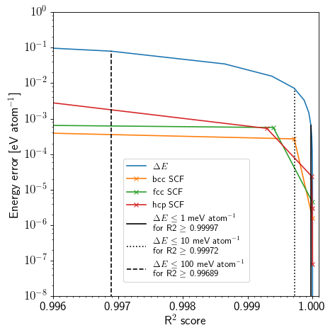a) | 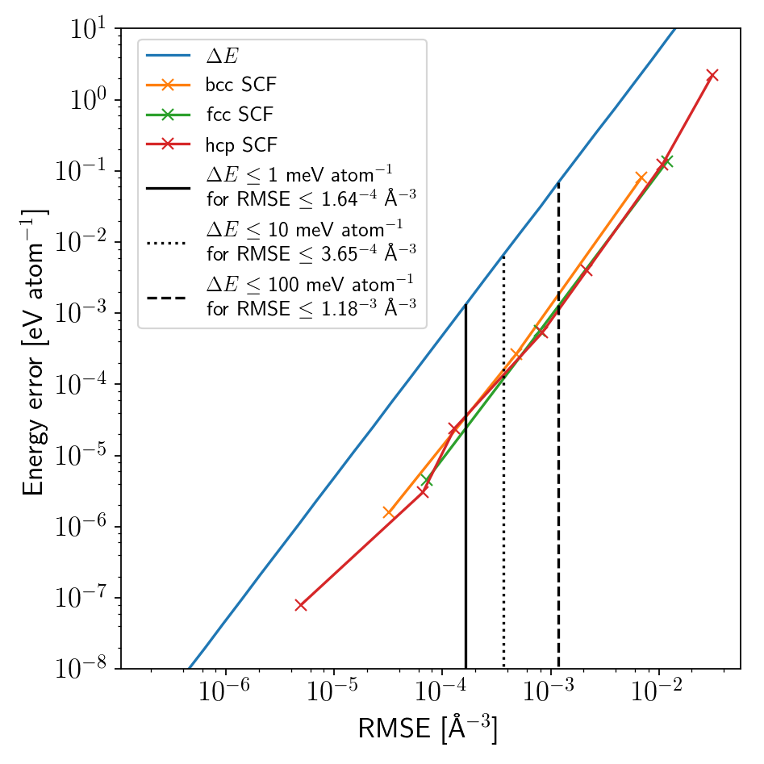b)
Figure 1 Relationship between $ΔE$ and a) the R² score and b) the root mean squared error (RMSE) for Al using OF DFT. The solid blue line represents energy deviations for fcc Al resulting from artificial distortions of $η_{normal}$ in real space. The orange, green and red solid lines with ‘x’ markers correspond to energy deviations during SCF cycles for bcc, fcc and hcp Al respectively. The black solid, dotted and dashed lines indicate values of R² scores and RMSEs obtained when $ΔE$ < 1 meV atom^{–1}, $ΔE$ < 10 meV atom^{–1} and $ΔE$ < 100 meV atom^{–1} for Al respectively based on $η_{normal}$.
To evaluate the performance of our density models for small structural changes, we have elastically strained various crystalline phases of Al using OF DFT and calculated $E\left[η_{pred}\left(r\right)\right]$ with respect to the ground state energy $E[η_{GS}\left(r\right)]$ using a cut-off energy of 800 eV. The applied strains are uniaxial in the range ±1%, closely equivalent to a ±3% volumetric strain. The models were trained on a random selection of half of the structures simultaneously, including fcc, bcc and hcp phases. In Figure 2 we show the resulting energy difference $E\left[η_{pred}\left(r\right)\right]-E[η_{GS}\left(r\right)]$ for each phase as a function of volumetric strain using the 2-body and the 2&3-body approximations, the latter highlighting the improvement in accuracy by including 3-body terms. The training was carried out using M_{2-body} = 200, M_{3-body} = 40, r_{2-body} = 10 Å and r_{3-body} = 7 Å. The resulting testing and training errors for the densities and energies are listed in Table 1.
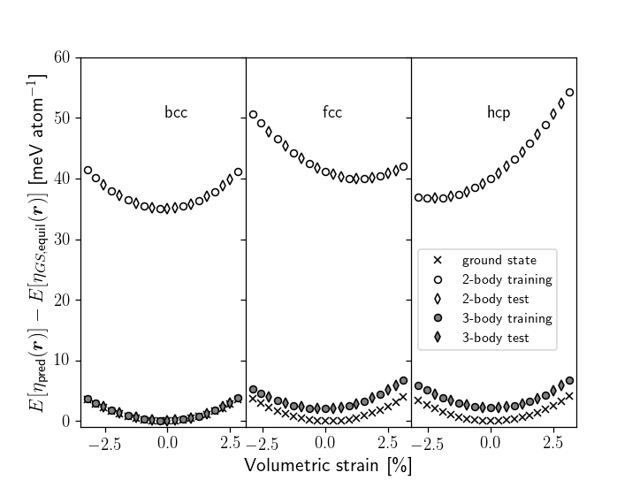
Figure 2 Energy per atom of strained fcc (a₀ = 4.04 $Å$), bcc (a₀ = 3.19 $Å$) and hcp (a₀ = 2.81 $Å$, c₀ = 4.67 $Å$) Al obtained by joint regression with 2-body and 2&3-body approximations of $η_{GS}\left(r\right)$ relative to the OF DFT ground state. Test (diamonds) and training (circles) sets are shown and ground state values are indicated with crosses.

Table 1 R² score for all Al phases in the test set for 2- and 2&3-body approximations. The mean absolute error (MAE) and maximum absolute error (MAX) are also given for OF DFT energies. 2&3-body approximations are indicated with “-2&3”, the others imply 2-body.
 | R²_{Test} ($η\left(r\right)$) | R²_{Test} (${\left\|∇_{r}η\left(r\right)\right\|}_{2}$) | R²_{Test} ($∆_{r}η\left(r\right)$) | MAE_{Train} [meV atom⁻¹] | MAE_{Test} [meV atom⁻¹] | MAX_{Train} [meV atom⁻¹] | MAX_{Test}  [meV atom⁻¹]
Fcc | 0.998 | 0.994 | 0.97 | 42.057 | 40.989 | 47.044 | 45.523
Fcc-2&3 | 0.99998 | 0.9998 | 0.998 | 2.086 | 2.1684 | 2.8524 | 2.7529
Bcc | 0.998 | 0.995 | 0.97 | 36.223 | 35.847 | 37.925 | 37.077
Bcc-2&3 | 0.999995 | 0.99999 | 0.997 | 0.1333 | 0.1106 | 0.3205 | 0.2293
Hcp | 0.997 | 0.993 | 0.97 | 40.281 | 41.681 | 50.153 | 49.072
Hcp-2&3 | 0.99998 | 0.99996 | 0.998 | 2.3824 | 2.33 | 2.6489 | 2.5324

The R² scores are only shown for the test set since they are identical to the training errors up to the level of precision shown. Note that the derivatives of $η\left(r\right)$ were calculated using finite differences of ~0.2 Å. The energies for $η_{pred}\left(r\right)$ are within at most 50.153 meV atom^{–1} and 2.8524 meV atom^{–1} from the reference ground state values using the 2-body and 2&3-body approximation respectively, for all phases studied. Among the phases, bcc is slightly better approximated with a maximum energy error of 0.2293 meV atom^{–1} whereas fcc and hcp have a maximum energy error of about 2 meV atom^{–1}. Since we sampled electron densities on a grid of ~ 0.25 Å, independent of the crystal, some crystals, like fcc Al, contain a larger number of electron density points than other crystals with a smaller primitive cell, like bcc Al. In order not to bias the training set towards a certain crystal by its larger representation of samples, we chose to take an equal number of electron density samples from each crystal. In Table 1, it can be seen that all density measures are almost identical although the OF DFT energy difference is an order of magnitude smaller for bcc Al than hcp and fcc Al. The difference in energy error therefore could be explained by the OF energy surface with respect to $η_{GS}\left(r\right)$ being more homogenous for bcc Al than it is for fcc and hcp Al.
To ascertain the performance of our method for a range of bonding types, we performed separate regressions for several different ionic, covalent and metallic systems: H₂ crystal (P6₃/mmc), NaCl (Fm$\overline{3}$m), W (bcc - Im$\overline{3}$m) & W₃O (Fm$\overline{3}$m), Al (fcc - Fm$\overline{3}$m, hcp - P6₃/mmc & bcc - Im$\overline{3}$m), BaTiO₃ (Pm$\overline{3}$m), single wall carbon nanotube SWCNT (chiral indices n = m = 3) and graphite (P6₃/mmc). Following the same procedure as above for the OF DFT study on Al, we use crystalline and high symmetry configurations strained equiaxially in the range ±1%. Energies for these structures are obtained with KS DFT instead of OF DFT as for Al. We again use half of the strained structures for the training and half for the test set. To investigate possible overfitting, several separate regressions were performed, each using a different amount of electron density data from the respective training set, varying between 1% and 95%. It can be seen in Figure 3 that the training error for all proportions used is usually only slightly better than or equal to the test error, indicating little overfitting. The general trend also seems to be that the approximation improves with increasing number of data points utilized from the training set, apart from Al which fluctuates around an R² of 0.99994 and an RMSE of 2.3×10⁻⁴ Å⁻³. The black curves in Figure 3 a) and b) are error bound estimates taken from Figure 1 and indicate energy error estimates for fcc Al, e.g. $ΔE<10$ meV atom⁻¹ are associated with an R² score > 0.998711 and RMSE < 3.65×10⁻⁴ Å⁻³. Using $ΔE$(R²) from OF Al as an estimate, we find that the SWCNT and the H₂ crystal are in the 10-100 meV atom^{–1} error range whereas the remaining phases, including graphite, fall below 10 meV atom^{–1}. The $ΔE$(RMSE) is similar for the Al systems but shifts the other systems to larger energy errors, with the tungsten system exhibiting the largest errors instead of the SWCNT. The error for graphite also notably shifts between the R² score and the RMSE. The SWCNT has the smallest observed R² score and second largest RMSE overall, which is likely due to it being the only structure which contains significant vacuum in the simulations, providing less useful information to our model. The shift in ordering between the R² score and RMSE are due to the respective sample variances, varying from about 9.9×10⁻⁴ Å⁻³ for the Al system to about 20.6 Å⁻³ for the W system. Although not included in the training, we found that the Laplacians of $η_{GS}\left(r\right)$ were approximated with R² scores and RMSEs of better than 0.8 and 10⁻¹ Å⁻⁵ for all systems respectively and further details are given in the Supplementary Information Section S.2. Note that both RMSE and R² score were computed over all density points contained in each structure having at least one neighboring atom, i.e. at least one atom within the cutoff distance r_{c}.
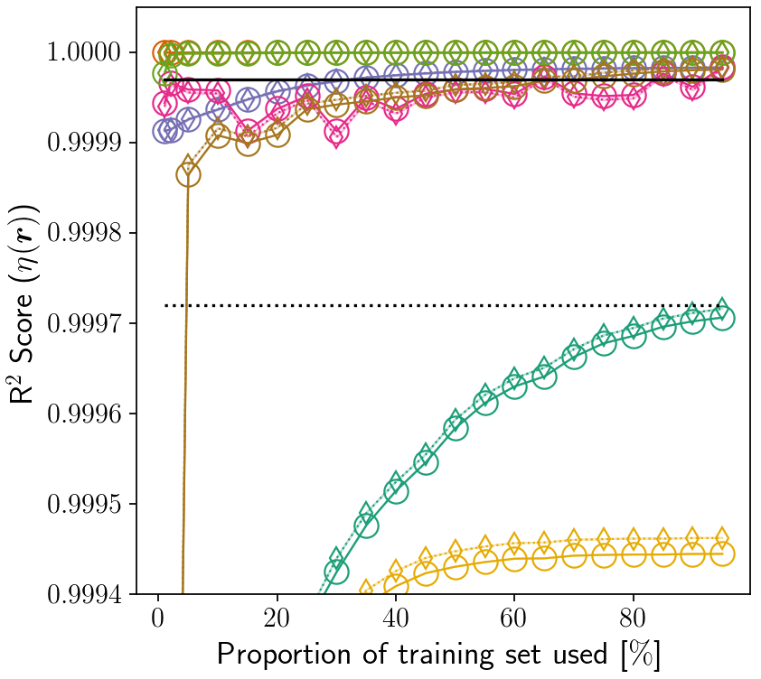  a) | 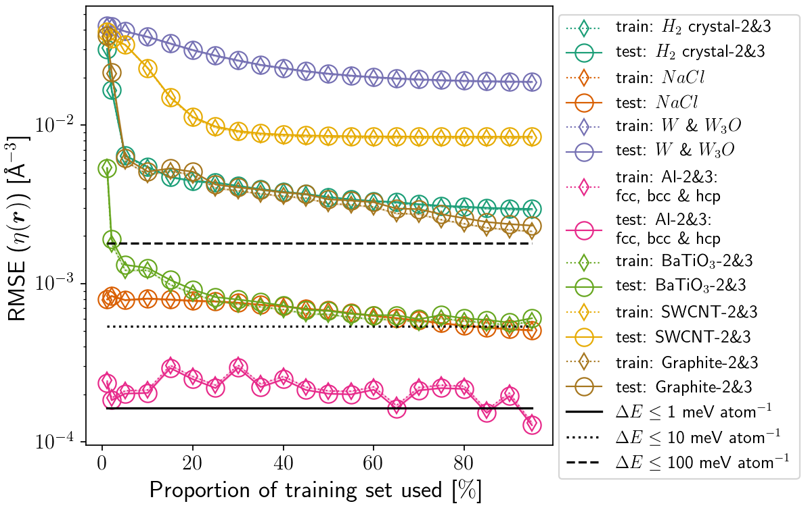b)
Figure 3 a) R² scores and b) RMSEs representing the error in $η_{pred}\left(r\right)$ for different sizes of training sets. Both measures are shown for several differently bonded materials (using the 2&3-body approximation where denoted with “-2&3”). The R² scores and RMSEs were obtained using all $η\left(r\right)$ for both the training and test set, regardless of the size of the training set used. Horizontal dashed line indicates R² scores > 0.9998711 obtained when $ΔE$ < 1 meV atom^{–1}, $ΔE$ < 10 meV atom⁻¹ and $ΔE$ < 100 meV atom^{–1}.
To visualize the meaning of the R² score and RMSE on a predicted density $η_{pred}\left(r\right)$, we show in Figure 4 cross-sections of $η_{GS}\left(r\right)$ and $η_{pred}\left(r\right)$ for the SWCNT using the 2-body and 2&3-body approximations. The R² scores for the 2-body and 2&3-body approximations in this case are 0.99 and 0.9996 respectively. Similarly, the RMSEs for both approximations are 2.23×10⁻² Å⁻³ and 4.57×10⁻³ Å⁻³ respectively. Figure 4 a) shows the 2-body prediction (background and solid lines) against $η_{GS}\left(r\right)$ (dashed lines). The 2-body prediction is relatively close, but underestimates the electron density of the covalent bonds clearly visible as a pinch of the highest density contour at the midpoint between covalent atom pairs. In contrast Figure 4 b) shows the 2&3-body prediction against $η_{GS}\left(r\right)$, with no discernable difference, despite having the lowest R² score and second largest RMSE for all systems in Figure 3. The corresponding values for the Laplacian of the electron density are shown in Figure S1 in the Supplementary Information Section S.2. Figure 4 c) shows the prediction error distribution of the electron density for the 2-body and 2&3-body approximations. While the 2&3-body approximation is symmetrical the 2-body approximation seems to have a slightly larger mass on the left-hand side, indicating slight systematic overestimation of the electron density.
The corresponding precision values from the regressed RVM, $β_{RVM}$, and the prediction error, $β_{error}$ (containing training and test set), are shown in Table 2 with $β_{RVM}$ being about 2-3 times smaller than $β_{error}$. The difference in β values is not limited to the SWCNT structures or RVMs. Computing $β_{error}$ for training and test set separately yields very similar values with a ratio of ~1. The exact reason for the difference between $β_{RVM}$ and $β_{error}$ remains to be determined.

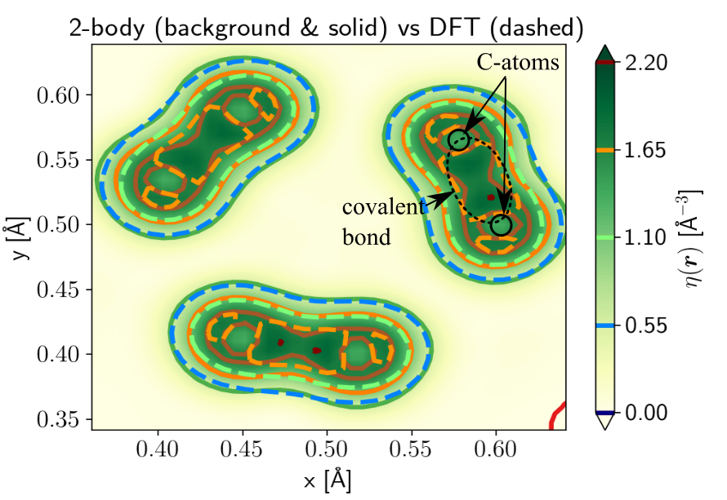a) | 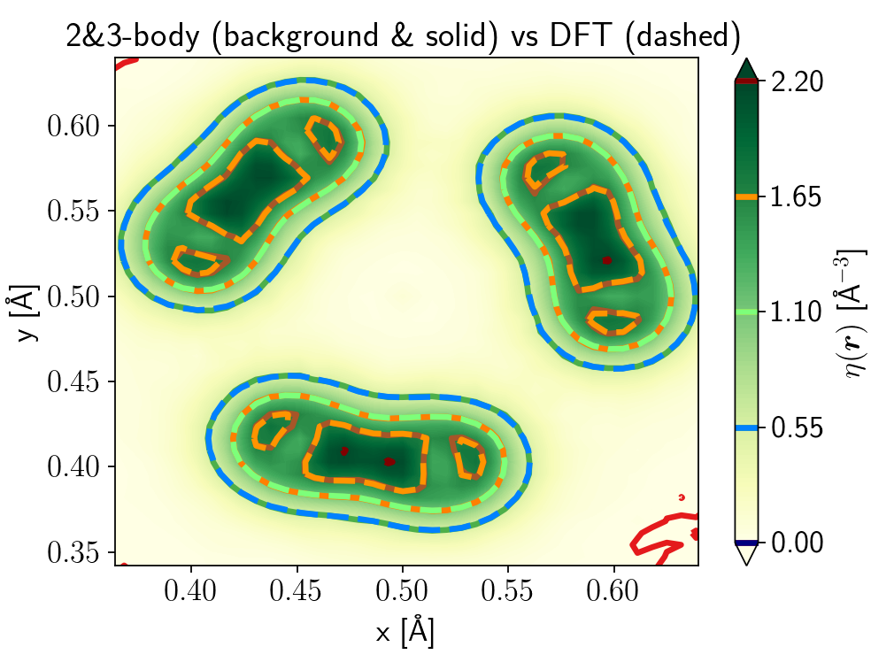  b)
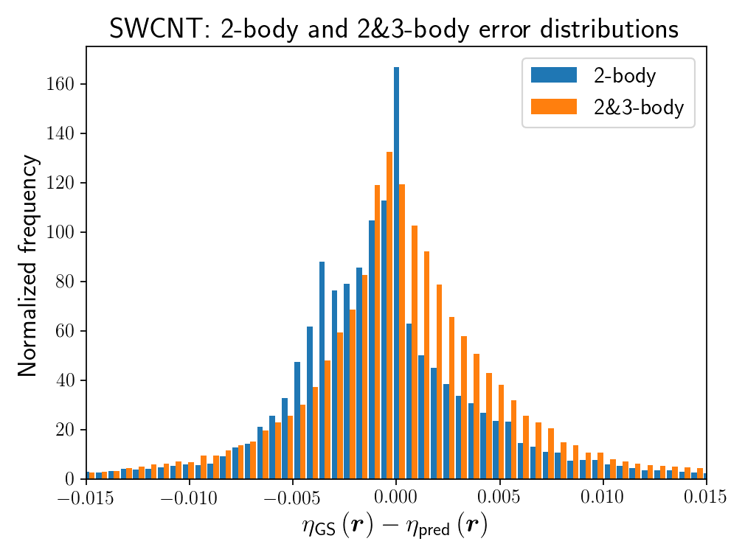
c)
Figure 4 Cross-sections through the SWCNT showing the predicted electron density (background and solid lines) superimposed on the ground state electron density (dashed lines) a) the 2-body prediction and b) the 2&3-body prediction. Chosen cross-section passes through the C-C bonds. c) histograms of $η_{GS}-η_{pred}$ for the 2-body (blue) and 2&3-body (orange) approximations in a) and b) using the complete supercell volume.
Table 2 Precisions for the predicted vs DFT electron densities for 2-body and 2&3-body approximations. $β_{error}$ is the empirical precision obtained from $η_{GS}\left(r\right)-η_{pred}\left(r\right)$ and $β_{RVM}$ is the precision obtained directly from the regressed RVM model.
 | 2-body | 2&3-body
$$β_{error}$$ | 2005.6 | 47881.9
$$β_{RVM}$$ | 673.6 | 21972.5

The Binary Al-Ni Alloy
To apply our 2-body approximation for $η_{GS}\left(r\right)$ to the EAM, we studied the binary alloy Al-Ni based on KS DFT calculations. The potentials were generated from an Al-Ni alloy database via the following three steps: 1) regress $η_{GS}\left(r\right)$ within 0.5 Å of all atom cores in all crystals in the alloy database, 2) optimize $E_{emb}$ and $E_{pair}$ for single element systems only and 3) fix $E_{pair}$ for like element pairs and optimize $E_{pair}$ for unlike element pairs as well as $E_{emb}$. The alloy database is composed of 287 structures, containing Al and Ni fcc, bcc and hcp phases, Al fcc configurations (2×2×2 supercells) at 1 K and 100 K sampled using Car-Parrinello molecular dynamics with and without a vacancy defect and binary phases including Al₃Ni₂ (ICSD 107713, P$\overline{3}$m1), AlNi₃ (ICSD 107862, P4/mmm), AlNi (ICSD 58037, Pm$\overline{3}$m), AlNi₃ (ICSD 58038, Pm$\overline{3}$m), Al3Ni5 (ICSD 58041, Cmmm) and, AlNi₃ (ICSD 608800, Fm$\overline{3}$m) structures. All crystals were strained equiaxially in the range ±1%. In addition, a uniaxial strain along x-axis, and simple shear strains parallel to the x-z plane, were applied to both fcc Al and Ni. The quality of the electron density regression in step 1 is shown in Figure 5 using the R² score in a) and the RMSE in b), grouped by structure/deformation type. Figure 5 a) shows that R² scores above 0.87 were achieved for all structures, with hcp Al having the lowest value. Figure 5 b) shows a similar shift as seen in Figure 3. This again is consistent with the sample variance being larger for structures with more Ni present than for structures of Al only.
The embedding and pair energy functions were constructed with basis functions of $M_{n}=$ 30 ($E_{emb,Al}$ and $E_{emb,Ni}$) and 40 ($E_{pair,Al,Al}$, $E_{pair,Ni,Ni}$ and $E_{pair,Al,Ni}$), respectively. The CMA-ES optimization was carried out over a maximum of 1000 iterations fitting energies and forces of all structures in the database, for a total number of “individuals” (potentials) equal to 20 times the number of parameters. Hence the potentials were generated including all structures in the training set. Convergence was achieved if the standard deviation of the fitness value among the individuals fell below 10^{–5}. The entire optimization process was performed multiple times with different initial values of the hyperparameters. Taking the 35 “best” and 35 “worst” potentials from the 175 potentials generated for each of the 13 optimization jobs and hyperparameter settings yielded 910 potentials (“best” and “worst” relative to the used fitness function).
Figure 6 (a, b) illustrates, for all materials in the Ni-Al system, how well the energies and forces derived from the generated potentials compare with the reference DFT values. Each potential obtained is shown as a red circle. The most accurate potential has a mean absolute error of 0.28 meV atom^{–1}. The mean and standard deviations over all potentials are shown as error bars. Figure 6 (b) shows the cartesian x-component of the forces, only, since the other components exhibit similar behavior. The standard deviations for energies and forces are shown in Table S1 and S2 in the Supplementary Information Section S.4.

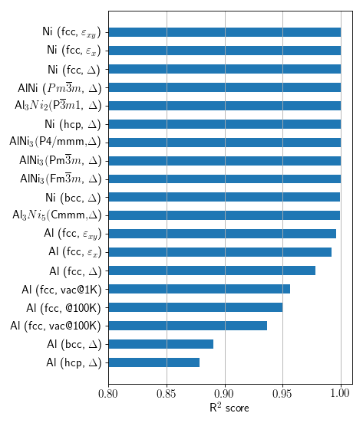a) | 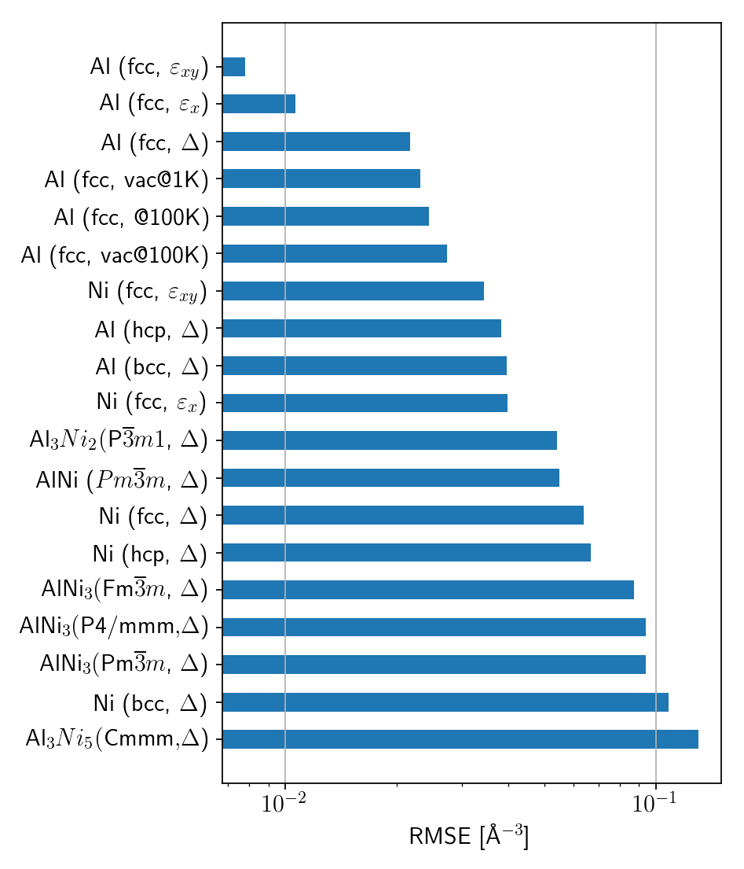b)
Figure 5 a) R² scores and b) RMSEs for all phases, deformations and configurations studied in the Al-Ni database. The R² scores are obtained using the 2-body density approximation and fitting the electron densities $η_{GS}\left(r\right)$ to within 0.5 Å of each atom core. The applied volumetric strain, normal strain along only the x cell vector and the shear strain parallel to the x-z-plane are indicated as Δ, $ε_{x}$ and $ε_{xy}$ respectively. The groups are sorted by increasing error measure from the top to the bottom, for both R² score and RMSE in a) and b) respectively.

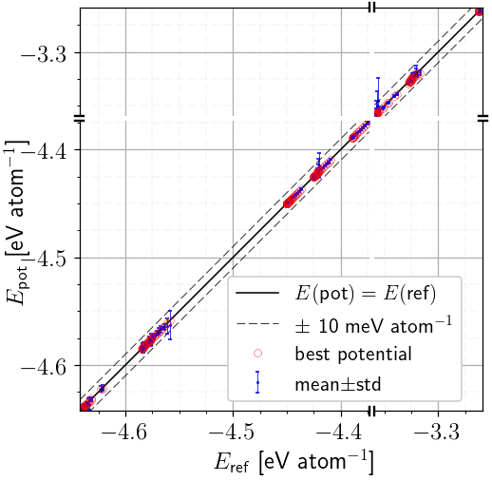a) | 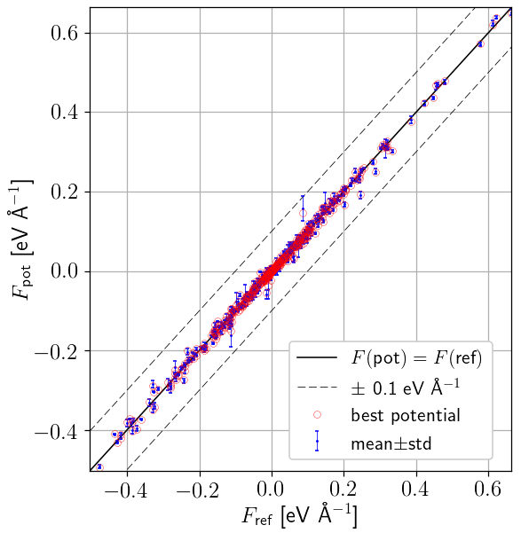b)
Figure 6 Comparison between the EAM predicted energies and forces from 910 generated Ni-Al potentials and the corresponding DFT reference values for all materials in the Ni-Al system: a) potential energies per atom and b) x-components of the forces for all atoms. Red circles represent the ‘best’ potential predicting values for all structures. The chosen ‘best’ potential has the smallest mean absolute energy error over all structures of 0.28 meV atom^{–1} among all 910 potentials. The mean energy and force values over all collected potentials are shown as blue dots with error bars representing one standard deviation.

Discussion
Using 2- and 3-body based approximations for the electron density we have shown that $η_{GS}\left(r\right)$ and its derivatives can be reproduced to high accuracy assuming only a linear superposition of atom contributions. Although all results shown here were obtained using RVMs, in light of the “no free lunch” theorem [28], we also applied Bayesian Ridge (BR) and Ordinary Least Squares (OLS) regression among others, as implemented in scikit-learn [29]. OLS, RVMs and BR give similar results in terms of the predictive error, for all phases tested, with RVMs leading to slightly sparser models, see the Supplementary Information Section S.3.
An alternative approach is to base the model on kernels following Brockherde et al. [10]. Coupling their $η_{pred}\left(r\right)$ with a further map approximating $E[η\left(r\right)]$ they could predict ground state energies accurately for both H₂O (within 2.5 – 212.5 meV) and H₂ (within 3.7 – 125.8 meV). The energy errors observed in the present work for high symmetry structures are in a similar range with the smallest and largest MAX values for the test set being 0.2293 meV atom^{–1} and 50.153 meV atom^{–1} respectively for Al, see Table 1. Using the $ΔE(R^{2})$ bounds seen in Figure 1 as an estimate and extending it to KS DFT for the all the materials shown in Figure 3, we would expect that each of them except the SWCNT and $H_{2}$-crystal would have an error smaller than 10 meV atom^{–1}. Similarly, we would expect energy errors of 10 meV atom⁻¹ or better for the Al system, NaCl and BaTiO₃, whereas the H₂ crystal, graphite, the SWCNT and the W system would be in the range of hundreds of meV atom⁻¹, using the $ΔE$(RMSE) bounds as an estimate. We think that assuming these bounds as an estimate is reasonable because the density surface produced by our model is continuous and for Al will lie between our lower and upper bound error (which are separated by two orders of magnitude).
Improvements to the current method of approximating $η_{GS}\left(r\right)$ could be achieved by changing the way the electron density points are sampled and pre-processed, e.g. by including information about the density derivatives as well. Alternatively, the density derivatives could be included explicitly. This would especially improve the calculated OF DFT energy since second order derivatives play a significant role in the kinetic energy contribution (the error distributions of the derivatives are wider for $η_{normal}\left(r\right)$ than for $η_{SCF}\left(r\right)$). Further improvement would be possible by selecting alternative features for 3-body terms or by including higher order many-body terms or by expanding the basis set to include, for example, Chebyshev polynomials or more localized functions, such as Gaussians or Wannier functions. More efficient basis sets could be found by including atomic orbital-based functions describing atom-centered contributions, not unlike the linear combination of atomic orbitals representation of $η_{GS}\left(r\right)$.
Making use of the 2-body approximation, we have developed EAM potentials using $η_{GS}\left(r\right)$ as $\overline{ρ}$. The 2-body approximations were obtained for electron densities near atom cores for a range of structures in the Al-Ni alloy system, leading to R² scores of at least 0.87 for pure Al phases and at least 0.99 for the rest and RMSEs between around 10⁻² Å⁻³ and 10⁻¹ Å⁻³. For Al, the R² scores are lower and the RMSEs are larger than desirable for OF DFT energy calculations but still capture the characteristic electron density features near the cores. The resulting EAM potentials were found to accurately reproduce DFT energies and forces well within 10 meV atom^{–1} and 0.1 eV Å^{–1} respectively.
The construction of EAM potentials for alloy systems usually involves the development of $E_{emb}$ and $E_{pair}$ functions for the elements first, fixing them and only then optimizing the unlike element $E_{pair}$ functions and possible additional factors [23,30]. In the present work we found it necessary (although computationally more expensive) to optimize the $E_{emb}$ functions for the entire alloy system in parallel with the $E_{pair}$ functions of the unlike element pairs. We think this is justified since the $E_{emb}$ functions are central to the EAM and are incorporated as functions of $\overline{ρ}$ which depend on the combined effect of the surrounding elements. Therefore, an extension to the EAM could be imagined where $\overline{ρ}$ is split into element contributions and additional $E_{emb}$ functions are introduced for the unlike element pairs. This would then also allow the application of the 3-body approximation for $η_{GS}\left(r\right)$ as a variant of the MEAM [15]. The above discussion indicates that possible applications of the present electron density regression method could be empirical interatomic potentials, for example using the 2-body approximation to develop and be consistent with standard glue-type potentials such as the EAM. Alternatively, we imagine using 2-body, 2&3-body and possibly higher order approximations to construct empirical potentials which resemble more rigorous integrals, in the asymptotic limit, over the unit cell and correspond to a regression of the kinetic energy density functional, as in the work of Brockherde et al. [10]. Interestingly, this method can be used to predict densities in structures in arbitrary regions or as a learning approach to bridge classical and quantum mechanical methods such as in the quantum mechanics / molecular mechanics (QM/MM) method.

Conclusion
In conclusion, we have proposed a method for describing ground state electron densities in solids, $η_{GS}\left(r\right)$, in terms of linear models using Bayesian regression. The output of these linear models are functions which may be used to systematically develop empirical potentials for two or more elements, e.g. in the form of embedding density functions, or predict $η_{GS}\left(r\right)$. The error predicting $η_{GS}\left(r\right)$ has been quantified using the R² score, the RMSE and the energy difference $E\left[η_{pred}\left(r\right)\right]-E\left[η_{GS}\left(r\right)\right]$ using orbital free DFT for various phases of Al. The maximum test set error is found to be within 0.2293 meV atom^{–1} and 50.153 meV atom^{–1} for 2&3-body and 2-body approximations of the electron density respectively, with R² scores better than 0.999 for both. The proposed method has also been applied to a variety of crystalline and high symmetry systems containing metallic, covalent and ionic bonds and lattice types demonstrating accurate 3-body based predictions of their $η_{GS}\left(r\right)$. Based on 2-body approximations to $η_{GS}\left(r\right),$ EAM potentials have been developed which accurately reproduce the energies and forces of DFT data, in one case with a mean absolute energy error of only 0.28 meV atom^{–1}.
Acknowledgements
The authors would like to thank Prof. Chris Pickard (CJP), Dr. Anita Faul (AF) and Prof. Mark Tuckerman (MJT) for interesting and useful discussions. Specifically, we thank CJP for recommending several of the systems which we tested our model on, AF for suggesting the use and discussing the implementation of RVMs and MJT for our discussion on the work of Brockherde et al. [10]. We also thank the referees for their insightful and constructive comments which have led us to make significant improvements to the manuscript. The work was supported by Rolls-Royce plc and EPSRC grants EP/J500380/1 and EP/K503009/1 (E. Schmidt) and the EPSRC Centre for Doctoral Training in Computational Methods for Materials Science, grant number EP/L015552/1 (A. Fowler). Some of the calculations were performed at the Cambridge University High Performance Computing Service (HPCS). The post-processed data and code can be accessed at doi.org/10.17863/CAM.14349. The current version of the code may also be accessed via GitHub at github.com/eschmidt42/PottyTrainer. The code for RVMs is available at github.com/eschmidt42/RVMs.

References
[1] P. Hohenberg, W. Kohn, Inhomogeneous electron gas, Phys. Rev. 136 (1964) 864–871. doi:10.1103/PhysRevB.7.1912.
[2] C.J. Pickard, R.J. Needs, Ab initio random structure searching, J. Phys. Condens. Matter. 23 (2011) 53201. doi:10.1088/0953-8984/23/5/053201.
[3] C.W. Glass, A.R. Oganov, N. Hansen, USPEX--Evolutionary crystal structure prediction, Comput. Phys. Commun. 175 (2006) 713–720. doi:10.1016/j.cpc.2006.07.020.
[4] S. Curtarolo, W. Setyawan, G.L.W. Hart, M. Jahnatek, R. V. Chepulskii, R.H. Taylor, S. Wang, J. Xue, K. Yang, O. Levy, M.J. Mehl, H.T. Stokes, D.O. Demchenko, D. Morgan, AFLOW: An automatic framework for high-throughput materials discovery, Comput. Mater. Sci. 58 (2012) 218–226. doi:10.1016/j.commatsci.2012.02.005.
[5] G. Pizzi, A. Cepellotti, R. Sabatini, N. Marzari, B. Kozinsky, AiiDA: automated interactive infrastructure and database for computational science, Comput. Mater. Sci. 111 (2016) 218–230. doi:10.1016/j.commatsci.2015.09.013.
[6] A. Jain, S.P. Ong, G. Hautier, W. Chen, W.D. Richards, S. Dacek, S. Cholia, D. Gunter, D. Skinner, G. Ceder, K.A. Persson, Commentary: The Materials Project: A materials genome approach to accelerating materials innovation, APL Mater. 1 (2013) 11002. doi:10.1063/1.4812323.
[7] A. Otero-de-la-Roza, E.R. Johnson, V. Luaña, Critic2: A program for real-space analysis of quantum chemical interactions in solids, Comput. Phys. Commun. 185 (2014) 1007–1018. doi:10.1016/j.cpc.2013.10.026.
[8] G.S. Ho, V.L. Lignères, E.A. Carter, Introducing PROFESS: A new program for orbital-free density functional theory calculations, Comput. Phys. Commun. 179 (2008) 839–854. doi:10.1016/j.cpc.2008.07.002.
[9] S.J. Clark, M.D. Segall, C.J. Pickard, P.J. Hasnip, M.I.J. Probert, K. Refson, M.C. Payne, First principles methods using CASTEP, Zeitschrift Für Krist. - Cryst. Mater. 220 (2005) 567–570. doi:10.1524/zkri.220.5.567.65075.
[10] F. Brockherde, L. Vogt, L. Li, M.E. Tuckerman, K. Burke, K.-R. Müller, Bypassing the Kohn-Sham equations with machine learning, Nat. Commun. 8 (2017) 872. doi:10.1038/s41467-017-00839-3.
[11] P. Mitev, G.A. Evangelakis, E. Kaxiras, Embedded atom method potentials employing a faithful density representation, Model. Simul. Mater. Sci. Eng. 14 (2006) 721–731. doi:10.1088/0965-0393/14/4/013.
[12] A.P. Bartók, M.C. Payne, R. Kondor, G. Csányi, Gaussian Approximation Potentials: The Accuracy of Quantum Mechanics, without the Electrons, Phys. Rev. Lett. 104 (2010) 136403. doi:10.1103/PhysRevLett.104.136403.
[13] A.P. Bartók, G. Csányi, Gaussian Approximation Potentials: A Brief Tutorial Introduction, Int. J. Quantum Chem. 115 (2015) 1051–1057. doi:10.1002/qua.24927.
[14] K.T. Schütt, F. Arbabzadah, S. Chmiela, K.R. Müller, A. Tkatchenko, Quantum-chemical insights from deep tensor neural networks, Nat. Commun. 8 (2017) 13890. doi:10.1038/ncomms13890.
[15] M.I. Baskes, Modified embedded-atom potentials for cubic materials and impurities, Phys. Rev. B. 46 (1992) 2727–2742. doi:10.1103/PhysRevB.46.2727.
[16] Y. Mishin, M.J. Mehl, D.A. Papaconstantopoulos, Phase stability in the Fe–Ni system: Investigation by first-principles calculations and atomistic simulations, Acta Mater. 53 (2005) 4029–4041. doi:10.1016/j.actamat.2005.05.001.
[17] D.J.C. MacKay, Bayesian Interpolation, Neural Comput. 4 (1992) 415–447. doi:10.1162/neco.1992.4.3.415.
[18] M.E. Tipping, Sparse Bayesian Learning and the Relevance Vector Machine, J. Mach. Learn. Res. 1 (2001) 211–244. http://www.jmlr.org/papers/v1/tipping01a.html.
[19] S. Roweis, Z. Ghahramani, A unifying review of linear gaussian models, Neural Comput. 11 (1999) 305–45. doi:10.1162/089976699300016674.
[20] C.M. Bishop, Pattern Recognition and Machine Learning, 1st ed., Springer Science+Business Media, Cambridge, 2009.
[21] A.C. Faul, M.E. Tipping, Analysis of sparse Bayesian learning, Adv. Neural Inf. Process. Syst. 14 (2002) 383–389. http://papers.nips.cc/paper/2121-analysis-of-sparse-bayesian-learning.pdf.
[22] M.E. Tipping, A. Faul, Fast Marginal Likelihood Maximisation for Sparse Bayesian Models, Proc. 9th Int. Work. Artif. Intell. Stat. (2003). https://pdfs.semanticscholar.org/11f4/d997de8e35a1daf8b115439345d9994cfb69.pdf.
[23] M.S. Daw, M.I. Baskes, Embedded-atom method: Derivation and application to impurities, surfaces, and other defects in metals, Phys. Rev. B. 29 (1984) 6443–6453. doi:10.1103/PhysRevB.29.6443.
[24] S. Plimpton, Fast Parallel Algorithms for Short-Range Molecular Dynamics, J. Comput. Phys. 117 (1995) 1–19. doi:10.1006/jcph.1995.1039.
[25] N. Hansen, A. Ostermeier, Completely Derandomized Self-Adaptation in Evolution Strategies, Evol. Comput. 9 (2001) 159–195. doi:10.1162/106365601750190398.
[26] F.-A. Fortin, F.-M. De Rainville, M.-A. Gardner, M. Parizeau, C. Gagne, DEAP: Evolutionary Algorithms Made Easy, J. Mach. Learn. Res. 13 (2012) 2171–2175. http://www.jmlr.org/papers/v13/fortin12a.html (accessed November 3, 2016).
[27] E. Jones, T. Oliphant, P. Peterson, SciPy: Open source scientific tools for Python, (2001).
[28] D.H. Wolpert, W.G. Macready, No free lunch theorems for optimization, IEEE Trans. Evol. Comput. 1 (1997) 67–82. doi:10.1109/4235.585893.
[29] F. Pedregosa, G. Varoquaux, Scikit-learn: Machine Learning in Python, J. Mach. Learn. Res. 12. Oct. (2011) 2825–2830. http://www.jmlr.org/papers/v12/pedregosa11a.html.
[30] Y. Mishin, Atomistic modeling of the gamma and gamma prime-phases of the Ni-Al system, Acta Mater. 52 (2004) 1451–1467. doi:10.1016/j.actamat.2003.11.026.

