Optical and Electronic Ion Channel Monitoring from Native Human Membranes
Anna-Maria Pappa^{1#}, Han-Yuan Liu^{2#}, Walther Traberg-Christensen¹, Quentin Thiburce³, Achilleas Savva¹, Aimie Pavia^{4,5}, Alberto Salleo³, Susan Daniel²* and Rόisín M. Owens¹*
¹Department of Chemical Engineering and Biotechnology, Philippa Fawcett Drive, CB30AS, Cambridge, UK
²Robert F. Smith School of Chemical and Biomolecular Engineering, Olin Hall, Ithaca, NY 14853, USA
³Department of Materials Science and Engineering, Stanford University, 496 Lomita Mall, Stanford, CA 94305, USA
⁴Department of Flexible Electronics, Ecole Nationale Supérieure des Mines, CMP-EMSE, 13541 Gardanne, France
⁵Panaxium SAS, 13100 Aix-en-Provence, France
ABSTRACT
Transmembrane proteins represent a major target for modulating cell activity, both in terms of therapeutics drugs but also for pathogen interactions. Work on screening such therapeutics or identifying toxins has been severely limited by the lack of available methods that would give high content information on functionality (ideally multi-modal) and that are suitable for high-throughput. Here, we have demonstrated a platform that is capable of multi-modal (optical and electronic) screening of ligand gated ion-channel activity in human derived membranes. The TREK-1 ion-channel was expressed within supported lipid bilayers, formed via vesicle fusion of blebs obtained from the HEK cell line overexpressing TREK-1. The resulting reconstituted native membranes were confirmed via fluorescence recovery after photobleaching to form mobile bilayers on top of films of the polymeric electroactive transducer poly(3,4-ethylenedioxythiophene) polystyrene sulfonate (PEDOT:PSS). PEDOT:PSS electrodes were then used for quantitative electrochemical impedance spectroscopy measurements of ligand-mediated TREK-1 interactions with two compounds, spadin and arachidonic acid, known to supress and activate TREK-1 channels, respectively. PEDOT:PSS based organic electrochemical transistors were then used for combined optical and electronic measurements of TREK-1 functionality. The technology demonstrated here is highly promising for future high-throughput screening of transmembrane protein modulators owing to the robust nature of the membrane integrated device and the highly quantitative electrical signals obtained. This is in contrast with live-cell based electrophysiology assays (e.g. patch clamp) which compare poorly in terms of cost, usability and compatibility with optical transduction.
KEYWORDS : ion channel, TREK-1, organic electrochemical transistor, impedance, conducting polymer, PEDOT:PSS, supported lipid bilayer

Proteins at the cell surface, primarily transmembrane proteins (TMPs) such as ion channels and G protein-coupled receptors, represent targets of an estimated 60% of all approved drugs.¹ Still, membrane proteins have not yet been fully explored as drug-targets, partly due to inadequacies of current technologies to interface and investigate TMP-mediated signal transduction in their native environment.² Indeed, high attrition rates of drugs in late phase drug trials points to the need for change in “standard modus operandi” of drug discovery.³
Due to the pivotal role played by protein–lipid interactions in the structure and function of membrane proteins, methods to monitor TMPs in model plasma membranes have emerged. Amongst those, supported lipid bilayers (SLB) have been suggested as the preferred system for ion channel recording and pharmaceutical screening due to their ability to recreate lateral lipid diffusion in the absence of solvent that would denature TMPs.^{4, 5} Alternative methods that rely on solvent based formation of a lipid bilayer followed by reconstitution with purified membrane proteins in vitro, are limited in their application, due to denaturation of various proteins or inability to recover correct orientation.^{6, 7} To combat these issues, the Daniel group have developed methods for reconstituting native cell membranes on conventional solid substrates (i.e., glass, silicon) by fusing plasma membrane vesicles with SLBs,⁸ allowing the study of TMPs in their native environment, preserving not only diffusion and mobility of membrane proteins surrounded by native lipids, but also their orientation.^{9, 10} However, the use of “biologically incompatible” surfaces, that is, conventional inorganic/flat supports, still poses limitations in terms of protein mobility and potentially function. Hydrogels or polymeric cushions that mimic the cell microenvironment can be used to bridge this incompatibility at the interface.^{11, 12} As previously shown, films of the conducting polymer poly(3,4-ethylenedioxythiophene) polystyrene (PEDOT:PSS) absorb electrolyte and swell significantly in the aqueous biological environments providing a stable hydrogel-like interface for cell/ cell membrane integration while preserving mechanical and electrical properties.¹³⁻¹⁵ Electrical monitoring of cell membranes is highly prized but extremely challenging, rarely compatible with high-throughput screening. As membrane biophysicists know, a major challenge is to achieve contiguous high sealing membranes on electrodes while maintaining protein structure. We recently challenged the dogma that native membranes could only be formed on smooth, rigid surfaces by forming Baby Hamster Kidney (BHK) cell membranes PEDOT:PSS through an optimised bleb fusion process.¹⁶ The formation of a biohybrid construct comprising a cushioning conducting polymer surface functionalized with native cell membranes enables direct electronic TMP-mediated signal transduction in an in vivo-like environment, where proteins can undergo conformational changes needed during transduction. A major added advantage of using PEDOT:PSS is that it is optically transparent when prepared in thin films, giving the possibility of combined optical and electronic transduction from a single experiment.
RESULTS AND DISCUSSION
To demonstrate the advantage of having proteins in an in-vivo like environment, we herein use our platform to study ion channels in their native environment, by reconstituting the membrane of HEK (human embryonic kidney) cells transfected with TREK-1 ion channels (HEK- TREK-1). TREK-1 is a well characterised ion channel with known pharmacological response, making it an ideal test case for our technology.¹⁷ TREK-1 channels are two pore domain potassium ion channels,¹⁷ representing attractive druggable targets for several pathologies, especially neurological disorders.¹⁸ Screening of new compounds against TREK-1 was greatly facilitated through its constitutive expression in HEK cells, confirming the action of the polyunsaturated fatty acid, arachidonic acid (AA), and the antidepressant molecule, spadin, in their ability to activate and suppress TREK-1 activity respectively.¹⁹ As with the majority of studies on ion channels, TREK-1 action was previously investigated using the patch clamp method that allows direct recording of ion channel activity, in terms of electrical current flowing through the membranes of cells.²⁰ Despite its inherent sensitivity, the patch clamp method is a relatively low-throughput and technically challenging method. Advances have been made in terms of throughput, but this is still hampered by a reliance on live cells,²¹ and its associated drawbacks (cost, sterility, highly controlled environmental conditions, low yield etc.). HEK-TREK-1 membranes were reconstituted on top of PEDOT:PSS films by fusing native plasma membrane material (blebs) obtained from the HEK-TREK-1 cells with liposomes and then adding PEG to heal the layer (See Fig.1a for a schematic showing the incorporation of TREK-1 into SLBs and Fig.S1 for a schematic showing the optimized method of blebbing and membrane fusion). TREK-1 was cloned into a pIRES2-eGFP vector, which co-transcribes eGFP along with the protein of interest, in this case TREK-1, avoiding a bulky fusion protein. Thus, the presence of the TREK-1 protein in the HEK cells is inferred due to the presence of enhanced green fluorescent protein (eGFP) in the cells (Fig.1b). The TREK-1 ion channels are over-expressed, as suggested by the strong signal in the dot blot after addition of the anti-TREK1 antibody (Fig.1c). The lateral mobility and fluidity of the lipids within the HEK-TREK-1 derived membrane on the PEDOT:PSS films was assessed using the well-established method, fluorescent recovery after photobleaching (FRAP), by incorporating a dye in the blebs prior to their fusion (Fig.1d). The kinetics of recovery of the fluorescence intensity in the photobleached area reveal a mobile fraction of 0.95 ± 0.12 and diffusion coefficient of 0.84 ± 0 .09 µm²/s comparable to state-of-the-art values obtained on glass substrates.^{9, 10, 12} FRAP of the HEK SLBs carried out as a control is shown in SI (Fig.S2). Considerable effort has been expended to demonstrate that overexpressed proteins in blebbed membranes maintain their correct orientation.⁸ The dot blots indicate a high concentration of TREK-1 available for binding to the secondary antibody but do not necessarily confirm orientation. To illustrate correct orientation maintained during the blebbing process, we overexpressed a second protein, GPI-YFP, in the HEK cells (this was previously demonstrated by us in BHK cells along with another transmembrane protein, P2X2).¹⁶ The GPI anchored YFP protein contains an extracellular cleavage proteinase K (PK) site. As shown (Fig.S3) the significant loss of fluorescence signal after treatment with PK indicates the correct orientation of the protein in the membrane.
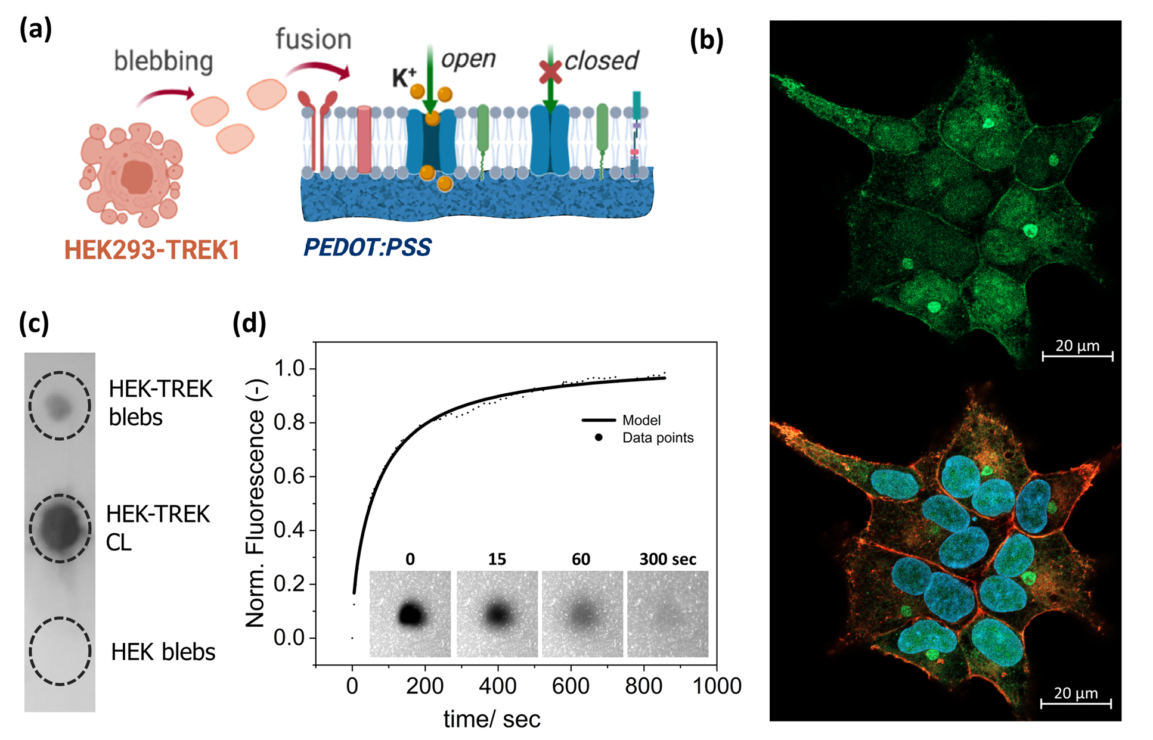
Figure 1. Reconstituting native human plasma membranes (HEK) bearing the TREK-1 ion channels on PEDOT:PSS films. (a) Schematic of vesicle fusion process using extracellular vesicles (blebs) from the HEK-TREK-1 cell line (TREK-1 ion channels are shown in blue) (b) Immunofluorescence imaging of HEK-TREK-1 cells showing GFP (co-transcribed with TREK-1) in green, DAPI stained nuclei (blue) and F-actin (stained with rhodamine-phalloidin) (red). (c) Dot blot analysis of the blebs confirming the presence of TREK-1 channels in HEK-TREK-1 cell lysates (CL) and blebs, but not in the HEK blebs. (d) FRAP on the membranes suggesting good lateral mobility and diffusivity of the lipids in the native bilayer.

To assess the electrical properties of the HEK-TREK-1 membranes, electrochemical impedance spectroscopy (EIS) was next performed (Fig.2a) using gold electrodes coated with PEDOT:PSS films. The fabrication of the electrodes is shown in Fig.S4. The formation of the lipid bilayer was electrically monitored and by modelling the response of the system, the resistance and capacitance of the membrane were extracted. The characteristic semi-circle formation in the Nyquist plot (Fig.2b) suggests the addition of an R_{m}//C_{m} circuit component to the initial capacitive PEDOT:PSS electrode circuit (R_{s} in series with C_{pedot}).²² The calculated capacitance and resistance values of the membrane from a representative experiment were 0.09 μF/cm² and 40.67 Ω cm² respectively. As a point of comparison, we show the Nyquist plot of an equivalent HEK cell derived membrane along with its gradual disruption using a common SLB disruptor, ethanol, which further substantiates the sensitivity of the method to detect interactions and disruption of the SLB (Fig.S5). Finally, to further explore the effects of membrane composition on the electrical membrane properties, both native membranes (HEK and HEK-TREK-1) are compared to those of typical SLBs consisting of liposomes only (Fig.S6). The HEK membranes exhibit higher resistivity compared to the TREK-1 transfected ones (ca. 0.06 vs 0.04 kΩ cm²) likely due to the absence of the overexpressed ion channels. Similarly, as expected, the liposome-only membranes exhibit an order of magnitude (ca. 0.78 vs 0.04 kΩ cm²) higher membrane resistance values likely due to the tighter packing of lipids in the absence of proteins or other defects.²³
The method shown here allows transduction of ion channel activity in a similar manner to the patch clamp method. In contrast to patch clamp, with our devices, TMPs in their native environment can be directly characterized without technical difficulties related to the use of live cells, benefitting from intimate, cushioned contact between the electrode and the membrane. To illustrate the latter, we measured the effect of the addition of TREK-1 modulators on the HEK-TREK-1 cell derived membrane properties (i.e., membrane resistance / R_{m}) and the effect on equivalent HEK cell-derived membranes lacking the TREK-1 ion channels (as illustrated in Fig.2c). The chosen concentration of modulators have been reported to effectively activate or inactivate the TREK-1 in literature.^{19, 24, 25} As seen, the TREK-1 suppressor, spadin, results in an increase of the normalised membrane resistance (change of 44 ± 0.9%) as a result of ion channel closing, but has no discernible effect on the HEK membranes (Fig.2d). A representative Nyquist plot showing the HEK-TREK-1 SLBs before and after spadin addition (10 µM) is shown in the SI (Fig.S7). Before addition of arachidonic acid (AA), a TREK-1 activating compound, we added a general K⁺ blocker that blocks all K⁺ ion channels including the TREK-1, resulting in a considerably more resistive SLB.¹⁹ As expected the addition of AA results in a leakier membrane (decrease of R_{m}), as a result of TREK-1 opening (Fig.2e). There is a large drop in the membrane resistance (decrease of 97.06 ± 1.7 %) following AA addition (10 µM). The magnitude of this decrease indicates that a majority of the ion channels expressed in the membrane are sensitive to opening by AA. Representative Nqyuist plots showing the sequence of addition of the K⁺ blocker and AA as measured by EIS are shown in Fig.S8. It should be noted that the values shown in the bar graphs are normalised to the value of the individual membrane before addition of spadin or AA. These results clearly demonstrate the suitability of the native membrane configuration for ionic current measurements from ion channels using EIS.

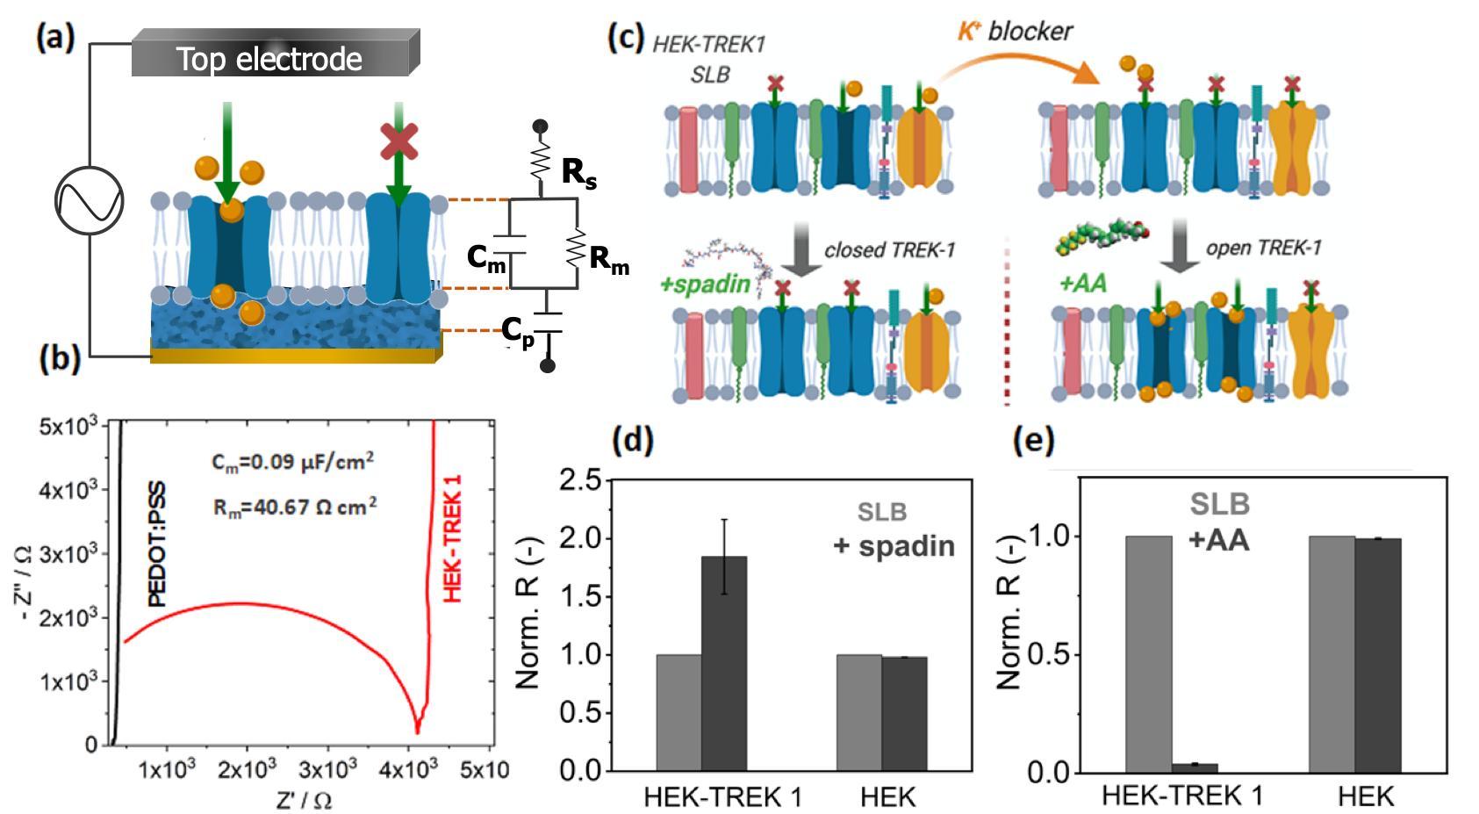
Figure 2. EIS monitoring and modelling of HEK-TREK-1 membrane formation and ion channel function in response to different drugs (i.e., activators and suppressors) using PEDOT:PSS electrodes: (a) Schematic of the biomembrane integrated electrodes with TREK-1 shown as a blue TMP with orange cations passing through. The equivalent circuit of our model is also shown. (b) EIS response of the HEK-TREK-1 membrane compared to the bare PEDOT:PSS electrode in the form of a Nyquist plot (real vs imaginary impedance) and the calculated membrane capacitance and resistance values (for the HEK-TREK-1 membrane). (c) Schematic of the complex native membranes (K⁺ ion channels are depicted in yellow, with other TMPs in pink and green, while TREK-1 ion channels are shown in blue) showing the different drug additions and their effect on TREK-1 channel function. (d) Spadin (10 µM) supresses TREK-1 activity thus increasing the resistance of the membranes shown here normalised to the baseline SLB resistance (e) Arachidonic acid (10 µM) activates TREK-1 channels thus decreasing the resistance of the membranes shown here normalised to the baseline SLB resistance.

We have recently shown excellent sensitivity and specificity using organic electrochemical transistors (OECTs), widely known as highly efficient ion-to-electron transducers,²⁷ to transduce drug-lipid interactions using a reductionist membrane model based on lipid monolayers. These lipid models, despite posing compositional and structural limitations, are effective in isolating the effect of drugs that act solely on the phospholipids of the cell membrane.^{23, 26} A major advantage of the OECT compared to other devices used for recording current, is its ability to monitor small alterations in ionic flux in real‐time with high temporal resolution owing to superior ion‐to‐electron transduction.²⁷ Briefly, the operation principle of OECTs comprising PEDOT:PSS in the channel, is as follows: application of a positive gate bias promotes the removal of holes from PEDOT chains, which drives cations from the electrolyte to compensate the negatively-charged PSS⁻ chains, thus dedoping the PEDOT:PSS channel and decreasing the current that flows between the two electrodes (source and drain) in contact with the channel. The fabrication of OECTs commonly involves the patterning of two parylene-C layers, with the upper layer peeled off to pattern the polymer channel, while the bottom layer acts as an insulating layer between the electrolyte and the metal interconnects, preventing parasitic effects such as leakage currents and stray capacitances. However, the deposition of pinhole-free, homogeneous parylene-C typically requires 1 μm-thick layers, thus creating tall steps on the substrate that may interfere with membrane formation. We therefore used a 100 nm SiO₂ thin-film instead of parylene-C as insulator, thus decreasing by tenfold the height of the tallest features and improving the likelihood of high-quality membrane formation. The transistor channels are then patterned with a sacrificial Ge layer used as a hard mask protecting the sensitive polymer from the harmful chemicals used during photolithography and acting as a plasma etch stop. This optimized device fabrication method (illustrated in Fig.S9) was used to achieve lower topography PEDOT:PSS channels of approximately 100nm in thickness. This is postulated to result in improved SLB fusion as previously described.¹³ A contiguous, well-formed SLB is highly insulating and would thus increase the resistance between channel and gate. As such, a membrane functionalized OECT (Fig.3a) is expected to give a slower response to a given applied bias compared to an unfunctionalized device. As expected, the speed of the device response (τau) to a square gate pulse increases when a HEK-TREK-1 SLB is formed on the device (Fig.3b). The transparency of PEDOT:PSS films in the OECT channels (in contrast to the PEDOT:PSS electrodes which have opaque gold films beneath), is a major advantage compared to the patch clamp method. Indeed, the OECT devices when placed under a confocal microscope while the three terminals of the device are connected, enable simultaneous electrical and optical monitoring of the SLBs formed on the channels of the OECT (Fig.S10). The lateral mobility and fluidity of the lipids within the membrane were characterized using FRAP (Fig.3c) to evaluate the quality of the SLB, as described previously. These measurements were carried out at the same time as the OECT response was measured in order to confirm the quality of the membrane formed on the device and further validate the experiment. The kinetics of recovery of the fluorescence intensity in the photo-bleached area reveal a mobile fraction of 0.75 and diffusion coefficient of 1.50 µm²/s comparable to state-of-the-art values obtained on glass substrates. The optical characterization of the membrane is in agreement with the electrical data recorded simultaneously and shown in Fig. 3b.
The effect of the AA (using the same protocol as before for PEDOT:PSS electrodes) on the HEK-TREK-1 SLB was also assessed using the electrical response of the OECTs. The response of the devices was calculated to be 126.5 ± 11.6 μsec (vs the initial speed of 43.3 ± 11.5 μsec) after SLB formation, and 583.3 ± 56.2 μsec after adding the general K+ blocker. Addition of the TREK-1 activator AA (10 μM), results in an almost complete recovery of the speed of the device to 96.6 ± 5.77 μsec, presumably by increasing the number of ions that pass through the membrane. We note with interest that the response after addition of AA reverts to a speed that is faster than the initial response of the SLB before addition of the general K+ blocker. We assume that this may be as a result of the AA not just directly affecting the TREK-1 channel, but also affecting the protein lipid environment, reported to be critical in modulating its function.²⁸ This would occur if some of the TREK-1 were initially closed and are subsequently opened by AA treatment.^{28, 29} Our results are consistent with whole cell patch clamp studies on AA addition using the same configuration (addition of 10 μM AA in the present of a general K+ blocker) where the current at 0 mV increased by 5-fold due to opening of TREK-1 channels by the AA activator.¹⁹ The magnitude of the decrease detected via EIS is significantly higher indicating a higher dynamic range in the EIS type experiments due to scanning of a wide-range of frequencies. However, there are advantages to rapid, transient experiments such as those shown here, in that multiple experiments can be taken in quick succession, as we illustrate here with the dose response results shown (Fig.3d). It should also be noted that the transistors used here are significantly smaller than the PEDOT:PSS coated electrodes. The results obtained with the OECTs confirm the trend of the EIS results obtained in Figure 2 but provide additional optical confirmation of the SLB functionality, while the transient experiments performed here with the OECTs represent a rapid and effective multi-modal transduction method for efficiently characterising membrane properties.

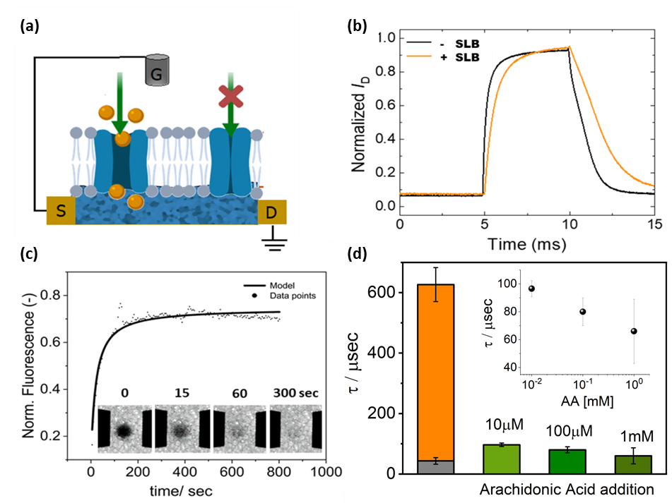
Figure 3. OECT -based monitoring of ion channel activity of HEK-TREK-1 membranes: (a) Schematic of an OECT device bearing the HEK-TREK-1 membrane. (b)Temporal response of the drain current. A 0.5 V pulse was applied at the gate, while the drain voltage was -0.5 V. (c) FRAP measurements performed simultaneously with the electrical measurements from the same OECT channel (50 µm x 50 µm) shown in b. (d) Device response time (speed) after application of a square gate bias before and after addition of the TREK-1 activator, AA. Initial device response is shown in grey and bilayer with general K⁺ blocker is shown in orange. Green bars denote addition of Arachidonic Acid at 10 µm, 100 µm and 1mM as indicated. Inset shows the calibration curve of the device response to different AA concentrations.

CONCLUSIONS
We have demonstrated a platform that is capable of multi-modal (optical and electronic) screening of ligand-gated ion channel activity in human derived membranes. As proof of principle we characterised the TREK-1 ion channel in its native lipid environment, formed via vesicle fusion of blebs obtained from the HEK cell line overexpressing TREK-1. The resulting reconstituted native membranes were shown to form on top of a polymeric electroactive transducer PEDOT:PSS designed to closely resemble the cellular microenvironment, acting as a cushion to preserve membrane fluidity and mobility as well as TMP activity and orientation, which we confirmed optically. We then went on to show electrical monitoring of ligand mediated TREK-1 interactions with two compounds, spadin and arachidonic acid, known to suppress and activate TREK- shown here normalised to the baseline SLB resistance 1 channels, respectively. Finally, we demonstrated the ability to combine optical and electronic measurements of TREK-1 functionality using transistor-based devices with the additional bonus of significantly reducing measurement times.
The results shown here are highly promising for future development of high-throughput monitoring of transmembrane proteins. Transmembrane proteins are an incredibly important class of biomolecules, representing a major target for modulating cell activity, both in terms of therapeutics drugs but also for pathogen interactions. Work on screening such therapeutics or identifying toxins has been severely hampered by the lack of available methods that would give high content information on functionality (ideally multi-modal) and that are suitable for high-throughput. Transistor technology provides a solution for miniaturization and massive parallelization for high‐throughput drug screening. Although electrodes can also enable parallelization, we have seen that the same sensitivity levels can be achieved with transistors smaller by an order of magnitude, thus offering inherent advantages toward miniaturization. Electrical measurements are also advantageous in terms of their response time, the fact that they are label-free and their suitability for dynamic, continuous monitoring. Our technology may be thought of as an analog to the patch clamp, but with additional features that could vastly improve the quality and type of data that can be collected. This device allows dual mode, complementary data collection; a much more robust membrane that is biologically matched to the physiological conditions; compatibility with production of many parallel devices for high-throughput experiments, data collection, and analysis; and extendable to cell lines not compatible with patch clamping. Combined, our results place our technology at the forefront for drug testing, providing a scalable, sturdy and cost-efficient alternative to using whole cells.
Future work will concentrate on demonstrating scalable multiplexed operation of our devices along with monitoring of endogenously expressed ion channels and other transmembrane proteins in cells that are not suitable for methods such as patch clamp due to their size (e.g. bacteria) or heterogeneous morphology (e.g. neurons). Combination of the transistors with advanced optical methods that enable single molecule tracking is also envisaged.

METHODS

Cell Culture. Human embryonic kidney 293 cells (HEK-293; kind gift from Marc Borsotto, Université de Nice Sophia Antipolis, France) were cultured in 75 cm² flasks with Advanced Dulbecco's modified Eagle medium (DMEM; Thermo Fisher Scientific, TFS) with the addition of 10% fetal bovine serum (Merck), 50 U/ml penicillin and 50 μg/ml streptomycin (TFS), 1% (v/v) GlutaMax (TFS) and 50 μg/ml gentamicin (TFS). HEK-293 cells transfected overexpressing TREK-1 (potassium channel subfamily K member 2; KCNK2) protein (HEK-TREK-1; kind gift from Marc Borsotto, Université de Nice Sophia Antipolis, France), were similarly cultured in 75 cm² flasks with the same media as HEK supplemented with 500 μg/ml G 418 disulfate salt solution (Merck). Cell were cultured until 80-90% confluent before passaging and cells were cultured until P60 and P30 for HEK-293 and HEK-TREK-1, respectively. The pYFP-GPI-N1 plasmid used for the Proteinase K experiment has been reported in previous literature.⁹ The plasmid was used for transfection of HEK 293 cells for production of a glycophosphatidylinositol (GPI) anchored yellow fluorescent (YFP) protein. The pYFP-GPI-N1 plasmid were gifts to the Daniel group from the Baird/Holowka group at Cornell University.
Preparation of Plasma Cell Membrane Vesicles (Blebs). This procedure has been reported previously.^{9,26} In brief, 9 × 10⁵ HEK and HEK-TREK-1 cells were seeded culture dishes (10 cm) (Corning) and grown for 24-48 hours in a 37 °C, 5% CO₂ incubator. Cells were washed with GPMV buffer (2 mM CaCl₂, 10 mM HEPES, 150 mM NaCl at pH 7.4) and then incubated with 4 ml of GPMV buffer supplemented with 25 mM formaldehyde (FA) and 2 mM dithiothreitol (DTT) (0.075%FA) to induce formation of blebs, for 1 hour at 37 °C. The solution containing the blebs was placed on ice for 15 min to separate cell debris from blebs, which were subsequently collected from the supernatant.
Preparation of Liposomes. 25 mg/mL 1,2-dioleoyl-sn-glycero-3-phosphocholine (DOPC) and 25 mg/mL 1,2-dioleoyl-3-trimethylammonium-propane (DOTAP) (Avanti Polar Lipids) in chloroform were combined at a ratio of 4:1 and dried under nitrogen. Lipid films were stored under vacuum to evaporate remaining chloroform. The dried lipid film was resuspended in PBS to concentration of 2 mg/ml. The solution was then extruded 15 times through a 50 nm membrane (GE Healthcare).
Formation of Supported Membranes and Bilayers. Planar cell membrane bilayers were assembled by adding 100 µl of bleb solution at approximately 5 × 10⁸ blebs/ml into a well and incubating for 45 mins and then rinsed with PBS. 100 µl of liposomes at 2 mg/ml was added into the well and incubated for a further 45 mins followed by a final PBS rinse. 100 µl polyethylene glycol 8000 (PEG8k, 30% w/v) in PBS buffer was then added into the well and incubated for 15 mins. The well was again rinsed with PBS buffer to remove any remaining PEG8k after bilayer formation.
Protein Extraction from Cells and Immunoblot Preparation. Cultured cells were washed twice with cold PBS to extract cellular proteins and solubilised in 1 ml radio immunoprecipitation assay lysis and extraction buffer (25mM Tris-HCl pH 7.6, 150mM NaCl, 1% NP-40, 1% sodium deoxycholate, 0.1% SDS; TFS) supplemented with 10 μl Halt Protease Inhibitor Cocktail and 10 μl EDTA (TFS). Lysed samples were incubated on ice for 5 min, collected into a microcentrifuge tube and centrifuged at 4 $°$C; 14,000 x g for 15 min to pellet cell debris. The supernatant was stored at -80 °C pending further analysis. Blebs were centrifuged at 4 $°$C; 31,000 x g for 2 h to concentrate the sample prior to analysis.
Immunoblot Analysis. Samples were added directly onto PVDF (polyvinylidene fluoride) Transfer Membranes (TFS) wetted in NuPAGE Transfer Buffer (Invitrogen). Membranes were blocked with 3% (w/v) nonfat-dried milk powder in PBS (TFS, Oxoid) with 0.1% (v/v) Tween-20 (PBST) (TFS) for 1 h. Membranes were subsequently probed with rabbit anti-Trek1 (KCNK2) (RayBiotech; 1:10,000) monoclonal primary antibody for 1 h in PBST followed by incubation with HRP-conjugated anti-rabbit IgG H&L (Invitrogen; 1:100,000) secondary antibody in PBST for 1 h. All incubations were carried out on a rotating wheel drum at RT. Blots were washed 5 times in PBST for 5 min after each incubation step and were visualised using Pierce enhanced chemiluminescence Western Blotting Substrate (TFS) on a G:BOX Chemi XX6 (Syngene).
FRAP Experiment for Characterization of Membrane Fluidity. An inverted Axio Observer Z1, Carl Zeiss MicroImaging GmbH with a 10x objective was used for FRAP. 200 μl of bleb solution was labeled with 1 μl 0.36 mM Octadecyl Rhodamine B chloride (R18, Molecular Probes) fluorophore, in a sonicating bath for 15 mins. A G25 spin column (GE Healthcare) was used to remove excess fluorophore. Labeled blebs were assembled into bleb as described above. Photobleaching was carried out with a 150 mW 561 nm optically pumped semiconductor laser (Coherent, Inc.) creating a 20 μm diameter spot with a 500 ms exposure time. Recovery was monitored for 15 mins and the fluorescence intensity change over time was fit with a Bessel function according to Soumpasis et al. The equation, D = w²/4t_{1/2} where w is the radius of the photobleached spot and t_{1/2} is the time required to achieve half of the maximum recovery intensity, was used for calculation of the diffusion coefficient.
Immunofluorescence. HEK-TREK-1 cells were fixed in 4% paraformaldehyde and then permeabilised with 0.1% of Triton X-100 and stained for F-actin with ifluor594 (Abcam), and counterstained with DAPI for nuclei. GFP fluorescence was also measured. An inverted Zeiss Axio Observer.Z1 microscope with an α Plan-Apochromat 100× objective and solid-state lasers with 488 nm wavelength (green), 403 nm wavelength (DAPI) and 594 nm wavelength (red) was used to image the samples.
Proteinase assay for determination of protein orientation. Fluorescently labeled membrane proteins contained in blebs were used to determine protein orientation, as reported previously. ⁹ Briefly, total internal reflection fluorescence microscopy (TIRF) was used to record an initial image after bilayer formation. Then, 100 μg/mL Proteinase K (Ambion) was used to cleave the YFP portion of GPI-YFP resulting in a loss of fluorescent signal as the YFP label leaves the evanescent field. Signal reduction was measured by particle counting.⁹
Preparation of PEDOT:PSS films on glass substrates. Glass slides (25 × 25 mm No.1.5, VWR) were cleaned with piranha solution (70% (v/v) H₂SO₄ (BDH) and 30% (v/v) H₂O₂ (Sigma 50 wt %)) for 10 min and then rinsed with DI water for a further 20 mins. Glass slides were treated with oxygen plasma (Harrick Plasma, Ithaca, NY) at 18 W for 2 mins. The PEDOT:PSS solution contained 95% v/v CleviosTM PH 1000 (Heraeus), 5% v/v ethylene glycol (Sigma-Aldrich), 0.002% v/v 4-Dodecylbenzenesulfonic acid (Sigma-Aldrich), and 1% v/v (3-Glycidyloxypropyl) trimethyoxysilane (Sigma-Aldrich). PEDOT:PSS was spin coated onto plasma treated glass slides (dried under nitrogen and treated with oxygen plasma for 2 mins just prior to use) at 2500 rpm for 35 sec, baked at 140°C for 1 hour, followed by immersing in DI water for 4 hours. A PDMS well was attached to hold buffer solutions.
Fabrication of PEDOT:PSS-coated gold electrodes. The fabrication protocol relies on a 4 stacks layer step. First, a layer of 3μm thick parylene C is added via chemical vapor deposition on top of the wafer. Then, 150nm thick Cr/Au electrodes are patterned using photolithography with AZnLof 2070 as the lift off resist. Another layer of Parylene C 2μm thickness is adding with silane A74 to improve adhesion. The openings are made though with reactive ions etching (CF₄ & O₂) over Az 15nXt patterned as protecting layer. PEDOT:PSS solution, Clevios PH1000 containing 5 vol% ethylene glycol and 1 vol% (3-glycidyloxypropyl)trimethyoxysilane, is spin-coated at 1500 rpm for 90 seconds, baked on a hotplate at 130 ºC for 1 hour and dry etched using orthogonal resist 5011 as protective mask. Finally, a dielectric resist, DE1 from Orthogonal Inc, is spin coated and patterned on top as the encapsulation layer via photolithography.
Fabrication of OECTs. Silicon wafers with a 1 μm thermal oxide were cleaned in hot Piranha solution for 20 min at 120 °C. Metal interconnects (50 nm Au layer with a 5 nm Ti adhesion layer deposited via e-beam evaporation) were defined using a photoresist/lift-off resist bilayer. 100 nm of SiO₂ insulation layer was then added by chemical vapour deposition and selectively etched via photolithography and inductively-coupled CHF₃ plasma reactive ion etching. To this was added a PEDOT:PSS (Clevios PH1000) solution containing 5 vol% ethylene glycol and 1 vol% (3-glycidyloxypropyl) trimethyoxysilane, by spin-coating at 2000 rpm for 120 s, then baking on a hotplate at 120 °C for 20 mins. This was then coated with a 120 nm Ge sacrificial layer added by e-beam evaporation. The Ge layer was patterned using photolithography and inductively-coupled CF₄ plasma reactive ion etching. Inductively-coupled O₂ plasma reactive ion etching was used to transfer the pattern with Ge as a hard mask. Ge was then dissolved by oxidation in an air-bubbled water bath over approximately 48 hours.
Electrochemical Impedance Measurements. A potentiostat (Autolab PGSTAT128N) equipped with a frequency response analysis module was used to measure impedance spectra. Ag/AgCl electrodes and a platinum mesh were used as reference and counter electrodes, respectively. The PEDOT:PSS working electrodes had areas ranging between 0.0102 cm² (rectangular) and 0.0078 cm² (circular). The applied AC voltage was 0.01 V and a DC voltage of 0 mV versus OCP (open circuit potential). Unless otherwise stated, the electrolyte solution used was PBS.
Transistor and simultaneous optical measurements. OECTs were characterized under a confocal microscope using a dual-channel source-meter unit (NI-PXI) with custom-written control code in LabVIEW. All measurements were performed using a Ag/AgCl pellet (D = 2 mm × H = 2 mm – Warner instruments) as the gate electrode. The channels studied were 50 μm in length and 50 μm in width. The devices were placed under the confocal microscope on top of a 1.2 mm thick supporting glass slide. FRAP measurements were performed with 10 x magnification objective and at the same time a drain voltage -0.5 V was continuously applied. The OECT response time was calculated by applying square shaped pulses at the gate electrode, 0.5 V in magnitude and 5 ms in width.
TREK-1 ion channel assays. TREK-1 functionality was measured as described,¹⁹ in the presence of a cocktail of potassium channel inhibitors (K+ blockers: 3 mM 4-aminopyridine (4-AP), 10 mM tetraethylamonium (TEA), 10 mM glibenclamide, 100 nM apamin and 50 nM charybdotoxin, all dissolved in PBS ). AA and spadin were also dissolved PBS.

ASSOCIATED CONTENT
Supporting Information
The Supporting Information is available free of charge on the ACS Publications website.
- Schematic of bilayer formation, characterization of fluidity of bilayer, characterization of protein orientation, electrode fabrication, ethanol disruption of bilayer, EIS Comparison of SLBs with different lipid compositions, Nyquist plot of addition of spadin to bilayer, scheme for addition of AA to bilayer, OECT fabrication, simultaneous optical and electronic measurements in OECTs.
AUTHOR INFORMATION
Corresponding Authors
*Rόisín M. Owens, Email: rmo37@cam.ac.uk, and Susan Daniel, Email: sd386@cornell.edu
Author Contributions
The manuscript was written through contributions of all authors. All authors have given approval to the final version of the manuscript. Anna-Maria Pappa and Han-Yuan Liu contributed equally to this manuscript.

ACKNOWLEDGMENTS
S.D., R.O., and A.S acknowledge funding for this project, sponsored by the Defense Advanced Research Projects Agency (DARPA) Army Research Office and accomplished under Cooperative Agreement Number W911NF-18-2-0152. The views and conclusions contained in this document are those of the authors and should not be interpreted as representing the official policies, either expressed or implied, of DARPA or the Army Research Office or the U.S. Government. The U.S. Government is authorized to reproduce and distribute reprints for Government purposes notwithstanding any copyright notation herein. A.M.P. acknowledges funding from the Oppenheimer Junior Research Fellowship and the Maudslay-Butler Research Fellowship at Pembroke College, Cambridge. H.Y.L. Acknowledges funding from the Fleming Fellowship at the RF Smith School of Chemical and Biomolecular Engineering at Cornell University. Part of this work was performed at the Stanford Nanofabrication Facilities (SNF) and Stanford Nano Shared Facilities (SNSF), supported by the National Science Foundation as part of the National Nanotechnology Coordinated Infrastructure under award ECCS-1542152. We also wish to acknowledge the kind gift of the HEK-TREK-1 cells from Marc Borsotto Université de Nice Sophia Antipolis, France. Finally, we wish to acknowledge Chrysanthi-Maria Moysidou for the immunofluorescent imaging.

REFERENCES

1. Overington, J. P.; Al-Lazikani, B.; Hopkins, A. L., How Many Drug Targets Are There? Nat. Rev. Drug Discovery 2006, 5, 993-996.
2. Tanaka, M.; Sackmann, E., Polymer-Supported Membranes as Models of the Cell Surface. Nature 2005, 437, 656-663.
3. Yin, H.; Flynn, A. D., Drugging Membrane Protein Interactions. Annu. Rev. Biomed. Eng. 2016, 18, 51-76.
4. Tamm, L. K.; McConnell, H. M., Supported Phospholipid Bilayers. Biophys J 1985, 47, 105-113.
5. Daniel, S.; Albertorio, F.; Cremer, P. S., Making Lipid Membranes Rough, Tough, and Ready to Hit the Road. MRS Bull. 2006, 31, 536-540.
6. Terrettaz, S.; Mayer, M.; Vogel, H., Highly Electrically Insulating Tethered Lipid Bilayers for Probing the Function of Ion Channel Proteins. Langmuir 2003, 19, 5567-5569.
7. Keizer, H. M.; Dorvel, B. R.; Andersson, M.; Fine, D.; Price, R. B.; Long, J. R.; Dodabalapur, A.; Köper, I.; Knoll, W.; Anderson, P. A. V.; Duran, R. S., Functional Ion Channels in Tethered Bilayer Membranes—Implications for Biosensors. ChemBioChem 2007, 8, 1246-1250.
8. Liu, H.-Y.; Grant, H.; Hsu, H.-L.; Sorkin, R.; Bošković, F.; Wuite, G.; Daniel, S., Supported Planar Mammalian Membranes as Models of In Vivo Cell Surface Architectures. ACS Appl. Mater. Interfaces 2017, 9, 35526-35538.
9. Richards, M. J.; Hsia, C.-Y.; Singh, R. R.; Haider, H.; Kumpf, J.; Kawate, T.; Daniel, S., Membrane Protein Mobility and Orientation Preserved in Supported Bilayers Created Directly from Cell Plasma Membrane Blebs. Langmuir 2016, 32, 2963-2974.
10. Hsia, C.-Y.; Chen, L.; Singh, R. R.; DeLisa, M. P.; Daniel, S., A Molecularly Complete Planar Bacterial Outer Membrane Platform. Sci. Rep. 2016, 6, 32715-32715.
11. Andersson, J.; Köper, I., Tethered and Polymer Supported Bilayer Lipid Membranes: Structure and Function. Membranes (Basel) 2016, 6, 30.
12. Liu, H.-Y.; Chen, W.-L.; Ober, C. K.; Daniel, S., Biologically Complex Planar Cell Plasma Membranes Supported on Polyelectrolyte Cushions Enhance Transmembrane Protein Mobility and Retain Native Orientation. Langmuir 2018, 34, 1061-1072.
13. Zhang, Y.; Inal, S.; Hsia, C.-Y.; Ferro, M.; Ferro, M.; Daniel, S.; Owens, R. M., Supported Lipid Bilayer Assembly on PEDOT:PSS Films and Transistors. Adv. Funct. Mater. 2016, 26, 7304-7313.
14. Ohayon, D.; Pitsalidis, C.; Pappa, A.-M.; Hama, A.; Zhang, Y.; Gallais, L.; Owens, R. M., Laser Patterning of Self-Assembled Monolayers on PEDOT:PSS Films for Controlled Cell Adhesion. Adv. Mater. Interfaces 2017, 4, 1700191.
15. Dijk, G.; Rutz, A. L.; Malliaras, G. G., Stability of PEDOT:PSS-Coated Gold Electrodes in Cell Culture Conditions. Adv. Mater. Technol. 2020, 5, 1900662.
16. Liu, H.-Y.; Pappa, A.-M.; Pavia, A.; Pitsalidis, C.; Thiburce, Q.; Salleo, A.; Owens, R. M.; Daniel, S., Self-Assembly of Mammalian Cell Membranes on Bioelectronic Devices with Functional Transmembrane Proteins. Langmuir 2020 doi.org/10.1021/acs.langmuir.0c00804.
17. Djillani, A.; Mazella, J.; Heurteaux, C.; Borsotto, M., Role of TREK-1 in Health and Disease, Focus on the Central Nervous System. Front Pharmacol 2019, 10, 379-379.
18. Moreno, S.; Devader, C. M.; Pietri, M.; Borsotto, M.; Heurteaux, C.; Mazella, J., Altered Trek-1 Function in Sortilin Deficient Mice Results in Decreased Depressive-Like Behavior. Front Pharmacol 2018, 9, 863.
19. Moha ou Maati, H.; Peyronnet, R.; Devader, C.; Veyssiere, J.; Labbal, F.; Gandin, C.; Mazella, J.; Heurteaux, C.; Borsotto, M., A Human TREK-1/HEK Cell Line: A Highly Efficient Screening Tool for Drug Development in Neurological Diseases. PLOS ONE 2011, 6, e25602.
20. Neher, E.; Sakmann, B., Single-Channel Currents Recorded from Membrane of Denervated Frog Muscle Fibres. Nature 1976, 260, 799-802.
21. Obergrussberger, A.; Stölzle-Feix, S.; Becker, N.; Brüggemann, A.; Fertig, N.; Möller, C., Novel Screening Techniques for Ion Channel Targeting Drugs. Channels 2015, 9, 367-375.
22. Berggren, M.; Malliaras, G. G., How Conducting Polymer Electrodes Operate. Science 2019, 364, 233.
23. Pitsalidis, C.; Pappa, A.-M.; Porel, M.; Artim, C. M.; Faria, G. C.; Duong, D. D.; Alabi, C. A.; Daniel, S.; Salleo, A.; Owens, R. M., Biomimetic Electronic Devices for Measuring Bacterial Membrane Disruption. Adv. Mater. 2018, 30, 1803130.
24. Schewe, M.; Nematian-Ardestani, E.; Sun, H.; Musinszki, M.; Cordeiro, S.; Bucci, G.; de Groot, B. L.; Tucker, S. J.; Rapedius, M.; Baukrowitz, T., A Non-Canonical Voltage-Sensing Mechanism Controls Gating in K2P K+ Channels. Cell 2016, 164, 937-949.
25. Soussia, I. B.; Choveau, F. S.; Blin, S.; Kim, E.-J.; Feliciangeli, S.; Chatelain, F. C.; Kang, D.; Bichet, D.; Lesage, F., Antagonistic Effect of a Cytoplasmic Domain on the Basal Activity of Polymodal Potassium Channels. Front Mol Neurosci 2018, 11, 301-301.
26. Cavassin, P.; Pappa, A.-M.; Pitsalidis, C.; F. P. Barbosa, H.; Colucci, R.; Saez, J.; Tuchman, Y.; Salleo, A.; Faria, G. C.; Owens, R. M., Organic Transistors Incorporating Lipid Monolayers for Drug Interaction Studies. Adv. Mater. Technol. 2020, 5, 1900680.
27. Rivnay, J.; Inal, S.; Salleo, A.; Owens, R. M.; Berggren, M.; Malliaras, G. G., Organic Electrochemical Transistors. Nat. Rev. Mater. 2018, 3, 17086.
28. Anishkin, A.; Loukin, S. H.; Teng, J.; Kung, C., Feeling the Hidden Mechanical Forces in Lipid Bilayer Is an Original Sense. Proc. Natl. Acad. Sci. 2014, 111, 7898.
29. Cabanos, C.; Wang, M.; Han, X.; Hansen, S. B., A Soluble Fluorescent Binding Assay Reveals PIP2 Antagonism of TREK-1 Channels. Cell Rep. 2017, 20, 1287-1294.

Table of Contents (TOC)

