Supplementary Material
High-Pressure Phase Transitions of Nitinol, NiTi, to a Semiconductor with Unusual Topological Structure

Guangtao Liu¹, Hanyu Liu² , Xiaolei Feng³ and Simon A. T. Redfern^{3,4 *}

¹ National Key Laboratory of Shock Wave and Detonation Physics, Institute of Fluid Physics, China Academy of Engineering Physics, Mianyang 621900, China
² Geophysical Laboratory, Carnegie Institution of Washington, Washington, DC 20015, USA
³ Department of Earth Sciences, University of Cambridge, Downing Street, Cambridge, CB2 3EQ, UK
⁴ Center for High Pressure Science and Technology Advanced Research, Shanghai 201203, China

Corresponding author: satr@cam.ac.uk (Simon A. T. Redfern)

Contents

1. Parameter Convergence Test
2. Elastic Constants C_{ij} (GPa)
3. Equation of states of all phases in NiTi.
4. Band structures of NiTi.
1. Parameter Convergence Test
The selected Pbcm and B32 (Fd-3m) structure are shown as examples here.
a) When Monkhorst-Pack grid is 2π×0.05 Å⁻¹ in reciprocal space,
Energy cutoff (eV) | Pbcm, Energy (eV/atom) | B32, Energy (eV/atom)
200 | -6.7282 | -6.4148
300 | -6.9699 | -6.6487
400 | -6.9654 | -6.6440
450 | -6.9648 | -6.6434
500 | -6.9649 | -6.6435
600 | -6.9647 | -6.6433
700 | -6.9646 | -6.6432
800 | -6.9646 | -6.6432
we set energy cutoff with 450 eV in structural optimization, enthalpy and electronic structure calculations.
b) When energy cutoff is 450 eV,
Monkhorst-Pack grid | Pbcm, Energy (eV/atom) | B32, Energy (eV/atom)
1.0 | -7.0872 | -6.6342
0.8 | -6.9887 | -6.6018
0.6 | -6.9898 | -6.6552
0.5 | -6.9835 | -6.6552
0.4 | -6.9623 | -6.6438
0.3 | -6.9648 | -6.6434
0.2 | -6.9658 | -6.6430
0.15 | -6.9649 | -6.6419
0.1 |  | -6.6425
we set Monkhorst-Pack grid with 2π×0.05 (~ 0.3) Å⁻¹ in structural optimization, enthalpy and electronic structure calculations.
2. Elastic Constants C_{ij} (GPa)
Pbcm phase at 20 GPa
301.99414 151.45338 186.80861 0.00000 0.00000 0.00000
151.45338 376.57869 192.37652 0.00000 0.00000 0.00000
186.80861 192.37652 357.17950 0.00000 0.00000 0.00000
0.00000 0.00000 0.00000 80.18312 0.00000 0.00000
0.00000 0.00000 0.00000 0.00000 81.51821 0.00000
0.00000 0.00000 0.00000 0.00000 0.00000 22.79107
It satisfies the criteria for mechanical stability (orthorhombic phase):
C_{ii} > 0, C₁₁ + C₂₂ + C₃₃ + 2(C₁₂ + C₁₃ + C₂₃) > 0,
C₁₁ + C₂₂ - 2C₁₂ > 0, C₁₁ + C₃₃ - 2C₁₃ >0, C₂₂ + C₃₃ - 2C₂₃ >0.

B32 (Fd-3m) phase at 40 GPa
392.36040 255.38702 255.38702 0.00000 0.00000 0.00000
255.38702 392.36040 255.38702 0.00000 0.00000 0.00000
255.38702 255.38702 392.36040 0.00000 0.00000 0.00000
0.00000 0.00000 0.00000 171.01783 0.00000 0.00000
0.00000 0.00000 0.00000 0.00000 171.01783 0.00000
0.00000 0.00000 0.00000 0.00000 0.00000 171.01783
It satisfies the criteria for mechanical stability (cubic phase):
C₁₁ >0, C₄₄ >0, C₁₁ > |C₁₂|, C₁₁ + 2C₁₂ > 0.

3. Equation of states of all phases in NiTi
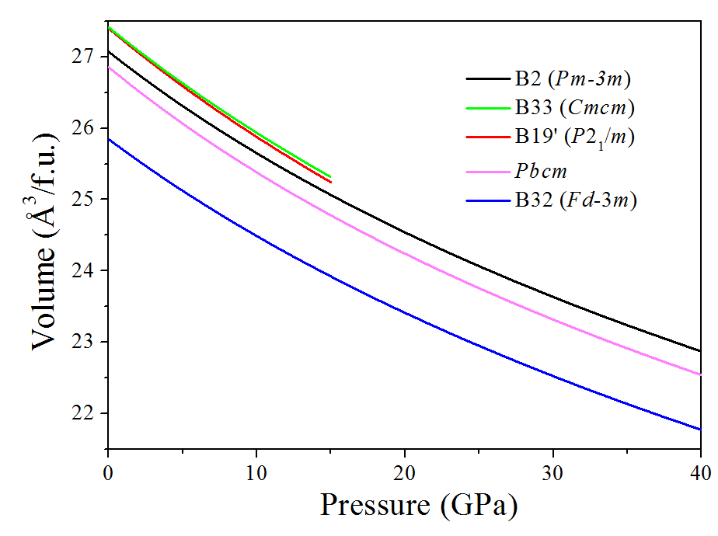
4. Band structures of NiTi
Band structures along high symmetry path.
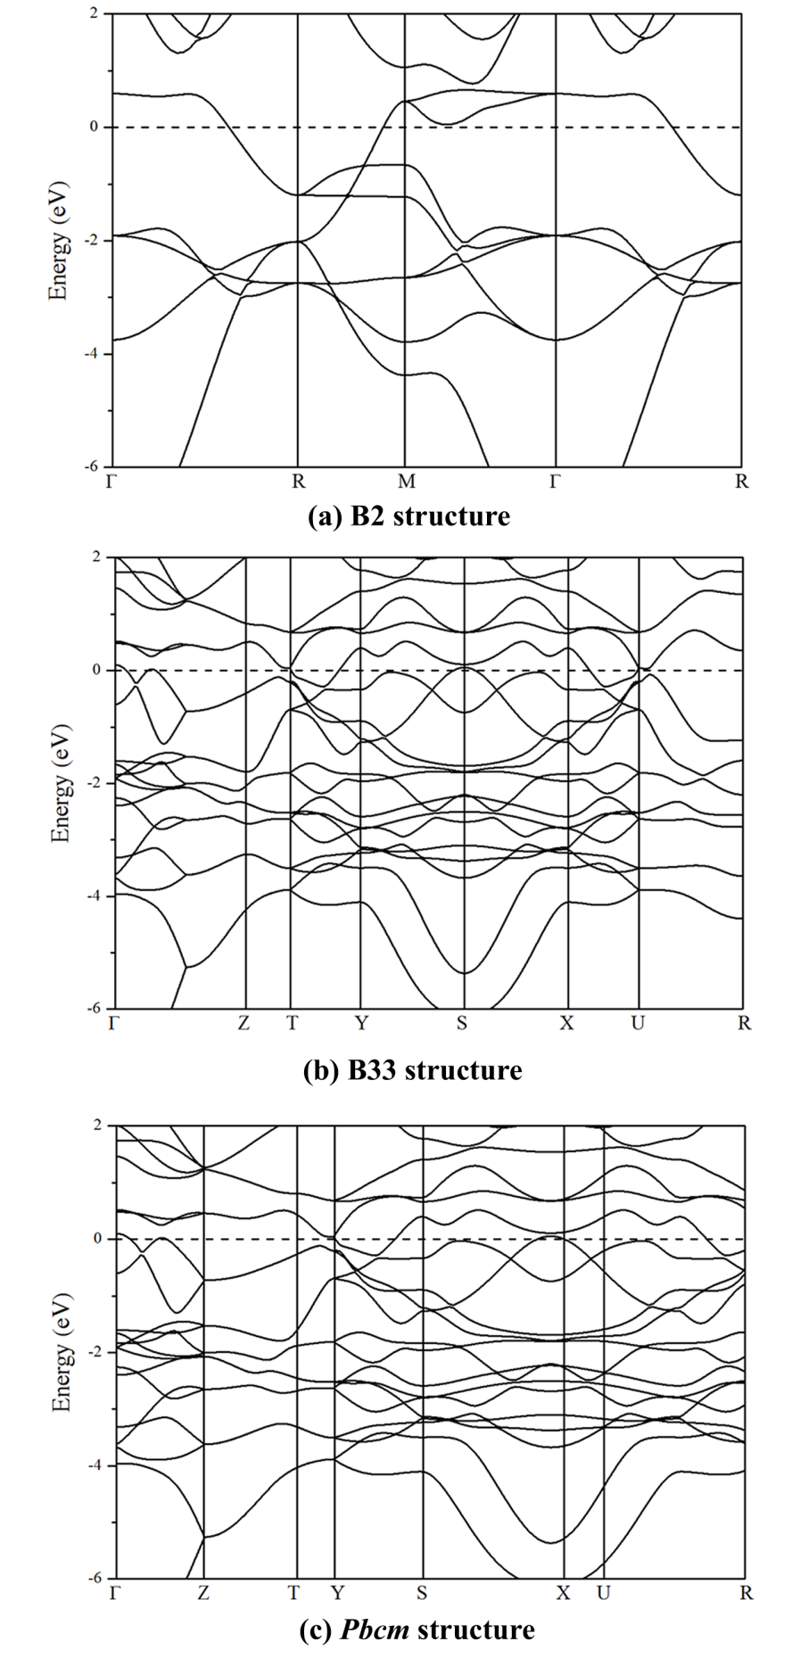
(a) B2 structure at 0 GPa, (b) B33 structure at 0 GPa and (c) Pbcm structure at 30 GPa.

