Block Copolymer Micelles for Photonic Fluids and Crystals
Mikko Poutanen¹, Giulia Guidetti², Tina I. Gröschel^{1,6}, Oleg Borisov^{3,4,5}, Silvia Vignolini²,
Olli Ikkala^{1,*} & Andre H. Gröschel^{1,6,*}
¹ Department of Applied Physics, Aalto University School of Science, FI-00076 Aalto, Finland
² Department of Chemistry, University of Cambridge, Lensfield Rd., Cambridge CB21EW, UK
³ Institut Pluridisciplinaire de Recherche sur l’Environnementet les Matériaux UMR 5254 CNRS/UPPA, F-64053 Pau, France
⁴ Institute of Macromolecular Compounds, Russian Academy of Sciences, 199004, St. Petersburg, Russia

⁵ St. Petersburg State Polytechnic University, 195251, St. Petersburg, Russia
⁶ Physical Chemistry and Centre for Nanointegration Duisburg-Essen (CENIDE), University of Duisburg-Essen, D-45127 Essen, Germany
ABSTRACT: Block copolymer micelles (BCMs) are self-assembled nanoparticles in solution with a collapsed core and a brush-like stabilizing corona typically in size range of tens of nanometers. Despite being widely studied in various fields of science and technology, their ability to form structural colors at visible wavelength has not been demonstrated, mainly due to the stringent length requirements of photonic lattices. Here, we describe the precision assembly of block copolymers to micelles with super-stretched corona, yet with narrow size distribution to qualify as building blocks for tunable and reversible micellar photonic fluids (MPFs) and micellar photonic crystals (MPCs). The BCMs form free-flowing MPFs with an average interparticle distance of 150-300 nm as defined by the electrosteric repulsion arising from the highly charged and stretched corona. Under quiescent conditions, millimeter-sized free-floating MPCs with classical FCC lattice grow in the photonic fluid-medium upon refinement of the positional order of the BCMs. We discuss the generic properties of MPCs with special emphasis on surprisingly narrow reflected wavelengths with full width at half-maximum as small as 1 nm. We expect this concept to open a generic and facile way for self-assembled tunable micellar photonic structures.
KEYWORDS: block copolymers, micellar crystals, photonic crystals, self-assembly, structural color.

Introduction
Photonic crystals are materials that exhibit vibrant structural colors originating from coherent photon scattering from structural periodicities, i.e. modulation of the refractive index, on optical length scale of half of the wavelength of light.^{1–4} They are found in many natural systems,^{5,6} stimulating various approaches for the formation of synthetic photonic crystals. Such colors do not bleach (unlike dyes) and can respond to stimuli,¹ allowing e.g. sensing.^{7,8} Within the wide variety of photonic structures, particularly studied are photonic crystals based on close-packed hard microspheres, e.g. SiO₂-particles, involving hard-core repulsion with a diameter ranging in the order of d = 150 - 300 nm to reflect visible light.⁹ To create functional and tunable photonic crystals, softer repulsive potentials are needed to allow adjustable periodicities often provided by polymeric materials.¹⁰ In that context, photonic crystals have been made of cross-linked microgels of poly(N-isopropyl acrylamide),^{11–13} hard micro- and nanoparticles with hairy corona brushes,^{14–16} and, fascinatingly, small molecule surfactants.¹⁷
Block copolymers incorporate two or more incompatible polymer segments leading to self-assembly of a rich variety of functional nanostructures, which have been widely used in different applications.^{18–21} With respect to photonic applications, block copolymers have so far displayed structural colors only in lamellar bulk morphologies, where the required periodicity can be reached by incorporating ultra-high molecular weights^{22,23} or by promoting polymer chain stretching, e.g., using covalent or supramolecular comb architectures or solvent swelling.^{24–29} Alternatively the dielectric contrast has been increased in medium molecular weight block copolymers by selective sol-gel mineralization of inorganic materials (e.g. silica) within one of the lamellar domains.³⁰ Yet, the ability of solvent-based self-assembled block copolymer micelles to form micellar photonic crystals (MPCs) has not been reported so far.
In selective solvents, block copolymers self-assemble into various solution nanostructures,^{31–33} patchy particles,^{34,35} multicompartment micelles,³⁶ lyotropic mesophases,^{37,38} and 2D/3D hierarchical superstructures.^{39,40} With narrow size dispersity, spherical BCMs even qualify as building blocks for long-range ordered 3D superlattices with BCC and FCC crystal structures, and even (short-range ordered) quasi-crystalline lattices.⁴¹ These micellar crystals usually exhibit lattice parameters of few dozen nanometers at typically high concentrations (> 400 g/L).⁴² As BCMs typically exhibit hydrodynamic diameter of D_{h} < 100 nm it is not surprising that they have not been associated with photonic crystals.
In order to show photonic properties, previously it has been expected that a suitable BCM would require a massive stabilizing corona and/or a large micelle core to reach the lattice spacing of d = 150-300 nm. Both requirements either imply ultrahigh molecular weights or specific topology, posing challenges in synthesis and, more importantly, in controlling self-assembly, i.e. high molecular weights are associated with slow self-assembly kinetics and increased size-dispersity of the resulting BCMs. Alternatively, to achieve micellar photonic fluids and crystals from BCMs, we propose to first self-assemble moderate molecular weight block copolymers into BCMs with very narrow size-dispersity by sequential dialysis, followed by extensive corona expansion by introducing charges into the corona (as outlined in Scheme 1). The electrosteric repulsion of the superstretched corona could then stabilize the location of the BCMs within micellar self-assemblies and crystals with increased unit cell sizes qualifying as photonic fluids or photonic crystals. Since block copolymers are widely tunable in terms of the physical properties (extensive libraries already exist), such a structuring concept toward photonic materials would be very desirable and could open an easy way to produce a large variety of new functional materials.
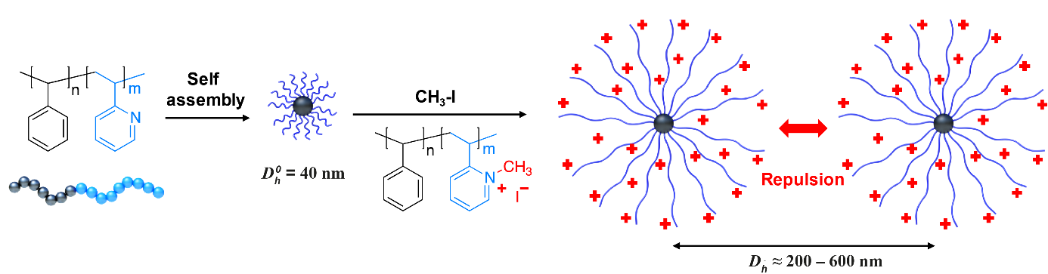
Scheme 1. Proposed approach to create near-monodisperse block copolymer micelles with hydrodynamic diameter (D_{h}) satisfying the length scales for photonic lattices.
Here, we describe such a process to form BCMs for the spontaneous self-assembly into hydrated and dynamic MPCs displaying structural colors. We will first describe the preparation of near mono-disperse BCMs with super-stretched corona and their properties in MPFs with homogeneous average interparticle distances of about 150 nm. The micellar cores in MPFs incorporate a low fraction of 10⁻⁵ - 10⁻⁶ of the total volume; still the BCMs are, surprisingly, able to provide structural colors. Importantly, at proper conditions, the MPFs further crystallize into co-existent MPCs with crystallite dimensions ranging from 100 µm to millimeters. They are visible to the bare eye and the Bragg-scattering brightly reflects colors from the near IR to the near UV range across the visible spectrum. The intensity and position of the reflected wavelength can be tuned by core-size, concentration of BCMs, and salt concentration.

Results and discussion
Formation of BCMs and MPCs. The preparation of micellar photonic fluids (MPFs) and micellar photonic crystals (MPCs) from block copolymer micelles (BCMs) requires three key steps: 1) formation of near-monodisperse BCMs, 2) corona expansion through ionization, and 3) adjusting the concentration to tune inter-micellar distance. These steps are summarized in Figure 1 and Figure 2 with schematics and photographs. Block copolymer specifics are given in Table 1 (and Table S1), and preparative details in the Experimental Section and Supplementary Information.
Table 1: Specifics of the PS-b-P2VP block copolymers mainly used in this work (see SI for extended list incorporating still additional block copolymers used for additional measurements). ”S” and “V” stand for PS and P2VP.
code | N_{S}ª | N_{V}ª | M_{n}^{b} (kg/mol) | f_{S}^{c} | f_{V}^{c} | R_{core}^{d} (nm) | R_{h}^{e} (nm)
SV1 | 168 | 528 | 73 | 0.24 | 0.76 | 9.46 | 81
SV2 | 217 | 719 | 98 | 0.23 | 0.77 | 9.93 | 110
SV3 | 1057 | 793 | 180 | 0.61 | 0.39 | 17.5 | 87.8
ª Degree of polymerization of the respective block. ^{b} Molecular weight determined with a SEC using a THF as the eluent and PS standards for calibration. ^{c} Calculated block weight fractions. ^{d} Average core radius of BCMs determined from 500 particles in cryo-TEM. ^{e} Hydrodynamic radius of BCMs determined with DLS.
First, the block copolymer, e.g. polystyrene-block-poly(2-vinylpyridine) (abbrev. PS₁₆₈-b-P2VP₅₂₈ or SV1), is molecularly dissolved (c = 10 g/L) in a common solvent for both blocks, here N,N-dimethylacetamide (DMAc) (Figure 1a). The block copolymer solution is then dialyzed sequentially against first isopropanol (IPA) and then methanol (MeOH). Both solvents are selective for P2VP and induce self-assembly into BCMs with a PS core and P2VP corona (Figure 1b). The sequential dialysis from “soft” (IPA) to “hard” (MeOH) non-solvent for PS is essential to mold the micelle cores to near-monodisperse size distribution through gradual collapse of the PS chains. Next, the P2VP corona is quaternized with methyl iodide (MeI) to P(Me2VP⁺)I⁻. This induces gelation, which is an indication of drastic increase of the corona size due to charge repulsion of the P(Me2VP⁺)I⁻ chains. Solvent exchange to water further enhances corona expansion of the BCMs and at a concentration of 10 g/L the solution changes to a colloidal gel⁴³ (Figure 1c). The collective volume requirement of all swollen coronae surpasses the available space within the solvent immobilizing BCMs as a transparent micellar gel. Based on the Daoud-Cotton model, the volume fraction of a highly charged polyelectrolyte corona scales with radius as $\sim {(r/r_{core} )}^{-2}$,⁴⁴ indicating that the optical contrast of the dissolved P(Me2VP⁺)I⁻ corona with the solvent decreases rapidly (see SI). From the aqueous solution, we determine the average core radius in cryo-TEM to be R_{core} = 9.46 ± 0.87 nm (Figure 1d). The core size is defined by the chain length of the PS block (aggregation number) and self-assembly path, and is quite adjustable.
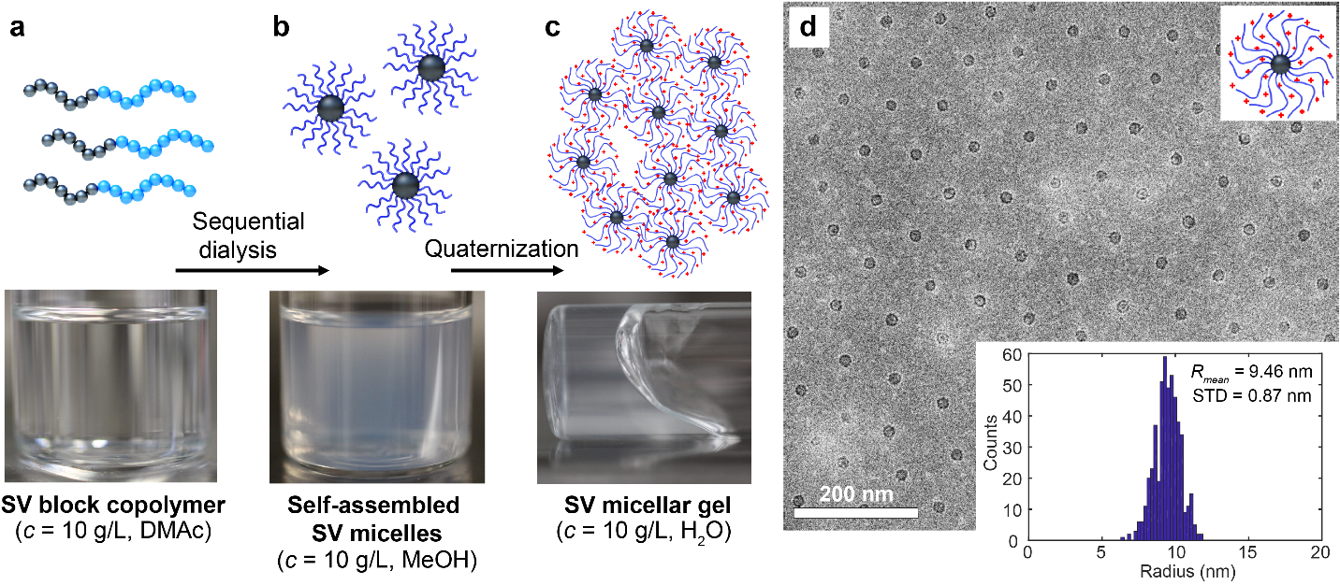
Figure 1. Molding of PS-b-P2VP (SV1) block copolymer into near-monodisperse BCMs. Schematics and photographs of a) SV1 block copolymer solution in DMAc and b) sequential solvent exchanges to isopropanol and then methanol to form self-assembled SV1 BCMs with PS cores. c) Quaternization of P2VP ionizes the corona promoting swelling and gelation (colloidal glass). d) Cryo-TEM image of SV1 BCMs and histogram of the PS core radii with narrow size-distribution (inset).
At high concentrations (c > 4.0 g/L) the aqueous micellar gel has a faint bluish color originating from Rayleigh scattering of the BCMs (Figure 2a). Dilution causes amplification of the blue color (Figure 2b), followed by bathochromic shift to green and red. The dilution increases mobility of the self-assembled highly-charged BCMs leading to fluidity, thus allowing maximization and refinement of the micellar average interparticle distance towards the photonic periodicities. Therefore, such materials are here denoted as micellar photonic fluids (MPFs). Finally, to trigger colloidal crystallization, the MPF is further diluted to c = 2.0 - 0.2 g/L, where high enough mobility allows BCMs to crystallize under quiescent conditions into MPCs with well-defined 3D periodicity, leading to distinct structural colors (Figure 2c). The MPF and MPC phases co-exist in the solutions. The observed time needed for crystallization varies with concentration from 15 min to a few days. We emphasize that both the narrow size dispersity of the BCMs, promoted by the sequential dialysis, and the strongly repulsive corona are crucial for BCMs to crystallize into MPC. For instance, direct solvent exchange from DMAc to methanol results in slightly higher size dispersity of the BCMs that do not show structural colors.
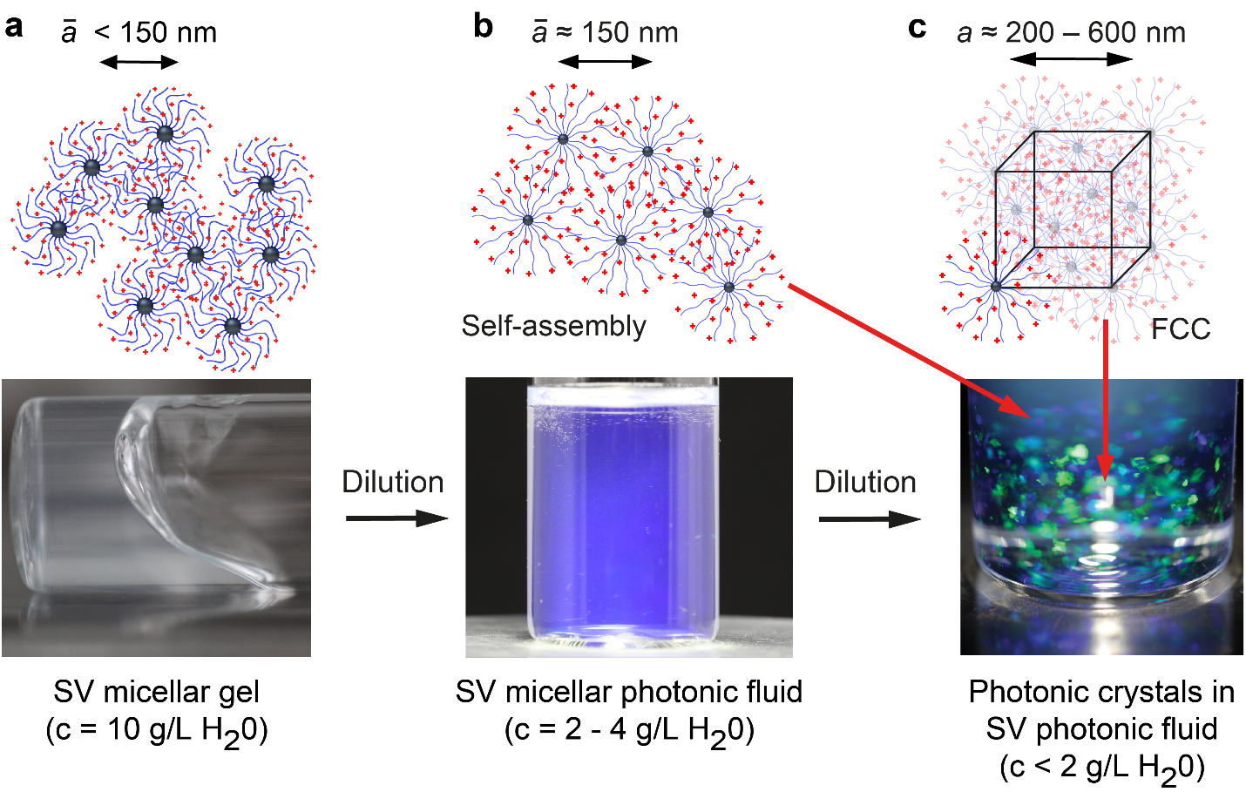
Figure 2. Preparation of MPCs from near-monodisperse (PS-b-P2VP) SV1 BCMs. Schematics and photographs of a) SV1 aq. micellar gel (colloidal glass) and b) dilution to first MPFs and further to c) MPCs under suitable quiescent conditions.
Properties of micellar photonic materials. With the above described preparation process, multiple block copolymers can form BCMs with differently sized cores and coronas, which systematically qualify for MPFs and MPCs. Upon dilution of the jammed micellar gels, the BCMs become mobile enough and crystallize into MPCs with stronger and sharper colors (Figure 3a). Eventually, the crystalline and amorphous phases separate into two layers, as also previously observed with photonic crystals of hard colloids (Figure 3b, Figure S1).⁴⁵ The phase separation is more evident with larger core radii. The fraction of the crystalline phase varies with crystallization conditions and type of BCM, but it is not investigated here. When the MPCs are viewed from a single angle, a limited number of colors is observed, and the colors blue-shift upon increasing the angle of incident light (Figure 3c), which is in accordance with Bragg diffraction of photonic structures. Depending on the sample, the individual MPCs show single colored and sharp reflections visible by eye ranging from red to purple, indicating monocrystalline domains (Figure 3d). To analyze the lattice of the MPCs, they were studied with confocal fluorescent microscopy by staining the micelle cores with small fluorescent dyes (e.g. Nile Red; see also Figure S2). Interestingly, the crystallites show a distinct close to mono-domain lattice structure and are freely floating in an amorphous phase of less ordered MPF (Figure 3e). This situation is schematically illustrated in (Figure 3f).
To quantify the lattice of the MPCs, we employ reflectance measurements and simulations. Exemplified on SV1, which has a R_{core} = 9.46 nm and R_{h} = 81 nm, the reflectance measurements show sharp peaks positioned at 517.4 nm, 450.2 nm and 321.9 nm at c = 1.25 g/L (Figure 3g). The two higher wavelength reflections correspond to green and purple reflections (inset in Figure 3g). The reflections arise from an FCC lattice (See SI for details) with a unit cell size of 336 nm and lattice planes corresponding to family of planes with Miller’s indices of {111}, {200}, and {220}, respectively. Figure 3h shows a schematic of the FCC lattice derived from the spectra in Figure 3g with micelle cores drawn to scale. Considering the ~10 nm radius of the cores, the unit cell size is 33 times larger, implying that only a small volume fraction is occupied by micelle cores. Still, and particularly in samples with larger periodicity, the reflections are clear and even up to 10 reflection peaks can be accurately assigned (Figure S3). Measurement of reflectivity spectra from single crystallites also shows single reflection peaks that can be assigned to the different lattice planes (Figure S4). In addition to the reflection peaks from the crystalline lattice, a broader background reflection arises from the amorphous fraction. This amorphous fluid-like phase corresponds to the photonic fluid state prior to crystallization where the color is retained even while stirring the low viscous solution (Figure S5). This suggests that the color arises from the permanent homogeneous radial density distribution with an average photonic interparticle distance. Stirring and recrystallization shows that the process is also fully reversible (Figure S5).
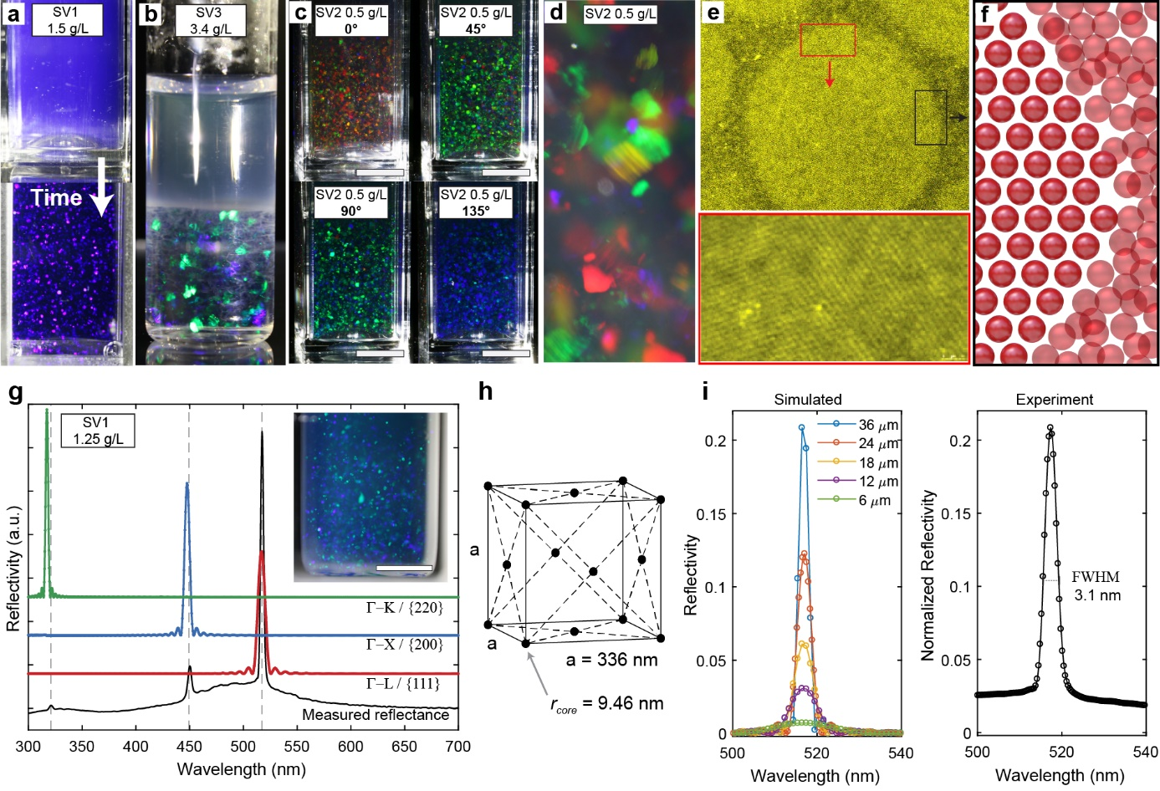
Figure 3. MPFs and MPCs based on different PS-b-P2VPs (SV1-3). a) MPF of SV1 at c = 1.5 g/L and crystallization into MPCs from MPFs under quiescent conditions. b) Separation of MPFs and MPCs phases of SV3 BCMs with a core radius of 17.5 nm. c) Angle-dependent colors of MPFs and MPCs of SV2 at c = 0.5 g/L. d) Close-up image of single and sharply colored reflections of SV2 at c = 0.5 g/L ranging from red to purple. e) Fluorescence confocal image of freely flowing MPC crystallites and lattice structure (micelle cores labeled with Nile Red). f) Schematic of the interface between crystalline and amorphous phase. g) Experimental and simulated reflection spectra suggesting FCC lattices. h) Schematic of an FCC lattice with core sizes drawn to scale (with respect to g). i) Simulated reflection and corresponding experimental measurement of the {111} peak of SV1 with lattice size of 336 nm and different crystal thickness. Scale bar 5 mm in all images.
The reflectivity spectra of the MPC crystallites were simulated for an FCC crystal consisting of core-shell BCMs with a lattice size of 336 nm and the refractive index profile of the SV1 BCMs (Figure 3g). The investigated directions were Γ-L, Γ-X and Γ-Κ, which correspond to the family of planes {111}, {100} and {110}, respectively. The simulated reflectivity spectra and the band diagram (Figure S6) match the experimental data in terms of the peak positions and full width at half-maxima (FWHM), and confirm both the assignment of the peaks to the lattice planes as well as the sharp reflection peaks arising from the smooth decay of the refractive index in the micelle corona (Figure S7). Even though the density of the corona decreases rapidly with distance from the core, the simulations demonstrate that it has a significant contribution to the reflections probably due to the gradual variation of the refractive index (Figure S7). The small deviations in the spectral position between the simulated and the calculated peaks is caused by the wavelength dependence of refractive index of water that is not included in the simulations.
The MPCs exhibit very sharp reflectance peaks. To study the origin of the peak widths in more detail, reflections of the {111} family plane of 336 nm lattice were simulated for crystal thicknesses from 6 µm to 36 µm. (Figure 3i) leading to peak widths of 20.6 – 3.7 nm. The results reveal that the thicker the crystals, the sharper and more intense the reflections, as is expected for scattering structures.⁴⁶ This is evident also in the reflections arising from the amorphous photonic fluid background, as they are much broader in comparison to the reflections of the crystallites. Based on the simulations, the experimentally obtained FWHM of 3.1 nm arises from crystallites larger than 36 µm, i.e. minimum 100 times the lattice size, indicating very high order. The observation of clear twinning lines in the crystallites further support the good order of the MPCs (Figure S8) as the domains around the twinning lines have to be well defined. Visually, the MPC crystallites are millimeter-sized, but it is expected that the inhomogeneity of packing and small variations of the lattice spacing also increase the peak widths (not taken into account in the simulations). In experiments, values for the FWHM as small as ~1 nm were observed with higher periodicities (Figure S9). The absolute measured reflection intensity of the {111} peak was 1.1% for SV1 and 2.0 g/L. The measured value seems small, but considering that the millimeter-sized crystallites are randomly oriented and only the crystals with the correct angle contribute to the measurement, the actual diffraction efficiency can be considerably higher.
Tunability of micellar photonic materials. To show the versatility of BCMs for photonic crystals, we change conditions for crystallization for SV1 and SV2 that exhibit approximately the same core sizes, R_{core} = 9.46 nm and R_{core} = 9.93 nm, correspondingly, but different thicknesses of the corona, R_{h} = 81 nm and R_{h} = 109 nm. The photograph in Figure 4a and the specular reflectance data from concentration series prepared from SV1 and SV2 BCMs (Figure 4b, c) demonstrate that the reflected wavelengths can span from the UV across the full visible spectrum to near infrared. BCMs of SV1 crystallize to form MPCs in the range from c = 2.5 g/L - 1.25 g/L, with the red-shifting {111} reflections having wavelengths from 416.4 nm to 517.4 nm. As expected from the larger corona, BCMs of SV2 are able to crystallize at lower concentrations than SV1 (Figure 4c), i.e. in the range of c = 0.5 g/L - 0.25 g/L, which leads to {111} reflections at 712.3 nm and 870 nm, respectively. The combination of SV1 and SV2 MPCs shows that similar sized cores can be assembled into a large range of periodicities, by tuning the micelle coronas.
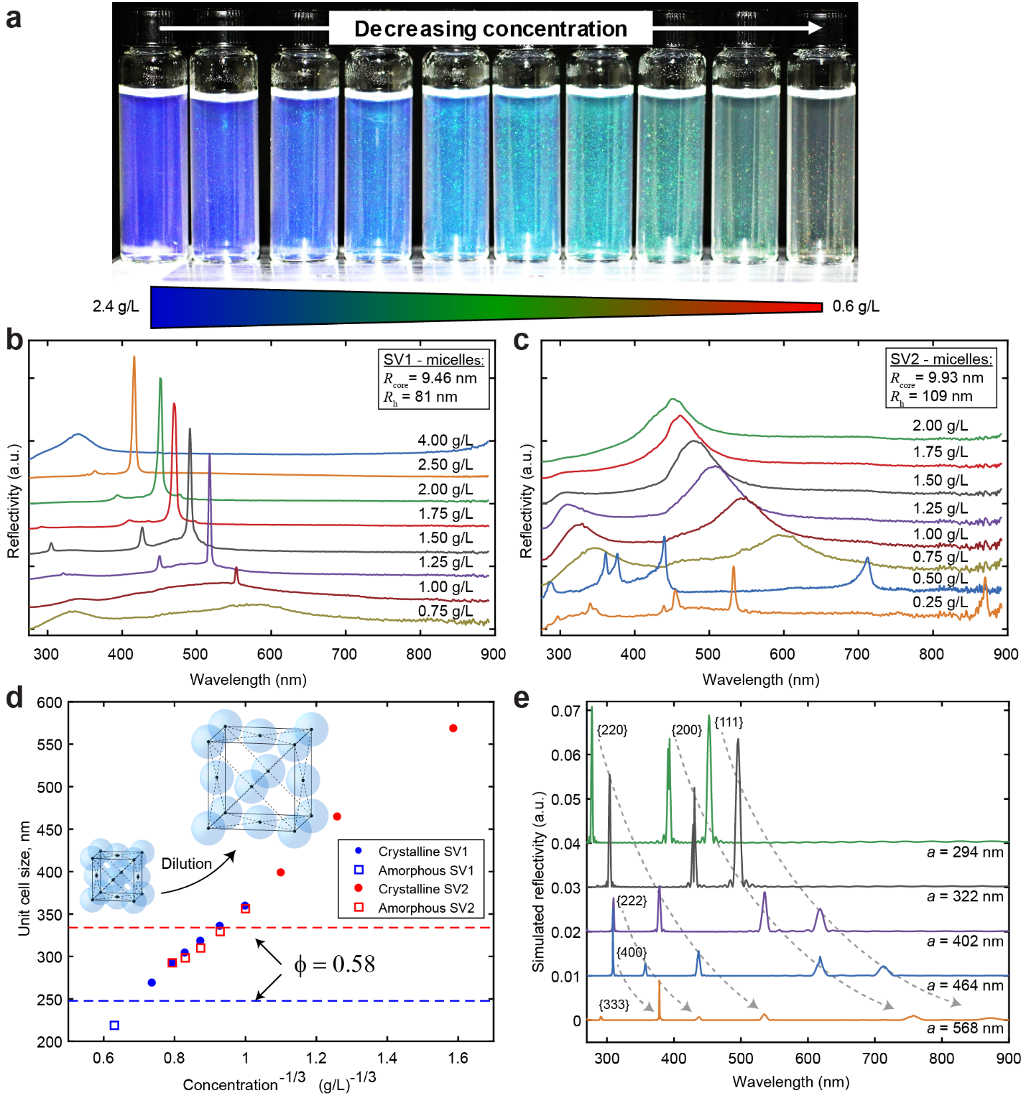
Figure 4. Concentration dependence of structural colour, reflection spectra, and lattice size for PS-b-P2VP micellar photonic fluids and crystals. a) Photographic series of SV1 MPFs and MPCs at c = 2.4 g/L - 0.6 g/L in 0.2 g/L increments displaying structural colors across the visible range. Reflection spectra of b) SV1 and c) SV2 MPCs at different c. d) The unit cell size, a, as a function of $c^{ -1/3}$. Schematics present changes of lattice size with dilution. The horizontal lines represent the unit cell sizes at which the volume filling of spheres with hydrodynamic radii, R_{h}, is 0.58. e) Simulated reflection spectra of SV2 BCMs as sum of the directions Γ-L, Γ-X and Γ-Κ for lattice sizes corresponding to experimental findings.
Closer inspection of the MPFs and MPCs reflection peak positions reveals that wavelength, and therefore unit cell size (calculated based on the {111} direction), scales with concentration as $c^{-1/3 }$ (Figure 4c). This correlation is expected if the BCMs fill the volume evenly, and indicates that the concentration of the crystallites follows the concentration of the solution. This correlation verifies that electrostatic repulsion of the highly-charged polyelectrolyte corona stabilizes the crystallites as FCC lattice, where the electrostatic repulsion of the BCMs is minimized and the number concentration determines the spacing of the BCMs in the photonic structures. Entropic contributions support the assembly as the entropy of the BCMs is maximized in the lattice where they have the most translational freedom. Considering the lower limit of the crystallization, the long reach of the stabilizing corona largely increases the hydrodynamic radius of the BCMs, i.e. decreases the Brownian diffusion of the particles, which allows the electrostatic repulsion to induce crystallization even with nanodot-like cores of the BCMs. The combination of strength of the electrostatic repulsion and extent of Brownian diffusion of the BCMs set the low concentration limit for the crystallization, meaning that BCMs with larger coronae are able to crystallize at lower concentrations as was experimentally observed. On the other hand, the high concentration limit is set by the kinetic arrest arising from the high effective volume fraction of the BCMs, mostly caused by the corona. For different colloidal systems, it has been shown that spherical particles have a colloidal glass transition, which for hard spheres is at volume fraction Φ = 0.58.⁴⁵ Above this limit, the particle-particle interactions arrest the system kinetically into a glassy state and due to the slow kinetics, the crystallization does not occur. Even though the samples do not crystallize, they show the reflection from the amorphous structure, seen as broad specular reflection peaks (e.g. here c > 0.50 g/L for SV2 and c > 2.50 g/L for SV1). Based on the R_{h} and by approximating the particles as hard spheres, it is possible to estimate the unit cell size below which the crystallization does not occur (Figure 4c). These limits are 249 nm and 334 nm for SV1 and SV2, respectively, and are close to the experimentally observed limits of the crystallization.
We simulated the reflection spectra from the different lattice sizes corresponding to the crystal SV2 for the directions Γ-L, Γ-X and Γ-Κ (Figure 4e). For a given lattice size and direction, the contributions of different lattice planes can be assigned, e.g. for the direction Γ-L and 0.25 g/L peaks corresponding to the planes (111), (222) and (333) are visible at 873 nm, 437 nm, and 291 nm, respectively. The simulated data are in good agreement with the experimental data. For a constant crystal thickness, the reflection intensity decreases and the peak broadens when increasing lattice size. This is expected from the smaller concentration of scattering centers, but also from the small scattering centers, because the scattering cross-section decreases with wavelength. Photonic crystals have not been prepared previously from small nanodot-like scattering centers due to limitations in preparation of small particles capable of crystallizing on a much larger periodicity. In an FCC lattice, with a unit cell size of 560 nm, the volume filling of the 10 nm radius cores is only 0.0001%. The small core-diameter reduces diffuse scattering, which allows the solutions and crystallites to be clear and nearly transparent in wavelengths not satisfying Bragg conditions.
Besides micelle concentration (= number concentration), the electrostatic repulsion of the expanded micelle corona is also a convenient handle to tune the system (Figure 5). Increasing the salinity of the solution, e.g. by addition of specific amounts of potassium iodide (KI), reduces the corona chain repulsion and volume requirement of the corona. According to DLS, the micelle radius changes with salt concentration (c_{KI}) and decreases above $c_{\text{KI}}=1⋅{10}^{-4}$ M (Figure 5a). To demonstrate the formation of MPCs from micellar gels (overcrowded systems), we add a drop of KI solution to SV2 micellar gels at c = 1.5 g/L. In Figure 5b, we see the trapped droplet in the highly viscous micellar gel (slow diffusion kinetics), where the higher c_{KI} triggers crystallization. The corona contraction relieves the overcrowded system, promoting mobility and crystallization.
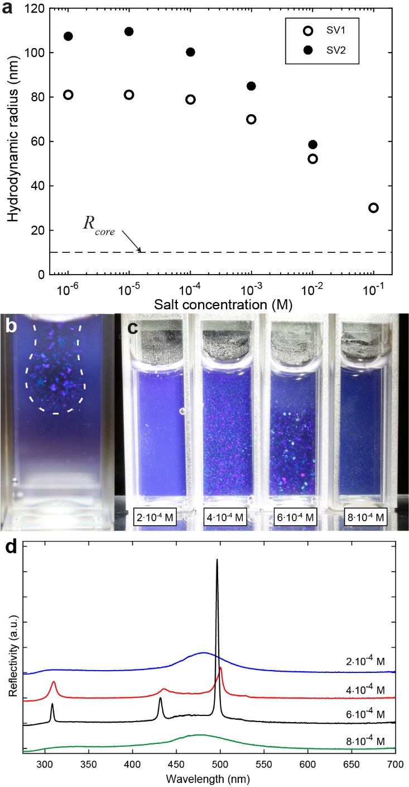
Figure 5: Salt-induced formation of MPCs based on PS-b-P2VP. a) The hydrodynamic radii of the BCMs as a function of salt concentration as measured by dynamic light scattering. The dashed line represents the radius of the core measured by TEM. b) Crystallization induced by one drop of potassium iodide solution to SV2 at c = 2.0 g/L. c) Image series of SV2 samples with c = 1.5 g/L at different salt concentrations, and d) the specular reflectance spectra of the samples in (c).
Samples mixed with different c_{KI} demonstrate that the formation of the MPC crystallites can be optimized for any micelle concentration (Figure 5c). At $c_{\text{KI}}=2⋅{10}^{-4 }$M, the SV2 BCMs are still in an overcrowded, amorphous state, which is confirmed by the broad halo in the reflectance spectrum (Figure 5d, blue). Between $c_{\text{KI}}=4⋅{10}^{-4}$ M and 6$⋅{10}^{-4}$ M, the SV system crystallizes, whereas the crystallites are better ordered at $c_{\text{KI}}=6⋅{10}^{-4}$ M as is evident from the image and the spectra (Figure 5d, black). Naturally, the addition of salt simultaneously decreases the Debye screening length of the solution, i.e. effective length of electrostatic repulsion, which decreases the low concentration limit of the micelle crystallization. At $c_{\text{KI}}=8⋅{10}^{-4}$ M, BCMs are contracted to such an extent that volume filling is below the crystallization point. Nevertheless, by optimizing the conditions, all samples can be crystallized from the overcrowded state (Figure S10).
Finally, we change the specifications of the block copolymers to alter the core size and core material of the BCMs. BCMs have been reported with a very large variety of properties, which suggests the possibility to produce MPC crystallites with diverse properties as well. It seems as if the only requirements to form MPF and MPCs is that the block copolymer self-assembles into spherical BCMs with a polyionic corona. This can be accomplished with diblock co- and triblock terpolymers as exemplified by PS₁₀₅₇-b-P2VP₇₉₃ (SV3) with a larger core of R_{h} = 17.5nm, PMMA₁₇₀₀-b-P2VP₁₅₂₄ (MV) with different core chemistry, and PS₃₅₈-b-PB₃₆₈-b-P2VP₅₉₄ (SBV) with compartmentalized core (Figure 6 and S13). Following the previously discussed recipe, all of these polymers assemble to spherical BCMs and MPCs at suitable concentrations, yet the formed crystallites display very different morphology. Figure 6a shows a photographic series of two individual crystallites of SV3 with angle-dependence of the reflected wavelength and clearly visible twinning defects. These crystallites display a smooth surface typical for most BCMs with small to medium sized corona (e.g. SV1-4 with P_{n,V} < 800), which leads to a comparably low viscosity at c = 1 g/L. In contrast, Figure 6b shows a photographic series of two individual crystallites of MV that also display angle-dependence of the reflected wavelength, but with a pronounced dendritic, fractal-like structure. MV BCMs have a significantly longer corona (P_{n,V} = 1595), which results in higher viscosity at c = 1 g/L. The difference thus likely arises from the diffusion dynamics during crystallization and for entire crystallite causing shear forces that act on the crystallite surface,⁴⁷ which has been investigated in density-matched and microgravity environments. Under low viscosity conditions (SV), crystallites are able to float and the resulting shear forces “polish” the edges towards smooth surfaces. Small shear forces, and therefore dendritic instabilities are expected in the samples with a more massive corona and higher viscosity. A more thorough analysis of the crystallite shapes will be part of future work to give a more systematical interpretation of the shear forces. Yet another and totally different crystallization behavior was observed for SBV BCMs, where centimeter-sized spherulitic crystallites grew at the water/air/glass interface after aging (Figure S11). The exact mechanism remains unclear at this point and deeper studies are underway to better understand the subtleties of such systems.
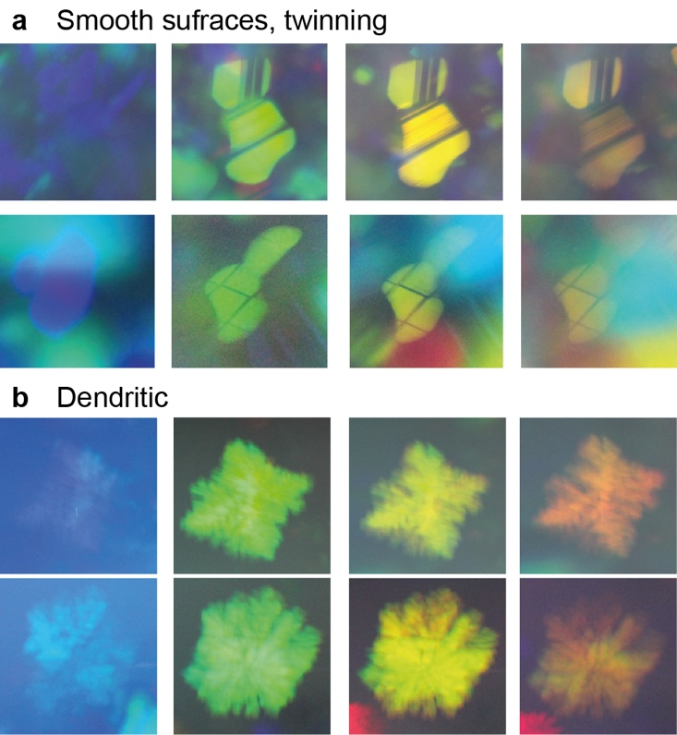
Figure 6. Kinetically and diffusion-controlled MPCs. Photographic series of two crystallites of a) SV3 BCMs showing smooth surface and twinning, and b) fractal clusters after dendritic growth of MV BCMs.

Conclusion
In summary, we showed that block copolymer micelles with superstretched corona form a useful and generic platform to generate structural colors in solvent media as photonic fluids and crystals. By a sequence of solvent exchanges and ionization, block copolymers involving a quaternizable block are converted to block copolymer micelles with a nanodot-like core and a charged, solvent swollen superstretched corona. They lead to self-assembled micellar photonic fluids, with on-average periodicity between the block copolymer micelles as driven by the narrow size-dispersity and electrostatic repulsion between the charged corona. Such liquids show faint hues resulting from structural colors despite being mobile and dynamic. The micellar photonic fluids can further undergo a transition to co-existent micellar photonic crystals under quiescent conditions. They incorporate a FCC crystal lattice of block copolymer micelles and bright structural colors are observed due to the high degree of order. The colors are tunable by the extent of dilution, salt concentration and chemistry of employed block copolymers. Using block copolymer micelles to create photonic crystals has several advantages such as tunable particle size, a large library of applicable block copolymers, scalability (Figure S12), and unlike for many hard colloids the possibility of drying, storage and rehydration (Figure S13). We foresee that the approach is generally applicable to polyionic block copolymers towards larger libraries of functional micellar photonic fluids and crystals. The highly responsive systems may be useful for sensing of chemicals and physical imposed conditions.

Experimental
Materials. Block copolymers SV1, SV2 and SBV were synthesized via anionic polymerization (for details see SI). MV and SV4 were purchased from Polymer Source. All solvents were of analytical grade and used as received. For dialysis, MilliQ-water was used while organic solvents were of technical grade. Dialysis tubes of regenerated cellulose with a molecular weight cut-off of 12,000–14,000 g/mol were purchased from Aldrich, equilibrated in deionized water for 10 min and washed with excess dioxane before use. Nile red was used as received.
Preparation of MPFs and MPCs. The block copolymers are dissolved in DMAc at concentrations of 10 g/L (typically 100 mg/10 ml), stirred overnight and solvent was exchanged through dialysis (tube MWCO = 13 kg/mol) against first isopropanol and followed by methanol. Dialyses were exchanged twice. Quaternization was performed by adding 10-fold molar excess of MeI (depending on the corona length) to the micellar solution in methanol and the reaction was allowed to proceed overnight. The produced gel was dialyzed against 2 L of MilliQ water to remove remaining MeI and methanol. The dialysis water was changed twice per day for 1 week. The final hydrogels had a concentration of 3.0-7.0 g/L depending on the block copolymer and were stored in the dark to prevent side-reactions of iodine. To induce crystallization, the hydrogels were diluted with MilliQ water to the desired concentration of 0.2-2.0 g/L.
Fluorescence confocal microscopy (FCM). For confocal fluorescence microscopy, BCMs were labelled by infiltrating hydrophobic fluorescent dyes into the hydrophobic PS core. Therefore, 125 µL of a 0.5 g/L Nile Red in acetone solution was added to 5 mL of micellar solution in methanol. After sonication for 30 min in the sonication bath, the sample was placed in a water bath at 50 °C for 1 hour to evaporate acetone. Quaternization of the P2VP corona prevents the dye from leaking out of the core. The resulting labelled gel was dialyzed against MilliQ water to remove excess dye and MeI. The dialysis bath was changed until no dye could be detected outside the dialysis tube. The remaining color is attributed to the dye within the core (Figure S2). Prior to measurements, the gel was diluted to concentrations ranging from c = 0.2-2.0 g/L and the samples were allowed to crystallize in FCM imaging chambers.
Elemental analysis. The degree of quaternization of $α$ = 38 % was determined with elemental analysis of the iodine content (f_{I} = 19.9 wt%).
Transmission electron microscopy (TEM). The samples were imaged with FEI Tecnai 12 microscope. For the samples, 3 µL of 0.5 g/L solution was placed on a carbon grid and the sample was plotted with filter paper after 30 s. The sample was allowed to dry in room air. The samples were imaged without staining.
Cryogenic Transmission Electron Microscopy (Cryo-TEM). Cryo-TEM imaging was carried out using a JEM 3200FSC field emission microscope (Jeol) operated at 300 kV in bright field mode with an Omega-type zero-loss energy filter. The images were acquired with an Ultrascan 4000 CCD camera (Gatan) and with Gatan Digital Micrograph software (version 1.83.842), while the specimen temperature was maintained at -187 °C. Vitrified samples were prepared using a FEI Vitribot placing 3 μL of sample solution on 200-mesh holey carbon copper grids under 100% humidity, then blotted with filter paper for 0.5-1.5 s, immediately plunged into a -170 °C ethane/propane mixture and cryotransfered to the microscope.
Reflectance spectra. Specular reflectance measurements were performed with an optical fiber reflection probe (Ocean Optics, Inc.) with a deuterium-halogen light source (DH2000 BAL, Ocean Optics, Inc.) and an Ocean Optics USB2000+ diode array spectrometer. The probe was inserted into the sample to achieve best possible resolution. A specular reflectance standard was used to correct for the spectral shape of the light source, but due to the geometry of the measured volume, the reflectivity values are arbitrary. The reflectance spectra for determining full-widths at half-maximum were measured using a Perkin-Elmer Lambda 950 spectrophotometer with a 150 mm integrating sphere. With the integrating sphere, the reported reflectivity was measured as the difference between total and diffuse reflectance.

Single crystal images and spectra. Optical characterization was performed in reflection mode on a customized Zeiss Axio microscope using a halogen lamp (Zeiss HAL100) as a light source using Koehler illumination and a 10x water immersion objective (W-N-Aprochromat, 420947-9900-000, Zeiss, NA:0.3). The light reflected off the sample is split between a CCD camera (UI-3580LE-C-HQ, IDS) and an optical fiber (100µm diameter core size, FC-UV100-2-SR, Avantes) mounted in confocal configuration and connected to a spectrometer (AvaSpec-HS2048, Avantes). This setup allowed for the spectra acquisition from specific areas of the samples. All the spectra were normalized to the reflection of a silver mirror in water.
Simulations. The light interaction with the crystals was simulated using a three-dimensional finite-difference time-domain (FDTD) method⁴⁸. For the simulations, the software Lumerical Solutions, Inc. was used. Band diagrams were calculated by using the freely available software package MIT Photonic bands (MPB).⁴⁹
Dynamic light scattering (DLS). The hydrodynamic radii of the BCMs were measured with Zeta-sizer Malvern Nano. The samples were diluted to 0.05 g/L prior to the measurement.

ASSOCIATED CONTENT
Supporting Information (SI). Supporting figures, experimental details, synthesis and details of block copolymers and BCMs, simulations on reflection spectra, and refractive index profiles are given in the supporting information (PDF). These files are available free of charge.
AUTHOR INFORMATION

Corresponding Authors
* E-mail (O. Ikkala) olli.ikkala@aalto.fi, * E-mail (A.H. Gröschel) andre.groeschel@uni-due.de

Author Contributions
MP, GG and AHG performed all experiments except cryo-TEM that was done by TIG. GG and SV performed simulations. The manuscript was jointly written by MP, GG, SV, OI, and AHG. All authors discussed results, commented on the manuscript, and have given approval to the final version of the manuscript. AHG conceived the project that was supervised by OI and AHG.

Funding Sources
This work was carried out under the Academy of Finland's Centre of Excellence Programme (2014-2019) and supported by ERC-2011-AdG (291364-MIMEFUN). AHG is grateful for financial support from Evonik Industries AG in form of an endowed Juniorprofessorship (2016-2022) as well as from the German Research Foundation (DFG) for an Emmy Noether Independent Junior Research Group (2017-2022, # 376920678). SV and GG acknowledge financial support from the European Research Council [ERC-2014-STG H2020 639088] and the EPSRC [1525292 and EP/L016087/1]. This work was partially supported by Russian Science Foundation grant # 14-33-00003.

Notes
Any additional relevant notes should be placed here.

ACKNOWLEDGMENTS
The authors thank Antti Isomäki for introduction to FCM intrument and helpful discussions on the data. The authors made use of the imaging facility at Biomedicum Helsinki as well as the Aalto University Nanomicroscopy Center (Aalto-NMC).

ABBREVIATIONS

BCM, block copolymer micelle; MPF, micellar photonic fluid; MPC, micellar photonic crystal; S, polystyrene; V, poly(2-vinylpyridine); SV, polystyrene-block-poly(2-vinylpyridine); MV, poly(methyl methacrylate)- block-poly(2-vinylpyridine); FWHM, full width at half maximum; KI, potassium iodide; FCM, fluorescence confocal microscopy

REFERENCES
(1) Ge, J.; Yin, Y. Responsive Photonic Crystals. Angew. Chemie Int. Ed. 2011, 50, 1492–1522.
(2) Moon, J. H.; Yang, S. Chemical Aspects of Three-Dimensional Photonic Crystals. Chem. Rev. 2010, 110, 547–574.
(3) Galisteo-Lõpez, J. F.; Ibisate, M.; Sapienza, R.; Froufe-Pérez, L. S.; Blanco, Ú.; Lõpez, C. Self-Assembled Photonic Structures. Adv. Mater. 2011, 23, 30–69.
(4) Joannopoulos, J. D.; Johnson, S. G.; Winn, J. N.; Meade, R. D. Photonic Crystals: Molding the Flow of Light; 2nd ed.; Princeton University Press, 2008.
(5) Vukusic, P.; Sambles, J. R. Photonic Structures in Biology. Nature 2003, 424, 852–855.
(6) Parker, A. R. 515 Million Years of Structural Colour. J. Opt. A Pure Appl. Opt. 2000, 2, R15–R28.
(7) Fenzl, C.; Hirsch, T.; Wolfbeis, O. S. Photonic Crystals for Chemical Sensing and Biosensing. Angew. Chemie Int. Ed. 2014, 53, 3318–3335.
(8) Holtz, J. H.; Asher, S. A. Polymerized Colloidal Crystal Hydrogel Films as Intelligent Chemical Sensing Materials. Nature 1997, 389, 829–832.
(9) Vogel, N.; Retsch, M.; Fustin, C. A.; Del Campo, A.; Jonas, U. Advances in Colloidal Assembly: The Design of Structure and Hierarchy in Two and Three Dimensions. Chem. Rev. 2015, 115, 6265–6311.
(10) Zhao, Q.; Finlayson, C. E.; Snoswell, D. R. E.; Haines, A.; Schäfer, C.; Spahn, P.; Hellmann, G. P.; Petukhov, A. V.; Herrmann, L.; Burdet, P.; et al. Large-Scale Ordering of Nanoparticles Using Viscoelastic Shear Processing. Nat. Commun. 2016, 7, 11661.
(11) Hellweg, T.; Dewhurst, C. D.; Brückner, E.; Kratz, K.; Eimer, W. Colloidal Crystals Made of Poly( N -Isopropylacrylamide) Microgel Particles. Colloid Polym. Sci. 2000, 278, 972–978.
(12) Debord, J. D.; Eustis, S.; Byul Debord, S.; Lofye, M. T.; Lyon, L. A. Color-Tunable Colloidal Crystals from Soft Hydrogel Nanoparticles. Adv. Mater. 2002, 14, 658–662.
(13) Nayak, S.; Lyon, L. A. Soft Nanotechnology with Soft Nanoparticles. Angew. Chemie Int. Ed. 2005, 44, 7686–7708.
(14) Crassous, J. J.; Siebenbürger, M.; Ballauff, M.; Drechsler, M.; Henrich, O.; Fuchs, M. Thermosensitive Core-Shell Particles as Model Systems for Studying the Flow Behavior of Concentrated Colloidal Dispersions. J. Chem. Phys. 2006, 125, 204906.
(15) Ohno, K. Colloidal Crystals Formed by Polymer Brush-Afforded Fine Particles. Polym. Chem. 2010, 1, 1545–1551.
(16) Perro, A.; Meng, G.; Fung, J.; Manoharan, V. N. Design and Synthesis of Model Transparent Aqueous Colloids with Optimal Scattering Properties. 2009, 25, 11295–11298.
(17) Hoffmann, H. Fascinating Phenomena in Surfactant Chemistry. Adv. Mater. 1994, 6, 116–129.
(18) Schacher, F. H.; Rupar, P. A.; Manners, I. Functional Block Copolymers: Nanostructured Materials with Emerging Applications. Angew. Chemie Int. Ed. 2012, 51, 7898–7921.
(19) Gröschel, A. H.; Müller, A. H. E. Self-Assembly Concepts for Multicompartment Nanostructures. Nanoscale 2015, 7, 11841–11876.
(20) Bates, F. S.; Fredrickson, G. H. Block Copolymers—Designer Soft Materials. Phys. Today 1999, 52, 32–38.
(21) Antonietti, M.; Förster, S. Vesicles and Liposomes: A Self-Assembly Principle Beyond Lipids. Adv. Mater. 2003, 15, 1323–1333.
(22) Fink, Y.; Urbas, A. M.; Bawendi, M. G.; Joannopoulos, J. D.; Thomas, E. L. Block Copolymers as Photonic Bandgap Materials. J. Light. Technol. 1999, 17, 1963–1969.
(23) Edrington, A. C.; Urbas, A. M.; DeRege, P.; Chen, C. X.; Swager, T. M.; Hadjichristidis, N.; Xenidou, M.; Fetters, L. J.; Joannopoulos, J. D.; Fink, Y.; et al. Polymer-Based Photonic Crystals. Adv. Mater. 2001, 13, 421–425.
(24) Puzzo, D. P.; Arsenault, A. C.; Manners, I.; Ozin, G. A. Electroactive Inverse Opal: A Single Material for All Colors. Angew. Chemie Int. Ed. 2009, 48, 943–947.
(25) Valkama, S.; Kosonen, H.; Ruokolainen, J.; Haatainen, T.; Torkkeli, M.; Serimaa, R.; ten Brinke, G.; Ikkala, O. Self-Assembled Polymeric Solid Films with Temperature-Induced Large and Reversible Photonic-Bandgap Switching. Nat. Mater. 2004, 3, 872–876.
(26) Miyake, G. M.; Piunova, V. A.; Weitekamp, R. A.; Grubbs, R. H. Precisely Tunable Photonic Crystals from Rapidly Self-Assembling Brush Block Copolymer Blends. Angew. Chemie Int. Ed. 2012, 51, 11246–11248.
(27) Noro, A.; Tomita, Y.; Matsushita, Y.; Thomas, E. L. Enthalpy-Driven Swelling of Photonic Block Polymer Films. Macromolecules 2016, 49, 8971–8979.
(28) Kang, Y.; Walish, J. J.; Gorishnyy, T.; Thomas, E. L. Broad-Wavelength-Range Chemically Tunable Block-Copolymer Photonic Gels. Nat. Mater. 2007, 6, 957–960.
(29) Arsenault, A. C.; Puzzo, D. P.; Manners, I.; Ozin, G. A. Photonic-Crystal Full-Colour Displays. Nat. Photonics 2007, 1, 468–472.
(30) Kang, C.; Kim, E.; Baek, H.; Hwang, K.; Kwak, D.; Kang, Y.; Thomas, E. L. Full Color Stop Bands in Hybrid Organic/inorganic Block Copolymer Photonic Gels by Swelling-Freezing. J. Am. Chem. Soc. 2009, 131, 7538–7539.
(31) Wang, X.; Guerin, G.; Wang, H.; Wang, Y.; Manners, I.; Winnik, M. A. Cylindrical Block Copolymer Micelles and Co-Micelles of Controlled Length and Architecture. Science 2007, 317, 644–647.
(32) Hudson, Z. M.; Boott, C. E.; Robinson, M. E.; Rupar, P. A.; Winnik, M. A.; Manners, I. Tailored Hierarchical Micelle Architectures Using Living Crystallization-Driven Self-Assembly in Two Dimensions. Nat. Chem. 2014, 6, 893–898.
(33) Discher, B. M. Polymersomes: Tough Vesicles Made from Diblock Copolymers. Science 1999, 284, 1143–1146.
(34) Lunn, D. J.; Finnegan, J. R.; Manners, I. Self-Assembly of “patchy” Nanoparticles: A Versatile Approach to Functional Hierarchical Materials. Chem. Sci. 2015, 6, 3663–3673.
(35) Gröschel, A. H.; Schacher, F. H.; Schmalz, H.; Borisov, O. V; Zhulina, E. B.; Walther, A.; Müller, A. H. E. Precise Hierarchical Self-Assembly of Multicompartment Micelles. Nat. Commun. 2012, 3, 710.
(36) Löbling, T. I.; Borisov, O.; Haataja, J. S.; Ikkala, O.; Gröschel, A. H.; Müller, A. H. E. Rational Design of ABC Triblock Terpolymer Solution Nanostructures with Controlled Patch Morphology. Nat. Commun. 2016, 7, 12097.
(37) Förster, S.; Berton, B.; Hentze, H. P.; Krämer, E.; Antonietti, M.; Lindner, P. Lyotropic Phase Morphologies of Amphiphilic Block Copolymers. Macromolecules 2001, 34, 4610–4623.
(38) Thomas, A.; Schlaad, H.; Smarsly, B.; Antonietti, M. Replication of Lyotropic Block Copolymer Mesophases into Porous Silica by Nanocasting: Learning about Finer Details of Polymer Self-Assembly. Langmuir 2003, 19, 4455–4459.
(39) Qiu, H.; Hudson, Z. M.; Winnik, M. A.; Manners, I. Multidimensional Hierarchical Self-Assembly of Amphiphilic Cylindrical Block Comicelles. Science 2015, 347, 1329–1332.
(40) Gröschel, A. H.; Walther, A.; Löbling, T. I.; Schacher, F. H.; Schmalz, H.; Müller, A. H. E. Guided Hierarchical Co-Assembly of Soft Patchy Nanoparticles. Nature 2013, 503, 247–251.
(41) Fischer, S.; Exner, A.; Zielske, K.; Perlich, J.; Deloudi, S.; Steurer, W.; Lindner, P.; Förster, S. Colloidal Quasicrystals with 12-Fold and 18-Fold Diffraction Symmetry. Proc. Natl. Acad. Sci. 2011, 108, 1810–1814.
(42) Förster, S.; Timmann, A.; Schellbach, C.; Frömsdorf, A.; Kornowski, A.; Weller, H.; Roth, S. V; Lindner, P. Order Causes Secondary Bragg Peaks in Soft Materials. Nat. Mater. 2007, 6, 888–893.
(43) Weeks, E. R. Three-Dimensional Direct Imaging of Structural Relaxation Near the Colloidal Glass Transition. Science 2000, 287, 627–631.
(44) Förster, S.; Hermsdorf, N.; Böttcher, C.; Lindner, P. Structure of Polyelectrolyte Block Copolymer Micelles. Macromolecules 2002, 35, 4096–4105.
(45) Pusey, P. N.; van Megen, W. Phase Behaviour of Concentrated Suspensions of Nearly Hard Colloidal Spheres. Nature 1986, 320, 340–342.
(46) Kinoshita, S.; Yoshioka, S.; Miyazaki, J. Physics of Structural Colors. Reports Prog. Phys. 2008, 71, 76401.
(47) Zhu, J.; Li, M.; Rogers, R.; W.Meyer; Ottewill, R. H.; Space Shuttle Crewk STS-73; Russel, W. B.; Chaikin, P. M. Crystallization of Hard-Sphere Colloids in Microgravity. Nature 1997, 387, 883–885.
(48) Kane Yee. Numerical Solution of Initial Boundary Value Problems Involving Maxwell’s Equations in Isotropic Media. IEEE Trans. Antennas Propag. 1966, 14, 302–307.
(49) Johnson, S.; Joannopoulos, J. Block-Iterative Frequency-Domain Methods for Maxwell’s Equations in a Planewave Basis. Opt. Express 2001, 8, 173–190.

BRIEFS (Word Style “BH_Briefs”). If you are submitting your paper to a journal that requires a brief, provide a one-sentence synopsis for inclusion in the Table of Contents.
SYNOPSIS (Word Style “SN_Synopsis_TOC”). If you are submitting your paper to a journal that requires a synopsis, see the journal’s Instructions for Authors for details.

Options for TOC: Which one do you like most?
