Full magnetization of bulk (RE)Ba₂Cu₃O_{7-δ} magnets with various rare-earth elements using pulsed fields at 77 K

Difan Zhou, Yunhua Shi, Wen Zhao, Anthony R. Dennis, Michael Beck, Mark D. Ainslie, Kysen G. B. Palmer, David A. Cardwell and John H. Durrell

Abstract— REBa₂Cu₃O_{7-δ} bulk superconductors are able to trap large magnetic fields, as a result, have potential to work as strong magnets. In this study, highly textured yttrium, gadolinium and samarium based cuprate bulk superconductors were prepared using conventional top-seeded melt-textured growth, and magnetized by employing both field cooling (FCM) and pulsed field magnetization (PFM) techniques at 77 K. The same peak value of trapped field was achieved using FCM and PFM, which means all the bulk samples were fully magnetized by using the PFM method. In addition, the magnitude of the pulsed field required to fully magnetize the bulk samples varied with rare earth element in the (RE)BCO formulation.
Index Terms—High temperature superconductor, trapped field, textured melt growth, pulsed field magnetization

Introduction
T
he strong pinning of flux lines in top-seeded melt-textured growth (TSMG) processed bulk superconductors mean they can sustain large circulating supercurrents. This manifests itself as a permanent magnet but by “trapping” magnetic field in the material rather than by aligning spins. The highest trapped field on record is 17.24 T for YBa₂Cu₃O_{7-δ} [1], and 17.6 T for GdBa₂Cu₃O_{7-δ} [2]. These fields were achieved in twin stacks of 25 mm diameter samples, where the energy density is extremely high, and is therefore promising for power applications [3]-[5]. At low temperatures, the mechanical properties of the materials become the critical parameter limiting the potential trapped field rather than the superconducting properties of the material.
The batch production of HTS bulks was first realized in the YBa₂Cu₃O_{7-δ} system whose relatively lower melting temperature makes the seeding procedure easier [6]. With the development of new seeding techniques, such as the use of generic seeds [7] and thin film seeds [8], the batch growth of Gd-, Sm- and other RE- bulk superconductors has been realized and is now both viable and reliable. A higher RE³⁺ ion solubility (Nd > Sm > Gd > Dy > Y) [9] tends to lead to a faster growth rate, and increases the uniformity of the bulks [10]. The substitution of RE on the Ba site is an issue, however this substitution also contributes to flux pinning in the magnetic field (δT_{c} pinning) [11]. Other specific properties, e.g. lower thermal conductivity of DyBa₂Cu₃O_{7-δ} for current leads and lower paramagnetic moment RE for NMR [12], and supply constraints of rare earth elements have also to be taken into consideration.
The feasibility of HTS magnets for practical applications also depends critically on the availability of a practical magnetization technique. Pulsed field magnetization (PFM) using a pulsed conventional copper solenoid has the benefit of simplicity and low cost. However, magnetic field at least two times that required by field cooling magnetization (FCM) is required, since it is essentially a zero field cooling (ZFC) process. Moreover, rapid flux motion during the field penetration process can generate significant heat. The maximum trapped field from PFM, using a multi-pulse multi-temperature technique, is 5.2 T [13]. It has been reported recently that, by using PFM, a trapped field larger than 90 % of the FC result was achieved at 77 K [14]. Weinstein et al. have demonstrated that, by exploiting flux jumps, magnetization can be achieved with an external magnetic field much less than twice the desired magnetic field [15].
In this paper, we first compare the flux trapping capability of our REBa₂Cu₃O_{7-δ} bulk samples in terms of different rare earth systems. And then the full magnetization of these samples is discussed.

Experimental details

Preparation of HTS bulk samples
The bulk superconductors were selected randomly from standard samples prepared by a buffer aided top-seeded melt-growth technique. Chemical composition, heating profile and localized superconducting properties (T_{c}, J_{c}, micro-structure) can be found in [16] for YBa₂Cu₃O_{7-δ}, [17] for GdBa₂Cu₃O_{7-δ} and [18] for SmBa₂Cu₃O_{7-δ}. Three well textured samples, one of each composition, with a diameter of 25 mm and a thickness of 12 mm were selected for magnetization tests.

Magnetization tests
For FCM, the bulk samples were cooled in liquid nitrogen in a uniform field of 1.4 T generated in a conventional electromagnet. The peak trapped field was measured at the center of the top surface using a handheld Hall probe 15 minutes after removing the external field. The trapped field distribution was then scanned by using an array of Hall probes at approximately 1 mm above the sample surface.
The PFM experimental set-up is shown schematically in figure 1. The applied field was generated in a copper coil immersed in liquid nitrogen. A maximum energy of 9 kJ was discharged from a capacitor bank, and the rise time of the pulse was approximately 50 ms. The bulk sample was placed at the center of the coil, and the field was measured during the PFM process by Hall sensors placed on the surface of the bulk. The trapped field across the sample (i.e. through the center and two growth sectors) was subsequently plotted. All the tests were performed with a single pulse, which means the samples were demagnetized before the next pulse was applied.

FIG. 1 HERE

Results and discussion

Field cooling results
Figure 2 shows the distribution of the trapped field for all three samples after FCM. The uniformity of the trapped field confirms that the samples have grown in the form of large, single grains. The peak field measured at the center of the top-surface is 0.66 T, 1.02 T and 0.83 T for the YBa₂Cu₃O_{7-δ}, GdBa₂Cu₃O_{7-δ} and SmBa₂Cu₃O_{7-δ} samples, respectively. One of the reasons for a better flux trapping performance in Gd- and SmBa₂Cu₃O_{7-δ} bulks compared with YBa₂Cu₃O_{7-δ} is the higher solubility of the Gd³⁺ and Sm³⁺ ions. This ensures a more sufficient solute for the peritectic reaction, leading to faster and more sustainable growth which, in turn, reduces the chance of forming sub-grain boundaries, especially in the growth section area. The growth sectors of the YBa₂Cu₃O_{7-δ} sample are highlighted by dashed circles in the contour map of trapped field (figure 2 (a)). The field is relatively lower in these areas, which is due partly to restriction of super-current loop by the sub-grain boundaries.
Differences in flux trapping performance can also due to additional pinning arising from RE/Ba substitution as mentioned above. This phenomenon is understood to be more significant at lower temperatures. However, the substitution in SmBa₂Cu₃O_{7-δ} is more severe, which may reduce the superconducting transition temperature (T_{c}) of the sample, thus affecting the flux trapping performance. This may explain why the trapped field of SmBa₂Cu₃O_{7-δ} is slightly lower than that of GdBa₂Cu₃O_{7-δ} in our process.

FIG. 2 HERE

Pulsed field magnetization results
The profiles of the trapped field measured across the growth sectors are shown in figure 3. The peak trapped field increases with the increasing applied field, and the field distribution gradually changes from an “M” shape to a cone shape. This is in good agreement with the Bean critical state model, in which the slope of the trapped field is proportional to J_{c}. It can be inferred that the Gd- and SmBa₂Cu₃O_{7-δ} samples possess a higher overall J_{c} than the YBa₂Cu₃O_{7-δ} sample.
Table I shows a comparison of the trapped field achieved from FC and PFM. It is clear that the peak value of trapped field achieved from PFM is the same as that obtained from FCM, which is understood as the full capability of the bulk material to trap magnetic field. In addition, the required field to fully magnetize the sample is slightly lower for YBa₂Cu₃O_{7-δ} compared with Gd- and SmBa₂Cu₃O_{7-δ}.

TABLE I HERE

A peak trapped field after PFM close to that from FCM on the same sample at 77 K has been reported by several groups [19]. However, a small loss of magnetic flux caused by the temperature rise during the flux penetration is usually expected in PFM. In order to understand the reason for this full magnetization, the variation of field across the surface of the GdBa₂Cu₃O_{7-δ} sample was measured during the PFM process. In figure 4 this is shown for PFM of the GdBa₂Cu₃O_{7-δ} sample with a pulsed field of 2.45 T, which resulted in full magnetization. During the rise (figure 4a) of the pulse, the magnetic field was initially shielded by the current induced by the penetrating field. However, at t = 25 ms, a sharp rise in magnetic field was measured at the center, accompanied by a small dip in field at the edge. We suggest that a general de-pinning of flux lines occurred at this point, leading to full magnetization.
Over the longer time-scale shown in figure 4 (b), the peak of the field at the centre surpasses that of the values measured towards the edge, and a slight delay in time compared with the applied field can also be observed. The measured field declines quickly with the fall of the pulsed field, and starts to stabilize at around 0.5 s where the external field goes to zero. Importantly, at this time the measured central magnetic field is still well above 1 T.
Previous experimental and simulation research has noted that heat is generated predominantly during the rise of the pulse and soon after the peak of the pulse, due to the motion of flux lines [20],[21]. Since the bulk sample is immersed in a LN₂ bath, it is reasonable to assume that one second is long enough to remove the heat generated in the PFM process and bring the temperature of the bulk sample back to 77 K. As the central field stays above 1 T for the whole process, it is not surprising that trapped field is very close to the one obtained by FCM. It is worth mentioning that the ramp-down rate of the pulse is considerably slow, 10 times slower than the ramp-up rate, which may reduce flux creep. The benefit of a slow pulse has been discussed based on simulation results by Fujishiro et al. [22].

Conclusion
We have carried out a comparison of the ability to trap magnetic field in YBa₂Cu₃O_{7-δ}, GdBa₂Cu₃O_{7-δ} and SmBa₂Cu₃O_{7-δ} bulk samples. The Gd- and SmBa₂Cu₃O_{7-δ} samples exhibit slightly better flux trapping performance using both FC and PFM techniques. In the PFM process, it was found that the flux fully penetrated into the bulk sample during the rise of the pulsed field, which enabled the full magnetization of the samples, and the same peak value of trapped field was achieved using FCM and PFM. These results show that the pulse charging approach to magnetization is practicable and applicable to a range of cuprate bulk materials.

References
- M. Tomita, and M. Murakami, “High-temperature superconductor bulk magnets that can trap magnetic fields of over 17 tesla at 29 K,” Nature, vol. 421, pp. 517-520, 2002.
- J. H. Durrell, A. R. Dennis, J. Jaroszynski, M. D. Ainslie, K. G. B. Palmer, Y. H. Shi, A. M. Campbell, J. Hull, M. Strasik, E. E. Hellstrom, and D. A. Cardwell, “A trapped field of 17.6 T in melt-processed, bulk Gd-Ba-Cu-O reinforced with shrink-fit steel,” Supercond. Sci. Technol., vol. 27, Art. ID. 082001, 2014.
- D. Zhou, M. Izumi, M. Miki, B. Felder, T. Ida, and M. Kitano, “An overview of rotating machine systems with high-temperature bulk superconductors,” Supercond. Sci. Technol., vol. 25, Art. ID. 103001, 2012.
- M. Strasik, J. R. Hull, J. A. Mittleider, J. F. Gonder, P. E. Johnson, K. E. McCrary, and C. R. McIver, “An overview of Boeing flywheel energy storage systems with high-temperature superconducting bearings,” Supercond. Sci. Technol., vol. 23, Art. ID. 034021, 2010.
- F. N. Werfel, U. Floegel-Delor, R. Rothfeld, T. Riedel, B. Goebel, D. Wippich, and P. Schirrmeister, “Superconductor bearings, flywheels and transportation,” Supercond. Sci. Technol., vol. 25, Art. ID. 014007, 2012.
- W. Gawalek, T. Habisreuther, M. Zeisberger, D. Litzkendorf, O. Surzhenko, S. Kracunovska, T. A. Prikhna, B. Oswald, L. K. Kovalev, and W. Canders, “Batch-processed melt-textured YBCO with improved quality for motor and bearing applications,” Supercond. Sci. Technol., vol. 17, pp. 1185-1188, 2004.
- N.H. Babu, Y. Shi, K. Iida, and D. A. Cardwell, “A practical route for the fabrication of large single-crystal (RE)-Ba-Cu-O superconductors,” Nat. Mater. vol. 4, pp. 476-480, 2005
- C. Y. Tang, X. Yao, J. Hu, Q. L. Rao, Y. R. Li, and B. W. Tao, “YBCO melt-textured growth seeded by superheating YBCO/MgO thin film,” Supercond. Sci. Technol., vol. 18, pp. L31-L34, 2005.
- Ch. Krauns, M. Sumida, M. Tagami, Y. Yamada, and Y. Shiohara, “Solubility of RE elements into Ba−Cu−O melts and the enthalpy of dissolution,” Z. Phys. B, vol. 96, pp. 207-212, 1994
- D. Zhou, S. Hara, B. Li, K. Xu, J. Noudem, and M. Izumi, “Significant improvement of trapped flux in bulk Gd-Ba-Cu-O grains fabricated by a modified top-seeded melt growth process,” Supercond. Sci. Technol., vol. 26, Art. ID. 015003, 2013.
- W. Ting, T. Egi, K. Kuroda, N. Koshizuka, and S. Tanaka, “Evidence of a new magnetic flux pinning center in Nd₁Ba₂Cu₃O_{y} single crystals,” Appl. Phys. Lett., vol. 70, pp. 770-772, 1997
- S. Nariki, H. Teshima, and M. Morita, “Performance and applications of quench melt-growth bulk magnets,” Supercond. Sci. Technol., vol. 29, Art. ID. 034002, 2016.
- H. Fujishiro, T. Tateiwa, A. Fujiwara, T. Oka, and H. Hayashi, “Higher trapped field over 5 T on HTSC bulk by modified pulse field magnetizing,” Physica C, vol. 445, pp. 334-338, 2006.
- T. Ida, K. Shigeuchi, S. Okuda, M. Watasaki, and M. Izumi, “Waveform control pulse magnetization for HTS bulk magnet,” J. Phys.: Conf. Ser., vol. 695, Art. ID. 012009, 2016
- R. Weinstein, D. Parks, R. P. Sawh, K. Carpenter, and K. Davey, “A significant advantage for trapped field magnet applications-A failure of the critical state model,” Appl. Phys. Lett., vol. 107, Art. ID. 152601, 2015.
- Y. Shi, J. H. Durrell, A. R. Dennis, Z. Zhang, W. Zhai, N. H. Babu, and D. A. Cardwell, “A Comparison of 0 degrees-0 degrees and 45 degrees-45 degrees bridge-Seeded, YBCO single grains,” J. Am. Ceram. Soc., vol. 96, pp. 1757-1762, 2013.
- Y. Shi, D. K. Namburi, W. Zhao, J. H. Durrell, A. R. Dennis, and D. A. Cardwell, “The use of buffer pellets to pseudo hot seed (RE)-Ba-Cu-O-(Ag) single grain bulk superconductors,” Supercond. Sci. Technol., vol. 29, Art. ID. 015010, 2016.
- W. Zhao, Y. Shi, A. R. Dennis, and D. A. Cardwell, “Use of Sm-123+Sm-211 Mixed-Powder Buffers to Assist the Growth of SmBCO and ZrO₂-doped SmBCO Single Grain, Bulk Superconductors,” IEEE Trans. Appl. Supercon., vol. 25, Art. ID. 6801305, 2015.
- Y. Itoh and U. Mizutani, “Pulsed field magnetization of melt-processed Y-Ba-Cu-O superconducting bulk magnet,” Jpn. J. Appl. Phys., vol 35, pp. 2114-2125, 1996.
- M. D. Ainslie and H. Fujishiro, "Modelling of bulk superconductor magnetization," Supercond. Sci. Technol., vol. 28, no. 5, Art. ID: 053002, 2015.
- M. D. Ainslie, H. Fujishiro, T. Ujiie, J. Zou, A. R. Dennis, Y. Shi, and D. A. Cardwell, "Modelling and comparison of trapped fields in (RE)BCO bulk superconductors for activation using pulsed field magnetization," Supercond. Sci. Technol., vol. 27, no. 6, Art. ID: 065008, 2014.
- H. Fujishiro and T. Naito, "Simulation of temperature and magnetic field distribution in superconducting bulk during pulsed field magnetization," Supercond. Sci. Technol., vol. 23, no. 10, Art. ID: 105021, 2010.

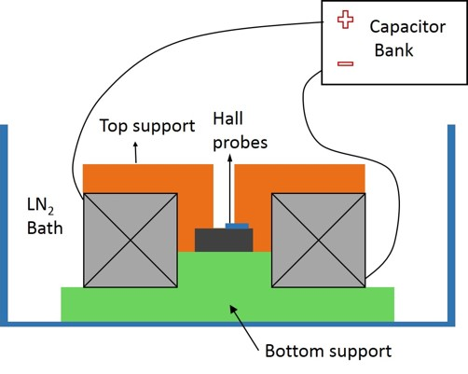

Fig. 1. Schematic image of the PFM set-up. Bulk sample was placed in the centre of a solenoid coil immersed in liquid nitrogen bath. In-situ measurement of the field during the PFM was made by using hall sensors attached to the top surface of the sample.

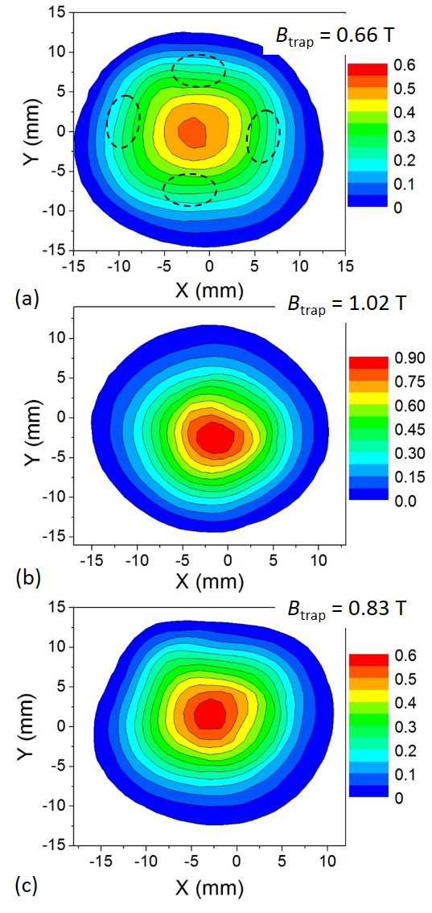
Fig. 2. Trapped field distribution of the samples (a) YBa₂Cu₃O_{7-δ}, (b) GdBa₂Cu₃O_{7-δ} and (c) SmBa₂Cu₃O_{7-δ} after the FCM.

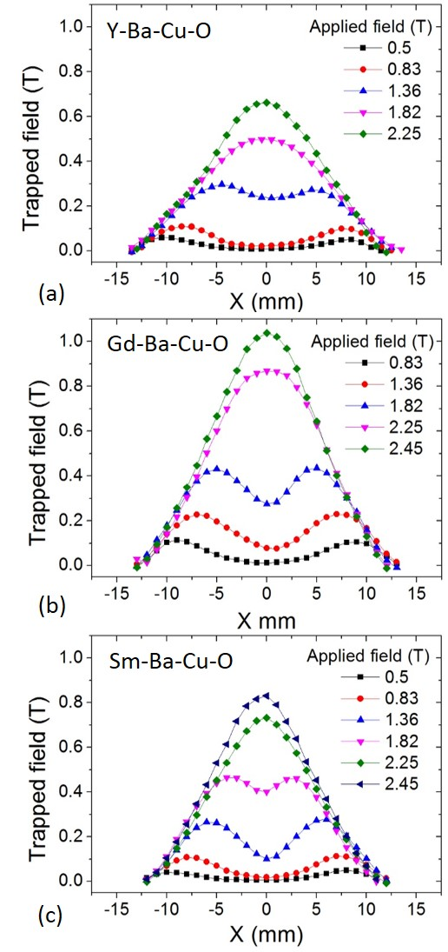

Fig. 3. Trapped field profiles measured across the growth sectors after the PFM for samples (a) YBa₂Cu₃O_{7-δ}, (b) GdBa₂Cu₃O_{7-δ} and (c) SmBa₂Cu₃O_{7-δ}.
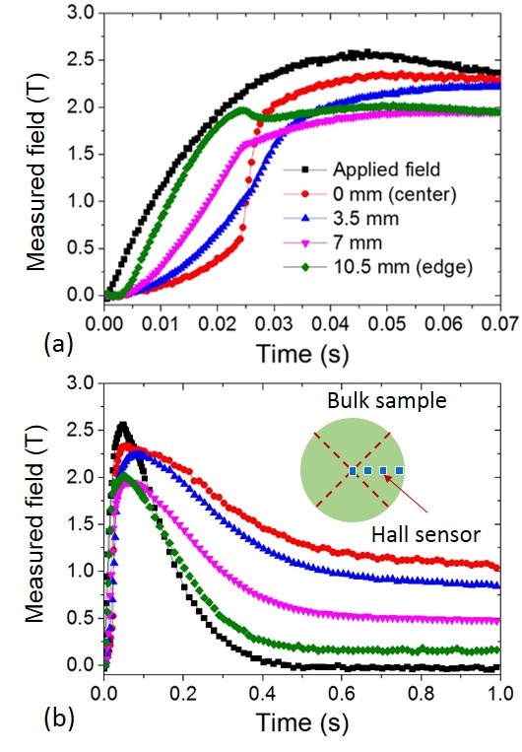
Fig.4 Field measured during the rise of the pulse (a) and the whole process (b), the arrangement of the hall sensors is shown in the in-set of (b). A sudden rise of field at the center accompanied by a dip of field at the edge can be observed during the rise of the pulse.

Table I
A Comparison of Trapped Field from FCM and PFM
Material | Trapped field (FC) | Trapped field (PFM) | Applied field
YBa₂Cu₃O_{7-δ} | 0.66 T | 0.66 T | 2.25 T
GdBa₂Cu₃O_{7-δ} | 1.02 T | 1.03 T | 2.45 T
SmBa₂Cu₃O_{7-δ} | 0.83 T | 0.83 T | 2.45 T

Automatically generated dates of receipt and acceptance will be placed here; authors do not produce these dates. This work was supported by The Boeing Company and by EPSRC (EP/K02910X/1). All data are provided in full in the results section of this paper. The work of M. D. Ainslie was supported by a Royal Academy of Engineering Research Fellowship. The authors are with the Department of Engineering, University of Cambridge, Trumpington Street, Cambridge, CB2 1PZ, UK (e-mail: dz286@cam.ac.uk)

