Structurally graduated collagen scaffolds applied to the ex vivo generation of platelets from human pluripotent stem cell-derived megakaryocytes: enhancing production and purity
Jennifer H Shepherd¹ and Daniel Howard², Amie K Waller², Holly Rebecca Foster², Annett Muller², Thomas Moreau², Amanda L Evans², Meera Arumugam², Guénaëlle Bouët Chalon ², Eleonora Vriend¹, Natalia Davidenko¹, Cedric Ghevaert², Serena M Best¹ and Ruth E Cameron¹.
1. Cambridge Centre for Medical Materials, Department of Materials Science and Metallurgy, 27 Charles Babbage Road, Cambridge, CB3 0FS, U.K.
2. Department of Haematology, University of Cambridge, National Health Blood Service Centre, Long Road, Cambridge, CB2 0PT.
First authorship is shared between Jennifer Shepherd and Daniel Howard, with Cedric Ghevaert, Serena M Best and Ruth E Cameron sharing final author
Abstract
Platelet transfusions are a key treatment option for a range of life threatening conditions including cancer, chemotherapy and surgery. Efficient ex vivo systems to generate donor independent platelets in clinically relevant numbers could provide a useful substitute. Large quantities of megakaryocytes (MKs) can be produced from human pluripotent stem cells, but in 2D culture the ratio of platelets harvested from MK cells has been limited and restricts production rate. The development of biomaterial cell supports that replicate vital hematopoietic micro-environment cues are one strategy that may increase in vitro platelet production rates from iPS derived Megakaryocyte cells.
In this paper, we present the results obtained generating, simulating and using a novel structurally-graded collagen scaffold within a flow bioreactor system seeded with programmed stem cells. Theoretical analysis of porosity using micro-computed tomography analysis and synthetic micro-particle filtration provided a predictive tool to tailor cell distribution throughout the material. When used with MK programmed stem cells the graded scaffolds influenced cell location while maintaining the ability to continuously release metabolically active CD41⁺ CD42⁺ functional platelets. This scaffold design and novel fabrication technique offers a significant advance in understanding the influence of scaffold architectures on cell seeding, retention and platelet production.
Keywords:
Scaffold architecture, Bioreactor, Parallel flow membrane filter, Collagen, Bone marrow model, Depth straining, interconnectivity, Settling zones, Shear flow, Human Induced Pluripotent Stem Cells, Forward Programming, Megakaryocytes, Platelets.
Declarations of Interest
CG is an advisory board member for Platelet Biogenesis (Boston, US).
Contributors
JS and DH were the primary authors, JS planned, manufactured and tested the collagen cell support materials, DH planned and carried out the cell and bioreactor experiments.
AW and HF set up the platelet functional assays and carried the functional analysis on the platelet produced in the bioreactor.
AM, TM and AE set up the assays related to the forward programming of pluripotent stem cells and carried out the production of MKs that were seeded into the bioreactor.
MA and GBC carried out the initial work assessing MK seeding and platelet production within the collagen scaffolds.
EV carried out preliminary work on collagen support design and microparticle filtration
ND was involved with production of collagen cell support materials
CG contributed to the writing of the paper, designed experiments related to the production of MKs from pluripotent stem cells, bioreactor set up, analysis of platelet production and function.
SMB and REC advised on collagen scaffold production, characterisation and optimisation

- Introduction
The major role peripheral blood platelets play is to provide haemostasis through the process of thrombus formation. They also have a key role in the, maintenance of vascular integrity, tissue repair, the development of the lymphatic system and the innate immune response. There is a significant and growing demand for platelet transfusions for patients with primary bone marrow failure, haematological malignancies, inherited platelet disorders and for patients undergoing chemotherapy or radiotherapy for cancer or in the context of hematopoietic stem cell transplantation[1] . Unlike the provision of red cells, platelets represent a challenge in terms of maintaining supply related principally to the fact that they have to be stored above 18°C in order to maintain functionality thereby increasing the risk of bacterial contamination. Donor-derived platelets must therefore be discarded 5-7 days after donation and testing. As a consequence, there is a real drive for the development of a system for the ex vivo generation of donor independent platelets [1-7] .
Megakaryocytes (MKs) that produce the thrombocytes are the largest and rarest cells in the bone marrow making up just 0.01% [8] of the cell population. Automated measuring of marrow MK’s gave a range of MK sizes centred from 5 to 50 μm in normal adult controls with a mean of 19.4 +/- 3.0 μm [9]. By contrast, platelet sizes range from 2 to 4 μm being discoid in shape in un-activated form. To assemble and release platelets the MKs become polyploid and undergo a maturation process where the bulk of their cytoplasm is packaged into multiple long proplatelets. Each MK is able to protrude 10-20 proplatelets which then repeatedly elongate, thin and branch [10]. Nascent platelets then form selectively along the tips of the proplatelets. Platelet production in vivo is highly efficient with 10¹¹ platelets produced each day with an estimated 1-2*10³ platelets released per MK cell[2].
A potential alternative to donor platelet supply is the production of platelets from a renewable source of stem cells, such as human pluripotent stem cells (hPSCs). Definitive steps towards platelet production have been made, however each platelet unit for transfusion contains approximately 3*10¹¹ platelets, therefore highly efficient ex vivo systems are required in order to make this an economically viable venture. In 2011 Lasky and Sullenbarger[3] suggested that there were, at this stage, no available method of producing platelets in vitro in clinically useful numbers and Lambert et al [1] further suggested that in order to address the challenge, large-scale continuous harvesting techniques using bioreactor technologies outside the scope of most research groups would be necessary. We have previously published a forward programming technology (FoP) that can generate large amounts of MKs from hPSCs in chemically-defined media suitable for the generation of a clinical product[7]. However, we and others have shown that the efficiency of platelet collected from these MKs in vitro remains universally well below their true potential (currently 1-10 platelets per MK). To try to address this critical step in platelet production some groups have focused their work on designing bioreactors where the main driver for platelet production has been to submit cultured MKs to high shear in order to promote proplatelet formation and elongation[3, 11-13], others have focused in recreating a 3-dimensional structure akin to the bone marrow environment[14-16].
The work described in this manuscript, takes the approach of using a porous structurally graduated scaffold that can not only provide a structure to support the MKs in a bone marrow-like material but also sieving capacity based on differential cell sizes to enhance the purity of the platelet output.
The material selected for the scaffold is collagen, which has been widely used as a 3-dimensional scaffold structure for tissue regeneration [17-19], tissue analogues in vitro [20] and can be assumed to already fulfil many of the requirements of the support structure for the production of clinical grade cells. We use an extensively crosslinked form of collagen I which changes it into a largely inert template. This approach is supported by the recent work of Davidenko et al, [21] showing that carbodiimide crosslinking of collagen leads to the ablation of integrin-dependent cell stimulation by collagen whilst adding stability and strength to the 3-dimensional structure [21].
Lyophilisation is a technique that can bulk produce relatively homogenous, highly interconnected collagen-based scaffold structures [22-24]. We consider, whether through application of a multi-stage freezing process, this technique could be used to construct structurally graduated scaffolds that would provide a structural support for MKs but also have sieving capacity, based on differential cell size. Iterative freezing, rather than repetition of the complete freeze-drying and cross-linking process [25] should result in the desired graduation. After production of lyophilised scaffolds using a 2-stage freezing process at -20°C and -40°C, we investigate the application of theoretical porosity analysis from high resolution micro- computed tomography scans as well as micro-particle filtration as predictive tools for cell behaviour.
The 2-layer collagen scaffolds were integrated into a novel twin chamber culture system, whereby one side of the chamber allows the seeding of the cultured hPSC-derived MKs into the scaffold while cross flow subjects them to shear forces to induce platelet release into the parallel collecting flow. The scaffold was designed in order to contain the MKs within its porous structure whilst allowing collection of platelets by the outlet flow, taking advantage of the discrepancy in size between the MKs (>10µm) and their platelet progeny (<4µm).
The work thus combines novel engineered scaffold structures and a bespoke bioreactor with a highly efficient hPSC culture protocol to bring functional in vitro platelet production closer to clinically relevant levels.
- Materials and Methods
  - Materials
Type I collagen from Bovine Dermis was provided by Collagen Solutions (UK). Acetic acid, 1-ethyl-3-(3-dimethylaminopropyl) carbodiimide (EDC), N-Hydroxysuccinimide (NHS), prostaglandin I2 (PGI₂), Acid citrate-dextrose (ACD), 3,3′-Dihexyloxacarbocyanine iodide (DIOC6), Ethylenediaminetetraacetic acid (EDTA), thrombin receptor activator peptide 6 (TRAP6), formaldehyde and Dulbecos Phosphate Buffered Saline (DPBS) were purchased from Sigma Aldrich (UK). Calcein, AM (50 µg aliquots), and Calcein violet, AM live cell tracker dyes and CellTracker™ Red CMTPX dye were purchased from InVitrogen (UK). HORM collagen by Takeda Austria. Vena8 Biochip from Cellex, Dublin. Anti-CD41a APC-H7, anti-CD42a APC and anti-P-selectin APC were purchased from BD Pharmingen (UK). Anti-fibrinogen FITC was purchased from Agilent (UK). Calcium free RPMI media was purchased from Gibco (UK). Platelet storage bags were purchased from Macopharm (UK). OCT cryostat embedding compound was purchased from VWR (UK). Polysine slides and PermaFluor aqueous mounting media were purchased from Thermo Scientific (UK). Biosera Bovine serum albumin (BSA) was purchased from Labtech (UK).
  - Layered Scaffold Production
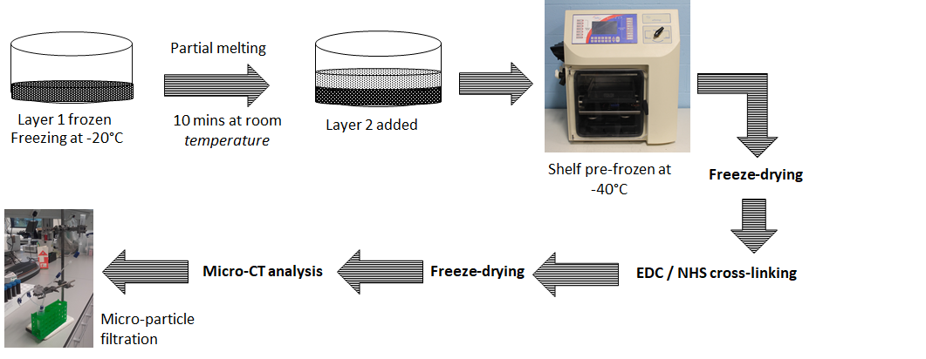
Type I insoluble collagen was swollen for 48 hours in 0.05M acetic acid at 4°C prior to blending and vacuum degassing in order to produce a 1wt.% suspension. Suspensions were frozen and lyophilised in a 24-well plate. 380 μl of suspension was added per layer giving a scaffold thickness of 3.5mm. A schematic of the scaffold production process is demonstrated in Fig. 1. A two-stage freezing process was applied with the base layer frozen at -20°C proceeding the application and freezing of a top layer at -40°C. The authors have considered scaffold production at a range of freezing temperatures and rates and found rapid freezing at temperatures of -20°C and -40°C to result in a statistically significant difference in mean pore size and interconnectivity (see supplementary data Figure S1). The interconnectivity data particularly suggested promise for these two freezing conditions for cell-sieving capability. Application of a vacuum and sublimation dried the scaffold whilst retaining the ice-templated structure. EDC/NHS cross-linking was carried out at a concentration of 100% as defined previously [21] . Cross-linking reagents were dissolved in 95% ethanol and samples were soaked for 2 hours before thorough washing with deionised water. A further freeze-drying cycle was then carried out.
Figure 1: Schematic of the production flow chart for dual layer structurally graduated collagen scaffolds. Collagen slurry (1wt %) was pipetted into standard 24 well plates prior to freezing in -20°C freezer for 1 hour. After 10 minutes at room temperature to allow partial melting, the second layer of slurry was added prior to further freezing and sublimation using a VirTis AdVantage freeze-dryer with a shelf temperature of -40°C. EDC/NHS cross-liking was applied prior to a final freeze-drying step.

Micro-computed Tomography
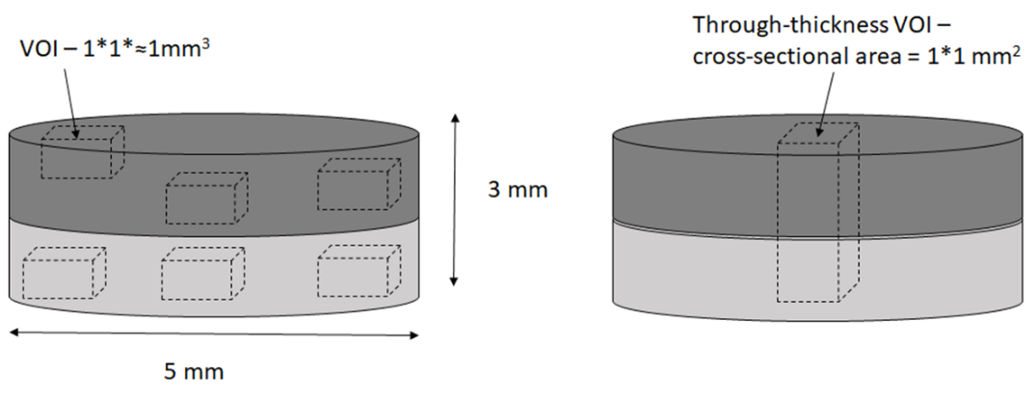
Samples of collagen support material were extensively analysed using a Skyscan 1272 Micro-CT system (Bruker Belgium). 5 mm diameter punched samples were scanned with a pixel size of 1.5 µm, an operating voltage of 25kV, 0.2° step size with frame averaging of 2 and 180° rotation. The resulting projections were processed into 3D data sets using a full cone beam Feldkamp reconstruction algorithm with NRecon software (Bruker, Belgium). Systematic volumes of interest (VOIs) were selected through the scaffold structures and detailed three-dimensional pore analysis carried out in CTAn (Bruker Belgium). For the purposes of pore size analysis, multiple VOIs of 1*1mm cross-section were selected in top and bottom regions of the scaffold (Fig. 2a.). Precise thickness of these VOIs was dependent upon the specific structure of each scaffold (ensuring analysis was of the bulk region of the layers and not the interface) but was approximately 1mm.
b.
a.
Figure 2: Schematic of volume of interest (VOI) positioning for micro-CT analysis; (a.) multiple VOIs in bulk of upper and lower layers for pore size analysis; (b.) through-thickness VOI for interconnectivity analysis.
The shrink-wrap feature of CTAn was used in an analysis of scaffold interconnectivity, VOIs were modified to allow penetration only from the top x-y plane and the shrink wrap feature used to identify the volume accessible to a virtual object ‘d’. This was used to investigate the penetration of ‘cell-sized’ particles through the individual layer structures. Because interconnectivity is not a scalable property (the percentage porosity penetrable applies only for the specific size of region of interest considered), it was important to additionally consider interconnectivity in approximately through-thickness sections (Fig. 2b) of the entire composite structure. 3D representations of accessible pathways as well as false-coloured models of pore size distribution were generated using CTVox (Bruker, Belgium). For structural analysis, three VOIs were selected from top and bottom regions of each of two scaffold samples with no significant intra-sample variation observed.

Micro-particle retention
In order to replicate the bioreactor set-up described below, 8mm square sections of collagen scaffold were secured in a polycarbonate test-block after overnight soaking in 70% ethanol. Solutions of 10 μm and 20 μm monodisperse polystyrene microparticles (Sigma Aldrich) were used at a concentration of 1x10⁶ and 5x10⁵ml⁻¹ respectively. Filtration analysis of the two-sized particles were carried out separately. Scaffolds were soaked in DPBS before degassing and 10ml DPBS was run through the scaffold. 5ml of microsphere solution was then run through the scaffold and collected, followed by thorough washing with DI H₂O. Outflow was analysed using a C-Chip disposable Haemocytometer (C-chip, Nanoentek) on a Zeiss Axio Observer Z1 phase contrast microscope fitted with a Zeiss Axiocam 503 mono camera using a 10* objective lens. Particles were counted using ImageJ and particle distribution was also investigated through the scaffold structure using micro-CT. For micro-CT analysis scaffolds were thoroughly washed with DI H₂O to remove excess residual salts from the DPBS and samples then freeze-dried to maintain pore structure. Scanning was carried out in the dry state with a pixel size of 3 μm.

Production of Megakaryocytes by Forward Programming iPS cells.
The production of MKs from hPSCs was carried out using forward programming (FoP) as described in Moreau et al [7]. In short, hPSCs were transduced with replication deficient lentiviral vectors to overexpress the 3 transcription factors FLI1, TAL1 and GATA1. After 2 days in a mesoderm promoting medium (Essential-6, Gibco) containing bone morphogenetic protein 4 (BMP4 10ng/mL, Bio-Techne) and fibroblast growth factor 2 (FGF2 20ng/mL, Bio-Techne) the cells were cultured in a MK culture medium (CellGro, CellGenix) containing thrombopoietin (TPO 20ng/mL, Bio-Techne) and stem cell factor (SCF 25ng/mL, Gibco), which was refreshed by 50% medium exchange every 72 hours. These Forward Programmed MKs (FoP MKs) were used after 20 or more days in culture when the population of MKs (cells expressing CD41 or αIIb, a marker of early MK development cells) was >90% whilst matured MKs’ represented >70% based on the co-expression of the CD41a and CD42a (a marker of mature MK integral to the von Willebrand factor [vWF] receptor) and exclusion of DAPI. Before seeding into the bioreactor, MKs were centrifuged at 120g and resuspended in RPMI media and used at a concentration of 4 million viable cells in 5 mL for cell retention assays when testing filtration rates and 400,000 viable cells in 5 mL for seeding into the bioreactor system for overnight culture and collection of platelets for functional assays.

Parallel flow filter bioreactor design and operation
The parallel flow bioreactor design shapes a stable, near laminar, flow over the surfaces of the graded collagen scaffold. Flow in the channels before and after the bioreactor were regulated externally away from the flow chamber (Figure 3) by addition of pinch valves and restrictions. The chamber was custom made from polycarbonate to provide a resilient polymer surface with low platelet reactivity, the fixtures and fittings were made from Polypropylene and medical grade PVC tubing to reduce exposure of the cells to charged or cell reactive surfaces. A 10 cm link of PDMS tubing was put before and after the chamber to provide gas exchange. A regulated gravitational flow system was used to seed and setup the system to reduce interaction of cells or platelets with a mechanical pumping system. An 8x8x4mm duel layered collagen scaffold was glued into a holding frame within the bioreactor system (with a 5x5mm aperture at the upper and lower surfaces). The bioreactor system was initiated with 5 ml DPBS by gravity feed, 5 ml DPBS to rinse the system, 5 ml blocking solution of RPMI containing 0.01% BSA for 30 minutes, followed by thorough DPBS rinsing and finally twice washed with 5 ml of RPMI culture media for ten minutes.
For culture and platelet production runs 400,000 FoP MKs were loaded into the collagen scaffold in 5mL of RPMI media (as described previously) over 5 minutes followed by three 5 ml washes of RPMI media to remove any unbound cells and residual platelets from the system. The bioreactor was then put in a 37°C 5% CO₂ supplemented incubator and perfused by gravity from reservoirs of RPMI media controlled by external pinch valves to provide a sequential pulsed flow for a second every 20 seconds overnight (19 hours+) as an indicator of long-term culture performance. Pulsed flow was to provide a high peak flow rate while keeping the collection volume to a minimum. The outflow was collected into a polypropylene container pre-loaded with 50% ACD in RPMI and kept on a rocker at 18 RPM at room temperature (21°C).
Figure 3. The bioreactor was designed to provide a stabilised controlled flow of media across and through the collagen cell support (a.) Simplified schematic of media flow around and through the collagen cell filter (central block) by controlling the flow to divert media through, provide shear flow and flow out into the collection side (bottom left side of the diagram), (b.) CAD of the flow shaping central bioreactor block that contains the collagen filter, (c.) central bioreactor block connected to the reservoirs and connector lines (clamped for moving to the incubator), (d.) the system with central flow block in the incubator, connected to the external control valves and computer control, (e.) diagrammatic overview of the system showing the order of valves (V) and flow resistors (R) to bias and provide control of the flow through the system.

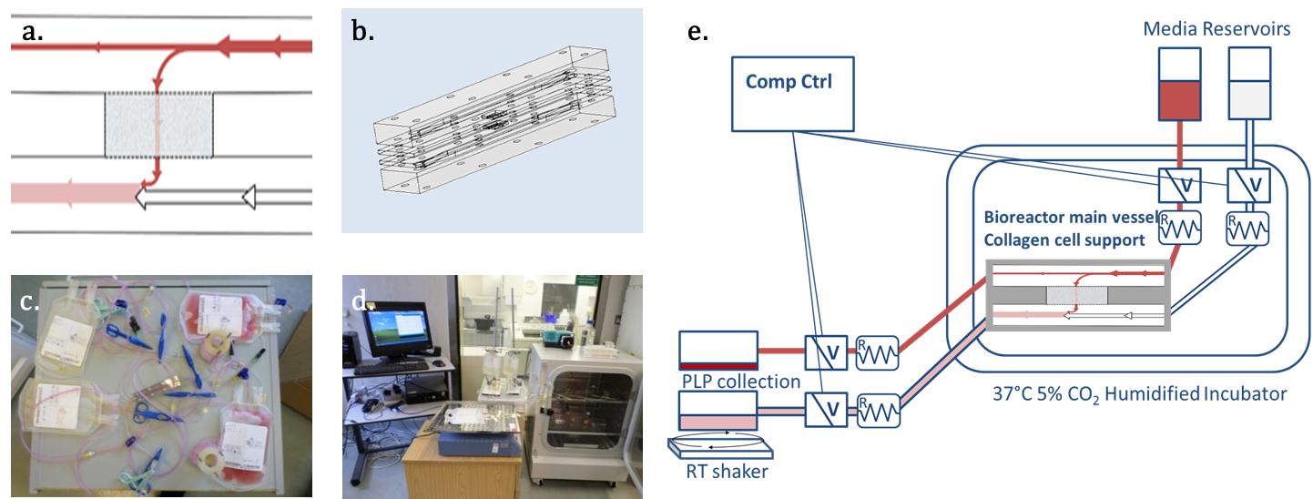
Flow cytometry for bioreactor cell and platelet retention and release analysis
Samples were taken from the starting cell inflow solution, seeding outflow, three washes and the overnight collection. 400µL of each sample was incubated with 1;20,000/100nM Calcein AM (Thermo Scientific), anti-CD41a APC-H7 and anti-CD42a APC. The vital dye Calcein AM is cell permeable. Once inside the cytoplasm it is hydrolysed by cytoplasmic esterases making it fluorescent and cell impermeable. Cells that stain positive with Calcein AM are therefore metabolically active and have an intact membrane. Following incubation, samples were diluted in 500µL of PBE buffer (PBS containing 5mM EDTA and 0.2% BSA). The overnight collection contained ACD in order to prevent platelet activation in the collected sample. Flow count fluorospheres (Beckman Coulter) were used to compare the volumes used in the analysis. Samples were analysed using both forward scatter (FS) / side scatter (SS) and fluorescent immune-labelling using a Gallios Flow cytometer (Beckman Coulter) and compared against non-stained and blank tests. Viable MK and platelet retention was calculated as the absolute number of triple positive events (CD41+, CD42+ and calcein AM+) in the MK or platelet gate (as defined by FS/SS). Calculation of the number of MKs retained within the scaffolds was based on the number in the inflow minus the seeding outflow and washes. The number of platelets produced per MK overnight was based on the number of platelets in the overnight collection and per retained MK.
  - Platelet function measured by flow cytometry
The bioreactor outflow was centrifuged at 120g for 20 min then 1.5 µM of labile PGI₂ added to the supernatant before further centrifugation at 1420g for 10 min to temporarily sequester activation. The platelet pellet was then re-suspended in Tyrode’s buffer (134mM NaCl, 2.9mM KCl, 0.34mM Na2HPO4.2H20, 12mM NaHCO3, 20mM HEPES, 1mM MgCl2.6H20, 5mM D-Glucose, pH 7.3.) and used for functional assays within 4 hours. For functional flow cytometry 5µl of platelets were incubated with Calcein violet AM, anti-CD41a APC-H7, anti-fibrinogen FITC, anti-P-selectin APC and 10 µM of thrombin receptor activator peptide 6 (TRAP6) for 20 mins. Samples were then fixed and diluted in 495 µl of 0.2 % formyl saline. Samples were analysed using forward/side scatter and fluorescent immune-labelling using a Gallios Flow cytometer and compared against isotype controls.
2.9. In vitro thrombus formation under flow
Collected bioreactor outflow was centrifuged at 120 g for 20 mins and 1.5µM of labile PGI₂ was added to the supernatant before further centrifugation at 1420 g for 10mins. After suspension in Tyrode’s buffer (see above), in vitro platelets or donor platelets were stained with 1µM CellTracker™ Red and added 1:99 to human donor platelets previously stained with DIOC6 (green) in whole blood. Samples were perfused through a collagen coated (HORM collagen, Takeda Austria) Vena8 Biochip (Cellex, Dublin) blocked with 1% BSA. Samples were run at 40µl/min, equal to 1000 s-1 for 1 min, as an in vitro approximation for clot formation in arterial shear flow, and imaged on an Axiovert 40 CFL microscope. Clots were examined for surface area using the different fluorescent dyes and compared. Images were analysed using ImageJ software by calculating the mean and standard deviation of the mean fluorescence intensity of the field of view. This figure acted as a minimum threshold number allowing the measurement of the area covered by red or green stained platelets[26]. The red area (CellTracker red) was then divided by the green (DIOC6) area to give percentage incorporation.
2.10. Platelet adhesion and spreading microscopy
To examine platelet adhesion characteristics glass coverslips were coated with 200 μg/mL fibrinogen in DPBS for 1 hour at room temperature and subsequently blocked with 1% BSA before rinsing. 200 μl of overnight bioreactor outflow was added onto coverslips coated with fibrinogen and incubated for 1 hour at 37°C, gently washed with DPBS 3 times and fixed with 4% PFA. Fixed adhered platelets were then rinsed and permeablised with saponin gelatine PBS before incubation with anti-α-tubulin antibody at 1:250 washed and detected with anti mouse alexa488 diluted 1:1000, also containing Phalloidin Alexa555 1:2000 (to detect Actin) and DAPI (to detect nucleic acids) for 1 hour. Samples were then rinsed in saponin gelatine PBS 3 times then PBS before mounting. Samples were imaged on a Leica DMi8 fluorescence microscope.

Microscopy of MK loaded scaffolds
Scaffolds containing FoP MKs were stained with 200nM Calcein AM for one hour before thorough rinsing with DPBS and fixation in 4% paraformaldehyde. The scaffold cassette holder and stained scaffolds were then removed and immediately imaged on the upper and lower surfaces using phase contrast and fluorescence with an EVOSfl microscope. For histological examination a 3 mm diameter biopsy punch section was taken of the scaffolds. The biopsy was soaked in CryoMbed and snap frozen using dry ice-cooled ethanol and sectioned with a Leica CM3050S cryostat. Sections were mounted on polysine charged slides and cover slipped using PermaFluor aqueous mounting media.
  - Statistical Analysis
Normality of data was investigated using the Shapiro–Wilk test. Statistical significance was then determined using either a student’s t test or a Kruskal - Wallis followed by a Mann-Whitney (Wilcoxon) test with significance defined as p<0.05 (JMP® software SAS Institute Inc).

Results

Characterisation of the pore structure
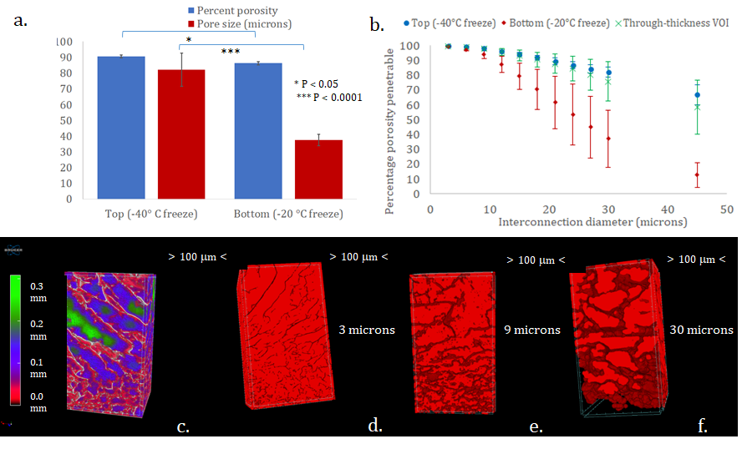
The multi-stage freezing process resulted in a scaffold with significant variation in pore structure between top and bottom regions (Fig. 4a). In terms of both mean pore size and percent porosity, the top region demonstrated a more open structure. This result was reinforced in the interconnectivity analysis (Fig. 4b) where the top region maintained high accessibility to a size of up to 50 μm diameter whilst the base region was only around 10% accessible to this largest theoretical sphere.
Figure 4: Porosity analysis of dual layer structures. Bottom layers were frozen at -20°C and top at -40°C. (a.) A statistically significant difference was observed between the two layers in terms of both percent porosity (P<0.01) and pore size (p<0.0001), (b.) interconnectivity analysis was carried out through a shrink-wrap process with increasingly larger voxel size (the effective interconnection diameter). For top and bottom analysis regions of interest were approximately 1mm³, also included is the through-thickness interconnectivity analysis considered section 1 mm *1 mm * through-thickness. (c.) - (e.) Volume rendered models (CTVox Bruker Micro-CT Ltd) of through-thickness VOIs demonstrating typical structural variability. In (c.) false coloured pore size distribution is superimposed upon the scaffold structure; (d.) , (e.) and (f.) show accessible pathways calculated during the percolation analysis for theoretical spheres of diameter 3 µm, 9 µm and 30 µm respectively. Due to the projected nature of the images > 100 µm < refers to separation between the graduations on the binding boxes.
Interconnectivity analysis of through-thickness VOIs resulted in values of percentage porosity accessible only marginally reduced compared with the more open top-region. Given the top to bottom directional interconnectivity analysis this clearly demonstrates a highly accessible interfacial region with only the bottom region limiting theoretical sphere passage. The false coloured, volume rendered model of the scaffold structure superimposed with pore size distribution (Fig. 4c) provides a key tool in visualising the structural variation of the scaffolds, whilst also indicating the coherent nature of the interface. Volume rendered models of the accessible pathways (Fig. 4d-f), provide a clear pictorial impression of the interconnectivity analysis. Both MKs and platelets have a diameter less than 30 μm (Fig. 4f) and thus this theoretical analysis may suggest minimal selection capability for the cells in question.

Microparticle filtration
Analysis of the scaffolds filtration potential was carried out by flowing microspheres of varying sizes (10 and 20 μm) through the scaffold. Whilst no 20 μm particles appeared to fully penetrate the structure, on average 60% of the smaller microparticles passed through (Fig.5a). A high level of cell-selection capability was thus indicated. Micro-CT scanning of washed and freeze-dried samples after the filtration process (Fig. 5b-g) indicated 20 μm particles could be imaged and also independently segmented in the reconstructed images. The 20 μm particles were well distributed through the whole scaffold structure with a number gradient apparent through thickness. Whether it was a consequence of fewer 10 μm particles being constrained within the scaffold, or their reduced size making them less detectable given the ratio between diameter and scan pixel size, 10 μm particle presence was harder to identify.
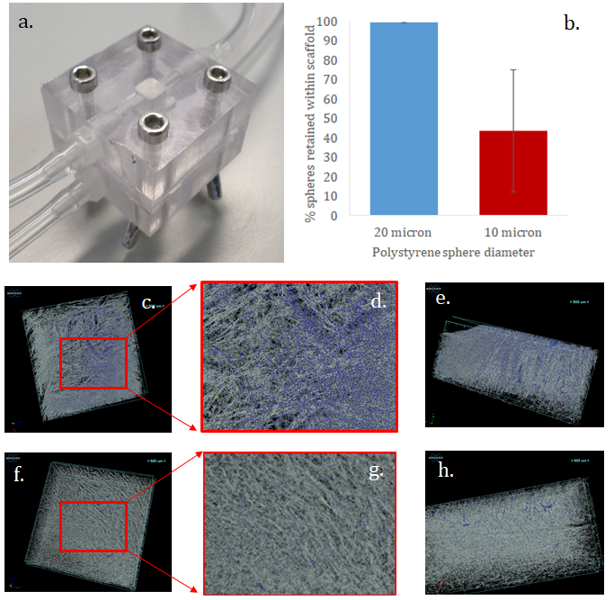

Figure 5: (a) The simplified version of the bioreactor used as a test system. (b) Numbers of 10 and 20 μm micro-particles remaining in the filtrate after passage through the dual-layer structure, calculated using a C-chip Haemocytometer. Whilst a significant proportion of the 10 micron particles passed through the scaffold, no significant number of the 20 micron diameter particles were observed in the filtrate. (c–h) CTVox false-coloured projections of microparticles within the collagen scaffold. (c-e) are of 20 μm particles and (f-h) 10 μm particles. (c) and (f) show the top surface of the scaffold structures with (d) and (g) focusing in to highlight the particle distribution; (e) and (h) are vertical cross-sections through the centre of the scaffold demonstrating through-thickness particle distribution. 20 micron particles were clearly observed through the scaffold structure with number appearing to decrease with distance through the scaffold. 10 micron particles were less evident, attributed in part to their size and scanning and segmentation constraints but more to the relatively small proportion retained within the scaffold structure.

Collagen scaffolds selectively retained MKs and released platelet particles
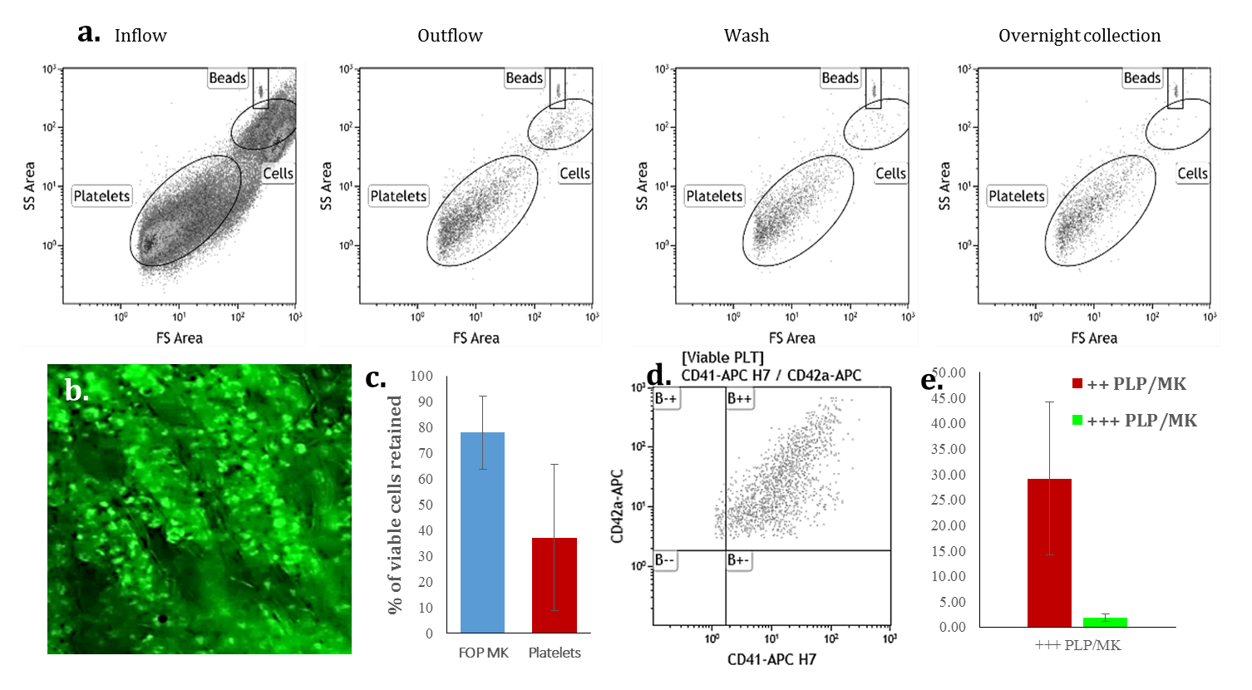
Dual layer collagen scaffolds mounted within the parallel flow bioreactor described in Figure 3 demonstrated retention of FoP MKs throughout the structure as shown by DIOC6 staining (Fig. 6). The larger FoP MKs were selectively retained compared to the smaller platelets which is evident in the FS/SS flow plot of the inflow, outflow and washes (Fig. 6a.) where greatly decreased numbers of cells are present after the inflow whilst platelet-size events continue to be collected. We quantified this by defining viable MKs and platelets through using three criteria: 1. the FS/SS size scatter, 2. expression of CD41 and CD42 surface markers and 3. activation/cytoplasmic retention of the viable stain Calcein AM (Figure 6d.). Collagen scaffold retention of viable MKs was 78% ± 17, whilst viable platelet retention was 37% ± 33 (Fig. 6c.) indicating a selection capacity similar to that described in the simulated rate exemplified in Fig. 5b. We also confirmed that platelets were released from the seeded MKs by pre-staining the cells with Calcein-AM prior to seeding and checking for labelled particles to be produced, Platelets from the overnight collection were fluorescent without the addition of any further dye (data not shown). We went on to quantify the number of platelets released overnight (as described above). Each CD41⁺ CD42⁺ MK cell trapped within the bioreactor was capable of releasing 29.2 ±15 CD41⁺ CD42⁺ platelets. When high calcein AM fluorescent signal was added as a third criteria, the number of metabolically active intact platelets released per viable MK was much lower at 1.8 ±0.7 (Fig. 6d,e.), indicating that a subset of the platelets had either reduced metabolic activity and/or porous membrane reflecting cell death.
Figure 6: (a.) Flow cytometry plots (FS/SS) of the FoP MKs and platelet solution before loading into a scaffold, from the Inflow, and then in the Outflow (filtrate), Wash and Overnight collection from the bioreactor (inc count beads for volume reference). (b.) FoP MKs labelled with DIOC6 (green) were seeded into the collagen scaffold in the parallel flow chamber (4e6 seeded). (c.) Retention of CD41⁺ CD42⁺ iPSC FoP MK cells and in vitro platelets within the scaffold based on flow cytometry forward scatter, side scatter and Calcein conversion (size and cell activity, n=3). (d.) In vitro platelets were gated based on FS/SS for size and granularity, membrane integrity and enzyme activity (Calcein-AM staining) and the presence of CD41 and CD42 cell surface markers. (e.) In vitro platelet recovery estimate by comparison to the number of cells trapped within the collagen scaffold (n=5). Results shown as the mean number of CD41 and CD42 in vitro platelets per MK +/- SEM.

Platelet particles released by MK’s within the collagen scaffold are functional

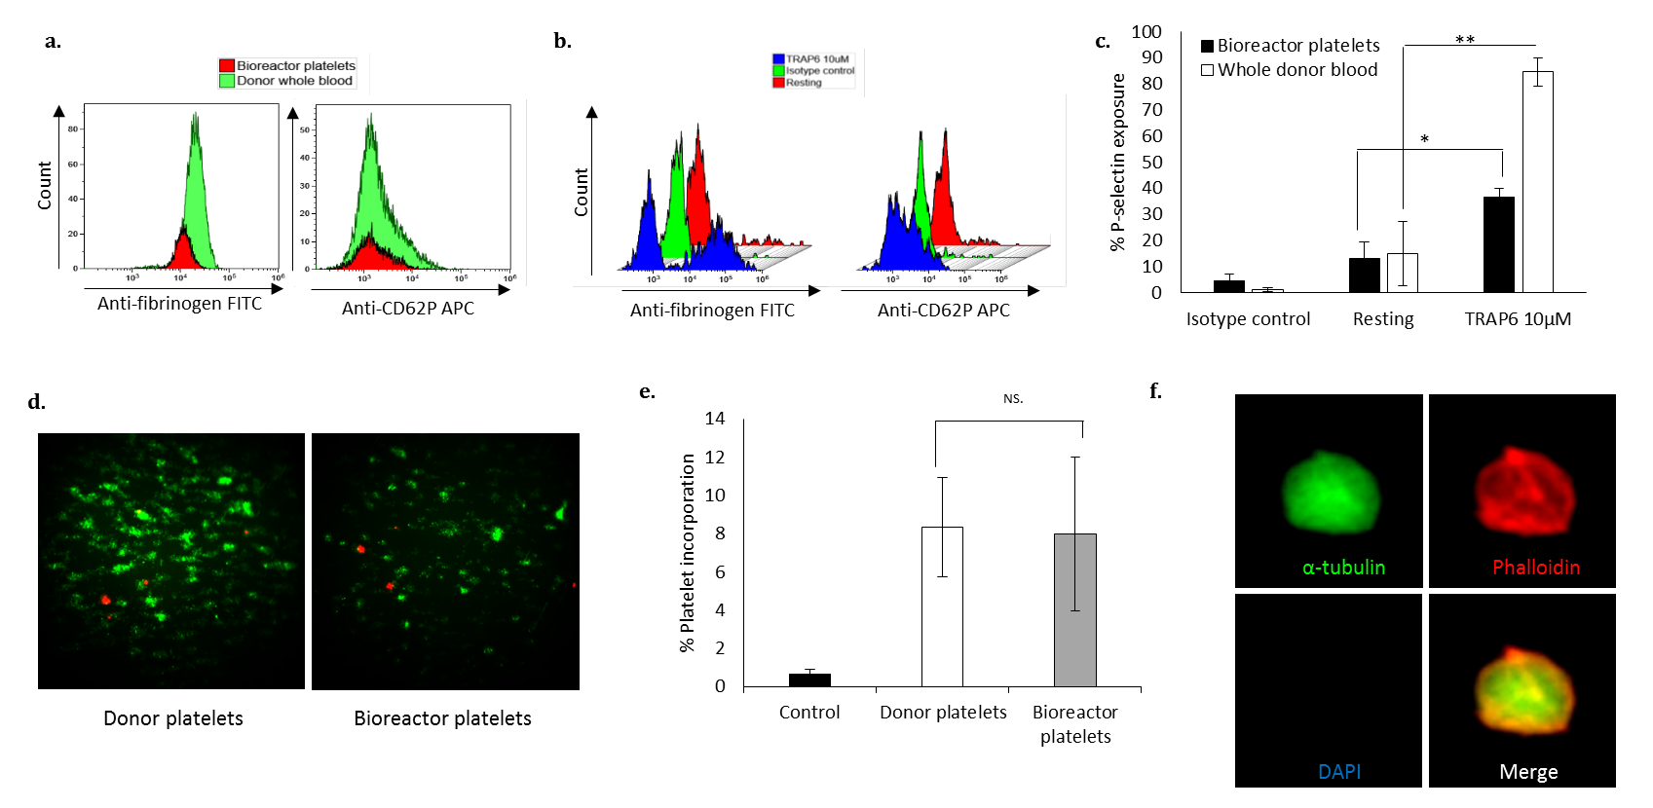
Under normal circumstances platelets circulate in a resting, inactivated state. Upon injury to the blood vessel, platelets bind to the exposed extracellular matrix under the influence of shear, leading ultimately to the activation of integrin αIIbβ3 which allows activated platelets to bind to each other via fibrinogen bridges [27]. Further activation of αIIbβ3 on neighbouring platelets stimulates outside-in-signalling resulting in the release of platelet granular contents accelerating thrombus formation and promoting the coagulation cascade [28]. First we demonstrated that viable platelets released by the FoP MKs trapped within the collagen scaffold were not activated by measuring fibrinogen binding to activated αIIbβ3 and P-selectin exposure (a marker of α-granules released), using flow cytometry on the collected platelets in the absence of any agonists. There was minor variation between the collected platelets and donated control platelets for fibrinogen binding and P-selectin exposure (Fig. 7a). When the collected platelets were challenged with platelet agonist TRAP6 a shift in the percentage positive platelets was observed for fibrinogen binding and P-selectin exposure (Fig. 7b,c). The mean percentage positive platelets with exposed P-selectin was 36.9 ±3%, compared to a shift of 84.8 ±8.4% for donor-derived platelets stimulated in the same way (Fig. 7c.). In addition, the collected platelets were labelled and added to a whole blood sample and circulated through a collagen-coated high shear flow chamber. The coated chamber mimics an injured blood vessel and the number of “transfused” platelets taking part in the thrombi can be assessed microscopically (Fig 7d.). The in vitro derived platelets were shown to incorporate into the thrombi generated within the flow chamber and did so with a comparable efficiency to donor-derived platelets (Fig 7e.). Finally, we looked at platelet spreading in static conditions on fibrinogen-coated slides and showed that the in vitro-derived platelets spread and showed typical cytoskeletal organisation (Fig. 7f.).
Figure 7: Platelets from the bioreactor outflow and from whole donor blood were stained with calcein AM violet, anti-CD42 PE-CF954, anti-fibrinogen FITC and anti-CD62P APC and analysed by flow cytometry. (a) Representative histograms showing fibrinogen binding and P-selectin exposure of the CD42⁺/calcein AM violet⁺ viable platelets without agonist confirming the absence of pre-activation of the platelets collected from the bioreactor. (b) Representative histograms showing CD42⁺/calcein AM violet⁺ platelets fibrinogen binding (b) and P-selectin exposure with and without the addition of the thrombin analog agonist TRAP6. (c.) Mean of P-selectin exposure with and without the addition of TRAP6 (n=3, + SEM, *P<0.05, **P<0.01). (d.-e.) Platelets from the bioreactor outflow or from a blood donor were stained with CellTracker™ Red CMTPX and added to whole human donor blood containing platelets pre-stained with DiOC₆ (green). The blood was run at high shear through a collagen-coated Vena8 biochip to assess thrombus formation. (d) shows representative images of donor and bioreactor outflow platelets (in red) taking part in the thrombus formation together with the endogenous platelets from the whole blood (in green) (e.) The numbers of donor and bioreactor platelets taking part in thrombi were quantified and shown to be similar (n=3, +SEM, ^{NS.}P>0.05). (f.) Platelets from the bioreactor outflow were spread on fibrinogen coated glass coverslips and stained with anti-tubulin (green), phalloidin (Actin staining, in red)) and DAPI (nucleic acids). The spread platelets show the typical stress fibres distribution.

Discussion
These scaffolds are examples of functionally graded materials [29] and can be designed to provide biological and mechanical functions similar to those of native tissues. Tissues often show structural graduation and an associated partitioning of specific cell types; A scaffold such as that created here can thus have far wider application than the ex vivo cell separation described; any replication of tissue structure or cell distribution is likely to enhance in situ tissue regeneration.
There is a body of research considering multilayer systems with pore size variation. The use of soluble porogens [30-32] proves a popular method of inducing this variation as packing spheres of different diameters is a highly efficient method of generating pore size variation; other methods include centrifugation [33] and additive manufacturing [34]. The highly interconnected structure of freeze-dried scaffolds has led to particular application in cartilage repair and Levingstone et al used a multi-stage freeze-drying process in order to mimic the inherent gradient structure of healthy osteochondral tissue [25]. In Levingstone’s process, freeze-drying and cross-linking are carried out at each stage with hydration with acetic acid prior to the pouring of the next slurry layer. Three layer structures were produced with fully interconnected interfaces and high interfacial strengths, but the structure could not accurately be defined as graduated with distinct pore size variation between the layers. As a consequence of our single drying step after two stage freezing and partial melting of the primary layer, a clear graduation in pore size was observed (Fig. 4). This was particularly desired in the platelet application process where graduation was more likely to support high numbers of live MK cells and allow for pro-platelet formation, elongation, branching and platelet generation, whilst minimising MK transfer into the outflow.
In this work we have considered porosity analysis as a predictor for cell location under unidirectional flow. Scaffolds fabricated from natural polymers particularly through freeze-drying have an intrinsic variability. They can be hard to characterise and as Ashworth et al [35] have pointed out the relationship between scaffold interconnectivity and cell migration is an important but complex factor in tissue regeneration [35]. The size and degree of interconnections are key. Traditionally pore structure has been analysed using serial sectioning[36] and scanning electron microscopy[37], however it is for the characterisation of such structures that micro-computed tomography comes to the forefront.
The method of accessible space for various minimum interconnections has been previously considered by Moore et al [38] who used a non-directional analysis of the percentage porosity penetrable. However as Ashworth et al point out, such an analysis is not scalable, the percentage applies only to the region of interest in question [35]. Whilst Ashworth introduced the idea of percolation diameter as a scale invariant parameter, this analysis can be applied only to a homogeneous scaffold structure; the idea of an infinite scaffold is meaningless with a graduated structure. Instead in our study we considered an approximately through-thickness region of interest and a directional interconnectivity analysis, for completion this was compared to smaller volumes of interest within the bulk of each layer. This theoretical analysis predicted a highly accessible space for both MKs and platelets. Treating the MKs as 30 μm particles, the through-thickness analysis predicted around 80% accessibility (Fig. 4b) and as demonstrated in Fig. 4f complete paths through the thickness of the scaffold structure. Whilst this might suggest minimal promise as a cell sieving material, the analysis does not take into account; cell-substrate interactions, the blocking of pathways by cells, generated extra-cellular matrix or high cell loiter times. The promise of the system as a cellular sieve was much better demonstrated in the microparticle analysis. Here close to 100% of the 20 μm diameter particles were retained within the scaffold structure, compared to only 40% of the 10 μm particles. The retained 20 μm particles were found to be well-distributed through the scaffold. When the same analysis was carried out with MKs and platelets, retention in the scaffold was approximately 80% and 40% respectively (Fig. 7). Cells are not dense spheres and are able to deform and squeeze through smaller channels hence perhaps the reduced retention values. The microparticle analysis is undoubtedly a simplification of the complex cellular interactions which exist between cell and scaffold, but it does appear this analysis may provide some predictor of cell behaviour in the context discussed here.
The collagen scaffold described functions primarily as a bypass flow filter but with the key crucial differences that the flow is specifically stabilised and shaped and larger MKs are retained within the material where they can be maintained for extended culture whilst still releasing the smaller platelets. Given their differential sizes and the carefully designed porosity of the collagen scaffolds, these platelets can be harvested at high purity. Easier to produce isotropic filters that allow passage of sub-10 μm particles locate cells mostly on the surface of the material, thereby reducing available surface area and producing detrimental areas of high cell density. Additionally, isotropic filters fill quickly and reduce flow rates and put cells at a greatly increased susceptibility of being washed off the surface. Infiltration within the scaffold traps more cells and gives better niche definition for extended culture. This collagen scaffold has provided a stable structure capable of maintaining the MKs while at the same time allowing for the provision of a shear flow for promoting proplatelet formation and allowing the collection of newly released platelets at the outlet.
The internal structure of the foamed collagen forms zones of low flow at the edges of the chambers allowing cells to settle, whilst flow from one chamber reticulation to another produces a central flow region that provides a gradient of shear, thereby maintaining cell interaction with the scaffold, adjacent to higher flow regions.
It is possible that further modifications of the geometry and surface characteristics may increase accommodation of the differentiation stages and improve the efficiency of platelet production. The simulation based on microCT data as well as simulated runs with microbeads provided a useful guide to future designs prior to using more time consuming expensive cellular products.
Collagen I is the main constituent of the bone marrow extracellular matrix where it prevents platelet formation prior to the maturing MKs reaching the sinusoids and of course platelets readily become activated when in contact with collagen. This is mediated by several collagen receptors, chiefly the integrin α2β1and the activating receptor GPVI and its inhibitory counterpart LAIR1[39] (the latter is predominantly expressed on the MKs). The cross linker used in this study has previously been shown to abrogate the majority of interaction between adhesive integrins (such as α2β1) and the cross-linked scaffolds [40-42]. However, our data shows that the cross-linked collagen scaffold allows the passage of CD41⁺ CD42⁺ platelets that remain in a resting state and are still capable of activation when challenged suggesting that the cross-linking inactivates enough GPVI interaction with platelets to allow passage of platelets.
MKs found within the bone marrow niche efficiently produce high numbers of functional platelets (estimated at over 10³ per MK) but our ability to mimic or trigger this mechanism remains limited. Increasing demand for platelet transfusion support for thrombocytopenic patients has given an impetus to the research striving to produce platelets ex vivo. As the technology to produce MKs from renewable sources of stem cells has improved, the next question focuses on the mechanisms of platelet release and the generation of a functional platelet product at high purity. In this paper, we demonstrate a novel 2-layer collagen scaffold can provide a structure into which MKs derived from stem cells can be seeded and efficiently retained and cultured. We show that, following this capture within the porous structure, viable, functional in vitro origin platelets are released and can be collected in the outflow of a bioreactor that has been specifically designed to purpose.
Platelets are exquisitely sensitive to a range of stimuli and therefore more likely to be damaged or activated by mechanical devices therefore we used a gravity feed system, which is in common use for the processing of blood products (leucodepleting filters for example) or their administration by the bed side. The main advantages of gravity feed, particularly in the case of platelets production from MKs, is that restrictions or blockages do not go above normal operating pressure and that platelets do not come into contact with pumping equipment[43].
As the technology to mass produce platelets in vitro moves closer to potential clinical applications, we need to be increasingly stringent in how we define the final product (as suggested in [44]Wang et al 2015) . In this manuscript we have used classical criteria of FS/SS scatter reflecting size and granularity by flow cytometry and the expression of both CD41 and CD42, two of the main receptors that allow platelets to provide haemostasis, to compare our results with previously published ones. We have also adhered to more rigorous definitions, including calcein-AM viable stain and functional assays providing evidence that the produced platelets are active and have the potential to take part in clotting. The in vitro platelets produced in this system contained a subset of calcein high or low CD41+ CD42⁺ platelet-size particles when incubated with low concentration calcein (1:20,000, 100nM). We analysed the response to agonists of “triple positive” CD41⁺ CD42⁺ Calcein AM⁺ platelets. It was much better than that of CD41⁺ CD42⁺ platelets (supplementary figure S2), reflecting the fact that functional platelets reside within the population of cells meeting all 3 criteria. We suggest that these rigorous criteria should be adopted across the field in order to provide full information on the platelets collected from any in vitro production system prior to future human studies.

Conclusion
We have been able to produce a graded porous collagen material designed for the complex stages of in vitro platelet production by modelling parent cell distribution and platelet release using a simplified test system of sized beads and microCT simulation. In a flow bioreactor this material was capable of retaining the stem cell derived FoP MKs promoting the release of platelets into an outflow for collection. Our approach presents us with a prime opportunity for scale up as it uses an efficient MK production methodology from a renewable source of banked, tissue matched stem cells, a modular bioreactor design and biomaterials capable of being mass produced in large format.
Acknowledgements
This work was supported by the European Research Council [ERC Advanced Grant 320598 3D-E], EPSRC grant EP/N019938/1 and grants from the NHS Blood and Transplant, the Medical Research Council (MR/L022982/1) and the European Union (SilkFusion: AMD-767309-3).
Data Availability
The data required to reproduce these findings are available to download from [INSERT PERMANENT WEB LINK(s)].

References
[1] M.P. Lambert, S.K. Sullivan, R. Fuentes, D.L. French, M. Poncz, Challenges and promises for the development of donor-independent platelet transfusions, Blood 121(17) (2013) 3319-3324.
[2] K.R. Machlus, J.E. Italiano, The incredible journey: From megakaryocyte development to platelet formation, The Journal of Cell Biology 201(6) (2013) 785-796.
[3] L.C. Lasky, B. Sullenbarger, Manipulation of oxygenation and flow-induced shear stress can increase the in vitro yield of platelets from cord blood, Tissue Engineering Part C: Methods 17(11) (2011) 1081-1088.
[4] S. Nakamura, N. Takayama, S. Hirata, H. Seo, H. Endo, K. Ochi, K.-i. Fujita, T. Koike, K.-i. Harimoto, T. Dohda, A. Watanabe, K. Okita, N. Takahashi, A. Sawaguchi, S. Yamanaka, H. Nakauchi, S. Nishimura, K. Eto, Expandable Megakaryocyte Cell Lines Enable Clinically Applicable Generation of Platelets from Human Induced Pluripotent Stem Cells, Cell Stem Cell 14(4) (2014) 535-548.
[5] T. Matsunaga, I. Tanaka, M. Kobune, Y. Kawano, M. Tanaka, K. Kuribayashi, S. Iyama, T. Sato, Y. Sato, R. Takimoto, T. Takayama, J. Kato, T. Ninomiya, H. Hamada, Y. Niitsu, Ex Vivo Large-Scale Generation of Human Platelets from Cord Blood CD34+ Cells, STEM CELLS 24(12) (2006) 2877-2887.
[6] M.P. Avanzi, W.B. Mitchell, Ex Vivo production of platelets from stem cells, British Journal of Haematology 165(2) (2014) 237-247.
[7] T. Moreau, A.L. Evans, L. Vasquez, M.R. Tijssen, Y. Yan, M.W. Trotter, D. Howard, M. Colzani, M. Arumugam, W.H. Wu, A. Dalby, R. Lampela, G. Bouet, C.M. Hobbs, D.C. Pask, H. Payne, T. Ponomaryov, A. Brill, N. Soranzo, W.H. Ouwehand, R.A. Pedersen, C. Ghevaert, Large-scale production of megakaryocytes from human pluripotent stem cells by chemically defined forward programming, Nature Communications 7 (2016) 11208.
[8] A. Nakeff, B. Maat, Separation of Megakaryocytes From Mouse Bone Marrow by Velocity Sedimentation, Blood 43(4) (1974) 591.
[9] M.C. Sola-Visner, R.D. Christensen, A.D. Hutson, L.M. Rimsza, Megakaryocyte Size and Concentration in the Bone Marrow of Thrombocytopenic and Nonthrombocytopenic Neonates, Pediatric Research 61 (2007) 479.
[10] J.L. Richardson, R.A. Shivdasani, C. Boers, J.H. Hartwig, J.E. Italiano, Mechanisms of organelle transport and capture along proplatelets during platelet production, Blood 106(13) (2005) 4066.
[11] Y. Nakagawa, S. Nakamura, M. Nakajima, H. Endo, T. Dohda, N. Takayama, H. Nakauchi, F. Arai, T. Fukuda, K. Eto, Two differential flows in a bioreactor promoted platelet generation from human pluripotent stem cell–derived megakaryocytes, Experimental Hematology 41(8) (2013) 742-748.
[12] J.N. Thon, L. Mazutis, S. Wu, J.L. Sylman, A. Ehrlicher, K.R. Machlus, Q. Feng, S. Lu, R. Lanza, K.B. Neeves, D.A. Weitz, J.E. Italiano, Platelet bioreactor-on-a-chip, Blood 124(12) (2014) 1857.
[13] A. Blin, A. Le Goff, A. Magniez, S. Poirault-Chassac, B. Teste, G. Sicot, K.A. Nguyen, F.S. Hamdi, M. Reyssat, D. Baruch, Microfluidic model of the platelet-generating organ: beyond bone marrow biomimetics, Scientific Reports 6 (2016) 21700.
[14] I. Pallotta, M. Lovett, D.L. Kaplan, A. Balduini, Three-dimensional system for the in vitro study of megakaryocytes and functional platelet production using silk-based vascular tubes, Tissue Engineering Part C: Methods 17(12) (2011) 1223-1232.
[15] B. Sullenbarger, J.H. Bahng, R. Gruner, N. Kotov, L.C. Lasky, Prolonged continuous in vitro human platelet production using three-dimensional scaffolds, Experimental Hematology 37(1) (2009) 101-110.
[16] C.A. Di Buduo, P.M. Soprano, L. Tozzi, S. Marconi, F. Auricchio, D.L. Kaplan, A. Balduini, Modular flow chamber for engineering bone marrow architecture and function, Biomaterials 146 (2017) 60-71.
[17] K.A. Faraj, T.H. Van Kuppevelt, W.F. Daamen, Construction of collagen scaffolds that mimic the three-dimensional architecture of specific tissues, Tissue engineering 13(10) (2007) 2387-2394.
[18] Y.-G. Ko, N. Kawazoe, T. Tateishi, G. Chen, Preparation of novel collagen sponges using an ice particulate template, Journal of Bioactive and Compatible Polymers 25(4) (2010) 360-373.
[19] H. Lu, Y.-G. Ko, N. Kawazoe, G. Chen, Cartilage tissue engineering using funnel-like collagen sponges prepared with embossing ice particulate templates, Biomaterials 31(22) (2010) 5825-5835.
[20] J.J. Campbell, A. Husmann, R.D. Hume, C.J. Watson, R.E. Cameron, Development of three-dimensional collagen scaffolds with controlled architecture for cell migration studies using breast cancer cell lines, Biomaterials 114 (2017) 34-43.
[21] N. Davidenko, C.F. Schuster, D.V. Bax, N. Raynal, R.W. Farndale, S.M. Best, R.E. Cameron, Control of crosslinking for tailoring collagen-based scaffolds stability and mechanics, Acta Biomaterialia 25 (2015) 131-142.
[22] K.M. Pawelec, J. Shepherd, R. Jugdaohsingh, S.M. Best, R.E. Cameron, R.A. Brooks, Collagen scaffolds as a tool for understanding the biological effect of silicates, Materials Letters 157 (2015) 176-179.
[23] H. Schoof, J. Apel, I. Heschel, G. Rau, Control of pore structure and size in freeze-dried collagen sponges, Journal of Biomedical Materials Research 58(4) (2001) 352-357.
[24] I.V. Yannas, D.S. Tzeranis, B.A. Harley, P.T.C. So, Biologically active collagen-based scaffolds: advances in processing and characterization, Philosophical Transactions of the Royal Society a-Mathematical Physical and Engineering Sciences 368(1917) (2010) 2123-2139.
[25] T.J. Levingstone, A. Matsiko, G.R. Dickson, F.J. O’Brien, J.P. Gleeson, A biomimetic multi-layered collagen-based scaffold for osteochondral repair, Acta Biomaterialia 10(5) (2014) 1996-2004.
[26] A.K. Waller, T. Sage, C. Kumar, T. Carr, J.M. Gibbins, S.R. Clarke, Staphylococcus aureus Lipoteichoic Acid Inhibits Platelet Activation and Thrombus Formation via the Paf Receptor, The Journal of Infectious Diseases 208(12) (2013) 2046-2057.
[27] J.W. Heemskerk, E.M. Bevers, T. Lindhout, Platelet activation and blood coagulation, Thromb Haemost 88(2) (2002) 186-93.
[28] M.J. Cho , J. Liu , T.I. Pestina , S.A. Steward , D.W. Thomas , T.M. Coffman , D. Wang , C.W. Jackson , T.K. Gartner, The roles of α_{IIb}β₃-mediated outside-in signal transduction, thromboxane A2, and adenosine diphosphate in collagen-induced platelet aggregation, Blood 101(7) (2003) 2646-2651.
[29] R. Scaffaro, F. Lopresti, A. Maio, F. Sutera, L. Botta, Development of polymeric functionally graded scaffolds: a brief review, Journal of Applied Biomaterials & Functional Materials 15(2) (2017) 0-0.
[30] T. Nie, L. Xue, M. Ge, H. Ma, J. Zhang, Fabrication of poly(L-lactic acid) tissue engineering scaffolds with precisely controlled gradient structure, Materials Letters 176 (2016) 25-28.
[31] G. Tang, H. Zhang, Y. Zhao, Y. Zhang, X. Li, X. Yuan, Preparation of PLGA Scaffolds with Graded Pores by Using a Gelatin-Microsphere Template as Porogen, Journal of Biomaterials Science, Polymer Edition 23(17) (2012) 2241-2257.
[32] R. Scaffaro, F. Lopresti, L. Botta, S. Rigogliuso, G. Ghersi, Preparation of three-layered porous PLA/PEG scaffold: relationship between morphology, mechanical behavior and cell permeability, Journal of the Mechanical Behavior of Biomedical Materials 54 (2016) 8-20.
[33] S.H. Oh, I.K. Park, J.M. Kim, J.H. Lee, In vitro and in vivo characteristics of PCL scaffolds with pore size gradient fabricated by a centrifugation method, Biomaterials 28(9) (2007) 1664-1671.
[34] A. Di Luca, K. Szlazak, I. Lorenzo-Moldero, C.A. Ghebes, A. Lepedda, W. Swieszkowski, C. Van Blitterswijk, L. Moroni, Influencing chondrogenic differentiation of human mesenchymal stromal cells in scaffolds displaying a structural gradient in pore size, Acta Biomaterialia 36 (2016) 210-219.
[35] J.C. Ashworth, M. Mehr, P.G. Buxton, S.M. Best, R.E. Cameron, Cell Invasion in Collagen Scaffold Architectures Characterized by Percolation Theory, Advanced Healthcare Materials 4(9) (2015) 1317-1321.
[36] F.J. O’Brien, B.A. Harley, I.V. Yannas, L. Gibson, Influence of freezing rate on pore structure in freeze-dried collagen-GAG scaffolds, Biomaterials 25(6) (2004) 1077-1086.
[37] S.-M. Lien, L.-Y. Ko, T.-J. Huang, Effect of pore size on ECM secretion and cell growth in gelatin scaffold for articular cartilage tissue engineering, Acta Biomaterialia 5 (2009) 670-679.
[38] M.J. Moore, E. Jabbari, E.L. Ritman, L. Lu, B.L. Currier, A.J. Windebank, M.J. Yaszemski, Quantitative analysis of interconnectivity of porous biodegradable scaffolds with micro-computed tomography, Journal of Biomedical Materials Research Part A 71A(2) (2004) 258-267.
[39] Y. Miura, T. Takahashi, S.M. Jung, M. Moroi, Analysis of the Interaction of Platelet Collagen Receptor Glycoprotein VI (GPVI) with Collagen: a dimeric form of GPVI, but not the monomeric form, shows affinity to fibrous collagen, Journal of Biological Chemistry 277(48) (2002) 46197-46204.
[40] N. Davidenko, C.F. Schuster, D.V. Bax, R.W. Farndale, S. Hamaia, S.M. Best, R.E. Cameron, Evaluation of cell binding to collagen and gelatin: a study of theeffect of 2D and 3D architecture and surface chemistry, Journal of Materials Science: Materials in Medicine 27(10) (2016) 148.
[41] D.V. Bax, N. Davidenko, D. Gullberg, S.W. Hamaia, R.W. Farndale, S.M. Best, R.E. Cameron, Fundamental insight into the effect of carbodiimide crosslinking on cellular recognition of collagen-based scaffolds, Acta Biomaterialia (2016).
[42] J.-D. Malcor, D. Bax, S.W. Hamaia, N. Davidenko, S.M. Best, R.E. Cameron, R.W. Farndale, D. Bihan, The synthesis and coupling of photoreactive collagen-based peptides to restore integrin reactivity to an inert substrate, chemically-crosslinked collagen, Biomaterials 85 (2016) 65-77.
[43] C.K. Byun, K. Abi‐Samra, Y.K. Cho, S. Takayama, Pumps for microfluidic cell culture, ELECTROPHORESIS 35(2-3) (2014) 245-257.
[44] Y. Wang , V. Hayes , D. Jarocha , X. Sim , D.C. Harper , R. Fuentes , S.K. Sullivan , P. Gadue , S.T. Chou , B.J. Torok-Storb , M.S. Marks , D.L. French , M. Poncz, Comparative analysis of human ex vivo–generated platelets vs megakaryocyte-generated platelets in mice: a cautionary tale, Blood 125(23) (2015) 3627-3636.

Supplementary Data
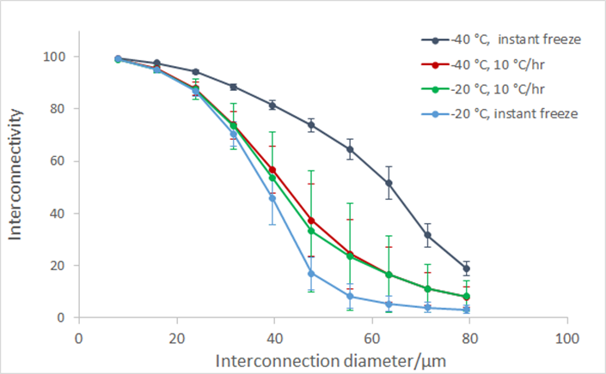
Figure S1: Interconnectivity data from preliminary single stage scaffolds created with defined freezing temperatures and rates. Instant freeze described a scaffold placed onto a shelf prefrozen to the given temperature. The structure produced through ‘instant freeze’ at -40°C showed a significantly more interconnected structure than that at -20°C
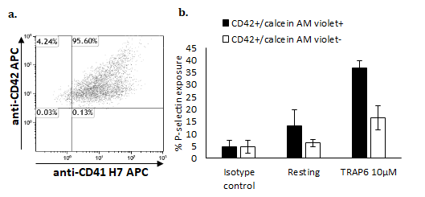
Figure S2: (a) Platelets from a stationery iPSC culture were stained with calcein AM, anti-CD24 APC and anti-CD41 H7 APC. (b) Bioreactor platelets were stained with anti-CD42 PE-CF594, calcein AM violet and anti-CD62P APC and activated with TRAP6.

