Analysing malaria incidence at the small area level for developing a spatial decision support system: a case study in Kalaburagi, Karnataka, India.
S. Shekhar⁺, E-H. Yoo*, S.A. Ahmed#, R. Haining×, S. Kodannolly⁺
⁺ Department of Geography, Central University of Karnataka, India.
* Department of Geography, State University of New York, Buffalo, USA.
# Department of Geology, Kuvempu University, Shankaraghatta, India.
×Department of Geography, University of Cambridge, England.
Abstract
Notwithstanding long standing efforts to reduce the incidence of infectious diseases they continue to be a major cause of morbidity and premature death in many parts of the world. Part of the challenge is to understand better the factors that are associated with disease incidence at the local level and to put in place operational systems to achieve sustainable reduction. Spatial decision support systems have already proved their value in helping to reduce, in some cases eliminate, infectious diseases including malaria but to be effective in any particular part of the world they need to be designed to reflect local circumstances and local data availability over time. We report the first stage of a project to develop a spatial decision support system for infectious diseases for Karnataka State in India. The focus of this paper is on malaria incidence and we draw on small area data on new cases of malaria analysed in two-monthly time intervals over the period February 2012 to January 2016 for Kalaburagi taluk, a small area in Karnataka. We report the results of data mapping and cluster detection (identifying areas of excess risk) including evaluating the temporal persistence of excess risk and the local conditions with which high counts are statistically associated. We conclude by commenting on how this work might feed into a practical spatial decision support system useful to health practitioners tackling infectious diseases in Karnataka.
Keywords: disease mapping, cluster detection, small area data modelling, profile regression, malaria incidence
- Introduction:
Malaria is the most important parasitic disease of humans and one of the leading causes of morbidity and mortality in tropical countries (Roy, et al.,2015). India, with a population in excess of 1 billion, has the largest number of people living at risk of malaria in South East Asia. It accounts for nearly 80% of all malaria cases in the region (Vas Dev and Sharma, 2013). According to the World Malaria Report 2014, 22% (275.5m) of India’s population live in high transmission areas (> 1 case per 1000 population), 67% (838.9m) live in low transmission areas (0–1 cases per 1000 population) and 11% (137.7m) live in malaria-free areas (0 cases). Whilst about 90% of India’s population live in areas where malaria is endemic 80% of all reported cases occur in tribal, hilly and inaccessible areas containing 20% of India’s population. Despite these challenges, India is working and making progress towards the elimination of malaria. Since 2000, the country has more than halved the number of malaria cases, down from 2 million to 882,000 in 2013 through expanding WHO-approved community based diagnostic testing, artemisinin-based combination therapies, providing durable bed-nets and implementing indoor spraying (NVBDCP website; WHO, 2015). Nonetheless India’s public health system continues to face many challenges including implementation of surveillance and response programs to accurately estimate and control the national malaria burden (Das et al.,2012).
In the year 2006, over 62,800 cases of malaria were reported in Karnataka state, a high transmission area, whilst in 2013, just over 13,300 cases were reported. The incidence of malaria in Karnataka is therefore also showing a downward trend as in the nation as a whole. But whilst there is currently a global focus and dedication of resources towards elimination in India, malaria programs pursuing this goal within resource poor and remote settings in the country face significant challenges in meeting the operational requirements for sustainable reduction. A spatial decision support system (SDSS) offers the potential to contribute significantly to this effort in such areas. An SDSS, as its name implies, is a form of decision support system (DSS) consisting of a set of linked computer models (Cromley and McLafferty, 2012). However an SDSS has a number of distinguishing features: it supports spatial data input, capturing the spatial relationships and structures associated with spatial objects; it provides spatial analytical techniques; it supports output in various forms including maps (Densham, 1991). It supports spatially oriented planning by providing a platform to rapidly collect, store and extract essential data throughout key phases of program implementation; effectively manage and ensure essential services are delivered at optimal levels of coverage in target areas; actively locate and classify transmission to guide swift and appropriate responses (Kelly, 2013). If the SDSS is also being designed to support spatial epidemiology the spatial analytical techniques will include a Rapid Inquiry Facility (RIF) which is used for disease mapping and risk analysis by generating standardised rates and relative risk estimates for small areas (see http://www.sahsu.org/content/rapid-inquiry-facility).
Interactive SDSSs have proved their usefulness in malaria elimination in many countries (Daash et al., 2009; Srivastava et.al.,2009; Wangdi et al, 2016 ). Public health practitioners (PHPs) new to geographic information benefit from enhanced interpretive support documentation when using internet-based, interactive public health atlases.(Koenig et al., 2011) A prototype SDSS coupled with a Rapid Inquiry Facility (RIF) is currently being developed for Kalaburagi (formerly known as Gulbarga) district in Karnataka State. The SDSS will be used to improve public health and to enable better management of available resources. The RIF will be used by the district’s local administrators to allocate resources more efficiently based on inputs provided by authorised Primary Health Centre employees as well as mobile app. users.
The main objective of this paper is to report the findings of work collecting and analysing small area malaria and other data in order to better understand the spatial-temporal geography of malaria from April 2012 to March 2015 in Kalaburagi taluk, an administrative unit, (also known as a tehsil) which consists of 139 spatial units with a total population of just under 800,000. We analyse the data in two-monthly time windows in order to assess the stability of relationships. This will be important if any system is to be developed which will be of help to health practitioners. However working at such fine spatial-temporal scales does raise the question of how to deal with small numbers. In reporting these results the paper also considers the analytical capability that will be embedded in the SDSS. The SDSS and RIF will be the subject of a second paper. We envisage a process in which as new data become available these data are subject to the same or similar analyses to the ones reported here thereby expanding the knowledge base contained within the SDSS/RIF. We will discuss the challenges associated with these activities in the concluding section of the paper.

- Review of literature
In India, malaria endemicity is associated with diverse ecologies, multiple disease vector species and nine widely distributed anopheline vectors transmitting three plasmodial species: P. falciparum, P. vivax, and P. malariae (Sharma, 1998; Anirudh et al, 2013). The states of Orissa, Chhattisgarh, West Bengal, Jharkhand, and Karnataka contribute the most cases (Kumar et al, 2007). Efforts to use environmental data for epidemic prediction and response began in the early 1920s in India (Myers et al. 2000). It has long been understood that mosquito numbers depend on climate and that meteorological variables can be used to predict the onset and severity of malaria epidemics (Gil, 1921 and 1923).
Malarial incidence, its severity, temporal dynamics and spatial distribution are strongly determined by climatic factors, and in particular temperature, precipitation, and relative humidity levels which in turn are affected by altitude differences (Dhara, 2013, Fanello et al., 2007, Singh et al. 2009, Sipe and Dale, 2003, Srimath et.al, 2015). Even small differences in climate can have very marked effects on the intensity of malaria transmission, even in areas subject to malaria control for many years (Kleinschmidt, et al ,2001). The amount, intensity and duration of rainfall affect the size of the mosquito population (Russell et al. 1963). Rainfall also increases relative humidity (RH) and modifies temperature, which affects the longevity of mosquitoes and hence the transmission of the disease (Molineaux and Gramiccia 1980). If RH is below 60%, the life of mosquitoes is shortened which in turn reduces disease transmission. RH values of 60–80% are considered to be optimum for the transmission of malaria (Pampana 1969, quoted by Dhiman et al. 2010).
The maximum number of positive malaria cases are reported between May and October and this period coincides with substantial amounts of rainfall (Bhattacharya, Sharma et al, 2006). Research into malaria and monsoonal rains in the desert and semi-arid regions of India has shown that the maximum correlation between monthly cases and rainfall was obtained when rainfall was accumulated for the five to six previous months (Laneri et.al., 2010).
The occurrence of malaria is bound closely to conditions that favour survival of the anopheles mosquito and the life cycle of the parasite. These conditions are determined predominantly by climatic factors, vegetation cover, and the vector’s access to water surfaces for breeding (Kleinschmidt, et al ,2001). The largest abundancies of mosquitoes, and disease outbreaks, are located in and around a 2.5 km buffer zone of water, wetland and cultivated areas and the type of vegetation which surrounds the breeding sites may also be important in determining the abundance of mosquitoes (Palaniandi, 2012, Sipe and Dale, 2003, Wielgosz et al., 2012). Stagnant water is the commonest breeding place followed by ditches and ponds and even coconut shells can act as breeding places for these vectors (Boratne et al, 2010).
Analysing and modelling the relationship between climatic variables and malaria using correlation and regression methods has been undertaken for many years in India (see for example Srimath et.al, 2015). A study of Dehradun City, Uttaranchal, showed a high positive correlation between monthly parasite incidence and climatic variables (temperature, rainfall and humidity). The highest significant correlation (r = 0.718; p < 0.0001) was found between rainfall and malaria incidence when the data were staggered to allow a lag of one-month (Devi and Jauhari, 2006). There is a higher seasonal concentration of malaria in forested than in non-forested areas. A statistically significant correlation (r = 0.689; p = 0.040) between annual changes in malaria cases and temperature levels was observed in forested areas in the Kokrajhar district of Assam (Nath and Mwchahary, 2013).
The effect of land cover changes associated with urbanisation on the burden of malaria was demonstrated in the Mangalore taluk of southern India. Fresh and stagnant surface water collection increased by 31% between 2000 and 2003. Some of these artificial water collections were due to urban construction activities and some due to more general human activities such as discarded vehicle tyres and coconut shells, tree holes, open water tanks, open wells (Mohan et al. 2014).
Increases in malaria transmission also depend on socio-economic factors, vector management and health seeking behaviour (Keiser et al., 2005). These include human population density and behaviour, housing type and location, water supply, sewage and waste management systems, land use and irrigation systems, availability and use of vector control programmes, access to health care, and general environmental hygiene. Social and demographic factors such as population growth, urbanization, immigration, changes in land use and agricultural practices, deforestation, international travel, and breakdown in public health services have all played a role in the recent resurgence of infectious diseases (Dhara, 2013). Awareness and knowledge about selected mosquito-borne diseases is least among the illiterate and economically backward members of the population and is lower amongst females compared to males (Boratne et al., 2010). Even though the environment plays an important role in malaria transmission, increasing coverage by malaria interventions (e.g. sleeping under a bed net), better community health facilities (with population/health worker ratios below 3000; population/doctor ratios between 20,000 and 50,000), better public knowledge about the disease (particularly educating mothers) as well as improving socio-economic conditions will be key to achieving sustainable malaria burden decreases (Samadoulougou, et.al., 2014).
Sharma and Mehrotra’s (1986) study into malaria resurgence in India showed that by 1964, following an intensive programme of DDT spraying, malaria was eradicated from 88% of the country but that due to shortages of DDT, focused outbreaks occurring in 1965 and later could not be contained. Large areas where malaria had been eradicated saw recurrences of outbreaks. They remarked that the situation was exacerbated by a health service infrastructure that was neither adequate nor mature enough to engage in effective disease surveillance. More recent global reviews have provided confirmation of the importance of maintaining the gains won through malaria control programmes if resurgence is to be avoided, identifying what works and what does not in reaching and sustaining zero malaria transmission (see for example Cohen et al. 2012; WHO, 2012).
Inadequate and delayed treatment of early stage malaria, especially in the non-immune population may result in progression to severe malaria, which is associated in turn with high case fatality rates as reported in the case of Jalpaiguri district, in the North of West Bengal (Sarkar et al., 2009). A study by Dhingra and Neeraj et al. (2010) into adult and child mortality using a nationally representative mortality survey showed that of all malaria deaths 90% were in rural areas and 86% did not take place in a health-care facility. Control of urban malaria deserves special attention because the vector-breeding sites and appropriate control measures in rural and urban areas differ. Mumbai, with over 2,500 construction sites in the city, experienced a huge outbreak of malaria during the 2010 monsoon season (Gaurav Dhawan et al., 2014).
These findings emphasize the importance of detecting and responding to malaria outbreaks with the minimum delay. One option is the development of early warning systems based on case notification another option is to build statistical models and identify covariates that act as signals of the likelihood of an increased risk in the near future. Distributed lag models incorporating weather-derived variables have been shown to identify epidemics with reasonable accuracy and better timeliness than other approaches. The prediction of malaria cases using lagged weather data performed well in predicting periods of increased numbers of malaria cases (see for example Teklehaimanot et al., 2004). Using Bayesian statistical models, Kleinschmidt, et al (2002) investigated spatial and temporal variations in small-area malaria incidence rates for the period mid-1986 to mid-1999 for two districts in northern KwaZulu Natal, South Africa. Smoothing of small-area maps of incidence and growth in incidence are important for interpreting the spatial distribution of disease and rapid changes in disease incidence. In another study Kleinschmidt, et al (2001) undertook a spatial statistical analysis of small-area malaria incidence rates in relation to rainfall and temperature. Because of their potential confounding effects, they included proximity to permanent water bodies and distance to the Mozambique border in their study.

We conclude this review with reference to studies in Karnataka, the location of the study area for this paper, which has one of the highest malaria incidence rates in India. The peak number of recorded cases in Karnataka, 630,000, was observed in 1976 but in 1997 and 1998 there were still 180,000 and 110,000 cases respectively. Due to new vector control measures introduced in 1998, Karnataka has seen a steady decline in the annual incidence of malaria between 2001 and 2011, but it is still categorized as one of the high transmission zones of India (Acharya et al. 2013). Highest incidences in this period were recorded in Bijapur, Raichur, Kolar, Bellary, Dakshina Kannada and Mandya districts, which together accounted for more than 60% of Karnataka’s malaria cases. These districts have different climatic zones and malaria cases vary from the rural rain-fed zones of Raichur district to urban Mangalore. Karnataka experiences a relatively high prevalence of malaria in the age group 21 to 30 years and amongst males compared to females. Previously An. fluviatilis was the predominant vector responsible for causing malaria outbreaks but currently An. culicifacies is the predominant vector throughout Karnataka. Prevalence is observed in both rain-fed and irrigated areas of rural Karnataka. Like all the other states of India, malaria incidence correlates with the onset of the monsoon, as demonstrated for example by Mysore district which showed 21 out of an annual total of 84 cases occurring in June, 2011. Mangalore city receives 90% of its annual rainfall between May and September and experiences increased malaria incidence from the month of June onwards. However malaria outbreaks also occur in Belgaum, Bijapur and parts of Northern Karnataka which receive moderate amounts of rainfall and experience high temperatures. Rural to urban migration is one of the reasons for urban malaria as in the case of Mangalore. Other reasons include lack of health education, not taking prescribed medications properly and poor economic conditions.
- Study Area, Data and Methods
  - Study area and data
The district of Kalaburagi (formerly Gulbarga), which means ‘stony land’ in the local language Kannada, is situated on the Deccan plateau at an elevation of between 300 and 750 metres above mean sea level in the northern part of Karnataka State in South India. It is the second largest district in Karnataka with a total population of over 2.5million (4.2% of the state total) that has grown by approximately 18% over the last ten years and now has an average population density of just under 240 people per sq. km.. Kalaburagi district presently comprises the following 7 taluks: Kalaburagi, Aland, Afzalpur, Jevargi, Sedam, Chitapur and Chincholi. It is 613km north of Bangalore and well connected by road and rail networks. Figure 1 shows the location of Kalaburagi taluk which is the study area within Kalaburagi district.

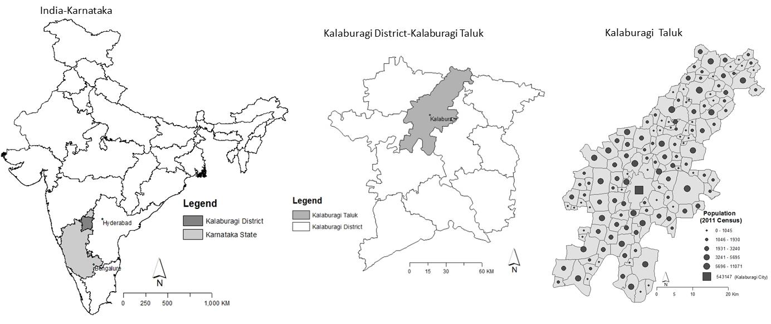
Figure 1. Location of study area with population counts (2011 Census) by small areas
The climate of the district is generally dry with an annual rainfall of about 750mm. The year in Kalaburagi district can be divided into three main seasons. The summer (temperatures: 26 °C to 45 °C) lasts from late February to mid-June and is followed by the southwest monsoon, which lasts from late June to late September (23 °C to 33 °C). This is then followed by dry winter weather until mid-January (30°C to 31 °C). The data analysis we report in section 4 (April 2012 to March 2015) is based on dividing each year into 6 two-month periods that fit approximately into these three seasons: February + March (warm and dry); April + May (hot and dry); June + July (hot and wet); August + September (warm and wet); October + November (warm and dry); December + January (cool and dry). The purpose of this grouping of months is to analyse the incidence data by small periods of time whilst reducing to the extent possible the small number problem. The 139 spatial data units into which Kalaburagi taluk is divided comprises 138 small villages plus Kalaburagi City which has a population of over 540,000. The 138 small villages have an average population size of just over 2,000 and standard deviation of just over 1,650. In the 2011 Census, the smallest village had a population of only 87, the largest just over 11,000 (see Figure 1).
From the 2011 Indian Census, the district literacy rate is 64.9 percent (males: 74.4%; females: 55.1%) and has a registered work participation of 42.4 percent (males: 52.2%; females: 32.2%); Amongst all workers in the district 77.7 percent are Main workers and 22.3 percent are Marginal workers. Of the total work force of the district, 58.5 percent are engaged in the agricultural sector comprising cultivators (20.3 percent) and agricultural labourers (38.2 percent). About 57.6 percent of the total population in the district are classified as non-workers. Kalaburagi District has 918 villages, 10 Statutory Towns and 1 Census Town. (For more details and explanation of terms see: http://censusindia.gov.in/Metadata/Metada.htm#2)
In Karnataka during 2014 over 3,600 malaria cases were reported representing an increase of 7% on the previous year that was of great concern and one of the motivations for this study. In total there are 83 Primary Health Centers (PHCs) in Kalaburagi district of which 12 are located in Kalaburagi taluk. Data coordination is one of the major impediments to an effective and efficient health care delivery system. There is an existing data flow pattern. Data from all PHC registers are expected to be collated on a daily basis and are aggregated into a monthly summary. The summary forms are sent to the Local Government Monitoring and Evaluation Unit, mainly the surveillance unit, which then sends this to the District Health Office. Data flow is not as smooth as it needs to be. For example, facilities do not always collate and send their data to the surveillance office or to the district office in a timely manner. Improving data quality and data availability to support decision-making, whether at the local or community level, remains part of the challenge.

The National Vector Borne Disease Control Programme for prevention and control of vector borne diseases, including malaria, is being implemented as per the guidelines of the Government of India to achieve the goals set out under National Health Policy 2002 viz., the goal of reducing mortality due to malaria and other vector borne diseases by 50% by the year 2013 and a further 25% by 2015. This program monitors district/state data reporting by aggregating the total number cases from each PHC reporting each month. For effective action detailed monitoring and surveillance data are needed in real time which is currently lacking in the Kalaburagi PHC data. Table 1 shows summary statistics for the 18 two month periods taken from the PHC database (April+May 2012 to February+March 2015).
Malaria counts | Minimum | Maximum | Sum | Mean | Standard Deviation
Feb-Mar12 | 0.00 | 30.00 | 153.00 | 1.10 | 4.70
April-May 12 | 0.00 | 30.00 | 89.00 | 0.64 | 3.17
Jun-Jul 12 | 0.00 | 33.00 | 156.00 | 1.12 | 4.61
Aug-Sep12 | 0.00 | 40.00 | 161.00 | 1.16 | 5.03
Oct-Nov12 | 0.00 | 70.00 | 179.00 | 1.29 | 6.86
Dec-Jan13 | 0.00 | 38.00 | 130.00 | 0.94 | 4.50
Feb-Mar 13 | 0.00 | 19.00 | 102.00 | 0.73 | 2.94
April-May13 | 0.00 | 22.00 | 112.00 | 0.81 | 3.33
Jun-Jul13 | 0.00 | 40.00 | 215.00 | 1.55 | 6.22
Aug-Sep13 | 0.00 | 20.00 | 120.00 | 0.86 | 3.57
Oct-Nov13 | 0.00 | 32.00 | 133.00 | 0.96 | 4.18
Dec-Jan14 | 0.00 | 15.00 | 83.00 | 0.60 | 2.33
Feb-Mar14 | 0.00 | 15.00 | 31.00 | 0.22 | 1.62
Apr-May14 | 0.00 | 18.00 | 34.00 | 0.24 | 1.78
Jun-Jul14 | 0.00 | 28.00 | 54.00 | 0.39 | 2.76
Aug-Sep14 | 0.00 | 13.00 | 29.00 | 0.21 | 1.40
Oct-Nov14 | 0.00 | 15.00 | 38.00 | 0.27 | 1.77
Dec-Jan15 | 0.00 | 17.00 | 32.00 | 0.23 | 1.91
Feb-Mar15 | 0.00 | 20.00 | 29.00 | 0.21 | 1.79
Apr-May15 | 0.00 | 1.00 | 1.00 | 0.01 | 0.08
Jun-Jul15 | 0.00 | 1.00 | 1.00 | 0.01 | 0.08
Aug -Sep15 | 0.00 | 1.00 | 3.00 | 0.02 | 0.15
Oct-Nov15 | 0.00 | 2.00 | 5.00 | 0.04 | 0.22
Dec-Jan16 | 0.00 | 2.00 | 2.00 | 0.01 | 0.17
Table 1. Summary statistics for village level malaria incidence data by two monthly periods.
3.2 Methods
The methodology applied to the data comprises four main elements. First, we map the geographical pattern of reported new cases of malaria over the four year period at the village level. Mapping was done in ArcGIS 10. Populations at the village level are concentrated in small settlements so our preferred method for visualizing these data is to retain the village boundaries and show the incidences and standardised incidence ratios as proportional circles. The size of each circle is proportional to the value of the statistic. To save space we show only maps of annualised data.

Second, we want to be able to identify clusters of spatially contiguous villages showing excess risk of new cases of malaria. A cluster will comprise villages where the probability of being infected with malaria for those populations living within the cluster is significantly greater than for those populations living outside the cluster. Whilst methods have been developed for cluster detection (see for example Anselin, 1995, Getis and Ord 1995) many suffer from the multiple testing problem. We assume that the numbers of cases of malaria in Kalaburagi taluk are the outcome of a poisson process and use the spatial scan statistic for poisson counts developed by Kulldorff (1997) and implemented in the SaTScan software (www.satscan.org). This cluster or hotspot detection test does not suffer from the multiple testing problem although it does have limitations. The scan test is conservative for all clusters beyond the first or primary cluster and the boundary of each cluster is not exact since the inclusion or exclusion of villages on the boundary of any significant cluster would in most cases not alter the statistical significance of the cluster.

Mapping the location of the village hotspots allows comparison through time helping to determine the temporal persistence or otherwise of the hotspots. We also apply a formal test for temporal persistence by fitting a logistic Bayesian Hierarchical Model (BHM) with spatial random effects (the dependent variable for village i has the value 1 if village i is a hotspot, 0 otherwise). We include a single covariate which measures the number of new cases of malaria in the preceding two month period. To test for possible spill-over effects we try two definitions for the covariate and compare model goodness of fit: (a) the number of new cases of malaria in the village itself in the preceding two month period; (b) the number of new cases in the village plus its adjacent neighbours in the preceding two month period. Two villages are adjacent neighbours if they share a common boundary. Other definitions of adjacency are possible (see for example Haining, 2003 ,p79-87). Spatial random effects were modelled using the Besag-York-Mollie (BYM) model. The BYM model has been widely applied in spatial epidemiological research. It is a convolution of an intrinsic conditional spatial autoregressive model plus a white noise process (see Besag et al. 1991). We tested a number of different prior specifications for the spatially structured and spatially unstructured random effects in the BYM, while for computational efficiency we used the integrated nested Laplace approximation (INLA). We used the R software packages (spdep v 0.6-6 and diseasemap v 1.4.0) to define the spatial neighbours of each village and to fit models.
The third phase of the methodology moves the analysis from establishing the temporal persistence (or otherwise) of hotspots to seeking a better understanding of why hotspots are located where they are on the map. For each of the 18 time windows we analyse the relationship between the hotspots of malaria and the environmental (meterological and ecological), social and economic attributes of the villages. Again we use a logistic BHM with BYM random effects. There are 11 covariates in the model but we do not include a covariate measuring the number of newly infected individuals from the previous time period to measure the size of the pool of infected individuals. There are two reasons for this. First, since in this data set the hotspots remain very stable over time this covariate (in either of the forms discussed above) dominates model fits. Second, the longer term aim is to construct models that might help in anticipating the need for health resources to combat a severe malaria outbreak. Having established the persistence of hotspots over time, the purpose now is to complement this with evidence about area characteristics that might be associated with malaria outbreaks. Some of the covariates in the model for time t include rainfall levels, relative humidity and vegetation cover not only at time t but also t-1.
The fourth and final phase models the village counts of new cases in each of the two-monthly time windows. We do not rule out the possibility of spatial heterogeneity in the relationship between the dependent or outcome variable and the set of covariates. Whilst this may not be a major issue when analysing data for a single taluk it may be an issue when scaling up to the district or state level. Some commonly used methods, including geographically weighted regression (Fotheringham et al, 2002) and spatially varying coefficients (Gelfand et al., 2003) models are problematic when there is multicollinearity in the set of covariates (Wheeler and Tiefelsdorf, 2005; Wheeler and Calder, 2007). Multicollinearity is likely to be a particular problem in this study where, in fitting any particular model, we are including covariates on the same attribute measured at both time t and t-1 so that there is likely to be high levels of correlation between them. Other covariates that measure different attributes (such as rainfall, relative humidity and vegetation cover) may also be correlated. The presence of correlation amongst the covariates means that only joint effects can be estimated not the risk levels associated with individual risk factors. So we have chosen to fit, to the village level case counts, Poisson profile regression models with a spatial conditional autoregressive (CAR) model added to the fixed effect term in the model. We used the PReMiumM package in the R library (Molitor et al., 2010; Liverani et al., 2015). Profile regression classifies each village into one of several “clusters” or groups on the basis of similarity in terms of their outcomes and the levels of their covariates (fixed effects). In the present context the term “cluster” is potentially misleading because in profile regression it does not mean that villages in the same “cluster” are contiguous simply that they have similar characteristics in terms of counts of cases and covariate characteristics. Villages in the same profile regression “cluster” are not necessarily contiguous for profile regression is not a model for region-building.
From the foregoing, it will be clear that BHMs with spatial random effects form an important part of the methodology of this paper and potentially of the SDSS. Hierarchical Models provide an important statistical modelling tool for separating two types of quantifiable uncertainty - data uncertainty given the process (specified through the product of independent likelihood functions) from process uncertainty (through a model for the parameters of the likelihood function which specifies the relationship between these parameters and a set of covariates plus a random effects term). Bayesian versions also allow the analyst to recognize and model uncertainty in the parameters through specified prior distributions. So BHMs handle three types of quantifiable uncertainty. Also, because inference from a Bayesian model is based on posterior distributions it is natural to couch conclusions and policy recommendations in terms of probabilities (see for example Li et al., 2013).
Fitting a Hierarchical Model with random effects helps to cope with the problem of over-dispersion in count data which is variation greater than can be accounted for by a Poisson model leading to underestimates of both the number of areas with zero counts and those with relatively large counts. This is a particular problem when modelling this malaria data (see table 1). Using a spatial random effects term has particular benefits for modelling small area count data. Some of the over-dispersion may be due to the effects of covariates not included in the model which are spatially autocorrelated at the scale of the spatial units. Some of the over-dispersion may be due to the process of malaria spread in which mosquitos bite people already infected and carry the disease to the uninfected in the same village; there may be a spatial “spillover effect” associated with this process particularly if settlements are close together or people travel between villages. Including a spatial random effect in the model means parameter estimates have greater precision since area-specific estimates “borrow strength” from other nearby areas rather than depending on just the data for the specific area. Second, the problem of data non-independence, which might otherwise need to be handled in the likelihood function and which for certain types of distributions, notably the Poisson, is highly problematic (see for example Besag, 1974) can be handled in the process model.
- Results
Figure 2 shows maps of annual malaria incidences (2012-2015) for each of the 139 spatial units: annual counts and standardized incidence ratios. As can be seen cases of malaria arise in many parts of Kalaburagi taluk but the northern region of the taluk reports the largest number of cases. The largest indirect standardized incidence ratios are also found in the northern region but 2013 presents an exception to this general pattern. Hereafter analysis focuses on incidence counts by two monthly intervals.
The villages marked by ⊗ in Figure 3 are members of the primary (and only) statistically significant SatScan hotspot cluster. These are clusters of villages where the risk of contracting malaria is significantly greater for villages inside the cluster than for villages outside the cluster. Only one significant cluster was detected in each two-month period and without exception this was located in the northern part of Kalaburagi taluk and contained the same set of 12 villages during the period April/May 2012 to Dec 2013/January 2014. Thereafter only two (the same two) of the twelve villages in the northeast corner form a hotspot by which time the total number of new cases of malaria has fallen (see table 1), falling still further after Feb-March 2015.

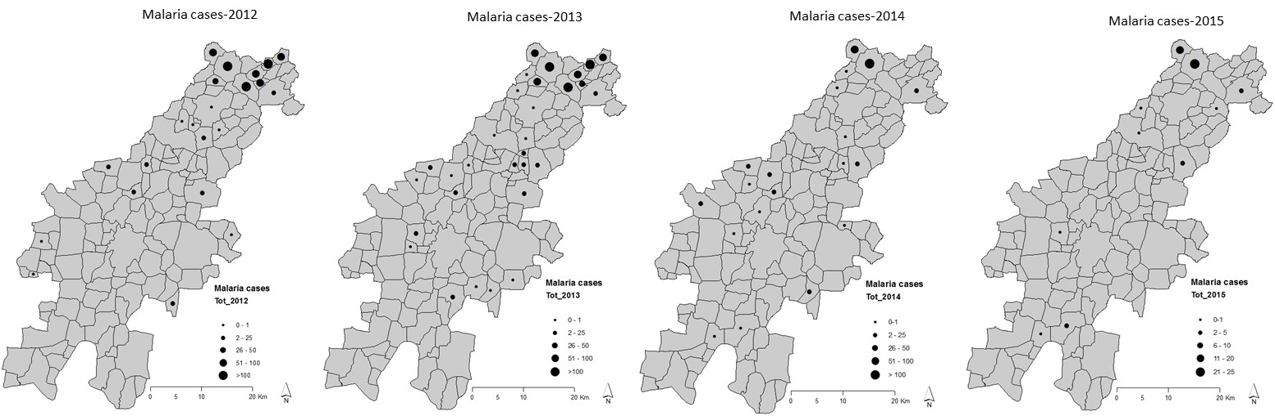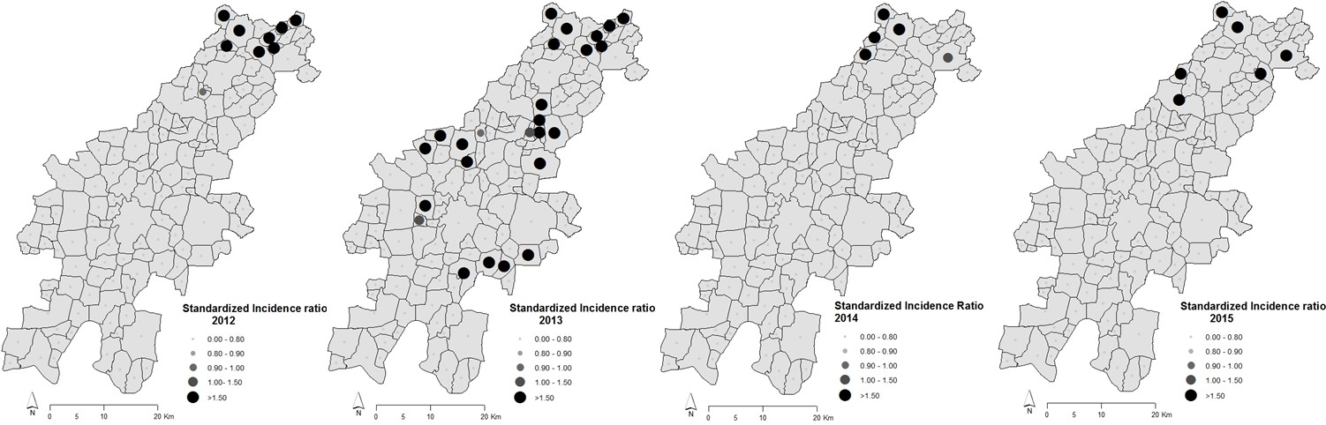

Fig 2. Top: Annual counts of numbers of new cases by small areas (2012-2015) for Kalaburagi taluk. Bottom: Annual indirect standardized incidence ratios (2012-2015) for Kalaburagi taluk.
The villages marked by ⊗ in Figure 3 are members of the primary (and only) statistically significant SatScan hotspot cluster. These are clusters of villages where the risk of contracting malaria is significantly greater for villages inside the cluster than for villages outside the cluster. Only one significant cluster was detected in each two-month period and without exception this was located in the northern part of Kalaburagi taluk and contained the same set of 12 villages during the period April/May 2012 to Dec 2013/January 2014. Thereafter only two (the same two) of the twelve villages in the northeast corner form a hotspot by which time the total number of new cases of malaria has fallen (see table 1), falling still further after Feb-March 2015.

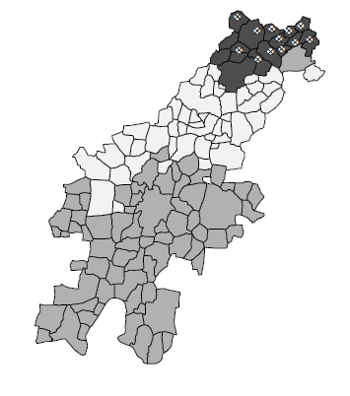  April-May 2012 | 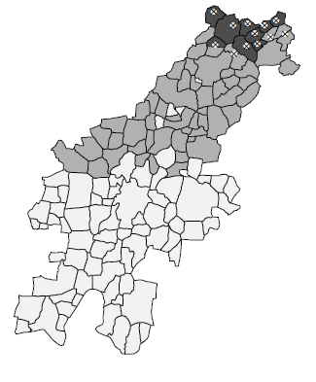  June-July 2012 | June-July 2012
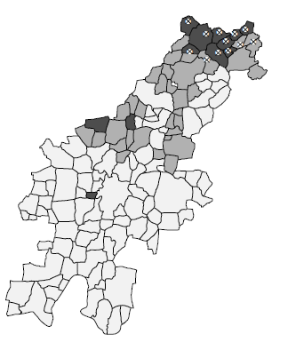  Aug-Sept 2012 | 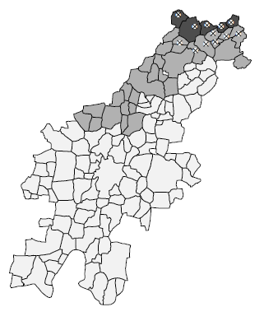  Oct-Nov 2012 | Oct-Nov 2012

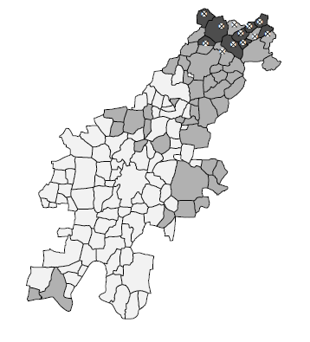  Dec 2012-Jan 2013 | 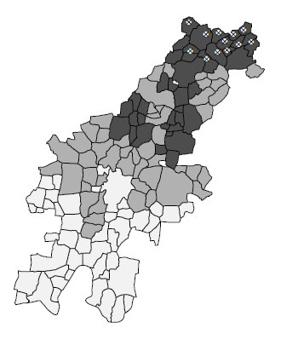  Feb-March2013
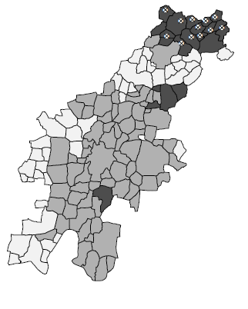  April-May 2013 | 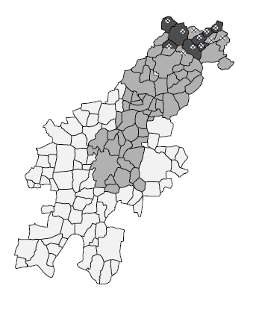  June-July 2013

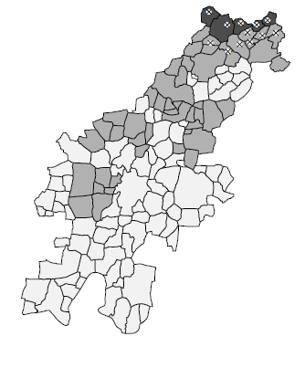  Aug-Sept 2013 | 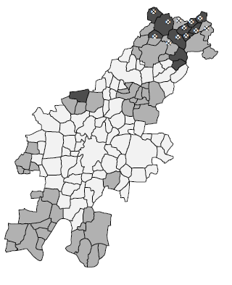  Oct-Nov 2013
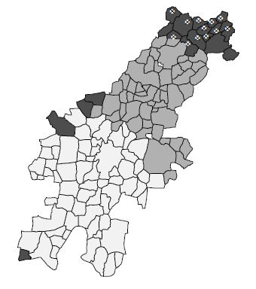  Dec 2013-Jan 2014 | 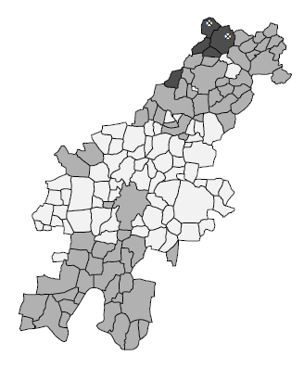  Feb-March 2014

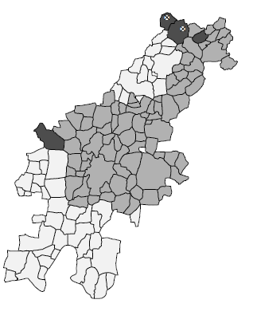  April-May 2014 | 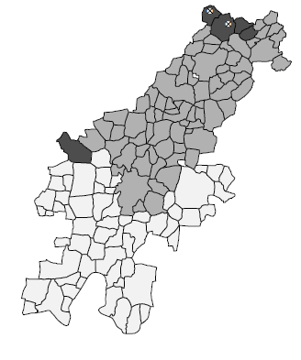  June-July 2014
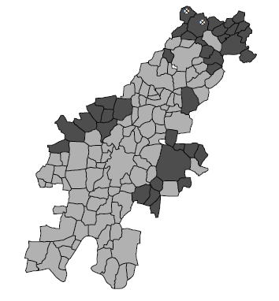  Aug-Sept 2014 | 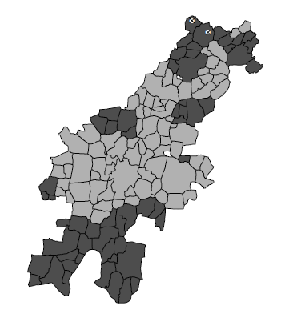  Oct-Nov 2014

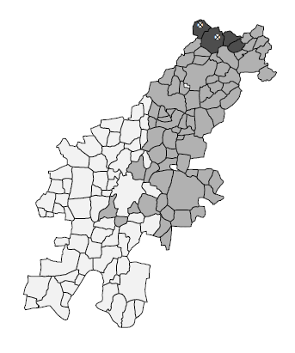  Dec 2014-Jan 2015 2014 | 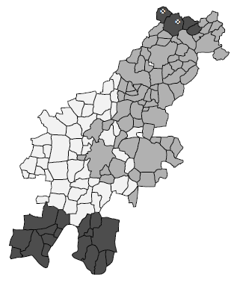  Feb -March 2015

Fig. 3. Satscan hot spot villages (⊗); Villages are shaded according to which cluster (or group) they belong to from profile regression modelling. Shading goes from dark (high risk) to light (low risk). See figure 4.

The temporal persistence of the hotspot villages is evident from the maps in figure 3 but for completeness table 2 reports the results of fitting the logistic BHM with BYM spatial random effects described in section 3.2. The column of posterior means refers to the estimate of the regression parameter for the single covariate in the model (malaria incidence in the previous two months). The very small number of hotspot villages from February/March 2014 onwards is probably the cause of the large parameter estimates from April/May 2014 onwards and results of the fit are probably unreliable. If we consider only the period prior to February/March 2014 the model fits suggest that the number of new cases at time t in a village provides an indication of whether a village will be a hotspot in the following time period. This is not surprising. However, adding the number of cases in adjacent villages provides a better indication. This provides some evidence for taking into account possible inter-village spill-over effects in contracting malaria. If we use the size of the newly infected population at time t-1 as a predictor of whether a village will be a hot spot or not at time t, then there are more cases of a significant association with the outcome (being a hotspot or not) when the size of the newly infected population in the adjacent villages is included in the construction of the covariate. In only 5 out of the first 11 time periods, excluding the count of new cases in adjacent villages produces 95% credible intervals that do not overlap 0.0; when including the count from adjacent villages, 10 of the 95%credible intervals do not overlap 0.0.

 | Including adjacent villages |  |  | Excluding adjacent villages
Time period | Posterior  Mean | Lower bound 95% credible interval | Upper bound 95% credible interval | Posterior  Mean | Lower bound 95% credible interval | Upper bound 95% credible interval
1. April-May 2012 | 0.94 | 0.49 | 1.67 | 1.98 | -2.63 | 11.74
2. June-July 2012 | 5.43 | 0.38 | 13.33 | 6.18 | 0.09 | 31.45
3. Aug-Sept. 2012 | 1.62 | 0.55 | 3.35 | 1.55 | 0.06 | 4.99
4. Oct-Nov 2012 | 1.62 | 0.31 | 3.80 | 2.83 | 0.09 | 19.67
5. Dec 2012-Jan 2013 | 0.93 | 0.47 | 1.70 | 3.74 | -0.89 | 16.05
6. Feb-March 2013 | 1.14 | 0.59 | 2.03 | 3.62 | -0.09 | 12.57
7. April-May 2013 | 6.63 | -2.87 | 20.89 | 5.27 | -0.61 | 37.96
8. June-July 2013 | 1.66 | 0.47 | 3.55 | 8.08 | -0.53 | 73.80
9. Aug-Sept. 2013 | 0.78 | 0.37 | 1.44 | 1.07 | 0.05 | 3.42
10. Oct-Nov 2013 | 1.21 | 0.63 | 2.18 | 2.07 | 0.26 | 6.25
11. Dec 2013-Jan 2014 | 0.85 | 0.46 | 1.49 | 4.13 | -0.12 | 37.84
12. Feb-March 2014 | 1.55 | -0.55 | 4.47 | 0.49 | 0.19 | 0.95
13. April-May 2014 | 349.35 | 168.54 | 529.31 | 250.06 | 183.36 | 306.76
14. June-July 2014 | 368.60 | 105.41 | 636.64 | 152.40 | 121.73 | 190.12
15. Aug-Sept. 2014 | 453.89 | -609.64 | 1441.99 | 268.91 | 130.31 | 405.64
16. Oct-Nov 2014 | 305.79 | 194.46 | 501.57 | 201.81 | 171.63 | 244.30
17. Dec 2014-Jan 2015 | 348.05 | 134.35 | 565.03 | 250.63 | 188.13 | 340.02
18. Feb-March 2015 | 426.80 | 155.16 | 832.51 | 299.71 | 226.50 | 401.87

Table 2. Bayesian Hierarchical Model with spatial random effects: Posterior means and 95% credible intervals for Bernoulli outcome (village is a hotspot (1) or not (0) at time t) with a single covariate (X₁) equal to the size of the newly infected population at time t-1 in the village plus the adjacent villages and excluding the adjacent villages.

Tables 3a-3c summarize the results of fitting the logistic BHM with BYM random effects to the village hotspot results including three classes of covariates in the model. These are meteorological covariates (3a), ecological covariates (3b) and social and demographic covariates (3c). Because of the large number of villages in Kalaburagi taluk that share a boundary with villages in other taluks, for which we have no data, and because malaria is no respecter of administrative boundaries, we include a dummy variable with villages on the boundary assigned 1, those in the interior of the taluk assigned 0. For reasons discussed in section 3.2 we do not include a covariate measuring the size of the infected pool at the previous time period.

Time period | Rain (time t) | Rain (time t-1) | Rel. Hum. (time t) | Rel. Hum. (time t-1)
1.April-May 2012

2.June-July 2012 | 89.95  (59.2, 130.7) |  | 48.32  (2.77, 94.54)
3.Aug-Sept. 2012 |  |  | -3.0  (-5.96, -0.08)
4.Oct-Nov 2012 |  | 78.69  (39.11, 125.53) |  | -35.77  (-69.72, -11.53)
5.Dec 2012-Jan 2013

6.Feb-March 2013 |  |  | 43.74  (16.91, 78.49)
7.April-May 2013 |  | 157.45  (104.04, 214.99)
8.June-July 2013
9.Aug-Sept. 2013 |  | 112.09  (84.60, 152.69) | -63.21  (-105.45, -30.96)
10.Oct-Nov 2013 | 43.43  (9.10, 89.17) |  |  | -41.64  (-63.76, -24.62)
11.Dec 2013-Jan 2014
12.Feb-March 2014
13.April-May 2014 |  |  | ND | ND
14.June-July 2014 |  |  | ND | ND
15.Aug-Sept. 2014 |  |  | ND | ND
16.Oct-Nov 2014 |  |  | ND | ND
17.Dec 2014-Jan 2015 |  |  | ND | ND
18.Feb-March 2015 |  |  | ND | ND

Table 3a. Bayesian Hierarchical Model with spatial random effects excluding the number of newly infected at time t-1: Posterior means with 95% credible intervals in brackets for Bernoulli outcome (village a SatScan hotspot (1) or not (0) at time t). Results for the meteorological covariates. ND denotes No Data – covariate not included in model fit. Blank entries denote non-significant covariates.

Time period | NDVI (time t) | NDVI (time t-1) | PW500 | Boundary
1.April-May 2012
2.June-July 2012 |  |  |  | -21.48  (-33.49, -12.95)
3.Aug-Sept. 2012
4.Oct-Nov 2012 |  |  |  | -11.12  (-19.03, -5.29)
5.Dec 2012-Jan 2013 |  |  |  | -4.41  (-8.76, -1.13)
6.Feb-March 2013 |  |  |  | -7.80  (-13.82, -3.16)
7.April-May 2013 | -0.08  (-0.13, -0.04) |  |  | -52.61  (-88.04), -26.11)
8.June-July 2013
9.Aug-Sept. 2013 |  | -0.04  (-0.08, -0.01) |  | -41.91  (-54.79, -33.03)
10.Oct-Nov 2013 | 0.01  (0.00, 0.01) |  |  | -14.77  (-24.19, -7.42)
11.Dec 2013-Jan 2014 |  | 0.01  (0.01, 0.02)
12.Feb-March 2014
13.April-May 2014
14.June-July 2014 | 0.01  (0.00, 0.03) | -0.02  (-0.05, -0.00) |  | 28.43  (6.27, 62.12)
15.Aug-Sept. 2014 |  |  |  | 22.79  (3.58, 53.42)
16.Oct-Nov 2014
17.Dec 2014-Jan 2015
18.Feb-March 2015

Table 3b. Bayesian Hierarchical Model with spatial random effects and excluding the number of newly infected at time t-1: Posterior means and 95% credible intervals in brackets for Bernoulli outcome (village a SatScan hotspot (1) or not (0) at time t). Results for the ecological covariates and boundary variable.

Time period | % Female population | %Age group < 6 years | % illiterate | VPC
1.April-May 2012 |  |  |  | 68.7%
2.June-July 2012 | 0.95  (0.12, 2.31) | 3.51  (0.57, 7.36) | -1.10  (-2.47, -0.09) | 76.2%
3.Aug-Sept. 2012 |  |  |  | 96.1%
4.Oct-Nov 2012 |  |  |  | 47.4%
5.Dec 2012-Jan 2013 |  |  |  | 61.9%
6.Feb-March 2013 |  |  |  | 71.6%
7.April-May 2013 |  | -13.96  (-25.25, -5.83) | 5.89  (2.65, 10.20) | 99.9%
8.June-July 2013 |  |  |  | 97.4%
9.Aug-Sept. 2013 |  |  |  | 98.1%
10.Oct-Nov 2013 |  |  | 0.74  (0.17, 1.43) | 50%
11.Dec 2013-Jan 2014 |  |  |  | 83.7%
12.Feb-March 2014 |  |  |  | 57.4%
13.April-May 2014 |  |  |  | 56.0%
14.June-July 2014 |  |  |  | 48.4%
15.Aug-Sept. 2014 |  |  |  | 51.6%
16.Oct-Nov 2014 |  |  |  | 51.6%
17.Dec 2014-Jan 2015 |  |  |  | 53.8%
18.Feb-March 2015 |  |  |  | 51.5%

Table 3c. Bayesian Hierarchical Model with spatial random effects and excluding the number of newly infected at time t-1: Posterior means and 95% credible intervals for Bernoulli outcome (village a SatScan hotspot (1) or not (0) at time t). Results for the social and demographic covariates. VPC denotes variance partition coefficient expressing the % of total unexplained variation that is spatially structured.

As with the previous set of results we view the model fits after February/March 2014 with scepticism and will not discuss them further. As anticipated from the literature review, the class of covariates most often associated with credible intervals that exclude the value 0.0 are the meteorological covariates (11 out of a possible 48). Three of the social and demographic covariates have credible intervals that exclude 0.0 (6 out of 36). The only ecological covariate to show significance is NDVI (4 out of 36 – we exclude June-July 2014 from this count). The covariate measuring the proportion of a village within 500 metres of a water body (PW500) is never significant. The variance partition coefficient (VPC) which measures the proportion of the unexplained variation captured by the random effects term that is spatially structured (table 3c) shows that this component is larger than the spatially unstructured component of unexplained variation. As remarked in section 3.2 this either reflects the effect of omitted covariates that are spatially structured or spill-over effects in disease spread. Given the earlier comments regarding the results reported in table 2 this lends further weight to the possible role of spill-over effects. We should also note that in 7 of the first 11 model fits the boundary covariate is significant (and negative) which reflects the fact that whilst the one hotspot is close to the northern boundary of Kalaburagi taluk most of the boundary villages are not members of a hotspot.
There is evidently no consistent pattern as to which covariates are significant in explaining the location of malaria hotspots in Kalaburagi taluk. A close reading of tables 3a to 3c shows that not only does no covariate appear as significant in even a majority of time periods, the same covariate may even have a different parameter sign from one time period to another. Part of the problem may be linked to the spatial extent of the study area and the lack of spatial variation at the taluk level in some of the covariates (particularly the meteorological covariates). It may also be linked to the small proportion of Kalaburagi villages that are in hotspots that means that the fit of any model will be driven more by the characteristics of those villages that are not members of hotspots than those that are. We shall have more to say about this in section 6 in the context of the development of the SDSS.
Figure 4 shows the 18 risk factor profiles (one for each of the two monthly time intervals) obtained from profile regression applied to the malaria incidence counts at time t and the same set of covariates as described previously but including the number of newly infected individuals at time t-1. The plots show the number of “clusters” or groups in each two month interval with the vertical axis measuring the expected number of new cases of malaria. Note that the axes are not scaled identically across the set of graphs. The boxplots are obtained by sampling the posterior distributions of the expected number of cases for each cluster.
The horizontal line on each profile plot is the weighted mean risk across all the clusters with the weights determined by the number of spatial units in each cluster. The right-most boxplot in each time period contains the group of villages with the highest risk. If that right-most boxplot has dark shading this indicates that the level of risk is significantly greater than the weighted average. This can be seen by comparing the position of the lower small black dot on each boxplot with the position of the horizontal line. If the lower dot lies above the horizontal line, the level of risk for that cluster is significantly higher. The lower black dot refers to the 5th percentile, the upper black dot to the 95th percentile. If the right most boxplot is white then the lower black dot is below the horizontal line but the upper black dot is above it indicating that the level of risk is not significantly different from the weighted average. The other boxplots refer to lower risk clusters which are also shaded to indicate whether their lower level of risk is significantly different from the weighted average level of risk. The shading in Figure 3 shows the location of the highest risk groups.
Whilst there is some overlap between the SaTScan clusters and the high risk group identified by profile regression there are also some discrepancies both on the margins of the SaTScan clusters as well as at other locations in Kalaburagi taluk. This suggests that there are areas with relatively high levels of risk and similar levels of the covariates beyond the hotspot areas (e.g. February-March 2013; June-July 2014) whilst within the hotspot areas there is some heterogeneity when case counts and covariate characteristics are considered together (e.g. October-November 2012). Results are summarized in table 4. It can be seen that the size of the newly infected population from the previous time period (t-1) is
Apr-May 2012 | June-July 2012 | Aug-Sept 2012 | Oct-Nov 2012 | Dec2012-Jan 2013 | Feb-Mar 2013
Apr-May 2013 | June-July 2013 | Aug-Sept 2013 | Oct-Nov 2013 | Dec 2013-Jan 2014 | Feb-Mar 2014
Apr-May 2014 | June-July 2014 | Aug-Sept 2014 | Oct-Nov 2014 | Dec 2014-Jan 2015 | Feb-March 2015

Figure 4. Posterior distributions for the expected number of new cases for each cluster in each two-monthly time interval. The boxplots are obtained from sampling the posterior distributions. Note the vertical axes are not identical across the set of graphs. The upper and lower small black circular dots on each boxplot define the 95% credible interval for the mean of the posterior distribution.

consistently associated with the number of new cases of malaria at time t as are rainfall (either at time t, or time t-1 or both) and relative humidity (at time t) in the highest risk group. Other covariates including NDVI at time t and the proportion of the population who are illiterate are occasionally significantly associated with higher levels of risk.

Time period | No. of significant high risk clusters (number of villages in cluster) | Increased risk
1. April-May 2012 | 1 (18) | Infected population (t-1); rainfall (t)
2. June-July 2012 | 1 (9) | Infected population (t-1); rainfall (t); rainfall (t-1); RH(t)
3. Aug-Sept. 2012 | 1 (12) | Infected population (t-1); rainfall (t); rainfall (t-1); NDVI(t)
4. Oct-Nov 2012 | 1 (5) | Infected population (t-1); rainfall (t-1); Border village
5. Dec 2012-Jan 2013 | 1 (9) | Infected population (t-1); Rainfall (t-1) RH(t); illiterate.
6. Feb-March 2013 | 1 (41) | Infected population (t-1); RH(t)
7. April-May 2013 | 1 (21) | Infected population (t-1); RH(t)
8. June-July 2013 | 1 (8) | Infected population (t-1); rainfall (t); RH(t)
9. Aug-Sept. 2013 | 1 (5) | Infected population (t-1); rainfall (t-1); Border village
10. Oct-Nov 2013 | 1 (12) | Infected population (t-1); rainfall (t); RH(t); NDVI(t); illiterate
11. Dec 2013-Jan 2014 | 0 | Infected population (t-1); RH(t); illiterate
12. Feb-March 2014 | 1 (5)
13. April-May 2014 | 0
14. June-July 2014 | 1 (5) | Infected population (t-1)
15. Aug-Sept. 2014 | 0 | Border village; NDVI(t); illiterate
16. Oct-Nov 2014 | 0 | Border village; Infected population (t-1); NDVI(t); illiterate
17. Dec 2014-Jan 2015 | 1 (4) | Infected population (t-1)
18. Feb-March 2015 | 0 | Border village; infected population (t-1); NDVI(t); illiterate

Table 4. Significant covariates associated with the significant high risk cluster from profile regression. Where no significant high risk cluster exists, the significant covariates associated with the highest risk cluster are recorded. Infected population (t-1) refers to the recorded number of newly infected cases of malaria at time t-1.

5. Discussion of results
The period February 2012 to January 2016 in Kalaburagi taluk can be divided into three periods in terms of malaria incidence (table 1): February 2012 to January 2014 a period of relatively high counts (ranging from 83 to 215 recorded cases per two month period); February 2014 to March 2015 a period with fewer cases (ranging from 29 to 54 recorded cases per two month period); April 2015 to January 2016 the period with by far the fewest number of cases (fewer than 5 cases per two month period). The period February 2012 to January 2014 reported over 86% of all the cases in the four year period covered by the database. There is clearly substantial year on year variation in the number of new cases and although the recent past yielded very few cases probably linked to vector control (distributing bed-nets and indoor chemical spraying), past experience warns that no assumptions should be made about the sustainability of this fall in numbers. Other districts in Karnataka including Bidar, Dharwad, Gadag and Haveri, which were until recently not problematic have shown rising numbers of cases.
Of the 1892 recorded cases in the database over 22% were recorded in the two months June and July and over 16% in the two months August and September. These are the wettest months in the year. However the fact that 60% of cases were recorded in the 8 months from October to May which are the dry months shows that the problem of malaria incidence is not confined to the wettest months of the year. This monthly share appears to be quite stable whether we are considering a period when there were many cases of malaria (the first period) or few cases (the second period).
Perhaps unsurprisingly variation in counts of malaria incidence across the villages is greatest in the period of most cases (February 2102 to January 2014). Figures 2 and 3 show that this is due to the concentration of cases in the northern area of Kalaburagi taluk where the SaTScan cluster detection test applied to the two-monthly data repeatedly confirmed the presence of a statistically significant cluster of cases comprising some dozen or so vulnerable villages. This pattern is quite stable over the time period of our analysis although after January 2014 the number of villages contained in the significant cluster shrinks to two and, as noted, the total number of cases falls steeply. It is possible that these two villages that remain with excess relative risk of malaria after January 2014 (and throughout the rest of our study window) suffer a higher level of malaria endemicity (or disease intensity) than other parts of Kalaburagi taluk. This might be linked to the prevalence of malaria in those two villages or perhaps some local environmental problem. We have noted that whether a village is a place of excess relative risk of malaria or not at time t is best modelled using the size of the newly infected population in the same village and the neighbouring villages at time t-1 (table 2). That including, rather than disregarding, the size of the infected pool in the neighbouring villages should provide a better predictor of whether a village is a malaria hotspot suggests that spatial spill-over effects may be important in understanding the spread of malaria in Kalaburagi taluk. However whether these spill-overs are associated with the movement and mixing of people linked to travelling to markets for example or the local survival and spread of the disease vector remains an open question.
Our efforts to better understand the geography of new cases of malaria were generally disappointing (tables 3a to 3c). More significant covariates were found during the period of highest incidence (up to January 2014) than during other periods but apart from rainfall levels at time t and t-1 other covariates either were never found to be statistically significant (e.g. proportion of village area within 500 metres of a water body) or were significant only for specific time periods (e.g. the social and demographic covariates) or were significant for several time periods but fluctuated in sign (e.g. relative humidity and NDVI). This has implications for using this technique to construct a malaria “risk” surface as part of the SDSS. On the other hand, the results obtained from profile regression modelling (table 4) suggest that combining data on the number of new cases reported at the previous time period with rainfall data at the current and the previous time period might provide the basis for constructing a “predictive” risk surface map which might help to identify those villages at most risk. The evidence arising from this phase of analysis complemented that provided by SaTScan (see Figure 3).
6. Conclusions
This paper has focused on malaria incidence in a small area of Karnataka. The ultimate goal of this work is to build an SDSS to assist health practitioners respond to a range of infectious disease outbreaks spread by mosquitoes including dengue, filaria and chikungunya as well as malaria in Karnataka State with the ultimate goal of achieving a sustainable reduction in the number of cases of these diseases. The work reported here builds the evidence base for such a system in the case of malaria whilst also illustrating some of the statistical capability that should be part of the SDSS. Further work is needed to build the local area evidence base for the other mosquito borne diseases.
It is anticipated that the SDSS will include a small area mapping facility that can produce maps of disease counts, rates and standardised disease ratios at the village level for user defined intervals of time. Ideally, if the data are made available, these maps should be disaggregated by age and gender. The SDSS should include graphs that plot change over time for user defined sub-areas.
The SDSS will be designed to help practitioners identify and if possible anticipate areas where rapid response is needed (where excess risk is greatest). The results presented here have identified areas of larger counts and excess risk and we argue that any system should include a cluster detection routine such as SaTScan to analyse future datasets. Not only does a cluster detection test identify the areas of excess risk in reported data, because of the temporal persistence of clusters in Kalaburagi taluk, combining this evidence with rainfall data means the potential exists to construct a predictive risk surface index as part of the SDSS. As more evidence and data accumulate, the system may be adapted to “learn” to recognize the ebbs and flows of malaria outbreaks as a function of changing meteorological conditions and how they respond to different types of interventions. We anticipate that whilst the more advanced regression techniques used in this phase of the research may not be appropriate for inclusion in the SDSS itself, the results arising from the application of these methods to existing and new data should be embedded into the SDSS. Further consideration of these issues will be the subject of a later paper.
Another challenge is to scale up the analysis to the whole state. The experience gained from the reported work will help to define the kinds of data and data processing that will be needed. Given the size of Karnataka and the nature of how health care is delivered across the state, it may be necessary to develop different priorities for action in different parts of Karnataka and for this reason it may be useful to be able to calculate statistics for user defined sub-areas – for example indirect standardized incidence ratios based on different spatially defined reference populations.
To facilitate response, the SDSS should include data on the health care infrastructure (locations of clinics and hospitals, their human resources, the facilities they offer and their capacities, availability of facilities including water, telephone, electricity, vehicles) as well as the general infrastructure of the area including access to roads, electricity, water, telephones. For further information on health service delivery in Karnataka see Sekher (2005), Sekher, Prasad et al. (2006), Sekher Ahmad et al. (2012),
Records of malaria control campaigns also need to be included – when and where bed-nets were distributed and chemical spaying carried out. Not only will this help in understanding spatial and temporal patterns in malaria cases but also allow the costs and benefits of different programmes in different areas at different times to be evaluated. In order to be able to assess as well as compare health outcomes, disease data needs to include prevalence and mortality data as well as incidence data as differences in prevalence and mortality rates relative to incidence rates provide a measure of the effectiveness of health service response. An area currently attracting much interest is the use of social media and phone apps to track infectious disease outbreaks with the aim of helping public health officials respond rapidly to suspected outbreaks because timing is usually of the essence. Assessing the availability of such data in this region and finding ways to incorporate such data into traditional disease surveillance methodology and outbreak management is an important further challenge (Charles-Smith et al., 2015).

Acknowledgements.
The authors gratefully acknowledge receipt of a UK-India Education and Research Initiative grant from the British Council (UGC 2014-15/32). Dr Yoo’s participation was made possible by the award of a Visiting Fellowship by Lucy Cavendish College, Cambridge.
References:
Anselin L. Local indicators of spatial association – LISA. Geographical Analysis, 1995;27:93-115.
Besag J. Spatial interaction and the statistical analysis of lattice systems. Jo. Royal Statistical Society, B, 1974; 36: 192-225.
Besag J, York J, Mollie A. Bayesian image restoration with two applications in spatial statistics. Ann. Inst. Stat. math. 1991;43:1-21.
Charles-Smith L, Reynolds T, Cameron M, Conway M, Lau E, Olsen J, et al. Using Social Media for Actionable Disease Surveillance and Outbreak Management: A Systematic Literature Review. PLoS ONE 2015, 10(10): e0139701. doi:10.1371/journal.pone.0139701
Cohen J, Smith D, Cotter C, Ward A, Yamey G, Sabot O, Moonen B. Malaria resurgence: a systematic review and assessment of its causes. Malaria Journal 2012; 11:122 http://www.malariajournal.com/content/11/1/122.
Cromley E, McLafferty S. (2012) GIS and Public Health (2nd ed.). The Guildford Press, New York.
Das A, Anvikar A, Cator L, Dhiman R, Eapen A, Mishra N, et al. Malaria in India: The Center for the Study of Complex Malaria in India. Acta Tropica, 2011; 121(3): 267–273. http://doi.org/10.1016/j.actatropica.2011.11.008
Devi N, Jauhari R (2006). Climatic variables and malaria incidence in Dehradun, Uttaranchal, India.. J Vector Borne Dis. 2006 Mar; 43(1):21-8.
Dhingra N et al (2010). Adult and child malaria mortality in India: a nationally representative mortality survey, The Lancet , Volume 376 , Issue 9754 , 1768 – 1774 Published Online: 21 October 2010. DOI: http://dx.doi.org/10.1016/S0140-6736(10)60831-8
Fanello C, Karema C, van Doren W, Van Overmeir C, Ngamije D, D’Alessandro U. A randomised trial to assess the safety and efficacy of artemether–lumefantrine (Coartem®) for the treatment of uncomplicated Plasmodium falciparum malaria in Rwanda. Trans Royal Soc Tropical Medicine and Hygiene, 2007;101:344-350.
Fotheringham A, Brunsdon C, Charleton M. Geographically weighted regression: the analysis of spatially varying relationships. Wiley, New York, 2002.
Gelfand A, Kim H-J, Sirmans C, Banerjee S. Spatial modeling with spatially varying coefficient processes. Jo. Am. Stat. Assoc, 2003;98: 387-396.
Getis A, Ord J. Local spatial autocorrelation statistics:distributional issues and an application. Geographical Analysis 1995; 27:286-306.
Haining R. Spatial data analysis: theory and practice. Cambridge University Press, Cambridge, 2003.
Kelly G. A spatial decision support system for malaria elimination, PhD thesis submitted to the University of Queensland, Australia, 2013.
Koenig A, Samarasundera E, Cheng T. Interactive map communication: Pilot study of the visual perceptions and preferences of public health practitioners. Public Health, 2011:125(8); 554–560. doi:10.1016/j.puhe.2011.02.011
Kulldorff M. A spatial scan statistic. Communications in Statistics: Theory and Methods. 1997; 26: 1481-96.
Li G, Haining R, Richardson S, Best N. Evaluating the no cold calling zones in Peterborough, England: application of a novel statistical method for evaluating neighbourhood policing policies. Env. & Planning 2013; 45(8):2012-2026
Mohan V, Naumova E. (2014). Temporal changes in land cover types and the incidence of malaria in Mangalore, India. Int Jo of Biomedical Res, 2014;5(8): 494–498.
Nath D, Mwchahary D. Association between Climatic Variables and Malaria Incidence: A Study in Kokrajhar District of Assam, India: Climatic Variables and Malaria Incidence in Kokrajhar District. Global Jo of Health Science 2013; 5(1): 90–106. http://doi.org/10.5539/gjhs.v5n1p90.
National Vector Borne Disease Control Programme, Directorate General of health Services, Ministry of Health and Family welfare, http://www.nvbdcp.gov.in/UMS.html Accessed on 9th Aug 2016.
Roy P, Joshi M, Kumar A, Sonal G, Dhariwal A. Plasmodium vivax Malaria—Not So Benign Now: Caution for Clinicians. Journal of the Indian Medical Association, 2015; 113(12).
Sarkar J, Murhekar M, Shah N, van Hutin Y. Risk factors for malaria deaths in Jalpaiguri district, West Bengal, India: evidence for further action. Malaria Journal 2009, 8:133 doi:10.1186/1475-2875-8-133.
Sekher T. Health care for the rural poor: decentralization of health services in Karnataka, India. http://paa2005.princeton.edu/papers/50314
Sekher T. Health care services under PRIs: experiences from Karnataka State. In R.Prasad and G.Rajanikanth (eds) Rural Development and Social Schange. National Institute of Rural Development (NIRD), Hyderabad 2006.
Sekher T. Health care service delivery and local self governments: experiences and lessons from Karnataka, India. In A.Ahmad and L.Narayan (eds) Health Care Systems in Asia: Issues and Opportunities. Academic Foundation, New Delhi, 2012.
Sharma V, Mehrotra K Malaria resurgence in India: a critical study. Soc Sci Med 1986; 22:835–845.
Sharma V. Fighting malaria in India. Current Science 1998;75:1127-40.
Sipe N, Dale P. Challenges in using geographic information systems (GIS) to understand and control malaria in Indonesia. Malaria Journal 2003;2:36.
Srimath-Tirumula-Peddinti R, Neelapu N, Sidagam N. Association of Climatic Variability, Vector Population and Malarial Disease in District of Visakhapatnam, India: A Modeling and Prediction Analysis. PLoS ONE, 2015;10(6), e0128377. http://doi.org/10.1371/journal.pone.0128377.
Wheeler D, Calder C. An assessment of coefficient accuracy in linear tregression models with spatially varying coefficients. Jo. Geog. Systems, 2007; 9:145-166.
Wheeler D, Tiefelsdorf M. Multicollinearity and correlation among local regression coefficients in geographically weighted regression. Jo. Geog. Systems, 2005; 7:161-187.
Van Eijk A, Ramanathapuram L, Sutton P, Kanagaraj D, Sri Lakshmi Priya G, Ravishankaran S, Eapen A. What is the value of reactive case detection in malaria control? A case-study in India and a systematic review. Malaria Journal 2016; 15: 67. http://doi.org/10.1186/s12936-016-1120-1.
Vas Dev, Sharma V. The Dominant Mosquito Vectors of Human Malaria in India, Anopheles mosquitoes - New insights into malaria vectors. Manguin S (Ed.), InTech, DOI: 10.5772/55215. Available from: http://www.intechopen.com/books/anopheles-mosquitoes-new-insights-into-malaria-vectors/the-dominant-mosquito-vectors-of-human-malaria-in-india 2013.
Wangdi K, Banwell C, Gatton M, Kelly G, Namgay R, Clements A. Development and evaluation of a spatial decision support system for malaria elimination in Bhutan, Malaria Journal, 2016 15:180 DOI 10.1186/s12936-016-1235-4
WHO. India drives down malaria rates, sets sights on elimination, . http://www.who.int/features/2015/india-programme-end-malaria/en/
Wielgosz B, Mangheni M, Tsegai D, Ringler C. Malaria and agriculture. A global review of the literature with a focus on the application of integrated pest and vector management in East Africa and Uganda. IFPRI Discussion Paper 2012;01232:1-64.

