Title page
Spinal cord ischaemia in pancreas transplantation: the UK experience

Authors:
Benedict L. Phillips MRCS¹
Georgios Papadakis MRCS²
Rachel Bell MS FRCS³
Sanjay Sinha MS FRCS⁴
Chris J. Callaghan PhD FRCS¹
Murat Akyol MD FRCS²
Christopher J. E. Watson MD FRCS⁵
Martin Drage PhD FRCS¹

¹ Department of Nephrology and Transplantation, Guy’s and St Thomas’ NHS Foundation Trust, London, United Kingdom
² Department of Transplantation, Royal Infirmary of Edinburgh, Little France, Edinburgh, United Kingdom
³ Department of Vascular Surgery, Guy’s and St Thomas’ NHS Foundation Trust, London, United Kingdom
⁴ Oxford Transplant Centre, Oxford University Hospitals NHS Foundation Trust, Oxford, United Kingdom
⁵ Department of Surgery, University of Cambridge, Addenbrooke’s Hospital, Cambridge, United Kingdom

Correspondence information:
Benedict Lyle Phillips,
Department of Nephrology and Transplantation, Guy’s Hospital, Great Maze Pond, London, SE1 9RT
Email : benedict.phillips@nhs.net
Phone : 020 7188 1543

Authorship page

Authorship
BP participated in research design, data collection and analysis, and writing of the paper. GP participated in data collection. RB participated in writing of the paper. SS, CC, MA, CW, MD participated in research design, data collection and writing of the paper.

Funding
No funding was required for this study.

Disclosure
The authors of this manuscript have no conflicts of interest in relation to this paper to disclose as described by the Transplantation.

Abbreviations

ASA, anterior spinal artery
BP, blood pressure
DAPTT, dilute activated partial thromboplastin time
DBD, donation after brain death
DCD, donation after circulatory death
DM, diabetes mellitus
HD, hemodialysis
ICU, intensive care unit
IQR, interquartile range
MAP, mean arterial pressure
MRI, magnetic resonance imaging
PAK, pancreas after kidney transplant
PTA, pancreas transplant alone
PT, pancreas transplantation
SCI, spinal cord ischaemia
SCIIPT, spinal cord ischaemia in pancreatic transplantation
SPK, simultaneous pancreas and kidney transplant
TEG, thromboelastography
UK, United Kingdom

Abstract

Background: Spinal cord ischaemia (SCI) is a rare but devastating condition that can occur in the peri-operative period resulting in paraplegia. Although diabetes mellitus is a risk factor for SCI in other types of major surgery, SCI is not widely recognised in transplantation. The aim of this study was to quantify the risk of spinal cord ischaemia in pancreatic transplantation.
Methods: All UK pancreas transplant units were surveyed between 2017-2018. The risk of SCI in pancreas transplantation was estimated using the number of radiologically-confirmed cases relative to the number of pancreatic transplants from UK registry data during the same time period.
Results: There have been six cases of spinal cord ischaemia during pancreas transplantation since 2002. No aortic clamping occurred in any recipient. During or after surgery, all patients experienced episodes of hypotension (systolic blood pressure ≤90mmHg) prior to the onset of neurological symptoms. Epoprostenol, epidural anesthesia and post-operative haemodialysis may have contributed to systemic hypotension. The mainstay of early treatment for SCI for all cases was blood pressure control.
Discussion: Based on these findings, there is approximately a 1:440 risk of spinal cord ischaemia in pancreas transplantation. Hypotension appears to be a prominent risk factor. Strategies for mitigating the risk of spinal cord ischaemia are discussed, drawing on evidence from thoraco-abdominal aortic aneurysm surgery. The risk of long-term neurological deficit should be discussed with prospective pancreas recipients given the potential impact on post-transplant quality of life.

Introduction

Pancreas transplantation is a surgical treatment option for diabetes mellitus and is the most effective method of establishing euglycaemia, with the potential to reverse or ameliorate some of the secondary complications of diabetes ¹. Selected patients with renal failure may benefit from simultaneous pancreas and kidney (SPK) transplantation, or may undergo pancreas after kidney transplantation (PAK). Whilst there are complications associated with pancreas transplantation, beyond the first year of transplantation there are survival and quality of life benefits ^{2,3}.

Spinal cord ischaemia (SCI) is a rare but devastating condition, which can result in loss of lower limb function and impaired continence. Twenty eight percent of patients undergoing open thoraco-abdominal aortic aneurysm repair develop SCI⁴. However, SCI is not widely acknowledged as a risk in transplantation, and we were able to find just one previous case in the literature ⁵.

The anterior two-thirds of the spinal cord receives its blood supply from the anterior spinal artery, which arises from the vertebral artery and courses down the anterior aspect of the spinal cord (figure 1). The anterior spinal cord receives further contributions from radicular arteries, which arise directly from the aorta and pass through the intervertebral foramina before forming anastomoses with the anterior spinal artery. The artery of Adamkiewicz is the most dominant radicular artery and typically supplies the anterior spinal cord between T9 to T12 ⁶, though some anatomical variability exists⁷. The thoracic spinal cord is a relative watershed area and is therefore dependent on augmented blood flow from these radicular arteries. The pathophysiology of SCI is likely to be multifactorial but is associated with systemic hypotension during and after surgery ⁸.

Following a case of spinal cord ischaemia following pancreas transplantation at Guy’s Hospital, we sought to determine the incidence of this unexpected complication. In this paper, we report the United Kingdom experience of SCI in pancreatic transplantation (SCIIPT). The aim of this report is to quantify the risk of SCIIPT, in order to better inform patients during the consent process, and to raise awareness among transplant surgeons as to the possible aetiology and treatment options.

Methods
Data collection
The clinical lead in all eight UK pancreas transplant units was contacted between May 2017 to May 2018 to identify cases of SCIIPT. Centres with cases were sent a structured questionnaire to collect detailed clinical and outcome data (supplementary digital content Table S1). Hypotension was defined as a systolic blood pressure of ≤90mmHg. The reporting period represented pancreas transplantation between January 2002 to December 2018 in the UK.

Data analysis
As the incidence of SCIIPT is low, no comparative statistical analyses were applied. Descriptive statistics regarding demographic, operative and patient outcomes were performed. The risk of SCIIPT was estimated using the number of radiologically-confirmed cases relative to the number of pancreatic transplants from UK registry data during the same time period ⁹.

Results

Survey responses
All eight pancreas transplant centres in the UK responded to the survey, with four centres reporting cases of SCIIPT. All four centres reporting SCIIPT completed the detailed structured questionnaire.

Risk analysis and baseline demographics
Since 2002, there have been six cases of SCI following pancreatic transplantation (PT) in the UK (table 1). According to the UK transplant registry, during the study period 2633 pancreas transplants have been performed ⁹. Based on these figures, there is approximately a 1 in 440 risk of SCIIPT.

Three cases of SCIIPT were reported from Cambridge and one case each from Oxford, Edinburgh and London. SCI affected pancreas transplant recipients with a median (IQR) age of 41 (24-49) years, with 27 (21-42) years of exposure to type I diabetes mellitus. SCI occurred following SPK transplantation in four cases. One case occurred following PAK transplantation and the final case following pancreas transplantation alone (PTA). Prior to transplantation, five recipients had established end-stage renal disease and were on renal replacement therapy.

Pre-operative assessment and management

All patients had routine thrombophilia screening prior to transplantation. All thrombophilia screens were negative, aside from one patient. With regard to the one patient with an abnormal thrombophilia screen, dilute activated partial thromboplastin time (DAPTT) analysis indicated transient lupus anticoagulant positivity, which was not demonstrated 26 days later when repeated. In view of the lack of thromboembolic events in the past, a multi-disciplinary team deemed this patient suitable for SPK transplantation with routine thromboembolism prophylaxis. In addition to a thrombophilia screen, four recipients had pre-operative thromboelastography (TEG) testing, of which one recipient had high clot propagation (α-angle) and high maximum amplitude (clot strength). Given that this patient had a normal thrombophilia screen and no previous thromboembolic events in the past, routine prophylactic-dose enoxaparin 40mg daily was planned. None of the six patients had known autonomic neuropathy. One patient had mild diabetic peripheral neuropathy. The risk of SCI was discussed and documented in one recipient, after SCI had occurred on two previous occasions at that center.

Operative findings

During induction of anaesthetic, large-bore central venous catheters were inserted in all patients. Continuous blood pressure monitoring was implemented, through insertion of an arteria line, in five patients.

Intra-operatively, none of the six cases of SCI had clamping of the aorta and no arterial branches were tied. Operative strategies to reduce the risk of SCI, such as epidural cooling, were not implemented in any case. Spinal cord neurophysiology was not recorded in any patient, therefore none of the cases of SCI were identified intraoperatively.

During or after surgery, all patients experienced episodes of hypotension prior to the onset of neurological symptoms. Risk factors for hypotension were examined in detail, including haemorrhage, re-operation, epidural anaesthesia and the use of peripheral vasodilators such as epoprostenol.

Two recipients had significant intra-operative blood loss (500-2000ml) and a third patient returned to theatre due to post-operative haemorrhage from the arterial anastomosis of the renal allograft. Prior to the onset of neurological symptoms, three patients required surgical re-exploration (due to post-operative haemorrhage, suspected graft thrombosis or suspected bowel leak). Intraoperatively, five patients experienced hypotension ranging from ten minutes to one hour, either during organ implantation or subsequent surgical re-exploration. Three patients had epidural anesthesia and two patients received an IV infusion of epoprostenol during and after pancreatic graft reperfusion.

Post-operative findings
Post-operative hypotension occurred in three recipients, of which two had already experienced intraoperative hypotension. Two patients required renal replacement therapy in the early post-operative period for delayed kidney transplant function. Due to difficulties in gaining urgent central venous access, one patient underwent haemodialysis via an arteriovenous fistula, rather than haemofiltration. This may have further contributed to post-operative hypotension in this patient.

Prior to the onset of SCI, five of the six transplant recipients were given pharmacological venous thromboembolism prophylaxis in the form of unfractionated or low molecular weight heparin.

The onset of SCI, as defined by commencement of neurological symptoms, occurred within 48 hours of transplantation in five patients. Loss of lower limb sensation was the primary symptom expressed by all patients. Epidural anesthesia appeared to confound the diagnosis of SCI in one case. Urgent magnetic resonance imaging (MRI) was arranged to confirm the diagnosis of SCI in all cases. The diagnosis of SCI was first documented on the first post-operative day in three patients, on the second post-operative day in two patients, and on the 11th post-operative day in one patient. MRI was reportedly normal in one case, but showed SCI affecting between T1-T9 in four cases; the MR report was not available for one case. There was no evidence of epidural hematoma in the three patients who had epidural anaesthesia. Cerebrospinal fluid drainage was implemented in one recipient after the diagnosis of SCI was made. The mainstay of early treatment for SCI for all cases was BP control, and subsequent neurorehabilitation.

All patients suffered significant neurological defects following SCI. At last follow-up, one patient has died from complications of bedsores, three patients are dependent on a wheelchair and one patient requires a walking aid. Only one patient regained the ability to walk without aids following neurorehabilitation. Two patients continue to have chronic urinary and faecal incontinence. At last follow-up (February 2019), one patient had returned to work and two patients have died (11 years and 6 years post-transplantation).

Discussion
There is approximately a 1 in 440 risk of spinal cord ischaemia in pancreas transplantation. All four transplant centers in this report now discuss the risk of SCI with potential PT recipients (personal communications). Given the incidence and the potential impact on patients’ decision to proceed with PT, we believe all patients undergoing assessment should be informed of the risk of SCI. The potential risk factors for SCIIPT are summarised in table 2.

The UK saw a significant shift in medicolegal practice in 2015 in which the landmark case ‘Montgomery v Lanarkshire’¹⁰ demonstrated that doctors have a duty to inform patients of risks that a patient may find significant. This marked a change from the previous ‘Bolam test’, in which doctors must act in accordance with a responsible body of medical opinion ¹¹. Patients not only have a right to be informed of significant complications for their consent to be fully informed, but without adequate consent clinicians are at risk of litigation. The transplant community must therefore evolve its practice to better inform patients and to avoid medicolegal conflict. A nationwide consent process exists in the UK and is currently being revised to allow a more unified approach discussing risk with transplant recipients.

Hypotension during and after transplantation was probably the main contributing factor to the pathogenesis of SCIIPT. The thoracic spinal cord is a relative watershed area, which is susceptible to infarction in systemic hypotension. Diabetes mellitus, uraemia and long-term haemodialysis are independently associated with accelerated atherosclerosis ^{12,13}, which possibly further increase the risk of SCI during relative hypotension. A target blood pressure should be set during and after pancreas transplantation, with a clear plan if targets are not met. Continuous blood pressure monitoring, via arterial line, enables early recognition of hypotension, and provides opportunities to reverse hypoperfusion promptly. Central venous catheters are the gold standard device for monitoring central venous pressure and provide means to direct fluid resuscitation to rapidly ameliorate hypotension ¹⁴. We recommend central venous access in all pancreas transplant patients as this provides fluid status monitoring, rapid fluid resuscitation and access for haemodialysis in the event of delayed kidney transplant function. Euvolaemia and an adequate blood pressure are necessary to withstand a transient drop in blood pressure that occurs immediately after reperfusion ¹⁵. Communication between the surgical and anaesthetic leads is particular important during this critical moment of the operation to ensure stable haemodynamic control. Blood pressure control with IV fluids alone may be particularly difficult in patients with a poor cardiac ejection fraction, whilst the use of some vasoactive agents is associated with inferior kidney transplant survival. The avoidance of hypotension during pancreas transplantation is therefore challenging, and should be done under the supervision of a senior anaesthetist.

Epoprostenol can be used as an antiplatelet agent to reduce the risk of graft thrombosis following PT but may also have contributed to systemic hypotension through its vasodilator effect. The use of prostaglandins in pancreas transplantation should therefore be weighed against the risk of vasodilation and consequent systemic hypotension. It is the opinion of the authors that the practice of routine prostaglandin inhibitor administration at organ perfusion should be abandoned. In cases where intraoperative anticoagulation is indicated, non-vasodilatory agents may be preferable, such as unfractionated heparin.

Epidural anesthesia may also lower systemic blood pressure, further contributing to reduced blood flow to the spinal cord. Epidural catheterisation may also increase pressure in the epidural space, reducing perfusion pressure in the spinal arteries, and is independently associated with risks of epidural haematoma formation. In addition, anaesthesia of the lower limbs may mask the presentation of SCI and delay intervention as it did so in one case described in this report. Transversus abdominus plane or rectus sheath block are alternative forms of regional anaesthesia in pancreas transplantation which are not associated with hypotension ^{16,17}. The authors would not recommend routine use of epidural anaesthesia in pancreas transplantation.

Following SPK transplantation, between 13-35% of kidney transplants will have delayed graft function ¹⁸. In the immediate post-transplant period, when avoidance of hypotension is important, haemofiltration may be safer than haemodialysis in diabetic patients with hypotension.

Although hypotension has been identified as a probable risk factor for SCIIPT, the incidence of hypotension during pancreas transplantation in patients who have not developed SCIIPT has not been defined in the literature. Anecdotally, hypotension is often encountered during pancreas transplantation, probably due bleeding ¹⁹, autonomic dysregulation in diabetes and post-reperfusion syndrome ²⁰. It is not clear what ultimately led to spinal cord infarction in these six patients. Whether the exact mechanism has been defined or not, SCIIPT remains a significant risk to patients. In context, this is comparable to the risk of bile duct injury in laparoscopic cholecystectomy ²¹ - a complication often described to patients during informed consent.

There is significant risk of thrombosis during PT, because diabetic patients are hypercoagulable, coupled with the transient hypercoagulable state of acute surgical stress ²². There is currently no unanimous approach to post-operative anticoagulation during PT in the UK. The current approach among the majority of the authors is that under certain circumstances, such as a known recipient hypercoagulability, concerns regarding the vascular anastomosis, blood flow through the transplant arteries or veins, or the macroscopic appearance of the organs, intraoperative intravenous unfractionated heparin may reduce the risk of graft thrombosis. The authors do not routinely give intraoperative anticoagulation. TEG-directed anticoagulation has been reported to be associated with a reduced incidence of thrombosis in SPK transplantation ²³ and may provide a more patient-tailored approach.

Aortic surgeons have adapted their practice to reduce the risk of SCI in their patients. Routine use of lumbar drains, with target cerebrospinal fluid pressures of 10-15mmHg, has reduced the rate of SCI in thoracoabdominal vascular surgery ²⁴⁻²⁸. Epidural cooling and spinal cord perfusion augmentation aim to maintain adequate spinal cord perfusion, whilst reducing the metabolic demand of the spinal cord²⁹⁻³¹. Permissive hypertension (target mean arterial pressure 80-100mmHg) has also been employed in aortic surgery to increase spinal cord perfusion ³². The transplant community should consider the risks and benefits of these strategies in pancreas transplantation in order to mitigate the risk of SCIIPT.

SCI may be suspected clinically in a patient complaining of lower limb motor or sensory deficit. However, real-time neurophysiology and spinal cord perfusion monitoring have the advantage of detecting SCI in the anaesthetised patient ³³⁻³⁷. This may be pertinent in pancreas transplantation where the recipient may remain anaesthetised in the early post-operative period in ICU, or if lower limb findings are being masked by epidural anaesthesia. Early detection and treatment of SCI may rescue neurological function ³². In the absence of spinal cord perfusion or neurophysiology monitoring, we are not able to determine exactly when SCI occurred, during the primary operation, re-exploratory laparotomy or post-operative recovery period. These methods of early detection may have been helpful in the cases described. A ‘spinal rescue protocol’ may provide clinicians with clear sequence of steps to restore spinal cord oxygenation and avoid long-term neurological deficit ³².

There appears to be differences between the SCI in aortic surgery and pancreas transplantation. MRI findings in the pancreas cases suggested infarction of the spinal cord between T1-T9, which does not represent the typical distribution of the Artery of Adamkiewicz (T9-T12), possibly suggesting that smaller radicular arteries are compromised during SCIIPT. Further research is necessary to understand the pathogenesis of SCIIPT, and whether interventions used in aortic surgery would confer neuroprotection in pancreas transplantation.

The limitations of this study are inherent in its design. Its retrospective nature and reliance on the accuracy of survey respondents meant that there was risk of recall and reporting bias. Correspondence with the UK pancreas transplant units was limited to the lead surgeon, which may have further introduced reporting bias. It is therefore possible that cases of SCIIPT were not reported and the incidence has been under-reported in this study. The survey design was semi-structured. It is therefore possible that an un-recognised risk factor for SCIIPT was not considered in the survey’s questioning. An alternative method could have been unstructured interviews with all pancreas transplant surgeons in the UK, though logistically challenging. Furthermore, it was not possible to provide a meaningful control group. Although many pancreas transplant recipients have potential risk factors for SCI, not all of these patients develop SCI. However, the UK transplant registry does not record operative and post-operative observations such as blood pressure, or anaesthetic strategies such as epidural anaesthesia. Therefore, a limitation of this study is that a comparison group could not be used to statistically interrogate the possible risk factors of SCIIPT.

In conclusion, spinal cord ischaemia is an under-recognised and under-reported complication in pancreas transplantation which is potentially avoidable with attention to peri- and post-operative blood pressure. In this retrospective observational study, it was associated with systemic hypotension in all cases, and in no instance was the aorta clamped. We urge greater awareness among doctors and patients of this devastating condition.

Acknowledgements
UK pancreas transplant centers for their participation in identifying cases of spinal cord ischaemia in pancreas transplantation.

Figure legends
Figure 1 – Arterial supply of the spinal cord. The anterior spinal artery (ASA) arises from the vertebral artery and courses down the anterior aspect of the spinal cord. Radicular arteries arise from the aorta, pass through the intervertebral foramina, and form anastomoses with the ASA. The artery of Adamkiewicz is the most dominant radicular artery and supplies anterior spinal cord between T9 to 12, though anatomical variability exists

Figure 2 - T2-weighted sagittal magnetic resonance imaging of thoracic spine. Abnormal T2 signal within the spinal cord between T1 (denoted by the presence of the first rib) and T5, suggestive of spinal cord ischaemia (arrow). The spinal cord may also appear expanded, due to oedema, in the acute phase (not shown)

References
1. Dholakia S, Mittal S, Quiroga I, et al. Pancreas Transplantation: Past, Present, Future. The American journal of medicine. 2016;129(7): 667-673.
2. Dean PG, Kukla A, Stegall MD, Kudva YC. Pancreas transplantation. BMJ (Clinical research ed). 2017;357: j1321.
3. Gross CR, Limwattananon C, Matthees BJ. Quality of life after pancreas transplantation: a review. Clinical transplantation. 1998;12(4): 351-361.
4. Messe SR, Bavaria JE, Mullen M, et al. Neurologic outcomes from high risk descending thoracic and thoracoabdominal aortic operations in the era of endovascular repair. Neurocritical care. 2008;9(3): 344-351.
5. Kiok MC. Neurologic complications of pancreas transplants. Neurologic clinics. 1988;6(2): 367-376.
6. Svensson LG, Klepp P, Hinder RA. Spinal cord anatomy of the baboon--comparison with man and implications for spinal cord blood flow during thoracic aortic cross-clamping. South African journal of surgery Suid-Afrikaanse tydskrif vir chirurgie. 1986;24(1): 32-34.
7. Etz CD, Kari FA, Mueller CS, et al. The collateral network concept: a reassessment of the anatomy of spinal cord perfusion. The Journal of thoracic and cardiovascular surgery. 2011;141(4): 1020-1028.
8. Maniar HS, Sundt TM, 3rd, Prasad SM, et al. Delayed paraplegia after thoracic and thoracoabdominal aneurysm repair: a continuing risk. The Annals of thoracic surgery. 2003;75(1): 113-119; discussions 119-120.
9. National Health Service Blood and Transplant. Pancreas transplantation annual reports available at https://www.odt.nhs.uk/statistics-and-reports/organ-specific-reports/ [accessed on 1 July 2019]. 2018.
10. Montgomery v Lanarkshire Health Board [2015] SC 11 [2015] 1 AC 1430.
11. Buttigieg GG. Re-visiting Bolam and Bolitho in the light of Montgomery v Lanarkshire Health Board. The Medico-legal journal. 2018;86(1): 42-44.
12. Zeadin MG, Petlura CI, Werstuck GH. Molecular mechanisms linking diabetes to the accelerated development of atherosclerosis. Can J Diabetes. 2013;37(5): 345-350.
13. Vanholder R, Massy Z, Argiles A, Spasovski G, Verbeke F, Lameire N. Chronic kidney disease as cause of cardiovascular morbidity and mortality. Nephrology, dialysis, transplantation : official publication of the European Dialysis and Transplant Association - European Renal Association. 2005;20(6): 1048-1056.
14. Sanfilippo F, Noto A, Martucci G, Farbo M, Burgio G, Biasucci DG. Central venous pressure monitoring via peripherally or centrally inserted central catheters: a systematic review and meta-analysis. J Vasc Access. 2017;18(4): 273-278.
15. Mittel AM, Wagener G. Anesthesia for Kidney and Pancreas Transplantation. Anesthesiology clinics. 2017;35(3): 439-452.
16. Hausken J, Rydenfelt K, Horneland R, et al. First Experience With Rectus Sheath Block for Postoperative Analgesia After Pancreas Transplant: A Retrospective Observational Study. Transplantation proceedings. 2019;51(2): 479-484.
17. Yeap YL, Fridell JA, Wu D, et al. Comparison of methods of providing analgesia after pancreas transplant: IV opioid analgesia versus transversus abdominis plane block with liposomal bupivacaine or continuous catheter infusion. Clinical transplantation. 2019;33(6): e13581.
18. Kopp WH, Lam HD, Schaapherder AFM, et al. Pancreas Transplantation With Grafts From Donors Deceased After Circulatory Death: 5 Years Single-Center Experience. Transplantation. 2018;102(2): 333-339.
19. Banga N, Hadjianastassiou VG, Mamode N, et al. Outcome of surgical complications following simultaneous pancreas-kidney transplantation. Nephrology, dialysis, transplantation : official publication of the European Dialysis and Transplant Association - European Renal Association. 2012;27(4): 1658-1663.
20. Dalal A. Intestinal transplantation: The anesthesia perspective. Transplantation reviews (Orlando, Fla). 2016;30(2): 100-108.
21. Bailey RW, Zucker KA, Flowers JL, Scovill WA, Graham SM, Imbembo AL. Laparoscopic cholecystectomy. Experience with 375 consecutive patients. Annals of surgery. 1991;214(4): 531-540; discussion 540-531.
22. Muthusamy AS, Giangrande PL, Friend PJ. Pancreas allograft thrombosis. Transplantation. 2010;90(7): 705-707.
23. Vaidya A, Muthusamy AS, Hadjianastassiou VG, et al. Simultaneous pancreas--kidney transplantation: to anticoagulate or not? Is that a question? Clinical transplantation. 2007;21(4): 554-557.
24. Coselli JS, LeMaire SA, Koksoy C, Schmittling ZC, Curling PE. Cerebrospinal fluid drainage reduces paraplegia after thoracoabdominal aortic aneurysm repair: results of a randomized clinical trial. J Vasc Surg. 2002;35(4): 631-639.
25. Coselli JS, LeMaire SA, Schmittling ZC, Koksoy C. Cerebrospinal fluid drainage in thoracoabdominal aortic surgery. Seminars in vascular surgery. 2000;13(4): 308-314.
26. Khan NR, Smalley Z, Nesvick CL, Lee SL, Michael LM, 2nd. The use of lumbar drains in preventing spinal cord injury following thoracoabdominal aortic aneurysm repair: an updated systematic review and meta-analysis. Journal of neurosurgery Spine. 2016;25(3): 383-393.
27. Arora H, Ullery BW, Kumar PA, Cheung AT. Pro: Patients at Risk for Spinal Cord Ischemia after Thoracic Endovascular Aortic Repairs Should Receive Prophylactic Cerebrospinal Fluid Drainage. Journal of Cardiothoracic and Vascular Anesthesia. 2015;29(5): 1376-1380.
28. Khan SN, Stansby G. Cerebrospinal fluid drainage for thoracic and thoracoabdominal aortic aneurysm surgery. The Cochrane database of systematic reviews. 2012;10: Cd003635.
29. Davison JK, Cambria RP, Vierra DJ, Columbia MA, Koustas G. Epidural cooling for regional spinal cord hypothermia during thoracoabdominal aneurysm repair. J Vasc Surg. 1994;20(2): 304-310.
30. Ishikawa A, Mori A, Kabei N, et al. Epidural cooling minimizes spinal cord injury after aortic cross-clamping through induction of nitric oxide synthase. Anesthesiology. 2009;111(4): 818-825.
31. Sinha AC, Cheung AT. Spinal cord protection and thoracic aortic surgery. Current opinion in anaesthesiology. 2010;23(1): 95-102.
32. Augoustides JG, Stone ME, Drenger B. Novel approaches to spinal cord protection during thoracoabdominal aortic interventions. Current opinion in anaesthesiology. 2014;27(1): 98-105.
33. Ertl M, Schierling W, Kasprzak P, et al. Optic Nerve Sheath Diameter Measurement to Identify High-Risk Patients for Spinal Ischemia after Endovascular Thoracoabdominal Aortic Aneurysm Repair. Journal of Neuroimaging. 2015;25(6): 910-915.
34. Keenan JE, Benrashid E, Kale E, Nicoara A, Husain AM, Hughes GC. Neurophysiological Intraoperative Monitoring during Aortic Arch Surgery. Seminars in Cardiothoracic and Vascular Anesthesia. 2016;20(4): 273-282.
35. Luehr M, Mohr FW, Etz CD. Indirect Neuromonitoring of the Spinal Cord by Near-Infrared Spectroscopy of the Paraspinous Thoracic and Lumbar Muscles in Aortic Surgery. Thoracic and Cardiovascular Surgeon. 2015;64(4): 333-335.
36. See RB, Awosika OO, Cambria RP, et al. Extended Motor Evoked Potentials Monitoring Helps Prevent Delayed Paraplegia after Aortic Surgery. Annals of Neurology. 2016;79(4): 636-645.
37. Etz CD, Di Luozzo G, Zoli S, et al. Direct spinal cord perfusion pressure monitoring in extensive distal aortic aneurysm repair. The Annals of thoracic surgery. 2009;87(6): 1764-1773; discussion 1773-1764.

Table 1: Summary of characteristics and findings in each patient with spinal cord ischemia in pancreas transplantation

Information | Patient 1 | Patient 2 | Patient 3 | Patient 4 | Patient 5 | Patient 6
Recipient age at transplant (years) | 36 | 47 | 24 | 45 | 54 | 23
Recipient gender | Male | Male | Male | Male | Female | Male
Mobility pre-transplant | Fully mobile | Fully mobile | Wheelchair user | Fully mobile | Fully mobile | Fully mobile
Duration of diabetes (years) | 31 | 40 | 23 | 23 | 48 | 13
Dialysis status at transplantation | HD | PD | HD | HD | Functioning kidney transplant (PAK transplant) | Functioning native kidneys (PTA)
Relevant past medical history | None | Peripheral vascular disease | None | Coronary stenting and previous TIA | Hypertension | None
Smoking history | None | Ex-smoker  6 pack year | None | Ex-smoker  12 pack year | None | Ex-smoker
Thrombophilia screen  Pre-operatively | Transient lupus anticoagulant positivity | Normal | Normal | Normal | Normal | Normal
Thromboelastography  Pre-transplantation | No | Yes (normal) | Yes (high clot propagation and maximum amplitude) | Yes (normal) | No | Yes (normal)
SCI discussed during the consent process? | No | No | No | Yes | No | No
Donor age (years) | 50 | 32 | 18 | 16 | 19 | 46
Donor type | DCD | DBD | DBD | DBD | DBD | DBD
Graft type | SPK | SPK | SPK | SPK | PAK | PTA
Was the aorta cross-clamped intra-operatively? | No | No | No | No | No | No
Intra-operative monitoring | Central venous catheter | Arterial line and central venous catheter | Arterial line and central venous catheter | Arterial line and central venous catheter | Arterial line and central venous catheter | Arterial line and central venous catheter
Intraoperative blood loss (mL) | 500mL | ≤ 250mL | >2000mL | ≤ 250mL | ≤ 250mL | ≤ 250mL
Intra-operative hypotension (≤90 mmHg systolic) | Yes | No | Yes | Yes | Yes | Yes
Post-operative hypotension (≤90 mmHg systolic) | Yes | Yes | Not recorded | No | No | Yes
Post-operative prophylactic-dose anticoagulation given? | Unfractionated heparin 5000 units SC 12-hourly | Enoxaparin 40mg 12-hourly | Epoprostenol infusion during & after pancreatic reperfusion and enoxaparin 40mg 12-hourly | Epoprostenol infusion during & after pancreatic reperfusion and dalteparin 5000 units 12-hourly | Unfractionated heparin 5000 units SC 12 hourly | None
Epidural anaesthesia | No | Yes | Yes | Yes | No | Yes
Re-exploration before onset of neurological symptoms (indication) | Yes (suspected renal graft thrombosis) | Yes (post-operative haemorrhage) | Yes (suspected bowel leak) | No | No | No
Post-operative pancreas function | Primary function | Primary function | Primary function | Primary function | Graft pancreatectomy due to graft thrombosis 5 days post-operatively | Primary function
Post-operative kidney function | Graft nephrectomy  (renal graft thrombosis) | Delayed graft function | Primary function | Primary function | Primary function | Primary function
Intervention implemented for SCI | Blood pressure control, lumbar drain | Blood pressure control | Blood pressure control | Blood pressure control | Blood pressure control | Blood pressure control
Functional outcome at last follow-up | Requires walking aid, faecal incontinence | Required wheelchair. Died 11 years post transplant from unrelated cause | Wheelchair user pre-operatively | Undergoing inpatient neurorehabilitation | Requires walking aid | Died 6 years post-transplantation from bed sores secondary to paraplegia
Donation after brain stem death (DBD), donation after circulatory death (DCD), hemodialysis (HD), pancreas after kidney (PAK), pancreas transplant alone (PTA), peritoneal dialysis (PD), subcutaneous (SC), spinal cord ischaemia (SCI), simultaneous pancreas and kidney (SPK).

Table 2 – Summary of potential risk factors for spinal cord ischaemia following pancreas transplantation

. | Patient 1 | Patient 2 | Patient 3 | Patient 4 | Patient 5 | Patient 6
Thrombophilia screen normal | ✖️ | ✔️ | ✔️ (borderline TEG) | ✔️ | ✔️ | ✔️
Prophylactic dose anticoagulation | ✔️ | ✔️ | ✔️ | ✔️ | ✔️ | ✖️
Aortic branches tied | ✖️ | ✖️ | ✖️ | ✖️ | ✖️ | ✖️
Hypotension during/after surgery | ✔️ | ✔️ | ✔️ | ✔️ | ✔️ | ✔️
Significant bleeding (>500mL) | ✔️ | ✔️ | ✔️ | ✖️ | ✖️ | ✖️
Re-operation | ✔️ | ✔️ | ✔️ | ✖️ | ✖️ | ✖️
Epidural anaesthesia | ✖️ | ✔️ | ✔️ | ✔️ | ✖️ | ✖️
Epoprostenol at reperfusion | ✖️ | ✖️ | ✔️ | ✔️ | ✖️ | ✖️
TEG - Thromboelastography

Figure 1 – Arterial supply of the spinal cord. The anterior spinal artery (ASA) arises from the vertebral artery and courses down the anterior aspect of the spinal cord. Radicular arteries arise from the aorta, pass through the intervertebral foramina, and form anastomoses with the ASA. The artery of Adamkiewicz is the most dominant radicular artery and supplies the anterior spinal cord between T9 to 12, though anatomical variability exists

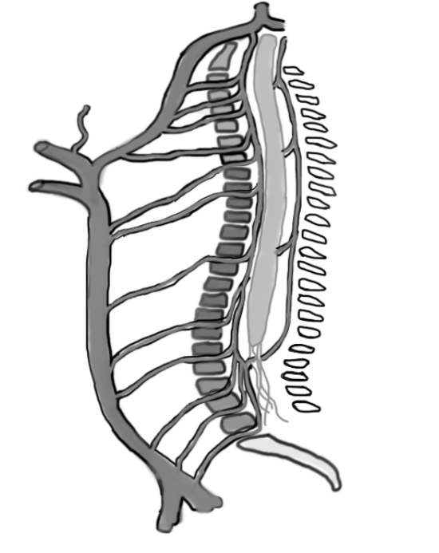
Anterior spinal artery Basilar artery Posterior spinal artery
C1
C2
C3
C4
C5
C6
C7

T1
T2
T3
T4
T5
T6
T7
T8
T9
T10
T11
T12

L1
L2
L3
L4

L5

Sacrum

Vertebral artery

Subclavian artery

Aorta

Radicular arteries

Great radicular artery
(Artery of Adamkiewicz)

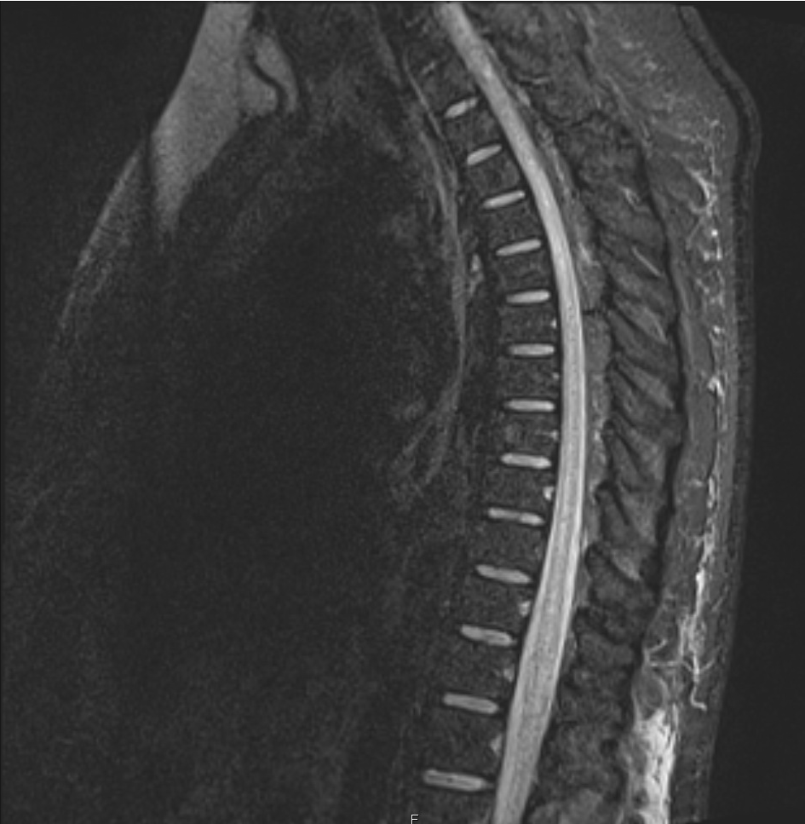
Figure 2 - T2-weighted sagittal magnetic resonance imaging of thoracic spine. Abnormal T2 signal within the spinal cord between T1 (denoted by the presence of the first rib) and T5, suggestive of spinal cord ischaemia (arrow). The spinal cord may also appear expanded, due to oedema, in the acute phase (not demonstrated here).

