Cardiovascular risk factors and lifestyle behaviours in relation to longevity: a Mendelian randomization study

Short title: Modifiable risk factors of longevity

Sabine van Oort, MD^{1, 2}, Joline W.J. Beulens, PhD^{2, 3}, Adriana J. van Ballegooijen, PhD^{2, 4},
Stephen Burgess, PhD^{5, 6}, Susanna C. Larsson, PhD^{7, 1}

¹ Department of Surgical Sciences, Uppsala University, Uppsala, Sweden
² Amsterdam University Medical Centers, Vrije Universiteit Amsterdam, department of Epidemiology and Data Science, Amsterdam Public Health Research Institute and Amsterdam Cardiovascular Sciences Research Institute, Amsterdam, the Netherlands
³ Julius Center for Health Sciences and Primary Care, University Medical Center Utrecht, Utrecht, the Netherlands
⁴ Amsterdam University Medical Centers, Vrije Universiteit Amsterdam, department of Nephrology, Amsterdam, the Netherlands
⁵ MRC Biostatistics Unit, University of Cambridge, Cambridge, United Kingdom
⁶ Department of Public Health and Primary Care, University of Cambridge, Cambridge, United Kingdom
⁷ Unit of Cardiovascular and Nutritional Epidemiology, Institute of Environmental Medicine, Karolinska Institutet, Stockholm, Sweden

Abstract
Background: The American Heart Association introduced the Life's Simple 7 initiative to improve cardiovascular health by modifying cardiovascular risk factors and lifestyle behaviours. It is unclear whether these risk factors are causally associated with longevity.
Objectives: This study aimed to investigate causal associations of Life's Simple 7 modifiable risk factors, as well as sleep and education, with longevity using the two-sample Mendelian randomization design.
Methods: Instrumental variables for the modifiable risk factors were obtained from large-scale genome-wide association studies. Data on longevity beyond the 90th survival percentile were extracted from a genome-wide association meta-analysis with 11,262 cases and 25,483 controls whose age at death or last contact was ≤ the 60th survival percentile.
Results: Risk factors associated with a lower odds of longevity included: genetic liability to type 2 diabetes (OR 0.88; 95% CI: 0.84;0.92), genetically predicted systolic and diastolic blood pressure (per 1-mmHg increase: 0.96; 0.94;0.97 and 0.95; 0.93;0.97), body mass index (per 1-SD increase: 0.80; 0.74;0.86), low-density lipoprotein cholesterol (per 1-SD increase: 0.75; 0.65;0.86), and smoking initiation (0.75; 0.66;0.85). Genetically increased high-density lipoprotein cholesterol (per 1-SD increase: 1.23; 1.08;1.41) and educational level (per 1-SD increase: 1.64; 1.45;1.86) were associated with a higher odds of longevity. Fasting glucose and other lifestyle factors were not significantly associated with longevity.
Conclusion: Most of the Life's Simple 7 modifiable risk factors are causally related to longevity. Prevention strategies should focus on modifying these risk factors and reducing education inequalities to improve cardiovascular health and longevity.
Keywords: Mendelian randomization; instrumental variable analysis; longevity; lifestyle; cardiovascular risk factors

List of abbreviations
BMI = Body mass index
CVD = Cardiovascular disease
DBP = Diastolic blood pressure
GWAS = Genome-wide association study
HDL = High-density lipoprotein
IVW = Inverse-variance weighted
LDL = Low-density lipoprotein
MR = Mendelian randomization
MR-PRESSO = Mendelian Randomization Pleiotropy RESidual Sum and Outlier
MVPA = Moderate-to-vigorous physical activity
SBP = Systolic blood pressure
SNP = Single nucleotide polymorphism

Introduction
Over the past decades, life expectancy has increased enormously [1]. Still, it is largely unclear why certain individuals survive to extreme ages and become the longest-lived of their generation, while others die earlier. Longevity tends to cluster within families, probably as a result of shared genetic and environmental factors [2]. The variation in lifespan is estimated to be heritable for ~25% [1], which leaves 75% to be influenced by environmental factors. Better insight into the association between potentially modifiable risk factors and longevity can inform strategies for a long and healthy life.
In 2010, the American Heart Association introduced the Life’s Simple 7 initiative [3]. The goal was to optimize cardiovascular health by focusing on seven modifiable risk factors, including three cardiovascular risk factors (glucose, blood pressure and cholesterol) and four lifestyle behaviours (body mass index (BMI), smoking, physical activity and diet). Cardiovascular disease remain the leading cause of death worldwide [4], and the majority of the Life's Simple 7 modifiable risk factors have been associated with longevity in previous prospective observational studies [5-11]. Yet, from these observational studies it is not possible to infer causality, due to potential reverse causation bias and residual confounding.
In Mendelian randomization (MR), genetic variants that modulate the risk factors of interest are used as instrumental variables [12]. Genetic variants are randomly allocated during meiosis and cannot be changed throughout life, thus genetic associations are somewhat protected from reverse causation bias and residual confounding. Consequently, it is possible to address causal hypotheses using the MR design.
The MR design has been previously used to investigate causality between several cardiovascular risk factors and parental lifespan [13]. Because offspring shares 50% of its genome with each parent, parental lifespan can be used as a proxy outcome. A limitation of this kin-cohort design in general is that parents have to reach their reproductive age to be included. Furthermore, parental lifespan in the previous MR study was self-reported, which might have introduced misclassification bias. Recently, an individual-level genome-wide association study (GWAS) on longevity was published [14]. This enables the investigation of cardiovascular risk factors and lifestyle behaviours without the additional assumptions of a kin-cohort design.
The objective of this study was to investigate causal associations between multiple potentially modifiable risk factors and longevity using the MR design. We investigated the cardiovascular risk factors and lifestyle behaviours as described in Life's Simple 7, as well as educational level as measure of socio-economic status and sleep as novel lifestyle-related risk factor.

Methods
Two-sample MR design
We used a two-sample MR design: a genetic instrumental variable analysis based on summary-level data with single nucleotide polymorphisms (SNPs) as instruments for the risk factor. To obtain unbiased estimates of the causal effects, it is essential that the MR assumptions hold. These assumptions include: 1) the SNPs are associated with the exposure; 2) the SNPs are independent of confounders of the risk factor-outcome association; and 3) the SNPs influence the outcome only via the exposure [12].

Data sources for and selection of the genetic instruments
We identified genetic instruments for each modifiable risk factor by considering the largest GWAS or meta-analysis conducted primarily among individuals of European ancestry. Details on the data sources from which we obtained the instrumental variables can be found in Table 1.
SNPs were selected as instrumental variables if associated with the modifiable risk factors at the genome-wide significance threshold (P<5×10⁻⁸). SNPs located in or close to the APOE or FOXO3 genes were excluded, as these genes are known to be strongly related to longevity via multiple pathways. If SNPs within each trait were in linkage disequilibrium (r² >0.1), we included the SNP with the strongest correlation to the exposure (e.g. the smallest P-value). Finally, we excluded SNPs that were not available in the longevity GWAS.
An overview of the modifiable risk factors and corresponding traits included in this MR study has been provided in Figure 1. We included SNPs for type 2 diabetes (N=285) [15], fasting glucose (N=35) [16], systolic blood pressure (SBP) (N=242) and diastolic blood pressure (DBP) (N=300) [17], lipids (low-density lipoprotein (LDL) (N=53) and high-density lipoprotein (HDL) (N=64) cholesterol and triglycerides (N=35)) [18], BMI (N=841) [19], smoking (initiation (N=357) and heaviness (N=46)) [20], alcohol consumption (N=89) [20], alcohol dependence (N=3) [21], coffee consumption (N=14) [22], physical activity (moderate-to-vigorous physical activity (MVPA) (N=5) [23] and sedentary behaviour (N=4) [24]), insomnia (N=237) [25], sleep duration (overall (N=77) and short (N=26, <7 hours versus 7-8 hours) and long (N=7, ≥9 hours versus 7-8 hours) sleep duration) [26], and educational level (N=1196) [27]. The phenotypic variance explained by the genetic instruments varied from 0.073% for MVPA to 16.3% for type 2 diabetes (Table 1).

Data source for longevity
A recently published GWAS meta-analysis on longevity was used to extract the genetic associations with longevity [14]. This meta-analysis included European-ancestry participants from ~20 population-based or family-based cohorts in the United States and Europe (i.e. Denmark, Finland, France, Iceland, Italy, the Netherlands, United Kingdom). Cases were individuals who lived beyond an age at or above the 90th survival percentile (N=11,262), based on cohort life tables from census data from the appropriate country, sex, and birth cohort. Controls (N=25,483) were individuals who died at or before the age at the 60th survival percentile or whose age at the last follow-up visit was at or before the 60th survival percentile. Many of the included cohorts recruited individuals who were already relatively old at the start of follow-up [14]. Therefore, for many studies the number of controls was small in comparison to the number of cases.
To harmonize the data from the exposure and longevity GWASs, the effect estimates of the SNPs with unmatched effects and other alleles were flipped. The present study was approved by the Swedish Ethical Review Authority.

Statistical analyses
We used the inverse-variance weighted (IVW) method as main analysis method. To obtain one causal IVW estimate for each exposure, Wald ratio estimates of different SNPs were combined in a multiplicative random-effects meta-analysis [12]. This method leads to precise causal estimates, but these might be affected by pleiotropy or invalid instrument bias in case not all MR assumptions hold. Therefore, we used several sensitivity analyses to evaluate the robustness of the results and check for pleiotropy: the weighted median method, contamination mixture method, MR-Egger regression and Mendelian Randomization Pleiotropy RESidual Sum and Outlier (MR-PRESSO). The weighted median method is a method to check invalid instrument bias and provides a consistent causal estimate if over 50% of the weight in the analysis is from valid SNPs [28]. The contamination mixture method is a robust method if the largest group of SNPs estimating the same quantity is the group of valid instruments [29]. MR-Egger regression can detect and adjust for directional pleiotropy, but has low precision [28]. The MR-PRESSO method evaluates whether exclusion of potential outlier SNPs influences the results, which is an indication of potential pleiotropy [30].
The genetic instruments for LDL cholesterol, HDL cholesterol and triglycerides are partly overlapping [18]. Therefore, we performed multivariable MR as a sensitivity analysis to obtain causal estimates adjusted for this genetic correlation.
In case a significant causal effect was observed in the main analysis, we used multivariable MR to assess whether the association was potentially mediated by the major non-communicable diseases type 2 diabetes and cardiovascular disease (CVD) [31]. We assessed the attenuating effects after adjustment for each disease separately. For CVD we used GWAS summary data from the FinnGen Study [32] and for type 2 diabetes from the DIAbetes Genetics Replication And Meta-analysis (DIAGRAM) consortium [15].
We performed post-hoc power calculations for the main IVW analyses using an online power calculation tool (https://sb452.shinyapps.io/power/) (Supplementary Table 1) [33].
The statistical analyses were conducted in RStudio (Version 1.2.5019) with the R packages MendelianRandomization [34] and MRPRESSO [30]. Results were reported as odds ratios (OR) with corresponding 95% confidence intervals (CI). To adjust for multiple testing, we used a Bonferroni-corrected, two-sided significance level of 0.0025 (0.05 divided by 20 risk factors). P-values above the Bonferroni-corrected significance level, but below 0.05 were considered as suggestive for a potential association.

Results
Modifiable risk factors and longevity: main results
Risk factors that were associated with a lower odds of longevity included (Figure 2): genetic liability to type 2 diabetes (OR 0.88; CI: 0.84;0.92), genetically predicted higher systolic and diastolic blood pressure (OR per 1-mmHg increase: 0.96; CI 0.94;0.97 for SBP and 0.95; CI: 0.93;0.97 for DBP), genetically predicted higher LDL cholesterol (OR per 1-SD increase: 0.75; CI: 0.65;0.86), genetically predicted higher BMI (OR per 1-SD increase: 0.80; CI: 0.74;0.86), and genetic liability to smoking initiation (OR 0.75; CI: 0.66;0.85). A higher odds of longevity was observed for genetically-predicted HDL cholesterol (OR per 1-SD increase: 1.23; CI: 1.08;1.41) and for educational level (OR per 1-SD increase: 1.64, CI: 1.45;1.86). The following genetically-predicted risk factors were suggestively associated with a lower odds of longevity: higher triglycerides (OR per 1-SD increase: 0.81; CI 0.67;0.98), alcohol dependence (OR 0.86; CI: 0.76;0.97), and insomnia (OR 0.92; CI 0.86;0.98). No significant associations with longevity were observed for genetically-predicted fasting glucose, smoking heaviness, MVPA, sedentary behaviour, alcohol consumption, coffee consumption, and sleep duration (Figure 2).

Results sensitivity analyses to assess the MR assumptions
Potential pleiotropy was indicated by the MR-Egger analyses of type 2 diabetes and BMI, as the intercepts significantly deviated from zero (Supplementary Table 2), but the MR-PRESSO analysis did not identify any outlying SNPs. For fasting glucose, the SNP rs6943153 was classified as an outlier in the MR-PRESSO analysis. Exclusion of this SNP revealed a trend between higher genetically-predicted fasting glucose and a lower odds of longevity (OR 0.68; CI: 0.49;0.96). For alcohol consumption, a trend towards an inverse association was revealed by the weighted median (OR 0.46; CI: 0.25;0.83) and contamination mixture method (OR 0.50; CI: 0.31;0.80). Results for the other modifiable risk factors were robust across the sensitivity analyses (Supplementary Table 2).
Adjusting for the genetic correlation between the different lipids led to a partial attenuation of the association between HDL cholesterol and longevity (OR 1.15; CI: 0.98;1.34) and to a full attenuation of the suggestive association between triglycerides and longevity (OR 1.02; 95% CI: 0.81;1.29). The estimate for LDL cholesterol was marginally affected (OR 0.76; CI: 0.66;0.89).

Mediation by major non-communicable diseases
A simplified overview of the hypothesized relationships between the different cardiovascular risk factors, lifestyle behaviours, mediating diseases and longevity has been depicted in Supplementary Figure 1. We observed an attenuation of the association between DBP and longevity after adjustment for CVD (OR 0.97; CI: 0.95;1.00) (Supplementary Figure 2). Likewise, the association between BMI and longevity attenuated after adjustment for diabetes (OR 0.90; CI: 0.82;0.99) and partially attenuated after adjustment for CVD (OR 0.83; CI: 0.76;0.90). The effects of the other risk factors on longevity were not or only partially affected by adjustment for diabetes or CVD.

Discussion
In this MR study, eight of the twenty investigated modifiable risk factors were significantly associated with longevity. A higher genetically predicted HDL cholesterol and educational level were associated with a higher odds of being long-lived, whereas type 2 diabetes, SBP, DBP, LDL cholesterol, BMI, and smoking initiation were associated with a lower odds of longevity. For an additional three risk factors - triglycerides, alcohol dependence and insomnia - we found suggestive evidence for a causal association with a lower odds of longevity. For the majority of the Life's Simple 7 modifiable risk factors - except for physical activity and certain dietary factors - we found sufficient evidence for a causal association with longevity.

Interpretation of the findings
Blood pressure, LDL cholesterol, smoking initiation, and educational level were robustly associated with longevity in this MR study without indication of violation of the MR assumptions. Moreover, the associations were in similar direction as previously reported by prospective observational studies [5, 7, 8, 10, 11] and by the previous MR study on cardiovascular risk factors and parental longevity [13], although they used a smaller number of SNPs as instrumental variables. Taken together, these traditional cardiovascular risk factors are likely to be causally associated with longevity.
This MR study does not support the so-called obesity paradox: a survival benefit in people with a higher BMI, which has been previously found in observational studies among people with chronic diseases [35]. However, the setting of this MR study was in a general population. The observational literature among the general population indicates an increased mortality risk in overweight and obese individuals [36] and is thus in line with our findings of a harmful effect of higher BMI on longevity. Moreover, a previous MR study found a linear dose-response relation of BMI with mortality in never smokers and a J shaped relation in ever smokers [37]. This strengthens the evidence that the obesity paradox in previous observational studies is a product of bias by confounding through smoking and reverse causation [38]. The effect of BMI is most likely partially driven by vertical pleiotropic effects via type 2 diabetes, since potential pleiotropy was indicated by the MR-Egger regression and the association between BMI and longevity attenuated after adjustment for the genetic correlation with type 2 diabetes. Moreover, hypertension and CVD could also play a role. Nevertheless, if overweight reduction provides a longevity benefit via effects on diabetes or CVD, this should still be advocated as public health goal.
The suggestively harmful effect of higher triglycerides on longevity we observed in our study can be explained by the overlap in the genetic instruments of the different lipids. As the causal estimate for HDL also attenuated after adjustment for this genetic overlap, this suggests that mainly high LDL cholesterol affects longevity.
Our observation that alcohol dependence, based on SNPs situated in the alcohol dehydrogenase region, was suggestively associated with a lower odds to be long-lived, while no clear association was observed between alcohol consumption and longevity, might suggest that especially excessive drinking affects longevity. However, we cannot rule out that the U-shaped association between alcohol and mortality according to the observational literature [39] has been the result of residual confounding or reverse causation, as our MR study was not designed to reveal U-shaped associations.
Drawing causal conclusions on the suggestively harmful association between insomnia and longevity observed in this MR study is not yet possible. A recent meta-analysis of observational studies on insomnia and mortality has been inconclusive (pooled HR 1.07; CI: 0.96;1.19) with high heterogeneity between studies [40]. For triangulation it is necessary that future observational cohorts and future MR studies reduce heterogeneity by improving the definition and assessment of insomnia, and that future MR studies further improve precision by acquiring larger sample sizes for either insomnia or longevity.
We are also not able to draw conclusions on causality yet on the association of smoking heaviness, coffee consumption, physical activity, and sleep duration with longevity. Although these risk factors have been associated with longevity or mortality in observational studies [5, 7-9, 41, 42], it remains unclear whether the null associations observed in our MR study were due to the absence of a causal effect or related to the low power of these analyses (7% to 38%) (Supplementary Table 1) because of the small phenotypic variance explained by the genetic instruments (varying from 0.073% to ~1%) (Table 1). The latter is supported by the wide confidence intervals for the causal estimates of these risk factors across all analyses.

Underlying mechanisms
Cardiovascular diseases and type 2 diabetes are probably on many of the pathways from risk factor to longevity, as was also observed in our mediation analyses. Modification of the cardiovascular risk factors and lifestyle behaviours potentially reduces or delays the onset of non-communicable diseases, which in turn benefits longevity. Yet, a part of the associations could not be explained by the onset of diabetes and cardiovascular disease. This might suggest that other non-communicable diseases play a role as well, such as chronic respiratory diseases, certain types of cancer, psychiatric illnesses or Alzheimer's disease. Another explanation might be that modifiable risk factors not only influence disease onset, but also influence disease progression or disease severity, which was not captured in our mediation analyses. Finally, it might also implicate that there is a potential disease-independent effect of these risk factors on longevity, for example via influences on other determinants of health, such as functional status, cognition or frailty [43].
The modifiable risk factor education is a more upstream determinant of health. It is likely that several pathways play a role in the beneficial effect of high educational level on longevity. Higher education might lead to more knowledge and skills to make healthier and more long-term choices regarding lifestyle and prevention of diseases. This is reflected by a previous MR study showing that a large part of the association between education and cardiovascular disease can be explained by BMI and smoking [44]. Other contributing factors might include more resources to maintain a healthy lifestyle, less exposure to occupation-related health hazards and better access to health care.

Implications
The Life's Simple 7 modifiable risk factors glucose, blood pressure, cholesterol, overweight and smoking are causally related to longevity. Modifying these risk factors can potentially improve health: partly via effects on cardiovascular diseases and type 2 diabetes, but our study also implicates an independent effect of these risk factors on longevity. As each risk factor has its own causal effect on longevity, all risk factors are potential prevention targets. This study provides evidence for governmental policy makers to improve public health by implementing prevention strategies as the Life's Simple 7 and to reduce education inequalities in the population.
Larger sample sizes for either the exposure or outcome GWAS are needed to be able to draw causal conclusions on certain cardiovascular risk factors, but mostly lifestyle behaviours such as physical activity and alcohol consumption. Longer follow-up durations of cohorts with genetic data are needed for acquiring larger sample sizes on the individual longevity phenotype. Our findings were similar to those of the parental lifespan MR [13], which implicates that using a parental longevity phenotype would be an effective strategy for increasing sample sizes in the nearby future.

Strengths and limitations
The validity of causal inference from this MR study largely depends on whether the instrumental variable assumptions hold. The majority of our results were robust to a wide variety of sensitivity analyses to assess potential invalid instrument bias and pleiotropy. Moreover, we were able to include multiple, independent, genome-wide significant SNPs as instruments for the different risk factors to ensure that the first MR assumption was fulfilled. Lastly, the longevity phenotype used as outcome in this study was derived from a homogeneous case-control GWAS meta-analysis due to standardization of the survival percentiles according to sex, country, and birth cohort.
It is important to acknowledge that the small variation in exposure explained by the genetic instruments for smoking heaviness, alcohol and coffee consumption, physical activity, and sleep duration resulted in low precision. Consequently, these null associations cannot be interpreted as no causal effects. Another shortcoming is that participants had to survive to a certain age to be included in many of the cohorts from the longevity GWAS meta-analysis. This potentially led to an underrepresentation of people with early mortality in the control group and thus to an underestimation of the true effect if those people had more unfavourable risk factors. Moreover, there was a maximum of ~30-35% overlap between the GWAS for longevity and the GWASs for eight of the twenty risk factors (Table 1). Although the overlap was only partial, this might have inflated the type 1 error rate. Another limitation is that we were only able to evaluate alcohol and coffee consumption as dietary factors, because no robust and specific genetic instruments are currently available for other dietary components. Finally, our findings are only generalizable to populations of European ancestry.

Conclusions
This MR study provided evidence that most of the Life's Simple 7 modifiable risk factors and educational level are causally related to longevity. Part of these effects are driven by mainly cardiovascular diseases and type 2 diabetes, but there is an independent effect of the risk factors on longevity as well. Prevention strategies should focus on modifying these risk factors and reducing education inequalities to improve cardiovascular health and longevity.

Acknowledgements
We gratefully acknowledge the authors and participants of all GWAS from which we used summary statistics data.

Funding
This work was supported by the Amsterdam Public Health Research Institute [two personal travel grants to S.O.], the Swedish Research Council [Vetenskapsrådet; 2019-00977 to S.C.L.], and the Wellcome Trust and the Royal Society [204623/Z/16/Z to S.B.]. This work was supported by funding from the National Institute for Health Research [Cambridge Biomedical Research Centre at the Cambridge University Hospitals National Health Service Foundation Trust]. The views expressed are those of the authors and not necessarily those of the National Health Service, the National Institute for Health Research or the Department of Health and Social Care. The funding bodies had no role in the design of the study, the collection, analysis and interpretation of data, or in writing the manuscript.

Competing interests
The authors declare that they have no competing interests.

Data availability
All data analysed in this study are based on publicly available summary statistics data provided by genetic consortia.

References
1 N. van den Berg, M. Beekman, K. R. Smith, A. Janssens and P. E. Slagboom. Historical demography and longevity genetics: Back to the future. Ageing Research Reviews 2017; 38: 28-39.
2 N. van den Berg, M. Rodríguez-Girondo, I. K. van Dijk, et al. Longevity defined as top 10% survivors and beyond is transmitted as a quantitative genetic trait. Nature communications 2019; 10: 35.
3 D. M. Lloyd-Jones, Y. Hong, D. Labarthe, et al. Defining and setting national goals for cardiovascular health promotion and disease reduction: the American Heart Association's strategic Impact Goal through 2020 and beyond. Circulation 2010; 121: 586-613.
4 G. B. D. C. o. D. Collaborators. Global, regional, and national age-sex-specific mortality for 282 causes of death in 195 countries and territories, 1980-2017: a systematic analysis for the Global Burden of Disease Study 2017. Lancet 2018; 392: 1736-88.
5 T. Brenn. Survival to Age 90 in Men: The Tromso Study 1974-2018. Int J Environ Res Public Health 2019; 16.
6 T. Heir, J. Erikssen and L. Sandvik. Life style and longevity among initially healthy middle-aged men: prospective cohort study. BMC Public Health 2013; 13: 831.
7 L. Wilhelmsen, K. Svärdsudd, H. Eriksson, et al. Factors associated with reaching 90 years of age: a study of men born in 1913 in Gothenburg, Sweden. Journal of Internal Medicine 2011; 269: 441-51.
8 L. B. Yates, L. Djoussé, T. Kurth, J. E. Buring and J. M. Gaziano. Exceptional Longevity in Men: Modifiable Factors Associated With Survival and Function to Age 90 Years. Archives of Internal Medicine 2008; 168: 284-90.
9 L. Brandts and P. A. van den Brandt. Sex-specific associations between smoking habits and reaching longevity: Netherlands Cohort Study. Geriatrics & gerontology international 2018; 18: 1249-58.
10 D. F. Terry, M. J. Pencina, R. S. Vasan, et al. Cardiovascular risk factors predictive for survival and morbidity-free survival in the oldest-old Framingham Heart Study participants. Journal of the American Geriatrics Society 2005; 53: 1944-50.
11 A. Urtamo, S. K. Jyväkorpi, H. Kautiainen, K. H. Pitkälä and T. E. Strandberg. Major cardiovascular disease (CVD) risk factors in midlife and extreme longevity. Aging Clinical and Experimental Research 2020; 32: 299-304.
12 S. Burgess and S. G. Thompson. Mendelian randomization: methods for using genetic variants in causal estimation. Chapman and Hall/CRC. 2015.
13 P. K. Joshi, N. Pirastu, K. A. Kentistou, et al. Genome-wide meta-analysis associates HLA-DQA1/DRB1 and LPA and lifestyle factors with human longevity. Nature communications 2017; 8: 910.
14 J. Deelen, D. S. Evans, D. E. Arking, et al. A meta-analysis of genome-wide association studies identifies multiple longevity genes. Nature communications 2019; 10: 3669.
15 A. Mahajan, D. Taliun, M. Thurner, et al. Fine-mapping type 2 diabetes loci to single-variant resolution using high-density imputation and islet-specific epigenome maps. Nat Genet 2018; 50: 1505-13.
16 R. A. Scott, V. Lagou, R. P. Welch, et al. Large-scale association analyses identify new loci influencing glycemic traits and provide insight into the underlying biological pathways. Nat Genet 2012; 44: 991-1005.
17 E. Evangelou, H. R. Warren, D. Mosen-Ansorena, et al. Genetic analysis of over 1 million people identifies 535 new loci associated with blood pressure traits. Nat Genet 2018; 50: 1412-25.
18 C. J. Willer, E. M. Schmidt, S. Sengupta, et al. Discovery and refinement of loci associated with lipid levels. Nature genetics 2013; 45: 1274-83.
19 L. Yengo, J. Sidorenko, K. E. Kemper, et al. Meta-analysis of genome-wide association studies for height and body mass index in approximately 700000 individuals of European ancestry. Hum Mol Genet 2018; 27: 3641-9.
20 M. Liu, Y. Jiang, R. Wedow, et al. Association studies of up to 1.2 million individuals yield new insights into the genetic etiology of tobacco and alcohol use. Nature Genetics 2019; 51: 237-44.
21 R. K. Walters, R. Polimanti, E. C. Johnson, et al. Transancestral GWAS of alcohol dependence reveals common genetic underpinnings with psychiatric disorders. Nature Neuroscience 2018; 21: 1656-69.
22 V. W. Zhong, A. Kuang, R. D. Danning, et al. A genome-wide association study of bitter and sweet beverage consumption. Human Molecular Genetics 2019; 28: 2449-57.
23 Y. C. Klimentidis, D. A. Raichlen, J. Bea, et al. Genome-wide association study of habitual physical activity in over 377,000 UK Biobank participants identifies multiple variants including CADM2 and APOE. International journal of obesity (2005) 2018; 42: 1161-76.
24 A. Doherty, K. Smith-Byrne, T. Ferreira, et al. GWAS identifies 14 loci for device-measured physical activity and sleep duration. Nature communications 2018; 9: 5257.
25 P. R. Jansen, K. Watanabe, S. Stringer, et al. Genome-wide analysis of insomnia in 1,331,010 individuals identifies new risk loci and functional pathways. Nature genetics 2019; 51: 394-403.
26 H. S. Dashti, S. E. Jones, A. R. Wood, et al. Genome-wide association study identifies genetic loci for self-reported habitual sleep duration supported by accelerometer-derived estimates. Nature communications 2019; 10: 1100.
27 J. J. Lee, R. Wedow, A. Okbay, et al. Gene discovery and polygenic prediction from a genome-wide association study of educational attainment in 1.1 million individuals. Nat Genet 2018; 50: 1112-21.
28 S. Burgess, J. Bowden, T. Fall, E. Ingelsson and S. G. Thompson. Sensitivity Analyses for Robust Causal Inference from Mendelian Randomization Analyses with Multiple Genetic Variants. Epidemiology (Cambridge, Mass.) 2017; 28: 30-42.
29 S. Burgess, C. N. Foley, E. Allara, J. R. Staley and J. M. M. Howson. A robust and efficient method for Mendelian randomization with hundreds of genetic variants. Nature communications 2020; 11: 376.
30 M. Verbanck, C. Y. Chen, B. Neale and R. Do. Detection of widespread horizontal pleiotropy in causal relationships inferred from Mendelian randomization between complex traits and diseases. Nat Genet 2018; 50: 693-8.
31 S. Burgess and S. G. Thompson. Multivariable Mendelian randomization: the use of pleiotropic genetic variants to estimate causal effects. American journal of epidemiology 2015; 181: 251-60.
32 FinnGen. FinnGen: Documentation of R2 release. 2020.
33 S. Burgess. Sample size and power calculations in Mendelian randomization with a single instrumental variable and a binary outcome. International journal of epidemiology 2014; 43: 922-9.
34 O. O. Yavorska and S. Burgess. MendelianRandomization: an R package for performing Mendelian randomization analyses using summarized data. International journal of epidemiology 2017; 46: 1734-9.
35 H. R. Banack and A. Stokes. The ‘obesity paradox’ may not be a paradox at all. International Journal of Obesity 2017; 41: 1162-3.
36 Global BMI Mortality Collaboration, E. Di Angelantonio, N. Bhupathiraju Sh, et al. Body-mass index and all-cause mortality: individual-participant-data meta-analysis of 239 prospective studies in four continents. Lancet (London, England) 2016; 388: 776-86.
37 Y. Q. Sun, S. Burgess, J. R. Staley, et al. Body mass index and all cause mortality in HUNT and UK Biobank studies: linear and non-linear mendelian randomisation analyses. BMJ (Clinical research ed.) 2019; 364: l1042.
38 S. H. Preston and A. Stokes. Obesity paradox: conditioning on disease enhances biases in estimating the mortality risks of obesity. Epidemiology (Cambridge, Mass.) 2014; 25: 454-61.
39 T. Stockwell, J. Zhao, S. Panwar, et al. Do "Moderate" Drinkers Have Reduced Mortality Risk? A Systematic Review and Meta-Analysis of Alcohol Consumption and All-Cause Mortality. Journal of studies on alcohol and drugs 2016; 77: 185-98.
40 N. Lovato and L. Lack. Insomnia and mortality: A meta-analysis. Sleep medicine reviews 2019; 43: 71-83.
41 C. Hublin, M. Partinen, M. Koskenvuo and J. Kaprio. Sleep and Mortality: A Population-Based 22-Year Follow-Up Study. Sleep 2007; 30: 1245-53.
42 N. D. Freedman, Y. Park, C. C. Abnet, A. R. Hollenbeck and R. Sinha. Association of coffee drinking with total and cause-specific mortality. The New England journal of medicine 2012; 366: 1891-904.
43 E. Keeler, J. M. Guralnik, H. Tian, R. B. Wallace and D. B. Reuben. The impact of functional status on life expectancy in older persons. The journals of gerontology. Series A, Biological sciences and medical sciences 2010; 65: 727-33.
44 A. R. Carter, D. Gill, N. M. Davies, et al. Understanding the consequences of education inequality on cardiovascular disease: mendelian randomisation study. BMJ (Clinical research ed.) 2019; 365: l1855.

Address for correspondence:
Sabine van Oort, MD
Amsterdam UMC, location VUmc
Department of Epidemiology and Data Science
De Boelelaan 1089a
1081HV Amsterdam, The Netherlands
E-mail: s.vanoort1@amsterdamumc.nl

Figures
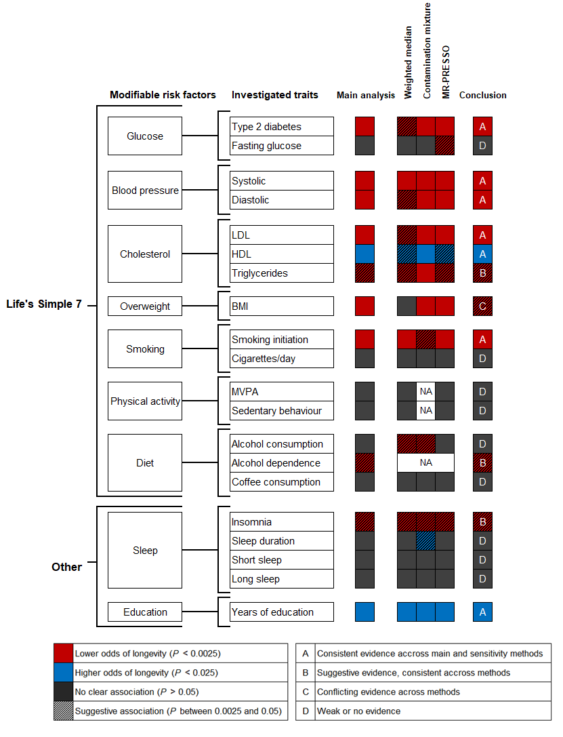
Figure 1. Overview of the design and results of this MR study on modifiable risk factors and longevity
Life’s Simple 7 according to the American Heart Association’s initiative [3]
The inverse-variance weighted method was used for the main analysis.
All results can be found in Figure 2 and Supplementary Table 2.
Abbreviations: BMI = body mass index; HDL = high-density lipoprotein; LDL = low-density lipoprotein; MVPA = moderate-to-vigorous physical activity; NA = not applicable due to limited number of SNPs

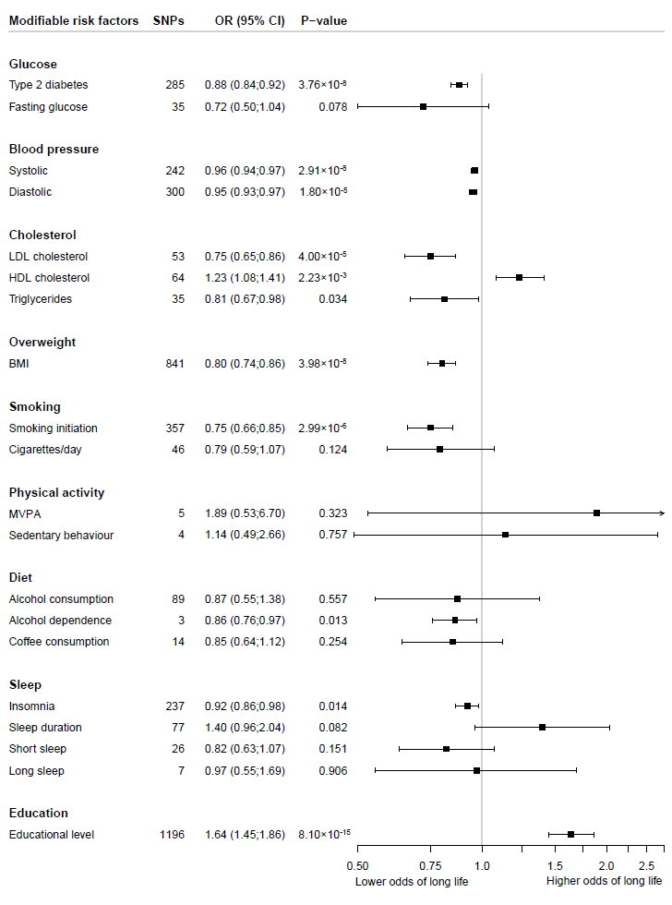
Figure 2. The association between modifiable risk factors and longevity beyond the 90th percentile using the inverse-variance weighted Mendelian randomization method
Odds ratios represent the associations with longevity of respectively: type 2 diabetes; 1-mmol/L increase in fasting glucose; 1-mmHg increase in SBP; 1-mmHg increase in DBP; 1-SD increase in LDL cholesterol; 1-SD increase in HDL cholesterol; 1-SD increase in triglycerides; 1-SD increase in BMI; ever smoked regularly compared to never smoked; 1-SD increase in number of cigarettes smoked per day; 1-SD increase in log-transformed alcoholic drinks/week; alcohol dependence; 50%-change in coffee consumption; 1-SD increase in MET-minutes/week of MVPA; 1-SD increase in sedentary time; insomnia; 1-hour/day increase in sleep duration; <7 hours sleep duration compared to 7-8 hours; ≥9 hours sleep duration compared to 7-8 hours; 1-SD increase in years of educational attainment.
Abbreviations: BMI = body mass index; HDL = high-density lipoprotein; LDL = low-density lipoprotein; MVPA = moderate-to-vigorous physical activity; OR = odds ratio.

Table 1. Overview of the data sources of the instrumental variables used in the Mendelian randomization study
Risk factor | Sample size | Ancestry | Unit* | SNPs† | Variance (%)‡ | Overlap§
Glucose
Type 2 diabetes [15] | 898,130 | European | odds of type 2 diabetes | 285/403 | 16.3% for 403 SNPs | ~10-20%
Fasting glucose [16] | 133,010 | European | mmol/L | 35/36 | 4.8% for 36 SNPs | None
Blood pressure
Systolic blood pressure [17] | >1 million | European | mmHg | 242/362 | 5.66% for 362 SNPs | ~20-25%
Diastolic blood pressure [17] | >1 million | European | mmHg | 300/405 | 5.32% for 405 SNPs | ~20-25%
Cholesterol
LDL cholesterol [18] | 188,577 | primarily European | 1-SD increase in LDL cholesterol | 53/58 | 14.6% for 58 SNPs | None
HDL cholesterol [18] | 188,577 | primarily European | 1-SD increase in HDL cholesterol | 64/71 | 13.7% for 71 SNPs | None
Triglycerides [18] | 188,577 | primarily European | 1-SD increase in triglycerides | 35/40 | 11.7% for 40 SNPs | None
Overweight
Body mass index [19] | ~700,000 | European | 1-SD increase in body mass index | 842/941 | ~6.0% for 941 SNPs | ~30-35%
Smoking
Smoking initiation [20] | 1,232,091 | European | ever smoked regularly compared to never smoked | 357/378 | 2.3% for 378 SNPs | ~15-25%
Cigarettes per day [20] | 337,334 | European | 1-SD increase in number of cigarettes smoked per day | 46/55 | ~1% for 55 SNPs | ~15-25%
Diet
Alcohol consumption [20] | 941,280 | European | 1-SD increase in log-transformed alcoholic drinks/week | 89/99 | ~0.2% for 99 SNPs | ~15-25%
Alcohol dependence [21] | 46,568 | European | odds of alcohol dependence | 3/3 | ~0.4% for 3 SNPs | None
Coffee consumption [22] | 375,833 | European | 50% change | 14/15 | ~0.5% for 15 SNPs | None
Physical activity
MVPA [23] | 377,234 | European | 1-SD increase in MET-minutes /week of MVPA | 5/9 | 0.073% for 9 SNPs | None
Sedentary behaviour [24] | 91,105 | European | 1-SD increase in sedentary time | 4/4 | 0.08% for 4 SNPs | None
Sleep
Insomnia [25] | 1,331,010 | European | odds of insomnia | 237/248 | 2.6% for 248 SNPs | None
Sleep duration [26] | 446,118 | European | hour/day | 77/78 | 0.69% for 78 SNPs | None
Short sleep duration [26] | 411,934 | European | <7 hours compared to 7-8 hours /day | 26/27 | NA | None
Long sleep duration [26] | 339,926 | European | ≥9 hours compared to 7-8 hours /day | 7/8 | NA | None
Education
Educational level [27] | 1,131,881 | European | 1-SD increase in years of educational attainment | 1196/1271 | 11-13% for 1271 SNPs | ~15-30%
Abbreviations: MET = metabolic equivalent of task; MVPA = moderate to vigorous physical activity; NA = Not available; SD = standard deviation; SNP = single nucleotide polymorphism
* Units as used in the MR analysis
† Number of SNPs included in MR / number of SNPs identified in GWAS
‡ The phenotypic variance explained by the genetic instruments, as reported in the risk factor GWASs.
§ The estimated overlap of the longevity GWAS with the risk factor GWASs. The percentages represent the part of the total number of longevity cases and controls derived from overlapping sources.

