Extending ecological trap theory to account for mobile animals in dynamic environments.

Dejan Stojanovic^{1,3}, Matthew H. Webb¹, Robert Heinsohn¹, William J. Sutherland² and Aleks Terauds¹

- Fenner School of Environment and Society, Australian National University, Canberra, Australia
- Department of Zoology, University of Cambridge, Cambridge, United Kingdom
- Corresponding author: dejan.stojanovic@anu.edu.au

Running Head: Extending ecological trap theory

Abstract
- Ecological traps arise when animals prefer low quality habitats. Ecological trap theory assumes animals cannot escape and that traps are permanent. But variation is ubiquitous in many ecosystems, and current theory does not account for mobile animals or environmental fluctuations.
- Nomadic animals exploit variable environments by moving between the richest patches in a landscape. They exemplify the need to improve ecological trap theory because the effects of traps on mobile populations are unknown. Under increasing anthopogenic mediated environmental change, nomads offer urgently needed insights into how animals survive in unstable environments.
- We develop a conceptual model that expands ecological trap theory to account for mobile animals in variable environments. We consider a hypothetical landscape with discrete source and sink habitats. Relative attractiveness of sources/sinks to nomads depends on a variable settlement cue (eg. pulsed food availability). In this scenario, habitat selection by nomads is represented as a continuum of preference, with sources at one extreme and sinks at the other. The model predicts that a population in this landscape could face three distinct scenarios depending on relative attractiveness of source versus sink habitats: (1) source/sink dynamics, (2) equal preference and (3) severe ecological traps.
- We test our conceptual model against six years of field data on nomadic swift parrots Lathamus discolor. A heterogeneously distributed swift parrot predator has created discrete source and sink habitats (i.e. predator absent/present respectively). We modeled parrot occupancy against annual variations in availability of their settlement cue (food) over their whole breeding range. Parrots settled wherever food was most abundant each year. By following food, swift parrots settled in both sources and sinks. Consequently, they experienced all scenarios predicted by our model within three years of the study. Because sinks predominate in the study area, swift parrots were repeatedly caught in severe or equal preference ecological traps in five of six years.
- Our conceptual model extends the theoretical framework for testing hypotheses about ecological traps for animals in variable environments. We show that population limitation in nomads is more complex than previously thought. We provide a novel starting point for further research into the conservation and evolutionary implications of chronically understudied nomads in unpredictable environments.

Keywords
Evolutionary trap, migration, population limitation, Lathamus discolor, predation, sugar glider Petaurus breviceps, mobile species

Introduction
Anthropogenic habitat change can lead to the creation of novel habitats, which are utilized with varying degrees of success by native species (1-3). However, a growing number of studies in degraded landscapes are reporting the occurrence of ecological traps (4, 5). An ecological trap occurs when the environmental cues used by animals to select habitat become mismatched to true habitat quality. In these cases animals prefer low quality habitat, despite the negative fitness outcomes associated with using that habitat (4, 6, 7). Ecological traps make evolved habitat selection cues maladaptive, and population decline and extinction can occur quickly (8).
Robertson et al. (6) concluded that ecological traps can be diagnosed using three key lines of evidence: (i) individuals exhibit preference for one resource over another; (ii) a reasonable measure of individual fitness can be associated with the use of each resource and; (iii) that fitness associated with the preferred resource is lower. Two general types of ecological trap have been recognized (‘equal preference’ i.e. sources and sinks equally preferred; ‘severe’ i.e. sinks preferred over sources) (6) and both are typically reported from systems that lend themselves to detailed study over time (9, 10) or space (11-13).

For sedentary and philopatric species, ecological traps are a serious problem because escape from traps is unlikely (4). However many species have less predictable movement patterns than sedentary/philopatric species. For instance, mobile animals living in variable environments can undertake irregular movements over variable distances and directions to exploit temporary rich patches of resource availability (hereafter called 'nomads', 14). Nomads may either be (i) less vulnerable to ecological traps, because they can move away from trap habitats, or (ii) equally/more vulnerable to ecological traps, because in degraded landscapes they could move away from one trap habitat into another. In this context, nomads are poorly understood relative to sedentary/philopatric species (14, 15), and their movements may expose them to a wider array of threats in degraded landscapes (16, 17). Current ecological trap theory assumes that trapped animal populations are locked into an extinction vortex because environmental conditions are stable, or animals do not move (8). However, ecosystems are already changing in response to global warming (18, 19), and nomads offer insights into how animals survive in unstable environments (17). Furthermore, recent studies have suggested that refining and improving ecological theories fundamentally depends on testing them against field data (20). This study aims to refine ecological trap theory by accounting for unpredictable environmental variation, exemplified by nomadic species. We expand ecological trap theory by explicitly addressing how environmental variation drives population limitation of nomads in degraded landscapes.

We developed a conceptual model of population limitation for nomads in landscapes where they might be exposed to ecological traps. In our model, anthropogenic change (e.g. an introduced predator) heterogeneously degrades some areas of habitat, creating patches of discrete sink (low fitness) and source habitats (high fitness). Nomads use environmental cues (eg. food availability) to evaluate the relative attractiveness of different locations, and settle in the richest patch (21). Our model assumes that these settlement cues are unaffected by anthropogenic change, and allows the perceived attractiveness of sources and sinks to vary over space and time (as might occur due to pulses of food availability in a variable environment). Ecological traps occur when sinks are more attractive than sources (6) and in our model, both habitat types can vary in their relative attractiveness. Our model improves current ecological trap theory by representing settlement choices of nomads as a continuum of preference (determined by settlement cues) for sources at one extreme and sinks at the other. Our model predicts that nomads could encounter three scenarios:
(1) Source/sink dynamics would occur if settlement cues made sources more attractive than sinks. Nomads would preferentially settle in sources, thereby making an adaptive choice.
(2) Equal preference ecological traps would occur if sources and sinks were equally attractive due to equal occurrence of the settlement cue. Half of the nomads would make an adaptive settlement choice (by preferring sources), and the other half would make a maladaptive choice (by preferring sinks).
(3) Severe ecological traps would occur if settlement cues made sinks more attractive than sources. Nomads would preferentially settle in sinks, thereby making a maladaptive choice.
Our model shows how nomads experience different fitness outcomes depending on their settlement choices over time and space. Relative to sedentary/philopatric species, fluctuating environmental conditions and the attractiveness of sources and sinks have unusually complex demographic consequences for nomads. This refinement to ecological trap theory provides a foundation for understanding how demographic processes vary over space and time within a single mobile population.

To evaluate the efficacy of our model, we test it against field data collected from a multi-year research program on an endangered nomadic bird. Compared to the scarce ecological data available for most nomads (22), there have recently been major advances in knowledge about the ecology of swift parrots Lathamus discolor. Food availability (flowering trees) determines swift parrot settlement patterns (23), and they select the richest patch of flowering to nest in (16). Depending on where flowering/settlement occurs, nesting birds can suffer intense predation by sugar gliders Petaurus breviceps (24). Sugar glider gliders are heterogeneously distributed across the swift parrot breeding range, occurring at all breeding sites on the Tasmanian mainland, but not on offshore islands. In this study, we: (1) show that environmental cues used by nomads can lure populations into and out of ecological traps, (2) demonstrate dramatic inter-annual variation in population limitation processes for nomads in degraded landscapes, (3) show that availability of sink habitats relative to source habitats at broad spatial scales influences the likelihood of being caught in ecological traps, and (4) provide the first evidence for complex and variable demographic consequences of habitat degradation on nomads.

Methods
Study species and study area
We studied swift parrots over six years over their entire potential breeding range in Tasmania, Australia (Fig. 1, 16, 23-25). Swift parrots are small (60-80 g) nectarivorous nomadic migrants that exploit patchily distributed, ephemeral flowering of blue Eucalyptus globulus and black gums E. ovata for food when nesting (23). By moving to the richest patch, swift parrots rear similar numbers of nestlings, irrespective of where nesting occurs (16). Sugar gliders are small, volant arboreal marsupials which were likely introduced to Tasmania (26, 27). Sugar gliders are sympatric with swift parrots on mainland Tasmania (28, 29) and are their major predator (24). Recent analyses indicates that swift parrots are critically endangered by glider predation (25), which intensifies with deforestation (24, 25). Sugar gliders were not introduced to Tasmania’s offshore islands, so island nesting swift parrots have high breeding success (24). Consequently we consider islands as source habitat, and the Tasmanian mainland as sink habitat.

Modeling approach
We test our conceptual model against field data collected by Webb et al. (23) and Stojanovic et al. (24) for wild swift parrots. Using the evidence framework presented by Robertson et al. (6) to demonstrate the occurrence of an ecological trap, we consider tree flowering as the settlement cue used by swift parrots to select nesting habitat (23), and breeding success (i.e. the number of fledglings produced) as the outcome of settlement choices (16). We compared and modeled occupancy of source and sink habitats to diagnose which scenario (source/sink dynamics, equal preference or severe ecological traps) swift parrots experienced each year.

We used the spatially explicit models outlined in Webb et al. (23) to generate occupancy predictions for swift parrots at all surveyed sites for each year of the study. In these zero-inflated binomial models, a spatially explicit term was included in the occupancy component of the models (see 23 for further details). We then used interpolation (kriging with ~2 km pixel size, 5 neighbours and 2.5 km search radius) to generate a raster spatial layer of these predictions (implemented in Manifold Systems Professional V8 GIS Software). We used this relatively fine scale interpolation to try and minimize the effect of Tasmanian mainland predictions on island predictions and vice versa. Flower scores recorded at each site were treated in the same way and included as covariates in the models described below.

High occupancy areas are a good representation of where swift parrots nest in a given year (16) so we excluded any cell where occupancy was < 0.5. To provide a baseline of annual settlement choices, we first compared occupancy on islands to that on the Tasmanian mainland using simple boxplots and t-tests. However, in recognition of the importance of flowering in determining swift parrot settlement, we then constructed a suite of models, using occupancy (p) as the response variable with interpolated flower score (F) and location (i.e. island/source or mainland/sink) as predictor variables. In these models, the sign and effect size of the location covariate provide an indication of swift parrot preferences for sources (island sites) or sinks (mainland sites) in each year. Therefore, in years when there was a strong preference for sink habitats (i.e. higher occupancy), the location coefficient was positive with a relatively large effect size, and the inverse was true when source habitats were preferred.

We first fitted a range of generalized linear models of occupancy against flower and location (implemented using R package stats::glm in R version 3.1.2; 30). Model diagnostics indicated that the best models for each year had a Gaussian distribution with an identity link. However, these models did not take into account potential spatial autocorrelation in the data (see also 24). To address this we fitted Generalized Additive Models (GAMs- using R Package mgcv::gam; 31) and added a bivariate smooth term based on the centre latitude and longitude of each cell (s(latitude, longitude)). We fitted these models using both a Gaussian distribution and a Gamma distribution (both with an identity link), the latter to provide more flexibility in modeling the error structure. We also fitted a model with the smooth term grouped by location (s(latitude,longitude, by=location)) to try and improve model fit and reduce the potential for mainland sites to influence island sites, and vice versa. Again, model diagnostics indicated that the model with the Gaussian distribution and identity link was the best fit to the data in each year. To account for potential over fitting issues associated with GAMs, we also tried other methods of accounting for spatial autocorrelation, including simultaneous autoregressive models (SAR) (implemented in the R-package spdep::spautolm and GLMs using a spatial autocovariate generated using spdep::autocov_dist; 32). Finally, we used a Bayesian framework to fit Gaussian distributed GLMMs with Markov Chain Monte Carlo (MCMC) methods (using the R package MCMCglmm::MCMCglmm; 33). In these models we included each cell as a random effect (i.e. unit level random effect).
To evaluate the fitness consequences of swift parrot settlement choices, we compared the number of fledglings produced in source and sink habitats each year using boxplots and t-tests.
Results
The direct comparisons of occupancy on island and the mainland sites provide evidence of all three scenarios predicted by our conceptual model. In 2009, 2012 and 2013 there appeared to be equal preference in settlement between the two regions; in 2010 there was a clear preference for island sites and in 2011 and 2014 there was strong evidence that swift parrots preferentially settled on the mainland (Fig. 2).

To test these scenarios in more detail, by taking into account the effect of a strong settlement cue (i.e. flowering) and spatial autocorrelation, we selected two types of models. Firstly, we considered Markov Chain Monte Carlo GLMMs with the unit level random effect superior to the simple GLMs because they account for inherent, unmeasured variation in occupancy at the cell (i.e. pixel) level. Secondly, GAMs with smooth bivariate spatial terms grouped by the location parameter appeared to be the only models that successfully accounted for spatial autocorrelation in both the island and mainland regions independently. By effectively creating separate spatial smooths for island and mainland sites, this method partitioned spatial autocorrelation in a way that the other methods (i.e. SAR models and simple GAMs) could not. Model diagnostics (residuals vs fitted values, q-q plots, residual histograms) also indicated the GAMs with the separate spatial smooths fitted the data better. In both the MCMC GLMMs and GAMs reported on here, the flowering term and the spatial covariate (in the case of the GAMs) were significant in each year (see Table S1 for all model summaries). While these terms were useful in improving our models, hereafter, we focus on the direction and effect size of the location term in order to test our ecological trap predictions.

In the MCMC GLMMs the effect size of location indicated that there was equal settlement preference in 2013 and very weak settlement preference for mainland sites in 2009 and 2012 (Fig 3a). In all three of these years we interpreted this as evidence of an equal preference ecological trap. The models indicated a clear preference for mainland sites in 2011, and given there was no occupancy higher than 0.5 on islands in 2014, both of these years were interpreted as severe ecological trap years. Only in one year (2010) was there evidence that swift parrots preferentially settled on island sites, indicating that they experienced source/sink dynamics. In contrast, there was no evidence of this scenario when spatial autocorrelation was taken into account using GAMs, with equal preference for mainland and island areas observed in most years (2009-2012) and a strong preference for mainland sites in 2013 (Fig 3b). However we interpret the results of the GAMs with some caution, as there is potential for these models to ‘overfit’ with the spatial smooth term explaining a disproportionate amount of the variation in some years.

The fitness consequences of these scenarios are clearly illustrated by Figure 3, where the overall number of chicks produced on islands was significantly higher than the mainland (t=6.15, p<0.001; Fig 4). For further detail, we have provided annual swift parrot productivity in Supplementary Materials Figure S1.

Discussion
We proposed a conceptual model to predict the demographic consequences for nomadic species living in degraded landscapes. Using data from a unique research program on a nomadic bird, we test our conceptual model against the dynamic and complex demographic processes acting on wild swift parrots. The model predicts that nomadic animals in variable, anthropogenically degraded environments face three potential outcomes: (1) source/sink dynamics, (2) equal preference or (3) severe ecological traps. Based on resource availability and settlement patterns of swift parrots, our preferred models (MCMC GLMMs) indicated that swift parrots experienced all possible scenarios within the first three years of our study (Fig 3a). Over all, swift parrots were repeatedly caught in severe or equal preference ecological traps, but only once experienced source/sink dynamics. Even when spatial autocorrelation was taken into account, swift parrots were repeatedly caught in equal preference and severe ecological traps.

The modelled predictions of ecological traps and source sink dynamics were corroborated by data on swift parrot reproductive success. Swift parrots nesting in source habitats produced more fledglings than birds in sinks (Fig. 4). Despite this, our models show that swift parrots selected where to settle based on flowering, and in most cases, this was a ‘mistake’ in fitness terms. Our study clearly demonstrates that our conceptual model predicted the full range of demographic scenarios imposed on swift parrots each year by variable environmental conditions.

The strong performance of our model against field data for swift parrots represents an important refinement to ecological trap theory. We break new ground in testing hypotheses about population limitation of mobile species, and our model can be easily generalised to other systems. Our model improves the capacity of land managers to diagnose ecological traps and understand the effects of anthropogenic change both on nomads and philopatric/sedentary species in a changing climate. Resource phenology is a critical cue for all migratory species (34), and accounting for the fitness consequences of phenological change (35) is an important global issue for conservation science. We provide a sound theoretical framework for testing hypotheses to address this challenge.

Our study also has important ramifications for the evolution of nomadic species in degraded landscapes. Temporary formation of source/sink dynamics (as might occur if flowering was most abundant on offshore islands) releases swift parrots from the negative effects of ecological traps until the next trap occurs. Most studies that consider the evolutionary capacity of animals to escape ecological traps deal with systems where traps are perennial and there is no respite (5, 8). Variation in the reliability of flowering as a settlement cue may inhibit the evolution of escape mechanisms for swift parrots. Their small population size, long generation time and high predation rates (25) may mean that evolution of an escape mechanism is highly unlikely, if not impossible. The evolutionary consequences of intermittently adaptive and maladaptive habitat selection open a fascinating avenue for further research.

Our results add to a mounting body of evidence that the effects of ecological traps in nature are less clear-cut than traditional theories imply. Trap habitats created by degradation of high quality habitats have severe demographic consequences (5), but anthropogenic habitat changes are diverse and typically cumulative. In the case of swift parrots, there are likely to be synergistic interactions between multiple threatening processes over time and space. For instance, Stojanovic et al. (24) found that predation risk decreased as cover of mature forest increased in the landscape surrounding a nest. This effect is likely to further complicate potential fitness outcomes predicted by our conceptual model. Differential rates of deforestation across the Tasmanian mainland may create a gradient of predation intensity within sinks (24) so that some low quality sites are riskier than others. Our data also indicate that the proportion of sink habitat available in the landscape may play a role in increasing vulnerability to traps. The source habitats in our study were two relatively small islands, which are dwarfed by the Tasmanian mainland. In a landscape where source habitats are limited, swift parrots are more likely to be repeatedly trapped in sinks because these areas provide more potential habitat. Further testing of our model against field data is urgently needed to refine and improve its sensitivity to other factors that limit fitness.

Our conceptual model provides strong evidence that facultative migrants can make maladaptive settlement choices in anthropogenically-degraded landscapes. Ecological trap theory, which was developed around sedentary/philopatric species in stable environments, may be inadequate to describe the conditions faced by nomadic species in variable environments. Our study expands ecological trap theory to explain how spatiotemporal resource variation creates dynamic and ephemeral ecological traps and source-sink dynamics over time and space. By collapsing these complex processes into one axis, we provide a simple, testable and generalised model with broad applicability. Refining ecological theory against real world data is crucial, and our study represents an important step toward understanding how environmental variation impacts evolution and population limitation of animals.

Acknowledgments
We thank the Loro Parque Fundacion, Australian Research Council, the Ecological Society of Australia and the Australian Geographic Society for funding. H. Cook, A. Biggs Dale, A. Dale, M. Eyles, J. & R. Harris, M. Holdsworth, F. Hume, D. James, M. Johnstone, S. Pinner, C. Phu, K. Pogson, L. Rayner, C. Sato, E. and B. Wakefield, A. Wiltshire and P. Wise provided enormous support. The work was conducted with approval from the ANU Animal Experimentation Ethics Committee (FES0910) and the Tasmanian Department of Primary Industries, Parks, Water and Environment (TFA 10193).

Literature Cited

1. Quine C & Humphrey J (2010) Plantations of exotic tree species in Britain: irrelevant for biodiversity or novel habitat for native species? (Translated from English) Biodiversity and Conservation 19(5):1503-1512 (in English).
2. Lindenmayer DB, et al. (2008) Novel ecosystems resulting from landscape transformation create dilemmas for modern conservation practice. Conservation Letters 1(3):129-135.
3. Grubler MU, et al. (2008) Female biased mortality caused by anthropogenic nest loss contributes to population decline and adult sex ratio of a meadow bird. (Translated from English) Biological Conservation 141(12):3040-3049 (in English).
4. Battin J (2004) When good animals love bad habitats: Ecological traps and the conservation of animal populations. Conservation Biology 18:1482-1491.
5. Fletcher RJ, Jr., Orrock JL, & Robertson BA (2012) How the type of anthropogenic change alters the consequences of ecological traps. (Translated from English) Proceedings of the Royal Society of London 279(1738):2546-2552 (in English).
6. Robertson BA, Rehage JS, & Sih A (2013) Ecological novelty and the emergence of evolutionary traps. Trends in Ecology & Evolution 28:552-560.
7. Robertson GA & Hutto RL (2006) A framework for understanding ecological traps and an evaluation of existing evidence. Ecology 87:1075-1085.
8. Kokko H & Sutherland WJ (2001) Ecological traps in changing environments: ecological and evolutionary consequences of a behaviourally mediated Allee effect. Evolutionary Ecology Research 3(5):537-551.
9. Tozer DC, Burke DM, Nol E, & Elliott KA (2012) Managing ecological traps: logging and sapsucker nest predation by bears. (Translated from English) Journal of Wildlife Management 76(5):887-898 (in English).
10. Weldon AJ & Haddad NM (2005) The effects of patch shape on indigo buntings: evidence for an ecological trap. (Translated from English) Ecology 86(6):1422-1431 (in English).
11. Ekroos J, Öst M, Karell P, Jaatinen K, & Kilpi M (2012) Philopatric predisposition to predation-induced ecological traps: habitat-dependent mortality of breeding eiders. (Translated from English) Oecologia 170(4):979-986 (in English).
12. Hawlena D, Saltz D, Abramsky Z, & Bouskila A (2010) Ecological Trap for Desert Lizards Caused by Anthropogenic Changes in Habitat Structure that Favor Predator Activity. (Translated from English) Conservation Biology 24(3):803-809 (in English).
13. Isaac B, Cooke R, Ierodiaconou D, & White J (2014) Does urbanization have the potential to create an ecological trap for powerful owls (Ninox strenua)? Biological Conservation 176(0):1-11.
14. Newton I (2012) Obligate and facultative migration in birds: ecological aspects. (Translated from English) Journal of Ornithology 153(1):171-180 (in English).
15. Newton I (2008) The migration ecology of birds (Academic Press, London) p 976.
16. Stojanovic D, et al. (In Press) Exploiting the richest patch has a fitness payoff for the swift parrot. Journal of Animal Ecology.
17. Dingle H (2014) Migration: the biology of life on the move. Second Edition (Oxford University Press).
18. Charmantier A, et al. (2008) Adaptive phenotypic plasticity in response to climate change in a wild bird population. Science 320(5877):800-803.
19. Visser ME & Both C (2005) Shifts in phenology due to global climate change: the need for a yardstick. Proceedings of the Royal Society B: Biological Sciences 272(1581):2561-2569.
20. Rillig MC, et al. (2015) Biodiversity research: data without theory ‚Äì theory without data. (Translated from English) Frontiers in Ecology and Evolution 3 (in English).
21. Cornelius J, Watts H, Dingle H, & Hahn T (2013) Obligate versus rich patch opportunism: evolution and endocrine mechanisms. General and Comparative Endocrinology 190(0):76-80.
22. Runge CA, Martin TG, Possingham HP, Willis SG, & Fuller RA (2014) Conserving mobile species. Frontiers in Ecology and the Environment In Press.
23. Webb MH, et al. (2014) Location matters: Using spatially explicit occupancy models to predict the distribution of the highly mobile, endangered swift parrot. Biological Conservation 176(0):99-108.
24. Stojanovic D, Webb M, Alderman R, Porfirio L, & Heinsohn R (2014) Discovery of a novel predator reveals extreme but highly variable mortality for an endangered bird. Diversity and Distributions 20(10):1200-1207.
25. Heinsohn R, et al. (2015) A severe predator-induced decline predicted for endangered, migratory swift parrots (Lathamus discolor). Biological Conservation 186:75-82.
26. Gunn RC (1851) On the introduction and naturalization of Petaurus sciureus in Tasmania. Papers and Proceedings of the Royal Society of Tasmania 1:253-255.
27. Lindenmayer D (2002) Gliders of Australia: a natural history (UNSW Press, Sydney).
28. Suckling G & Macfarlane M (1983) Introduction of the Sugar Glider, Petaurus breviceps, into Re-established Forest of the Tower Hill State Game Reserve, Vic. Wildlife Research 10(2):249-258.
29. Caryl FM, Thomson K, & van der Ree R (2013) Permeability of the urban matrix to arboreal gliding mammals: Sugar gliders in Melbourne, Australia. Austral Ecology 38(6):609-616.
30. R Development Core Team (2008) R: A language and environment for statistical computing (R Foundation for Statistical Computing, Vienna, Austria).
31. Wood S (2006) Generalized Additive Models: an introduction with R (Chapman and Hall/CRC).
32. Bivand R, et al. (2013) spdep: Spatial dependence, weighting schemes, statistics and models (http://CRAN.R-project.org./package=spdep, R Package, Version 0.5-5.6).
33. Hadfield J (2010) MCMC Methods for multi-response Generalized Linear Mixed Models: The MCMCglmm R Package. Journal of Statistical Software 33(2):1-22.
34. Kölzsch A, et al. (2015) Forecasting spring from afar? Timing of migration and predictability of phenology along different migration routes of an avian herbivore. Journal of Animal Ecology 84(1):272-283.
35. Gordo O, Tryjanowski P, Kosicki JZ, & Fulín M (2013) Complex phenological changes and their consequences in the breeding success of a migratory bird, the white stork Ciconia ciconia. Journal of Animal Ecology 82(5):1072-1086.

Figure Legends
Fig. 1. Map of the study area, showing where Swift Parrot nests were monitored. The regions are: (1) Devonport; (2) the Eastern Tiers; (3) Wielangta; (4) Buckland; (5) the Meehan Range; (6) Bruny Island; (7) the Southern Forests and; (8) Maria Island. The two islands are source habitats (sugar gliders absent), whereas all Tasmanian mainland sites are sinks (sugar gliders present).
Fig. 2. Annual comparison (including t-tests) of swift parrot settlement patterns (as indicated by interpolated occupancy predictions –see Webb et al 2014) across source (island) and sink (mainland) habitats.
Fig. 3. Settlement preferences of swift parrots in each year plotted onto a conceptual model of habitat selection by nomadic animals, using (a) Markov Chain Monte Carlo Generalized Linear Mixed Models, and (b) Generalized Additive Models. Settlement preference was determined by the direction and size of the location coefficients in each of the models, which also took into account annual variation in attractiveness (determined by food availability) of source and sink habitats. Nomads may experience (1) source/sink dynamics (blue) if they prefer source habitats, (2) equal preference ecological traps (yellow) if they equally prefer sources and sinks, or (3) severe ecological traps (red) if they prefer sinks.

Fig. 4. Comparison of the median (boxplots) and mean (t-tests) number of nestlings produced per year by swift parrots nesting in source (island) or sink (mainland) habitats from 2010 to 2014. Over all, reproductive success was highest in sources because sugar gliders caused the failure of swift parrot nests in sinks.

Supplementary Materials Fig. S1. Annual number of fledglings produced by swift parrots. Swift parrots nesting in sources produced more than double the number of chicks per year than those in sinks. The difference in productivity between sources and sinks was the result of predation by sugar gliders on parrot nests across the Tasmanian mainland.

Fig. 1
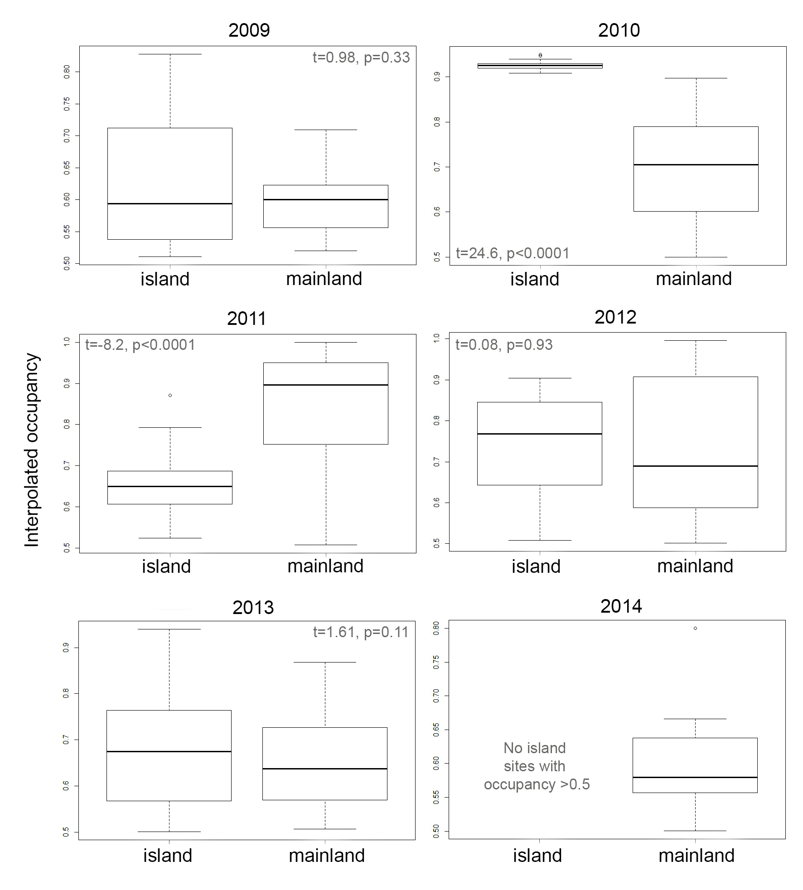

Fig. 2
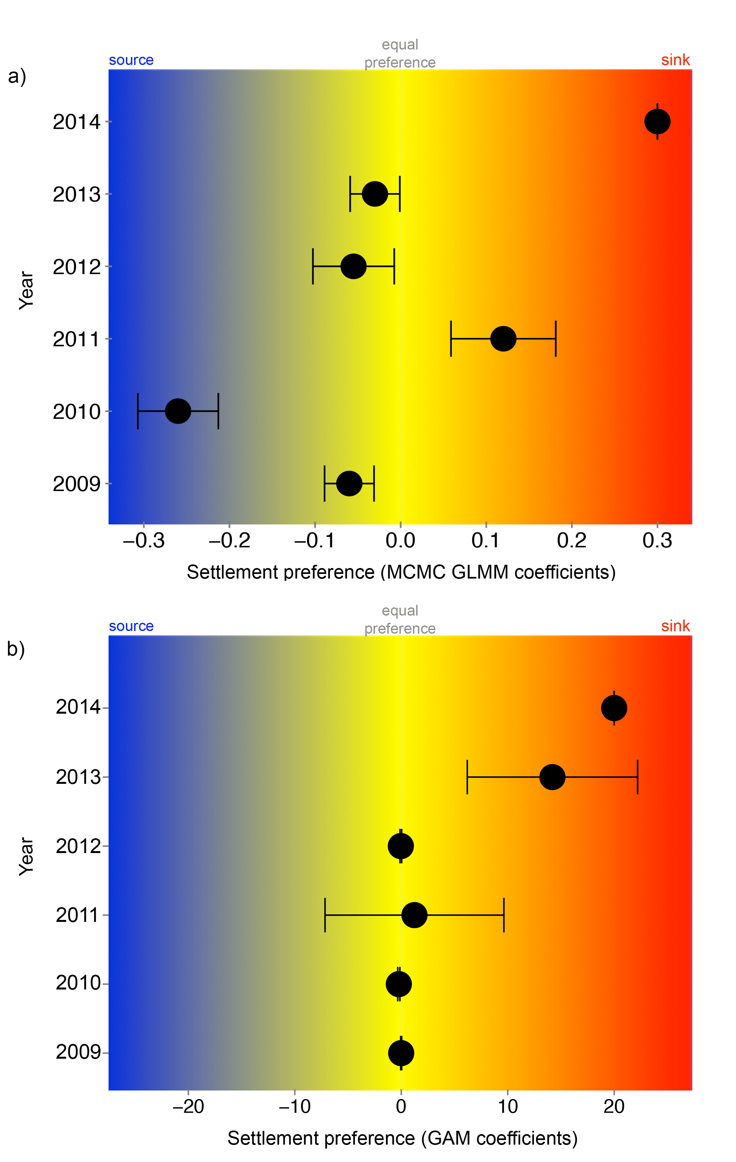
Fig. 3

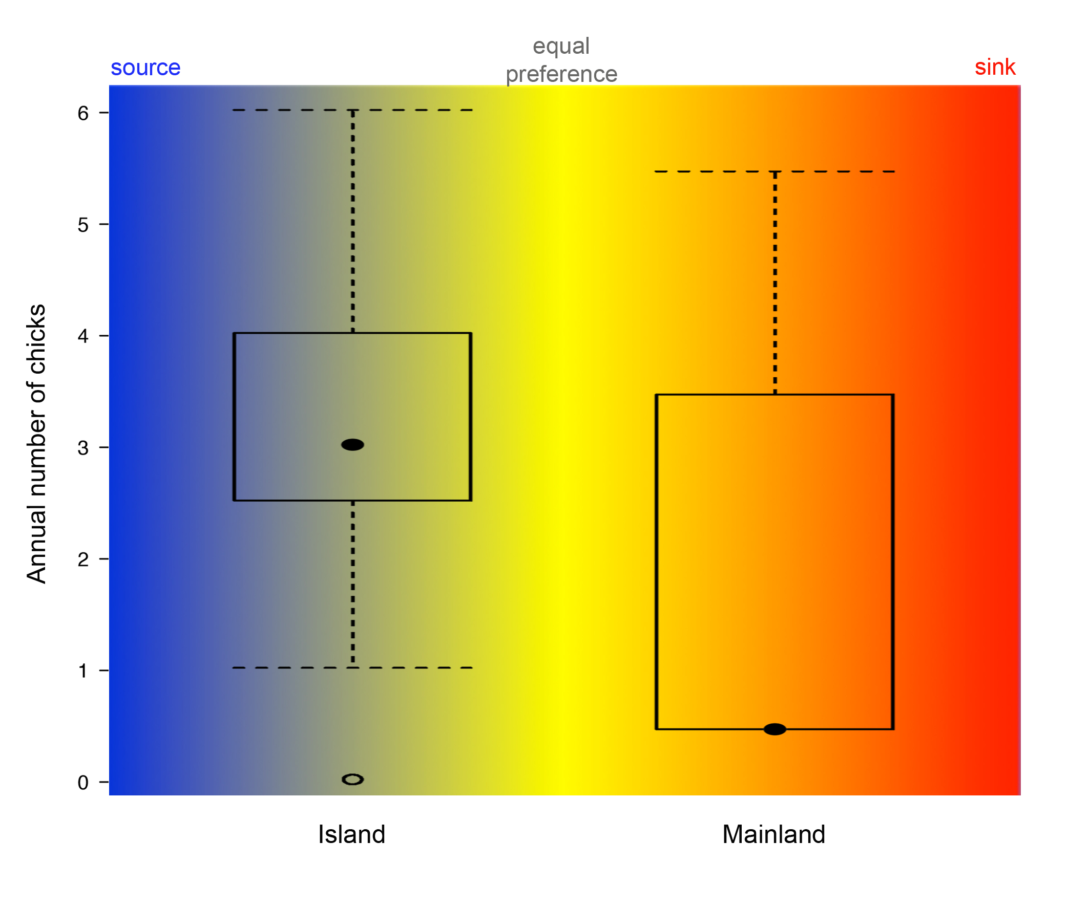
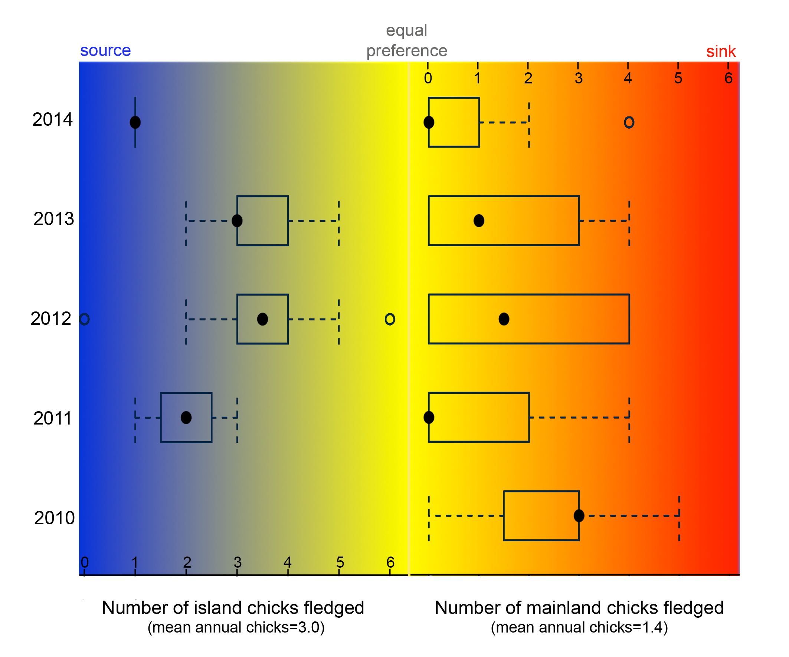

Supplementary Materials Fig. S1.

Biosketch
Dejan Stojanovic is a conservation biologist, and this research was undertaken as part of his PhD research on the swift parrot. His research focuses on the conservation and management of threatened species and their habitat, with a focus on how threatened species cope with habitat loss.

