Should we screen women for abdominal aortic aneurysm? Analysis of clinical benefit, harms and cost-effectiveness
Dr Michael J Sweeting^{1,2 *}, Dr Katya L Masconi¹, Dr Edmund Jones¹, Dr Pinar Ulug³, Dr Matthew J Glover⁴, Professor Jonathan A Michaels⁵, Professor Matthew J Bown⁶, Professor Janet T Powell³, Professor Simon G Thompson¹

1 Department of Public Health and Primary Care, University of Cambridge, Cambridge, CB1 8RN, UK.
2 Department of Health Sciences, University of Leicester, Leicester, LE1 7RH, UK
3 Vascular Surgery Research Group, Imperial College London, Charing Cross Hospital, London, W6 8RP, UK.
4 Health Economics Research Group, Brunel University London, Uxbridge, UB8 3PH, UK.
5 Health Economics and Decision Science, ScHARR, University of Sheffield, Sheffield, S1 4DA, UK.
6 Department of Cardiovascular Sciences and NIHR Leicester Biomedical Research Centre, University of Leicester, Leicester, LE2 7LX, UK.

* Correspondence to: michael.sweeting@le.ac.uk
Telephone: +44 (0)116 252 5469
Dr M. J. Sweeting, Department of Health Sciences, George Davies Centre, University Road, Leicester, LE1 7RH, UK

Abstract
Background:
One-third of UK deaths from ruptured abdominal aortic aneurysm (AAA) are in women. In men, national screening programmes reduce deaths from AAA and are cost-effective. The benefits, harms and cost-effectiveness in offering a similar programme to women have not been formally assessed.
Methods:
A discrete event simulation model was set up for AAA screening, surveillance and intervention. Relevant women-specific parameters were obtained from sources including systematic literature reviews, national registry/administrative databases, major AAA surgery trials, and UK National Health Service reference costs.
Findings:
AAA screening for women, as currently offered to UK men (at age 65, AAA diagnosis at an aortic diameter of ≥3.0cm and elective repair considered at ≥5.5cm) gave, over a 30-yeartime horizon, an estimated incremental cost effectiveness ratio (ICER) of £30,000 (95% CI 12,000 to 87,000) per quality adjusted life-year (QALY) gained, with 3,900 invitations to screening required to prevent one AAA-death and an over-diagnosis rate of 33%. A modified option for women (screening at age 70, diagnosis at 2.5cm and repair at 5.0cm) was estimated to be more cost-effective, with an ICER of £23,000 (9,500 to 71,000) per QALY and 1,800 invitations to screening required to prevent one AAA-death, but an over-diagnosis rate of 55%. There was considerable uncertainty in the ICER, largely driven by uncertainty about AAA prevalence, the distribution of aortic sizes for women at different ages and the impact of screening on quality-of-life.
Interpretation:
By UK standards an AAA screening programme for women, mimicking that in men, is unlikely to be cost-effective. Further research on the aortic diameter distribution in women and potential quality of life decrements associated with screening are needed to assess the full benefits and harms of modified options.
Funding:
The UK National Institute for Health Research (NIHR) Health Technology Assessment (HTA) programme commissioned this research (project number 14/179/01).

300/300 words

Keywords: abdominal aortic aneurysm, screening, women, cost-effectiveness
Main manuscript 3719 words

Introduction
Abdominal aortic aneurysm (AAA) traditionally has been a disease of men, strongly associated with smoking. However, today one-third of AAA rupture deaths are in women^{1,2}. In men, synthesis of four randomised trials has shown a benefit of population-based screening in reducing AAA-related mortality by up to 40% although any reduction in all-cause mortality is small^{3,4}. Several countries including Sweden and the UK have introduced cost-effective population screening programmes for AAA in older men, and screening for older men is available in the USA, in and regionally in Italy and other countries⁵⁻⁸. The only randomised trial of AAA screening in women, conducted in the 1990s, was underpowered⁹. Recently, the United States Preventive Services Task Force has recommended against screening in women, although this has not been formally assessed⁷. The reasons for this recommendation include the reportedly lower prevalence of AAA in women, based on the maximum aortic diameter thresholds defined in men (≥3cm) and paucity of evidence in women¹⁰. However, with long-term health-economic modelling in men suggesting that population-based screening would be cost-effective with an AAA prevalence as low as 0.35-0.5%, smoking now almost as common amongst women as men, and with the relationship between smoking and AAA almost twice as strong for women compared to men, the case for AAA screening in women needs to be formally assessed¹¹⁻¹³.
There would be no quick answers from conducting a randomised trial of AAA screening in women, due to the very large sample size and long-term follow-up required. The alternative is long-term modelling. This requires contemporary and reliable estimates of parameters that can influence the clinical-effectiveness and cost-effectiveness of screening in women. The aim of this project was to collect this information and then apply discrete event simulation modelling to explore the hypothesis that a variation of the current AAA screening programmes for men might prove clinically beneficial and cost-effective in reducing deaths from ruptured AAA in women.

Methods
A decision model was developed to assess the differences in life-years, quality-adjusted life-years (QALYs) and costs for a population of women invited to AAA screening versus a population who are not invited to screening (the status quo). The West of Scotland Research Ethics Committee 5 provided a favourable ethical opinion for the project, reference 15/WS/0136.
The reference case evaluated the long-term cost-effectiveness of an invitation to a one-off ultrasound screen for all women in the UK at age 65, based on the UK National Abdominal Aortic Aneurysm Screening Programme (NAAASP) for men; namely a diagnosis of AAA when aortic diameter was ≥3.0cm, annual surveillance for individuals with the smallest AAA (3.0-4.4cm) at their most recent scan, a surveillance scan every 3 months for those with a medium AAA (4.5-5.4cm), and referral to a vascular surgeon for a large AAA ($≥$5.5cm)⁶. Those with no AAA detected would not be re-screened. We took a UK National Health Service (NHS) perspective for costs including invitation, screening, consultations, elective surgery, and emergency surgery for ruptured AAAs¹⁴.
A total of 12 different screening options were evaluated, including changing the age at screening from 65 to 70 years, lowering the diagnosis threshold from 3.0cm to 2.5cm (based on the available data on aortic diameter distribution in older women¹⁵) and reducing the intervention threshold from 5.5cm to 5.0cm or 4.5cm. The most cost-effective option was selected as the best alternative screening strategy.
Predefined outcomes from the model were AAA deaths, life-years, QALYs, costs and the incremental cost-effectiveness ratio (ICER). Both costs and life-years were discounted at 3.5% per annum (see Supplementary Appendix). Secondary outcomes included numbers of women over-diagnosed (screen-detected AAAs in which the disease would without screening have remained without symptoms or incidental detection) and numbers over-treated (repairs of screen-detected AAA that would without screening not have resulted in AAA death or surgery).
Modelling
A discrete event simulation model was designed and implemented, as described in detail elsewhere¹⁶. Briefly, a previous multi-state Markov model of AAA screening in men¹¹ was redeveloped and programmed as a more flexible discrete event simulation model to allow rapid assessment of different screening options, and was validated for men against data from the randomised Multicentre Aneurysm Screening Study¹⁶. The model simulated a sequence of key screening and clinical events for 10 million women (with results presented per 1 million women invited) from the time of invitation to screening up to their date of death or age 95 (the time horizon). Each woman had a counterpart who shared some key characteristics (age, aortic diameter at baseline, rate of aortic growth, potential time of non-AAA death), except that the counterpart was not invited to screening. The structure of the model (Supplementary Figure 1) allowed women to drop out of the surveillance programme or for an AAA to be incidentally detected. Women who were referred for a consultation could either be 1) returned to surveillance if their diameter, as confirmed by a CT scan, was less than the intervention threshold, 2) placed on a waiting list for elective surgery, or 3) not offered repair due to comorbidities¹⁷. Over-diagnosis and over-treatment rates were calculated by comparing those with screen-detected AAA with their unscreened counterpart. All analyses were conducted using the R software for statistical computing.
Data sources for women
Input parameters for women were obtained from a combination of literature reviews, clinical trial data, bespoke hospital datasets, and analysis of routine and registry data sources. Parameter values used in the reference case are given in full in Supplementary Table 1 and are described briefly here.
AAA prevalence, aortic diameter distribution, growth and rupture rates
Prevalence at different ages, based on the standard definition of an aortic diameter ≥3cm was obtained from a systematic review of the literature¹⁰, and estimated as 0.43% (95% CI 0.23, 0.80) and 0.70% (0.37, 1.34) for those age 65 and 70 years respectively (the prevalence at age 70 being an interpolation between estimates at 65 and 75 years). The baseline aortic diameter distribution for women was obtained either from the screening of 70 year old women in Sweden¹⁵ or using data from NAAASP⁶ re-weighted to give the appropriate prevalence for women (further details in Supplementary Appendix). Based on the definition of being 50% larger than a normal aortic diameter¹⁸, the former data suggested that 2.5cm might be an appropriate alternative AAA threshold for women (Supplementary Appendix).

AAA growth rates were estimated from a previous study using linear mixed effects models¹⁹, with 1743 women providing 4800 person-years of observation for analysis(Supplementary Appendix). Rupture rates from the same study¹⁹ were modelled as a function of AAA diameter using joint longitudinal and time-to-event models, with rupture rates increasing with larger diameters (Supplementary Appendix).

Operative mortality rates
Data on operative mortality rates for both endovascular (EVAR) and open aneurysm repairs, and elective and emergency operations were extracted from the UK National Vascular Registry (NVR)²⁰ and Hospital Episode Statistics (HES)²¹. The overall estimated 30-day mortality rates were 2.4% for elective EVAR, 8.1% for elective open repair, 35.9% for emergency EVAR, and 44.2% for emergency open repair (further details in Supplementary Appendix).

Other parameters
Attendance rates were obtained from the randomised AAA screening trial in women⁹, 72.7% at 65 years, decreasing to 67.6% at age 70. More recent audit data from Leicester and London showed little evidence of differential loss to surveillance between women and men, or between self-referred and screen-detected individuals. Therefore, the loss to AAA surveillance was assumed constant at 5.5 per 100 person-years (based on unpublished NAAASP data for men). The incidental detection rate was calculated as 2.93 per 100 person-years derived from data reported from New Zealand²² (similar to unpublished UK data given in Supplementary Appendix).
Randomised trials of AAA screening have shown little evidence that an AAA screened-positive population has lower long-term health-related quality of life (HRQoL) than a population screened-negative or not invited to screening^{23,24}. For the reference case, QALYs for all women, screened and unscreened, were therefore calculated using age and sex-specific UK population EuroQol-5D utility survey data²⁵ and any transient reduction in HRQoL following elective AAA repair was not considered. The HRQoL weights used were 0.78 for ages 65-74, and 0.71 for ages ≥75. In a sensitivity analysis, we investigated how possible HRQoL decrements resulting from diagnosis and surveillance, surgery (elective and emergency) and non-intervention for elective repair could affect mean QALYs and the cost-effectiveness ratio.

Age-specific non-AAA mortality rates for women were estimated using two datasets: overall life tables from the UK population 2012-14 and rates of death by age and cause²⁶. Non-AAA mortality rates were calculated by subtracting AAA-specific death rates from the overall mortality rates.
Costs were obtained from the NAAASP, 2014/15 NHS reference costs¹⁴ (pre-surgical consultation, post-surgical monitoring) and previous microeconomic modelling of the EVAR-1 (elective)²⁷ and IMPROVE (emergency)²⁸ surgery trials. Key components of the trial-based elective and emergency repair costs (vascular ward and critical care hospital stay) were from contemporaneous women-specific data from HES and updated 2014/2015 NHS reference costs. Other components were inflated to 2014/2015 prices to reflect general NHS inflation, using published indices²⁹. The costs of re-interventions were taken from published trial data²⁷, inflated using published indices²⁹.

Parameter uncertainty
Probabilistic sensitivity analyses (PSA) were conducted to investigate the impact of parameter uncertainty on the cost-effectiveness results; distributions of the input parameters are given in Supplementary Table 1. A series of deterministic sensitivity analyses were also conducted to investigate robustness of results to changes in individual or groups of parameters; key sensitivity analyses investigated varying the prevalence and using a re-weighted aortic diameter distribution from the Swedish screening study in women¹⁵. Changes to the aortic diameter distribution used the same prevalence as in the reference case but included a higher proportion of women with >4.5cm diameter AAA (17% of detected AAAs at screening compared with 0.8% in the reference case).
Patient and public involvement
A public focus group was convened to provide input to the project (Supplementary Appendix).
Role of the funding source
The National Institute of Health Research had no role in study design, data collection, data analysis, data interpretation, in the writing of the report or in the decision to submit the article for publication. The views and opinions expressed herein are those of the authors and do not necessarily reflect those of the HTA programme, NIHR, UK NHS or Department of Health. The corresponding author had full access to all the data in the study and had final responsibility for the decision to submit for publication.

Results
Reference case based on protocol used in UK screening programme for men
Detailed numbers of events for the reference case, per 1 million women, are presented in Table 1. Screening detected AAA in 0.31% of the population resulting in 23% more AAAs detected in total from age 65 to 95, leading to an additional 452 elective operations per 1 million women invited to screening, 21% more than predicted to occur under no screening. Most of these additional operations occurred between the ages of 67 and 77 (Figure 1A, Supplementary Figure 2A). In contrast, there were 97 (4%) fewer emergency operations (Supplementary Figure 2B), and 396 (4%) fewer AAA ruptures, predominantly occurring after age 70 (Figure 1A). Approximately half of the AAA ruptures in the group invited to screening occurred in women with aortic diameter <3 cm at initial screening (Supplementary Table 2). There were 85 (7%) fewer AAA-related deaths in the first ten years after screening and 257 (3%) fewer overall from age 65 to 95. For every four women who avoided an AAA-death due to screening, one woman died due to additional elective repair (342 vs 85, Table 1). There is an early negative impact of screening on AAA-deaths due to the high operative mortality for elective repair, particularly since less than half of the repairs in women <75 years use EVAR²⁰ (Figure 1B). Overall, 3,900 women would need to be invited to screening to prevent one AAA-death.
The increase in mean QALYs and costs in those invited to screening, discounted at 3.5% per annum, were 0.0011 and £34 respectively, which gave an ICER of £30,000 (95% CI 12,000 to 87,000) per QALY gained (Table 2). The ICER fell considerably as the time-horizon increased since benefits from screening continued to accrue over a 30-year period (Supplementary Figure 3). The wide confidence interval for the ICER was mainly due to the uncertainty in the incremental QALYs (Supplementary Figure 4A). The probability that the reference case is cost-effective for different willingness-to-pay (WTP) thresholds is shown in Figure 2.
Doubling the AAA prevalence or changes to the aortic diameter distribution both resulted in the ICER dropping below £20,000 per QALY gained (Figure 3). Conversely, a halving of AAA prevalence or a doubling of the incidental detection and drop-out from surveillance rates both resulted in a much larger ICER, whilst changes to other parameters were less influential. Possible reductions in HRQoL associated with an AAA diagnosis resulted in large changes in the ICER (a decrease in utility of 0.01 during surveillance resulted in the ICER increasing to £43,000) (Supplementary Table 3). Transient reductions in HRQoL following either elective or emergency surgery (affecting 1 in 200 invited women) did not affect the ICER but sizeable lifetime reductions in HRQoL following non-intervention for repair (affecting 1 in 700 invited women) would have a larger effect. A combination of these effects resulted in the ICER increasing to £52,000 (Figure 3).

Best alternative strategy
A best alternative strategy was considered: (i) offering screening at age 70 years, together with (ii) lowering the threshold for AAA diagnosis to 2.5cm and (iii) lowering the threshold for considering surgery to 5.0cm(Table 1). This resulted in a substantially larger number of screen-detected AAAs (1.23% of the population) and more elective repairs performed due to the screening programme (Figure 1A, Supplementary Figure 2C; 1,301 more vs 452 more in the reference case per 1 million invited women), attributable to the higher age and lowered intervention threshold. There was a greater overall reduction in emergency operations (Supplementary Figure 2D) and AAA-related deaths (Figure 1A), with 229 (12%) fewer AAA-related deaths from age 70 to 80 and 566 (8%) fewer overall from age 70 to 95, per 1 million women (Figure 1B). However, there was also an increase in the number of AAA-deaths following elective repair: for every 7 women who avoided an AAA-related death due to screening, 2 women died due to elective repair of screen-detected AAA (789 vs 223, Table 1). About a quarter of AAA ruptures in the invited to screening group occurred in women who initially had aortic diameter of <2.5cm (Supplementary Table 2). Overall, 1,800 women would need to be invited to screening to prevent one AAA-death.
The best alternative strategy gave an overall ICER of £23,000 (95% CI 9,500 to 71,000) (Table 2). Across the PSAs there was a wide spread in the estimated incremental QALYs highlighting uncertainty in parameters that affect differences in average life-expectancy between populations invited and not invited to screening, with narrower spread for incremental costs (Supplementary Figure 4B). The cost-effectiveness acceptability curve for this strategy was more favourable than the reference case (Figure 2).
Over-diagnosis and over-treatment
In the reference case, 33% of screen-detected AAAs would not otherwise have been identified during the woman’s lifetime (Table 1). In the best alternative strategy the over-diagnosis rate increased to 55%. Of the 752 screen-detected AAA elective repairs in the reference case and 2,077 in the best alternative strategy per 1 million women, 94 (13%) and 494 (24%) were over-treated, respectively.
Discussion
Comprehensive modelling has shown that offering women screening for AAA, using the same screening strategy as for UK men, would reduce deaths from AAA by 7% from age 65 to 75 and by 3% from age 65 to 95, would require 3900 screening invitations to avoid one AAA-death, and is unlikely to be cost-effective. The best alternative screening strategy was based on screening at age 70, giving a reduction of 12% in AAA- deaths from age 70 to 80 and by 8% from age 70 to 95, reducing both the number of screening invitations needed to prevent one AAA-death to 1800 and the ICER to £23,000 but with an over-diagnosis rate of >50%. This is in stark contrast to AAA screening in men, where less than 700 men need to be invited to screening to avoid one AAA-death⁵, and where contemporary modelling, based on current AAA prevalence in the UK, estimated screening to reduce AAA-related deaths by 18% from age 65 to 75 and by 6% from age 65 to 95 with a corresponding ICER of £7,400¹¹.
Addressing sex-specific clinical issues might reduce the harms from screening and improve the future clinical benefit and cost-effectiveness estimates for women; these include expanding the use of EVAR in women (to reduce both the non-intervention rate and the mortality from elective repair). This should be achievable given that the UK-wide quality improvement programme reduced overall elective in-hospital mortality for AAA repair from 5.4% in 2006 to 2.9% in 2016-17^{30,31} and mortality is much lower still for elective repair of screen-detected aneurysms (in men)⁶.
The best alternative strategy at age 70 using woman-specific definitions of AAA (maximum aortic diameter ≥2.5cm) is likely to identify many more aneurysms but in over half of these women the AAA would have remained asymptomatic without incidental detection. The concern of over-diagnosis therefore must be recognised for screening strategies that are more cost-effective for a population. The previous definition of AAA for men (a maximum aortic diameter ≥3 cm) was used in most published studies of AAA prevalence in women¹⁰, so that prevalence appears to be much lower in women than men. This is a major driver of the lower cost-effectiveness compared to men. In women the average aortic diameter is smaller than in men³² providing reasonable justification for sex-specific diagnosis thresholds, since an aneurysm may be defined by a >50% focal increase in arterial diameter.
Nevertheless, screening these women at age 70, as in the best alternative strategy, means that many of these women would not require intervention during their lifetime. Still, after the intervention threshold is reached, elective repair is recommended for most women as demonstrated by the relatively low over-treatment rates in both the reference case (threshold 5.5cm) and the best alternative strategy (threshold 5.0cm). This adds to the debate about whether the threshold for intervention of 5.5 cm (derived from randomised trials in which women were under-represented) could be lowered in women. Women have a four-fold increased risk of rupture in AAA of <5.5cm diameter for a given AAA diameter compared to men¹⁹. This, together with inspection of the available data for the population distribution of aortic diameters in women indicates that it would be reasonable to consider lower intervention thresholds in women. This would have the effect of potentially offering elective repair at a younger age, reducing the non-intervention rates and operative mortality.
The possible deleterious effects of a positive AAA diagnosis and subsequent surveillance on quality of life could have a sizeable impact on the cost-effectiveness of screening, as demonstrated in the sensitivity analysis. Small and temporary changes in utility associated with screening may be important, given that there are concerns that Euroqol EQ-5D is not sufficiently sensitive to identify such effects. Furthermore, psychosocial consequences of AAA screening, for which the available quantitative studies have been deemed insufficient^{33,34}, could affect health care costs³⁵ and complications following elective repair, which may be more common in women than in men³⁶, could further reduce quality of life. Whilst the magnitude of any decrements needs clarification, their effect is only likely to reduce cost-effectiveness.
The modelling also did not consider the likely higher cardiovascular risk in women with AAA nor the potential benefits of cardiovascular risk management, given that women often are undertreated³⁷. A higher risk of other cardiovascular deaths in women with AAA would lower the cost-effectiveness of AAA screening, whilst a screening programme that incorporated risk management could reduce operative mortality and cardiovascular risk, and thus improve cost-effectiveness. Opinion in our convened patient and public focus group initially favoured universal screening and did not favour the screening of only high-risk subgroups. Given the strength of the association between smoking and AAA in women, there might be merit and public support in formally assessing the effectiveness of a screening programme for women who have ever smoked. Alternatively, for women it may be more appropriate to consider a combined cardiovascular disease screening programme²³.
This project has been underpinned by the development and implementation of a bespoke discrete event simulation model to assess AAA screening¹⁶. This model, which builds on a previously developed Markov model, gives more flexibility to assess different screening options, allows heterogeneity in AAA growth rates between individuals, and permits parameters to depend on patient characteristics, such as elective operative mortality increasing with age and AAA diameter. Other strengths of this research stem from the contemporary systematic reviews of the recent literature to obtain best estimates for women-specific parameters, with individual patient clinical trial and registry data providing accurate information on post-operative outcomes for both elective and emergency repair.
A limitation of this research is that there were key quantities for which information was limited or lacking, especially the prevalence of AAA in women (based on woman-specific definition of AAA) and the impact of both screening and elective repair on quality of life. Prevalence estimates were obtained from a systematic review of studies conducted between 2000 and 2012, with over half of women recruited from self-purchase of screening, which could lead to underestimation of general population prevalence. A population prevalence of 0.8% (the upper limit of our sensitivity analysis) would result in a more favourable cost-effectiveness ratio. However, conversely, it is possible that prevalence has decreased since the studies were conducted, reflecting trends in both AAA prevalence seen in men and smoking amongst women, which could lower the cost-effectiveness of screening. Furthermore, since costs were all UK-based, it is not clear how relevant our cost-effectiveness results are to other healthcare providers; the results on clinical benefit and harm are likely to be more generalisable.
In conclusion, based on current evidence and definitions of AAA in men, population AAA screening of women would yield little benefit. Other screening options have more favourable cost-effectiveness but may lead to more over-diagnosis and over-treatment. Further research on the population-based aortic size distribution in older women is needed, to provide a woman-specific definition of AAA, together with better quantitative studies of the impact of screening on quality of life.

Acknowledgements
We are grateful to a number of people who kindly provided input, data or analyses to help us with this project, including: Prof Jonothan Earnshaw, Jo Jacomelli and Lisa Summers for data on screening, surveillance and referral to surgery for men in NAAASP; Dr S Svensjo (Uppsala) for individual data on women screened for AAA in Sweden; Dr David Epstein (Granada) for analyses of resource use and costs in the EVAR-1 trial; Dr Manuel Gomes (London) for analyses of resource use and costs in the IMPROVE trial; Professor Simon Griffin (Cambridge) for additional discussion on possible quality of life decrements. Additional support for this project for work done at the University of Cambridge came from the UK Medical Research Council (MR/L003120/1), the British Heart Foundation (RG/13/13/30194), and the UK National Institute for Health Research (Cambridge Biomedical Research Centre). Patient and Public Involvement was supported by the UK National Institute for Health Research (Leicester Biomedical Research Centre).

Conflict of interests:
All authors have completed the ICMJE uniform disclosure form at www.icmje.org/coi_disclosure.pdf and declare: support from the UK National Institute for Health Research Health Technology Assessment programme for the submitted work; no financial relationships with any organisations that might have an interest in the submitted work in the previous three years ; no other relationships or activities that could appear to have influenced the submitted work.

Contributors
MJS, KLM and JTP co-wrote the first draft of the paper, all other authors contributed substantial amendments and critical review. MJS led the statistical and computational components of the project. KLM ran the discrete event simulation models and produced tables and figures. EJ constructed and programmed the discrete event simulation model, undertook model validation and produced tables and figures. PU undertook systematic reviews. MJG modelled costings and provided health economics input. JAM analysed Hospital Episode Statistics data. MJB provided clinical input, developed the project website and set-up and oversaw the public and patient involvement group. JTP provided clinical input, sourced woman-specific data and led the systematic reviews. SGT was the principal investigator and directed all aspects of the project.

Research in Context
Evidence before this study
Historically abdominal aortic aneurysm (AAA) has been considered a common disease in older male smokers, with prevalence being 4-5 fold higher in men versus women. Four randomised trials of population screening in older men have shown that screening can reduce AAA-related deaths (by up to half) and meta-analysis of these trials indicates a small decrease in all-cause mortality: associated studies have shown that screening is cost-effective. Therefore, in many countries or regions there are programmes for ultrasonographic AAA screening for men. In women, AAA screening is not recommended, even though (i) there has been only a single underpowered randomised trial, (ii) the rupture rate of small AAAs is four times higher in women than men, and (iii) today one-third of the deaths from AAA rupture are in women. Moreover, women with incidentally detected AAA are disadvantaged with respect to type and availability of elective repair and have higher elective operative mortality and complication rates compared to men. Although the impact of AAA screening on quality of life has been assessed in men, the instruments used might not have been sensitive to detect either small changes or changes in specific health domains and there are no studies in women.
Added value of this study
This is the first study to formally assess the long-term benefits, costs and harms of screening older women for AAA. Woman-specific parameters to feed into a discrete event simulation model for AAA screening, surveillance and intervention were obtained from a wide variety of sources including contemporary systematic reviews, original data, clinical trials and registries. The model estimated the numbers of key screening and clinical events over time for 10 million women from a UK perspective. The flexibility of the model permitted assessment of the clinical and cost-effectiveness of screening women using the same protocol used for the nationwide UK AAA screening programme in men and a range of different scenarios which might be more suitable for women.
Implication of all the available evidence
Our study findings suggest that a screening programme of 65-year women, using the same screening, surveillance and intervention protocol as defined for UK men, would need 3900 women to be invited to screening to save 1 death from AAA, one-third of the screen-detected AAAs would be over-diagnosed and such a programme would not be cost-effective (in the UK).. The best alternative screening scenario for women would use screening at age 70, diagnosis of AAA when the maximum aortic diameter reaches 2.5cm and with intervention considered when the AAA diameter reaches 5.0cm. In this scenario 1800 women would need to be invited to screening to save 1 death from AAA, but more than a half of screen-detected AAAs would be over-diagnosed. In contrast for AAA screening in men age 65, recent estimates have shown that fewer than 700 men need to be invited to avoid one AAA-related death. There is considerable uncertainty as to whether this best alternative scenario in women would be cost-effective because of uncertainty in the key input parameter of AAA prevalence at different ages and lack of information about the quality of life decrements associated with screening. Therefore urgent research on the population-based aortic diameter distribution in older women is necessary and on the quality of life decrements associated with screening, before closing the door on the possibility that in some health care systems, population screening for AAA in women might be cost-effective.

Figure 1. Aneurysm deaths and aneurysm repairs for reference case and best alternative strategy
A) Differences in elective operations, emergency operations and AAA deaths amongst 1 million women (invited to screening minus not invited to screening group); reference case and best alternative strategy; B) Percentage reduction in number of AAA deaths from screening by age; reference case and best alternative strategy. Due to small number volatility, the percent reduction in AAA deaths is not shown when the number of AAA deaths is <50 (approximately the first year after invitation to screening).
A)
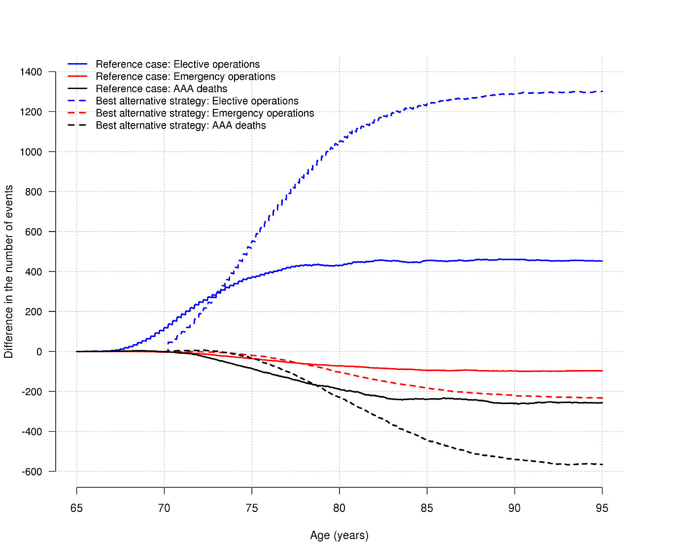

B)
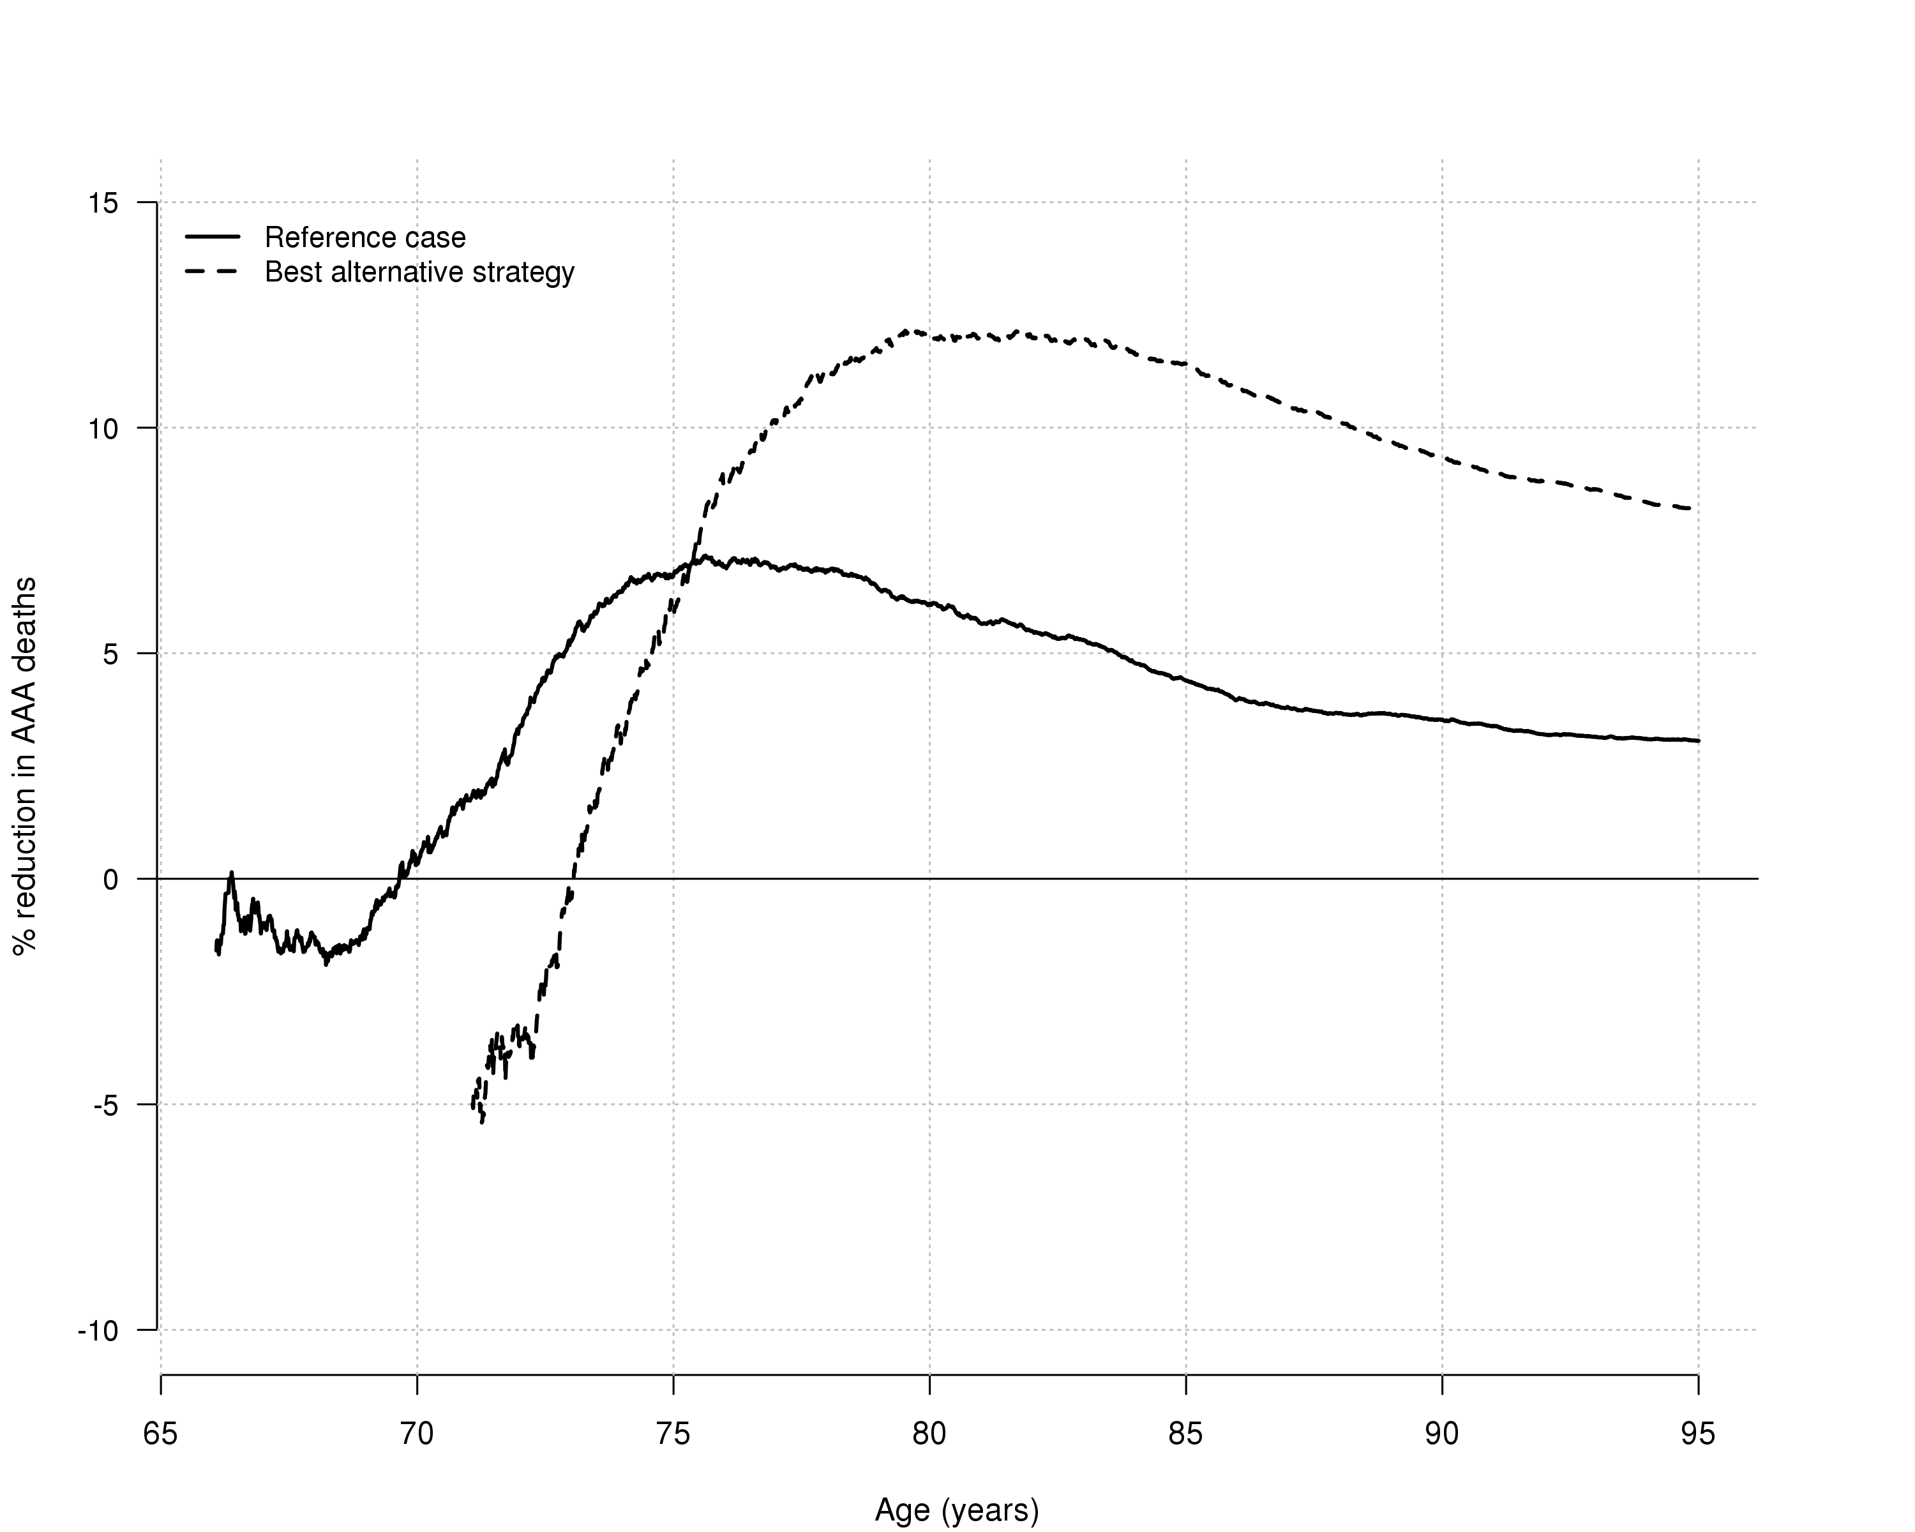

Figure 2. Cost-effectiveness acceptability curves of invitation to AAA screening from the probabilistic sensitivity analyses: reference case and best alternative strategy
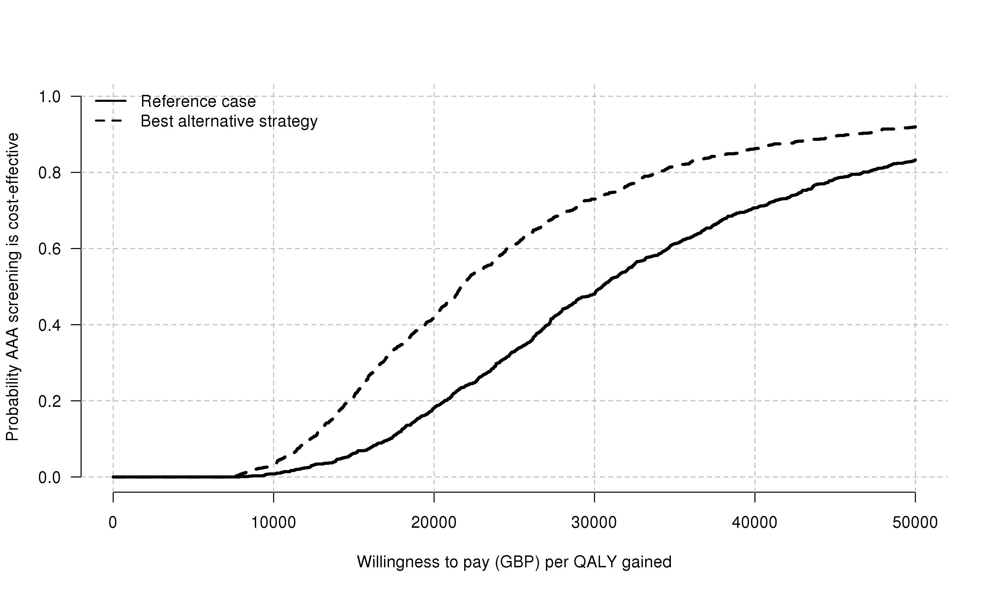
GBP – British Pound. The probability of cost-effectiveness at £20,000 per QALY is 0.18 and 0.42 for the reference case and best alternative strategy, respectively.

Figure 3: Tornado plot showing ICER estimates for sensitivity analyses. Blue bars show a decrease in the ICER from the reference case (grey vertical line, £30,170), red bars show an increasing ICER from the reference case. 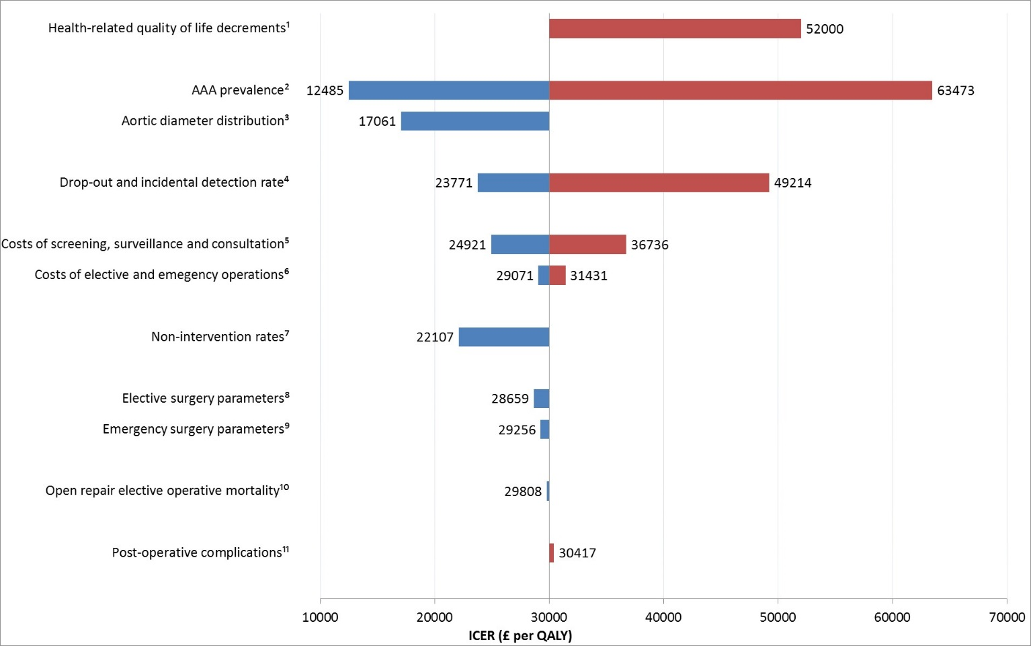
Details of changes to all parameter values given in Supplementary Table 1.
ICER – Incremental cost-effectiveness ratio, QALY – Quality adjusted life-year.
¹Health-related quality of life decrements for diagnosis, surgery and non-intervention for elective surgery (Supplementary Table 3). ²Used the NAAASP-based distribution but doubled and halved the AAA prevalence. ³NAAASP-based AAA distribution replaced with one based on 5140 women aged 70 screened in Sweden, whilst keeping the prevalence of AAA constant¹⁵. ⁴Halved and doubled the drop-out from surveillance and incidental detection rates simultaneously. ⁵Reduced (by 20%) and increased (by 25%) the screening, surveillance, and consultation costs. ⁶Reduced (by 20%) elective surgery costs whilst increasing (by 25%) emergency surgery costs, and vice-versa. ⁷Allowed non-intervention rate to depend on age. ^{8,9}Sensitivity of operative parameters investigated by using systematic review data (rather than NVR/HES) to inform elective and emergency operative parameters^{17,25}. ¹⁰Reduced the open repair operative mortality from 8.1% estimated from NVR/HES to 5%. ¹¹Increased re-intervention rate after elective open repair and AAA mortality rate after emergency repair.
Table 1: Clinical benefits and harms of AAA screening among 1 million women from screening age until age 95; reference case and best alternative strategy for AAA screening
 | Reference case¹ |  |  | Best alternative strategy²
 | Not invited to screening | Invited to screening | Difference (% of that in non-invited group) | Not invited to screening | Invited to screening | Difference (% of that in non-invited group)
AAAs detected  Screen-detected  Incidentally detected | 9,529  0  9,529 | 11,697  3,101  8,596 | +2,168 (+23%) | 13,835  0  13,835 | 22,924  12,309  10,615 | +9,089 (+66%)
Elective AAA repair | 2,165 | 2,618 | +452 (+21%) | 2,375 | 3,676 | +1,301 (+55%)
Elective AAA repair contraindicated | 1,173 | 1,398 | +225 (+19%) | 1,261 | 1,956 | +695 (+55%)
AAA rupture | 9,235 | 8,839 | –396 (–4%) | 7,465 | 6,555 | –910 (–12%)
Emergency AAA repair | 2,336 | 2,239 | –97 (–4%) | 1,869 | 1,636 | –233 (–13%)
AAA-related deaths:  Due to elective surgery / long-term complications of elective repair  Due to rupture / long-term complications of emergency repair | 8,388  308  8,080 | 8,131  393  7,738 | –257 (–3%)  +85 (+28%)  –342 (–4%) | 6,886  324  6,562 | 6,321  547  5,774 | –566 (–8%)  +223 (+69%)  –789 (–12%)
Non AAA-related deaths | 855,079 | 855,285 | +186 (+0%) | 849,789 | 850,220 | +431 (+0%)
Re-interventions:  After elective repair  After emergency repair | 505  322 | 619  302 | +114 (+23%)  -20 (-6%) | 543  234 | 913  193 | +370 (+68%)  -41 (-18%)
Surveillance measurements | 13,773 | 16,367 | +2,594 (+19%) | 17,995 | 26,648 | +8,653 (+48%)
 | Over-diagnosis and over-treatment |  |  | Over-diagnosis and over-treatment
Screen-detected AAA diagnosis:  Over-diagnosis³ | 3,101  1,036 (33%) |  |  | 12,308  6,732 (55%)
Screen-detected AAA repair:  Over-treatment⁴ | 752  94 (13%) |  |  | 2,077  494 (24%)

¹ Invitation to screening at age 65 years, diagnosis threshold 3.0cm, intervention threshold 5.5cm. ² Invitation to screening at age 70 years, diagnosis threshold 2.5cm, intervention threshold 5.0cm. ³ Screen-detected AAAs in which the disease would not have otherwise become evident (incidentally detected) or caused any problems (AAA rupture) within the woman’s lifetime. ⁴ Elective AAA repair arising from screen-detection of AAA that in the absence of screening would not have resulted in AAA death or surgery

Table 2. Mean life-years and costs for reference case and best alternative strategy from screening age until age 95
 |  | Reference case¹ |  |  | Best alternative strategy²
 |  | Not invited to screening | Invited to screening* | Difference | Not invited to screening | Invited to screening* | Difference
Life-years
 | Undiscounted | 20.5451 | 20.5480 | 0.00291 | 16.4305 | 16.4353 | 0.00484
 | Discounted | 13.9351 | 13.9367 | 0.00156 | 11.8599 | 11.8627 | 0.00281
 | Discounted, QA | 10.4484 | 10.4495 | 0.00112 | 8.7257 | 8.7277 | 0.00200
Costs (£)
 | Undiscounted | 90.33 | 126.23 | 35.90 | 84.53 | 134.93 | 50.40
 | Discounted | 50.55 | 84.36 | 33.81 | 52.76 | 97.83 | 45.07
ICER (£ per life-year or QALY gained)
 | Discounted, life-years  Discounted, QA |  |  | 21,620  (95% CI 8,862, 61,794)  30,170  (95% CI 12,238, 87,002) |  |  | 16,016  (95% CI 6,800, 50,039)  22,540  (95% CI 9,522, 70,638)
¹ Invitation to screening at age 65 years, diagnosis threshold 3.0cm, intervention threshold 5.5cm. ² Invitation to screening at age 70 years, diagnosis threshold 2.5cm, intervention threshold 5.0cm. * Selective sampling of individuals above the diagnosis threshold was used to calculate accurate incremental estimates whilst mean life-years and costs within groups were obtained from full population sampling. For consistency, estimates in the Invited group are therefore obtained by adding the incremental estimates to the estimates from the Not Invited group.
QA - quality-adjusted, QALY – Quality adjusted life-year, ICER – Incremental cost-effectiveness ratio

References
1. Office for National Statistics. Deaths registered in England and Wales (Series DR). 2016. https://www.ons.gov.uk/peoplepopulationandcommunity/birthsdeathsandmarriages/deaths/datasets/deathsregisteredinenglandandwalesseriesdrreferencetables (accessed 1 November 2016).
2. Anjum A, Powell JT. Is the incidence of abdominal aortic aneurysm declining in the 21st century? Mortality and hospital admissions for England & Wales and Scotland. Eur J Vasc Endovasc Surg 2012; 43(2): 161-6.
3. Cosford PA, Leng GC. Screening for abdominal aortic aneurysm. Cochrane Database Syst Rev 2007; (2): CD002945.
4. Lederle FA. The Last (Randomized) Word on Screening for Abdominal Aortic Aneurysms. JAMA Intern Med 2016; 176(12): 1767-8.
5. Wanhainen A, Hultgren R, Linne A, et al. Outcome of the Swedish Nationwide Abdominal Aortic Aneurysm Screening Program. Circulation 2016; 134(16): 1141-8.
6. Jacomelli J, Summers L, Stevenson A, Lees T, Earnshaw JJ. Impact of the first 5 years of a national abdominal aortic aneurysm screening programme. Br J Surg 2016; 103(9): 1125-31.
7. Guirguis-Blake JM, Beil TL, Sun X, Senger CA, Whitlock EP. Primary Care Screening for Abdominal Aortic Aneurysm: A Systematic Evidence Review for the US Preventive Services Task Force. Rockville (MD); 2014.
8. Giardina S, Pane B, Spinella G, et al. An economic evaluation of an abdominal aortic aneurysm screening program in Italy. J Vasc Surg 2011; 54(4): 938-46.
9. Scott R, Bridgewater S, Ashton H. Randomized clinical trial of screening for abdominal aortic aneurysm in women. British Journal of Surgery 2002; 89(3): 283-5.
10. Ulug P, Powell J, Sweeting M, Bown M, Thompson S. Meta‐analysis of the current prevalence of screen‐detected abdominal aortic aneurysm in women. British Journal of Surgery 2016; 103(9): 1097-104.
11. Glover M, Kim L, Sweeting M, Thompson S, Buxton M. Cost‐effectiveness of the National Health Service abdominal aortic aneurysm screening programme in England. British Journal of Surgery 2014; 101(8): 976-82.
12. Svensjo S, Mani K, Bjorck M, Lundkvist J, Wanhainen A. Screening for abdominal aortic aneurysm in 65-year-old men remains cost-effective with contemporary epidemiology and management. Eur J Vasc Endovasc Surg 2014; 47(4): 357-65.
13. Stackelberg O, Bjorck M, Larsson SC, Orsini N, Wolk A. Sex differences in the association between smoking and abdominal aortic aneurysm. Br J Surg 2014; 101(10): 1230-7.
14. Department of Health. NHS reference costs 2014 to 2015, 2015.
15. Svensjö S, Björck M, Wanhainen A. Current prevalence of abdominal aortic aneurysm in 70‐year‐old women. British Journal of Surgery 2013; 100(3): 367-72.
16. Glover MJ, Jones E, Masconi KL, Sweeting MJ, Thompson SG, collaborators S. Discrete event simulation for decision making in health care: lessons from abdominal aortic aneurysm screening. Med Decis Making 2018; 38(4): 439-51.
17. Ulug P, Sweeting MJ, von Allmen RS, Thompson SG, Powell JT, SWAN Collaborators. Morphological suitability for endovascular repair, non-intervention rates, and operative mortality in women and men assessed for intact abdominal aortic aneurysm repair: systematic reviews with meta-analysis. The Lancet 2017; 389(10088): 2482-91.
18. Kent KC. Clinical practice. Abdominal aortic aneurysms. N Engl J Med 2014; 371(22): 2101-8.
19. Thompson SG, Brown LC, Sweeting MJ, et al. Systematic review and meta-analysis of the growth and rupture rates of small abdominal aortic aneurysms: implications for surveillance intervals and their cost-effectiveness. Health technology assessment (Winchester, England) 2013; 17(41): 1-118.
20. Sidloff DA, Saratzis A, Sweeting MJ, et al. Sex differences in mortality after abdominal aortic aneurysm repair in the UK. Br J Surg 2017; 104(12): 1656-64.
21. NHS Digital. Hospital Episode Statistics. 2016.
22. Khashram M, Jones G, Roake J. Prevalence of abdominal aortic aneurysm (AAA) in a population undergoing computed tomography colonography in Canterbury, New Zealand. European Journal of Vascular and Endovascular Surgery 2015; 50(2): 199-205.
23. Lindholt JS, Sogaard R. Population screening and intervention for vascular disease in Danish men (VIVA): a randomised controlled trial. The Lancet 2017; 390(10109): 2256-65.
24. Ashton H, Buxton M, Day N, Kim L, Marteau T, Scott R. The Multicentre Aneurysm Screening Study (MASS) into the effect of abdominal aortic aneurysm screening on mortality in men: a randomised controlled trial. The Lancet 2002; 360(9345): 1531-9.
25. Kind P, Dolan P, Gudex C, Williams A. Variations in population health status: results from a United Kingdom national questionnaire survey. BMJ 1998; 316(7133): 736-41.
26. Office for National Statistics. National Life Tables, United Kingdom: 2012-2014 and Deaths registered in England and Wales (Series DR). 2015. http://www.ons.gov.uk/ (accessed 1 November 2016.
27. Patel R, Sweeting MJ, Powell JT, Greenhalgh RM, investigators Et. Endovascular versus open repair of abdominal aortic aneurysm in 15-years' follow-up of the UK endovascular aneurysm repair trial 1 (EVAR trial 1): a randomised controlled trial. Lancet 2016; 388(10058): 2366-74.
28. IMPROVE Trial Investigators. Comparative clinical effectiveness and cost effectiveness of endovascular strategy v open repair for ruptured abdominal aortic aneurysm: three year results of the IMPROVE randomised trial. BMJ 2017; 359: j4859.
29. Curtis L, Burns A. Unit Costs of Health and Social Care 2015. University of Kent, Canterbury, 2015.
30. Mani K, Lees T, Beiles B, et al. Treatment of abdominal aortic aneurysm in nine countries 2005-2009: a vascunet report. Eur J Vasc Endovasc Surg 2011; 42(5): 598-607.
31. Waton S, Johal A, Heikkila K, Cromwell D, Boyle J, Loftus I. National Vascular Registry: 2017 Annual report. London: The Royal College of Surgeons of England, November 2017.
32. Rogers IS, Massaro JM, Truong QA, et al. Distribution, determinants, and normal reference values of thoracic and abdominal aortic diameters by computed tomography (from the Framingham Heart Study). The American journal of cardiology 2013; 111(10): 1510-6.
33. Johansson M, Jorgensen KJ, Brodersen J. Harms of screening for abdominal aortic aneurysm: is there more to life than a 0.46% disease-specific mortality reduction? Lancet 2016; 387(10015): 308-10.
34. Cotter AR, Vuong K, Mustelin L, et al. Do psychological harms result from being labelled with an unexpected diagnosis of abdominal aortic aneurysm or prostate cancer through screening? A systematic review. BMJ Open 2017; 7(12): e017565.
35. Rasmussen JF, Siersma V, Pedersen JH, Heleno B, Saghir Z, Brodersen J. Healthcare costs in the Danish randomised controlled lung cancer CT-screening trial: a registry study. Lung Cancer 2014; 83(3): 347-55.
36. Deery SE, Soden PA, Zettervall SL, et al. Sex differences in mortality and morbidity following repair of intact abdominal aortic aneurysms. J Vasc Surg 2017; 65(4): 1006-13.
37. Alabas OA, Gale CP, Hall M, et al. Sex Differences in Treatments, Relative Survival, and Excess Mortality Following Acute Myocardial Infarction: National Cohort Study Using the SWEDEHEART Registry. J Am Heart Assoc 2017; 6(12).

