Detailed correlations between SERS enhancement and plasmon resonances in subwavelength closely spaced Au nanorod arrays
Yu Huang,^{*a} Xian Zhang,^{b} Emilie Ringe,^{c} Lingwei Ma,^{b} Xiang Zhai,ª Lingling Wang,ª and Zhengjun Zhang^{*b}
ªSchool of Physics and Electronics, Hunan University, Changsha 410082, China
^{b}Key Laboratory of Advanced Materials (MOE), School of Materials Science and Engineering, Tsinghua University, Beijing 100084, China
^{c}Department of Materials Science and Nanoengineering, Rice University, 6100 Main Street, Houston, TX 77005, USA
*E-mail: huangyu@hnu.edu.cn, zjzhang@tsinghua.edu.cn

Graphical abstract
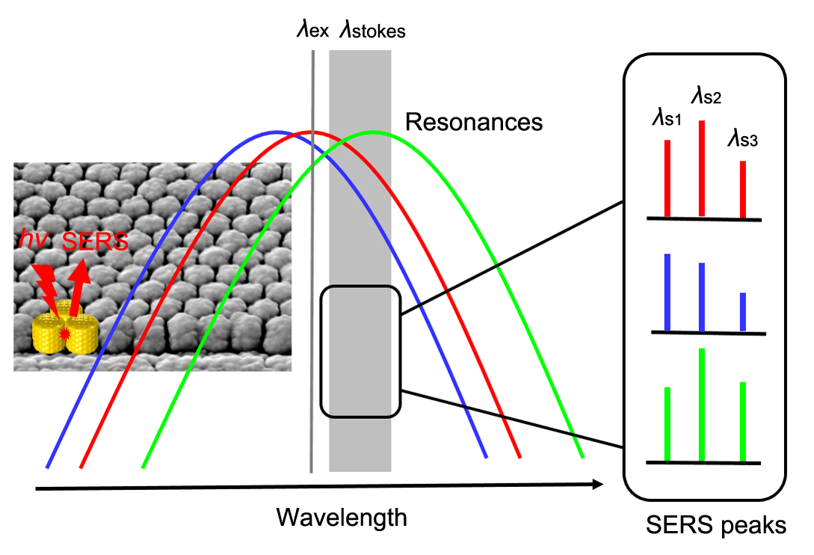
For subwavelength closely spaced Au nanorod arrays, the continuous dependence of individual SERS peak heights on the Stokes Raman shift has been visualized and further clarified.

Abstract
Depending on the experimental conditions and plasmonic systems, the correlations between near-field surface enhanced Raman scattering (SERS) behaviors and far-field localized surface plasmon resonance (LSPR) responses have sometimes been accepted directly, or argued, or explored. In this work, we focus on the attractive subwavelength closely spaced metallic nanorod arrays and investigate in detail the complex relationship between their SERS behaviors and plasmon resonances. This is achieved utilizing a combination of array fabrication, conventional LSPR spectra, SERS measurements, electron microscopy and numerical modeling. Three key factors that may impact the correlations have been comprehensively analyzed: the intrinsic near-field to far-field redshift is found to be rather small in the lattice; the nanofeature morphology considering the surface roughness has actually little impact on the spectral alignment of the near- and far-field responses; the continuous dependence of individual SERS peak heights on the Stokes Raman shift has been visualized and further clarified. By 3D finite element method (FEM) plasmon mapping, the physical origin of the collective resonances in the lattice is verified directly to be the second-order Fabry-Perot-like cavity mode. The strong near-field enhancement results from the coupling of surface plasmon polaritons (SPPs) prapagating at the two sidewalls of neighbouring nanorods forming the resonant cavity. These physical principles demonstrated here benefit significantly the optimization of nano-optics devices based on closely spaced metallic nanorod arrays, as well as the fundamental understanding on the near- and far-field relationship.

Keywords: SERS, closely spaced Au nanorod arrays, Stokes Raman shift, finite element method (FEM), cavity mode

Introduction
Surface enhanced Raman scattering (SERS) is a powerful technique for chemical and biological sensing with high sensitivity and selectivity.^{1,2} Due to the huge enhancement factor (EF) beyond 10⁸ that can be reached in SERS, analytes at single molecule level can even be detected.^{3,4} The electromagnetic (EM) enhancement is now widely accepted as the dominant mechanism contributing to SERS enhancement.⁵⁻⁷ It involves extreme light confinement within ultrasmall volumes sustained by localized surface plasmon resonances (LSPRs). They are light-driven collective oscillations of the conduction electrons at the surface of metallic nanostructures, enabling giant enhancement of local electric fields that are orders of magnitude (~10²) stronger than the incident fields.⁸
It is of particular interest to obtain higher enhancement and tunable SERS substrates. However, direct measurement of the near-field SERS EF over a wide spectral range is experimentally demanding as typical Raman spectroscopy systems often have single excitation sources. Therefore, the optical signals of LSPRs observed in far field, like transmission, reflection, extinction or scattering, are often used as a more convenient guide to the optimization of SERS substrates.^{6,9} The performance of LSPRs strongly depends on the size, shape, material, as well as the dielectric environment.¹⁰ For large structures, surface plasmons (SPs) can be excited and prapagate at metal-dielectric interfaces (i.e., surface plasmon polaritons, SPPs).
Owing to the limit of methods that can directly compare and correlate both responses under similar environmental conditions, the near- and far-field spectral responses of plasmonic systems have often be assumed to be identical. In other words, the highest enhancement for a given SERS substrate is commonly supposed to be achieved in a spectral region where there is an obvious optical spectral feature. Recently, more and more papers have debated on this subject theoretically and experimentally.¹⁰⁻¹⁷ There are some significant factors to consider for the detailed understanding and demonstration of the correlation between the near-field SERS behaviors and the far-field optical responses.
To be specific, the first factor is the Stokes Raman shift. Basically, SERS can be explained as a “twofold” EM enhancement process: the EM fields of the incident photons are first enhanced at the vicinity of plasmonic nanostructures, and then the re-emitted Stokes Raman scattering photons are enhanced again by surface plasmons.¹⁸ Consequently, the SERS EM EF is given by the well-known equation:
$EF=\frac{{\left|E_{loc}(λ_{ex)}\right|}^{2}∙{\left|E_{loc}(λ_{s)}\right|}^{2}}{{\left|E_{0}\right|}^{2}∙{\left|E_{0}\right|}^{2}}$ , (1)
where E₀ is the incident (or excitation) field, E_{loc}(λ_{ex}) and E_{loc}(λ_{s}) are the local fields at the excitation and Raman scattering wavelengths, respectively. In visible and near infrared range, the Stokes shifted wavelength can be more than 200 nm apart from the excitation wavelength. Using wavelength-scanned SERS, the maximum SERS enhancement was shown to occurs when the plasmon resonance is located at midway between the excitation and the Raman scattering wavelengths.¹⁹ Further, double-resonance SERS substrates with plasmon resonances at both wavelengths were demonstrated to offer much higher enhancement than similar structures with single resonances.²⁰⁻²²
Next factor is the near-field to far-field spectral shift. It is now fully appreciated that the localized near-field plasmonic response is intrinsically red-shifted compared to the radiated far-field one.²³⁻²⁵ The shift increases with the nanoparticle size and has been observed to be as large as hundreds of nanometers.^{26,27} Basically, this red-shift is associated with the resonance damping which can be intuitively understood as the losses of the plasmonic systems in analogy with classically driven damped harmonic oscillators.²⁸
Even though above two factors may result in deviation from a simple correlation between SERS behaviors and far-field optical properties, a direct link between them can still hold. In complex systems like aggregated nanoparticles or nanoparticle-on-mirror constructs.^{6,9,12,29} limited correlation between the spectral position of the LSPR maxima and the maximum SERS EF is observed. This breakdown occurs because of different origins of the far-field optical response and the near-field SERS EM enhancement. For complex systems, the former is the total and average behavior of the entire structure while the latter may be determined by small areas where electric fields are intense and highly localized, i.e., hot spots. Thus the actual nanofeature morphology and spatial distribution may strongly impact the spectral alignment of the far- and near-field responses.^{9,30,31}
Periodic metallic nanostructures are of particular interest in plasmonics, because they can provide better control and further optimization of the optical responses, enabling the study of SERS effects for instance.³²⁻⁴⁰ It is found that at normal incidence, when the array periodicity is comparable with the excitation wavelength, collective resonances of the lattice can be generated by the diffractive coupling of individual LSPRs, of which the physical origin is attributed to the Fano resonances.^{36,41} Specifically, subwavelength closely spaced metallic nanorod arrays form attractive plasmonic systems due to their extreme optical anisotropy and sustained guided modes below the diffraction limit of light. Besides SERS, they also have exciting potential in many other applications such as waveguiding, sensing, metamaterials, enhanced nonlinear effects and so on.⁴²⁻⁴⁸
Here we utilize a combination of conventional LSPR spectra, SERS measurements, electron microscopy and numerical modeling to investigate in detail the complex relationship between the near-field SERS behaviors and far-field optical properties for subwavelength closely spaced Au nanorod arrays. While only one or two factors are considered in most of previous studies for other structures, all above three factors that may impact the correlations will be comprehensively analyzed. Structural models considering the surface roughness are developed, and full electrodynamics calculations are performed with these models to provide a quantitative description of the observed optical properties. The results demonstrated here would be of benefit to the optimization of nano-optics devices based on closely spaced metallic nanorod arrays, especially for SERS substrates, as well as the fundamental understanding on the issues where the interaction between the near- and far- field is of central imporance.

Results and discussion
General Idea. A general idea of this study is schematically depicted in Fig. 1. Small gaps or cavities between the closely spaced Au nanorod arrays can sustain strong local fields, which made them suitable for SERS applications. According to the twofold EM enhancement mechanism (Eq. 1), the Raman signals of the target molecules is proportional to the squared product of the local electric field intensities at the excitation and Stokes wavelengths (i.e., λ_{ex}, λ_{stokes}). Monotonic tuning of the plasmon resonance across the excitation wavelength and over the Stokes Raman shift range is expected to gradually manipulate the relative heights of individual SERS peaks (i.e. λ_{s1}, λ_{s2}, λ_{s3}). This evolution may rule out the influence induced by the factor: the intrinsic near- to far-field spectral shift or another factor: surface roughness, and thus serves as direct evidence of strong correlations between near-field SERS enhancement and far-field plasmon resonances.
Array Fabrication. To study SERS effects, we focus on subwavelength closely spaced metallic nanorod arrays as they offer exceptional stability, homogeneity, and tenability. Using electron beam lithography (EBL) and glancing angle deposition (GLAD) method,^{45,49} we have prepared a range of periodic Au nanorod arrays with sufficiently narrow spacing, as is shown in Fig. 2. Two dimensional periodic hexagonal arrays of Si pillars with 200 nm in diameter, 100 nm in height and 200 μm × 200 μm in area were initially prepared by EBL, and vertically aligned Au nanorods were subsequently grown on the Si template using GLAD method.^{45,49} Through fine control over the fabrication parameters, it is able to tune the Au array period A and nanorod spacing d. The pre-set edge-to-edge distance s between neighbouring Si pillars was gradually increased from 125 to 175 nm with 25 nm intervals, leading to A = 325, 350, 375 nm. During GLAD, the Au vapor flux angle was set to be ~88º. Owning to shadowing effects and surface diffusion, the Au nanorods became thicker than the Si pillars. As a result, the Au nanorod diameter is D = 317 ± 8, 336 ± 9, 355 ± 7 nm.⁴⁵ The average inter-rod gap is thus d ≈ 8, 14, 20 nm, respectively. For convenience, we use the s value to indicate different samples in the following sections. See Methods section for additional fabrication details.
Reflectance Measurements and Simulations. The reflectance LSPR spectra were measured at normal incidence by angle-resolved microspectrometer (Fredor Science, ARM62) with a linearly polarized Kohler light source. As is shown in Fig. 3(a), pronounced reflection dips at around λ = 710, 632 and 609 nm are observed for s = 125, 150 and 175 nm, respectively, indicating an efficient coupling of the arrays to the incident light.
3D full electrodynamics calculations were performed using the finite element method (FEM) to further elucidate the origin of the resonance dips.¹² Fig. 3(b) shows typical structural models with geometric sizes (d, D, h and s) equivalent to those of the SEM measurements. Basically, the “smooth” model was composed of smooth Au nanorods and a templated Si substrate. Note that during GLAD, Au nanorods were actually roughened by raised particles present at the surfaces (Fig. 2), we have developed a computational “rough” model as well [Fig. 3(d)]. In the rough model, the surface of Au nanorods was covered by small separated particles with ~40 nm in diameter and 5 nm in height.⁴⁵
The simulated reflectance spectra, calculated at 5 nm wavelength intervals, are plotted in the bottom panel of Fig. 3(c). Solid curves correspond to the smooth models and dashed curves the rough models. The two sets of simulated spectra exhibit almost the same resonances dips at λ = 710, 635 and 610 nm; they closely resemble the experimental spectra, with the exception that the experimental dips are broadened due to the nonuniformity of the nanorods. The small differences in the magnitude between the calculated and experimental spectra can be mainly attributed to disparities between the modeled and experimental geometry. A key fact impacting the ordering of the sample is the surface diffusion during fabrication. As the disorder of the array increases, the featured resonance dips can be more broadened and even diminished. More precisely, the collective resonances in the lattice are very sensitive to the inter-rod gap d, this behavior has previously been observed experimentally for well-ordered nanorod arrays.^{47,50} With the increase of d, the resonance dip will shift to shorter wavelengths. Indeed, in our experiment, as d increases from ~8 nm to ~20 nm, the dip shifts from λ = 710 to 610 nm. The heterogeneity of gaps in the fabricated samples therefore broaden the resonances.
SERS EF Measurements. To investigate the correlations between the far-field LSPR spectra and the near-field SERS behaviors, we chose an excitation wavelength (633 nm) that just overlaps with the peak position of the middle experimental resonance dip. Rhodamine 6G (R6G) was used as the Raman probe molecule. The molecular resonance is about 500-575 nm, away from 633nm excitation wavelength.⁵¹ Fig. 4(a) shows the average Raman spectra. They were obtained by measuring and averaging the Raman spectra from six randomly-selected areas in each sample.⁴⁵ The background has been subtracted mainly considering a broad continuum photoluminescence peak at ~350 cm⁻¹ (~650 nm).^{52,53}
For s =125 and 150 nm the relative intensity of individual Raman peaks undergoes a reversal: the peak intensity of s =125 nm at 612 cm⁻¹ is a litter lower than that of s =150 nm, but when the Raman shift increases to 1647 cm⁻¹, the former peak intensity becomes nearly two times as high as the latter one. This is interesting given the common practice that the strongest characteristic peak or another single peak is used for comparison and judgement of the SERS substrates. The assumption that different characteristic peaks exhibit consistent relative intensities is accepted directly. Meanwhile, this is indeed the case if we compare the Raman spectrum and peaks of s =150 nm with that of s =175 nm, where the substrate exhibits a weaker SERS response over the whole Stoke Raman shift wavelength range.
For quantitative analysis, the experimental SERS EFs for the seven main peaks of R6G at 612, 774, 1181, 1309, 1364, 1509 and 1647 cm⁻¹ (658, 665, 684, 690, 693, 700 and 706 nm on wavelength scale under 633 nm excitation wavelength, respectively) have been carefully evaluated (See Methods section) and then plotted in Fig. 4(b). Typical values of SERS EF observed on these arrays are on the order of 10⁴-10⁵, which is a significant average enhancement, although they are on the lower end of values commonly reported in the literature.^{6,9} As can been seen, the SERS EFs of individual peaks at different Raman shift wavelength are not constant; on the contrary, they vary a lot. The EF for s =125 nm tends to be higher for peaks at larger Raman shifts. For s =150 nm, the EF rapidly decreases as the Raman shift wavenumber increases. A similar trend can be found for s =175 nm while the EFs are nearly an order of magnitude lower.
Near-field Enhancement Calculations. A self-defined average near-field enhancement spectroscopy is used in this paper to collect the spatial near-field spectral characteristics and facilitate direct comparsion between experimental results and modeling predictions. The spectra are calculated by the spatial average of |E_{loc}|²/|E₀|², integrated over a line 1 nm away from the side surface of the Au nanorods:^{25,54}
$〈E^{2}〉=\frac{\int{\left({{\left|E_{loc}\right|}^{2}}/{{{|E}_{o}|}^{2}}\right) dl}}{l}$, (2)
where l is the length of the line indicated by the black lines in the inset of Fig. 5(a). These lines approximate a monolayer of analyte molecules adsorbed on the surface. The <E²> spectra are obtained using the same structural models for the simulations on the reflectance in Fig. 3. In doing so, we are able to extract the resonance wavelength where a maximum near-field enhancement is achieved, and further address the near-field to far-field spectral shift for the closely spaced Au nanorod arrays.
Fig. 5(a) shows the calculated <E²> spectra for the smooth and rough structural models. The excitation wavelength λ_{ex} = 633 nm and the considered Stokes Raman shift range λ_{s} = 658-706 nm are marked. Overall, the near-field enhancement of the rough structures is stronger than that of the smooth ones. Note also that there is always a <E²> peak appears for all speactra at a wavelength corresponding to that of the simulated reflection dip in Fig. 3(a). Considering the 5 nm wavelength intervals during calculation, the deviation between the near- and far-field responses is rather small, illustrating the strong correlation between the near-field enhancement and far-field optical response for the lattice structures. Furthermore, we have calculated the average EF given by Equation 1:^{6,53}
$〈EF〉=\frac{\int{{\left|E_{loc}(λ_{ex)}\right|}^{2}∙{\left|E_{loc}(λ_{s)}\right|}^{2}dl}}{{\left|E_{0}\right|}^{2}∙{\left|E_{0}\right|}^{2}∙l}$. (3)
Based on the EM mechanism, <EF> is directly comparable to the experimentally observed SERS EF. The calculation results are shown in Fig. 5(b). For each structural model, <EF> values at the seven featured Raman shift wavenumbers are calculated. Their values are on the order of 10³-10⁵, which is consistent with the experimental results. Moreover, as the Raman shift increases, the <EF> increases for s = 125 nm and monotonically decreases for s = 150 and 175 nm. Both the <EF> trend and the relative intensities correlate well with the SERS EF in Fig. 4(b). With these results, we can conclude that the heights of individual SERS peaks are strongly related to the plasmon resonances of the Au nanorod arrays. In addition, compared with the smooth models, the corresponding <EF> values are much larger using the rough models. As is known, since the discovery of SERS in the 1970s, surface roughness has always been playing a promoting role.^{5,55} Thus the numerical modeling here can also provide an intuitive physical insight into the effect of surface roughness on SERS.
Plasmon Mapping and Physical Mechanisms. It is worth mentioning that for these subwavelength periodic Au nanorod arrays at normal incidence, there is no sharp asymmetric Fano-type spectral feature in the reflectance measurement or simulation, the reflection dips cannot be interpreted by the diffractive coupling (Fano resonances) in the lattice.^{36,56} Also there is no inter-coupling between cavities, because the Au nanostructures are too large for the electrical field to penetrate from one side into the other side of single nanorod, providing that the penetration depth of the electric field within the metals, i.e. the skin depth, is about a dozen nanometers for Au and Ag in the visible and near-infrared region.⁵⁷
Instead, the physical origin of the collective resonances in the lattice can be explained by the plasmon mapping shown in Fig. 6. For each structural model, the spatial electric field distributions (in the form of logarithmic |E_{loc}/E₀|²) when the <E²> values reaches the maximum are plotted. Figs. 6(a)-6(c) in the top panel correspond to the smooth models of s = 125, 150, 175 nm at the resonance wavelength λ = 710, 635, 610 nm, respectively; while the middle ones are for the rough models. As expected, the local electric field in the gaps is greatly enhanced. The maximum |E_{loc}/E₀|² = 4.4 × 10², 3.1 × 10³ is achieved for s = 125 nm of the smooth and rough models, respectively. As mentioned previously, the resonances are strongly impacted by the inter-rod gap d. The intensity of local fields decreases rapidly with the increase of d.
Typically, corresponding 3D surface charge distributions at the resonance dips are plotted in Figs. 6(g) and 6(h), where the Fabry-Perot-like cavity modes can be easily recognized. To some extent, for a moderate Au nanorod diameter D, that is, smaller than the excitation wavelenth and much larger than twice the skin depth, in the influence of the Au nanorod diameter D on the resonance position is relatively insignificant, as demonstrated in our previously published papers.^{45,46} However, by decreasing d or increasing h, higher-order cavity modes can be generated at shorter wavelengths for the lattice, accompanied by a pronounced redshift of the previous lower-order modes. These Fabry-Perot resonances result from interference between forward and backward propagating SPPs in the gap or cavity.^{50,58} As a result, longitudinal standing waves arise in the cavity, with recognizable nodes seen from the plasmon mapping. The dominant standing wave here is in a 2π (= π/2 + π + π/2) phase style [Figs. 6(b) and 6(g)]. The strong near-field enhancement results from the coupling of SPPs at the two sidewalls of neighbouring nanorods forming the resonant cavity.
Actually, the condition of the Fabry-Perot-like resonance can be derived from the boundary conditions of the node and antinode at each end of the cavity:^{46,50,58}
$2k_{m}h_{cavity}=π+2πm$, (4)
where k_{m} is the wavevector of surface plasmons at the metal surface, h_{cavity} is the cavity length which is supposed to be larger than the cylindrical height h of the Au nanorod considering the tapered ends,⁴⁶ π is the phase shift as a result of the bottom plasmon reflection, m = 2 is the resonance order here. The complicated dispersion relation k_{m} can be approximated with the analytical model for the planar metal-insulator-metal (MIM) waveguide.^{46,59,60}
Usually, the cavity modes are found in MIM waveguide structures.^{59,60} The fundamental cavity mode corresponds to a dipole surface charge distributed antisymmetrically at each metal sidewall, i.e., a π (= π/2 + π/2) phase style standing wave. Therefore the collective resonances here can understood as the lattice coupling of the second-order cavity mode. Viewed from single nanorod, the plasmon mapping here also reveals a transverse six-pole mode. Thus Fabry-Perot-like cavity modes can also be treated as a lattice coupling of this multipole mode. The resonance dips observed in the reflectance spectra are large-scale macroscopic optical responses due to the accumulated signals from individual cavity modes in the lattice with little discrepancy.
Compared Fig. 6(h) with 6(g), the cavity mode remains when the Au surface is roughened, which is of great importance for practical application. Returning to Fig. 5(a), it is now clear that as the Stokes Raman shift wavelength increases, the growing coupling of this mode leads to the increase of the SERS peak intensities for array s = 125 nm; while the gradual decoupling of this mode yields weakened SERS signals for arrays s = 150 and 175 nm.

Conclusion
In summary, we have demonstrated, both experimentally and theoretically, the detailed correlations between plasmon resonances and the relative SERS enhancement for subwavelength closely spaced Au nanorod arrays. Three key factors that may impact the correlations have been summarized and comprehensively analyzed: the intrinsic near-field to far-field redshift is found to be rather small for these lattice structures; the nanofeature morphology considering the surface roughness has little impact on the spectral alignment of the near- and far-field responses, but does sustain stronger near-field enhancement; the continuous dependence of individual SERS peak heights on the Stoke Raman shift has been visualized and further clarified, which in return confirms the EM mechanism for SERS. By 3D FEM plasmon mapping, the physical origin of the collective resonances in the lattice is attributed to the Fabry-Perot-like cavity modes. The strong near-field enhancement results from the coupling of SPPs prapagating at the two sidewalls of neighbouring nanorods forming the resonant cavity. The physical principles demonstrated here benefit significantly the optimized design of SERS substrates, particularly, the design of routine substrates tailored to a specific excitation wavelength. These conclusions should also be of significant interest in other plasmonic applications based on closely spaced metallic nanorod arrays, as well as the fundamental understanding on the issues where the interaction between the near- and far- field is of central imporance.

Methods section
Sample Fabrication and SEM Characterization. To reduce the surface diffusion, the substrate holder was cooled to ~20 ºC by a house-designed liquid nitrogen cooling system during GLAD.⁶¹ The background vacuum of the chamber was below 2 × 10⁻⁵ Pa. The substrate holder rotated at a speed of 2 rpm, and the deposition rate, about 0.5 nm/s, was monitored by a quartz crystal microbalance (QCM). All samples were characterized by scanning electron microscopy (SEM, FEI Quanta 200 FEG) operated at 15 kV. The deposition height of the nanorods measured by the QCM is about 350 nm, leading to the height of the cylindrical part h = 240 nm in the modeling, which can also be evaluated through SEM images. To estimate the surface area, both the primary smooth nanorod structure and the raised little particles at the surface are taken into account. Counted from SEM images, the size distribution of the raised particles follows a normal distribution. The SERS-active area (specific surface area) of gold nanorods over 1 × 1 (μm²) vertically projected region on the array is estimated to be S = 7.3 ± 0.4, 6.5 ± 0.3, 6.1 ± 0.2 (μm²) for s = 125, 150 and 175 nm, respectively.⁴⁵
SERS Measurements and EF Calculations. Each sample was dipped in 10⁻⁶ M aqueous solution of R6G for 30 minutes and dried with a nitrogen stream, leaving a monolayer of adsorbed probe molecules on the Au surface. Meanwhile, we utilized a capillary tube filled with R6G molecules with a concentration of 10⁻² M as the reference sample. The SERS measurements were obtained by a Reinshaw 100 Raman spectrometer with a 633 nm He-Ne laser as the excitation source. The laser polarization was set identically to that of the ARM62 light source. For the Au nanoarrays, the Raman signals were collected under the laser power P_{SERS} = 0.47 mW with the spot size of the laser beam defocused to Ф ≈ 10 μm in diameter, the accumulation time t_{SERS} = 10 s per 600 cm⁻¹ and 10× objective. To improve the signal-to-noise ratio for the reference sample, the conditions were adjusted a little with the laser power P_{N} = 4.7 mW, and the accumulation time t_{N} = 30 s per 600 cm⁻¹. The average SERS EF is given by:^{18,62}
$EF=\frac{{\left[{I_{SERS}}/{P_{SERS}t_{SERS}}\right]}/{N_{SERS}}}{{\left[{I_{N}}/{P_{N}t_{N}}\right]}/{N_{N}}}$, (5)
where I_{SERS} and I_{N} are the measured Raman peak intensities for the array substrates and the reference sample respectively, N_{SERS} and N_{N} are the corresponding number of molecules probed in the measurements. N_{SERS} is evaluated by the following equation:
$N_{SERS}={π{\left(\frac{Φ}{2}\right)}^{2}∙S}/σ$, (6)
where σ ≈ 4 × 10⁻¹⁸ m² is a single-molecule occupied area of the densely arranged R6G monolayer.⁶² Besides, N_{N} = c_{N} ∙ V_{probe} ∙ N_{A}, where c_{N} = 10⁻² M is the concentration of the reference sample, V_{probe} is the probe volume of the laser, approximated as the volume of an ellipsoid: 4/3π ∙ (Ф/2)² ∙ h_{c}/2, N_{A} is Avogadro constant, h_{c} ≈ 22 μm is the laser confocal depth.¹² The error bars in Fig. 4 are calculated using the error propagation method considering the average Raman peak intensities of the reference and samples, and the uncertainty of specific surface areas of the samples.
FEM Simulations. 3D full electrodynamics FEM simulations were performed using COMSOL Multiphysics software package (installed on a 12-core Intel Xeon CPU, 256 GB RAM workstation). Periodic boundary conditions are loaded onto the hexagonal unit cell to simulate infinite periodic Au nanorod arrays. In the modeling, the bottom Si substrate is set to be semi-infinite, each end of the Au nanorod is capped with a semi-ellipsoid (minor axis/major axis = 0.4), with the cylindrical part h = 240 nm. For s = 125, 150, 175 nm, the inter-rod gap is set to be d = 8, 14, 20 nm respectively in the smooth models, while in the rough models, due to the raised little particles, the inter-rod separation at the cavities is [4, 14], [10, 20], [16, 26] nm, respectively. To ensure high accuracy of the numerical results, the minimum size of the adaptive meshing grid is 0.5 nm at the cavities. In order to save the computational resource, we did the integral just over the fixed lines for the average near-field enhancement spectroscopy. Still, over 128 GB memory were occupied during the calculations of the rough models. It takes more than 24 hours to obtain an entire spectrum.
The optical constants of Si were evaluated by a quadratic interpolation of published values in Palik’s book while a Lorentz-Drude dispersion model was used to fit Au dielectric function:^{63,64}
$ε\left(w\right)=1-\frac{f_{0}{w_{p}}^{2}}{w\left(w-iΓ_{0}\right)}+\sum_{j=1}^{m}{\frac{f_{j}{w_{p}}^{2}}{\left({w_{j}}^{2}-w^{2}\right)+iwΓ_{j}}}$, (7)
where $w_{p}$ is the plasma frequency with oscillator strength $f_{0}$ and damping constant $Γ_{0}$. The last term in the equation is the result of the Lorentz modification, where m is the number of oscillators with frequency $w_{j}$, strength $f_{j}$ and damping constant $Γ_{j}$. The fitting parameter values are f₀ = 0.760, w_{p} = 9.03 eV, Γ₀ = 0.053 eV, f₁ = 0.024, Γ₁ = 0.241 eV, w₁ = 0.415 eV, f₂ = 0.010, Γ₂ = 0.345 eV, w₂ = 0.830 eV, f₃ = 0.071, Γ₃ = 0.870 eV, w₃ = 2.969 eV, f₄ = 0.601, Γ₄ = 2.294 eV, w₄ = 4.304 eV, f₅ = 4.384, Γ₅ = 2.214 eV, w₅ = 13.32 eV.⁶⁴
To visualize the cavity modes, surface charge density ρ is calculated by considering the skin effect and applying the Gauss’ law in the integral form during FEM calculations:⁶⁵
$ρ=\frac{ε_{0}\left(n_{x}∙E_{x}+n_{y}∙E_{y}+n_{z}∙E_{z}\right)}{δ(1-e^{{-R}/δ})}∝\left(n_{x}∙E_{x}+n_{y}∙E_{y}+n_{z}∙E_{z}\right)$, (8)
where ε₀ is the permittivity of vacuum, n = (n_{x}, n_{y}, n_{z}) is the outward normal vector of the NP surface, E_{loc} = (E_{x}, E_{y}, E_{z}) is the local electric field and δ is the skin depth, which is about a dozen nanometers for Au in the visible and near-infrared region.⁵⁷ The use of this 3D mapping approach is ideally suited to recognize complicated and hybridized plasmon modes.^{25,65,66}

Acknowledgements
The authors gratefully thank Prof. Wensheng Lai for the access to COMSOL Multiphysics software. This work was supported by the National Natural Science Foundation of China (51531006, 51572148, 61505052, 51701068, 61775055), the Research Project of Chinese Ministry of Education (113007A), the Fundamental Research Funds for the Central Universities (531107040995) and the Tsinghua University Initiative Scientific Research Program.

Notes and references
1 B. Sharma, R. R. Frontiera, A.-I. Henry, E. Ringe and R. P. Van Duyne, Mater. Today, 2012, 15, 16-25.
2 S.-Y. Ding, J. Yi, J.-F. Li, B. Ren, D.-Y. Wu, R. Panneerselvam and Z.-Q. Tian, Nat. Rev. Mater., 2016, 1, 16021.
3 S. Nie and S. R. Emory, Science, 1997, 275, 1102-1106.
4 K. Kneipp, Y. Wang, H. Kneipp, L. T. Perelman, I. Itzkan, R. Dasari and M. S. Feld, Phys. Rev. Lett., 1997, 78, 1667-1670.
5 F. J. GarciaVidal and J. B. Pendry, Phys. Rev. Lett., 1996, 77, 1163-1166.
6 M. D. Doherty, A. Murphy, R. J. Pollard and P. Dawson, Phys. Rev. X, 2013, 3, 011001.
7 H. Wei and H. Xu, Nanoscale, 2013, 5, 10794-10805.
8 E. Hao and G. C. Schatz, J. Chem. Phys., 2004, 120, 357-366.
9 S. L. Kleinman, B. Sharma, M. G. Blaber, A. I. Henry, N. Valley, R. G. Freeman, M. J. Natan, G. C. Schatz and R. P. Van Duyne, J. Am. Chem. Soc., 2013, 135, 301-308.
10 K. L. Kelly, E. Coronado, L. L. Zhao and G. C. Schatz, J. Phys. Chem. B, 2003, 107, 668-677.
11 E. C. Le Ru, C. Galloway and P. G. Etchegoin, Phys. Chem. Chem. Phys., 2006, 8, 3083-3087.
12 K. L. Wustholz, A. I. Henry, J. M. McMahon, R. G. Freeman, N. Valley, M. E. Piotti, M. J. Natan, G. C. Schatz and R. P. Van Duyne, J. Am. Chem. Soc., 2010, 132, 10903-10910.
13 N. Guillot, H. Shen, B. Fremaux, O. Peron, E. Rinnert, T. Toury and M. L. de la Chapelle, Appl. Phys. Lett., 2010, 97, 023113.
14 F. J. Colas, M. Cottat, R. Gillibert, N. Guillot, N. Djaker, N. Lidgi-Guigui, T. Toury, D. Barchiesi, A. Toma, E. Di Fabrizio, P. G. Gucciardi and M. L. de la Chapelle, J. Phys. Chem. C, 2016, 120, 13675-13683.
15 M. Kang, J.-J. Kim, Y.-J. Oh, S.-G. Park and K.-H. Jeong, Adv. Mater., 2014, 26, 4510-4514.
16 D. Kurouski, N. Large, N. Chiang, N. Greeneltch, K. T. Carron, T. Seideman, G. C. Schatz and R. P. Van Duyne, Analyst, 2016, 141, 1779-1788.
17 V. Weber, A. Feis, C. Gellini, R. Pilot, P. R. Salvi and R. Signorini, Phys. Chem. Chem. Phys., 2015, 17, 21190-21197.
18 E. C. L. Ru and P. G. Etchegoin, Principles of Surface-Enhanced Raman Spectroscopy: and related plasmonic effects, Elsevier, 2009.
19 A. D. McFarland, M. A. Young, J. A. Dieringer and R. P. Van Duyne, J. Phys. Chem. B, 2005, 109, 11279-11285.
20 Y. Chu, M. G. Banaee and K. B. Crozier, ACS Nano, 2010, 4, 2804-2810.
21 M. G. Banaee and K. B. Crozier, ACS Nano, 2011, 5, 307-314.
22 N. A. Cinel, S. Buetuen, G. Ertas and E. Ozbay, Small, 2013, 9, 531-537.
23 B. J. Messinger, K. U. Vonraben, R. K. Chang and P. W. Barber, Phys. Rev. B, 1981, 24, 649-657.
24 J. M. Sanz, D. Ortiz, R. Alcaraz de la Osa, J. M. Saiz, F. Gonzalez, A. S. Brown, M. Losurdo, H. O. Everitt and F. Moreno, J. Phys. Chem. C, 2013, 117, 19606-19615.
25 Y. Huang, Q. Zhou, M. Hou, L. Ma and Z. Zhang, Phys. Chem. Chem. Phys., 2015, 17, 29293-29298.
26 G. W. Bryant, F. J. G. De Abajo and J. Aizpurua, Nano Lett., 2008, 8, 631-636.
27 P. Alonso-Gonzalez, P. Albella, F. Neubrech, C. Huck, J. Chen, F. Golmar, F. Casanova, L. E. Hueso, A. Pucci, J. Aizpurua and R. Hillenbrand, Phys. Rev. Lett., 2013, 110, 203902.
28 J. Zuloaga and P. Nordlander, Nano Lett., 2011, 11, 1280-1283.
29 F. Peyskens, A. Dhakal, P. Van Dorpe, N. Le Thomas and R. Baets, ACS Photonics, 2016, 3, 102-108.
30 D. Kurouski, N. Large, N. Chiang, A.-I. Henry, T. Seideman, G. C. Schatz and R. P. Van Duyne, J. Phys. Chem. C, 2017, 121, 14737-14744.
31 J. P. Litz, J. P. Camden and D. J. Masiello, J. Phys. Chem. Lett., 2011, 2, 1695-1700.
32 B. Auguie and W. L. Barnes, Phys. Rev. Lett., 2008, 101, 143902.
33 W. Zhou, M. Dridi, J. Y. Suh, C. H. Kim, D. T. Co, M. R. Wasielewski, G. C. Schatz and T. W. Odom, Nat. Nanotechnol., 2013, 8, 506-511.
34 A. Vitrey, L. Aigouy, P. Prieto, J. Miguel Garcia-Martin and M. U. Gonzalez, Nano Lett., 2014, 14, 2079-2085.
35 H. Ni, M. Wang, T. Shen and J. Zhou, ACS Nano, 2015, 9, 1913-1925.
36 Y. Huang, L. Ma, M. Hou and Z. Zhang, Plasmonics, 2016, 11, 1377-1383.
37 J. D. Caldwell, O. Glembocki, F. J. Bezares, N. D. Bassim, R. W. Rendell, M. Feygelson, M. Ukaegbu, R. Kasica, L. Shirey and C. Hosten, ACS Nano, 2011, 5, 4046-4055.
38 Y. Zhou and S. Zou, J. Phys. Chem. C, 2016, 120, 20743-20748.
39 A. Yang, A. J. Hryn, M. R. Bourgeois, W.-K. Lee, J. Hu, G. C. Schatz and T. W. Odom, Proc. Natl. Acad. Sci. U. S. A., 2016, 113, 14201-14206.
40 K. Sakai, K. Nomura, T. Yamamoto, T. Omura and K. Sasaki, Sci. Rep., 2016, 6, 34967.
41 Y. Francescato, V. Giannini and S. A. Maier, ACS Nano, 2012, 6, 1830-1838.
42 C. R. Simovski, P. A. Belov, A. V. Atrashchenko and Y. S. Kivshar, Adv. Mater., 2012, 24, 4229-4248.
43 W. Wei, K. Chen and G. Ge, Adv. Mater., 2013, 25, 3863-3868.
44 O. Hess, J. B. Pendry, S. A. Maier, R. F. Oulton, J. M. Hamm and K. L. Tsakmakidis, Nat. Mater., 2012, 11, 573-584.
45 Y. Huang, X. Zhang, E. Ringe, M. Hou, L. Ma and Z. Zhang, Sci. Rep., 2016, 6, 23159.
46 Y. Huang, X. Zhang, J. H. Li, L. W. Ma and Z. J. Zhang, J. Mater. Chem. C, 2017, 5, 6079-6085.
47 T. Siegfried, Y. Ekinci, O. J. F. Martin and H. Sigg, Nano Lett., 2013, 13, 5449-5453.
48 H. Chen, L. Shao, Q. Li and J. Wang, Chem. Soc. Rev., 2013, 42, 2679-2724.
49 M. M. Hawkeye and M. J. Brett, J. Vac. Sci. Technol. A, 2007, 25, 1317-1335.
50 D. P. Lyvers, J.-M. Moon, A. V. Kildishev, V. M. Shalaev and A. Wei, ACS Nano, 2008, 2, 2569-2576.
51 J. A. Dieringer, K. L. Wustholz, D. J. Masiello, J. P. Camden, S. L. Kleinman, G. C. Schatz and R. P. Van Duyne, J. Am. Chem. Soc., 2009, 131, 849-854.
52 S.-H. Ciou, Y.-W. Cao, H.-C. Huang, D.-Y. Su and C.-L. Huang, J. Phys. Chem. C, 2009, 113, 9520-9525.
53 K. Q. Lin, J. Yi, J. H. Zhong, S. Hu, B. J. Liu, J. Y. Liu, C. Zong, Z. C. Lei, X. Wang, J. Aizpurua, R. Esteban and B. Ren, Nat. Commun., 2017, 8, 14891.
54 T. Shibanuma, G. Grinblat, P. Albella and S. A. Maier, Nano Lett., 2017, 17, 2647-2651.
55 D. L. Jeanmaire and R. P. Van Duyne, J. Electroanal. Chem., 1977, 84, 1-20.
56 A. E. Miroshnichenko, S. Flach and Y. S. Kivshar, Rev. Mod. Phys., 2010, 82, 2257-2298.
57 F. J. G. de Abajo, Rev. Mod. Phys., 2010, 82, 209-275.
58 M. Bora, E. M. Behymer, D. A. Dehlinger, J. A. Britten, C. C. Larson, A. S. P. Chang, K. Munechika, H. T. Nguyen and T. C. Bond, Appl. Phys. Lett., 2013, 102, 251105.
59 J. A. Dionne, L. A. Sweatlock, H. A. Atwater and A. Polman, Phys. Rev. B, 2006, 73, 035407.
60 Y. Kurokawa and H. T. Miyazaki, Phys. Rev. B, 2007, 75, 035411.
61 Q. Zhou, X. Zhang, Y. Huang, Z. Li, Y. Zhao and Z. Zhang, Appl. Phys. Lett., 2012, 100, 113101.
62 M. Zheng, X. Zhu, Y. Chen, Q. Xiang and H. Duan, Nanotechnology, 2017, 28, 045303.
63 E. D. Palik, Handbook of Optical Constants of Solid, Academic Press, New York, 1985.
64 A. D. Rakic, A. B. Djurisic, J. M. Elazar and M. L. Majewski, Appl. Opt., 1998, 37, 5271-5283.
65 Y. Huang, L. Ma, M. Hou, J. Li, Z. Xie and Z. Zhang, Sci. Rep., 2016, 6, 30011.
66 Y. Huang, L. Ma, J. Li and Z. Zhang, Nanotechnology, 2017, 28, 105203.

Figures
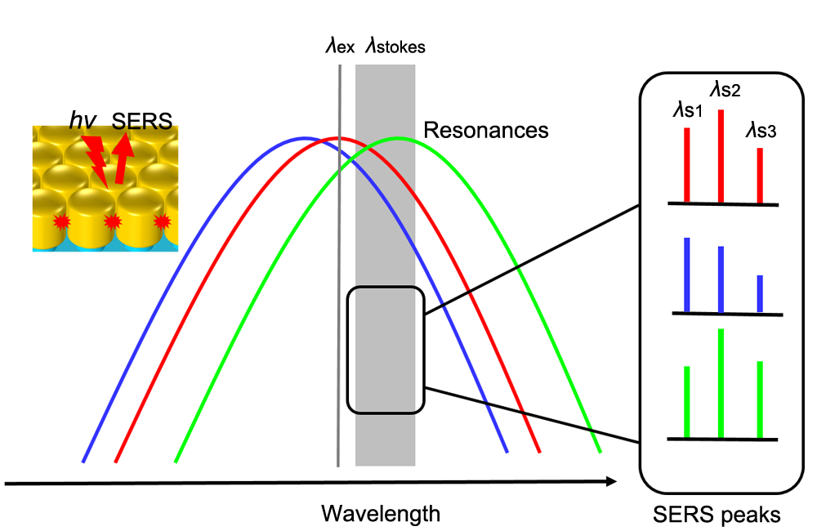
Fig. 1 Schematic idea of this work. Small cavities between the Au nanorods can sustain strong local fields and thus SERS signals. The SERS enhancement is proportional to the squared product of the local electric field intensities at the excitation and Stokes wavelengths (i.e., λ_{ex}, λ_{stokes}). Monotonic tuning of the plasmon resonance across the excitation wavelength and over the Stokes Raman shift range should give rise to gradual evolutions of the relative heights of individual SERS peaks (i.e. λ_{s1}, λ_{s2}, λ_{s3}), which can clearly reveal the correlations between near-field SERS enhancement and far-field plasmon resonances.
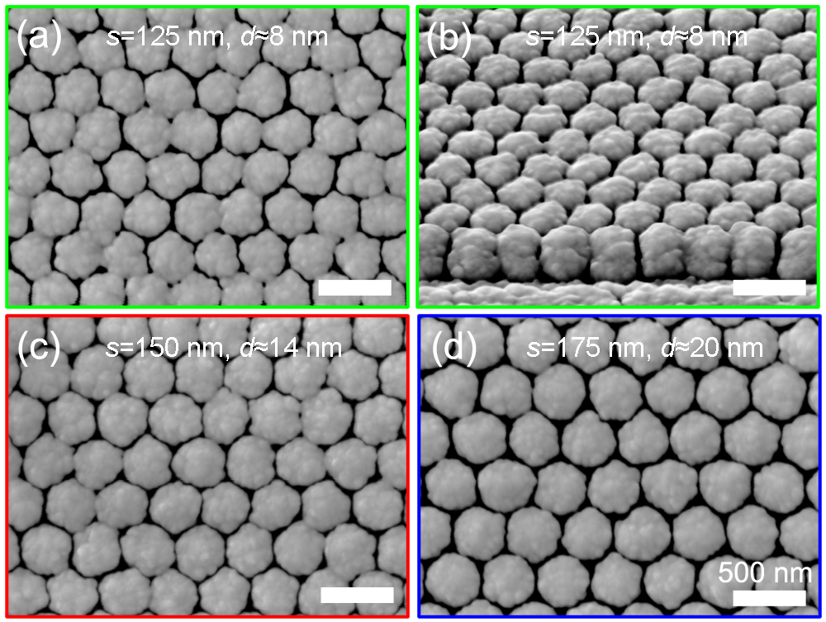
Fig. 2 SEM images of the fabricated closely spaced Au nanorod arrays on templated Si substrates. The value of the pre-set separation s between bottom Si pillars is used to indicate the arrays. The white scale bar is 500 nm. (a) Top view, s = 125 nm, the average inter-rod gap d ≈ 8 nm. (b) Oblique view, s = 125 nm. (c) Top view, s = 150 nm, d ≈ 14 nm. (d) Top view, s = 175 nm, d ≈ 20 nm.

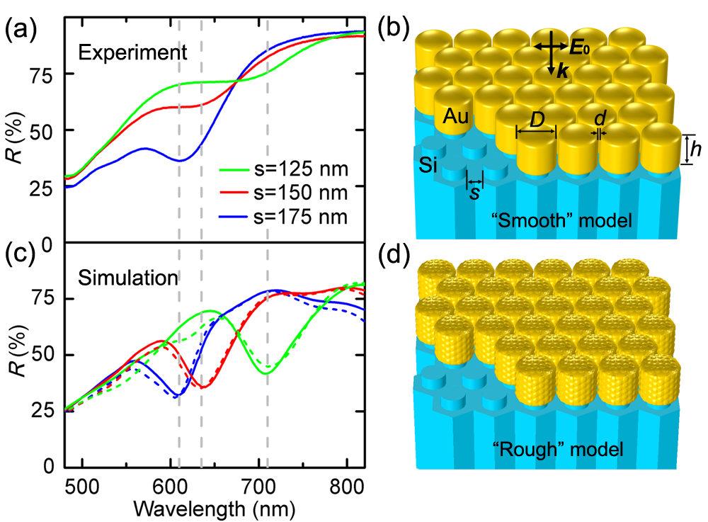
Fig. 3 (left panel) LSPR spectra in terms of reflectance R. For comparison, the experimental measurements are shown in (a), while FEM simulation results are in (c). The position of the resonance dip is λ ≈ 710, 635, 610 nm (indicated by vertical gray dashed lines) for s = 125 (green curves), 150 (blue curve), 175 nm (red curves), respectively. The simulated reflectance spectra using “smooth” structural models are plotted in solid curves while “rough” structural models dashed curves. (right panel) Typical geometric modeling for FEM calculations. (b) is the smooth model, the size parameters (d, D, h and s) are equivalent to those of the SEM measurements. The height of the cylindrical part is h = 240 nm. The parameter s is the edge-to-edge distance between neighbouring Si pillars at the bottom. The array period A is measured by the center-to-center distance between Si pillars, which also equals the sum of the Au nanorod diameter D and their spacing d. Correspondingly, (d) shows the rough model considering the effect of surface roughness. Note that the surface of Au nanorods is covered by small separated particles.

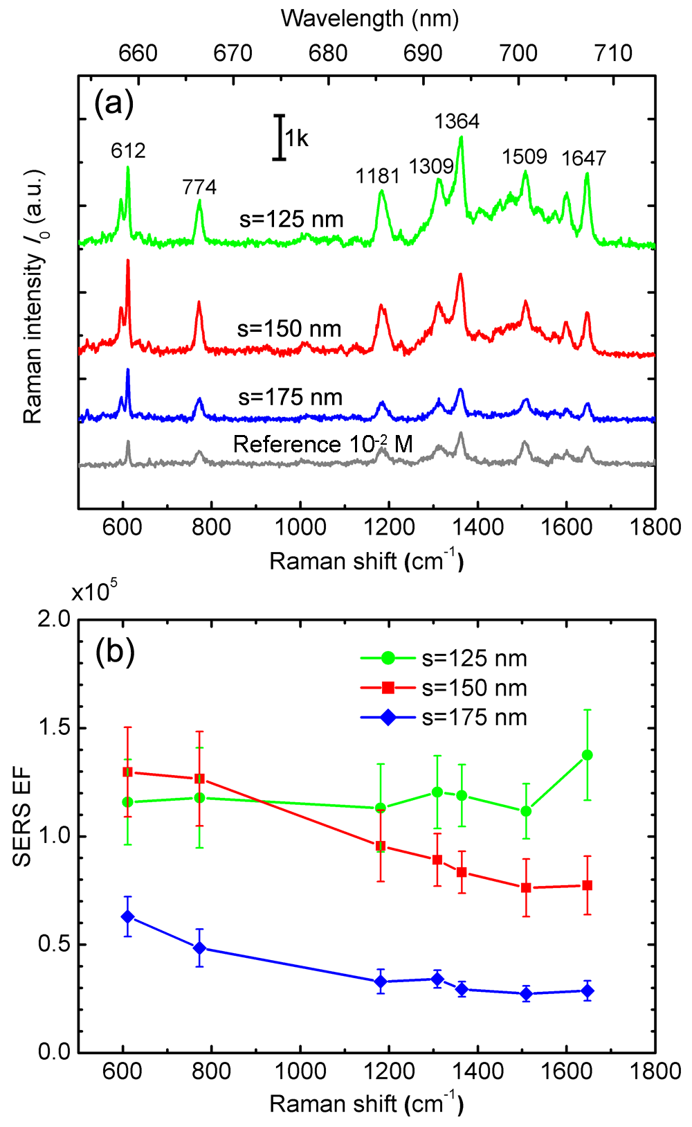
Fig. 4 (a) Average Raman spectra. The arrays s = 125, 150, 175 nm were measured using 10⁻⁶ M R6G as the probe molecule while the reference sample was 10⁻² M bulk R6G solution. (b) Experimental SERS EFs for the seven characteristic peaks at 612, 774, 1181, 1309, 1364, 1509 and 1647 cm⁻¹.

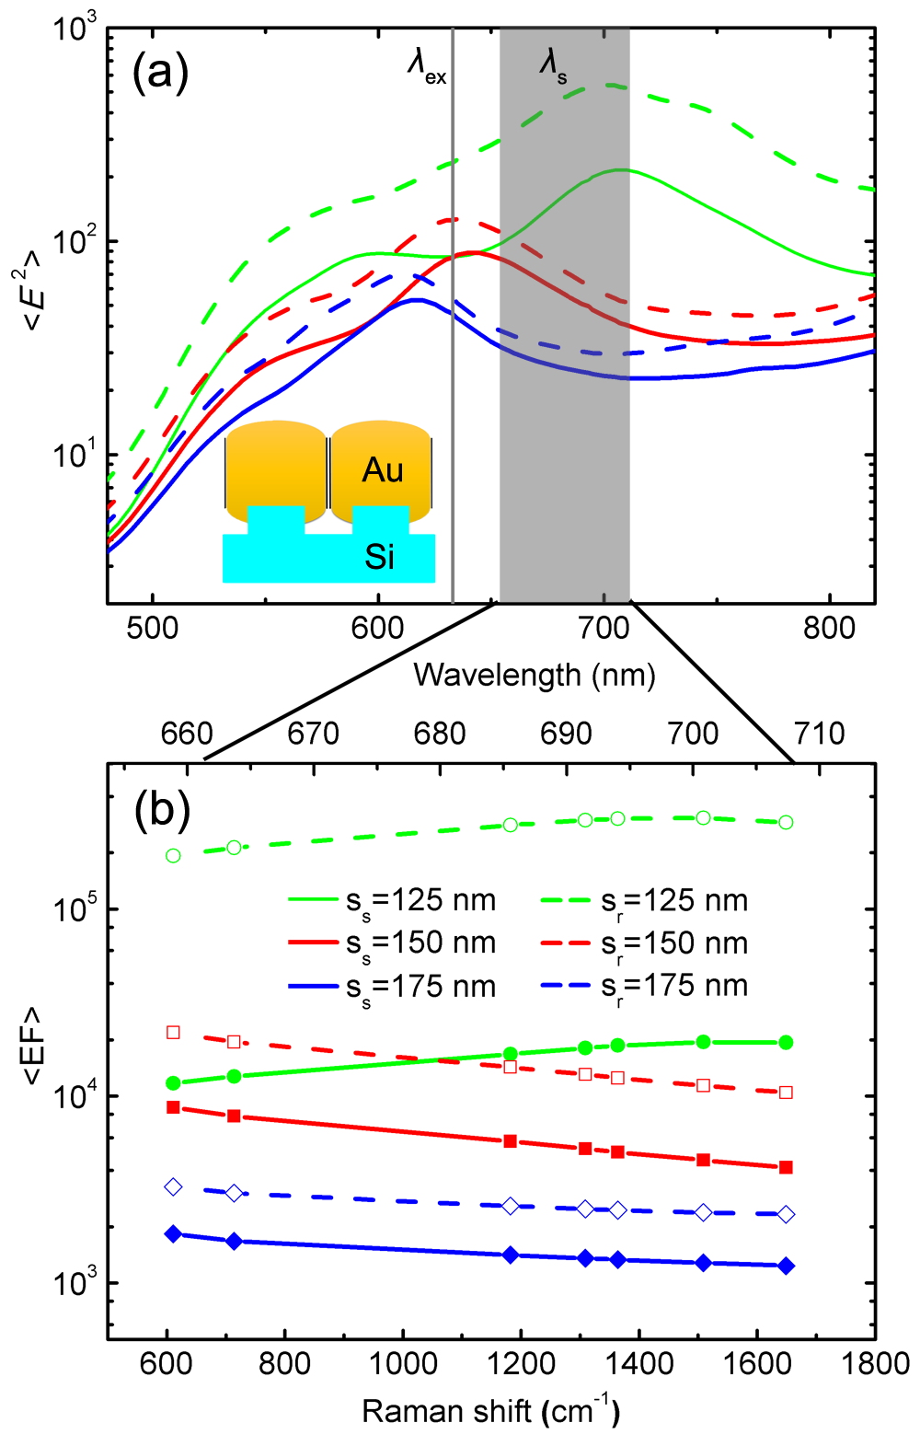
Fig. 5 (a) FEM simulated near-field <E²> spectra for the smooth (solid curves) and rough (dashed curves) models. The inset shows the auxiliary lines near the side surface of the Au nanorods for the integral average of local electric fields |E_{loc}|²/|E₀|². The excitation wavelength λ_{ex} = 633 nm and the considered Stokes Raman shift range λ_{s} = 658-706 nm are marked in the plot. (b) Corresponding average EFs <EF> at the seven featured Raman shift wavenumbers. The <EF> was obtained by the average of the squared product of the local electric field intensities at the excitation and Stokes wavelengths. The subscript “s” means the smooth model while “r” represents the rough model.

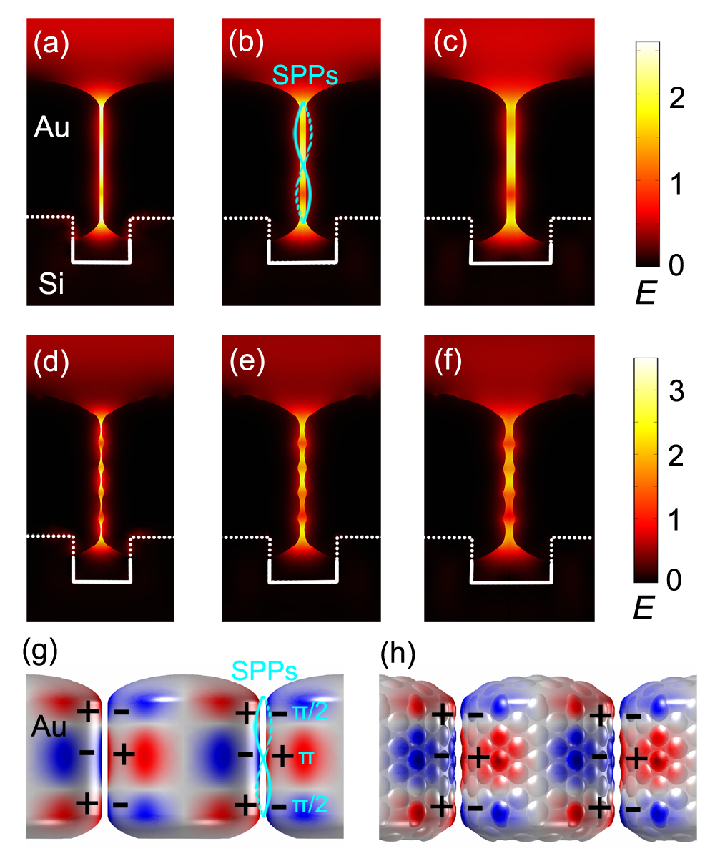
Fig. 6 Typical FEM plasmon mapping. (a)-(c) the spatial electric field distributions (in the form of logarithmic |E_{loc}/E₀|²) for the smooth models of s = 125, 150, 175 nm at the resonance wavelength λ = 710, 635, 610 nm, respectively. (d)-(f) Corresponding electric field distributions for the rough models at the same resonance wavelengths from left to right. (g)-(h) 3D surface charge distributions at λ = 635 nm for the smooth and rough models of s = 150 nm, indicating clearly the Fabry-Perot-like cavity mode. Red color represents positive charge while blue is negative.

